Original Research Article
Characterization and potential use of Kombé clay materials in the adsorption of chromate and nitrate ions

ABSTRACT:
This work aims to evaluate the ability of Kombé clays, in the Republic of Congo, to adsorb chromate and nitrate ions in water. To do this, we first characterized the clay to obtain information on its physicochemical and mineralogical properties. We then performed chromate and nitrate ion adsorption tests on this material to assess its adsorption capacity.
To characterize the Kombé clay, we used several analytical techniques, such as particle size distribution and Atterberg limits, X-ray diffraction (XRD), chemical analysis, cation exchange capacity (CEC), and specific surface area (SS). The results obtained show that the Kombé clay is plastic and composed of 52% clay, 18% silt, and 30% sand, with a predominance of kaolinite and a significant amount of quartz. Its CEC is 3 meq/100 g and its SS is 16 m²/g. Adsorption tests conducted on this clay indicate that it can be used for the adsorption of chromate and nitrate ions. The adsorption results show that Kombé clay removes 2.59% of chromate ions and 15.94% of nitrate ions.
In light of these results, this study reveals that Kombé clay can be used in the treatment of polluted water as an adsorbent, as well as in applications for traditional and structural ceramics (bricks, tiles, etc.). However, this adsorption capacity is low and needs to be improved.
Keywords: Clay material, Kombé, characterization, adsorption, physicochemical and mineralogical properties.

- INTRODUCTION
Clay materials, as a soil category, possess remarkable physicochemical properties, such as cation exchange capacity, high specific surface area, and notable plasticity [1]. These characteristics give clays significant adsorption and retention capacity for several chemical species, making them useful in many applications, including water purification, decontamination of polluted soils [2], ceramics [3], etc. In the Republic of Congo, several studies have already demonstrated the interesting properties of clay materials from certain localities, showing their potential in fields such as ceramics, civil engineering [3-6], and the environment [7-9]. However, there is a lack of data on clay materials present in several other localities, which limits the comprehensive assessment of their properties and potential applications. This research study aims to evaluate the performance of Kombé clay as an adsorbent for environmental pollution remediation.
The approach adopted began with a physicochemical and mineralogical characterization using analytical techniques such as particle size analysis, Atterberg limit analysis, X-ray diffraction (XRD), chemical analysis, cation exchange capacity (CEC) measurement, and specific surface area analysis.
Laboratory adsorption tests were then conducted using model pollutant ions, including chromate (${CrO}_{4}^{2-}$) and nitrate (${NO}_{3}^{-}$), to better understand the potential of this clay for the treatment of environmental pollution.

MATERIALS AND METHODS
  - Location of the Sampling Site
The materials used in this study were collected in Kombé, a neighborhood in Madibou District 8, Brazzaville, Republic of Congo. The geographic coordinates taken using a Sportiva 2/Two Nav GPS are: Longitude: 15.1682°E and Latitude: 4.3504°S. The following figure 1 illustrates the sampling area.
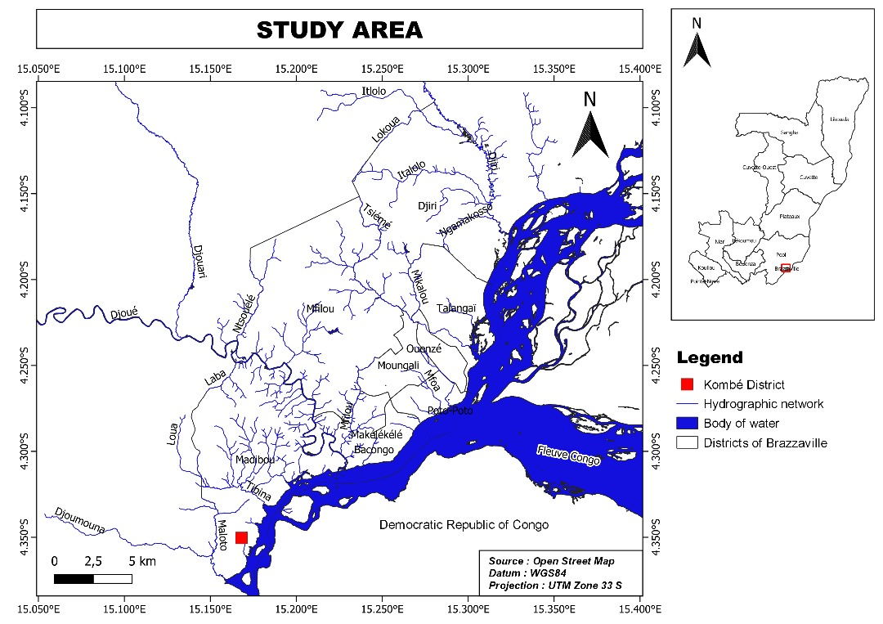
Figure 1: Map of the Sampling Site

2.2. Sample Preparation:
2.2.1. Description
The collected materials were dried, ground, and sieved using a series of sieves from 2 mm to 0.08 mm and a 56 µm sieve, followed by the extraction of the fine fraction (fraction < 2 µm) by sedimentometry. The different samples were named K-B, K-56, and K-F, respectively, for the raw, unsieved Kombé clay material, the 56 µm sieve, and the fine fraction.
2.2.2. Equipment Used
The following equipment was used for grinding and sieving:
• A porcelain mortar and pestle;
• A series of six (6) sieves from 2 mm to 0.08 mm;
• A 56 µm sieve.
The following equipment was used for sedimentometry:
• A Bouyoucos-type torpedo-shaped hydrometer, graduated from 0.995 to 1.030 g/cm3;
• Two 2-liter test tubes;
• A mechanical immersion stirrer;
• A manual stirrer for homogenizing the suspension before testing;
• A graduated thermometer;
• A stopwatch.
2.2.3. Reagents Used
• Sodium hexametaphosphate;
• Distilled water.
• Potassium chromate,
• Sodium nitrate,
• Hydrochloric acid solution,
• Sodium hydroxide solution.
2.3. Characterization Methods
2.3.1. Particle Size Analysis
Particle size analysis of Kombé clay materials was carried out at the Building and Public Works Control Office (BCBTP) in Brazzaville using the method described in standards NF P94 056 and NF P94 057 [10].
2.3.2. Atterberg Limits
Atterberg limits were Carried out at the Building and Public Works Inspection Office (BCBTP) in Brazzaville in accordance with standards NF P94 051 (1992) and NF P94 051 (1993) [11]
- Determination of the liquid limit:
The liquid limit ($W_{L})$ was carried out using the CASAGRANDE apparatus and was calculated using the following formula (I)
$$W_{L}=W× \frac{N^{0,121}}{25} (I)$$
Where: N = the number of blows and W = the water content
- Determination of the plastic limit:
The plastic limit (Wp) was determined using the following equation II:
$Wp = \frac{Wp1+Wp2+Wp3}{3}$ (II)
Wp1+Wp2+Wp3 are the plastic limits over the course of three tests.
- Plasticity Index (PI)
The plasticity index was calculated by the difference between the liquid limit and the plastic limit according to the following relation (III):
$PI = WL-Wp$ (III)
    - X-ray Diffraction
X-ray diffraction was performed at the Darmstadt University of Technology (TU Darmstadt - Joint Research Group Laboratory of Materials Design by Synthesis) in Germany, using a Bruker D8 diffractometer equipped with a copper (CuKa) anticathode. The angular analysis range was 5° to 90°.
    - Chemical Analysis
Chemical analysis was performed using an Inductively Coupled Plasma Atomic Emission Spectrometer (ICP-AES) at the Centre for Petrographic and Geochemical Research (C.R.P.G.) in Nancy, France.
    - Cation Exchange Capacity
CEC was determined using the METSON method. The procedure used is that described in AFNOR standard NFX31-130 [12]; the test sample was 2.5 g of clay material ground to 2 mm.
    - Specific Surface Area
The specific surface area of ​​the Kombé material was determined using the B.E.T. method [13] in the laboratory of the Technical University of Darmstadt (TU Darmstadt - Joint Research Group Laboratory of Materials Design by Synthesis) in Germany.
    - Chromate and Nitrate Adsorption Tests
The chromate and nitrate adsorption tests were performed using the batch method, and the data obtained allowed us to construct adsorption isotherms based on the following equation:
$Qe = \frac{(C0 - Ce). V}{m}$ [14] (IV)
Where:
C₀: initial concentration of the solute or adsorbate (mol/L);
Ce: equilibrium concentration of the solute in the solution (mol/L);
m: mass of the adsorbent (g);
Qe: amount of solute adsorbed per unit mass of the adsorbent (mol/g);
V: volume of the solution (L).
- RESULTS AND DISCUSSION
Table 1: Sieving results of the Kombé sample
Sieve diameter | 1mm | 0,4mm | 0,2mm | 0,1mm | 0,08mm
mR (en g) | 0 | 4.1 | 22.8 | 58.2 | 69.9
%R | 0 | 1.36 | 7.6 | 19.4 | 23.3
100-%R | 100 | 99 | 92 | 81 | 77

Table 2: Results of sedimentometry of the Kombé sample
Grain diameter (mm) | 0,105 | 0,075 | 0,055 | 0,038 | 0,025 | 0,017 | 0,012 | 0,0085 | 0,006 | 0,005 | 0,0016 | 0,0014
% of grains (d) | 77 | 75 | 71 | 68 | 64 | 64 | 60 | 60 | 57 | 57 | 52 | 52
mR: cumulative mass of rejects;
%R: percentage of cumulative rejects;
100-%R: percentage of passing particles;
% of grains d: percentage of grains with a diameter d.
Using table 1 and 2 allowed us to plot the particle size curve for the Kombé sample (Figure 2), with the particle size (in millimeters) on the x-axis and the weight percentage on the y-axis.
Coarse sand | Fine sand | Silt | Clay

Figure 2: Granulometric analysis curve of the Kombé sample
Analysis of this granulometric curve reveals the following granulometric composition: 52% clay, 18% silt and 30% sand. This result made it possible to position this Kombé sample in the texture triangle of Figure 3 below.
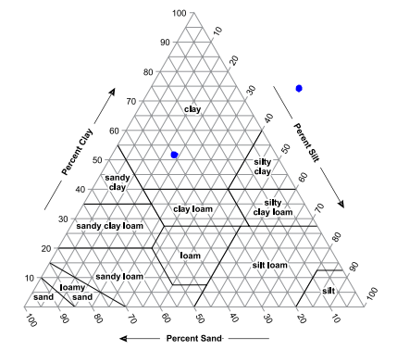
KOMBE
Figure 3: Sample positioning in the texture triangle "Soil Survey Manual"
Given the location of this sample within this texture triangle, the Kombé material has a clayey texture. This same observation was made by Banzouzi Samba et al. in a study of the material extracted at Ntokou. [5]
Atterberg limits of the Kombé sample
Table 3: Results of the Atterberg limits of the Kombé sample
Number of strokes | Liquid limit |  |  |  |  | Plastic limit
Number of strokes | 15 | 19 | 23 | 27 | 31
Tare number | 23 | 48 | 370 | 730 | D | A | 51 | 128
Water content | 50,6 | 49,3 | 48,1 | 47,6 | 46,6 | 22,5 | 23,1 | 19,0
PI=27% | W_{L}= 48,1% |  |  |  |  | W_{P}= 21,5%

The results of the Atterberg limits of this sample were positioned in the Casagrande abacus below:
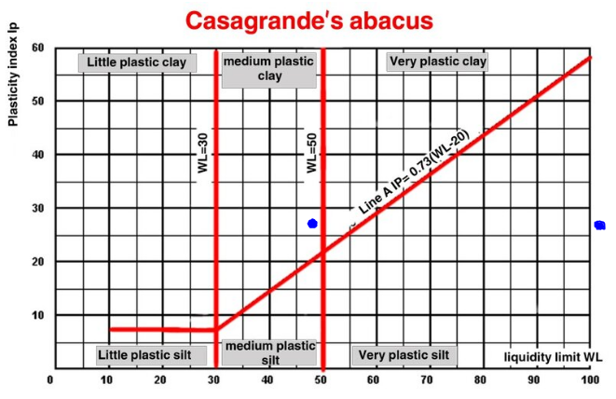
KOMBE
Figure 4: Positioning of the Kombé sample in the Casagrande abacus
The liquid limit and plasticity index of the Kombé material were plotted on the Casagrande diagram. Given its position in this diagram, the Kombé material is a plastic clay material. The plasticity of the Kombé sample can be explained by its clay content, which is at the acceptable limit according to the results of the particle size analysis.
With this plasticity index (PI) value of 27%, this material can be used in the field of traditional ceramics, as demonstrated by Chedlia Ounissi et al. in the study and ceramic application of clays from southeastern Tunisia [15].
X-ray diffractogram of the Kombé sample
The diffractogram in Figure 5 below presents the results of X-ray diffraction on the Kombé material sample.
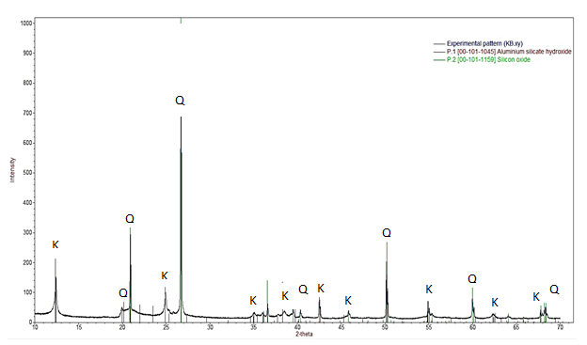
Figure 5: Diffractogram of the Kombé sample (K-B)
Analysis of the diffractogram of the Kombé material reveals the presence of clay minerals and crystalline phases, primarily in the form of tectosilicates.
Two main mineralogical phases were identified in this sample: quartz and kaolinite.
The set of diffraction peaks at 4.434; 4.225; 3.347; 2.229; 2.2332; 1.670; 1.540; 1.371; and 1.2554 Å confirms the presence of quartz as a very common tectosilicate. This suggests that quartz is a major component of this sample. Furthermore, the characteristic peaks of kaolinite (7.072; 3.557; 2.558; 2.495; 2.373; 2.335; 2.279; 2.2332; 2.124; 1.667; 1.488; 1.4333; 1.4165 and 1.381 Å) demonstrate that kaolinite is the predominant clay mineral in this Kombé sample.
It is noteworthy that the quartz peaks are significantly more intense than those of kaolinite. This not only means that the proportion of quartz is higher in the sample, but also indicates a higher degree of crystallinity for quartz compared to kaolinite. In other words, the quartz crystal lattice is more ordered and better formed than that of kaolinite in this sample [16]
Chemical Composition of the Kombé Sample
Table 4 below gives the results of chemical analysis of major elements (Si, Al, Fe, Mn, Mg, Ca, Na, K, Ti, and P) as a percentage of the most stable oxide.
Table 4: Results of the Chemical Analysis of Kombé
Sample | SiO₂  % | Al₂O₃  % | Fe₂O₃  % | MnO  % | MgO  % | CaO  % | Na₂O  % | K₂O  % | TiO₂  % | P₂O₅  % | PF  % | Total  %
Kombé | 73,04 | 15,29 | 1,92 | <L.D. | 0,24 | <L.D. | <L.D. | 0,42 | 0,88 | <L.D. | 8,06 | 99,84
With: LD: detection limit and PF: loss on ignition at 1000°C
Chemical analysis revealed that the Kombé clay is remarkably rich in silica (SiO₂), with a content of 73.04%. This high silica content is consistent with the results of the grain size analysis, which indicate a significant proportion of quartz (SiO₂). Silica is also a major component of kaolinite with the formula Al₂Si₂O₅(OH)₄, a predominant clay mineral species often associated with this type of deposit.
The calcium oxide (CaO) and sodium oxide (Na₂O) contents are very low, suggesting significant chemical alteration of the parent material. This low concentration of alkali and alkaline-earth elements indicates a near absence of minerals such as plagioclase (calcium-sodium feldspars), granite, and gneiss, which are often the main sources of these oxides. This phenomenon is consistent with the kaolinization process, where feldspars are decomposed into kaolinite, releasing alkali and alkaline-earth elements.
The loss on ignition (PF), measured at 8.06%, corresponds to the thermal decomposition of clay minerals, mainly kaolinite, which releases water of constitution at high temperatures. This value is typical of kaolinitic clays.
The SiO₂/Al₂O₃ molar ratio is an essential indicator for classifying and evaluating the refractory potential of clays. This ratio, being 4.77 for the Kombé sample, places this clay in the category of siliceous refractory clays, whose ratio is typically between 3.5 and 6.7 in the classification of refractory clays according to ISO10081-1, 2003 [17].
This value confirms the potential of Kombé clay for applications requiring high thermal resistance, such as refractory bricks or specialty cements. This result is consistent with the work of POUNTOUENCHI Amadou (2020) [18] on clays of similar compositions, which demonstrated their successful use in the manufacture of refractory ceramic materials.
The kaolinite and quartz contents in the Kombé sample were determined using the following formulas:
$\%Kaolinite= \frac{{\%Al}_{2}O_{3}}{102}x 258$ (V)
$\%Quartz=\%{SiO}_{2}-\%Kaolinite x\frac{60 x 2}{258}$ (VI)
The mineralogical balance of this material is 38.67% kaolinite and 55.05% quartz. Analysis of this balance confirms the significant amount of silica in the Kombé sample, given the relatively high percentage of quartz. This is consistent with the results of the grain size analysis, which showed a relatively high percentage of sand.
Cation exchange capacity of the Kombé sample
Analysis of the Kombé clay sample revealed a CEC of 3 meq/100g. This value is very low compared to other clays, but is entirely consistent with the mineralogical composition. The observed low CEC confirms the predominance of kaolinite in the sample.
Kaolinite is a 1:1 clay mineral. This crystal structure has very few isomorphic substitutions in its lattice, which explains its low surface charge and, consequently, its low CEC. CEC values ​​for pure kaolinite typically range from 3 to 15 meq/100g [14]. The Kombé clay sample, with a value of 3 meq/100g, is in the lower part of this range, which confirms that the Kombé clay is a kaolinite. These results are consistent with the conclusions of several studies on the characterization of kaolinite deposits. For example, N.O. Pascal [19] demonstrated the effect of heat treatment on the CEC of kaolinitic clays. He observed that these clays reached CEC values of 13 and 15 meq/100g at 1000°C, which suggests that at low CECs, kaolinitic clays have high resistance to high temperatures, making them particularly suitable for the production of refractory materials. This result corroborates the potential use of Kombé clay in this field.
Specific Surface Area of ​​the Kombé Sample
The specific surface area results for the Kombé sample is 16.2 m²/g.
Analysis of the surface properties of Kombé clay highlights two key parameters: specific surface area (SS) and cation exchange capacity (CEC). The specific surface area of ​​this sample is perfectly consistent with that of pure kaolinite, whose typical values ​​range from 10 to 30 m²/g [20]. This low surface area is explained by the nature of kaolinite, a 1:1 phyllosilicate, where the layers are lightly charged and the surface charges are mainly located at the ends of the layers.
The low CEC, reported at 3 meq/100g, reinforces this conclusion. Such a low CEC is characteristic of kaolinite, as its crystalline structure undergoes few atomic substitutions, which reduces the number of negatively charged sites for cation exchange. The convergence of these two results, low specific surface area and low CEC, irrefutably confirms that kaolinite is the predominant mineral in the Kombé sample. Although the specific surface area and CEC values ​​of Kombé clay are low, they are not negligible in terms of adsorption.
A study by Chen, M. et al. [21] showed that adsorption on kaolinite does not depend solely on specific surface area. Pore geometry and the specific interaction between cations and organic molecules also play a crucial role. These results suggest that Kombé clay, despite its low SS and CEC values, may have exploitable adsorption potential. These findings may lead Kombé clay to applications in water treatment and pollution remediation.
Adsorption tests of chromate and nitrate ions on Kombé clay
- Adsorption of chromate ions on different fractions of Kombé clay materials

Figure 6: Adsorption isotherm for chromate ions on samples of K-B, K-56 and K-F
- Adsorption of nitrate ions on different fractions of Kombé clay materials

Figure 7: Adsorption isotherm for Nitrate ions on samples of K-B, K-56 and K-F
All adsorption experiments were conducted using the batch method at room temperature and a fixed pH of 3. The constant parameters included a mass of 10 mg of clay placed in contact with a solution volume of 50 mL.
Analysis of the curves in Figures 6 and 7 reveals that the quantities of chromate and nitrate adsorbed on the unsieved crude sample (K-B) are lower than those adsorbed on the 56 µm sieved sample (K-56). These quantities adsorbed on the unsieved crude sample and on the 56 µm sieved sample are themselves lower than those adsorbed on the fine fraction (K-F).
For the initial concentration of 0.000064 mol/L of nitrate ions, the results highlight a negligible variation in adsorption capacity (Qe) between the raw sample (K-B, Qe = 0.000041 mol/g) and the 56 µm sieved fraction (K-56, Qe = 0.000040 mol/g). This slight discrepancy is attributed to a very similar particle size distribution between these two fractions.
However, a slight increase in performance is observed with the fine sample (K-F), which achieves an adsorption capacity of 0.000051 mol/g for nitrate ions. A similar observation was made for chromate ions, where the difference between samples K-B (0.0000031 mol/g) and K-56 (0.0000053 mol/g) remains minimal. The same enhanced performance profile was observed with sample K-F for chromate ions (0.0000083 mol/g), and these trends persisted across all other initial concentrations tested.
The improved adsorption performance of sample K-F is directly correlated with its enrichment in finer particles. The increased particle size translates into an increase in the material's specific surface area. This phenomenon multiplies the number of active adsorption sites available, acting as an ultra-efficient scavenger for pollutants. In other words, the adsorbent's performance is directly proportional to the abundance of the clay phase (the main constituent responsible for ion capture). This observation is consistent with previous work on clayey materials, including a study that showed that the permeability of a layer decreases as its clay content increases. [22]
Similarly, research on the migration of heavy metals in the subsoil [23] has established that pollutant retention is maximized in clay-rich soils (40 to 50% clay) at short depths (a few centimeters) compared to less clayey soils (20% clay) where migration is deeper (several decimeters).
Finally, analysis of these isotherm curves (Figure 6 and 7) reveals a Type S shape, in accordance with the Giles classification [24]. This profile is characteristic of a situation where there is competition for the occupation of active sites between the solvent and the solute [25]. In this specific system, the Type S isotherm indicates steric competition between water molecules (the solvent) and pollutant ions (chromate or nitrate, the solute) for access and attachment to the positively charged adsorption sites of the clay.

- CONCLUSION
The objective of this work was to evaluate the performance of Kombé clay as an adsorbent in order to understand its properties and assess its potential practical applications in the environmental field for pollution remediation.
Previous characterization studies of this material revealed that it is plastic and primarily composed of kaolinite, with significant amounts of quartz.
The cation exchange capacity (CEC) and specific surface area values ​​were found to be low, but nevertheless suggested the possibility of interaction with various substances, including pollutants.
Adsorption tests of chromate and nitrate ions demonstrated that Kombé clay can capture and remove these pollutants (up to a maximum of 15.94% of nitrate ions and 2.59% of chromate ions) from aqueous solutions. However, the adsorption efficiency is low and needs to be optimized to confirm the material's potential use in environmental remediation applications as a low-cost adsorbent.
Additionally, the mineralogical and physicochemical properties obtained in this study suggest that Kombé clay is a local resource that can be used for the production of structural ceramics (such as bricks and tiles), due to its kaolinitic nature, plasticity, and refractory properties.
Future research should focus on optimizing the adsorption properties of this clay through various treatments (such as thermal and acid activation) to improve its adsorption capacity and better utilize it as a local resource for environmental pollution remediation.

Disclaimer (Artificial intelligence)
Option 1:
Author(s) hereby declare that NO generative AI technologies such as Large Language Models (ChatGPT, COPILOT, etc.) and text-to-image generators have been used during the writing or editing of this manuscript.
Option 2:
Author(s) hereby declare that generative AI technologies such as Large Language Models, etc. have been used during the writing or editing of manuscripts. This explanation will include the name, version, model, and source of the generative AI technology and as well as all input prompts provided to the generative AI technology
Details of the AI usage are given below:
1.
2.
3.

REFERENCES
- Konta, J., 1995. Clay and man: Clay raw materials in the service of man. Appl. Clay Sci., 10(4): 275-335.
- Beatrice O. Otunola ∗, Olusola O. Ololade, A review on the application of clay minerals as heavy metal adsorbents for remediation purposes. Environmental Technology & Innovation 18 (2020) 100692.
- Voula, R.M., Diamouangana, F.Z.M., Moutou, J.-M., Samba,V.I.B., Foutou, M.P. and Ngoma, J.P.(2021) Characterization and Valuation of a Clay Soil Sampled in Londela-Kayes in the Republic of Congo. Journal of Minerals and Materials Characterization and Engineering, 9, 117-133. https://doi.org/10.4236/jmmce.2021.92009
- Moutou, J.M., Foutou, P.M., Matini, L., Samba, V.B., Mpissi, Z.F.D. and Loubaki R. (2018) Characterization and evaluation of the potential uses of Mouyondzi clay. Journal of minerals and materials Characterization and Engneeing, 6, 119-138.
- Banzouzi S.V.I, Diamouangana M.Z.F, Moutou J.M.S.B., Makosso V.R., Vila N. T. A., Loubaki R. and Foutou P.M. The Characterization and Valorization of Clay Extracted from Ntokou Locality (Brazzaville, Republic of Congo). Res. J. Environ. Earth Sci., (2020) 12:3 64. http://doi.org/10.19026/rjees.12.6056
- Moutou J.M., Loubaki R., Nsongo T. and Foutou P.M. (2019). Characterization and technological properties of two clay soils in Republic o Congo. Res. J. Material Sci. Vol. 7(1), 1-10. ISSN 2320-6055.
- Moutou J.M., Bibila Mafoumba C., Matini L., Ngoro Elenga F. and Kouhounina L. Characterization and evaluation of the adsorption capacity of dichromate ions by a clay soil of Impfondo. Res. J. Chem. Sci. Vol. 8(4), 1-14, April (2018)
- Diamouangana M.Z. F., Moutou J.M., Matini L., Mongo O. M. C. F. and Kouhounina B.L. M. Synthesis of an inorgano-clay complex from Loukolela clay and application in the adsorption of humic matter. Int. Res. J. Environmental Sci. Vol. 8(3), 12-20, July (2019)
- Kouhounina B.M. et al. Study of the adsorption of glycine by two local clays of Congo Brazzaville. Int. Res. J. Environmental Sci. Vol. 10(2), 52-63, April (2021)
- AFNOR (1992). NF P94 056. Particle Size Analysis of Soils: Sieving Method. AFNOR (1992). NF P94-057. Particle Size Analysis of Soils: Sedimentation Method.
- AFNOR (1993). [NF P94-051] NF P 94-051. Determination of Atterberg Limits.
- AFNOR (2000). NF X31-130 — Soil Quality – Chemical Methods – Determination of Cation Exchange Capacity (CEC) and Extractable Cations. 15p
- H. Chamayou and J.P. Legros, (1989). The Physical, Chemical, and Mineralogical Basis of Soil Science. Collection Technique Vivantes. Agence de la Francophonie publisher. 28 Vol. ISBN-10 : 9290281480, ISBN-13 : 978-9290281481.
- Brunauer S., (1943). The Adsorption of the Gases and Vapors Physical Adsorption, Princeton University Press, 511p.
- Chedlia Ounissi, Salah Mahmoudi1*, Luca Valentini, Ali Bennour et Gilberto Artioli (2022). Study and ceramic application of clays from the southeastern Tunisia. Rev. Fr. Geotech. 171, 2, 2022. https://doi.org/10.1051/geotech/2022004
- A. Guinier (1956). Theory and technique of radiocrystallography, DUNOD Publishing, Paris, France. 2e ed. 1 vol., 736 pages.
- ISO 10081-1: 2003. Classification of dense shaped refractory products. Part 1: Silica-alumina. Edition 2, 2003.
- POUNTOUENCHI Amadou (2020). Development and characterization of aluminosilicate refractory bricks based on clayey materials from Koutaba and Mayouom (Western Region): effect of the addition of coffee production residues and rice husks. Ph/D thesis in Inorganic Chemistry, University of Yaoundé 1 Faculty of Sciences, Department of Inorganic Chemistry, Yaoundé, Cameroon. Pp77/220.
- Nkoulou Oyono Pascal (2023). Effect of Heat Treatment on the Cation Exchange Capacity of Kaolinitic Clays. Dissertation of DI.P.E.S.II, University of Yaoundé 1, Ecole Normale Supérieure de Yaoundé, Department of Chemistry. Yaoundé-Cameroon, pp. 32/51
- Guyot J. (1969), Measurement of Specific Surface Areas of Clays by Adsorption. Ann. Argon, 20 (4), 33-359.
- Chen, M.; Yang, T.; Han, J.; Zhang, Y.; Zhao, L.; Zhao, J.; Li, R.; Huang, Y.; Gu, Z.; Wu, J. (2023) The Application of Mineral Kaolinite for Environmental Decontamination: A Review. Catalysts, 13, 123. https://doi.org/10.3390/catal13010123
- Brighenti G. and Macini P., (1993). Permeability of clay layers to polluting effluents. Geoconfine 93, Arnould, Barrès and Côme (eds). Balkema, Rotterdam, ISBN.
- A. M’leyeh, E. Srasra and A. Cheref, (2002). Fixation of heavy metals by clays from the Borj Chekir municipal landfill (SW of Tunis), Tunis (EPCOWM’2002), p.533-546.
- Giles, C. H., Smith, D. and Huitson, A. (1974). A General Treatment and Classification of the Solute Adsorption Isotherm. I. Theoretical. Journal of Colloid and Interface Science, (47): 755-765.
- Larson, A. Widegren, J.A. Falconer, (1995). Transient studies of 2-propanol photocatalytic oxidation on titania. J.L. Catal., J.Chemical Science, 25, 157-611.

