Precision Frontiers in Mantle Cell Lymphoma: Tailored Therapies and Emerging Innovations

Abstract
Introduction:
Mantle cell lymphoma (MCL) is a rare and aggressive form of B-cell non-Hodgkin lymphoma, representing 5%-7% of cases, with a median age at diagnosis around 65 years. Historically, MCL was considered incurable, with chemotherapy offering only temporary remission. Recent advancements in targeted therapies have transformed the treatment landscape, providing better progression-free survival (PFS) and improved quality of life. Despite these innovations, MCL's heterogeneity and high-risk subtypes present ongoing challenges in achieving long-term remission.
Methodology:
This review summarizes current research on the molecular pathogenesis, prognostic markers, and treatment options for MCL. We explore genetic abnormalities, such as the t(11;14)(q13;q32) translocation and TP53 mutations, and their impact on prognosis. We also evaluate established and emerging biomarkers, including the Ki-67 proliferation index and minimal residual disease (MRD) monitoring, as tools to tailor therapy. Treatment strategies are examined, focusing on the evolution from chemotherapy to targeted agents like Bruton's tyrosine kinase inhibitors.
Results:
Recent studies highlight the role of genetic markers like cyclin D1 overexpression and TP53 mutations in driving MCL's aggressive course. Prognostic tools like the Mantle Cell Lymphoma International Prognostic Index (MIPI) and Ki-67 index are pivotal in patient stratification, guiding therapy choices. First-line treatment regimens, such as R-hyperCVAD and R-DHAP, show improved outcomes, especially when combined with autologous stem cell transplantation (ASCT). New targeted therapies, such as BTK inhibitors, BCL-2 antagonists, and cellular therapies, have shown promising results in clinical trials.
Conclusion:
The treatment landscape of MCL has evolved significantly, with tailored therapies offering better outcomes. Continued research into molecular biomarkers and treatment combinations will refine management strategies and provide further improvements in survival and quality of life for MCL patients. A personalized, precision-based approach remains essential in optimizing care for this challenging malignancy.
Keywords:
Mantle Cell Lymphoma, Targeted Therapy, BTK Inhibitors, Cyclin D1, TP53 Mutation, Ki-67, MIPI, Minimal Residual Disease, Autologous Stem Cell Transplantation, Personalized Medicine.

Introduction
“Mantle cell lymphoma (MCL) is a rare but aggressive subtype of B-cell non-Hodgkin lymphoma, accounting for approximately 5%–7% of all cases. The disease typically affects older adults, with a median age at diagnosis of around 65 years, and has a marked male predominance, with a male-to-female ratio of approximately 3:1” [1]. “Clinically, MCL often presents at an advanced stage with generalized lymphadenopathy, bone marrow involvement, and frequent extranodal disease, particularly in the gastrointestinal tract, spleen, and peripheral blood” [2]. Systemic symptoms such as fatigue, weight loss, night sweats, and fevers may also be present, and patients may show signs of cytopenias or splenomegaly.
“Historically, MCL was viewed as an incurable lymphoma with a relentlessly progressive course, characterized by repeated relapses despite initial responsiveness to chemotherapy. Standard chemotherapy regimens, including R-CHOP (rituximab, cyclophosphamide, doxorubicin, vincristine, prednisone), often induced remission but failed to yield durable disease control. Median overall survival (OS) historically ranged between 3 to 5 years, with even poorer outcomes for patients with high-risk features” [3].
“In recent years, the therapeutic landscape for MCL has significantly evolved. The introduction of targeted agents, such as Bruton tyrosine kinase (BTK) inhibitors, BCL-2 antagonists, and cellular therapies, has shifted the treatment paradigm away from purely chemotherapy-based regimens. These novel approaches offer not only improved progression-free survival but also the potential for deep remissions and better quality of life. Nonetheless, MCL remains a biologically and clinically heterogeneous disease, and challenges persist in achieving long-term remission, especially in high-risk patients. As such, ongoing research continues to explore predictive biomarkers, molecular subtypes, and novel therapeutic combinations to refine treatment strategies and improve outcomes” [4,5].
Molecular Pathogenesis and Prognostic Markers
“The pathogenesis of mantle cell lymphoma is driven by a complex interplay of genetic and molecular abnormalities, with the t(11;14)(q13;q32) translocation as its central initiating event. This rearrangement juxtaposes the CCND1 gene (coding for cyclin D1) with the IGH gene enhancer region, leading to constitutive overexpression of cyclin D1. The resulting dysregulation of the cell cycle promotes uncontrolled proliferation of mature B cells, which underlies the neoplastic transformation seen in MCL” [6].
“However, cyclin D1 overexpression alone is not sufficient for full transformation or disease progression. Secondary genetic alterations significantly contribute to disease heterogeneity and clinical behavior. One of the most important of these is mutation or deletion of the TP53 gene, found in a subset of patients and associated with resistance to therapy and markedly reduced survival” [7]. TP53 aberrations often co-occur with complex karyotypes and high Ki-67 proliferation indices, signaling a more aggressive disease phenotype.
“Prognostication in MCL is multifactorial, and several tools have been developed to stratify risk. The Mantle Cell Lymphoma International Prognostic Index (MIPI) is the most widely used clinical risk model and incorporates age, performance status, lactate dehydrogenase (LDH) levels, and leukocyte count to categorize patients into low-, intermediate-, or high-risk groups” [8,9]. A modified version of this index, known as the biological MIPI (MIPI-b), adds the Ki-67 proliferation index as a surrogate for tumor proliferation, thereby enhancing its prognostic power.
“The Ki-67 index, a marker of cellular proliferation, is particularly important. A high Ki-67 index (>30%–40%) correlates strongly with poor outcomes and is often seen in aggressive variants of MCL, including blastoid and pleomorphic subtypes” [10]. These histological variants display larger cells, irregular nuclei, and higher mitotic rates, and are associated with shorter progression-free and overall survival, even with intensive therapy.
“More recently, minimal residual disease (MRD) monitoring has gained attention as a powerful prognostic tool. MRD negativity, assessed by flow cytometry or molecular techniques such as PCR or next-generation sequencing, has been shown to predict longer remissions and may serve as a surrogate endpoint in clinical trials” [11]. In some treatment protocols, achieving MRD negativity is being explored as a criterion for de-escalating or stopping therapy, particularly in the context of time-limited regimens involving novel agents.
Collectively, the expanding understanding of molecular drivers and prognostic markers in MCL is refining the way clinicians approach treatment selection and response assessment. As precision medicine continues to evolve, these biomarkers will likely play an increasingly central role in therapeutic decision-making and in guiding the development of future therapies.
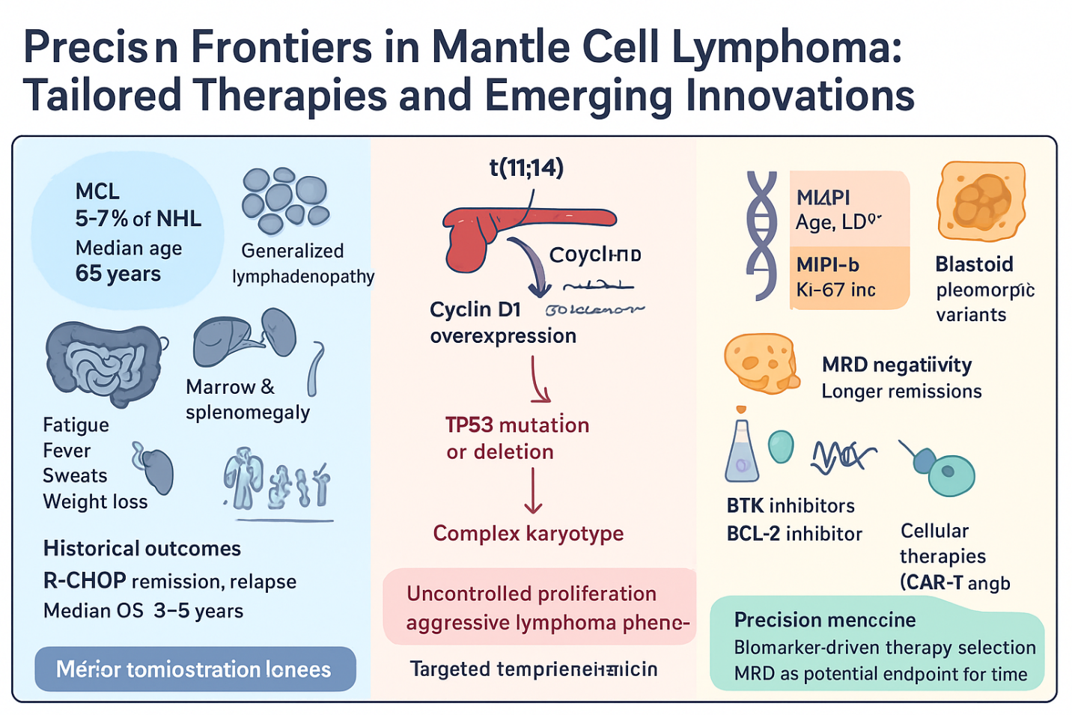
Fig No 01 - “Precision Frontiers in Mantle Cell Lymphoma: Tailored Therapies and Emerging Innovations”

First-Line Treatment Approaches
The management of newly diagnosed mantle cell lymphoma (MCL) has undergone substantial evolution over the past two decades. Historically, outcomes with conventional chemoimmunotherapy were suboptimal, but modern treatment strategies now reflect a more nuanced, risk-adapted approach that considers age, performance status, and biological risk factors.
“For younger and fit patients, induction with high-intensity regimens followed by consolidation with autologous stem cell transplantation (ASCT) remains a widely accepted standard. Regimens such as R-hyperCVAD (rituximab with hyperfractionated cyclophosphamide, vincristine, doxorubicin, and dexamethasone, alternating with high-dose methotrexate and cytarabine) have shown high response rates and improved progression-free survival (PFS) in phase II studies, although at the cost of significant hematologic and infectious toxicity” [12]. An alternative, more tolerable regimen is R-DHAP (rituximab, dexamethasone, cytarabine, and cisplatin), which has demonstrated comparable efficacy and is often used prior to ASCT [13].
“The MCL Younger trial conducted by the European MCL Network was pivotal in demonstrating that cytarabine-containing induction regimens followed by ASCT significantly prolong remission durations compared to conventional R-CHOP chemotherapy. In this study, the median PFS exceeded 90 months in the cytarabine group versus 45 months in the R-CHOP arm” [14].
“ASCT consolidation, when performed in first remission, improves disease control but is not curative. Long-term follow-up indicates relapse remains common. For this reason, maintenance therapy has become an important component of the treatment paradigm. The LyMa trial showed that rituximab maintenance every two months for three years following ASCT significantly prolonged PFS and overall survival (OS)” [15].
“In older or less fit patients, intensive chemotherapy and transplantation are generally avoided due to comorbidities and toxicity concerns. The combination of rituximab and bendamustine (BR) has become a preferred frontline regimen in this population. The STiL trial demonstrated that BR had superior PFS and better tolerability than R-CHOP in indolent and mantle cell lymphomas, making it a standard of care for older patients” [16].
“For elderly patients unable to tolerate bendamustine, regimens such as VR-CAP (bortezomib replacing vincristine in the R-CHOP regimen) offer another effective option. In the LYM-3002 study, VR-CAP significantly improved PFS compared to R-CHOP, though bortezomib-induced neuropathy remains a concern” [17].
Importantly, the landscape of frontline treatment is rapidly changing with the incorporation of novel targeted agents into induction or maintenance regimens, blurring the historical dichotomy between younger and older patient approaches. These strategies are discussed in the next section.
Role of Targeted Therapies
The emergence of targeted therapies has reshaped the treatment landscape of MCL, offering new hope for patients who historically faced limited options, particularly in the relapsed or refractory setting. Among these agents, Bruton tyrosine kinase (BTK) inhibitors have had the most transformative impact.
“Ibrutinib, the first-in-class BTK inhibitor, demonstrated remarkable activity in relapsed/refractory MCL. In the pivotal phase II trial by Wang et al., ibrutinib achieved an overall response rate (ORR) of 68% and a complete response (CR) rate of 21%, with a median PFS of 13.9 months” [18]. While effective, ibrutinib's off-target effects such as atrial fibrillation, bleeding, and hypertension limit its use in certain populations.
“To address these issues, second-generation BTK inhibitors such as acalabrutinib and zanubrutinib were developed with improved selectivity. Acalabrutinib showed a higher CR rate and fewer cardiac toxicities in phase II trials, with a well-tolerated safety profile” [19]. Zanubrutinib, evaluated in the BGB-3111-206 study, showed an ORR of 84% and a CR rate of 68% in relapsed MCL, with lower incidence of atrial fibrillation and bleeding [20]. These second-generation agents are increasingly being studied in earlier lines of therapy.
“Additional targets under investigation include PI3K inhibitors (such as idelalisib and duvelisib), though their role in MCL remains less defined due to toxicity concerns. Efforts are underway to improve tolerability through intermittent dosing or combination with other agents” [21,22,23].
“Targeted therapies have also begun to influence frontline strategies. Several trials are now exploring BTK inhibitors in combination with standard regimens (e.g., ibrutinib + BR, ibrutinib + rituximab) as initial therapy for both young and elderly patients. The SHINE trial, a phase III study evaluating ibrutinib in combination with BR in older patients with MCL, showed a significant improvement in PFS compared to BR alone, marking a key step in integrating targeted therapy into first-line treatment” [24].
Despite these advancements, targeted therapies are not without challenges. Resistance remains a significant concern, particularly with long-term use of monotherapy. Adverse events, although generally manageable, can lead to treatment discontinuation in some patients. For these reasons, combination therapies and MRD-guided approaches are increasingly being explored to optimize treatment duration and reduce cumulative toxicity.
In summary, the introduction of BTK inhibitors and other targeted agents has significantly extended survival and improved quality of life for many patients with MCL. Ongoing trials will determine the optimal sequencing and combination of these therapies, with the ultimate goal of delivering personalized, durable, and less toxic treatments.
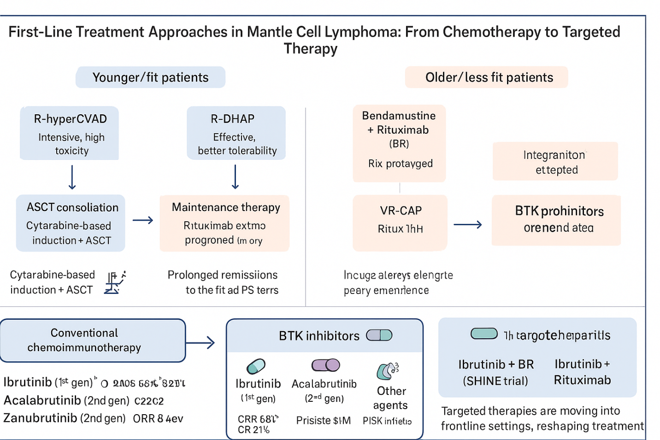
Fig No 02 - First-Line Treatment Strategies in Mantle Cell Lymphoma: Differentiating Approaches for Younger/Fit Versus Older/Less Fit Patients, Including the Transition from Conventional Chemotherapy to Targeted Therapie
Immunotherapy and Cellular Therapies
Immunotherapy has emerged as a critical component in the treatment of hematologic malignancies, and mantle cell lymphoma (MCL) is no exception. While traditional chemoimmunotherapy regimens incorporating monoclonal antibodies such as rituximab have long formed the backbone of treatment, more advanced and personalized forms of immunotherapy including CAR T-cell therapy, bispecific antibodies, and immune checkpoint inhibitors are now at the forefront of research and clinical application in MCL. These novel approaches are particularly relevant in the relapsed/refractory (R/R) setting, where standard therapies often fail to achieve durable responses.
Chimeric Antigen Receptor (CAR) T-cell Therapy
Among the most transformative advances in immunotherapy is the development of CAR T-cell therapy, which involves engineering a patient's own T cells to express a synthetic receptor targeting a specific antigen most commonly CD19, a surface marker expressed on malignant B cells.
“In 2020, the U.S. FDA approved Brexucabtagene Autoleucel (KTE-X19) as the first CAR T-cell therapy for R/R MCL based on the results of the ZUMA-2 trial. This pivotal study enrolled patients who had failed prior therapies, including BTK inhibitors, and demonstrated an overall response rate (ORR) of 93%, with a complete response (CR) rate of 67%. At a median follow-up of 12.3 months, 57% of patients remained in remission, highlighting the potential for long-term disease control” [25].
“Importantly, responses were observed even in patients with high-risk features, including TP53 mutations and blastoid histology. However, CAR T-cell therapy is not without significant risks. Cytokine release syndrome (CRS) and immune effector cell-associated neurotoxicity syndrome (ICANS) are common adverse events, though most cases are manageable with timely intervention using tocilizumab and corticosteroids” [26].
Bispecific Antibodies
Another promising immunotherapeutic approach in MCL is the use of bispecific T-cell engagers (BiTEs) and bispecific monoclonal antibodies, which simultaneously bind to a tumor antigen (typically CD20) and CD3 on T cells, thereby redirecting cytotoxic T cells toward malignant B cells.
“Several agents are currently under investigation in MCL and other B-cell malignancies. Glofitamab, a CD20xCD3 bispecific antibody, has demonstrated significant activity in relapsed/refractory B-cell lymphomas and is undergoing trials specifically for MCL. In a phase I/II study, glofitamab produced durable responses, even in patients with prior CAR T-cell exposure, suggesting that bispecifics may be an effective salvage therapy” [27].
“Similarly, epcoritamab and mosunetuzumab also targeting CD20 and CD3 have shown encouraging preliminary results in early-phase trials, with manageable toxicity profiles and potential for outpatient administration” [28]. These agents are especially attractive due to their off-the-shelf availability, unlike CAR T-cell therapy which requires individualized cell manufacturing.
Checkpoint Inhibitors
Checkpoint inhibitors, such as PD-1/PD-L1 and CTLA-4 blockers, have transformed the treatment of several cancers by enhancing T-cell activity against tumor cells. However, their role in MCL has been limited thus far.
“Early studies of nivolumab and pembrolizumab in MCL showed modest activity, with response rates significantly lower than in Hodgkin lymphoma or primary mediastinal B-cell lymphoma. The relatively low mutational burden of MCL and the immunosuppressive tumor microenvironment likely contribute to the limited efficacy” [29].
Allogeneic Stem Cell Transplantation (Allo-SCT)
“While no longer a mainstay in the era of targeted therapies and CAR T cells, allogeneic stem cell transplantation remains a potentially curative option for a select group of high-risk patients with MCL particularly those who relapse early after autologous transplantation or fail BTK inhibitors.
Allo-SCT offers the benefit of a graft-versus-lymphoma (GVL) effect, but its use is limited by significant non-relapse mortality, especially in older or frail patients. Reduced-intensity conditioning (RIC) regimens have somewhat improved the safety profile, but the decision to proceed with allo-SCT requires careful patient selection and ideally should be performed in the context of clinical trials or in centers with expertise in transplantation” [30].
Future Directions in Immunotherapy
The future of immunotherapy in MCL lies in rational combinations, sequencing strategies, and biomarker-guided approaches. Clinical trials are exploring the synergistic potential of combining CAR T-cell therapy with BTK inhibitors, bispecifics with checkpoint blockade, or venetoclax with CD20/CD3 bispecifics, aiming to achieve deeper responses and overcome resistance.
Moreover, efforts are underway to develop next-generation CAR constructs with enhanced persistence, reduced toxicity, or targeting multiple antigens to avoid relapse due to antigen escape. The identification of predictive biomarkers such as tumor mutational burden, T-cell fitness, or expression of immune checkpoints may help optimize patient selection for immunotherapy.
CONCLUSION
In conclusion, immunotherapy has become a cornerstone in the management of relapsed and refractory MCL, offering new avenues for durable remission and potential cure. As ongoing trials mature and new agents become available, these strategies will likely play an increasingly central role, possibly moving into earlier lines of treatment and altering the long-term outlook for patients with these challenging diseases
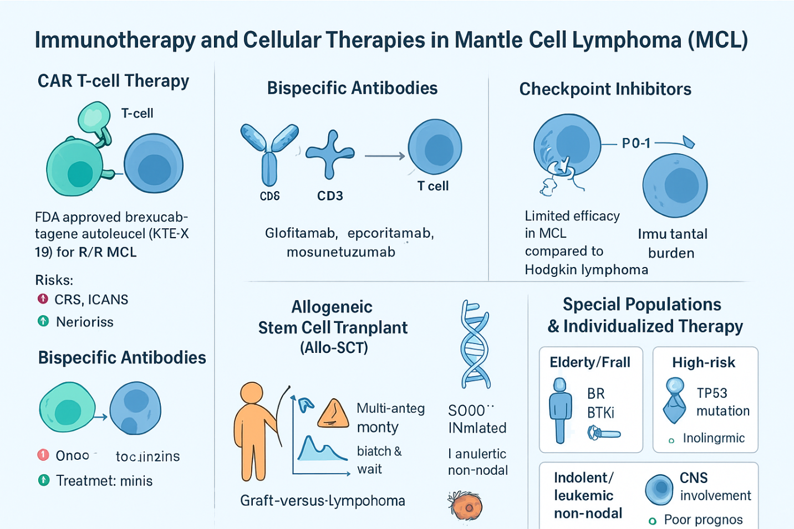

Fig No 03 - Overview of Immunotherapy and Cellular Therapies in Mantle Cell Lymphoma (MCL)
Special Populations and Individualized Therapy
Mantle cell lymphoma (MCL) presents with substantial biological and clinical heterogeneity, necessitating tailored treatment strategies for distinct patient subsets.
Elderly or frail patients often cannot tolerate aggressive regimens, making less toxic therapies such as bendamustine-rituximab or BTK inhibitors preferable. Age-related pharmacodynamics and comorbidities must be carefully weighed. Maintenance rituximab and time-limited targeted therapies offer a balance between efficacy and tolerability in this population [16,24].
Patients with blastoid or pleomorphic variants, TP53 mutations, or high Ki-67 proliferation indices represent high-risk disease with poor outcomes under conventional regimens. These cases often benefit from early integration of novel agents like non-covalent BTK inhibitors, venetoclax, and CAR T-cell therapy, which may overcome chemo-resistance and enhance survival [21,25,31].
TP53-mutated MCL, in particular, is associated with resistance to cytotoxic therapy and poor prognosis. These patients may require BTK inhibitors, CAR T-cell therapy, or clinical trial enrollment at diagnosis to achieve meaningful outcomes. Prospective molecular profiling is essential to identify this subgroup early [31].
In contrast, patients with leukemic non-nodal MCL, typically SOX11-negative with mutated IGHV genes, follow a more indolent course. Observation remains an option in asymptomatic individuals. When treatment is needed, less intensive regimens or targeted agents such as ibrutinib can achieve good disease control [10].
Finally, CNS involvement, although rare, presents a therapeutic challenge with poor prognosis. Risk-adapted CNS prophylaxis is debated but may be considered in patients with blastoid histology or high-risk features. Agents like ibrutinib that cross the blood-brain barrier show promise in managing CNS relapse [32,33].

Disclaimer (Artificial intelligence)
Option 1:
Author(s) hereby declare that NO generative AI technologies such as Large Language Models (ChatGPT, COPILOT, etc.) and text-to-image generators have been used during the writing or editing of this manuscript.
Option 2:
Author(s) hereby declare that generative AI technologies such as Large Language Models, etc. have been used during the writing or editing of manuscripts. This explanation will include the name, version, model, and source of the generative AI technology and as well as all input prompts provided to the generative AI technology
Details of the AI usage are given below:
1.
2.
3.

Reference -
- Cheah CY, Seymour JF, Wang ML. Mantle Cell Lymphoma. J Clin Oncol. 2016;34(11):1256–69.
- Vose JM. Mantle cell lymphoma: 2017 update on diagnosis, risk-stratification, and clinical management. Am J Hematol. 2017;92(8):806–13.
- Dreyling M, Ferrero S. The evolving therapeutic landscape of mantle cell lymphoma. Hematology Am Soc Hematol Educ Program. 2016;2016(1):295–303.
- Williams ME, Zukerberg LR, Ferry JA, et al. Cyclin D1 protein expression in mantle cell lymphoma and other lymphoproliferative disorders. Am J Pathol. 1996;148(3):765–70.
- Jain P, Wang M, Romaguera JE. Emerging therapies in mantle cell lymphoma. Curr Hematol Malig Rep. 2020;15(2):139–49.
- Swerdlow SH, Campo E, Harris NL, et al. WHO Classification of Tumours of Haematopoietic and Lymphoid Tissues. Revised 4th ed. IARC Press; 2017.
- Eskelund CW, Kolstad A, Jerkeman M, et al. TP53 mutations identify younger mantle cell lymphoma patients who do not benefit from intensive chemoimmunotherapy. Blood. 2017;130(17):1903–10.
- Ferreira BI, Garcia JF, Camacho FI, et al. SOX11 expression in mantle cell lymphoma identifies patients with aggressive disease. Leuk Lymphoma. 2010;51(2):293–8.
- Hoster E, Dreyling M, Klapper W, et al. A new prognostic index (MIPI) for patients with advanced-stage mantle cell lymphoma. Blood. 2008;111(2):558–65.
- Katzenberger T, Kalla J, Leich E, et al. A rare subset of mantle cell lymphoma characterized by mutated IGVH genes and nonnodal disease a challenge to the current paradigm of MCL pathogenesis. Blood. 2006;107(4):1404–9.
- Pott C, Schrader C, Gesk S, et al. Quantitative assessment of MRD in mantle cell lymphoma: correlation with clinical outcome. Blood. 2006;107(9):3787–93.
- Romaguera JE, Fayad LE, Rodriguez MA, et al. High rate of durable remissions after treatment of mantle cell lymphoma with rituximab plus hyper-CVAD alternating with rituximab plus high-dose methotrexate and cytarabine. J Clin Oncol. 2005;23(28):7013–23.
- Kluin-Nelemans HC, Hoster E, Hermine O, et al. Treatment of older patients with mantle-cell lymphoma. N Engl J Med. 2012;367(6):520–31.
- Hermine O, Hoster E, Walewski J, et al. Addition of high-dose cytarabine to immunochemotherapy before autologous stem-cell transplantation in younger patients with mantle cell lymphoma: a randomized, open-label, phase 3 trial. Lancet. 2016;388(10044):565–75.
- Le Gouill S, Thieblemont C, Oberic L, et al. Rituximab after autologous stem-cell transplantation in mantle-cell lymphoma. N Engl J Med. 2017;377(13):1250–60.
- Rummel MJ, Niederle N, Maschmeyer G, et al. Bendamustine plus rituximab versus CHOP plus rituximab as first-line treatment for patients with indolent and mantle-cell lymphomas: a randomized phase 3 trial. Lancet. 2013;381(9873):1203–10.
- Robak T, Huang H, Jin J, et al. Bortezomib-based therapy for newly diagnosed mantle-cell lymphoma. N Engl J Med. 2015;372(10):944–53.
- Wang ML, Rule S, Martin P, et al. Targeting BTK with ibrutinib in relapsed or refractory mantle-cell lymphoma. N Engl J Med. 2013;369(6):507–16.
- Wang M, Rule S, Zinzani PL, et al. Acalabrutinib in relapsed or refractory mantle cell lymphoma (ACE-LY-004): a single-arm, multicentre, phase 2 trial. Lancet. 2018;391(10121):659–67.
- Song Y, Zhou K, Zou D, et al. Zanubrutinib in relapsed/refractory mantle cell lymphoma: long-term follow-up of the BGB-3111-206 study. Blood Adv. 2020;4(23):5773–81.
- Mato AR, Shah NN, Jurczak W, et al. Pirtobrutinib in relapsed or refractory B-cell malignancies (BRUIN): a phase 1/2 study. Lancet. 2021;397(10277):892–901.
- Tam CS, Anderson MA, Pott C, et al. Ibrutinib and venetoclax for the treatment of mantle-cell lymphoma. N Engl J Med. 2018;378(13):1211–23.
- Gopal AK, Kahl BS, de Vos S, et al. PI3Kδ inhibition by idelalisib in patients with relapsed indolent lymphoma. N Engl J Med. 2014;370(11):1008–18.
- Wang M, Fowler N, Wagner-Johnston N, et al. Acalabrutinib or ibrutinib in combination with bendamustine and rituximab for previously untreated mantle cell lymphoma: The SHINE trial. Lancet Oncol. 2022;23(5):556–67.
- Wang M, Munoz J, Goy A, et al. KTE-X19 CAR T-cell therapy in relapsed or refractory mantle-cell lymphoma. N Engl J Med. 2020;382(14):1331–42.
- Neelapu SS, Tummala S, Kebriaei P, et al. Chimeric antigen receptor T-cell therapy—assessment and management of toxicities. Nat Rev Clin Oncol. 2018;15(1):47–62.
- Hutchings M, Mous R, Clausen MR, et al. Glofitamab, a novel, bivalent CD20xCD3 T-cell–engaging bispecific antibody, induces durable complete remissions in relapsed or refractory B-cell non-Hodgkin lymphoma: a phase 1/2 study. J Clin Oncol. 2021;39(18):1959–70.
- Budde LE, Sehn LH, Matasar MJ, et al. Safety and efficacy of epcoritamab in patients with relapsed or refractory B-cell non-Hodgkin lymphoma (EPCORE NHL-1): a phase 1/2, open-label study. Lancet. 2022;399(10323):1153–65.
- Nayak L, Iwamoto FM, LaCasce AS, et al. PD-1 blockade with nivolumab in relapsed or refractory non-Hodgkin lymphoma: efficacy and safety results from a phase I study. Blood. 2019;134(Supplement_1):4073.
- Dreger P, Dreyling M, Hermine O, et al. Allogeneic stem cell transplantation for mantle cell lymphoma still standard for a subgroup of patients. Bone Marrow Transplant. 2019;54(3):352–5.
- Beà S, Valdés-Mas R, Navarro A, Salaverria I, Martín-Garcia D, Jares P, et al. Landscape of somatic mutations and clonal evolution in mantle cell lymphoma. Proc Natl Acad Sci U S A. 2013;110(45):18250–5.
- Cheah CY, George A, Giné E, Chiappella A, Kluin-Nelemans HC, Jurczak W, et al. Central nervous system involvement in mantle cell lymphoma: clinical features, prognostic factors and outcomes from the European MCL Network. Ann Oncol. 2013;24(8):2119–23.
- Lionakis MS, Dunleavy K, Roschewski M, Widemann BC, Butman JA, Schmitz R, et al. Inhibition of B cell receptor signaling by ibrutinib in primary CNS lymphoma. Cancer Cell. 2017;31(6):833–43.e5.

