Clinical and Environmental investigation of a Scrub Typhus case in Delhi NCR: its implications for Public Health
Abstract
Introduction:
Scrub typhus, caused by Orientia tsutsugamushi, is a re-emerging zoonotic infection in India, transmitted by larval mites (chiggers), and is an important cause of undifferentiated febrile illness. Early diagnosis is often missed due to nonspecific symptoms, leading to life-threatening complications. While scrub typhus has been historically reported from rural and hilly regions of India, recent studies indicate the emergence of urban and peri-urban hotspots, including Delhi and the adjoining regions.
Aim:
To describe a field investigation of a confirmed scrub typhus case in Delhi-NCR, detailing clinical, epidemiological, and environmental aspects, and to highlight implications for urban public health surveillance.
Case Presentation:
We investigated a 22-year-old male admitted with a 10-day history of fever, weakness, and a characteristic necrotic eschar over the left flank. Scrub typhus IgM ELISA was positive, confirming the diagnosis. The patient had no recent travel history but reported the presence of rodent burrows and bed bug infestation around his residence, indicating potential exposure to chigger habitats in the domestic environment. He was successfully treated with intravenous doxycycline along with supportive therapy.
Field Investigation:
An environmental surveillance was conducted in the area of residence, where soil samples were taken. Two out of ten soil samples (20%) came out to be positive. Inspection revealed poor living hygiene, vegetation in peri-domestic area and evidence of rodent activity, providing potential foci for mite breeding.
Results:
The patient presented with a febrile illness and a classical eschar. Laboratory confirmation by IgM ELISA established scrub typhus diagnosis. Two out of ten (20%) of soil samples collected from the living quarters tested positive for O. tsutsugamushi on PCR, confirming the presence of environmental reservoirs. Rodent burrows and bedding infestation were evident, indicating peri-domestic transmission risk.
Conclusion: Scrub typhus can occur in urban areas; timely diagnosis, entomological surveillance, and preventive measures are essential. Even a single case in Delhi should trigger an outbreak investigation due to emerging hot spots in Delhi and the National Capital Region (NCR).
Keywords: Scrub Typhus, Field Investigation, Delhi, Eschar, Public Health Response, Environmental Surveillance

Introduction: -
Scrub typhus has re-emerged as a significant cause of undifferentiated febrile illness in South and Southeast Asia.(1) Scrub typhus is increasingly identified as a notable cause of fever of unknown origin and must be distinguished from other febrile illnesses.(2) It is an acute infectious disease caused by Orientia tsutsugamushi (3) and transmitted to humans via bites from trombiculid mites.(4) Humans are accidental hosts in this zoonotic cycle(5,6), which primarily involves rodents as reservoirs.(7)
The illness can vary widely in severity, ranging from a mild, self-limiting condition to a life-threatening infection with a 30–70% fatality rate(8) if left undiagnosed or untreated, often involving multi-organ dysfunction.(9–11) After entering the body, the pathogen multiplies at the bite site, giving rise to a hallmark necrotic lesion known as an eschar(12), before spreading through the blood and lymphatic systems. Infected individuals may present with fever, rash, muscle pain, and enlarged lymph nodes. Because clinical signs are variable and often non-specific, diagnosis is challenging.(13) This is further complicated by the presence of approximately 30 antigenic variants of O. tsutsugamushi, six of which are most strongly linked to severe disease. Humans are incidental hosts, as the disease is primarily zoonotic.(14)
Epidemiology:
Globally, there are an estimated one million new cases each year among populations living in endemic regions.(15) Scrub typhus is endemic within the region known as the “tsutsugamushi triangle,” stretching from northern Japan and far-eastern Russia in the north, to northern Australia in the south, and westward to Pakistan.(16,17) Research from the 1960s and 1970s confirmed its widespread presence across many parts of India.(18–20) However, in subsequent decades, the disease largely disappeared from scientific attention, likely due to factors such as the extensive use of insecticides for controlling other vector-borne diseases, the empirical treatment of undifferentiated febrile illnesses with tetracycline and chloramphenicol, and lifestyle changes.
Historically, scrub typhus was prevalent in the Himalayan foothills, including Jammu & Kashmir, Himachal Pradesh, Sikkim, Manipur, Nagaland, Meghalaya, Assam, and West Bengal, with occasional cases reported from Tamil Nadu and Kerala. In recent years, however, its epidemiological footprint has expanded, with confirmed cases and hotspots now being reported from Delhi, Chandigarh, Haryana, Rajasthan, Maharashtra, and Uttarakhand, signifying a wider geographic spread and changing transmission dynamics.(14,21)
Traditionally, its vector, the trombiculid mite, was confined to shrubs in hilly and forested regions.(22) Newer studies, however, indicate that mite-infested rodents are now also transmitting the disease in urban areas. This re-emergence may be linked to shifts in human activity, rapid unplanned urbanization, deforestation, increased travel, migration, tourism, outdoor activities and changes in the vector bionomics such as camping in forested areas. Emerging evidence indicates that Delhi and the adjoining National Capital Region are now exhibiting localised transmission foci and outbreak hotspots. The present study aims to describe the clinical profile, laboratory characteristics, and outcomes of patients with scrub typhus presenting to a tertiary care hospital in Delhi, with a focus on highlighting the changing epidemiological trends and emergence of local transmission in an urban and densely populated area.
Case Report
A 22-year-old individual with no known comorbidities was admitted to a tertiary care hospital in Delhi on 10 August 2025, presenting with intermittent fever (100–102°F) for 10 days, accompanied by generalized fatigue, nausea, and headache.
The patient was apparently well until 28 July 2025, when he noticed a small papular lesion over the left flank, located at the 2 o’clock position approximately 12 cm lateral to the umbilicus. Over the next three days, the lesion gradually enlarged, ulcerated, and developed a black crust. By 31 July 2025, this had evolved into a well-demarcated necrotic area, associated with local tenderness. (Sequence of events as depicted in Figure 2)
Around the same period, he developed a febrile illness characterized by high-grade fever, malaise, and body aches, with no associated respiratory, gastrointestinal, or urinary symptoms. He self-medicated with oral antipyretics without significant relief. The fever persisted, and by the 13th day from onset, the lesion had transformed into a classical indurated eschar with central necrosis surrounded by erythema (Figure 1). The patient denied any recent history of travel outside Delhi, visits to forested or rural areas, or animal exposure.
On examination at admission, he was febrile (temperature 101°F), pulse 92/min, blood pressure 112/70 mmHg, and respiratory rate 18/min. There was no pallor, icterus, cyanosis, clubbing, or lymphadenopathy. A single eschar measuring 1.2 × 1.0 cm with a central necrotic crust and erythematous halo was noted over the left flank. There was mild hepatosplenomegaly on abdominal ultrasound but no rash, oedema, or signs of meningeal irritation. Cardiovascular and respiratory examinations were unremarkable.
A provisional diagnosis of acute undifferentiated febrile illness with eschar was made, and scrub typhus was suspected. Laboratory investigations confirmed the diagnosis (As shown in Table 2).

Parameter | Observation
Age | 22 years
Sex | Male
Marital Status | Unmarried
Occupation | Chef
Area | Delhi
History of bite | Patient does not recall
Travel History | Nil
Duration of Fever | 10 days
Lymphadenopathy | Absent
Hepatosplenomegaly | Present (USG dt 12 Aug 25)
Respiratory Symptoms | Absent
Gastro-intestinal Symptoms | Absent
Eschar | Present
Rash (maculopapular) | Absent
CNS symptoms | Absent
Complete Blood Count | Hb 12 g/ dl, WBC: 8.84 x 10³/Ul. DLC: N51.8% L 36% M10.4% E 0.9% B 0.9% PLT: 2.5 lacs/uL
Widal Test | Not done
Malaria Test | Not done
Dengue (NS1 Ag) | Negative
Dengue Serology | Ig M Negative
Scrub Typhus ELISA (Ig M titres) | Positive dated 11 Aug 25
Leptospira Ig M & G | Not done
Table 1: Clinico-Demographic Profile of the patient

Investigations
On 11 August 2025, laboratory testing at the hospital (sample No. SE0810072 / serum dated 10.08.2025) reported Scrub Typhus IgM positivity, thereby confirming the diagnosis. The presence of a visible eschar along with positive serology clinched the diagnosis. Serology showed positive IgM antibodies against Orientia tsutsugamushi (ELISA OD >0.6), confirming scrub typhus. Dengue NS1 antigen and malaria rapid tests were negative.

Parameter | Result | Reference Range | Interpretation
Haemoglobin (g/dL) | 12.8 | 13.0–17.0 | Mildly low
Total Leukocyte Count (/µL) | 10,800 | 4,000–10,000 | Mild leukocytosis
Platelet Count (/µL) | 140,000 | 150,000–450,000 | Mild thrombocytopenia
SGOT/AST (U/L) | 98 | <40 | Elevated
SGPT/ALT (U/L) | 87 | <40 | Elevated
Alkaline Phosphatase (U/L) | 180 | 44–147 | Mildly elevated
Serum Bilirubin (mg/dL) | 1.2 | 0.2–1.0 | Mildly elevated
Serum Creatinine (mg/dL) | 1.0 | 0.6–1.2 | Normal
Urea (mg/dL) | 32 | 15–40 | Normal
Table 2: Laboratory Investigations of the patient
Epidemiological History
The patient is a resident of Village Parle, Kalahandi district, Odisha with no recent travel in the preceding 3–4 weeks (incubation: 6–21 days, average 10–12 days) as depicted in Table No. 2. He resided in a shared residential facility in an urban area within the living quarters. No other similar febrile illnesses or eschar lesions were reported among his peers. The patient was labelled as a confirmed case of Scrub Typhus based on the case definitions
by the National Centre for Disease Control (NCDC, Delhi) (Table No. 3).
Case Definitions
Suspect | Acute undifferentiated febrile illness of five days or more with or without eschar should be suspected as a case of rickettsial infection (if eschar is present, fever of less than five days duration should also be considered as scrub typhus). Other presenting features may be headache and rash (rash more often seen in fair persons), after encephalopathy, lymphadenopathy, multi-organ involvement like liver, lung and kidney and acute respiratory distress. Patients presenting with features of AES could be scrub typhus.
Probable | A suspected clinical case showing significant titres (1:80 or above) in OX2, OX19 and OXK antigens by Weil-Felix test and an optical density (> 0.5 or evaluated with locally determined cutoff) for IgM antibodies by specific group ELISA is considered positive.
Confirmed | A case compatible with the clinical description of scrub typhus with at least one of the following:  1. High titre of IgM antibodies in ELISA (evaluated with locally determined cutoff) for a single clinical sample*.  2. A four-fold rise in the Weil-Felix test (total antibodies) between acute and convalescent-phase serum specimens run in parallel. 3. Seroconversion on ELISA/ IFAT (demonstrating the conversion of IgM to IgG antibodies).
*A single serum sample showing high titres of IgM antibodies may indicate acute infection.
Table No. 3– Case definitions as per the National Centre for Disease Control, Directorate General of Health Services, Government of India.(8)
Treatment
The patient was initiated on Injection Doxycycline 100 mg IV every 12 hours, along with Injection Cefoperazone-Sulbactam 1 g IV every 12 hours as empiric coverage for secondary bacterial infection. Symptomatic management included Injection Paracetamol 1 g IV every 12 hours for fever and Injection Pantoprazole 40 mg IV twice daily for stress ulcer prophylaxis.
The patient became afebrile within 48 hours of initiating doxycycline and showed progressive improvement in symptoms. The eschar began to heal, and laboratory parameters normalised. He was discharged in stable condition after completion of 7 days of doxycycline therapy.
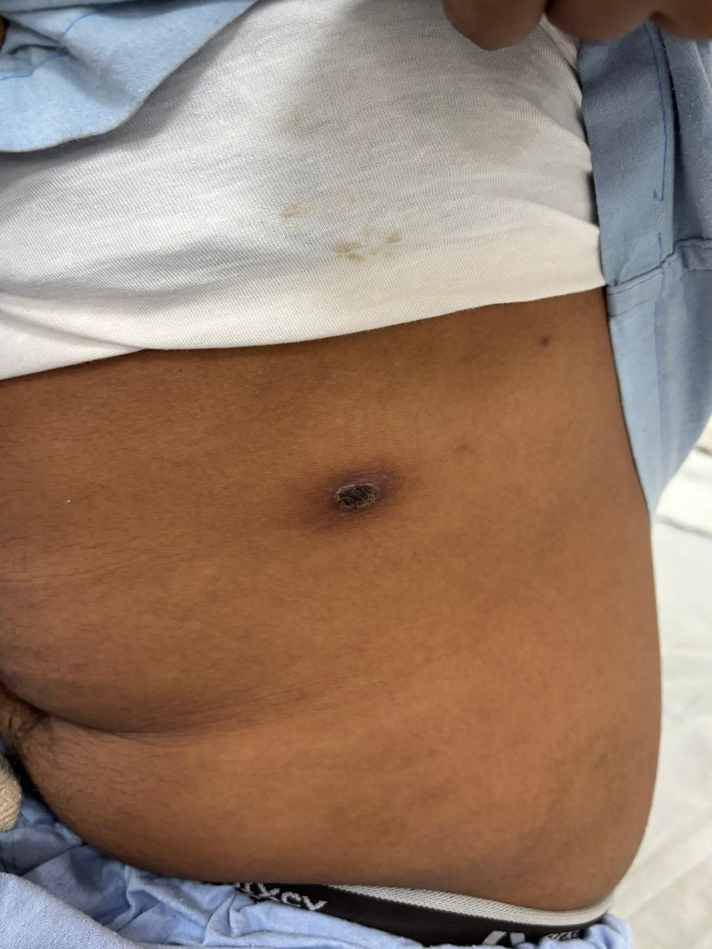

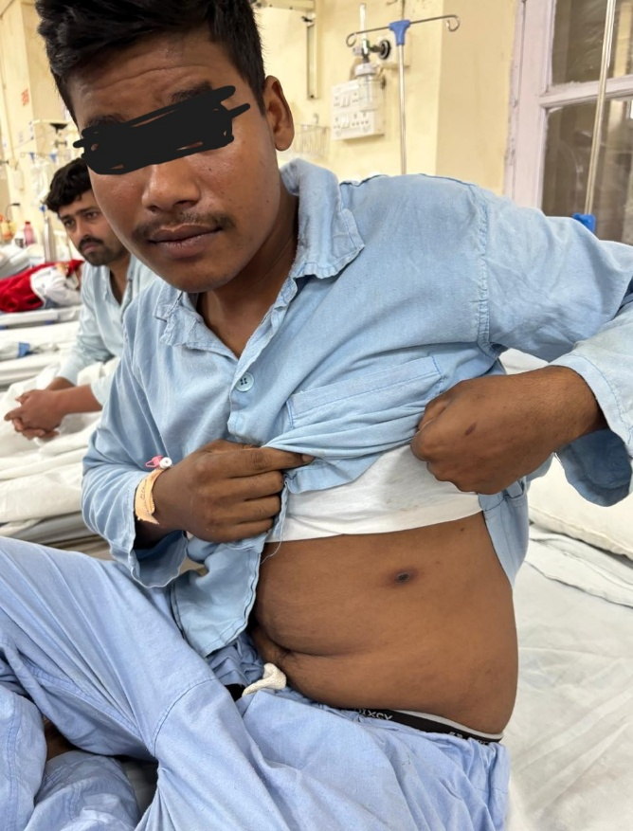
Fig 1: Presence of a lesion with central necrosis on left flank of the patient. (Eschar)

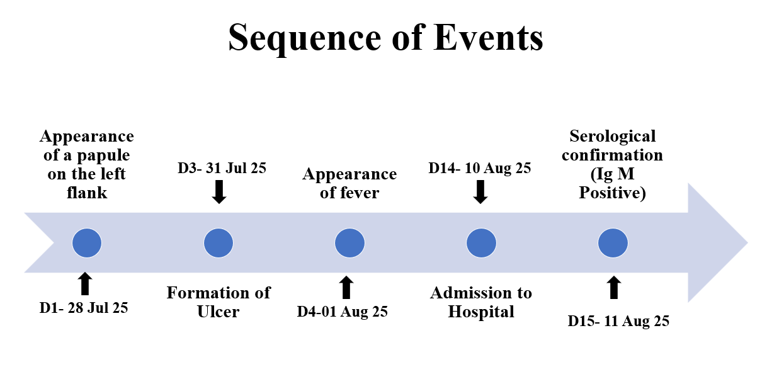
Fig. 2: Depicting the sequence of events of the disease

Field Investigation:
After confirmation of the case, an environmental investigation was initiated at the patient’s residence to assess possible exposure sources and vector habitats. The surveillance was undertaken by a field team consisting of a resident doctor, a health inspector, and a health assistant. A spot map depicting the residence and surrounding sampling sites was prepared to aid analysis (Fig. 3). The major findings are summarised below
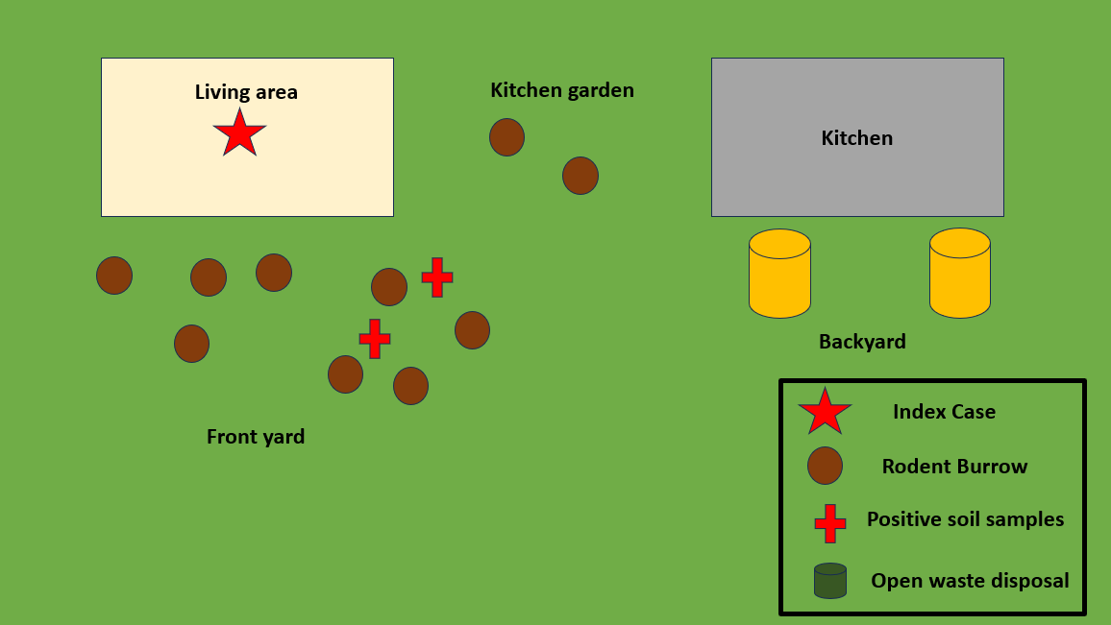
Fig 3: Spot Map showing the Scrub Typhus Case Investigation, Delhi

- Rodent activity: Multiple rodent burrows were observed in and around the peri-domestic environment, particularly near stored food and discarded material. Rodent droppings confirmed active infestation (Fig. 4).
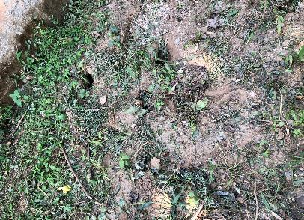
Fig. 4: Rodent burrows and droppings near the place of residence
- Soil sampling: Ten soil samples were collected from suspected burrow sites and peri-domestic vegetation. Microscopic examination revealed the presence of chigger larvae in 2 of the 10 samples (20%). (Fig. 5 and Fig. 6).
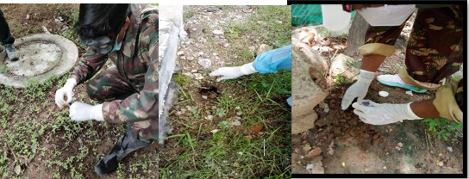
Fig. 5: Soil sampling near rodent burrow

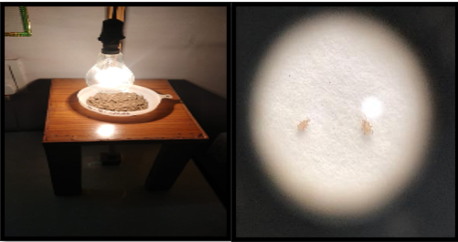
Fig. 6: A) Soil sample processing for mite extraction using a modified Berlese funnel setup.
(B) Microscopic view showing chigger larvae (trombiculid mites) isolated from soil samples under stereomicroscope (40×).

- Bedding and mattresses: Infestation with bed bugs was documented in sleeping areas.
- Waste Management: Improper waste segregation and open food disposal were noted near the cookhouse, providing sustenance for rodents and potential vector amplification.
- General hygiene: Poor sanitation and evidence of rodent droppings further supported the possibility of persistent foci of infection.
Conclusion of Field Survey:
The findings suggested local vector presence and potential peri-domestic transmission. The positive soil samples confirm that O. tsutsugamushi exists in the environment, indicating that this case was locally acquired rather than imported from an endemic zone.
Discussion:
The present study highlights the clinical and epidemiological profile of Scrub typhus diagnosed in Delhi. It has re-emerged as a significant public health problem in the past two decades, often presenting as an Acute Undifferentiated Febrile Illness (AUFI) that can be confused with other viral illnesses, leading to overlooked cases and severe complications.(23) The causative agent, Orientia tsutsugamushi, exhibits considerable antigenic diversity with over 30 distinct serotypes due to variations in the 56 kDa type-specific antigen (TSA), which is the most abundant and immunodominant protein on the pathogen’s surface.(24) This antigenic variability contributes significantly to the broad spectrum of clinical presentations and disease severity seen in scrub typhus.
Clinically, scrub typhus must be differentiated from other febrile illnesses common in endemic areas, such as enteric fever, dengue, leptospirosis, and malaria, which should be ruled out before diagnosis. A key diagnostic feature is the presence of an eschar—an area of necrotic skin at the mite bite site, which may be seen in 7% to 80% of cases globally, with higher detection rates in children and certain countries like Japan and Korea compared to Taiwan and Thailand. In India, detection of eschars is particularly challenging due to darker skin pigmentation and ranges widely between 4% and 46%.(25) In some cases, conditions such as chronic itching or multiple skin lesions can obscure the identification of eschars. However, in our case, the eschar was characteristic of scrub typhus, which was confirmed serologically within 24 hours of admission.
Our findings align with recent entomological and zoonotic evidence from Delhi by Tilak et al. (2022)(26), who reported high rodent infestation rates and dense chigger populations—particularly Leptotrombidium deliense and Schoengastiella ligula—in the Palam area, confirming local vector and reservoir activity. The presence of Orientia DNA in rodent tissues and contaminated soil underscores the role of rodent–mite–soil interfaces in sustaining transmission cycles in peri-urban habitats. Similar associations between rodent burrows, chigger-infested soil, and scrub typhus outbreaks have been documented in Puducherry and Himachal Pradesh(27). These findings collectively highlight the need to integrate entomological surveillance with clinical reporting to identify emerging urban hotspots.
If untreated or undiagnosed, scrub typhus can progress to severe, life-threatening complications involving multiple organ systems. Respiratory complications like acute respiratory distress syndrome (ARDS), gastrointestinal findings such as hepatosplenomegaly and abnormal liver function, skin manifestations including rashes and perivasculitis causing endothelial damage, and hypoalbuminemia are common.(13) Central nervous system (CNS) involvement—ranging from meningitis and meningoencephalitis to cranial nerve palsies and seizures—adds to morbidity and increases the mortality risk. Studies have reported varying degrees of CNS complications linked to specific cranial nerve involvement.
Early diagnosis and treatment are crucial to prevent progression to severe disease. Positive IgM antibody titers for scrub typhus support clinical diagnosis, especially when coupled with characteristic symptoms and epidemiological history such as travel to endemic areas. The cornerstone of treatment remains doxycycline, which serves not only as therapy but also a diagnostic test, as clinical improvement is rapid following its administration. Research shows that doxycycline effectively reduces fever and complications, with respiratory failure and coagulation abnormalities due to pancytopenia observed in some cases. In severe forms, combination therapy with doxycycline and azithromycin may offer improved outcomes. Definitive diagnosis relies on IgM ELISA or indirect immunofluorescence assays. PCR provides confirmatory evidence, especially for environmental detection. However, in resource-limited field settings, clinical suspicion and prompt doxycycline initiation remain lifesaving.
In summary, scrub typhus is a complex, re-emerging zoonotic infection with diverse clinical manifestations influenced by the pathogen’s antigenic diversity.(28) Its diagnosis relies heavily on clinical suspicion, exclusion of other febrile illnesses, detection of eschars where possible, serological confirmation, and responsiveness to doxycycline. Awareness and timely intervention are key to reducing severe complications and mortality associated with this disease.
Conclusions:
The present study highlights the re-emergence and local transmission of scrub typhus in Delhi. The detection of confirmed cases and the clustering of infections during monsoon and post-monsoon seasons underscore the existence of active transmission foci within urban and peri-urban environments. The nonspecific clinical presentation of scrub typhus often leads to diagnostic delays and potentially life-threatening complications, emphasizing the need for heightened clinical suspicion among healthcare providers.
Recommendations:
The present case exhibited clinical and epidemiological features consistent with scrub typhus. The detection of chigger larvae in soil samples and indications of rodent activity warrant further environmental surveillance in the surrounding area. The absence of travel history supports the likelihood of local transmission, suggesting the presence of both the agent and vector within the residential vicinity. Strengthening surveillance systems, ensuring early laboratory diagnosis, and incorporating scrub typhus testing in all cases of acute undifferentiated febrile illness are crucial for timely management. Public health authorities should also focus on vector control, community awareness, and integrated fever surveillance to prevent outbreaks. Given the shifting epidemiological pattern, continuous monitoring and targeted preventive strategies are must.(29)

Active surveillance for rickettsial infections is essential to ascertain the true burden and spatial distribution of scrub typhus in India.(30) While such surveillance initiatives have commenced in several districts, further entomological and epidemiological studies are required to better characterize local transmission foci and ecological risk factors.
Targeted vector control measures should include treatment of soil and peri-domestic vegetation with residual insecticides, reduction of rodent populations, and clearing of dense vegetation around habitations. Individuals living or working in potentially infested areas should adopt personal protective measures such as wearing full-length clothing, impregnating garments and bedding with miticides (e.g., benzyl benzoate), and applying repellents containing diethyltoluamide (DEET) to exposed skin.
Chemoprophylaxis may be considered for short-term high-risk exposure in endemic areas. Controlled trials have demonstrated that weekly administration of doxycycline (200 mg) can significantly reduce the incidence of clinical disease, although asymptomatic infections may still occur. Strengthening integrated vector management and clinician awareness remains critical to reducing morbidity and preventing outbreaks of scrub typhus in emerging foci.
Public Health Implications
This case serves as a sentinel event, underscoring the emergence of scrub typhus transmission in urban and peri-urban settings. The detection of local vector activity and environmental positivity points to the need for sustained entomological surveillance beyond conventionally endemic zones. Integrating rickettsial disease surveillance into existing vector-borne disease control programmes, such as the National Vector Borne Disease Control Programme (NVBDCP), can facilitate early identification of new hotspots and prompt public health action. Adoption of an integrated “One Health” approach, encompassing human, animal, and environmental health surveillance, could further strengthen early warning systems for scrub typhus and related zoonoses.
Timely recognition and coordinated, multidisciplinary response involving clinicians, microbiologists, entomologists, and environmental health teams are essential to prevent potential outbreaks and reduce disease burden in densely populated communities. Strengthening awareness, laboratory capacity, and reporting mechanisms will further enhance preparedness for emerging rickettsial infections in urban India.

Disclaimer (Artificial intelligence)
Option 1:
Author(s) hereby declare that NO generative AI technologies such as Large Language Models (ChatGPT, COPILOT, etc.) and text-to-image generators have been used during the writing or editing of this manuscript.
Option 2:
Author(s) hereby declare that generative AI technologies such as Large Language Models, etc. have been used during the writing or editing of manuscripts. This explanation will include the name, version, model, and source of the generative AI technology and as well as all input prompts provided to the generative AI technology
Details of the AI usage are given below:
1.
2.
3.

COMPETING INTERESTS DISCLAIMER:
Authors have declared that they have no known competing financial interests OR non-financial interests OR personal relationships that could have appeared to influence the work reported in this paper.

References:
1. Sondhiya G, Manjunathachar HV, Singh P, Kumar R. Unveiling the burden of scrub typhus in acute febrile illness cases across India: A systematic review & meta-analysis. Vol. 159, Indian Journal of Medical Research. Scientific Scholar LLC; 2024. p. 601–18.
2. Gupta V, Gautam V. Scrub Typhus--A short review. J Commun Dis. 2004 Dec;36(4):284–9.
3. MATHAI E, ROLAIN JM, VERGHESE GM, ABRAHAM OC, MATHAI D, MATHAI M, et al. Outbreak of Scrub Typhus in Southern India during the Cooler Months. Ann N Y Acad Sci. 2003 Jun 18;990(1):359–64.
4. Devasagayam E, Dayanand D, Kundu D, Kamath MS, Kirubakaran R, Varghese GM. The burden of scrub typhus in India: A systematic review. PLoS Negl Trop Dis. 2021 Jul 27;15(7):e0009619.
5. K. S, K. S. J. A CASE STUDY ON SCRUB TYPHUS. Int J Pharm Pharm Sci. 2023 Oct 1;47–8.
6. BHARATHI M, KALYANI CS, SIRISHA T. AN OUTBREAK OF SCRUB TYPHUS IN A REMOTE VILLAGE-AN OVERVIEW. Int J Curr Pharm Res. 2023 Jul 15;15–9.
7. Kore VB, Mahajan SM. Recent Threat of Scrub Typhus in India: A Narrative Review. Cureus. 2022 Oct 9;
8. National Centre for Disease Control DG of HSG of I. CD Alert [Internet]. Delhi; 2024 Aug [cited 2025 Oct 28]. Available from: https://ncdc.mohfw.gov.in/
9. Kore VB, Mahajan SM. Recent Threat of Scrub Typhus in India: A Narrative Review. Cureus. 2022 Oct 9;
10. Chi WC, Huang JJ, Sung JM, Lan RR, Ko WC, Chen FF. Scrub Typhus Associated with Multiorgan Failure: a Case Report. Scand J Infect Dis. 1997 Jan 8;29(6):634–5.
11. Cracco C, Delafosse C, Baril L, Lefort Y, Morelot C, Derenne JP, et al. Multiple Organ Failure Complicating Probable Scrub Typhus. Clinical Infectious Diseases. 2000 Jul 1;31(1):191–2.
12. Rajagopal R, Khati C, Vasdev V, Trehan A. Scrub typhus: a case report. Indian J Dermatol Venereol Leprol. 2003;69(6):413–5.
13. Kim DM, Won Kim S, Choi SH, Ra Yun N. Clinical and laboratory findings associated with severe scrub typhus [Internet]. Vol. 10, BMC Infectious Diseases. 2010. Available from: http://www.biomedcentral.com/1471-2334/10/108
14. Sneka P, Sangamithra V, Hamsadwani KP. Scrub Typhus - A Case Series. Journal of Medical Sciences and Health. 2022 Sep 15;8(2):159–61.
15. Kumar R, Thakur S, Bhawani R, Kanga A, Ranjan A. Clinical Profile and Complications of Scrub Typhus: Hospital-Based Study in Sub-Himalayan Region. J Assoc Physicians India. 2016 Dec;64(12):30–4.
16. Xu G, Walker DH, Jupiter D, Melby PC, Arcari CM. A review of the global epidemiology of scrub typhus. PLoS Negl Trop Dis. 2017 Nov 3;11(11).
17. Sharma A, Mahajan S, Gupta ML, Kanga A, Sharma V. Investigation of an Outbreak of Scrub Typhus in the Himalayan Region of India. Vol. 58, Jpn. J. Infect. Dis. 2005.
18. Mohapatra RK, Al-Haideri M, Mishra S, Mahal A, Sarangi AK, Khatib MN, et al. Linking the increasing epidemiology of scrub typhus transmission in India and South Asia: are the varying environment and the reservoir animals the factors behind? Frontiers in Tropical Diseases. 2024;5.
19. Rapsang A, Bhattacharyya P. Scrub typhus. Indian J Anaesth. 2013;57(2):127.
20. Mahajan SK. Scrub typhus. J Assoc Physicians India. 2005 Nov;53:954–8.
21. Bhuvaneshwari V, Amsaveni R. Emerging threat of scrub typhus: A call for greater awareness and research. Int Immunopharmacol. 2025 Oct;164:115387.
22. Gurung S, Pradhan J, Bhutia P. Outbreak of scrub typhus in the North East Himalayan region-Sikkim: An emerging threat. Indian J Med Microbiol. 2013 Jan;31(1):72–4.
23. Kore VB, Mahajan SM. Recent Threat of Scrub Typhus in India: A Narrative Review. Cureus. 2022 Oct;14(10):e30092.
24. Tamura A, Ohashi N, Urakami H, Miyamura S. Classification of Rickettsia tsutsugamushi in a Orientia. INTERNATIONAL JOURNAL OF SYSTEMATIC BACTERIOLOGY. International Union of Microbiological Societies; 1995.
25. Park J, Woo SH, Lee CS. Evolution of Eschar in Scrub Typhus. The American Society of Tropical Medicine and Hygiene. 2016 Dec 7;95(6):1223–4.
26. Tilak R, Mukherjee R, Malik A, Bhatti VK, Pandya K, Wankhade UB. Is Delhi an Emerging Scrub Typhus Hotspot? An Entomological and Zoonotic Exploration of a Scrub Typhus Outbreak. Journal of Communicable Diseases. 2022;54(1):100–6.
27. Candasamy S, Ayyanar E, Paily K, Karthikeyan PA, Sundararajan A, Purushothaman J. Abundance &amp; distribution of trombiculid mites &amp; Orientia tsutsugamushi, the vectors &amp; pathogen of scrub typhus in rodents &amp; shrews collected from Puducherry &amp; Tamil Nadu, India. Indian Journal of Medical Research. 2016 Dec;144(6):893–900.
28. Journal of pure & applied microbiology : an international research journal of microbiology. 2007;
29. Khan ID, Bahal P, Singh B, Priya P, Pandey R, Makkar A, et al. Emergence of “Urban Scrub Typhus” during Monsoon Season in an Urban Pocket and Biodiversity Hotspot of New Delhi, India. Journal of Marine Medical Society. 2022 Jul;24(2):124–30.
30. Kumar Sharma A. Eco-entomological investigation in Scrub Typhus affected area of Thiruvananthapuram, Kerala (India) and their control/containment measures. Eco-entomological investigation in Scrub Typhus affected area of Thiruvananthapuram, Kerala (India) and their control/containment measures [Internet]. Vol. 2, Article in International Journal of Current Microbiology and Applied Sciences. 2013. Available from: http://www.ijcmas.com

