Digital removable partial dentures: A mini review
Abstract
Digital removable partial dentures (RPDs) have revolutionized prosthodontics by integrating computer-aided design (CAD), computer-aided manufacturing (CAM), and intraoral scanning technologies, significantly improving accuracy, customization, and patient comfort. These advancements have streamlined workflows, reduced clinical time, and enhanced prosthesis fit and aesthetics through innovations in materials such as cobalt-chromium, titanium, and polyetheretherketone (PEEK).
Despite notable progress, digital RPD fabrication continues to face challenges related to soft-tissue capture, repairability, high implementation costs, and the need for standardized accuracy metrics and long-term clinical validation. Additionally, gaps in clinician training, interoperability across digital systems, and accessibility in low-resource settings hinder widespread adoption. Future developments must focus on improving material durability, developing AI-integrated design systems, and promoting educational and sustainable frameworks to ensure equitable and efficient delivery of digital prosthodontic care.
Keywords: Digital dentistry, Removable partial denture, CAD/CAM, Intraoral scanner, Additive manufacturing

Introduction
Removable partial dentures (RPDs) remain an indispensable component of global oral rehabilitation, particularly as aging populations expand and economic barriers limit access to fixed or implant-supported prostheses. They provide a practical, affordable, and minimally invasive solution for partially edentulous patients, especially among geriatric and lower-income groups where implant therapy may be cost-prohibitive or medically contraindicated.¹
With a high prevalence of Kennedy Class I and II edentulism worldwide, RPDs play a crucial role in restoring mastication, speech, aesthetics, and overall quality of life, often serving as both definitive and transitional prostheses when long-term restorative plans or financial constraints exist. Traditionally fabricated through the lost-wax casting technique using cobalt-chromium frameworks and acrylic bases, conventional RPDs required manual impressions, extensive laboratory work, and were susceptible to errors in fit and occlusion.²
The advent of digital dentistry encompassing CAD/CAM systems, intraoral scanning, and 3D printing has revolutionized RPD fabrication by enhancing precision, reproducibility, and customization while significantly reducing clinical and laboratory time.^{3,26}
These technologies enable fully digital workflows that eliminate gypsum casts, streamline design through virtual modeling, and allow for subtractive or additive manufacturing of frameworks and bases.^{4,27}
Advances in material science, including the introduction of lightweight, flexible, and biocompatible resins and thermoplastics, have improved comfort, durability, and aesthetics, contributing to higher patient satisfaction, particularly in Kennedy Class III and IV cases. As intraoral scanning and 3D printing technologies become more accessible, the adoption of digital RPDs continues to grow across both developed and developing regions, driven by increasing demand for efficient, esthetic, and cost-effective tooth replacement solutions and supported by the expanding capability for same-day denture fabrication.^{5,28}
Review of Literature
The current landscape of digital removable partial dentures (RPDs) demonstrates remarkable progress driven by advancements in digital impression systems, CAD/CAM technologies, and material science, fundamentally transforming prosthodontic practice.
Campbell et al. (2017) emphasized that the successful adoption of digital removable partial dentures (RPDs) relies heavily on adequate patient education and awareness regarding maintenance, functionality, and long-term benefits to ensure optimal satisfaction and sustained prosthesis performance.⁶
Tamimi et al. (2020) reported that while novel biocompatible materials such as polyetheretherketone (PEEK) and titanium have significantly improved the strength, corrosion resistance, and comfort of RPDs, further long-term clinical studies are needed to validate their mechanical performance, durability, and overall clinical longevity.⁷
Fueki et al. (2022) highlighted that despite the technological progress in digital dentistry, the high initial costs of digital equipment, software, and manufacturing systems remain major barriers to accessibility, particularly in resource-constrained settings.⁸
Saini et al. (2024) discussed that the integration of computer-aided design and computer-aided manufacturing (CAD/CAM) has revolutionized RPD fabrication by enabling virtual modeling, customized framework design, and automated production processes, which enhance fit, adaptation, and aesthetics compared to conventional methods.⁹
Wang et al. (2024) observed that digital impression technologies have greatly improved the precision, reproducibility, and comfort of oral data acquisition, minimized the number of clinical visits and reducing overall treatment time.¹⁰
Collectively, these studies demonstrate that digital RPDs represent a major step forward in prosthodontics by improving efficiency, accuracy, and patient-centered care; however, challenges concerning cost, training, and long-term evidence must be addressed to ensure widespread clinical integration.
Table 1: Finding and Practical implication of Review of Literature
S. No. | Author(s) & Year | Focus / Study Theme | Key Findings / Observations | Clinical / Practical Implications
1 | Campbell et al. (2017) | Patient education and awareness in digital RPD adoption | Emphasized that the successful implementation of digital RPDs depends largely on adequate patient education concerning prosthesis maintenance, functionality, and long-term benefits. | Highlights the need for comprehensive patient counseling and follow-up programs to ensure satisfaction, proper use, and longevity of the prosthesis.
2 | Tamimi et al. (2020) | Evaluation of advanced biocompatible materials (PEEK, titanium) | Reported that novel materials like PEEK and titanium enhance RPD strength, corrosion resistance, and patient comfort, but stressed the necessity for further long-term clinical trials to confirm their mechanical durability and clinical longevity. | Suggests ongoing research and clinical validation before these materials can replace conventional metal frameworks in standard practice.
3 | Fueki et al. (2022) | Economic and infrastructural barriers in digital dentistry | Highlighted that despite major technological progress, the high initial investment cost for digital systems (equipment, software, manufacturing) limits accessibility, especially in resource-limited regions. | Indicates a need for cost-effective digital solutions and potential policy support to improve global access to digital dental technology.
4 | Saini et al. (2024) | Impact of CAD/CAM integration in RPD fabrication | Discussed that CAD/CAM technology has transformed RPD production through virtual design, customized frameworks, and automated processes, improving fit, adaptation, and esthetics compared to conventional methods. | Demonstrates how CAD/CAM enhances efficiency, precision, and patient satisfaction while reducing human error in prosthesis fabrication.
5 | Wang et al. (2024) | Role of digital impression technology in RPD workflow | Observed that digital impression systems improved the precision and reproducibility of oral scans, increased patient comfort, and reduced clinical chair time and number of visits. | Supports the clinical shift toward fully digital workflows for improved efficiency, patient experience, and consistency in RPD fabrication.

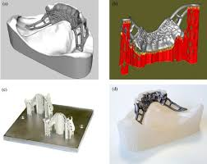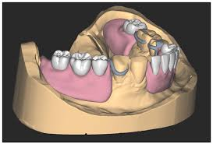
Figure 1: Digital Fabrication of RPD Frameworks

Digital Fabrication of RPD Frameworks
The digitalization of removable partial denture (RPD) fabrication has primarily focused on the framework component, revolutionizing a process that was once labor-intensive and prone to human error. Conventional frameworks, traditionally produced through the lost-wax casting technique, required multiple manual steps including surveying, designing, blocking out undercuts, applying relief, and completing the wax-up all of which introduced potential inaccuracies.¹²
In contrast, modern dental CAD software now performs these steps digitally, enabling precise determination of the path of insertion and removal, automated design of clasps, connectors, rests, and mesh components, and seamless customization to individual anatomical features. This digital transformation eliminates the need for duplicate impressions, refractory casts, and several intermediate laboratory procedures, thereby simplifying the workflow, reducing material use, minimizing technician-dependent variability, and improving reproducibility.¹³
The resulting frameworks exhibit higher precision, better fit, and consistent quality across cases. Currently, three major digital fabrication methods are used for RPD frameworks. The first is subtractive manufacturing, where metal frameworks are directly milled from titanium or cobalt-chromium (CoCr) discs using computer numerical control (CNC) milling machines offering excellent accuracy but at high equipment and tool costs. The second is a hybrid analog-digital approach, where the wax pattern for casting is digitally designed and either milled or 3D-printed before being conventionally cast, thus combining digital precision with the proven mechanical properties of cast metals.¹⁴
The third and most advanced technique is additive manufacturing, primarily through selective laser melting (SLM) or direct metal laser sintering (DMLS), which constructs frameworks layer by layer by melting metal powder with high-energy lasers. SLM allows fabrication of intricate geometries and fine mesh designs with reduced waste and high dimensional accuracy, though post-processing such as polishing and heat treatment remains necessary.¹⁵
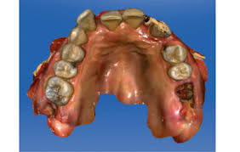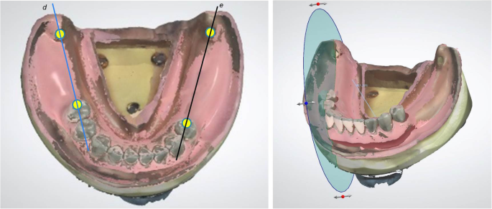
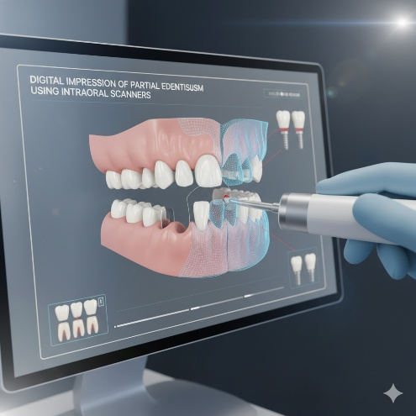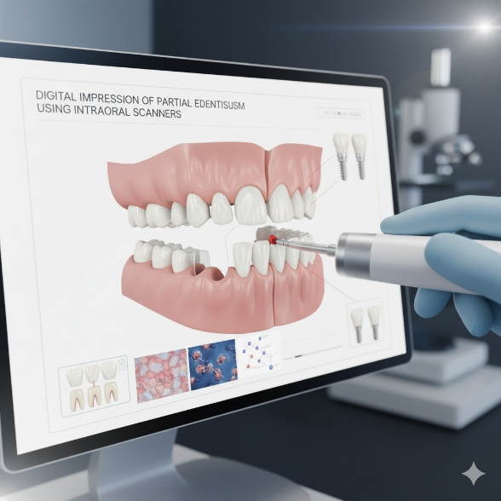
Figure 2: Digital Impression of Partial Edentulism Using Intraoral Scanners

Digital Impression of Partial Edentulism Using Intraoral Scanners
Recent advancements in intraoral scanning (IOS) technology have significantly transformed impression-taking for removable partial dentures (RPDs), offering improved accuracy, efficiency, and patient comfort compared to traditional methods. Increasing numbers of studies and clinical reports have demonstrated that dentures fabricated from IOS data for partially edentulous arches achieve clinically acceptable fit and adaptation. Digital impressions provide several advantages, including reduced patient discomfort particularly beneficial for those with strong gag reflexes while also eliminating deformation associated with impression material removal.¹⁶
By enabling direct digital communication between dental clinics and laboratories, IOS technology facilitates secure data transfer, superior record preservation, and enhanced reproducibility, while minimizing risks of model damage and reducing transportation costs and turnaround time. Moreover, digital impressions improve infection control by eliminating the need for physical impression materials and models. In patients with severe periodontal disease requiring immediate dentures, IOS allows accurate data acquisition without the risk of mobilizing or extracting teeth during impression-making.¹⁷
Additionally, when centric occlusion is maintained by existing teeth, IOS can eliminate the need for occlusal rims, thereby reducing clinical visits and simplifying the workflow. However, limitations persist, particularly in cases of extensive free-end edentulism where residual ridges present fewer anatomical landmarks and flat surfaces, predisposing to image-stitching errors. To address this, Shimizu’s method recommends the placement of markers on the residual ridge to serve as scanning landmarks, improving trueness and reducing stitching discrepancies.¹⁷ Despite these improvements, capturing functional impressions such as mucosal morphology under load and dynamic movement of the vestibule, lips, tongue, and cheeks remains challenging with current IOS systems. Consequently, hybrid approaches are often employed, combining anatomical IOS data of remaining teeth and ridges with conventional functional impressions obtained via the altered cast technique. In workflows relying solely on IOS data, the denture base may serve as a custom tray for border molding and functional impression-taking, followed by indirect relining to ensure optimal adaptation.¹⁸
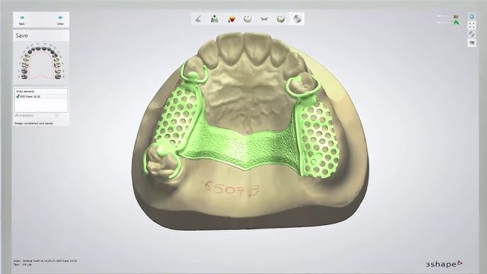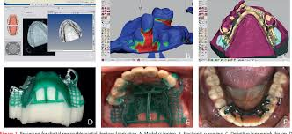
Figure 3: Current State of Digital Removable Partial Denture (RPD) Fabrication
Current State of Digital Removable Partial Denture (RPD) Fabrication
The evolution of digital removable partial denture (RPD) fabrication represents a paradigm shift in prosthodontics, integrating precision engineering, computer-aided design, and advanced materials to enhance clinical accuracy and patient satisfaction. Digital impression acquisition, achieved through intraoral scanners or extraoral model scanning, has significantly improved the precision of RPD frameworks by capturing detailed anatomical data with minimal discomfort. Intraoral scanning offers superior trueness, particularly in partially edentulous arches with stable abutments, while extraoral scanning remains preferable in cases with soft-tissue mobility or deep undercuts.¹⁹
Despite its advantages, intraoral scanning still faces limitations in capturing mobile tissues and functional borders, often necessitating hybrid workflows combining intraoral and conventional impressions for optimal anatomical accuracy. The CAD design phase enables meticulous customization of framework components including connectors, clasps, rests, and meshwork through parametric algorithms that ensure reproducibility and adaptability to patient-specific anatomy, while advanced file formats such as STL, OBJ, and PLY enhance software interoperability across design and manufacturing platforms.²⁰
Manufacturing techniques have also diversified: milled titanium and CoCr frameworks ensure superior precision and biocompatibility, though at higher costs and equipment requirements, whereas selective laser melting (SLM) and direct metal laser sintering (DMLS) enable complex, lightweight geometries with reduced material waste. 3D-printed resins, though currently limited in mechanical strength, are gaining traction for temporary frameworks, prototypes, and hybrid workflows that combine digital precision with conventional casting reliability. Material advancements, including reinforced resins, PEEK, and printable CoCr alloys, have improved biocompatibility and structural integrity, though challenges persist regarding long-term wear, color stability, and fracture resistance compared to metals.²¹
The incorporation of digitally fabricated precision attachments such as extracoronal, bar, and ball attachments has further refined retention and esthetics, while PEEK-based components have demonstrated reduced abutment stress in distal extension cases. However, repairability remains a concern, as digitally produced frameworks are often difficult to modify once fractured, necessitating refabrication or hybrid analog-digital repair strategies. From an economic perspective, while digital workflows demand high initial investments in scanners, CAD/CAM systems, and milling/printing units, they substantially reduce manual labor, chairside adjustment, and turnaround time transforming multi-week production cycles into streamlined processes of a few days. ²²
Future Challenges and Directions in Digital Removable Partial Denture (RPD) Development
Despite remarkable advancements, the field of digital removable partial dentures (RPDs) continues to face multifaceted clinical, technological, regulatory, educational, and social challenges that must be addressed to achieve universally accessible, high-quality, and sustainable prosthodontic care. Clinically, digital impression systems still struggle to accurately capture soft tissues and long-span free-end saddles, particularly in distal extension (Kennedy Class I/II) cases, where the lack of dynamic border molding may compromise fit and function. Future innovation must focus on advanced intraoral scanners with improved optics, motion tracking, and AI-driven soft-tissue modeling to enhance accuracy.²³
Similarly, recording dynamic occlusion and ridge morphology remains a limitation, highlighting the need for functional movement tracking technologies and virtual articulation systems that simulate occlusal dynamics for better long-term adaptation. Material and manufacturing challenges persist as well though 3D-printable CoCr and titanium alloys have gained traction, their mechanical resilience, fatigue resistance, and biocompatibility require long-term validation, while standardized fatigue and wear testing protocols are necessary for evaluating new reinforced resins, composites, and liner materials.²⁴
Regulatory gaps further complicate adoption, as the absence of unified accuracy metrics (trueness, precision, fit) prevents consistent clinical evaluation, and the rapid introduction of printable biomaterials demands updated regulatory frameworks emphasizing safety, performance, and post-market monitoring. Repairability also presents a major challenge, with limited chairside options for relining or modifying digitally fabricated frameworks; thus, research into compatible repair materials, digital reprint templates, and modular component systems is essential. On the digital infrastructure front, data interoperability and AI integration remain in early stages AI-driven CAD systems show promise in automated RPD design and predictive fit analysis, yet seamless integration across clinical and laboratory software requires standardized open-source formats and cloud-based collaboration.^{25,29}
From an educational standpoint, the shift to digital prosthodontics calls for formalized curricula, certification programs, and continuing education to bridge the skills gap between conventionally trained practitioners and those proficient in digital workflows.²¹ Access and equity also demand attention, as high initial costs of scanners, printers, and software restrict adoption in low-resource settings; scalable solutions such as regional “hub-and-spoke” models and cloud-based design hubs could democratize access by linking smaller clinics to centralized fabrication facilities. Finally, sustainability has emerged as a crucial consideration comprehensive life-cycle analyses comparing casting, milling, and 3D printing are needed to quantify environmental footprints and identify pathways toward greener dental manufacturing.^{25,30}
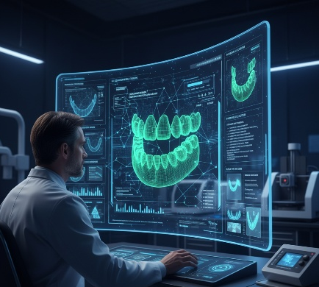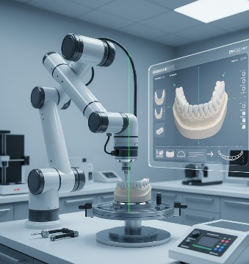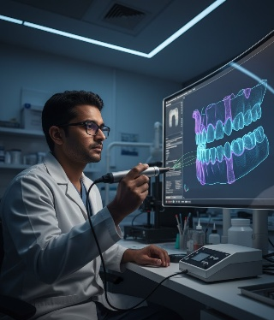
Figure 4: Future Directions in Digital Removable Partial Denture (RPD) Development
Table 2: Emerging Technologies Transforming Digital Removable Partial Denture (RPD) Fabrication and Clinical Practice
S. No. | Technology / Integration Area | Key Features / Functional Role | Clinical Advantages / Impact | Current Challenges / Limitations
1 | Robotic-Assisted Prosthodontics | Experimental use of robotic systems for implant placement and abutment preparation in complex prosthodontic cases. | - Provides unmatched precision in implant angulation and attachment alignment.  - Enables minimally invasive and consistent outcomes.  - Reduces operator-related variability in critical prosthetic stages. | - Still in experimental and research phases.  - Requires high-cost infrastructure and regulatory approval.  - Limited accessibility in general clinical settings.
2 | Haptic-Enabled CAD/CAM Systems | Integration of virtual tactile (haptic) feedback that simulates manual dexterity during RPD digital design. | - Enhances operator control during digital framework adjustments.  - Allows sensing of undercuts and pressure zones, improving comfort and adaptation.  - Bridges the gap between manual craftsmanship and digital precision. | - High equipment and training costs.  - Limited commercial availability.  - Dependence on user expertise and software compatibility.
3 | Artificial Intelligence (AI)-Driven Design Platforms | Use of machine learning algorithms for automated framework design, clasp optimization, and biomechanical stress prediction. | - Ensures data-driven personalization using patient-specific parameters.  - Improves accuracy and efficiency of RPD design.  - Predictive analytics support early failure detection and preventive maintenance planning. | - Limited AI integration in everyday prosthodontic software.  - Requires large annotated datasets for accurate predictions.  - Regulatory and ethical challenges in AI deployment.
4 | Digital Wax-Up / Virtual Wax Patterning | Replacement of manual sculpting with parametric, 3D-reproducible virtual wax designs compatible with 3D printing and milling systems. | - Enables highly standardized and reproducible prosthetic wax-ups.  - Directly integrates with additive/subtractive manufacturing workflows.  - Improves esthetics, precision, and turnaround time. | - Requires advanced operator proficiency and CAD knowledge.  - Potential for software dependency and steep learning curve.  - Limited tactile evaluation compared to traditional methods.
5 | Hybrid Impression Techniques | Combination of digital scanning with conventional border molding to accurately capture edentulous tissues. | - Provides comprehensive soft-tissue detail not achievable by current digital-only methods.  - Ensures accuracy of fit and retention in distal extension cases.  - Serves as a transitional approach bridging analog and digital workflows. | - Lack of a fully digital equivalent for border molding.  - Additional clinical steps increase chairside time.  - Requires clinician adaptability to dual workflows.
6 | Systemic Challenges in Integration | Global and institutional factors affecting adoption of advanced digital technologies in prosthodontics. | - Promotes innovation and modernization in dental practice.  - Encourages research-driven precision and sustainability.

Conclusion
The integration of robotic surgery, haptic feedback, artificial intelligence (AI), and digital wax patterning is redefining the landscape of removable partial denture (RPD) fabrication and clinical execution.
Robotic-assisted prosthodontics, though still experimental, holds promise for unparalleled precision in implant placement and minimally invasive abutment preparation, particularly in complex cases requiring exact attachment alignment.
Haptic-enabled CAD/CAM systems further enhance digital workflows by offering virtual tactile feedback that mimics manual dexterity, allowing clinicians to sense undercuts and pressure points during virtual design, thereby improving fit and comfort.
Meanwhile, AI-driven platforms automate framework design, optimize clasp configurations, and predict biomechanical stress points using patient-specific data, while predictive analytics enable early identification of potential failures and individualized maintenance planning.
Virtual wax-up technologies now replace manual sculpting with parametric, reproducible designs directly compatible with additive or subtractive manufacturing systems, though they demand advanced operator training. Despite these advances, hybrid impression techniques remain essential to capture edentulous tissues accurately, as no universal digital substitute for border molding yet exists.
However, challenges persist limited haptic and AI adoption may widen the gap between advanced centers and general practices, compounded by workforce training deficits, high implementation costs, and regulatory ambiguity.

Disclaimer (Artificial intelligence)

Author(s) hereby declare that generative AI technologies such as Large Language Models, etc. have been used during the writing or editing of manuscripts. This explanation will include the name, version, model, and source of the generative AI technology and as well as all input prompts provided to the generative AI technology
Details of the AI usage are given below:
1. Figure 2 & 4 -Generated by Gemini 2.5 -Nano Banana
2. Chat GPT 4.5 Used for Structuring Abstract
3. Perplexity used as Research Assistant for Latest Advances

References
- Moreno A, Haddad MF, Goiato MC, Rocha EP, Assunção WG, Filho HG, Santos EG, Sonego MV, Santos DM. Epidemiological data and survival rate of removable partial dentures. J Clin Diagn Res. 2016 May;10(5):ZC84–7. doi: 10.7860/JCDR/2016/16638.7816. PMID: 27437367; PMCID: PMC4948543.
- Etman M, Bikey D. Clinical performance of removable partial dentures: a retrospective clinical study. Open J Stomatol. 2012;2:173–81.
- Tasaka A. Current state and future challenges of digital removable partial dentures. J Prosthodont Res. 2025;69(1):viii–ix. doi: 10.2186/jpr.JPR_D_24_00296. PMID: 39805608.
- Mansour M, Sanchez E, Machado C. The use of digital impressions to fabricate tooth-supported partial removable dental prostheses: a clinical report. J Prosthodont. 2016;25:495–7. PMID: 26371612.
- Suzuki Y, Harada N, Watanabe K, Maruo R, Shimpo H, Ohkubo C. Clinical application of an intraoral scanner and CAD/CAM system for a Kennedy class I partially edentulous patient. J Oral Sci. 2022;64:109–11. PMID: 34937814.
- Campbell SD, Cooper LF, Craddock HL, Hyde TP, Nattress B, Pavitt S, Seymour DW. Removable partial dentures: the clinical need for innovation. J Prosthet Dent. 2017;118(3):273–80. doi: 10.1016/j.prosdent.2017.01.008.
- Tamimi F, Almufleh B, Caron E, Alageel O. Digital removable partial dentures. Int J Comput Dent. 2020;4(1):1–12. doi: 10.1007/s41894-020-00074-y.

- Fueki K, Inamochi Y, Takaichi A, Murakami N, Wada J, Arai Y, Ueno T, Wakabayashi N. A systematic review of digital removable partial dentures. Ann Jpn Prosthodont Soc. 2022;14(1):17–24. doi: 10.2186/ajps.14.17.
- Saini R, Zafar MS, Adanir N, Alarcón-Sánchez MA, Heboyan A. Assessing the current landscape and future directions of digital denture technology. Eur J Gen Dent. 2024. doi: 10.1055/s-0044-1791844.
- Wang Y, Wei B. Current status of the application of digital impression technology in removable partial dentures. Chin J Stomatol. 2024;6:12. doi: 10.13591/j.cnki.kqyx.2024.06.012.
- Şakar O. Current status on partial edentulism and removable partial dentures. In: Şakar O, editor. Removable Partial Dentures: A Practitioner's Manual. Cham: Springer; 2016. p. 3–8. doi: 10.1007/978-3-319-20556-4_1.
- Bogdan-Andreescu CF, Ionescu TP, Burcea A, Matei A, Albu CC, Bohîlțea LC. The role of removable partial dentures in contemporary dentistry. Rom J Oral Rehabil. 2025;17(1):253–61. doi: 10.62610/rjor.2025.1.17.25.
- Marinello CP, Brugger R. Digital removable complete denture—an overview. Curr Oral Health Rep. 2021;8:1–15.
- Piao XY, Jeon J, Shim JS, Park JM. A digital workflow for the fabrication of a milled removable partial denture. Int J Environ Res Public Health. 2022 Jul 13;19(14):8540. doi: 10.3390/ijerph19148540. PMID: 35886391; PMCID: PMC9324999.
- Hsu MH, Chang Y. The literature on digital technologies for removable dental prostheses: a two-decade bibliometric analysis. J Dent Sci. 2024;19:1–12. doi: 10.1016/j.jds.2024.08.015.
- Current trends and future directions in prosthetic and implant dentistry in the digital era. Basel: MDPI; 2022. doi: 10.3390/books978-3-0365-6050-2.
- Alaghbari SS, Saeed EAM, Zhen L, Al Moaleem MM, Chen H, Gashan BM, Dong S, Niu L, Hu B. Accuracy assessment of digital impressions with varied scanning paths in partially edentulous ridges with mobile abutment teeth: an in vitro comparative study. PLoS One. 2025 Jul 31;20(7):e0327380. doi: 10.1371/journal.pone.0327380. PMID: 40743048; PMCID: PMC12312966.
- Tasaka A, Mori R, Hirabayashi T, Kogawa S, Ito K, Wadachi J, et al. A new proposal for the workflow using CAD/CAM technology for fabrication of resin-based removable partial dentures. J Prosthodont Res. 2023;68:355–7. PMID: 37853626.
- Wang X, Ma D, Zhong S, Ye Q, Zhao Y, Ren N, et al. A digital workflow for designing and manufacturing metal frameworks and removable partial dentures: a novel dental technique. J Prosthodont. 2024; Epub ahead of print. PMID: 38566576.

- Fueki K, Inamochi Y, Wada J, Arai Y, Takaichi A, Murakami N, Ueno T, Wakabayashi N. A systematic review of digital removable partial dentures. Part I: clinical evidence, digital impression, and maxillomandibular relationship record. J Prosthodont Res. 2022;66(1):40–52. doi: 10.2186/jpr.JPR_D_20_00116. PMID: 33504721.
- Bandiaky ON, Lokossou DL, Soueidan A, Le Bars P, Gueye M, Mbodj EB, et al. Implant-supported removable partial dentures compared to conventional dentures: a systematic review and meta-analysis of quality of life, patient satisfaction, and biomechanical complications. Clin Exp Dent Res. 2022;8:1–12.
- Chander NG, Gopi A. Trends and future perspectives of 3D printing in prosthodontics. Med J Armed Forces India. 2024 Jul–Aug;80(4):399–403. doi: 10.1016/j.mjafi.2024.05.003. PMID: 39071750; PMCID: PMC11280134.
- Oh KC, Jeon J, Kim JH. Fabrication of a removable partial denture combining conventional and digital techniques. J Prosthet Dent. 2021 Apr;125(4):588–91. doi: 10.1016/j.prosdent.2020.01.046. PMID: 32331784.
- Bors A, Mucenic S, Monea A, Ormenisan A, Beresescu G. From conventional to smart prosthetics: redefining complete denture therapy through technology and regenerative science. Medicina (Kaunas). 2025 Jun 18;61(6):1104. doi: 10.3390/medicina61061104. PMID: 40572792; PMCID: PMC12195548.
- Singh R, Mistry G, Choudhary M, Parab S, Ansari R, Sachdev SS. An update on CAD-CAM usage for removable partial denture fabrication: a systematic review. Bioinformation. 2024 Dec 31;20(12):1794–9. doi: 10.6026/9732063002001794. PMID: 40230937; PMCID: PMC11993392.
- Takaichi, A., Fueki, K., Murakami, N., Ueno, T., Inamochi, Y., Wada, J., ... & Wakabayashi, N. (2022). A systematic review of digital removable partial dentures. Part II: CAD/CAM framework, artificial teeth, and denture base. Journal of Prosthodontic Research, 66(1), 53-67.
- Tamimi, F., Almufleh, B., Caron, E., & Alageel, O. (2020). Digital removable partial dentures. Clinical Dentistry Reviewed, 4(1), 9.
- Akl, M. A., & Stendahl, C. G. (2022). Removable partial denture frameworks in the age of digital dentistry: A review of the literature. Prosthesis, 4(2), 184-201.
- Lee, J. W., Park, J. M., Park, E. J., Heo, S. J., Koak, J. Y., & Kim, S. K. (2017). Accuracy of a digital removable partial denture fabricated by casting a rapid prototyped pattern: A clinical study. The Journal of Prosthetic Dentistry, 118(4), 468-474.
- Fueki, K., Inamochi, Y., Wada, J., Arai, Y., Takaichi, A., Murakami, N., ... & Wakabayashi, N. (2022). A systematic review of digital removable partial dentures. Part I: Clinical evidence, digital impression, and maxillomandibular relationship record. Journal of prosthodontic research, 66(1), 40-52.

