Rice Genetic Variation for Salt tolerance among Recombinant Inbred Lines in Coastal Saline Soils

Original Research Article

.
ABSTRACT

Aim: To assess phenotypic performance and to estimate genetic variability for salt tolerance in both seedling and reproductive stages of rice under coastal saline soils.

Study Design: Field experiment was carried out to evaluate Recombinant Inbred lines (RILs) derived from the cross MCM 109/BRR 0119 for salt tolerance in Alpha-lattice design.

Place and duration of study: The present study was conducted at natural coastal saline soils of Acharya N. G Ranga Agricultural University (ANGRAU)- Agricultural Research Station (ARS), Machilipatnam during Kharif, 2024.

Methodology: 150 RILs at F₅ generation were studied at pH 8.4 and EC 7.2 dSm⁻¹ and collected data on yield and salinity traits. Statistical analysis was performed using PBIB.test, GCV, PCV, heritability and GA as per cent of mean were drawn from variability package of R software.

Results: The analysis of variance (ANOVA) for 12 characters attributed there was significant differences among 150 RILs studied under salinity (P<0.01). The traits ear bearing tillers hill⁻¹, salinity scoring at reproductive stage, shoot Na⁺/K⁺ ratio at harvesting stage and grain yield per plant (g) exhibited high estimates of GCV, PCV, heritability and genetic advance as per cent of mean suggesting additive gene action. While the traits plant survival (%), plant height (cm), panicle length (cm), number of filled grains per panicle, spikelet fertility % and hundred grain weight (g) exhibited moderate PCV and GCV values with high heritability and genetic advance indicating substantial genetic variability for effective selection.

Conclusion: Selecting RILs based on variability traits results in development of salt tolerant high yielding varieties suitable for coastal saline soils.
Key words: RILs, GCV, PCV, heritability, genetic advance.
1. INTRODUCTION
“Rice (Oryza sativa L.) is an important staple crop that feeds more than half of the world population. Rice production is majorly affected by abiotic stresses. Among the abiotic stresses, salinity is the second most widespread soil problem in rice growing countries of the world after drought which continues due to climate change and poor irrigation practices” (Hussain et al., 2018; Samy et al., 2024). “Soil salinity is a complex trait influenced by soil salinity parameters, weather parameters like rain fall and temperature making the development of salt tolerant rice varieties a critical breeding priority” (Girija et al., 2024). “Rice crop is sensitive to salinity at seedling and reproductive stages. Identifying rice genotypes tolerating salinity both at seedling and reproductive stages that maintain stable yield in coastal saline soils requires an understanding of genetic variability and trait relationship in terms of direct and indirect effects to develop salt tolerant rice varieties” (Vani et al., 2025). “Genotypic coefficient of variation, phenotypic coefficient of variation, heritability and genetic advance are the essential tools for evaluating the effectiveness of selection and to predict the genetic variability present in the breeding population. Many of the researchers have manifested genetic variability and heritability is the key parameters to identify salt tolerant genotypes in field conditions” (Nounjan et al., 2018). “Despite this, very limited information is available on genetic variability and heritability for salt tolerance in natural coastal saline soils” (Ahmadizadeh et al., 2021). “The large segregating bi-parental population provides adequate representation of recombination events and express transgressive segregation in advanced generations. Evaluating this population in field conditions rather than hydroponics exposes the genotypes to natural saline conditions thereby increase the breeding relevance of the results” (Laghari et al., 2025). Hence, the present study aimed to identify the tolerant RILs with high genetic variation which can serve as potential resources for future breeding programmes of coastal saline soils.

2. methodology

The present investigation was conducted to estimate genetic variability using 150 F₅ RIL population from the cross MCM 109 (female parent) and BRR 0119 (male parent) along with five checks including susceptible check - BPT 5204 (Samba Mahsuri), resistant checks - MCM 103, MTU 1293, FL 478 and MCM 125. The experiment was carried out during Kharif, 2024 at natural coastal saline soil of Agricultural research station, Machilipatnam. This center was located at 81.7⁰ E longitude and 16.10⁰ N latitude in Krishna district of Andhra Pradesh. Nursery was raised in normal soil and 35 days old seedlings were transplanted in saline soil with pH 8.5 and EC 7.1 dSm⁻¹. An Alpha-lattice design was adopted with 10 plants per entry with a spacing of 20 х 15 cm. Phenotypic screening of these RILs was performed from September 2024 to December 2024 following all recommended agronomic practices.

2.1. Data collection
Data was collected from five randomly selected plants per RIL for 12 traits viz., plant survival (%), days to 50 per cent flowering, salt tolerance at both seedling and reproductive stages as per SES (IRRI, 2014), plant height (cm), ear bearing tillers hill⁻¹, panicle length (cm), number of filled grains per panicle, spikelet fertility (%), hundred grain weight (g), grain yield per plant (g) and shoot Na⁺/K⁺ ratio at harvesting stage. Soil pH and EC at different crop growth stages (Table 1) and weather parameters prevailed during crop growth (Table 2) were also recorded.

2.2. Salinity scoring
Salt tolerance was assessed using the standard evaluation system (SES) at both seedling and reproductive stages (IRRI, 2014) without modifying the original data (Tables 3a and 3b). Visual scoring at seedling stage had five different scores ranking from 1 to 9. The score 1 indicates that the line is highly tolerant with normal growth, no leaf symptoms and score 9 indicates high susceptibility where plants prone to death. By considering spikelet sterility (%), reproductive stage scoring was given at maturity with 1 as Normal growth, spikelet sterility ≤5% and 9 indicates growth severely stunted, papery florets/chaffy panicle with very high sterility at >70%. This scoring discriminated the susceptible from the tolerant and the moderately tolerant genotypes.

2.3. Statistical Analyses
Normality for the data was tested with frequency distribution curves (histograms) and homogeneity of variances tested using scatter plot in excel spread sheets. When assumptions were violated, data were transformed appropriately (log/square root) then ANOVA was performed (P<0.01) using PBIB.test in Agricolae package of R software and trait means were computed in excel. Later, these mean values are used to estimate GCV, PCV, heritability and genetic advance as per cent of mean through variability package in R studio programming version 4.4.3 as suggested by Singh and Chaudhary, 1985.

3. RESULTS AND DISCUSSION
The analysis of variance (ANOVA) revealed significant differences (P<0.01) among 150 RILs for 12 traits studied under salinity (Table 4) confirming genetic variability for the traits. Similar trend of results was reported by Sitaresmi et al. (2022). The mean performance and frequency distribution (Table 5; Figure 1) indicated presence of transgressive segregation with 24.6% of RILs higher than MCM 109 (female) and 13.3% higher than BRR 0119 (male) in grain yield per plant (g). Among the RILs studied, four RILs (F₅ 112, F₅ 122, F₅ 202 and F₅ 248) exhibited high salinity tolerance at seedling stage, reproductive stage and shoot Na⁺/K⁺ ratio at harvesting stage with good yields (Table 6) indicating their potential as elite genotypes. The variation in length of panicles demonstrated an association between reproductive growth and salinity tolerance (figure 2).

For the trait plant survival (%), the estimates of GCV (11.77%) and PCV (13.29%) were moderate indicating that genetic factors played a significant role in trait expression instead of environment. High heritability (78%) with genetic advance as per cent of mean (21.48%) represented the presence of additive gene action thus enabling plant survival (%) for breeding salt tolerant varieties. Similar trend of results were noted for Rasel et al. (2018).

Low estimates of GCV (9.48%) and PCV (9.79%) were observed for days to 50 per cent flowering as it was highly influenced by environment suggesting limited scope for selection. This trait recorded high heritability (93%) with moderate genetic advance as per cent of mean (18.91%) indicating the moderate expected gain from selection for this trait. Apart from lowest GCV and PCV values, selection can be followed effectively for preferable duration of early or medium salt tolerant varieties. The results are in similar trend with Bharali et al. (2024).

The GCV (15.51%) and PCV (15.74%) estimates were moderate for plant height (cm) indicating the presence of genetic variability with a notable effect of environment. High heritability (97%) with high genetic advance as per cent of mean (31.47%) was observed for this trait with predominance of additive gene action and effective for good plant biomass under salinity. This trend of result was found in line with previous reports of Behera et al. (2023) and Bharali et al. (2024).

The character ear bearing tillers hill⁻¹ possessed more GCV (27.44%) and PCV (27.69%) values indicating the possibility of improvement of the genotypes for salt tolerance through the selection and high heritability (98%) with high genetic advance as per cent of mean (56.04%) represented additive gene action with effective selection for later generations. This pattern of results was found in line with Bhargava et al. (2021)

The moderate estimates of GCV (13.8%) and PCV (13.01%) for panicle length (cm) revealed moderate variation among the genotypes. High heritability (88%) coupled with high genetic advance as per cent of mean (25.29%) was noted for this trait. According to the results the trait is ideal for breeding programmes for phenotypic selection in saline soils. The results were in agreement with Senguttuvel et al. (2016) and Zhang et al. (2019).
For number of filled grains per panicle, moderate estimates of GCV (17.74%) and PCV (17.83%) were observed indicating moderate variation among the genotypes. High heritability (98%) with high genetic advance as per cent of mean (36.36%) was observed indicating the preponderance of additive gene action. Hence simple selection for more number of filled grains can be rewarding under saline conditions. The obtained results were in trend with Pardhi et al. (2025).

The estimates of GCV (16.23%) and PCV (16.93%) were moderate for spikelet fertility (%) indicating moderate variation among the genotypes studied. High heritability (91%) with high genetic advance as per cent of mean (32.03%) for this trait indicated the existence of additive gene action and therefore selection of spikelet fertility is rewarding to develop reproductive stage salt tolerant lines. The results follow the similar trend with Kulsum et al. (2022) and Kerketta et al. (2024).

Hundred grain weight (g) expressed moderate estimates of GCV (15.78%) and PCV (16.66%) indicating moderate variation among the genotypes studied. High heritability (89%) with high genetic advance as per cent of mean (30.81%) was observed indicating the preponderance of additive gene action in the inheritance of this trait and selection of genotypes with preferable grain type like fine grain might be rewarding as reported similarly with Kulsum et al. (2022).

Grain yield per plant (g) showed equal and high GCV and PCV values (72.67%) revealing that the trait is predominantly controlled by genetic factors, with minimal influence of environment. High heritability (99%) with moderate genetic advance as per cent of mean (15.79%) was observed indicating the preponderance of non-additive gene action in the inheritance of this trait and direct selection of genotypes with high yield may be non-rewarding. Instead of genetic advance as per cent of mean, high heritability coupled with high GCV value indicated presence of additive gene action making the trait rewarding for selection which is found to be in trend with the results of Bharali et al. (2024)

The estimates of GCV (21.2%) and PCV (27.61%) for salt tolerance at seedling stage were high showing the influence of environmental factors on the trait. Moderate heritability (58%) coupled with high genetic advance as per cent of mean (33.53%) exhibited role of additive gene action and possibility in effective selection of tolerant traits which is found to be similar with the results of Rohit et al. (2017).

The estimates of GCV (30.11%) and PCV (33.13%) were high for reproductive stage salinity score indicating the possibility of improvement of the genotypes for salt tolerance through the selection. High heritability (82%) coupled with high genetic advance as per cent of mean (56.37%) was observed indicating the presence of additive gene action for this trait and selection of salt tolerant genotypes with reproductive stage salinity score below 3 might be rewarding. The results of our study were comparable to the works of Senguttuvel et al. (2016).

Shoot Na⁺/K⁺ ratio at harvesting stage noted high estimates of GCV (65.88%) and PCV (66.34%) indicating the possibility of improvement of those genotypes for salt tolerance through the selection. High heritability (98%) coupled with high genetic advance as per cent of mean (63.02%) observed are indication of additive gene action and selection of RILs with low Na⁺/K⁺ might be rewarding for salt tolerance. This study identified similar patterns as established in results of Prashanth et al. (2020).

To sum up, the traits ear bearing tillers hill⁻¹, salinity scoring at reproductive stage, shoot Na⁺/K⁺ ratio at harvesting stage and grain yield per plant (g) expressed higher GCV, PCV, heritability and GA values while traits like plant survival (%), plant height (cm), panicle length (cm), number of filled grains per panicle, spikelet fertility (%) and hundred grain weight (g) expressed moderate PCV and GCV values with high heritability and genetic advance (Table 7) indicating additive gene action. Hence, selection of the RILs duly considering above traits might result in salt tolerant high yielding varieties.

Table 1. Salinity parameters at different crop growth stages

Stage of the crop | pH | E.C. (dS/m)
Tillering | 8.5 | 7.1
Flowering | 8.2 | 7.0
Harvesting | 8.7 | 7.2
Table 2. Month wise weather parameters prevailed during crop growth
Name of the month | Temperature (ºC) | Rainfall (mm) | No. of rainy days
July | 28.86 | 370.72 | 15
August | 30.05 | 216.20 | 5
September | 29.66 | 205.60 | 9
October | 28.8 | 31.7 | 3
November | 28.21 | 19.8 | 3
December | 26.00 | 15.4 | 3

Table 3a. Modified Standard Evaluation Score (SES) for visual salt injury (score scale
1 to 9) (IRRI, 2014) at seedling stage
Score | Observation | Tolerance
1 | Normal growth, no leaf symptoms | Highly tolerant
3 | Nearly normal growth, but leaf tips or few leaves whitish and rolled | Tolerant
5 | Growth severely retarded, most leaves rolled, only a few are elongating | Moderately tolerant
7 | Complete cessation of growth, most leaves dry, some plants drying | Susceptible
9 | Almost all plants dead or drying | Highly susceptible

Table 3b. Standard evaluation score (SES) at reproductive stage as per SES (IRRI,
2014)
Score | Observation | Tolerance
1 | Normal growth, spikelet sterility at ≤ 5% | Highly tolerant
3 | Growth slightly stunted, spikelet sterility at >5% - 20% | Tolerant
5 | Growth moderately stunted, ¼ of leaves brown, panicles partially exerted, spikelet sterility at 21% - 40% | Moderately tolerant
7 | Growth severely stunted with about ½ of all leaves become brown, panicles poorly exerted, highly sterility at 41% - 70% | Susceptible
9 | Growth severely stunted with almost all the leaves become brown and affected, panicles not exerted, delayed heads or papery florets/chaffy panicle with very high sterility at > 70% | Highly susceptible

 | Mean Sum of Squares
Source | df | PS (%) | SS | DFF | RS | PH (cm) | EBT/ hill | PL (cm) | FG/Panicle | SF (%) | Na⁺/K⁺ | 100 GW (g) | GY (g)
Genotype | 156 | 149.1** | 2.0** | 157.4** | 6.7** | 218.8** | 8.6** | 9.3** | 862.7** | 258.5** | 10.4** | 0.1** | 16.0**
Error | 149 | 6.0 | 0.52 | 5.3 | 0.7 | 3.1 | 0.04 | 0.5 | 3.8 | 9.3 | 0.01 | 0.007 | 0.002
Table 4. Analysis of Variance (ANOVA) for salinity and yield related traits
**Significance at P≤0.01 level

Table 5. Summary of RILs studied in natural coastal saline soils of ARS,

Machilipatnam

 |  | Range
Traits | Mean | Maximum | Minimum | S. E. | C.D. (5%) | C.V
PS (%) | 94.67 | 100 | 54 | 0.69 | 4.84 | 9.06
DFF | 94.54 | 118.5 | 82 | 0.73 | 4.57 | 9.63
SS | 2.21 | 7 | 1 | 0.08 | 1.43 | 27.27
PH (cm) | 53.9 | 98.09 | 42 | 0.85 | 3.7 | 19.77
EBT/ hill | 3.9 | 10.25 | 1 | 0.16 | 0.4 | 27.36
PL (cm) | 16.08 | 22.42 | 6.95 | 0.17 | 1.46 | 13.43
FG/ Panicle | 59.91 | 165.3 | 14 | 1.67 | 3.93 | 9.02
RS | 2.79 | 7 | 1 | 0.13 | 1.71 | 27.97
SF (%) | 88.31 | 100 | 51.87 | 0.91 | 6.09 | 12.85
Na⁺/K⁺ | 0.67 | 4.25 | 0.11 | 0.05 | 0.89 | 11.88
100 GW (g) | 1.57 | 2.85 | 1.1 | 0.02 | 0.16 | 15.82
GY (g) | 4.72 | 26.74 | 1.14 | 0.27 | 0.09 | 25.32

PS (%) = plant survival percentage, DFF= days to fifty per cent flowering, SS= salinity scoring at seedling stage, PH= plant height (cm), EBT/hill= ear bearing tillers hill⁻¹, PL= panicle length (cm), FG/panicle= number of filled grains per panicle, RS= salinity scoring at reproductive stage, SF (%)= spikelet fertility percentage, Na⁺/K⁺= shoot sodium to potassium ratio at harvesting stage, 100 GW= hundred grain weight (g), GY= grain yield per plant (g).
Fig.1. Frequency curves of mean performance of RILs under salinity in natural coastal saline soil of ARS, Machilipatnam

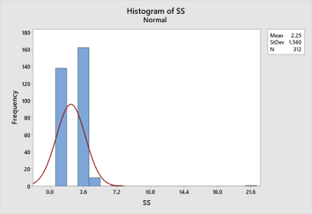
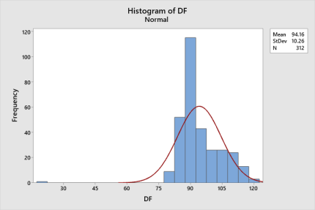
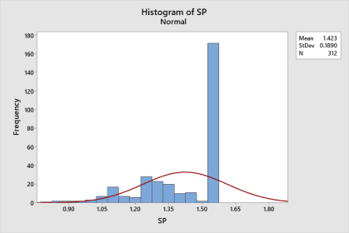
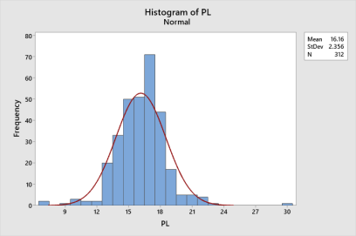
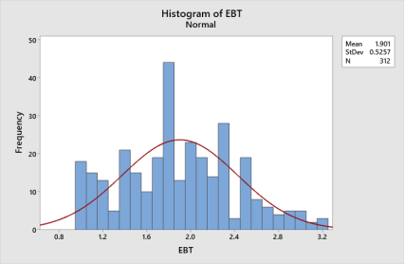
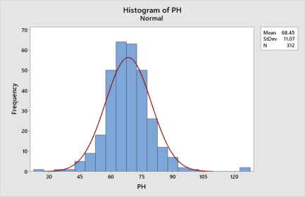

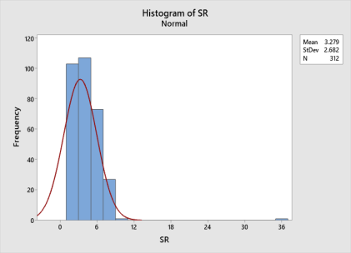
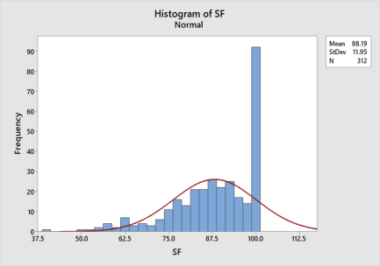
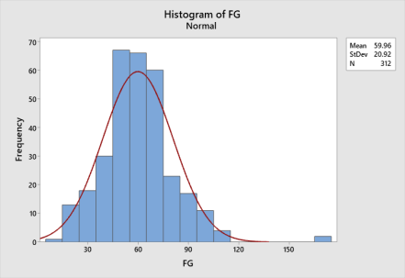

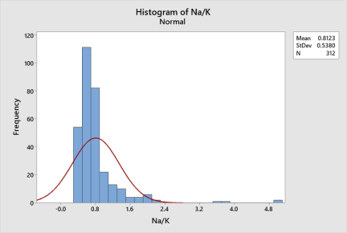
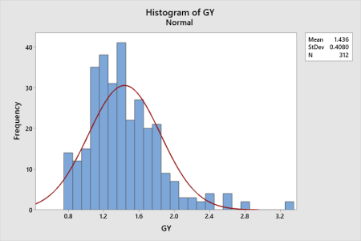
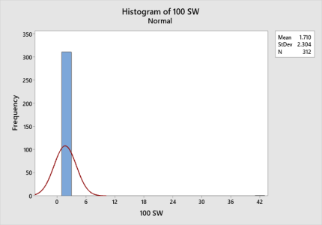
Standard peaks of histograms revealed traits for positively skewness and normal distribution (bell – shaped curves).
Table 6. List of RILs exhibiting significant higher grain yield per plant and high

tolerance to salinity traits

S. No. | RILs | Seedling stage  salinity score | Reproductive stage  salinity score | Shoot Na⁺/K⁺ ratio  at harvesting stage | 100 grain weight (g) | Grain yield per plant (g)
1 | F₅ 112 | 1 | 1 | 0.32 | 1.70 | 15.35
2 | F₅ 248 | 1 | 1 | 0.14 | 1.84 | 12.80
3 | F₅ 202 | 1 | 1 | 0.2 | 1.65 | 8.28
4 | F₅ 122 | 1 | 1 | 0.12 | 1.75 | 8.19
 | MCM 109 | 1 | 3 | 0.15 | 1.59 | 5.21
 | BRR 0119 | 3 | 5 | 0.21 | 1.79 | 6.86

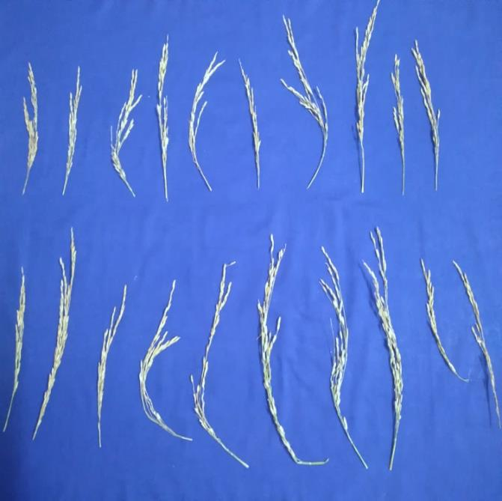
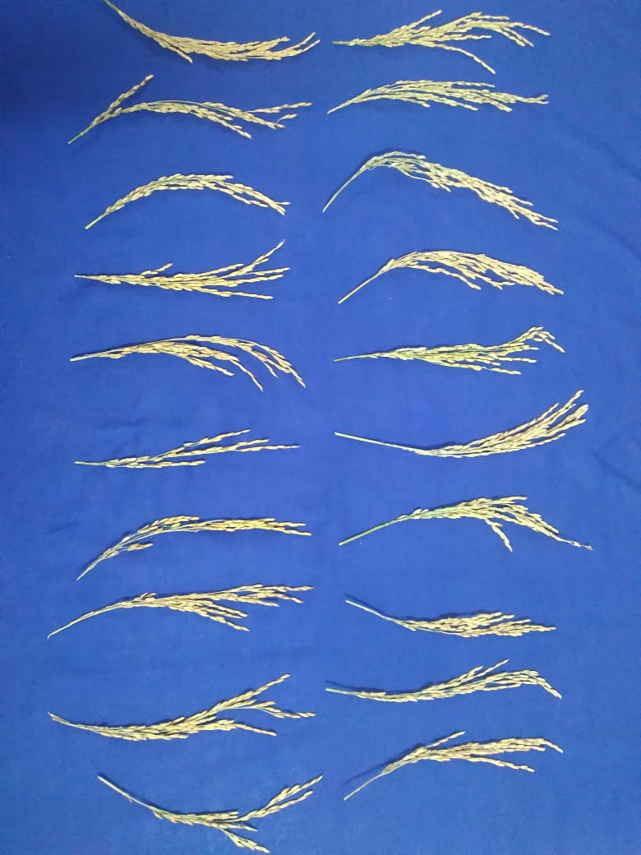
Fig.2. Variation in panicle lengths at better and poor survived field conditions

Table 7. Variability studies for salinity and yield related traits of F₅ RILs
Trait | Coefficient of variation |  | h²B (%) | GA | GAM (%)
 | PCV (%) | GCV (%)
PS (%) | 13.29 | 11.77 | 78 | 0.3 | 21.48
DFF | 9.79 | 9.48 | 93 | 17.85 | 18.91
SS | 27.61 | 21.2 | 58 | 0.47 | 33.53
PH (cm) | 15.74 | 15.51 | 97 | 21.58 | 31.47
EBT/ hill | 27.69 | 27.44 | 98 | 1.06 | 56.04
PL (cm) | 13.8 | 13.01 | 88 | 4.07 | 25.29
FG/ Panicle | 17.83 | 17.74 | 98 | 2.77 | 36.36
RS | 33.13 | 30.11 | 82 | 0.95 | 56.37
SF (%) | 16.93 | 16.23 | 91 | 0.41 | 32.03
Na⁺/K⁺ | 66.34 | 65.88 | 98 | 1.63 | 63.02
100 GW (g) | 16.66 | 15.78 | 89 | 0.48 | 30.81
GY(g) | 72.67 | 72.67 | 99 | 7.01 | 15.79
PS (%) = plant survival percentage, DFF= days to fifty per cent flowering, SS= salinity scoring at seedling stage, PH= plant height (cm), EBT/hill= ear bearing tillers hill⁻¹, PL= panicle length (cm), FG/panicle= number of filled grains per panicle, RS= salinity scoring at reproductive stage, SF (%)= spikelet fertility percentage, Na⁺/K⁺= shoot sodium to potassium ratio at harvesting stage, 100 GW (g)= hundred grain weight (g), GY (g)= grain yield per plant (g).
4. Conclusion

The evaluation of F₅ RILs under field conditions expressed a remarkable genotypic variability for salinity and yield traits studied in coastal saline soils. High estimates of PCV, GCV, heritability and genetic advance as per cent of mean (GA) were observed for the traits ear bearing tillers hill⁻¹, salt tolerance at reproductive stage, shoot Na⁺/K⁺ ratio at harvesting stage and grain yield per plant (g) and moderate estimates were observed for the traits plant survival (%), plant height (cm), panicle length (cm), number of filled grains per panicle, spikelet fertility (%) and hundred grain weight (g) indicating the predominance of additive gene action. Therefore, selection based on these traits could be influential in developing high yielding salt tolerant varieties. The RILs F₅ 112 and F₅ 248 can be released as high yielding saline tolerant varieties after evaluation in salinity trials and multi-location trials whereas RILs F₅ 122 and F₅ 202 can be registered as genetic stocks for highly tolerant coastal saline conditions.

COMPETING INTERESTS DISCLAIMER:
Authors have declared that they have no known competing financial interests OR non-financial interests OR personal relationships that could have appeared to influence the work reported in this paper.
DISCLAIMER (ARTIFICIAL INTELLIGENCE)
Author(s) hereby declare that NO generative AI technologies such as Large Language Models (Chat GPT, COPILOT, etc) and text-to-image generators have been used during the writing or editing of this manuscript.

References
- Ahmadizadeh, M., Babaeian-Jelodar, N., Mohammadi-Nejad, G., Bagheri, N., & Singh, R.K. (2021). High-density linkage mapping for agronomic and physiological traits of rice (Oryza sativa L.) under reproductive-stage salt stress, Journal of Genetics, 100, 1-12. https://doi.org/10.1007/s12041-021-01301-6.
- Behera, B., Sahu, S., Kar, R. K & Pandey, R. K. (2023). Studies on genetic variability for some metric traits in slender grain rice genotypes. Journal of Applied and Natural Science, 15(1), 1–6. https://doi.org/10.31018/jans.v10i1.1633.
- Bharali, V., Yadla, S., Fiyaz, R. A., Rao, V. S., & Jukanti, A. K. (2024). Genetic inheritance studies in rice (Oryza sativa L.) for grain protein, quality and yield. Electronic Journal of Plant Breeding, 15(3), 604-611. 10.37992/2024.1503.079.
- Bhargava, K., Shivani, D., Pushpavalli, S. N. C. V. L., Sundaram, R. M., Beulah, P., & Senguttuvel, P. (2021). Genetic variability, correlation and path coefficient analysis in segregating population of rice. Electronic Journal of Plant Breeding, 12(2), 549-555. https://doi.org/10.37992/2021.1202.077.
- Girija Rani, M., Sailaja, V., Padmavathi, J., & Sanjay K. (2024). Identification of favourable alleles for multiple traits and nutrient management in salt tolerant rice varieties to enhance productivity in coastal saline ecosystem. Asian Journal of Microbiology, Biotechnology and Environmental Sciences, 26(1), 99-105. http://doi.org/10.53550/AJMBES.2024.v26i01.016.
- Hussain, M., Ahmad, S., Hussain, S., Lal, R., Ul-Allah, S., & Nawaz, A. (2018). Rice in saline soils: physiology, biochemistry, genetics and management. Advances in Agronomy, 148, 231-287. https://doi.org/10.1016/bs.agron.2017.11.002.
- IRRI. Standard Evaluation System for rice (SES). (2014). International Rice Research Institute, Los Baños, Philippines.
- Kerketta, P., Sao, A., Ekka, A., Sai, R & Singh, R. (2024). Application of genetic parameters for betterment of yield and yield contributing traits in rice (Oryza sativa L.). International Journal of Advanced Biochemistry Research, 8(4), 346-351. https://doi.org/10.33545/26174693.2024.v8.i4e.955.
- Kulsum, U., Sarker, U., & Rasul, M. G. (2022). Genetic variability, heritability and interrelationship in salt-tolerant lines of T. Aman rice. Genetika, 54(2), 761-776. https://doi.org/10.2298/GENSR2202761K.
- Laghari, A. A., Ahmad, A., Memon, S., Musavi, S. A. M., Ali, A., Kumar, A., & Guo, Q. (2025). Genetic diversity in F₃ segregating populations of rice (Oryza sativa L.) genotypes under salt stress. Frontiers in Plant Science, 16, 1568859. 10.3389/fpls.2025.1568859.
- Nounjan, N., Chansongkrow, P., Charoensawan, V., Siangliw, J. L., Toojinda, T., Chadchawan, S., & Theerakulpisut, P. (2018). High performance of photosynthesis and osmotic adjustment are associated with salt tolerance ability in rice carrying drought tolerance QTL: physiological and co-expression network analysis. Frontiers in plant science, 9, 1135. https://doi.org/10.3389/fpls.2018.01135.
- Pardhi, K. C., Meshram, M. P., Patil, S. A., Barde, Y. D., Kunte, S. G., & Nikose, S. V. (2025). Assessment of genetic variability in F₅ generation under transplanted condition in rice (Oryza sativa L.), Plant Archives, 25(1), 1196-1200. https://doi.org/10.51470/PLANTARCHIVES.2025.v25.supplement-1.162.
- Prashanth, C., Mahantashivayogayya, K., Diwan, J. R., Kuchanur, P. H., & Vishwanath, J. (2020). Genetic variability and association studies on bpt-5204 based rice mutants under saline stress soil. International Journal of Current Microbiology and Applied Sciences, 9(2), 2441-2450. https://doi.org/10.20546/ijcmas.2020.902.279.
- Rasel, M. D., Hassan, L., Hoque, M. I. U., & Saha, S. R. 2018. Estimation of genetic variability, correlation and path coefficient analysis in local landraces of rice (Oryza sativa L.) for the improvement of salinity tolerance. Journal of the Bangladesh Agricultural University, 16(1), 41-46. https://doi.org/10.3329/jbau.v16i1.36479.
- Rohit Yadav., Rajpoot, P., Verma, O. P., Singh, P. K., Singh, P., & Pathak, V. (2017). Genetic variability and heritability in rice for yield and its attributes under sodic soil. Journal of Pharmacognosy and Phytochemistry, 6(5): 2021-2024.
- Samy, P. M. A., Singh, R. K., Gregorio, G. B., Gautam, R. K., Krishnamurthy, S. L., & Thirumeni, S. (2024). Genetic improvement of rice for salt tolerance. In Genetic Improvement of Rice for Salt Tolerance, Singapore: Springer Nature Singapore, 1-8.
- Senguttuvel, P., Raju, N.S., Padmavathi, G., Sundaram, R.M., Madhav, S., Hariprasad, A.S., Kota, S., Bhadana, V.P., Subrahmanyam, D., Rao, L.S. and Brajendra, B., (2016). Identification and quantification of salinity tolerance through salt stress indices and variability studies in rice (Oryza sativa L.). Sabrao journal of breeding and genetics, 48(2), 172-179.
- Singh, R. K., & Chaudhary, B. D. (1985). Biometrical Methods in Quantitative Genetic Analysis. Kalyani Publishers, New Delhi, 85-89.
- Sitaresmi, T., Gunarsih, C., & Hairmansis, A. (2022). Grain yield and yield component trait association and salinity tolerance of rice lines under mild saline stress condition. In IOP Conference Series: Earth and Environmental Science, 978(1), 12-17.
- Vani Praveena M, Venkata Ramana Rao P, Jyothi Badri, Sreenivas Ch, Ramesh D & Vasu Deva Reddy D. (2025). Association and Genetic Variability Studies for Reproductive Stage Salinity Tolerance Traits in Rice (Oryza sativa L.). International Journal of Plant & Soil Science, 37(6), 477–485. https://doi.org/10.9734/ijpss/2025/v37i65526.
- Zhang, A., Liu, Y., Wang, F., Li, T., Chen, Z., Kong, D., Bi, J., Zhang, F., Luo, X., Wang, J., & Tang, J., 2019. Enhanced rice salinity tolerance via CRISPR/Cas9-targeted mutagenesis of the OsRR22 gene. Molecular breeding, 39(3), 47. https://doi.org/10.1007/s11032-019-0954-y.

