Original Research Article

Exogenous Calcium Mediates Improved Salt Stress Tolerance in Soybean

.
ABSTRACT
Aims:
To evaluate the effect of exogenous calcium (Ca²⁺) on salinity-induced stress in soybean (Glycine max) and to determine its role in improving growth, physiological, and biochemical parameters contributing to salt tolerance.
Study Design:
A factorial pot experiment arranged in a completely randomized design (CRD) with three replications was conducted.
Place and Duration of Study:
Crop Physiology Division, Bangladesh Institute of Nuclear Agriculture (BINA), Mymensingh, and Subarnachar, Noakhali, during the 2023–2024 growing season.
Methodology:
Four soybean genotypes (Sem-05, Sem-08, Sem-11, and Binasoybean-6) were exposed to salinity stress (8 dS m⁻¹ NaCl) with foliar application of calcium sulfate (CaSO₄·2H₂O) at concentrations of 5, 10, and 15 mM. Growth, yield attributes, chlorophyll, proline, soluble sugar, malondialdehyde (MDA), and hydrogen peroxide (H₂O₂) contents were measured. Data were analyzed statistically using ANOVA, and treatment means were compared with the LSD test at a 5% level of significance.
Results:
Calcium application significantly mitigated the adverse effects of salinity across all genotypes. The 10 mM Ca treatment showed the most beneficial effects, increasing shoot and root biomass, chlorophyll content, and osmolyte accumulation while reducing MDA and H₂O₂ levels. Sem-11 and Binasoybean-6 exhibited superior tolerance, recording the highest yield (6.61 and 5.90 kg ha⁻¹, respectively) and lowest was in Sem-08 (1.51 kg ha⁻¹) under salinity with calcium application. Calcium supplementation improved Na⁺/K⁺ homeostasis and enhanced antioxidant enzyme activity, leading to reduced oxidative damage and improved physiological stability.
Conclusion:
Exogenous calcium application, particularly at 10 mM concentration, effectively enhances salt tolerance in soybean by stabilizing membranes, maintaining ion balance, and strengthening antioxidant defenses. This approach offers a cost-effective, non-genetic strategy to improve soybean productivity in saline-prone environments.

Keywords: calcium supplementation, ion homeostasis, oxidative stress, salinity, and yield performance

1. INTRODUCTION

Soil salinity is a major environmental stress limiting crop productivity worldwide, especially in irrigated areas where poor drainage and excessive irrigation cause salt accumulation. Soybean, an essential leguminous crop for global food security, is highly sensitive to salinity stress, which results in stunted growth, disrupted photosynthesis, ion imbalance, and reduced yield (Aboh & Eyong 2023). The increasing prevalence of salinity due to climate change and intensive agricultural practices poses a significant threat to soybean cultivation in saline-prone regions (Mahfuza et al., 2022).
Salinity stress primarily disrupts plant metabolism by accumulating toxic ions like sodium (Na⁺) and chloride (Cl⁻), impairing nutrient uptake, water relations, and enzyme activities (Munns & Tester, 2008). Additionally, prolonged salt exposure induces oxidative stress via reactive oxygen species (ROS) generation, causing cellular damage including lipid peroxidation, protein denaturation, and membrane destabilization (Hasanuzzaman et al., 2022). This oxidative damage overwhelms the plant’s antioxidant defense systems, further inhibiting growth (Hasanuzzaman et al., 2020).
Calcium (Ca²⁺) plays a pivotal role in plant stress signaling and tolerance. Exogenous calcium application has been reported to improve salt tolerance by maintaining ion homeostasis, enhancing antioxidant defenses, and stabilizing cellular structures under saline conditions (Feng et al., 2023). Calcium mediates key signaling pathways that regulate osmotic balance, activate stress-responsive genes, and interact with hormones such as abscisic acid (ABA) to mitigate salt-induced osmotic stress (Yang et al., 2023; Xiao & Zhou 2023). Hadi and Karimi (2012) highlight the importance of calcium in improving physiological resilience and cellular processes, ultimately supporting plant growth and productivity under saline conditions.
Previous studies have demonstrated that calcium application improves physiological traits like seed germination, root and shoot growth, photosynthesis, and nutrient uptake in soybean under salt stress (Hameed et al., 2025). However, the detailed molecular mechanisms by which calcium confers salt tolerance in soybean remain unclear. It is suggested that calcium influences antioxidant enzymes, ion transporters, and compatible solute accumulation such as proline, contributing to stress mitigation (Mahfuza et al., 2022).
This study investigates the role of exogenous calcium in enhancing soybean tolerance to salinity stress. It evaluates key biochemical responses, with emphasis on ion homeostasis and oxidative stress regulation, to clarify the mechanisms underlying calcium-mediated salt tolerance. The findings provide valuable insights for improving soybean productivity and developing effective management strategies in saline environments.
2. MATERIAL AND METHODS
2.1 Plant Material and Treatment
On the basis of yield and yield contributing characters, three mutant lines (Sem-05, Sem-08 and Sem-11) one check variety of soybean Binasoybean-6 (high yielding, salt-tolerant) were used as planting materials for this experiment. The experiments of this study were conducted at the pot yard of crop physiology division BINA and Subarnochor, Noakhali. Sodium hypochlorite at 2.5% concentration was used for seed sterilization. After being germinated on filter paper in Petri Annex Anex Ayurs, four seedlings were transplanted to plastic pots (20 L). The salt-stress (8 dS m⁻¹ NaCl) treatment will be started 40 days after sowing (DAS) (Guan et al., 2023) where all the pot is put in a saline solution of 7 days at reproductive stage. At the same time, calcium (Ca) in the form of CaSO4.2H2O (5, 10, and 15 mM) was sprayed on plant foliage every alternate day as treatment (Sharavdorj et al., 2022). The treatment combinations were: control (T1) water; 5 mM Ca (T2); 10 mM Ca (T3); 15 mM Ca (T4); 8 dS m⁻¹ NaCl (T5); 8 dS m⁻¹ NaCl + 5 mM Ca (T6); 8 dS m⁻¹ NaCl + 10 mM Ca (T7); and 8 dS m⁻¹ NaCl + 15 mM Ca (T8).
2.2 Assessment of Yield Contributing Parameters and Yield
The soybean was harvested at maturity. Yield data were recorded from each pot. Plant height was measured by scale after harvest. Total branch number plant⁻¹, pod plant⁻¹, seed pod⁻¹ 100 seed weight and grain weight plant⁻¹ were counted from five plants per replication of each genotype of all the treatments.
2.3 Chlorophyll content Determination
Chlorophyll content was measured using acetone extract method by spectrophotometer reading. (Lichtenthaler and Wellburn., 1983)
2.4 Proline content Determination
Proline content was measured as described previously by Bates et al. (1973).
2.5 Soluble Sugar Determination
Soluble sugar content was measured according to Yoshida et al. (1976).
2.6 Determination of Hydrogen peroxide (H2O2)
Hydrogen peroxide (H2O2) was estimated as described previously by Velikova et al. (2000).
2.7 Determination of Melondealdehyde (MDA)
Malondialdehyde (MDA) was estimated as described previously by Rao and Sresty (2000)
2.8 Statistical analysis
RStudio software was used for statistical evaluation of the collected data. The data were analyzed using the analysis of variance (ANOVA) technique and comparison of the mean difference was carried out by the least significant difference (LSD) test with a 5% level of significance.

3. results and discussion
3.1 Effect of Exogenous Calcium application on Shoot and root Growth under Salinity Stress
The effect of salinity (8 dS m⁻¹ NaCl) and foliar application of calcium (CaSO₄) on shoot length of soybean genotypes is presented in Fig. 1 (a). Salinity significantly reduced shoot length across all genotypes, with the most pronounced reduction observed in Bina soybean-6, which decreased from 21.33 cm under salinity stress (T1) to 25.38 cm upon calcium supplementation (T2). In contrast, Sem-08 exhibited the longest shoots under both saline (29.12 cm) and calcium-treated conditions (30.11 cm), while Sem-11 showed intermediate growth responses. Overall, calcium application partially mitigated the inhibitory effect of salinity on shoot elongation, indicating a protective role of exogenous calcium in maintaining vegetative growth.
(a)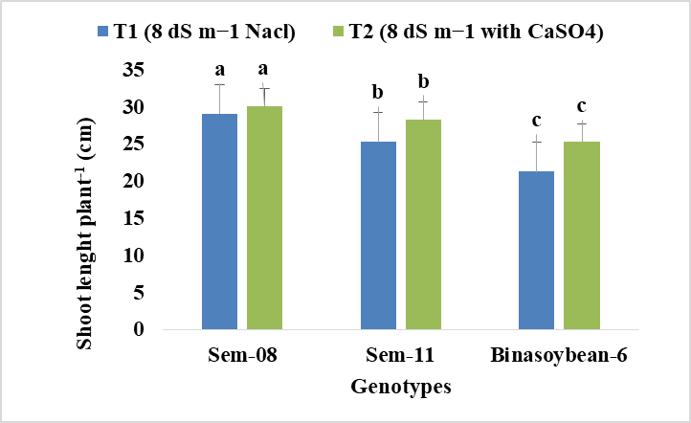 | (b)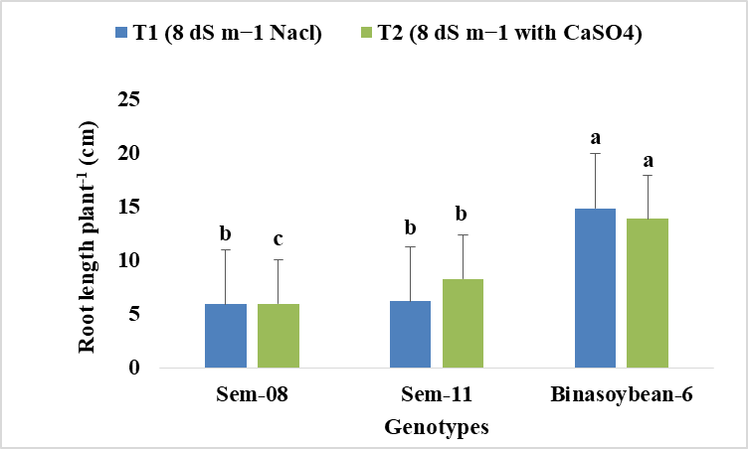
Fig 1 (a), (b): Effect of salinity (8 dSm⁻¹ NaCl) and foliar application of calsium on shoot-root length
plant⁻¹.
Salinity-induced inhibition of shoot growth is often a consequence of ionic toxicity combined with osmotic stress, which together disrupt cell elongation and division by impairing turgor, ion homeostasis, and cell wall remodeling (Zhao et al., 2025). Calcium has been reported to stabilize cell membranes, regulate ion transport, and enhance osmotic adjustment under salt stress (Wang et al., 2019). The observed improvement in shoot length following calcium application aligns with previous findings in soybean and other crops, where calcium supplementation alleviated Na⁺-induced growth suppression (Valivand et al., 2021).
Root growth responses varied among the genotypes (Fig. 1 (b)). Bina soybean-6 displayed the highest root length under both T1 (14.9 cm) and T2 (13.9 cm), whereas Sem-08 consistently produced shorter roots (5.92 cm in T1 and 5.97 cm in T2). Sem-11 showed intermediate root elongation. Interestingly, root length in tolerant genotypes (e.g., Bina soybean-6) appeared less affected by salinity, suggesting a better adaptive root response to stress conditions. In contrast, susceptible genotypes exhibited stunted root growth.
Root elongation under salt stress is a critical adaptive trait, enabling plants to explore deeper soil layers for water and nutrients (Munns et al., 2016). Calcium likely contributes to root growth maintenance by regulating cell wall stability, mitigating Na⁺ toxicity, and enhancing root hydraulic conductivity (Feng et al., 2023). The differential response among genotypes underscores the importance of genetic variability in salt tolerance mechanisms.
The combined data suggest that exogenous calcium improves overall plant growth under salinity by enhancing shoot elongation and supporting root development, particularly in tolerant genotypes. These findings indicate that calcium not only stabilizes cellular structures but also modulates stress signaling pathways that mitigate salinity induced growth inhibition. Such calcium-mediated tolerance mechanisms have been documented in soybean and other crops, highlighting its potential as a practical agronomic intervention for saline soils (Zhu, 2016).
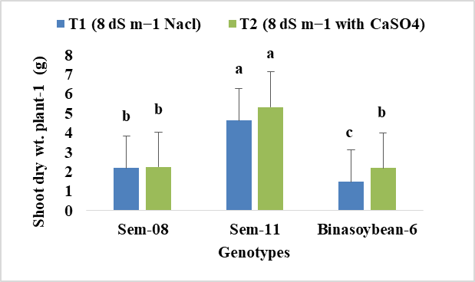 | 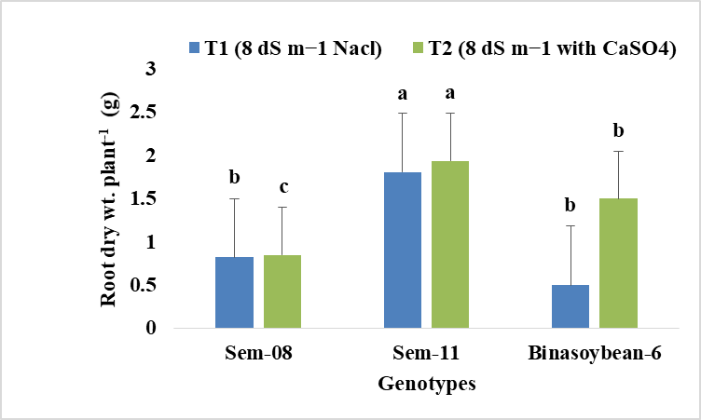
Fig 2: Effect of salinity (8 dSm⁻¹ NaCl) and foliar application of calsium on shoot-root dry weight plant⁻¹.

Exogenous calcium application significantly alleviated the adverse effects of salt stress (8 dSm⁻¹ NaCl) on soybean growth, as evidenced by improvements in both shoot and root dry weights across multiple genotypes. Under saline conditions without calcium treatment, soybean plants showed marked reductions in biomass accumulation, indicating stress-induced growth inhibition. However, foliar application of calcium under salt stress markedly enhanced shoot biomass in all genotypes, with Sem-11 exhibiting the highest shoot dry weight increase from 4.63 g to 5.33 g. Similarly, Bina soybean-6 demonstrated a notable rise in shoot dry weight from 1.49 g under salt stress alone to 2.19 g with calcium treatment.
The root dry weight also responded positively to calcium supplementation under salinity, with Bina soybean-6 showing the greatest root biomass increment (from 1.81 g to 1.94 g). This suggests that calcium application supports root growth and function despite the ionic and osmotic challenges imposed by salt stress. The lowest root biomass was observed in Sem-11 under salt alone, yet it improved significantly following calcium application.
These findings align with established roles of calcium in mitigating salt stress in plants by stabilizing cell membranes and reducing oxidative damage (Hasanuzzaman et al., 2022). Calcium plays a crucial role in maintaining ion homeostasis under saline conditions by modulating ion transporters and restricting excessive Na+ influx while promoting K+ retention, which is essential for cellular functions (Hameed & Gechev, 2025). Moreover, calcium enhances antioxidant enzyme activities, including superoxide dismutase and peroxidase, thus alleviating oxidative stress caused by salt-induced reactive oxygen species accumulation (Yin et al., 2015; Adhikari et al., 2025).
The increased biomass under calcium treatment suggests improved photosynthetic capacity and osmotic regulation, which enables better growth under salinity (Mahfuza et al., 2022). In particular, the enhancement in root biomass is critical, as roots are the primary interface for water and nutrient uptake and must cope with the detrimental effects of salt accumulation. Previous studies have also demonstrated that calcium fortifies root cell walls and promotes pectin synthesis, restoring root growth under saline stress (An et al., 2014).
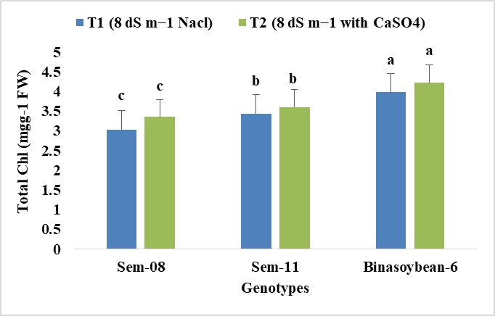
Fig 3: Effect of salinity (8 dSm⁻¹ NaCl) and foliar application of calsium on total Chlorophyll content.
3.2 Total Chlorophyll content
The results clearly demonstrate that salinity stress (8 dS m⁻¹ NaCl) significantly reduced chlorophyll content across all soybean genotypes, with the most pronounced effect observed in Sem-08 (3.03) and the least in Binasoybean-6 (3.98), indicating inherent genotypic variation in salt tolerance. This chlorophyll degradation is a well-established consequence of salinity, often resulting from ion toxicity-induced chloroplast damage and increased chlorophyllase activity (AbdElgawad et al., 2020). However, the foliar application of calcium (CaSO₄) effectively mitigated this damage, leading to a significant increase in chlorophyll content in all genotypes. The ameliorative effect was most substantial in the sensitive Sem-08 (+10.6%), followed by Binasoybean-6 (+6.0%) and Sem-11 (+4.7%). This recovery can be attributed to calcium's vital role in stabilizing chloroplast membranes and maintaining photosynthetic efficiency under stress (Hu et al., 2018). Furthermore, calcium is known to regulate stomatal aperture and enhance the antioxidant defense system, thereby reducing oxidative stress and protecting photosynthetic pigments (Ahanger et al., 2018; Kumar et al., 2018). The superior performance and consistent ranking of Binasoybean-6, even under stress, confirm its robust genetic capacity for salinity tolerance, a trait that was further enhanced by calcium supplementation. These findings align with the concept that integrating agronomic practices, like nutrient management, with the use of resilient genotypes is a key strategy for sustainable crop production in saline environments (Hasanuzzaman et al., 2021).
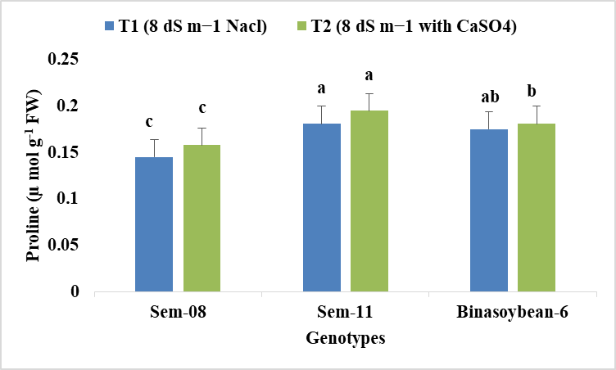 | 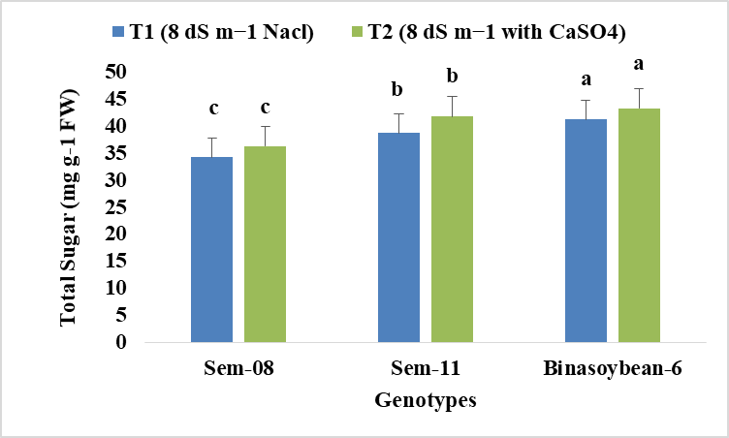
Fig 4: Effect of salinity (8 dSm⁻¹ NaCl) and foliar application of calsium on proline accumulation and total soluble sugar content

3.3 Proline and total soluble sugar accumulation
Salinity stress (8 dS m⁻¹ NaCl) significantly induced the accumulation of osmolytes proline and total soluble sugars across all soybean genotypes, serving as a key mechanism for osmotic adjustment. The genotype Sem-11 exhibited the highest proline content (0.181 µ mol g⁻¹ FW), while Bina soybean-6 showed superior sugar accumulation (41.23 mg g⁻¹ FW), indicating intrinsic genotypic variation in stress response mechanisms. This suggests Sem-11 possesses a robust proline synthesis mechanism, known to Proline, being an amino acid that responds to stress, has the ability to accumulate under adverse environmental conditions and act as a signal for the transmission of stress memory to subsequent generations" (Mushtaq et al., 2025) while Bina soybean-6 demonstrates heightened efficiency in carbohydrate mobilization because Starch metabolism inhibition occurred in the reserve mobilization of germinating soybeans subjected to varying salt stress levels... germinating soybeans exposed to moderate salt stress countered the stress by amassing substantial quantities of sucrose (Zhang et al., 2025)
Foliar application of calcium (T2) further enhanced osmoprotectant accumulation, increasing average proline content from 0.167 to 0.178 µ mol g⁻¹ FW and average sugar content from 38.07 to 40.45 mg g⁻¹ FW. This ameliorative effect aligns with calcium's role as a secondary messenger in stress signaling pathways, upregulating genes involved in osmoprotectant biosynthesis (Rahman et al., 2016; Srivastava et al., 2013). Bina soybean-6 maintained the highest sugar accumulation under both conditions (43.29 mg g⁻¹ FW in T2), earning the statistical rank 'a'. The reduced standard deviation for proline from T1 to T2 indicates calcium application promoted more consistent osmotic responses across genotypes.
Overall, the enhanced accumulation of these osmolytes under calcium supplementation demonstrates crucial mitigation of ionic stress, supporting that exogenous calcium fortifies the biochemical defense system in soybeans and improves salinity resilience, consistent with studies on glycophytic crops (Hameed et al., 2025).

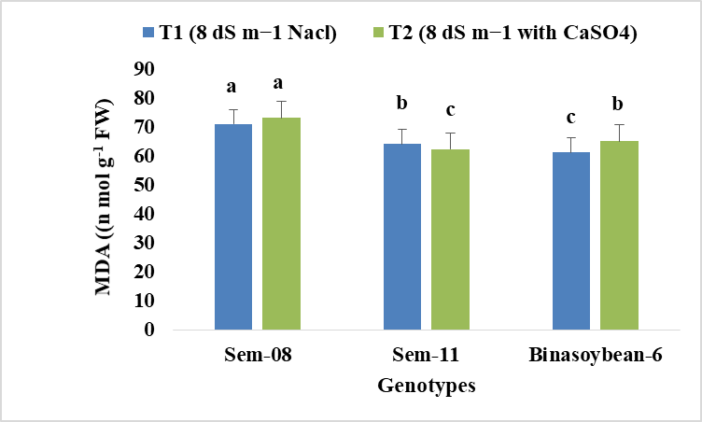 | 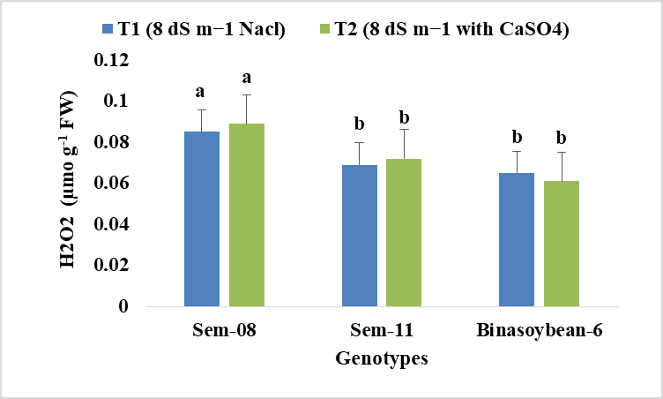
Fig 5: Effect of salinity (8 dSm⁻¹ NaCl) and foliar application of calsium on Malondealdehyde (MDA) content and Hydrogen peroxide (H₂O₂) content.

3.4 Melondealdehyde (MDA) content and Hydrogen peroxide content in soybean under saline condition and foliar calcium application
Salinity stress induced oxidative stress in all soybean genotypes, evidenced by increased malondialdehyde (MDA) and hydrogen peroxide (H₂O₂). Sem-08 showed highest susceptibility with greatest MDA (71.11 nmolg⁻¹FW) and H₂O₂ (0.085 µ mol g⁻¹ FW), indicating severe membrane damage. In contrast, Bina soybean-6 demonstrated inherent tolerance with lowest values for both MDA (61.32 n mol g⁻¹ FW) and H₂O₂ (0.065 µ mol g⁻¹ FW), highlighting genotypic variation in oxidative stress management (Hossain and Dietz, 2016; Sofy et al., 2020).
Foliar calcium application showed genotype-specific effects. While it didn't mitigate damage in sensitive Sem-08, it reduced H₂O₂ in tolerant Bina soybean-6 (0.065 to 0.061 µ mol g⁻¹ FW). Calcium activates antioxidant enzymes like SOD, CAT and POD that scavenge H₂O₂ and reduce lipid peroxidation (MDA) (Srivastava et al., 2013). The differential response underscores that calcium's efficacy is genotype-dependent, primarily enhancing antioxidant defense in resilient genotypes to maintain cellular integrity under salinity (Hameed et al., 2025).

3.5 Interaction effect of genotypes and different level of saline condition
The interaction between genotype and calcium sulfate application under saline conditions (8 dS m⁻¹) significantly influenced yield and yield-related traits in soybean. From Table-1 among the treatments, Sem-11 with 10 mM Ca recorded the highest number of pods per plant (18.44 pods plant⁻¹), followed by Binasoybean-6 with 10 mM Ca (17.21 pods plant⁻¹) and Sem-08 control (18.67 pods plant⁻¹). In contrast, Sem-08 under 8 dS m⁻¹ without calcium produced the lowest number of pods (6.83), and Sem-05 failed to survive under untreated and most treated saline conditions except for 10 mM Ca, where it produced 12.61 pods. Seeds pod⁻¹ also improved under calcium treatment. The highest value (2.61) was recorded in Binasoybean-6 with 10 mM Ca, followed by Sem-11 (2.42) and Sem-11 control (2.40). Sem-05 at 10 mM Ca had the lowest (1.15), indicating a limited response. In terms of 100 seed weight, Binasoybean-6 with 10 mM Ca had the highest value (15.49 g), closely followed by its control (15.46 g), while Sem-08 without calcium and

Table 1. Interaction effect of genotype and different level of salinity on yield and yield contributing parameters
Interaction | Mutants/varieties | Pods plant⁻¹ (no.) | Seeds pod⁻¹ (no.) | 100 seed wt. (g) | Seed yield (kg ha⁻¹)
8 dSm⁻¹ | Sem-05 | - | - | - | -
8 dSm⁻¹ | Sem-08 | 6.83 h | 1.67 gh | 6.03 h | 1.52 i
8 dSm⁻¹ | Sem-11 | 13..00 f | 2.27 d | 12.43 d | 5.95 c
8 dSm⁻¹ | Binasoybean-6 | 9.73 g | 2.11 e | 12.33 d | 2.86 g
8 dSm⁻¹ with T₁ | Sem-05 | - | - | - | -
8 dSm⁻¹ with T₁ | Sem-08 | 6.78 h | 1.69 g | 6.00 h | 1.54 i
8 dSm⁻¹ with T₁ | Sem-11 | 14.00 e | 2.51 b | 13.11 b | 6.13 b
8 dSm⁻¹ with T₁ | Binasoybean-6 | 9.65 g | 2.15 e | 11.59 e | 5.78 cd
8 dSm⁻¹ with T₂ | Sem-05 | 12.61 f | 1.15 h | 8.08 g | 4.55 f
8 dSm⁻¹ with T₂ | Sem-08 | 18.00 a | 2.21 d | 11.57 e | 5.36 d
8 dSm⁻¹ with T₂ | Sem-11 | 18.44 a | 2.42 c | 13.66 b | 6.61 a
8 dSm⁻¹ with T₂ | Binasoybean-6 | 17.21 b | 2.61 a | 15.49 a | 5.90 cd
8 dSm⁻¹ with T₃ | Sem-05 | - | - | - | -
8 dSm⁻¹ with T₃ | Sem-08 | 5.78 i | 1.95 f | 6.10 h | 1.64 h
8 dSm⁻¹ with T₃ | Sem-11 | 12.95 f | 2.31 cd | 12.15 d | 5.87 cd
8 dSm⁻¹ with T₃ | Binasoybean-6 | 9.75 g | 2.08 ef | 11.84 e | 4.78 e
Control | Sem-05 | 15.95 d | 2.13 e | 10.11 f | 6.35 b
Control | Sem-08 | 18.67 a | 2.27 d | 11.97 c | 5.06 d
Control | Sem-11 | 17.62 b | 2.40 c | 13.24 b | 6.65 a
Control | Binasoybean-6 | 16.56 c | 2.53 a | 15.46 a | 5.85 cd
F test | - | ** | ** | ** | **
**Significance at p<0.01 level of probability, T₁= 5 mM Ca, T₂=10 mM Ca, T₃=15 mM Ca
T1 (5 mM Ca) recorded the lowest (6.03 g and 6.00 g, respectively). For seed yield, Sem-11 with 10 mM Ca showed the highest productivity (6.61 kg ha⁻¹), statistically comparable to its control (6.65 kg ha⁻¹) and Sem-11 with 5 mM Ca (6.13 kg ha⁻¹). The lowest yield (1.52 kg ha⁻¹) was observed in Sem-08 under salt stress without calcium. The results indicate that exogenous calcium sulfate application significantly enhanced yield and yield-contributing traits in soybean genotypes under salinity stress. Calcium not only improved pod number, seeds per pod, and seed weight but also helped certain sensitive genotypes (like Sem-05) partially recover under otherwise lethal saline conditions. Sem-11 consistently outperformed all other genotypes across treatments, especially under 10 mM Ca, suggesting strong inherent salinity tolerance further enhanced by calcium. This aligns with earlier results showing Sem-11 had better biomass and biochemical stability under salinity, both with and without calcium application. Calcium likely contributed to improved yield performance by:
- Stabilizing membranes and mitigating ion toxicity, particularly by limiting Na⁺ uptake and improving K⁺/Na⁺ selectivity.
- Enhancing enzyme activity involved in nutrient metabolism and seed development.
- Supporting reproductive development, as seen in increased pod and seed counts.
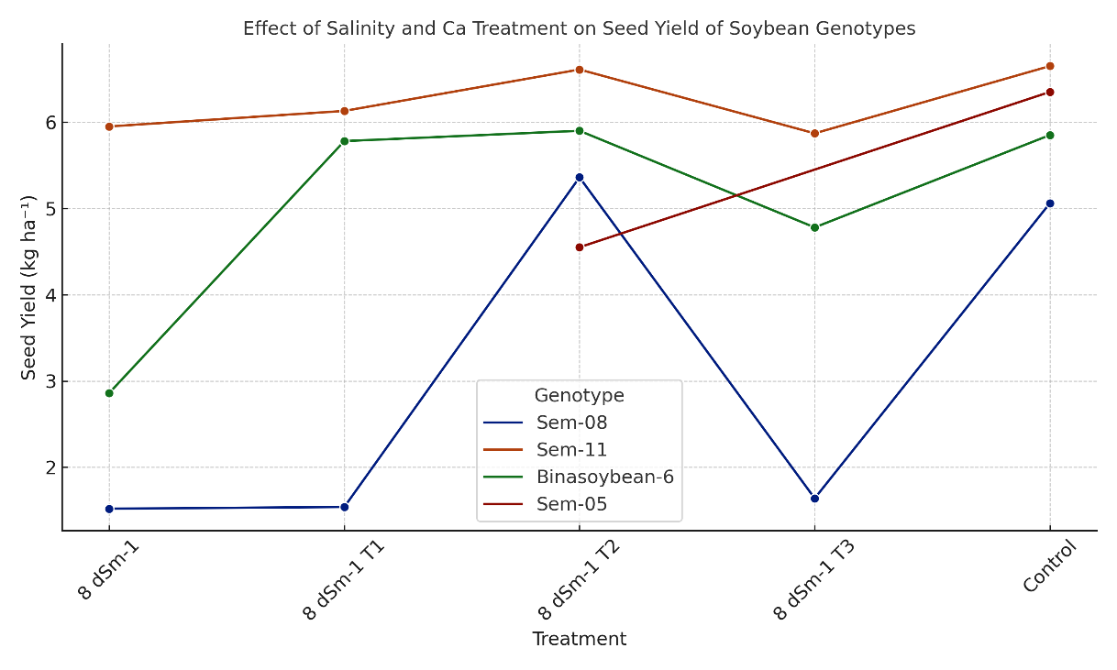
- Reducing oxidative damage to reproductive tissues under stress.
Fig 6: Line chart showing the effect of salinity (8 dS m⁻¹) and different Ca treatments (T1=5 mM, T2=10 mM, T3=15 mM) on seed yield of four soybean genotypes.
Binasoybean-6 also responded positively to calcium, particularly at 10 mM, where it showed the highest 100 seed weight and second-highest pod number, reflecting good physiological recovery under salinity. Meanwhile, Sem-08, though moderately tolerant, showed a limited response to calcium, and Sem-05 remained highly sensitive, though 10 mM Ca enabled minimal survival and seed production. Interestingly, 10 mM calcium sulfate appeared to be the most effective dose across all genotypes. While 5 mM gave marginal benefits, and 15 mM sometimes reduced yield components (likely due to osmotic imbalance or ion toxicity), 10 mM provided optimal enhancement of both vegetative and reproductive traits. Fig 6 shows how seed yield (kg ha⁻¹) changes across salinity and calcium treatments for each genotype. It is clearly saw that Sem-11 and Binasoybean-6 perform better under salinity, especially with 10 mM Ca. These findings suggest that foliar calcium sulfate application, particularly at 10 mM concentration, is an effective agronomic strategy to alleviate salinity stress in soybean, especially in genotypes with inherent stress tolerance like Sem-11 and Binasoybean-6. The marked improvement in yield parameters under calcium treatment highlights the nutrient’s contribution to maintaining ion balance, protecting reproductive tissues, and supporting assimilate partitioning, making it a promising agronomic strategy for securing soybean productivity in saline environments (Phang et al., 2008)
3.6 Correlation Analysis of Yield and Yield Contributing Parameters
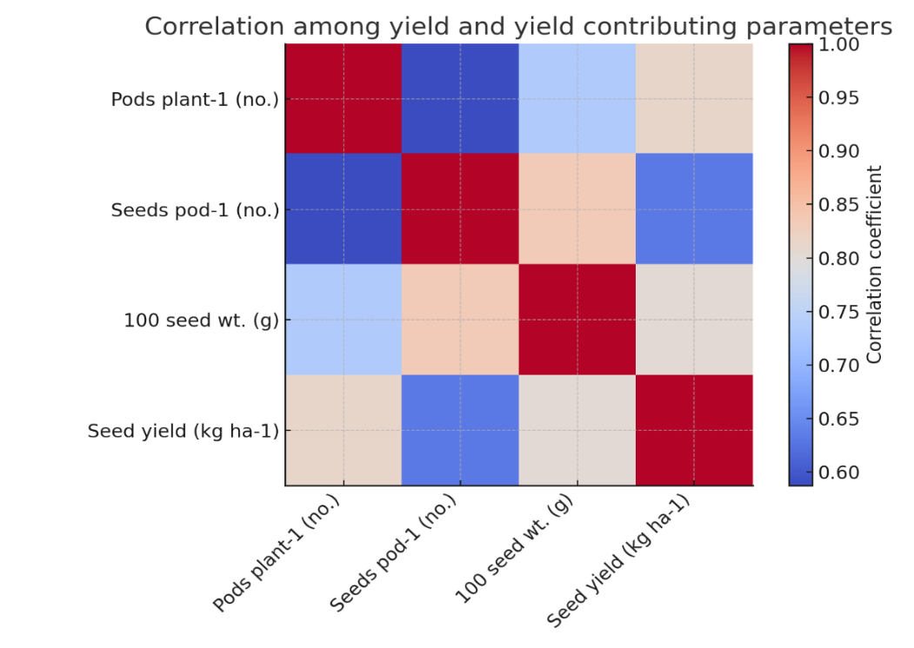
The correlation analysis among yield and yield-contributing parameters in soybean revealed strong positive relationships among all traits (Fig 7). Pods per plant showed the highest correlation with seed yield (r = 0.81), followed by 100-seed weight (r = 0.80), while seeds per pod had a moderate positive relationship (r = 0.63). Additionally, pods per plant were strongly correlated with 100-seed weight (r = 0.73), indicating that genotypes producing more pods also tend to have heavier seeds. These results suggest that pods per plant and seed weight are major determinants of soybean yield performance, particularly under salinity and calcium treatments. Genotypes that maintain pod production and higher seed weight under stress conditions may therefore exhibit greater yield stability. Similar findings were reported by Berhanu, Tesso, and Lule (2021), who observed significant positive correlations between pods per plant, seeds per pod, and 100-seed weight with overall yield in soybean genotypes. They concluded that these parameters could serve as reliable selection criteria in breeding programs. Likewise, Spoorthi et al. (2025) found that pods per plant and 100-seed weight had the strongest positive direct effects on yield across different seasonal conditions.

Fig 7: Correlation Analysis of Yield and Yield Contributing Parameters

The consistency of these findings reinforces that enhancing pod production and seed filling are key strategies for improving soybean productivity. Thus, selecting for these traits can effectively increase yield potential and adaptability under varying environmental stresses, including salinity.
3.7 Effect of salinity on yield and yield contributing characters
The field evaluation of four soybean genotypes (Sem-05, Sem-08, Sem-11, and Binasoybean-6) under natural saline conditions at Subornachor, Noakhali (salinity ~7.1 dS m⁻¹ at reproductive stage) revealed significant genotypic variation across all yield and yield-related parameters (Table 2). These findings provide important insights into the performance of selected genotypes under real-world stress environments and validate controlled condition results. Days to maturity differed significantly among genotypes, ranging from 110 days in Binasoybean-6 to 135 days in Sem-11. Sem-05 and Sem-11 exhibited longer growth durations (132 and 135 days, respectively), which may allow more time for reproductive development, although it can also expose plants to prolonged stress.
Table 2: Yield and yield contributing parameters at Subornachor, Noakhali field condition (Salinity level approx. 6.1 dSm⁻¹ at reproductive stage)
Mutants/varieties | Days to Maturity | Plant Height (cm) | Branches plant⁻¹ (no.) | Pods plant⁻¹(no.) | Seeds pod⁻¹ (no.) | Pod length (cm) | 100 seed wt. (g) | Seed yield (kg ha⁻¹)
Sem-05 | 132 b | 92 a | 5 a | 77 a | 4 a | 2.67 a | 15.66 a | 3048 a
Sem-08 | 115 c | 34 c | 2 c | 23 d | 3 b | 2.00 d | 15.71 a | 2302 d
Sem-11 | 135 a | 91 a | 5 a | 55 c | 4 a | 2.17 c | 11.30 c | 2779 c
Binasoybean-6 | 110 d | 67 b | 4 b | 72 b | 3 b | 2.33 b | 13.04 b | 2872 b
CV(%) | 14.12 | 9.89 | 14.23 | 13.74 | 14.31 | 8.21 | 11.22 | 8.74
F test | ** | ** | ** | ** | ** | ** | ** | **
**significance at 1% level of probability
In terms of plant height, Sem-05 (92 cm) and Sem-11 (91 cm) were significantly taller than Sem-08 (34 cm) and Binasoybean-6 (67 cm). Taller plant stature, especially in Sem-05 and Sem-11, may have contributed to better light interception and enhanced biomass partitioning to reproductive structures. Branch number per plant was also highest in Sem-05 and Sem-11 (5 branches), followed by Binasoybean-6 (4). Sem-08, in contrast, had only 2 branches, which may explain its poor pod and yield performance. More branches typically support greater pod development, aligning with the trend observed in pod number per plant, where Sem-05 (77) and Binasoybean-6 (72) outperformed others. Interestingly, Sem-11, though structurally strong, produced fewer pods (55), indicating a possible delay in reproductive efficiency under prolonged stress. For seeds per pod, Sem-05 and Sem-11 recorded the highest (4), whereas Sem-08 and Binasoybean-6 had 3, which is consistent with their reproductive vigor observed in previous stress trials. Similarly, pod length followed a comparable pattern, with Sem-05 (2.67 cm) having the longest pods, while Sem-08 exhibited the shortest (2.00 cm), reflecting the overall weak reproductive capacity of this genotype under salinity. In terms of 100-seed weight, Sem-05 (15.66g) and Sem-08 (15.71g) recorded the highest values, although Sem-08's weight advantage did not translate to higher yield due to fewer pods and seeds. Sem-11, in contrast, had the lowest seed weight (11.30 g), which may have reduced its final yield despite robust plant structure. The most critical trait, seed yield, was highest in Sem-05 (3048 kg ha⁻¹), followed by Binasoybean-6 (2872 kg ha⁻¹), Sem-11 (2779 kg ha⁻¹), and lowest in Sem-08 (2302 kg ha⁻¹). This result is particularly interesting for Sem-05, which previously showed high sensitivity to salt stress under controlled conditions. Its superior field performance may be attributed to moderate salinity levels, favorable soil buffering, or better adaptation under natural conditions. On the other hand, Sem-11, which consistently showed high biochemical and physiological tolerance in controlled studies, maintained a strong, though not highest, yield under field stress. Its long maturity duration and low seed weight might have limited its full yield potential. Binasoybean-6, a known salt-tolerant variety, demonstrated good field adaptability with high yield, acceptable maturity duration, and strong reproductive traits, confirming its potential as a reliable cultivar for saline environments. Sem-08, as seen in all prior analyses, remained the weakest performer, further validating its low salt tolerance.
These results confirm that genotype and environment interactions play a significant role in performance under salt-affected conditions. Genotypes like Sem-05, despite weak lab responses, can thrive in field settings, while consistent performers like Binasoybean-6 and Sem-11 offer stable yield potential under both controlled and natural salinity stress. The observed variability emphasizes the need for multi-location trials before genotype recommendation for salt-affected regions.
4. Conclusion
Exogenous calcium application, particularly at 10 mM concentration, effectively enhanced salt tolerance in soybean by improving growth, maintaining ion balance, and activating antioxidant defense systems. Calcium supplementation mitigated the harmful effects of salinity across all genotypes most notably in Sem-11 and Binasoybean-6 with significant increases in shoot and root biomass, higher chlorophyll and osmolyte content, and lower oxidative damage markers. These results demonstrate that calcium stabilizes cellular functions, reduces sodium toxicity, and promotes overall physiological stability under saline conditions. The study highlights calcium supplementation as a practical, cost-effective strategy for improving soybean resilience and productivity in salt-affected environments.

COMPETING INTERESTS DISCLAIMER:
Authors have declared that they have no known competing financial interests OR non-financial interests OR personal relationships that could have appeared to influence the work reported in this paper.
Disclaimer (Artificial intelligence)
Option 1:
Author(s) hereby declare that NO generative AI technologies such as Large Language Models (ChatGPT, COPILOT, etc.) and text-to-image generators have been used during the writing or editing of this manuscript.

REFERENCES
AbdElgawad, H., Zinta, G., Hegab, M. M., Pandey, R., Asard, H., & Abuelsoud, W. (2016). High salinity induces different oxidative stress and antioxidant responses in maize seedlings organs. Frontiers in plant science, 7, 276.
Aboh, A. A., & Eyong, O. I. (2023). Effects of salinity stress on growth parameters of soybeans (Glycine max) cultivated in obubra local government area, of cross river state Nigeria. Asian Journal of Research in Crop Science, 8(4), 465-470.
Adhikari, A., Sapkota, M., Savidya, R. N., Tosin, A. T., Adam, M., Alam, M. N., ... & Lee, I. J. (2025). Calcium enhances the effectiveness of melatonin in improving nutritional properties of soybean sprouts and germination under salt and cadmium stress. International Journal of Molecular Sciences, 26(3), 878.
Ahanger, M. A., Tomar, N. S., Tittal, M., Argal, S., & Agarwal, R. (2017). Plant growth under water/salt stress: ROS production; antioxidants and significance of added potassium under such conditions. Physiology and Molecular Biology of Plants, 23(4), 731-744.
An, P., Li, X., Zheng, Y., Eneji, A. E., & Inanaga, S. (2014). Calcium effects on root cell wall composition and ion contents in two soybean cultivars under salinity stress. Canadian Journal of Plant Science, 94(4), 733-740.
Bates, L. S., Waldren, R. P. A., & Teare, I. D. (1973). Rapid determination of free proline for water-stress studies. Plant and soil, 39(1), 205-207.
Berhanu, H., Tesso, B., & Lule, D. (2021). Correlation and path coefficient analysis for seed yield and yield related traits in soybean (Glycine max (L.)) genotypes. Plant, 9(4), 106-110.
Feng, D., Wang, X., Gao, J., Zhang, C., Liu, H., Liu, P., & Sun, X. (2023). Exogenous calcium: Its mechanisms and research advances involved in plant stress tolerance. Frontiers in Plant Science, 14, 1143963.
Guan, R. X., Guo, X. Y., Qu, Y., Zhang, Z. W., Bao, L. G., Ye, R. Y., ... & Qiu, L. J. (2023). Salt tolerance in soybeans: focus on screening methods and genetics. Plants, 13(1), 97.
Gupta, B., & Huang, B. (2014). Mechanism of salinity tolerance in plants: physiological, biochemical, and molecular characterization. International journal of genomics, 2014(1), 701596.
Hadi, M. R., & Karimi, N. (2012). The role of calcium in plants'salt tolerance. Journal of plant nutrition, 35(13), 2037-2054.
Hameed, A., Khan, M. A., Tahir, M. H. N., Lodhi, M. S., Muzammil, S., Shafiq, M., ... & Faisal, M. (2025). In Silico identification and characterization of SOS gene family in soybean: Potential of calcium in salinity stress mitigation. PloS one, 20(2), e0317612.
Hasanuzzaman, M., Bhuyan, M. B., Zulfiqar, F., Raza, A., Mohsin, S. M., Mahmud, J. A., ... & Fotopoulos, V. (2020). Reactive oxygen species and antioxidant defense in plants under abiotic stress: Revisiting the crucial role of a universal defense regulator. Antioxidants, 9(8), 681.
Hasanuzzaman, M., Raihan, M. R. H., Masud, A. A. C., Rahman, K., Nowroz, F., Rahman, M., ... & Fujita, M. (2021). Regulation of reactive oxygen species and antioxidant defense in plants under salinity. International Journal of Molecular Sciences, 22(17), 9326.
Hasanuzzaman, M., Raihan, M. R. H., Nowroz, F., & Fujita, M. (2022). Insight into the mechanism of salt-induced oxidative stress tolerance in soybean by the application of Bacillus subtilis: coordinated actions of osmoregulation, ion homeostasis, antioxidant defense, and methylglyoxal detoxification. Antioxidants, 11(10), 1856.
Hayat, S., Hayat, Q., Alyemeni, M. N., Wani, A. S., Pichtel, J., & Ahmad, A. (2012). Role of proline under changing environments: a review. Plant signaling & behavior, 7(11), 1456-1466.
Hossain, M. S., & Dietz, K. J. (2016). Tuning of redox regulatory mechanisms, reactive oxygen species and redox homeostasis under salinity stress. Frontiers in plant science, 7, 548.
Hu, W., Tian, S. B., Di, Q., Duan, S. H., & Dai, K. (2018). Effects of exogenous calcium on mesophyll cell ultrastructure, gas exchange, and photosystem II in tobacco (Nicotiana tabacum Linn.) under drought stress. Photosynthetica, 56(4), 1204-1211.
Kumar, V., Khare, T., Shriram, V., & Wani, S. H. (2018). Plant small RNAs: the essential epigenetic regulators of gene expression for salt-stress responses and tolerance. Plant Cell Reports, 37(1), 61-75.
Lichtenthaler, H. K., & Wellburn, A. R. (1983). Determinations of total carotenoids and chlorophylls a and b of leaf extracts in different solvents.
Mahfuza, S. N., Ahsan, A. F. M. S., Ahmed, I. M., Ahmed, F., Talukder, A. R., & Islam, M. N. (2022). Morpho-Physiological Responses of Soybean Varieties to Salinity Stress. Bangladesh Agronomy Journal, 25(1), 15-22.
Munns, R., & Tester, M. (2008). Mechanisms of salinity tolerance. Annu. Rev. Plant Biol., 59(1), 651-681.
Munns, R., James, R.A., & Läuchli, A. (2016). Approaches to increasing the salt tolerance of wheat and other cereals. Journal of Experimental Botany, 57(5), 1025–1043.
Mushtaq, N. U., Saleem, S., Rasool, A., Shah, W. H., Tahir, I., Seth, C. S., & Rehman, R. U. (2025). Proline Tagging for Stress Tolerance in Plants. International Journal of Genomics, 2025(1), 9348557.
Phang, T. H., Shao, G., & Lam, H. M. (2008). Salt tolerance in soybean. Journal of integrative plant biology, 50(10), 1196-1212.
Rahman, A., Nahar, K., Hasanuzzaman, M., & Fujita, M. (2016). Calcium supplementation improves Na+/K+ ratio, antioxidant defense and glyoxalase systems in salt-stressed rice seedlings. Frontiers in plant science, 7, 609.
Rao, K. M., & Sresty, T. V. S. (2000). Antioxidative parameters in the seedlings of pigeonpea (Cajanus cajan (L.) Millspaugh) in response to Zn and Ni stresses. Plant science, 157(1), 113-128.
Sharavdorj, K., Byambadorj, S. O., Jang, Y., & Cho, J. W. (2022). Application of magnesium and calcium sulfate on growth and physiology of forage crops under long-term salinity stress. Plants, 11(24), 3576.
Sofy, M. R., Seleiman, M. F., Alhammad, B. A., Alharbi, B. M., & Mohamed, H. I. (2020). Minimizing adverse effects of pb on maize plants by combined treatment with jasmonic, salicylic acids and proline. Agronomy, 10(5), 699.
Spoorthi, B., Naidu, G. K., Deshpande, S. K., Mummigatti, U. V., Somanagouda, G., Huilgol, S., ... & Banu, H. (2025). Direct and indirect effects of component traits on soybean seed yield under seasonal variation. Bangladesh Journal of Botany, 54(3), 441-446.
Srivastava, A. K., Rai, A. N., Patade, V. Y., & Suprasanna, P. (2013). Calcium signaling and its significance in alleviating salt stress in plants. Salt stress in plants: signalling, omics and adaptations, 197-218.
Valivand, M., & Amooaghaie, R. (2021). Foliar spray with sodium hydrosulfide and calcium chloride advances dynamic of critical elements and efficiency of nitrogen metabolism in Cucurbita pepo L. under nickel stress. Scientia Horticulturae, 283, 110052.
Velikova, V., Yordanov, I., & Edreva, A. J. P. S. (2000). Oxidative stress and some antioxidant systems in acid rain-treated bean plants: protective role of exogenous polyamines. Plant science, 151(1), 59-66.
Wang, Q., Yang, S., Wan, S., & Li, X. (2019). The significance of calcium in photosynthesis. International journal of molecular sciences, 20(6), 1353.
Xiao, F., & Zhou, H. (2023). Plant salt response: Perception, signaling, and tolerance. Frontiers in Plant Science, 13, 1053699.
Yin, Y., Yang, R., Han, Y., & Gu, Z. (2015). Comparative proteomic and physiological analyses reveal the protective effect of exogenous calcium on the germinating soybean response to salt stress. Journal of proteomics, 113, 110-126.
Yoshida, S., & Coronel, V. (1976). Nitrogen nutrition, leaf resistance, and leaf photosynthetic rate of the rice plant. Soil Science and Plant Nutrition, 22(2), 207-211.
Zhang, Z., Zhao, Q., Wang, W., Feng, R., Cao, Y., Wang, G., ... & Du, Y. (2025). Starch-sucrose metabolic homeostasis in germinating soybean reserve mobilization with different levels of salt stress. Plant Physiology and Biochemistry, 110050.
Zhao, S., Tariq, F., & Ma, C. (2025). Integrative dynamics of cell wall architecture and plant growth under salt stress. Frontiers in Plant Science, 16, 1644412.
Zhu, J. K. (2016). Abiotic stress signaling and responses in plants. Cell, 167(2), 313-324.

