Foliar feeding of micro-nutrient influencing physical attributes of winter season guava (Psidium guajava L.) cv. L-49

Abstract
Enhancing fruiting and physical attributes of guava is crucial for growers as these traits directly contribute to total yield production. Hence, the present investigation was undertaken to study the effect of foliar application of micronutrients on the physical and yield attributes of winter season guava (Psidium guajava L.) cv. L-49. The experiment comprised nine treatments, namely: T₀ -Control (water spray), T₁ - Calcium chloride 0.1%, T₂ - Calcium chloride 0.2%, T₃ - Borax 0.1%, T₄ -Borax 0.2%, T₅ - Calcium chloride 0.1% + Borax 0.1%, T₆ - Calcium chloride 0.1% + Borax 0.2%, T₇- Calcium chloride 0.2% + Borax 0.1%, and T₈ - Calcium chloride 0.2% + Borax 0.2%, with three replications laid out in a randomized block design (RBD). The results revealed that the treatment Calcium chloride 0.2% + Borax 0.1% (T₇) recorded the highest fruit set (67.54%), fruit retention (57.84%), fruit length (8.89 cm), fruit width (8.85 cm), fruit weight (136.67 g), fruit volume (121.63 cc), specific gravity (1.18), yield per tree (62.17 kg), and yield per hectare (168.61 q/ha), compared to the control. The study concludes that foliar application of calcium chloride (0.2%) combined with borax (0.1%) is an effective approach to improve fruit size, quality, and overall productivity of winter season guava.

KEYWORDS: Borax, Calcium chloride, Foliar application, Micronutrients, Psidium guajava
INTRODUCTION
Guava (Psidium guajava L.), belonging to the family Myrtaceae, is an economically and nutritionally important fruit crop widely cultivated in tropical and subtropical regions. Although the genus Psidium comprises about 150 species, P. guajava L. is the only one extensively commercialized due to its adaptability, prolific bearing, pleasant flavor, high vitamin C content, and tolerance to diverse climatic conditions. Originating from tropical America, extending from Mexico to Peru, guava is now cultivated across Asia, Africa, and other tropical regions.
The growth, productivity, and fruit quality of guava are highly influenced by the balanced supply of macro- and micronutrients. Nutrient deficiencies lead to chlorosis, poor flowering, reduced yield, and inferior fruit quality. Among various nutrient management approaches, foliar fertilization has emerged as an efficient technique for the quick correction of nutrient deficiencies and enhancement of fruit quality. By enabling direct nutrient absorption through leaf surfaces, foliar feeding ensures rapid physiological responses and circumvents limitations associated with soil nutrient availability under adverse conditions such as pH imbalance or low moisture. Compared with soil application, foliar fertilization can be 10-20 times more efficient (Zaman and Schumann, 2006), ensuring better nutrient use efficiency, uniform canopy coverage, and minimal nutrient losses.
Micronutrients such as zinc, boron, calcium, and potassium play pivotal roles in key metabolic and reproductive processes-enzymatic activation, hormonal regulation, cell division, and fruit development-directly influencing yield and fruit quality. Zinc and boron, in particular, enhance fruit set, reduce pre-harvest drop, and improve fruit size and quality in many fruit crops. Helper (2005) reported that foliar application of calcium and boron significantly increased guava fruit size by promoting cell division and elongation, while calcium also improved fruit firmness and post-harvest life through better cell wall integrity. Similarly, Singh et al. (2004) and Pal et al. (2008) demonstrated that borax application improved guava fruit weight, size, and volume. Tripathi et al. (2018) further confirmed that borax minimized fruit drop and enhanced retention in aonla cv. NA-7, highlighting its broader applicability in fruit crops. Moreover, the combined foliar application of borax and calcium chloride exhibited synergistic effects, improving both yield and fruit quality in guava (Poojan et al., 2020).
Despite extensive research on nutrient management, limited studies have focused on the integrated foliar application of multiple micronutrients during the winter season, when guava growth and physiological activity slow due to low temperatures. This period-specific nutritional requirement remains underexplored, particularly for the widely grown cultivar L-49, known for its adaptability and productivity.
Hence, the present investigation was undertaken to evaluate the effect of foliar application of selected micronutrients (zinc, boron, calcium, and potassium) on the physical attributes and yield parameters of winter season guava (Psidium guajava L.) cv. L-49. The study aims to generate insights that could refine foliar nutrient management practices for enhancing fruit yield and quality under cooler growing conditions.
MATERIAL AND METHODS
The experiment was conducted during 2019-20 at the Horticultural Research Farm, Department of Horticulture, Babasaheb Bhimrao Ambedkar University, Lucknow, on twenty-one (21)-year-old guava (Psidium guajava L.) trees of cv. L-49. The experimental site is situated in the subtropical region of central Uttar Pradesh at 26°56′ N latitude, 80°52′ E longitude, and at an altitude of 111 meters above mean sea level. The soil of the experimental site was clay loam, well-drained, and well-aerated, with a loose texture conducive to proper root development. The experiment was consisting of 9 treatments and three replications such as T₀- Control (Water spray), T₁ - Calcium chloride 0.1%, T₂ ₋ Calcium chloride 0.2%, T₃- Borax 0.1%, T₄- Borax 0.2%, T₅- Calcium chloride 0.1% + Borax 0.1%, T₆- Calcium chloride 0.1% + Borax 0.2%, T₇- Calcium chloride 0.2% + Borax 0.1% and T₈- Calcium chloride 0.2% + Borax 0.2%. Each replication comprised a single tree, resulting in a total of 27 trees in the experiment. Fruit set and fruit retention was calculated as per the standard formula and expressed in percentage (Darshan et al., 2023). Fruit length and fruit width was measured with the help of digital Vernier calipers and expressed in centimeter. Weight of fruits was measured with electronic weighing balance and expressed in gram, while fruit volume was assessed by water displacement methods and represent in cubic centimeters. Specific gravity of fruits was determined by dividing fruit weight and fruit volume.
STATISTICAL ANALYSIS
The experiment was conducted following a randomized block design, and data analysis was performed using SAS version 9.4. The interaction means were evaluated through analysis of variance (ANOVA), and significant differences were determined using the least significant difference (LSD) test at the 5% probability level (p≤0.05).
RESULT AND DISCUSSION
FLOWERING PARAMETERS
The data presented in (Fig. 1A and Fig. 1B) clearly demonstrate that foliar application of micronutrients had a significant effect (p<0.05) on the percentage of fruit set and fruit retention in guava. The highest fruit set (67.54%) and fruit retention (57.84%) were recorded in plants treated with a combination of calcium chloride (0.2%) + borax (0.1%), followed by CaCl₂ (0.2%) + borax (0.2%), whereas the control exhibited the lowest values (47.12% and 38.49%), respectively. The inclusion of error bars in Fig. 1 indicates that the observed differences among treatments were statistically reliable.
The superior performance of borax-treated plants can be attributed to boron’s role in enhancing pollen viability, fertilization efficiency, and carbohydrate translocation toward developing fruits. Similarly, calcium plays a key role in cell wall stability and enzymatic activation, which supports better fruit development and reduces premature fruit drop. The synergistic effect of boron and calcium thus appears to enhance sink strength and minimize abscission. These findings are consistent with Yadav et al. (2012) in ber, who reported improved fruit retention with combined Ca and B application, and Awasthi and Lal (2009) in guava, who observed higher fruit set under similar treatment conditions. However, the present results indicate a relatively greater magnitude of improvement, possibly due to differences in cultivar response (cv. L-49) and environmental conditions.
PHYSICAL PARAMETERS
Foliar spraying with various treatments significantly enhanced fruit length, breadth, weight, volume, and specific gravity compared to the control (Table 1). The maximum fruit length (7.89 cm), breadth (7.84 cm), weight (135.67 g), volume (120.63 ml), and specific gravity (1.18) were recorded in plants treated with calcium chloride (0.2%) combined with borax (0.1%), followed closely by calcium chloride (0.2%) + borax (0.2%). In contrast, the control (water spray) recorded the minimum values-6.53 cm length, 5.72 cm breadth, 103.89 g weight, 92.33 cc volume, and 0.95 specific gravity. The statistically significant improvement in fruit physical attributes under micronutrient treatments may be attributed to their catalytic roles in enzymatic and metabolic processes, which promote better nutrient absorption, translocation, and utilization, ultimately enhancing fruit development and quality. Similar improvements in fruit quality due to foliar micronutrient application were also reported by Dutta (2004) in mango cv. ‘Himsagar’ and Bhatt et al. (2012) in ‘Dashehari’, corroborating the present findings.
YIELD PARAMETERS
The data presented in Table 1 reveal that foliar application of micronutrients exerted a significant influence on the physical and yield-attributing characteristics of guava cv. L-49, particularly fruit yield per tree and per hectare. The fruit yield per tree ranged from 44.33 kg to 62.17 kg, while the corresponding yield per hectare varied from 124.71 q/ha to 168.61 q/ha, indicating a marked enhancement in productivity due to micronutrient application. The maximum fruit yield (62.17 kg per tree and 168.61 q/ha) was recorded under the treatment receiving the most effective combination of micronutrients, followed by yields of 59.66 kg per tree and 163.07 q/ha, respectively. Conversely, the minimum yield (44.33 kg per tree and 124.71 q/ha) was observed in the untreated control.
The improvement in yield can be attributed to the physiological roles of boron and calcium supplied through borax and calcium chloride sprays. Boron is known to influence reproductive development and cell wall formation, while calcium enhances membrane stability, enzyme activity, and assimilate translocation. The combined application of these nutrients likely promoted fruit growth, resulting in increased fruit size (length and breadth), weight, and overall yield. These findings corroborate the results of Bhatt et al. (2012) in mango cv. Dashehari, who reported similar enhancement in fruit development and productivity following micronutrient sprays.
CORRELATION ANALYSIS
The correlation heatmap (Fig. 2) reveals a strong and cohesive relationship among eight fruit-related traits, characterized by uniformly positive and statistically significant (p < 0.01) Pearson coefficients. Fruit yield per tree shows the strongest associations with fruit weight (r = 0.96), fruit retention (r = 0.93), fruit volume (r = 0.91), and fruit set (r = 0.90), indicating that improvements in these component traits directly enhance productivity. A similar pattern is observed for yield per hectare, which correlates closely with per-tree yield (r = 0.96) and major yield components such as fruit weight and retention (r = 0.90–0.92), confirming consistent scaling from individual to population levels.

Among physical attributes, fruit weight exhibits tight integration with width (r = 0.91) and volume (r = 0.84), highlighting the central role of mass and girth in yield formation. In contrast, fruit length shows only moderate correlations with yield (r ≈ 0.70), suggesting that width contributes more substantially to overall fruit size and biomass accumulation. Reproductive traits-fruit set and retention-are strongly interlinked (r = 0.91) and display robust correlations with yield and fruit size variables (r = 0.81-0.93), underscoring their dual influence on fruit number and individual fruit development.
Overall, the matrix reflects a harmonized pattern of trait interactions with no negative correlations, implying that simultaneous selection or management for multiple yield-enhancing traits is feasible without trade-offs. Emphasis on improving fruit retention, set, and weight is therefore expected to produce the most substantial and stable gains in guava productivity.
CONCLUSION
The present investigation demonstrated that foliar application of micronutrients, particularly calcium chloride at 0.2% combined with borax at 0.1%, significantly improved the physical attributes and yield of winter season guava (Psidium guajava L.) cv. L-49. This treatment recorded the highest fruit set, fruit retention, and superior fruit dimensions, weight, volume, and specific gravity, along with maximum yield per tree and per hectare. The positive response may be attributed to calcium’s role in growth regulation, cell wall stability, and enzyme activation, and boron’s role in carbohydrate translocation, pollen viability, and hormonal balance. The synergistic effect of combined micronutrient application proved more effective than individual applications, highlighting the importance of integrating calcium and boron in foliar feeding regimes. This study affirms that targeted micronutrient foliar applications during critical fruit development stages can substantially enhance productivity and quality in winter guava cultivation.

COMPETING INTERESTS DISCLAIMER:
Authors have declared that they have no known competing financial interests OR non-financial interests OR personal relationships that could have appeared to influence the work reported in this paper.

Disclaimer (Artificial intelligence)
Option 1:
Author(s) hereby declare that NO generative AI technologies such as Large Language Models (ChatGPT, COPILOT, etc.) and text-to-image generators have been used during the writing or editing of this manuscript.
Option 2:
Author(s) hereby declare that generative AI technologies such as Large Language Models, etc. have been used during the writing or editing of manuscripts. This explanation will include the name, version, model, and source of the generative AI technology and as well as all input prompts provided to the generative AI technology
Details of the AI usage are given below:
1.
2.
3.

REFERENCES
Awasthi, Priya and Lal, S. (2009). Effect of calcium, boron and zinc foliar sprays on the yield and quality of guava (Psidium guajava) Pantnagar J. Res. 7 (2): 223- 225.
Bhatt Arvind, Mishra N K, Mishra D S and Singh C P (2012). Foliar application of potassium, calcium, zinc and boron enhanced yield, quality and shelf life of mango cv. Dashehari. Hort Flora Res Spectrum1 (4):300-305.
Darshan, D., Shukla, A. K., Hota, D., Singh, V., & Kumar, V. (2023). Foliar application of growth regulators and nutrients for enhanced yield attributes of guava cv Lalit. Emergent Life Sciences Research, 9, 72-76.
Dutta P (2004). Effect of foliar application on panicle growth, fruit retention and physico-chemical characters of mango cv. Himsagar. Indian J Hort 61 (30): 265-266.
Hepler, P. K. (2005). Calcium: a central regulator of plant growth and development. The Plant Cell, 17(8), 2142-2155.
Kumar, S., Singh, A.K. and Singh, A. (2011). Effect of foliar application of various growth regulators nutrients on shelf life and chemical attributes of guava cv. Lucknow-49. Plant Archives 11: 107-111.
Kumar, S., Yadav, P., Jain, V. And Malhotra, S.P. (2011). Oxidative Stress and Antioxidative System in Z. mauritiana. Food Technology and Biotechnology 49: 453–459.
Pal, Anju; Pathak, R.K.; Pal, Krishna and Tejbir, S. (2008). Effect of foliar application of nutrients on yield and quality of guava (Psidium guajava L.) fruits cv. Sardar. Prog. Res. 3 (1): 89- 90.
Panse, V.G. and Sukhatme, P.V. (1985). Statistical method for agricultural workers, ICAR, New Delhi.
Poojan, S., Pandey, D., Trivedi, A. K., Pandey, A. K., & Pandey, M. (2020). Efficacy of foliar application of nutrients on yield and quality of guava. Journal of Environmental Biology, 41(5), 1061-1067.
Sharma, L. K., Sood, P., & Yadav, D. S. (2020). Effect of foliar application of nutrients on growth, yield and quality of mango under rain-fed conditions of Himachal Pradesh. Journal of Krishi Vigyan, 9(1), 84-87.
Singh, R., Chaturvedi, O. P., & Singh, R. (2004). Effect of pre harvest spray of zinc, boron and calcium on the physico chemical quality of guava fruits (Psidium guajava L.) International seminar onrecent Trend on Hi-tech Hort. and PHT Kanpur. Horticulture and Post-Harvest Technology Kanpur, 204.
Tripathi, V. K., Pandey, S. S., Kumar, A., Dubey, V., & Tiwari, P. (2018). Influence of foliar application of gibberellic acid, calcium and boron on fruit drop, yield and quality attributes of aonla (Emblica officinalis) cv. NA 7. Indian Journal of Agricultural Sciences, 88(11), 1784-88.
Yadav, P., Kumar, S., Jain, V. and Malhotra, S.P. (2012). Cell wall metabolism of two varieties of ber (Ziziphusmauritiana Lam.) fruit during ripening. Food Technology and Biotechnology 50: 467–472.
Zaman Q U and Schumann A W. 2006. Nutrient management zones for citrus based on variation in soil properties and tree performance. Precision Agriculture 7: 45–63.

Fig. 1A and Fig. 1B: Effect of foliar application of micronutrients on Fruit set and Fruit retention of guava cv. L-49.

Treatment | Fruit length  (cm) | Fruit width  (cm) | Fruit weight (g) | Fruit volume  (cc) | Fruit yield (kg/tree) | Fruit yield (q/ha) | Fruit specific gravity
T₀ | 6.53 | 5.72 | 103.89 | 92.33 | 44.33 | 124.71 | 0.95
T₁ | 7.29 | 6.59 | 111.58 | 105.63 | 50.07 | 138.65 | 1.06
T₂ | 6.86 | 6.36 | 119.95 | 108.78 | 55.42 | 153.57 | 1.05
T₃ | 7.48 | 6.15 | 108.48 | 103.57 | 48.63 | 134.82 | 1.13
T₄ | 6.01 | 6.76 | 113.86 | 114.42 | 52.38 | 144.93 | 1.05
T₅ | 7.73 | 6.21 | 111.29 | 110.76 | 53.61 | 149.67 | 1.15
T₆ | 7.60 | 6.40 | 121.98 | 108.70 | 56.26 | 142.65 | 1.14
T₇ | 8.89 | 8.85 | 136.67 | 121.63 | 62.17 | 168.61 | 1.18
T₈ | 8.79 | 8.20 | 130.76 | 116.40 | 59.66 | 163.07 | 1.16
SEm ± | 0.20 | 0.17 | 0.56 | 0.64 | 0.741 | 0.57 | 0.02
CD at 5 % | 0.56 | 0.43 | 1.66 | 1.91 | 2.23 | 1.57 | 0.03
Table 1: Effect of foliar application of micronutrients on physical and yield attributing characteristics of guava cv. L-49.

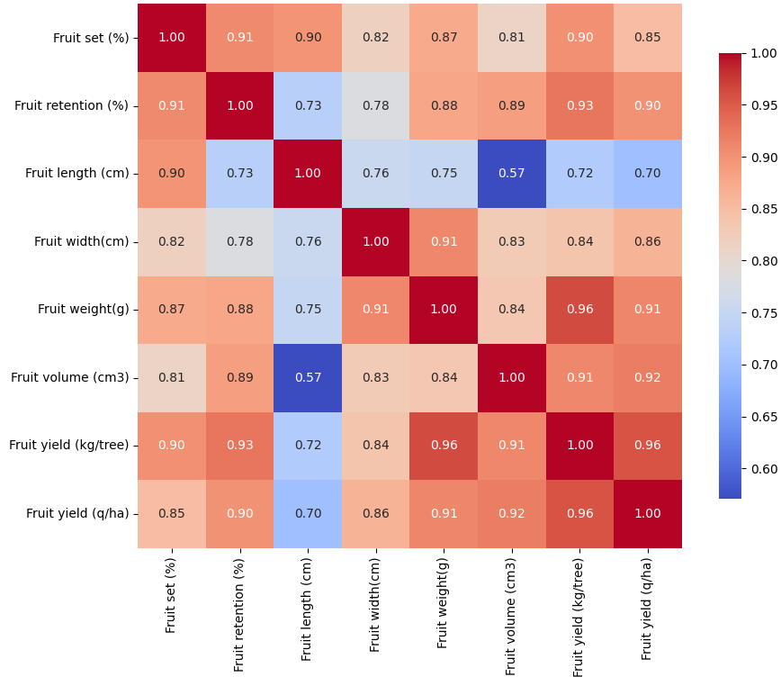
Fig. 2: Pearson Correlation Matrix of Fruit traits and Yields

