Sensitivity to Lippia alba (Mill.) NE Br essential oil of two Aspergillus flavus strains isolated from peanut seeds (Arachis hypogaea L.) collected from two agroecological zones in Senegal
ABSTRACT
Aspergillus flavus is most often associated with acute or chronic aflatoxicosis due to its ability to produce aflatoxin. These recent years, many studies have been conducted to identify biopesticides able to mitigate the aflatoxinogenic strains in soils and crops. Then, essential oils naturally contain various bioactive molecules whose antifungal properties offer promising prospects for mitigating the dangers posed by aflatoxins. This study aims to determine the chemical composition of Lippia alba essential oil and to assess its effectiveness on 2 strains of A. flavus isolated from peanut seeds in Senegal. Chemical analysis by GC-MS of the essential oil (EO) of Lippia alba revealed more oxygenated monoterpenes (84.3%) than hydrocarbons (8.4%) and oxygenated (2.4%) sesquiterpenes. Neral (34.6%) and geranial (46.6%) were also identified as major and distinctive biochemical components present in the essential oil extracted from Lippia alba plants in Senegal. Furthermore, the biological activity of this EO, at three different doses (100, 500, and 1000 ppm), was more effective in inhibiting the mycelial growth of the two isolates of Aspergillus flavus (TN and V), compared to Azoxystrobin (Positive control). The inhibition rates recorded with the highest dose (1000 ppm) reached 91.4% on the TN isolate (Peanut Basin isolate) and 84.6% on the V isolate (Casamance isolate). In contrast, after 11 days of incubation, Azoxystrobin at 1000 ppm produced 34.3% and 66.9% inhibition rates, respectively, on the TN and V isolates. Due to their chemical composition, essential oils are positioned as an alternative to synthetic pesticides and in the fight against crop pests and mycotoxins. However, for the practical use of this EO as a fungicide, future research would need to include searching for a suitable carrier appropriate inert material, allowing the development of a biopesticide formula directly applicable to peanut seeds without any negative impact on their physico-chemical, functional, and organoleptic properties.

Keywords: essential oils; Aspergillus flavus; antifungal activity; aflatoxin; peanuts; Miller

INTRODUCTION
Lippia alba (Miller) N.E. Brown is an aromatic plant belonging to the Verbenaceae family. It mainly grows in South and Central American countries as well as in tropical African regions. “Lippia alba (Mill.) N. E. Brown is a plant mainly used in the form of infusions and decoctions of its leaves due to their sedative action. The pharmacological properties of L. alba as an anxiolytic, sedative and motor relaxant in rats started to draw attention as a possible anaesthetic for fish” (Kampke et al., 2018; Malik et al., 2021). Traditionally, plants of this species are used in various preparations as remedies for gastrointestinal and respiratory ailments, antimalarial, and antiviral treatments [3,4]. The leaves are sometimes used in food preservation [5]. These observations have led to several studies conducted on L. alba, which have highlighted interesting biological properties of its essential oil (EO), attributable to its various chemical constituents or extracts [1,6,7]. “The results for the composition of L. alba essential oils are invariably non-coincident, as has been seen in the literature. The distinct results described for the composition of L. alba oil may be associated with different environmental conditions for the plant production” (da Silva Junior et al., 2019). Indeed, the EO of L. alba exhibits different chemical chemotypes related to the part of the plant from which it is extracted and the specific characteristics of its origin area [1,6,8]. “Terpenic compounds (limonene, carvone, citral, β-caryophyllene, tagetenone, myrcene, γ-terpinene, camphor, 1,8-cineole, and estragole) are frequently identified in this essential oil composition” [1,8,9]. The antimicrobial activity of L. alba has been demonstrated against both human and plant fungal diseases. For example, the citral and myrcene-citral chemotypes showed a significant impact against fungal pathogens (Candida albicans, Trichophyton rubrum, and Fonsecaea pedrosoi) [7]. Furthermore, antifungal and anti-aflatoxin activities against Aspergillus flavus and Aspergillus parasiticus have been demonstrated, even at low treatment doses, with the citral and myrcene-citral chemotypes [6,14], as well as with the neral and geranial chemotypes [14,15]. This led us to carry out further investigations about the chemical components of the essential oil extracted from L. alba leaves collected in Senegal, and to test its efficacy against two A. flavus strains isolated from peanut seeds collected in two agroecological zones in this country.

MATERIAL AND METHODS

A. flavus strains
The Aspergillus flavus isolates used in this study were obtained at the Phytopathology and Weed Science Laboratory of the Directorate of Plant Protection (DPV) of Senegal, from peanut seeds collected in Taïba Niassène (isolate TN) and Velingara (isolate V) (Figure 1).
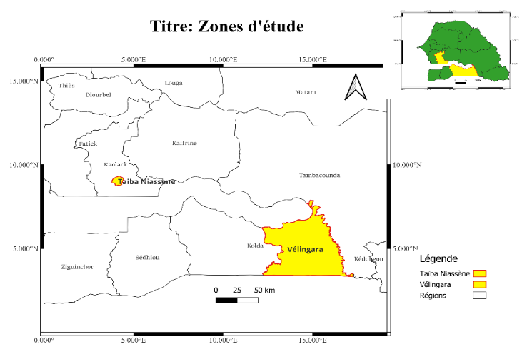

Figure 1. Peanut samples collection sites

On AFPA, V isolate appears fluffy white, producing many small black sclerotia whose density varies from the centre to the periphery of the colony (Plate 1). Isolate TN appears without sclerotia, with a powdery texture and a yellow colour that becomes light green at the colony edges (Plate 2). The growth rate of the TN isolate is faster than that V isolate, with an average diameter of 9 cm after 7 days of incubation. On the reverse side, both isolates are characterised by brown pigmentation, which is, however, more pronounced in the TN isolate (Plate 2). Isolate V is rather characterised by a radiating structure on the reverse side (Plate 1). Under the microscope, both isolates present a hyaline, non-septate conidiophore topped with uniseriate conidial heads producing globular and clear-looking conidia (Plates 1, 2).

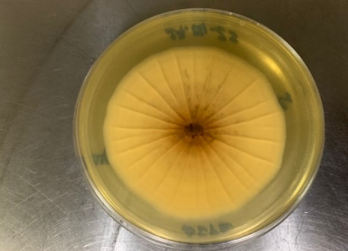
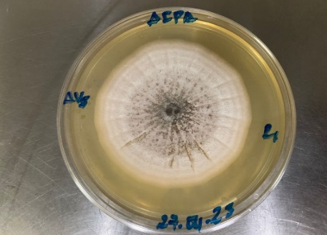
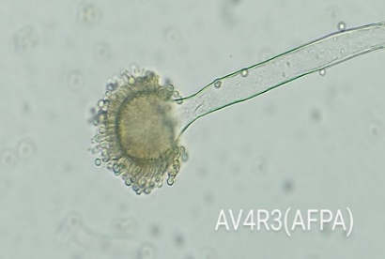

C
B
A
Plate 1. Macroscopic and microscopic aspects of the A. flavus V strain

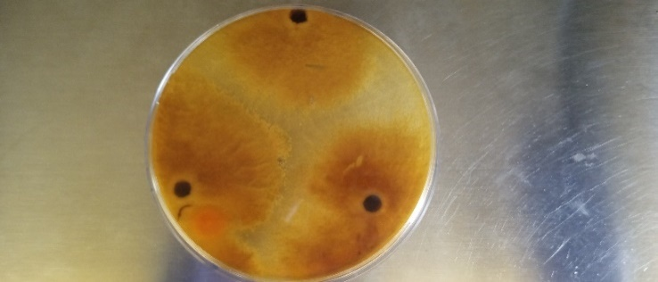
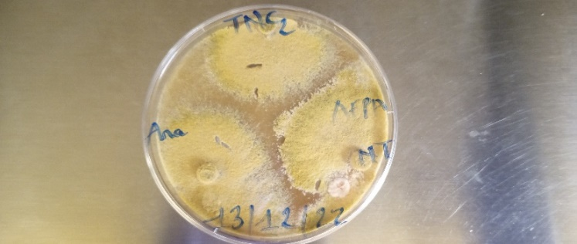
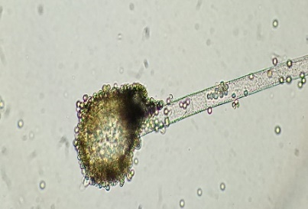

C
A
B
Plate 2. Macroscopic and microscopic aspects of the A. flavus TN strain

Plant material
The essential oil was extracted from Lippia alba leaves collected in Sindia (Thiès, Senegal) (Figure 2). The identification of the plant species was carried out at the Laboratory of the Fundamental Institute of Black Africa (IFAN) of Cheikh Anta Diop University of Dakar. “The leaves were air-dried for two weeks at room temperature and then subjected to hydrodistillation for 5 hours using a Clevenger-type apparatus according to the method recommended in the European Pharmacopoeia” [22]. The yield of essential oil obtained from the extraction was 1.7%.

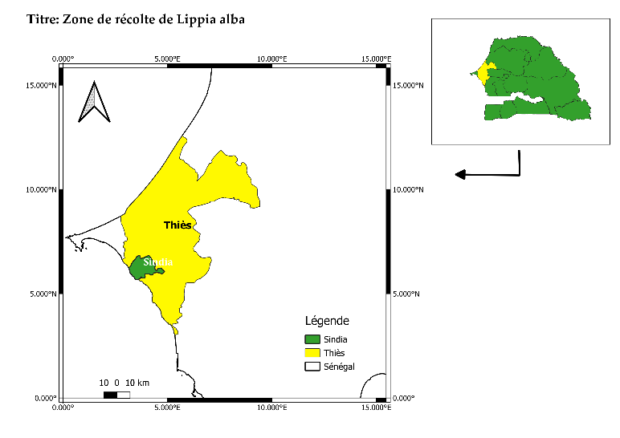

Figure 2. L. alba plant harvesting sites

Chemical composition
The chromatographic analyses were carried out using a Perkin-Elmer Autosystem XL GC apparatus (Waltham, MA, USA) equipped with a dual flame ionisation detection (FID) system and fused-silica capillary columns, namely Rtx-1 (polydimethylsiloxane) and Rtx-wax (poly-ethyleneglycol) (60 m × 0.22 mm i.d; film thickness 0.25 µm). The oven temperature was programmed from 60 to 230 ◦C at 2 ◦C/min and then held isothermally at 230 ◦C for 35 min: hydrogen was used as carrier gas (1 mL/min). The injector and detector temperatures were maintained at 280 ◦C, and samples were injected (0.2 µL of pure oil) in the split mode (1:50). The retention indices (RI) of the compounds were determined proportionally to the retention times of a series of n-alkanes (C5-C30) by linear interpolation using the equation of Van den Dool and Kratz (1963) via Perkin-Elmer software (TotalChrom navigator). “The relative proportions of the oil constituents were determined from the GC peak areas, without the use of correction factors. In addition, the samples were analyzed using a Perkin-Elmer Turbo mass detector (quadrupole) coupled with a Perkin-Elmer Autosystem XL, equipped with Rtx-1 and Rtx-Wax fused silica capillary columns. The oven temperature was programmed from 60 to 230°C at 2°C/min, then maintained isothermally at 230°C (35 min): hydrogen was used as the carrier gas (1 mL/min). The following chromatographic conditions were used: injection volume, 0.2 µL of pure oil; injector temperature, 280°C; fractionation, 1:80; ion source temperature, 150°C; ionization energy, 70 eV; MS(EI) acquired over the mass range 35-350 Da; scan speed, 1 s. The identification of the different components was based on (a) comparison of their GC retention indices (RI) on non-polar and polar columns, determined from the retention times of a series of n-alkanes with linear interpolation, with those of authentic compounds or data from the literature; (b) computer comparison with commercial mass spectrum libraries and comparison of the spectra with those in our personal library; and (c) comparison of RI and MS spectral data from authentic compounds or data from the literature” [23-25].

Treatments and incubation
The culture medium, based on potato dextrose agar (PDA), was prepared by dissolving 39 g of powder in 1 L of distilled water, then sterilizing at 121°C for 20 minutes. A volume of 1 ml of essential oil (EO) was taken and mixed with 1 ml of pure ethanol to facilitate its dissolution. The EO + ethanol mixture was then added at different concentrations (100, 500, and 1000 ppm) to 50 ml of PDA cooled to 50°C. The resulting solution was homogenized for 1 minute and distributed into three 9 cm diameter Petri dishes. Azoxystrobin at a dose of 1000 ppm and PDA + ethanol were used as positive and negative controls, respectively (Table 1). Discs 0.6 cm in diameter were taken from each fungal strain, aged 5 days on PDA, and placed in the center of the dishes containing the different culture media. All inoculated media were then placed in an incubator set at 25°C. In each Petri dish, the mycelial growth of A. flavus was monitored through daily measurements of the colony diameter using a graduated ruler. After 11 days of culture, the inhibition rate (IR) of the mycelial growth was calculated using the following formula:

IR (%)$=\frac{DT0-DT}{DT0}$

DT0 = colony diameter in the negative control; DT = colony diameter in the treated medium.

Table 1. Overview of the tested treatments

Traitement code | Isolates | Product | Dose (ppm) | Study Status
T0 | TN | PDA | - | Negative control
T1 | TN | EO L. alba | 100 | Tested
T2 | TN | EO L. alba | 500 | Tested
T3 | TN | EO L. alba | 1000 | Tested
T4 | TN | Azoxystrobin | 1000 | Positive control
T0’ | V | PDA | - | Negative control
T1’ | V | EO L. alba | 100 | Tested
T2’ | V | EO L. alba | 500 | Tested
T3’ | V | EO L. alba | 1000 | Tested
T4’ | V | Azoxystrobin | 1000 | Positive control

Statistical Analyses
The data for this study were stored in an Excel spreadsheet, which was also used for the graphical representations. Statistical analyses (analysis of variance, and the Student Newman-Keuls comparison of means) relating to the inhibition rate corresponding to the different treatment were performed at 5% threshold.

Results and discussion

Chemical composition of the essential oil
The essential oil yield obtained from the L. alba leaves was 1.7%. The chemical analysis of the essential oil reveals, quantitatively, 19 constituents (Table 2) representing qualitatively 96.4% of the total composition. These results showed mostly a citral chemotype composed of 46.6% geranial and 34.6% neral. Minor compounds were recorded in small proportions: trans-β-caryophyllene (4.2%), caryophyllene oxide (2%), isogeranial (1.2%), and limonene (0.7%) (Tablee’ 2).
This similar high proportion of citral was observed in several essential oils extracted from this species growing in ecologically different areas. Indeed, with a yield of 0.15%, the essential oil extracted from L. alba leaves growing in Brazil contained 33.32% neral and 50.94% geranial according to [19]. Similarly, high citral levels (60%) were found in essential oils extracted from the aerial parts of this plant harvested in autumn, growing in Argentina [1], and in winter in Brazil with some amounts of geraniol (9%) and myrcene (5%) [20]. In Côte d’Ivoire, the plant predominantly showed citral (45.86%) and geraniol (14%) [21]. However, other chemotype variants are obtained elsewhere. The γ-Terpinene chemotype (46%) with traces of p-cymene (9%) and β-caryophyllene (7%) have been reported from Brazil [22]. A high concentration of Limonene (34%-47%), piperitone (37%-24%), and 1,8-cineole (10%-13%) was obtained from leaves harvested in autumn in Argentina [23]. The essential oil obtained from Lippia alba leaves harvested during the fresh dry season in the commune of Niague-Tivaoune Peulh in Senegal was composed of almost equivalent proportions of limonene (37.5%) and citral (39.9%) [24].

Table 2: Chemical composition of the L. alba EO

Nª | Compounds | lRI^{b} | RIa^{c} | RIp^{d} | L. alba
1 | 6-methylhept-5-en-2-one | 963 | 963 | 1337 | 0.5
2 | Limonene | 1025 | 1022 | 1200 | 0.7
3 | (E)--Ocimene | 1041 | 1034 | 1247 | 0.1
4 | Linalol | 1086 | 1081 | 1544 | 0.5
5 | Citronellal | 1132 | 1131 | 1479 | 0.1
6 | Isogeranial | 1156 | 1159 | 1748 | 1.2
7 | Neral | 1215 | 1214 | 1679 | 34.6
8 | Geranial | 1244 | 1247 | 1731 | 46.6
9 | Geranyl acetate | 1362 | 1361 | 1752 | 1.3
10 | β-Elemene | 1389 | 1386 | 1589 | 0.5
11 | Trans-β-Caryophyllene | 1421 | 1417 | 1583 | 4.2
12 | -Guaiene | 1440 | 1440 | 1583 | 0.9
13 | Humulene | 1455 | 1450 | 1660 | 1.1
14 | γ-Muurolene | 1474 | 1470 | 1681 | 0.4
15 | Germacrene D | 1479 | 1476 | 1704 | 0.7
16 | α-Bulnesene | 1503 | 1494 | 1711 | 0.5
17 | Trans--bisabolene | 1530 | 1532 | 1753 | 0.1
18 | Caryophyllene oxide | 1570 | 1573 | 1959 | 2.0
19 | Humulene epoxyde 2 | 1602 | 1598 | 2044 | 0.4
 | Hydrocarbon monoterpenes |  |  |  | 0.8
 | Oxygenated monoterpenes |  |  |  | 84.3
 | Hydrocarbon sesquiterpenes |  |  |  | 8.4
 | Oxygenated sesquiterpenes |  |  |  | 2.4
 | Other compounds |  |  |  | 0.5
 | Total identified (%) |  |  |  | 96.4
 | Yields (w/w vs dry material) |  |  |  | 1.7
 | ª Order of elution is given on apolar column (Rtx-1).
 | ^{c} Retention indices on the apolar Rtx-1 column (RIa).
 | ^{d} Retention indices on the polar Rtx-Wax column (RIp).

Antifungal activity of Lippia alba EO
The results about mycelial growth inhibition revealed different sensitivity levels of the two A. flavus isolates to the L. alba EO, higher compared to Azoxystrobin. Consequently, the action of the EO was more pronounced on the TN isolate than on the V isolate, proportionally to the application doses (Plate 3). The statiscal analysis shows a highly significant difference (p < 0.000) between the 2 strains' radial growth inhibition rates. Indeed, with the low dose (T1 and T1’), the inhibition rate was 70.5% for the V isolate, whereas it reached 88.8% for the TN isolate. The same trend has been observed with the intermediate dose (T2 and T2’), in which were established at 80.2% and 91.4% the inhibition rates for the isolates V and TN, respectively. Similarly, the inhibition rate was stabilised at 91.4% for the TN isolate and increased for the V isolate up to 84.6% in the maximum dose of 1000 ppm (T3 and T3’). Furthermore, on the negative controls (T0 and T0’), they showed a rapid mycelial growth, covering the entire surface of the Petri dishes within 72 hours. On the positive controls T4 and T4’ (Azoxystrobin), the recorded inhibition rates were respectively 34.3% and 66.9% for the V and TN isolates, after 11 days of incubation.

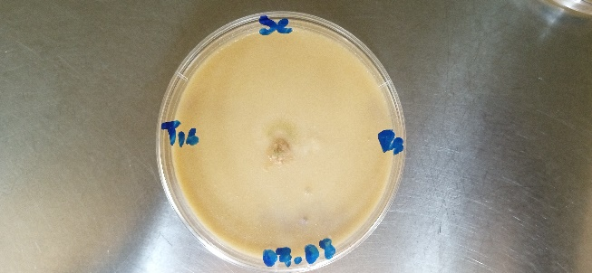
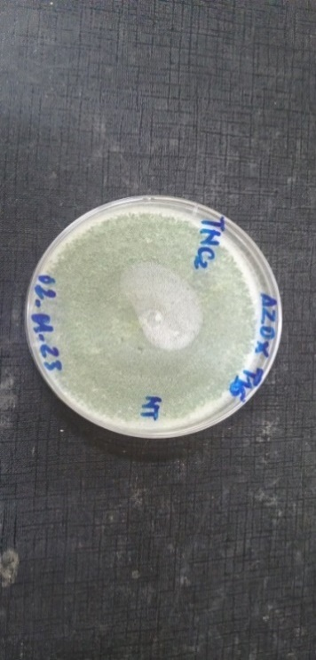
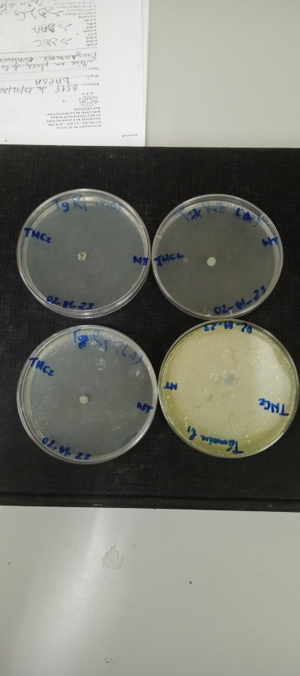
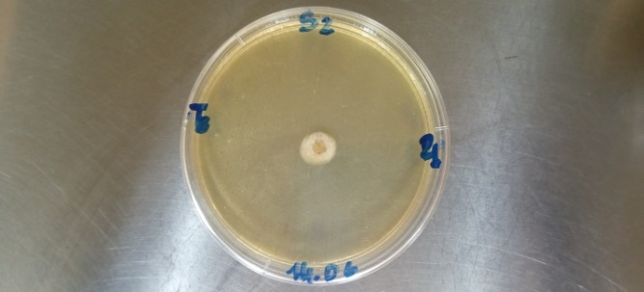
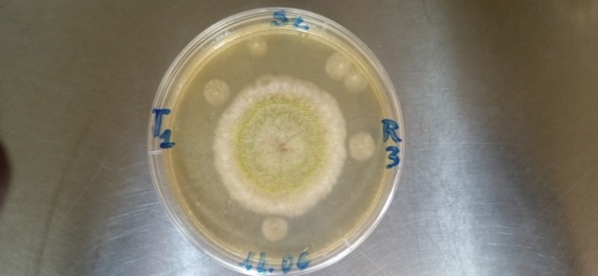
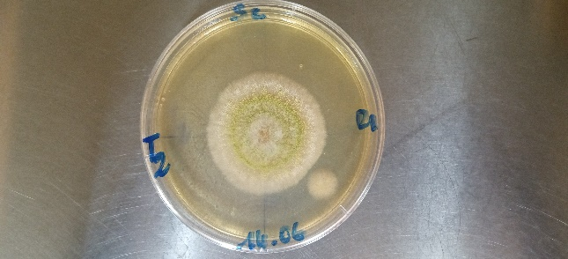
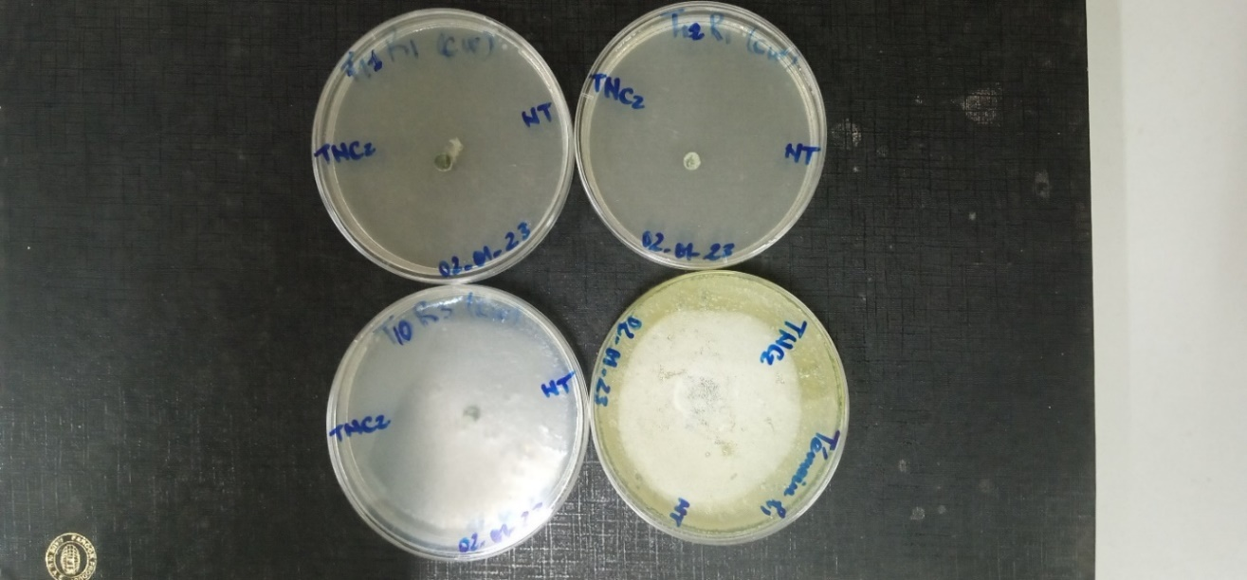
T 1
T 2
T 3
T 4
T 1’
T 2’
T 0’
T 0
T 3’
T 4’

Plate 3. Showing the different treatments impact on the mycelial growth of the V and TN strains

However, the radial growth inhibition showed a decreasing evolution in time, for all the treatments, except for the T2’ and T3’ (V on 500 & 1000 ppm EO) during 11 days of incubation. This decrease was found to be more pronounced for the TN strain than for the V one. Then, at the lowest dose T1 (100 ppm), the inhibition rate has fallen from 70.5% to 36.1% after 11 days of incubation. For the treatments T2, T3, and T4, the inhibition rates were stabilised at 47.47% at the 11th day. However, with the TN strain, the decrease began after 10 dayswith the lowest dose T1' (100 ppm) and reached 73.7% at the 11th day (Figure 3B).

B
A
Figure 3. Evolutionary tendencies of the v (A) & TN (B) A. flavus strains growth inhibition by L. alba EO during 11 days incubation

Table 3. Variation of the mycelial growth inhibition rates of the A. flavus V and TN strains depending to the media treatments.
Doses (ppm) | AV isolate |  | TN isolate
 | Inhibition Rate (%)¹ | Average Diameter (cm)¹ | Inhibition Rate (%)¹ | Average Diameter (cm)¹
100 (T1, T1’) | 70,5±18,2 | 3.9±0.02 | 88,8±7,4 | 2,1±0.02
500 (T2, T2’) | 80,2±16,2 | 2.2±0.001 | 91,4±5 | 0.8±0.001
1000 (T3 et T3’) | 84,6±14 | 2,7±0.22 | 91,4±5 | 0.8±0.001
1000 (Azoxystrobin) | 66,9±15,9 | 4.2±0.22 | 34,3±16 | 8.20±0.22

The bioactive properties of L. alba EO and its components have long been used for pharmacological, medicinal, aromatic, or cosmetic purposes [25–30]. Furthermore, many studies have shown biocidal effects of L. alba EO against stored-product insects [3], as well as against pathogenic microorganisms, bacteria (Escherichia coli, Listeria innocua, Listeria monocytogenes, Pseudomonas aeruginosa, Salmonella choleraesuis and Staphylococcus aureus) and fungi (Aspergillus flavus, A. glaucus, A. ochraceous, Colletotrichum gloeosporioides, A. niger, C. musae, and Fusarium oxysporum) [4,6,7,31]. Antifungal test results showed that L. alba EO possesses strong antifungal properties, particularly against Aspergillus flavus. It significantly reduces mycelial growth, with a much more remarkable effect on the TN isolate compared to the V isolate. This differential response may be due to the intrinsic properties of the microorganisms being tested on one hand, and the biological properties of the constituents of L. alba EO on the other. Composed mainly of Neral (34.6%) and Geranial (46.6%), L. alba EO has a remarkable effect against pathogenic microorganisms, especially fungi [5,8,19]. These results are consistent with those of Pandey et al. [15], who studied the efficacy of certain essential oils against the proliferation of Aspergillus flavus with a particular reference to the efficacy of L. alba EO. Likewise, Shukla et al. [9] demonstrated the effectiveness of L. alba (Mill.) NE Brown EO and its constituents against fungi isolated from certain edible legume seeds and the production of aflatoxin B1. According to their findings, geraniol (22.2%) and nerol (14.2%), as major components, showed remarkable antifungal effects against all fungal isolates with a low application dose of 1 μL/mL. Similarly, Pandey et al. [15] showed that “the application of a L. alba EO rich in geranial (36.9%) and neral (29.3%), and to a lesser extent in myrcene (18.6%) in the storage system, significantly inhibited fungal proliferation and aflatoxin production without affecting the seed germination rate”. A strong effectiveness of L. alba EO against Gram-positive and Gram-negative bacterial species was observed with the following concentrations: 50%, 25%, 6.25%, 3%, 1.5%, 0.8%, 0.4%, and 0.2%) [15]. Due to its heterogeneous composition and the antimicrobial activity of most of its components, it seems unlikely that there is a single mechanism of action or that a single constituent is responsible for this high antimicrobial activity [11,32,33]. Indeed, according to Guinoiseau et al. [34] and Caballero-Gallardo et al. [3], limonene is a component of L. alba EO with an isopropyl group at position 4 that exhibits remarkable biological activity. Additionally, the synergistic effect of caryophyllene oxide on the efficacy of this EO has been reported by Gimenes et al. [35,36]. Furthermore, the sensitivity between the two isolates to L. alba EO could explain this observed difference in efficacy. Indeed, the membrane properties of microorganisms appear to provide some resistance to toxic agents [34]. However, this barrier shows some vulnerability with the increase in the application dose of the treatment product, as demonstrated by Escobar et al. [31] and Gimenes et al. [35]. Several studies indicate that the toxicity of EO toward microorganisms is associated with the lipophilic nature and low molecular weight of its constituents. This allows the EO to quickly cross cell membranes, causing changes in their conformation and functions, thereby increasing their permeability [33,37]. Furthermore, the particularity between the two isolates is mainly characterised by the production of sclerotia by V strain, which could justify the reduced effectiveness of different doses of L. alba EO on the latter. Indeed, the secretion of hydrolytic enzymes [38–40] and the production of sclerotia (survival structures) [41–43] thus confer certain strains of Aspergillus flavus high virulence and resistance. Furthermore, the relationship between aflatoxin production, the sclerotial phenotype, and the degree of resistance has been reported by Escobar et al. [31] and Gao et al. [44].

CONCLUSION
The study showed that the L. alba EO (geranial 46.6% and neral 34.6%) has a high antifungal activity against both isolates of Aspergillus flavus. However, it appears to be less effective on the isolate from Casamance (V) than on the one from the Peanut Basin (TN), showing respectively 84.6% and 91.4% of mycelial growth inhibition rates on the highest dose (1000 ppm) tested. Thus, L. alba EO could be used safely to protect peanuts against the fungus A. flavus. The use of essential oils is a promising method, avoiding synthetic chemical fungicides and offering a new approach to managing mycotoxin-producing fungi. However, for the practical use of this EO as a fungicide, future research would need to include searching for a suitable carrier appropriate inert material, allowing the development of a biopesticide formula directly applicable to peanut seeds without any negative impact on their physico-chemical, functional, and organoleptic properties.

Disclaimer (Artificial intelligence)
Option 1:
Author(s) hereby declare that NO generative AI technologies such as Large Language Models (ChatGPT, COPILOT, etc.) and text-to-image generators have been used during the writing or editing of this manuscript.
Option 2:
Author(s) hereby declare that generative AI technologies such as Large Language Models, etc. have been used during the writing or editing of manuscripts. This explanation will include the name, version, model, and source of the generative AI technology and as well as all input prompts provided to the generative AI technology
Details of the AI usage are given below:
1.
2.
3.

References
1. Hennebelle T, Sahpaz S, Dermont C, Joseph H, Bailleul F. The Essential Oil ofLippia alba: Analysis of Samples from French Overseas Departments and Review of Previous Works. C&B. 2006 Oct;3(10):1116–25.
2. de Albuquerque Lima T, de Queiroz Baptista NM, de Oliveira APS, da Silva PA, de Gusmão NB, dos Santos Correia MT, Napoleão TH, da Silva MV, Paiva PMG. Insecticidal activity of a chemotype VI essential oil from Lippia alba leaves collected at Caatinga and the major compound (1,8-cineole) against Nasutitermes corniger and Sitophilus zeamais. Pesticide Biochemistry and Physiology. 2021 Aug 1;177:104901.
3. Caballero-Gallardo K, Fuentes-Lopez K, Stashenko EE, Olivero-Verbel J. Chemical Composition, Repellent Action, and Toxicity of Essential Oils from Lippia origanoide, Lippia. alba Chemotypes, and Pogostemon cablin on Adults of Ulomoides dermestoides (Coleoptera: Tenebrionidae). Insects. 2022 Dec 31;14(1):41.
4. Glamočlija J, Soković M, Teević V, Linde GA, Colauto NB. Chemical characterization of Lippia alba essential oil: an alternative to control green molds. Braz J Microbiol. 2011 Dec;42(4):1537–46.
5. Mutlu-Ingok A, Devecioglu D, Dikmetas DN, Karbancioglu-Guler F, Capanoglu E. Antibacterial, Antifungal, Antimycotoxigenic, and Antioxidant Activities of Essential Oils: An Updated Review. Molecules. 2020 Oct 14;25(20):4711.
6. Mesa-Arango AC, Montiel-Ramos J, Zapata B, Durán C, Betancur-Galvis L, Stashenko E. Citral and carvone chemotypes from the essential oils of Colombian Lippia alba (Mill.) N.E. Brown: composition, cytotoxicity and antifungal activity. Mem Inst Oswaldo Cruz. 2009 Sep;104(6):878–84.
7. Sales G, Medeiros S, Soares I, Sampaio T, Bandeira M, Nogueira N, Queiroz M. Antifungal and Modulatory Activity of Lemon Balm (Lippia alba (MILL.) N. E. BROWN) Essential Oil. Sci Pharm. 2022 May 11;90(2):31.
8. Santos Filho LGAD, Reis RBD, Souza ASQ, Canuto KM, Brito ESD, Castro KNC, Pereira AML, Diniz FM. Chemical composition and biological activities of the essential oils from Lippia alba and Lippia origanoides. An Acad Bras Ciênc. 2023;95(1):e20220359.
9. Shukla R, Kumar A, Singh P, Dubey NK. Efficacy of Lippia alba (Mill.) N.E. Brown essential oil and its monoterpene aldehyde constituents against fungi isolated from some edible legume seeds and aflatoxin B1 production. International Journal of Food Microbiology. 2009 Oct 31;135(2):165–70.
10. Quintero WL, Moreno EM, Pinto SML, Sanabria SM, Stashenko E, García LT. Immunomodulatory, trypanocide, and antioxidant properties of essential oil fractions of Lippia alba (Verbenaceae). BMC Complement Med Ther. 2021 Dec;21(1):187.
11. Porfírio EM, Melo HM, Pereira AMG, Cavalcante TTA, Gomes GA, Carvalho MGD, Costa RA, Júnior FEAC. In Vitro Antibacterial and Antibiofilm Activity of Lippia alba Essential Oil, Citral, and Carvone against Staphylococcus aureus. The Scientific World Journal. 2017;2017:1–7.
12. Mesa-Arango AC, Montiel-Ramos J, Zapata B, Durán C, Betancur-Galvis L, Stashenko E. Citral and carvone chemotypes from the essential oils of Colombian Lippia alba (Mill.) N.E. Brown: composition, cytotoxicity and antifungal activity. Mem Inst Oswaldo Cruz. 2009 Sep;104(6):878–84.
13. Santos N, Pascon R, Vallim M, Figueiredo C, Soares M, Lago J, Sartorelli P. Cytotoxic and Antimicrobial Constituents from the Essential Oil of Lippia alba (Verbenaceae). Medicines. 2016 Aug 12;3(3):22.
14. Tang X, Shao YL, Tang YJ, Zhou WW. Antifungal Activity of Essential Oil Compounds (Geraniol and Citral) and Inhibitory Mechanisms on Grain Pathogens (Aspergillus flavus and Aspergillus ochraceus). Molecules. 2018 Aug 22;23(9):2108.
15. Pandey AK, Sonker N, Singh P. Efficacy of Some Essential Oils Against Aspergillus flavus with Special Reference to Lippia alba Oil an Inhibitor of Fungal Proliferation and Aflatoxin B ₁ Production in Green Gram Seeds during Storage: Efficacy of some essential oils…. Journal of Food Science. 2016 Apr;81(4):M928–34.
16. Joulain D, König WA. The atlas of spectral data of sesquiterpene hydrocarbons. EB-Verlag; 1998.
17. Adams RP, others. Identification of essential oil components by gas chromatography/mass spectrometry. [Internet]. Allured publishing corporation; 2007 [cited 2017 Mar 13]. Available from: https://www.cabdirect.org/cabdirect/abstract/20083116584
18. NIST (National Institute of Standards and Technology) N. PC Version of the NIST/EPA/NIH Mass Spectra Library [Internet]. 2008 [cited 2016 Jul 4]. Available from: http://www.nist.gov/srd/nist1a.cfm
19. Glamočlija J, Soković M, Teević V, Linde GA, Colauto NB. Chemical characterization of Lippia alba essential oil: an alternative to control green molds. Braz J Microbiol. 2011 Dec;42(4):1537–46.
20. Tavares E, Julião L, Lopes D, Bizzo H, Lage C, Leitão S. Análise do óleo essencial de folhas de três quimiotipos de Lippia alba (Mill.) NE Br.(Verbenaceae) cultivados em condições semelhantes. Revista Brasileira de Farmacognosia. 2005;15:1–5.
21. Coulibaly FH, Rossignol M, Haddad M, Carrasco D, Azokou A, Valente A, Ginibre C, Koné MW, Chandre F. Biological effects of Lippia alba essential oil against Anopheles gambiae and Aedes aegypti [Internet]. In Review; 2023 Oct [cited 2024 Jan 18]. Available from: https://www.researchsquare.com/article/rs-3483590/v1
22. Gomes AF, Almeida MP, Leite MF, Schwaiger S, Stuppner H, Halabalaki M, Amaral JG, David JM. Seasonal variation in the chemical composition of two chemotypes of Lippia alba. Food Chemistry. 2019 Feb;273:186–93.
23. Hennebelle T, Sahpaz S, Dermont C, Joseph H, Bailleul F. The Essential Oil ofLippia alba: Analysis of Samples from French Overseas Departments and Review of Previous Works. C&B. 2006 Oct;3(10):1116–25.
24. Defat L. Travail de fin d’études: “Etude d¿une formulation insecticide composée d¿huile essentielle de Lippia alba et d¿argiles locales sénégalaises contre Sitophilus zeamaïs (curculionidae).” 2023;
25. García-Barriga H. Plantas Medicinales de Colombia. null, editor. 1974. 506 p. (null; vol. null).
26. Meskaoui AE, Bousta D, Dahchour A, Harki EH, Farah A, Ennabili A. PLANTES MEDICINALES ET AROMATIQUES MAROCAINES : OPPORTUNITES ET DÉFIS. 2008;
27. Cormier-Salem MC, Roussel B. Localiser les produits et valoriser les spécialités locales: Une dynamique générale et foisonnante. Autrepart. 2009 Jun 1;n° 50(2):3–15.
28. Festy D. Huiles essentielles: le guide visuel. Paris: Quotidien malin éd; 2014.
29. Bersan SM, Galvão LC, Goes VF, Sartoratto A, Figueira GM, Rehder VL, Alencar SM, Duarte RM, Rosalen PL, Duarte MC. Action of essential oils from Brazilian native and exotic medicinal species on oral biofilms. BMC Complement Altern Med. 2014 Dec;14(1):451.
30. Sissinto Adjovi YC, Joli Fossou P, Tahirou A, Ulrich Ahehehinnou H. Evaluation De L’utilisation Des Huiles Essentielles De Six Plantes Aromatiques Collectées Au Benin Dans La Lutte Alternative Contre Les Aflatoxins. ESJ. 2022 Mar 31;18(11):207.
31. Escobar P, Milena Leal S, Herrera LV, Martinez JR, Stashenko E. Chemical composition and antiprotozoal activities of Colombian Lippia spp essential oils and their major components. Mem Inst Oswaldo Cruz. 2010 Mar;105(2):184–90.
32. Carson CF, Mee BJ, Riley TV. Mechanism of Action of Melaleuca alternifolia (Tea Tree) Oil on Staphylococcus aureus Determined by Time-Kill, Lysis, Leakage, and Salt Tolerance Assays and Electron Microscopy. Antimicrob Agents Chemother. 2002 Jun;46(6):1914–20.
33. Oussalah M. L’effet antimicrobien des films biodégradables à base d’huiles essentielles et le mécanisme d’action de trois huiles essentielles sur des bactéries Grampositif et Gram-négatif. 2006.
34. Guinoiseau E. Molécules antibactériennes issues d’huiles essentielles: séparation, identification et mode d’action. 2010;
35. Gimenes L, Silva JCRL, Facanali R, Hantao LW, Siqueira WJ, Marques MOM. Essential Oils of New Lippia alba Genotypes Analyzed by Flow-Modulated Comprehensive Two-Dimensional Gas Chromatography (GC×GC) and Chemometric Analysis. Molecules. 2021 Apr 16;26(8):2332.
36. Sá Filho JCF de, Nizio DA de C, Oliveira AMS de, Alves MF, Oliveira RC de, Luz JMQ, Nogueira PC de L, Arrigoni-Blank M de F, Blank AF. Geographic location and seasonality affect the chemical composition of essential oils of Lippia alba accessions. Industrial Crops and Products. 2022 Nov 15;188:115602.
37. Bhavaniramya S, Vishnupriya S, Al-Aboody MS, Vijayakumar R, Baskaran D. Role of essential oils in food safety: Antimicrobial and antioxidant applications. Grain & Oil Science and Technology. 2019 Jun;2(2):49–55.
38. Karimi-Avargani M, Bazooyar F, Biria D, Zamani A, Skrifvars M. The special effect of the Aspergillus flavus and its enzymes on biological degradation of the intact polylactic acid (PLA) and PLA-Jute composite. Polymer Degradation and Stability. 2020 Sep 1;179:109295.
39. Mellon JE, Cotty PJ, Dowd MK. Aspergillus flavus hydrolases: their roles in pathogenesis and substrate utilization. Applied Microbiology and Biotechnology. 2007 Dec 1;77(3):497–504.
40. Ningthoujam R, Jangid P, Dhingra HK. Production of Hydrolytic Cellulase Enzyme by Isolate Aspergillus flavus OR and Trichoderma reseei Using Rice Straw as the Feedstock Material. 2022;
41. Barros G, Torres A, Chulze S. Aspergillus flavus population isolated from soil of Argentina’s peanut-growing region. Sclerotia production and toxigenic profile. J Sci Food Agric. 2005 Nov;85(14):2349–53.
42. Senghor AL, Ortega-Beltran A, Atehnkeng J, Jarju P, Cotty PJ, Bandyopadhyay R. Aflasafe SN01 is the First Biocontrol Product Approved for Aflatoxin Mitigation in Two Nations, Senegal and The Gambia. Plant Disease. 2021 May 1;105(5):1461–73.
43. Geiser DM, Dorner JW, Horn BW, Taylor JW. The Phylogenetics of Mycotoxin and Sclerotium Production in Aspergillus flavus and Aspergillus oryzae. Fungal Genetics and Biology. 2000 Dec 1;31(3):169–79.
44. Gao J, Liu Z, Yu J. Identification of Aspergillus section Flavi in maize in northeastern China. Mycopathologia. 2007 Aug 1;164(2):91–5.
45. Kampke, E. H., de Souza Barroso, M. E., Marques, F. M., Fronza, M., Scherer, R., Lemos, M. F., ... & Gomes, L. C. (2018). Genotoxic effect of Lippia alba (Mill.) NE Brown essential oil on fish (Oreochromis niloticus) and mammal (Mus musculus). Environmental Toxicology and Pharmacology, 59, 163-171. 46. Malik, S., Odeyemi, S., Pereira, G. C., Freitas Jr, L. M. D., Abdul-Hamid, H., Atabaki, N., ... & Abiri, R. (2021). New insights into the biotechnology and therapeutic potential of Lippia alba (Mill.) NE Br. ex P. Wilson. Journal of Essential Oil Research, 33(6), 523-535.

47. da Silva Junior, A. Q., da Silva, D. S., Figueiredo, P. L. B., Sarrazin, S. L. F., Bouillet, L. E. M., de Oliveira, R. B., ... & Mourao, R. H. V. (2019). Seasonal and circadian evaluation of a citral-chemotype from Lippia alba essential oil displaying antibacterial activity. Biochemical Systematics and Ecology, 85, 35-42.

