Soil Quality Assessment under Open-Cast Coal Mining in the Gayatri Coal Mines, Surajpur, Chhattisgarh, India

Abstract
Open-cast coal extraction has rapidly expanded across central India, yet its influence on the fundamental properties of soils in many active mining belts remains poorly documented. The present investigation examines how continued mining activity has altered the chemical balance, nutrient availability, and general soil condition in the Gayatri Coalfield of Surajpur District, Chhattisgarh. Sixteen samples were taken from two depth intervals (15–30 cm and 30–50 cm) at varying distances from the mine and compared with soils from nearby agricultural land used as a control. Laboratory analysis of pH, electrical conductivity, organic carbon, major nutrients (N, P, K, S), and micronutrients (Zn, B, Fe, Mn, Cu) revealed clear patterns of disturbance. Soils close to the mining zone were distinctly more acidic, showed marked losses of organic carbon and nitrogen, and displayed irregular micronutrient levels, while the control soils maintained near-neutral pH and higher organic matter. Increased concentrations of iron and manganese near the mine point to metal release triggered by geological exposure and surface oxidation. These findings demonstrate that open-cast mining has substantially weakened soil fertility in the region and emphasize the need for restoration programmes that combine organic inputs, microbial activity enhancement, and sustained environmental monitoring.
Keywords: open-cast mining, soil fertility, nutrient depletion, heavy metals, reclamation,

1. Introduction

Coal extraction, particularly through open-cast methods, has long been recognized as a major driver of ecological disturbance because it removes vegetation cover along with the upper, nutrient-rich layers of soil that support natural fertility (Ghose, 2004; Ram & Masto, 2010). Once these layers are stripped away, the soil loses much of its structural cohesion, and its physical as well as chemical properties begin to deteriorate. This disturbance is often expressed through a steady loss of organic carbon, disruption of nutrient cycling processes, and a marked reduction in microbial abundance and enzyme activity factors that are essential for maintaining healthy and productive soils. Furthermore, when deeper mineral-bearing strata are exposed, they undergo rapid oxidation, which increases soil acidity and promotes the release and movement of trace metals. These processes, in combination, create harsh soil conditions that can remain long after mining stops, often leaving the land acidic, biologically weak, and largely unproductive. In India, several restoration practices—such as adding organic inputs, planting native species, and reconstructing soil profiles have been applied to counteract the impacts of open-cast mining (Mukhopadhyay et al., 2014; Tripathi et al., 2016). Although useful, these interventions frequently fall short of their full potential, largely because of irregular implementation, insufficient monitoring, and inconsistent management. The Gayatri Coal Mining area in Surajpur District, Chhattisgarh, is a clear example of these challenges; extensive extraction activities have transformed formerly fertile agricultural land into degraded mine spoil. Despite this transformation, detailed scientific assessments of soil quality in this region remain scarce. In light of this gap, the present study aims to (i) examine the physico-chemical behaviour of soils across the Gayatri mining landscape, (ii) compare the condition of mined soils with that of nearby agricultural fields, and (iii) evaluate the degree of degradation so that appropriate strategies for reclamation and long-term soil restoration can be proposed for sustainable land use in the post-mining environment.

2. Materials and Methods

2.1 Study Area
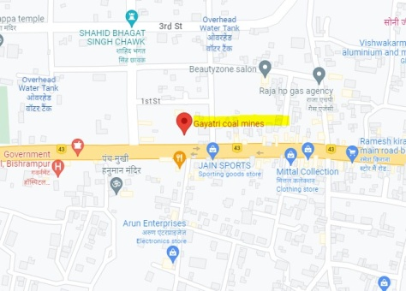
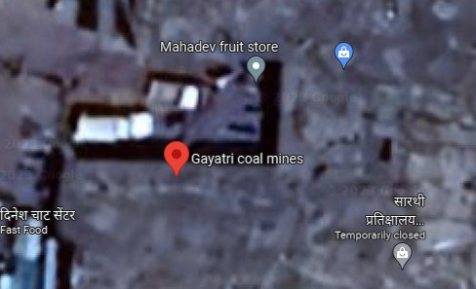
The Gayatri Coal Mine (23.1097°N, 82.9051°E) is an open-cast project operated by South Eastern Coalfields Limited (SECL) in Surajpur District, Chhattisgarh. The region is characterized by tropical climatic conditions and red-yellow soils derived from Gondwana sedimentary rocks. These soils, classified into Kanhar, Matasi, Dorsa, and Bhata subtypes, are inherently low in fertility and organic matter (Dewangan et al., 2025).

Figure 1: Gayatri Open-Cast Coal Mine, Chhattisgarh (GPS: 23.109945°N, 82.905101°E).

2.2 Sampling Design
Soil samples were collected during February–March 2025 from three directions (north, east, west) at distances of 2 km and 3 km from the mine. Control samples were taken from agricultural lands located 5–6 km south of the mining area. Each location was sampled at two depths: 15–30 cm and 30–50 cm.

Table 1. Soil sampling details from Gayatri Coal Mining Area
Sample ID | Area Type | Direction | Depth (cm) | Distance from Mine (km)
S1–S4 | Mining Area (North) | North | 15–50 | 2–3
S5–S8 | Mining Area (West) | West | 15–50 | 2–3
S9–S12 | Mining Area (East) | East | 15–50 | 2–3
S13–S16 | Control (Agriculture) | South | 15–50 | 5–6

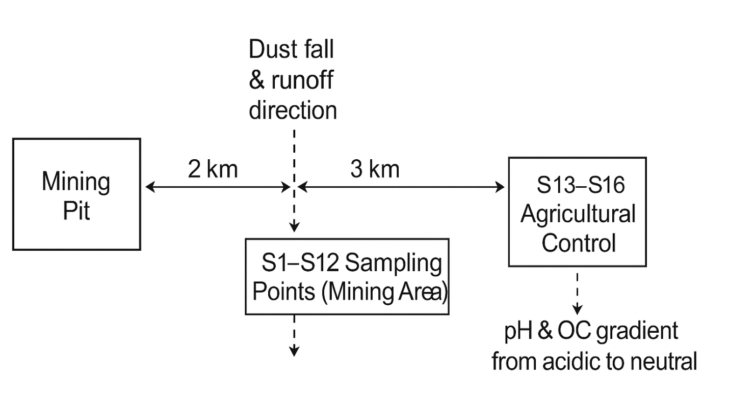

Figure 2. Conceptual diagram of soil sampling layout and impact zones

2.3 Analytical Methods

The present study was conducted in the Gayatri Coal Mining Area (23.1097° N, 82.9051° E), an extensive open-cast mining site operated by South Eastern Coalfields Limited (SECL) in the Surguja District of Chhattisgarh, India. The mine spans approximately 616.96 hectares and encompasses the villages of Getra, Jobga, and Pondi, representing one of the major coal extraction zones in the region. The landscape is geologically underlain by Gondwana sedimentary formations, which give rise to red and yellow soil types. These soils are naturally low in fertility and are classified into four subtypes Kanhar, Matasi, Dorsa, and Bhata based on differences in texture, drainage capacity, and organic matter content. Mining operations have further intensified the inherent infertility of these soils by stripping surface layers, clearing vegetation, and exposing subsurface materials to oxidation. Such disturbances have caused substantial declines in organic matter and total nitrogen, accompanied by increased soil acidity and enhanced mobility of heavy metals, thereby accelerating soil degradation (Dewangan et al., 2025). To assess the extent of this degradation, soil sampling was undertaken between February and March 2025 during the dry season, a period selected to minimize variability associated with fluctuating moisture levels. Samples were collected from three cardinal directions north, east, and west at distances of 2 km and 3 km from the mine boundary, representing gradients of mining influence. At each sampling point, soils were sampled at two depths: 15–30 cm (surface layer) and 30–50 cm (subsurface layer). Control samples were collected from agricultural fields located 5–6 km south of the mining area, where no direct mining disturbance occurs. These control sites were chosen for their comparable topography and land-use history, enabling a reliable assessment of mining-induced changes in soil characteristics. Detailed site coordinates and sampling information are presented in Table 3. All collected samples were analyzed using standard soil analytical procedures. Soil pH was measured with a calibrated pH meter, while electrical conductivity (EC) was determined using a conductivity meter to estimate soluble salt content. Organic carbon (OC) was quantified using the Walkley–Black wet oxidation method, and total nitrogen (N) was determined via Kjeldahl digestion. Available phosphorus (P) was measured using Bray’s extraction followed by spectrophotometric analysis, and potassium (K) was quantified using a flame photometer. Sulphur (S) content was assessed spectrophotometrically, whereas micronutrients zinc (Zn), iron (Fe), manganese (Mn), and copper (Cu) were analyzed using Atomic Absorption Spectroscopy (AAS). Boron (B) was estimated spectrophotometrically following established standard methods (Dewangan et al., 2025; Ahirwal et al., 2016). Advanced statistical analyses, including one-way ANOVA, were performed to evaluate spatial variations among mining zones, soil depths, and control sites. This comprehensive comparative assessment provides critical insights into the extent of soil fertility loss, nutrient depletion, and trace metal accumulation associated with open-cast coal mining, offering a scientific foundation for future reclamation and sustainable soil management strategies in the Gayatri mining region

3. Results and Discussion

3.1 Patterns in Soil Quality Across the Study Sites
The soil samples collected from the mining zone (S1–S12) and the undisturbed control locations (S13–S16) showed clear contrasts in several physico-chemical attributes. In the mining area, organic carbon and total nitrogen were noticeably lower, while the soils also tended to be slightly more acidic. These shifts were apparent even before statistical testing and reflect the loss of vegetative cover and the extensive removal of topsoil that typically accompany opencast mining.

Table 2. Soil Sampling Sites and Group Classification
Sample ID | Group | Notes
S1–S12 | Mining | Samples collected from 2–3 km from mine boundary in N, E, W directions at 15–30 cm and 30–50 cm depths
S13–S16 | Control | Agricultural fields located 5–6 km south of the mining zone

3.2 Soil Acidity and Conductivity
Soil pH varied from 5.28 to 6.84 across the study sites (Table 2). Mining zones, particularly in northern and eastern directions, were more acidic, whereas western and control soils were slightly alkaline. Acidification likely results from oxidation of pyrite minerals and depletion of base cations (Makdoh&Kayang, 2015). Electrical conductivity ranged between 0.11–0.97 dS/m, indicating non-saline conditions but reflecting mineral leaching processes.

3.3 Organic Carbon and Macronutrients
Organic carbon (OC) was lowest (0.10%) in soils closest to the mine and exceeded 1.0% in agricultural soils. Nitrogen levels ranged from 25–150 kg/ha, confirming nutrient loss due to topsoil removal and reduced microbial biomass (Adeli et al., 2019). Phosphorus was higher in control soils due to fertilization, while potassium showed irregular distribution (140–343 kg/ha), reflecting K-bearing mineral weathering. Sulfur content was relatively uniform, indicating minimal secondary pollution.

3.4 Micronutrient and Heavy Metal Distribution
Mining soils showed elevated Fe, Mn, and Cu concentrations (up to 17.9 ppm Fe and 16.8 ppm Mn) due to geological exposure and coal dust deposition (Roy & Mukherjee, 2022). However, low pH and OC reduce metal bioavailability. Agricultural soils displayed balanced micronutrient profiles within safe agronomic limits, consistent with findings from similar coal mining regions (Wulandari et al., 2022).

Table 3. Summary of soil physico-chemical properties in mining and control sites
Parameter | Range (Mining) | Range (Control)
pH | 5.28 – 6.84 | 6.33 – 6.84
EC (dS/m) | 0.11 – 0.97 | 0.71 – 0.79
OC (%) | 0.10 – 0.97 | 1.20 – 1.35
N (kg/ha) | 25 – 87.8 | 137.9 – 150.7
P (kg/ha) | 140.0 – 343.9 | 208.3 – 281.4
K (kg/ha) | 156.8 – 343.9 | 208.3 – 239.2
S (kg/ha) | 21.4 – 29.5 | 22.6 – 27.6
Fe (ppm) | 8.3 – 17.9 | 8.4 – 14.9
Mn (ppm) | 11.3 – 19.5 | 12.2 – 16.5
Cu (ppm) | 0.42 – 2.48 | 0.47 – 0.91

3.5 ANOVA-Based Differences Between Mining and Control Sites
The one-way ANOVA confirmed that total nitrogen (N) differed sharply between the two groups (F = 10.20; p = 0.0065). Soils from the control area held substantially higher N values, underscoring the direct influence of vegetation, litter inputs, and intact topsoil layers on nitrogen preservation. This pattern is consistent with what is generally observed in disturbed landscapes, where nitrogen tends to decline early and recovers slowly due to the loss of organic inputs and microbial activity.Organic carbon (OC) showed a weaker but still meaningful contrast (p ≈ 0.08). Although the statistical significance was marginal, the overall decline in OC within the mining zone was clear. This drop is expected: once the biological surface layer is removed or thinned, carbon storage declines quickly and is not replenished unless vegetation is restored.Copper (Cu) and sulphur (S) displayed near-significant differences (p values slightly above 0.05). Mining samples showed wider fluctuations in Cu in particular, suggesting small pockets of metal enrichment where overburden or freshly exposed strata influence the surface soil. Soil pH also trended lower in the mining region (p ≈ 0.10), indicating mild acidification probably linked to exposure of sub-soil material and the oxidation of sulphide-bearing fragments.Parameters such as EC, P, K, Zn, B, Fe, and Mn did not show statistically significant differences between groups. Even though the ranges varied slightly, the numerical overlap was large enough that the differences were not strong in a statistical sense. Their spatial variability, however, still hints at subtle changes arising from excavation, deposition of loose material and altered drainage.

Table 4. Summary of ANOVA Results for Soil Physico-Chemical Parameters
S.No. | Parameter | F-value | p-value
 | pH | 3.02 | 0.104
 | EC | 2.35 | 0.147
 | Organic Carbon (OC) | 3.56 | 0.080
 | Total Nitrogen (N) | 10.20 | 0.0065
 | Phosphorus (P) | 2.06 | 0.174
 | Potassium (K) | 0.35 | 0.565
 | Sulphur (S) | 3.73 | 0.074
 | Zinc (Zn) | 0.40 | 0.539
 | Boron (B) | 0.03 | 0.867
 | Iron (Fe) | 0.15 | 0.708
 | Manganese (Mn) | 0.18 | 0.680
 | Copper (Cu) | 4.04 | 0.064

3.6 Multivariate Structure Shown by PCA
The PCA offered a complementary view of the dataset. The first two principal components captured a considerable share of the total variation and separated the samples largely along gradients of nutrient content and metal concentration. Scores of the control samples clustered tightly, which is expected for soils under steady management and stable vegetation cover. In contrast, the mining samples were scattered over a broader portion of the ordination space, reflecting the uneven nature of disturbance across the mining belt.Variables contributing strongly to PC1 included organic carbon, nitrogen, sulphur and copper. These parameters jointly define the primary axis of change between undisturbed and disturbed soils. PC2 was more strongly aligned with the metals (Fe, Mn, Zn) together with EC, suggesting that secondary variation arises from metal mobility, weathering processes and soluble salts.Taken together, the PCA patterns reinforce the ANOVA findings: the most consistent and ecologically important shift in the mining area is the combined reduction of organic matter and nitrogen, while metals and salts contribute to additional but less uniform variation.

3.7 Interpretation and Implications
The results paint a coherent picture of soil degradation associated with open-cast mining. The loss of organic carbon and nitrogen indicates that the biological engine of the soil—its capacity to cycle nutrients and support vegetation—has been weakened. Where mining exposes fresh mineral surfaces, trace elements may accumulate locally, giving rise to small pockets of metal enrichment. The modest increase in acidity in the disturbed zones further contributes to these changes.From a management perspective, these findings highlight the importance of restoring organic inputs early in the reclamation process. Measures such as topsoil re-application, incorporation of organic amendments and the establishment of fast-growing ground cover species can gradually rebuild soil structure and nutrient reserves. Without such interventions, recovery of soil fertility is likely to remain slow and uneven across the landscape.

4. Conclusion

The present study provides clear evidence that open-cast coal mining in the Gayatri region has significantly altered key soil properties that sustain ecosystem functioning. Organic carbon and total nitrogen showed the most noticeable declines in the mining zone, indicating substantial disruption of soil biological processes and reduced nutrient retention capacity. These shifts reflect the combined effects of topsoil removal, loss of vegetation cover, and exposure of mineral substrata during excavation. Although the remaining nutrients and micronutrients exhibited variable responses, their irregular distribution across mining sites highlights the heterogeneous nature of mining-induced disturbance. The multivariate analysis further distinguished the relatively stable control soils from the more scattered mining samples, illustrating the extent of spatial variability introduced by extraction activities. Overall, the findings underscore the need for site-specific reclamation strategies that prioritise organic matter restoration, vegetation re-establishment, and systematic soil amendment to support long-term recovery of mine-affected landscapes.

COMPETING INTERESTS DISCLAIMER:

Authors have declared that they have no known competing financial interests OR non-financial interests OR personal relationships that could have appeared to influence the work reported in this paper.

Disclaimer (Artificial intelligence)
Option 1:
Author(s) hereby declare that NO generative AI technologies such as Large Language Models (ChatGPT, COPILOT, etc.) and text-to-image generators have been used during the writing or editing of this manuscript.
Option 2:
Author(s) hereby declare that generative AI technologies such as Large Language Models, etc. have been used during the writing or editing of manuscripts. This explanation will include the name, version, model, and source of the generative AI technology and as well as all input prompts provided to the generative AI technology
Details of the AI usage are given below:
1.
2.
3.

References
- Ahirwal, J., & Maiti, S. K. (2016). Assessment of soil properties of different land uses generated due to surface coal mining activities in tropical Sal (Shorearobusta) forest, India. Catena, 140, 155–163. https://doi.org/10.1016/j.catena.2016.01.028
- Alekseenko, A. V., & Pankratov, D. A. (2025). Pollution of coal-mine soils: Global reference dataset and implications for soil remediation. Environmental Earth Sciences, 84, 211. https://doi.org/10.1007/s12665-025-12160-0
- Chakraborty, R., & Sengupta, S. (2024). Impact of opencast mining on soil physico-chemical properties: A case study from eastern India. International Journal of Environmental Engineering Science, 5(1), 20-32. https://doi.org/10.1000/ijees.2024.206
- Dewangan, S. K., Singh, S., & Preeti. (2025). Assessment of soil physico-chemical properties in Manpur, Chandrapur, and Pachira, District Surajpur, Chhattisgarh. International Journal of Scientific Research and Engineering Development, 8(2).
- Ghose, M. K. (2004). Effect of opencast mining on soil fertility. Journal of Scientific and Industrial Research, 63(12), 1006–1009.
- Kong, L., Yang, H., Wang, X., Chen, Y., & Zhang, J. (2023). Impact of ecological restoration on the physicochemical properties and microbial communities in abandoned open-pit coal mines. Scientific Reports, 13, 7342. https://doi.org/10.1038/s41598-023
- Masto, R. E., Sheik, S., Nehru, G., Selvi, V. A., George, J., & Ram, L. C. (2015). Assessment of environmental soil quality around SonepurBazari mine of Raniganj coalfield, India. Solid Earth, 6(3), 811–821. https://doi.org/10.5194/se-6-811-2015
- Mou, Y., Zhang, L., & Li, F. (2025). Evaluative potential for reclaimed mine soils under four restoration treatments: Soil organic carbon and total nitrogen accumulation. Sustainability, 17(13), 6130. https://doi.org/10.3390/su17136130
- Mukhopadhyay, S., Masto, R. E., Yadav, A., George, J., Ram, L. C., & Shukla, S. P. (2014). Soil quality index for evaluation of reclaimed mine soil. Sustainability, 6(9), 5557–5574. https://doi.org/10.3390/su6095557
- Pandey, B., Agrawal, M., & Singh, S. (2022). Ecological restoration of coal mine-degraded lands in dry tropical climate: What has been done and what needs to be done? Environmental Quality Management, 32(1), 7–25. https://doi.org/10.1002/tqem.21820 (year not martch)
- Pulikova, E. P., Ivanov, D. A., & Petrovsky, E. V. (2024). Soil physicochemical and microbial properties affect nitrogen cycling in technogenically transformed coal dump soils. Journal of Hazardous Materials, 433, 137123. https://doi.org/10.1016/j.jhazmat.2024.137123
- Roy, I., & Mukherjee, A. (2022). Physicochemical properties and bacterial population of mine spoils in an opencast coal mine area. Proceedings of the National Academy of Sciences, India Section B: Biological Sciences, 92(3), 581–588. https://doi.org/10.1007/s40011-021-01320-4
- Thakur, T. K., & Singh, K. (2025). Land degradation and ecological restoration in central India: A geospatial and machine-learning analysis of coal-mining impacts. Land Degradation & Development, 36(4), 1123-1138. https://doi.org/10.1002/ldr.70266
- Tripathi, N., Singh, R. S., &Chaulya, S. K. (2016). Ecological restoration of mined-out areas of dry tropical environment, India. Environmental Monitoring and Assessment, 188(11), 605. https://doi.org/10.1007/s10661-016-5612-9 (year not martch)
- Wang, Y., Fan, T., Lu, A., Fang, W., Zhao, Y., Chen, Y., Wang, S., & Wang, X. (2023). Soil microbe and physicochemical characteristics in tensile fracture zone caused by mining subsidence. Polish Journal of Environmental Studies, 32(3), 2361–2372. https://doi.org/10.15244/pjoes/162378
- Wulandari, D., Herika, D., Agus, C., Cheng, W., &Tawaraya, K. (2022). Soil chemical properties of opencast coal mining site in Indonesia and its effect on plant growth. Biodiversitas Journal of Biological Diversity, 23(1), 1–10. https://doi.org/10.13057/biodiv/d230101

