Original Research Article
Effects of fertilizer and soil type on the agro-morphological parameters of the sorghum-cowpea system in the semi-arid zone of Burkina Faso

Abstract
Degradation of cultivated soils limits agricultural productivity and soil fertility. In Burkina Faso, the effect of soil type variability on cropping systems remains poorly documented, deserving further investigation. This study tests the effect of soil variability on sorghum-cowpea cropping system agronomic performance, with and without NPK fertilization. Two soil types (Lixisols and Cambisols) were tested at two fertilization levels (0 and 100% NPK) in a greenhouse using a split-plot design in vegetation pots. The agromorphological parameters of sorghum and cowpea were evaluated. Cambisols improve sorghum and cowpea agronomic performance more than Lixisols. Adding 100% NPK stimulates cowpea production (+40% and +15% above-ground and root biomass, respectively). In sole crop, Cambisols also improve sorghum above-ground biomass compared to Lixisols (+13% and +4%, respectively). Our results show that the recommended 100 kg.ha⁻¹ of NPK mineral fertilizer dose is not conducive to good cowpea root biomasse in our sorghum-cowpea intercropping systems, as it is probably too high compared to the starter dose for cowpea in Lixisols. Thus, Cambisols could be a more competitive choice to obtain superior agronomic performance in terms of yield and crop quality (sorghum-cowpea).

Keywords : Soil type, Biomass component, Cropping system, sorghum, cowpea, Burkina Faso

- INTRODUCTION
Sorghum is among the most cultivated cereals crop in Sub-Saharan Africa. In Burkina Faso, sorghum is the leading cereal crop in terms of national production, accounting for at least 40% of the total area devoted to cereal cultivation (MAAH, 2020 ; DGESS/MARAH, 2023).
However, despite its importance, sorghum's average national yield is less than one ton per hectare (Dabat et al., 2012; Ganeme et al., 2021). This poses a major threat to production and food security. Several factors contribute to this low yield, including poor farming practices (Akpo et al., 2016), irregular rainfall (Sultan and Gaetani, 2016; IPCC, 2021), and declining soil fertility (Tittonell and Giller, 2013). Numerous studies have shown that most of Burkina Faso's agricultural soils are tropical ferruginous soils characterized by low organic matter content of generally less than 2% (Kissou et al., 2018; Bacyé et al., 2019).
Soil fertility is considered to be the primary biophysical constraint on crop productivity in this area (Ollabodé et al., 2022). These soils are characterized by a low content of organic matter, poor exchangeable bases, a deficiency of phosphorus and nitrogen, a poor absorption complex, and a low capacity to retain water (Ilboudo et al., 2025). This results in lower agricultural yields (Coulibaly et al., 2020) and the gradual disappearance of vegetation. Given the importance of the agricultural sector, sustainable farming techniques must be adopted, such as crop rotation (Koulibaly et al., 2016), introducing legumes into rotations (Bado et al., 2012) and managing crop residues (Abdou et al., 2016, Assogba et al., 2022). Several studies have demonstrated the beneficial impact of legume cultivation on soil fertility and subsequent cereal yields. Legumes enhance crop productivity by safeguarding the soil from degradation, managing weeds, and enhancing and maintaining soil fertility through the fixation of atmospheric nitrogen (Bado et al., 2006; Kermah et al., 2018, Namatsheve et al., 2021). Despite various solutions being implemented to address degradation and increase agricultural productivity, yields remain unsatisfactory for farmers and do not meet population needs. If farmers had a good understanding of soil properties and characteristics, they would be able to take the necessary steps to increase yields and restore soil fertility.
Therefore, it is important to understand the effects of the specific interactions between soil types and cropping systems. The overall objective of this study is therefore to determine the effect of soil variability, cropping systems and fertilization on the agronomic performance of sorghum and cowpea in intercropping, compared to sorghum grown alone. Specifically, we aim to determine the combined effect of soil types and fertilization on growth, biomass production, and interactions between the sorghum-cowpea system, whether intercropped or not. Assuming that soil type and NPK fertilizer input have a variable influence on the crop system, the following agro-morphological parameters of sorghum and cowpea were evaluated: (i) height, (ii) diameter and (iii) above-ground and root biomass.
- MATERIAL AND METHODS
  - Study Site
The study was conducted in a controlled greenhouse environment in Ouagadougou, in the Sudano-Sahelian zone of Burkina Faso (Figure 1). This agroecological zone is characterized by two seasons: a dry season from November to June and a rainy season from July to October. Annual rainfall in the area ranges from 600 to 900 mm, with an average temperature of 28.1°C.
Figure 1 : Location of study area in Ouagadougou (Burkina Faso, West Africa)
  - Plant material
The plant material consisted of sorghum (Kapelga variety) and cowpea (Komcalé variety). Both are some improved varieties largely used by farmers.
  - Experimental design and crop management
The experimental design was split-plot with four replicates. The first factor was fertilization, with two treatments: T0, which received no NPK application; and T+100, which received the recommended NPK dose of 100 kg/ha. The NPK formula used contained 14% nitrogen, 23% phosphorus and 14% potassium, and was labelled 14-23-14. The second factor was the cropping system, with two treatments: sole crop and intercropping. The third factor was soil type, with two levels : Lixisol and Cambisol. These soils were chosen because they account for the majority of Burkina Faso's agricultural land. The chemical characteristics of the soils used are shown in Table 1.
The soil samples taken for testing were sieved using a sieve with 2 mm diameter holes. Plastic pots with an average volume of 1381 cm³ were filled with 4 kg of sieved soil and 49.6 g of compost per pot was added. The bottom of each pot was pierced to prevent excess water creating anaerobic conditions for the roots. The pots were moistened to 75% field capacity (approximately 480 ml for brown soils and 413 ml for tropical ferruginous soils) one day before sowing, then watered to half field capacity every two days after sowing.
For sowing, sorghum was sown on 21 July 2023 at a rate of six (06) seeds per pot. Cowpeas were sown 10 days later (31 July 2023) at a rate of four seeds per pot. The sorghum plants were thinned to two (2) plants per pot. NPK was applied 15 days after sowing (DAS). Transplanting took place at 60 DAS. This involved tipping the contents of each pot into a basin and separating the above-ground biomass from the root biomass by cutting at the plant collar.
Table 1: Original chemical characteristics of the soils used
Soil types | clay (%) | silt (%) | sand (%) | C (%) | Total N (%) | Av P (mg/Kg) | pH | Av K (mg/Kg) | CEC (méq/100g)
Cambisol | 54.9 | 11.77 | 33.33 | 1.043 | 0.099 | 7.38 | 6.34 | 20.46 | 5.44
Lixisol | 47.06 | 7.85 | 39.21 | 0.558 | 0.047 | 7.81 | 5.65 | 18.55 | 5.41
Av P : Available Phosphorus ; N : Nitrogen ; Av K : Available Potassium
  - Data collection
The vegetative parameters evaluated for both plants in the system were height and diameter. Diameter at the collar was measured using calipers from 28 DAS onwards, every week until the end of the experiment. The first height measurement was taken at 19 DAS, with subsequent measurements taken weekly. Measurements were taken from the base of the plant to the last point of leaf intersection.
With regard to production parameters, above-ground and root biomass were assessed after harvesting sorghum and cowpea plants. The cut roots were first soaked in water and carefully rinsed to remove any soil they contained. The above-ground and root biomass were dried in an oven at 50°C for 48 hours and weighed to obtain their dry weight.
  - Data analysis
The data were entered and processed in Excel. A comparison of the averages for all sorghum parameters was made using a mixed linear model with soil type, cropping system and fertilization as fixed effects. The block was used as a random effect. The same analysis was performed on the cowpea parameters, using soil type and fertilization as fixed effects. The separation of means was performed at a 5% threshold. R software version 4.1.2 was used for these analyses.

- RESULTS
3.1 Effect of soil type, cropping system and fertilization on sorghum growth parameters
Soil type and cropping system had significant effects (p < 0.05) on all growth parameters of sorghum plants, except for above-ground and root biomass (for soil type and cropping system, respectively). Regardless of the soil type considered, the greatest height was recorded in sole cropping, at an average of 23 cm, compared to 19.6 cm in intercropping (Figure 2a). The largest diameter was also recorded in sole cropping on Cambisol (10.8 cm on average; Figure 2b). In addition, sole cropping were more productive than intercropping, with increases in above-ground sorghum biomass on cambisol in sole cropping of +13%, and 4% on lixisol, compared to intercropping.
Cambisol achieved the greatest height, with an average of 22.7 cm, compared to 18.2 cm for Lixisol. The above-ground biomass of sorghum was greater on Cambisol (Figure 2c), while the root biomass of sorghum was greater on Lixisol (Figure 2d).
Interaction between soil type and crop system was significant. Thus the difference between sorghum performances in intercropping and in sole cropping is less pronounced on Lixisols than on cambisol.
The effect of fertilization was significant for all parameters measured except height, while the effect of its interaction with the soil is only significant for above-ground biomass (Table 2). Interactions between cropping systems and fertilization had no significant effect on the height and diameter growth of sorghum.
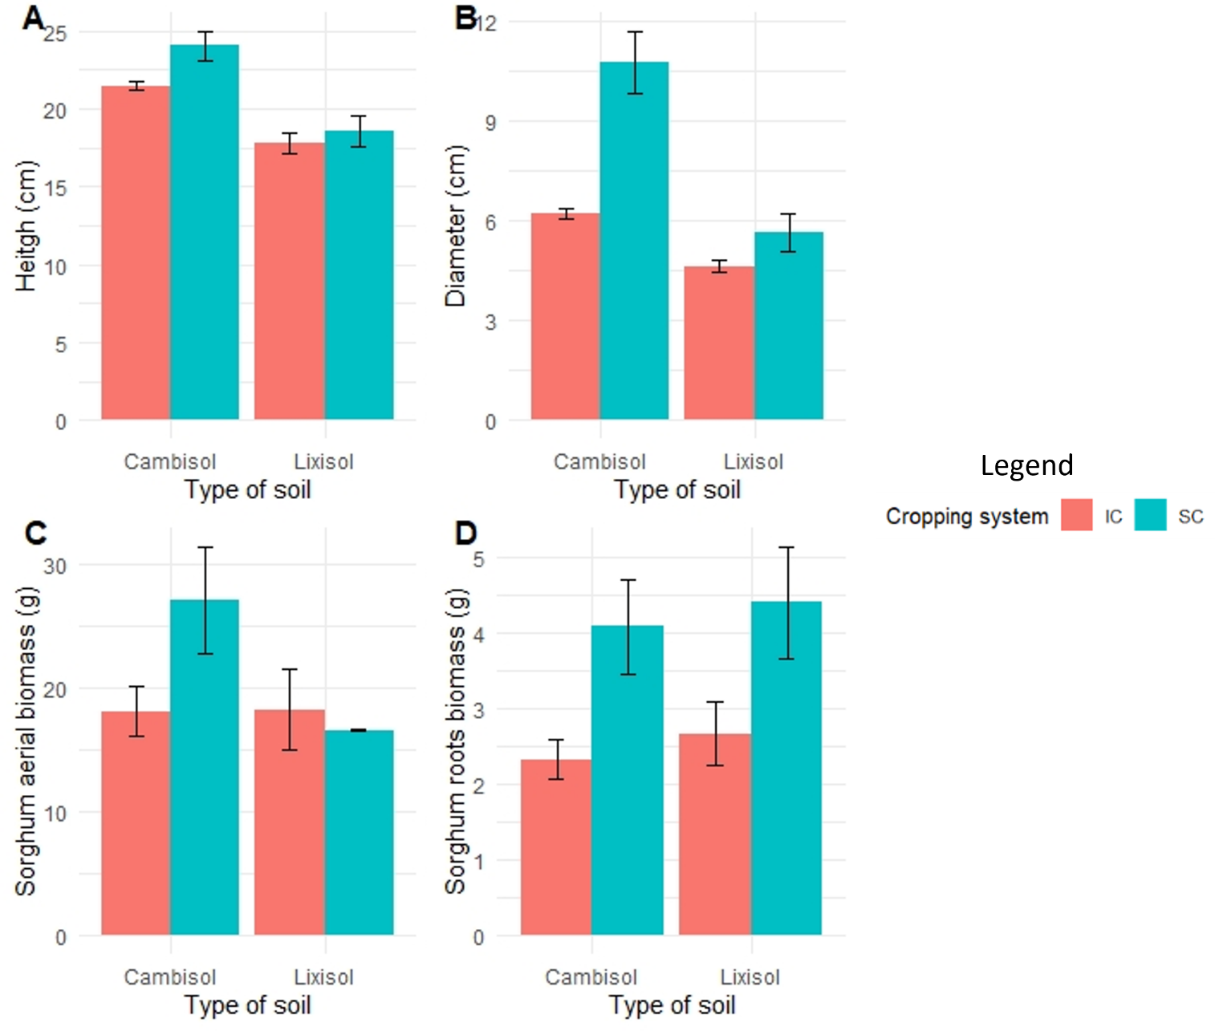
Figure 2 : Effect of soil type and fertilization on sorghum parameters according to cropping systems
IC : Inter crop; SC = Sole crop
Table 2 : Result of variance analysis on sorghum parameters
 | Height | Diameter | Above-ground biomass | Roots biomass
Soil type | 0.0001 *** | 0.0000 *** | 0.0252* | 0.5185 ns
Crop systems | 0.0038 ** | 0.0000 *** | 0.1061ns | 0.0009 ***
Fertilization | 0.8371ns | 0.0000 *** | 0.0006*** | 0.0517 *
Soil : crop systems | 0.0908ns | 0.0000 *** | 0.0223* | 0.4419 ns
Soil : fertilization | 0.1329ns | 0.0619ns | 0.0547* | 0.8860 ns
Crop systems  : fertilization | 0.000 *** | 0.0000 *** | 0.7368ns | 0.2148 ns
***Very highly significant at P = 0.000; **highly significant at P < 0.001; *significant à P < 0.01;. significant at P < 0.05; ns, not significant.

3.2 Effect of soil type and fertilization on growth and production parameters of cowpea
The highest values for height, diameter, above-ground biomass and root biomass were recorded on Cambisol compared to those on Lixisol (Figures 3A, 3B, 3C and 3D). The increases in these parameters under T+100 compared to T0 were +14%, +6%, 40% and +15% for height, diameter, above-ground biomass and root biomass, respectively. On the other hand, on Lixisols, it was the T0 treatment that showed a favorable trend in cowpea growth and root biomass.
Soil type and fertilization significantly (p < 0.05) influenced cowpea parameters (height, diameter, above-ground biomass) in intercropping with sorghum (Table 3). The interaction between soil type and fertilization significantly influenced cowpea height and above-ground biomass.
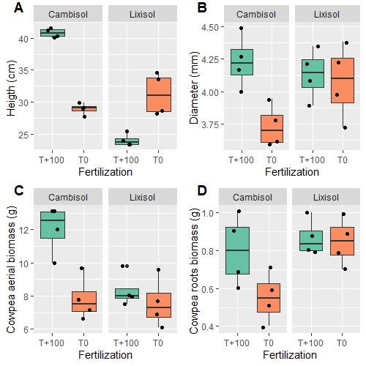
Figure 3 : Effect of soil type and fertilization on cowpea parameters
Table 3 : Results of the analysis of variance for cowpea parameters.
 | Height | Diameter | Above-ground biomass | Roots biomass
Soil type | 0.0000 *** | 0.2873 ** | 0.0119 * | 0.0202 *
Fertilization | 0.0243* | 0.0246 * | 0.0030 ** | 0.0754 ns
Soil : fertilization | 0.0000*** | 0.0642 ns | 0.0237 * | 0.1164 ns
***Very highly significant at P = 0.000; **highly significant at P < 0.001; *significant à P < 0.01;. significant at P < 0.05; ns, not significant.
4. Discussion
4.1 Effects of soil type and crop system on the agronomic parameters of sorghum
The height and diameter growth of sorghum and cowpea plants was better on cambisols. Cambisols have low acidity and a fairly high clay content. Like tropical ferruginous soils, this allows for a very high water and nutrient retention capacity, promoting good rooting and growth conditions for crops. These results corroborate the findings of Sanou et al., (2025) and Ilboudo et al., (2025) regarding the agronomic value of cambisols. These authors assert that cambisols' low acidity is favourable for cereal crop development. In terms of number of shoots, the biomass results show that cambisols performed better than tropical ferruginous soils. These results could indicate a deficiency in basic mineral elements (N, P, K) in lixisols, which are essential for plant growth, hence the low capacity of these soils to produce significant biomass. In line with our results, Guébré et al. (2024) showed that low nitrogen content is a limiting factor for cereal yields; similarly, they showed that nitrogen deficiency leads to a reduction in biomass.
Thus, our results indicate that Cambisols have good agricultural potential, even if they require moderate fertilizer correction to improve plant roots. Their high organic matter, nitrogen and phosphorus content gives them good nutrient reserves, particularly suited to agriculture, especially sorghum cultivation (Bassole et al., 2023). Indeed, More than 40% of soils in the sub Saharan African region are nutrient depleted (Barbier and Hochard, 2018; Ntinyari et al., 2022, Zongo et al., 2025).
According to Ouedraogo et al. (2022), lixisols require targeted interventions to enhance productivity. Research conducted in Burkina Faso has highlighted the depletion of lixisols, revealing a 76.83% decrease in organic carbon and an 82.48% decrease in available phosphorus after ten years of continuous cultivation, as well as a decrease in pH (Coulibaly et al., 2020). In the face of these challenges, some authors propose management practices tailored to the topography and unique soil characteristics, which could greatly enhance agricultural productivity, including the cultivation of sorghum (Blanchard et al., 2014; Seyni et al., 2019).
Furthermore, the low performances recorded in intercropping compared to sole cropping suggest competition between crops, which could hinder sorghum growth due to the rapid emergence of associated cowpea. The negative effect of interspecific interaction on intercropped performances was shown by several authors (Li et al., 2020, Namatsheve et al., 2021). In this study, the interspecific competition is less pronounced on lixisols. Intercropping could be used as a strategy to improved crop productivity in this kind of soils.
4.2 Effect of fertilization on growth and production parameters of cowpea
Cowpea crops grown on Cambisols showed greater growth and biomass with the T+100 treatment. This indicates that mineral fertilizer inputs positively impacted cowpea production on Cambisols. These results suggest that the initial nutrient levels in our soils are insufficient for optimal cowpea growth. These findings align with those of Guébré (2014) and Zongo et al. (2024), who demonstrated the beneficial impact of organo-mineral inputs on nodulation and above-ground and root biomass production in cowpea. Indeed, improved above-ground biomass production was observed with the application of organo-mineral fertilizer.
As reported by Zongo et al. (2021), the low availability of mineral elements is a known problem in our agrosystems. They showed that better biomass production requires the application of phosphate fertilizers and compost.
However, better growth in height and root biomass was observed under control conditions in lixisols, unlike in cambisols. These results suggest that fertilizer inputs negatively influence the root activity of cowpea. A dose higher than that tolerated by the plant would indeed be responsible for the poor results recorded under T+100 treatments. It is well known that excessive application of mineral fertilizers (NPK) can cause soil acidification.
Indeed, inputs above the 'starting dose' (which varies depending on soil and climatic conditions) generally inhibit nitrogen fixation (Zahran, 1999; Zongo et al., 2021). Compaoré et al. (2003) also note that phosphorus becomes a limiting factor for plant production when Bray I phosphorus values are below 10–20 mg/kg of soil. These observations corroborate those of Wang et al. (2023), who found significant improvements in soil phosphorus availability in a residue-free maize/soybean intercropping system. Similarly, Michel (2005) showed that many factors influence the fertilizing value of different nutrient sources: soil texture, structure and temperature, type, quantity and period of fertilizer application. Furthermore, a reduction in symbiotic nitrogen fixation depending on the doses of nitrogen applied, especially from mineral fertilizers (Salvagiotti et al., 2008 ; Boudsocq et al., 2022).
Indeed, mineral fertilization alone does not ensure the sustainability of agricultural production systems (Ibrahima et al., 2009). Organo-mineral fertilization is therefore required, as it has beneficial effects on lixisols by reducing organic matter losses, increasing nitrogen content and improving calcium, magnesium and potassium content (Lompo, 2009).
This study shows that adding mineral fertilizers to lixisols partially immobilizes the root activity of cowpea when it is grown alongside sorghum. This negatively impacts the stem diameter growth and biomass production of cowpea. We hypothesize that adding 100 kg ha⁻¹ of NPK fertilizer to lixisols promotes cowpea height growth, but this remains higher than the starter dose likely to be efficiently used by crops. This could therefore have a negative influence on the root activity of cowpea and thus on its nodulation and effective symbiotic fixation. Further research into the application of different doses of mineral fertilizer and its impact on nodulation in our sorghum-cowpea agroecosystems is necessary to determine the levels tolerated by the plant.
- CONCLUSION
The aim of this study was to determine the impact of mineral fertilizers in combination with different soil types on two cropping systems (mixed and single). Our results showed that, when additional mineral fertilizer was applied, the single crop exhibited greater growth in height, diameter, above-ground biomass and root system. These results clearly demonstrate nutrient deficiencies in our soils and competition between crops, particularly due to the rapid emergence of cowpea plants. The best results recorded under cambisols reflect their intrinsic fertility compared to lixisols. This demonstrates cambisols' ability to promote agricultural production in contexts of nutritional deficiency. Furthermore, the recommended dose of 100 kg ha⁻¹ of NPK mineral fertilizer appears to be less conducive to the successful production of sorghum and cowpeas under lixisols in semi-arid environments. Therefore, to ensure the long-term sustainability of sorghum-cowpea production, it is essential to consider soil type, fertilizer dosage and cropping system. These results should be confirmed in a field trial in order to formulate fertilization and cropping system recommendations according to soil type.

DISCLAIMER (ARTIFICIAL INTELLIGENCE)
Author(s) hereby declare that NO generative AI technologies such as Large Language Models (ChatGPT, COPILOT, etc.) and text-to-image generators have been used during the writing or editing of this manuscript.

COMPETING INTERESTS DISCLAIMER:
Authors have declared that they have no known competing financial interests OR non-financial interests OR personal relationships that could have appeared to influence the work reported in this paper.

REFERENCES
Abdou G, Ewusi-Mensah N, Nouri M, Tetteh FM, Safo E. Y, Abaido R. C. (2016). Nutrient release patterns of compost and its implication on crop yield under Sahelian conditions of Niger. Nutrient Cycling in Agroecosystems, 105 (2): 117-128. DOI: https://dx.doi.org/10.1007/s10705-016-9779-9.
Akpo M. A, Saidou A, Yabi I, Balogoun I, Bigou B. B. L. 2016. Farmer indicators for assessing soil quality in the Okpara basin in Benin. Soil Study and Management, 23: 53-64. http://researchGateiOS.fr
Assogba G. G. C., Adam M., Berre D., Descheemaeker K. (2022). Managing biomass in semi-arid Burkina Faso: Strategies and levers for better crop and livestock production in contrasted farm systems. Agricultural Systems 201 (2022) 103458. https://doi.org/10.1016/j.agsy.2022.103458
Bado B. V., Bationo A., Cescas M.P. (2006). Assessment of cowpea and groundnut contributions to soil fertility and succeeding sorghum yields in the Guinean savannah zone of Burkina Faso (West Africa). Biology and Fertility of Soils, 43: 171‑176 doi:10.1007/s00374-006-0076-7
Bado B.V., Lompo F., Bationo A., Segda Z., Sedogo M.P., Cescas P., Mel V.C., (2012). Nitrogen recoveries and yield improvement in cowpea sorghum and fallow sorghum rotation in West African savannah. Journal of Agricultural Science and Technology, 2: 758-767
Barbier, E. B and Hochard J. P. (2018). “Land degradation and poverty,” Nat Sustain, vol. 1, pp. 623–631 . https://doi.org/10.1038/s41893-018 0155-4
Bassole Z., Yanogo I. P., Idani F. T. (2023). Characterization of leached tropical ferruginous soils and tropical eutrophic brown soils for agricultural use in the Goundi- Djoro lowland (Burkina Faso). International Journal of Biological and Chemical Science, 17(1), 247–266. https://doi.org/10.4314/ijbcs.v17i1.18
Blanchard M., Coulibaly K., Bognini S., Dugué P., Vall É. (2014). Diversity in the quality of organic fertilizers produced by West African farmers: consequences recommendations? What for are the fertilization Biotechnology, Agronomy and Society and Environment, 18(4), 512–523.
Boudsocq, S., Cros, C., Hinsinger, P., Lambers, H.J.P., (2022). Changes in belowground interactions between wheat and white lupin along nitrogen and phosphorus gradients, 476, 97–115.
Compaoré E., Frossard E., Sinaj S., Fardeau J-C. and Morel J-L., (2003). Influence of land use management on soil isotopically exchangeable phosphate in soils from Burkina Faso. Communication in Soil Science and Plant Analysis, 34:1. 201-223p.
Coulibaly K., Traore M., Guiro A., Bacye B., Nacro HB. (2020). Relationship between soil fertility and rainwater productivity on maize (Burkina Faso). In Climate Risks and Agriculture in West Africa, Sultan B., Bossa AY., Salack S., Sanon M. (eds.). IDR Editions, Syntheses Collection: Marseille; 75-84.
Dabat M., Lahmar R., Guissou R. (2012). La culture du niébé au Burkina Faso : Une voie d’adaptation de la petite agriculture à son environnement? Autrepart, 62: 95‑114 doi:DOI : 10.3917/autr.062.0095.
DGESS/MARAH. (2023). Rapport de la campagne agricole 2022-2023. Direction Générale des Études et des Statistiques Sectorielles, Ministère de l'Agriculture, des Ressources Animales et Halieutiques.
Ganeme A, Douzet J-M, Traore S, Dusserre J, Kabore R, Tirogo H, Nabaloum O, Ouédraogo NW-ZS and Adam M (2021) Sorghum/cowpea intercropping at the poquet, a traditional practice in the low-yielding Sudano-Sahelian zone: current status and avenues for improvement. International Journal of Innovation and Applied Studies 31, 836–848.
Guébré, D., Traoré, S., Zongo, K. F., & Hien, E. (2024). Sorghum and cowpea intercropping response to woody residue amendments in Sahelian agroecosystems of Burkina Faso. Geoderma Regional, 37, 00781.
Ibrahima A., Abib F. C., Ndjouenkeu R., and Ntoupka M. (2009). Impact of organic matter management on the mineral status of soils and crops in the Sudano-Guinean savannahs of Ngaoundéré, Cameroon. Proceedings of the conference "African savannahs in development: innovating to last," 1-10 pp.
Ilboudo A., Guébré D., Ouédraogo H., Ganeme A., Zongo K. F , Hien E. (2025). Characterization and evaluation of the agronomic suitability of three soil types for sorghum production in the Sudano-Sahelian zone of Burkina Faso. Journal of Experimental Agriculture International, 47(6): 103-118.
IPCC, 2021. In Ipcc Cambridge University Press. In Press. 159 p. Available à l’adresse https://www.ipcc.ch/report/ar6/wg1/downloads/report/IPCC_AR6_WGI_TS.pdf
Kermah M., Franke A.C., Adjei-Nsiah S., Ahiabor B.D.K., Abaidoo R.C., Giller K.E. (2018). N2-fixation and N contribution by grain legumes under different soil fertility status and cropping systems in the Guinea savanna of northern Ghana. Agriculture, Ecosystems and Environment, 261: 201‑210 Elsevier doi:10.1016/j.agee.2017.08.028.
Kissou R, Gnankambary Z, Nacro HB, Sedogo MP. (2018). Local classification and use soils in the Sahelian zone in Burkina Faso. Int. J. Biol. Chem. Sci., 12(1): 610-617
Koulibaly B, Dakuo D, Traore K, Ouattara A, Ouattara K, Traore O, (2016). Soil tillage practices and crop rotations effects on yields and chemical properties of a lixisol in Burkina Faso. Journal of Applied Biosciences, 106: 10320-10332
Li S., Evers J.B., Werf W. van Der, Wang R., Xu Z., Guo Y., Li B., Ma Y. (2020). Plant architectural responses in simultaneous maize/soybean strip intercropping do not lead to a yield advantage. Annals of Applied Biology,: 1‑16 doi:10.1111/aab.12610.
Lompo F. (2009). Induced effects of fertility management methods on phosphorus levels and the solubilization of natural phosphates in two acidic soils of Burkina Faso. Thesis. University of Cocody. 80-191p
MAAH. (2020). Résultats définitifs de la campagne agropastorale 2019 / 2020 et perspectives alimentaire et nutritionnelle, Rapport. Ouagadougou. 82 p.
Michel T. (2005). Some notions of fertilization, in Ouedraogo A., Kabore F., Kabore O. (2022). Perception of soil fertility and adaptation strategies of agricultural producers in Samandéni (Burkina Faso). International Journal of Biological and Chemical Sciences, 16(4), 1536–1553. https://doi.org/10.4314/ijbcs.v16i4.15
Namatsheve T., Chikowo R., Corbeels M., Mouquet-Rivier C., Icard-Vernière C., Cardinael R. (2021). Maize-cowpea intercropping as an ecological intensification option for low input systems in sub-humid Zimbabwe: Productivity, biological N2-fixation and grain mineral content. Field Crops Research, 263 doi:10.1016/j.fcr.2020.108052.
Ntinyari W., Giweta M., Gweyi-Onyango J., Mochoge B., Mutegi J., Nziguheba G., Masso C. (2022). “Assessment of the 2006 Abuja fertilizer declaration with emphasis on nitrogen use efficiency to reduce yield gap in maize production,” Front. Sustain. Food Syst. 5:2021, 2022. https://doi.org/10.3389/fsufs.2021.758724
Ollabodé K., Bationo A., Lompo F. (2022). Soil fertility as a biophysical constraint to crop productivity in sub-Saharan Africa. Agronomy Journal, 114(4), 1634-1645.
Tittonell P., Giller K.E. (2013). When yield gaps are poverty traps: The paradigm of ecological intensification in African smallholder agriculture. Field Crops Research, 143: 76‑90 Elsevier B.V. doi:10.1016/j.fcr.2012.10.007.
Salvagiotti F., Cassman K. G., Specht J. E., Walters D. T., Weiss A. And Dobermann A. (2008). Nitrogen uptake, fixation and response to fertilizer N in soybeans: A review. Field Crops Research 108, pp. 1–13.
Sanou B. C., Guébré D., Hien, E. (2025). Effets de la diversité des sols et du niveau topographique sur l’activité microbienne et le cycle du carbone en contexte de bas-fonds sud-soudaniens du Burkina Faso. European Scientific Journal, ESJ, 21(21), 153. https://doi.org/10.19044/esj.2025.v21n21p153
Seyni Bodo B, Morvan X., Malam Issa O., Tidjani Adamou D., Ambouta Karimou J-M., Marin B., Ponthieu M., Fronteau G. (2019). Connaissance locale de la variabilité de surface du sol et des contraintes associées pour la production du niébé en zone sahélienne du Niger, Etude et Gestion des Sols, 26, 65-79 Comment télécharger cet article : http://www.afes.fr/publications/revue-etude-et-gestion-des-sols/volume-26
Sultan B., Gaetani M. (2016). Agriculture in West Africa in the twenty-first century: Climate change and impacts scenarios, and potential for adaptation. Frontiers in Plant Science, 7: 1‑20 doi:10.3389/fpls.2016.01262.
Wang W., Yin, F., Gu J., Wang Z., Zhang F., Li L., Cheng Z. (2023). Effects of maize/ soybean intercropping on rhizosphere soil phosphorus availability and functional genes involved in phosphorus cycling in Northwest China. Plant Soil. https://doi. org/10.1007/s11104-023-06363-2.
Zahran H. H. (1999). Rhizobium-Legume Symbiosis and Nitrogen Fixation under severe conditions and in an arid climate. Microbiology and Molecular Biology Reviews: 63 (4), pp. 968-989.
Zongo K.F., Hien E., Mare B.T., Guébré D., (2021). Performance of the mixed sorghum cowpea association on sorghum and soil productivity in the Sudano-Sahelian zone of Burkina Faso. International Journal of Biological and Chemical Sciences, 15: 987 - 1005 197 doi:10.4314/ijbcs.v15i3.12.
Zongo K. F., Kyelem M., Guébré D., Mare B. T., Coulibaly A., Hien E. (2025). Effect of Quail Dropping and Compost on Soil Biological and Chemical Fertility, Growth and Biomass Production of Maize. Int.J.Curr.Microbiol.App.Sci. 14(09): 83-96. doi: https://doi.org/10.20546/ijcmas.2025.1409.010
Zongo K. F., Kabore S. A., Guébré D, Komondi A., Kyelem M., Sanon A., Zongo W. T. V., Hien E. (2024). Organic, mineral and organo-mineral fertilization and agronomic performance of chilli pepper (Capsicum chinense Jacq.) in the Semi-arid Burkina Faso. International Journal of Plant, Animal and Environmental Sciences. 14: 89-97

