Interactive Effects of Calcium Chloride and Borax Foliar sprays on the Biochemical Quality of Guava (Psidium guajava L.)

ABSTRACT
This study evaluated the impact of pre-harvest foliar applications of calcium chloride and borax alone and in combinations on critical biochemical parameters of guava (Psidium guajava L.) cv. L-49. Nine treatment groups included various concentrations of calcium chloride and borax, both individually and in combination, with untreated controls for comparison. Analysis focused on total soluble solids (TSS), titratable acidity, ascorbic acid content, reducing sugar, non-reducing sugar, and total sugar contents. Results demonstrated significant improvements in fruit biochemical quality with combined applications, particularly at higher concentrations. The combination of calcium chloride 0.2% with borax 0.1% significantly improved TSS, ascorbic acid, reducing, non-reducing, and total sugar contents, while also minimizing acidity. These improvements in fruit quality result from better nutrient uptake, stronger cell walls, and positive metabolic changes. These findings support the synergistic role of calcium and boron in improving not only yield but also the nutritional and organoleptic value of guava.
Keywords: Ascorbic Acid, Borax, Calcium Chloride, Guava cv. L-49, Micronutrient Interaction
INTRODUCTION
Guava (Psidium guajava L.) is one of the most economically important subtropical fruit crops cultivated in India and worldwide. Renowned for its rich ascorbic acid content, pleasant aroma, and unique taste, guava commands significant demand both for fresh consumption and for processing. Despite its adaptability and high productivity, the fruit is prone to rapid postharvest deterioration, which limits its marketability and export potential. Biochemical attributes such as total soluble solids (TSS), acidity, ascorbic acid, and sugar content are vital determinants of fruit quality and consumer acceptance (Deepthi et al., 2016).
Pre and post-harvest nutritional strategies, especially involving micronutrients like calcium and boron, have shown promise for enhancing fruit quality, storability, and market value. Calcium, usually supplied as calcium chloride, is pivotal in reinforcing cell wall structure through the cross-linking of pectic substances, stabilizing membrane integrity, and delaying senescence. These cellular effects translate into improved texture, reduced postharvest losses, and longer shelf life. On the other hand, boron commonly applied as boric acid or borax functions in cell wall biosynthesis, sugar translocation, enzyme activation, and is often linked with improved fruit set, size, and quality traits (Sonkar et al., 2024). Studies have documented that foliar sprays of these nutrients enhanced guava fruit yield, shelf life, and biochemical constituents. For instance, combined applications were found superior in augmenting TSS, sugars, and ascorbic acid while minimizing undesirable acidity. These effects are likely a result of synergistic metabolic enhancements driven by improved nutrient allocation and the maintenance of cellular homeostasis (Poojan et al., 2020). India, particularly the Gangetic plains and regions such as Uttar Pradesh, is among the key producers of guava. Nevertheless, productivity is often constrained by suboptimal management of fruit quality parameters. Targeted foliar treatments with calcium and boron can offer growers practical solutions for maintaining fruit firmness and biochemical quality, thus enhancing consumer appeal and market returns (Shukla et al., 2024). Foliar sprays of calcium and boron in combination not only elevate critical quality traits like TSS and vitamin C but also reduce titratable acidity, generically leading to an improved TSS-acid ratio and organoleptic score. Enhanced sugar accumulation is attributed to calcium's role in carbohydrate metabolism and hydrolytic activity on fruit cell wall polysaccharides. Similarly, boron's involvement in ascorbic acid biosynthesis and sugar partitioning further accentuates the quality and nutritive composition of guava (Vani et al., 2020).
Thus, optimizing dose and method of application for these micronutrients is crucial for maximizing the quality and storability of guava. “Hence, the present investigation aimed to evaluate the synergistic effects of foliar-applied calcium chloride and borax on key biochemical quality parameters of guava cv. L-49 under subtropical conditions.”
MATERIAL AND METHODS
Experimental Site
The experiment was conducted during 2019-20 at the Horticultural Research Farm, Department of Horticulture, Babasaheb Bhimrao Ambedkar University, Lucknow, on twenty-one-year-old guava trees (cv. L-49). The experiment consisted of nine treatments and was laid out in a Randomized Block Design (RBD) with three replications. The crop received its first foliar application of micronutrients and plant growth regulators in the first week of August, coinciding with the fruit set stage. A second application was carried out in the second week of September during the fruit development stage. Throughout the experimental period, the crop was supplied with the recommended dose of fertilizers, comprising 600 g N, 300 g P₂O₅, and 300 g K₂O.
Table 1. Experimental details
S.NO. | Treatment | Doses
T₀ | Control (Water spray) | -
T₁ | Calcium chloride | 0.1%
T₂ | Calcium chloride | 0.2%
T₃ | Borax | 0.1%
T₄ | Borax | 0.2%
T₅ | Calcium chloride + Borax | 0.1% + 0.1%
T₆ | Calcium chloride + Borax | 0.1% + 0.2%
T₇ | Calcium chloride + Borax | 0.2% + 0.1%
T₈ | Calcium chloride + Borax | 0.2% + 0.2 %

Observation recorded
Total soluble solids
Total Soluble Solids (TSS) were measured using a hand refractometer. A few drops of extracted fruit juice were placed on the prism, and readings were taken through the eyepiece under proper light. TSS values, expressed in °Brix, indicate the percentage of soluble sugars and dissolved solids, reflecting fruit sweetness (Islam et al., 2013).
Acidity
Acidity was determined by titrating a known volume of fruit juice with standardized NaOH using phenolphthalein as an indicator, following Ranganna (1986). The endpoint was a persistent light pink color, and titratable acidity was calculated and expressed as a percentage of citric acid.
Acidity (%) =$\frac{Titre value × Normality of NaOH × Equivalent weight of acid × 100​}{Volume of sample taken \left(mL\right) ×100}$
Ascorbic acid
Ascorbic acid content was determined by the 2, 6-dichlorophenol indophenol (DCPIP) titration method (Gill et al., 2016). A known quantity of fruit pulp was homogenized with 3% metaphosphoric acid, filtered, and titrated with standardized DCPIP solution until a light pink color persisted for 15 seconds. The results were expressed as mg ascorbic acid per 100 g pulp.
Reducing, non-reducing and total sugars
Sugar analysis, including the estimation of reducing sugar, non-reducing sugar, and total sugar content, was carried out using standard chemical procedures outlined by Ranganna (1986).
For reducing sugar, the Lane and Eynon method was employed, which is based on the titration of the sugar solution against Fehling’s solution using methylene blue as an internal indicator. The reducing sugars present in the sample reduce the cupric ions in Fehling’s solution to cuprous oxide under hot alkaline conditions, and the endpoint is indicated by the decolorization of methylene blue.
To determine total sugar, the sample was first subjected to acid hydrolysis using dilute hydrochloric acid to convert non-reducing sugars (mainly sucrose) into reducing sugars. The hydrolyzed solution was then neutralized and titrated against Fehling’s solution following the same procedure as for reducing sugars.
The non-reducing sugar content was calculated by subtracting the percentage of reducing sugar from the percentage of total sugar. The results were expressed as a percentage of total sugars present in the fruit pulp on a fresh weight basis.
Statistical analysis
The data were statistically analyzed using OPSTAT software, and the significance of treatment effects was determined using the Critical Difference (CD) at the 5% level. The Standard Error of the Mean (SEm) was also calculated to assess variation among replicates.
RESULTS AND DISCUSSION
Total Soluble Solids (TSS)
The results indicate that TSS levels in guava fruits increased progressively with the combined application of calcium chloride and borax, reaching a maximum of (12.67 °Brix) 0.2% CaCl₂ + 0.1% borax, compared to (7.61 °Brix) in control fruits (Fig. 1A). The increase in TSS from these treatments is attributed to enhanced sugar accumulation and enzymatic activity that promotes carbohydrate conversion during ripening. Calcium and boron are known to aid sugar synthesis and transport within plant tissues, thereby boosting TSS content (Pandey et al., 2015). Similar results were reported in guava cv. L-49 by Hada et al., (2018), where calcium and boron sprays significantly improved sugar metabolism and fruit sweetness.
Titratable Acidity (%)
Acidity content decreased with the application of calcium chloride and borax, with the lowest (0.46%) noted under 0.2% CaCl₂ + 0.1% borax treatment compared to 0.76% in control (Fig. 1B). The reduction in acidity is likely due to the rapid conversion of organic acids to sugars during fruit ripening, a process enhanced by calcium’s role in cell wall stabilization and boron’s involvement in glycolytic enzyme activation (Romero-Aranda et al., 1998; Poojan et al., 2020). A similar trend was observed by Awasthi et al. (2009), where the combined foliar application of calcium and boron substantially lowered acid content in guava fruits.
Ascorbic Acid (mg/100g pulp)
Ascorbic acid content increased significantly with the interaction of calcium and boron treatments, reaching 177.34 mg/100g under 0.2% CaCl₂ + 0.1% borax compared to 155.46 mg/100g in control (Fig. 1C). Boron stimulates the enzymatic synthesis of ascorbic acid, while calcium preserves cell integrity and reduces oxidative degradation during ripening (Bhardwaj et al., 2019; Hada et al., 2018). Similar findings were reported by Ravi et al. (2023), who noted that preharvest application of calcium chloride combined with boron enhanced vitamin C concentration by reducing oxidative stress and improving cell wall resilience.
Reducing Sugars (%)
The percentage of reducing sugars in guava fruit pulp showed a significant increase with the application of calcium chloride and borax treatments (Table 2). The highest reducing sugar content of 4.87% was observed under combined treatment of 0.2% calcium chloride + 0.1% borax, which was considerably higher than the 2.50% in control fruits. This increase can be attributed to the role of calcium in activating hydrolytic enzymes that catalyze the breakdown of starch into simpler sugars such as glucose and fructose, which are reducing sugars (Vani et al., 2020). Calcium aids carbohydrate-metabolizing enzymes and maintains cell wall integrity, supporting sugar accumulation by preventing premature fruit spoilage (Singh & Chauhan, 1982; Saha et al., 1993). Boron enhances sugar accumulation by promoting transmembrane transport via sugar–borate complexes, improving sugar mobility within fruit tissues (Awasthi, 2009). These complexes enhance phloem loading and unloading, making sugars more available for metabolic processes and storage, contributing to increased reducing sugar content (Bhardwaj et al., 2019).
Non-Reducing Sugars (%)
Non-reducing sugar content also improved significantly under calcium and boron treatments, reaching a maximum of 4.68% at 0.2% calcium chloride + 0.1% borax treatment compared to 2.88% in control (Table 2). Non-reducing sugars such as sucrose are vital for fruit sweetness and overall flavor quality, and their increase suggests enhanced sucrose synthesis and accumulation. Boron's function in sugar metabolism includes strengthening cellular membranes and participating in carbohydrate metabolism enzymes, thus facilitating sucrose synthesis and stability (Pandey et al., 2015). The synergy between calcium and boron likely results in improved sugar metabolism by stabilizing cell membranes and enhancing enzyme activities responsible for sugar accumulation (Yadav et al., 2018). Boron facilitates sugar transport by forming complexes that protect sucrose from hydrolysis during transport, allowing for higher accumulation of non-reducing sugars in fruit tissues.
Total Sugars (%)
Total sugar content displayed a marked effect, with maximum accumulation (8.55%) under 0.2% CaCl₂ + 0.1% borax, followed by 7.72% in 0.2% CaCl₂ + 0.2% borax, compared to 5.38% in control (Table 2). Both elements play complementary roles calcium enhances sugar translocation through membrane stabilization, while boron improves sugar metabolism through enzymatic activation (Pandey et al., 2015; Hada et al., 2018). Such positive interactions align with previous reports in guava where combined Ca and B sprays increased total sugars and enhanced fruit sweetness (Vani et al., 2020).
Correlation among biochemical parameters
The Pearson correlation heatmap illustrates the interrelationship among various fruit quality parameters, including total soluble solids (TSS), acidity, ascorbic acid, and different forms of sugars (reducing, non-reducing, and total sugars) (Fig. 2). The results reveal a clear pattern of association consistent with the natural biochemical changes that occur during fruit ripening.
A strong positive correlation was observed among TSS, total sugars, reducing sugars, non-reducing sugars, and ascorbic acid, indicating that as the fruit matures, these components increase simultaneously. This suggests that the accumulation of sugars and the synthesis of ascorbic acid contribute significantly to the enhancement of sweetness and nutritional value of the fruit. Higher TSS values, which represent the soluble sugar content, are therefore associated with improved taste and quality.
Conversely, acidity exhibited a negative correlation with TSS and all sugar components, implying that as the fruit ripens and sugar levels rise, the acidity decreases. This inverse relationship is a common characteristic of ripening fruits, where the conversion of organic acids into sugars leads to a sweeter and less tart flavor profile.
Overall, the correlation analysis highlights that fruit ripening is accompanied by an increase in sugars and vitamin C content and a reduction in acidity, which together contribute to better sensory quality and consumer acceptability. These findings confirm that the measured parameters are closely linked and play a crucial role in determining the overall chemical composition and quality of the fruit.
Conclusion
The combined foliar application of 0.2% CaCl₂ and 0.1% borax significantly enhanced guava fruit quality attributes by increasing soluble solids, sugars, and vitamin C, while reducing acidity. Such treatments are therefore recommended for improving fruit biochemical composition and market value under subtropical conditions.
Conflict of Interest
The authors declare that there is no conflict of interest regarding the publication of this research work. The study was conducted independently without any commercial or financial relationships that could be construed as a potential conflict.

COMPETING INTERESTS DISCLAIMER:
Authors have declared that they have no known competing financial interests OR non-financial interests OR personal relationships that could have appeared to influence the work reported in this paper.
Disclaimer (Artificial intelligence)
Author(s) hereby declare that NO generative AI technologies such as Large Language Models (ChatGPT, COPILOT, etc.) and text-to-image generators have been used during the writing or editing of this manuscript.
References
- Awasthi, P. A. (2009). Effect of calcium, boron, and zinc foliar sprays on the yield and quality of guava (Psidium guajava L.). CAB International Digital Library, 5555/20103104872.
- Bhardwaj, R. L., Yadav, S., & Singh, D. P. (2019). Improving fruit quality characteristics and yield of guava (Psidium guajava L.) with micronutrient management. Plant Archives, 19(2), 405–410.
- Deepthi, V. P., Sekhar, R. C., Srihari, D. and Sankar, A. S. (2016). Guava fruit quality and storability as influenced by harvest maturity and postharvest application of calcium salts.
- Hada, T. S., Singh, P., & Meena, R. S. (2018). Studies on the foliar feeding effect of nutrients on quality and biochemical parameters of guava. The Bioscan, 13(3), 1021–1026.
- Islam, M. K., Khan, M. Z. H., Sarkar, M. A. R., Absar, N., & Sarkar, S. K. (2013). Changes in acidity, TSS, and sugar content at different storage periods of the postharvest mango (Mangifera indica L.) influenced by Bavistin DF. International Journal of Food Science, 2013(1), 939385.
- Pandey, P., Sharma, S., & Kumar, R. (2015). Influence of foliar feeding of micronutrients on the phytochemical characteristics of guava. Annals of Phytomedicine, 4(1), 45–50.
- Poojan, S., Patel, R. P., & Pandya, H. V. (2020). Efficacy of foliar application of nutrients on yield and quality of guava cv. Allahabad Safeda. Journal of Environmental Biology, 41(5), 1120–1127.
- Ranganna, S. (1986). Handbook of analysis and quality control for fruit and vegetable products. Tata McGraw-Hill Education.
- Romero-Aranda, R., Moya, J. L., & Cuartero, J. (1998). Boron and calcium effects on tomato fruit quality. Journal of Plant Physiology, 153(3), 403–408.
- Shukla, U., Lata, R., Verma, R. S., Shekhawat, C., Yadav, S. and Singh, V. (2024). Efficacy of Foliar Application of Micronutrients on Bio-chemical Attributes of Guava (Psidium guajava L.) cv. Allahabad Safeda. Asian Journal of Soil Science and Plant Nutrition, 10(4), 562-568.
- Vani, N. U., Bhagwan, A., Kumar, A. K. and Sreedhar, M. (2020). Effect of preharvest spray of different forms of calcium on postharvest quality of guava cv. Allahabad Safeda. International Journal of Current Microbiology and Applied Sciences, 9(7), 197-209.
- Yadav, I. S., Kumar, D., & Rajkumar, M. (2018). Influence of zinc, calcium, and boron sprays on physical and chemical quality attributes in guava cv. Lalit. Journal of Agricultural Science and Practice, 3(4), 98–100.
Fig.1: Interactive Effects of Calcium Chloride and Borax on Biochemical quality on the (A) TSS; (B) acidity; (C) and ascorbic acid content of guava cv. L-49.

Treatments | Reducing sugar (%) | Non- reducing sugar (%) | Total sugar (%)
Control | 2.50 | 2.88 | 5.38
Calcium chloride 0.1% | 3.55 | 2.68 | 6.23
Calcium chloride 0.2% | 3.66 | 2.58 | 6.24
Borax 0.1% | 3.60 | 2.78 | 6.38
Borax 0.2% | 2.62 | 3.62 | 6.22
Calcium chloride 0.1% + Borax 0.1% | 3.62 | 2.76 | 6.39
Calcium chloride 0.1% + Borax 0.2% | 3.28 | 3.26 | 6.54
Calcium chloride 0.2% + Borax 0.1% | 4.87 | 4.68 | 8.55
Calcium chloride 0.2% + Borax 0.2% | 4.73 | 3.99 | 7.72
SEm ± | 0.12 | 0.12 | 0.17
CD 0.05 | 0.36 | 0.36 | 0.50
Table 2: Interactive Effects of Calcium Chloride and Borax on reducing, non-reducing and total sugars of guava cv. L-49.

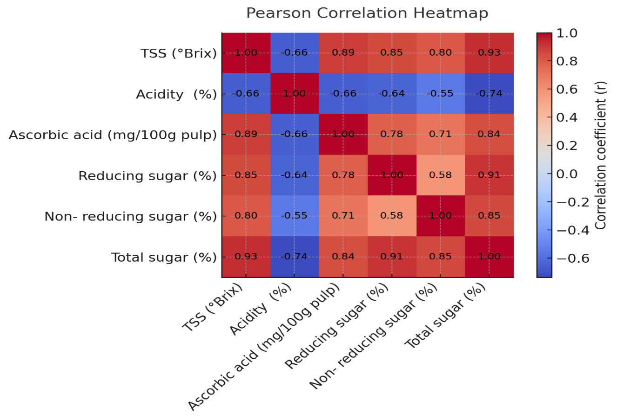

Fig. 2: Pearson correlation heat map for various biochemical parameters of guava cv. L-49.

