Original Research Article

Floristic Diversity and Carbon Sequestration in Cocoa Agroforestry Systems of Côte d’Ivoire

ABSTRACT

In the fight against the global challenges of climate change, carbon storage in agroforestry systems is seen as a biological mitigation strategy. In Côte d'Ivoire, farmers are increasingly practising agroforestry, particularly in cocoa cultivation. However, the carbon sequestration potential of cocoa-based agroforestry systems (SAFc) has not been adequately measured at the local level, particularly in key production areas such as Nawa and Indénié-Djuablin.
The objective of this study is to assess the carbon sequestration potential of cocoa agroforestry systems in these regions. The fundamental hypothesis of this five-month study was to estimate population parameters such as species richness and density, and growth parameters such as age and circumference of cocoa trees and associated shade trees in order to determine the carbon stock of these SAFCs. Secondary data obtained from the ANADER and Coffee and Cocoa Council databases were used to select cocoa farmers practising agroforestry in the areas studied. The plantations of the selected producers were visited. out of 200 producers contacted, 10 plantations were selected in seven locations to host the sampling program. The selection of plantations was carried out from November to December 2024. Tree biomass was assessed using allometric formulas to calculate the above-ground biomass, below-ground and total biomass of each individual tree. Variables that conformed to normal distribution were analysed using one-way analysis of variance (ANOVA), while those that did not meet the assumptions of ANOVA were analysed using Kruskal-Wallis parametric ANOVA on mean ranks using R software version R4.3.2. Nawa contained the most diverse SAFCs (31 species) compared to 23 species in Indénié-Djuablin. The SAFCs in these two regions were mostly young (86%), and the carbon stock varied according to tree density, which in turn varies according to history, previous cultivation, and particularly associated species. The average density (cocoa trees and shade trees) was 805 trees ha⁻¹ (Nawa) and 686 trees ha⁻¹ (Indénié-Djuablin), and the average carbon stock was 66 tC ha⁻¹ (Nawa) and 36 tC ha⁻¹ (Indénié-Djuablin). The SAFCs studied store more than monocultures but less than old-growth agroforests. The carbon storage data from this study could serve as a reference for generating carbon certification scenarios.

Keywords: Theobroma cacao L., agroforestry systems, biodiversity, carbon stock, climate change, Côte d'Ivoire

1. INTRODUCTION
The continuous use of fossil fuels in the industrial sectors suggests the dire need for comprehensive reduction measures in utilising fossil fuel-based energy sources (Lau et al., 2021). This contributes to the catastrophic increase in global carbon emissions (Bose et al., 2024). In the context of combating the global challenges of climate change, carbon storage in terrestrial ecosystems is currently seen as an essential mitigation strategy. CO₂ can remain in the atmosphere for 3–10 centuries. It is crucial to both drastically reduce emissions and apply carbon sequestration techniques. This requires immediate action to cut CO₂ emissions and implement "negative emission" technologies to meet the goal of a decarbonised global economy by 2050 (Dasgupta & Mahanty, 2024). In tropical areas, agroforestry systems, particularly those incorporating cocoa (Theobroma cacao L.), are essential for their ability to serve as carbon sinks while ensuring sustainable agricultural production (Dawoe et al., 2016; Madountsap et al., 2018; Ballesteros-Possú et al., 2022).
Cocoa has a significant impact on the economies of producing countries. In Côte d'Ivoire, the world's leading producer, cocoa accounts for 10% of national GDP and 40% of exports, and the sector employs around 8 million people (ISS, 2025; FAO, 2025). In Ivorian cocoa plantations, the use of agroforestry systems is widespread and offers enormous potential for carbon storage in biomass and soils (Saj et al., 2018; Kouadio et al., 2025). However, this potential has not yet been sufficiently measured at the local level, particularly in key production areas such as the Nawa and Indénié-Djuablin regions (Koua et al., 2018; CIRAD, 2021).
These two areas, characterised by divergent agroecological conditions and intensive cocoa production provide a suitable environment for examining the effectiveness of agroforestry systems in carbon sequestration (Kouao et al., 2020; Diomandé et al., 2022). The objective of this study is to assess the carbon sequestration potential of cocoa agroforestry systems in these regions. This will provide a more effective understanding of their role in mitigating climate change, while providing a scientific basis for sustainable agricultural and environmental policies in Côte d'Ivoire.
2. material and methods

2.1 Study area
The study was conducted in Nawa and Indénié-Djuablin (Figure 1). The Nawa region is located in south-western Côte d'Ivoire between 5°57′57″-7°7′58″ west longitude and 5°17′40″-6°44′29″ north latitude. Nawa has a sub-equatorial climate. It has two wet seasons and two dry seasons. The long-wet season covers the period from April to July. The short-wet season lasts for three months (September-November). The long dry season begins in December and ends in March, and the short dry season lasts throughout August (Konan et al., 2021). Average rainfall is between 1.600 and 1.800 mm per year. Average temperatures range between 26 and 28 °C, with April being the sunniest month (DonnéesMondiales, 2025). The region's terrain consists of vast plateaus, and the vegetation is partly dense (Taï National Park, a biosphere reserve and UNESCO World Heritage Site). The soils of Nawa are mainly ferralitic, with textures ranging from clayey silt to silty sand (AIRF, 2021).
The Indénié-Djuablin region is located in the south-east of the country at 6° 43' 47" north latitude and 3° 29' 47" west longitude. Average rainfall ranges from 1.200 to 1.600 mm per year, with maximum sunshine in November (DonnéesMondiales, 2025). The terrain of this region consists of plains with an average altitude of 250 m (SODEFOR, 2002). The vegetation is humid, wooded and herbaceous (Kouamé et al., 2009). The soils of Nawa are mainly ferralitic (AIRF, 2021).

2.2 Material

2.2.1 Plant Material
The plant material consists of cocoa trees and shade trees with a diameter of more than 10 cm.

2.2.2 Technical Material
The study required the following equipment: a pair of boots, a notepad, an A4 notebook, a pen. a smartphone, a tape measure, oil paint, a paintbrush, a slate, a packet of chalk, 50 m of red and white tape, a roll of adhesive tape, 150 m of rope, a 1 kg measuring jug, a trowel, 10 packs of packaging bags, a pair of gloves and a pickaxe.
2.3 Methods

2.3.1 Selection of plantations
2.3.1.1 Pre-survey phase
Secondary data obtained from the ANADER and Coffee and Cocoa Council databases were used to select cocoa farmers practising agroforestry in the areas studied.

2.3.1.2 Survey phase
The plantations of the selected producers were visited. This enabled us to select those that met the following criteria: presence of associated shade trees larger than the cocoa trees; plots in production (from 4 years of age), and a minimum plot size of 1 hectare. Thus, out of 200 producers contacted, 10 plantations were selected in seven locations to host the sampling program. The selection of plantations was carried out from November to December 2024.

2.3.2 Sampling scheme
In each selected plantation, a 50m x 20m (1000m²) plot was marked out using the surface floristic survey method, which consists of recording all taxa present on square, rectangular or circular areas (Kouamé., 2009). In each plot, three circles with a radius of 30 m were marked out at equidistant intervals of 120° (Figure 2). The companion tree species (trees and shrubs) were inventoried in the plantation. The 1000 m² plots were used to list the cocoa trees and characterise the associated trees. The circles with a radius of 30 meters were used to collect soil samples.
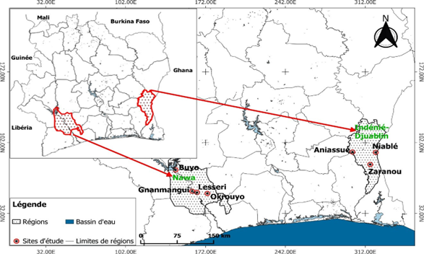

Fig. 1. Study area
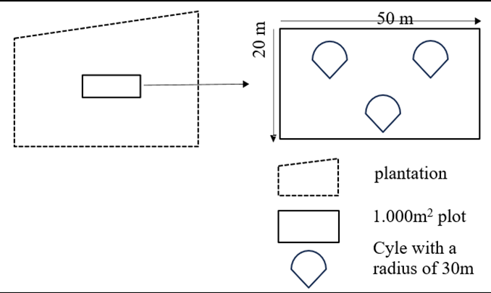

Fig. 2. Sampling device

2.3.3 Data collection
2.3.3.1 Individual producer survey
We submitted an individual questionnaire to the owners of the 10 selected plantations to collect information on the age and area of the plantation. associated shade trees, density of associated trees, previous crop, technical itinerary and benefits derived from the presence of shade trees.

2.3.3.2 Tree identification

Identification consists of giving the scientific name of the trees. This was done using the local name and photos of the leaves and fruits taken in the field, which were then compared with existing databases in several publications, including La Flore Forestière de Côte d'Ivoire by Aubréville (1959), Woody Plants of Western African Forests by Hawthorne & Jongkind (2006), Photoguide for the Forest Trees of Ghana by Hawthorne & Gyakari (2006), Les arbres utiles du Gabon by Meunier et al. (2015), and Les arbres des cacaoyères Recueil by Sanial and Ettien (2022). The trees were identified throughout the plantation.

2.3.3.3 Measurement of diameter at breast height (DBH) and tree count
The DBH of cocoa trees was measured 30 centimetres above the ground (Andrade et al., 2008; Cerny, 2024). When the cocoa tree had a trunk composed of several small trunks starting from the collar, the DBH of each small trunk was measured, and their sum constituted the DBH of the cocoa tree. The DBH of shade trees was measured 1.3 metres above the ground. Only trees with a DBH greater than 10 centimetres in the plot were included in the study. These measurements were taken with a tape measure, and the DBH was recorded in a notebook along with the local name of the tree. The trees measured were marked with paint so that they would not be measured more than once. In each plot, all trees marked with paint were counted to establish tree density.

2.3.3.4 Soil sample collection
Soil samples were collected from holes measuring 50 cm square and 60 cm deep, dug for this purpose with a pickaxe. Three holes were dug in each circle (Figure 2). In each hole, one sample was collected from 0 to 20 cm, another sample from 20 to 40 cm and another sample from 40 to 60 cm. The samples were packed in plastic bags and labelled with adhesive tape.

2.3.3.5 Analysis of soil samples
A total of 216 soil samples were collected at a rate of 9 samples per circle in 8 plots. In each region, one composite sample was taken at a depth of 20 cm, another composite sample at a depth of 40 cm and another composite sample at a depth of 60 cm. Organic carbon was analysed in the laboratory using the Walkley and Black method (1934). This method involves cold oxidation of the total organic carbon present in the soil using a potassium dichromate (K₂Cr₂O₇) solution in the presence of sulphuric acid (H₂SO₄).
2.3.3.6 Assessment of woody biodiversity
Density (N) is the number of trees per hectare. It is calculated using the following formula (Rondeux, 1993):
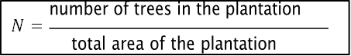
The basal area of a tree is the cross-sectional area of that tree at 1.30 m above the ground (Rondeux, 1993). It is the area occupied by a tree per hectare. The basal area of a stand (G) represents the sum of the basal areas of the individual trees (g) that make up that stand (Pardré and Bouchon, 1988). They are calculated using the following equations:
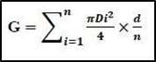
G = basal area of a stand;
Di = diameter of tree I;
d= stand density per hectare;
n= population size in the plot.
The species richness of each region was determined by calculating various biodiversity indices such as Shannon (H), Simpson (D) and Piélou (E) (Ramade, 1994; Shannon and Weaver, 1949). These three indices were calculated using the diversity function of the "vegan" package version 4.3.2 from RStudio.
2.3.3.7 Assessment of biomass. soil carbon and carbon stocks
Tree biomass was assessed using allometric formulas to calculate the above-ground. below-ground and total biomass of each individual tree. The allometric formulas used for shade trees differ from those used for cocoa trees.
• Shade trees
Above-ground biomass (AGB) is calculated according to Chave et al. (2014) using the following formula: , where D = DBH
AGB (kg/tree) = 0.0673* (pD2)0.976
Belowground biomass (BGB) is calculated according to Mokany et al. (2006) using the following formula:
BGB (t/ha) = BA*R
Where R = 0.205 if BA < 125 t/ha or BA > 625 t/ha and R = 0.235 if 125 < BA < 625 t/ha.
• Cocoa trees
Above-ground biomass is calculated according to Chave et al. (2005) using the following formula:
AGB (kg/tree) = exp(−2.134+2.530⋅ln(D)+0.850⋅ln(ρ))
, where D = DHP
The belowground biomass is calculated according to IPCC (2006) using the following formula:
BGB (t/ha) = 0.2 × AGB
NB: The above-ground biomass after digital application gives us a result in kg/tree. We convert BA from kg/tree to t/ha using the following calculation:

BA (t/ha) = (BA (kg/tree) * Density) / 100
• Shade trees and cocoa trees
The total biomass (TB) is obtained by adding AGB (t/ha) and BGB for the individual:
TB (tonnes/hectare) = AGB + BGB

The total biomass was first converted to carbon equivalent and then to CO₂ according to IPCC (2006) using the following formulas:
C (t C.ha-1) = 0.5 * B and CO2 (t CO2.ha-1) = 3.67 *C
The above-ground, below-ground and total biomass, as well as the conversions to carbon and CO₂, were calculated using Excel.
Once the organic carbon content per depth and per region had been obtained in the laboratory, we calculated the soil carbon equivalent according to IPCC (2006) using the following formulas:
C (t C.ha-1) = depth (cm) * %C * 1.45*10
We then calculated the average soil carbon equivalent per region.
Finally, the equivalent carbon stock of the plantation was calculated using the following formula:
Total carbon T/ha = ∑ carbon equivalent per tree + soil’s carbon equivalent average per region
2.3.4 Statistical analyses
Variables that conformed to normal distribution were analysed using one-way analysis of variance (ANOVA), while those that did not meet the assumptions of ANOVA, even after transformation, were analysed using Kruskal-Wallis parametric ANOVA on mean ranks using R software version R4.3.2. In cases where there was a difference between means, the P-value was calculated.
3. results and discussion

3.1 Age of AFSs
The survey results show that the majority (86%) of AFSs surveyed are under 20 years of age (Figure 3). This majority was observed in both regions visited. AFSs over 20 years of age are in the minority (14%) and were all recorded in Nawa.
Following analysis of the survey data, AFSs were grouped into two age categories: under 20 years (86%) and over 20 years (14%). The predominance of AFSs under 20 years (86%) confirms that we are indeed dealing with young cocoa plots in the study area. In fact, in Nawa and Indénié-Djuablin, producers are rehabilitating their orchards or starting new plantations due to the ageing of orchards or the spread of Swollen Shoot. These practices have been reported by several authors in Côte d'Ivoire (Konan et al., 2023; Doumbia et al., 2024; Gnagbo et al., 2024).
3.2 Previous land uses of AFSs
In this section, the results reveal two trends. In the Indénié-Djuablin region, one-third of AFSs are located on former fallow land, one-third on former forest land, and one-third on former orchards (Figure 4). The second trend shows that in the Nawa region, half (50%) of AFSs are established on former forest land. Similarly, the other half (50%) is established on former orchards. In this region, no AFSs have been established on former fallow land. The Kruskal-Wallis test gives (P =.3); there is no statistically significant difference between the regions compared.
The survey results show that producers established the current AFSs following fallow land, forests or ageing orchards. The results of the Kruskal-Wallis test show that the previous crops are the same in Nawa and Indénié-Djuablin. These previous crops could be explained by the vegetation and agricultural history of the regions. Indeed, Nawa and Indénié- Djuablin have dense forest vegetation, and part of the forest has been destroyed to make way for cocoa cultivation, which was introduced in the 1870s (Koné et al., 2014; Amouan, 2020). Furthermore, agriculture is a key sector of activity in both regions, where farmers practise fallow farming to regenerate the soil (Osseni et al., 1989; Li & Nath, 2024).

Fig. 3. Age of plantations

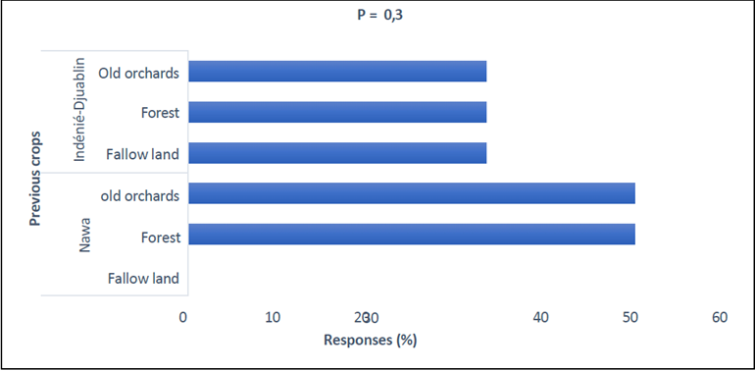
Fig. 4. Previous land uses by region
3.3 Floristic diversity of AFSs
Regarding species abundance, a total of 1.272 individuals were recorded, divided into 32 species, 28 genera and 14 families in the study area. In Nawa, we recorded 879 individuals divided into 31 species, 27 genera and 14 families. In Indénié-Djuablin, we recorded 393 individuals divided into 24 species, 21 genera and 10 families (Table I). The results on species frequency show that the flora was dominated by Termiliana superba (23%), Termiliana ivorensis (13%) and Ricinodendron heudelotii (8%) in Nawa and Indénié- TDjuablin. In Nawa, the least frequent species were Adansonia digita (0.11%), Cecropia pelelata (0.11%), Heritiera densiflora (0.34%) and Tieghemella heckelii (0.34%), In Indénié- Djuablin, the least frequent species were Adansonia digitata (0.25%), Albizia zygia (0.51%) and Khaya ivorensis (0.51%) (Table I). The results on the use or usefulness of associated species, according to farmers' perceptions, reveal that certain species have multiple uses. Indeed, according to repeated analyses, in Nawa, 21 species provide optimal shade for cocoa trees, 13 species are used in traditional medicine, 12 species are consumed locally, 12 species provide timber, 11 species provide firewood, 8 species produce fruit with commercial value, 5 species fertilise the soil, and 3 species have cultural value. In Indénié-Djuablin, 15 species provide optimal shade for cocoa trees, 10 species provide traditional medicine, 10 species generate timber, 9 species are consumed locally, 8 species produce fruit with commercial value, 7 species provide firewood, 5 species fertilise the soil, and 2 species have cultural value (Table I). With regard to the results on the origin of species, in Nawa, 19 species are indigenous and 11 are exotic. However, in Indénié-Djuablin, 14 species are indigenous and 9 are exotic (Table I). Regarding the vulnerability of the species encountered based on their IUCN status, six of them are vulnerable: Entandrophragma angolense, Entandrophragma utile, and Monodora myristica. Khaya ivorensis, Terminalia ivorensis and Tieghemella heckelii (Table I).
The inventories carried out identified 31 species divided into 27 genera and 14 families in Nawa. and 24 species divided into 21 genera and 10 families in Indénié-Djuablin. These species numbers are lower than the 179 species identified by Kouadio et al. (2025) in the cocoa plantations of central-western Côte d'Ivoire. This difference in the number of species could be explained by the methodology used. Indeed, the inventory methodology used by Kouadio et al. (2025) is that of forest inventories on a surface area (100 m x 50 m). This method differs from the surface survey method (50 m x 20 m) used in our work. Furthermore, the number of species obtained is also lower than the 84 species identified by Konan et al. (2023) in the cocoa plantations of western Côte d'Ivoire (Biankouma). The high number of species obtained by Konan et al. (2023) could be justified by the surface floristic survey, which consists of recording all woody (trees and shrubs) and non-woody (palms and banana trees) species. This choice in terms of floristic inventory would have favoured the discovery of a greater number of plant species. When we consider the distribution of species by region, the AFSs in Nawa recorded the highest number of species. This significant number of species in this region could be explained by the cultivation practices adopted by producers. The extensive knowledge of species among producers in Nawa could promote the preservation of a large number of species in cocoa plantations (Lipchitz & Pouch, 2008; Olwig et al., 2024).
When we consider the distribution of species among themselves. the abundance of Termiliana superba (23%) and Termiliana ivorensis (13%) in AFSs could be explained by their rapid growth, the quality of their shade and their promotion by the cocoa sector's support structures (ANADER and the Coffee and Cocoa Council). These species grow rapidly, provide optimal shade for cocoa trees and are among the species distributed as seedlings during agroforestry promotion campaigns conducted by the relevant national and international institutions (Dupuy et al., 1989; Béhaghel Ivan, 1995; Tagbi et al., 2015). As for Ricinodendron heudelotii (8%), its abundance in AFS could also be explained by its rapid growth, but also by its nutritional and economic importance in Ivorian cuisine (Nikiema et al., 2024). In addition to these species, the species listed in the study area are generally used for shade for cocoa trees, traditional medicine, food for farmers, timber, fuelwood and soil fertilisation (Smith et al., 2014; Gyau et al., 2015 and Koulibaly et al., 2017). The significant proportion of native species in the Nawa and Indénié-Djuablin CAFS shows the importance of local tree species in the lives of producers. Indeed, faced with the devastating effect of cocoa cultivation on forest cover, leading to the disappearance of several useful species, many producers tend to conserve native trees for their medicinal, food, fertilising and/or commercial value when creating plantations. The conservation of local tree species in plantations has also been reported by Cissé et al. (2016) in the cocoa agroforests of Lakota (central-western Côte d'Ivoire). Furthermore, research by Plas (2020) has shown that cocoa farmers in western Côte d'Ivoire preserve many native trees in their plantations, which are generally used for food, medical care, or to protect young plants from the sun's rays. The vulnerability status of Entandrophragma angolense, Entandrophragma utile, and Monodora myristica. Khaya ivorensis, Terminalia ivorensis and Tieghemella heckelii, according to the IUCN (2015), could be justified by their indigenous origin coupled with their quality as timber. Indeed, these local species are overexploited by a poorly regulated domestic timber trade (Aubréville, 1959; Hawthorne & Jongkind, 2006; Hawthorne & Gyakari, 2006; Meunier et al., 2015; Sanial and Ettien, 2022).
3.4 AFS biodiversity indices
Biodiversity indices were higher in Nawa. Indeed, in Nawa, the averages for Shannon and Simpson were 2.05 and 0.82, respectively, compared to 1.88 and 0.80 in Indénié-Djuablin. The Pielou index showed a similar result for both regions with 0.87 (Table 2). However, statistical analyses showed that there was no significant difference between the specific richness of AFSs in the two regions (Kruskal-Wallis, P=.6). The results highlight that there is average diversity in the community studied, with a relatively balanced distribution of individuals between species (no species is totally dominant).
The diversity indices calculated showed greater diversity in terms of SAFs in Nawa. However, statistical analyses showed that there was no significant difference between the specific richness of AFSs in the two regions. This similarity between the specific richness of the two regions could be explained by their vegetation. Indeed, Nawa and Indénié-Djuanblin share dense forest vegetation, which explains the high number of native species in AFS. The average diversity in the study area has been demonstrated in several studies in Côte d'Ivoire (Adou Yao and N'Guessan, 2006; Koulibaly et al., 2017).

Table 1. Proportions and IUCN status of shade trees inventoried in AFSs per region
Note: LC = Least Concern; VU = Vulnerable; NC = Not Classified; IN = Indigenous; EX = exotic; al = food; bo = timber; md = traditional medicine; bc = fuelwood; ve = sale/income diversification; fs = soil fertility; om = shade; cu = cultural; Indénié = Indénié-Djuablin

Table 2. Biodiversity indices by region
3.5 Stand density (cocoa trees and shade trees) in AFS
In Nawa, the average stand density was 805 trees ha⁻¹ with a standard deviation of 161 trees.ha⁻¹. The minimum stand density was 640 trees ha⁻¹, and the maximum stand density was 1020 trees ha⁻¹. The minimum shade tree density was 70 trees ha⁻¹, and the maximum shade tree density was 180 trees ha⁻¹ (Figure 5). In Indénié-Djuablin, the average stand density was 686 trees ha⁻¹ with a standard deviation of 227 trees ha⁻¹. The minimum stand density was 500 trees ha⁻¹, and the maximum stand density was 940 trees ha⁻¹. The minimum shade tree density was 30 trees ha⁻¹ and the maximum shade tree density was 170 trees ha⁻¹ (Figure 5). The Kruskal-Wallis test P=.5 showed that there was no significant difference between stand densities in CFSAs in the two regions.
The calculated tree density ranged from 500 trees/ha to 1.020 trees/ha. These results are similar to those obtained in several studies conducted in Ivorian cocoa plantations (Konan et al., 2023; Kouadio et al., 2025). Furthermore, the high stand density in AFS could be justified by the fact that producers transplant cocoa trees at spacings of 2.5 m x 2.5 m or 2.5 m x 3 m to increase the survival rate of the trees. This cultivation choice allows producers to plant as many cocoa trees as possible on their plots. The high density of shade trees in AFS (30 to 180 trees/ha) could be explained on the one hand by the cultivation technique adopted by producers and on the other hand by the spacing used for planting shade trees. The establishment of these plots begins either with the introduction of cocoa trees after clearing the original forest or with the rehabilitation of old cocoa plantations, while retaining useful tree species. Then, in order to maintain shade and diversify their sources of income, farmers tend to keep the wild trees that emerge and introduce tree species at spacing that varies from one producer to another (Koko et al., 2013; Cerny, 2024).
3.6 Basal area of AFS
The results show that in the Nawa AFSs, the average basal area was 27.4 m² ha⁻¹ with a standard deviation of 23 m² ha⁻¹. The minimum basal area was 11.5 m2ha-1 and the maximum basal area was 61.4 m² ha⁻¹ (Figure 6). In Indénié-Djuablin, the average basal area was 24.5 m² ha⁻¹ with a standard deviation of 13.3 m² ha⁻¹. The minimum basal area was 10 m² ha⁻¹and the maximum basal area was 36.5 m² ha⁻¹ (Figure 6).
The calculated basal area ranged from 10 m²ha⁻¹to 61.4 m²ha⁻¹. These results are similar to those obtained in several studies conducted in Ivorian agroforests (Konan et al., 2023; Cerny, 2024). Furthermore, the high basal area value could be justified by the rapid growth of the dominant species Termiliana superba, Termiliana ivorensis and Ricinodendron heudelotii.
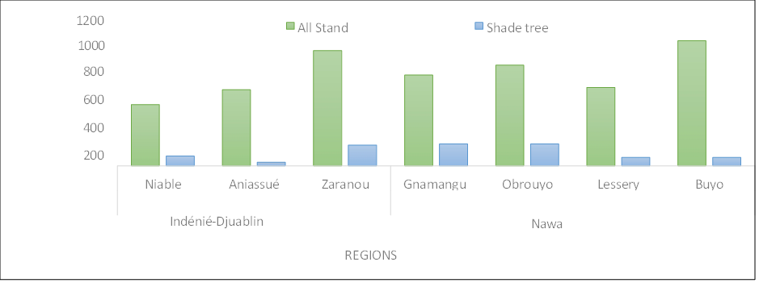

Fig. 5. All stand density and shade tree density in AFS by region

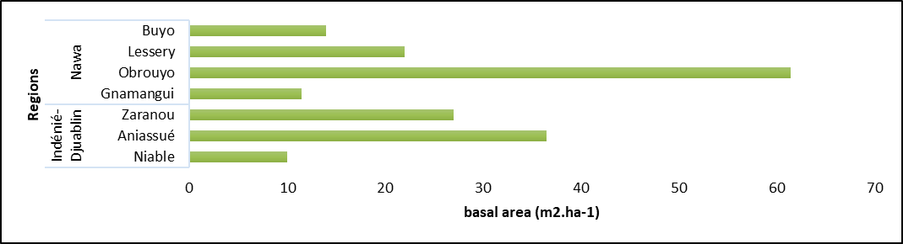

Fig. 6. Basal area of AFS by region

3.7 Carbon stock in different carbon pools
In Nawa, the total carbon stock in AFSs averaged 66.5 t C ha⁻¹ with a standard deviation of 83.2 t C ha⁻¹. The minimum total carbon stock was 16.6 t C ha⁻¹ and the maximum was 190.5 t C ha⁻¹ (Table 3). Considering the carbon stock in t CO2.ha⁻¹, the average was 244 t CO₂ ha⁻¹ with a standard deviation of 305 t CO₂ ha⁻¹. In Indénié-Djuablin, the total carbon stock in AFS averaged 36.3 t C ha⁻¹ with a standard deviation of 24.4 t C ha⁻¹. The minimum total carbon stock was 9.2 t C ha⁻¹ and the maximum was 56.7 t C ha-1. Considering the carbon stock in t CO₂ ha⁻¹, the average was 133 t CO₂ ha⁻¹ with a standard deviation of 86 t CO₂ ha⁻¹ (Table 3). There was a significant difference between the potential carbon stocks of the two regions (Kruskal-Wallis, P=.4).
The calculated carbon stock ranged from 9.2 t C ha⁻¹ to 190.5 t C ha⁻¹. These results are similar to those obtained in several studies conducted in agroforests in Colombia, Cameroon, Ghana and Côte d'Ivoire (Dawoe et al., 2016; Madountsap et al., 2018; Ballesteros-Possú et al., 2022; Kouadio et al., 2025). The carbon sequestration potential is average, with carbon stocks ranging from 30–70 t C/ha on average. These CAFAs store more than monocultures but less than old agroforests. When we consider the averages of carbon stocks and their standard deviations by region, the AFSs in Nawa show the greatest heterogeneity. This heterogeneity could be explained by the age of the AFSs. Indeed, Nawa is the only region where AFSs over 20 years old have been recorded. Due to their age, these AFSs could harbour shade trees and/or cocoa trees with large DBH. This would justify an even greater potential carbon stock (Jagoret et al., 2020).

Table 3: Carbon stock according to carbon pools in AFSs
4. Conclusion
The objective of this study was to determine the floristic diversity and carbon stock of living biomass (above and below ground) and soils in the Nawa and Indénié-Djuablin regions. The AFSs in the two regions studied had average species richness with good species diversity and a balanced distribution of individuals between species. The species Termiliana superba, Termiliana ivorensis, Ricinodendron heudelotii, Colaa acuminata and Entandrophragma angolense were abundant as shade trees in the study area. The survey found that trees are used for food, timber, traditional medicine, fuelwood, supplementary income, soil fertilisation, shade and cultural objects. Among the shade tree species inventoried, Entandrophragma angolense, Entandrophragma utile, Monodora myristica, Khaya ivorensis, Terminalia ivorensi, and Tieghemella heckelii are on the IUCN Red List. The density of shade trees ranged from 30 to 180 shade trees per hectare, and the average diversity indices, density, basal area and carbon stock were higher in the Nawa region. The average potential carbon stock was 66 t C ha⁻¹ with a standard deviation of 83 t C ha⁻¹ in Nawa and 36 t C ha⁻¹ with a standard deviation of 24 t C ha⁻¹ in Indénié-Djuablin. The results of this work have revealed strategies for optimising cocoa-based agroforestry systems in production areas. They also provide a basis for the development of sustainable development mechanisms and support for the implementation of greenhouse gas emission reduction processes in developing countries. The carbon storage data from this study could be used as a reference for generating carbon certification scenarios.

COMPETING INTERESTS DISCLAIMER:
Authors have declared that they have no known competing financial interests OR non-financial interests OR personal relationships that could have appeared to influence the work reported in this paper.

Disclaimer (Artificial intelligence)
Option 1:
Author(s) hereby declare that NO generative AI technologies such as Large Language Models (ChatGPT, COPILOT, etc.) and text-to-image generators have been used during the writing or editing of this manuscript.
Option 2:
Author(s) hereby declare that generative AI technologies such as Large Language Models, etc. have been used during the writing or editing of manuscripts. This explanation will include the name, version, model, and source of the generative AI technology and as well as all input prompts provided to the generative AI technology
Details of the AI usage are given below:
1.
2.
3.

References
Adou yao c. Y. And n’guessan e. K. 2006. Spontaneous floristic diversity of coffee and cocoa plantations in the monogaga classified forest. Côte d'ivoire. Schweiz. Z. Forstwes. 157(2): 31-36. Doi: https://doi.org/10.3188/szf.2006.0031.
Airf. 2021. The nawa region in côte d'ivoire. Https://www.regions- francophones.org/actualite/5770/5606-la-region-de-la-nawa-en-cote-ivoire.htm …accessed on 21/05/2025
Amouan k. P. 2020. Study of land use changes from 1985 to 2015 in the nawa region (south-west côte d'ivoire). University of cocody. Côte d'ivoire 95p andrade. H. J., Segura.
M. A., Somarriba. E. &amp; villalobos. M. 2008. Biophysical and financial assessment of carbon sequestration through land use on indigenous cocoa farms in talamanca. Costa rica. Agroforestry in the americas. 46: 45–50p
Aubréville a., 1959. The forest flora of côte d'ivoire.
Ballesteros-possú w., Valencia j.c.. Navia-estrada j.f. 2022. Assessment of a cocoa- based agroforestry system in the southwest of colombia. Sustainability. 14. 9447. Https://doi.org/ 10.3390/su14159447
Béhaghel i. 1995. Summary of trials of terminalia superba (fraké-limba) provenances in côte d'ivoire and congo. Abidjan: cirad-forêt. 37 p.
Cerny c. 2024. Quantification of carbon stocks and assessment of woody biodiversity in agroforestry cocoa plantations in western côte d'ivoire (man. Mountain district). Master's thesis. University of liège. Belgium. 80 p.
Chave. J., Andalo. C., Brown. S., Cairns. M. A., Chambers. J. Q., Eamus. D., Fölster. H., Fromard. F., Higuchi. N., Kira. T., Lescure. J.-p., Nelson. B. W., Ogawa. H., Puig. H., Riéra.
B., & Yamakura t. 2005. Tree allometry and improved estimation of carbon stocks and balance in tropical forests. Oecologia.145(1): 87–99
Chave. J., Réjou. M. M., Burquez. A. 2014. Improved allometric models to estimate the aboveground biomass of tropical trees. Global change biology. 20: 3177-3190
Cirad. 2021. Towards sustainable soil organic carbon management practices in côte d'ivoire. Https://www.cirad.fr/espace-presse/communiques-de-presse/2021/restauration-des- sols-en-cote-d-ivoire?utm_source=chatgpt.com accessed on 10/07/2025
Cissé a., Kouadio a. J. C., Djaha k., Vroh b. T. A., Yves a. Y. C. 2016. Characterisation of cocoa-based agroforestry practices in dense semi-deciduous forest areas: the case of lakota (central-west. Côte d'ivoire). European scientific journal. 12(21): 50-69.
Dawoe e., Asantew., Acheampong e. And bosu p. 2016. Shade tree diversity and above- ground carbon stocks in theobroma cacao agroforestry systems: implications for redd+ implementation in a west african cacao landscape. Carbon balance manage. 11:17
Diomandé m., Kpan o. J. G., Koffi r. K., Koffi a. And biémi j. 2022. Integrated climate risk management for cocoa production in côte d'ivoire. Research gate. 977-993 global data World data. 2025. Climate of the region of nawa nawa region https://www.donneesmondiales.com/afrique/cote-divoire/climat-bas-sassandra.php
…accessed on 22/05/2025
Doumbia m., Sib o., Kouame y. A. G., Soro s., Yeboue n. L. And Traore k. 2024. Importance. Diversity and economic value of trees associated with cocoa trees in different agroforestry systems. World journal of advanced research and reviews. 24 (02): 2423–2439
Dupuy b., Cabaret n. and N'guessan a. 1989. Provisional production table for framiré (terminalia ivorensis) in côte d'ivoire. Abidjan: cirad-ctft. 20 pp
Fao.2025:Https://www.fao.org/redd/fr/#:~:text=qu%27estce%20que%20redd.à%20atténuer%20les%2 0changements%20climatiques … accessed on 19/05/2025
Gnagbo a., Pagny f. P. J., Voui b. B. N. B., Guehi l., Tiebré m-s. And adou yao c. Y. 2024. Evaluating carbon sequestration and biodiversity in cocoa agroforestry systems: a case study from the man region. Côte d’ivoire. International journal of environment and climate change. 14 (10): 691-700.
Gyau a., Smoot k. and Diby l. 2015. Drivers of tree presence and densities: the case of cocoa agroforestry systems in the soubre region of republic of côte d’ivoire. Agroforest syst. 89: 149–161. Https://doi.org/10.1007/s10457-014-9750-1
Hawthorne w. & gyakari n. 2006. Photoguide for the forest trees of ghana: a tree- spotter’s hawthorne w.d. & jongkind c.c. 2006. Woody plants of western african forests.
A guide IPCC. 2006. IPCC guidelines for national greenhouse gas inventories. Forestry. The institute for global environmental strategies (iges). Japan.
ISS. 2025. Côte d’ivoire’s cocoa economy: time to make the chocolate. Https://futures.issafrica.org/blog/2025/cote-divoires-cocoa-economy-time-to-make-the- chocolate. Com accessed on 10/07/2025
Iucn. 2015. Iucn red list of threatened species. Version 11. Iucn species survival commission. Gland. Switzerland and cambridge. 37 p.
Jagoret p., Saj s., And carimentrand a. 2020. Agroforestry cocoa farming in africa: the art of reconciling sustainable production and ecological services. Cirad. 4 pages.
Koko l. K., Snoeck d., Lekadou t. T. And assiri a. A. 2013. Cocoa-fruit tree intercropping effects on cocoa yield. Plant vigour and light interception in côte d’ivoire. Agroforestry systems. 87: 1043-1052. Doi: https://doi.org/10.1007/s10457-013-9619-8.
Konan g. D., Kpangui k. B., Kouakou k. A. And barima y. S. S. 2023. Typology of cocoa-based agroforestry systems according to the cocoa production gradient in côte d'ivoire. International journal of biological and chemical sciences. 17(2): 378-391pp
Konan k. P., Dibi-kangah a. P. And koné m. 2021. Climate variability and cocoa yield in the region of the nawa (south west file:///c:/users/lenovo/desktop/papers%20about%20carbon%20stock%20and%
20tree%20diversity/climate%20yield%20cocoa%20nawa.pdf …accessed on 21/05/2025
Koné m., Kouadio k. Kouadio y. L., Neuba d. F. R. And malan d. F. 2014. Degradation of dense tropical rainforest: the case of the indénié-djuablin region in eastern côte d'ivoire. Journal of animal and plant sciences. 21(3): 3324–3338pp
Koua s. H., Coulibaly n. A. M-d., Alloueboraud w. A. M. 2018. Characterisation of cocoa orchards and diseases in côte d'ivoire: the case of the departments of abengourou. Divo and soubré. Journal of animal & plant sciences. 35 (3): 5706–5714 pp
Kouadio k. A. L., Kouakou a. T. M., Zanh g. G., Jagoret p., Bastin j-p. And yao b. S. S. 2025. Floristic structure. Potential carbon stocks. And dynamics in cocoa-based agroforestry systems in côte d'ivoire (west africa). Agroforest syst. 99:12
Kouamé d. 2009. Role of frugivorous animals in forest regeneration and conservation: the case of the elephant (loxodonta africana cyclotis matschié. 1900) in azagny national park (south-east côte d'ivoire). Doctoral thesis. University of cocody-abidjan. Abidjan. Côte d'ivoire. 215p
Kouame m. L. O., Egnankou m. W. And traore d. 2009. Ordination and classification of vegetation in the wetlands of south-eastern côte d'ivoire. Agronomie africaine 21(1): 1–13 pp.
Kouao j.m., Kouassi a.m., Dekoula s.c., Asseufi b.d. 2020. Analysis of climate regionalisation in côte d'ivoire in a context of climate change. Larhyss journal. 41: 233–259 pp
Koulibaly a., Amon a. D., Konan d., Goetze d., Traoré k. 2017. Assessment of the impact of land clearing practices on vegetation for sustainable cocoa cultivation in côte d'ivoire. International journal of science and research (ijsr). 6(1): 6-391. Doi: http://dx.doi.org/10.21275/art20163891
Li p. & nath a. J. 2024. The history and revival of swidden agriculture research in the tropics. Cabi agriculture and bioscience. 5: 84.
Lipchitz. A. & pouch. T. 2008. Changes in the global coffee and cocoa markets. Géoéconomie. 1: 101p
Madountsap t. N., Zapfack l., Chimi d. C., Kabelong b. L.-p., Forbi p. F., Tsopmejio T. I., Tajeukem v. C., Ntonmen y. A. Fl., Tabue m. R. B. & nasang j. M. 2018. Carbon storage potential of cacao agroforestry systems of different age and management intensity. Climate and development. 12 p.
Meunier q., Moumbogou c. & doucet j.-l. 2015. Useful trees of gabon. Presses
Mokany k., Raison r. J., & prokushkin a. S. 2006. Critical analysis of root: shoot ratios in terrestrial biomes. Global change biology. 12 (1): 84–96.
Nikiema d., Mouloungui z., Oi koua k., Sandjon b., Raynaud c., Cerny m., Fabre j-f., Merah o., Lacroux é., Adjou a., Valentin r. 2024. Overview of the establishment and uses of ricinodendron heudelotii (euphorbiaceae): focus on the central and southern regions of ivory coast. Ocl. 31:12.
Olwig. M.f., Asare. R., Vaast. P., Bosselmann. A.s. 2024. Can agroforestry provide a future for cocoa? Implications for policy and practice. In: olwig. M.f., Skovmand bosselmann. A., Owusu. K. (eds) agroforestry as climate change adaptation. Palgrave macmillan. Cham. Https://doi.org/10.1007/978-3-031-45635-0_6
Osseni b., Diomandé m. And cirad-irfa 1989. Importance of fallow land in traditional farming systems in côte d'ivoire. Fruits. 44 (1): 13–19.
Pardré. J. & bouchon. J. 1988. Dendrometry (2nd ed.). National school of rural engineering. Water and forestry (engref). Nancy. France. 328 pages
Plas b. 2020. Agroforestry cocoa plantations in the man region: a farming system in decline or the emergence of a post-forestry strategy. Master's thesis in agroecology. University of liège. Belgium. 76 p.
Ramade f. 1994. What is meant by biodiversity and what are the issues and problems inherent in its conservation? Bulletin of the entomological society of france. 99 (1): pp. 7–18
Rondeux j. 1993. Measuring trees and forest stands. Gembloux. Presses agronomiques de gembloux. 521 p.
Saj s., Jagoret p., Mvondo sakouma k., Essobo j.-d., Bouambi e. And todem-ngogue H. 2018. Trade-offs between carbon sequestration. Conservation and productivity in cocoa- based agroforestry systems in central cameroon. In: agroforestry and ecosystem services in tropical areas. Seeking trade-offs between provisioning services and other ecosystem services. Update sciences and technologies. 99-111 p.
Sanial e. And ettien r. 2022. Trees in cocoa plantations: a compendium of farmers' knowledge on the interactions between companion trees and cocoa trees in côte d'ivoire. Nitidae. 95 p.
Shannon. C. E., &amp; weaver. W. 1949. The mathematical theory of communication. University of illinois press. 117 p
Smith d., E., Gnahoua. G.m., Ohouo. L. 2014. Farmers in côte d’ivoire value integrating tree diversity in cocoa for the provision of ecosystem services. Agroforest syst 88. 1047– 1066. Https://doi.org/10.1007/s10457-014-9679-4
Sodefor. 2002. Management plan for the bossématié classified forest (1995-2014). Forestry sector project of the abengourou management centre. Abidjan. Côte d’ivoire. 97 pp.
Tagbi. K. A., Radji. R., Adjonou. K., Kokutse. A. D., & Kokou. K. 2015. Evaluation of growth parameters of local forest species planted in togo: the case of Terminalia superba engl. &amp; diels and terminalia ivorensis a. Chev. European scientific journal. Esj. 11(33).
Walkley. A. & Black. I. A. 1934. An examination of the degtjareff method for determining soil organic matter. And a proposed modification of the chromic acid titration method. Soil science. 37(1): pp. 29–38
Lau, H. C., Ramakrishna, S., Zhang, K., & Radhamani, A. V. (2021). The role of carbon capture and storage in the energy transition. Energy & Fuels, 35(9), 7364-7386.
Bose, D., Bhattacharya, R., Kaur, T., Pandya, R., Sarkar, A., Ray, A., ... & Chemudupati, R. I. (2024). Innovative approaches for carbon capture and storage as crucial measures for emission reduction within industrial sectors. Carbon Capture Science & Technology, 12, 100238.
Dasgupta, K., & Mahanty, A. (2024). Carbon sequestration in a changing climate: management techniques and strategic solutions. Asian Research Journal of Agriculture, 17(4), 703–713.

