Comparative Evaluation of ELISA and PCR for Chlamydia trachomatis Diagnosis in HIV Patients: Implications for Screening in Resource-Limited Settings

Abstract
Background: Chlamydia trachomatis, a prevalent and often asymptomatic global STI, leads to severe reproductive health complications if undiagnosed. Accurate diagnosis is vital for control, but cost and infrastructure limit highly sensitive NAATs like PCR in resource-constrained settings. ELISA offers an affordable alternative, yet its diagnostic performance, particularly in distinguishing active from past infections, requires evaluation. This study compared ELISA and PCR for C. trachomatis detection in Owerri, Nigeria, assessing implications for screening in resource-limited contexts. Methods: A cross-sectional study was conducted on 518 participants (318 symptomatic, 200 asymptomatic) in Owerri, Nigeria. Serum samples were tested for C. trachomatis IgG antibodies using ELISA, while swab samples were analyzed for C. trachomatis DNA by PCR, serving as the reference standard. A comparative analysis of ELISA and PCR results was performed on a subset of 40 samples to determine ELISA's sensitivity, specificity, positive predictive value (PPV), and negative predictive value (NPV). Results: Overall, both ELISA and PCR detected C. trachomatis in 35 (6.8%) participants. However, on the 40-sample subset, ELISA demonstrated a high sensitivity of 92.9% but a low specificity of 27.3%. The PPV was 74.3%, and the NPV was 40.0%. This indicates that while ELISA was effective at identifying most true positives, it yielded a significant number of false positives and had limited ability to reliably rule out infection. Conclusion: ELISA shows high sensitivity for C. trachomatis antibody detection, but its low specificity and negative predictive value limit its standalone use for active screening due to inability to differentiate past from current infections. PCR and other NAATs remain superior for active diagnosis. Integrated strategies or investment in accessible NAATs are crucial for effective C. trachomatis control in resource-limited settings.

Keywords: Chlamydia trachomatis, ELISA, PCR, Diagnostic Performance, Sensitivity, Specificity, Resource-Limited Settings, Nigeria.

Introduction
Chlamydia trachomatis remains the most frequently reported bacterial sexually transmitted infection (STI) globally, posing a significant public health challenge due to its high prevalence and severe long-term sequelae, particularly in women (WHO, 2011; Malhotra et al., 2013). A defining characteristic of C. trachomatis infection is its largely asymptomatic nature, with a majority of infected individuals exhibiting no overt symptoms (Parija, 2012). This silent progression facilitates widespread transmission and often leads to delayed diagnosis and treatment, culminating in severe complications such as pelvic inflammatory disease (PID), ectopic pregnancy, and tubal factor infertility (Aastha & Mrinangka, 2021; Ozolins, 2011; Peipert, 2003). Effective control of C. trachomatis is therefore heavily reliant on accurate and timely diagnosis, which is crucial for identifying infected individuals, preventing further transmission, and mitigating the risk of long-term complications.

The landscape of C. trachomatis diagnosis has evolved significantly over time, encompassing various methodologies with distinct advantages and limitations. Historically, cell culture was considered the gold standard due to its high specificity, but its technical demands, slow turnaround time, and high cost have limited its widespread application, especially in routine clinical settings (Black, 1997). Direct antigen detection methods, such as Enzyme Immunoassays (EIAs) and immunofluorescence assays (IFAs), offered improvements in speed and cost-effectiveness but often suffered from lower sensitivity compared to culture (Black, 1997). In recent decades, Nucleic Acid Amplification Tests (NAATs), including Polymerase Chain Reaction (PCR), have emerged as the preferred diagnostic method in many developed nations due to their superior sensitivity and specificity, ability to detect non-viable organisms, and suitability for non-invasive samples (CDC, 2010; WHO, 2016). NAATs are highly effective in detecting current infections and are widely recommended for screening programs.

However, despite the diagnostic prowess of NAATs, their implementation in resource-limited settings, such as many parts of sub-Saharan Africa, presents considerable challenges. The high cost of reagents, the requirement for sophisticated laboratory infrastructure, specialized equipment, and highly trained personnel often render widespread NAAT-based screening programs economically unfeasible or logistically impractical (Enwuruh & Umeh, 2014; Nwankwo et al., 2014). This disparity creates a critical gap in diagnostic capabilities, forcing healthcare systems in these regions to rely on less sensitive or less specific methods, or to forego comprehensive screening altogether.

Serological tests, such as Enzyme-Linked Immunosorbent Assay (ELISA), offer a more affordable and less technically demanding alternative for C. trachomatis detection. ELISA assays detect antibodies (IgG, IgM, IgA) produced by the host in response to Chlamydia infection. While serology can indicate past or current exposure and is useful for epidemiological surveillance, a key limitation is its inability to reliably distinguish between active infection and resolved past infection, particularly with IgG antibodies which can persist for long periods (Black, 1997; Jenab et al., 2009). Furthermore, the sensitivity and specificity of serological tests can vary, potentially leading to false positives or negatives, which complicates their utility for diagnosing acute infections (Jenab et al., 2009). Despite these limitations, the accessibility and lower cost of ELISA make it an attractive option for large-scale screening and epidemiological studies in settings where NAATs are not readily available.

Given these contrasting features, a comparative evaluation of ELISA and PCR in a local context is essential to inform pragmatic diagnostic strategies. In Owerri, Imo State, Nigeria, where the burden of STIs is significant and healthcare resources are constrained, understanding the performance of these diagnostic tools is paramount. This study therefore aims to comparatively evaluate the diagnostic performance of the Enzyme-Linked Immunosorbent Assay (ELISA) against Polymerase Chain Reaction (PCR) for the detection of Chlamydia trachomatis infection among symptomatic and asymptomatic individuals in Owerri. By assessing their respective strengths and weaknesses within this specific setting, the findings will provide crucial insights into the implications for effective Chlamydia trachomatis screening strategies, ultimately contributing to improved public health outcomes in resource-limited environments.

Materials and Methods
Study Design and Population
This study employed a cross-sectional design to comparatively evaluate diagnostic methods for Chlamydia trachomatis infection in Owerri, Imo State, Nigeria. Participants were HIV positive confirmed from their clinical folder. They were recruited from out-patients attending sexually transmitted infections (STI) and HIV clinics at the Federal Medical Center (FMC), Owerri, and from apparently healthy asymptomatic individuals within the general population. The study was conducted from September 2018 to September 2019.

A total of 518 participants were enrolled, comprising 318 symptomatic subjects and 200 asymptomatic subjects. Inclusion criteria involved symptomatic men and women with clinical symptoms of urogenital infection, asymptomatic healthy men and women, all aged 15 to 45 years and above, who provided informed consent and had not received antibiotic treatment in the preceding four weeks. Exclusion criteria included individuals below 15 years, those unwilling to provide consent, or subjects who had received antibiotic treatment within the last four weeks.

Sample Collection and Processing
From each of the 518 participants, a 3-5 ml volume of blood was collected by venepuncture under aseptic conditions. Serum was separated from clotted blood samples by centrifugation and stored at -20°C for serological analysis (ELISA). Additionally, for molecular analysis, endocervical swabs were collected from female participants and urethral swabs from male participants where feasible. These swab samples were stored appropriately for subsequent DNA extraction.

IgG Detection by ELISA Assay
The presence of Chlamydia trachomatis IgG antibodies in serum samples was determined using a commercially available Enzyme-Linked Immunosorbent Assay (ELISA) kit (Bio-check). The assay was performed strictly according to the manufacturer's instructions. Briefly, diluted serum samples, along with positive, negative, and cut-off calibrator controls, were dispensed into microtiter wells and incubated. Following incubation and washing steps, enzyme conjugate was added, followed by a second incubation and washing. Tetramethyl benzidine (TMB) reagent was then added, and the reaction was stopped with 1N-HCL. Optical density (OD) was read at 450nm using a microtiter plate reader. Results were interpreted based on the IgG index: less than 0.901 was negative, 0.91 to 0.99 was equivocal, and 1.00 or greater was positive.

DNA Extraction
Genomic DNA was extracted from the collected endocervical and urethral swab samples using a commercial DNA extraction kit (specific kit details as per thesis, e.g., Puregene DNA Isolation Kit or Qiagen DNeasy Blood & Tissue Kit) following the manufacturer's protocol. The concentration and purity of the extracted DNA were verified using a Nanodrop spectrophotometer, and samples were stored at -20°C.

Polymerase Chain Reaction (PCR) for Chlamydia trachomatis Detection
Polymerase Chain Reaction (PCR) was employed as the reference standard for the detection of Chlamydia trachomatis DNA. Primers targeting a conserved region of the C. trachomatis cryptic plasmid or the major outer membrane protein (ompA) gene were utilized (specific primer sequences and PCR conditions). Each PCR reaction included appropriate positive and negative controls. Amplified DNA products were resolved by electrophoresis on a 1.5% agarose gel, stained with ethidium bromide, and visualized under UV transillumination. Samples showing the expected band size were considered positive for C. trachomatis DNA.

Comparative Analysis of ELISA and PCR Results
The diagnostic performance of the ELISA assay was evaluated against PCR, which served as the gold standard for detecting active Chlamydia trachomatis infection. Sensitivity, specificity, positive predictive value (PPV), and negative predictive value (NPV) of the ELISA test were calculated using standard epidemiological formulas.

Sensitivity: (True Positives / (True Positives + False Negatives)) x 100%

Specificity: (True Negatives / (True Negatives + False Positives)) x 100%

Positive Predictive Value (PPV): (True Positives / (True Positives + False Positives)) x 100%

Negative Predictive Value (NPV): (True Negatives / (True Negatives + False Negatives)) x 100%
Concordance between the two tests was also assessed.

Statistical analysis
Descriptively, the data generated were analyzed for prevalence and presented as pie chart while the sensitivity, specificity, positive predictive value and negative predictive value were mathematically calculated.

Results and Discussion

A total of 518 participants were included in the study. Overall, Chlamydia trachomatis IgG antibodies were detected in 35 (6.8%) participants by ELISA as seen in Figure 1 below.

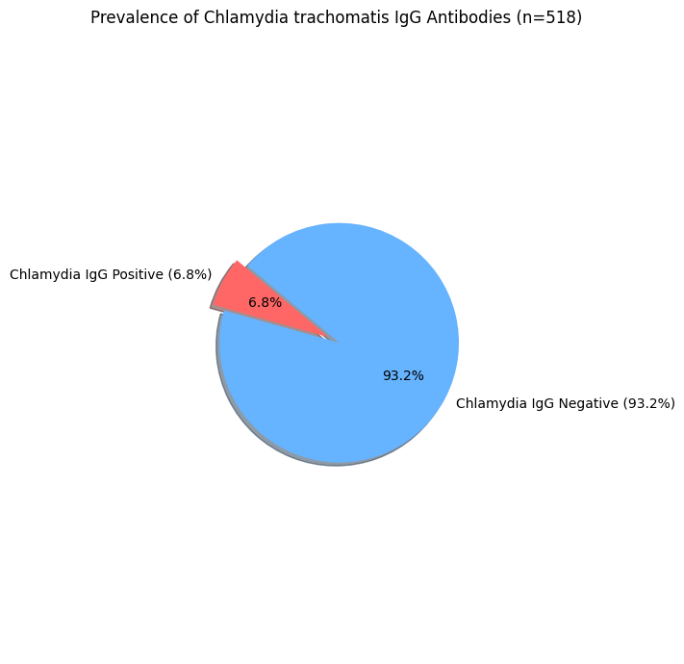
Figure 1: Prevalence of Chlamydia trachomatis using ELISA

Comparative Performance of ELISA and PCR
The comparative evaluation of ELISA using PCR as the reference standard was performed on a subset of 40 samples from the study cohort. Of these 40 samples, PCR detected Chlamydia trachomatis DNA in 26 samples and 20 in ELISA as seen in Figure 2 below:

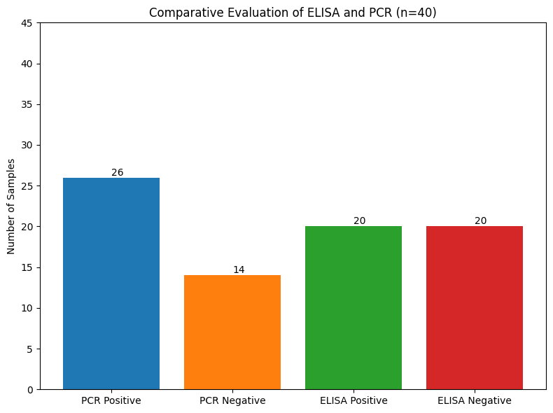
Figure 2: Comparative Evaluation of ELISA and PCR P

Diagnostic Performance
This Figure 3 below presents the calculated values for key diagnostic performance indicators of the ELISA assay when compared against PCR as the reference standard in the study subset.
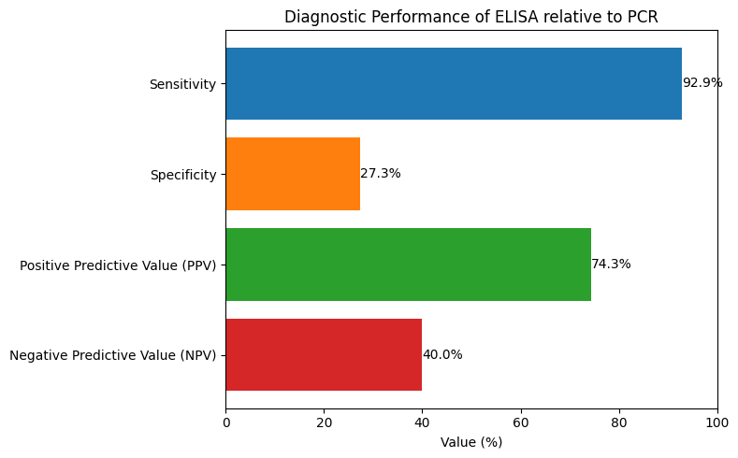
Figure 3: Diagnostic Performance of ELISA Relative to PCR
Horizontal bar chart shows the diagnostic performance metrics of ELISA relative to PCR, including Sensitivity (92.9%), Specificity (27.3%), Positive Predictive Value (PPV=74.3%), and Negative Predictive Value (NPV=40.0%).

This study aimed to comparatively evaluate the diagnostic performance of the Enzyme-Linked Immunosorbent Assay (ELISA) against Polymerase Chain Reaction (PCR) for the detection of Chlamydia trachomatis infection in Owerri, Nigeria, with implications for screening in resource-limited settings. The overall seroprevalence of C. trachomatis IgG antibodies by ELISA was 6.8%. However, the in-depth comparative analysis on a subset of 40 samples revealed important insights into the actual diagnostic utility of ELISA when PCR is considered the gold standard.

The most striking finding from this comparative analysis is the high sensitivity (92.9%) of the ELISA assay, indicating its strong ability to correctly identify individuals who are truly infected with C. trachomatis as detected by PCR. This high sensitivity is a valuable characteristic for a screening test, as it minimizes false negatives, ensuring that most infected individuals are identified (Black, 1997; Jenab et al., 2009). This aspect is particularly crucial for C. trachomatis due to its predominantly asymptomatic nature, where missing an infection can lead to severe long-term complications and continued transmission.

However, the study also revealed a considerably low specificity of ELISA (27.3%) and a low negative predictive value (40.0%). This low specificity means that a significant number of individuals who tested positive by ELISA were, in fact, negative by PCR (false positives). The low negative predictive value further implies that a negative ELISA result does not reliably rule out an infection, as a substantial proportion of individuals testing negative by ELISA might actually be positive by PCR (false negatives, although the sensitivity figure suggests few were missed). This finding contrasts sharply with the expectation of high concordance, as might be inferred from the overall prevalence figures, and highlights the limitations of serological assays for diagnosing active infections. The presence of false positives in ELISA can lead to unnecessary treatment, patient anxiety, and a strain on healthcare resources (Jenab et al., 2009; Nwankwo et al., 2014).

The discrepancy between the high sensitivity and low specificity observed in this study is a common challenge with serological tests for C. trachomatis. IgG antibodies, detected by ELISA, can persist for extended periods after a resolved infection, making it difficult to differentiate between past exposure and current active infection (Black, 1997). This inherent limitation of serology is a major reason why NAATs, which detect bacterial nucleic acid, are preferred for diagnosing active infections and for screening programs. Studies globally have consistently demonstrated the superior performance of NAATs in terms of both sensitivity and specificity for detecting active C. trachomatis infections compared to serological methods (CDC, 2010; WHO, 2016). For instance, research by Jenab et al. (2009) also highlighted the limitations of ELISA compared to PCR, particularly in differentiating active from past infections.

The implications of these findings for resource-limited settings are significant. While ELISA offers advantages in terms of cost-effectiveness and ease of implementation compared to PCR, its low specificity and NPV, as demonstrated here, limit its utility as a standalone diagnostic tool for active C. trachomatis infection. A high rate of false positives could overwhelm healthcare systems with unnecessary follow-up and treatment, while a low NPV could lead to missed active infections and continued disease progression and transmission. Therefore, relying solely on ELISA for active infection diagnosis and screening in such settings may not be optimal.

Despite these limitations, ELISA still holds value for epidemiological surveillance to estimate cumulative exposure rates in a population, as it can detect past infections. However, for clinical management and public health control strategies focused on interrupting transmission and preventing complications from active infections, more accurate methods like PCR are indispensable. The challenge remains in bridging the gap between the diagnostic ideal (NAATs) and the practical realities of resource constraints. Future strategies in resource-limited settings might consider a tiered approach, where ELISA could be used for initial broad-based screening, with PCR reserved for confirmation of positive ELISA results or for high-risk populations, to maximize resource efficiency while maintaining diagnostic accuracy.

A limitation of this comparative analysis is that it was performed on a subset of 40 samples, which might not fully represent the entire study population of 518. A larger comparative study across the full cohort would provide more robust statistical power and a more comprehensive understanding of the tests' performance.

Conclusion
This study found that while ELISA shows high sensitivity for Chlamydia trachomatis antibody detection, its specificity and negative predictive value are low compared to PCR for diagnosing active infections. ELISA's inability to differentiate between past and current infections due to antibody persistence limits its standalone use for active screening in resource-limited settings, potentially leading to false positives and missed cases. PCR and other NAATs remain superior for active infection diagnosis. Integrated diagnostic strategies or investment in more accessible NAATs are crucial for effective C. trachomatis control.

Ethical Approval and Consent
Approval for this study was obtained from the Ethics Committee of Federal Ministry of Health, Owerri, Imo State. Also, the participation of the patients were based on the submission of their written consent.

COMPETING INTERESTS DISCLAIMER:
Authors have declared that they have no known competing financial interests OR non-financial interests OR personal relationships that could have appeared to influence the work reported in this paper.

Disclaimer (Artificial intelligence)
Option 1:
Author(s) hereby declare that NO generative AI technologies such as Large Language Models (ChatGPT, COPILOT, etc.) and text-to-image generators have been used during the writing or editing of this manuscript.
Option 2:
Author(s) hereby declare that generativ AI technologies such as Large Language Models, etc. have been used during the writing or editing of manuscripts. This explanation will include the name, version, model, and source of the generative AI technology and as well as all input prompts provided to the generative AI technology
Details of the AI usage are given below:
1.
2.
3.

References
Aastha, P.,& Mrinangka, D. (2021). Pathogenesis and Virulence of Chlamydia Trachomatis. Journal of Pharmaceutical Research International, 33(60B), 1592–1599. https://doi.org/10.9734/jpri/2021/v33i60B34782

Black, C. M. (1997). Current methods of laboratory diagnosis of Chlamydia trachomatis infections. American Society of Microbiology; Clinical Microbiology Reviews, 10(1), 160-184.

Centers for Disease Control and Prevention (2010). Sexually Transmitted Diseases Treatment Guidelines. Morbidity and Mortality Weekly Report (MMWR), 59(RR-12), 1-110.

Enwuruh, P., & Umeh, S. (2014). Asymtomatic carriage of Chlamydia trachomatis among young adults in Owerri, South East Nigeria. Journal of Nursing and Health Science, 3, 49-53.

Jenab, A., Golbang, N., Golbang, P., Chamani-Tabriz, L., & Roghanian, R. (2009). Diagnostic value of PCR & ELISA for Chlamydia trachomatis in a group of asymptomatic & symptomatic women in Isfahan, Iran. IJFS, 2(4), 193-198.

Malhotra, M., Sood, S., Mukherjee, A., Muralidhar, S., & Bala, M. (2013). Genital Chlamydia trachomatis: An update. Indian Journal of Medical Research, 138(3), 303-316.

Nwankwo, E., Magaji, O., & Sadiq, N. (2014). Prevalence of Chlamydia trachomatis infection among patients attending infertility and STDs clinics in Kano, North Western Nigeria. Africa Health Sciences, 14(3), 672-678.

Ozolins, D. (2011). Why are chlamydiae and Hpv major public health problems. Journal of International Federation of Clinical Chemistry, 22(1), 36-38.

Parija, S.C. (2012). Textbook of microbiology and immunology (2nd ed.). New Delhi: Elsevier publishing.

Peipert, J.F. (2003). Genital chlamydial infections. New England Journal of Medical Science, 349, 2424–2430.

World Health Organization (2011). Global prevalence and incidence of selected curable sexually transmitted diseases: Overview and estimates. Geneva: World Health Organization.

World Health Organization (2016). Global health sector strategy on sexually transmitted infections 2016-2021. Geneva: World Health Organization.

