Isolated posterior atypical presentation of Vogt-Koyanagi-Harada syndrome in a young girl: A rare case report

Abstract
Background: Vogt-Koyanagi-Harada (VKH) disease is a rare autoimmune disorder affecting melanocyte-rich tissues, including the uvea, meninges, skin, and inner ear. Posterior involvement is typical, yet isolated posterior forms are exceptionally rare and diagnostically challenging.
We present a pediatric case of atypical isolated posterior VKH successfully managed with corticosteroid therapy.
Case Presentation: A 15-year-old girl presented with sudden bilateral visual loss following diffuse headaches. Fundus examination revealed serous retinal detachments in both eyes. Optical coherence tomography (OCT) showed multilobulated subretinal fluid and disruption of outer retinal layers. Fluorescein angiography demonstrated multiple pinpoint hyperfluorescent leaks and dye pooling, while indocyanine green angiography revealed delayed choroidal perfusion. Laboratory and imaging workup excluded other causes such as posterior scleritis, infectious choroiditis, and central serous chorioretinopathy. She was treated with intravenous methylprednisolone followed by oral tapering, leading to marked improvement in vision and anatomical resolution.
Conclusion: Isolated posterior atypical VKH is an uncommon presentation that may mimic several inflammatory or infectious choroidopathies. Early recognition and aggressive corticosteroid therapy are key to achieving favorable visual outcomes and preventing chronic evolution. Follow-up of patients with ocular VKH is long, even lifelong, because relapses and late complications can occur even several years after the onset of the disease.

Keywords: Vogt-Koyanagi-Harada disease, posterior uveitis, corticosteroid therapy, pediatric uveitis

Introduction
Vogt–Koyanagi–Harada (VKH) disease is a multisystem autoimmune disorder characterized by bilateral granulomatous panuveitis associated with systemic manifestations such as meningismus, tinnitus, alopecia, and vitiligo, reflecting a T-cell–mediated immune response directed against melanocytic antigens (1). The condition primarily affects melanocyte-containing tissues, including the uvea, meninges, inner ear, and skin, highlighting its autoimmune pathogenesis (1,2). The incidence of VKH varies geographically, with higher prevalence among Asian, Middle Eastern, and Hispanic populations (3).

Typically, VKH presents as bilateral granulomatous uveitis involving both the anterior and posterior segments . However, atypical or incomplete forms limited to the posterior segment have been infrequently described, particularly in pediatric patients (4). These presentations pose significant diagnostic challenges, as they may mimic conditions such as sympathetic ophthalmia, posterior scleritis, or central serous chorioretinopathy (5).

Recent advances in multimodal imaging—especially optical coherence tomography (OCT) and indocyanine green angiography (ICGA)—have improved diagnostic precision by identifying distinctive features of choroidal inflammation (6). Early diagnosis and prompt initiation of high-dose corticosteroid therapy remain crucial for optimizing visual outcomes and preventing progression to the chronic, depigmenting stage of the disease .

Case Presentation
A 15-year-old girl with no significant medical history presented to the Ophthalmology Department with a three-day history of progressive bilateral visual loss, preceded by diffuse headache. She denied ocular trauma, surgery, or systemic symptoms such as fever, rash, or recent infection.
On ophthalmologic examination, best-corrected visual acuity was counting fingers at 1 meter in both eyes. Intraocular pressures were within normal limits. The anterior segments were quiet, without keratic precipitates, anterior chamber cells, or flare. Fundus examination showed loss of the foveal reflex and multiple localized serous retinal detachments at the posterior pole bilaterally (Figure1).

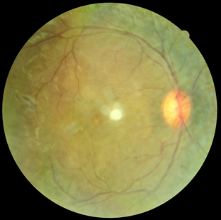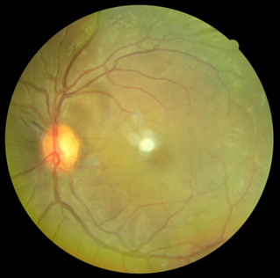
Figure 1 : Retinal photography of the left and right eyes showing the serous retinal detachment
Spectral-domain optical coherence tomography (SD-OCT) revealed multilobulated serous retinal detachments with hyperreflective septa and outer retinal layer disruption, consistent with exudative detachment (Figure2) . Fluorescein angiography demonstrated multiple pinpoint hyperfluorescent leaks in the early phase, followed by pooling of dye in the subretinal space (Figure3) . Indocyanine green angiography showed delayed choroidal filling and late hypocyanescent spots suggestive of choroidal inflammation (Figure4).

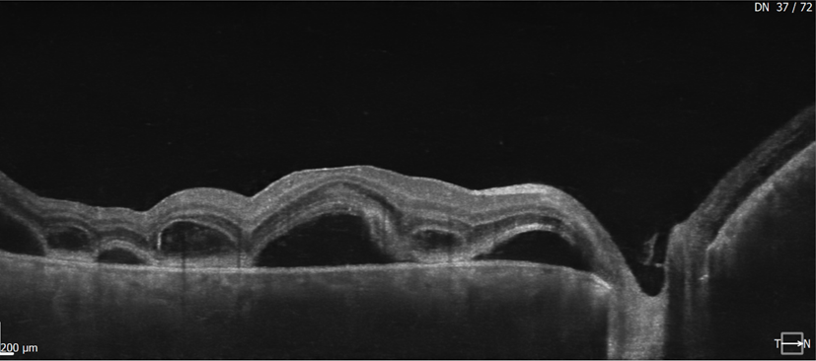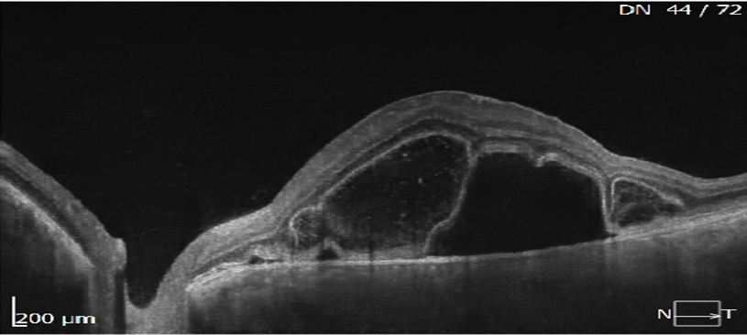
Figure 2 : SD-OCT showing the multilobulated serous retinal detachments

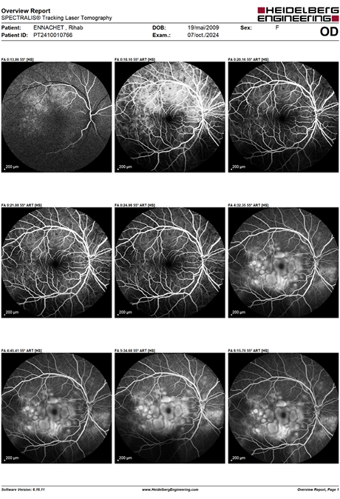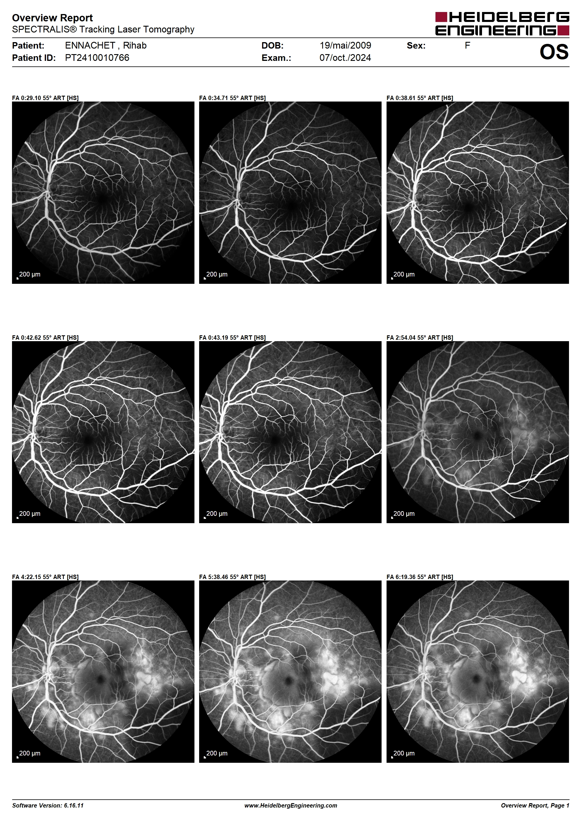
Figure 3: Fluorescein angiography showing the multiple pinpoint hyperfluorescent leaks in the early phase.

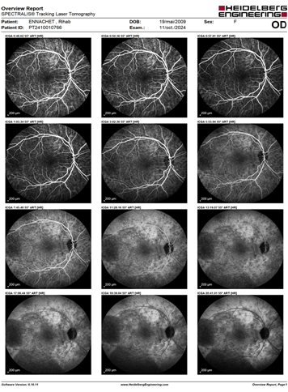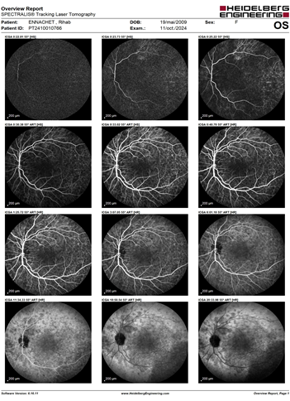
Figure 4: Indocyanine green angiography showed delayed choroidal filling and late hypocyanescent spots suggestive of choroidal inflammation

Extensive laboratory workup was conducted to exclude infectious and autoimmune etiologies, including tests for syphilis, tuberculosis, sarcoidosis, toxoplasmosis, and viral infections—all negative. Cerebrospinal fluid analysis showed normal cell count and protein levels, without pleocytosis. HLA typing identified positivity for HLA-DR4, supporting the diagnosis of VKH. Pure-tone audiometry revealed mild bilateral sensorineural hearing loss.
The patient was admitted and received intravenous methylprednisolone at 15 mg/kg/day for three consecutive days, followed by oral prednisolone at 1 mg/kg/day with calcium and potassium supplementation. Topical corticosteroids and cycloplegic drops were also administered. Visual acuity improved to 5/10 in the right eye and 8/10 in the left eye after one month. Follow-up OCT showed almost complete resolution of subretinal fluid and restoration of foveal contour (Figure5) . The corticosteroid dose was gradually tapered over three months without relapse.
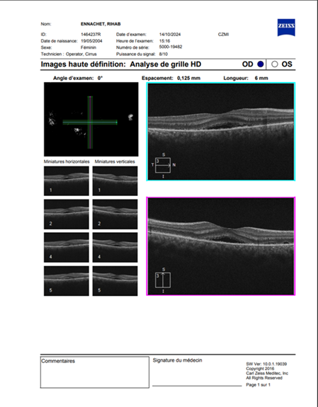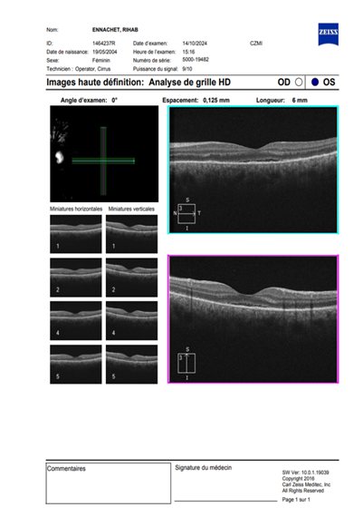
Figure 5: SD-OCT showed the resolution of subretinal fluid and restoration of foveal contour

Discussion
VKH disease represents a T-cell-mediated autoimmune response targeting melanocytes, leading to diffuse granulomatous inflammation of the uveal tract. The disease course is classically divided into four stages: prodromal, acute uveitic, convalescent, and chronic recurrent. Our case corresponds to the acute uveitic stage, manifesting exclusively as posterior segment involvement without anterior inflammation which makes our case atypical.
The atypical posterior form of VKH is rarely reported, particularly in children. Isolated posterior involvement may delay diagnosis, as initial symptoms—such as headache and visual loss—can mimic other choroidal or retinal pathologies. Differentiation from sympathetic ophthalmia is crucial; however, the absence of ocular trauma or surgery rules out this possibility. Posterior scleritis may also present with serous retinal detachment but is typically associated with scleral thickening on ultrasonography and pain on ocular movement, which were absent here.
Multimodal imaging plays a pivotal role in establishing the diagnosis. OCT demonstrates multilobulated serous detachment and disruption of the photoreceptor layers, while ICGA detects choroidal hypoperfusion and inflammatory foci even before fundoscopic signs appear. These findings are highly suggestive of VKH and help differentiate it from central serous chorioretinopathy, which shows focal leakage and no choroidal inflammation.
High-dose systemic corticosteroids remain the cornerstone of therapy, particularly when initiated early during the acute phase. Several studies have shown that prompt corticosteroid treatment reduces recurrence rates and prevents chronic depigmenting complications such as “sunset-glow” fundus. In refractory or recurrent cases, immunosuppressive agents such as azathioprine, cyclosporine, or mycophenolate mofetil may be added. Biologic therapies targeting TNF-alpha have also shown efficacy in resistant VKH.
Our patient responded favorably to systemic corticosteroids alone, highlighting the effectiveness of early aggressive treatment. The absence of recurrence during follow-up further supports the importance of early recognition and sustained corticosteroid tapering. Pediatric VKH cases, although rare, tend to have better outcomes when treatment is initiated before chronicity sets in.
This case contributes to the limited literature on isolated posterior atypical VKH presentations in children and underscores the value of multimodal imaging in differentiating it from mimicking conditions. Awareness among clinicians is essential, as early diagnosis can prevent irreversible vision loss and reduce systemic morbidity.

Conclusion
Isolated posterior atypical VKH syndrome is an uncommon but important diagnostic consideration in young patients presenting with bilateral exudative retinal detachments and headache. Early multimodal imaging, exclusion of infectious causes, and prompt initiation of corticosteroid therapy are critical for visual recovery. Long-term follow-up is recommended to monitor for recurrence and ensure complete disease resolution.
Consent
As per international standards, parental written consent has been collected and preserved by the author(s).

Disclaimer (Artificial intelligence)
Option 1:
Author(s) hereby declare that NO generative AI technologies such as Large Language Models (ChatGPT, COPILOT, etc.) and text-to-image generators have been used during the writing or editing of this manuscript.
Option 2:
Author(s) hereby declare that generative AI technologies such as Large Language Models, etc. have been used during the writing or editing of manuscripts. This explanation will include the name, version, model, and source of the generative AI technology and as well as all input prompts provided to the generative AI technology
Details of the AI usage are given below:
1.
2.
3.

References

- Moorthy RS, et al. Vogt-Koyanagi-Harada syndrome. Surv Ophthalmol. 1995;39(4):265-292.

- Read RW, et al. Revised diagnostic criteria for Vogt-Koyanagi-Harada disease. Am J Ophthalmol. 2001;131(5):647-652.

- Damico FM, et al. New insights into Vogt-Koyanagi-Harada disease. Arq Bras Oftalmol. 2009;72(3):413-420.

- Rao NA. Pathology of Vogt-Koyanagi-Harada disease. Int Ophthalmol. 2007;27(2-3):81-85.

- Yang P, et al. Clinical features and outcomes of Vogt-Koyanagi-Harada disease in Chinese patients. Ophthalmology. 2007;114(3):606-614.

- Du, L., Kijlstra, A., & Yang, P. (2016). Vogt-Koyanagi-Harada disease: novel insights into pathophysiology, diagnosis and treatment. Progress in retinal and eye research, 52, 84-111. https://pubmed.ncbi.nlm.nih.gov/26875727/
- Lavezzo MM, et al. Vogt-Koyanagi-Harada disease: review of a rare autoimmune disease targeting melanocytes. Orphanet J Rare Dis. 2016;11:29.

- Herbort CP, et al. Vogt-Koyanagi-Harada disease: diagnostic and therapeutic update. Ocul Immunol Inflamm. 2023;31(1):18-29.

- Baltmr, A., Lightman, S., & Tomkins-Netzer, O. (2016). Vogt–Koyanagi–Harada syndrome–current perspectives. Clinical Ophthalmology, 2345-2361. https://www.tandfonline.com/doi/abs/10.2147/OPTH.S94866

- Greco, A., Fusconi, M., Gallo, A., Turchetta, R., Marinelli, C., Macri, G. F., ... & de Vincentiis, M. (2013). Vogt–koyanagi–harada syndrome. Autoimmunity reviews, 12(11), 1033-1038. https://www.sciencedirect.com/science/article/pii/S1568997213000372

