Mixed Connective Tissue Disorder with Pulmonary Hypertension: A case report

ABSTRACT
Background:
First identified by Sharp et al. in 1972, Mixed Connective Tissue Disease (MCTD) is an autoimmune overlap syndrome that is typified by anti-U1RNP antibody positivity and symptoms of polymyositis, systemic lupus erythematosus, and systemic sclerosis.
Case Presentation:
A 39-year-old female presented with fever, limb and small joint pain, exertional dyspnea, bluish discoloration of fingers on cold exposure (Raynaud’s phenomenon), and dysphagia. Examination was unremarkable. Investigations revealed anemia (Hb 8.4 g/dL), thrombocytopenia (0.80 lakhs/cumm), elevated troponin-T (29.11 pg/mL), and CPK (255 IU/L). ECG showed poor R-wave progression with T-wave inversion (V1–V4), and echocardiography revealed dilated right chambers with severe tricuspid regurgitation and pulmonary hypertension. ANA and anti-U1RNP were positive, along with anti-Scl-70; skin biopsy showed sclerosis.
Discussion:
The patient fulfilled both Alarcón-Segovia and Kasukawa diagnostic criteria for MCTD based on serology and clinical findings. Cardiac and pulmonary involvement underscored the disease’s systemic nature.
Conclusion:
Early recognition of overlapping autoimmune features and serological markers is vital for timely diagnosis and management of MCTD to prevent life-threatening complications.
Keywords: MCTD, anti-U1RNP, Raynaud’s phenomenon, pulmonary hypertension, autoimmune overlap syndrome.

INTRODUCTION
Chronic inflammation mediated by the immune system is a characteristic that sets apart a class of acquired diseases called connective tissue disorders. In many diseases, immunological dysregulation results in autoreactive T cells or autoantibodies. Because the immune components target various organs throughout the body, they can produce a wide range of indications and symptoms ^{[1]}.
The autoimmune condition known as mixed connective tissue disorder was initially identified by Sharp et al. in 1972 as a disease syndrome that “shared characteristics with polymyositis, systemic sclerosis, and systemic lupus erythematosus (SLE)” ^{[2]}.
Mixed connective tissue disorder (MCTD) is an uncommon inflammatory autoimmune disease that resembles lupus, scleroderma, and polymyositis in some ways. Sjogren's syndrome and/or rheumatoid arthritis are common in people with MCTD.
The symptoms of various connective tissue disorders, which usually develop gradually rather than all at once, are included in the symptoms of MCTD. Fatigue, low-grade fever, joint and muscle pain, inflammation, Raynaud's phenomenon, and swollen, puffy fingers are some of the symptoms of MCTD.^{[3]}.
Causes of MCTD
The precise cause of mixed connective tissue disorder is unknown to researchers. Although some research suggests that people with a biological family history of connective tissue diseases may be more susceptible to the disease, it is not directly inherited. Another potential cause is exposure to specific viruses, chemicals, or materials, such as silica and polyvinyl chloride^{[3]}.
Risk factors for MCTD
Females in their 20s and 30s are most likely to experience MCTD. However, this illness can strike people of any age, including young ones.

Complications of MCTD include:
“Heart disease, kidney damage, digestive tract damage, anemia, hearing loss, nerve damage, pulmonary hypertension, and interstitial lung disease” ^{[3]}.

“MCTD is sometimes called an overlap disease. When patients first arrive, they frequently have nonspecific symptoms like swollen fingers, arthralgia, myalgia, muscle weakness, acid reflux or dysphagia, Raynaud's phenomenon, shortness of breath when moving, and general fatigue. As symptoms worsen and anti-U1RNP antibody titers rise, one or more of the three conditions becomes more prevalent. Mixed connective tissue illness is an autoimmune disease that disproportionately affects women and tends to run in families, though its exact cause is unknown. This rare illness has a wide range of presentations and no known cause, making diagnosis difficult” [4].

We found a case of MCTD with pulmonary hypertension in which the initial presentation was breathlessness, fever, and pain in the limbs and small joints.

Case Presentation
A 39-year-old female patient presented with chief complaints of fever, pain in limbs and small joints, with breathlessness on exertion, and the patient also gave a history of bluish discolouration of fingers when washing hands with cold water for 2 months, and dysphagia for one month.
On examination, her blood pressure was found to be normal, and she was moderately built and nourished. Systemic examination, such as CVS, CNS, RS, P/A, was normal.
On investigating her hemoglobin was 8.4g/dl with platlet count 0.80 lakhs/cumm, renal and liver function test were normal, troponin-T levels were raised (29.11pg/ml), and CPK levels of 255 IU/L and her ECG shows poor R wave progression, T-wave inversion in V1-V4 and two dimensional echocardiography shows dilated RA, RV with severe TR and severe pulmonary artery hypertension.
Serological examination showed that ANA screening was positive and ANA profile was anti-U1RNP positive, which has been considered as hallmark of MCTD, and anti-scl-70 was positive, with skin biopsy showing the features of sclerosis.
With a positive serology and two of the five clinical criteria—Raynaud's phenomenon and hand edema—our patient met the Alarcon-Segovia diagnostic criteria (Table 5). Along with the typical symptoms of Raynaud's phenomenon, edematous hands with positive serology, and mixed findings of dysphagia, scleroderma, and high CPK values, our patient also met the Kasuwaka diagnostic criteria (Table 4). This led to the diagnosis of MCTD.

Table 1: Treatment of the patient includes
Name of the drug | Frequency | Route | Dose
Inj Amoxiclav | 1-0-0 | IV | 1.2g
Inj Furosemide | 1-1-0 | IV | 20mg
Inj Pantoprazole | 1-0-0 | IV | 40mg
Tab Azathioprine | 1-0-0 | Po | 50mg
Tab HCQ | 1-0-1 | Po | 200mg
Tab Cholecalciferol | Weekly once | Po | 60k IU
Tab Calcium | 0-1-0 | Po | 500mg
Tab Paracetamol | 1-1-1 | Po | 500mg
Tab Tadalafil | 0-0-1 | Po | 10mg

The above treatment was followed for 5days, and then the patient was discharged after the 5th day with tab calcium OD, tab tadalafil 10mg OD, tab azathioprine 50mg, tab HCQ 200mg OD, and was advised to review in OPD after 15 days.

Table 2: Laboratory examination of the patient
Hb | 8.4 g/dL
TLC | 4080 cells/cumm
MCV | 87.4 fL
MCH | 25.3 pg
Platlet count | 0.80 lakh/cumm
Serum creatinine | 0.8 mg/dL
Total CPK | 255 IU/L
Troponin-T | 29.11pg/mL
CK-MB | 7.9 ng/mL

Table 3: Serological examinations of the patient
Antibody Name | Result Of The Patient
ANA | Positive
Scl-70 | Positive
ss-b | Negative
Pm-scl | negative
Anti-U1 RNP | Positive (high titer)
Jo-1 | Negative
ds-DNA | Negative
Anti-histone | Negative
AMA-M2 | Negative

Table 4: Kasukawa diagnostic criteria for mixed connective tissue disorder
- Common Symptoms
Raynauds phenomenon
Swollen fingers or hands
- Presence Of Anti-U1 RNP
- Mixed findings
A) Systemic lupus erythematosus (SLE) like
Polyarthritis
Pericarditis
Lymphadenopathy
Facial erythema
Leucopenia/thrombocytopenia
B) Scleroderma-Like
Sclrodactyly
Pulmonary fibrosis
Esophageal dysmotility
C) Polymyositis-Like
Muscle weakness
High creatine phosphokinase
Myopathic electromyogram (EMG)
Requirement for diagnosis: at least one common symptom, with positive U1RNP antibodies, and one or more findings in at least two of the three categories A, B, and C.

Table 5: Alarcon-Segovia diagnostic criteria for mixed connective tissue disorder
Serologic criteria | Positive anti-U1 RNP at hemagglutination titer >1:1600
Clinical criteria | Edema of the hands  Synovitis  Myositis  Raynauds  Acrosclerosis

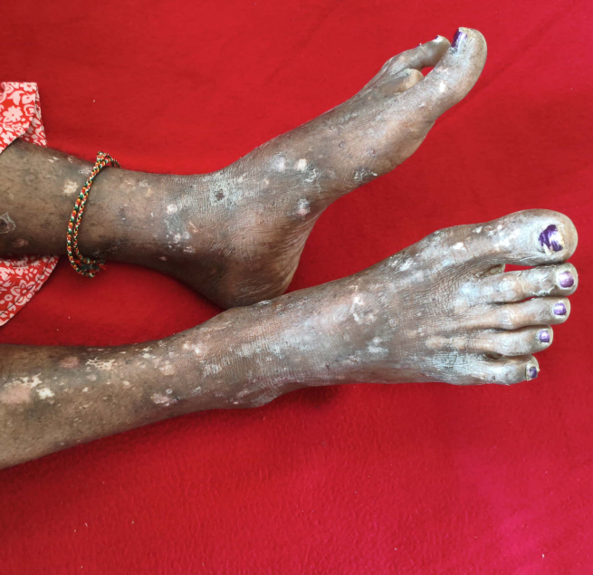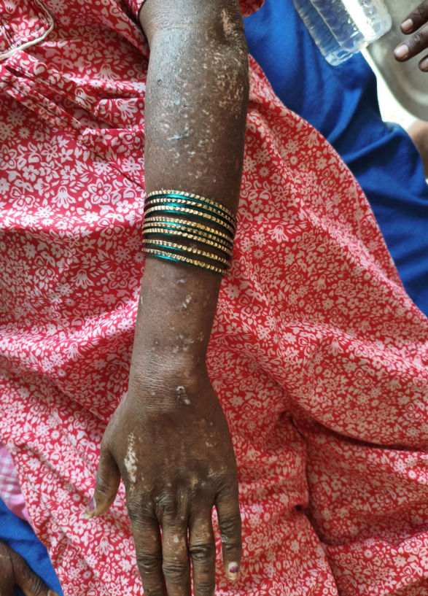
FIG 1: Cutaneous manifestations in a patient with mixed connective tissue disorder demonstrating multiple hypo-pigmented macules and plaques distributed over the extensor aspects of the forearms and legs consistent with scleroderma like skin changes.

DISCUSSION
The initial history of Raynaud's phenomenon, which included generalized swelling and dysphagia, as well as physical examinations like acrosclerosis, guided our laboratory and radiologic workup and ultimately helped us make the diagnosis.

In 1972, Sharp and colleagues established the idea of mixed connective disease as a distinct immune-mediated connective tissue disease^{[4]}.
Although the cause of MCTD is uncertain, a small number of instances have been documented following vinyl chloride exposure and even following breast augmentation procedures^{[5]}. There are known cases of MCTD with higher HLADR 4 instances in comparison to controls.

A 2011 Norwegian study found that the annual incidence of MCTD in adults was 2.1 per million, with a prevalence of 3.8 per 100,000^{[6]}.The mean age of onset was 31.9 years, and more than three-quarters of the patients were female.^{[7]}. This validates a forecast for female sex and the disease's rarity.
MCTD should be kept as a differential diagnosis when symptoms of autoimmune diseases, such as swollen fingers, arthritis, myalgia, or muscle weakness, as well as Raynaud's phenomenon, acid reflex or dysphagia, and shortness of breath during activity, overlap. MCTD can be classified using a variety of criteria. The Alacron-Segovia criteria are listed in Table 5, and the Kasukawa diagnostic criteria are listed in Table 4. ^{[8]}.

Our patient satisfied the Alarcon-Segovia diagnostic criteria with a positive serology and two of the five clinical criteria: Raymaud's phenomenon, hand edoema, and myositis, as demonstrated by a serum CPK value of 255 IU/l.
Along with the usual symptoms of Raynaud's phenomenon, such as edematous hands with positive serology, our patient also met the Kasukawa diagnostic criteria, showing mixed results for dysphagia, scleroderma, and high cpk values. Few of those patients have symptoms, even though many people may have abnormal lung function tests, especially the single breath diffusion capacity. Since pulmonary artery hypertension, the presenting complaint, is unusual in early mctd, our patient experienced dyspnea in the interim.^{[9]}. Yet, two-dimensional echocardiography revealed that our patient had pulmonary artery hypertension.
The two most prevalent renal symptoms are mesangial proliferation and membranous glomerulopathy; diffuse proliferative glomerulonephritis and vascular or glomerular sclerosis are less frequent^{[10]}. Renal function test and urine examination were both normal.
MCTD would be treated with a mix of drugs, such as immunosuppressants like azathioprine, steroids like prednisolone, COX 2 inhibitors like celecoxib, NSAIDS like naproxen, and antimalarials like HCQ. Calcium channel blockers like nifedipine, nitrates like nitroglycerin, and angiotensin receptor blockers like losartan are used to treat Raynaud's phenomenon. Our patient was prescribed an immunosuppressant (azathioprine) and an antimalarial (HCQ) for pulmonary artery hypertension. Therefore, “two different people with the same disease but different clinical manifestations will require different management”.^{[11]}.

CONCLUSION
A rare inflammatory autoimmune disease, mixed connective tissue disorder (MCTD) shares symptoms and indicators with lupus, sclerodermsa, and polymyositis, among other conditions. Rheumatoid arthritis and/or Sjogren's syndrome are common in people with MCTD.A 2011 Norwegian study found that over three-quarters of patients were female, and the prevalence of MCTD in adults was 3.8 per 100,000 with an annual incidence of 2.1 per million.MCTD should be considered as a differential diagnosis when symptoms of autoimmune diseases overlap. The most often used diagnostic criteria for MCTD are the Kasukawa and Alarcon-Segovias criteria. A high titer positive serology for anti-U1RNP is a hallmark of MCTD. MCTD is an autoimmune condition, so there isn't a universal treatment; rather, it is managed according to the symptoms of each patient. For example, antimalarial medications and immunosuppressants may be utilized for MCTD treatment, calcium channel blockers and nitrates can address Raynaud's phenomenon, while NSAIDs can help alleviate pain. Vasodilators like sildenafil and tadalafil are utilized for managing pulmonary artery hypertension, which is less frequent in its initial phases

Consent
As per international standards or university standards, patient(s) written consent has been collected and preserved by the author(s).
Disclaimer (Artificial intelligence)
OPTION 1: The authors hereby declare that no generative Artificial Intelligence (AI) technologies, including text-to-image generators or large language models (e.g., ChatGPT, Copilot, etc.), were used in the data analysis, writing, or editing of this manuscript. All of the content was created by the author or authors using their own knowledge, which was backed up by pertinent references and literature.

REFERENCE
- Kumar TS, Aggarwal A. Approach to a patient with connective tissue disease. The Indian Journal of Pediatrics. 2010 Oct;77(10):1157-64.
- Sharp GC, Irvin WS, May CM, Holman HR, McDuffie FC, Hess EV, Schmid FR. Association of antibodies to ribonucleoprotein and Sm antigens with mixed connective-tissue disease, systemic lupus erythematosus and other rheumatic diseases. New England Journal of Medicine. 1976 Nov 18;295(21):1149-54.
- https://my.clevelandclinic.org/health/diseases/15039-mixed-connective-tissue-disease
- Gunnarsson R, Molberg Ø, Gilboe IM, Gran JT, PAHNOR1 Study Group. The prevalence and incidence of mixed connective tissue disease: a national multicentre survey of Norwegian patients. Annals of the rheumatic diseases. 2011 Jun 1;70(6):1047-51.
- Sunil P, Swathi H, Kauser M, Marulasreshta GD, Kumar SR, Prashanth G. Mixed Connective Tissue Disorder: A Rare Case Report. International Journal of Preclinical & Clinical Research. 2022 Dec 13;3(3):74-.
- Katewa R, Jakhar RS, Barala GL. Mixed connective tissue disorder: a case report. International Journal of Case Reports and Images (IJCRI). 2014 Sep 1;5(9):650-5.
- Hench PK, Edgington TS, Tan EM. EVOLVING CLINICAL SPECTRUM OF MIXED CONNECTIVE-TISSUE DISEASE (MCTD). InArthritis and Rheumatism 1975 Jan 1 (Vol. 18, No. 4, pp. 404-404). 227 EAST WASHINGTON SQ, PHILADELPHIA, PA 19106: LIPPINCOTT-RAVEN PUBL.
- Alarcon-Segovia D, Cardiel MH. Comparison between 3 diagnostic criteria for mixed connective tissue disease. Study of 593 patients. The Journal of rheumatology. 1989 Mar 1;16(3):328-34.
- Haroon N, Nisha RS, Chandran V, Bharadwaj A. Pulmonary hypertension not a major feature of early mixed connective tissue disease: A prospective clinicoserological study. Journal of Postgraduate Medicine. 2005 Apr 1;51(2):104-8.
- Maldonado ME, Perez M, Pignac-Kobinger J, Marx ET, Tozman EM, Greidinger EL, Hoffman RW. Clinical and immunologic manifestations of mixed connective tissue disease in a Miami population compared to a Midwestern US Caucasian population. The Journal of rheumatology. 2008 Mar 1;35(3):429-37.
- Maldonado ME, Perez M, Pignac-Kobinger J, Marx ET, Tozman EM, Greidinger EL, Hoffman RW. Clinical and immunologic manifestations of mixed connective tissue disease in a Miami population compared to a Midwestern US Caucasian population. The Journal of rheumatology. 2008 Mar 1;35(3):429-37.

