A clinical comprehensive analysis of the correlation between decompensated Chronic Liver Disease in Portal Hypertensive Gastropathy and Diabetic Nephropathy

Abstract
This is a case report of a 48-year-old male who presented with decompensated chronic liver disease, complicated by portal hypertensive gastropathy, diabetic nephropathy, and chronic kidney disease. He presented with symptoms of vomiting, fever, low urine output, and impairment of the liver and kidneys. Ultrasound showed liver congestion with ascites; endoscopy revealed Grade II oesophageal varices and portal gastropathy. Thereafter, he tested positive for Hepatitis C infection and therefore had a viral aetiology for liver disease. He was treated with antibiotics, insulin, pantoprazole, and medications for liver protection. Propranolol and midodrine are used to manage portal pressure and blood pressure, respectively. Drotaverine is used to alleviate abdominal pain. This case represents the interaction of liver, kidney, and metabolic disorders. It requires using appropriate drugs with cautious dosage to avoid toxicity. In such complex cases, the role of a pharmacist is crucial for safe and effective therapy.

Keywords: Hypotension, Diabetic Neuropathy, Portal Hypertensive Gastropathy, Chronic Kidney Disease

Introduction
Portal hypertensive gastropathy (PHG) is a cirrhotic or non-cirrhotic portal hypertensive complication. PHG is a significant condition as it may cause acute (and even massive) or occult blood loss. It is endoscopically defined as a classically described mucosal abnormality having a mosaic-like appearance, like the snake skin, with or without erythema. These lesions have been described earlier as inflammatory or erosive and considered to be a type of gastritis in cirrhotic and portal-hypertensive patients [1]. The pathophysiology of PHG involves dilatation and congestion of gastric wall capillaries and submucosal veins due to increased portal hypertension pressure and reduced mucosal perfusion. These vascular changes disrupt the mucosa's integrity, making it susceptible to haemorrhage [2]. PHG is said to be found in 20-80% of patients with portal hypertension and is more frequent in decompensated cirrhotic patients. Decompensated cirrhosis is an advanced stage of liver disease with the development of clinically apparent complications such as oesophageal or gastric varices, ascites, spontaneous bacterial peritonitis, hepatic encephalopathy, and coagulopathy [3]. The development of PHG also contributes to the risk of upper GI bleeding, besides the already compromised hemodynamic status of such patients [4]. Comorbid CKD and type 2 DM complicate the treatment of decompensated CLD. Diabetic nephropathy leads to end-stage renal failure with worsening renal function, affecting drug clearance and metabolism, and the patient is at risk for nephrotoxicity [5]. CKD influences the pharmacokinetics of medications, necessitating dose adjustments [6]. Antibiotics, diuretics, and other agents should be used cautiously. In addition, metabolic disturbances and insulin resistance of DM can exacerbate hepatic fibrosis and steatosis, thereby accelerating the development of CLD. [7]. Hepatorenal dysfunction has also been reported to be concomitant and developing a global disease called the hepatorenal–metabolic axis, being a part of the therapeutic challenge, but more particularly concerning maximisation of drug therapy and anticipation of side effects induced by drugs [8]. The case is presented to demonstrate the clinical, diagnostic, and pharmacotherapeutic challenge of managing a patient with decompensated chronic liver disease complicated by portal hypertensive gastropathy, diabetic nephropathy, and chronic kidney disease. It emphasises the need for well-coordinated multidisciplinary care, with specific attention to the pharmacist's role in ensuring safe, individualised, and effective treatment for the patient in the context of multi-organ dysfunction. This manuscript is essential to the scientific community because it presents a sporadic case linking liver, kidney, and metabolic disorders. It discusses the clinical and pharmacological challenges in managing such patients. The case illustrates the hepatorenal–metabolic relationship in advanced disease. It emphasises the importance of multidisciplinary management and judicious use of drugs. The role of the clinical pharmacist is well highlighted in ensuring safe and effective therapy.

Case Presentation
A 48-year-old male patient from Village Jhanda Bagga, Ferozepur District, with type 2 diabetes mellitus and secondary diabetic nephropathy secondary to chronic kidney disease, was admitted on October 1, 2025, in the medicine ward. The patient was a long-time tobacco and alcohol user. He was brought to the clinic with a history of decreased urine output for one day, two days of continuous vomiting, and intermittent high-grade fever lasting for 10–15 days with associated rigours and chills. In addition, black stools, a sign of gastrointestinal bleeding, along with diffuse weakness, poor oral intake, and increased fatigue, were also present. All these necessitated admission for assessment and treatment. The patient was an established case of type 2 diabetes mellitus (T2DM) for the past 2 years and was insulin-treated for sugar level management. He had chronic kidney disease (CKD), which was likely secondary to diabetic nephropathy, with increasingly deteriorating renal function over the years. Ischemic heart disease, bronchial asthma, or tuberculosis were never reported in the past. His past medical history included chronic alcohol consumption for more than 10 years, with daily consumption of local alcoholic drinks, and frequent consumption of tobacco, both of which are classic risk factors for liver injury. There was no history of illicit or hepatotoxic drug abuse by the patient. His family history was not significant for diabetes, hypertension, or liver disease. An ultrasonogram of the abdomen revealed coarse hepatic echotexture with a slightly irregular edge of the liver, as in chronic parenchymal liver disease. There was splenomegaly and moderate volume ascites, as in portal hypertension and decompensated liver disease [9]. The portal vein was patent without focal intrahepatic bile dilatation. The gallbladder was partially filled, with normal wall thickness and no calculi present. The two kidneys were bilaterally enlarged, with cortical echogenicity and thin corticomedullary differentiation, typical of diabetic nephropathy and chronic kidney disease. The urinary bladder was minimally distended without evidence of calculi or hydronephrosis. Haematological abnormalities included anaemia (haemoglobin 8.9 g/dL) and mild leukocytosis (WBC 12.8 × 10³/µL), but a normal platelet count. The liver function tests revealed elevated total bilirubin (2.8 mg/dL; direct 1.6 mg/dL), elevated transaminases (AST 55 U/L, ALT 62 U/L), and low albumin, all consistent with liver injury as seen in chronic liver disease. Renal function tests showed significant increases in urea (102 mg/dL) and serum creatinine (6.6 mg/dL), consistent with acute renal failure complicating chronic renal disease. It was experiencing hyponatremia (Na 131 mmol/L), mild hyperkalemia (K 5.0 mmol/L), and decreased chloride (Cl 96 mmol/L) [10]. Arterial blood gas was in keeping with mild respiratory alkalosis (pH 7.45, pCO₂ 29.2 mmHg) and normal oxygenation. Inflammatory markers were indicated by an elevated C-reactive protein of 47.6 mg/L, while a procalcitonin level of 0.45 ng/mL was not inappropriately elevated to rule out a serious bacterial infection. Serology confirmed Hepatitis C virus infection by HCV Tridot positivity and elevated viral load (HCV RNA 1.47 × 10⁶ IU/mL; 6.17 log IU/mL) on quantitative PCR, establishing active viral replication as the aetiology of liver disease [12]. Urine analysis showed proteinuria (2–3+), numerous pus cells (20–35 / hpf), and occasional RBCs, highlighting diabetic nephropathy with possible urinary infection. Ultrasonography of the abdomen revealed coarse hepatic echotexture with ill-defined margins, splenomegaly, and moderate ascites in keeping with portal hypertension and decompensated chronic liver disease. The kidneys were hyperechoic and enlarged with impaired corticomedullary differentiation in keeping with chronic diabetic nephropathy. Upper gastroscopy done on 7 October 2025 was reported to reveal Grade II oesophageal varices and portal hypertensive gastropathy, absolute evidence of clinically significant portal hypertension as a decompensated liver disease complication. He was started on cefoperazone 1 g IV twice a day as broad-spectrum antibiotic prophylaxis against or control of spontaneous bacterial peritonitis and sepsis. Inj. Human insulin (14-14-14 units subcutaneously) was also administered on a sliding scale for glycemic control. Pantoprazole 40 mg IV once a day was given for acid suppression and prevention of gastrointestinal bleeding. Intravenous normal saline at 60 mL/hr was continued for hydration and correction of electrolyte imbalance. Hepatoprotective and adjuvant treatment was Tab. Udihep-D (silymarin + ursodeoxycholic acid) daily once and Tab. Bacstun-DS (rifaximin) twice a day to inhibit ammonia-forming gut bacteria and prevent hepatic encephalopathy. Tab. Ultoford-SR 500 mg at bedtime once a day and Syp. Cuminific Plus 30 mL at night was given as an ancillary supplement to hepatic and metabolic functions. Treatment of portal hypertension and to prevent variceal bleed was done with Tab. Ciplar-LA 40 mg/day (propranolol) was initiated. For symptom control of orthostatic hypotension and renal perfusion, Tab. Midodrine 2.5 t.d.s. was initiated. For abdominal pain and smooth muscle spasm due to hepatic congestion and ascites, Inj. Drotin (drotaverine) was administered twice daily as an antispasmodic. For abdominal pain and smooth muscle spasm due to hepatic congestion and ascites, Inj. Drotin (drotaverine) was administered twice daily as an antispasmodic. Serial renal function tests, urine output, and fluid status were monitored closely in the patient. Dietary recommendation with a high-protein, low-sodium diet and alcohol abstinence was strongly advised.
Discussion
This case shows the pharmacotherapeutic and clinical complexity of managing a patient with decompensated CLD complicated by portal hypertensive gastropathy, diabetic nephropathy, and CKD. Portal hypertensive gastropathy is a microvascular complication of portal hypertension in end-stage CLD. Pathophysiology involves increased portal venous pressure, leading to gastric mucosal capillary and venular congestion and dilatation. This leads to the "snake-skin" or mosaic endoscopic pattern [1]. Unlike variceal haemorrhage from rupture of dilated oesophageal or stomach submucosal veins and presentation in a traditional manner as acute massive haematemesis, bleeding in PHG is slow, diffuse, and chronic. It is more commonly presented as iron-deficiency anaemia rather than acute haematemesis. The concomitant hepatic, renal, and metabolic impairment in this patient specifies the interconnection known as the hepatorenal–metabolic axis. Systemic vasodilation and reduced adequate circulatory volume in severe liver disease lead to renal hypoperfusion and activation of the renin-angiotensin-aldosterone system, thereby contributing to hepatorenal dysfunction. Type 2 diabetes mellitus, a chronic disease, also contributes to the cause of glomerulosclerosis, endothelial damage and potentiation of renal damage. The additive effect is responsible for altered pharmacokinetics in the majority of drugs due to reduced hepatic metabolism and renal clearance, necessitating careful dose adjustment and therapeutic monitoring. Pharmacologic treatment of such patients should be individualised. Prophylactic antibiotics (e.g., cefoperazone) were used judiciously to prevent infection-induced decompensation, but need tracking due to their partial hepatic metabolism [11]. Pantoprazole was appropriately used for gastroprotection in PHG.
In contrast, non-selective beta-blockers (propranolol) remain the gold standard for reducing portal hypertension and preventing variceal bleeding by reducing portal venous inflow [12]. Insulin therapy was adjusted to obtain glycemic control since part of the oral hypoglycemics is contraindicated in hepatic and renal failure. Drotaverine is effective for the symptomatic relief of smooth muscle spasm, undergoes minimal hepatic metabolism, and has less toxicity than anticholinergics. Ursodeoxycholic acid (Udihep) and rifaximin contributed significantly to hepatoprotection and prophylaxis against hepatic encephalopathy. In CKD and CLD, drug dosage needs to be adjusted for drugs that are either excreted (e.g., diuretics, antibiotics, insulin) or metabolised by the liver. Nephrotoxic agents such as NSAIDs, aminoglycosides, and contrast media should be strictly avoided [13]. Similarly, hepatotoxic agents (e.g., paracetamol at excessive doses, specific antivirals) should be used with caution. Where anaemia is a secondary finding of chronic bleeding from PHG, oral or intravenous iron is a consideration with close monitoring for tolerance, particularly in patients with impaired renal clearance. Several case series reported in the literature support this. For instance, Simbrunner et al. (2020) described a case of portal hypertensive gastropathy and chronic anaemia in decompensated HCV cirrhosis, which was managed successfully with beta-blockers and iron repletion [14]. Kumar et al. (2021) also described how chronic renal dysfunction in cirrhosis represents a key component of the hepatorenal spectrum, underscoring the interplay between renal and hepatic systems [15]. The hospital pharmacist here plays a key role in maximising treatment, preventing drug-related complications, and monitoring patient compliance. Pharmacists can modify the dose according to renal and hepatic function, check for drug interactions, and educate patients regarding restriction of dietary sodium, abstinence from alcohol intake, and compliance with prolonged HCV therapy. Regular follow-up and counselling also prevent decompensation recurrence and hospital readmission.
Conclusion
This case demonstrated the clinical severity of the treatment of portal hypertensive gastropathy in a decompensated patient of chronic liver disease with diabetic nephropathy and chronic kidney disease. A multidisciplinary treatment approach, incorporating medical, nutritional, and pharmacological interventions, should be used to manage it effectively. The pharmacist's role is pivotal in maximizing drug therapy to an optimum degree, preventing complications, and ensuring safety.

Consent

As per international standards or university standards, patient(s) written consent has been collected and preserved by the author(s).

Disclaimer (Artificial intelligence)
The author (s) hereby declare that generative AI technologies, such as Large Language Models, etc., have been used during the writing or editing of manuscripts. This explanation will include the name, version, model, and source of the generative AI technology, as well as all input prompts provided to it.
Details of the AI usage are given below:
1. ChatGPT
2. GPT-5
3. Purpose of us: for language editing, grammar correction, and improving the clarity of sentences. No part of the case study was generated without author verification, and all content was reviewed and approved by the authors.

References
- Gjeorgjievski, M., & Cappell, M. S. (2016). Portal hypertensive gastropathy: A systematic review of the pathophysiology, clinical presentation, natural history and therapy. World Journal of Hepatology, 8(4), 231. https://doi.org/10.4254/wjh.v8.i4.231
- Cubillas R, Rockey DC. Portal hypertensive gastropathy: a review. Liver International 2010;30:1094–102. https://doi.org/10.1111/J.1478-3231.2010.02286.X.
- D’Amico G, Bernardi M, Angeli P. Corrigendum to ‘Towards a new definition of decompensated cirrhosis’ [J Hepatol 76 (2022) 202–207] (Journal of Hepatology (2022) 76(1) (202–207), (S0168827821004384), (10.1016/j.jhep.2021.06.018)). J Hepatol 2022;76:757. https://doi.org/10.1016/j.jhep.2021.12.023.
- Antunes, C., Tian, C., & Copelin II, E. L. (2024). Upper Gastrointestinal Bleeding. In StatPearls. StatPearls Publishing.
- Dabla PK. Renal function in diabetic nephropathy. World J Diabetes 2010;1:48. https://doi.org/10.4239/WJD.V1.I2.48.
- Kyriakopoulos, C., & Gupta, V. (2024). Renal Failure Drug Dose Adjustments. In StatPearls. StatPearls Publishing.
- Zhang W, Song WJ, Chen W, Pan Z, Zhang J, Fan L, et al. Metabolic dysfunction-associated steatotic liver disease-related hepatic fibrosis increases risk of insulin resistance, type 2 diabetes, and chronic kidney disease. Eur J Gastroenterol Hepatol 2024;36:802–10. https://doi.org/10.1097/MEG.0000000000002767.
- Bucsics T, Krones E. Renal dysfunction in cirrhosis: acute kidney injury and the hepatorenal syndrome. Gastroenterol Rep (Oxf) 2017;5:127–37. https://doi.org/10.1093/GASTRO/GOX009.
- Rosselli M, Roccarina D, Grgurevic I. Ultrasound in Chronic Liver Disease. Liver Ultrasound: From Basics to Advanced Applications 2024:124–55. https://doi.org/10.1002/9781119612650.CH8.
- Thapa BR, Walia A. Liver function tests and their interpretation. Indian J Pediatr 2007;74:663–71. https://doi.org/10.1007/S12098-007-0118-7/METRICS.
- Zoratti C, Moretti R, Rebuzzi L, Albergati IV, Di Somma A, Decorti G, et al. Antibiotics and Liver Cirrhosis: What the Physicians Need to Know. Antibiotics 2022, Vol 11, Page 31 2021;11:31. https://doi.org/10.3390/ANTIBIOTICS11010031.
- Turco L, Reiberger T, Vitale G, La Mura V. Carvedilol as the new non-selective beta-blocker of choice in patients with cirrhosis and portal hypertension. Liver International 2023;43:1183–94. https://doi.org/10.1111/LIV.15559.
- Morano JP, Zelenev A, Lombard A, Marcus R, Gibson BA, Altice FL. Strategies for Hepatitis C Testing and Linkage to Care for Vulnerable Populations: Point-of-Care and Standard HCV Testing in a Mobile Medical Clinic. J Community Health 2014;39:922–34. https://doi.org/10.1007/S10900-014-9932-9/METRICS.
- Simbrunner B, Marculescu R, Scheiner B, Schwabl P, Bucsics T, Stadlmann A, et al. Non-invasive detection of portal hypertension by enhanced liver fibrosis score in patients with different aetiologies of advanced chronic liver disease. Liver Int 2020;40:1713–24. https://doi.org/10.1111/LIV.14498.
- Kumar R, Priyadarshi RN, Anand U. Chronic renal dysfunction in cirrhosis: A new frontier in hepatology. World J Gastroenterol 2021;27:990–1005. https://doi.org/10.3748/WJG.V27.I11.990.

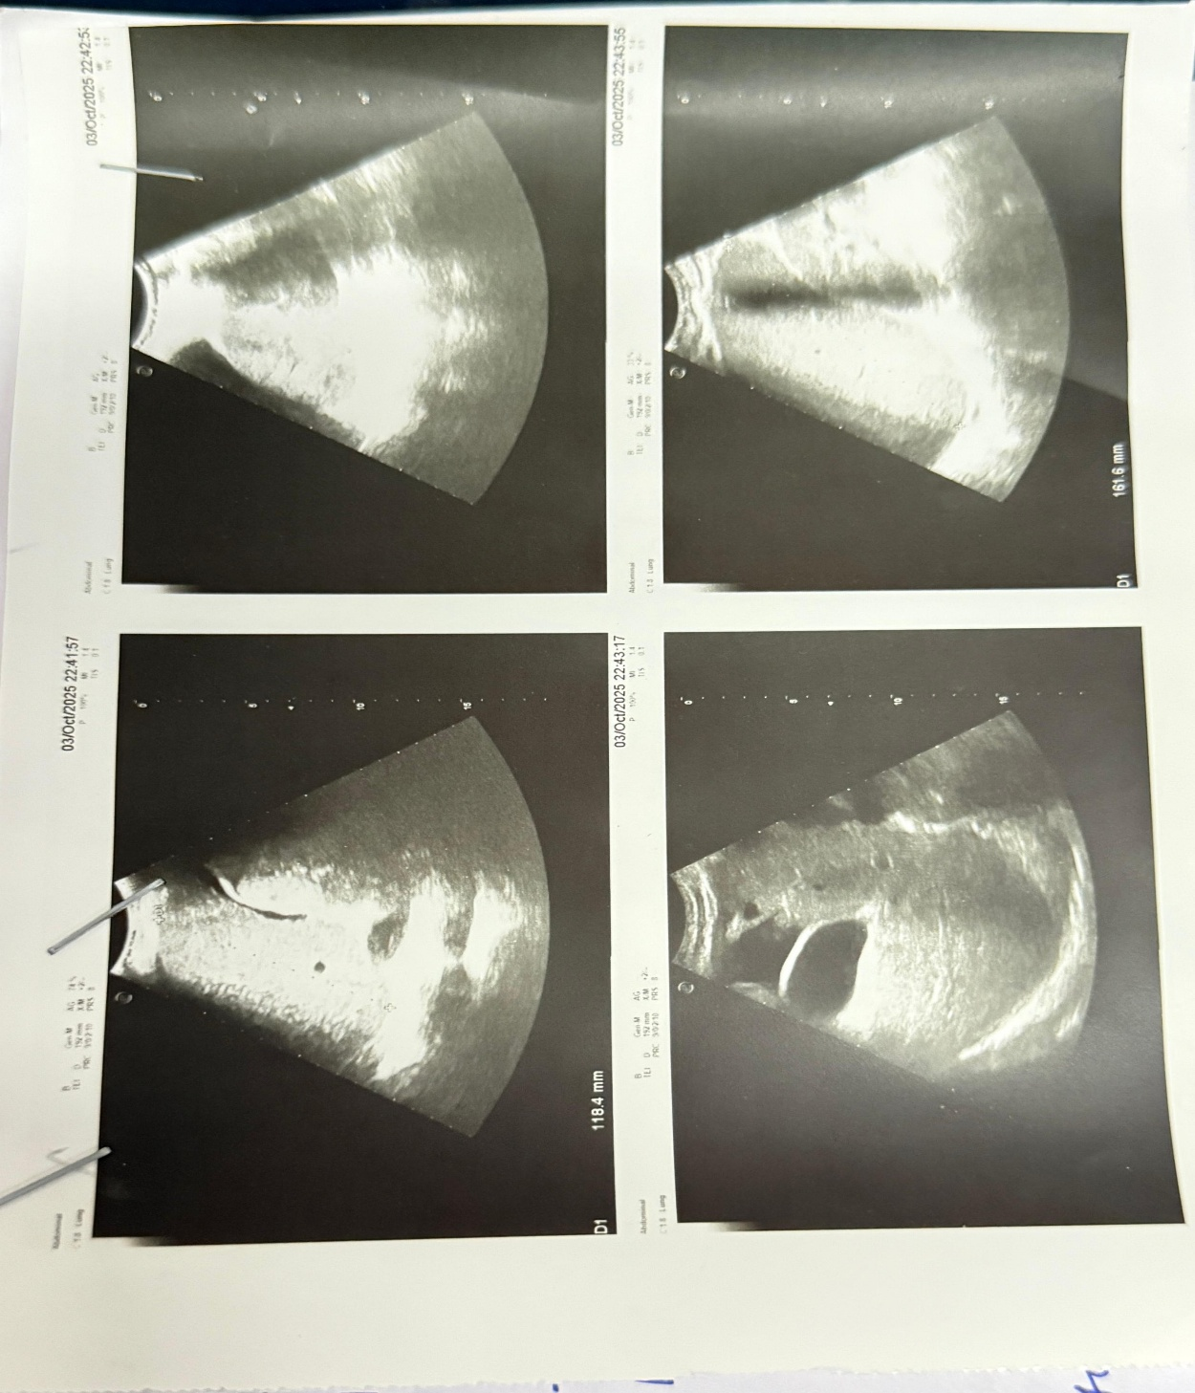
Fig. .1 Abdominal Ultrasound Images

