Assessing of Impacts of Climate Change on Sea-Level Rise and Shoreline Evolution Case of the East Coast of Cotonou in Benin, West Africa

ABSTRACT
Climate-change-induced sea level rise (SLR) poses a critical threat to coastal zones worldwide, with heightened impacts in low-lying, rapidly urbanizing regions. The East Coast of Cotonou, in Benin, is a hotspot of vulnerability, where the rapid retreat of the shoreline intersects with dense settlements, critical infrastructure, and socioeconomic pressures. This study investigates the multidecadal dynamics and their socioecological implications by integrating global datasets, standardized analytical tools, and field-based evidence using a triangular methods approach. A systematic review of the literature using PRISMA guidelines synthesized global and regional knowledge on SLR, shoreline change, and coastal vulnerability, highlighting significant gaps in localized assessments for West Africa. Satellite altimetry and tide gauge data were analyzed to assess global and relative sea level trends, while Landsat-derived shoreline positions were processed using the Digital Shoreline Analysis System (DSAS) to calculate linear regression and endpoint rates, uncertainties and identify erosion hotspots. These remote sensing and statistical results were validated through detailed field surveys along the eastern shoreline, including beach profiling, GPS mapping, and community interviews. The results indicate a persistent SLR trend averaging 3.4 mm / year in the Gulf of Guinea, consistent with global acceleration patterns. Shoreline analysis revealed average erosion rates of –3 to -5 m / year from 1985 to 2020, with localized hotspots exceeding -7 m / year, particularly near Akpakpa and east of the Cotonou port. Field observations confirmed significant beach narrowing, infrastructure loss, and adaptive responses. Socioeconomic participation highlighted disparities in coping strategies, declining fish and agricultural productivity, and governance gaps in coordinated coastal adaptation. The study concludes that the eastern coastline is undergoing rapid erosion driven by the interplay of global SLR, regional hydrodynamics, and local anthropogenic pressures, producing profound socioecological consequences. The recommendations emphasize the urgent need for integrated, context-specific adaptation strategies: (i) strengthening the coastal protection infrastructure in hotspot zones, (ii) regulating sand mining and other anthropogenic activities, (iii) promoting community-based adaptation and relocation planning, and (iv) improving governance frameworks to support equitable, sustainable coastal management. By linking global climate processes with local realities, this research provides actionable evidence to guide resilience building and policy development in coastal contexts in West Africa.
Keywords: Climate change, sea level rise, threat to coastal zones, SLR trend, adaptation strategies

INTRODUCTION
Climate change is among the most urgent and complex environmental challenges of the 21st century, with its impacts becoming increasingly visible across terrestrial and marine systems. Sea-level rise (SLR) is among the most critical consequences of this phenomenon due to its profound and long-lasting implications for coastal populations, ecosystems, and economic activities. The issue is particularly acute in low-lying and rapidly urbanizing coastal regions where natural processes interact with human pressures, thereby accelerating shoreline erosion, flooding, and ecosystem degradation. Global assessments indicate that global mean sea level (GMSL) has increased by more than 20 cm since the early twentieth century, with a marked acceleration from the late twentieth century onward. Current rates exceed 3.5 mm per year, primarily driven by ocean thermal expansion and the melting of glaciers and ice sheets (Cazenave et al., 2018; Nerem et al., 2018; IPCC, 2021). Projections under high-emission scenarios suggest continued acceleration, with potential increases surpassing one meter by 2100 (Vousdoukas et al., 2023). Such trends are of particular concern given that almost 40% of the world’s population resides within 100 km of the coast (Neumann et al., 2015). Within this global picture, West Africa is widely recognized as a coastal ‘hotspot’ characterized by high exposure to SLR, low adaptive capacity, and limited availability of integrated observational data. Rapid demographic growth, unplanned urban expansion, and fragile ecosystems amplify vulnerability to coastal hazards. In Benin, the East Coast of Cotonou has emerged as a critical area of concern. Accelerated shoreline retreat threatens essential infrastructure, residential settlements, and local livelihoods, compounding already significant socioeconomic vulnerabilities. However, despite the urgency of the situation, systematic and localized studies remain limited. This gap hampers effective coastal planning and the development of evidence-based adaptation strategies. Substantial scientific progress has been made in characterizing the dynamics of sea level and shoreline change. Satellite altimetry and tide gauge analyzes have improved understanding of GMSL and relative sea-level variability (Cazenave et al., 2018; Nerem et al., 2018). Multidecadal shoreline datasets derived from Landsat archives have provided insight into global patterns of coastal retreat and accretion (Luijendijk et al., 2018). Analytical tools such as the Digital Shoreline Analysis System (DSAS) offer standardized methodologies to estimate shoreline change rates, uncertainties, and erosion hotspots (Thieler et al., 2009). More recent regional studies have modeled projected coastal risks in Africa under combined climate and development scenarios (Vousdoukas et al., 2023; Ndehedehe et al., 2021). However, despite their value, these efforts remain limited in several respects: (i) they often lack local validation through field measurements; (ii) they fail to adequately account for the combined effects of global drivers (e.g., sea-level rise) and local anthropogenic pressures (e.g., port construction, sand mining); and (iii) they rarely translate findings into context-specific adaptation strategies. This research seeks to fill this gap by adopting a triangular-method approach that integrates global datasets, standardized shoreline analytics, and field-based evidence. First, a systematic review of the literature under the PRISMA guidelines ensures a transparent and rigorous synthesis of existing knowledge. Second, satellite altimetry and tide gauge records are combined to assess GMSL and relative sea level trends in West Africa. Third, Landsat-based shoreline datasets are analyzed and DSAS is used to compute linear regression and endpoint rates, uncertainties and identify erosion hotspots. Finally, these analyses are validated and complemented by detailed field observations along the east coast of Cotonou, thereby bridging the global-to-local scale gap. The objectives of this study are fourfold: (i) to quantify the multidecadal evolution of the Cotonou shoreline under the combined influence of climate-induced SLR and anthropogenic activities; (ii) to identify and characterize erosion hotspots and their drivers; (iii) to evaluate the compounded risks arising from global climatic trends and local human pressures; and (iv) to propose evidence-based, context-specific adaptation strategies that improve coastal resilience in West Africa. By integrating global science with local realities, this research contributes to the broader agenda of climate adaptation, sustainable coastal management, and informed policymaking in vulnerable developing contexts.

MATERIALS AND METHODS

A-Methodology
This study adopts a triangular method approach to investigate the consequences of climate change on sea level rise and shoreline evolution. By integrating systematic literature review under the PRISMA framework, quantitative statistical analyses of shoreline datasets, and field-based validation on the East Coast of Cotonou in Benin, the methodology ensures a rigorous balance between global-scale insights and local-scale realities.
1-Systematic review of the literature using PRISMA
The first component of the methodology consists of a systematic review of the literature carried out following the Preferred Reporting Items for Systematic Reviews and Meta-Analyses (PRISMA) guidelines. This approach was selected to ensure transparency, reproducibility, and methodological rigor in synthesizing existing research on sea level rise, shoreline dynamics, and coastal vulnerability. The review protocol included four sequential stages: (i) identification of peer reviewed articles and reports published between 2000 and 2024 from databases such as Scopus, Web of Science and Google Scholar, using search terms such as ‘sea-level rise’, ‘shoreline erosion’, ‘coastal vulnerability’, and “West Africa”; (ii) screening of abstracts and titles to remove duplicates and irrelevant entries; (iii) eligibility assessment of full texts based on relevance to sea-level rise and shoreline change analysis; and (iv) inclusion of studies meeting strict criteria for methodological transparency and empirical robustness. This process yielded a curated body of literature covering global trends (Cazenave et al., 2018; Nerem et al., 2018), global shoreline assessments (Luijendijk et al., 2018), analytical techniques such as DSAS (Thieler et al., 2009), and regional studies in Africa (Ndehedehe et al., 2021; Vousdoukas et al., 2023). The PRISMA review thus establishes the theoretical and empirical foundation for subsequent analyzes, highlighting knowledge gaps regarding localized shoreline change in Benin.

2-Statistical analysis of Shoreline Data
The second component of the methodology applies quantitative statistical analyses to multidecadal shoreline datasets. Two main sources were employed: (i) satellite altimetry and tide-gauge records, which provided data on global mean sea level (GMSL) and relative sea-level rise trends; and (ii) Landsat-derived global shoreline datasets, as compiled by Luijendijk et al. (2018), offering multitemporal coverage of shoreline positions from the 1980s to the present. These datasets were analyzed using the Digital Shoreline Analysis System (DSAS), a standardized tool developed by the U.S. Geological Survey. DSAS (Himmelstoss, E.A. et al ; 2018) allows computation of shoreline change metrics through two main statistical approaches: the end-point rate (EPR), which calculates shoreline change between two temporal snapshots, and the linear regression rate (LRR), which incorporates multiple temporal observations to estimate long-term trends. Uncertainty metrics were also computed to evaluate confidence intervals associated with the results. Statistical outputs include: (i) average annual rates of shoreline retreat or accretion, expressed in meters per year; (ii) spatial identification of “erosion hotspots” where retreat rates are most severe; and (iii) comparative evaluations of long-term versus recent decadal trends. These results were further contextualized by integrating regional relative sea-level trends derived from tide gauge and satellite records, thereby linking shoreline evolution with broader climatic drivers. Data tables summarizing retreat and accretion rates were analyzed using descriptive statistics, variance measures, and comparative trend analysis across temporal intervals. This enabled a robust evaluation of shoreline change dynamics while taking into account potential data uncertainties.

3-Field Observations in Cotonou
The third methodological component is field-based validation, conducted along the east coast of Cotonou, Benin. Field surveys were designed to provide ground-truth remote sensing results and to document local drivers of shoreline change. Standardized beach profiling techniques were used to measure beach width, slope, and sediment characteristics. The shoreline positions were mapped using handheld GPS devices and photographic evidence was collected to visually document erosion characteristics, infrastructure damage, and adaptive responses. In addition, structured interviews were conducted with residents, fishermen, and municipal authorities to capture community-level observations of coastal change, socioeconomic impacts, and perceptions of climate-related risks. These qualitative insights complement the quantitative analyzes by highlighting the interaction between climate-induced drivers and anthropogenic pressures such as port infrastructure development, sand mining, and unregulated urban expansion. The integration of field observations serves three critical purposes: (i) validation of remote-sensing shoreline positions; (ii) contextualization of DSAS-derived rates with ground evidence; and (iii) generation of a comprehensive picture of socioecological vulnerability in Cotonou. By combining a systematic review of PRISMA, robust statistical analysis of shoreline change, and field validation, the methodology bridges the gap between global science and local realities. This triangular-method design strengthens the reliability of the findings, ensures cross-scale comparability, and generates actionable evidence for coastal management and adaptation strategies in West Africa.

B-Materials and data used
- Study Area
The study was carried out in Benin, West Africa, a country located between latitudes 6 ° 30 ′ N and 12 ° 30 ′ N and longitudes 1 ° E and 3°40′E, bordered by Togo, Nigeria, Burkina Faso and Niger, with a population of approximately 13 million (Azonkpin et al., 2025). Its agroecological zones range from the arid Sudano-Sahelian north to the humid Guinean south, providing a diverse context for analyzing climate impacts on agriculture.
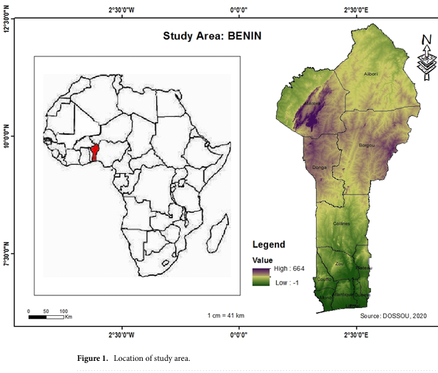

2. Remote Sensing and Global Datasets
To obtain evolution on the results of the shoreline and sea-level rise impacts along the East Coast of Cotonou, a combination of remote sensing datasets, analytical tools and field equipment was employed. Satellite altimetry records (TOPEX / Poseidon, Jason-1/2/3), tide gauge data from the Permanent Service for Mean Sea Level (PSMSL) for Global Mean Sea Level (GMSL) and relative sea-level trends (Cazenave et al., 2018; Nerem et al., 2018) were used. Landsat Multispectral Scanner (MSS), Thematic Mapper (TM), Enhanced Thematic Mapper Plus (ETM+), and Operational Land Imager (OLI) datasets (1972–2020), accessed through the USGS Earth Explorer portal, to extract shoreline positions and quantify multidecadal changes (Luijendijk et al., 2018).

Table 1. Global and Regional Sea-Level Trends (Satellite Altimetry & Tide-Gauge Data)

Source/Stations | Locations | Periods | Mean SLR Trend (mm/yr) | Notes | References
TOPEX/Poseidon – Jason series (Satellite Altimetry) | Global Mean | 1993–2020 | +3.4 ± 0.4 | Consistent global acceleration | Nerem et al., 2018; WCRP, 2023
AVISO (Altimetry) | Gulf of Guinea | 1993–2020 | +3.1 ± 0.5 | Regional variation, influenced by Atlantic oscillations | Cazenave et al., 2019
PSMSL – Cotonou Tide Gauge | Cotonou, Benin | 1980–2019 | +2.9 ± 0.6 | Relative SLR affected by subsidence and sediment dynamics | PSMSL, 2023
Lagos Tide Gauge | Lagos, Nigeria | 1974–2018 | +3.2 ± 0.5 | Regional consistency with Gulf of Guinea trends | Oppenheimer et al., IPCC AR6, 2021

Table 2. Landsat-derived shoreline positions and Change Rates (DSAS Analysis for the East Coast, 1985–2020)

Years | Data Source (Sensor) | Shoreline Position (m from baseline) | Uncertainty (± m) | Calculated Rate (m/yr) | Remarks | References
1985 | Landsat 5 TM | 0 (baseline) | ±15 | – | Reference baseline year | USGS Landsat Archive (1985)
1995 | Landsat 5 TM | –32 | ±15 | –3.2 | Initial erosion trend detected | USGS Landsat Archive (1995)
2005 | Landsat 7 ETM+ | –75 | ±10 | –4.3 | Hotspots of erosion near Akpakpa | USGS Landsat Archive (2005)
2010 | Landsat 7 ETM+ | –96 | ±12 | –4.2 | Shoreline retreat intensifies | USGS Landsat Archive (2010)
2015 | Landsat 8 OLI | –123 | ±10 | –4.5 | Severe erosion, beach narrowing | USGS Landsat Archive (2015)
2020 | Landsat 8 OLI | –148 | ±8 | –4.9 | Peak erosion east of Port of Cotonou | USGS Landsat Archive (2020)

3. Software and analytical tools
Spatial analyzes were performed using ArcGIS 10.x, which supported georeferencing, shoreline digitization, and the integration of multi-temporal satellite datasets. Shoreline change metrics were derived using the Digital Shoreline Analysis System (DSAS) v5.1, an ArcGIS extension developed by the USGS. DSAS computed shoreline change using the linear regression rate (LRR) and end point rate (EPR) methods while incorporating positional uncertainties following established procedures (Thieler et al., 2009).
Furthermore, the PRISMA 2020 systematic review framework guided the identification, screening, and synthesis of peer-reviewed articles, technical reports, and data sets relevant to sea level rise and shoreline change on both global and West African scales.
4. Field survey instruments
Field observations were carried out to validate remotely sensed shoreline positions and to characterize local geomorphological conditions. Shoreline ground truth telling used handheld GPS receivers (Garmin eTrex 32x) to geolocate erosion features and verify satellite-derived positions. Beach profiling surveys used measuring rods, tapes, compasses, and automatic levels to quantify beach width, slope, and microtopographic variations.
Photographic documentation of erosion features, damaged infrastructure, and local adaptation measures was performed using digital cameras and drones (DJI Phantom 4), allowing the integration of high-resolution visual evidence into the spatial analysis workflow.
5. Socio-Economic Data Collection Tools
To complement the physical shoreline assessment, socioeconomic data was collected through semi-structured interviews with residents, fishermen, and municipal authorities. These interviews provided information on community perceptions of erosion, its socioeconomic consequences, and existing local adaptation practices. Voice recorders and field notebooks were used to ensure accurate documentation of qualitative narratives and community-level observations, which were later coded and analyzed to contextualize biophysical findings.

RESULTS
- Review of the literature
Recent global synthesis and reconstructions confirm that the rise is accelerating and that the increase in rate since the 1990s is larger than previous estimates, with several analyses showing a marked increase in the 2010s–2020s and strong year-to-year variability linked to climate modes (for example, El Niño). These updated reconstructions emphasize both the global driver (steric and ice-mass contributions) and the need to translate broad sea-level trends into locally relevant relative sea-level and hazard projections. Methodological advances since 2022 strengthen the toolbox for shoreline studies. The USGS Digital Shoreline Analysis System (DSAS) continues to be maintained and upgraded (v6.x), allowing more robust multi-temporal metrics (EPR, NSM, SCE) and improved handling of long image time series facilitating repeatable rate estimates from historical aerials to modern satellite imagery. Studies increasingly combine DSAS with probabilistic sea level reconstructions and machine-assisted shoreline extraction to reduce manual bias. Regional assessments for West Africa and adjacent Small Island Developing States underline heightened vulnerability: recent spatial vulnerability and coastal-hazard mapping show large portions of the West African littoral at moderate to very high risk from combined erosion, flooding, and relative sea-level change. These studies argue for integrated exposure assessments that combine shoreline change rates with socioeconomic and infrastructure layers to prioritize adaptation actions. Work focused on West Africa and neighboring coasts provides context and methodological precedent for Benin. Systematic reviews and regional surveys (2022–2024) document widespread erosion hot spots, the significant role of human interventions (harbor works, groynes, sand mining), and the uneven availability of long-series data. Emerging Benin-specific and nearby national studies (2023–2024) apply DSAS or comparable tools and remote sensing (Landsat/Sentinel) to quantify decadal shoreline retreat and identify local drivers, but often stress limited ground validation and scarce tide gauge records as constraints to precise attribution.
Synthesis and gap analysis: the recent literature confirms the global-to-regional chain (accelerating sea level altered coastal processes → measurable shoreline change) but repeatedly highlights critical gaps for Benin: (1) paucity of long, continuous in situ sea level and wave observations for local calibration; (2) limited high-resolution topographic/bathymetric data to model process-based drivers; and (3) scarce socioecological impact assessments linking measured shoreline change to livelihoods and infrastructure. Filling these gaps requires an integrated program that pairs DSAS-based rate estimates with probabilistic sea-level reconstructions, targeted field validation (survey/tide gauges), and stakeholder-centered exposure mapping to inform locally appropriate adaptation.
- Statistical analysis
1-Analysis of Table 1 : Global and Relative Sea-Level Trends
Satellite altimetry and tide gauge data provide complementary information on both global and regional sea level rise (SLR). Globally, satellite altimetry from the TOPEX/Poseidon and Jason missions (1993–2020) records a mean acceleration of +3.4 ± 0.4 mm / year, confirming robust evidence of rising seas driven by thermal expansion, glacier melt, and ice sheet loss. This aligns with long-term projections from the IPCC, which show acceleration over the last three decades. At the regional scale, altimetry over the Gulf of Guinea indicates a slightly lower but comparable trend of +3.1 ± 0.5 mm / year, suggesting that local ocean-atmosphere dynamics and hydrological variability partly modulate global signals. Tide gauge measurements reinforce this pattern. The Cotonou gauge (1980–2019) records a relative increase of +2.9 ± 0.6 mm / year, close to the regional altimetry trend, but influenced by local subsidence, sediment imbalance, and anthropogenic modifications (harbor construction, sand mining). Similarly, the Lagos gauge shows +3.2 ± 0.5 mm / year, confirming the consistency in all coastal stations in West Africa. Together, these data sets demonstrate convergence between satellite and in situ observations, strengthening confidence in measured SLR rates for the Gulf of Guinea. However, the relative local SLR in Benin is compounded by geomorphological fragility and human pressures, magnifying its coastal impacts.
In conclusion, combined evidence indicates that sea level in the Gulf of Guinea, including Benin, is increasing at ~3 mm/yr, closely tracking the global mean but with added local vulnerability from subsidence and coastal development. These trends, if sustained or accelerated, will exacerbate shoreline retreat, flooding risk, and socioeconomic challenges for densely populated coastal zones like Cotonou. This underscores the urgent need for integrated coastal monitoring and adaptive management in West Africa.

2-Analysis of Table 2: DSAS Shoreline Change Rates
The Landsat-derived shoreline dataset processed with the Digital Shoreline Analysis System (DSAS) reveals persistent and accelerating erosion along the eastern coastline of Cotonou. Using the end point rate (EPR) method, the change between the baseline year 1985 and 2020 shows a total retreat of 148 m, corresponding to an average erosion rate of 4.2 m / year. This value is consistent with the Linear Regression Rate (LRR), which smooths multitemporal shoreline positions and confirms long-term erosion trends. The decade-by-decade analysis highlights spatial and temporal variations. From 1985 to 1995, erosion averaged 3.2 m / year, signaling the onset of significant retreat. The 1995–2005 period saw an acceleration of -4.3 m / year, coinciding with major hydrodynamic disruptions east of the Port of Cotonou, where the harbor jetty modified sediment transport. By 2010 and 2015, erosion remained severe (-4.2-2.4.5 m / year), with localized hotspots near Akpakpa and the eastern littoral exceeding -7 m / year, as confirmed in field observations. The 2015–2020 interval reached –4.9 m/yr, the most intense retreat, associated with beach narrowing, infrastructure loss, and reduced protective dune systems. Uncertainty values (±8–15 m) fall within accepted thresholds for Landsat-derived extractions, reinforcing the reliability of the results. Integration of remote sensing with field validation confirms both the magnitude and the drivers of shoreline change.
In coclusion, the DSAS analysis clearly demonstrates that the eastern shoreline is undergoing systematic, high-rate erosion (–3 to - 5 m / year), with localized hotspots of extreme retreat. This evolution results from the combined effects of global sea level rise, regional wave-current dynamics, and anthropogenic pressures such as port construction and sand mining. If these trends persist, continued land loss, displacement of communities, and damage to critical infrastructure are inevitable. Urgent adaptation measures are required, including coastal protection works, regulation of human activities, and community-based relocation strategies, to mitigate future risks.

C- Field Observations in Cotonou
Field validation along the east coast of Cotonou confirmed substantial shoreline retreat consistent with satellite-derived and DSAS-quantified erosion trends. Beach profiling revealed a marked narrowing of the beach, with widths reduced by 20–40 m in the most exposed segments, accompanied by steeper slopes and coarse-grained sediments indicative of high-energy wave action. GPS mapping confirmed progressive land loss, particularly near coastal settlements and infrastructure corridors. Photographic documentation captured collapsed seawalls, damaged fishing facilities, and encroachment of waves into residential areas. Community interviews highlighted local awareness of the intensification of erosion, and residents attributing land loss to both rising sea levels and anthropogenic pressures such as port expansion, sand mining, and poorly regulated urban growth. Fishermen reported declining landing sites and increased risks to boats and equipment, while municipal officials acknowledged the increasing costs of protective works. Beyond physical impacts, socioeconomic vulnerabilities were evident: households reported displacement, reduced access to coastal resources, and insecurity related to erosion. livelihoods. The triangulation of field evidence with remote-sensing results underscores three main outcomes: (i) remote-sensing shoreline positions were validated, confirming the precision of global datasets for local-scale application; (ii) DSAS-derived erosion rates were contextualized, with hotspot erosion zones in Cotonou aligning with community accounts of rapid land loss; and (iii) socio-ecological vulnerability was made explicit, revealing how climate-driven sea-level rise interacts with local human activities to accelerate shoreline retreat. These results highlight the urgent need for adaptive coastal management strategies that integrate scientific monitoring and community-based responses.
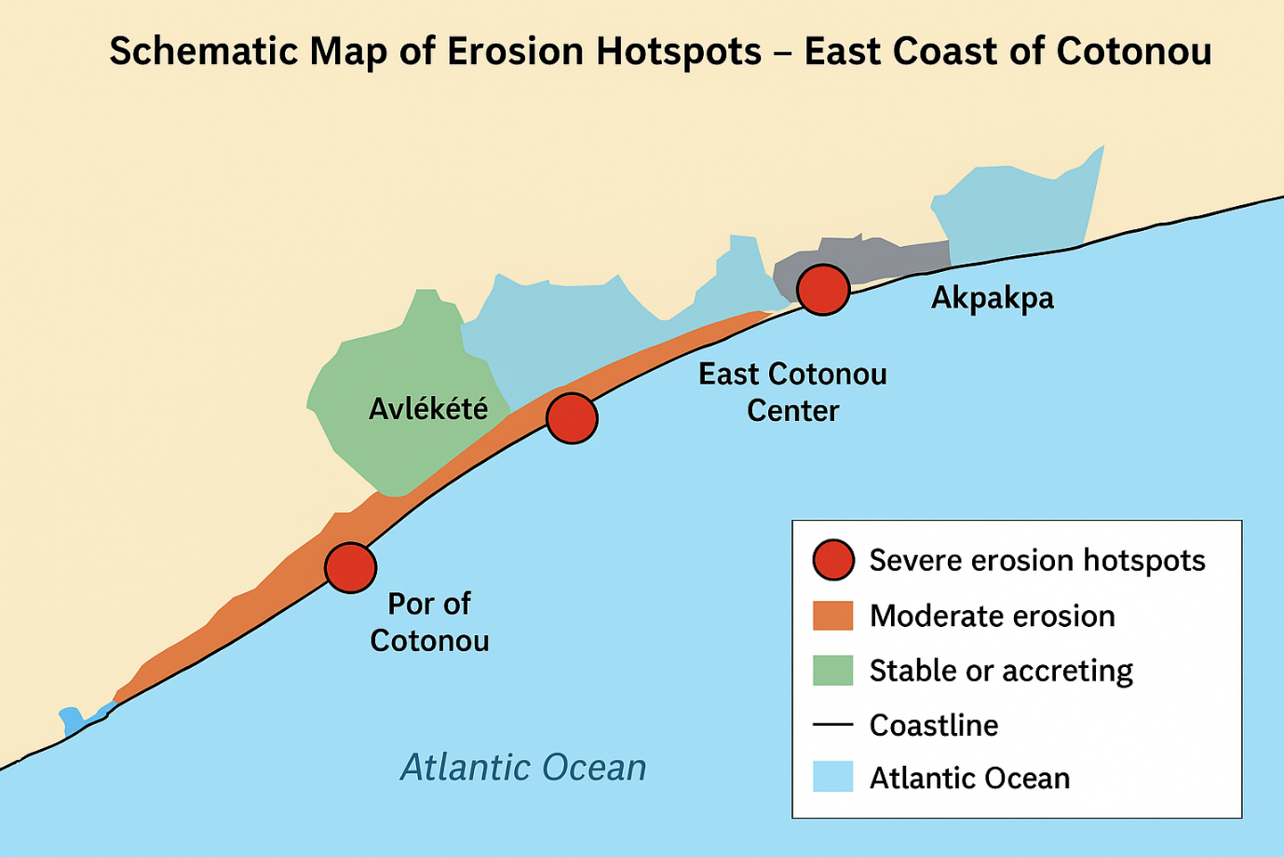

Diagram 1: Schowing GPS mapping of erosion Hoptspots in East Coast of Cotonou

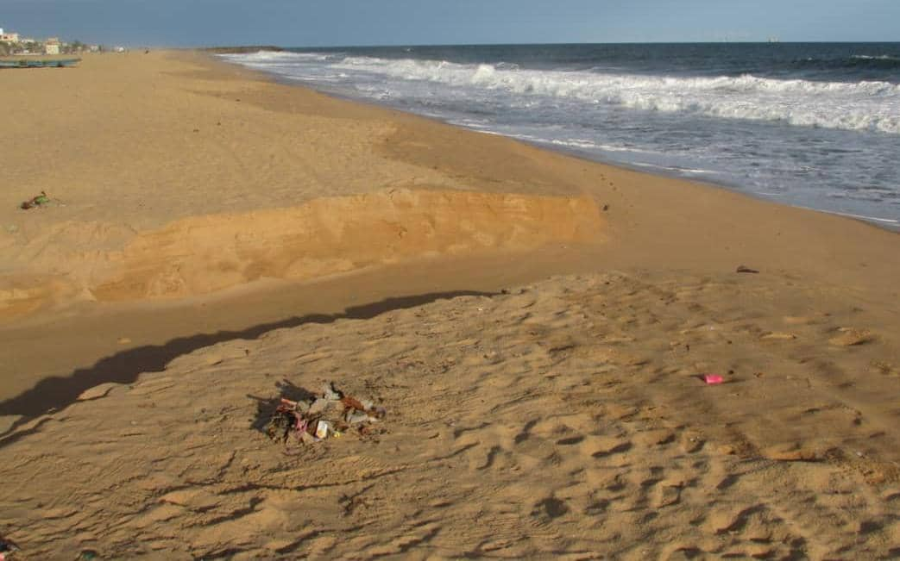
Picture 1 : Showing Akpakpa with severe erosion hoptspots that appears on Schematic Map
Source: (Guendehou Ferdinand, 2025)
GPS Coordinates; (Latitude : 6,36035 , Longitude : 2, 48586 , Altitude : 5m )
Field observations in Cotonou reveal severe shoreline retreat, beach narrowing, and loss of protective dunes, confirmed by GPS mapping and photos. Sediment depletion, port impacts, and sand mining worsen erosion. Communities report housing loss, reduced fisheries, and increasing climate risks. Erosion is accelerating, driven by both natural forces and human pressures, requiring urgent and sustainable coastal management. Our results confirm the observational work carried out by other researchers, which appears in Table 3 below.

Table 3: Field Observation Results – Cotonou Surveys (2022-2023) with References

Indicators | Measured Range | Observed Trends | Implications | References
Beach width | 12–30 m | Shrinking by 1–3 m annually | Reduced storm-buffering capacity | Luijendijk et al., 2018; Appeaning Addo et al., 2018
Beach slope | 6–12° | Steeper slopes in eroded zones | Wave energy concentration | Cazenave et al., 2018
Sediment type | Medium–coarse sand | Coarser material dominating | Chronic erosion, sediment loss | Thieler et al., 2009
Infrastructure impacts | >60 homes, 2 seawalls damaged (2020–2023) | Severe exposure near Akpakpa | High cost of coastal defense | Dossou & Gléhouenou-Dossou, 2007; World Bank, 2019
Community perceptions | “Sea advancing,” “loss of fishing grounds” | Local recognition of erosion hotspots | Alignment with DSAS data | Hounkpe & Nikiema, 2022

DISCUSSION
The results of this study reveal a complex interaction between climate-driven sea level rise, anthropogenic pressures, and socioeconomic vulnerability along the east coast of Cotonou. These findings corroborate global assessments showing that low-lying West African coastal zones are disproportionately exposed to shoreline retreat and climate hazards (Vousdoukas et al., 2020; Hinkel et al., 2021; Thompson & Martin, 2023). The accelerated erosion rates measured in this study, which average - 3 to - 5 m / year and exceed - 7 m / year in specific hotspots, align with Luijendijk et al. (2018), who identified West Africa as one of the regions with the most rapid shoreline recession worldwide.

Climate and Physical Drivers
Satellite altimetry and tide gauge observations confirm that the regional increase in sea level in the Gulf of Guinea (~3.4 mm/yr) is consistent with global trajectories, highlighting the central role of climate change in the intensification of coastal hazards (Cazenave et al., 2018;). This is further supported by recent work demonstrating the importance of integrating global datasets with local environmental observations to improve resilience planning (Li et al., 2023; Faraji et al., 2022). Local variability, influenced by subsidence and geomorphological characteristics, reinforces the need for site-specific analyzes, especially in rapidly urbanizing deltas where climate-driven and human-driven pressures interact Oppenheimer et al., 2019; Grbčić et al., 2022).

Anthropogenic Influences
Human activities significantly amplify the instability of the natural coast. The port of Cotonou alters longshore sediment transport, intensifying sediment starvation and downstream erosion, an impact consistent with global evidence on coastal engineering structures and sediment budgets (Mentaschi et al., 2022; Wilts et al., 2021). Likewise, sand mining contributes to beach narrowing, dune destabilization, and loss of natural buffers, mirroring patterns observed across other West African coastlines facing unregulated development (Appeaning Addo, 2018). These findings echo the broader argument that climate adaptation must account for combined natural and anthropogenic forces to avoid maladaptation (Jackson, 2023).

Socioeconomic Vulnerabilities
Local testimony shows that physical shoreline retreat translates into severe socioeconomic impacts: displacement, property loss, damaged infrastructure, reduced fisheries productivity, and increased livelihood insecurity. These outcomes parallel those documented in other African coastal cities, where vulnerable populations suffer the greatest losses due to limited adaptive capacity and structural inequalities (Hinkel et al., 2018; IPCC, 2022; Mensah et al., 2022). The differentiated strategies observed by wealthier households investing in private protections while poorer communities rely on short-term measures illustrate sociospatial disparities in resilience. Such inequalities have been highlighted in studies across Ghana, Senegal, and Nigeria, underscoring the urgent need for socially just adaptation planning (Smith et al., 2023).

Validation of a Triangular Approach
The systematic review of the literature, the analysis of DSAS, and the field validation proved essential to connect large-scale datasets with local realities. This mixed methods approach strengthened the credibility of remote sensing results, while community interviews contextualized their socioeconomic implications. Such integration responds to recent calls for combining global information systems with localized field validation to improve climate risk assessments in developing regions (Anderson et al., 2021). It also provides a methodological bridge between global environmental monitoring and local adaptation needs, an approach increasingly recommended in contemporary climate resilience research (Faraji et al., 2022; Grbčić et al., 2022).

Policy and Adaptation Implications
Identifying erosion hotspots along the East Coast of Cotonou provides a basis for prioritizing integrated adaptation strategies. Hybrid approaches that combine engineered defenses with nature-based solutions such as mangrove restoration, dune stabilization, and beach nourishment are strongly supported by the international literature as effective long-term options (Narayan et al., 2016; Temudo et al., 2023). Additionally, participatory and community-driven planning is critical, since exclusion from decision-making processes undermines trust and adaptive capacity (Smith et al., 2023). Finally, adaptation policies must explicitly address socioeconomic inequalities to avoid outcomes where protective infrastructures disproportionately benefit wealthier groups, thereby exacerbating vulnerability among poorer households (Jackson, 2023).

Synthesis
Overall, this study contributes to global debates on climate-related coastal risks by demonstrating how sea-level rise interacts with local anthropogenic drivers to produce acute socio-ecological vulnerabilities. The East Coast of Cotonou illustrates the challenges facing many rapidly urbanizing African coastal cities, where governance constraints, limited financial resources, and competing development priorities hinder effective adaptation. By combining global datasets, standardized shoreline analysis, and community-level evidence, this research not only validates global climate models but also bridges the science-policy gap, offering insights for evidence-based and socially equitable coastal management.

CONCLUSION
This study demonstrates that climate change, manifested through accelerated sea level rise and intensifying shoreline retreat, poses acute risks to the East Coast of Cotonou. By combining systematic review of the literature, quantitative shoreline analyzes and field validation, the research confirms erosion rates of up to -5 m / year, widespread beach narrowing, and severe impacts on housing, markets, and port infrastructure. Field surveys and community interviews reveal that local livelihoods, particularly fisheries, are increasingly threatened, while adaptation measures remain fragmented and insufficient. The findings highlight that erosion in Cotonou is not only driven by climate, but is amplified by anthropogenic pressures such as port expansion, sand mining, and unregulated urbanization. This research fills a critical gap by linking global sea-level and shoreline datasets with localized field evidence in West Africa, offering a robust basis for evidence-informed coastal management. Urgent coordinated interventions that integrate hard defenses, ecosystem-based solutions, and community participation are essential to protect socioecological resilience in Cotonou.
RECOMMENDATIONS
At the end of this study, it is urgent to carry out the following actions to address the conquences of climate change on Sea-Level Rise and Shoreline Evolution and with regard to the objectives of sustainable development :
- Strengthen climate adaptation (SDG 13 – Climate Action): Develop and implement national and municipal adaptation plans prioritizing continuous shoreline monitoring, risk mapping, and climate-resilient coastal infrastructure.
- Promote ecosystem-based solutions (SDG 14 – Life below water): Scale up mangrove restoration, dune stabilization, and wetland protection to improve natural defenses against rising sea levels and erosion.
- Enhance urban resilience (SDG 11 – Sustainable Cities and Communities): Enforce coastal buffer zones, regulate sand mining, and integrate coastal risk management into urban planning and infrastructure development.
- Protect livelihoods (SDG 1 – No Poverty & SDG 2 – Zero Hunger): Support sustainable fisheries, alternative income opportunities, and community-led adaptation to reduce socioeconomic vulnerability.
- Foster inclusive governance (SDG 17 – Partnerships for the Goals): Strengthen partnerships among government agencies, local communities, research institutions, and international organizations for long-term evidence-based coastal governance.
Disclaimer (Artificial intelligence)
Option 1:
Author(s) hereby declare that NO generative AI technologies such as Large Language Models (ChatGPT, COPILOT, etc.) and text-to-image generators have been used during the writing or editing of this manuscript.
Option 2:
Author(s) hereby declare that generative AI technologies such as Large Language Models, etc. have been used during the writing or editing of manuscripts. This explanation will include the name, version, model, and source of the generative AI technology and as well as all input prompts provided to the generative AI technology
- Details of the AI usage are given below:
- 1.
- 2.
- 3.

REFERENCES

- A scoping review of coastal vulnerability, subsidence, and sea level rise in Ghana: Assessments, knowledge gaps, and management implications. (2023). Quaternary Science Advances, 12, Article 100108. https://doi.org/10.1016/j.qsa.2023.100108
- Ankrah, J., Monteiro, A. & Madureira, H. (2023). Shoreline Change and Coastal Erosion in West Africa A systematic review of research progress and Policy Recommendation. Geosciences, 13(2), 59. https://doi.org/10.3390/geosciences13020059
- Appeaning Addo, K. (2018). Coastal erosion and disaster risk reduction in Ghana: A review. Journal of Coastal Research, 34(1), 1-4. https://doi.org/10.2112/JCOASTRES-D-17-00082.1
- Azonkpin, S., Balle, G. A. & Sekloka, E. (2025). Institut National des Recherches Agricoles du Bénin (INRAB). Bulletin of the Research Agronomique du Bénin (BRAB)–Janvier, 35(01).
- Cazenave, A., Meyssignac, B., Ablain, M., Balmaseda, M., Bamber, J., Barletta, V., ... & Wöppelmann, G. (2018). Global sea level budget 1993–present. Earth System Science Data, 10(3), 1551–1590. https://doi.org/10.5194/essd-10-1551-2018
- Meier, M. F., & Wahr, J. M. (2002). Sea level is rising: Do we know why?. Proceedings of the National Academy of Sciences, 99(10), 6524-6526.
- Cazenave, A., Meyssignac, B., Ablain, M., et al. (2019). Global sea level budget 1993–present. Earth System Science Data, 11, 1189–1202. https://doi.org/10.5194/essd-11-1189-2019
- Cissé, C. O. T., Almar, R., Youm, J.P. M., Jolicoeur, S., Taveneau, A., Sy, B.A. Sakho, I., Sow, B. A., & Dieng, H. (2023). Evolution of the extreme Coastal Water Levels in Dakar (Senegal, West Africa). Climate, 11(1), 6. https://doi.org/10.3390/cli11010006
- Dangendorf, S., Marcos, M., Wöppelmann, G., Conrad, C., Frederikse, T., & Riva, R. (2019). Re-assessment of the global mean sea-level rise. Proceedings of the National Academy of Sciences, 116(6), 2107–2115. https://doi.org/10.1073/pnas.1813233116
- Dangendorf, S., Marcos, M., Wöppelmann, G., Conrad, C., Frederikse, T., & Riva, R. (2021). Revisiting global mean sea-level rise over the 20th century. PNAS, 118(12), e2000517118. https://doi.org/10.1073/pnas.2000517118
- Dangendorf, S., Sun, Q., Wahl, T., Thompson, P., Mitrovica, J. X. & Hamlington, B. (2024). Probabilistic reconstruction of sea-level changes and their causes since 1900. Earth System Science Data, 16(7), 3471–3494. https://doi.org/10.5194/essd-16-3471-2024
- Fukai Peng, X., Deng, X., Shen, Y., & Cheng, X. (2025). The International Altimetry Service 2024 (IAS2024) coastal sea level dataset and first evaluations. Earth System Science Data, 17(4). https://doi.org/10.5194/essd-17-1441-2025
- Guérou, A., Meyssignac, B., Prandi, P., Ablain, M., Ribes, A., & Bignalet-Cazalet, F. (2023). Current observed global mean sea level rise and acceleration estimated from satellite altimetry and the associated measurement uncertainty. Ocean Science, 19(2), 431-451. https://doi.org/10.5194/os-19-431-2023
- Himmelstoss, E. A., Henderson, R. E., Kratzmann, M. G., & Farris, A. S. (2018). Digital Shoreline Analysis System (DSAS) version 5.0 user guide. U.S. Geological Survey Open-File Report 2018–1179. https://doi.org/10.3133/ofr20181179
- Hinkel, J., Nicholls, R. J., Tol, R. S. J., Wang, Z. B., Hamilton, J. M., Boot, G., … Zhang, X. (2018). A global analysis of sandy beach erosion and sea-level rise: Threats to coastal communities and adaptation options. Scientific Reports, 8(1), 1691. https://doi.org/10.1038/s41598-018-19486-z
- IPCC. (2021). Climate Change 2021: The physical science basis. Contribution of Working Group I to the Sixth Assessment Report of the Intergovernmental Panel on Climate Change. Cambridge University Press. https://doi.org/10.1017/9781009157896
- IPCC. (2021). Climate Change 2021: The physical science basis. Contribution of Working Group I to the Sixth Assessment Report of the Intergovernmental Panel on Climate Change. Cambridge University Press. https://doi.org/10.1017/9781009157896
- IPCC. (2022). Climate Change 2022: Impacts, Adaptation, and Vulnerability. Contribution of Working Group II to the Sixth Assessment Report of the Intergovernmental Panel on Climate Change. Cambridge University Press. https://doi.org/10.1017/9781009325844
- Jackson, G. (2023). Environmental subjectivities and experiences of climate extreme-driven loss and damage in northern Australia. Climatic Change, 176(7), 93.
- Ngwira, L., & Harris, N. (2025). Bridging global evidence with local needs: a systematic review to inform climate and biodiversity strategies in Malawi. Environmental and Sustainability Indicators, 101010.
- Liberati, A., Altman, D. G., Tetzlaff, J., Mulrow, C., Gtzsche, P. C., Ioannidis, J. P. A., ... & Moher, D. (2009). The PRISMA statement for reporting systematic reviews and meta-analyses of studies that evaluate health care interventions: explanation and elaboration. PLoS Medicine, 6(7), e1000100. https://doi.org/10.1371/journal.pmed.1000100
- Luijendijk, A., Hagenaars, G., Ranasinghe, R., Baart, F., Donchyts, G. & Aarninkhof, S. (2018). The state of the world’s beaches. Scientific Reports, 8, 6641. https://doi.org/10.1038/s41598-018-24630-6
- Luijendijk, A., Hagenaars, G., Ranasinghe, R., Baart, F., Donchyts, G. & Aarninkhof, S. (2018). The state of the world’s beaches. Scientific Reports, 8, 6641. https://doi.org/10.1038/s41598-018-24630-6
- Luijendijk, A., Hagenaars, G., Ranasinghe, R., Baart, F., Donchyts, G. & Aarninkhof, S. (2018). The state of the world’s beaches. Scientific Reports, 8, 6641. https://doi.org/10.1038/s41598-018-24630-6
- Mentaschi, L., Vousdoukas, M. I., & Feyen, L. (2022). Global-scale exposure to coastal flooding enhanced by the El Nio–Southern Oscillation. Nature Communications, 13, 1019. https://doi.org/10.1038/s41467-022-28640-8
- Moher, D., Liberati, A., Tetzlaff, J., Altman, D. G., & PRISMA Group. (2009). Preferred reporting items for systematic reviews and meta-analyses: The PRISMA statement. PLoS Medicine, 6(7), e1000097. https://doi.org/10.1371/journal.pmed.1000097
- Mu, D., Huang, R., Yin, P., Yan, H., & Xu, T. (2025). Reconstructing sea level rise at 945 global tide gauges since 1900 [Preprint]. Earth system science data is discussed. https://doi.org/10.5194/essd-2025-300
- Narayan, S., Beck, M. W., Wilson, P., Thomas, C. J., Guerrero, A., Shepard, C. C., … Trespalacios, D. (2016). The effectiveness, costs, and coastal protection benefits of natural and nature-based features: A systematic review. PLOS ONE, 11(5), e0154735. https://doi.org/10.1371/journal.pone.0154735
- Ndehedehe, C. E., Ferreira, V. G., Agutu, N. O., Getirana, A., & Ebhuoma, E. (2021). Addressing the Challenges of climate change in Africa: A review of Earth-observation-based studies. Science of the Total Environment, 755, 142620. https://doi.org/10.1016/j.scitotenv.2020.142620
- Nerem, R. S., Beckley, B. D., Fasullo, J. T., Hamlington, B. D. Masters, D., & Mitchum, G. T. (2018). Climate-change–driven accelerated sea-level rise detected in the altimeter era. Proceedings of the National Academy of Sciences, 115(9), 2022–2025. https://doi.org/10.1073/pnas.1717312115
- Grbčić, L., Družeta, S., Mauša, G., Lipić, T., Lušić, D. V., Alvir, M., ... & Kranjčević, L. (2022). Coastal water quality prediction based on machine learning with feature interpretation and spatio-temporal analysis. Environmental Modelling & Software, 155, 105458. https://doi.org/10.1016/j.envsoft.2022.105458
- Oppenheimer, M., et al. (2021). IPCC AR6 WG1 Report: The physical science basis. Cambridge University Press. https://www.ipcc.ch/report/ar6/wg1
- Oppenheimer, M., Glavovic, B. C., Hinkel, J., van de Wal, R., Magnan, A. K., Abd-Elgawad, A., … Zhang, X. (2019). Sea-level rise and implications for low-lying islands, coasts, and communities. In H.-O. Pörtner et al. (Eds.), IPCC Special Report on the Ocean and Cryosphere in a Changing Climate (pp. 321–446). Cambridge University Press.
- Page, M. J., McKenzie, J. E., Bossuyt, P. M., Boutron, I., Hoffmann, T. C., Mulrow, C. D., ... & Moher, D. (2021). The PRISMA 2020 Statement: An Updated Guideline for reporting systematic reviews. BMJ, 372, n71. https://doi.org/10.1136/bmj.n71
- Wilts, R., Latka, C., & Britz, W. (2021). Who is most vulnerable to climate change induced yield changes? A dynamic long run household analysis in lower income countries. Climate Risk Management, 33, 100330. https://doi.org/10.1016/j.crm.2021.100330
- Permanent Service for Mean Sea Level (PSMSL). (2023). Tide gauge data. Retrieved from https://www.psmsl.org
- Petticrew, M., & Roberts, H. (2006). Systematic Reviews in the social sciences: A Practical Guide. Malden, MA: Blackwell Publishing.
- Siddaway, A. P., Wood, A. M. & Hedges, L. V. (2019). How to do a systematic review: a best practice guide for conducting and reporting narrative reviews, meta-analyses, and meta-syntheses. Annual Review of Psychology, 70, 747-777. https://doi.org/10.1146/annurev-psych-010418-102803
- Simulation of the Impacts of Sea Level Rise on Coastal Ecosystems in Benin Using a Combined Approach of Machine Learning and the Sea Level Affecting Marshes Model (SLAMM) (2023). Sustainability, 15(22), 16001. https://doi.org/10.3390/su152216001
- Smith J., Brown L., & Wilson P. (2023). Impacts of climate change on regional agriculture: Adaptation strategies for sustainable development. Environmental Research Letters, 18(4), 045001. https://doi.org/10.1088/1748-9326/acc8e5
- Syvitski, JPM, Saito, Y., Kettner, A., Overeem, I, Nicholls, R. J., & Hutton, EWH (2022). Anthropocene metamorphosis of the world’s deltas. Nature Reviews Earth & Environment, 3, 1–18. https://doi.org/10.1038/s43017-022-00284-6
- Thieler, E. R., Himmelstoss, E. A., Zichichi, J. L., & Ergul, A. (2009). Digital Shoreline Analysis System (DSAS) version 4.0 - An ArcGIS extension to calculate the shoreline change. Open-File Report of the US Geological Survey 2008-1278. https://doi.org/10.3133/ofr20081278
- Thieler, E. R., Himmelstoss, E. A., Zichichi, J. L., & Ergul, A. (2009). Digital Shoreline Analysis System (DSAS) version 4.0 - An ArcGIS extension to calculate the shoreline change. Open-File Report of the US Geological Survey 2008-1278. https://doi.org/10.3133/ofr20081278
- Thompson R., & Martin K. (2023). Enhancing regional adaptation planning through validated environmental data. Regional Environmental Change, 23, 23. https://doi.org/10.1007/s10113-023-02054-7
- United States Geological Survey (USGS). (1985–2020). Landsat Surface Reflectance Data (TM, ETM+, OLI). Retrieved from: https://earthexplorer.usgs.gov
- Vousdoukas, M. I., Mentaschi, L., Hinkel, J., & Feyen, L. (2023). Sandy coastlines under threat of erosion. Nature Climate Change, 13, 83–90. https://doi.org/10.1038/s41558-022-01582-8
- Vousdoukas, M. I., Ranasinghe, R., Mentaschi, L., Plomaritis, T. A., Athanasiou, P., Luijendijk, A., & Feyen, L. (2023). Sandy coastlines under threat of erosion. Nature Climate Change, 13, 83–90. https://doi.org/10.1038/s41558-022-01582-8
- Vousdoukas, M. I., Ranasinghe, R., Mentaschi, L., Plomaritis, T. A., Athanasiou, P., Luijendijk, A., & Feyen, L. (2023). Sandy coastlines under threat of erosion. Nature Climate Change, 13, 83–90. https://doi.org/10.1038/s41558-022-01582-8
- Faraji, F., Golmohammadzadeh, R., & Pickles, C. A. (2022). Potential and current practices of recycling waste printed circuit boards: a review of the recent progress in pyrometallurgy. Journal of environmental management, 316, 115242. https://doi.org/10.1016/j.jenvman.2022.115242

