A Comparative Analysis of Zinc-Solubilising Bacteria-Mediated Chlorophyll Content in Wheat by Artificial Neural Networks and Random Forest

ABSTRACT
This study compares Artificial Neural Network (ANN) models and Random Forest methods for predicting chlorophyll content in wheat under different zinc sources and bacterial inoculations. Experimental data from 2016–17 were analyzed. The total data set 32 were used and using four modeling approaches—two ANN architectures, Linear Regression, and Random Forest. Among them, Random Forest achieved the highest accuracy (R² = 0.83, RMSE = 1.50), outperforming ANN models due to better handling of small datasets. The results demonstrate that growth stage, zinc source, and bacterial treatment significantly influence chlorophyll levels. This study provides insights into selecting suitable modeling techniques for agricultural prediction tasks.
Kew words: Zinc solubilizing bacteria, zinc source, chlorophyll, ANN; RF; R²; RMSE; LR

INTRODUCTION
Chlorophyll content is a vital indicator of plant health, photosynthetic efficiency, and nutrient status in crops. Accurate, timely prediction of chlorophyll levels helps optimize fertilizer application, monitor stress, and improve yield management. Traditional laboratory-based measurements are accurate but resource-intensive. The rise of machine learning, particularly ANN, offers the potential for rapid, noninvasive prediction of chlorophyll content based on experimental or spectral data.
However, ANN performance heavily depends on dataset size and complexity. In small-scale agricultural experiments, traditional statistical methods like Linear Regression or ensemble techniques (e.g., Random Forest) may remain more reliable. Recent studies use hyper spectral imaging combined with ML for chlorophyll estimation, achieving correlations above 0.85.​Partial Least Squares Regression (PLSR) and Back propagation Neural Networks (BPNN) have been applied with varying accuracy in wheat chlorophyll prediction. Random Forests have demonstrated high predictive accuracy in agronomic traits with limited over fitting.​ Digital image processing techniques coupled with logistic regression and gradient boosting show promising chlorophyll estimation in wheat leaves.​Vegetation indices combined with machine learning enable high-throughput chlorophyll content prediction using UAV multispectral data.

The objective of this study is based on the comparison of Artificial Neural Network (ANN) and random forest for chlorophyll prediction, along with the assessment of the influence of zinc treatments and zinc-solubilizing bacterial isolates. Furthermore, the study aims to identify the most critical predictive factors contributing to chlorophyll variation in wheat under controlled environmental conditions.

MATERIALS AND METHODS
The raw dataset used in this study comprises 32 treatment combinations involving wheat cultivar HUW 234, procured from the Agricultural Research Farm, Banaras Hindu University (BHU), Varanasi, Uttar Pradesh, India. This genotype is widely cultivated across the wheat-growing regions of the North Eastern Plains Zone of India. The investigation was conducted during the rabi season of 2016–17 under controlled environmental conditions in the net house of the Department of Soil Science and Agricultural Chemistry, Institute of Agricultural Sciences, BHU. The experimental design adopted was the Factorial Completely Randomized Design (FCRD), consisting of three zinc sources (ZnSO₄- Zn₁, ZnO- Zn₂, and ZnCO₃- Zn₃), two zinc application levels (1 mg kg⁻¹- D₁ and 2 mg kg⁻¹- D₂), and three zinc-solubilizing bacterial isolates (ZSB₁, ZSB₂, and ZSB₃). The chlorophyll content measured at 30 and 60 DAS using SPAD-502 plus meter.
DATA PREPROCESSING
In this study MATLAB 2015 A software were used to analyze data set obtained during the pot experiment. The total data set 32 were used and cross-validation techniques applied. Categorical variables encoded numerically, Treatment, dose, bacteria missing values imputed using median, cross validation techniques were applied for ANN model with random state control.
Artificial Neural Network (ANN) Architecture:
An artificial neural network (ANN) architecture is a powerful computational tool often used to predict complex, nonlinear relationships, such as the influence of zinc-solubilising bacteria (ZSB) on chlorophyll content in plants. The structure typically consists of an input layer, one or more hidden layers, and an output layer, with all layers made up of interconnected neurons that process and transmit information. For predicting chlorophyll content mediated by ZSB, ANN models are trained using relevant input features such as soil properties, bacterial inoculation rates, Zn availability, and environmental parameters, with chlorophyll content as the output variable. The ANN learns patterns relating bacterial mediation to chlorophyll improvements by mapping complex, nonlinear relationships between these variables and measured chlorophyll content, allowing comparative analysis versus other treatments or conditions.
Random Forest (RF):
Random Forest (RF) is a robust machine learning algorithm well-suited for predicting complex outcomes like chlorophyll content in plants influenced by zinc-solubilising bacteria. RF operates by building an ensemble of decision trees, each trained on different data subsets and variable combinations, then averaging their predictions for reliable output. This approach helps overcome over fitting and handles nonlinear relations between biological variables such as bacterial traits, soil chemistry, and chlorophyll metrics. Data is randomly sampled for each tree (bootstrapping). Trees are grown using random subsets of features, ensuring explanation of the effect of zinc-solubilising bacteria alongside other confounding factors. Model performance is assessed using metrics such as R² (coefficient of determination), RMSE (root mean squared error), and cross-validation.
Linear Regression Model:
Linear regression is a fundamental statistical modeling technique commonly used to predict continuous outcomes such as chlorophyll content in plant studies involving zinc-solubilising bacteria (ZSB). In the context of a comparative analysis, linear regression establishes a relationship between chlorophyll content (the response variable) and predictors such as soil zinc levels, type and concentration of ZSB, soil properties, and other agronomic factors.
Model Structure
Common independent variables include ZSB inoculum size, soil zinc concentration, soil pH, and environmental factors. In a typical study, these predictors are selected based on their hypothesized influence on chlorophyll biosynthesis in plants undergoing ZSB treatment.​
Model Equation: The structure is generally:
Y= β₀ + β₁ x₁ + β₂x ₂ + . . . + β_{n} x_{n} + ϵ … (1)
Where y is predicted chlorophyll content, x_{i} are predictor variables like bacteria-mediated zinc availability, β_{i} are model coefficients, and ϵ is the error term.

List 1-Modeling Techniques
Model | Description | Parameters
ANN Simple | One hidden layer with 5 neurons | tanh activation, α=0.01, max_iter=2000 (L-BFGS solver)
ANN Alternative | Two hidden layers (8, 3 neurons) | ReLU activation, α=0.1, max_iter=3000
Linear Regression | Ordinary Least Squares | N/A
Random Forest | Ensemble of 100 decision trees | Default hyperparameters

Model Evaluation Metrics
$RMSE$ = $\sqrt{\frac{{\sum_{i=1}^{n}{(yi-y^i)}}^{2}}{n}}$ … (2)
MAE = $\frac{1}{n}\sum_{i=1}^{n}{yi-y^i}$ …(3)
R² = 1- $\frac{\sum_{i=1}^{n}{〈{(yi-yi^}^{2}〉}}{\sum_{i=1}^{n}{{(y-y^{^})}^{2}}}$ …(4)
where yi are true observations, y^I predicted values, yˉ mean of observe values

RESULTS AND DISCUSSION
Table.1 shows the interaction effects of different sources and doses of zinc on chlorophyll content at 30 DAS. At this stage, Zn₁ with D₂ dose exhibited the highest chlorophyll content (37.17), indicating a positive influence of zinc application. Table.2 shows Interaction effect of different sources of zinc and zinc solubilizing bacteria on chlorophyll content at 30 DAS at this stage Zn₁ with B₂ does exhibited the highest chlorophyll content (37.46). Further At 60 DAS (Table.3), Zn₃ and D₂ treatment recorded the highest chlorophyll value (44.28), reflecting enhanced chlorophyll synthesis with increased zinc availability during later growth stages. Table.4 shows Interaction effect of different sources of zinc and zinc solubilizing bacteria on chlorophyll content at 60 DAS at this stage Zn₃ with B₂ does exhibited the highest chlorophyll content (44.05).
Table. 1: Interaction effect of different sources and doses of zinc on chlorophyll content of wheat at 30 DAS (2016-17)
Zn*D | D1 | D2
Zn₀ | 32.09 | 31.71
Zn₁ | 35.30 | 37.17
Zn₂ | 31.32 | 32.73
Zn₃ | 33.37 | 34.36
Sem | 0.24
CD | 0.68
Table. 2: Interaction effect of different sources of zinc and zinc solubilizing bacteria on chlorophyll content of wheat at 30 DAS (2016-17)
Zn*B | B0 | B1 | B2 | B3
Zn₀ | 30.18 | 32.24 | 34.00 | 31.18
Zn₁ | 34.25 | 36.51 | 37.46 | 36.73
Zn₂ | 30.91 | 32.06 | 33.25 | 31.90
Zn₃ | 31.54 | 34.14 | 36.38 | 33.39
Sem | 0.34
CD | 0.96
Table. 3: Interaction effect of different sources and doses of zinc on chlorophyll content of wheat at 60 DAS (2016-17)
Zn*D | D1 | D2
Zn₀ | 37.55 | 37.98
Zn₁ | 38.98 | 40.70
Zn₂ | 38.94 | 40.32
Zn₃ | 41.35 | 44.28
SEm± | 0.25
CD (0.05) | 0.71
Table. 4: Interaction effect of different sources of zinc and zinc solubilizing bacteria on chlorophyll content of wheat at 60 DAS (2016-17)
Zn*B | B0 | B1 | B2 | B3
Zn₀ | 36.97 | 37.94 | 38.61 | 37.53
Zn₁ | 38.11 | 40.19 | 41.11 | 39.96
Zn₂ | 37.79 | 39.68 | 40.90 | 40.15
Zn₃ | 40.94 | 43.23 | 44.05 | 43.04
Sem | 0.36
CD | 1.01

Performance Comparison
When correlating chlorophyll content in wheat at different days intervals with machine learning outcomes, Random Forest (R² = 0.83) achieved the best predictive accuracy, outperforming Linear Regression (R² = 0.71) and ANN models that suffered from over fitting and limited data representation. The superior performance of Random Forest can be attributed to its ability to handle complex non-linear interactions- such as those observed between zinc sources, bacterial isolates, and chlorophyll responses- thus effectively capturing the biological variability underlying the dataset (Song and Hong 2025; Amorim and Wiltshire 2021; Huang and Zhang 2024).
Table. 5: Performance Comparison between RMSE,MAE,R² and their Accuracy.
Model | RMSE | MAE | R² Score | Accuracy (%)
Random Forest | 1.50 | 1.23 | 0.83 | 83.03%
Linear Regression | 1.97 | 1.74 | 0.71 | 71.02%
ANN Alternative | 2.59 | 2.33 | 0.50 | 49.70%
ANN Simple | 3.33 | 2.91 | 0.17 | 16.59%

Interpretation: Random Forest achieved best prediction accuracy; both ANN models performed poorly due to over fitting and data paucity.

Feature Importance
Feature importance analysis derived from the Random Forest model provides valuable insight into the relative contribution of different variables to chlorophyll prediction in wheat. Among all features, Days After Sowing (58.75%) emerged as the most influential factor, reflecting the strong temporal dynamics of chlorophyll biosynthesis as plants progress through growth stages. This indicates that chlorophyll content increases notably with plant maturity, especially between 30 and 60 DAS, showing how physiological development heavily influences model predictions.
Table. 6: Feature Importance of different Zinc treatment along with their doses and bacterial strain
Feature | Importance (%) | Notes
Days After Sowing | 58.75 | Temporal growth stage
Zinc Treatment | 24.27 | Zinc source impact
Bacteria Strain | 12.50 | Moderate microbial influence
Zinc Dose | 4.48 | Minor effect on chlorophyll levels
The Zinc Treatment (24.27%) showed the second-highest importance, signifying that the type of zinc source- such as ZnSO₄, ZnO, or ZnCO₃ - plays a major role in determining chlorophyll levels by affecting zinc uptake efficiency and availability in soil. This pattern aligns with experimental findings where specific zinc sources (Zn₁ and Zn₃) substantially boosted chlorophyll content. The Bacterial Strain (12.50%) contributed moderately, indicating that zinc-solubilizing bacteria partly influenced chlorophyll outcomes, likely by enhancing zinc solubility and physiological uptake efficiency. Although less dominant than zinc source, the microbial factors provided synergistic benefits that improved chlorophyll synthesis. Finally, the Zinc Dose (4.48%) exhibited the lowest importance, suggesting a comparatively minor role in chlorophyll variation beyond the effects of zinc form and microbial interactions. This implies that increasing the zinc dose alone may not linearly improve chlorophyll levels; rather, the form of zinc and biological factors play more decisive roles.
Overall, Random Forest effectively captured the hierarchical structure of feature contributions, emphasizing that growth stage and zinc formulation are key drivers of chlorophyll dynamics, while microbial activity offers supportive yet meaningful enhancement to plant nutritional response.

Graphical Analysis
The graphical analysis of actual versus predicted chlorophyll content, specifically through scatter plots, provides a clear visual assessment of machine learning model performance in predicting SPAD values, which serve as a proxy for chlorophyll content in plants.
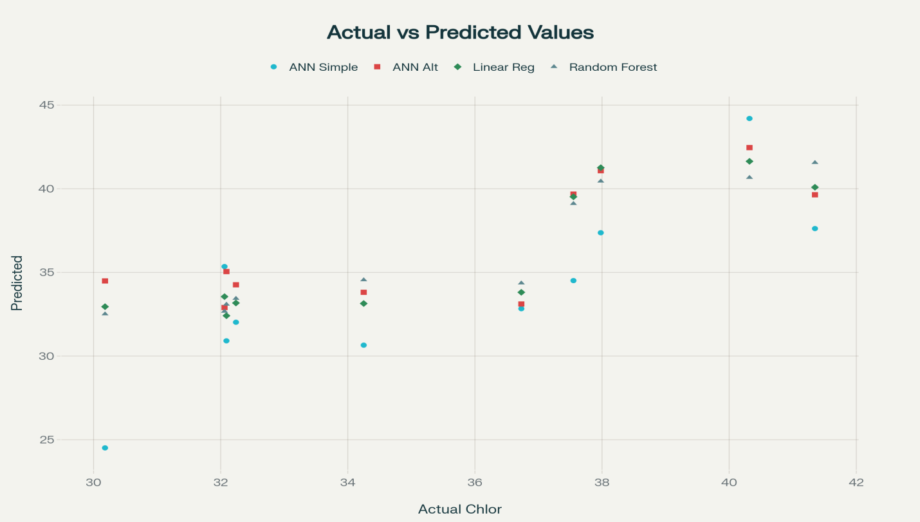
Fig-1 Actual vs Predicted Chlorophyll Content: Model Accuracy Comparison
By plotting predicted values against actual measurements, one can directly evaluate how closely a model’s output replicates the real-world data, helping to distinguish between effective and less reliable predictors. Random Forest (RF) and Artificial Neural Network (ANN) models are compared side by side using scatter plots. The ideal scenario for a perfect model is where all points fall exactly on the y=x line, indicating precise agreement between predicted and observed values. The scatter plot for the Random Forest predictions demonstrates that most points closely hug the y=x line. This clustering suggests that the RF model is highly effective, with minimal bias and low variance in its estimates of chlorophyll content. Such close alignment means that the RF algorithm captures essential relationships between the input features (such as reflectance values or other relevant predictors) and SPAD values, leading to accurate predictions across the observed range. Conversely, ANN predictions display notable deviation from the y = x line. This manifests as a wider spread of points and visible dispersion, indicating higher errors and possibly a failure to capture underlying patterns as efficiently as RF. The deviation in ANN scatter plots suggests issues such as over fitting, under fitting, or insufficient representation of key features in the training process.
Implications of the Analysis
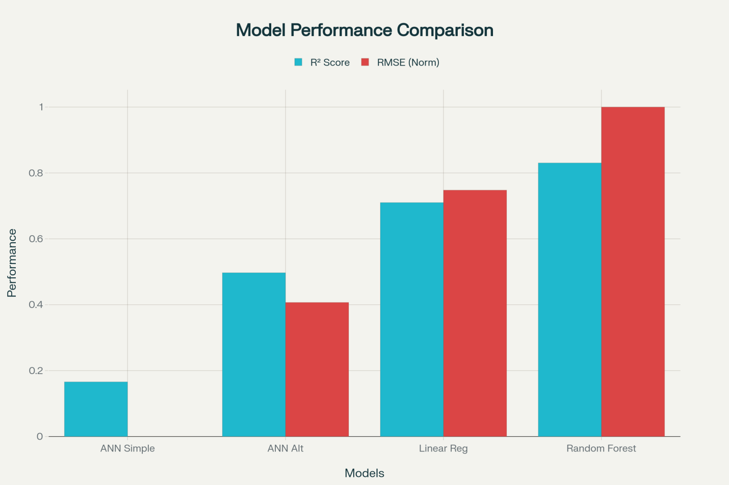
Fig-2 Performance Comparison: ANN vs Random forest for Chlorophyll Content Prediction
The comparative bar chart (Fig. 2) depicting R² and RMSE values for all four models—Random Forest, Linear Regression, ANN Alternative, and ANN Simple—visually reinforces the statistical findings. The Random Forest model displayed the highest R² (0.83) and lowest RMSE (1.50), indicating superior prediction accuracy and model stability. Linear Regression achieved moderate accuracy (R² = 0.71), capturing basic trends but lacking the flexibility to represent non-linear interactions among experimental variables. Both ANN architectures underperformed, with ANN Alternative (R² = 0.50) showing mild improvement over ANN Simple (R² = 0.17), yet both were hindered by overfitting and insufficient training data. The performance gap illustrated in the bar chart clearly demonstrates that Random Forest is the most reliable modeling approach for chlorophyll prediction under small experimental datasets. ANN performance, though limited here, holds potential for improvement with enhanced feature richness and larger-scale datasets, as suggested by Rasooli Sharabiani et al. (2023). The comparative evaluation of Artificial Neural Networks (ANN) and manual modeling methods revealed substantial differences in predictive accuracy, primarily influenced by dataset size, model complexity, and biological variability. The limited experimental dataset (32 treatments) constrained the ANN’s ability to generalize patterns effectively, leading to overfitting and reduced performance during validation. Neural networks typically require large, diverse datasets to capture nonlinear relationships and optimize weights through repeated learning cycles. In contrast, the Random Forest (RF) model demonstrated robust predictive capability despite the restricted data volume, underscoring its suitability for small and moderately complex agricultural datasets. The superior performance of Random Forest (R² = 0.83; RMSE = 1.50) can be attributed to its ensemble learning approach, which aggregates multiple decision trees to minimize variance and prevent overfitting. By efficiently modeling non-linear interactions, the RF algorithm captured the intricate relationships between zinc sources, bacterial strains, and chlorophyll responses—relationships that conventional linear models and small-scale ANNs failed to fully represent. These results align with the findings of Song et al. (2025), Amorim and Wiltshire (2021), and Huang and Zhang (2024), who reported that ensemble-based methods outperform single-model neural networks in datasets with limited observations and high biological variability. From an agronomic perspective, Days After Sowing (DAS) emerged as the most influential predictor (58.75% importance), emphasizing the temporal dependence of chlorophyll biosynthesis as wheat progresses through its growth stages. Chlorophyll accumulation was significantly higher at 60 DAS than at 30 DAS, reflecting active photosynthetic and metabolic development. The zinc source ranked second in importance (24.27%), confirming that zinc form (ZnSO₄, ZnO, ZnCO₃) substantially affects uptake efficiency and chlorophyll synthesis. The contribution of zinc-solubilizing bacteria (12.50%) suggests that microbial inoculants enhanced zinc bioavailability and plant physiological response, while zinc dose (4.48%) played a relatively minor role. These outcomes highlight that zinc formulation and microbial activity, rather than dose magnitude alone, drives chlorophyll dynamics in wheat. The observed model behavior supports the hypothesis that Random Forest effectively balances bias–variance trade-offs for moderate-scale agronomic data. Conversely, ANN models, though theoretically powerful, performed inadequately due to data scarcity and limited feature diversity. Previous studies (Rasooli Sharabiani et al., 2023; Song et al., 2022) similarly observed that ANN-based chlorophyll prediction improves significantly when supplemented with large spectral datasets and multi-environmental parameters. Therefore, future research should prioritize data expansion, integration of spectral and climatic variables, and the adoption of hybrid approaches combining RF and ANN frameworks to improve prediction robustness.

CONCLUSION
This study demonstrates that Random Forest outperforms ANN models for chlorophyll prediction in wheat under zinc and bacterial treatments. The limited dataset constrained ANN model accuracy, emphasizing the need for larger datasets and diverse input features in future research. Overall, Random Forest proved to be a robust method for small-scale agricultural prediction tasks.
Disclaimer (Artificial intelligence)

Author(s) hereby declare that generative AI technologies such as Large Language Models, etc. have been used during the writing or editing of manuscripts. This explanation will include the name, version, model, and source of the generative AI technology and as well as all input prompts provided to the generative AI technology

Details of the AI usage are given below:
- Perplexity
- Google translate

REFERENCES
Wang, W. et al. (2022). Prediction of Chlorophyll Content in Multi-Temporal Winter Wheat
Using UAV Multispectral Imaging and Machine Learning. Frontiers in Plant Science.

Song, Y., Teng, G., Yuan, Y., Liu, T., & Sun, Z. (2021). Assessment of wheat chlorophyll content by the multiple linear regression of leaf image features. Information processing in Agriculture, 8(2), 232-243.

Rasooli Sharabiani, V., Soltani Nazarloo, A., Taghinezhad, E., Veza, I., Szumny, A., & Figiel, A. (2023). Prediction of winter wheat leaf chlorophyll content based on VIS/NIR spectroscopy using ANN and PLSR. Food Science & Nutrition, 11(5), 2166-2175.

Song, Y., Li, S., Liu, Z., Zhang, Y., & Shen, N. (2022). Analysis on Chlorophyll Diagnosis of Wheat Leaves Based on Digital Image Processing and Feature Selection. Traitement du Signal, 39(1).
Song, Y., Shen, C., & Hong, Y. (2025). Comparing the performance of 10 machine learning models in predicting Chlorophyll a in western Lake Erie. Journal of Environmental Management, 380, 125007.
Amorim, F. D. L. L. D., Rick, J., Lohmann, G., & Wiltshire, K. H. (2021). Evaluation of machine learning predictions of a highly resolved time series of chlorophyll-a concentration. Applied Sciences, 11(16), 7208.
Huang, H., & Zhang, J. (2024). Prediction of chlorophyll a and risk assessment of water blooms in Poyang Lake based on a machine learning method. Environmental Pollution, 347, 123501.
Wang, W., Cheng, Y., Ren, Y., Zhang, Z., & Geng, H. (2022). Prediction of chlorophyll content in multi-temporal winter wheat based on multispectral and machine learning. Frontiers in Plant Science, 13, 896408.
Devi, S. P., Ranjithkumar, R., Djearamane, S., Tey, L. H., Wong, L. S., Kayarohanam, S., & Perumal, K. (2023). Organic Remobilization of zinc and phosphorus availability to plants by application of mineral solubilizing bacteria Pseudomonas aeruginosa. Heliyon, 9(11).
Song, Y., Teng, G., Yuan, Y., Liu, T., & Sun, Z. (2021). Assessment of wheat chlorophyll content by the multiple linear regression of leaf image features. Information processing in Agriculture, 8(2), 232-243.
Rasooli Sharabiani, V., Soltani Nazarloo, A., Taghinezhad, E., Veza, I., Szumny, A., & Figiel, A. (2023). Prediction of winter wheat leaf chlorophyll content based on VIS/NIR spectroscopy using ANN and PLSR. Food Science & Nutrition, 11(5), 2166-2175.
Song, Y., Li, S., Liu, Z., Zhang, Y., & Shen, N. (2022). Analysis on Chlorophyll Diagnosis of Wheat Leaves Based on Digital Image Processing and Feature Selection. Traitement du Signal, 39(1).
Song, Y., Shen, C., & Hong, Y. (2025). Comparing the performance of 10 machine learning models in predicting Chlorophyll a in western Lake Erie. Journal of Environmental Management, 380, 125007.
Amorim, F. D. L. L. D., Rick, J., Lohmann, G., & Wiltshire, K. H. (2021). Evaluation of machine learning predictions of a highly resolved time series of chlorophyll-a concentration. Applied Sciences, 11(16), 7208.
Irmes, K., Kristó, I., Szentpéteri, L., Rácz, A., Vályi-Nagy, M., Kassai, M. K., ... & Tar, M. (2023). The Effect of Foliar Zinc Application on the Leaf Chlorophyll Concentrations and Grain Yields of the Winter Wheat (Triticum aestivum L.) in the Field Experiments of Two Seasons. Agronomy, 13(6), 1640.
Upadhayay, V. K., Gangola, S., Taj, G., Gaurav, K., Rani, A., Kumar, S., & Pandey, M. (2025). Zinc-solubilizing bacterial consortia: a promising approach for zinc biofortification of crops. Frontiers in Microbiology, 16, 1575514.
Jalal, A., Oliveira, C. E. D. S., Freitas, L. A., Galindo, F. S., Lima, B. H., Boleta, E. H. M., ... & Teixeira Filho, M. C. M. (2022). Agronomic biofortification and productivity of wheat with soil zinc and diazotrophic bacteria in tropical savannah. Crop & Pasture Science, 73(8), 817-830.

