FLOOD PROFILE AND MANAGEMENT STRATEGIES IN GHANA: LESSONS FROM DISASTERS IN THE NORTH AND IN ACCRA.

ABSTRACT
Flooding is becoming one of the most challenging environmental problems confronting Ghana and increasingly it has become difficult for the government to control, because certain activities are deeply ingrained in the socio-cultural and economic systems of the people. The effects of flooding on livelihoods and on the ecosystem in Ghana are extensive and damaging. As a result, the study sought to outline pre-disaster, disaster and post-disaster flooding strategies that would help residents to mitigate or prevent the occurrence of flooding in Ghana. Using a thematic analysis and desktop review, the study reviewed academic studies on flood disasters of 2007, 2010, 2015 and 2020 in Ghana. The results revealed that human induced factors account for the most incidence. Additionally, the social and economic effects were not found to be limited to victims alone but to the ecosystem as well. For policy makers then, the study recommends the integrated flood management approach such as the use of GIS & Remote Sensing techniques, as well as collaboration between and/among state agencies like National Disaster Management Organisation (NADMO), Ghana Meteorological Agency (GMET), the various Metropolitan, Municipal and District Assemblies (MMDAs), and managers of the Bagre Dam to reduce the incidence and by extension, the impact of flooding in Ghana.

Key words: Catchment characteristics, disasters, edaphic factors, environment, flooding, hydrological dynamics, GIS & Remote Sensing, geo-spatial techniques, vulnerability.

1.0 Introduction
Flooding is a natural phenomenon that occurs in many parts of the world (Dekongmen et al, 2021; Douglas, 2017). It has many devastating effects on the lives and properties of its victims (Serdeczny et al, 2017). Human beings in the pursuit of development disturb the natural system in order to create a built-up environment (Ibrahim & Mensah, 2021). Though flooding is a natural phenomenon, anthropogenic activities further exacerbate the effects of flooding in both rural and urban areas (Laar, 2025). The United Nations Framework Convention on Climate Change (2007) intimates that flooding has undesirable socio-economic impacts on the general wellbeing and livelihoods of flood prone communities. Huge populations get displaced, buildings collapse, lives are lost and people migrate as a result of severe floods (Wilborn, 2018; Winsemius et al, 2018). The United Nations further echoes that flooding has critical effects on the social, economic, environmental, physical and psychological wellbeing of people. Furthermore, Braimah et al., (2014) together with Mensah & Ahadzie (2020) have explained that, though flooding is one of the most hazardous, frequent and widespread disasters, it seems to be part of the lives of some communities in the world including coastal communities in the Greater Accra and Central regions, but also inland areas of Northern and Upper Regions of Ghana (Atanga et al, 2023). Some communities such as Glefe in the Greater Accra region prefer to live on fragile lands close to the see due to their customs and belief systems, whilst others along the White Volta River in northern Ghana will not relocate to farm on higher grounds despite perennial flood destruction of their farms (Oteng-Ababio, 2015; Yaro et al, 2021).
Ghana has experienced flooding over the years especially in Accra and Cape Coast. Asumadu-Sarkodie et al., (2015) expounds that flooding problems in Accra and Cape Coast date back to the late 1930s when the cities started to expand and even till now, flooding has become a perennial issue (Ibrahim & Mensah, 2021). Studies by Nyarko (2000) and Owusu & Waylen, 2009) show a link between climate change and flooding but the consequences of these flooding are further worsened by indiscriminate human activities like encroachment on wetlands, construction of buildings in flood-prone areas as well as poor execution of city development plans. Additionally, other factors include the lack of storm drains and proper waste disposal practices (Oteng-Ababio, 2015). Attipoe (2014) also purports that the failure on the part of state agencies like NADMO and various District Assemblies are to be blamed for the recurrence of flooding since these agencies have failed to execute their tasks to the latter. Nonetheless, the effect of the famous June 3rd disaster has given cause for the nation to focus on measures to control flooding or mitigate its effects in various cities across the country. Principal among these measures is educational campaigns that target flood prone areas (Asare-Kyei, 2015). Additionally, some engineering solutions like dredging of rivers or gutters and storm drain construction have also been seen in areas like the Kwame Nkrumah Circle in Accra as well as Apewosika in the Cape Coast Metropolis (Atanga et al, 2023). In the midst of all these measures, Ahadzie & Proverbs (2010) purports that the best approach to reducing the menace of flooding is through a change in anthropogenic activities that exacerbate the problem in the first place, hence the need for a rigorous educational plan for country since records from NADMO identified these areas to be the topmost flood prone areas in Ghana.
The paper stands to contribute to practice and literature relating to the reduction of the incidence of flooding through an educational approach. The study deviates from previous studies that focus on engineering and review of losses that accrue to victims of floods and also focus on the Greater Accra and Central Regions on one hand, and the Northern, Savannah, North-East as well as the Upper East and Upper West Regions which have not received as much attention as Accra. This puts the paper in a unique characteristic position to be a good source of literature to both student researchers and policy makers.

1.1 METHODOLOGY

1.1.1 Data search approach
The search for literature on flood disasters in Ghana began with the review of research articles, published and unpublished journals as well as other verified sources. While starting with online searches, the study first began with known publishers like Science Direct, Taylor and Francis, Sage and Wiley. This was deemed necessary since these journals were peer reviewed and also had high impact scores. By this analogy, the search results used in soliciting materials included ‘floods’, and ‘disasters’. The search results from these queries offered an array of materials of which some were deemed irrelevant to the study. An observation from the search words reveals the absence of a definite location since this would have narrowed the search and also offered better results. This was deliberately done to expand the scope of knowledge on the issues of flood disasters. Having derived enough information from the study, ‘Ghana’ was also included to the search results as a way of obtaining information on Ghana. The result from this new query offered an array of results and materials ranging from original papers, review articles and books. In the quest to obtain current information for the study, all materials that were published before 1990 were excluded from the study, since the past 30 years was deemed significant to witness a change in both spatial and physical arrangements. With very little success in the use of these journals, the study focused on Research Gate as an alternative source of information. Fortunately, results from research gate ranged from the causes of floods, managing or coping mechanism as well as preventive measures adopted by various flood victims.
Study areas
- Accra
The emergence of Accra as the capital city of Ghana owes more to our colonial history than a post independence state action. As such, like most cities with colonial legacy in sub-Saharan Africa, its expansion is largely due to net migration other than natural increase. Its growth also does not correspond with available infrastructure which creates a gap that is often compensated for by the creation of slums, most often a source of pollutants and choked drains. Located between 5⁰ 60’ N and 0⁰ 18’ W the city is geographically important in that the Prime Meridian passes through just outside its suburb of Tema thus making it a key reference point for the Eastern hemisphere (see Figure 1). And yet despite best efforts from successive governments to modernize the city befitting its status as a civil aviation hub in West Africa, perennial flooding is threatening to erode the gains made in so far as its socio-economic infrastructure is concern.
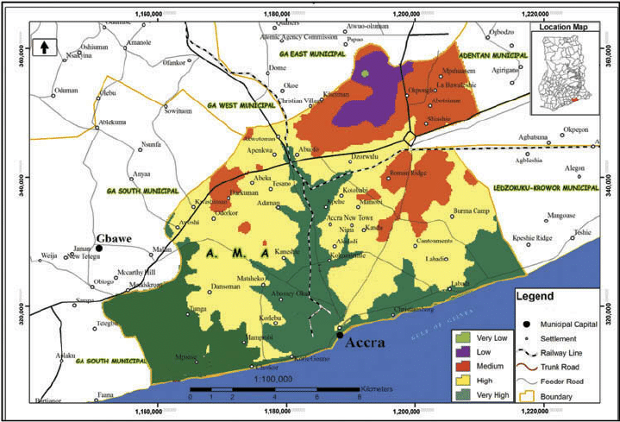
Figure 1: A digitized map of Accra showing flood-prone areas by colour codes.
Source: CERSGIS, 2013.
- Areas along the White Volta River of the north
The areas along the White Volta River in Ghana cuts across all 5 northern regions including: Northern, Savanna, North-East, Upper East and Upper West. As a generalization, the White Volta lies approximately between latitude 8°50'N to 11°05'N and longitude 0°06'E to 2°50'W (see Figure 2). Unlike coastal Accra and Cape Coast with their burgeoning population, these areas of the north are largely rural and scarcely populated. The areas are also mainly agrarian specialized in peasant farming and food crop rather than cash crop production (Laar, 2025; Laar & Dujin, 2025). Historically, crops like grains, legumes and tubers are the most important and widely cultivated across these savanna belts (Laar & Dujin, 2025). But equally important to note is that, the White Volta takes its source from northern nearby Burkina Faso where it is dammed at Bagre to support local agricultural activities. During peak water levels, the dam authorities often spill over excess water to avoid breakdown of the facility. The timing of these spillages most often spell doom for residents downstream who live and farm along the catchment areas and floodplains of the White Volta River.
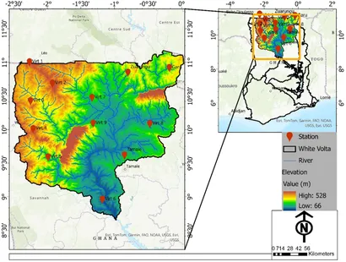
Figure 2: A digitized map of northern Ghana showing flood-prone areas along the White Volta by colour codes.
Source: CERSGIS, 2013.
Data sources
Since this is primarily a review paper, data was obtained largely from secondary data sources including scholarly academic journals and books. The thematic desktop review carried out enabled the researchers to gain in-depth knowledge and understanding of the study topic which also helped in forming analytical conclusions and certain generalizations.
Data Collection
To facilitate the visualization of the study area, digitized flood risk maps of Accra and flood-prone areas along the White Volta River of the north were downloaded from University of Ghana’s CERSGIS. This was intended to aid readers appreciate the perceived and actual causes of flood hazards in the study setting.
1.2 SELECTED FLOOD DISASTER PROFILING IN GHANA
1.2.0 The 2007 & 2020 Northern Flood Disasters
1.2.1 Causes of the Flood Disaster
Prior to the 2007 flood disaster, the three northern regions namely: Northern, Savannah and North-East; as well as the Upper East & Upper West Regions were facing the brunt of drought conditions which had already impacted negatively on agricultural produce (Laar, 2025; UNDP, 2009; Laar & Dujin, 2025). But following three days of high intensity rainfall of an estimated 30mm, the effects were devastating and prompted a humanitarian crisis of some magnitude (UNDP, 2009). It is quite obvious that the ensuing cumulative effect of the dry spell that already created both human and environmental vulnerabilities, coupled with the excessive rainfall reached a threshold that available local capacities could and would normally cope with (UNDP, 2009; Oteng-Ababio, 2013; & Pelling, 2003).
In like manner, three days of torrential rains in September, 2020 left its mark on the residence of entire northern Ghana, most especially those that reside in and around the catchment areas of the Black/White Volta and Oti Rivers and its tributaries. The situation was worsened following the spillage of the Bagre Dam. To put things in perspective, these parts of the country are largely remote and agrarian in nature with very limited social amenities and infrastructure quite unlike the coastal areas of Accra and Cape Coast (Yaro et al, 2021). Thus, the every day risks and/or existing socio-economic and political vulnerabilities had made a bad situation worse. An estimated 15,000 people were directly affected by the flood disaster which also saw at least 10 persons losing their lives (GNA, 2020). In addition, people’s homes and farms were submerged leading to further losses (see fig.3). Most of these losses were recorded in the North-East and Upper East Regions. In furtherance, critical economic infrastructure including roads & highways, bridges, among others suffered various degrees of structural damages. Portions of the Bolga-Bawku Highway for instance were washed away thus disconnecting the region from the rest of Ghana (GNA, 2020). The Bagre Dam spillages in particular continue to be an issue since public awareness through education and information dissemination always come a little too late.

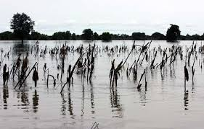
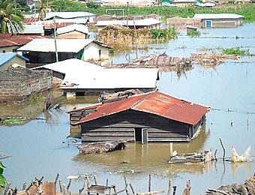
Figure 3: The 2007 & 2020 northern Ghana flood disaster in pictures
Source: GNA, 2020.

1.2.2 Planning and Prevention
In developing any recovery program, it is essential that stakeholders take into account the everyday risks situation and pre-existing vulnerabilities so as to stop the disaster from repeating itself (Oteng-Ababio, 2012). This could be achieved mainly through conduction of comprehensive risk & vulnerability assessment to uncover the underlying factors so that the ultimate goal of Disaster Planning (DP) is better achieved (Oteng-Ababio, 2011; Pelling, 2003). But it appears the concept of environmental justice is still remote to development planners in Ghana and indeed in most third world countries (Oteng-Ababio, 2012). This is because little has been achieved in our quest to address the issues of Annual Exceedance Probability of flooding especially in northern Ghana though a bit of some non-structural flood measures such as efficient sharing of information and integrated flood management solutions could suffice (Okyere et al, 2012; UNDP, 2012; Oteng-Ababio, 2012). Ametebelle et al (2025) and Atanga et al (2023) observes that the appropriate use of technology such as GIS & Remote Sensing techniques to map out hotspot flood zones and facilitate real time monitoring of human activities around these areas will go a long way to curbing flood problems in urban Ghana. Yet such a proposal is complicated by grey policy framework as government is either unable or unwilling to act in this direction (Oteng-Ababio, 2015). Perhaps, Public-Private-Partnerships where private individuals, organizations and civil society are roped in to help provide both expertise and resources needed in these integrated flood management if the state lacks the financial muscle to do just that. Thus, both structural and non-structural flood management strategies are necessary in mitigating the impacts of flood disasters in northern Ghana (Atanga et al, 2023). Until the everyday risks are identified and dealt with in their formative stages by disaster managers in Ghana, flood disasters are expected to remain cyclical and cause continuous destruction to lives and property especially so when climate change impacts are expected to disproportionately affect people and places (Laar, 2025; Nyarko, 2000; Laar & Dujin, 2025; Owusu et al, 2014; Owusu & Waylen, 2009). It is thought that, the construction of the Pwalugu Multi-purpose Irrigation Dam in the Upper East region will harvest excess water from the Bagre Dam spillages. However, this project that has already been stalled due to funding issues by the Government of Ghana and which is expected to cost up to US$993 million in total is a cause for concern (GNA, 2020). When fully completed though, the project will stimulate agricultural, industrial and other economic activities in the north, whilst also serving as the game changer in the fight against flood disasters in northern Ghana.
1.3 The 2010 Flooding & June 3 2015 Twin Disasters in Accra.
1.3.0 Causes of the Flood Disasters
Flooding in the city of Accra like most cities in Sub-Saharan Africa are a perennial problem that leaves city authorities with more questions to answer than they would normally have anticipated (Douglas, 2017). Country philosophers and social commentators alike, attribute this to several factors some of which include: edaphic and hydrological dynamics of Accra, lack of drainage facilities, lack of political will/commitment to deal with the issue once and for all, among others (UNDP, 2012; Okyere et al, 2012 & Oteng-Ababio, 2013). But the discourse also centers on mitigation efforts since that represents the better way forward from the modern disaster management perspective (Asare-Kyei, et al (2015). The post-independence era of Ghana has been characterized by economic crisis as successive governments struggle to bring economic stability to an otherwise promising nation with huge prospects of socio-economic success (Chamma, 2024; Bedeke, 2023). This has led to infrastructural deficit which seem to lure political leaders into the acquisition of loans from bilateral and multilateral agencies in their bid to ‘bridge the development gap’ (Laar, 2024). The city of Accra seems to be caught up in a complex web of creating sustainable growth and development in the midst of an ever-increasing population (Oteng-Ababio, 2013). As such, pre-disaster plans/preparedness is often complicated by financial constraints which have also reduced NADMO to a relief-oriented body (Oteng-Ababio, 2013). Nevertheless, NADMO in collaboration with MMDAs and other state institutions have over the years been able to sensitize Ghanaians about the need to be aware of both the man-made and natural hazards that we live with. Yet such steps were always never going to be enough considering the magnitude of losses that continue to overwhelm the country during and after flood disasters.
The flooding of cities in developing countries most especially in sub-Saharan Africa is almost ubiquitous and are characterised by recurrence, and Annual Return Intervals (Oteng-Ababio, 2013). This is partly a consequence of climate change impacts which has altered the patterns and intensity of rain storms and partly a function of improper land use planning, agglomeration of industrial and economic activities, edaphic & catchment characteristics as well as hydrological dynamics, and urbanization (Laar, 2025; Owusu et al, 2014; Laar & Dujin, 2025; UNDP, 2009). In most cities across sub-Saharan Africa, development usually do not correspond with the population dynamics which creates a deficit in infrastructure as available facilities are overly stretched (Oteng-Ababio, 2013). As a consequence, rainstorms of a slightly higher than normal intensity can trigger flooding of some magnitude since the available structures usually ‘collapse’ in the midst of choked storm drains and gutters (Douglas, 2017; Dekongmen et al, 2021). The results of these flooding most of the time leaves much to be desired as lives and properties are lost. But it also means sources of livelihoods are severely compromised thus putting a strain in the fight towards reducing extreme poverty and hunger through sustaining livelihood (Laar, 2025).
On June 20, 2010, 2 days of heavy down pour led to the flooding of the Ghanaian capital city of Accra (GNA, 2010; Oteng-Ababio, 2013). The after mouth of the flood disaster did not only leave people bitter about the catastrophe but also there was a cataclysm of some sort – 35 persons dead and many sources of livelihoods lost (Oteng-Ababio, 2013). Roads and bridges including the Ring Road in Accra were washed away in the flooding in much the same way as houses, schools, utility delivery systems and businesses (GNA, 2010). The flooding also left many suburbs like Odawna, Weija, Santa Maria, Hatso, Nima, Gbawe, Alajo, Mallam, and others without electricity and potable water for up to 5 days and caused serious disruption to economic and local industrial activities (Oteng-Ababio, 2013). An estimated 33,602 people were directly affected whilst an additional 15,000 people were displaced (UNDP, 2012).
In like manner, 3 days of torrential rains in Accra on June 3, 2015 left many parts of the city flooded (Myjoyonline.com, 2015). To put this into perspective, the issue of flooding in Accra is cyclical and is complicated by edaphic, as well as the hydrological dynamics of the city. The general soil characteristics favour water-logging other than infiltration (Atanga et al, 2017; Oteng-Ababio, 2015). Thus, a slightly higher than normal rainfall easily triggers surface runoff. As a consequence, areas in and around the Odaw River were particularly affected by the flood disaster (GNA, 2015). Of outmost interest of this paper is the terrible multiple disaster that is better described as ‘the day flood water catches fire’ (Oteng-Ababio, 2015). An explosion of a nearby fuel filling station at the Kwame Nkrumah Circle led to the gruesome killing of an estimated 150 people who were trapped by inundation of water and garbage from the heavily polluted Odaw River (GNA, 2015). But properties worth an estimated US dollars 12 million were consumed by the flooding and fire (NADMO, 2015). Particularly hit was the automobile and finance industries. Many car assembling industries and forex bureaus close to the area were either submerged in water or blazed down by the resulting inferno from the fuel station explosion (see figure 4). Many people also lost their businesses through the disaster.
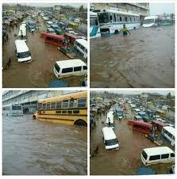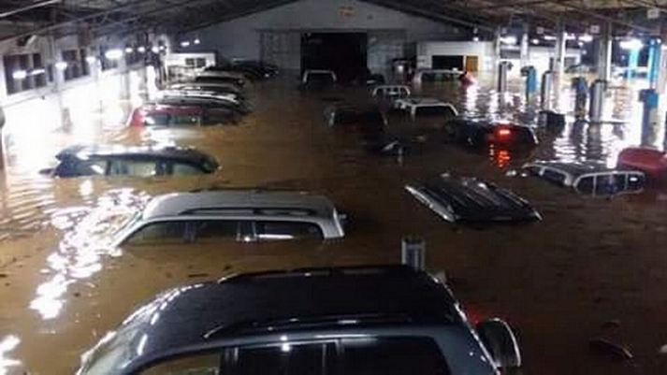
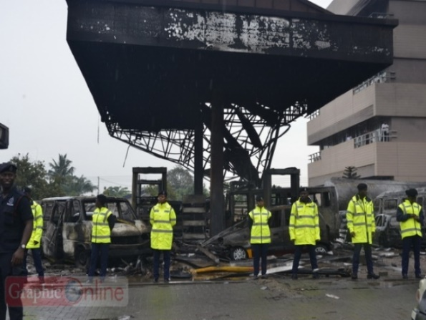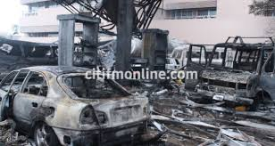

Figure 4: The June 3, 2015 twin disaster in Accra in pictures
Source: Graphiconline.com & Citifmonline.com

1.3.1 Planning and Prevention
Prior to the recent flood disasters in 2010 and 2015 there had been minimal efforts and planning to help reduce flood risk in the national capital. Taking action or steps to reducing exposure and probable future damages represent the more pragmatic modern paradigm to DP (Oteng-Ababio, 2011; 2012; 2013a & 2013b). The approval and take-off of the Conti project which would see the injection of some US$660million into the construction of a proper drainage system for Accra by the Government of Ghana in partnership with the Conti Group of Companies of Germany is thus a step in the right direction (GNA, 2015). Thus, to better address the issue of flooding in Accra and indeed, most of the major cities in Ghana, the author recommends the construction of closed storm drain systems. This state of affairs will prevent the discharge of solid waste materials that chokes up the drains and will go a long way to reducing the negative impacts of these disasters on lives and properties.
To reiterate the earlier flood management approach, flood plain zoning is needed to better appreciate the magnitude of the problem. People who build on water ways and on wetlands must face demolition of their properties and prosecution (Asare-Kyei et al, 2015). This will compensate for the poor drainage facilities in this city (Atanga et al, 2023). Additionally, the use of GIS and Remote Sensing, as well as other geo-spatial engineering solutions could be used to support flood management in the city (Atanga et al, 2023; Kwang & Osei-Jnr, 2017). As a modern city, Accra has emerged as a civil aviation hub in West Africa and as such, the socio-economic gains made over the years should not be eroded by mundane if not, vague rhetoric of poor management practices and engineering solutions of the city.

1.4 Conclusion
Just like any disaster, flooding disrupts family and economic activities and it is in this view that this paper outlines pre-disaster, disaster and post-disaster flooding strategies that would help residents to mitigate or prevent the occurrence of flooding. Thus, an interplay of chronic anthropogenic and demographic factors; and virtual institutional collapse of state agencies, coupled with edaphic and hydrological dynamics of many of the country’s flood prone areas have been the bane behind Ghana’s age-old flood disaster profile. You would imagine then, that further research is needed to explore into flood disaster management using remote sensing & GIS techniques which incorporates geo-spatial engineering solutions into National Development Planning (NDP) and foster the liberal management of flood disasters in Ghana. It is the expectations of this paper that the adoption and use of the recommendations and plans outlined would result in a smooth operation of activities geared toward reducing flood disasters in Ghana.

Disclaimer (Artificial intelligence)
Option 1:
Author(s) hereby declare that NO generative AI technologies such as Large Language Models (ChatGPT, COPILOT, etc.) and text-to-image generators have been used during the writing or editing of this manuscript.

References
Ahadzie, D. K., & Proverbs, D. G. (2010). Flooding and post flooding response strategies in Ghana. WIT Transactions on Ecology and the Environment, 133, 281–291. https://doi.org/10.2495/FRIAR100241
Amatebelle, C. E., Owolabi, S. T., Ogundeji, A. A., & Okolie, C. C. (2025). A systematic analysis of remote sensing and geographic information system applications for flood disaster risk management. Journal of Spatial Science, 70(3), 441–467. https://doi.org/10.1080/14498596.2025.2476973

Asare-Kyei, D.; Forkuor, G. & Venus, V. (2015). Modeling Flood Hazard Zones at the Sub-District Level with the Rational Model Integrated with GIS and Remote Sensing Approaches
Water 2015, 7(7), 3531-3564; https://doi.org/10.3390/w7073531

Asumadu-Sarkodie, S., Owusu, P. A., & Rufangura, P. (2015). Thermochemical processing and utilization of heavy-metal(loid)-contaminated biomass resulting from phytoextraction View project construction project management View project. Pelagia Research Library, 6(October), 53–78. https://doi.org/10.6084/M9.FIGSHARE.3381460
Asumadu-Sarkodie, S., Owusu Phebe, A., & Jayaweera Herath M P, C. (2015). Flood risk management in Ghana: A case study in Accra. Advances in Applied Science Research, 6(4), 196–201. www.pelagiaresearchlibrary.com
Atanga, A., Tankpa, V. & Acquah, I. (2023). Urbanization and flood risk analysis using
geospatial techniques. . PLoS ONE 18(10):e0292290. https://doi.org/10.1371/journal.pone.029229
Attipoe, S. K. (2014). An Assessment of Flood Mitigation Measures in Accra, Ghana. Kwame Nkrumah University of Science and Technology.
Bedeke, S.B (2023). Climate change vulnerability and adaptation of crop producers in sub-Saharan Africa: a review on concepts, approaches and methods. Environ Dev Sustain 25, 1017–1051 (2023). https://doi.org/10.1007/s10668-022-02118-8
Braimah, M. M., Abdul-Rahaman, I., Oppong-Sekyere, D., Momori, P. H., Abdul-Mohammed, A., & Dordah, G. A. (2014). A Study into the Causes of Floods and its Socio-economic Effects on the People of Sawaba in the Bolgatanga Municipality, Upper East, Ghana. International Journal of Pure and Applied Bioscience, 2(1), 189–195. www.ijpab.com

CERSGIS (2013). Flood risk map of Accra Metropolitan Area (City of Accra). Source: Centre for Remote Sensing and GIS (CERSGIS), University of Ghana, Accra, July – August 2013. Accessed: November 9, 2025.
Chamma, D. (2024) Climate change and economic growth in sub-Saharan Africa: an empirical analysis of aggregate- and sector-level growth. J. Soc. Econ. Dev. (2024). https://doi.org/10.1007/s40847-024-00377-x
David Baaman Laar & Barma Laribick Dujin. (2025). Climate Change and Food Security: Whispers from a Developing Country. Current Research on Geography, Earth Science and Environment Vol. 3, 152–167. https://doi.org/10.9734/bpi/crgese/v3/6415
https://doi.org/10.9734/bpi/crgese/v3/6415
Dekongmen, B.W., Kabo-bah, A.T., Domfeh, M.K. et al (2021). Flood vulnerability assessment in the Accra Metropolis, southeastern Ghana. Appl Water Sci 11, 134 (2021). https://doi.org/10.1007/s13201-021-01463-9

Douglas, I. (2017). Flooding in African cities, scales of causes, teleconnections, risks, vulnerability and impacts. International Journal of Disaster Risk Reduction; Vol. 26. pages 34 - 42.
GNA, (2010). Ghana News Agency. Heavy rains cause havoc in Accra, local news item. GNA,
Accra. Date accessed; October 21, 2025.
GNA, (2012). Ghana News Agency. EDITORIAL: AMA Building Inspectors Have Questions to Answer. GNA, Accra – Ghana; accessed on October 19, 2025.
GNA, (2013). Ghana News Agency. The Blazing End of a Commercial Nerve Center – Katamanto. Local news item; accessed on October 19, 2025.
GNA, (2020). Ghana News Agency; news archives. GNA, Accra – Ghana. Available at www.ghanaweb.com, accessed on October 14, 2025.
GNA, (2015). Ghana News Agency; news archives. GNA, Accra – Ghana. Available at www.ghanaweb.com, accessed on October 20, 2025.
Ibrahim, B. & Mensah, H. (2021). Rethinking climate migration in sub-Saharan Africa from the perspective of tripartite drivers of climate change. SN Soc Sci 2, 87 (2022). https://doi.org/10.1007/s43545-022-00383-y
IFRC, (2014). International Federation of Red Cross and Red Crescent Society. DREF Final Report: Emergency Plan of Action (EPoA) Ghana: Cholera Outbreak Response; Accra, Ghana. Available at www.ifrc.org; accessed on October 15, 2025.
TY - JOUR
Kwang, C.; Osei Jnr, E, (2017) Accra Flood Modelling through Application of Geographic Information Systems (GIS), Remote Sensing Techniques and Analytical Hierarchy Process
VL - 06 DO - 10.4172/2469-4134.1000191JO - Journal of Remote Sensing & GISER
Laar, D. B. (2025). Causes and Impacts of Drought Hazards on Crop Production
and Food Security in Ghana’s Northern Savanna Ecosystem: A Cause-
Effect Analysis. International Journal of Environment and Climate
Change, 15(9), 137-146
WWW.graphiconline.com, (2015). Flood Disaster Profile in Ghana since 1968. Date accessed; October 20, 2025.
WWW.gbcghana.com, (2015). NADMO Overwhelmed by the number of people affected by the June 3 Twin Disaster in Accra. In news item; accessed on October 10, 2025.
NADMO, (2015). National Disaster Management Organization Archives. Available at www.nadmo.gov.gh.
Mensah, H., & Ahadzie, D. K. (2020). Causes, impacts and coping strategies of floods in Ghana: a systematic review. SN Applied Sciences, 2(5), 1–13. https://doi.org/10.1007/s42452-020-2548-z
Nyarko, B. K. (2000). Flood risk zoning of Ghana: Accra experience. International Archives of the Photogrammetry, Remote Sensing and Spatial Information Sciences - ISPRS Archives, 33, 1039–1050.
Odame, P. K. (2017). Road transport infrastructure and mobility : Views of students with physcial disability in the University of Cape Coast [University of Cape Coast]. https://erl.ucc.edu.gh/jspui/handle/123456789/3211
Okyere, C. Y., Yacoba, Y., & Gilgenbach, D. (2013). The problem of annual occurrences of floods in Accra: An integration of hydrological, economic and political perspectives. Theoretical and Empirical Researches in Urban Management, 8(2), 45–79.
Oteng-Ababio, M. (2011). Neglected Vulnerabilities in a rapidly urbanizing city: reflections on
earthquake risks in Accra. Journal of Housing and the Built Environment. Vol. 27 No. 2 pp.187 - 205
Oteng-Ababio, M. (2012). (In) justice: Unequal exposure to ecological hazards in Metropolitan
Accra. International Journal of Environment and Planning A (In Press)
Oteng-Ababio, M. (2012). Integrated Environmental Health and Disaster Risk Reduction. ICDE,
Legon. Accra, Ghana.
Oteng-Ababio, M. (2013). Unscripted (In) justice: Unequal exposure to ecological hazards in
Metropolitan Accra, International Journal of Environment and Planning A, Vol. 45 No. 5 pp.
1199 - 1218
Oteng-Ababio, M. (2013). Prevention is Better than Cure:Assessing Ghana's Preparedness (Capacity) for Disaster Management. Jamba: Journal of Disaster Risk Studies 5 (2), Art. #75, pp1-11. http://www.dx.doi.org/10.42102/jamba.v5i2.75, 1-11.
Oteng-Ababio, M., K. Sarfo & E. Owusu-Sekyere (2015). Exploring the Realities of Resilience:
Case study of the Katamanto market fire in Accra, Ghana. International Journal of Disaster
Risk Reduction 12(2015) 311 - 318
Oteng-Ababio, M. (2014). More rhetoric or less action: digging into urban health vulnerabilities -insights from urbanizing Accra, Geo Journal (2014). http//dx.doi.org/10.1007/s10708-013-9498-
6
Oteng-Ababio, M. & K. Sarpong (2015). Reducing fire threats to markets: piloting community-
based fire risk assessment in Accra, Disaster (2015).
Owusu, K., P. Obour & S. Asare-Baffour (2014). Climate Variability and Climate Change Impacts on Small-holder Farmers in the Akuapem North District, Ghana. Handbook on Climate Change Adaptation, 1 - 13.
Owusu, K. & P. Waylen (2009). Trends in Spatio-Temporal Rainfall Variability in Ghana (1951-2000). Weather, 64(5); 115 - 120.
Potter, R., T. Binns, J. Elliot & D. Smith. (2008). Geographies of Development: An Introduction
to Development Studies. Pearson/Prentice Hall, London/New York.
WWW.tv3network.com. Cause of GOIL fire revealed as death in twin disaster hits 200, in news
item. Date accessed; October 21, 2025.
Pelling, M. (2003). The Vulnerability of Cities: Natural Disaters and Social Resilience. London: Earthscan.
Robinson, P. & A. Henderson-Sellers (1999).Contemporary Climatology. Harlow, UK: Lngman
Serdeczny, O., Adams, S., Baarsch, F. et al (2017). Climate change impacts in Sub-Saharan Africa: from physical changes to their social repercussions. Reg Environ Change 17, 1585–1600 (2017). https://doi.org/10.1007/s10113-015-0910-2
UNDP. (2009). UNDP's Response to Crisis Prevention and Recovery in Northern Ghana: Recovery Programming Support for Northern Ghana. Accra: UNDP.
UNDP. (2012). Community Resilience through Early Warning: Project Document. Accra, Ghana.
UNISDR (United Nations International Strategy for Disaster Reduction), How to make cities
more resilient: A handbook for local government leaders, United Nations, Geneva, 2009. page 102
Wisner, M. P. (2008). Disater Risk Reduction Cases of Urban Africa. London: Earthscan.
WWW.citifmonline.com, (2015). June 3 Ridge Hospital Nurses to be buried on July 10. In news
item; accessed on October 20, 2025.
WWW.graphiconline.com, (2013). Melcom Disaster: Psychological Association offers to help
victims overcome trauma; news item: accessed on October 21, 2025.
WWW.myjoyonline.com, (2012). Bureaucracy, probable cause of Melcom Disaster - Kwabena
Agyapong. Local news item; accessed on October 15, 2025.
WWW.myjoyonline.com, (2013; 2014). 65 Killed in Fire Disasters in 2013. Local news item;
accessed on October 10, 2025.
WWW.myjoyonline.com, (2015). Joy FM, Mobile Water donates 2,000 bags of sachet water to
disaster victims. Local news item; accessed on October 13, 2025.
Owusu, K. & P. Waylen (2009). Trends in spatio-temporal variability in annual rainfall in Ghana (1951-2000). Weather, 64(5), 115-120.
Welborn L (2018) Africa and climate change-projecting vulnerability and adaptive capacity. ISS Afr Rep 2018(14):1–24
Winsemius HC, Jongman B, Veldkamp TI, Hallegatte S, Bangalore M, Ward PJ (2018) Disaster risk, climate change, and poverty: assessing the global exposure of poor people to floods and droughts. Environ Dev Econ 23(3):328–348. https://doi.org/10.1017/S1355770X17000444
Yaro, J., Wahab, I., Afful-Mensah, G., & Awenam, M. B. (2021). The rise of
medium-scale farms in the northern Savannah of Ghana: Farmland
invasion or an inclusive commercialised agricultural revolution?

