Integration of Organic Farming and IPM Approaches for Sustainable Crop Protection: A Comprehensive Review

Abstract
This review aims to demonstrate synergistic methods of pest control and organic farming to achieve residue-free and sustainable crop production. Integrated Pest Management (IPM) plays a pivotal role in organic farming by reducing dependence on synthetic chemical pesticides and promoting ecological balance. Natural enemies, including predators, parasitoids, and pathogens provide sustainable pest suppression and contribute to crop health. Successful examples, such as Trichogramma spp. for controlling lepidopteran pests and entomopathogenic fungi like Beauveria bassiana highlight the practical applicability of biological control strategies across diverse cropping systems. These approaches enhance long-term soil and plant health. However, challenges such as inconsistent field performance, environmental limitations, and high production costs continue to restrict wider adoption. Recent advances in formulation technologies, mass production, and farmer awareness programs have improved the success of biocontrol agents in organic systems. A deeper understanding of ecological interactions, coupled with policy support and integration with modern tools, is essential for scaling up the effectiveness of biological control within organic IPM frameworks.
Keywords: Biological control, Integrated Pest Management (IPM), natural enemies, Trichogramma, Beauveria bassiana, organic farming, sustainable agriculture.

1. Introduction

Organic farming is essential to sustainable agriculture because it protects the environment, boosts biodiversity, and produces safe, nutritious food (Ishani et al., 2022). The demand for organic crops has steadily increased due to consumers' growing awareness of food safety, environmental degradation, and chemical-intensive farming's negative effects (El-Shafie, 2019). Organic farming has spread to millions of hectares in Europe, North America, and parts of Asia, as per FAO and IFOAM reports. Organic farming is booming in India due to government programs like PKKY and NPOP, and customer demand for chemical-free products. Sikkim, which went organic in 2016, has shown how organic farming may enhance farmers' livelihoods and address sustainability challenges.

These benefits aren't enough to convince organic producers to prioritise pest control. Synthetic pesticides are banned or heavily restricted in organic systems, unlike conventional agriculture's rapid use to fight epidemics. This restriction exposes farmers to sudden pest invasions, which can reduce crop yield and harm the economy. Small-scale farmers may lack the planning, monitoring, and expertise to use cultural practices, beneficial organisms, and natural processes. Bio-pesticides and biological control agents are organic pest management strategies, although they may function slower, have a shorter shelf life, or have uneven effects in different agro-climatic regions (Baker et al., 2020). Given these challenges, organic pest management must be well-organised and coordinated to safeguard crops.

IPM offers a comprehensive solution to these issues. Integrative pest management (IPM) uses mechanical, cultural, biological, and preventative methods, with chemical treatments reserved for extreme situations and eco-friendly whenever possible. Organic farming requires IPM to reduce synthetic pesticide use without compromising crop quality or output (Dara, 2019). Parasites, predators, and entomopathogenic fungi can target pests without disrupting ecological balance, while crop rotation, intercropping, and habitat alteration can help naturally reduce pest populations. Monitoring with sticky cards, pheromone traps, and field surveys reduces crop damage and losses, enabling quick responses. Organic farms can balance pest control, biodiversity, and customer safety with integrated pest management.

This review paper will discuss IPM in organic farming, including its pros and cons. This overview covers biological control agents, botanical pesticides, cultural and mechanical methods, and monitoring instruments for organic systems' IPM. It includes regional and global case studies to demonstrate effective adoption approaches and field challenges. The review also identifies research gaps and solves knowledge gaps, notably in developing inexpensive, farmer-friendly, and climate-resilient pest control solutions. This study uses literature to make research, policy, and practice suggestions. It seeks to explain how organic farming systems can integrate IPM.

2. Principles of Integrated Pest Management

IPM aims to reduce pest impacts on crop output, improve ecological security, and prolong agricultural operations. Prevention, monitoring, and intervention comprise a systematic IPM framework. These concepts are important for organic farming systems, which ban synthetic chemicals and require environmentally friendly pest management. Altieri (2018) states that IPM relies on understanding the agro-ecosystem and designing pest management strategies that work with natural control mechanisms.

IPM's fundamental principle, prevention, aims to reduce pest conditions. Because reactive control mechanisms are limited, organic systems rely primarily on prevention. Preventative measures include crop rotation, intercropping, sanitation, resistant variety use, and habitat management. Crop diversity attracts beneficial species that reduce pest populations and break pest life cycles. Prevention reduces pest outbreaks by limiting the ecosystem's pest-carrying capacity (Dar et al., 2021). Preventative techniques include soil health management to boost plant vitality and insect resistance. These methods are organic farming's first protection against pests until they become uncontrollable.
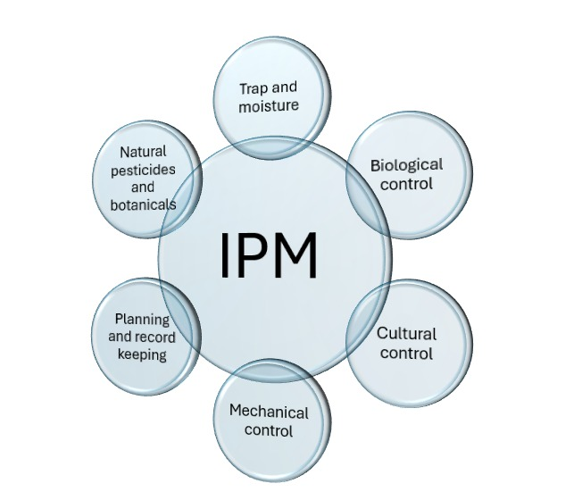
Figure 1 IPM principles [source: (Dar et al., 2021)]

The second concept, monitoring, involves monitoring pest populations and crop health. Monitoring data helps farmers decide when, if, and how to intervene. Pest species, life phases, and population dynamics must be precisely identified for effective pest treatment (Muneret et al., 2018). Organic farming uses field reconnaissance, sticky traps, and pheromone traps to monitor pests. Farmers can promptly detect infestation symptoms and take action using these methods. Monitoring ensures that actions are only done when necessary and avoids ecological imbalance. (Finckh et al., 2018) stressed that ecological threshold values, which consider biodiversity protection and long-term sustainability, are better for organic systems than conventional agriculture's strict economic thresholds.

Intervention is the third principle of IPM and involves taking action when pest levels are high. Organic farming emphasises cultural, mechanical, and biological interventions. People use predators, parasitoids, and microbial pesticides to control pests. For example, Trichogramma spp. have been used to control lepidopteran pests and entomopathogenic fungi like Beauveria bassiana in organic systems (Deguine et al., 2021). Mechanical methods like hand-picking, traps, and impediments are used in systems with limited human labour. Organic standards allow neem oil and pyrethrum when intervention is needed, but their use is closely regulated. According to (Headrick, 2021), pest control should never conflict with ecological sustainability to avoid harm.

Integrated pest management prioritises environmental balance. Eliminating all pests from an environment is impossible and undesirable. Instead, IPM controls insect populations while protecting ecosystems and economies. Due to organic farming's goal of biodiversity and ecological interactions, this principle is crucial. Natural enemies, pollinators, and soil bacteria maintain agricultural yield. (Romeh, 2018) emphasise the relevance of ecological intensification, reduced disturbance, and habitat management in conserving beneficial species. Both organic farming and IPM view the farm as a functioning ecosystem where pests, crops, and beneficial organisms are in harmony.

Another important consideration is how effectively IPM meets organic certification criteria. Most synthetic pesticides are banned or severely limited in organic farming due to strict rules. Certification organisations like the IFOAM and the USDA National Organic Program demand farmers to use ecologically friendly methods and follow organic principles. IPM meets these characteristics since it uses preventive, monitoring, and non-chemical interventions. However, certification criteria allow minimal usage of botanical products and bio-pesticides. IPM meets organic criteria and enhances the legitimacy and value of organic foods by ensuring pest control practices are transparent, safe, and sustainable (Mani, 2022). IPM-based organic certification frameworks let farmers manage pests without compromising their organic status.

Finally, IPM's three tenets—prevention, monitoring, and intervention—provide a sound framework for organic farming pest control. Here, ecological balance, long-term survival, and organic certification are key. Multiple authors have shown that interventions ensure focused and ecologically appropriate control, monitoring informs decision-making, and preventative cultural practices reduce pest risks. Together, they form a comprehensive pest-resistance approach for organic farming systems. As insect pressures and climate change increase, organic farmers are seeking integrated pest management to safeguard their crops, the environment, and their livelihoods (Ningombi et al., 2023).

3. Biological Control in Organic IPM

The core of Integrated Pest Management (IPM) in organic agricultural systems is biological control, a sustainable, environmentally beneficial, and farmer-friendly alternative to chemical pesticides. Biological management uses parasitoids, predators, and pathogens to control pests instead of synthetic inputs that disrupt ecological processes. Biological control manages pests and improves biodiversity and environmental stability (Bhanu & Yadav, 2019). Because organic systems cannot utilise chemical pesticides, biological management is the principal way to reduce pest populations safely.

Organic farming uses natural predators for biological control. Aphid, whitefly, and spider mite populations must be controlled by predatory insects like lacewings, ladybird beetles (Coccinellidae), and predatory mites (Phytoseiidae). (Grasswitz, 2019) found that predators, as generalists, provide broad-spectrum pest control. Ladybird beetles, when released in high numbers, reduce aphid infestations in fruit and vegetable crops, making them a valuable tool for organic farmers. Lacewings reduce insect pressures in organic greenhouse crops. Natural enemies are adaptable and compatible with other integrated pest management solutions like botanical insecticides.

Parasitoids are common biological controls. Parasiteoids are specialist natural adversaries that destroy hosts inside and feed on them. The egg parasitoid Trichogramma spp. has long controlled lepidopteran pests in vegetable, cotton, and maize crops for organic farmers. Trichogramma releases are one of the most successful augmentative biological control programs worldwide due to their low cost and mass manufacturing (Reiff et al., 2021). By adopting large-scale Trichogramma chilonis releases, Indian organic cotton producers have eliminated bollworm infestations without synthetic insecticides. Due to their specificity, parasitoids are ideal for organic systems, although release time and environmental factors determine their efficacy.

Pathogens such as bacteria, fungi, and viruses are key biological controls in organic IPM. Nucleopolyhedroviruses (NPVs), Metarhizium anisopliae, Beauveria bassiana, and Bacillus thuringiensis have reduced several pests. Organic farming uses Bt formulations to control Helicoverpa armigera and Plutella xylostella caterpillars. One of the most researched microbial insecticides, Bt is safe and effective in many agricultural systems (Stenberg, 2017). Metarhizium anisopliae kills termites and root grubs, while Beauveria bassiana kills whiteflies, thrips, and beetles. NPVs work well to manage Spodoptera litura and Helicoverpa spp. with minimal ecological impact (Akinyemi, 2021). Organic farmers have many cultural and preventative options due to the range of germ control agents.

Several successful examples illustrate that biological control can improve organic farming. In Europe, predatory mites like Phytoseiulus persimilis can be released to suppress spider mites in greenhouse tomatoes and cucumbers (Daelemans et al., 2022). Indian researchers used Trichogramma and neem-based formulations to dramatically reduce rice and cotton pest damage (Sen et al., 2024). Latin American horticulture crops using viral biopesticides have reduced pesticide residues and increased demand for organic food. These cases demonstrate how biological control can underpin organic IPM in a comprehensive and information-heavy framework.

Despite these advances, biological control is still not commonly adopted for many reasons. Biological control agents are susceptible to humidity, temperature, and UV light, making their field performance unpredictable. According to (Kaur & Kaur, 2020), farmers don't trust outcomes since they don't match controlled lab settings. Chemical insecticides work immediately, but natural enemies and viruses take longer. Even in the deadliest outbreaks, relief may take time. Low-resource communities may lack biocontrol agent storage, handling, and transport facilities. Many places still have trouble getting high-quality biocontrol products, so they have to rely on smaller providers with questionable quality control.

Policy concerns include slow approvals and limited marketing of biological control agents due to poor regulatory frameworks. Standardised regulatory frameworks and farmer education are needed to scale up biological control in organic systems (Kalkura et al., 2021). Synergistic effects boost pest suppression, whereas antagonistic interactions lower it; hence biological control treatment compatibility study is needed.

Table 1: Biological and Botanical Options in Organic IPM(Kaur & Kaur, 2020)
Category | Examples | Target Pests/Diseases | Mode of Action | Limitations
Natural predators | Ladybird beetles, lacewings | Aphids, whiteflies | Predation | Require habitat for survival
Parasitoids | Trichogramma spp. | Lepidopteran eggs | Parasitism of pest eggs | Host-specific, need release programs
Pathogens | Beauveria bassiana, Bt | Caterpillars, beetles, soil pests | Infection and toxin production | Sensitive to environmental factors
Botanicals | Neem, pyrethrum, rotenone | Sucking and chewing insects | Antifeedant, repellent, growth regulator | Variable efficacy in field
Essential oils | Garlic, eucalyptus, citronella | Stored grain pests, mites | Repellency, fumigant effect | High cost, rapid degradation

4. Botanical and Bio-pesticides
Botanical and bio-pesticides are increasingly used in organic pest management due to their eco-friendliness, compatibility with natural enemies, and organic certification. Botanical pesticides are plant-based, unlike bio-pesticides, which come from microbes or natural chemicals. Organic farming requires these synthetic pesticide alternatives due to their lower residue, non-target impacts, and ecological safety (Bottrell & Schoenly, 2018). Incorporating sustainable, environmentally friendly activities within IPM frameworks promotes soil health and biodiversity (Vashishth et al., 2022).
Azadirachta indica, or neem, is a popular and well-studied plant. Neem contains growth-regulating, insecticidal, and antifeedant bioactive compounds. These include azadirachtin, nimbin, and salannin. Azadirachtin disrupts moulting hormones, preventing insect development and reproduction (Brzozowski & Mazourek, 2018). Aphids, whiteflies, and caterpillars are among the chewing and sucking pests that neem-based formulations kill. Neem's systemic properties make it effective against soil pests when drenched. It is non-toxic to beneficial organisms, making it suitable for organic systems. Neem has been used in Indian vegetable, cotton, and rice crops as part of IPM programs to reduce synthetic pesticide use and maintain yields (Aubert et al., 2023).
Pyrethrum, another popular plant insecticide, derives from Chrysanthemum cinerariifolium flowers. Pyrethrins' interference with sodium channel function in the insect nervous system causes rapid paralysis and death. Pyrethrum is beneficial due to its broad-spectrum activity and quick knockdown (Zhou et al., 2024). Photodegradation shortens its residual activity period, requiring repeated applications in the field. Despite this, pyrethrum is still useful for organic farmers, notably for horticultural crops and faster pest outbreak suppression. Organic standards allow its use due to its low environmental persistence and natural origin. Essential oils from other plants may be insecticidal. Citronella, rosemary, thyme, and clove oils include antifungal, repellent, and insecticidal phenolic compounds and terpenes. (Piñero & Keay, 2018) say essential oils fumigant, inhibit enzyme activity, and disrupt insect neurological processes. They control greenhouse and storage pests successfully. However, instability, phytotoxicity at higher levels, and poor field stability prevent them widespread use.
Recent advances in nano-formulations and encapsulating technologies improve controlled release and durability (El-Shafie, 2019). Microbial pesticides are also important biopesticides. Bt, Beauveria bassiana, Metarhizium anisopliae, and NPVs are bacterial and fungal products. Insect larvae die from gut paralysis after eating Bt crystal proteins. (Baker et al., 2020) said organic certification systems approve Bt formulations, which work well against lepidoptera-eating pests. Fungal bio-pesticides like B. bassiana can pierce insect cuticles and proliferate inside the host. Their aid has controlled whiteflies, thrips, and beetles. Also, NPVs are viral bio-pesticides that destroy Spodoptera litura and Helicoverpa armigera with few negative effects (Dara, 2019). Microbial pesticides provide targeted control without harming beneficial insects, making them ideal for inorganic IPM.
Botanical and bio-pesticides halt insects physically or behaviourally, however their effectiveness varies. Even though they work slower than chemical pesticides, their compatibility with natural systems ensures their long-term sustainability. However, (Muneret et al., 2018) noted that their performance may vary in different field circumstances. This is especially true in tropical climates where humidity and temperature affect efficacy.
Organic farming allows botanical and bio-pesticides due to their low risk and natural origin. IFOAM and USDA National Organic Program-certified botanical and microbiological goods can be used under strict limits. Regulatory frameworks boost farmer confidence and product commercialisation (Finckh et al., 2018). Different registration methods in different countries might impede uptake and market access. Standardise our formulations and quality control to restore farmers' trust in our products.
Organic integrated pest management relies on botanical and bio-pesticides, which are safe, environmentally friendly, and compliant. They will become more important in organic agriculture systems as research and formulation and delivery technologies advance.
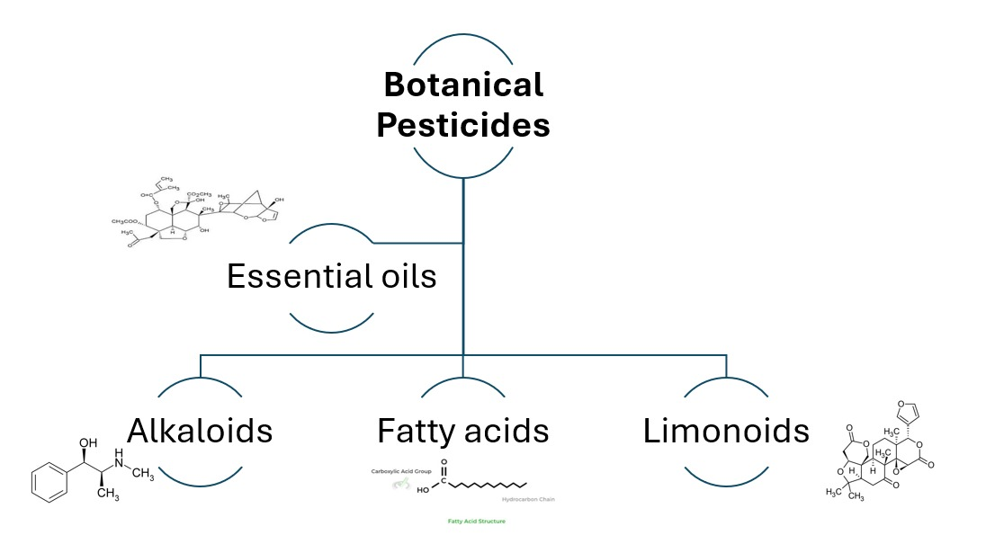
Figure 2: Botanical and Bio-pesticides contain

5. Cultural and Mechanical Practices
Cultural and mechanical pest management methods are among the oldest and most ecologically sound, and they are still important in organic farming systems that prohibit chemical use. These methods alter the agro-ecosystem to reduce pests and boost natural control. Cultural and mechanical methods reduce pest load through ecological manipulation, preventive, and farmer-led interventions, supporting sustainability and biodiversity protection (Deguine et al., 2021).
Crop rotation is a popular cultural practice. Farmers can disrupt soil-borne pest and disease life cycles by shifting crop sequences. Rotating cereals with legumes stops pest cycles and fixes nitrogen, improving soil fertility. Root-knot nematodes, cereal rusts, and stem borers are effectively controlled by crop rotation (Headrick, 2021). Rotation is a cost-effective preventive measure in organic systems without synthetic nematicides or fungicides.
Trap crops are cultivated to attract and repel pests from major crops. Mustard is planted with cabbage to attract diamondback moths and reduce crop pests. Trap cropping dramatically reduces pesticide use while maintaining yields (Romeh, 2018). Trap crops attract pests and concentrate biological control agents, boosting natural pest control.
Cultural IPM emphasises habitat management. Farmers build predator and parasitoid habitats using floral strips, hedgerows, and different cropping systems. Habitat diversification improves ecological resilience, pest-natural enemy interactions, and outbreak risks (Mani, 2022). Organic approaches encourage habitat management to complement synthetic pesticide bans and boost farm biodiversity. Mechanical methods eliminate pests quickly. Nets, row coverings, and mulches physically block pests from crops. These work well in small-scale horticulture systems. (Bhanu & Yadav, 2019) found that row covers greatly reduce insect-transmitted viral infections in vegetables. IPM programs benefit from sticky traps and pheromone traps' monitoring and control capabilities.

In smallholder organic systems, hand-picking pests, especially large ones like caterpillars and beetles, is laborious yet effective. Regular manual removal during early infestation stages can considerably reduce pest populations (Grasswitz, 2019). This strategy works effectively on small organic farms with labour, but not on huge mechanised farms.
Pest control is also helped by weed and soil management. In IPM, weeds must be controlled since they host pests and pathogens. Organic mulch reduces weeds and changes the microclimate, eliminating pest habitats. Composting and green manuring boost soil health and plant vigour, making crops pest-resistant (Kumar et al., 2022). Diversity Healthy soils provide beneficial microbes that compete with or reduce soil-borne diseases, indirectly controlling pests (Reiff et al., 2021).
Cultural and mechanical approaches succeed in varied organic systems. In European orgpests (yards, habitat diversification has increased predatory mite populations, reducing acaricide use (Stenberg, 2017). Trap farming with mustard in brassica fields in Asia has decreased pest burdens by 70% for smallholders. Row covers have also protected organic vegetable crops against flea beetles and aphids in North America. These examples show how cultural and mechanical approaches are adaptable and eco-friendly. However, limits exist. Cultural techniques like crop rotation require land and forethought, which small farmers may not have. Trap cropping may fail if pest pressure is great or crops are handled poorly. Mechanical approaches are effective yet labour-intensive and may raise manufacturing costs. These strategies require innovation and farmer training to scale in big farming systems (Akinyemi, 2021). Since they use ecological principles and non-chemical interventions, cultural and mechanical activities meet organic certification standards. Certification bodies promote these methods as first-line pest control, confirming organic IPM's preventive approach. Using cultural and mechanical techniques to demonstrate ecological balance rather than external inputs boosts organic system credibility (Daelemans et al., 2022).
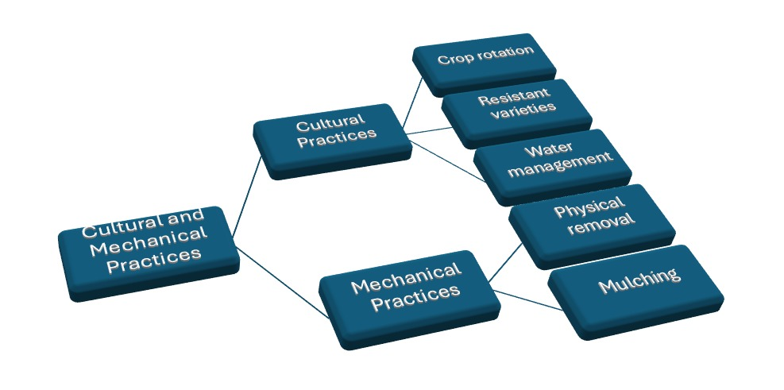
Figure 3: Cultural and Mechanical Practices

6. Monitoring and Decision-making in Organic IPM
Organic farmers use IPM tactics that focus on monitoring and decision-making. Organic systems rely on accurate observation to lead timely and environmentally sound interventions, unlike conventional agriculture, which uses chemicals at the first hint of infection. Pest monitoring includes field scouting, visual inspections, and decision-support systems like GIS and prediction algorithms. The most prevalent method is field scouting, when certified professionals or farmers regularly monitor insect concentrations, life phases, and natural enemies (Altieri et al., 2018). These recordings provide a dynamic pest population picture for timely interventions.
Light and pheromone traps are popular biological tools. Pheromone traps attract male insects with synthetic sex pheromones for population monitoring and direct suppression by disrupting mating (Sen et al., 2024). UV light traps can catch nighttime pests like moths and beetles. Their extensive use in cotton and rice systems in India's government-backed integrated pest management programs has been successful (Kaur & Kaur, 2020). Aphids and whiteflies that eat plant sap are also trapped and destroyed by sticky traps.
Organic pest management is hindered by economic threshold levels (ETL), a concept developed for conventional agriculture. At what pest density is control cost-effective? ETLs represent this. The ecological threshold level (Eco-TL) often trumps yield maximisation in biological systems (Kalkura et al., 2021). Eco-TLs consider economic harm, environmental sustainability, natural enemy defence, and soil health over time. Maintaining low aphid levels in vegetable gardens may help ladybird beetles reduce pests over time. Therefore, organic IPM decision-making must shift from economic concerns to ecological factors.
New digital decision-support technologies have improved monitoring in recent years. Smartphone-based pest identification apps and real-time weather data have helped several nations detect insect outbreaks early (Bottrell & Schoenly, 2018). These tools must be tailored to local farmers' farming systems and literacy levels. Overall, good monitoring and decision-making combine ecological principles with farmer skill and technology innovation.

7. Case Studies and Regional Experiences
Many agro-ecological settings worldwide had tried IPM in organic farming with varied success. The US, Europe, and India case studies help explain organic IPM.
In Uttarakhand, India, organic basmati rice systems use Trichogramma wasps, neem-based biopesticides, and light traps as a community-integrated pest management technique. This method reduced stem borer by 40% while maintaining yields (Brzozowski & Mazourek, 2018). As an organic state, Sikkim uses biopesticides like Beauveria bassiana and traditional cultural techniques like intercropping to manage pests. These methods have made farming more environmentally benign, but output swings in ginger and cardamom are still an issue.
European vegetable systems, notably Mediterranean ones, use organic IPM. In protected tomato cultivation in Almería, Spain, banker plants, bumblebee pollination, and predators like Nesidiocoris tenuis are used to battle whiteflies. (Aubert & Enjolras, 2023) report that this method reduces pesticide residues while providing high-quality exports. However, acceptance required significant infrastructure and training investments, highlighting the socio-economic side of implementation. Fungal problems plague organic wheat and barley in Northern Europe. Cultural methods like delayed sowing, crop rotation, and resistant varieties form the basis of IPM.
US organic apple farms demonstrate how to combine environmental and consumer needs. Granulovirus biopesticides, predator augmentation, and pheromone mating disruption have controlled the apple system pest codling moth (Cydia pomonella). Long-term research in Washington State indicated that pesticide use was reduced by over 60% yet pest management was comparable to traditional orchards (Zhou et al., 2024). For such systems to work, area-wide management was needed because isolated farms were more prone to reinfest.
Comparing crop experiences reveals successes and shortcomings. Integrated pest control (IPM) for vegetable crops is appealing due to the feasibility of mechanical interventions like netting and hand-picking and the prevalence of natural enemies. Cereals suffer when pest outbreaks outnumber natural enemies, especially in monocultures. Apples and citrus are resistant to cultural and biological IPM, but aesthetic quality demands in high-value export markets present additional challenges (Piñero & Keay, 2018).
Adoption failures are also instructive. After biopesticides failed in the field, some farmers abandoned organic integrated pest control. Despite doing well in lab testing, Metarhizium anisopliae failed under India's high temperatures (El-Shafie, 2019). These examples emphasise regional flexibility and research. Thus, case studies in diverse countries reveal that IPM makes sense in theory but depends on local pest complexes, farmer capacities, and market realities.

Table 2: Regional Experiences with Organic IPM
Region/Country | Crop Focus | Key IPM Strategies Adopted | Reported Outcomes | References
India (Uttarakhand) | Basmati rice | Trichogramma release, neem sprays, light traps | Stem borer reduced by ~40%, yields stable | (Dara, 2019)
Sikkim (India) | Ginger, cardamom | Intercropping, Beauveria bassiana, cultural practices | Lower pesticide residue, yield variability | (Muneret et al., 2018)
Spain (Almería) | Tomato (greenhouse) | Banker plants, Nesidiocoris tenuis, bumblebees | Export quality produce, reduced residues | (Finckh et al., 2018)
USA (Washington State) | Apple orchards | Pheromone mating disruption, granulovirus, predators | 60% pesticide reduction, area-wide success | (Deguine et al., 2021)
Northern Europe | Wheat, barley | Crop rotation, delayed sowing, resistant varieties | Reduced fungal disease pressure | (Aubert & Enjolras, 2023)

8. Challenges and Limitations
Organic IPM in organic farming faces several challenges, including inconsistent performance of biopesticides and natural enemies, knowledge and capacity gaps among farmers, market and policy constraints, and the impact of climate change on pest dynamics. Biopesticides and microbial formulations often face regulatory delays, inconsistent quality standards, and higher costs compared to conventional pesticides. Markets remain volatile and impose stringent cosmetic standards, which can lead to risk-averse pest management strategies. Climate change has also disrupted synchrony between pests and their natural enemies, reducing the reliability of biological control. Socio-economic barriers, such as labour availability and community participation, also make IPM interventions less feasible. To address these limitations, a multi-pronged approach involving adaptive research, farmer education, policy support, and climate-resilient innovations is needed.

9. Future Directions and Opportunities
The evolution of IPM in organic farming is transforming, driven by advancements in science, digital technologies, and policy frameworks. The future of IPM in organic farming will focus on improving pest control efficacy, enhancing resilience, sustainability, and farmer adoption. Advanced biocontrol agents and nano-formulations are promising, as they can improve stability, persistence, and targeted delivery. Information and communication technologies (ICTs) are also being integrated for pest monitoring and decision-making, enabling real-time identification of pests and natural enemies. Policy interventions, training programs, and farmer field schools will play a crucial role in scaling organic IPM. The integration of IPM with climate-smart agriculture (CSA) is another critical opportunity, as climate change is altering pest dynamics and disrupting natural enemy synchrony. Future IPM systems must be embedded within broader CSA frameworks, emphasising crop diversification, resilient varieties, water management, and carbon-friendly practices. This convergence of IPM and CSA could ensure organic farming remains viable in the face of ecological uncertainties.

10. Conclusion
This analysis reveals that organic farming needs IPM to survive. Organic farming is better for the environment, but it needs time to control pests without chemicals. Integrating botanicals, cultural practices, educated decision-making, and biological control, IPM supports organic certification and ecological resilience. The analysis emphasises that legislative barriers, variable biopesticide performance, and comprehension gaps prevent uniform use, despite improvements evidenced by case studies in the US, Europe, and India. Nano-biopesticide formulations, climate-smart agriculture, and ICT-driven pest surveillance offer potential futures. Supportive policy frameworks that ensure scalability and affordability and farmer training are essential. IPM in organic systems can improve pest control and maintain farming's ecological and economic grounds. More research is needed in biocontrol, digital tools, and climate change-induced pest dynamics. Scientists, farmers, and policymakers must collaborate to build resilient knowledge-driven systems. Only then can IPM be organic farming's long-term foundation.

Disclaimer (Artificial intelligence)
Option 1:
Author(s) hereby declare that NO generative AI technologies such as Large Language Models (ChatGPT, COPILOT, etc.) and text-to-image generators have been used during the writing or editing of this manuscript.
Option 2:
Author(s) hereby declare that generativ AI technologies such as Large Language Models, etc. have been used during the writing or editing of manuscripts. This explanation will include the name, version, model, and source of the generative AI technology and as well as all input prompts provided to the generative AI technology
Details of the AI usage are given below:
1.
2.
3.

Reference
- El-Shafie, H. A. F. (2019). Insect pest management in organic farming system. Multifunctionality and impacts of organic and conventional agriculture, 8, 1-20. DOI: 10.5772/intechopen.84483
- Baker, B. P., Green, T. A., & Loker, A. J. (2020). Biological control and integrated pest management in organic and conventional systems. Biological Control, 140, 104095. https://doi.org/10.1016/j.biocontrol.2019.104095
- Dara, S. K. (2019). The new integrated pest management paradigm for the modern age. Journal of Integrated Pest Management, 10(1), 12. https://www.researchgate.net/publication/332896288_The_New_Integrated_Pest_Management_Paradigm_for_the_Modern_Age
- Dar, S. A., Mir, S. H., Wani, S. H., Dolkar, T., Showkat, A., & Dawa, T. (2021). Insect Pest Management in Organic Agriculture—A Fast Growing Approach of 21st Century. International Journal of Agriculture, Environment and Sustainability, 3(1), 1-6. https://www.researchgate.net/publication/349117486_Insect_Pest_Management_in_Organic_AgricultureA_Fast_Growing_Approach_of_21st_Century
- Muneret, L., Mitchell, M., Seufert, V., Aviron, S., Djoudi, E. A., Pétillon, J., ... & Rusch, A. (2018). Evidence that organic farming promotes pest control. Nature sustainability, 1(7), 361-368. DOI: 10.1038/s41893-018-0102-4
- Finckh, M. R., Junge, S. M., Schmidt, J. H., & Weedon, O. D. (2018). Disease and pest management in organic farming: a case for applied agroecology. In Improving organic crop cultivation (pp. 291-322). Burleigh Dodds Science Publishing. https://www.researchgate.net/publication/329393235_Disease_and_pest_management_in_organic_farming_a_case_for_applied_agroecology
- Deguine, J. P., Aubertot, J. N., Flor, R. J., Lescourret, F., Wyckhuys, K. A., & Ratnadass, A. (2021). Integrated pest management: good intentions, hard realities. A review. Agronomy for Sustainable Development, 41(3), 38. DOI: 10.1007/s13593-021-00689-w
- Headrick, D. (2021). The future of organic insect pest management: Be a better entomologist or pay for someone who is. Insects, 12(2), 140. https://www.researchgate.net/publication/349104738_The_Future_of_Organic_Insect_Pest_Management_Be_a_Better_Entomologist_or_Pay_for_Someone_Who_Is
- Romeh, A. A. (2018). Integrated pest management for sustainable agriculture. In Sustainability of Agricultural Environment in Egypt: Part II: Soil-Water-Plant Nexus (pp. 215-234). Cham: Springer International Publishing. DOI:10.1007/698_2018_267
- Mani, M. (2022). Organic pest management in horticultural crops. Trends in horticultural entomology, 211-241. DOI:10.1007/978-981-19-0343-4_7
- Bhanu, C., & Yadav, V. (2019). Advances in integrated pest and disease management in organic farming. Modern concepts and practices of organic farming for safe secured and sustainable food production, 293. https://www.researchgate.net/publication/349237593_Modern_Concepts_and_Practices_of_Organic_Farming_for_Safe_Secured_and_Sustainable_Food_Production
- Grasswitz, T. R. (2019). Integrated pest management (IPM) for small-scale farms in developed economies: Challenges and opportunities. Insects, 10(6), 179. DOI: 10.3390/insects10060179
- Reiff, J. M., Kolb, S., Entling, M. H., Herndl, T., Möth, S., Walzer, A., ... & Winter, S. (2021). Organic farming and cover-crop management reduce pest predation in Austrian vineyards. Insects, 12(3), 220. DOI: 10.3390/insects12030220
- Stenberg, J. A. (2017). A conceptual framework for integrated pest management. Trends in plant science, 22(9), 759-769. DOI: 10.1016/j.tplants.2017.06.010
- Akinyemi, A. O. (2021). Exploring integrated pest management strategies in the control of the fall armyworm in smallholder organic agriculture farms in Africa. Agro-Science, 20(3), 65-70. DOI: https://doi.org/10.4314/as.v20i3.9
- Daelemans, R., Hulsmans, E., & Honnay, O. (2022). Both organic and integrated pest management of apple orchards maintain soil health as compared to a semi-natural reference system. Journal of Environmental Management, 303, 114191. DOI: 10.1016/j.jenvman.2021.114191
- Altieri, M. A., Farrell, J. G., Hecht, S. B., Liebman, M., Magdoff, F., Murphy, B., ... & Sikor, T. O. (2018). Integrated pest management. In Agroecology (pp. 267-281). CRC Press. https://www.taylorfrancis.com/chapters/edit/10.1201/9780429495465-14/integrated-pest-management-miguel-altieri-john-farrell-susanna-hecht-matt-liebman-fred-magdoff-bill-murphy-richard-norgaard-thomas-sikor?utm_source=chatgpt.com
- Sen, S., Borkataki, S., Taye, R. R., Nanda, S. P., & Reddy, M. D. (2024). Organic Pest Management: A Vision Toward a Safer Nation. In Advances in Organic Farming (pp. 533-550). Apple Academic Press. DOI: 10.1201/9781003502715-33
- Kaur, T., & Kaur, M. (2020). Integrated pest management: a paradigm for modern age. IntechOpen. DOI: 10.5772/intechopen.92283
- Kalkura, P., Kashyap, S., & Ramyashree, M. (2021). Pest control management system using organic pesticides. Global Transitions Proceedings, 2(2), 175-180. https://doi.org/10.1016/j.gltp.2021.08.058
- Bottrell, D. G., & Schoenly, K. G. (2018). Integrated pest management for resource-limited farmers: challenges for achieving ecological, social and economic sustainability. The Journal of Agricultural Science, 156(3), 408-426. DOI: https://doi.org/10.1017/S0021859618000473
- Brzozowski, L., & Mazourek, M. (2018). A sustainable agricultural future relies on the transition to organic agroecological pest management. Sustainability, 10(6), 2023. DOI: 10.3390/su10062023
- Aubert, M., & Enjolras, G. (2023). Organic farming vs. integrated pest management: which strategies do greenhouse tomato growers choose to reduce pesticide use? Tomato grower pesticide reduction strategies. International Journal of Agricultural Resources, Governance and Ecology, 19(4), 348-365. https://doi.org/10.1504/IJARGE.2023.142815
- Zhou, W., Arcot, Y., Medina, R. F., Bernal, J., Cisneros-Zevallos, L., & Akbulut, M. E. (2024). Integrated pest management: an update on the sustainability approach to crop protection. ACS omega, 9(40), 41130-41147. The DOI link is: https://doi.org/10.1021/acsomega.4c06628
- Piñero, J. C., & Keay, J. (2018). Farming practices, knowledge, and use of integrated pest management by commercial fruit and vegetable growers in Missouri. Journal of Integrated Pest Management, 9(1), 21. https://doi.org/10.1093/jipm/pmy011
- Vashishth, M., Maheshwari, S., Garg, R., & Kaushal, S. (2022). Soil microbial diversity in conventional and organic agricultural farming systems. The Pharma Innovation, 11(11), 1331–1337. https://doi.org/10.22271/tpi.2022.v11.i11Sq.16837
- Mohan, I., Paul, R., Kumar, N. A., & Kaushal, S. (2022). Organic farming’s impact on the environment: The controversy. International Journal of Economic Plants, 9(4), 344–348. https://doi.org/10.23910/2/2022.0497a
- Kumar, A., Chhabra, N., & Kaushal, S. (2022). The effective role of microbes in sustainable soil health. International Journal of Advances in Agricultural Science & Technology, 9(5), 26–40. https://doi.org/10.47856/ijaast.2022.v09i05.004
- Ningombi, D., Dafouti, A., Nagpal, P., Nanda, H. B., Banerjee, S., & Kaushal, S. (2023). Dynamic use of cow pat pit, biodynamic preparations and peppering in organic farming. International Journal of Plant & Soil Science, 35(10), 157–167. https://doi.org/10.9734/ijpss/2023/v35i102935

