Original Research Article

Characterisation and Energy Valorisation Trials of Septic Tank Sludge from Urban Areas in Benin, West Africa

Abstract
Introduction: Population growth is accompanied by a significant increase in waste production of all kinds, including that from latrines, which raises serious health and environmental issues. Furthermore, in today’s energy-intensive lifestyle, the exploration and utilisation of new renewable, sustainable, and environmentally friendly energy sources is imperative.
Aims: This study aims to explore the potential for energy recovery (biogas) from septic tank sludge in Benin.
Place and Duration of Study: Liquid sludge samples were collected from 29 May to 2 June 2023 at the Sludge Treatment Station (STS) in Adjagbo, within the commune of Abomey-Calavi.
Methodology: Sludge is subjected to anaerobic co-digestion with simple fruit waste and in the presence of iron filings. The process lasted between 17 and 24 days, depending on the composition of the digester.
Results: The raw biogas obtained comprises methane and carbon dioxide in proportions ranging from 55.2% to 65.3% and 34.7% to 44.8% for simple co-digestion, respectively, and between 60.82% and 71.35% and 28.65% to 39.18% in the presence of iron filings.
The results demonstrated the effectiveness of iron filings in biogas production and a reduction in process duration during co-digestion compared to simple digestion of fruit waste.
Conclusion: This study provides avenues for exploring the valorisation of sludge into renewable energy and considers the use of biodigesters in households as an alternative to conventional septic tanks. The results of this study provide valuable insights to guide effective sludge waste management practices in Benin.
Keywords: Sludge, anaerobic co-digestion, biogas, valorisation, Benin.

- Introduction
Rapid urbanisation and population growth in developing countries have led to a significant increase in the generation of wastewater and faecal sludge. This demographic increase has resulted in a substantial rise in waste production, with household waste contributing notably to health and environmental problems (Guengant and May, 2011; Gashaw, 2014). Among these wastes, septic tank sludge stands out as a neglected aspect of urban sanitation, posing a considerable challenge for management. This environmental issue concerns all stakeholders within the community. According to research conducted by Topanou et al. in 2024, septic tanks and latrines in the commune of Abomey-Calavi (Benin) are often emptied only when completely full, subsequently emitting foul-smelling gaseous products (Topanou et al., 2024). The organic matter settling in the tank undergoes biological transformation through anaerobic processes (liquefaction, acidogenesis, acetogenesis, and methanogenesis), during which numerous reduced compounds dissolve in the liquid phase, releasing volatile compounds, notably carbon dioxide and methane (Jean-Pierre et al., 2009). Furthermore, the release of large quantities of carbon dioxide and methane potent greenhouse gases into the environment during the decomposition of these wastes significantly contributes to global warming. In today’s energy-intensive lifestyle, the exploration of new renewable and sustainable energy sources is essential.
By 2040, the world is projected to have a population of 9 to 10 billion, necessitating adequate energy and material provision. The majority of residents in developing countries lack regular access to advanced energy forms, such as electricity, and thus rely heavily on solid fuels, such as firewood, to meet basic energy needs such as cooking and lighting. Environmental, regulatory, and societal considerations have led to the emergence of the idea that all types of waste should be viewed as a resource to be exploited. According to d’Arras, waste should be utilised to its fullest potential; thus, its valorisation is not only beneficial but necessary (d’Arras, 2008; Sefouhi et al., 2010). Consequently, it is feasible to transform waste into a genuine secondary raw material. Establishing such a virtuous cycle is a demanding yet modern objective, providing a sustainable alternative to waste management challenges (Bensmail and Touzi, 2012; Ignace et al., 2016). Managing, optimising, and valorising waste have become commitments to the future (d’Arras, 2008).
Moreover, numerous studies indicate that poor management of septic tank sludge and other types of waste is responsible for various nuisances, including aesthetic and olfactory issues, and the increasing detection of groundwater contamination has prompted the development of the concept of aquifer vulnerability to pollution (Alraggad et al., 2012; Singh et al., 2020, Poromna et al., 2022). Benin, a West African country with a population exceeding thirteen million in 2023, is not exempt from these challenges (INSAE, 2023). However, well-structured management of septic tank sludge can lead to the production of bioenergy and agricultural fertilisers. Acknowledging the significant role of the energy sector whose primary challenge is to ensure an energy transition for sustainable economic and social development alongside waste management to protect the environment from climate change, this study aims to contribute to improved management of septic tank sludge through energy valorisation via anaerobic co-digestion (d’Arras, 2008; Lo et al., 2020; Topanou et al., 2021).

- Materials and Methods
  - Sample Collection of Sludge and Fruit Waste
Liquid faecal sludge samples were collected from 29 May to 2 June 2023 at the Faecal Sludge Treatment Plant (FSTP) in Adjagbo, within the commune of Abomey-Calavi. The samples were collected in 25 L plastic containers that had been thoroughly washed with detergent, rinsed several times with distilled water, and air-dried prior to sampling. To obtain a sufficiently representative sample, collection was carried out during the discharge of the desludging trucks in three phases: one at the beginning, one after half of the tanker’s contents had been emptied, and one at the end.
During each sampling campaign, collections were conducted from Monday to Friday, meaning that sludge discharged on each weekday was sampled. To facilitate handling, each sample was labelled according to the order of collection. Fiften (15) samples were obtained over a period of three months. This sample size has been chosen since the it is a pilot study.
All the sludge samples originated from a mixture of septic tank and latrine sludge. The collected sludge was immediately transported to the laboratory and stored under refrigerated conditions.
The fruit waste, collected from two fruit vendors in the city of Abomey-Calavi, consisted mainly of papayas and cabbages.
  - Analytical Methods
The pH of the samples was measured in situ using a HACH model HQ4300 pH meter. Organic matter and organic carbon were determined by incinerating the dried sludge in an electric oven at 400°C, following the NF EN 15935 standard. Total nitrogen was measured after oxidising nitrogen compounds into nitrogen oxides at high temperatures, in accordance with the NF EN 12260 (T 90-060) standard (Rodier et al., 2009).
  - Description of Equipment Used
The digesters employed in this study are cylindrical polyethylene containers with a capacity of 5000 ml. Two distinct setups were created for each sample: the first was used to quantify the raw biogas (CO2, CH4, and other trace gases) for each sample. It consisted of three transparent polyethylene vessels, the first being a 5000 ml hermetically sealed container with a stopper, and the other two being 1-litre vessels containing a hydrochloric acid solution at a pH close to 2 (to prevent the absorption of carbon dioxide and other gases) and distilled water, respectively. The latter was used to monitor biogas production. To maintain the digester temperature within the optimal range (33-45°C), the digester was submerged in a water bath, which housed an electric heater to raise the temperature. The biogas measurement system included a graduated measuring cylinder, where the displacement of water corresponded to the volume of gas produced. The entire setup is illustrated in Figure 1.
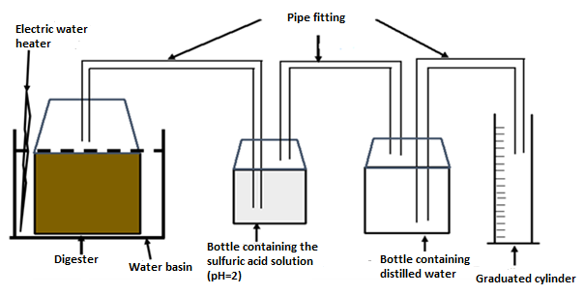
Figure 1 : Biogas production and quantification system
The second setup was designed for the quantification of methane. In this configuration, the objective is to directly measure the volume of methane produced. To achieve this, the previous vessel was replaced with another that facilitates the absorption of undesirable gases such as carbon dioxide (CO₂) and hydrogen sulphide (H₂S). The CO₂ and H₂S absorption system consists of a hermetically sealed bottle containing a molar solution of sodium hydroxide or potassium hydroxide at a pH close to 12 (see Figure 2).
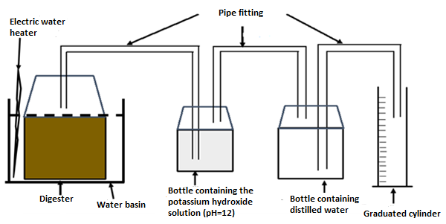
Figure 2: Methane Production System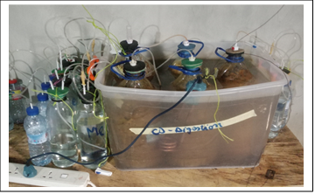
Photo 1: Close-up view of the anaerobic conditions of the experiment (©Agbatchi, November 2023)
  - Filling the Digester
After reducing the fruit waste into small particles, the samples were weighed. The resulting samples were introduced into the reactors as follows: the control reactor (R0) was filled with a mixture (M0) consisting of 2683±3 g of fresh fruit waste only. For each septic tank sludge sample, a mixture (M1) was prepared, comprising 2683±3 g of fruit waste mixed with 805 ml of septic tank sludge in a ratio of 77% fruit waste to 23% sludge (Ukondalemba et al., 2016). This mixture was introduced into four different reactors: two contained only the mixture M1 (one for quantifying the raw biogas produced and the other for methane), while the other two were filled with a mixture (M2) consisting of M1 plus an additional 1 g of iron filings.
In total, four (04) digesters were established for each septic tank sludge sample, along with two controls, resulting in twenty-two (22) digesters overall.
To create optimal anaerobic conditions, the mixture was adjusted to an alkaline pH (between 6.8 and 7.2), after which 1 litre of demineralised water was added to fully immerse the waste in each vessel. The mixture was gently agitated to ensure good contact between the bacteria and the waste. Each vessel was then connected to its respective apparatus.
  - Monitored Parameters
Prior to the anaerobic digestion process, parameters such as pH, temperature, volatile fatty acids, and total alkalinity were determined and monitored throughout the biogas production process in each vessel.
The pH was maintained in an alkaline range (6.8 - 7.2) prior to initiating biogas production. The temperature was elevated to between 33°C and 40°C and maintained within this range for the entire duration of the biogas production operation. Volatile fatty acids and total alkalinity were determined using pH-metric titration with a 0.1N hydrochloric acid solution, following the method developed by Nordmann W (Mézes et al., 2011).

- Results and Discussion
  - Characterisation of Faecal Sludge
Table 1 presents the physicochemical characteristics of the collected faecal sludge.
Analysis of the table reveals that the temperature of the faecal sludge ranges between 26.6 and 28.3°C. The pH values lie between 7.33 and 8.53, with an average of 8.22, indicating that the samples are generally alkaline (pH > 7), albeit tending towards neutrality.
The concentrations of total nitrogen (TN), total organic carbon (TOC), and organic matter (OM) range from 4840 to 5930 mg.L⁻¹, 170.4 to 660.0 mg.L⁻¹, and 306.3 to 1188.0 mg.L⁻¹, respectively. Additionally, the chemical oxygen demand (COD) and the five-day biochemical oxygen demand (BOD₅) show mean values of 18,730 mgO₂.L⁻¹ and 6612 mgO₂.L⁻¹, respectively.
Table 1: Physicochemical characterization of faecal sludge
 | B1 | B2 | B3 | B4 | B5 | Mean
COD (mgO₂.L⁻¹) | 2448 | 17760 | 22560 | 23520 | 27360 | 18729,60
pH | 8,53 | 8,37 | 8,52 | 7,33 | 8,37 | 8,22
Temp (°C) | 28,3 | 27,3 | 28,1 | 26,6 | 27,5 | 27,56
NT (mg.L⁻¹) | 4940 | 5780 | 4840 | 5460 | 5930 | 5390,00
OC (mg.L⁻¹) | 170 | 340 | 200 | 540 | 660 | 382,00
OM (mg.L⁻¹) | 306 | 612 | 360 | 972 | 1188 | 687,60
BOD₅ (mgO₂.L⁻¹) | 4394 | 12906 | 6654 | 7824 | 1280 | 6611,60
C/N | 0,03 | 0,06 | 0,04 | 0,10 | 0,11 | 0,07
COD/BOD5 | 0,56 | 1,38 | 3,39 | 3,01 | 21,38 | 2,83

  - Co-Digestion of Faecal Sludge

Preparation of Co-Digestion Mixtures
Given the low carbon content of the faecal sludge, as evidenced by a carbon-to-nitrogen (C/N) ratio of 0.07 far below the optimal range for anaerobic digestion (typically between 20 and 30) the sludge was subjected exclusively to co-digestion, using mixtures M1 and M2. Fruit waste was employed due to its high carbon content, and iron filings were added as electron donors to facilitate the oxidation of sulphides, which are malodorous gases potentially emitted during the digestion process.

Operation of Digesters
Figure 3 illustrates the variations in the mean concentrations of volatile fatty acids (VFA), bicarbonates (TAC), and pH in all digesters during biogas production.
Analysis of these figures shows that during anaerobic digestion, an increase in VFAs (Figure 3a) corresponds with a decrease in both pH and total alkalinity (TAC) (Figures 3b and 3c). The pH is particularly sensitive to changes in TAC (specifically bicarbonate content) as well as to VFA concentrations.
Overall, the digesters exhibited similar performance patterns. However, the pH (Figure 3c) and TAC (Figure 3b) in the digesters with iron-enhanced anaerobic co-digestion followed a consistently decreasing trend. In contrast, in the control digester, both pH (Figure 3c) and TAC (Figure 3b) experienced a slight increase between day 4 and day 7, accompanied by a marginal rise in VFA concentration. In the iron-enhanced co-digestion digesters, a minor increase in TAC was also observed between day 4 and day 7 (Figure 3b), while the pH remained relatively decreasing throughout the digestion process (Figure 3c).
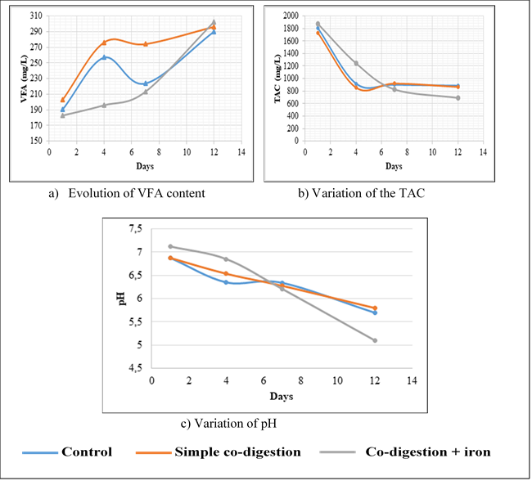
Figure 3: Evolution of Volatile Fatty Acids (VFA), Total Alkalinity (TAC), and pH during the Anaerobic Co-Digestion Process
  - Biogas Quantification
The ultimate aim of an anaerobic digestion process is the production of biogas. The cumulative biogas output from each digester is shown in Figure 4. It can be observed that biogas production in reactors B1, B2, and B4 is relatively low compared to the output of the control digester (Figure 4a). Additionally, the quantities of biogas generated in digesters B3 and B5 are nearly equivalent to those produced by the control digester.
Moreover, biogas production reached its peak more rapidly between the 17th and 24th day in digesters containing a mixture of faecal sludge and fruit waste. In contrast, the control digester only attained its maximum biogas yield on the 32nd day of the process (Figure 4a).
Furthermore, the data indicate that the presence of iron in the digesters enhanced biogas production across all systems, with the exception of digester B5, where output declined. Specifically, biogas production increased from 27,110 mL to 35,392 mL in the control digester, from 15,943 mL to 29,854 mL in digester B1, from 16,139 mL to 22,227 mL in digester B2, from 26,392 mL to 27,438 mL in digester B3, and from 13,553 mL to 43,937 mL in digester B4. Conversely, production in digester B5 fell from 27,438 mL to 18,207 mL (see Figures 4b and 4c).
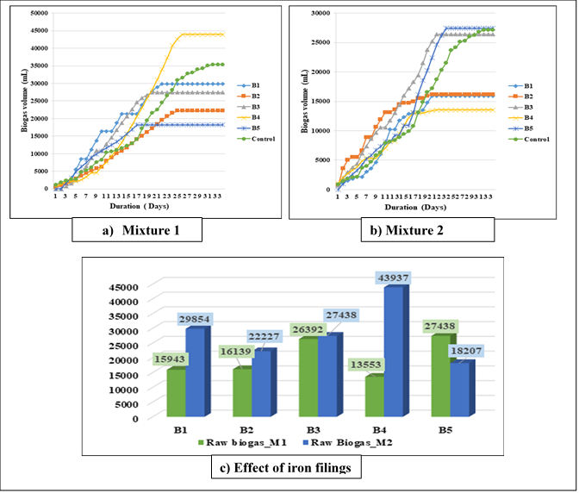
Figure 4: Cumulative Production of Raw Biogas for Simple Anaerobic Co-Digestion (a), Co-Digestion in the Presence of Iron (b), and the Effect of Iron Filings on the Process.
  - Quantification of Biogas Production
The primary objective of the anaerobic digestion process is biogas generation. The cumulative biogas production from each digester is shown in Figure 4. It can be observed that biogas output from digesters B1, B2, and B4 was significantly lower than that from the control digester (Figure 4a). Meanwhile, the volumes of biogas produced in digesters B3 and B5 were nearly equivalent to those observed in the control.
Furthermore, biogas production in digesters containing a mixture of faecal sludge and fruit waste reached its peak more rapidly, between the 17th and 24th day, whereas the control digester attained its maximum biogas production on the 32nd day of the process (Figure 4a).
The presence of iron in the digesters generally enhanced biogas production across all units, with the exception of digester B5, where production declined. Specifically, biogas production increased from 27,110 mL to 35,392 mL in the control digester, from 15,943 mL to 29,854 mL in digester B1, from 16,139 mL to 22,227 mL in digester B2, from 26,392 mL to 27,438 mL in digester B3, and from 13,553 mL to 43,937 mL in digester B4. However, in digester B5, production fell from 27,438 mL to 18,207 mL (see Figures 4b and 4c).
The quantity of biogas generated in digester B4 surpassed that of all other reactors: by 14,083 mL compared to B1, 21,710 mL compared to B2, 16,499 mL compared to B3, and 25,730 mL compared to B5. It also exceeded the output of the control digester by 8,545 mL (Figure 4b). In contrast, biogas production in digester B5 was lower in the presence of iron than in its absence.
Figure 5 presents the cumulative production of biogas purified using KOH.
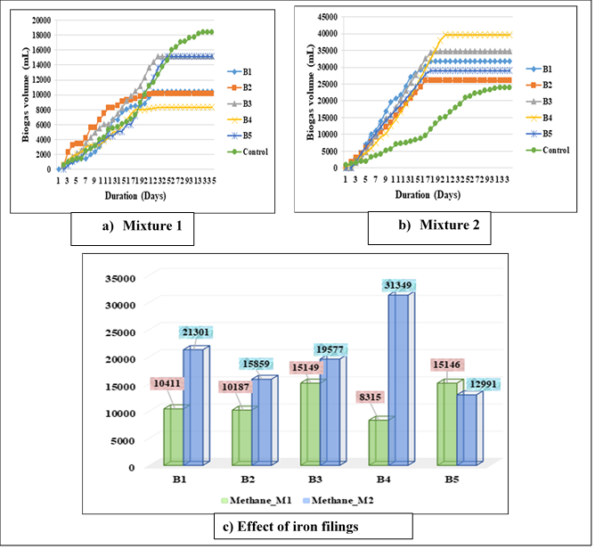
Figure 5: Cumulative production of KOH-purified biogas from standard anaerobic co-digestion (a), co-digestion with iron (b), and the effect of iron filings on the process (c).
This figure shows that the highest quantity of purified biogas was collected from the control digester over a 33-day period. Digesters B3 and B5 also yielded significant quantities of purified biogas over 25 and 23 days, respectively (Figure 5a).
Digesters B1, B2, and B4 produced relatively low volumes of purified biogas and over a shorter period, approximately 22 days. Moreover, in the presence of iron (Figure 5b), the control digester exhibited lower levels of purified biogas compared to the other digesters, with the highest production recorded in digester B4. This indicates a shift in the trend of purified biogas production under anaerobic co-digestion conditions.
It is also worth noting that in digesters B1, B2, B3, and B4, the inclusion of iron filings led to greater biogas production compared to when they were absent (Figure 5c).
In contrast, digester B5 exhibited a decline in biogas production when iron filings were introduced, relative to the standard co-digestion scenario without iron.
  - Composition of the Biogas
Figure 6 presents the composition of biogas in terms of methane and carbon dioxide under two conditions: anaerobic co-digestion without iron filings (mixture M1) and anaerobic co-digestion with iron filings (mixture M2).
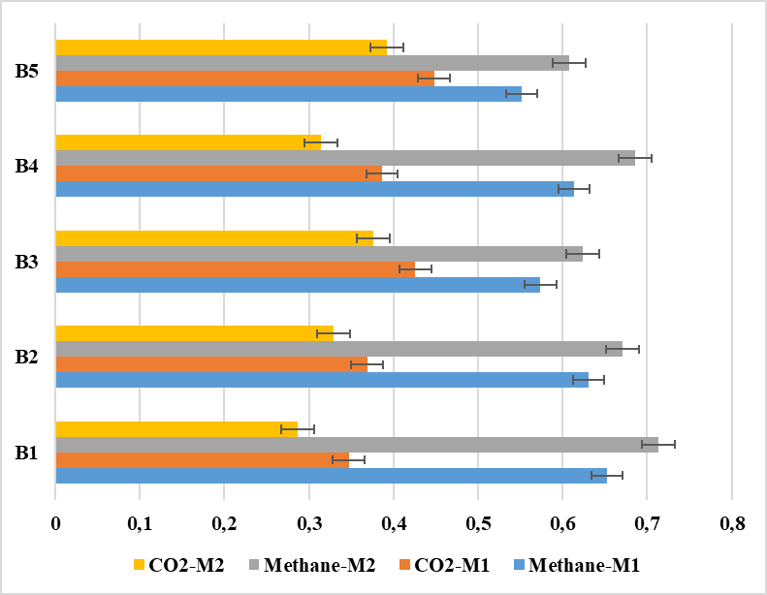
Figure 6: Composition of Biogas

  - Biogas Composition
Analysis of this figure reveals that the biogas produced through anaerobic co-digestion in the absence of iron comprises methane in proportions ranging from 55.2% to 65.3%, and carbon dioxide accounting for between 34.7% and 44.8%. In contrast, in the presence of iron filings, the methane concentration increases to between 60.82% and 71.35%, while the carbon dioxide content ranges from 28.65% to 39.18%. This demonstrates an increase in methane proportion and a corresponding reduction in carbon dioxide levels when iron is introduced into the anaerobic co-digestion process. These findings underscore the beneficial role of iron filings in enhancing biogas production during anaerobic digestion or co-digestion.
- Discussion
  - Characterisation of Faecal Sludge
The pH of the collected faecal sludge ranged from 7.33 to 8.53, with a mean value of 8.22. Higher temperatures have been reported by other authors, including Koné et al. in Ouagadougou (Burkina Faso) at 31.82°C, and Irotori et al. in Cotonou (Benin) at 30.93°C (Irotori et al., 2022; Kone et al., 2017). Nevertheless, similar pH values have been documented in sludge from septic tanks and latrines in the Ouémé Delta basin (Benin) (Irotori et al., 2022), in Abidjan (Côte d’Ivoire) (Soro et al., 2020), in Aného (Togo) (Poromna et al., 2020), and at drying beds in Zagtouli, Ouagadougou (Kone et al., 2017).
According to Koné et al., a pH between 5 and 9 supports the development of a broad range of microorganisms essential for sludge purification (Kone et al., 2017). The measured concentrations of total nitrogen (TN), organic carbon (OC), and organic matter (OM) confirm the presence of biodegradable material in the sludge. However, the C/N ratio of 0.07 is significantly below the optimal range (20–30 (Gashaw, 2014; Khalid et al., 2011), or 25–35 (Charnay, 2005) required for effective biological treatment. The COD/BOD₅ ratio of 2.83 further confirms the high proportion of biodegradable content (Kradolfer et al., 2013), consistent with observations in Abidjan, Ouagadougou, and Togo (Kone et al., 2017; Poromna et al., 2020; Soro et al., 2020). Therefore, biological treatment is not favourable for these sludge samples, likely due to their prolonged retention time in septic tanks (Topanou et al., 2024).
  - Digester Performance
The observed variations in pH, alkalinity (TAC), and volatile fatty acids (VFA) (Figure 3) may be attributed to disruptions in microbial activity, potentially caused by inhibitory compounds such as hydrogen sulphide (H₂S), and the manual regulation of temperature. Similar pH, TAC, and VFA trends were reported by Ukondalemba et al. (2016) during biogas production from faecal sludge mixed with fermentable household waste in Kinshasa (Ukondalemba et al., 2016).
  - Biogas Quantification
The notably higher biogas yield observed in digester B4 compared to B1, B2, B3, and the control digester may be explained by iron’s interaction with inhibitory substances such as ammoniacal nitrogen, hydrogen sulphide, hydrogen gas, and volatile fatty acids (Simon Poirier, 2016). These compounds can hinder anaerobic digestion, and their neutralisation through iron enhances biogas output.
Iron plays a regulatory role in maintaining optimal pH conditions, which in turn promotes methane production. Agani et al. (2016) observed that iron also reduces microbial inhibitors, including hydrogen sulphide, a major contributor to foul odours in sludge (Agani et al., 2016), as described by reaction (1) :
$$Fe+H_{2}S\underset{→}{ }FeS+H_{2}$$
The varying biogas quantities across digesters may be due to excessive sulphur compounds (>30 mg/Nm³) (Gasquet, 2021), which precipitate iron as FeS (reaction 1), reducing its bioavailability, or due to iron toxicity that inhibits microbial activity (Liu et al., 2024). Additionally, the variability in purified biogas quantities can be linked to differing levels of carbon dioxide generated in each digester.
The reversal in purified biogas output between co-digestion digesters and the control may be attributed to lower carbon dioxide production in the co-digestion digesters. Removal of CO₂ via potassium hydroxide results in higher purified biogas yields in co-digestion systems, and a decline in the control.
Improved biogas production in the presence of iron filings has been corroborated by several studies, including Agani et al., (2016) on fresh faecal sludge, and Zhang et al., (2014) on activated sludge.
As noted by Togbe, (2009), dihydrogen produced through the reaction of iron filings with H₂S may also reduce CO₂ under certain conditions via reaction (2). Furthermore, excess iron filings may directly react with CO₂, thereby increasing methane production and reducing carbon dioxide content (reaction 3) :
$${CO}_{2}+4H_{2}\underset{→}{ }{CH}_{4}+2H_{2}O (2)$$
$${8H}^{+}+{4Fe}^{0}+{CO}_{2}\underset{→}{ }{CH}_{4}+{4Fe}^{2+}+H_{2}O \left(3\right) {∆G}_{0}=-150.5KJ/mol {CH}_{4}$$
The observed decrease in biogas production in digester B5 in the presence of iron filings, compared to co-digestion without iron, could stem from insufficient iron, excessive sulphur compounds, or microbial inhibition caused by iron overload.
  - Biogas Composition
The methane and carbon dioxide proportions in the produced biogas are slightly lower than those reported by Ukondalemba 70% for anaerobic digestion and 75% for co-digestion (Ukondalemba et al., 2016) but comparable to results from Agani et al., who found methane concentrations ranging from 58% to 77.6%, and CO₂ from 22.4% to 42% in the presence of iron filings during anaerobic digestion of fresh faecal sludge (Agani et al., 2016). Variations in substrate quality may account for these discrepancies.

- Conclusion
In conclusion, the faecal sludge from the Adjagbo treatment plant holds significant potential for both energy and agricultural valorisation. From an energy perspective, given the low C/N ratio, anaerobic co-digestion with green waste whether or not supplemented with iron filings is essential to enhance carbon content. This approach has proven highly effective, not only in boosting biogas production but also in increasing methane yield due to the electron-donating properties of iron filings.
Additionally, co-digestion with fruit waste shortens the digestion duration to approximately 23 days, compared to 32 days for fruit waste digestion alone. This study provides a reliable evidence base for policymakers and stakeholders in the sanitation and waste-to-energy sectors to guide sustainable faecal sludge and organic waste management through renewable energy generation.

Availability of data and materials
Data are available at the Laboratory of Study and Research in Applied Chemistry, Polytechnic School of Abomey-Calavi, University of Abomey-Calavi. You should contact the corresponding author for the data request.

Declarations
Declarations Ethics approval and consent to participate
This study was approved by the Ethics Committee of the University of Abomey-Calavi. All methods were carried out under relevant guidelines and regulations and all experimental protocols were approved by the Ethics Committee. Informed Consent was obtained from all subjects and/or their legal guardian(s).

Consent for publication
Not applicable
Declaration of interests
The authors declare that they have no known competing financial interests or personal relationships that could have appeared to influence the work reported in this paper.
Disclaimer (Artificial Intelligence)
Author(s) hereby declare that NO generative AI technologies such as Large Language Models (ChatGPT, COPILOT, etc.) and text-to-image generators have been used during the writing or editing of this manuscript.

References
Agani, C.I., Fidèle Suanon, Biaou Dimon, Edouard Binessi Ifon, Frank Yovo, Valentin Dieudonné Wotto, Olusegun Kazeem Abass, Mathieu Nsenga Kumwimba, 2016. Enhancement of Fecal Sludge Conversion Into Biogas Using Iron Powder During Anaerobic Digestion Process. AJEP 5, 179. https://doi.org/10.11648/j.ajep.20160506.15
Alraggad, M., Al-Saleh, S., Al-Amoush, H., Jasem, A.H., Isied, D., 2012. Vulnerability of Groundwater System in Central Jordan Valley/Pollution Indicators and Decontamination Process. JWARP 04, 133–139. https://doi.org/10.4236/jwarp.2012.43016
Bensmail, L., Touzi, A., 2012. Biomass Recovery for Energy Purposes: Contribution of Biogas Production to Sustainable Development. Journal of Scientific Research 1, 19–23.
Charnay, F., 2005. Composting Urban Waste in Developing Countries: Development of a Methodological Approach for Sustainable Compost Production (Thesis). University of Limoges, France.
d’Arras, D., 2008. Waste, on the Path to the Circular Economy. Annales des Mines - Réalités industrielles November 2008, 42. https://doi.org/10.3917/rindu.084.0042
Gashaw, A., 2014. Anaerobic Co-Digestion of Biodegradable Municipal Solid Waste with Human Excreta for Biogas Production: A Review. AJAC 2, 55. https://doi.org/10.11648/j.ajac.20140204.12
Gasquet, V., 2021. H2S Purification from Biogas from Raw and Formulated Thermal Treatment Residues: Comparison of Performance and Understanding of Adsorption Mechanisms. Ecology, Environment. University of Lyon, 2020. French. NNT:2020LYSEI106. tel03177730.
Guengant, J.-P., May, J.F., 2011. Sub-Saharan Africa in World Demography. Studies 415, 305–316. https://doi.org/10.3917/etu.4154.0305
Ignace, A., Suanon, F., Dimon, B., Yovo Franck, Lyde Tomètin, Daouda Mama, Eni Azandegbe, 2016. Biogas Recovery from Sewage Sludge during Anaerobic Digestion Process: Effect of Iron Powder on Methane Yield. International Research Journal of Environment Sciences 5, 2319–1414.
INSAE, 2023. The Population of Benin in 2023 [WWW Document]. ZAKWELI. URL https://www.zakweli.com/population-benin/ (accessed 4.15.23).
Irotori, E.-L.L.N., Virgile Onesime Akowanou, A., Esperance Justine Deguenon, H., Kpehouenou Goussanou, B., Pepin Aina, M., 2022. Characterization of Faecal Sludge in the Oueme Delta. CSIJ 19–28. https://doi.org/10.9734/CSJI/2022/v31i5821
Jean-Pierre, C., Jean-Marc Perret, Clément Crétollier, Paul Le Pimpec, Stéphane Troesch, Mickaël Mesnier, 2009. Technical Guide on Fecal Sludge from Non-Collective Sanitation: Characterization, Collection, and Possible Treatments. Khalid, A., Arshad, M., Anjum, M., Mahmood, T., Dawson, L., 2011. The anaerobic digestion of solid organic waste. Waste Management 31, 1737–1744. https://doi.org/10.1016/j.wasman.2011.03.021
Kone, M., Service, E., Ouattara, Y., Ouattara, P., Bonou, L., Joly, P., 2017. Characterization of fecal sludge deposited on the drying beds of Zagtouli (Ouagadougou). Int. J. Bio. Chem. Sci 10, 2781. https://doi.org/10.4314/ijbcs.v10i6.30
Kradolfer, J., M. Deront, N. Adler, 2013. Analytical methods for influents/effluents from bioreactors or wastewater treatment plants.
Liu, X., Liu, Y., Wang, M., Deng, Q., Yang, H., 2024. Enhancing corn stalk-based anaerobic digestion with different types of zero-valent iron added during the acidification stage: Performance and mechanism. Journal of Environmental Sciences 145, 64–74. https://doi.org/10.1016/j.jes.2023.07.040
Lo, M., Sonko, E. hadji M., Dieng, D., Ndiaye Saliou, Diop Cheikh, Seck Alsane, Gueye Amadou, 2020. Co-composting of domestic fecal sludge with vegetable waste and fish waste in Dakar (Senegal). Int. J. Bio. Chem. Sci 13, 2914. https://doi.org/10.4314/ijbcs.v13i6.38
Mézes, L., Györgyi, B., Erika, S., Mikaly, P., Janos, B., Janos, T., 2011. Novel approach on the basis of FOS/TAC method. International Symposium “Risk Factors for Environment and Food Safety” and “Natural Resources and Sustainable Development” and “50 Years of Agriculture Research in Oradea”, Faculty of Environmental Protection 82–87.
Poromna, H., Gado, A.R., Kangni-Dossou, M., Gnandi, K., Ameyapoh, Y., 2022. Assessment of the Vulnerability of Groundwater to Pollution Caused by Poor Management of Fecal Sludge in the City of Aného, ​​Togo. European Scientific Journal, ESJ 18, 208–244. https://doi.org/10.19044/esj.2022.v18n21p208
Poromna, H., Lare, F., Sossou, S.K., Kangni-dossou, M., Gnandi, K., Ameyapoh, Y., 2020. Quantification and characterization of fecal sludge in the city of Aného, ​​Togo, for the selection of appropriate treatment. International Journal of Innovation and Scientific Research 49, 288–300.
Rodier, J., Legube, B., Merlet, N., 2009. Water analysis, Ninth edition. ed. DUNOD.
Sefouhi, L., Kalla, M., Aouragh, L., 2010. Study for sustainable management of household waste in the city of Batna (Algeria). Environment, InEngineering & Development No. 58-April 2010, 11–15. https://doi.org/10.4267/dechets-sciences-techniques.2994
Simon Poirier, 2016. Inhibitions of anaerobic digestion: ecological dynamics, microbial indicators, and resistance strategies. The case of phenol and ammoniacal nitrogen. (Thesis dissertation). Ecology, Environment. Agronomic, Veterinary and Forestry Institute, France.
Soro, G., Coulibaly, A., Kra, K.S.M., Yapo, O.B., 2020. Characterization and assessment of the pollutant load of fecal sludge from the district of Abidjan, southern Côte d'Ivoire. Rev. Ivoir. Sci. Technol 35, 78–96.
Togbe, Y.E.J.-O.A., 2009. Optimizing Biogas Production and Use in the Songhai Center (Thesis). University of Abomey-Calavi, Benin.
Topanou, N., Agbatchi, B., Gbaguidi, G.J., Fatombi, J., Tchobo, F.P., 2024. Uncovering the Challenges of Fecal Sludge Management in Benin’s Urban Hubs: The Cases of Abomey-Calavi and Natitingou. JEP 15, 767–780. https://doi.org/10.4236/jep.2024.157044
Singh, V., Phuleria, H. C., & Chandel, M. K. (2020). Estimation of energy recovery potential of sewage sludge in India: Waste to watt approach. Journal of Cleaner Production, 276, 122538.
Topanou, N., Fatombi, J.K., Gbaguidi, J.G., Aminou, T., Gérard, J., Domeizel, M., 2021. Impact of Domestic Solid Waste Management on Wet Land Water Quality: Case of Abomey-Calavi Municipality in Benin Republic. Natural Resources 12, 10. https://doi.org/10.4236/nr.2021.121002
Ukondalemba, L.M., Aleke, A.L., Ngahane, E.L., Eyul’Anki, D.M., Vasel, J.-L., 2016. The recovery of organic household waste and septic tank sludge by anaerobic digestion. International Journal of Innovation and Scientific Research 20.
Zhang, Y., Feng, Y., Yu, Q., Xu, Z., Quan, X., 2014. Enhanced high-solids anaerobic digestion of waste activated sludge by the addition of scrap iron. Bioresource Technology 159, 297–304. https://doi.org/10.1016/j.biortech.2014.02.114

