Landscape dynamics and impact of anti-salt micro-dams on rice cultivation in the Djiguinoum sub-watershed (South, Senegal)

.
ABSTRACT

The Lower Casamance region benefits from hydrological and soil conditions favorable to agriculture. Rice-growing plays an important role in the region's culture and dietary habits. It is practiced in lowlands and rice fields exposed to water during the winter. However, the expansion of saline lands caused by the rainfall deficit of the 1970s and 1980s and the dynamics of land use are now taking on increasing proportions, hampering the development of rice cultivation in Lower Casamance. To remedy this situation, a policy of safeguarding and developing lowlands has been initiated. It is in this context that this study was carried out to investigate the impact of anti-salt micro-dams and land-use dynamics on rice cultivation in the Djiguinoum sub-watershed. To achieve this, a cartographic approach was adopted through a diachronic analysis of Landsat 4 satellite images from 1984, Landsat 7 from 2000 and 2010 and Landsat 8 from 2024, socio-economic surveys and analysis of soil parameters. Analysis of land use dynamics shows that the areas of wooded savannah and rice paddies have declined by -34.48% and -63.67% respectively. However, built-up areas (599.27%) and open forests (99.06%) have seen remarkable growth, although open forests have declined by -18.68% between 2000 and 2010. In addition, over 35% of those surveyed reported persistent salinity in managed rice fields and a reduction in rice production. Similarly, over 60% of respondents consider water shortages and inadequate hydro-agricultural structures to be the main factors hampering rice growing in the sub-watershed. Soil analyses have shown that the soil in the sub-watershed is acidic, with a pH ranging from 3.21 to 4.56. Ultimately, people are well aware of the extent of this degradation, and several factors are encouraging the adoption of new restoration measures.
varices grades.
Keywords: Dynamics, landscape, impacts, micro-dams, anti-salt, Lower Casamance
1. INTRODUCTION

Rice is undoubtedly the world's second most important cereal after wheat. Nearly half the world's population relies on it for their daily sustenance (Diédhiou, 2004). Its consumption has grown most rapidly worldwide, from around 30 kg/capita/year in 1990 to 45 kg in 2010 (Ahmadi and Bouman, 2013; Mendez Mendez del Villar and Bauer, 2013). It is the largest source of calories in West Africa, and the third largest in Africa as a whole. The continent therefore continues to rely on imports to meet the growing demand for rice. Every year, West Africa alone spends over a billion dollars importing several tonnes of rice (Diédhiou, 2004). Rice accounts for more than 25% of total cereal consumption(Mendez del Villar, 2013). Senegal, with an average rice consumption of 90 kg per capita per year (Fall, 2016), is one of the main rice-consuming countries on the African continent (Zucchini et al., 2017). Rice imports in the decade 2002-2011 averaged 845,000 tonnes, compared with average national production (paddy equivalent) of around 320,000 tonnes (FAOSTAT, 2015).
The fact that Lower Casamance is part of the South Sudanese climate zone gives it special climatic and morpho-pedological characteristics (Sané, 2017). Senegal's leading rainfall region (over 1,000 mm per year), it has a relatively dense hydrographic network and one of the country's most extensive plant cover. It has long been perceived as the “agricultural granary” that could potentially meet the country's high demand for rice. Flooded rice cultivation, historically established in the estuarine zone of the Casamance River, held out great hopes for food self-sufficiency (Montoroi, 1996). Rice is the main crop grown. It plays an important role in the dietary habits of the people of Lower Casamance. However, in Senegal, rice production systems are characterized by their traditional character, as technical processes still rely essentially on human energy and the predominant use of manual tools, the kajendu1 (Sané, 2017). The drought of the 1970s and 1980s, combined with the current irregularity of rainfall, have led to profound environmental changes, both in terms of soil and social conditions. Environmental mutations have led populations to the contributing rural exodus and weakened agricultural production systems (Cormier-Salem and Sané, 2017).
The consequence of this state of affairs is the increasing salinization of rice-growing land, valleys and lowlands, and the erosion of plateaus. This led to an expansion of acidic and salty surfaces (“tans”) to the detriment of mangrove mudflats (Aubrun, 1988). This deterioration in climatic conditions has led to a drop in production and income, food insecurity and precarious living conditions for rural populations. These linked phenomena call on local communities to implement endogenous strategies to cope with the degradation of the natural environment.
A number of initiatives have been launched to deal with the difficulties facing farmers, including water management. The development of lowland rice-growing areas has been increasingly promoted by development actors as a means of securing the population's food supply (Jamin and Windmeijer, 1998; Manzelli et al. 2015; Bama, 2020). In Basse Casamance, for example, hydro-agricultural schemes involving the construction of traditionally-designed dykes were carried out even before independence, based on farmers' initiatives. These dikes are built from mud, with hollowed-out rowan trunks used as sluice gates, which are opened as needed. The dykes created by farmers' initiatives have reached their limits with age and the gradual return to normal rainfall. Faced with these difficulties, political authorities and local development support structures embarked on adaptation initiatives in the early 1980s that did not necessarily take account of local concerns. These initiatives involve the modernization of hydro-agricultural structures and appropriate soil management. This is reflected in an increase in the number of improved anti-salt micro-dams. Although their results have been mixed, these structures have brought about changes in the lowlands where they are located, in particular the watersheds. These hydro-agricultural structures are more often than not designed to reduce construction costs and take little account of operating constraints (Albergel et al., 1993).
Similarly, the lack of maintenance of the dykes has exacerbated the process of soil salinization and acidification, leading to the abandonment of rice fields. In most of the valleys of Lower Casamance, the areas most exposed to watercourses are the most affected, to the point that new dike developments proposed by either the government or NGOs are being carried out inside the valley, moving the original site of the old dikes (Mendy, 2018).
Added to this is a lack of coordination between the development partners involved in the construction of these facilities, and a lack of planning in their implementation. In order to better understand the changes brought about by the installation of anti-salt small dams, the aim of this study is to investigate the impact of anti-salt micro-dams and land-use dynamics on rice cultivation in the Djiguinoum sub-watershed.

2. material and methods
2.1 Study Area
The Djiguinoum watershed lies to the northeast of Ziguinchor, about 15 km on the right bank of the Casamance River and about 60 km from its mouth (Figure 1). It is located in the Bignona department and is surrounded in its eastern and western parts by the adjacent Koubalan and Tobor-Balingor valleys and in its northern part by a secondary valley of the Bignona marigot (Montoroi, 1996). The southern section is bounded by an anti-salt dike that crosses the lowland. It is located geographically between parallels 16' 15' and 16' 10' N and meridians 12' 39' and 12' 43' W (Figure 1). With a surface area of 27.84 km², it is a sub-basin of the Casamance River, whose entire basin covers an area of 13,800 km² at Ziguinchor and 20,150 km² at the mouth (Dacosta, 1989). The basin incorporates the various ecosystems found in the Casamance region, namely open forests, wooded savannahs, tree and shrub savannahs and plateaus for the continental domain, and mangrove swamps in low-lying areas and estuary shallows for the fluvio-marine domain. The northern half of the watershed is occupied by dry forest formations, although most species are evergreen. Its gradual degradation is transforming part of this forest into more or less wooded savannah. At the edge of the lowland was a palm grove, the result of selective preservation by the local population. The presence of a shallow water table facilitates its development, and the palm tree is an invaluable resource for the local population (Montoroi, 1996). Today, the palm grove has almost completely disappeared due to the advancing salinity. The mangrove no longer exists in the lowland following its destruction by drought combined with saline instruction (Marius et al., 1986). Only a few scattered trunks of Rhizophora and Avicennia bear witness to its former presence.
The Djiguinoum valley, already developed for salt control since 1984, flows directly into the Casamance River, 15 km northeast of Ziguinchor (Figure 1). Brunet, 1994 classifies lowland soils into two main groups: acid sulfate soils and hydromorphic soils. The first occupies the low-lying area which, before the dam was built, was subject to tidal oscillation from a central marigot. Hydromorphic soils are mainly found at the edge of the plateau and at the head of the valley. Hydromorphy is increasingly pronounced at the base of the slopes, and becomes widespread throughout the lowlands. Climatically, the area is characterized by two distinct seasons, a dry season from November to May and a rainy season from June to October, with a peak in August. It is considered to be of the coastal South Sudanian type (Sagna, 2008), with rainfall in excess of 1,400 mm, an average maximum temperature of 30°C and high humidity during the rainy season. The monthly distribution of rainfall is variable from one year to the next, resulting in high variability in total rainfall and the number of rainy days (Vieillefon, 1977).

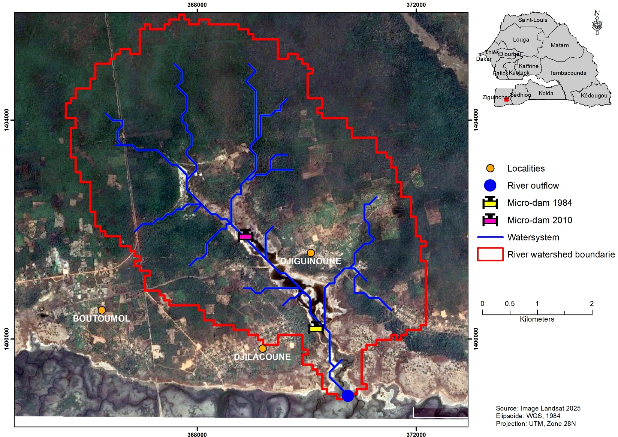

Figure 1: Map of study area location

2.2. The micro-dam

In order to revitalize rice-growing in the Djiguinoum valley, an anti-salt dam was built on the DJILAKOUN site in 1984. The structure consists of a laterite dike and a small concrete building at main bed level, with three openings fitted with cofferdams, the height of which is designed to prevent intrusion by the highest tides (Figure 2).This micro-dam has been installed to replace the one set up by farmers' initiatives, built from mud and using hollowed-out roan tree trunks as gates (Figure 3). Until 1987, no tangible desalination of the soil was observed (Boivin & Brunet, 1990). This led to the idea of rational management of the dam, which would enable leached salts to be evacuated throughout the cultivation period, taking advantage of the low tide levels downstream. In 2010, a second dam was installed by the NGO GRDR to replace the first, already damaged (Figure 4).

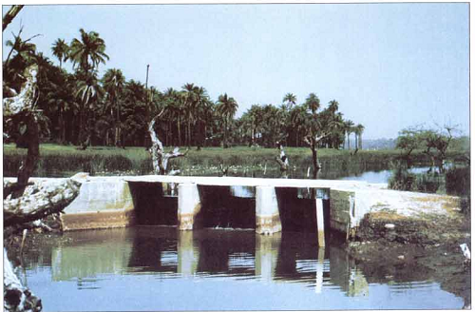

Figure 2: Modernized anti-salt small-dam built in 1984, source, Didier Brunet

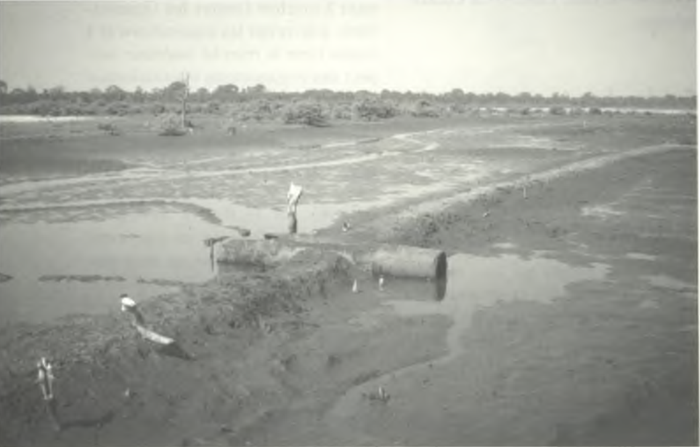

Figure 3: Traditional anti-salt small dam built in the 1950s, Didier Brunet

3. Satellite image selection and acquisition
The images used in this work were taken from the United State Geological Survey (USGS) archives at http://earthexplorer.usgs.gov/. Land cover mapping was based on images from the Landsat TM (Thematic Mapper) sensor for the 1984 image, the ETM+ (Enhanced Thematic Mapper) sensor for the 2000 and 2010 images, and the OLI (Operational Land Imager) sensor for the 2024 image. The characteristics of the selected images are listed in figure 4 and table 1. Le sous-bassin versant étudiés est couvert par les scènes Landsat 205-51 et 204-51. The two scenes were mosaicked together to cover the entire study area. They have the advantage of being available free of charge on the USGS website. The spatial resolution of these images is 30 meters, with a UTM zone 28 N projection and WGS84 reference ellipsoid. The images acquired during this period appear to be the most appropriate for landscape studies.
There are several reasons for the choice of years. 1984 was not only a year of drought, it was also the year in which the anti-salt micro-dam was installed. The year 2000 was chosen to assess the impact of the micro-dams after fifteen years of operation. The year 2010 was marked by the refurbishment of the old micro-dam and the installation of a second water evacuation structure by the NGO GRDR (Research and Implementation Group for Rural Development). By the end of 2024, rainfall will have returned to normal. The images were chosen at the end of the rainy season to minimize overgrowth of herbaceous vegetation. According to Mbow and Diaw (2003), the month of December is a period characterized by ground cover linked to the density of woody vegetation. What's more, the dry season has the advantage of low cloud cover. Landsat images were chosen for this study, as they offer data with high spatio-temporal resolution, are freely available and have the longest series allowing wetlands to be monitored (Foga et al., 2017).

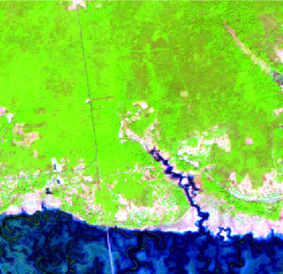
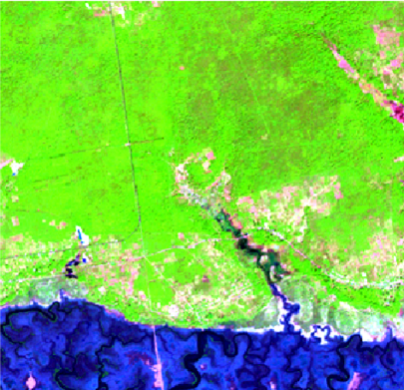
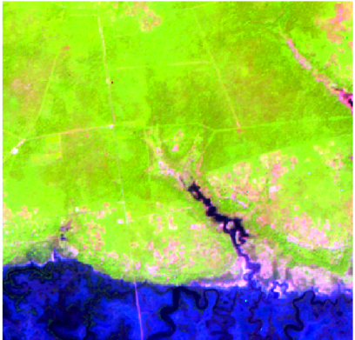
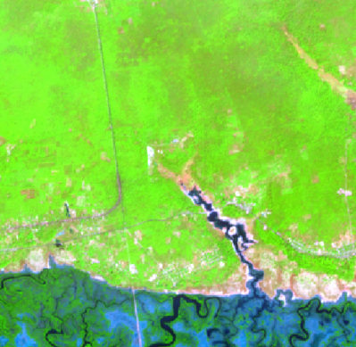
Landsat image 1984/11/18 Landsat image 2000/11/06 Landsat image 2010/12/28 Landsat image 2024/01/01

Figure 4 : Processed Landsat images

Table1: Characteristics of the satellite images used

Site | Acquisition date | Sensors | Spatial Resolution (m)
Djiguinoum | 1984/11/18 | TM | 30
Djiguinoum | 2000/11/06 | ETM+ | 30
Djiguinoum | 2010/12/28 | ETM+ | 30
 | 2024/01/12 | OLI | 30

3.1. Image preprocessing
Satellite image pre-processing is an important step in the study and detection of landscape change using remote sensing. Its purpose is to make compatible multidate t images i.e. taken at different dates (Jofack Sokeng et al., 2016). The two scenes were first mosaicked to obtain an image covering the entire study area. Pre-processing is carried out in ENVI 5.6. This involved applying geometric corrections to satellite images of different dates. USGS (United States Geological Survey) provides Landsat images already orthorectified and corrected to the appropriate coordinate system (Ouatara, 2011). Nevertheless, we have made a further correction on Landsat images to reduce the Root Mean Square Error (RMSE), which is generally below 1/2 pixel. They are then projected into the global WGS 1984, UTM, Zone 28N system. Detecting and characterizing landscape evolution using multidate satellite imagery requires atmospheric correction of the image to be used (Ouatara, 2011). These conversions provide a basis for standardized comparison of data in a single scene or between images acquired on different dates or by different captures (Chander et al., 2013). Several image enhancement and transformation techniques were applied to the extracted study area. These include band combinations, principal component analyses and ratio calculations. This led to the creation of neo-channels, notably PCA and NDVI. The latter makes it possible to detect changes in forest cover through changes in vegetation productivity (Guo et al., 2018). Differences or changes in species types, the presence of disturbed vegetation in an area with a similar vegetation type, even variations in climatic conditions, and the drivers of change can be reflected through NDVI (Yengoh et al., 2014). PCA allows us to synthesize a data set initially expressed by highly correlated variables into a reduced number of new “decorrelated” variables that express the maximum variance in the raw data (Carvalho et al., 2008). These enabled us to obtain the best color compositions, facilitating good spectral discrimination of the major land-use classes. For each image, after extraction of the study area from the large scene resulting from mosaicing the two scenes, color compositions were made from the combination of TM/ETM+ 5 4 3 and OLI 6 5 4 bands, corresponding to the near-infrared, mid-infrared and red spectral bands respectively. Satellite images were processed and analyzed using ENVI 5.6 and ARCGIS 10.8 software to develop land cover maps and spatial analyses. Changes in land cover units were detected using ARCGIS software. The classified images were imported into the software for this operation. Cross-referencing the attribute tables made it possible to identify changes in land cover units.

3.2. Supervised image classification
Determining and understanding the different thematic classes of ecosystems on satellite images was made possible by field observations combined with those derived from the high-resolution (50 cm) Pleiade 2015 image and previous work. These observations enabled us to distinguish the different spectral signatures that characterize the study area when defining the training plots. Thus, the land-use units listed are eleven land-use classes. Based on the spectral characteristics of the land-use types identified, sample plots were selected, visited and validated in the field. This field mission, which coincided with the month in which the 2023 image was taken, enabled us to select training sites that were close enough to the reality on the ground to offer good image classification. Thus, a supervised classification was applied to the different images. It relies on a priori knowledge of the terrain by the remote sensor, which identifies several areas on the image whose significance it knows (Ndao, 2012). Until recently, maximum likelihood classification was the most commonly used method for supervised classification of remote sensing data (Bhatta, 2008; Kumar et al., 2016). Moreover, this algorithm assumes that the training site statistics for each class follow a Gaussian distribution (Duminili, 2007). Maximum likelihood classification of Landsat images for the year 2024 was first carried out on the basis of training sites collected during field campaigns (Salomon et al., 2021).

3.3. Post classification

This was a very important step, enabling us to accurately confirm the information contained on the map. On these images, a maximum number of training zones were sampled in different land-use classes. This enhances the “overall accurency” of reference image classification (Idrissa et al., 2019). Four hundred and sixty (460) points evenly distributed over all the land-use units derived from the 2024 image classification were verified during a field campaign. This verification is used to validate the classification result through the calculation of confusion matrices (Foody, 2002; Oszwald, 2005 and Antoine, 2014). Image 2024 was used as a reference to validate the classification of land-use units in the 1984, 2000 and 2010 images. For each of the images processed, classification accuracy was estimated using confusion matrices that compare the mapping results with the data collected in the field. The measures used were the overall accuracy of the Kappa coefficient (Table 2). Overall accuracy is measured by the Kappa coefficient (Pointus, 2000; Koné et al., 2007; Abdel-Kawy et al., 2011; and Maârouhi et al., 2011).
Thus, in the case of our study, the analysis of the spatio-temporal dynamics of the different land-use units focused on the quantitative distribution of the different land-use units for all the selected dates. The spatio-temporal evolution of each land-use unit was assessed through the determination of the areas of the different land-use units on the images processed for the dates taken (Kpedenou et al., 2016). Histograms have been drawn up from the surface area values of the land-use units. To assess overall gains and losses over the period under consideration, rates of change (𝑇𝑔) in areas were calculated between 1984 and 2024 using the formula commonly employed by (Soro et al., 2014). 𝑇𝑔 = (𝑆2-𝑆1) /𝑆1 ∗ 100
Tg represents the overall rate of change. It expresses the proportion of an occupancy unit that changes over a given period or between two dates. S1 represents the surface area of a class at date t1; S2 the surface area of the same unit class at date t2.

Table 2: Summary of error matrixes for the classified images of 1984, 2000, 2010 and 2024
Land Class | Producer’s (Percent) |  |  |  | User’s (Percent)
Land Class | 1984 | 2000 | 2010 | 2024 | 1984 | 2000 | 2010 | 2024
Habitation | 90.00 | 65.31 | 68.42 | 70.22 | 79.89 | 62.34 | 58.21 | 57.08
Groundnut and mil field | 93.80 | 63.75 | 60.00 | 75.80 | 61.73 | 54.96 | 56.30 | 67.58
Water | 90.49 | 88.61 | 94.63 | 94.40 | 84.16 | 99.57 | 100 | 98.89
Clear Forest | 99.34 | 97.13 | 99.53 | 97.27 | 100 | 99.98 | 100 | 88.92
Flooded rice fields | 50.00 | 62.14 | 62.12 | 49.35 | 85.71 | 86.14 | 78.85 | 91.42
Woody Savannah | 98.89 | 99.79 | 96.30 | 95.29 | 89.90 | 99.38 | 96.30 | 97.57
Tans |  | 97.41 | 74.44 | 75.00 |  | 68.90 | 64.29 | 70.45
Mudflats | 66.67 | 95.58 | 100 | 97.10 | 79.67 | 84.38 | 82.86 | 83.40
LULC Map of | 1984 |  | 2000 |  | 2010 |  | 2024
Overall accuracy (Percent) | 94.211 |  | 94.580 |  | 92.0162 |  | 85.355
Kappa coefficient | 0.867 |  | 0.872 |  | 0.873 |  | 0.806

4. Socio-economic surveys
In addition to processing satellite imagery, a prospecting mission was carried out in the study site. The aim was to make contact with resource people (village chiefs, rice growers and technical agents who had worked on the project to set up anti-salt micro-dams). During the mission, we also took the opportunity to hold informal discussions with farmers. In addition, the questionnaire drawn up beforehand was tested with the population in order to make the necessary corrections to certain questions that were poorly worded and misunderstood by the population. The prospecting mission is followed by an actual fact-finding mission. For the purposes of this survey, a questionnaire targeting rice growers and technical agents was administered. One hundred and eighty (180) people were interviewed throughout the study site, most of them rice growers. Since most rice-growing in the study area is done by women, we interviewed one hundred (100) women and eighty (80) men. This distribution is based on village size. The probability or random sampling method was adopted. It has the advantage of giving all individuals an equal chance of being included in the sample. Information on agricultural yields, the impact of micro-dams, and agricultural and water management problems was collected from the people surveyed. Additional surveys were also carried out with people over 60 who, because of their age or social position, were able to see changes in farming practices. This survey of resource persons (village notables, old farmers, agricultural extension workers, former employees of agricultural development projects, presidents of women's associations, etc.) consisted of formal interviews. The aim was to understand recent changes in rice growing and rice field management. These interviews were also intended to gather their views on the search for solutions to the various constraints.

5. Soil data collection
To collect soil samples, transects were set up perpendicular to the valley, running from the plateau to the lowlands via the slopes. Composite soil samples were taken from each relief level (plateau, slope and lowland) on a 9 m² plot using an auger. Soil samples were taken to a depth of 20 cm (Figure 5). The samples were analyzed at the Analytical Methods Laboratory of the French National Research Institute for Sustainable Development (IRD).
The physical parameters determined from the soil samples are: pH (H2O), pH (KCl), electrical conductivity and salinity. Hydrogen potential, better known as pH, is used to measure the acidity or basicity of samples. The pH of pure water at 25°C, equal to 7, was chosen as the reference value for a neutral medium. On the site, a distinction is made between water pH (or actual acidity) and KCL pH (or potential acidity). The latter takes into account all acidic ions bound to the soil's absorbent complex, unlike the pH of water. To measure water pH, a soil solution is placed in water (ratio 1/2.5). The pH is measured after 1 hour's contact using a pH meter. For pH KCl, 3.8g of KCl is added to the previous solution, allowed to stand for 15 min, then the pH is measured. Interpretation of pH values was based on Canadian Agronomic and Agri-Food Standards (Table 3).
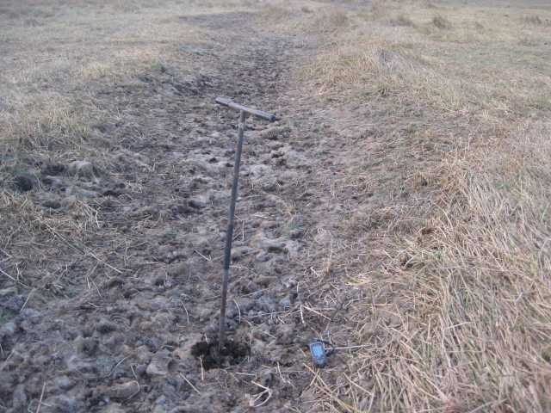

Figure 5: Soil sampling procedure, Photo taken in 2023

Table 3: pH standards (CRAAQ, 2003)
Reaction class | pH H₂O
Extremely acidic | < 4.5
Very highly acidic | 4.5 - 5.0
Highly acidic | 5.1 - 5.5
Moderately acidic | 5.6 - 6.0
Weakly acidic | 6.1 - 6.5
Neutral | 6.6 - 7.3
Weakly alkaline | 7.4 - 7.8
Moderately alkaline | 7.9 - 8.4
Highly alkaline | 8.5 - 9.0
Very highly alkaline | > 9.0

6. results and discussion

The Djiguinoum sub-watershed has undergone changes in land use. The causes of these changes are mainly climatic and anthropogenic. Indeed, in the Djiguinoum sub-watershed and in the Sahel in general, recurrent periods of drought tend to degrade ecosystems (DGEF, 2018). The vegetation in the sub-watersheds studied has a relatively dense coverage rate (20 to 60%). The Kappa coefficients, ranging from 0.85 to 0.92, reflect the reliability of the classifications made, according to the Landis and Koch scale (1977). In this regard, examination of the confusion matrix results (87 to 94%) confirms low overall confusion within the land use classes. There are two reasons for this: the choice of classes based on radiometric values and the choice of training plots, as well as knowledge of the study area, facilitated image analysis and visual interpretation. However, a few cases of confusion between classes (dry rice fields, tanning areas, and dwellings) were noted. This can be explained by the fact that cultivated areas are bare after harvest and their reflectance is therefore almost similar to that of tanning areas and buildings. The resolution of Landsat images (30 m) could also influence the accuracy of the classification of small areas (Bamba, 2010). The land use study highlights the dynamics of rice-growing areas and vegetation cover during the period 1984-2024. Land use mapping is necessary to understand changes in natural resources in order to ensure better management.

6.1. Land use changes between 1984 and 2000
The Djiguinoum sub-watershed covers a total area of 2,784 ha. In 1984, it was dominated by vegetation cover consisting of open forest and wooded savanna (Figures 6 A and B, Table 4).

Table 4 : Evolution of land use between 1984 and 2024 in the Djiguinoum sub-watershed

Classes | Areas 1984 | Areas 2000 | Areas  2010 | Areas  2024 | TC 1984-2000 | TC 2000-2010 | TC 2010-2024 | TC 1984-2024
Habitation | 8,26 | 12,29 | 20,86 | 57,76 | 48,79 | 69,73 | 176,89 | 599,27
Groundnut and mil field | 355,76 | 442,86 | 386,46 | 362,42 | 24,48 | -12,74 | -6,22 | 1,87
Clear forest | 616,47 | 1134,19 | 922,34 | 1227,15 | 83,98 | -18,68 | 33,05 | 99,06
Water | 56,64 | 32,85 | 42,18 | 37,17 | -42,00 | 28,40 | -11,88 | -34,38
flooded rice fields | 349,08 | 323,05 | 314,08 | 126,82 | -7,46 | -2,78 | -59,62 | -63,67
Woody savannah | 1356,21 | 792,48 | 1054,01 | 888,53 | -41,57 | 33,00 | -15,70 | -34,48
Tans |  | 16,96 | 10,62 | 20,16 | 0 | -37,38 | 89,83 | 0
Mudflats | 41,59 | 29,32 | 33,45 | 63,98 | -29,50 | 14,09 | 91,27 | 53,84

In fact, these land use units occupied 616.47 ha and 1,356.21 ha respectively, or 70.85% of the total area in 1984. Peanut and millet fields cover 355.76 ha and drained rice fields 349.08 ha. Thus, between 1984 and 2000, the area of open forest increased by 83.98%. The same is true for peanut and millet fields, whose area increased by 24.48%. In addition, the areas of wooded savanna and flooded rice fields decreased by 41.57% for wooded savanna and 7.46% for drained rice fields. Overall, between 1984 and 2000, the physiognomy of the sub-watershed changed in favor of vegetation cover, mainly open forest (Figure 2B).

6.2. Land use changes between 2000 and 2010
The results presented in Table 4 show a decrease in the area of open forests, peanut and millet fields, and flooded rice fields of -18.68%, -12.74%, and -2.78%, respectively, between 2000 and 2010. In contrast, the areas covered by wooded savanna and mudflats increased by 33.0% and 14.09%, respectively, between 2000 and 2010. Much of the area lost by open forests was occupied by wooded savannah, and that lost by flooded rice fields was occupied by mudflats (Figure 3 C). In 2010, the sub-watershed area was dominated by wooded savannah, although it lost some area.

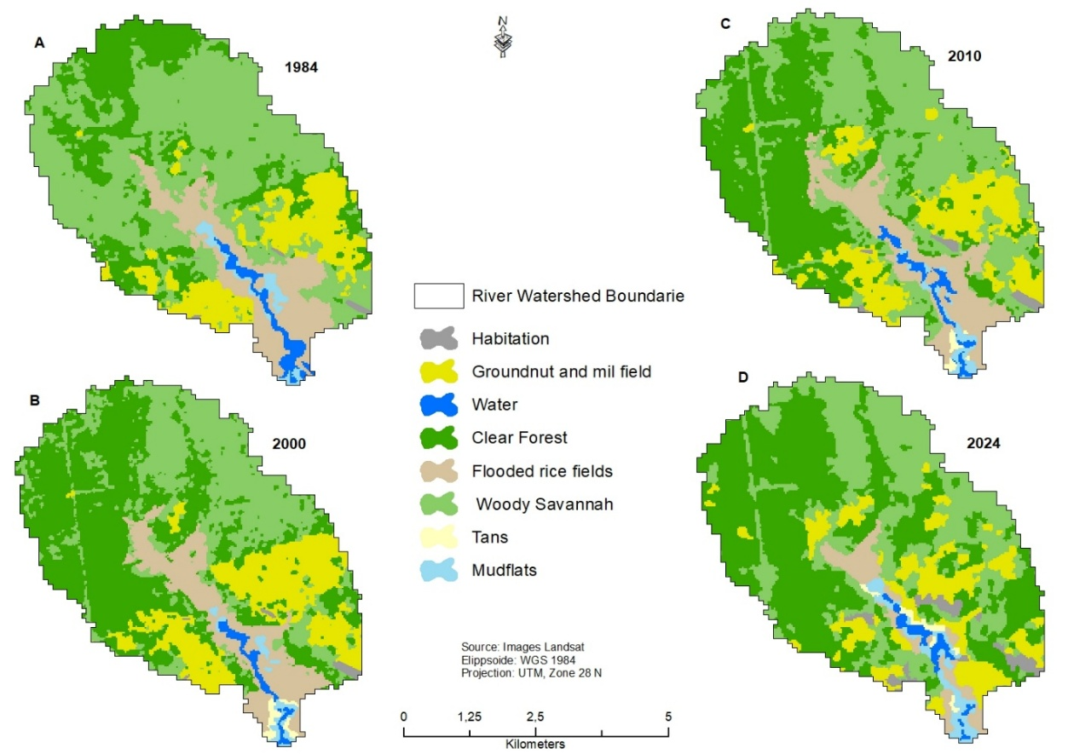

Figure 6: Land use maps for the years 1984 (A), 2000 (B), 2010 (C), and 2024 D in the Djiguinoum sub-watershed

The decline in rice field area in the Djiguinoum sub-basins is thought to be due to persistent soil salinization and technical failures of micro-dams, namely non-functional gates and spillways. These results are consistent with those obtained by Sawadogo et al. (2008), Bosc (2005), and Ecoutin et al. (1999) in Lower Casamance. Similarly, rainfall deficits, lack of adequate infrastructure, and poor management of hydro-agricultural facilities could be contributing factors to this situation. Furthermore, our results do not correspond to those observed in a previous study conducted on small sub-watersheds in northern Côte d'Ivoire (Cecchi et al., 2009) and in the upper Aït Bouguemez valley (Hammi et al., 2007), where irrigated rice-growing areas have increased. This difference can be explained by the fact that rice farmers in Lower Casamance do not have a tradition of irrigated rice cultivation, unlike those in Côte d'Ivoire and Morocco. Furthermore, our study was conducted over a longer period than that of Cecchi et al., which was carried out over a relatively short period (1986-1994). Similarly, in our study area, rice fields are facing soil salinization and acidification, whereas the studies by Cecchi et al. (2009) and Hammi et al. (2007) were conducted on land that was neither salinized nor acidified. The 34.38% decrease in water bodies, mainly due to runoff depositing sand in the valley floor, is confirmed by the findings of Idrissa et al. (2023).

6.3. Land use changes between 2010 and 2024
During the period 2010-2024, deforested forests occupied most of the sub-watershed, recording an increase of 33.05%. Similarly, marsh and mudflat areas also increased by 89.83% and 91.27% respectively during this period (Table 4, Figure 6 D). As for drained rice fields, peanut and millet fields, and wooded savanna, their areas decreased by 59.62%, 6.22%, and 15.70%, respectively, in 2024. Much of the land lost to flooded rice fields and wooded savanna was reclaimed by open forest and marshes. Overall, all land use classes in the Djiguinoum sub-watershed experienced a decrease in area between 1984 and 2024, with the exception of open forests, residential areas, and mudflats. The 99.06% increase in the area of open forests between 1984 and 2024 in the Djiguinoum sub-watershed could be explained by the fact that open forests are home to sacred sites that are strictly protected by the population, where logging and the use of fire are strictly prohibited. In addition, during the period from 1980 to 1995, the insecurity that prevailed in the region significantly reduced the impact of anthropogenic pressure on plant resources, but also led to the proliferation of cashew plantations in the region, which today constitute a new form of economy in the region through the sale of nuts. The expansion of cashew plantations has been confirmed by numerous authors, including Badiane et al. (2019) and Sané et al. (2018). As for wooded savanna areas, they decreased by 34.48% during the period 1984-2024 in the sub-basin, in favor of areas planted with peanuts/millet and residential areas during the study period. The decline in vegetation in favor of anthropized areas confirms the results of other studies, notably those by Abdou et al. (2022) in the lower Dallol Maouri valley in Niger, Biga et al. (2020) in Gothèye in Niger, Mamane et al. (2018) in the Tamou Total wildlife reserve, Millogo et al. (2017) in the province of Bam in Burkina Faso, Kpedenou et al. (2016) in southeastern Togo, Tidjani et al. (2009) in Gouré, Mahamane et al. (2007) in Gabi, Niger, and Bamba et al. (2008) in the province of Bas-Congo and Abdou et al. (2022) in the lower Dallol Maouri valley in Niger. Similarly, the trend toward degradation of vegetation cover and an increase in field size has also been observed by several authors in Niger (Baragé et al., 2018; Issoufou et al., 2018; Abdou et al., 2019; Aboubacar et al., 2023). The same is true of the work of Vasconcelos et al. (2002), who argue that the growing influence of rural activities, the frequency of droughts, and government strategies for managing and conserving natural ecosystems are often the cause of changes in ecosystems. The results obtained from land use mapping in the Djiguinoum sub-watershed are very encouraging. Land use mapping is now an important tool for monitoring terrestrial resources.

6.4. Impacts of small dams on rice cultivation
The impacts of small dams vary considerably depending on the type of farmer and the rice cultivation system. Overall, persistent salinity (36%), reduced agricultural production (35%), palm tree mortality (34%), abandonment of low-altitude rice fields, and changes in land use (28%) are considered to be the main impacts of micro-dams on rice cultivation according to the population surveyed (Figure 7). This situation results from technical and agro-pedological constraints related to micro-dams, but also from the natural environment and behaviors linked to rivalries between farmers exploiting low-lying areas and those exploiting slopes and plateaus.

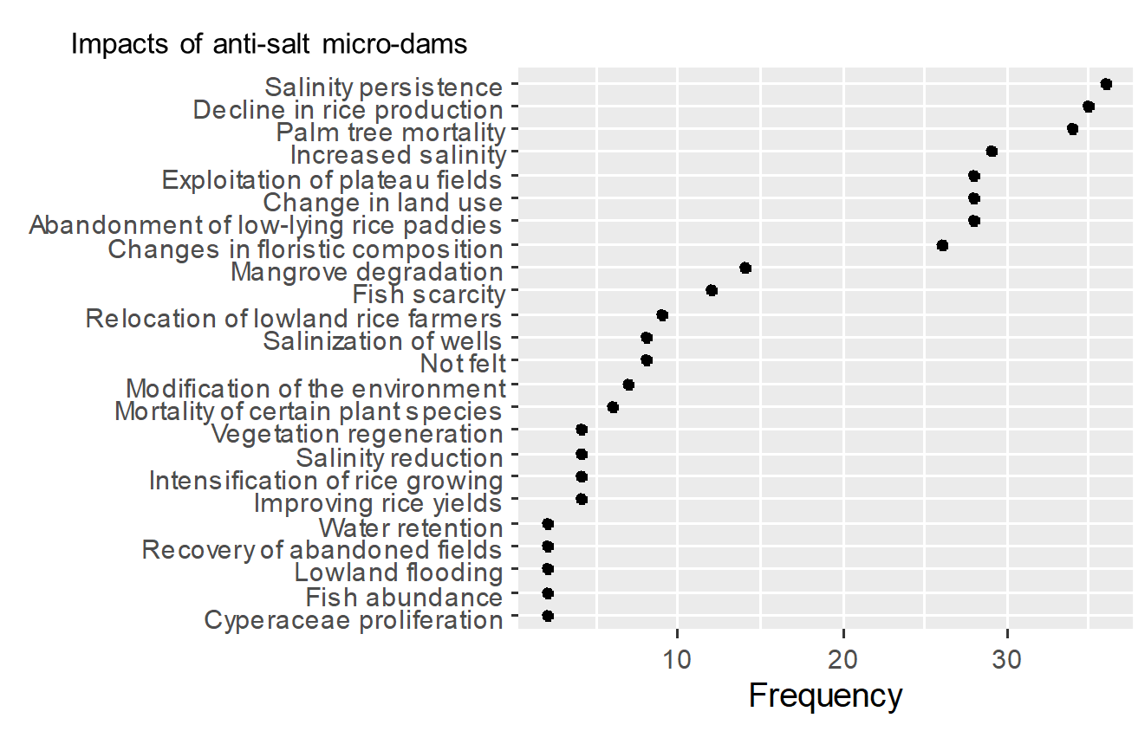

Figure 7: Impacts of small dams according to respondents

6.5. Other factors hindering rice cultivation

In addition, Figure 8 shows the factors that explain the decline in rice cultivation in Lower Casamance. Among these factors, the silting up of valleys has become one of the most decisive factors negatively influencing the expansion of rice cultivation, as highlighted by 48.4% of the population surveyed. This phenomenon is exacerbated by the degradation of vegetation on the plateaus, which significantly reduces water infiltration, thus facilitating the transport of sediments by runoff to the lowlands. In addition, 46.2% of those surveyed consider that stray animals have become one of the main obstacles to the intensification of rice cultivation in recent years. Similarly, 50.2% are convinced that the lack of secondary equipment hinders the functioning of the upstream sections of anti-salt micro-dams.
he results obtained from the surveys showed that the rice-growing potential of the Djiguinoum sub-watershed is under-exploited. In fact, in 2010, a year of abundant rainfall, only 39.61% of the sub-watershed's rice-growing potential was exploited. This trend is confirmed by the work of Badiane et al. (2019) in the commune of Adéane in Lower Casamance (Senegal). The main causes of this situation are persistent salinity, with the highest concentration in the sub-basin reaching 16.35 g/l, the absence of micro-dams upstream, and the resulting flooding due to poor water management, which hinders the development of potentially exploitable rice-growing areas. Added to this is animal migration, which is now a major problem for rice farmers. A similar result emerges from the work of Montoroi (1994) carried out in the same sub-watershed.

Figure 8: Some factors hindering the intensification of rice cultivation in Lower Casamance

6.6. Impacts of physical soil parameters

Quantitative analysis of the content levels interpreted on the basis of the soil standards mentioned above in Table 5 shows that 90% of the soils sampled at the Djiguinoum site have an extremely acidic pH (4.5) and 10% have a very strongly acidic pH (4.5-5.0). 70% of the soils have good conductivity with favorable salinity levels (0.10-2.10). In addition, 12% have severe conductivity levels and the same percentage for salinity. Thus, Figure 9 shows that the salinity level is independent of the distance between the anti-salt micro-dam and the sampling point.
Table 5: Summary of the impacts of the anti-salt micro-dam on physical soil parameters

Site | Observations and comments
DJIGUINOUM | 90% of soils: extremely acidic pH (4.5)  10% of soils (75): very strongly acidic pH (4.5–5.0)  The KCl pH is always lower than the water pH. All eight samples are acidic and have characteristics, according to standard X 31 - 071 of February 1983 (Soil Quality), of a humus-rich sand surface layer in a forest area (KCl pH: 3.5 - 5).  All soils (70%) have good conductivity with favorable salinity levels (0.10 - 2.10).  12% have severe conductivity levels (74) and the same for salinity.  18% have moderate conductivity levels (75 - 76) and the same for salinity.

Near the anti-salt micro-dam in the upstream section, the salinity level is 12.8‰. This rate decreases significantly to 0.1‰ and remains between 500 and 1,200 meters. Beyond this distance, salinity increases sharply, reaching a higher level of 14.4‰ at approximately 2,000 meters from the micro-dam. This increase can be explained by the presence of the Djiguinoum-Koubalan road upstream of the micro-dam, which acts as a second small dam by slowing down the desalination of the other upstream section furthest from the small dam. The lowest salinity levels are found more than 2,000 meters upstream of the micro-salt barrier.

Figure 9: Evolution of salinity levels upstream of the Djiguinoum micro-salt barrier

The poor functioning of micro-dams and persistent salinity may be the main factors explaining this situation. The results obtained when determining the physical parameters of the soil showed that all soils are acidic according to the pH values recorded. This result corroborates that obtained by Montoroi (1996). Thus, the decline in the area of peanut/millet fields benefits cashew cultivation. Overall, the results of surveys conducted among rice farmers show that micro-dam management poses problems in the sub-watershed studied, despite the existence of a management committee. As a result, micro-dams are struggling to solve the problem of rice field desalination and improve rice yields. The lack of involvement of beneficiary populations in the design and construction of water retention structures, the lack of training for management committee members, and the absence of well-designed development plans adapted to climatic and soil conditions are the reasons cited by populations to explain the failure of these hydraulic structures. The micro-dams are installed in a valley that is already salinized and acidic, which makes their operation very difficult.

7. Conclusion
This study showed, based on land use data, that in the Djiguinoum sub-watershed, wooded savanna formations declined between 1984 and 2024, giving way to peanut/millet fields and housing. However, the results showed a clear expansion of the open forest class during this period, which could be linked to management based on traditional rules guaranteed by sacredness. Thus, the decline in rice-growing areas can be attributed to the persistence of soil salinity and acidification despite the implementation of hydro-agricultural land restoration projects. The results of surveys on the effectiveness of anti-salt micro-dams, despite promising beginnings, have not yielded the expected results over time. Land salinization often continues through capillary action and has led to the abandonment of rice paddies covering large areas upstream of micro-dams. This salinization, combined with acidification, has led to poor development of the sub-basins, resulting in a reduction in the area suitable for rice cultivation. The study of the impacts of micro-dams leads us to believe that hydro-agricultural development in sub-watersheds remains a human endeavor whose success depends not only on the care taken in its preparation and implementation, but also on the daily efforts of the populations who must be able to benefit from the construction of these structures. However, the success of micro-dams necessarily depends on appropriate infrastructure, community involvement from the design stage through to completion, and effective management of the water retained by the structures. To avoid repeating past mistakes, we must capitalize on the lessons learned from a few successful experiences and use the knowledge already acquired by local populations to continue experimenting with micro-dams in the reclamation of salt-affected land. Therefore, in order for micro-anti-salt dams to adequately meet their initial objectives, i.e., intensifying rice cultivation by reducing soil salinity, we recommend washing the already salinized soil before constructing the anti-salt structures. Installing structures without washing the soil would aggravate the salinization process. In addition, a policy should be put in place to preserve land that is not contaminated by salt, and local populations should be involved from the design stage through to the completion of the project, drawing on their existing knowledge of managing water reservoirs upstream and downstream of the micro anti-salt dams. This approach will make it possible to move beyond a sectoral and vertical approach and empower local populations in the management of structures after projects.

DISCLAIMER (ARTIFICIAL INTELLIGENCE)
Author(s) hereby declare that NO generative AI technologies such as Large Language Models (ChatGPT, COPILOT, etc.) and text-to-image generatorshave been used during the writing or editing of this manuscript.

References

Abdel Kawy WA, Belal AA. 2011. GIS to assess the environmental sensitivity for desertification in soil adjacent to El Manzala Lake, East of Nile Delta, Egypt. American-Eurasian J. Agric. & Environ Sci., 10 : 844–856. (Ajoutes)

Abdou, A., Abdoulahi, S.C., Tidjani, M.A., Hassimi, M.S., Sabra, A.K.A., Soulé, A.E., & Kaire, M. (2019). Economics of land degradation in Tahoua, Niger. Cost-benefit analysis of land reclamation activities (benches, half-moons, and stone bunds) at four sites in the rural commune of Badaguichiri. A report by the ELD Initiative as part of the project "Reversing Land Degradation in Africa through Large-Scale Adoption of Agroforestry."

Abdou, I.K., Abasse, T., Massaoudou, M., Rabiou, H., Soumana, I., & Bogaert, J. 2019. Influence of Anthropogenic Pressures on the Landscape Dynamics of the Dosso Partial Wildlife Reserve (Niger). Int J Biol Chem Sci, 13(2): 1094-1108. https://dx.doi.org/10.4314/ijbcs.v13i2.41

Abdou, M., Nazoumou, Y., Favreau, G., & Issoufou, O. (2022). Land Cover and Use Dynamics and Water Table Rise in the Lower Dallol Maouri Valley. European Scientific Journal, 18 (14): 162.

Aboubacar, A., Bachir, M., Abdoulaye, D., & Dan Guimbo, I. (2023). Spatiotemporal dynamics of contracted vegetation in western Niger following the rainfall and anthropization gradient from 1990 to 2020. Int J Biol Chem Sci, 17(5): 1873-1888.

Ahmadi, N., & Bouman, B. (2013). Rice and Rice Farming: Economic, Ecological, and Scientific Issues. Cahiers Agricultures 22:333-5. doi: 10.1684/agr.2013.0665

Albergel, J., Gadelle, F., Lamachère, J.M., Lidon, B., Mokadem, A.I., & Ran, A.M. (1993). Agricultural Development of Lowlands in the Sahel: Typology, Hydrological Functioning, Agricultural Potential. Final Report of the CORAF-R3S Project, 343 p.

Antoine, M. (2014). Development and Automation of Classification Methods from Time Series of Remote Sensing Images: Application to Land Use Change and Carbon Balance Estimation. Doctoral Thesis, p. 203.

Aubrun, A. (1988). Ancient Mangroves of Lower Casamance (Senegal). Characterization - Pedology - Sedimentology. Doctoral Thesis, University of Strasbourg, 165 pp.

Badiane, A., Sané, T., & Thior, M. (2019). Impacts of Agrarian Landscape Dynamics on Agricultural Activities in the Municipality of Adéane in Lower Casamance (Senegal). European Scientific Journal, July 2019 edition, Vol. 15, No. 21, ISSN: 1857–7881 (Print) e - ISSN 1857-7431, URL: http://dx.doi.org/10.19044/esj.2019.v15n21p489

Bama, N.A.D., Elliott, D.Y., Mahanat, G., Elvire, V.G., Issa, S., Ouedraogo, I., & Ouédraogo, A. (2020). Impact of Smart Valleys on Soil Moisture Content and Rice Yield in Some Lowlands in Burkina Faso. Agricultural Sciences, 11, 860-868. https://doi.org/10.4236/as.2020.119055

Bamba, I. (2010). Anthropization and Spatio-Temporal Dynamics of Forest Landscapes in the Democratic Republic of Congo. Doctoral Dissertation, Université Libre de Bruxelles, 205 pp.

Bamba, I., Mama, A., Neuba, D.F., Koffi, K.J., Traore, D., Visser, M., Sinsin, B., Lejoly, J., & Bogaert, J. (2008). Influence of Anthropogenic Actions on the Spatio-Temporal Dynamics of Land Cover in the Central Congo Province (D.R. Congo). Sciences & Nature, 5(1): 49-60. DOI: 10.4314/scinat.v5i1.42151.

Barage M, Garba A, Moussa B, Jacques C. Ambouta JMK. 2018. Spatiotemporal dynamics of land use in the Tamou Total Wildlife Reserve in the context of climate variability (Western Niger). Int J Biol Chem Sci, 12(4): 1667-1687. http://ajol.info/index.php/ijbcs.

Bhatta, B. (2008). Remote Sensing and GIS. Oxford University Press: Oxford, UK. Lu D, Weng Q. 2007. A Survey of Image Classification Methods and Techniques for Improving Classification Performance. International Journal of Remote Sensing, 28(5): 823-70. DOI: https://doi.org/10.1080/01431160600746 456

Biga, I., Amani, A., Soumana, I., Bachir, M., & Mahamane, A. 2020. Spatiotemporal dynamics of land use in the municipalities of Torodi, Gothèye, and Tagazar in the Tillabéry region of Niger. Int J Biol Chem Sci, 14(3): 949-965. DOI: 10.4314/ijbcs.v14i3.24

Boivin, P., & Brunet, D. 1990. Results of four years of monitoring the salinity of a managed anti-salt valley using electromagnetic conductivity and kriging. Field report. Multigr., ORSTOM/Dakar-Bondy, 12 p.

Bosc, P.M. (2005). At the crossroads of powers. A peasant organization facing resource management (Lower Casamance, Senegal). I.R.D. editions, Collection à travers champs, Paris, 310 p.

Brunet, D. (1994). A Simple Hydraulic Scheme for the Rehabilitation of Salty Soils: Rice Cultivation in Lower Casamance. Drought, Volume 5, Issue 1: pp. 37-44.

Carvalho, M., & Gherardi, D.F.M. (2008). Mapping the Environmental Sensitivity to Oil Spill and Land Use/Land Cover Using Spectrally Transformed Landsat 7 ETM Data. Brazilian Journal of Aquatic Science and Technology, 12, 1-9. https://doi.org/10.14210/bjast.v12n2.p1-9

Cecchi, P., Gourdin, F., Koné, S., Corbin, D., Etienne, J., & Casenave, A. (2009). Small dams in northern Côte d'Ivoire: inventory and hydrological potential. Drought 2009, Volume 20, Issue 1: pp. 112-22

Chander, G., Mishra, N., Helder, D.L., Aaron, D.B., Angal, A., Choi, T. (2013). Applications of Spectral Band Adjustment Factors (SBAF) for Cross-Calibration. IEEE Transactions on Geoscience and Remote Sensing, 51, 1267-1281. DOI: 10.1109/TGRS.2012.2228007

Cormier-Salem, M.C., & Sané, T. (2017). Defining a common methodological framework for participatory mapping. Journal of Ethnoecology [June 2025]. URL: http://journals.openedition.org/ethnoecologie/2930; DOI: https://doi.org/10.4000/ethnoecologie.2930

Dacosta, H. (1989). Precipitation and Runoff in the Casamance Basin. Doctoral Dissertation, Cheikh Anta Diop University, Faculty of Arts and Humanities, Dakar, Senegal, 273 p.

Diédhiou, L. (2004). Rice, Symbols and Development among the Diolas of Lower Casamance. Laval University Press, 339 p.

Directorate General of Water and Forests (DGEF). (2018). Vegetation Monitoring Activity Report for the Observatory Sites and the Badaguichiri Project.

Duminili, T. (2007). Exploitation of Remote Sensing Data to Study the Implementation of Ecotourism in the Andavadoaka Region (Madagascar); Internship Report, University of Montpellier, p. 19. Montpellier

Ecoutin, J.M., Barry, M.B., Bouju, S., Charles-Dominique, E., Journet, O., Penot, E., Rûe, O., Souaré, D., & Sow, M. (1999). Technical Management of the Environment, in Cormier-Salem M.-C. ed., Rivers of the South: West African Societies and Mangroves. Paris: IRD Editions, 209-268.

Fall, A.A. (2016). Summary of Studies on the Status of the Rice Value Chain in West Africa: Benin, Burkina Faso, Mali, Niger, and Senegal, 83 p.

FAOSTAT. (2015). FAO statistical database http://www.fao.org/faostat/

Foga, S., Scaramuzza, P.L., Guo, S., Zhu, Z., Dilley, R.D., Beckmann, T., Schmidt, G.L., Dwyer, J.L., Joseph, Hughes, M., & Laue, B. 2017. Cloud detection algorithm comparison and validation for operational Landsat data products. Remote Sensing of Environment, 194: 379-390. DOI: https://doi.org/10.1016/j.rse.2017.03.026

Foody, G. M. (2002). Status of land cover classification accuracy assessment. Remote Sensing of Environment, vol. 80, p. 185-201.

Guo, M., Li, J., He, H., Xu, J., & Jin, Y. 2018. Detecting Global Vegetation Changes Using Mann-Kendal (MK) Trend Test for 1982–2015 Time Periods. Chinese Geographical Science, 28, 907–919. https://doi.org/10.1007/s11769-018-1002-2

Hammi, S., Simonneaux, V., Alifriqui, M., Auclair, L., & Montes, N. 2007. Changes in Forest Cover and Land Use Between 1964 and 2002 in the Upper Ait Bouguemez Valley (Central High Atlas, Morocco) and the Impact of Management Methods. Drought, Volume 18, Issue 4: p. 271-277

Idrissa, A., Abdou, A., Soukaradji, B., Biga, I., & Mahamane, A. 2023. Spatiotemporal analysis of land use in the Kirtachi commune in southwestern Niger. Int J Biol Chem Sci, 17(3): 1033-1047. http://ajol.info/index.php/ijbcs

Issoufou, M., Boureïma, O., & Ado, D. (2018). Evolution of land use in the northern part of the Bosso dallol, Filingué and Balleyara departments, Tillabéri-Niger region. European Scientific Journal, 14(30): 391-407.

Jamin, J.Y., Windmeijer, P.N., & Mahaman, M. (1998). Agroecological diversity of West African savannah lowlands. Regional representativeness of ongoing work in southern Mali. In: Development and development of lowlands in Mali. National assessment and perspectives, relevance to the West African savannah zone: Proceedings. Ahmadi Nourollah (ed.), Teme Bino (ed.). CIRAD-CA, IER. Montpellier: CIRAD, 299-306. (Conferences) ISBN 2-87614-323-2

Jofack Sokeng, V.C., Kouamé, F.K., Dibi N’da, H., Tankoano, B., Akpa, You., L., & Ngounou Ngatcha, B. (2016). Land Cover Mapping of the Western Highlands of Cameroon Using Neural Networks Applied to a LANDSAT 8 OLI Image. International Journal of Innovation and Scientific Research ISSN 2351-8014 Vol. 23 No. 2 May 2016, pp. 1-2. 443-454 © 2015 Innovative Space of Scientific Research Journals http://www.ijisr.issr-journals.org/International Journal of Innovation and Scientific Research, 23, 443-454.

Kpedenou, K.D., Boukpessi, T., Tanzidani, T., & Tchamie, K. (2016). Quantifying land use changes in Yoto Prefecture (Southeastern Togo) using Landsat satellite imagery. Rev. Sc. Env., 13: 137-156. URL: hal 01409418

Koné M, Aman A, Adou-Yao CY, Coulibaly L, N’guessan K E, 2007. Suivi diachronique par télédétection spatiale de la couverture ligneuse en milieu de savane soudanienne en Côte d’Ivoire. Revue Télédétection, 7: 433-446.

Kumar, L., Priyakant, S., Brown, J. F., Ramsey, R. D., Rigge, M., Stam, C. A., Hernandez, A. J., Hunt, J., & Reeves, M. C. (2016). Characterization Mapping and Monitoring of Range lands: Methods and Approaches. In Land Resources Monitoring, Modeling, and Mapping with Remote Sensing. CRC Press: Boca Raton, FL, USA; 309–350.

Maârouhi IM, Mahamane A, Saadou M, Bachmann Y, 2011. Dynamique spatio-temporelle des forêts claires dans le Parc national du W du Niger (Afrique de l’Ouest). Sècheresse, 22: 97-107.

Mahamane, A., Saadou, M., Bakasso, Y., Abassa, I., Aboubacar, I., & Karim, S. (2007). Diachronic Analysis of Land Cover and Vegetation Characteristics in the Municipality of Gabi (Maradi Region, Niger). Drought, 18(4): 296–304. DOI: 10.1684/sec.2007.0105

Mamane, B., Amadou, G., Baragé, M., Comby, J., & Ambouta, J.M.K. (2018). Spatio-Temporal Dynamics of Land Cover in the Tamou Total Wildlife Reserve in the Context of Climate Variability (Western Niger). Int. J. Biol. Chem. Sci., 12(4): 1667-1687. DOI: https://dx.doi.org/10.4314/ijbcs.v12i4.13

Manzelli, M., Fiorillo, E., Bacci, M. and Tarchiani, V. (2015). La riziculture de bas-fond au sud du Sénégal (Moyenne Casamance) : enjeux et perspectives pour la pérennisation des actions de réhabilitation et de mise en valeur. Cah Agric 24 : 301-312. doi : 10.1684/agr.2015.0772.

Mbow, C., & Diaw, A.T. 2003. Selection of spectral indices for vegetation mapping in savannah environments. AfricaGis, 24 p.

Marius, C., Lucas, J., & Kalck, Y. (1986). Evolution of the Gulf of Casamance in the Late Quaternary and Changes in Mangrove Vegetation and Soils Associated with the Current Drought. In Global Changes in Africa during the Quaternary, Paris, France, ORSTOM, Travaux et Documents, 197, pp. 293-295.

Mendez del Villar, P., & Bauer, J.M. 2013. Rice in West Africa: Dynamics, Policies, and Perspectives. Cahiers Agricultures 22:336-44. doi: 10.1684/agr.2013.0657
Millogo, D., Nikiéma, A.A., Koulibaly, B., & Zombré, N.P. (2017). Analysis of Land Cover Changes from Aerial Photographs of the Loaga Locality in Bam Province, Burkina Faso. International Journal of Biological and Chemical Sciences, 11(5): 2133-2143. DOI: https://dx.doi.org/10.4314/ijbcs.v11i5.16

Mendy,V. (2018). Dégradation des agroécosystèmes et problématique de la revitalisation de la riziculture en Basse Casamance, Thèse de doctorat, Université Assane Seck de Ziguinchor, 247

Montoroi, J.P. (1996). Development of lowlands in Lower Casamance (Senegal). Agriculture and Development 10:61-73.

Montoroi, J.P. (1994). Water dynamics and salt geochemistry in the Djiguinoum watershed (Casamance, Senegal). Consequences for the sustainable management of the mangrove ecosystem during drought. Doctoral dissertation, Henri Poincaré-Nancy I University, France, 349 pp.

Ndao, M. (2012). Dynamics and Environmental Management of Wetlands in Senegal from 1970 to 2010: Study of Land Use by Remote Sensing in the Niayes with Djiddah Thiaroye Kao (Dakar), Mboro (in Thiès and Saint Louis). Doctoral Thesis, University of Toulouse.

Ouatara, A. (2011). Mauritania and Senegal Coastal Area Urbanization, Groundwater Flood Risk in Nouakchott and Land User/Land Cover Change in the Mbour Area. Master's Thesis, 30 credits, Department of Earth and Ecosystem Sciences, Physical Geography and Ecosystem Analysis, Lund University. http://lup.lub.lu.se/student-papers/record/3015245

Pontius, RG, 2000. Quantification error versus location in comparison of categorical maps. Photogrammetric Engineering and Remote Sensing, vol. 66, (8): 1011–1016.

Sagna, P. (2005). Climate Dynamics and Its Recent Evolution in the Western Part of West Africa. Doctoral Thesis, Department of Arts. Géo FLHS / UCAD, volumes 1 and 2, 786 p.

Sane, Y., Ba, B.D., Fall, A.C.A.L., Sy, B.A., & Descroix, L. (2018). Constraints on the development of rice plots in the village of Colomba (Bignona department), southern Senegal. International Journal of Water and Environmental Science and Technology ISSN (electronic): 1737-9350; ISSN (print): 1737-6688; Volume III, Issue 2 - August 2018

Sané, T. (2017). Vulnerability and Adaptability of Agrarian Systems to Climate Variability and Social Change in Lower Casamance. Joint Doctoral Thesis. Cheikh Anta Diop University of Dakar and Sorbonne Paris Cité University. Prepared at Paris Di University. derot-Paris 7.

Sarr, M.A. (2009). Mapping land use changes between 1990 and 2002 in northern Senegal (Ferlo) using Landsat images. Cybergeo: European Journal of Geography, Environment, Nature, Landscape. URL: http://cybergeo.revues.org/index 22707.html. Accessed November 28, 2010.

Sawadogo, A., Zombre, N.P., Bock, L., & Lacroix, D. (2008). Evolution of Land Use in Ziga in Yatenga (Burkina Faso) Based on Aerial Photographs. Teledetection Review, 2008, Vol. 8, No. 1, pp. 59-73.
Skupinski, G., Binhtran, D., & Weber, C. (2009). Multi-Date Spot Satellite Images and Spatial Metrics in the Study of Urban and Suburban Change – The Case of the Lower Bruche Valley (Bas-Rhin, France). Cybergeo European Journal of Geography, 439. DOI: https://doi.org/10.4000/cybergeo.21995

Soro, G., Ahoussi, E.K., Kouadio, E.K., Soro, T.D., Oulare, S., Saley, M.B., & Biemi, J. 2014. Contribution of Remote Sensing to the Mapping of Spatio-Temporal Evolution of Land Cover Dynamics in the Lakes Region (Central Côte d'Ivoire). Afrique Science, 10(3). URL: http://www.afriquescience.info/document.php?id=3763

Tidjani, A.A., Ozer, A., & Karimoune, S. (2009). Contributions of Remote Sensing in the Study of Environmental Dynamics in the Tchago Region (Northwest of Gouré, Niger). Geo-Eco-Trop, 33: 69-80. URL: https://orbi.uliege.be/bitstream/2268/249 546/1/pub_331_06.pdf

Vasconcelos, M. J. P., Mussa, Biai, J. C., Araujo, A., & Diniz, M. A. (2002). Land cover change in two protected areas of Guinea-Bissau (1956-1998), Applied Geography, 22 (2), p.139-156, Apr 2002

Vieillefon, J. (1977). The soils of the mangroves and tannes of Lower Casamance (Senegal) Mém. Paris, ORSTOM, n° 83 - 291 p.

Yengoh, G.T., Dent, D., Olsson, L., Tengberg, A.E., & Tucker, C.J. 2014. The use of the Normalized Difference Vegetation Index (NDVI) to assess land degradation at multiple scales: a review of the current status, future trends, and practical considerations. Lund University Center for Sustainability Studies (LUCSUS), and The Scientific and Technical Advisory Panel of the Global Environment Facility (STAP/GEF)

Zucchini, E., Manzelli, M., Tarchiani, V., & Di Vecchia, A. (2017). The rainfed rice seed sector and market in Middle and Upper Casamance: challenges and perspectives, DOI: 10.13140/RG.2.2.34297.57441

