Desertification in the Rafsanjan Plain, Southeastern Iran: Linking Local Processes to Global Climate Change

Abstract
Aeolian deflation, active sand dunes, and dust storms are key drivers of land degradation in the Rafsanjan Plain, southeastern Iran, affecting both land use and local livelihoods. This study aims to assess the causes and consequences of desertification in the region by analyzing geomorphological features, land use changes, and environmental factors. We employed satellite imagery, field measurements, and spatial mapping to quantify changes in dune areas and cultivated lands from 1955 to 2008. The northern bajada and central playa contain diverse aeolian landforms, primarily supplied by southwestern alluvial fans. The analyses indicate that these aeolian features have expanded over time, while cultivated lands have gradually decreased. These changes are driven by variations in sediment supply, wind regimes, surface morphology, and vegetation cover, compounded by rising temperatures, reduced effective rainfall, and declining groundwater levels. The results demonstrate that climate change, combined with inadequate water and soil management, is accelerating desertification, highlighting the urgent need for sustainable regional mitigation strategies.
Key Words: Desertification, Aeolian, Landforms, Sediment Transport, Reactivation, Rafsanjan Plain

1. Introduction
Iran is a country characterized by diverse climatic zones, but more than two-thirds of its territory consists of arid and semi-arid regions (Maghsoudi et al, 2018., Nekouie Sadry et al, 2022). These areas, due to low precipitation, high evaporation rates, sparse vegetation, and fragile soils, are highly susceptible to desertification and aeolian processes (Maghsoudi & Ganjaeian, 2025). The extensive deserts and semi-deserts of central, southern, and eastern Iran not only shape the natural landscape but also play a crucial role in local socio-economic conditions, as the inhabitants of these regions heavily depend on agriculture and limited water resources. Consequently, understanding and managing aeolian processes is essential to mitigate their ecological, social, and economic impacts (Safari Namivandi et al, 2023., Maghsoudi & Ganjaeian, 2024., Negahban et al, 2025).
Increasing aeolian activity is becoming a serious problem in the world’s arid and semi‐arid environments (Zou et al. 2001; Zhang et al. 2018). It is considered the most severe threat to arid ecosystems and causes enormous annual financial losses in the health, transport, and agricultural sectors (Cao et al. 2015; Meibodi et al. 2015; Wang et al. 2016). Sand encroachment on highways, railroads, waterways, and other infrastructures, as well as on agricultural lands, is an ongoing and growing problem in many arid and semi-arid lands worldwide (Yang et al. 1988; Watson 1990; Khalaf et al. 1993).
Aeolian erosion poses a significant threat in Iran (Miri et al. 2010; Abbasi et al. 2015; Abbasi et al. 2018; Abbasnejad and Zahabnazouri 2013; Maghsoudi et al. 2012; Yamani et al. 2012., Shirzadi et al, 2023), primarily because arid and semi-arid climates dominate vast regions of central, southern, and eastern Iran (Broomandi et al. 2017., Ganjaeian et al, 2023). One notable area affected by these processes is the Rafsanjan Plain in south-central Iran, which is covered by extensive aeolian deposits. In certain areas, the shifting sands have been stabilized through plantations of Haloxylon aphyllum, particularly in the north-western portion of the plain near Nough. However, in other parts of the plain, active sand dunes continue to move, posing significant threats to human settlements, infrastructure, and agricultural lands, including commercial pistachio orchards and subsistence farms. Consequently, aeolian desertification in the Rafsanjan Plain has become a major obstacle to sustainable socio-economic development in the region (Xue et al. 2013).
The influence of anthropogenic activities on aeolian processes presents a complex picture. In some cases, human interventions exacerbate erosion by disrupting natural dune stabilization mechanisms (Doody, 2004., Mobarghaei & Mokhtari, 2018., Khoshnood Motlagh et al, 2021., Keshtkar et al, 2022). Deforestation, overgrazing, and intensive agriculture have exposed surface sediments to wind and rainfall, accelerating sediment transport and enhancing the risk of desertification (Hoffmann et al. 2013; Montgomery 2007).
Conversely, targeted human interventions can significantly mitigate sand encroachment and desertification, yielding societal and ecological benefits (Maghsoudi et al, 2021). Proper land management practices, such as soil surface protection, vegetation cover restoration, and controlled land use, can reduce sediment mobility and stabilize dunes (Uta et al. 2017). Understanding the impact of human activities on aeolian dynamics, both in coastal and arid regions, provides valuable insights for managing and mitigating active sand dune activity in the Rafsanjan Plain (Mezosi and Szatmari 1998; Al-helal et al. 2006; Yang 2009; Stancheva et al. 2010; Uta et al. 2017).
This study therefore focuses on assessing the drivers and consequences of aeolian activity in the Rafsanjan Plain, evaluating both natural and anthropogenic factors, with the aim of proposing sustainable management strategies to reduce desertification and support socio-economic development in this vulnerable arid landscape.

2. Materials and methods
Describing the geomorphology of the dunes and aeolian landforms in the area provides a comprehensive understanding of how desert dunes are being formed, how they are changing, and of how they may be impacting the local environment (Lancaster, 1995). Analysis of the ongoing formation processes of aeolian landforms in the area provide additional understandings of how these processes are changing so that future problems may be prevented and even mitigated (Dong and Lv, 2013).
In order to better understand these aeolian processes at work on the Rafsanjan Plain, the types of aeolian landforms were identified and mapped. The current status of aeolian geomorphologic units was determined by preparing a print laydown using 1:20000 aerial photos and Google Earth imagery. Then the aeolian landform units were identified and classified. Finally, the units were ground-proofed.
Wind rose diagrams for the Rafsanjan Plain were generated so that aeolian processes could be analysed (Figures 3). The wind data analyses were taken from the main synoptic station of the region, the Rafsanjan Airport station, at seasonal time scales for the period 1999 - 2007; In addition, the annual and high speed winds derived from the period 2007 - 2020 have been included (https://mesonet.agron.iastate.edu).
Granulation is one of the most basic properties of sediment particles that effects their transport and erosion. Grain size analysis is an important indicator of sediment origin, transport history and erosion conditions (Bui et al. 1989; Folk and Ward 1957), and in combination with analysis of the winds within the region, it served to provide a better understanding of the aeolian geomorphology of the Rafsanjan Plain. Therefore, a granulometric analysis of the sands and an analysis of the mineralogical composition of the deposits was conducted, to reveal more information about the wind regime and sand availability and its relationship to dune type (Wasson and Hyde 1983; Lancaster 2013). Several aeolian sand samples were collected from the plain, and grain size was determined using dry sieve analysis with a set of sieves for the fractions ranging from 63 to 2000 µ (Table 1 and Figure 6). Granulometry was performed to aid in determining sand sources, including primary sources (alluvial fans) and secondary contributions (deflation of valley bottoms and yardang erosion). These analysis will also provide evidence of the changing seasonal wind directions, and the role of topography in source mixing in these samples.
Previous analysis of the minerology of the sands was combined with this information to aid in determining the sources of the sands. This is possible because the alluvial fans of the Davaran Mountains in the north are very different from that of the Sharcheshmeh Mountains to the south.
To better understand the role of anthropogenic activities and climate change in impacting aeolian landforms, land cover maps from the 53-year period from 1955 to 2008 were analysed. Changes in the extent of agricultural areas and changes in dune vegetation and its impact upon dune stability. The maps were generated from remote sensed satellite images for 1955, 1995 and 2008. And these changes were document and their causes determined.

3. Results & Discussion
3.1. Study area
The Rafsanjan Plain, which is located in the south-eastern corner of central Iran in Kerman Province (Figure 1) is a tectonic depression with a northwest-southeast orientation and an area of ​​about 4000 square kilometres. The average elevation of this plain is about 1600 meters. The highest elevation in the Plain is near Kabutar Khan (1663 m) in the southeast, and gradually decreases toward the northwest where the lowest elevation of 1268 meters occurs as the basin narrows and all surface water exits through the narrow defile northwest of Bahreman. There it spills into a valley just south of Bafgh. The general slope from southeast to northwest is 3.2 m per km.
The main topographic units of the Rafsanjan region are comprised of the Rafsanjan Plain, and the Davaran and Sarcheshmeh or Sarcheshmeh Mountains and their pediments (Figure 2). The Rafsanjan plain is flanked on the northeastern side by the Davaran Mountains, which has a northwest to southeast orientation, and separates it from the Zarand Plain to the east. This mountain range averages about 15 km wide from southeast to north of Baghin (south of Kerman), and continues northwest to the vicinity of Hosseinabad Bafgh. Its length is about 200 km and its average height in the northern part of Rafsanjan plain is about 2000 meters. On the south-eastern edge lie the Sarcheshmeh Mountains, which are also oriented in a northwest-southeast direction, and separates the Rafsanjan Plain from Sirjan Plain to the west. Mount Badbakht Kuh (Unfortunate Mountain) lies about two thirds of the distance up the western edge of the Basin. The mountain is about 1500 m wide, 10 km long, and is 1872 m high. It is called this because it is very dry and devoid of vegetation. This mountain divides the Rafsanjan Plain into northern and southern sections. The area north of this mountain is known as the Nough Plain and the southern area is known as the Anar Plain. On the extreme south-eastern border of the Rafsanjan Plain lies Gabri Mountain, which separates it from the Baghin Plain.
The Davaran Mountain range is mainly composed of folded and discrete sedimentary rocks of Pre-Cambrian to Neogene age. Rocks of Eocene and younger volcanic rocks of the "Urmia-Dokhtar predominate the composition of the Sarcheshmeh Mountains (Dimitrijevic 1973). The “Unfortunate Mountain” is primarily composed of loose and easily erodible flysch rocks (Dimitrijevic 1973). The rivers that originate from in the Sarcheshmeh Mountains and enter the Rafsanjan plain are of special importance to the geomorphology of the region, because they create numerous large alluvial fans throughout the southern and south-eastern part of the Rafsanjan Plain. About half of the alluvial fans in the Rafsanjan Plain (all alluvial fans lying on the western and north-western margin of the plain) are the result of sediments that have been eroded from the Davaran Mountains and deposited at its lower margin. Floods, which rise
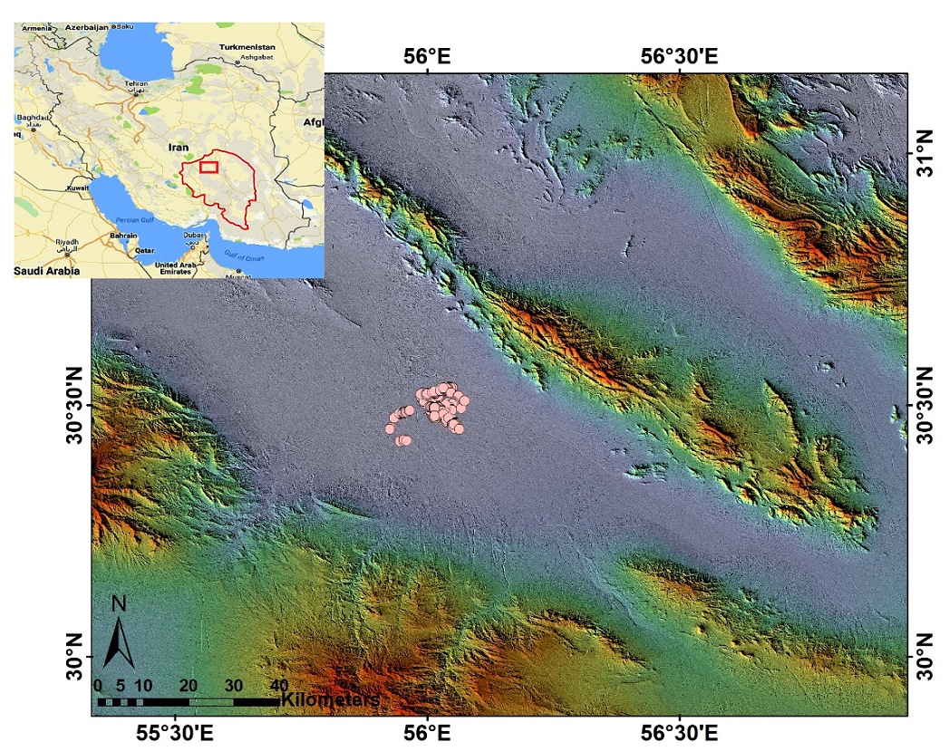

Fig. 1 Rafsanjan Plan and Yardang location

In the Sarcheshmeh and Davaran mountains, have carried eroded sediments into the Rafsanjan depression creating bajadas (bahadas) comprised of coalesced alluvial fans at the north and south edge of the plain. The alluvial fans of the northern plain of Rafsanjan form the northern Bajada. In the central part of the Rafsanjan Plain, at the limit of where the floods reach, a flat, clay floored playa has formed.
The city of Rafsanjan lies within and near the eastern edge of the playa at the confluence of the distal ends several large alluvial fans. Clearly its formation was due to the existence of these water sources. Among the sediments currently being deposited in the playa today are layers of gypsum and other salts that are formed due to the seasonal lacustrine evaporation.

The ongoing aeolian processes of the area is evidenced by the presence of active crescentic and longitudinal dunes (Negaresh 1988) Aeolian landforms lie mainly on the surface of both the northern bajada and the central playa and comprises about 1060 km2 of the Rafsanjan plain (Abbasnejad and Zahabnazouri, 2013). Because aeolian or wind-blown sand comprises more than 125 km² of the region (Parrish, 2001), the Rafsanjan dune sea is considered an Erg.

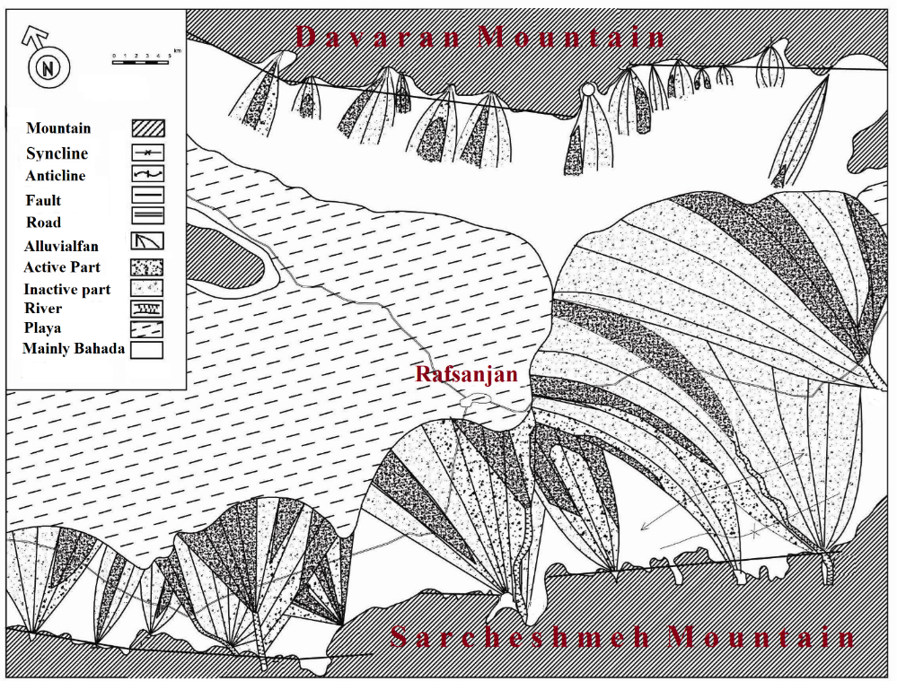
Fig. 2 Main geomorphologic landforms of Rafsanjan Plain

3.2. Wind Analysis
Because wind is the primary medium of sediment transport and landform development in desert areas (Lancaster 1985; Thomas 2013), analysis of wind speed and directional data in the Rafsanjan Plain provides a critical understanding of the prevalent wind regimes (at different temporal and spatial scales) that underlie sediment erosion and deposition in the Plain (Wal and McManus, 1993). It also explains the development of different types of sand dunes (Jewell and Nicoll 2011; Hereher 2014). In the Rafsanjan Plain the distribution and morphology of dunes is what would be expected given the current wind directions (Wasson and Hyde 1983). Today the prevailing wind directions change seasonally, but are also controlled regional topography (Jewell and Nicoll 2011; Zhang et al. 2012).
Examination of the annual wind rose (Figure 3) shows that the direction of the modern prevailing annual wind comes from the southwestern sector, the next most dominant wind comes from the northwest, though winds from due west are also equally common. Strong winds and storms with speeds of more than 11 meters per second blow from the southwest and but also from the west, southwest winds are most frequent (up to 22.2% of the time)
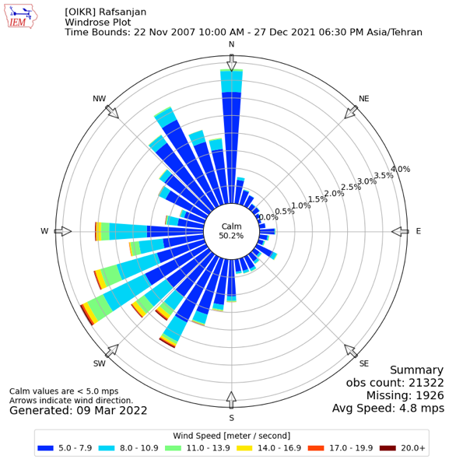

Fig. 3 Rafsanjan Synoptic Station wind record for Annual winds from January 2007 to December 2021.
Occurring throughout most seasons the year, but primarily in spring, autumn and winter.

3.3. Sand Sourcing and Aeolian Geomorphology
Characteristics of the dune sediments were especially useful in determining both sand source areas and the nature of aeolian, as well as of fluvial (which is also involved) sediment transport. The grain size distribution of samples from the Rafsanjan Plain have proven to be a key tool for distinguishing/unravelling the origins of its sedimentary environments. Sand dune sediments consist primarily of diameters around 500µ (NazimZadeh 1988). Grain size analysis (Table 1) is presented according to Folk’s (1980) sediment classification. The Folk and Ward (1957) grain size analysis reveals both the information regarding the sediment sources and the history of their transport. That is, genetic and/or dynamic relationships between the sand dunes and sand sources on the Rafsanjan Plain, can be used to determine both sediment supply and sand source areas (Mainguet 1984), and subsequent influences upon dune morphology and sediment composition due to the highly variable wind pattern.
Because sand availability is the primary control for the formation of aeolian features (Dong et al. 2011), identification of the major sources of sand on the Rafsanjan Plain, and evidence that indicates the path of that sand took from these sources, needs to be identified. The very distinctive mineralogy of the geology of the Rafsanjan Plain and its surrounding mountains, makes correlation of aeolian sediments with their source areas (mountain ranges and their alluvial fans) relatively straight forward (Hobbs et al. 2010). In addition, the physical properties of the aeolian dune sediments provides additional evidence of source areas i.e., comparison of grain size and sample mean, sorting, skewness and kurtosis (Figure 7), grain shape, and specific gravity, provided information regarding the genetic origin of the sediments in the Rafsanjan Plain (Refaat and Hamdan 2015). These studies were also preceded with field surveys to determine if any physical traces indicating travel routes of sands between source areas and dune existed (Mabbutt 1977).

Table 1. Granulometry of sand samples
Sample # | New Sample # | % Particle Size (µ) |  |  |  |  |  | Folk Statistic
 |  | 63 | 125 | 250 | 500 | 1000 | 2000 | Mean | Sorting | Skewness | Kurtosis
1 | 1 | 27.0% | 34.0% | 29.0% | 7.6% | 1.8% | 0.6% | 160.2 | 2.014 | 0.114 | 0.753
2 | 2 | 17.4% | 29.0% | 26.0% | 17.0% | 6.6% | 4.0% | 244.3 | 2.566 | -0.004 | 0.899
3 | 3S1 | 29.6% | 38.5% | 24.7% | 3.9% | 2.8% | 0.5% | 153.68 | 1.989 | 0.144 | 0.777
4 | 3S2 | 41% | 32% | 22% | 3% | 1.6% | 0.4% | 144.026 | 1.937 | 0.175 | 0.697
5 | 4w1 | 9% | 16.4% | 27% | 35.6% | 10% | 2% | 324.9 | 2.248 | -0.091 | 0.916
6 | 4w2 | 3.2% | 27.3% | 31% | 33.5% | 4% | 1% | 308.1 | 1.962 | 0.055 | 0.681
7 | 6 | 0.87% | 14.57% | 64.06% | 19.33% | 1.11% | 0.06% | 345.1 | 1.537 | 1.537 | 0.261
8 | 8 | 0.51% | 14.27% | 66.72% | 17.96% | 0.53% | 0.01% | 341.3 | 1.517 | 0.26 | 2.394
9 | 7 | 0.14% | 5.26% | 25.5% | 48.2% | 20.2% | 0.7% | 564.9 | 1.886 | -0.011 | 1.105
10 | 9 | 0.48% | 7.49% | 40.58% | 44.69% | 6.47% | 0.29% | 447.3 | 1.684 | -0.308 | 1.061
11 | 10 | 0.85% | 9.92% | 20.29% | 33.22% | 34.69% | 1.03% | 587.1 | 2.032 | -0.184 | 0.733
12 | 11 | 0.51% | 7.41% | 32.79% | 56.88% | 2.4% | 0.01% | 455.1 | 1.562 | -0.575 | 0.852
13 | 12 | 0.38% | 6.39% | 40.45% | 46.73% | 5.64% | 0.41% | 450 | 1.66 | -0.321 | 1.034

Memarian KhalilAbadi et al. (2005), following their study of the source areas of aeolian sediments on the Rafsanjan
Plain, asserted that the origin of sand within the region was from areas less than 20 Kilometers away (Table 2), these areas included: rangelands, abandoned agricultural lands, the Plain, the. eastern pediment surfaces, bare and poorly vegetated land, and pistachio orchards on the east and south eastern part of dried beds of the Shour, Shahzadeh-Abbas, and Kabutar Khan rivers that originate in the Sarcheshmeh Mountains.
In fact, the main sources of sand on the Rafsanjan Plain are the distal sections of the alluvial fans that border the southern fringe of the playa where sand has been deposited as flood water speeds dropped below velocities between 1 to 10 cm/second (according to the Hjulstrom diagram). This is borne out by granulometric analysis of the dune sands. The data revealed that they came from the distal alluvial fans just before the clay playa is reached. The mudrocks, comprising the yardangs on the floor of the Rafsanjan Plain also contain sand, and have served as a significant source of sand for the dunes. The sand in yardangs is released during sandblasting and is therefore considered a secondary and highly variable source of sand in this area.
The morphology of the sand dunes correlated with wind speed and direction provides additional evidence of the Rafsanjan sand sources. Because the annual prevailing winds blow from the southwest and west, the sands moving across the Plain come primarily from the western alluvial fans and bajada surfaces. Then they form significant dune fields that include nebkhas when sediment is trapped by shrubs, and barchan and parabolic dunes in more open areas. The development of their classic shapes again reveal the complex interactions between vegetation and sediment transport (Hesp 1981, 2002).

Table 2 Mineralogy of sand samples
Sample | Quartz | Quartz | Calcite | Calcite | Gypsum | Gypsum | Halite | Halite |  |  | Corundum | Corundum
 |  |  |  |  |  |  |  |  | Arthose,  K, A, S, O_{3,,,} | Arthose,  K, A, S, O_{3,,,} | Corundum | Corundum
1 | 7 | 7.0% | 7 | 7.0% | 46 | 46.0% | 3 | 3.0% | 3 | 3.0% | 3 | 3.0%
2 | 28 | 28.0% | 17 | 17.0% | 0 | 0.0% | 0 | 0.0% | 0 | 0.0% | 0 | 0.0%
3 | 13 | 14.8% | 12 | 13.6% | 0 | 0.0% | 0 | 0.0% | 0 | 0.0% | 4 | 4.5%
4 | 40 | 29.9% | 5 | 3.7% | 40 | 29.9% | 1 | 0.7% | 1 | 0.7% | 0 | 0.0%
Sample | Olivine pyroxene | Olivine pyroxene | Sedimentary rocks | Sedimentary rocks | Igneous rock | Igneous rock | Metamorphic rocks | Metamorphic rocks | Heavy metals | Heavy metals | Total
1 | 0 | 0.0% | 3 | 3.0% | 27 | 27.0% | 1 | 1.0% | 0 | 0.0% | 100
2 | 2 | 2.0% | 7 | 7.0% | 42 | 42.0% | 4 | 4.0% | 0 | 0.0% | 100
3 | 0 | 0.0% | 13 | 14.8% | 45 | 51.1% | 1 | 1.1% | 0 | 0.0% | 88
4 | 10 | 7.5% | 12 | 9.0% | 19 | 14.2% | 2 | 1.5% | 4 | 3.0% | 134

In the northern part of the plain, there is a complex interaction between fluvial transport of weathered sediments from the mountains through the fans to the plains as fluvial sands, and then back towards the mountains through aeolian transport of sand. This creates an almost closed cycle of sand transport in that part of the Plain. On the surface of the plain, both weathering and impact of particles during saltation produces new sand particles that contribute to the sand volume in the area as well.
Alluvial sands from the distal parts of these fans are transported by the dominant winds, which blow from the southwest. The sands, after traversing the central playa, are primarily deposited on the northern foothills, although several types of migrating dunes are observed in the central and the southern area of the playa. As a result the movement of sands may be understood as a complex system of 1) erosion of sands from the Davaran Mountains that lie in the north northeast, and from the Sharchesmeh Mountains in the south. In the south the southwest to west winds transport the Sharchesmeh sand across the valley where they are mixed with the sands from the Davaran Mountains. The southwest to west winds transport these mixed sands back into the Davaran Mountains where they are washed into the valley again creating a cycle of mixing. During the summer, winds from the north move both loose sands and sands deflated from the valley floor to the south. This way both recent and much older sediments are mixed and deposited in dunes as well. Finally there are the contributions from the larger rivers that bring sediments into the valley floor where they are mixed by the varying prevailing winds. This mixing, and relatively short distance transport is reflected in the grainsize analsysis. The abundance of coarse sand in some of the dunes is unexpected but explained by variable seasonal winds that transport sediments in the Rafsanjan Valley (Figure 4).
As an attempt to better understand of the regional, aeolian geomorphological processes at work in the Rafsanjan Plain, the types of aeolian landforms were identified using the following dune definitions (Dong & Lv 2014). The names of these dunes is based upon the nomenclature who first proposed classifying dunes into 1) simple, 2) compound and 3) complex dune forms (Pye and Tsoar 1990).

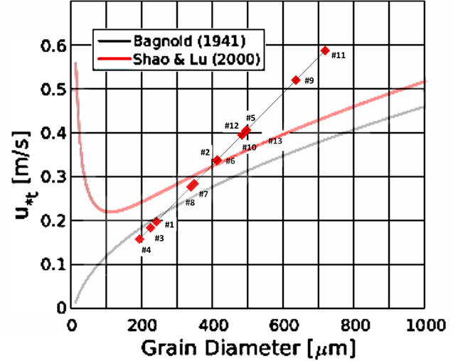

Fig.4 Plot of the Rafsanjan samples with regards to mean grain size of each sample and the fluid threshold velocity. Position of the Rafsanjan samples on the diagram probably reflects environmental factors unique to the Rafsanjan Plain.

Figure 5 shows the geomorphological map of the study area. This map illustrates various aeolian landforms and sand dune types identified across the Rafsanjan Plain. Based on field observations and geomorphological interpretations, the dunes of this region can be categorized into several main groups according to their origin and morphology:
- Topographic dunes, which form as a result of the influence of topographic obstacles, include echo dunes, climbing, falling and lee dunes. Most of these lie adjacent to the Davaran Mountains or even draped over the foot or the slopes.
- Autogenic dunes on this plain include barchanoids, seifs, dome dunes and a star dunes. Sand sheets and zibar units also belong to this group.
- Phytogenic dunes identified in the Rafsanjan Plain include parabolics, nebkhas, shadow dunes and vegetated linear dunes (Hesp 1981). They occupy a considerable part of the plain. Obviously, some of dunes that were identified were too limited in area to be mapped. Also, in some instances, there are more than one type of dune in a mapped unit.
- Compound dunes are composed of a number of dunes of the same major dune type but at different scales superimposed onto each other (McKee 1979).
- Complex dunes on the Rafsanjan playa are comprised of the superimposition of different dune types including: parabolic-seif and seif-barchans dunes (Livingstone et al. 2010). In addition, linear sand dunes with a morphology displaying a bimodal wind direction from a northwest and southwest direction also occur. This reveals both current and past wind directions (Eric et al. 2009).

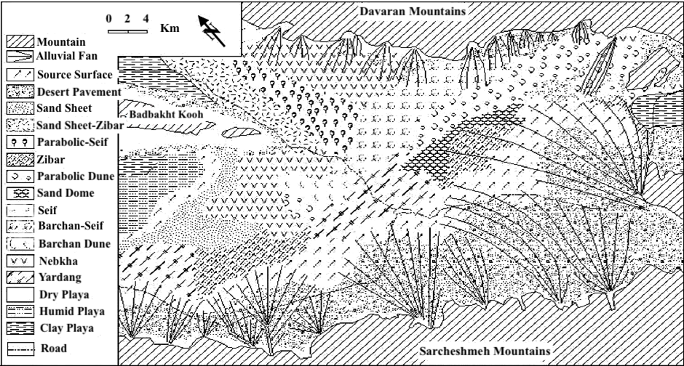
Fig. 5 Aeolian geomorphology map of Rafsanjan plain.

Some sections of the alluvial fan surfaces in both the southern and northern areas of the Rafsanjan Plain are covered by a layer of desert pavement comprised of angular or sub-rounded gravels resting on a layer of ﬁner sediment (Cooke and Warren 1973). This unit covers about 550 square kilometres, which is about 29 percentage of the geomorphological units in the region. The surface of the rocks that make up the desert pavement often have desert polish. Any vegetation that grows there is both sparse and very low. Despite its apparently stable surface, desert pavement is one of the more fragile areas of the Rafsanjan Plain.
Several theories of desert pavement present themselves (McFadden, et al. 1995). 1) The most common theory contends that they form through the gradual removal of sand, dust and other fine-grained material by the wind and intermittent rain, leaving the larger fragments behind. The larger fragments are left to settle into place through gravity. A second theory supposes that desert pavements result from the shrink/swell properties of the clay underneath the pavement that causes them to expand when precipitation is absorbed, and shrink when it dries. Eventually this transports rocks and pebbles to the surface to form a pavement. The most recent theory proposed by Stephen Wells and his coworkers at Cima Dome, explains geologically recent lava flows covered by younger soil layers, with desert pavement on top of them, made of rubble from the same lava, as an accumulation of soil beneath a protective layer of desert pavement with no stones or gravel in the soil. They suggest that the stones remain on the surface due to heave, and windblown dust accumulates beneath the pavement to slowly lift it (Wells, et al. 1995). However, when the surface layer of the desert pavement is disturbed, the underlying fine particles are exposed and are easily eroded and it becomes a major source of sand and dust production in the Rafsanjan Plain. Surface vegetation on desert pavement may help mitigate this problem.

3.4. Evolution of Land Use since 1955 and the Onset of Desertification
According to long-term wind roses, in this case from Kerman 100 km away the dominant and stormiest winds come from the southwest and west and north-west. Among the regional winds the southwest, western, and then the northwest winds have the greatest influence on land use and cause dust storms on the Rafsanjan Plain. However, when one looks at the decadal wind rose record, it is clear that there was a significant change in wind pattern directions and their strengths during the 1980s (Figure 6).
In order to identify the effects of wind erosion on land use, and to investigate the consequences that changes that the progress sand movement has had, land use maps of the study area were prepared from the beginning, middle and end of a 53-year period (Figures 7, 8, and 9).
The comparative study of land cover map and sand-range changes indicate that from 1955 to 1995 there was a decrease in the area of the erg, the most important reason being the conversion of sandy areas into agricultural land (Table 3). From 1995 to 2008 there has been an increase the area of the erg and in some regions (especially North- East and North-West) sand dunes have moved into adjacent lands as well. The most important reason was sand stabilization program and an increase in agricultural land. However, it is these lands that are now are under major threat of sand inundation.

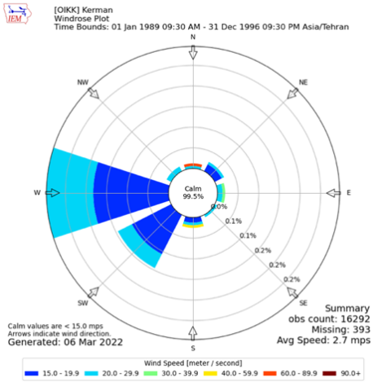
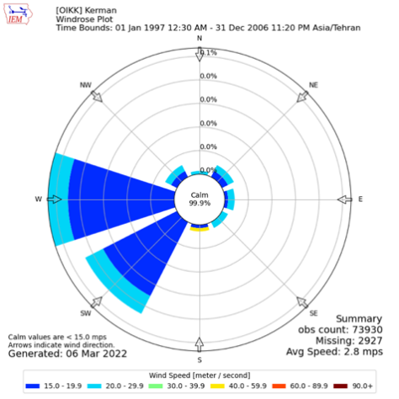
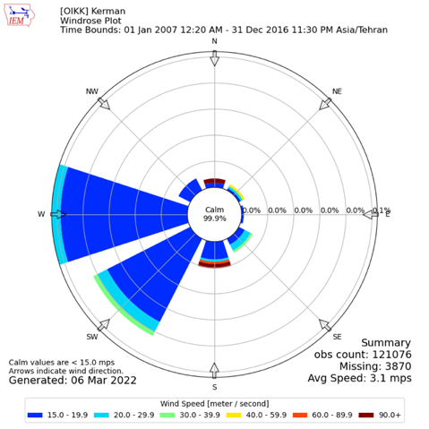
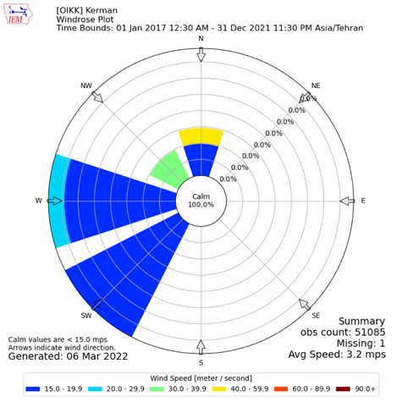
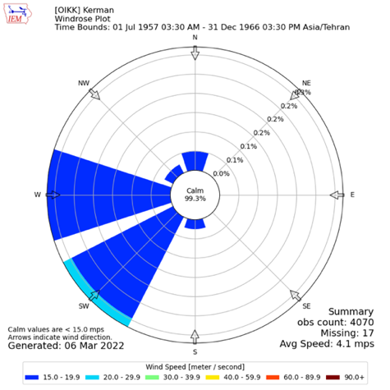
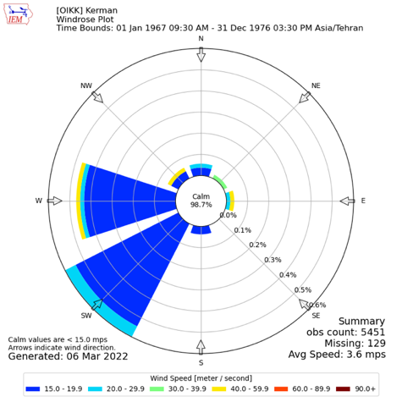
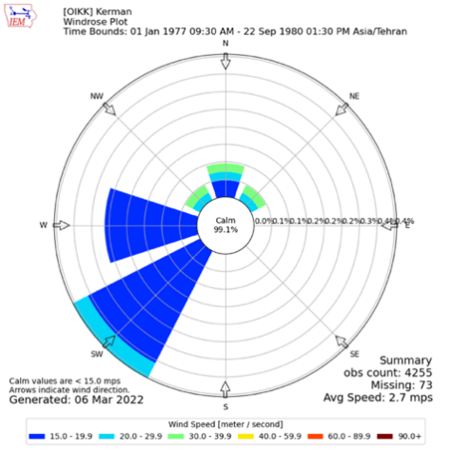
Fig. 6 Decadal windroses for Kerman, Iran, since 1957 showing the major change in wind direction in southern Iran including the Rafsanjan Plain sometime during the 1980s.

Table 3 Change in land use in the Rafsanjan Plain between 1955 and 2008
Year | City  Area Km² | Orchards Area Km² | Sand  Area Km²
1955 | 7.82 | 181.01 | 381.42
1995 | 57.98 | 356 | 271.21
2008 | 86.72 | 377.41 | 276.46

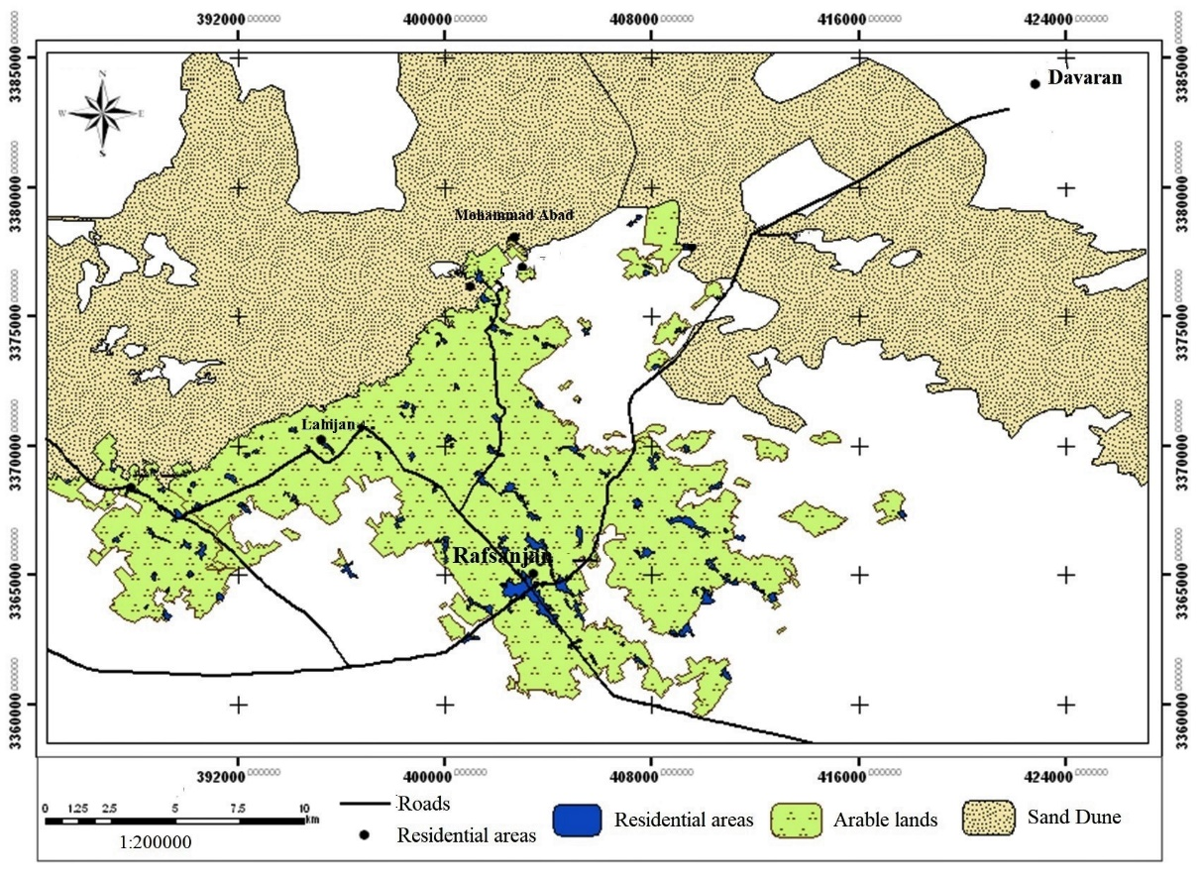
Fig. 7 Rafsanjan land use in 1955
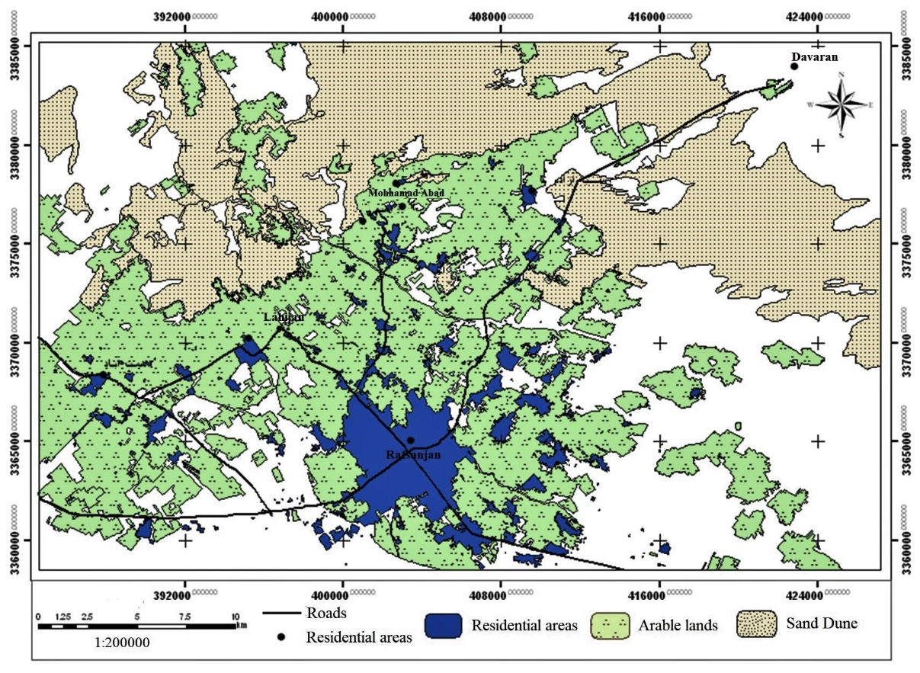
Fig. 8 Rafsanjan land use in 1995

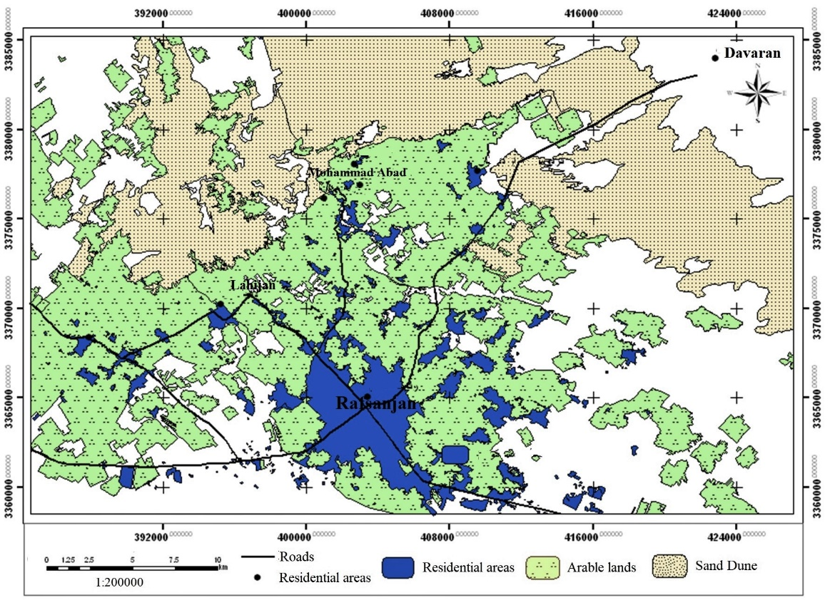
Fig. 9 Rafsanjan land use in 2008

The role of precipitation in influencing these changes, especially in light of the increasing impact of global warming must be considered as well. El Niño-Southern Oscillation (ENSO) or Southern Oscillation Index (SOI), Pacific Decadal Oscillation (PDO), and North Atlantic Oscillation (NAO) are distinguished as the most essential phenomena due to their considerable impacts on hydro-climatic systems. The predominance of the SOI in the climate of southern and southeastern Iran is significant (Dehghani et al. 2020). In autumn, winter, and spring, which is when most of the precipitation occurs, SOI has a significant correlation with more than 70% of the stations in these three seasons (Figure 10). Dehghani et al (2020) conclude that NAO and SOI have a positive correlation with fall, winter and spring precipitation in most stations while they have a negative correlation with summer precipitation. This pattern is the same for PDO in winter and spring while there is a positive and negative correlation with summer and autumn precipitation, respectively. It appears from their study that the Southern Oscillation Index has the greatest impact upon the precipitation in exteme southern Iran, but the monsoons don’t seem to play a significant role in precipitation thus far in the Rafsanjan Plain.
At Rafsanjan the monthly average precipitation, except for October and May, have all experienced significant decline in rainfall amounts. Especially March and November have experienced over a 14% decrease in precipitation. June, August and September have also experienced relative increases in precipitation. The increases in August, September and October may be related to increasing monsoonal penetration into the region.
Unlike other records in the region, December, January and February have lower precipitation then those months preceding and following them. Precipitation trends both annually and seasonally have been declining since 1987 (Figures 11 and 12). Precipitation has been highly variable, but the general decline has been steady. The high variability may explain some of the obvious alluvial fan activity that is seen in the satellite images above. With regards to the alluvial fan activity in the 1995 Google Earth view of the Rafsanjan Plain, it is clear that this was a significant period of increased spring and fall precipitation.

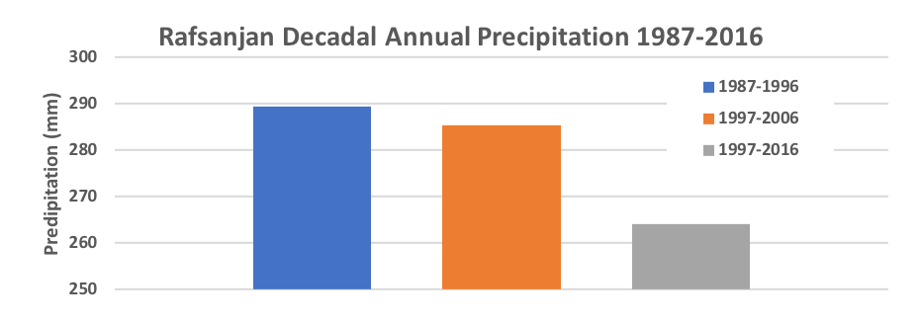
Fig. 10 Rafsanjan seasonal mean precipitation by decade from 1987 through 2016.
Fig. 11 Rafsanjan annual mean precipitation by decade from 1987 through 2016.

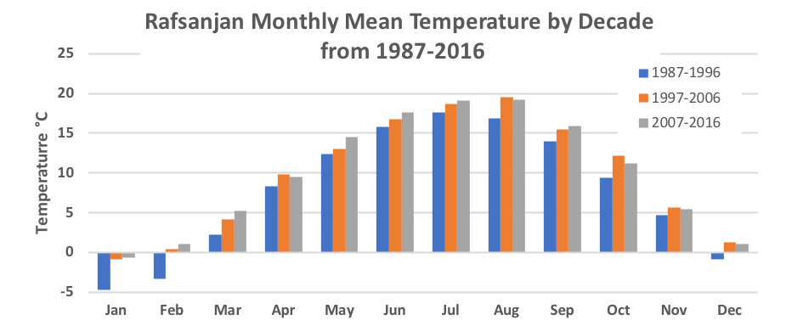

Fig. 12 Monthly Mean temperature by decade at Rafsanjan from 1996 through 2016.

Both the mean monthly, seasonal, and annual temperatures have been increasing in the Rafsanjan area (Figures 13 and 14). Effective precipitation in Rafsanjan has been highly variable during the last 30 years (Figure 15). It is clear that precipitation and temperature are usually out of phase as one would expect. That is, when temperature is higher effective precipitation declines due to higher evaporation rates, and when annual temperature is lower, effective precipitation increases, because evaporation rates are lower. The formula to calculate effective precipitation is as follows:

Effective Precipitation (mm) = (precip in mm) – 5) x 0.75

It is the reduction in effective precipitation that has added the environmental effect that has not only reduced the precipitation available for plants in the region…and all of southern Iran, but also has resulted in a significant loss off rain for the recharge of groundwater. This has resulted in a significant increase the number of deep wells to mine the groundwater and a lowering of the water table beyond the reach of the plants stabilizing many dunes.
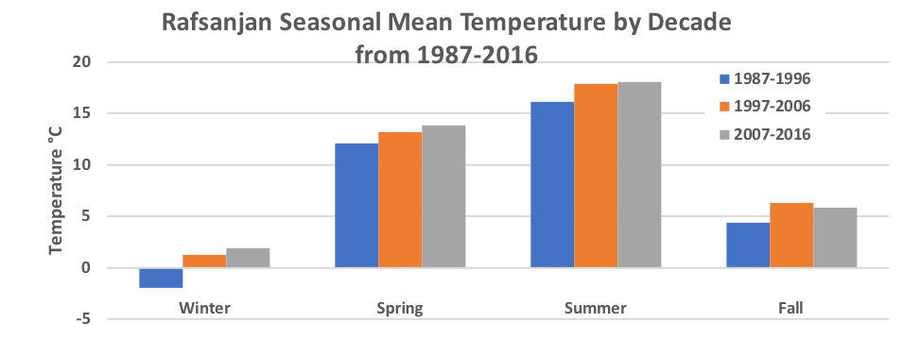
Fig. 13 Mean Seasonal Temperature by decade at Rafsanjan from 1987 through 2016

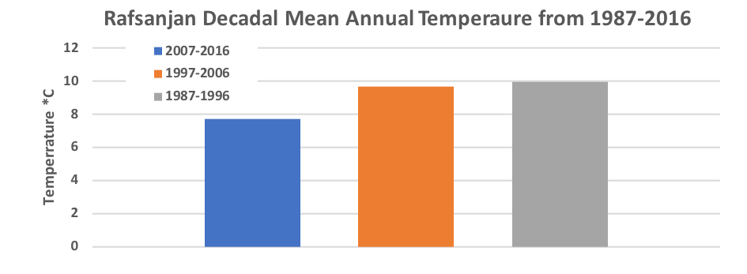
Fig. 14 Mean Annual Temperature by decade at Rafsanjan from 1987 through 2016

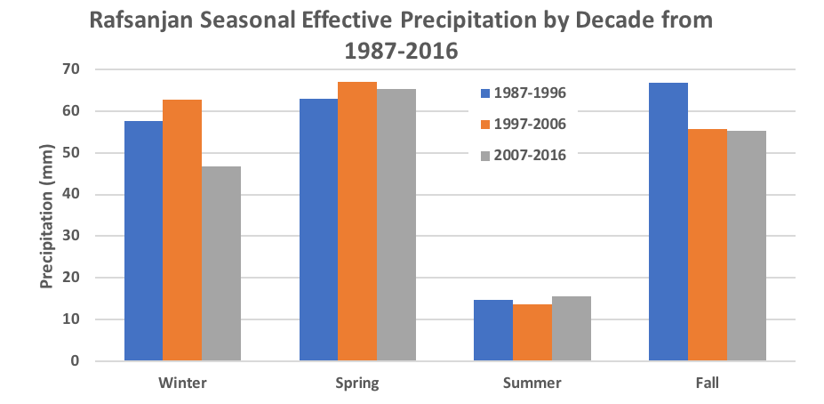
Fig. 15 Decadal Mean Seasonal Effective Precipitation at Rafsanjan from 1987 through 2016.

Between 1955 and 2008 the area of Rafsanjan city increased from 72.72 to 82.7 km², and the area of sand dunes reduced dramatically from 421.381 to 249.29 km² due to the conversion of sandy areas into agricultural lands, and to the removal of sand from agricultural lands, often for other uses such as to soften clayey soils, etc. An additional decrease of 8.11 km² in sandy areas, is supported by field observations and statements of farmers, to have been becaue farmers removed the sands swept into their gardens every year. However, the major reason for the reduction in the area of sands was clearly their conversion into agricultural lands.
Today, desertification of the Rafsanjan Plain is progressing at an alarming rate. Accumulation of wind-blown sediments on arable lands is accelerating, and soil fertility is declining at an ever increasing rate. In general, the factors affecting wind erosion in Rafsanjan plain include both natural and human impacts.
In summary, natural factors affecting wind erosion include: 1) reducing precipitation; 2) its irregular and severe fluctuation from year to year; 3) change in its monthly distribution; 4) decrease in the density of or lack of vegetation cover; 5) increasing annual temperature resulting in increased evaporation rates; 6) surface smoothness (as Rafsanjan is located in a low relief area) which during recent severe droughts have intensified the phenomenon of wind erosion. Human factors affecting wind erosion in Rafsanjan Plain include: 1) lack of proper application of principles of soil protection; 2) overgrazing by livestock; 3) and especially, severe exploitation of groundwater, which has resulted in severe reduction of groundwater levels and drying of wells. As a result, much of the land has been abandoned, and the abandoned lands have in themselves become a source of deflated sands. This has ultimately led to an intensification of wind erosion and desertification in the region.
Despite the fact that farmers remove sand from their lands, there is no way they can staveoff the effects of wind erosion. In some areas (Lahijan) sand has advanced into adjacent agricultural land, in the northeast wind erosion has destroyed pistachio orchards and buried them, filled canals and water wells, and, as a resulted in the abandonment of pistachio orchards. At current rates of sediment erosion and its movement towards and into areas where people live and work, huge financial losses have occurred (Cao et al. 2015). Due to the expansion of pistachio orchards into the sandy lands, and to the fragility of arid environments, it may be expected that with recurring drought over many years, the continuing progression of sands will result in the eventual destruction of the pistachio orchards.

4. Conclusions
According to research undertaken on the Rafsanjan Plain, the immense southern alluvial fans are the main sources of sand. Aeolian sediments have been transported from the southwest by the dominant prevailing regional winds, and have traversed the central part of the plain, and have accumulated predominately at the northern and north-eastern sides of the area. During transport, the sands have also accumulated, and formed sand dunes as a result of topographic or vegetational barriers. In some parts of the plain, non-dominant winds have acted in the process of aeolian geomorphology, as well. The entire surface area in this plain is ~1060 km² and is characterized by various aeolian geomorphological features including: areas of source deflation characterized by desert pavement, and by wind eroded yardangs and by areas of aeolian deposition characterized by barchans, barchans-coppices, seif-barchans, seifs, zibars, parabolics, linear vegetated dunes, nebkhas and dome dunes and sand sheets. Transported sands have also been carried up the Davaran Ridges where they have formed climbing, lee and echo dunes there. All of these features have been identified and mapped. It is clear from both sediment and mineralogical analysis that most aeolian deposits are a complex mix of sand sources from throughout the valley. It is also clear that in some areas the mixing is more extreme (Maghsoudi et al, 2011).
The information gleaned from the wind roses, indicate that that the most important wind affecting aeolian erosion has been the southwest, followed by the west wind. Southwest winds predominate in winter and spring, but also occur with less strength in the fall. Northwest and north winds predominate in the summer months when drought prevails, and sands are more easily transported. However, the greatest strength winds occur in winter, and originate from the southwest to the northwest. They also carry the largest proportion of sediment with them. It is also clear that there are shifts occurring in the dominant wind dirctions, and that they will effect the direction of sand movement making new areas vulnerable to inundation.
Comparison of land use map and sand-range changes revealed from 1955 to 1995 there was a decrease in the area of erg, its most important reason being the change of sand areas to agricultural land and from 1995 to 2020 there has been an increase in its area and in some regions (especially North- East and North-West) sand dunes have moved into the adjacent land. Comparison of land use in the years 1955 to 2020 indicate that the areas around the sandy lands are increasingly exposed to the threat of sand encroachment. The changes after 1995 may be due to shift in the location of the Winter Monsoon in India.
Aeolian landforms are being influenced by ongoing climate change as well as anthropogenic activities. Winter precipitation has decreased by 20% since 1951, and spring precipitation by 50%. Average annual temperature has increased by about 2°C. Effective precipitation has decreased by about 50 mm. The resulting impact upon groundwater recharge has been devastating, especially when combined with the increase in deep water water drilling and expansion of agricultural areas. This has already led to the abandonment of many pistachio orchards.
Several future scenarios present themselves: 1) in the most extreme, the region will face total desertification and human abandonment within the next few decades. 2) A culture of prevention and increase in local public and official awareness, could result in mobilization of stake holders and users, to begin a program that will protect the Rafsanjan Plain through a) a shift to water saving methods of irrigation, such as drip irrigation, which could deliver up to 90% of the water pumped from the ground to the field, ground surface mulching under the plants in agricultural areas to reduce water loss through evaporation, and b) through the institution of programs of aeolian process mitigation through either natural (plants) or artificial (fences) barriers to intercept the wind and reduce its sediment carrying capacity, c) by introducing ground surface covers, that prevent the wind from lifting sediment from the ground. Such measures would rescue the region from further desertification. The increased savings in water, might allow the revival of traditional irrigation methods such as the qanat system, coupled with drip irrigation, which could protect further loss of pistachio orchards to sand encroachment. If such measures are not taken, the ongoing invasion of sands will assure continued desertification of the region, and assured destruction of the agricultural lands of the Rafsanjan area.
As suggested at the beginning of this paper, the Rafsanjan Plain is a microcosm of what is happening globally in the marginal agricultural areas of the earth. To allow the collapse of these areas will assure the displacement of 100s of millions of people who will look to the more mesic temperate regions for relief. Therefore, to address the needs of these regions now, will have long-term benefits both economically, and politically.

Disclaimer (Artificial intelligence)
Option 1:
Author(s) hereby declare that NO generative AI technologies such as Large Language Models (ChatGPT, COPILOT, etc.) and text-to-image generators have been used during the writing or editing of this manuscript.
Option 2:
Author(s) hereby declare that generative AI technologies such as Large Language Models, etc. have been used during the writing or editing of manuscripts. This explanation will include the name, version, model, and source of the generative AI technology and as well as all input prompts provided to the generative AI technology
Details of the AI usage are given below:
1.
2.
3.

COMPETING INTERESTS DISCLAIMER:
Authors have declared that they have no known competing financial interests OR non-financial interests OR personal relationships that could have appeared to influence the work reported in this paper.

References
- Abbasi, H. R., Opp, C., Akavan, R., Khaksarian, F., & Gohardoost, A. (2015). Temporal and spatial variability of wind erosion in Sistanʼs Baringak Hamoun Lake [Oral presentation]. Marin Desert Conference, Rauischholzhausen, Germany, 12–13 February. https://doi.org/10.3390/atmos10100614
- Abbasi, H. R., Opp, C., Groll, M., Rouhipoor, H., & Gohardoost, A. (2018). A comparison of general models of activity of sand dunes in Iran. The Tenth International Conference on Aeolian Research (ICAR-X), Bordeaux, France, 25–29 June.
- Abbasnejad, A. (1993). Analysis of morphogenesis and environmental impacts of wind on the Rafsanjan Plain. Kerman University Research Center.
- Abbasnejad, A., & Zahabnazouri, S. (2013). Aeolian geomorphology of Rafsanjan Plain. Iranian Journal of Quantitative Geomorphology, 127–144.
- Ahmady-Birgani, H., McQueen, K. G., Moeinaddini, M., et al. (2017). Sand dune encroachment and desertification processes of the Rigboland Sand Sea, Central Iran. Scientific Reports, 7, 1523. https://doi.org/10.1038/s41598-017-01796-z
- Al-Dousari, A. M., Al-Elaj, M., Al-Enezi, E., & Al-Shareeda, A. (2009). Origin and characteristics of yardangs in the Um Al-Rimam depressions (N Kuwait). Geomorphology, 104(3), 93–104. https://doi.org/10.1016/j.geomorph.2008.05.010
- Al-Helal, A. B., & Al-Awadhi, J. M. (2006). Assessment of sand encroachment in Kuwait using GIS. Environmental Geology, 49, 960–967. https://doi.org/10.1007/s00254-005-0134-8
- Ardon, K., Tsoar, H., & Blumberg, D. G. (2009). Dynamics of nebkhas superimposed on a parabolic dune and their effect on the dune dynamics. Journal of Arid Environments, 73, 1014–1022. https://doi.org/10.1016/j.jaridenv.2009.04.021
- Borjian, H. (2017). Kerman i. Geography. Encyclopedia Iranica. https://iranicaonline.org/articles/kerman-geograph
- Bourke, M. C., & Goudie, A. S. (2009). Varieties of barchan form in the Namib Desert and on Mars. Aeolian Research, 1, 45–54. https://doi.org/10.1016/j.aeolia.2009.05.002
- Breed, C. S., McCauley, J. E., & Whitney, M. I. (1989). Wind erosion forms. In D. S. G. Thomas (Ed.), Arid zone geomorphology: Process, form and change in drylands (pp. 284–307). Wiley.
- Bridges, N. T., & Laity, J. E. (2013). Fundamentals of aeolian sediment transport: Aeolian abrasion. In J. F. Shroder (Ed.), Treatise on Geomorphology (pp. 134–148). Academic Press. https://doi.org/10.1016/B978-0-12-374739-6.00296-7
- Brookes, I. A. (2001). Aeolian erosional lineations in the Libyan Desert, Dakhla Region, Egypt. Geomorphology, 39, 189–209. https://doi.org/10.1016/S0169-555X(01)00026-5
- Broomandi, P., Dabir, B., Bonakdarpour, B., & Rashidi, Y. (2017). Identification of dust storm origin in southwest of Iran. Journal of Environmental Health Science and Engineering, 15, 1–14. https://doi.org/10.1186/s40201-017-0280-4
- Bui, E. N., Mazullo, J., & Wilding, L. P. (1989). Using quartz grain size and shape analysis to distinguish between aeolian and fluvial deposits in the Dallol Bosso of Niger (West Africa). Earth Surface Processes and Landforms, 14, 157–166. https://doi.org/10.1002/esp.3290140206
- Cao, H., Liu, J., Wang, G., Yang, G., & Luo, L. (2015). Identification of sand and dust storm source areas in Iran. Journal of Arid Land, 7, 567–578. https://doi.org/10.1007/s40333-015-0127-8
- Casper, B. B. (1996). Demographic consequences of drought in the herbaceous perennial Cryptantha flava: Effects of density, associations with shrubs and plant size. Oecologia, 106, 144–152. https://doi.org/10.1007/BF00328593
- Cooke, R., & Warren, A. (1973). Geomorphology in deserts. University of California Press. https://doi.org/10.1525/9780520329584
- Cooke, R., Warren, A., & Goudie, A. (1999). Desert geomorphology (526 pp.). UCL Press.
- Dehghani, M., Salehi, S., Mosavi, A., Nabipour, N., Shamshirband, S., & Ghamisi, P. (2020). Spatial analysis of seasonal precipitation over Iran: Co-variation with climate indices. International Journal of Geo-Information, 9, 73–97. https://doi.org/10.3390/ijgi9020073
- DeSilva, S. L., Bailey, J. E., Mandt, K. E., & Viramonte, J. M. (2010). Yardangs in terrestrial ignimbrites: Synergistic remote and field observations on Earth with applications to Mars. Planetary and Space Science, 58, 459–471. https://doi.org/10.1016/j.pss.2009.10.002
- Dimitrijevic, M. (1973). Geology of Kerman Region (G.S.I. Report yu/52).
- Dong, R. J., & Dong, Z. B. (2014). Aesthetic evaluation of yardang landforms landscape: The Dunhuang Yardang National Geo-park example. Sciences in Cold and Arid Regions, 7(3), 0265–0271.
- Dong, Z. B., Qu, J. J., Qian, G. Q., & Zhang, Z. C. (2011). Aeolian geomorphological regionalization of the Kumtagh Desert. Journal of Desert Research, 31, 805–814. (In Chinese with English abstract)
- Dong, Z., & Lv, P. (2013). Recent advances in research on the aeolian geomorphology of China's Kumtagh Sand Sea. Advances in Geosciences, 37, 41–46. https://doi.org/10.5194/adgeo-37-41-2014
- Du, J., Yan, P., & Dong, Y. (2010). The progress and prospects of nebkhas in arid areas. Journal of Geographical Sciences, 20, 712–728.
- Ehsani, A. H., & Quiel, F. (2008). Application of self organizing map and SRTM data to characterize yardangs in the Lut Desert, Iran. Remote Sensing of Environment, 112, 3284–3294. https://doi.org/10.1016/j.rse.2008.04.007
- Embabi, N. (1999). Playas of the western desert, Egypt. In J. Donner (Ed.), Studies of playas in the Western Desert of Egypt (pp. 5–47). Helsinki, CA: Finnish Academy of Science and Letters.
- Folk, R. L. (1980). Petrology of sedimentary rocks. Austin, TX: Hemphill Publishing.
- Folk, R. L., & Ward, W. C. (1957). Brazos river basin: A study in the significance of grain size parameter. Journal of Sedimentary Petrology, 27, 3–27. https://doi.org/10.1306/74D70646-2B21-11D7-8648000102C1865D
- Gabriel, A. (1938). The southern Lut and Iranian Baluchistan. Geographical Journal, 92, 193–210. https://doi.org/10.2307/1788828
- Ganjaeian, H., Mohammadian, K., Javedani, M., & Safari Namivandi, M. (2023). Estimating the desertification potential of Yazd Province using DVI indices. Desert management, 11(2), 35-48. https://doi.org/10.22034/jdmal.2023.2004871.1419 [In Persian]
- Goudie, A. S. (2007). Mega-yardangs: A global analysis. Geography Compass, 1, 65–81. https://doi.org/10.1111/j.1749-8198.2006.00003.x
- Goudie, A. S., Stokes, J., Cook, S., Samieh, O. A., & Rashidi, E. L. (1999). Yardang landforms from Kharga Oasis, south-western Egypt. Zeitschrift für Geomorphologie, 116, 97–112.
- Greeley, R., & Iversen, J. D. (1985). Wind as a geological process on Earth, Mars, Venus and Titan (pp. 133–144). Cambridge, NY: Cambridge University Press. https://doi.org/10.1017/CBO9780511573071
- Greeley, R., Bender, K., & Thomas, P. E. (1995). Wind-related features and processes on Venus: Summary of Magellan results. Icarus, 2, 399–420. https://doi.org/10.1006/icar.1995.1107
- Gutiérrez-Elorza, M., Desir, G., & Gutiérrez-Santolalla, F. (2002). Yardangs in the semiarid central sector of the Ebro Depression (NE Spain). Geomorphology, 44, 155–170. https://doi.org/10.1016/S0169-555X(01)00151-9
- Halimov, M., & Fezer, F. (1989). Eight yardang types in central Asia. Zeitschrift für Geomorphologie, 33, 205–217. https://doi.org/10.1127/zfg/33/1989/205
- He, Z., Li, S., & Harazono, Y. (1997). Wind-sandy environment and the effects of vegetation on wind breaking and dune fixation in Horqin Sandy Land, China. In Proceedings of Wind Erosion: An International Symposium/Workshop. USDA Agricultural Research Service, Wind Erosion Laboratory, Manhattan, KS, 7 pp.
- Hesp, P. A. (1981). The formation of shadow dunes. Journal of Sedimentary Petrology, 57, 101–112. https://doi.org/10.1306/212F7C1B-2B24-11D7-8648000102C1865D
- Hesp, P. A. (2002). Foredunes and blowouts: Initiation, geomorphology and dynamics. Geomorphology, 48, 245–268. https://doi.org/10.1016/S0169-555X(02)00184-8
- Hobbs, S. W., Paull, D. J., & Bourke, M. C. (2010). Aeolian processes and dune morphology in Gale Crater. Icarus, 210(1), 102–115. https://doi.org/10.1016/j.icarus.2010.06.006
- Hoffmann, T., Schlummer, M., & Notebaert, B. (2013). Carbon burial in soil sediments from Holocene agricultural erosion, Central Europe. Global Biogeochemical Cycles, 27, 828–835. https://doi.org/10.1002/gbc.20071
- Holm, D. A. (1960). Desert geomorphology in the Arabian Peninsula. Science, 132, 1369–1379.
- Jewell, P. W., & Nicoll, K. (2011). Wind regimes and aeolian transport in the Great Basin, U.S.A. Geomorphology, 129, 1–13. https://doi.org/10.1126/science.132.3437.1369
- Kamali, H., & Zahabnazouri, S. (2018). Surface morphology of meteorites in Lut Desert (Iran) environment. Astrobiology Outreach, 6(1), 163.
- Kaskaoutis, D., Rashki, A., Elias, E. H., Aristides, B., Philippe, F., Michel, L., & Harry, D. K. (2016). The Caspian Sea – Hindu Kush Index (CasHKI): Definition, meteorological influences and dust activities over southwest Asia. In Proceedings of the First International Conference on Dust, Shahid Chamran University, Ahvaz, Iran, 2–4 March.
- Kehl, M. (2009). Quaternary climate change in Iran—the state of knowledge. Erdkunde, 63(1), 1–17. https://doi.org/10.3112/erdkunde.2009.01.01
- Keshtkar, M., Mokhtari, Z., & Sayahnia, R. (2022). Impact of land use/land cover change on soil retention service. Journal of Landscape Ecology. https://doi.org/10.2478/jlecol2022-0010.
- Khalaf, F. I., Al-Ajmi, D., Saleh, N., & Al-Hashash, M. (1993). Aeolian processes and sand encroachment problems in Kuwait. Geomorphology, 6, 111–134. https://doi.org/10.1016/0169-555X(93)90042-Z
- Khalaf, F. I., Al-Hurban, A. E., & Al-Awadhi, J. (2014). Morphology of protected and nonprotected Nitraria retusa coastal nebkha in Kuwait, Arabian Gulf: A comparative study. Catena, 115, 115–122. https://doi.org/10.1016/j.catena.2013.12.001
- Khoshnood Motlagh, S., Sadoddin, A., Haghnegahdar, A., Razavi, S., Salmanmahiny, A. & Ghorbani, K. (2021). Analysis and prediction of land cover changes using the land change modeler (LCM) in a semiarid river basin, Iran. Land Degradation & Development, published 17 April 2021. https://doi.org/10.1002/ldr.3969
- Krinsley, D. H. (1970). A geomorphologic and paleoclimatologic study of the playas of Iran. USGS Final Scientific Report (Contract PROCP 70-800). US Air Force Cambridge Research.
- Laity, J. E. (2008). Desert and desert environments. Wiley-Blackwell, United Kingdom.
- Laity, J. E. (2009). Landforms, landscapes, and processes of Aeolian erosion. In J. F. Shroder (Ed.), Geomorphology of deserts (pp. 597–627). Dordrecht, Netherlands: Springer. https://doi.org/10.1007/978-1-4020-5719-9_19
- Lancaster, N. (1985). Variations in wind velocity and sand transport rates on the windward flanks of desert sand dunes. Sedimentology, 32, 581–593. https://doi.org/10.1111/j.1365-3091.1985.tb00472.x
- Lancaster, N. (1994). Dune morphology and dynamics. In A. D. Abrahams & A. J. Parsons (Eds.), Geomorphology of desert environments. London: Chapman and Hall.
- Lancaster, N. (2013). Sand seas and dune fields. In J. Shroder (Ed. in Chief), N. Lancaster, D. J. Sherman, & A. C. W. Baas (Eds.), Treatise on geomorphology (Vol. 11, Aeolian Geomorphology, pp. 219–245). San Diego, CA: Academic Press.
- Lang, L., Xunming, W., & Caixia, Z. (2013). Moisture availability over the past five centuries indicated by carbon isotopes of Tamarix taklamakanensis leaves in a Nebkha profile in the Central Taklimakan Desert, NW China. Aeolian Research, 17, 50–68. https://doi.org/10.1016/j.aeolia.2013.05.002
- Liu, L. Y., Li, X. Y., Shi, P. J., Gao, S. Y., Wang, J. H., Ta, W. Q., Song, Y., Liu, M. X., Wang, Z., & Xia, B. L. (2007). Wind erodibility of major soils in the farming-pastoral ecotone of China. Journal of Environmental Sciences, 68, 611–623. https://doi.org/10.1016/j.jaridenv.2006.08.011
- Livingstone, I., Bristow, C., Bryant, R. G., Bullard, J., White, K., Wiggs, G. F. S., Baas, A. C. W., Bateman, M. D., & Thomas, D. S. G. (2010). The Namib Sand Sea digital database of aeolian dunes and key forcing variables. Aeolian Research, 2(3), 93–104. https://doi.org/10.1016/j.aeolia.2010.08.001
- Lorenz, R. D. (2019). Yardangs and dunes: Minimum- and maximum-dissipation aeolian landforms. Earth System Dynamics Discussions. https://doi.org/10.5194/esd-2019-73
- Luo, W., Zhao, W., Liu, B., & Zhou, H. (2020). Nebkhas play important roles in desertification control and biodiversity protection in arid and semi-arid regions of China. Ecosystem Health and Sustainability, 6(1). https://doi.org/10.1080/20964129.2020.1844550
- Mabbutt, J. A. (1977). Desert landforms. Massachusetts: MIT Press.
- Maghsoodi, M., & Ganjaeian, H. (2025). Aeolian Geomorphology of Ergs and Dunefields in Iran. Desert, 30(1), 41-66. https://doi.org/10.22059/jdesert.2025.102461
- Maghsoudi, M., & Ganjaeian, H. (2024). Classification of ergs around the Kavir plain (Dasht-e Kavir) and the Masileh Playa and assessment of their changes. Quaternary Journal of Iran, 10(1, 2), 88-107. https://doi.org/10.22034/irqua.2025.2054847.1042 [In Persian]
- Maghsoudi, M., & Ganjaeian, H. (2025). Classification and analysis of the morphological and dynamic status of sand dunes (Case study: Khuzestan Reg). E.E.R. 15(2), 1-19. http://dx.doi.org/10.61186/jeer.15.2.1 [In Persian]
- Maghsoudi, M., & Ganjaeian, H. (2025). Studying the Distributions and Areas of Sand Dunes in Iran Using Remote Sensing Methods. Geography and Environmental Planning, 36(2), 89-112. https://doi.org/10.22108/gep.2025.145019.1721 [In Persian]
- Maghsoudi, M., Fathollahzadeh, M., & Ganjaeian, H. (2021). Monitoring wind speed changes and its effect on the displacement and changes of sand dunes in the Lut Sand Dunes. Sepehr, 30(118), 113-126. https://doi.org/10.22131/sepehr.2021.246137 [In Persian]
- Maghsoudi, M., Ganjaeian, H., & Hoseini, S. (2018). Evaluating the Effectiveness of Supervised and Unsupervised Classification Methods in Monitoring Regs (Case Study: Jazmourian Reg). Journal of Arid Regions Geographic Studies, 9(32), 81-92. https://jargs.hsu.ac.ir/article_161472.html [In Persian]
- Maghsoudi, M., Yamani, M., Mashhadi, N., Taghizadeh, M., & Zahabnazouri, S. (2011). Identification of sand sources of Nogh Erg by using wind analysis and sand grain morphometry. Geography and Environmental Planning, 22(3), 1–16.
- Mainguet, M. (1984). A classification of dunes based on aeolian dynamics and the sand budget. In Deserts and arid lands (pp. 31–58). Springer Netherlands. https://doi.org/10.1007/978-94-009-6080-0_2
- Mainguet, M. (1985). Le Sahel, un laboratoire naturel pour l’étude du vent, mécanisme principal de la désertification. In Proceedings of International Workshop on the Physics of Blown Sand (pp. 545–563). Aarhus, University of Aarhus, Denmark.
- Marefatnia, S., Salmani, M., Hosseinpour, H., & Zahabnazouri, S. (2025). Exploring Qanat as a virtual tourism attraction in Iran: Cultural, natural, and environmental significance. Journal of Creative Perspectives, 1(1).
- Mashhadi, N., Alavipanah, S. K., & Ahmadi, H. (2002). Geomorphology studies of yardangs in Lut Desert. Desert, 7, 25–43.
- McCauley, J. F., Grolier, M. J., & Breed, C. S. (1977). Yardangs. In D. O. Doehring (Ed.), Geomorphology in arid regions (8th Annual Geomorphology Symposium, pp. 233–272). Binghamton, NY.
- McFadden, L. D., Wells, S. G., & Jercinovich, M. J. (1987). Influences of aeolian and pedogenic processes on the origin and evolution of desert pavements. Geology, 15(6), 504–508. https://doi.org/10.1130/0091-7613(1987)15<504:IOEAPP>2.0.CO;2
- McKee, E. D. (1979). A study of global sand seas (Vol. 1052). United States Department of the Interior. https://doi.org/10.3133/pp1052
- Meibodi, A. E., Abdoli, G., Taklif, A., & Morshedi, B. (2015). Economic modeling of the regional policies to combat dust phenomenon by using game theory. Procedia Economics and Finance, 24, 409–418. https://doi.org/10.1016/S2212-5671(15)00697-8
- Melton, F. A. (1940). A tentative classification of sand dunes: Its application to dune history in the southern high plains. Journal of Geology, 48, 113–145. https://doi.org/10.1086/624871
- MemarianKhalilAbadi, H., AhmadiEkhtesasi, M. R., & Alavi Panah, S. K. (2005). Identification of wind sediment source in Rafsanjan Plain. Journal of Natural Resources, 58(3), 531–543.
- Mezosi, G., & Szatmari, J. (1998). Assessment of wind erosion risk on the agricultural area of the southern part of Hungary. Journal of Hazardous Materials, 61, 139–153. https://doi.org/10.1016/S0304-3894(98)00118-6
- Middleton, J. (1986). Dust storms in the Middle East. Journal of Arid Environments, 10(2), 83–96.
- Miri, A., Moghaddamnia, A., Pahlavanravi, A., & Panjehkeh, N. (2010). Dust storm frequency after the 1999 drought in the Sistan region, Iran. Climate Research, 41(1), 83–90. https://doi.org/10.3354/cr00840
- Mobarghaei, N. & Mokhtari, Z. (2018). Applying Ecosystem-based Adaptation approach in building climate-resilient cities. Popularization of Science, 8(2), 125-145. https://dor.isc.ac/dor/20.1001.1.22519033.1396.8.2.6.6
- Montgomery, D. R. (2007). Soil erosion and agricultural sustainability. Proceedings of the National Academy of Sciences, 104, 13268–13272. https://doi.org/10.1073/pnas.0611508104
- National Academies of Sciences, Engineering, and Medicine. (2020). Effectiveness and impacts of dust control measures for Owens Lake. Washington, DC: The National Academies Press.
- Nazim Zadeh Shoaee, M. (1988). Preliminary report on the geology of Quaternary sediments in Anar–Rafsanjan Basin. Manager of Southeast Regional Geological - Kerman.
- Negahban, S., Ganjaeian, H., Ghaysarian, S.S., & Ebrahimi, A. (2025). Identifying dust centers and analyzing the factors affecting their occurrence based on remote sensing data (Case study: Southwest Iran). Geography and environmental hazards, 13(4), 386-405. https://doi.org/10.22067/geoeh.2024.89088.1504 [In Persian]
- Negharesh, H. (1988). Geomorphology and hydrology of Rafsanjan Plain (Master's thesis). Tarbiat Modarres University, Tehran.
- Nekouie Sadry, B., Abdel Maksoud, K. M., & Zahabnazouri, S. (2022). Geotourism Development in the Middle East: A Comparative Study of Iran, Saudi Arabia, Oman and Jordan. In Tourism Planning and Development in the Middle East, 126–141. https://www.cabidigitallibrary.org/doi/abs/10.1079/9781789249149.0009
- oody, J. P. (2004). Coastal habitats to get bigger and better? In Proceedings of Littoral 2004 7th International Symposium: Delivering Sustainable Coasts: Connecting Science and Policy (pp. 83–88). Aberdeen, Scotland.
- Paillou, P., Seignovert, B., Radebaugh, J., & Wall, S. (2016). Radar scattering of linear dunes and megayardangs: Application to Titan. Icarus, 270, 211–221. https://doi.org/10.1016/j.icarus.2015.07.038
- Parrish, J. T. (2001). Interpreting pre-Quaternary climate from the geologic record. Columbia University Press.
- Powers, M. C. (1953). A new roundness scale for sedimentary particles. Journal of Sedimentary Petrology, 23.
- Pye, K., & Tsoar, H. (1990). Aeolian sand and sand dunes. London: Unwin Hyman. https://doi.org/10.1306/D4269567-2B26-11D7-8648000102C1865D
- Qin, S., Xin, G., Jiaqiang, L., & Shengyu, L. (2019). Spatial distribution of sand dunes and their relationship with fluvial systems on the southern margin of the Taklimakan Desert, China. Geomatics, Natural Hazards and Risk, 10(1), 2408–2428. https://doi.org/10.1080/19475705.2019.1699607
- Refaat, A. A., & Hamdan, M. A. (2015). Mineralogy and grain morphology of the aeolian dune sand of Toshka area, southeastern Western Desert, Egypt. Aeolian Research, 17, 243–254. https://doi.org/10.1016/j.aeolia.2015.04.006
- Safari Namivandi, M., Ganjaeian, H., Ebrahimi, A., & Ebadinezhad, S.A. (2023). Assessing Desertification Risk Potential Using DVI Model (Case Study: Northern Regions of Semnan Province). Geographical studies of arid regions, 14(53), 1-17. https://doi.org/10.22034/jargs.2023.397791.1032 [In Persian]
- Shirzadi, L., Hosseinzadeh, M.M., Nosrati, K., Zahabnazouri, S., & Capolongo, D. (2023). An evaluation of sheet erosion using dendrogeomorphological methods on Quercus brantii roots in the northern catchment of Zarivar Lake (Western Iran). Arabian Journal of Geoscience, 16, 142. https://doi.org/10.1007/s12517-022-11142-x
- Stancheva, M. (2010). Sand dunes along the Bulgarian Black Sea coast. Comptes Rendus de l’Académie Bulgare des Sciences, 63(7), 1037–1048.
- Terink, W., & Immerzeel, W. W. (2013). Climate change projections of precipitation and reference evapotranspiration for the Middle East and Northern Africa until 2050. International Journal of Climatology, 33(14). https://doi.org/10.1002/joc.3650
- Thomas, D. S. G. (2013). Aeolian paleoenvironments of desert landscapes. In J. Shroder (Ed.), N. Lancaster, D. J. Sherman, & A. C. W. Baas (Vol. Eds.), Treatise on geomorphology (Vol. 11, Aeolian Geomorphology, pp. 356–374). Academic Press.
- Tilman, D. (2000). Causes, consequences and ethics of biodiversity. Nature, 405, 208–211. https://doi.org/10.1038/35012217
- Tsoar, H. (2001). Types of aeolian sand dunes and their formation. In N. J. Balmforth & A. Provenzale (Eds.), Geomorphological fluids mechanics (Lecture Notes in Physics, Vol. 582, pp. 403–429). Springer. https://doi.org/10.1007/3-540-45670-8_17
- Wang, J., Xiao, L., Reiss, D., Hiesinger, H., Huang, J., Xu, Y., Zhao, J., Xiao, Z., & Komatsu, G. (2018). Geological features and evolution of yardangs in the Qaidam Basin, Tibetan Plateau (NW China): A terrestrial analogue for Mars. Journal of Geophysical Research: Planets, 123, 2336–2364. https://doi.org/10.1029/2018JE005719
- Wang, X., Lang, L., Yan, P., Wang, G., Li, H., Ma, W., & Hua, T. (2016). Aeolian processes and their effect on sandy desertification of the Qinghai-Tibet Plateau: A wind tunnel experiment. Soil & Tillage Research, 158, 67–75. https://doi.org/10.1016/j.still.2015.12.004
- Ward, A. W. (1979). Yardangs on Mars: Evidence of recent wind erosion. Journal of Geophysical Research: Solid Earth, 84(B14), 8147–8166. https://doi.org/10.1029/JB084iB14p08147
- Ward, A. W., & Greeley, R. (1984). Evolution of the yardangs at Rogers Lake, California. Bulletin of the Geological Society of America, 95, 826–837.
- Warren, A. (1972). Observation on dunes and bimodal sands in the Tenere Desert. Sedimentology, 19, 37–44. https://doi.org/10.1111/j.1365-3091.1972.tb00234.x
- Wasson, R., & Hyde, R. (1983). Factors determining desert dune type. Nature, 304, 337–339. https://doi.org/10.1177/0309133310375731
- Watson, A. (1990). The control of blowing sand and mobile desert dunes. In A. S. Goudie (Ed.), Techniques for desert reclamation (pp. 35–85). John Wiley.
- Wells, S. G., McFadden, L. D., Poths, J., & Olinger, C. T. (1995). Cosmogenic 3He surface-exposure dating of stone pavements: Implications for landscape evolution in deserts. Geology, 23(7), 613–616. https://doi.org/10.1130/0091-7613(1995)023<0613:CHSEDO>2.3.CO;2
- Whitney, M. I. (1983). Aeolian features shaped by aerodynamic and vorticity processes. In M. E. Brookfield & T. S. Ahlbrandt (Eds.), Eolian sediments and processes (pp. 223–245). Elsevier. https://doi.org/10.1016/S0070-4571(08)70797-0
- Wilson, I. G. (1973). Sedimentary geology, Ergs, 10, 77–106.
- Yamani, M., Zahabnazouri, S., & Goorabi, A. (2012). Assessment of morphometry and location of the Kerman Erg by analyzing wind characteristics and granulometry of sands. Iranian Journal of Geographical Investigations in Arid Environment, 17–23.
- Yang, C. Z. (2009). Assessment of aeolian desertification trends from 1975 to 2005 in the watershed of the Longyangxia Reservoir in the upper reaches of China's Yellow River. Geomorphology, 112, 205–211. https://doi.org/10.1016/j.geomorph.2009.06.003
- Yang, G. S., Liu, Y. X., & Shi, P. J. (1988). Estimates of aeolian sand encroachment into the Yellow River. Chinese Science Bulletin, 13, 1017–1021.
- Zahabnazouri, S., Belmont, P., David, S., Wigand, P. E., Elia, M., & Capolongo, D. (2025). Detecting Burn Severity and Vegetation Recovery after Fire Using dNBR and dNDVI Indices: Insight from the Bosco Difesa Grande, Gravina in Southern Italy. Sensors, 25(10), 3097. https://doi.org/10.3390/s25103097
- Zhang, K., Qu, J., & An, Z. (2012). Characteristics of wind-blown sand and near-surface wind regime in the Tengger Desert, China. Aeolian Research, 6, 83–88. https://doi.org/10.1016/j.aeolia.2012.08.003
- Zhang, X., Zhao, W., Wang, L., Liu, Y., Feng, Q., Fang, X., & Liu, Y. (2018). Distribution of shrubland and grassland soil erodibility on the Loess Plateau. International Journal of Environmental Research and Public Health, 15(1193). https://doi.org/10.3390/ijerph15061193
- Zhanjin, X., Zuodong, Q., Hongjian, L., Guangwei, D., & Xianwen, M. (2013). Evaluation of aeolian desertification from 1975 to 2010 and its causes in northwest Shanxi Province, China. Global and Planetary Change, 107, 102–108. https://doi.org/10.1016/j.gloplacha.2013.05.001
- Zou, X. Y., Wang, Z. L., Hao, Q. Z., Zhang, C. L., Liu, Y. Z., & Dong, G. R. (2001). The distribution of velocity and energy of saltating sand grains in a wind tunnel. Geomorphology, 36, 155–165. https://doi.org/10.1016/S0169-555X(00)00038-6

