Original Research Article

Balancing of oxidative stress and antioxidant accumulation in finger millet under high temperature and elevated CO₂ × drought stress interactions.

ABSTRACT

Aims:
The study aimed to evaluate the oxidative stress responses and antioxidant regulation in four finger millet genotypes (GPU 28, ML 365, GPU 66, and GPU 67) under high temperature and elevated CO₂ x drought stress interaction.
Study Design:
A controlled pot experiment was conducted with two-factorial Completely Randomized Design (CRD) to assess oxidative stress indicators and antioxidant activity under varied environmental stress combinations.
Place and Duration of Study:
The experiment was carried out at the College of Agriculture, Vellayani, using Polyhouse and Open Top Chamber (OTC) facilities during the 2023–2025 cropping seasons.
Methodology:
Four finger millet genotypes were exposed to high temperature and elevated CO₂ with drought treatments. Hydrogen peroxide (H₂O₂) accumulation in leaves was detected by 3,3′-diaminobenzidine (DAB) staining to visualize oxidative damage, while total antioxidant activity was estimated using the ferric reducing antioxidant power (FRAP) assay. The intensity of DAB staining and FRAP values were compared among genotypes and treatments to assess stress-induced variations in reactive oxygen species (ROS) accumulation and antioxidant defence.
Results:
High temperature stress caused intense DAB staining in all genotypes, indicating severe oxidative stress, with GPU 67 showing the highest H₂O₂ accumulation and GPU 28 the lowest. Under elevated CO₂ x drought interaction, lighter staining patterns were observed, suggesting reduced ROS buildup due to CO₂-induced mitigation of oxidative injury. Antioxidant activity increased significantly under both stress conditions, with the maximum increase recorded in ML 365 (5 fold) and GPU 28 (4 fold) under heat stress. Elevated CO₂ and drought also enhanced antioxidant levels, though to a lesser degree.
Conclusion:
High temperature imposed the greatest oxidative load on finger millet, while elevated CO₂ alleviated stress effects. Efficient antioxidant regulation indicates their potential resilience and productivity under future climate change scenarios. These findings provide valuable insights for breeding heat- and drought-resilient finger millet genotypes under future climate change scenarios.

Key words: DAB staining; Antioxidant regulation; ROS accumulation; high temperature; elevated CO₂ and drought

1. INTRODUCTION

Plants grow and reproduce in environments influenced by a complex interplay of abiotic and biotic factors. Biotic stresses such as pathogen invasion, insect infestation, and herbivore damage, together with abiotic stresses like heat, salinity, drought, cold, and heavy metal toxicity, collectively limit crop productivity worldwide. Fluctuations in these stress factors often trigger a generalized defense mechanism in plants, known as oxidative stress, which disrupts normal cellular functions by damaging biomolecules and organelles. Oxidative stress arises primarily from the excessive generation of reactive oxygen species (ROS), including superoxide anion (O₂•⁻), hydroxyl radical (OH•), hydrogen peroxide (H₂O₂), nitric oxide (NO), and singlet oxygen (¹O₂) (Apel and Hirt, 2004). These ROS are highly reactive because of their unpaired electrons and short lifespans. In addition to oxygen-centered radicals, carbon-centered radicals also contribute to oxidative damage. Both ROS and free radicals are mainly produced through the activity of enzymes such as NADPH oxidases and peroxidases (Hasanuzzaman and Fujita, 2022).
Under stress conditions, ROS levels increase drastically within cellular organelles—H₂O₂ accumulates in peroxisomes, while O₂•⁻ is generated via the electron transport chains of chloroplasts and mitochondria (Apel and Hirt, 2004). The plasma membrane serves as a key site for ROS generation in response to both internal and external stimuli. To counteract oxidative damage, plants have evolved a complex antioxidant defense system consisting of both enzymatic and non-enzymatic components. The enzymatic antioxidants—such as superoxide dismutase (SOD), ascorbate peroxidase (APX), peroxidase (POX), catalase (CAT), and glutathione reductase (GR)—play vital roles in detoxifying reactive oxygen species (ROS) and maintaining cellular redox balance. In addition, the mitochondrial alternative oxidase (AOX) pathway contributes to minimizing ROS formation by maintaining the balance of electron transport (Cannea et al., 2025). Alongside these enzymatic defenses, non-enzymatic antioxidants such as ascorbate, glutathione, vitamins, flavonoids, phenolic acids, and anthocyanins also play vital roles in scavenging reactive oxygen species and protecting cellular components from oxidative damage.
Several analytical and histochemical techniques have been developed for detecting reactive oxygen species (ROS) in plants, each offering distinct advantages and limitations. Among these, 3,3′-diaminobenzidine (DAB) staining is widely employed to visualize hydrogen peroxide (H₂O₂) accumulation, where the formation of brown-colored precipitates signifies sites of ROS production (Ramel et al., 2009).

2. material and methods

The impact of high temperature, elevated CO₂, and drought stress was assessed in four finger millet genotypes GPU 28, ML 365, GPU 66, and GPU 67 using the Polyhouse and Open Top Chamber system (OTCs) facilities available at the Department of Plant Physiology, College of Agriculture, Vellayani. The design was factorial Completely Randomized Design (CRD) with two factors (genotype and stress condition) with three replications in each. The statistical analysis was made using two way ANOVA in GRAPES KAU software.

Pot experiments were conducted under three environmental conditions: ambient (with a maximum temperature of 35°C), high temperature in the polyhouse (up to 40°C), and elevated CO₂ (500 ppm) combined with drought stress (maintained at 60% field capacity using the gravimetric method) in the OTCs facility.

2.1 Estimation of H₂O₂ by DAB Staining

H₂O₂ generation in plant samples were determined by 3, 3-Diaminobenzidine (DAB) staining technique described by (Kumar et al., 2014). The treatmented and control leaves after 60 days of planting were dipped in DAB solution prepared by dissolving 50 mg DAB in 45 ml distilled water in an amber-coloured bottle. The pH was adjusted to 3.8 using 0.l N HCl while mixing properly on a magnetic stirrer, the volume was made to 50 ml to get 1 mg ml⁻¹ solution. DAB staining solution was prepared freshly before use. Chlorophyll was removed for proper visualization of the stain. This was done by immersing the leaves in 3:1 (ethanol: glacial acetic acid (85 %)) and heating in a boiling water bath at 50-55°℃. The stained leaves were photographed against a contrast background for proper documentation.

2.2 Estimation of total antioxidants

Total antioxidant activity was determined using the ferric reducing antioxidant power (FRAP) assay, following the method of Benzie and Strain (1999). The FRAP assay estimates the total reducing power of antioxidants in a sample through a redox-linked colorimetric reaction, where antioxidants act as reductants and convert ferric (Fe³⁺) ions to ferrous (Fe²⁺) ions in the presence of an easily reducible oxidant system in stoichiometric excess.
For the assay, 0.5 g of leaf tissue was collected from the middle portion of the index leaf and homogenized in acetate buffer (pH 3.6). The homogenate was centrifuged, and the supernatant was used for analysis. A 250 µL aliquot of the sample extract was mixed with 3 mL of freshly prepared FRAP reagent, and absorbance was recorded at 593 nm immediately after vortexing (0 min) and again after 4 minutes of incubation. Ascorbic acid standards (100–1000 µM) were prepared and processed in the same manner for calibration.

3. results and discussion

Visualization of hydrogen peroxide accumulation using DAB (3,3′-diaminobenzidine) staining revealed distinct differences among the finger millet genotypes GPU 28, ML 365, GPU 66, and GPU 67 when exposed to high temperature and elevated CO₂ x drought interaction. The extent of brown coloration, indicative of H₂O₂ accumulation and oxidative stress, varied both across genotypes and treatments. Similar approaches have been employed to assess thermotolerance in maize and other crops, where temperature induction response (TIR) techniques have been standardized for identifying heat-resilient genotypes (Doddaghatta et al., 2023). Moreover, hormonal regulation plays a crucial role in determining plant stress responses, as growth hormones such as abscisic acid, cytokinins, and gibberellins modulate physiological adaptation under thermal and oxidative stress (Bhattacharya, 2022).

Under high temperature stress, the degree of DAB staining increased sharply in all genotypes, signifying an elevated level of oxidative stress. The brown coloration was particularly intense in GPU 67, followed by GPU66, ML365 and GPU 28 (fig1). The darker brown deposits in GPU 67 indicate excessive H₂O₂ accumulation, which may be attributed to enhanced ROS generation through heat-induced disruption of chloroplast and mitochondrial electron transport chains. The comparatively lighter staining in GPU 28 suggests better maintenance of redox homeostasis and indicates its relative tolerance to thermal stress. Similar genotype-dependent variations in ROS accumulation and oxidative injury under drought and temperature stress were also reported in finger millet by Bhatt et al. (2011), who observed that tolerant varieties maintained lower ROS levels and higher antioxidant enzyme activities. Comparable findings were noted by Srikanth et al. (2025), who highlighted that the antioxidant potential and osmolyte accumulation are key determinants of stress resilience in finger millet. Moreover, Mondal et al. (2023) also emphasized that excessive ROS production under heat stress is mainly due to impaired electron transport in chloroplasts and mitochondria, aligning with our present observations in GPU 67.

Recent studies further confirm that such genotype-specific ROS signatures are strongly influenced by differential activation of chloroplastic and apoplastic oxidases. For instance, Singh et al. (2022) demonstrated that heat-tolerant pearl millet cultivars maintained lower apoplastic ROS by enhancing SOD and CAT activity, while Singh et al. (2024) observed that contrasting millet genotypes exhibit varying NADPH oxidase regulation under high temperature.

Leaf tissues collected from all the genotypes under elevated CO₂ x drought interaction exhibited relatively lighter brown colouration compared to those collected from the experimental plants maintained under high temperature stress. This indicated reduced accumulation of H₂O₂, suggesting that elevated CO₂ potentially alleviated oxidative stress through enhanced carbon assimilation and downregulation of photorespiration. Among these, GPU 66 showed slightly higher brown colouration compared to other genotypes, suggesting relatively greater ROS accumulation, while GPU 28 and ML 365 showed visibly lighter staining, indicating more efficient oxidative balance (fig 2). Overall, the DAB staining pattern demonstrated that high temperature stress imposed the most severe oxidative load, while in the case of elevated CO₂ x drought interaction, elevated CO₂ was found to exerted a protective effect by minimizing ROS buildup.
These results are consistent with the observations of Shanker et al. (2022), who reported that elevated CO₂ mitigates water stress effects by improving photosynthetic efficiency and enhancing ROS-scavenging mechanisms. Recent evidence from Vanaja et al. (2024) in maize also demonstrated that elevated CO₂ can alleviate heat-induced oxidative stress through improved carbon fixation and reduced photorespiratory losses. Similarly, studies on combined CO₂ × drought and heat stress interactions have shown that CO₂ enrichment generally reduces oxidative injury while maintaining antioxidant equilibrium (Kadam et al., 2014) Parallel observations were made in wheat and rice where elevated CO₂ reduced the accumulation of malondialdehyde (MDA) and H₂O₂ by sustaining ascorbate–glutathione cycle efficiency (Zhang et al., 2024).

The quantitative estimation of total antioxidant activity provided insight into the capacities of different genotypes to counteract oxidative stress. Marked increases in total antioxidant activities were observed under all stress conditions, though the magnitude varied among genotypes and treatments. Under high temperature stress, all genotypes exhibited a substantial increase in total antioxidant content compared to ambient condition. The maximum increase was recorded in ML 365 (522.40%) and GPU 28 (403.78%), followed by GPU 66 (366.94%) and GPU 67 (311.11%) (Table1). The strong antioxidant enhancement in ML 365 and GPU 28 corresponds with their relatively lower DAB staining intensity, indicating efficient activation of antioxidant defence mechanisms that could effectively scavenge H₂O₂ and other ROS. In contrast, the intense DAB staining in GPU 67, despite a moderate increase in antioxidant levels, suggested that ROS production outpaced detoxification capacity, leading to cellular oxidative damage. Such observations imply that the inherent thermotolerance of finger millet genotypes is closely linked to their ability to upregulate antioxidant metabolism in response to heat-induced oxidative stress. Parallel increases in antioxidant enzyme activities, including SOD, CAT, and APX, were reported in finger millet genotypes exposed to drought and heavy metal stress by Rakkammal et al. (2024), confirming that activation of antioxidant metabolism is a central adaptive response to oxidative stress. Similarly, Mishra et al. (2023) emphasized that plants exhibiting higher enzymatic and non-enzymatic antioxidant potential under combined stresses show improved redox regulation and survival.

Under elevated CO₂ and drought conditions, total antioxidant content also increased substantially, though to a lesser extent than under high temperature. GPU 66 recorded the highest increase (260%), followed by GPU 67 (180.19%), GPU 28 (158.36%), and ML 365 (158.14%). This pattern partially aligns with the DAB staining results, where GPU 66 showed slightly higher staining intensity under elevated CO₂ x drought interaction, indicating moderate ROS accumulation and corresponding antioxidant activation. The general reduction in staining in the presence of elevated CO₂ confirmed the mitigating power of CO₂ enrichment on oxidative stress which could be through improving carbon fixation efficiency, lowering photorespiration, and enhancing the production of non-enzymatic antioxidants such as ascorbate, glutathione, and phenolic compounds (Xu et al., 2015; Manik et al., 2025). This observation aligns with Hill and Shlisel (2024), who reported that elevated CO₂ upregulates phenolic and terpenoid antioxidants, improving redox balance under stress. Similar protective trends were noted in cereals exposed to CO₂ × heat interactions, where CO₂ enrichment promoted the synthesis of ascorbate and glutathione, maintaining cellular redox equilibrium (Abdelhakim et al., 2021).

Furthermore, Rai et al. (2023) demonstrated in sorghum that CO₂-induced enhancement of antioxidant metabolism coincided with improved water-use efficiency and stomatal conductance regulation. Elevated CO₂ was also shown to induce nitric oxide (NO)-mediated signaling that enhances redox buffering capacity (Chavan et al., 2019). These mechanisms together may explain the reduced oxidative load observed in GPU 28 and ML 365 under elevated CO₂ × drought treatment. In agreement, AbdElgawad et al. (2015) highlighted that the synergistic CO₂ × drought response in cereals promotes higher accumulation of compatible solutes, indirectly supporting antioxidant enzyme function and reducing H₂O₂ accumulation.

The differential response among genotypes suggests a complex interplay between ROS generation and antioxidant defence. Elevated CO₂ appears to induce a mild oxidative signal that may act as a regulatory mechanism, triggering adaptive antioxidant responses (Rao et al., 2025). Strong antioxidant response of GPU 28 coupled with lower staining intensity suggests a pre-emptive activation of ROS-scavenging enzymes and non-enzymatic antioxidants, conferring it a protective advantage. GPU 67, on the other hand, exhibited higher oxidative stress, reflecting its relatively weaker antioxidant defence system and reduced capacity to limit H₂O₂ buildup. Such genotype-specific antioxidant strategies under combined stresses have also been reported in other cereals, where tolerant genotypes exhibited pre-emptive activation of ROS-scavenging pathways and higher accumulation of ascorbate-glutathione cycle components (Bao et al., 2024).

In a similar context, Debnath et al. (2024) noted that tolerant barley cultivars sustain a stronger AsA–GSH cycle under combined drought and heat stress through the coordinated regulation of GR and DHAR. This is consistent with our observation in GPU 28 and ML 365, suggesting that efficient ROS detoxification is crucial for maintaining metabolic stability. Additionally, Abdelhakim et al. (2021) reported that antioxidant induction under elevated CO₂ is often genotype-dependent, highlighting that the degree of redox buffering capacity determines the extent of stress tolerance. These findings support the hypothesis that GPU 28 and ML 365 employ anticipatory antioxidant activation as a protective strategy.

Collectively, these findings demonstrate a clear relationship between ROS visualization and total antioxidant accumulation in finger millet under combined abiotic stresses. High temperature stress emerges as the most potent inducer of oxidative imbalance, while elevated CO₂ exerts a mitigating influence. The genotypic differences highlight that GPU 28 and ML 365 possess superior oxidative stress management capacity compared to GPU 66 and GPU 67. This enhanced antioxidant capacity is likely linked to their physiological resilience and may contribute to better photosynthetic stability and cellular integrity under combined stress environments. These results reinforce previous reports that genotypic variability in antioxidant potential determines stress tolerance in finger millet (Bhatt et al., 2011; Srikanth et al., 2025). Moreover, under interactive CO₂ × drought and temperature regimes, elevated CO₂ generally acts as a protective factor, minimizing oxidative load and supporting metabolic stability (Shanker et al., 2022; Vanaja et al., 2024). Overall, our findings agree with recent insights that elevated CO₂ and antioxidant activation can synergistically enhance stress resilience in C₄ crops under complex climatic conditions (Kadam et al, 2014; Hill & Shlisel, 2024).

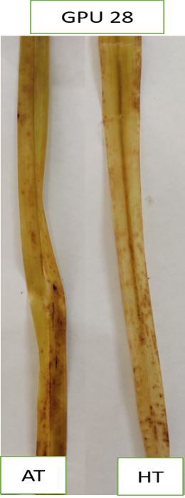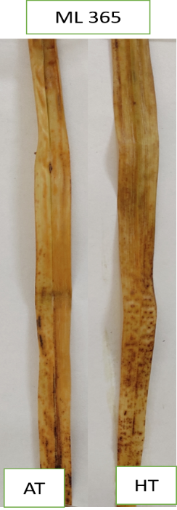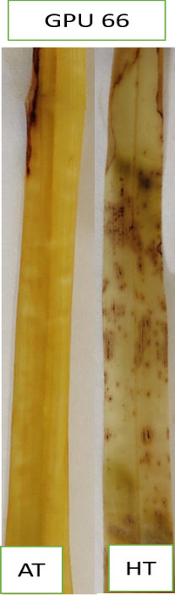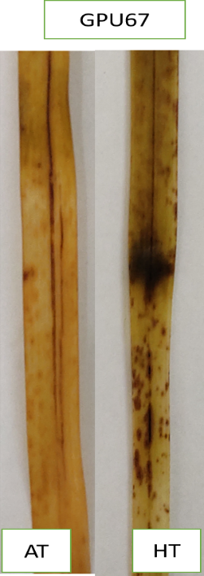

Figure 1: Determination of H₂O₂ by 3,3-Diaminobenzidine staining at flowering stage under high temperature stress condition (AT-ambient temperature, HT-high temperature)

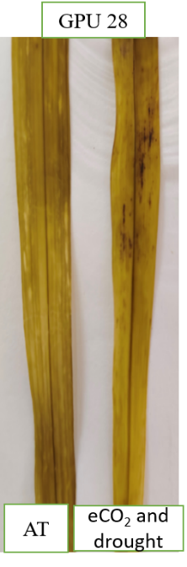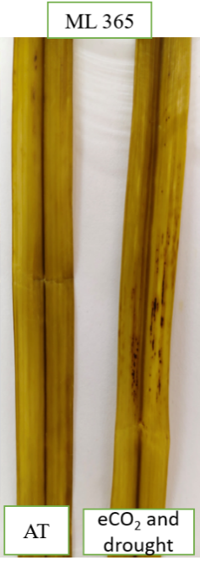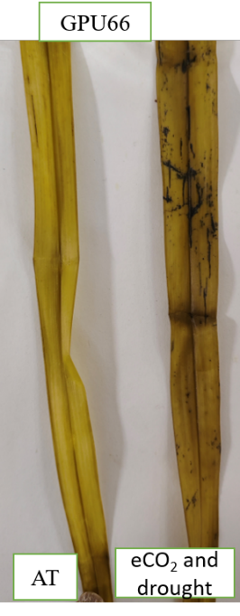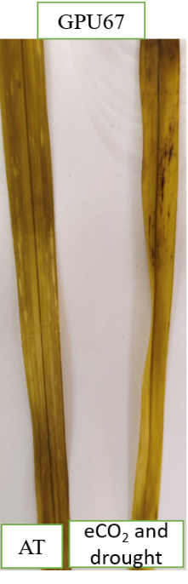
Figure 2: Determination of H₂O₂ by 3,3-Diaminobenzidine staining at flowering stage under elevated CO₂ and drought stress interaction (AT-ambient condition)

Total antioxidants (U/mg protein)
Genotypes | Ambient | HT | % change | Genotypes | Ambient | Elevated CO₂ and drought | % change
GPU28 | 1.32±0.01^{d} | 6.65±0.11ª | 403.78 | GPU28 | 3.05±0.06 | 7.88±0.52 | 158.36
ML365 | 1.25±0.01^{d} | 7.78±0.01^{b} | 522.40 | ML365 | 3.01±0.07 | 7.77±1.04 | 158.14
GPU66 | 1.21±0.11e | 5.65±0.06^{c} | 366.94 | GPU66 | 1.75±0.63 | 6.30±0.10 | 260.00
GPU67 | 1.35±0.01^{d} | 5.55±0.03^{c} | 311.11 | GPU67 | 2.02±0.06 | 5.66±0.32 | 180.19
Mean | 1.28±0.09^{b} | 6.40±0.60ª |  |  | 2.46±0.66^{b} | 6.90±1.12ª
 | SEm± | CD (0.05) |  |  | SEm± | CD (0.05)
Genotype | 0.02 | 0.07 |  |  | 0.19 | 0.59
Treatment | 0.02 | 0.05 |  |  | 0.14 | 0.42
GxT | 0.03 | 0.1 |  |  | 0.28 | NS
Table 1: Effect of high temperature stress and elevated CO₂ x drought interaction on total antioxidants of finger millet genotypes at flowering stage

4. Conclusion

The DAB staining pattern and total antioxidant response together illustrate the contrasting oxidative stress dynamics in finger millet genotypes under high temperature and elevated CO₂ x drought interaction. The intense brown coloration under high temperature stress confirmed higher H₂O₂ accumulation, indicating severe oxidative stress, whereas lighter staining under elevated CO₂ and drought reflected an alleviation of ROS production. The corresponding increase in total antioxidant content across treatments suggested an adaptive enhancement of the antioxidant defence system to mitigate oxidative damage. Among the genotypes, GPU 28 and ML 365 displayed greater antioxidant induction and lower DAB staining intensity, signifying superior oxidative stress management and higher tolerance potential. In contrast, GPU 67 exhibited pronounced H₂O₂ accumulation with comparatively weaker antioxidant enhancement, indicating limited detoxification efficiency under heat stress. The integration of these results clearly establishes a genotype-dependent balance between ROS generation and antioxidant defence, emphasizing the central role of antioxidant metabolism in stress adaptation. This relationship is further substantiated by the subsequent analysis of enzymatic antioxidants such as catalase, peroxidase, and superoxide dismutase, which provide deeper insights into the biochemical mechanisms conferring stress resilience in finger millet. Variation exhibited by selected genotypes in terms of oxidative stress levels experienced and activation of antioxidant mechanism clearly shows the possibilities for selection of genotypes suitable for different stress situation which are unique features of the changing climate.

COMPETING INTERESTS
Authors have declared that no competing interests exist
DISCLAIMER (ARTIFICIAL INTELLIGENCE
Author(s) hereby declares that NO generative AI technologies such as Large Language Models (ChatGPT, COPILOT, etc) and text-to-image generators have been used during writing or editing of this manuscript.

REFERENCES

- AbdElgawad H, Farfan-Vignolo ER, De Vos D, Asard H. Elevated CO₂ mitigates drought and temperature-induced oxidative stress differently in grasses and legumes. Plant Sci. 2015;231:1–10.
- Abdelhakim LOA, Palma CFF, Zhou R, Wollenweber B, Ottosen CO, Rosenqvist E. The effect of individual and combined drought and heat stress under elevated CO₂ on physiological responses in spring wheat genotypes. Plant Physiol Biochem. 2021;162:301–14.
- Apel K, Hirt H. Reactive oxygen species: metabolism, oxidative stress, and signal transduction. Annu Rev Plant Biol. 2004;55(1):373–99.
- Bao L, Liu J, Mao T, Zhao L, Wang D, Zhai Y. Nanobiotechnology-mediated regulation of reactive oxygen species homeostasis under heat and drought stress in plants. Front Plant Sci. 2024;15:1418515.
- Bhattacharya A. Plant growth hormones in plants under low-temperature stress: A review. Physiol Process Plants Low Temp Stress. 2022;517–627.
- Benzie IF, Strain JJ. Ferric reducing/antioxidant power assay: direct measure of total antioxidant activity of biological fluids and modified version for simultaneous measurement of total antioxidant power and ascorbic acid concentration. Methods Enzymol. 1999;299:15–27.
- Bhatt D, Negi M, Sharma P, Saxena SC, Dobriyal AK, Arora S. Responses to drought-induced oxidative stress in five finger millet varieties differing in their geographical distribution. Physiol Mol Biol Plants. 2011;17(4):347–53.
- Cannea FB, Padiglia A. Antioxidant defense systems in plants: mechanisms, regulation, and biotechnological strategies for enhanced oxidative stress tolerance. Life. 2025;15(8):1293.
- Chavan SG, Duursma RA, Tausz M, Ghannoum O. Elevated CO₂ alleviates the negative impact of heat stress on wheat physiology but not on grain yield. J Exp Bot. 2019;70(21):6447–59.
- Debnath T, Dhar DG, Dhar P. Molecular switches in plant stress adaptation. Mol Biol Rep. 2024;51(1):20.
- Doddaghatta H, Raviteja M, Dhanoji MM, Kuchanur PH, Amaregouda A, Patil RP, Shrikanth B. Standardisation of Temperature Induction Response Technique: A promising method for screening of maize genotypes for thermotolerance at seed level. Int J Plant Soil Sci. 2023;35(22):791–800.
- Hasanuzzaman M, Fujita M. Plant oxidative stress: biology, physiology and mitigation. Plants. 2022;11(9):1185.
- Hill AJ, Shlisel M. Impact of elevated atmospheric and intercellular CO₂ on plant defense mechanisms. J Crop Health. 2024;76(6):1307–15.
- Kadam NN, Xiao G, Melgar RJ, Bahuguna RN, Quinones C, Tamilselvan A, Prasad PVV, Jagadish KS. Agronomic and physiological responses to high temperature, drought, and elevated CO₂ interactions in cereals. Adv Agron. 2014;127:111–56.
- Kumar D, Yusuf MA, Singh P, Sardar M, Sarin NB. Histochemical detection of superoxide and H₂O₂ accumulation in Brassica juncea seedlings. Bio Protoc. 2014;4(8):e1108.
- Mishra N, Jiang C, Chen L, Paul A, Chatterjee A, Shen G. Achieving abiotic stress tolerance in plants through antioxidative defense mechanisms. Front Plant Sci. 2023;14:1110622.
- Mondal S, Karmakar S, Panda D, Pramanik K, Bose B, Singhal RK. Crucial plant processes under heat stress and tolerance through heat shock proteins. Plant Stress. 2023;10:100227.
- Rakkammal K, Pandian S, Ramesh M. Physiological and biochemical response of finger millet plants exposed to arsenic and nickel stress. Plant Stress. 2024;11:100389.
- Ramel F, Sulmon C, Bogard M, Couée I, Gouesbet G. Differential patterns of reactive oxygen species and antioxidative mechanisms during atrazine injury and sucrose-induced tolerance in Arabidopsis thaliana plantlets. BMC Plant Biol. 2009;9:28.
- Rao MJ, Duan M, Ikram M, Zheng B. ROS regulation and antioxidant responses in plants under air pollution: molecular signaling, metabolic adaptation, and biotechnological solutions. Antioxidants. 2025;14(8):907.
- Shanker AK, Gunnapaneni D, Bhanu D, Vanaja M, Lakshmi NJ, Yadav SK, Prabhakar M, Singh VK. Elevated CO₂ and water stress in combination in plants: brothers in arms or partners in crime? Biol (Basel). 2022;11(9):1330.
- Singh A, Mehta S, Yadav S, Nagar G, Ghosh R, Roy A, Chakraborty A, Singh IK. How to cope with the challenges of environmental stresses in the era of global climate change: an update on ROS stave off in plants. Int J Mol Sci. 2022;23(4):1995.
- Singh S, Viswanath A, Chakraborty A, Narayanan N, Malipatil R, Jacob J, Mittal S, Satyavathi TC, Thirunavukkarasu N. Identification of key genes and molecular pathways regulating heat stress tolerance in pearl millet to sustain productivity in challenging ecologies. Front Plant Sci. 2024;15:1443681.
- Srikanth K, Binodh A, Rajasekaran R, Senthil A, Boopathi NM, Francia E. Exploring morpho-physiological, biochemical, and molecular strategies of finger millet (Eleusine coracana) for drought stress tolerance: a review. Crop Pasture Sci. 2025;76(4).
- Vanaja M, Sarkar B, Sathish P, Jyothi Lakshmi N, Yadav SK, Mohan C, Sushma A, Yashavanth BS, Srinivasa Rao M, Prabhakar M, Singh VK. Elevated CO₂ ameliorates the high temperature stress effects on physio-biochemical, growth, yield traits of maize hybrids. Sci Rep. 2024;14(1):2928.
- Xu Z, Jiang Y, Zhou G. Response and adaptation of photosynthesis, respiration, and antioxidant systems to elevated CO₂ with environmental stress in plants. Front Plant Sci. 2015;6:701.
- Zhang X, Duan Y, Xing Q, Duan R, Shen J, Zong Y, Zhang D, Shi X, Li P, Hao X. Elevated CO₂ concentration enhances drought tolerance by mitigating oxidative stress and enhancing carbon assimilation in foxtail millet (Setaria italica). J Agron Crop Sci. 2024;210(6):e12778.

