Analysis of Greenhouse Gas Emissions (GHG) from Livestock Sector in India with Special Reference to Dairy in Telangana
Abstract
Livestock constitutes an integral component of Indian agriculture sector and also a major source of Greenhouse Gas Emissions(GHG) emissions. The study uses both secondary and primary data for estimating GHG emissions from livestock in India and also Telangana. The study presents spatial and temporal variations in GHG emissions from different age-groups, different Breeds, different censuses starting from 2003 to 2019 based on IPCC guidelines. The study mainly focus on estimating the carbon footprints of milk by applying Cool Farm Tool(CFT) in dairy setup especially in Telangana. The total GHGs emission from Indian livestock in 2019 is estimated at 281.23 Mt in terms of CO2 equivalent emissions. Although the Indian livestock contributes substantially to the methane budget, the per capita emission is only 24.89 kgCH4/animal/year. Top 10 states account for 75.47 % of missions from India. Telangana accounted for 3.46% of missions from India with a total of 9.73 Mt in 2019. Village level study indicated that per farm emissions were 173.56 kg CO2 equiv. per year and it is 3.91 kg CO2 per kg FPCM of buffalo milk produced. Co2 per kg FPCM is more in cow milk compared to buffalo milk due to inefficiency management practices resulting in low milk yield. Though the livestock is cause and sufferer of methane and GHG emissions, reducing animal numbers as a part of mitigation strategy will affect the food and nutritional security of people. Instead of reducing livestock numbers, mitigation strategies should aim at management practices like feeding, manure management, using methane reducing chemicals and also inventing new methods to converting methane to useful products which will help in achieving SDG goals relevant to livestock.. Reducing greenhouse gas emissions will not only address. The findings can inform policymakers and researchers in developing sustainable practices and strategies for emission reduction in the livestock sector to achieve SDG goals.
Keywords: Greenhouse Gas Emissions, Livestock, India, Dairy, Milk, FPCM, Enteric Fermentation, Cool Farm Tool, Carbon foot print, Telangana

Introduction
The increasing concentration of greenhouse gases (GHG) in the atmosphere, leading to the phenomenon of climate change, has been a major concern of whole world today. Climate change has multiple effects on crops, livestock, human life, health, ecosystem and it also has economic impact by destroying natural resources, and infrastructure. According to IPCC 6th Assessment Report, Global surface temperature was 1.09 °C higher in 2011–2020 than 1850–1900 and 3.3 to 3.6 billion people are highly vulnerable to climate change. There are two sources of GHG emissions i.e Natural and Anthropogenic activities. Anthropogenic emissions are more potent and needs to be reduced. The major greenhouse gases are Carbon dioxide(CO₂₎,Methane(CH4)and Nitrous Oxide(N₂0),Hydro fluorocarbons(HFCs), Per fluorocarbons (PFCs), Nitroflourides, Sulphur Hexaflouride (SF6). Out of these CO_{2,} CH4, N₂0 are important GHGs contributing to global warming and climate change. Concentration of GHG in the atmosphere is rapidly increasing due to anthropogenic activities leading to global warming. For every 1000 GtCO2 emitted by human activity, global surface temperature rises by 0.45°C.
In 2019, net global GHG emissions were estimated as 58.9 GtCO2-eq(IPCC 6th AR). Out this major share (34%) is accounted by the Energy sector followed by Industry (24%), AFOLU (22%). Transport and Building accounts for 15%& 6% respectively (Fig 1).

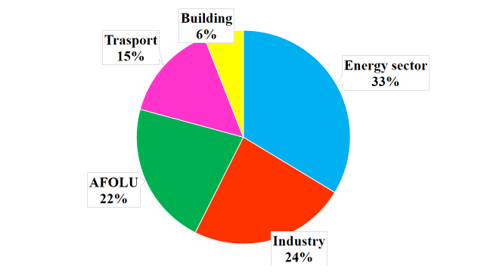
Fig1: Share of different sectors to net global GHG emissions(Source: IPCC 6th AR)
Note: AFOLU- Agriculture, Forestry and Other Land Use
Activity wise Agriculture accounts for 10%–12% of anthropogenic greenhouse gas (GHG) emissions and 70% of land use change emissions. Category wise Carbon dioxide accounts for 60% and Methane accounts for 20% of anthropogenic emissions. Though methane accounts for less share than carbon dioxide, it has perceived greater concern over these years as it is 25 times more potent in trapping atmospheric heat than the CO2. Within Agriculture sector livestock is contributing to a major share of methane, emitted mainly by two processes i.e. enteric fermentation and manure management. Further, the quantity of methane generation also depends on the type of animal, kind and amount of consumed feed and the nature of waste management.
GHG Emissions associated with livestock production systems
The livestock has been an integral part of mankind for ensuring nutritional and as well as livelihood security. It accounts for 40 percent of global agricultural GDP and employs 1.1 billion people and it is key to food security providing 33% of global protein consumption and 13 percent of kcal consumed(FAO). In India also, livestock continues to be a major means of livelihood in the rural India assuring nutrition, income and employment. India is largest producer of animal husbandry with highest livestock population, milk and meat production.
Increasing global human population is putting pressure on agriculture for the supply of more and more food. Shrinking of arable land due to industrialization is leading to intensification of agriculture and livestock production causing increased emissions of greenhouse gases and in turn global warming. Emissions have emerged as an essential issue affecting sustainable development of livestock. Being the largest producer of animal husbandry, mitigating livestock emissions has become a scientific issue to India to balance between economic development and climate change. Dual pressure of increasing livestock production and reducing emissions will facilitate quality of livestock production. Hence assessing the livestock emissions is important to adopt quantifiable mitigation strategies. It is in this context this study has been taken up to estimate GHG emissions from livestock sector in India with special emphasis on Telangana as it accounts for 6% of total livestock population and 8.46% of India’s GVA from livestock sector @ current prices in 2020 21.
As per the reports of GHG Platform India, 2022 Livestock emissions accounts for 7.5 per cent of total economy-wide emissions and ~63 per cent of gross emissions of AFOLU sector and 48 per cent of methane emissions in India. Within the livestock sub-sector, 88 per cent of emissions were due to bovines. Enteric fermentation was by far the dominant contributor to GHG emissions accounting for around 90 per cent of the sub-sector emissions.
Regarding Telangana, studies on quantification of GHG emissions in general and livestock sector in particular is lacking.
With this backdrop of importance of Livestock to food security and also major source of methane emissions, this study attempted to analyse the GHG emissions from the livestock sector in India with special emphasis on dairy in Telangana as the bovines are the major contributors of emissions from livestock sector and Telangana is a major livestock producer in India.
Methodology
Main objective of the study is to quantify the emissions from livestock sector in India with special emphasis on Dairying. For this secondary data on livestock population in different census was collected from DAHD of GOI, and IPCC standard values were used to estimate the emissions in different census periods. The study also estimated GHG emissions from Dairy in India with emphasis on Telangana by using both secondary and primary data. Primary data was used to quantify the ground level emissions from dairy. For this 5 villages in Rangareddy district of Telangana were selected and the data was collected from 120 farmers through the schedules. Popular tools available worldwide for assessment of livestock emissions are Global Livestock Environmental Assessment Model (GLEAM), The LEAP (Livestock Environmental Assessment and Performance), Cool Farm Tool(CFT). This study used Dairy module of Cool Farm Tool(CFT) to estimate the carbon foot prints of milk.
Results & Discussion
Temporal Trend in GHG Emissions from Livestock sector in India
The study analysed the temporal and spatial trend in GHG emissions in India by using the livestock inventory from 2003-2019. It also estimated the category wise emissions i.e breed wise, age wise, sex wise. Total emissions comprising both livestock and poultry was estimated as 247.4 Mt in 2003 which has increased to 281.23 Mt /yr in 2019(Fig 2). Among these total emissions, Livestock contributes for around 99.77 to 99.85% whereas poultry contribution is only 0.15 to 0.23%. The results are in conformity with findings of study by Abha Chhabra, 2013 who reported 247.4 Mt of GHG emissions in 2003 and found the major contribution by livestock.
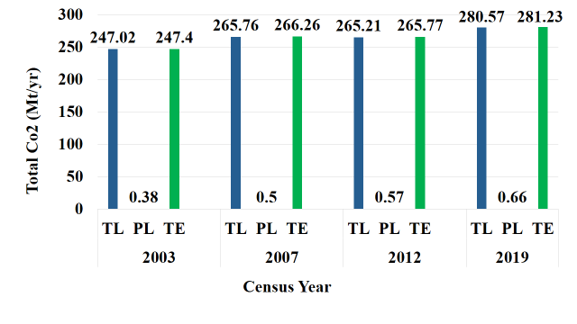Fig 2: GHG Emissions from Livestock sector in different censuses
Note: TL: Total Livestock emissions, PL: Poultry Emissions, TE: Total Emissions including both livestock and poultry
Census wise results showed that total emissions increased by 7.62% in 2007 but decreased by 0.18% in 2012 and again increased in 2019 by 5.82%
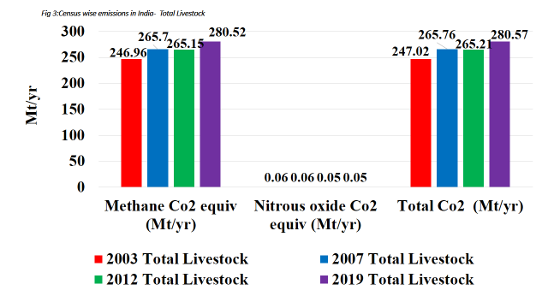Fig 3:Census wise emissions in India- Total Livestock
Livestock emissions have increased from 247.02 Mt to 280.57 Mt /yr of Co2 equivalent during 2003 to 2019(Fig 3) and the poultry emissions increased from 0.38 Mt to 0.66 Mt /yr of Co2 equivalent(Fig 4). With in the livestock emissions methane accounts for major share where as nitrous oxide emissions accounts for largest share in case of Poultry.
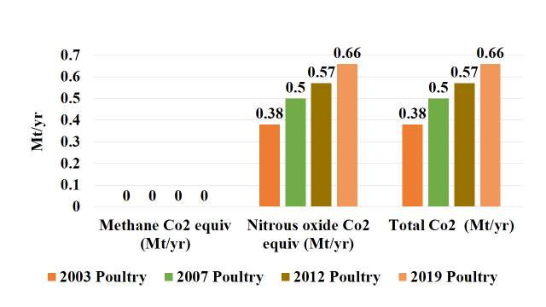Fig 4: Census wise emissions-India- Poultry
During 2019 livestock census, Methane emissions were highest in cattle (139.79 Mt/yr) followed by Buffalo (119.68Mt/yr) (Fig 5).

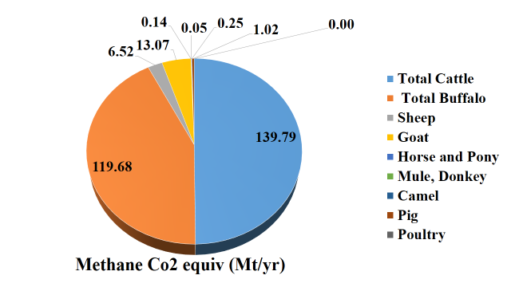Fig 5: Methane Emissions in India – 2019
Nitrous oxide emissions were highest in poultry that accounts for 0.66 Mt/yr Co2 equivalent where as it is negligible in livestock(Fig 6)
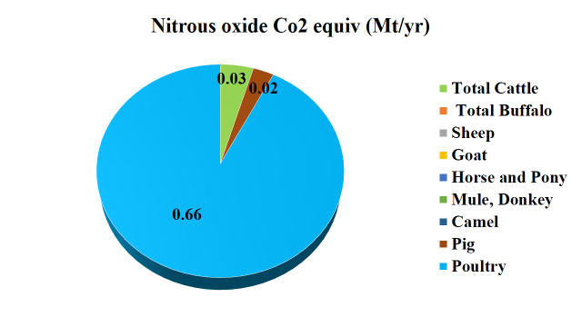Fig 6:Nitrous oxide Emissions in India- 2019
Category wise analysis showed that for both cattle and buffalo, dairy animals account for major share and non-dairy animals account for only smaller quantities(Fig 7). Small share of non-dairy may be attributed to decreasing no of non-dairy animals.While dairy animals share is increasing non-dairy animals share is decreasing for both cattle and buffalo during 2003-2019. Region wise emissions showed that rural areas contribute for major share

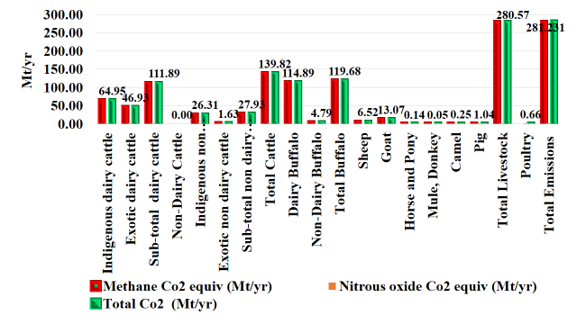
Fig 7: Source wise Emissions-2019

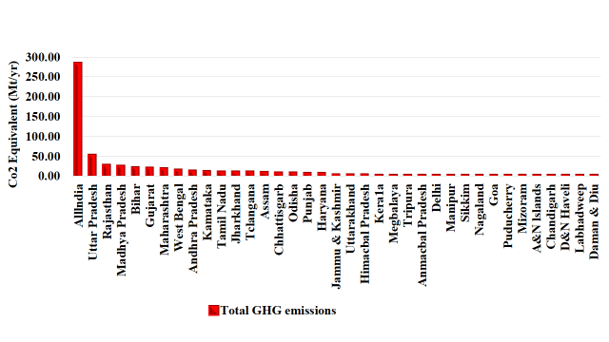
Fig 8: State wise GHG Emissions -Co2 Equivalent (Mt/Year)
Uttar Pradesh, Rajasthan, Madhya Pradesh, Bihar, Gujarat are the major emission producing states (Fig 8) which accounts for 18.36%, 9.73%, 8.8%, 7.46%, 6.98% in total Co2 emissions. Some states showed increasing trend in emissions while others showed decreasing trend
GHG emissions from Dairy in India- A case study of Telangana region
In this study GHG emissions from Milk is estimated. For this purpose Telangana is purposefully selected as it accounts for 6% of total livestock population and contributes for 8.46% of India’s GVA from livestock sector @ current prices in 2020-21. It is the second state next to West Bengal in terms of the growth of livestock population. 10.5% of state’s GVA comes from livestock as against 9% GVA from crop sector.
Temporal trend in GHG Emissions in Telangana
Methane Emissions have increased from 9.5 to 9.67 while total emissions increased from 9.55 to 9.73mt between 2012 to 2019(Fig 9). In terms of percentages it is 1.77 %, 15.68% for methane and nitrous oxide while the overall increase is 1.85%.

Table 1 :Census wise livestock emissions in Telangana
 |  | Enteric Fermentation (Tg/yr) | Manure Management (Tg/Yr) | total (Tg/Yr) | Nitrous oxide(Gg/year) | Methane Co2 equiv (Mt)/yr | Nitrous oxide Co2 equiv (Mt)/yr | Total Co2 (Mt)/yr
2012 | Total Livestock _2012 | 0.42 | 0.04 | 0.45 | 0.00 | 9.50 | 0.00 | 9.50
 | Poultry _2012 | 0.00 | 0.00 | 0.00 | 0.17 | 0.00 | 0.05 | 0.05
 | Total emissions _2012 | 0.00 | 0.04 | 0.45 | 0.18 | 9.50 | 0.05 | 9.55
2019 | Total Livestock _2019 | 0.42 | 0.04 | 0.46 | 0.00 | 9.67 | 0.00 | 9.67
 | Poultry _2019 | 0.00 | 0.00 | 0.00 | 0.20 | 0.00 | 0.06 | 0.06
 | Total emissions _2019 | 0.00 | 0.04 | 0.46 | 0.20 | 9.67 | 0.06 | 9.73
Source: Author’s calculations based on livestock population data from DAHD,GOI.

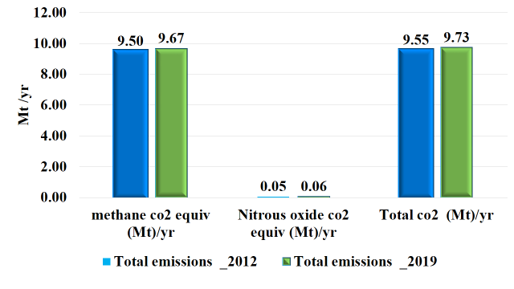
Fig 9: Census wise GHG emissions in Telangana

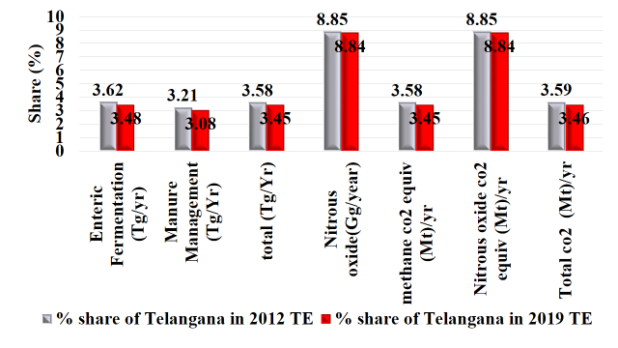
Fig 10: Share (%) of Telangana in India
Telangana accounted for 8.85% of N₂0 emissions of India(Fig 10) due to poultry industry while methane emissions are only 3.45%. Overall it has accounted for 3.46% of total GHG emissions of India.
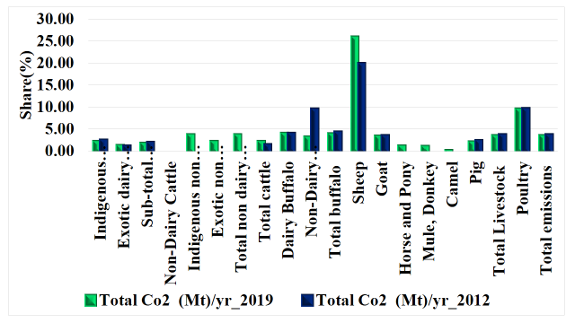Fig 11: Category wise Share of Telangana in GHG emissions (%) from India
It is not surprising that Telangana accounted for about 25% of total sheep emissions from India (Fig 11)followed by poultry(9.5%) which can be attributed to its share in sheep population in India.

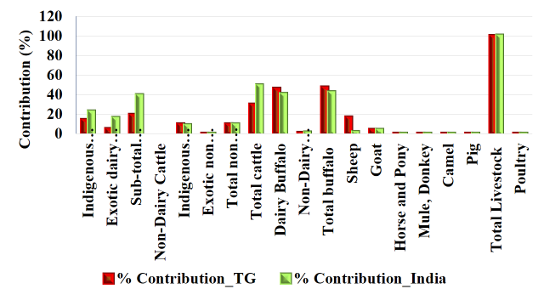Fig 12: GHG Emissions India Vs Telangana -2019
Comparison of Telangana with India showed a different picture. Within the total livestock, Cattle is the major source of emissions in India accounting for 49.72% of total emissions as the cattle is the major dairy animal in India where as in Telangana, buffalo is major source of emissions with 47.48% of share in total emissions from Telanagana (Fig 12) as buffalo is the major dairy animal in Telangana.
GHG Emissions from Dairy in Telangana villages
Using the Cool Farm Tool (CFT), we have estimated the emissions from dairy in Telangana i.e carbon foot prints of both Buffalo milk and Cow milk is estimated for different categories of farmers using the primary data. The study was conducted in 5 villages with 120 farmers having 2356 buffaloes and 344 cattle.
Socio economic characters indicate that majority of farmers is middle aged having more than 10 years experience in dairying and belongs to single caste/community. Majority of them are landless and hence the fodder comes from rented land. Dairying is the major source of occupation which is fully financed by themselves. Intensive system of feeding practices is common. Average herd size of surveyed farmers is 24 buffaloes and 5 cattle (including adults, male, kids) i.e buffaloes constitue 83% of herd size where as cattle’s share is only 17%(Table 2).
Table 2: Herd size of farmers in surveyed villages
Category | Buffalo |  |  |  | Cows |  |  |  | Buffalo and Cows | Share(%) in total
Category | Adult female | Adult male | Kids | Total | Adult female | Adult male | Kids | Total | Buffalo and Cows | Buffaloes | Cows
Small | 7 | 1 | 5 | 13 | 3 |  | 2 | 5 | 18 | 72.22 | 27.78
Medium | 15 | 1 | 8 | 24 | 2 |  | 1 | 3 | 27 | 88.89 | 11.11
Large | 33 | 1 | 13 | 47 | 4 |  | 3 | 7 | 54 | 87.04 | 12.96
Pooled | 15 | 1 | 8 | 24 | 3 |  | 2 | 5 | 29 | 82.76 | 17.24
Source: Author’s calculations based on survey data
Table 3: Livestock holdings of different farmers
% of farmers | % of buffaloes
50 | 22
25 | 24
25 | 53
Source: Author’s calculations based on survey data
Majority of them (50%) are small farmers holding only 22% of livestock where as 25% of large farmers hold 53% of livestock(Table 3)
Results of village level study using Cool Farm Tool(CFT)
Total emissions from selected 5 villages was 24528.66 tons out of which buffalo accounts for 22371.28 tons and cattle accounts for only 2157.38 tons.

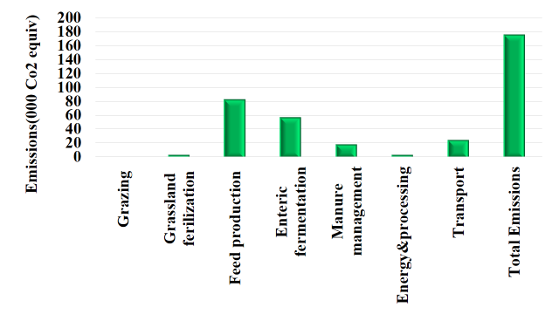Fig 13: Per farm GHG emissions from Buffalo(pooled)
Per farm GHG emissions from Buffalo is 1,73,560 Kg Co2 Equivalent (Fig 13) and emissions per kg FPCM(Fat& Protein Corrected Milk) is 3.91 Kg Co2 Equivalent. The results are synonymous with previous studies (Pirloet al. 2014; Garget al. 2016; Gerber et al. 2013). Feed Emissions accounts for largest share(46.2%) followed by enteric fermentation(31.4%). Large feed emissions is due to inbuilt conversion feature of feed into the farm produced feed in the cool farm tool.
Again with in the feed emissions milk buffaloes¹ accounted for major share(42.9%) due to their heavy feeding compared to other categories(Fig 14). Manure and enteric fermentation also shows similar results. Since there is no extensive feeding system grazing emissions turned out to be zero. Since the dairy module of CFT is designed for Cow milk, the results are seen as milk cows, dry cows instead of milk buffalo, dry buffalo. Using the dairy module we have customized the analysis for buffalo milk

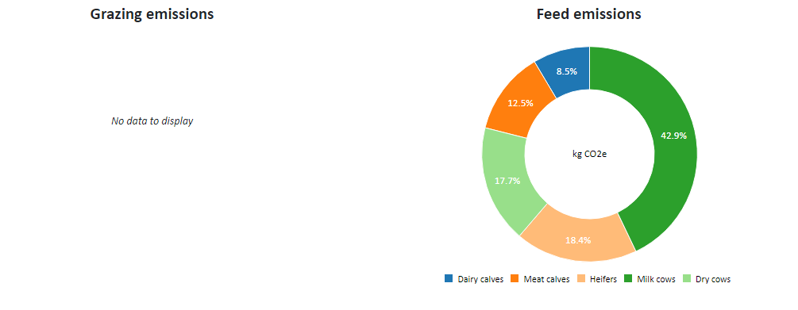

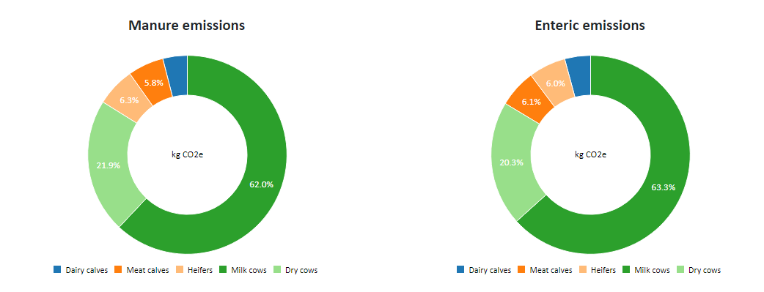
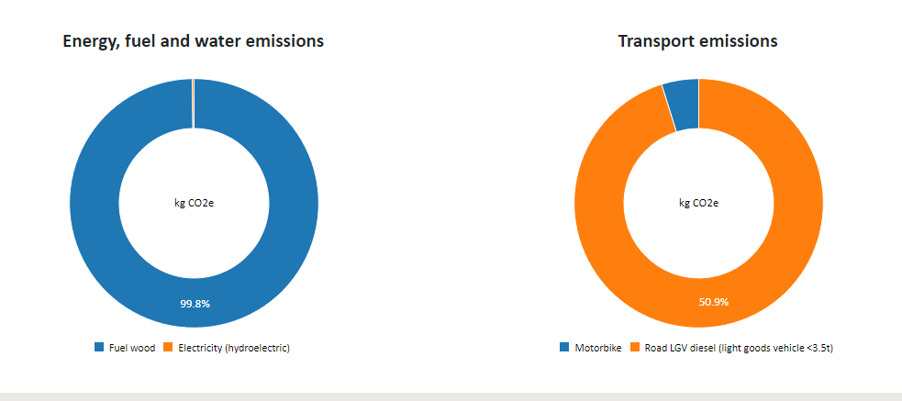
Fig 14: Per farm GHG emissions from Buffalo(pooled)-Category wise
¹Since the dairy module of CFT is designed for Cow milk, the results are seen as milk cows, dry cows instead of milk buffalo, dry buffalo. Using the dairy module we have customized the analysis for buffalo milk

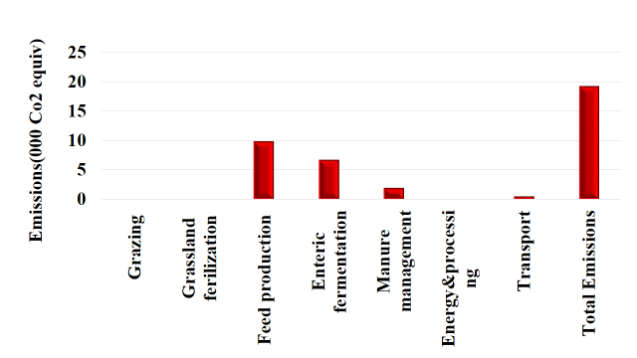
Fig 15: Per farm GHG emissions from Cattle(pooled)
Per farm cattle emissions were 19,250 Kg Co2 Equiv and emissions per kg FPCM is 8.26 Kg Co2 Equiv(Fig 15). Highest emissions per kg FPCM may be attributed to low milk yield.

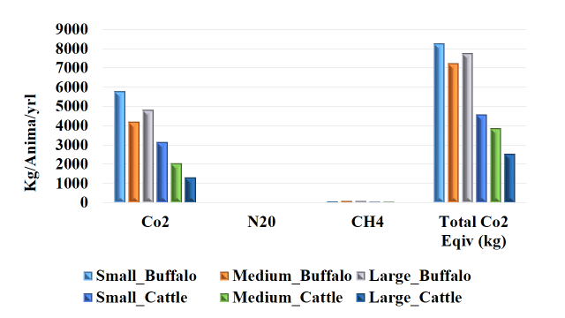
Fig 16: GHG Emissions per animal (Kg)/year
Co2 emissions account for major share in total emissions (Fig16)which can be attributed to feed emissions that range from 58 to 70% with an average of 63.225 for buffalo and this range is 51.5-68% with an average of 59% for cattle.

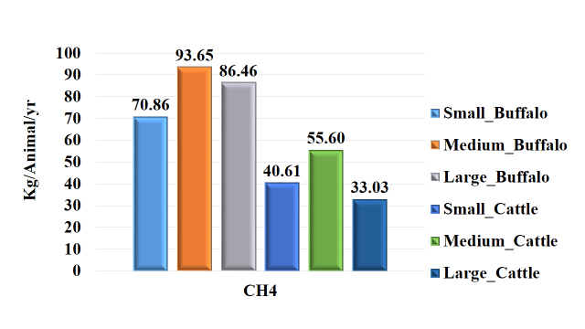Fig 17 :Methane Emissions per animal (Kg)/year
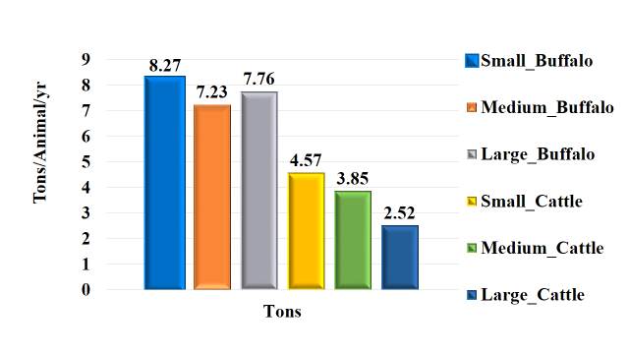Fig 18: GHG Emissions per animal (Tons)
Total GHG emissions decrease with increase in herd size in case of cattle(Fig 18). But in case of buffalo though there is no particular trend it shows that medium farmers are more efficient than large farmers in dairying and hence less emissions than other category farmers.
Overall per animal methane emissions are 83.66 and 43.08 kg/per animal/yr(Fig 17)and the total emissions are 7 .75 & 3.65 tons Co2 equiv for buffalo and cattle respectively.
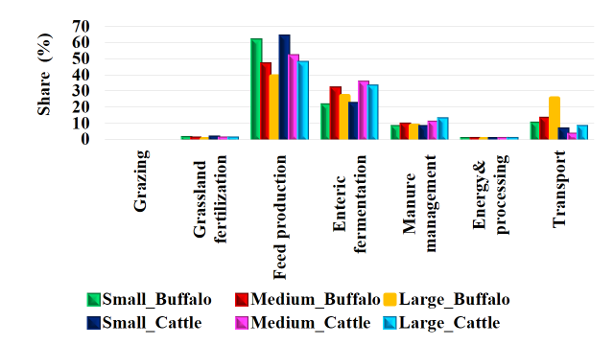
Fig 19: Share of different categories of emissions in total GHG Emissions on different size groups of farms
There is negative relation between Feed emissions and herd size(Fig 19) where as positive relation is noticed in transport emissions and herd size. This suggests to increase the herd size to reduce the total emissions as the feed emissions is the major source of total emissions.

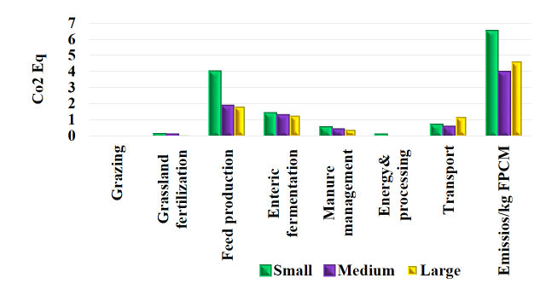Fig 20: Emissions per Kg FPCM (Co2 Eq) of Buffalo milk on different size groups of farms
Emissions Per kg FPCM is highest in small farmers due to low yield of buffalo milk(Fig 20). Emissions Per kg FPCM shows different picture in case of cattle. It is highest for medium farmers (Fig 21) which can be attributed to high enteric fermentation in cattle for medium farmers.

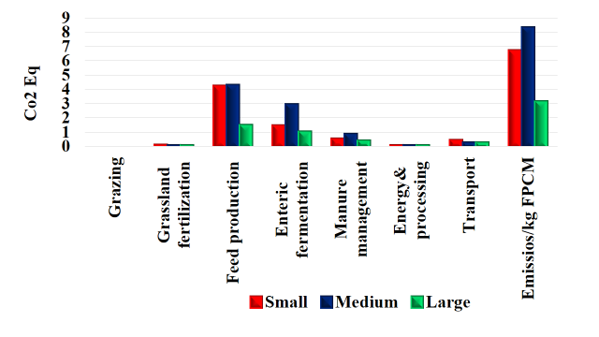
Fig 21: Emissions per Kg FPCM (Co2 Eq) of cow milk on different size groups of farm

Summary and Conclusions
Livestock constitutes an integral component of Indian agriculture sector and also a major source of GHGs emissions. Increase in livestock not only increases production but also associated with the increased emissions. The total GHGs emission from Indian livestock is estimated at 281.23 Mt in terms of CO2 equivalent emissions. Although the Indian livestock contributes substantially to the methane budget, the per capita emission is only 24.89 kgCH4/animal/year. Uttar Pradesh Rajasthan Madhya Pradesh Bihar Gujarat Maharashtra West Bengal Andhra Pradesh Karnataka Tamil Nadu are top 10 states which together account for 75.47 % of emissions from India.
Telangana accounted for 3.46% of missions from India with a total of 9.73 Mt in 2019. Village level study indicated that per farm emissions were 173560 kg CO2 equiv. per year and it is 3.91 kg CO2 per kg FPCM of buffalo milk produced. Co2 per kg FPCM is more in cow milk compared to buffalo milk due to inefficiency management practices resulting in low milk yield. Total emissions from the selected 5 villages was 244528.66 tons Co2 equivalent out of which 45.24% is contributed by feed followed by enteric fermentation(27.44%).
Livestock is both cause and sufferer of GHG emissions. Mitigation strategies like carbon tax will not yield useful result as indicated by the studies. It will have negative impact on food security by increasing malnutrition through increased prices and lower income and accessability. Being the major source for nutrient security and food and livelihood security, reducing animal numbers will not be a right option for mitigation strategy as majority of population is still undernourished. Reducing numbers will further aggravate the problem. Instead of reducing livestock, mitigation strategies should aim at using or converting methane to useful product. Reducing the greenhouses gas emissions by improving feed and manure management practices will help in achieving the SDG 13.Converting methane emissions from manure into biogas which can be converted into electricity and heat will help in achieving the SDG 7. Reducing greenhouse gases not only address climate action goal of SDG but also addresses other goals like Affordable and clean energy. To reduce the emissions first we need to trap and quantify them. So Iot enabled quantification techniques like sensors will help in trapping and quantifying emissions. This will help in traceability also. Hence traceability is important for achieving GHG emission reduction. In a country like India where record keeping is not a practice even for crops achieving traceability and thereby emission target from livestock, We have long way to go.

Disclaimer (Artificial intelligence)
Author(s) hereby declare that NO generative AI technologies such as Large Language Models (ChatGPT, COPILOT, etc.) and text-to-image generators have been used during the writing or editing of this manuscript.

References
- Abha Chhabra. 2013. Greenhouse gas emissions from Indian livestock. Climatic Change 117:329–344. DOI 10.1007/s10584-012-0556-8
- Balhara A K, Varij Nayan A D, Singh K P, Dahiya S S, Inderjeet Singh. 2017. Climate change and buffalo farming in major milk producing states of India – Present status and need for addressing concerns. Indian Journal of Animal Sciences 87 (4): 403–411
- Bhatta R, Malik PK, Sejian V. 2020. Livestock production and climate change: methane and stress amelioration. In: Transfer of Mitigation Technologies for Heat Stress in Farm Animals. Proceedings of Indo-Australian Workshop on Transfer of Mitigation Technologies for Heat Stress in Farm Animals. Sejian V, Chauhan SS, Malik PK, Krishnan G, Bagath M, Kolte AP, Bhatta R (Eds). ICAR-NIANP, Bengaluru, India, 2020, pp 33-43.
- Frank Errickson, KevinKuruc, Jonathan Mcfadden. 2021. Animal-based foods have high social and climate costs. Nature Food 2 : 274–281
- Garg A, Kankal B, Shukla PR. 2011. Methane emissions in India: sub-regional and sectoral trends. Atmospheric Environment 45:4922-4929
- Ganesan Anita L, Rigby M, Mark Lunt F, Robert Parker J, HartmutBoesch N, GouldingTaku U. 2017. Atmospheric observations show accurate reporting and little growth in India’s methane emissions. Nature Communications 8(836)
- IPCC, 2023: Climate Change 2023: Synthesis Report. Contribution of Working Groups I, II and III to the Sixth Assessment Report of the Intergovernmental Panel on Climate Change [Core Writing Team, H. Lee and J. Romero (eds.)]. IPCC, Geneva, Switzerland, 184 pp., doi: 10.59327/IPCC/AR6-9789291691647.
- Mahadeswara Swamy , Sumana Bhattacharya. 2006. Budgeting anthropogenic greenhouse gas emission from Indian livestock using country-specific emission coefficients. Current Science 91(10) :1340-1353
- Pordhiya KI, Gautam. 2023. Comparative carbon footprints of buffalo milk produced at smallholder and organised farms in Hisar district of Haryana, India. Indian Journal of Animal Sciences 93 (4): 389–394. https://doi.org/10.56093/ijans.v93i04.122556
- Patra A K. 2014. Trends and Projected Estimates of GHG Emissions from Indian Livestock in Comparisons with GHG Emissions from World and Developing Countries. Asian-Australasians Journal of Animal Sciences 27(4):592-599
- Shilpi Kumari, Dahiya RP, Naik SN, HiloidhariMoonmoon, Thakur Indu Shekhar, Sharawat Ishaet al. 2016. Projection of methane emissions from livestock through enteric fermentation: A case study from India. Environmental Development. 20:31-44.
- Singhal KK, MohiniMadhu, JhaArvind K, Gupta Prabhat K. 2005. Methane emission estimates from enteric fermentation in Indian livestock: Dry matter intake approach. Current Science 88(1):119-127
- Stefan Frank et al 2017 Environ. Res. Lett. 12 105004
- Thornton P, Steeg van de J, Notenbaert A, Herrero M. 2009. The impacts of climate change on livestock and livestock systems in developing countries: A review of what we know and what we need to know. Agricultural Systems 101(3):113-127
- Upadhyay RC, Singh SV, Kumar A, Gupta SK, Ashutosh. 2007. Impact of climate change on milk production of Murrah buffaloes. Italian Journal of Animal Sciences 6(2):1329-1332.
- https://coolfarm.org/the-tool/
- https://www.fao.org/gleam/en/
- https://www.fao.org/partnerships/leap/en/
- https://www.ghgplatform-india.org/
- https://www.ipcc.ch/report/ar6/syr/downloads/report/IPCC_AR6_SYR_FullVolume.pdf

