Effect of El Niño and La Niña on foodgrain production in Chhattisgarh state
Abstract
The present investigation was carried out to study the effect of El Niño and La Niña events on food grain production during the period of 2001-2023 in Chhattisgarh state. Long term district wise (station wise) daily rainfall data for the period (1960-2023) were collected from the Department of Agricultural Meteorology, College of Agriculture Raipur (Chhattisgarh). El Niño and La-Niña Years and Intensities based on Oceanic Nino Index (ONI) data for the period 1951-2023 were downloaded from the website of Golden gate weather services 2023. (https://ggweather.com/enso/oni.htm). Main objective of carrying out this study is impact assessment of these global phenomena in CG state and developing early warning systems for adaptation and mitigation strategies. The mean and per cent change for both seasonal as well as annual rainfall was calculated for all districts of Chhattisgarh in Excel. Similarly, the per cent change in the area, production and productivity during the weak, moderate, strong and very strong El Niño years as well as weak, moderate and strong La Niña years were calculated using the standard ethodology of departure from normal. Results revealed that generally El Niño and La Niña event occur every 3-4 years. El Niño event is more frequent than La Niña event. Weak El Niño and La Niña events are more frequent than other El Niño and La Niña events, respectively. Result on occurrence & frequency of El-Niño and La-Niña in Chhattisgarh state were analyzed since 1951. The average total foodgrain production and productivity of cereals, pulses and oilseed crops of Chhattisgarh state was found to decrease during El Niño years but no changes in crop acreage was observed. The decrease in total foodgrain production and productivity of crops might be attributed to decreasing S-W monsoon season rainfall caused due to El Niño effect in the region. It is the moderate El Niño category which is found to affect production and productivity of foodgrains adversely in the state. Chhattisgarh state received less than normal annual rainfall in this category and there was negative deviation by about 14 per cent. On an average there was decrease in acreage by about 2 per cent. In this category, production loss has been about 41 per cent and worst affected year was 2002-03 when loss in food grain production was about 54 per cent. Yield loss in moderate El Niño years has been about 27 per cent in the year 2009-10 to 53 per cent in the year 2002-03, both were all India severe drought years. Therefore, it has been inferred from the analysis that during all El-Niño years in the time period of 2001-23, Chhattisgarh state received less than normal annual rainfall and there was negative deviation by about 8 per cent. The mean rainfall during El Niño years was less than that during La Niña and normal years. The production loss effects in cereals, pulses and oilseeds -group was by about 15 per cent while productivity loss has been about 15 per cent but there was no change in acreage. The average total foodgrain production and productivity of cereals, pulses and oilseed crops of Chhattisgarh state was found to increase during La Niña years due to increasing quantity of S-W monsoon season rainfall in the region. Looking into this situation and making use of the available information on these events and studies carried out in Chhattisgarh state, strategic state level plan should be developed for the benefit to farming community.

Key Word -El Niño, La Niña, rainfall and foodgrain production

Introduction
The term El-Niño and La-Niña both have their origin in Spanish language with their respective meanings as “Christ child” and “a little girl”, respectively. The name El-Niño was chosen since as El-Niño events start around December near Christmas. El-Niño refers to a large-scale ocean-atmosphere climate interaction associated with the episodic warming in sea surface temperatures (SST) across the central and east-central Equatorial Pacific. Fishermen from the coast of South America recognized this event with the appearance of unusually warm water in the Pacific Ocean. El Niño is fundamentally a warming of the surface waters of the tropical eastern Pacific Ocean from South America coast to the international date line and normally occurs around Christmas and usually lasts for a few weeks to a few months. Sometimes an extremely warm event can develop that lasts for much longer time periods. In general, it is believed that the El Niño event would result in below normal rainfall during southwest monsoon and loss of foodgrains production of the country. There have been many studies on impact of El Niño events on monsoonal rainfall at national level (Krishnamurthy and Goswami 2000; Pai 2003;Kane 2005). Keshavamurthy (1982) concluded that there was no one to one relationship as El Niño years have not always produced severe droughts. Studies on El Niño and its subsequent implications on rainfall pattern and agricultural production are meager at state and district level.
Earlier also, research has been carried out on this aspect. The El-Niño Southern Oscillation (ENSO), one of the most well-known climate modes, can lead to large-scale climate variability and subsequent crop loss, posing a severe risk to global food security. The study's main goal was to examine the synchronous impacts of ENSO and the probability of simultaneous ENSO–related crop loss on the global yields of major crops and investigate the predictability of finer-scale variation in crop yields based on ENSO-related large-scale climate precursors. Here, using updated crop census data for ∼12,000 political units, the study first investigated the synchronous impact of ENSO on yield variability of major crops (i.e., maize, rice, wheat, and soybean) using Synthetic Analysis and bootstrap method, and then estimated the probability of simultaneous crop loss in the top five crop-producing countries by copula approach. Finally, multiple regression was developed to identify the best forecast model, the corresponding ENSO indices and the lead time for each political unit based on pre-occurred ENSO indices. (Cao et al, 2023)
La Niña is an opposite event of El Niño which is termed as the episodic cooling of ocean SST in the central and east-central equatorial pacific. The fluctuations in SST during El Niño and La Niña events are associated with large fluctuations in air pressure which is termed as Southern Oscillation. The negative phase of the Southern Oscillation occurs during El Niño episodes and refers to the situation when abnormally high air pressure covers Indonesia and the western tropical Pacific and abnormally low air pressure covers the eastern tropical Pacific. In contrast, the positive phase of the Southern Oscillation occurs during La Niña episodes and refers to the situation when abnormally low air pressure covers Indonesia and the western tropical Pacific and abnormally high air pressure covers the eastern tropical Pacific (Anonymous 2014).
Research work on El Niño and La Niña is crucial for understanding, predicting, and mitigating the global impacts of these climate phenomena. They significantly influence global weather patterns affecting ecosystems and economies. Continued research improves forecasting, enabling farming communities and planners to prepare for extreme weather events like droughts, floods, and storms. Studies on El Niño and its subsequent implications on rainfall pattern and agricultural production are meager at state and district level. Victor et al., (1995) and Sudheesh et.al., (2004) studied relationship between El Niño / SST and monsoon rainfall over Andhra Pradesh and Kerala, respectively. Case studies belong to particular state like Andhra Pradesh and Gujarat was conducted on the implications of El Niño episodes on crop production or productivity at district level (Rao et al., 2011 and Patel et. al., 2014). El Niño often linked to weaker monsoons and lower crop yields, especially for summer crops, due to deficit rainfall. Conversely, La Niña typically results in more rainfall and higher crop production. Work on El Niño and La Niña helps predict changes in temperature and rainfall that significantly affect agricultural output. El Niño can cause reduced rainfall and drought, threatening water supplies for irrigation and leading to lower yields for crops like rice and maize. La Niña can bring increased rainfall, which can boost crop productivity but also increase the risk of damaging floods.
The study highlights the significant impact of these phenomena on specific crops like rice, sugarcane, and pulses, and notes that the relationship between the events and crop yields is complex and varies by region (Pandey et al, 2018). The characterization of ENSO events and their impacts on agriculture is difficult to establish because there are several other factors also which have a profound impact on crop production and El Nino is just one of them. Furthermore, the impact of El Niño’s on crop conditions and development is dependent on the sensitivity of the phenological phase of crops during the peak period of influence of the event, since the flowering and grain filling phases of cereal crops are more sensitive to water stress.
In Chhattisgarh rice is grown in around 3.6 lakh ha. Of which about 27% area is under irrigation and the rest of the area is under rainfed condition. The productivity of the rice in Chhattisgarh depends upon rainfall quantum and distribution during the study period. In India, the productivity of rice increased because of augmentation of irrigation facility, development of high yielding varieties and improved management practices. However, in eastern part of India especially in Chhattisgarh this scenario is not realized due to diverse crop growing environments, land situations, physiographic and socio-economic conditions of the farmers (Unjan et al., 2017). In the light of above, the present study has been attempted to find out the effect of El Niño on seasonal and annual rainfall at district level as well as implications of different categories of warm episodes on crop acreage, production and productivity of Chhattisgarh State
Methodology and Data

Rainfall data
Long term district wise (station wise) daily rainfall data for the period (2001-2023) were collected from the Department of Agricultural Meteorology, College of Agriculture Raipur for 27 districts of Chhattisgarh. El Niño and La-Niña Years and Intensities (Based on Oceanic Nino Index (ONI) data for the period 1951-2023 were downloaded from the website of Golden gate weather services 2023. (https://ggweather.com/enso/oni.htm) as described in Table-1

Table 1 El Niño and La Niña Years and Intensities based on Oceanic Niño Index (ONI)*
El Niño (27 years) |  |  |  | La Niña –(25 years)
Weak -11 | Moderate-7 | Strong -6 | Very Strong -3 | Weak -12 | Moderate-6 | Strong -7
1952-53  1953-54  1958-59  1969-70  1976-77  1977-78  1979-80  2004-05  2006-07  2014-15  2018-19 | 1951-52  1963-64  1968-69  1986-87  1994-95  2002-03  2009-10 | 1957-58  1965-66  1972-73  1987-88  1991-92  2023-24 | 1982-83  1997-98  2015-16 | 1954-55  1964-65  1971-72  1974-75  1983-84  1984-85  2001-02  2005-06  2008-09  2016-17  2017-18  2022-23 | 1955-56  1970-71  1995-96  2011-12  2020-21  2021-22 | 1973-74  1975-76  1988-89  1998-99  1999-00  2007-08  2010-11

Ref.:: Jan Null. (2011). El Niño and La Niña Intensities. http://ggweather.com/enso/oni.htm.

Crop data
Long term crop production Data (cereals, pulses and oilseed crops) during 2001-2023 i.e. area, production & productivity (t/ha) of Raipur district and Chhattisgarh state was collected from Directorate of economics and Statistics, Department of Agriculture and farmers Welfare, Ministry of Agriculture and Farmer Welfare, Govt. of India.

Data analysis
Basic statistics of rice area, production and productivity
The mean and per cent change for total food grains area, production and productivity were calculated for all districts of Chhattisgarh in M.S. Excel.

Normal rainfall (Mean)
It is average of long-term rainfall in a region.

Normal rainfall (Mean) =$\frac{Total rainfall of all years}{Number of years}$

ENSO and crop area, production and productivity
The per cent change in the area, production and productivity during the weak, moderate, strong and very strong El Niño years as well as weak, moderate and strong La Niña years were calculated using the below formula. The per cent change was calculated for Chhattisgarh state.
% change (PC) in area = $\frac{\begin{aligned}\text{(Area harvested during El Niño/ La Niña year - } \\ \text{a}\text{verage a}\text{rea harvested )}\end{aligned}}{\text{A}\text{verage a}\text{rea harvested }}$× 100
% change (PC) in production=$\frac{\begin{aligned}\text{(Production during El Niño/ La Niña year -} \\ \text{ average production) }\end{aligned}}{\text{Average production }}$×100
% change (PC) in productivity=$\frac{\begin{aligned}\text{(Productivity during El Niño/ La Niña year -} \\ \text{ average productivity) }\end{aligned}}{\text{Average productivity }}$×100
The per cent change in area harvested under crops, production and productivity of crops was individually calculated for Chhattisgarh state.
Basic statistics of seasonal (S-W monsoon and N-E monsoon) rainfall and annual rainfall
The mean and per cent change for both seasonal as well as annual rainfall was calculated for all districts of Chhattisgarh in EXCEL.
% change for seasonal rainfall= $\frac{\begin{aligned}\text{(Seasonal rainfall during El Niño/ La Niña year -} \\ \text{ average seasonal rainfall) }\end{aligned}}{\text{Average seasonal rainfall }}$×100

% change for annual rainfall=$\frac{\begin{aligned}\text{(Annual rainfall during El Niño/ La Niña year - } \\ \text{average annual rainfall) }\end{aligned}}{\text{Average annual rainfall}}$×100
The per cent change in rainfall (both seasonal and annual) was individually calculated for all the districts of Chhattisgarh state.

Result and discussion
Effect of El Niño on food grain production in Chhattisgarh state:
Effect of different intensities of El Niño (very strong, strong, moderate and weak El Niño years) on crop acreage, production and productivity in Chhattisgarh state have been analysed. Annual variation in total food grains production and its yield over Chhattisgarh state during the period 2001-2023 is furnished in Fig. 1 and Fig. 2, respectively. Chhattisgarh state received less than annual rainfall due to very strong El-Niño and there was negative deviation by about 10 per cent and effect of this event was clearly visible. It can be observed that during the only very strong El Niño year, combined food grain (cereals, pulses and oilseeds) production has declined by about 16 per cent on an average while average yield has declined by about 15 per cent. The effect was also noticed on crop acreage as it has been negatively affected to the tune of 1 per cent (Table 2). There was no strong El Niño year during period 2001 to 2023.
In 2 moderate El Niño years, Chhattisgarh state received less than normal annual rainfall and there was negative deviation by about 14 per cent. On an average,there was decrease in acreage by about 2 per cent. In this category, production loss has been about 41 per cent and worst affected year was 2002-03 when loss in food grain production was about 54 per cent. Yield loss in moderate El Niño years has been about 27 per cent in the year 2009-10 while it was 53 per cent in the year 2002-03, both years were all India severe drought years. Overall decrease in production and productivity was observed to be about 41 and 40 per cent, respectively in spite of decrease in acreage under foodgrain by about 2 per cent only.
During 4 weak El Niño years, Chhattisgarh state received less than normal annual rainfall and there was negative deviation by about 4 per cent. On an average, acreage of food grains has increased by about 1 per cent while production has declined by about 2 per cent. Yield was affected to the tune of3 per cent in this category. In the year 2004-05, production was affected by about 27 per cent and yield was affected by about 28 per cent and increase in acreage was about 2 per cent. In the year 2006-07 and 2018-19, there was no change in the acreage.
Therefore, it has been inferred from the analysis that during all El-Niño years in the time period of 2001-23, Chhattisgarh state received less than normal annual rainfall and there was negative deviation by about 8 per cent. The production loss effects in cereals, pulses and oilseeds -group was by about 15 per cent while productivity loss has been about 15 per cent but there was no change in acreage.

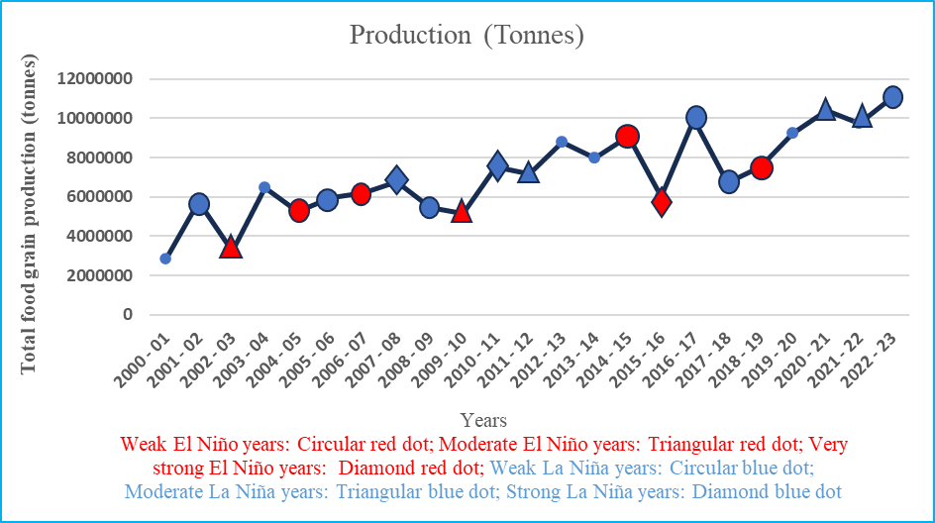
Fig. 1 Variation in total foodgrains production during 2001-2023 in Chhattisgarh state
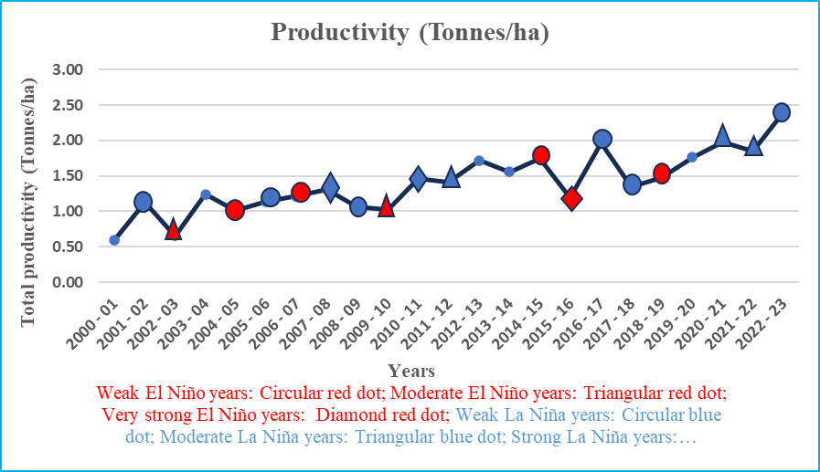
Fig. 2 Variation in total foodgrains productivity during 2001-2023 in Chhattisgarh state

Table 2 Area, production and productivity of food grains production in Chhattisgarh state (2001-2023) during El Niño years of different intensities (very strong, moderate and weak)
Year | Annual rainfall (mm) | % change | Area ('ha) | % change compared to average area during normal years | Production ('tonnes) | % change compared to average production during normal years | Productivity (t/ha) | % change compared to average yield during normal years
Very strong El Niño years
2015 - 2016 | 1107 | -10 | 5053037 | -1 | 6030248 | -16 | 1.19 | -15
AVG | 1107 | -10 | 5053037 | -1 | 6030248 | -16 | 1.19 | -15
Moderate El Niño years
2002 - 2003 | 1061 | -14 | 4972733 | -2 | 3262731 | -54 | 0.66 | -53
2009 - 2010 | 1061 | -14 | 5024061 | -1 | 5149290 | -28 | 1.02 | -27
AVG | 1061 | -14 | 4998397 | -2 | 4206011 | -41 | 0.84 | -40
Weak El Niño years
2004 - 2005 | 1156 | -6 | 5187538 | 2 | 5245984 | -27 | 1.01 | -28
2006 - 2007 | 1177 | -5 | 5103149 | 0 | 6197876 | -13 | 1.21 | -14
2014 - 2015 | 1211 | -2 | 5197231 | 2 | 9093679 | 27 | 1.75 | 25
2018 - 2019 | 1212 | -2 | 5107501 | 0 | 7542521 | 5 | 1.48 | 6
AVG | 1189 | -4 | 5148855 | 1 | 7020015 | -2 | 1.36 | -3
All El Niño years
2002 - 2003 | 1061 | -14 | 4972733 | -2 | 3262731 | -54 | 0.66 | -53
2004 - 2005 | 1156 | -6 | 5187538 | 2 | 5245984 | -27 | 1.01 | -28
2006 - 2007 | 1177 | -5 | 5103149 | 0 | 6197876 | -13 | 1.21 | -14
2009 - 2010 | 1061 | -14 | 5024061 | -1 | 5149290 | -28 | 1.02 | -27
2014 - 2015 | 1211 | -2 | 5197231 | 2 | 9093679 | 27 | 1.75 | 25
2015 - 2016 | 1107 | -10 | 5053037 | -1 | 6030248 | -16 | 1.19 | -15
2018 - 2019 | 1212 | -2 | 5107501 | 0 | 7542521 | 5 | 1.48 | 6
AVG | 1141 | -8 | 5092179 | 0 | 6074618 | -15 | 1.19 | -15
Average Rainfall - 1234 (mm), Average area -5100024(‘ha),Average production - 7150209 (‘tonnes), Average productivity -1.40 (t/ha)

Effect of La Niña on food grain production

Annual variation in total food grain production and its yield over Chhattisgarh state during the period 2001-2023 has been analyzed and is furnished in Fig. 1 and Fig. 2, respectively. Chhattisgarh state received less than the normal annual rainfall and there was negative deviation by about 2 per cent observed in strong La Niña years. It can be observed that during the 2 strong La Niña years, combined food grain (cereals, pulses and oilseeds) production has not changed while average yield has decreased by about 1 per cent. The effect was also noticed on crop acreage as it has increased by 1 per cent (Table 3).

Table 3 Area, production and productivity of food grains production in Chhattisgarh state (2001-2023) during La Niña years of different intensities (strong, moderate and weak)
Year | Annual rainfall (mm) | % change | Area ('ha) | % change compared to average area during normal years | Production ('tonnes) | % change compared to average production during normal years | Productivity (t/ha) | % change compared to average yield during normal years
Strong La Niña years
2007 - 2008 | 1220 | -1 | 5207650 | 2 | 6793456 | -5 | 1.3 | -7
2010 - 2011 | 1186 | -4 | 5123253 | 0 | 7514152 | 5 | 1.47 | 5
AVG | 1203 | -2 | 5165452 | 1 | 7153804 | 0 | 1.39 | -1
Moderate La Niña years
2011 - 2012 | 1250 | 1 | 5113530 | 0 | 7194141 | 1 | 1.41 | 1
2020 - 2021 | 1505 | 22 | 5244041 | 3 | 10407175 | 46 | 1.98 | 41
2021 - 2022 | 1268 | 3 | 5275370 | 3 | 9766223 | 37 | 1.85 | 32
AVG | 1341 | 9 | 5210980 | 2 | 9122513 | 28 | 1.75 | 25
Weak La Niña Years
2000 - 2001 | 1241 | 1 | 4822057 | -5 | 2860757 | -60 | 0.59 | -58
2005 - 2006 | 1235 | 0 | 5244575 | 3 | 5963455 | -17 | 1.14 | -19
2008 - 2009 | 1098 | -11 | 5147501 | 1 | 5466095 | -24 | 1.06 | -24
2016 - 2017 | 1259 | 2 | 5059544 | -1 | 9963825 | 39 | 1.97 | 41
2017 - 2018 | 1140 | -8 | 4994998 | -2 | 6743666 | -6 | 1.35 | -4
2022 - 2023 | 1454 | 18 | 4620232 | -9 | 11040175 | 54 | 2.39 | 70
AVG | 1238 | 0 | 4981485 | -2 | 7006329 | -2 | 1.42 | 1
All La Niña years
2000 - 2001 | 1241 | 1 | 4822057 | -5 | 2860757 | -60 | 0.59 | -58
2005 - 2006 | 1235 | 0 | 5244575 | 3 | 5963455 | -17 | 1.14 | -19
2007 - 2008 | 1220 | -1 | 5207650 | 2 | 6793456 | -5 | 1.3 | -7
2008 - 2009 | 1098 | -11 | 5147501 | 1 | 5466095 | -24 | 1.06 | -24
2010 - 2011 | 1186 | -4 | 5123253 | 0 | 7514152 | 5 | 1.47 | 5
2011 - 2012 | 1250 | 1 | 5113530 | 0 | 7194141 | 1 | 1.41 | 1
2016 - 2017 | 1259 | 2 | 5059544 | -1 | 9963825 | 39 | 1.97 | 41
2017 - 2018 | 1140 | -8 | 4994998 | -2 | 6743666 | -6 | 1.35 | -4
2020 - 2021 | 1505 | 22 | 5244041 | 3 | 10407175 | 46 | 1.98 | 41
2021 - 2022 | 1268 | 3 | 5275370 | 3 | 9766223 | 37 | 1.85 | 32
2022 - 2023 | 1454 | 18 | 4620232 | -9 | 11040175 | 54 | 2.39 | 70
AVG | 1260 | 2 | 5077523 | 0 | 7610284 | 6 | 1.50 | 7
Average Rainfall - 1234 (mm), Average area - 5100024 (‘ha), Average production - 7150209 (‘tonnes), Average productivity - 1.40 (t/ha).
During moderate La Niña years, Chhattisgarh state received more than the normal annual rainfall and there was positive deviation by about 9 per cent and positive effect was clearly visible. It can be observed that during the 3 moderate La Niña years, total food grain production has increased by about 28 per cent on an average over Chhattisgarh state while average yield has also increased by about 25 per cent. The effect was also noticed on crop acreage as it has been positively affected to the tune of 2 per cent.

In 6 weak La Niña years,no change in annual rainfall was observed. On an average acreage of food grains has decreased by about 2 per cent while production has declined by about 2 per cent. Yield was positively affected to the tune of 1 per cent in this category. In 2022-23, production was positively affected by about 54 per cent and yield was affected by about 70 per cent and loss in acreage was about 9 per cent.

Therefore, it was inferred from the analysis that for overall all La Niña events, Chhattisgarh state received more than normal annual rainfall and there was positive deviation by about 2 per cent. There has been no change in acreage in La Niña years and production increase in cereals, pulses and oilseeds group was by about 6 per cent while productivity increase has been about 7 per cent.
Similarly, Selvaraju (2003) attempted to examine the impact of ENSO on Indian food grain and oilseed production for the period from 1950-1999 and concluded that during the warm ENSO phase (El Niño years), the total food grain production frequently decreased (12 out of 13 years) by 1 to 15 per cent. In 10 out of 13 cold ENSO phase (La Niña years), the total food grain production increased from normal. The ENSO impact on rice production was highest among individual crops. The average drop in rice (Kharif season crop) production during a warm ENSO phase year was 3.4 million tonnes (7%).
Conclusion
Analysis on repercussions of El Niño effects in Chhattisgarh state’s foodgrains production and productivity indicated significant results since 2001. In the 2002-03, production was affected by 54 per cent and productivity was affected by 53 per cent and loss in acreage was about 2 per cent. In the 2009-10, production was affected by 28 per cent and productivity was affected by 27 per cent and loss in acreage was about 1 per cent. The foodgrains production and productivity was affected by 15 per cent each during El Niño years as compared to average value. The effects were opposite in La Niña events, foodgrains production and productivity increased by 6 and 7 per cent, respectively as compared to average value and there is no significant change in crop acreage in both events. . Looking into this situation and making use of the available information on these events and studies carried out in Chhattisgarh state, strategic state level plan should be developed for the welfare of farming community.

COMPETING INTERESTS DISCLAIMER:

Authors have declared that they have no known competing financial interests OR non-financial interests OR personal relationships that could have appeared to influence the work reported in this paper.

Author(s) hereby declare that NO generative AI technologies such as Large Language Models (ChatGPT, COPILOT, etc.) and text-to-image generators have been used during the writing or editing of this manuscript.

References:

Anonymous (2014). El Niño/southern oscillation. Geneva: World Meteorological Organization (WMO).
Cao, J., Zhang, Z., Tao, F., Chen, Y., Luo, X., & Xie, J. (2023). Forecasting global crop yields based on El Nino Southern Oscillation early signals. Agricultural Systems, 205, 103564.
Jan Null. (2023). El Niño and La Niña Intensities. http://ggweather.com/enso/oni.htm.

Kane, R.P. (2005). Unstable ENSO Relationship with Indian regional rainfall, Int. J. Climatol, 26(6): 771-783.
Keshavamurthy, R.N. (1982). Response of the Atmosphere to Sea Surface Temperature Anomalies over the Equatorial Pacific and the Teleconnections of the Southern Oscillation. J. Atmos. Sci., 39:1241-1259.
Krishnamurthy, V. and Goswami, B.N. (2000). Indian Monsoon–ENSO Relationship on Inter decadal Timescale. J. Climate, 13(3) : 579-595.

Pai, D.S. (2003). Teleconnections of Indian summer monsoon with global surface air temperature anomalies. Mausam 54: 407-418.

Pandey, V., Misra, A. K., & Yadav, S. B. (2018). Impact of El-Nino and La-Nina on Indian climate and crop production. In Climate change and agriculture in India: Impact and adaptation (pp. 11-20). Cham: Springer International Publishing
Patel, H. R., Lunagaria, M. M., Pandey, V., Sharma, P. K., Rao, B. B. and Rao, V. U. M. (2014). “El Niño episodes and agricultural productivity in Gujarat” Techn. Report No. 01/2014-15. Department of Agril Meteorology, AAU, Anand, Gujarat.
Rao, V.U.M., A.V.M. Subba Rao, B, Bapuji Rao, B.V. Ramana Rao, C. Sravani and B. Venkateswarlu. (2011). El Niño effect on climatic variability and crop production, a case study for Andhra Pradesh. Research Bulletin no. 2/2011, CRIDA, Hyderabad, 36.
Sudheesh, M.V., Rao, G.S.L.H.V.P. and Manikandan, N. (2004). Effect of El-Niño on the rainfall pattern of Kerala. Proceedings of the Indian Environmental Congress Thriuvanathapuram, 81-84.

Selvaraju, R. (2003). Impact of El Niño-southern oscillation on Indian food grain production. International Journal of Climatology, 23(2): 187–206.

Sudheesh, M.V., Rao, G.S.L.H.V.P. and Manikandan, N. (2004).Effect of El-Nino on the rainfall pattern of Kerala.Proceedings of the Indian Environmental Congress2004. December 16-18, 2004. Thriuvanathapuram. pp.81-84
Unjan, Deepika, A.S.R.A.S. Sastri, N. Manikandan, R. Singh and Uttam Diwan. 2017. Rainfall analysis for suitability of rainfed rice Cultivation in Chhattisgarh State during Pre and Post Global Warming Period. Int. .J. Curr. Microbiol. App. Sci. 6(6): 338-350. https://doi.org/10.20546/ijcmas.2017.606.040
Victor, U.S., Srivastava, N.N., Subba Rao, A.V.M. and Ramana Rao. B.V. (1995). El Niño’s effect on southwest monsoon rainfall in Andhra Pradesh, India Drought Network News University of Nebraska, Lincoln. USA.

