Mangrove Forests in a Changing World: Distribution, Change, Drivers, and Climate Relevance

Abstract
Mangrove forests are critical coastal ecosystems distributed across tropical and subtropical intertidal zones, forming a unique interface between land and sea. Although they occupy a relatively small global area, their ecological, socio-economic, and climatic significance is disproportionately large. This review synthesises current understanding of mangrove distribution, ecological roles, drivers of change and conservation strategies, drawing on recent datasets, case studies, and projections. Mangroves stabilise coastlines, reduce erosion, act as nursery grounds for fish and crustaceans, and support coastal livelihoods through fisheries, timber, and cultural practices. They are also among the most carbon-dense ecosystems, with mean carbon stocks exceeding 1,000 Mg C ha⁻¹, most of which is stored in soils. Their role in blue carbon sequestration and storage elevates them as a priority in climate mitigation strategies. Yet, over the past century, mangroves have faced extensive degradation, particularly in Asia, driven by aquaculture, agricultural expansion, fuelwood harvesting, and urban encroachment. Between 1996 and 2020, global mangrove cover declined by approximately 3.4 %, with losses concentrated in Southeast Asia. Recent evidence, however, indicates stabilisation and localised recovery, attributed to improved policy frameworks, restoration efforts, and recognition of their ecosystem services. Remote sensing datasets such as the Global Mangrove Watch (GMW v3.0) and the High-resolution Global Mangrove Forest map (HGMF 2020) have provided robust quantification of global and regional mangrove dynamics. These datasets reveal stark regional disparities, with Southeast Asia continuing to experience the highest losses, while South America and Oceania remain comparatively stable. Climate change presents an additional existential threat, with nearly 70% of Indo-Pacific mangroves projected to lack the vertical accretion capacity required to keep pace with sea-level rise. Nonetheless, evidence from successful restoration initiatives highlights the resilience of mangroves when hydrological processes are maintained. It concludes by outlining pathways for future research and management that integrate monitoring technologies, ecological engineering, community co-management, and policy frameworks to secure mangroves’ role in climate adaptation and mitigation.
Keywords: Mangrove forests; Blue carbon; Coastal ecosystems; Climate resilience; Sea-level rise; Restoration
Introduction
Mangroves are globally significant ecosystems occupying the intertidal zones of tropical and subtropical coastlines across more than 120 countries (Duke et al., 2007). These systems are characterised by specialised halophytic tree and shrub species such as Rhizophora, Avicennia, Bruguiera, and Sonneratia that exhibit remarkable physiological adaptations to saline and waterlogged soils. Features such as aerial roots that enable oxygen exchange, salt-excreting glands that regulate osmotic balance, and viviparous propagules that aid dispersal highlight their evolutionary resilience (Alongi, 2014). Soil salinity directly influences mangrove distribution, physiological processes, productivity, and seedling establishment and is critical to predict future mangrove distribution under changing climatic conditions (Sunkur et al., 2025).
The ecological importance of mangroves lies in their multifunctionality. They stabilise shorelines by binding sediments, thereby reducing erosion and mitigating storm surge impacts (Jariah et al., 2024). The protective role of mangroves has been demonstrated empirically, such as during the 1999 Odisha super-cyclone in India, where mortality rates were significantly lower in villages protected by intact mangroves compared to those lacking this buffer (Das & Vincent, 2009). Hydrodynamic studies confirm that mangroves reduce wave energy by approximately 50% within the first 100 m of forest, with efficiency depending on species composition and root density (Mazda et al., 2006; Horstman et al., 2014). Beyond protection, mangroves function as nurseries for juvenile fish, shrimp, and molluscs, sustaining coastal fisheries and ensuring food security for millions of people (Nagelkerken et al., 2008).
Equally important are their biogeochemical functions. Mangroves are among the most carbon-rich ecosystems on Earth, with mean ecosystem carbon stocks exceeding 1,000 Mg C ha⁻¹, of which soils account for up to 98% (Donato et al., 2011). Alongi (2014) estimated global mangrove burial of approximately 24 Tg C yr⁻¹, despite mangroves occupying less than 1% of coastal zones. Destruction of these ecosystems results in significant greenhouse gas emissions, with Adame et al. (2021) projecting cumulative losses of 2.4–3.4 Pg CO₂-eq by 2100 if deforestation persists.
Despite their ecological and climatic importance, mangroves have undergone extensive degradation. Coastal mangrove forests are at particular risk of climate change impacts beyond 2 °C warming. Their predominantly tropical and sub-tropical distribution overlaps with areas of the planet that are expected to face some of the worst impacts of climate change (Friess et al., 2022). Between the mid-20th century and the early 2000s, global mangrove cover declined rapidly due to aquaculture expansion, agricultural conversion, and urban development (Hamilton & Casey, 2016; Richards & Friess, 2016). Southeast Asia alone accounted for nearly 30% of global losses during 2000–2012, driven largely by shrimp aquaculture and rice cultivation. However, recent evidence suggests a slowing of losses and localised recovery, coinciding with stronger protection measures, ecological restoration, and improved awareness of their climate role (Thomas et al., 2017; Friess et al., 2022).
The advent of high-resolution remote sensing has revolutionised mangrove monitoring. The Global Mangrove Watch (GMW v3.0) dataset provides long-term global coverage from 1996 to 2020, while the High-resolution Global Mangrove Forest map (HGMF_2020) derived from Sentinel-2 offers unprecedented 10 m resolution (Bunting et al., 2022; Jia et al., 2023). These datasets form the empirical basis for much of our current understanding of global and regional mangrove dynamics.
Global Distribution and Recent Change
Mangroves are distributed unevenly across the tropics, with strong concentrations in Southeast Asia, northern South America, West Africa, and northern Australia. According to GMW v3.0, global mangrove cover declined from 152,604 km² in 1996 to 147,359 km² in 2020, reflecting a 3.4% net loss (Bunting et al., 2022). Losses were most pronounced between 1996 and 2010, when the extent dropped to 140,260 km², coinciding with rapid aquaculture development. However, partial recovery by 2020 demonstrates that stabilisation is possible when policy and ecological conditions are favourable.
The HGMF_2020 dataset corroborates these findings, reporting 145,068 km² in 2020 and emphasising Asia’s dominance, which accounts for 39.2% of global mangroves (Jia et al., 2023). Table 1 summarises global extent across datasets, while Figure 1 depicts the temporal trajectory of loss and recovery. Figure 2 compares extent estimates for 2020 across GMW and HGMF, highlighting the robustness of independent datasets.
Table 1. Global mangrove extent across datasets, 1996–2020
Dataset | Year(s) | Extent (km²) | Notes
GMW v3.0 | 1996 | 152,604 | Global SAR baseline
GMW v3.0 | 2010 | 140,260 | Peak of aquaculture-driven loss
GMW v3.0 | 2020 | 147,359 | Stabilisation and localised recovery
HGMF_2020 | 2020 | 145,068 | Sentinel-2, 10 m resolution

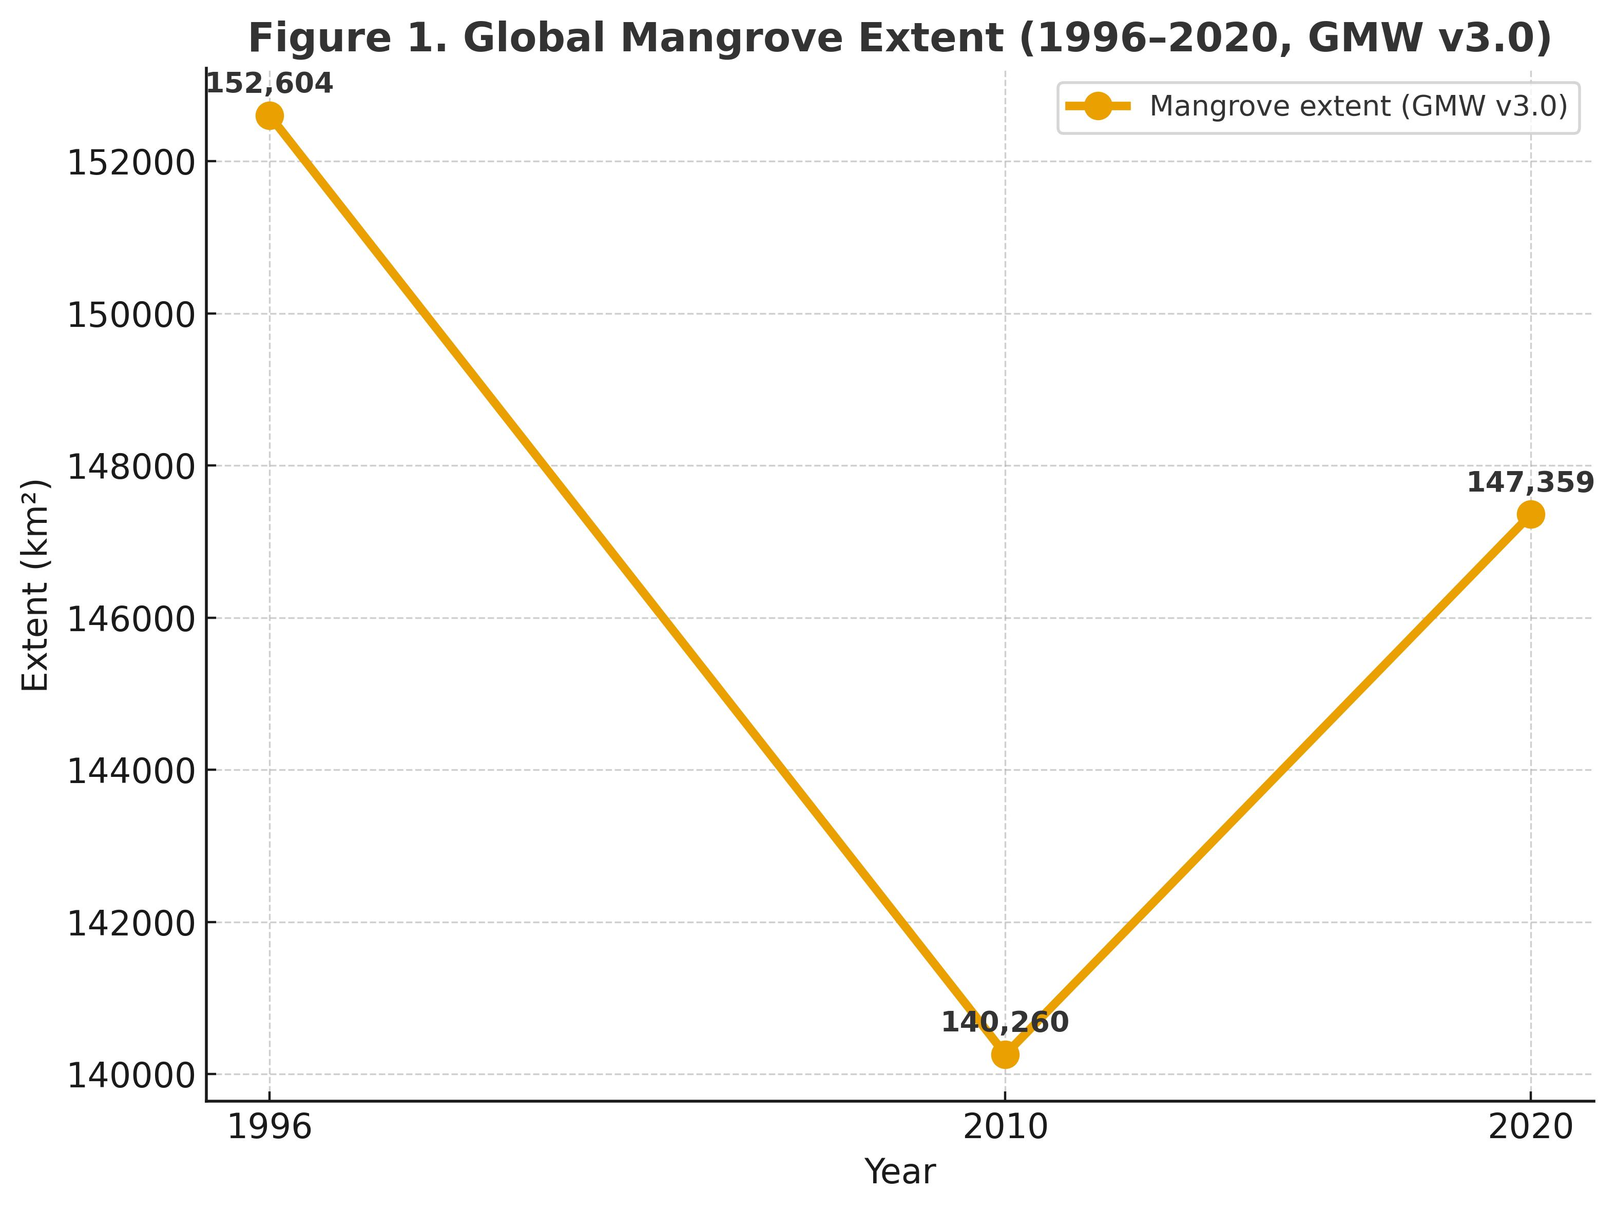
Figure 1. Global mangrove extent (1996–2020) from GMW v3.0.

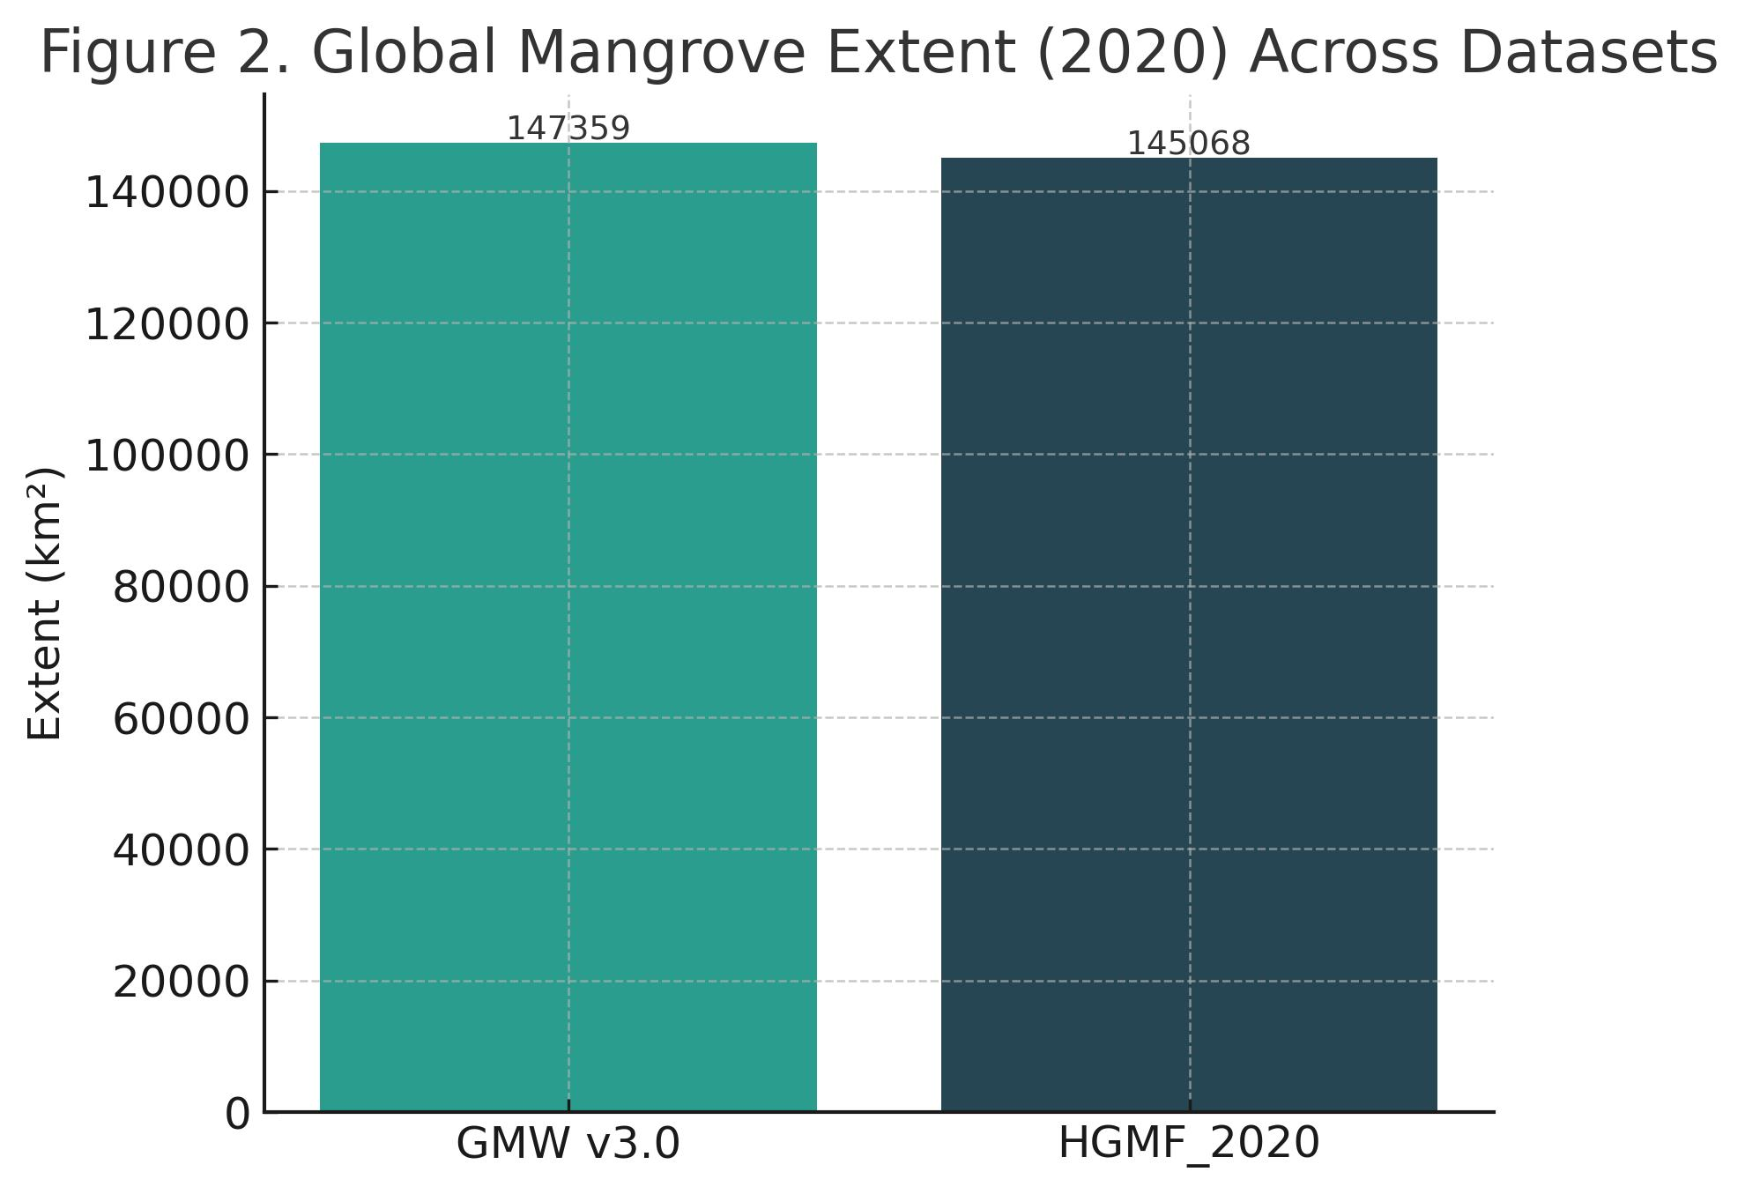
Figure 2. Comparison of global mangrove extent in 2020 across GMW v3.0 and HGMF_2020
Regional Patterns and Top Countries
Regional analyses reveal stark differences in extent, drivers, and trends. Asia is the global epicentre, hosting approximately 39.2% of mangroves, with Indonesia alone contributing ~45,000 km², or one-third of the global total (Jia et al., 2023). Brazil follows with ~13,000 km², concentrated along the Amazon estuary, while Australia supports ~10,000 km² along its northern coast. Nigeria and Mozambique represent Africa’s largest mangrove holders. Figure 3 shows regional contributions, emphasising Asia’s overwhelming dominance.
Losses remain concentrated in Southeast Asia, where aquaculture and rice agriculture continue to drive conversion (Richards and Friess, 2016). By contrast, South America shows relative stability due to high sediment supply in the Amazon delta (Thomas et al., 2017). Africa exhibits localised degradation from fuelwood harvesting, though community-based initiatives have emerged to counteract losses (Ward et al., 2016). Oceania demonstrates general stability but episodic dieback linked to extreme drought, as documented in northern Australia (Duke et al., 2017).
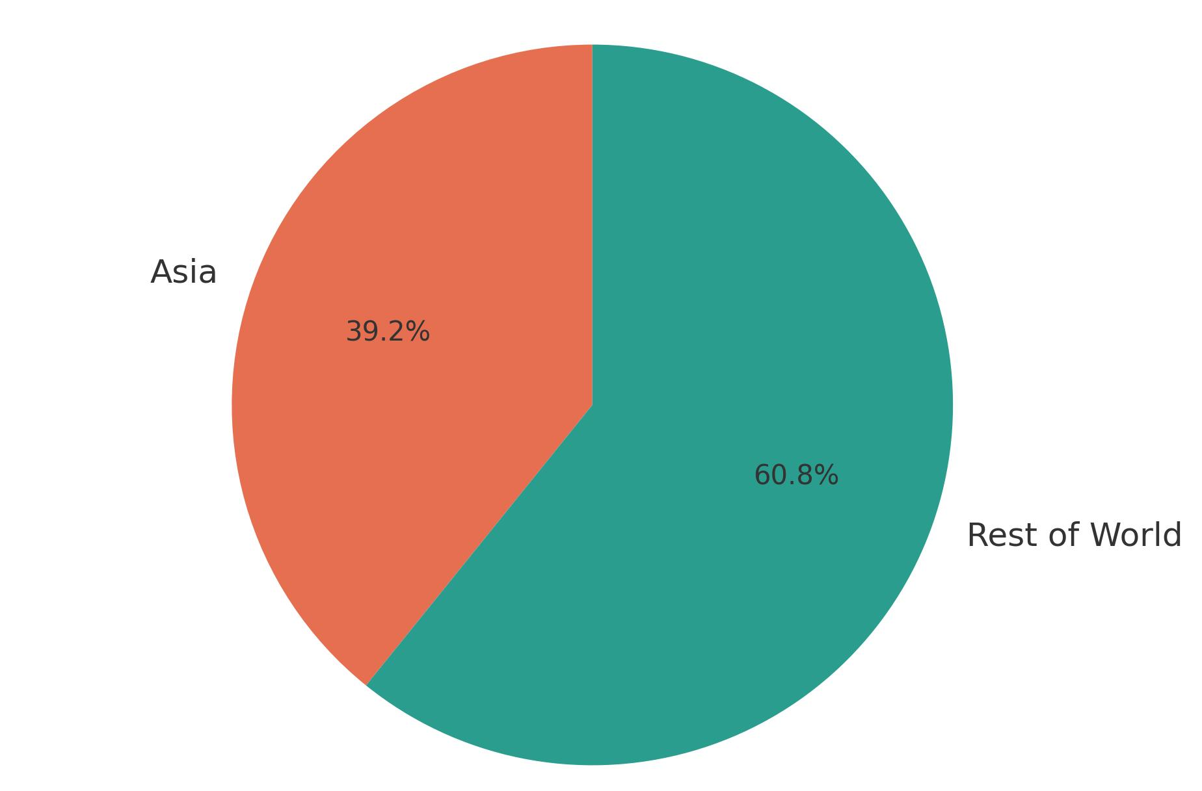
Figure 3. Regional share of mangroves in 2020 (Asia vs. the rest of the world) based on HGMF_2020.
Ecosystem Services and Blue Carbon
Mangroves provide multiple ecosystem services that are disproportionately large relative to their area. In terms of carbon storage, Donato et al. (2011) quantified mean stocks at 1,023 Mg C ha⁻¹, with soils contributing 49–98%. Alongi (2014) estimated annual global burial rates of 24 Tg C, underscoring their global role in carbon cycling. Table 2 summarises key carbon values, while Figure 4 illustrates mean carbon stocks across sites.
Table 2. Mangrove carbon storage and sequestration
Parameter | Value | Source
Mean carbon stock | 1,023 Mg C ha⁻¹ | Donato et al., 2011
Soil contribution | 49–98% | Donato et al., 2011
Global burial rate | 24 Tg C yr⁻¹ | Alongi, 2014
Projected emissions by 2100 | 2.4–3.4 Pg CO₂-eq | Adame et al., 2021

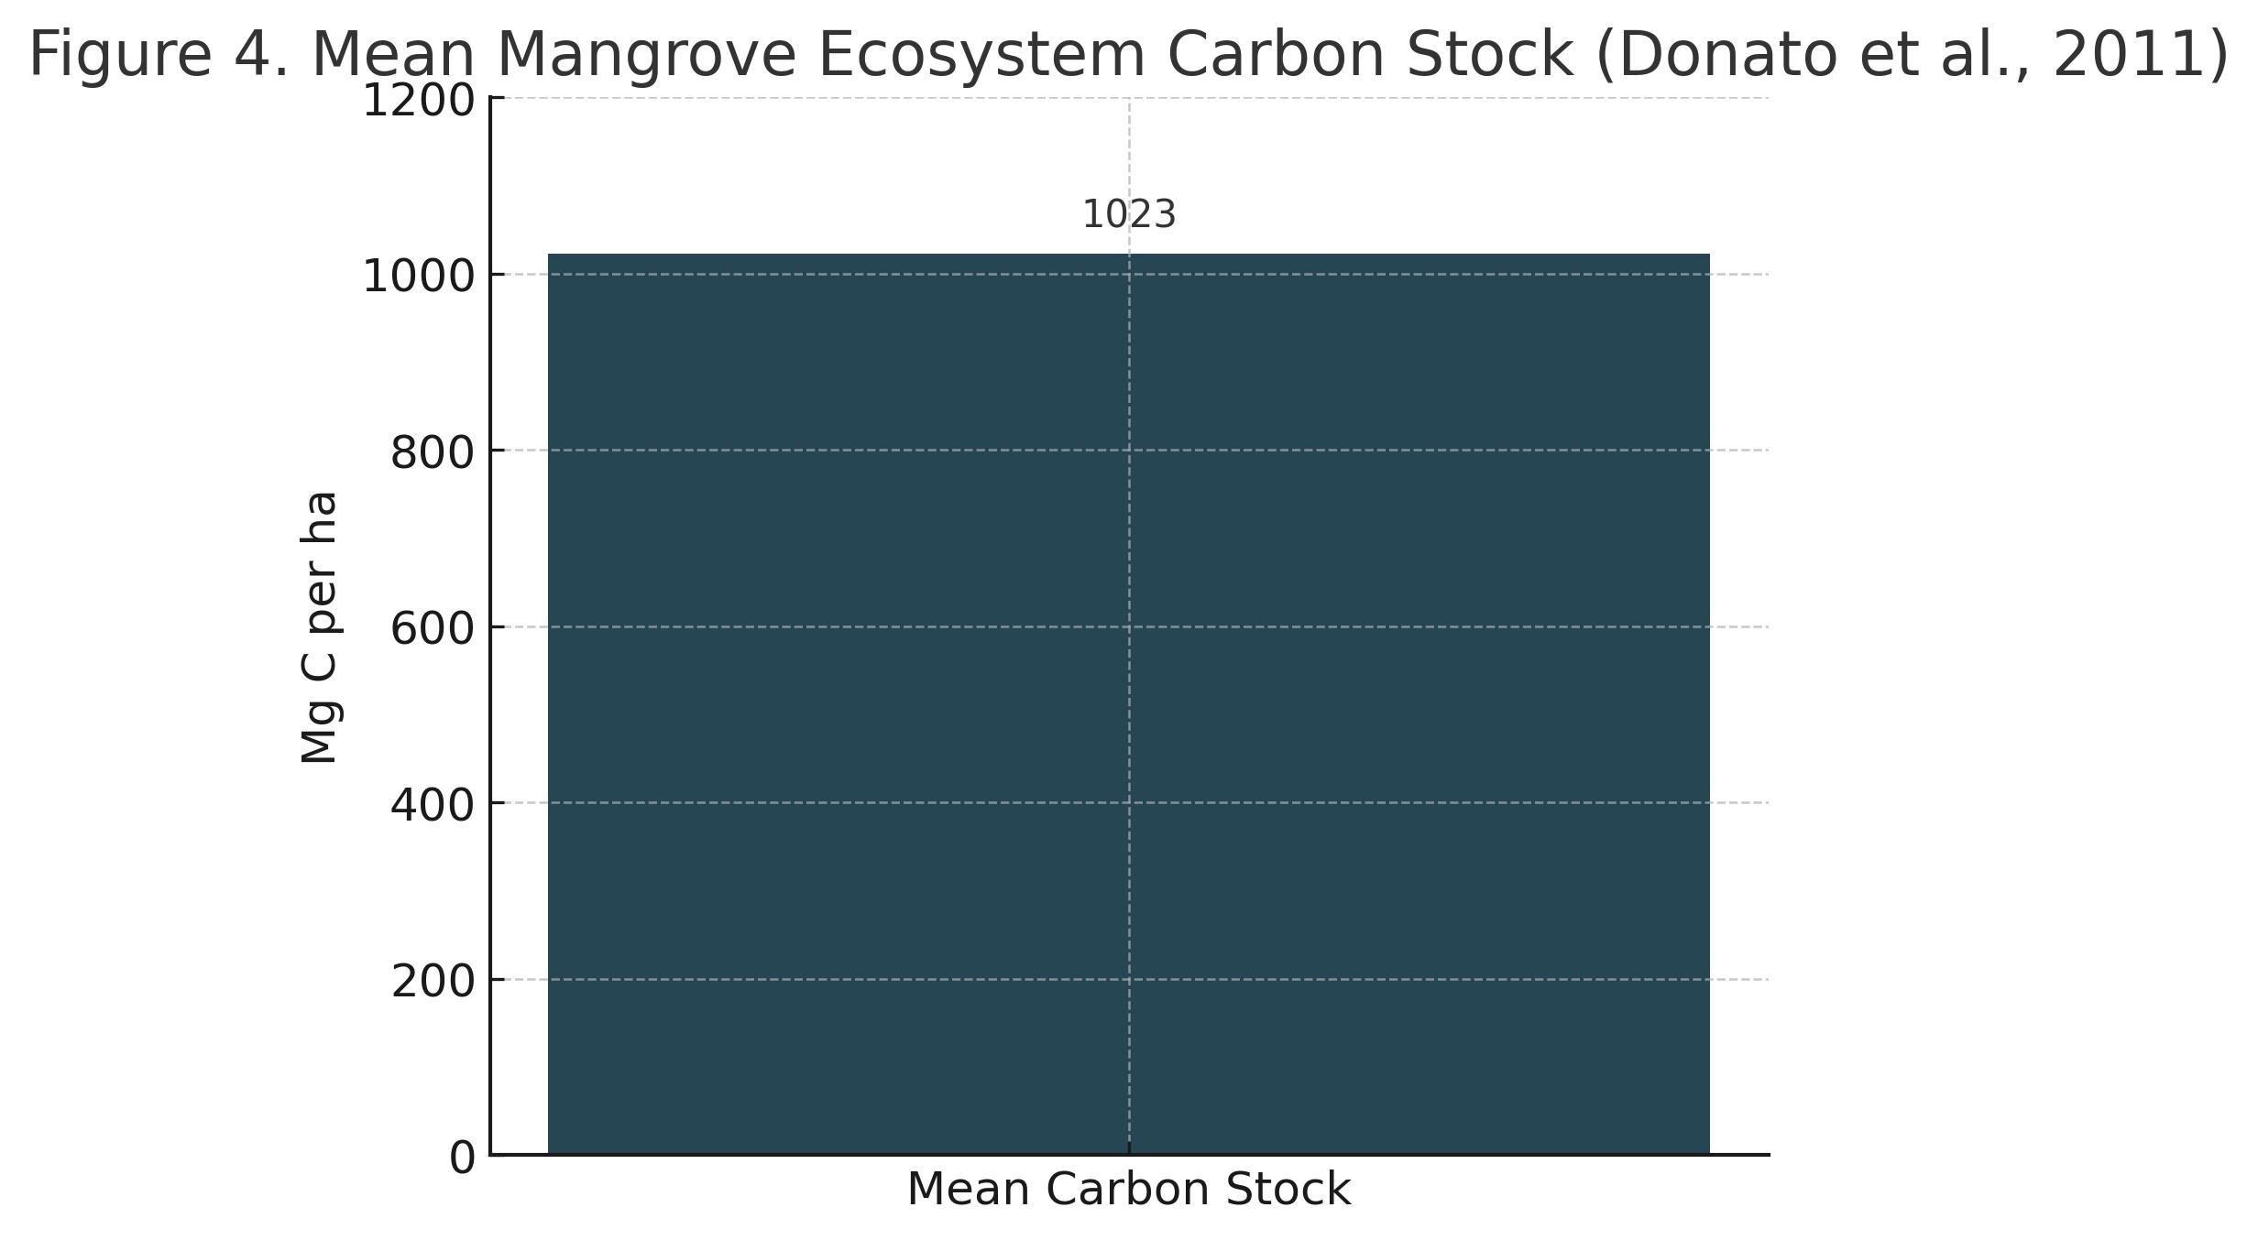
Figure 4. Mean mangrove ecosystem carbon stock (Donato et al., 2011).
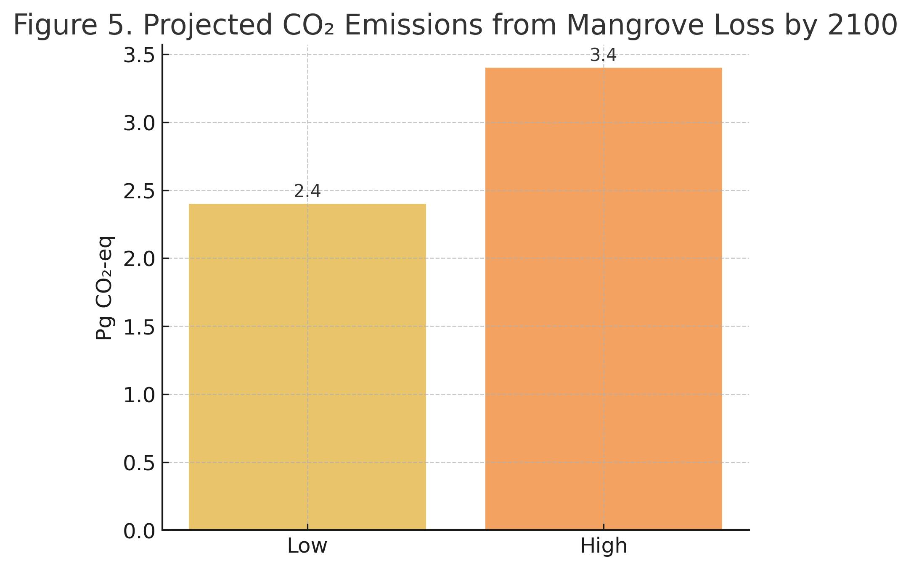
Figure 5. Projected global CO₂ emissions from mangrove loss by 2100 (Adame et al., 2021).
Mangroves also play a crucial role in coastal protection. Field evidence shows ~50% wave attenuation within 100 m of forest (Mazda et al., 2006), while the Odisha cyclone case study (Das & Vincent, 2009) highlights their socio-economic significance. Figure 6 demonstrates wave-energy reduction along a mangrove transect. Beyond carbon and coastal defence, mangroves sustain biodiversity by providing habitat complexity that supports fish, crustaceans, birds, and mammals (Nagelkerken et al., 2008; Bosire et al., 2008).
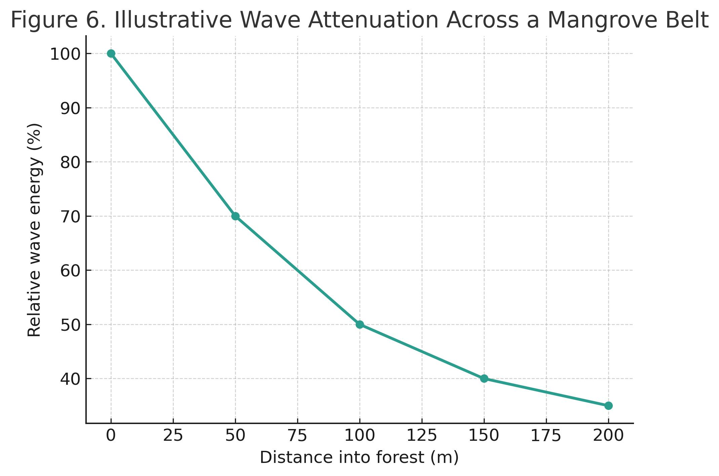
Figure 6. Illustrative wave attenuation profile across a mangrove belt.
Drivers of Loss, Stabilisation, and Gain
The history of mangrove deforestation is closely tied to the expansion of coastal economies. Anthropogenic pressures are the dominant drivers of loss, particularly in Asia, which has accounted for over 90% of global mangrove deforestation in recent decades (Richards & Friess, 2016). The single largest factor has been aquaculture expansion, most notably shrimp farming, which rapidly converted vast tracts of mangroves into artificial ponds. For example, Thailand lost nearly half of its mangroves during the 1980s and 1990s due to intensive aquaculture (Alongi, 2002). Agriculture also plays a role, as conversion to rice paddies and oil palm plantations is widespread in Myanmar, Vietnam, and Indonesia (Hamilton & Casey, 2016). Urbanisation contributes significantly to regions of rapid coastal growth; major cities such as Jakarta, Lagos, and Manila have expanded into former mangrove belts (Goldberg et al., 2020).
Fuelwood harvesting remains an important driver in Africa and South Asia. In countries such as Nigeria, Bangladesh, and India, mangroves are harvested for charcoal production and construction material, often without sustainable practices (Ward et al., 2016). Infrastructure projects such as roads, embankments, and dykes also fragment mangrove hydrology, preventing tidal exchange and altering salinity regimes that are vital for seedling recruitment (Lewis, 2005).
Natural drivers include cyclones, erosion, and pest outbreaks. For instance, the massive dieback of northern Australian mangroves during the 2015–2016 El Niño drought was attributed to hydrological stress combined with extreme heat (Duke et al., 2017). However, natural disturbances often lead to regeneration, provided sediment supply and hydrological connectivity remain intact (Friess et al., 2022).
Encouragingly, evidence indicates that losses have slowed in the past decade. Global Mangrove Watch data show that after a sharp decline between 1996 and 2010, mangrove extent partially recovered by 2020 (Figure 1). Localised gains are reported from hydrological restoration, such as in the Florida Everglades and the Philippines, where tidal reconnection allowed natural regeneration within a decade (Lewis, 2005). Similarly, mangroves have expanded into tidal flats in Bangladesh and northern Brazil, facilitated by sediment deposition and landward migration (Thomas et al., 2017).
Climate Change: Risks, Responses, and Resilience
Climate change represents both a threat and an opportunity for mangroves. On one hand, warming temperatures are enabling poleward expansion into salt-marsh zones. Evidence from northern Australia and the Gulf of Mexico shows mangroves encroaching into marshlands at rates of several kilometres per decade (Saintilan et al., 2014). Such range expansions suggest potential gains in some regions.
On the other hand, accelerated sea-level rise poses one of the greatest threats to mangrove persistence. A multi-country Indo-Pacific assessment by Lovelock et al. (2015) found that approximately 70% of sites lack the vertical accretion capacity to keep pace with projected 21st-century sea-level rise, rendering them vulnerable to submergence. Figure 7 illustrates the proportion of sites considered at risk. Sediment supply and tidal dynamics will determine which forests survive, with deltas such as the Ganges–Brahmaputra retaining higher resilience compared to sediment-starved coasts (Friess et al., 2022).
Mangroves also face increasing cyclone intensity. While these ecosystems can recover after storms, as seen in Bangladesh and the Philippines, where canopy recovery occurred within 4–6 years (Das & Vincent, 2009), repeated extreme events could exceed resilience thresholds. Furthermore, climate-related stressors such as prolonged droughts, heatwaves, and salinity shifts will likely exacerbate mortality events, as observed in northern Australia (Duke et al., 2017).
Yet mangroves also provide climate adaptation benefits. By attenuating storm surges and stabilising sediments, they enhance coastal resilience for human populations. The Odisha super-cyclone example remains a landmark case demonstrating how intact mangroves reduce human vulnerability (Das & Vincent, 2009).
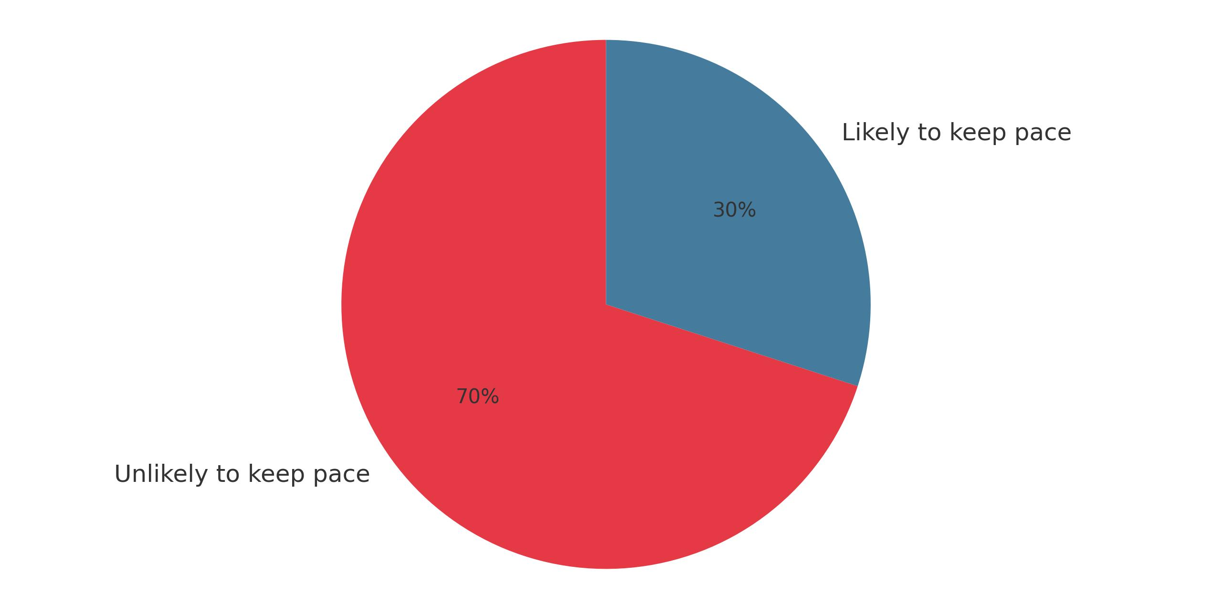
Figure 7. Proportion of Indo-Pacific mangroves vulnerable to sea-level rise, based on elevation capital (Lovelock et al., 2015).
Conservation, Restoration, and Policy Priorities
Given their ecological and socio-economic significance, mangroves have become a global conservation priority. The State of the World’s Mangroves 2024 report emphasises three urgent targets: halting net loss, doubling protected areas, and restoring half of historically lost mangroves by 2030 (Global Mangrove Alliance, 2024).
Restoration has emerged as a central strategy, but success depends on ecological principles. Lewis (2005) argues that simply planting mangrove seedlings, often in inappropriate sites, leads to high mortality and wasted resources. Instead, restoring tidal hydrology and allowing natural recruitment results in self-sustaining recovery. The Florida and Philippines case studies illustrate that ecological engineering approaches outperform monoculture plantations.
Policy frameworks are increasingly integrating mangroves into climate commitments. Incorporation into Nationally Determined Contributions (NDCs) under the Paris Agreement recognises their role in mitigation and adaptation. Blue carbon finance mechanisms are being piloted in Kenya, Indonesia, and Colombia, linking mangrove conservation to carbon markets (Adame et al., 2021). However, concerns exist over ensuring social equity and preventing exploitation of local communities. Safeguards and participatory governance are therefore essential.
Community-based management is another pillar of conservation. In Kenya, the Mikoko Pamoja project exemplifies how local communities can co-manage mangroves, benefiting from both ecosystem services and carbon revenue (Bosire et al., 2008). Similar initiatives in India’s Muthupet and Odisha demonstrate that co-management improves compliance, reduces illegal felling, and aligns conservation with livelihoods.
Case Studies: Sundarbans, Muthupet, and Pichavaram
The Sundarbans, shared between India and Bangladesh, provide a compelling case of site-specific restoration. A recent pilot-scale experiment in degraded Sundarbans patches demonstrated that mixed species planting tailored to salinity and elevation, coupled with hydrological restoration, outperformed conventional monoculture plantations (Bardhan, 2024). Survival rates, canopy cover, and species richness were significantly higher in adaptive plots, supported by soil salinity and sediment data. Figures in that study illustrate survival and growth curves, highlighting that ecological tailoring improves resilience.
In Tamil Nadu, the Muthupet and Pichavaram mangroves highlight the interplay between natural regeneration and risk reduction. Inundation modelling under various sea-level rise scenarios estimated that coastal exposure values declined significantly when mangroves were present: from 3.47 to 2.80 in Pichavaram, and from 4.78 to 2.10 in Muthupet (Selvaraj et al., 2025). Hyperspectral remote sensing has further mapped degraded versus healthy patches, with datasets showing salinity, moisture, and pixel-based degradation indices. Figures from these studies include inundation maps and degraded-area maps, demonstrating how technology informs management.
Together, these case studies emphasise that site-specific, hydrology-informed restoration (Sundarbans) and monitoring-driven adaptive management (Muthupet, Pichavaram) provide pathways for resilience.
Future Directions
Future mangrove conservation must be grounded in science, technology, and social inclusivity. Improved monitoring is crucial, with high-resolution optical and radar sensors, coupled with machine learning, enabling near-real-time detection of mangrove change. Harmonising datasets such as GMW and HGMF will provide consistent baselines for global monitoring. Research must prioritise resilience under climate change, particularly the interaction between sediment supply, elevation capital, and coastal squeeze. Integrated models linking geomorphology, hydrology, and species-specific tolerances are needed to predict mangrove trajectories under different sea-level rise scenarios. Restoration should shift away from plantation-centric approaches towards ecosystem-based interventions. Hydrological restoration, species diversification, and connectivity with adjacent ecosystems such as seagrass beds and coral reefs must be emphasised. Policy frameworks must embed mangroves into national climate strategies. While blue carbon markets offer opportunities, equity safeguards are critical to ensure benefits reach local communities. Community participation remains essential, with traditional knowledge complementing scientific monitoring for sustainable outcomes.
Conclusion
Mangrove forests epitomise both fragility and resilience in the Anthropocene. While they have experienced severe losses driven by aquaculture, agriculture, and urbanisation, recent evidence indicates stabilisation and localised recovery. As blue carbon ecosystems, mangroves contribute disproportionately to climate mitigation while simultaneously enhancing coastal resilience. Yet, climate change, particularly sea-level rise, poses existential threats that will require proactive management.
Conservation strategies must combine ecological engineering, community co-management, and policy integration. With strengthened monitoring, scientific restoration, and equitable financing, mangroves can remain vital allies in addressing global climate and biodiversity crises. Their future depends not on ecological limits but on political will, social inclusion, and sustained global investment.
Disclaimer (Artificial intelligence)
Option 1:
Author(s) hereby declare that NO generative AI technologies such as Large Language Models (ChatGPT, COPILOT, etc.) and text-to-image generators have been used during the writing or editing of this manuscript.
References
- Adame, M. F., Connolly, R. M., Lovelock, C. E., & Friess, D. A. (2021). Coastal wetlands as global carbon sinks. Nature Reviews Earth & Environment, 2(12), 900–915. https://doi.org/10.1038/s43017-021-00241-8
- Alongi, D. M. (2002). Present state and future of the world’s mangrove forests. Environmental Conservation, 29(3), 331–349. https://doi.org/10.1017/S0376892902000231
- Alongi, D. M. (2014). Carbon cycling and storage in mangrove forests. Annual Review of Marine Science, 6(1), 195–219. https://doi.org/10.1146/annurev-marine-010213-135020
- Bardhan, M. (2024). Ecological restoration at pilot-scale employing site-specific strategies in degraded mangrove patches in the Indian Sundarbans. Scientific Reports, 14, 63281. https://doi.org/10.1038/s41598-024-63281-8
- Bunting, P., Rosenqvist, A., Lucas, R. M., Rebelo, L. M., Hilarides, L., Thomas, N., Hardy, A., Itoh, T., Shimada, M., & Finlayson, C. M. (2022). Global Mangrove Watch: Updated remote sensing data for global mangrove extent and change monitoring (1996–2020). Remote Sensing, 14(16), 3657. https://doi.org/10.3390/rs14163657
- Das, S., & Vincent, J. R. (2009). Mangroves protected villages and reduced death toll during Indian super cyclone. Proceedings of the National Academy of Sciences, 106(18), 7357–7360. https://doi.org/10.1073/pnas.0810440106
- Donato, D. C., Kauffman, J. B., Murdiyarso, D., Kurnianto, S., Stidham, M., & Kanninen, M. (2011). Mangroves among the most carbon-rich forests in the tropics. Nature Geoscience, 4(5), 293–297. https://doi.org/10.1038/ngeo1123
- Duke, N. C., Meynecke, J. O., Dittmann, S., Ellison, A. M., Anger, K., Berger, U., … Dahdouh-Guebas, F. (2007). A world without mangroves? Science, 317(5834), 41–42. https://doi.org/10.1126/science.317.5834.41b
- Duke, N. C., Kovacs, J. M., Griffiths, A. D., Preece, L., Hill, D. J. E., van Oosterzee, P., Mackenzie, J., Morning, H. S., & Burrows, D. (2017). Large-scale dieback of mangroves in Australia. Marine and Freshwater Research, 68(10), 1816–1829. https://doi.org/10.1071/MF16322
- Friess, D. A., Rogers, K., Lovelock, C. E., Krauss, K. W., Hamilton, S. E., Lee, S. Y., Lucas, R., Primavera, J., Rajkaran, A., & Shi, S. (2022). The state of the world’s mangrove forests: Past, present, and future. Annual Review of Environment and Resources, 47(1), 1–30. https://doi.org/10.1146/annurev-environ-120920-104849
- Global Mangrove Alliance. (2024). The state of the world’s mangroves 2024. Global Mangrove Alliance. Retrieved from https://www.mangrovealliance.org
- Goldberg, L., Lagomasino, D., Thomas, N., & Fatoyinbo, T. (2020). Global declines in human-driven mangrove loss. Global Change Biology, 26(10), 5844–5855. https://doi.org/10.1111/gcb.15275
- Hamilton, S. E., & Casey, D. (2016). Creation of a high spatio-temporal resolution global database of continuous mangrove forest cover for the 21st century (CGMFC-21). Global Ecology and Biogeography, 25(6), 729–738. https://doi.org/10.1111/geb.12449
- Horstman, E. M., Dohmen-Janssen, C. M., Narra, P. M. F., van den Berg, N. J. F., Siemerink, M., & Balke, T. (2014). Wave attenuation in mangroves: A quantitative approach to field observations. Coastal Engineering, 94, 47–62. https://doi.org/10.1016/j.coastaleng.2014.08.005
- Jia, M., Wang, Z., Mao, D., Ren, C., Wang, C., & Zhu, Z. (2023). A high-resolution global map of mangroves and its spatio-temporal dynamics. Remote Sensing of Environment, 286, 113410. https://doi.org/10.1016/j.rse.2022.113410
- Lewis, R. R. (2005). Ecological engineering for successful management and restoration of mangrove forests. Ecological Engineering, 24(4), 403–418. https://doi.org/10.1016/j.ecoleng.2004.10.003
- Lovelock, C. E., Cahoon, D. R., Friess, D. A., Guntenspergen, G. R., Krauss, K. W., Reef, R., Rogers, K., Saunders, M. L., Sidik, F., Swales, A., Saintilan, N., Thuyen, L. X., & Triet, T. (2015). The vulnerability of Indo-Pacific mangrove forests to sea-level rise. Nature, 526(7574), 559–563. https://doi.org/10.1038/nature15538
- Mazda, Y., Magi, M., Kogo, M., & Hong, P. N. (2006). Wave reduction in a mangrove forest dominated by Sonneratia sp. Wetlands Ecology and Management, 14(4), 365–378. https://doi.org/10.1007/s11273-005-5384-0
- Nagelkerken, I., Blaber, S. J. M., Bouillon, S., Green, P., Haywood, M., Kirton, L. G., … Somerfield, P. J. (2008). The habitat function of mangroves for terrestrial and marine fauna: A review. Aquatic Botany, 89(2), 155–185. https://doi.org/10.1016/j.aquabot.2007.12.007
- Richards, D. R., & Friess, D. A. (2016). Rates and drivers of mangrove deforestation in Southeast Asia, 2000–2012. Proceedings of the National Academy of Sciences, 113(2), 344–349. https://doi.org/10.1073/pnas.1510272113
- Saintilan, N., Wilson, N. C., Rogers, K., Rajkaran, A., & Krauss, K. W. (2014). Mangrove expansion and salt marsh decline at mangrove poleward limits. Global Change Biology, 20(1), 147–157. https://doi.org/10.1111/gcb.12341
- Selvaraj, A., et al. (2025). Enhancement of tropical degraded mangrove mapping using hyperspectral data in the Muthupet mangrove forest, Tamil Nadu, India. Applied Earth Observation and Geoinformation, 156, 337–352. https://doi.org/10.1016/j.jag.2024.103551
- Thomas, N., Lucas, R., Bunting, P., Hardy, A., Rosenqvist, A., & Simard, M. (2017). Distribution and drivers of global mangrove forest change, 1996–2010. PLoS ONE, 12(6), e0179302. https://doi.org/10.1371/journal.pone.0179302
- Ward, R. D., Friess, D. A., Day, R. H., & MacKenzie, R. A. (2016). Impacts of climate change on mangrove ecosystems: A region by region overview. Ecosystem Health and Sustainability, 2(4), e01211. https://doi.org/10.1002/ehs2.1211
- Friess, D. A., Adame, M. F., Adams, J. B., & Lovelock, C. E. (2022). Mangrove forests under climate change in a 2 C world. Wiley Interdisciplinary Reviews: Climate Change, 13(4), e792.
- Sunkur, R., Kantamaneni, K., Bokhoree, C., Rathnayake, U., & Fernando, M. (2025). Modelling mangrove dynamics in Mauritius: Implications for conservation and climate resilience. Journal for Nature Conservation, 85, 126864.
- Jariah, H., Sujalu, A. P., & Milasari, L. A. (2024). Mitigation of mangrove forest destruction in East Kalimantan Province. Asian Journal of Research in Agriculture and Forestry, 10(2), 97–101.

