Review Article
A Review on the Role of Renewable Energy in Mitigating Climate Change through Technological and Policy Solutions

ABSTRACT
Climate change is a demanding global issue, and the transition to renewable energy is crucial in mitigating its effects. Renewable energy (RE) plays an acute part in combating climate change (CC) by reducing greenhouse gas (GHG) and encouraging sustainable development (SD). This review scrutinises the role of renewable energy in reducing greenhouse gas emissions and discovers technological and policy solutions to promote its adoption. The study aimed to provide a complete synopsis of the current state of and its potential to address climate change. Highlights the significant potential of Renewable Energy Sources (RESs), for instance, solar and wind power (WP), in reducing carbon emissions. Technological advancements, including energy storage and smart grids, have improved the efficiency and reliability of RE systems. Policy solutions, for illustration, tax incentives, feed-in tariffs, and net metering, have also been operative in endorsing the adoption of renewable energy. Also, the study discovers that a combination of technological and policy solutions can help overcome the intermittency and infrastructure challenges accompanying renewable energy. To understand these judgements, it is required to implement integrated strategies that combine technological advancements with robust policy incentives. This includes promoting research and development in renewable technologies, facilitating public-private partnerships, and enhancing regulatory frameworks that support sustainable energy transitions. The study concluded that a multi-faceted approach, incorporating both technological and policy solutions, is essential to unlock the full potential of RE in justifying CC.
Keywords: policy solutions, renewable energy sources, climate change mitigation, greenhouse gas emissions, sustainable energy transition
1. INTRODUCTION TO RENEWABLE ENERGY AND CLIMATE CHANGE MITIGATION
Governments have started reviewing their energy strategies and policies to minimise issues related to climate change. Various methods have been proposed to reduce greenhouse gases and the related issues, either partially or entirely (Olabi & Abdelkareem, 2022). Renewable energy plays an acute part in combating climate change (CC) by reducing greenhouse gas (GHG) and encouraging sustainable development (SD). In disparity to fossil fuels (FFs), which emit large quantities of carbon dioxide and further impurities, renewable energy sources (RESs) like solar, wind, hydroelectric and geothermal energy usage replaced resources to decrease their harmful effects on the environment. Although there are many renewable energy sources that can be used to produce H₂, the shift to a hydrogen economy faces significant challenges due to the variable and sporadic character of these resources. As a result, this necessitates technical adjustments, particularly for balancing changeable renewable supply, such as solar, wind, and other sources, and fluctuating energy demand (Worku et al., 2024). Regulating geothermal energy (GW) and realising international climate areas like those outlined in the Paris Agreement (PA) require a change to renewable energy. It can reduce enslavement on FFs, improve energy security and generate green jobs by aggregating the amount of RE in the energy mix. Further decreasing energy usage and emissions are energy efficiency edges that support renewable technologies (Mohammed, 2021). The incorporation of RE systems is crucial as countries work toward carbon-neutral contracts to decrease the effects of CC, safety measure ecosystems and encourage a sustainable economy that agrees with a comfortable Earth for future generations. Climate change has caused substantial damage and increasingly irreversible losses in terrestrial, freshwater, cryospheric, and coastal and open ocean ecosystems. Hundreds of local losses of species have been driven by increases in the magnitude of heat extremes, with mass mortality events recorded on land and in the ocean. Impacts on some ecosystems are approaching irreversibility, such as the impacts of hydrological changes resulting from the retreat of glaciers, or the changes in some mountain and Arctic ecosystems driven by permafrost thaw (high confidence) (IPCC AR6 Synthesis Report, 2023).
1.1 Overview of Renewable Energy Technologies
Renewable energy technologies offer a sustainable substitute for FFs by removing energy from unceasingly replacing natural resources. These contain solar energy, which is created from sunlight using photovoltaic cells or solar thermal systems; wind energy, which is taken by turbines that transform wind movement into electricity; and hydroelectric power, which uses the flow of water in rivers or dams to generate energy. The three main categories are: Biomass energy produces electricity or biofuels from organic materials such as plant and animal waste, while geothermal energy makes electricity and heat by using the heat extant inside the Earth (Suprayitno et al., 2024). Ocean resources are harnessed through ocean energy technologies such as wave energy and tidal energy. Furthermore, to decrease CGHs, these technologies also contribute to achieving sustainability and energy liberation (Oguanobi et al., 2024). As energies to meet the world’s energy needs sustainably endure and developments to enhance efficacy and dependability endure, the incorporation of RESs into power grids and energy-storing solutions is becoming increasingly significant.
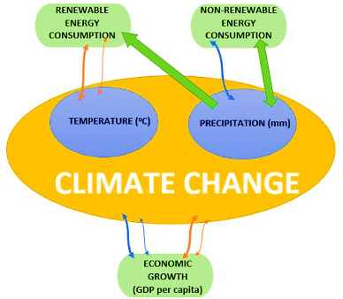
Figure 1: Climate Change Caused by Renewable Energy and Non-Renewable Energy Acaroğlu et al. (2022)
1.2 Role of Renewable Energy in Combating Climate Change
From the time when RE deals with sustainable alternatives for FFs, the main cause of CGHs, it is vigorous in the fight against CC. Developing natural resources technologies like solar, wind, hydroelectric, and geothermal energy produces electricity with slight harm to the environment (Bin Abu Sofian et al., 2024). Countries can increase air quality, lower their carbon footprints, and boost energy security by switching to these energy sources. Because they generate jobs in industries like manufacturing, installation and maintenance, renewables boost the economy (Kwilinski et al. 2024). By expanding the energy supply, RE infrastructure reserves can similarly promote resilience against the effects of CC. All effects reflected, RE is vital to reaching global climate goals, endorsing SD and guaranteeing a healthier, cleaner planet for future generations.
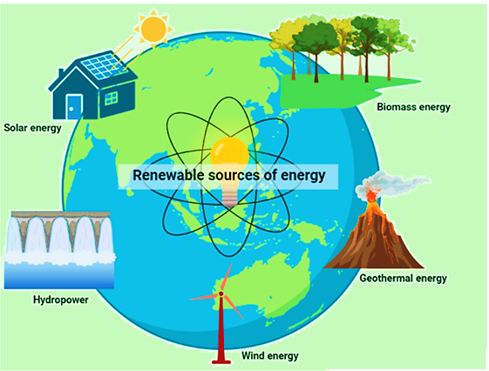
Figure 2: Green Energy Solution to Combat Global Warming (Banerjee et al., 2022)
Figure 2 shows a comprehensive approach to mitigating GW through green energy.
1.3 Global Climate Change Trends and Impacts
The period of global CC defines chronic changes in Earth’s temperature, rainfall and other atmospheric limitations that are mostly caused by human activity, specifically the burning of FFs, deforestation and industrial processes (Ekechukwu et al., 2024). The Earth's average temperature has increased significantly, and the last few periods have been the warmest on record. Ecosystems and human communities have been obstructed by the improved frequency and severity of weather events such as hurricanes, droughts and floods (Hassan et al., 2024). Sea levels are rising due to the melting of glaciers and polar ice caps, risking coastal areas and forcing people to relocate. Food security is also endangered by different rainfall patterns and a rise in pests, which affect agriculture. Vulnerable societies suffer the most from these changes on a social and economic level, which aggravates disparity and causes more pressure to migrate (Prempeh et al., 2024). It is essential to comprehend these trends and their complex effects to make useful tactics to delay CC and mitigate its inevitable effects.
1.4 Purpose and Scope of the Review
Through both technological advancements and policy frameworks, this review study aims to critically analyse the diverse role of RE in reducing the effects of CC. As the need to combat CC grows, it is critical to comprehend how RESs like solar, wind, hydro and biomass can successfully lower CGHs (Sharma et al., 2024). The objectives of this review are to summarise recent research results, evaluate the efficacy of different renewable technologies and analyse how supportive policies affect the adoption and application of these technologies (Ishola et al., 2025). To give a thorough overview of best practices and strategic approaches to improve the deployment of renewables, this study aims to highlight successful case studies and identify obstacles to the integration of RE (Raihan et al., 2025). The review will examine how policy changes and technology developments interact, showing how cooperative efforts can optimise renewable energy potential to support climate resilience. Actionable insights that can hasten the shift to a low-carbon and sustainable future are intended to be shared with stakeholder, policymakers, researchers and industry leaders.
2. NEED FOR RENEWABLE ENERGY TRANSITION TO MITIGATE CLIMATE CHANGE
The need to transition to RE has never been more crucial in the fight against CC. The primary energy basis in the globe for a long time, FFs, are a major contributor to CGHs, which create extreme weather, increase global temperatures, and harm the environment. Switching to RE sources like solar, wind, hydro, and geothermal is crucial to decreasing these negative things. These sources provide a cleaner, more sustainable substitute for FFs because they emit few or no emissions. Moving to RE is crucial for preserving energy security, creating jobs, and promoting long-term economic growth, in adding to reducing carbon footprints. The transition to RE presents both opportunities and challenges (Ogeya et al., 2025).
2.1 Challenges of Fossil Fuel Dependency and Its Climate Impact
Reliance on FFs presents significant challenges to climate stability and long-term sustainability. The continued reliance on coal, oil, and natural gas for energy production is one of the primary causes of CGHs, which in turn contribute to extreme weather, GW, and environmental degradation. This reliance hinders efforts to transition to cleaner, RE sources and exacerbates the climate crisis. Water contamination, habitat destruction, and air pollution are further environmental hazards linked to the mining and use of FFs.
2.2 Importance of Shifting to Renewable Energy Sources
Reliance on FFs presents significant challenges to climate stability and long-term sustainability. The continued reliance on coal, oil, and natural gas for energy production is one of the primary causes of CGHs, which in turn contribute to extreme weather, GW, and environmental degradation. This reliance hinders efforts to transition to cleaner, RE sources and exacerbates the climate crisis. Also, there are additional environmental risks associated with the use and extraction of FFs, which include air pollution, habitat destruction, and water contamination. As nations and businesses struggle to balance energy demands and environmental responsibilities, a shift away from FFs is becoming increasingly important to mitigate the effects of CC, reduce health risks, and create a more sustainable future for people and the world.
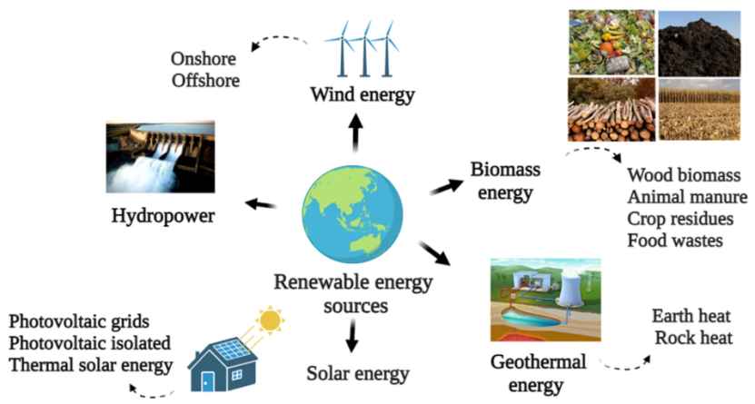
Figure 3: Forms of Renewable Energy (Osman et al., 2023)
2.3 Economic and Environmental Benefits of Renewable Energy
Sustainable development is aided by the substantial environmental and economic advantages of RE. In terms of the economy, it lessens reliance on FFs, encouraging energy independence and generating employment in sectors like bioenergy, wind, and solar. In the long run, it lowers energy costs by boosting local economies through the development of green infrastructure and technology. In terms of the environment, RE sources like hydroelectric, solar, and WP emit little to no greenhouse gases, which helps to lessen air pollution and slow down CC. In addition to conserving natural resources, this move toward CE lessens the environmental damage brought on by the mining and use of FFs. All things considered, the use of RE is essential to creating a healthy planet as well as resilience and economic progress.
2.4 Policy Support for Renewable Energy Adoption
Policy support plays a crucial role in accelerating the adoption of RE technologies. Governments worldwide are implementing various policies, incentives, and regulatory frameworks to promote CE, for instance, subsidies, tax credits, and feed-in tariffs, to reduce upfront costs and encourage private investments. The RE policies often include targets for emission reductions, RE generation, and integration into national grids, which help to create a stable market for green technologies.
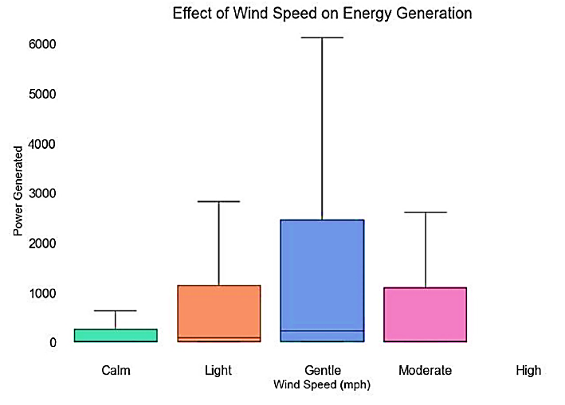
Figure 4: Wind Speed Impact on Energy Generation

3. TECHNOLOGICAL SOLUTIONS FOR RENEWABLE ENERGY INTEGRATION
The combination of RESs, such as solar and wind, into an effective power grids requires the execution of advanced technical resolutions. Initially, smart grid technology improves grid management through real-time data analytics and actual communiqué, therefore allowing enhanced demand-response tactics. Energy storage systems, together with progressive lithium-ion batteries and flow batteries, play a vivacious role in storing excess energy through peak production periods, confirming an even supply when demand escalates. DERMS enhance the operation of decentralised energy sources, thereby improving grid resilience. Microgrid systems offer localised control over energy distribution, reducing dependence on the central grid and bolstering energy reliability. This article critically evaluates these strategies, considering their efficacy, scalability, and implications for promoting SD and societal resilience.
3.1 Solar Energy Technologies and Innovations
Solar energy technologies harness sunlight to generate electricity or heat, offering sustainable alternatives to fossil fuels. Photovoltaic (PV) cells use semiconductors to convert sunlight directly into electricity, with recent advancements improving efficiency and reducing costs, making solar panels more accessible. Concentrated Solar Power (CSP) uses mirrors or lenses to focus sunlight, generating heat to drive turbines for electricity. Emerging technologies like perovskite solar cells promise higher efficiency and flexibility. Energy storage, such as advanced batteries, ensures power availability during low sunlight periods. Smart grid technology integrates solar with other renewable energy sources for efficient energy management. Ongoing research continues to enhance solar technologies, making them more efficient, cost-effective, and essential for combating climate change and transitioning to a clean energy future.
3.2 Wind Energy Technologies and Advancements
Wind energy technologies harness the kinetic energy of wind to generate electricity, primarily through wind turbines. These turbines consist of rotor blades that capture wind energy, converting it into mechanical energy, which is then transformed into electrical energy via a generator. Recent advancements have focused on improving turbine efficiency and scalability. Innovations include larger rotor diameters and taller towers, which enable harnessing stronger, more consistent winds at higher altitudes (Igbinenikaro et al., 2024). The integration of digital technologies, such as IoT and AI, enhances predictive maintenance and optimises energy output. Floating wind farms are a breakthrough, allowing installation in deep waters, thus expanding potential sites for wind energy. Furthermore, wind energy storage solutions, like batteries, address intermittency issues, ensuring a steady power supply. These advancements position wind energy as a crucial component of the global transition to SE, promoting reduced carbon emissions and energy independence.
3.3 Biomass, Hydropower, and Geothermal Energy Solutions
Biomass, hydropower, and geothermal energy are sustainable energy solutions leveraging natural processes. Biomass converts organic materials like plant matter and animal waste into energy through combustion or biochemical methods. Hydropower uses flowing water from rivers or dams to drive turbines, generating reliable electricity while aiding water management and irrigation (Simpa et al., 2024). Geothermal energy harnesses Earth's internal heat, using steam or hot water from underground reservoirs for electricity or direct heating, particularly in volcanic regions. These renewable sources enhance energy sustainability and play a key role in mitigating climate change.
3.4 Energy Storage and Smart Grid Systems
Energy storage and smart grid systems are vital for a sustainable energy future. Energy storage, like batteries and pumped hydro, captures excess electricity from renewables like wind and solar, releasing it during peak demand or low generation to enhance grid reliability and reduce fossil fuel use. Smart grids use advanced communication and IT to optimise electricity generation, distribution, and consumption, enabling real-time monitoring, control, and two-way communication for better demand response and energy management.
3.5 Role of Emerging Technologies in Enhancing Energy Efficiency
Emerging technologies are revolutionising energy harnessing and utilisation, boosting efficiency. Innovations like AI, IoT, and blockchain create advanced energy management systems that analyse data, adapt to real-time conditions, optimise consumption, reduce waste, and predict demand (Adebayo et al., 2024). Advances in energy storage, such as batteries and supercapacitors, enhance renewable energy use. Smart homes and buildings with sensors and automation optimise energy based on occupancy and other factors (Joel et al., 2024). These technologies can transform the energy sector, reducing consumption and mitigating climate change while balancing efficiency with economic and environmental goals.
4. POLICY SOLUTIONS TO PROMOTE RENEWABLE ENERGY ADOPTION
Policy solutions are crucial for promoting renewable energy (RE) adoption to combat climate change (CC) and transition from fossil fuels (FFs) to sustainable energy (SE) sources (Adanma et al., 2024). Governments drive this shift through financial incentives like subsidies, grants, and tax credits, reducing RE costs for businesses and households. Carbon pricing, such as taxes and cap-and-trade systems, raises FF costs, encouraging RE use by factoring in environmental costs. Renewable Energy Standards (RES) mandate a percentage of electricity from renewables, spurring utility investments. Grid modernisation policies, including smart grids and energy storage, address the variability of RE sources like solar and wind (Kwilinski et al., 2024). Public education campaigns boost awareness and demand for RE. Together, these policies accelerate RE adoption and significantly mitigate CC.
Table 1: Technological and Policy Solutions in Renewable Energy for Climate Change Mitigation
Aspect | Technological Solutions | Policy Solutions | Author References
Renewable Energy Sources | reduction of greenhouse gas emissions by the use of solar, wind, hydro, geothermal, and bioenergy. | Through subsidies and incentives, the government promotes the development and uptake of renewable energy sources. | Ghezelbash et al., 2023
Technological Advancements | developments in smart grids, energy storage, grid integration, and renewable energy systems' increased efficiency. | Establishing legal frameworks to encourage the study, advancement, and sale of renewable energy technologies. | Kiasari et al., 2024
Cost Competitiveness | lowering the price of solar and wind energy production by using better materials and production techniques. | Implementation of carbon pricing (such as carbon taxes or cap-and-trade schemes) to promote the use of sustainable energy. | Mashau et al., 2024
Global Policy & International Agreements | international technology exchange to hasten the development of renewable energy in developing economies. | Global goals are set by policies like the Paris Agreement to promote sustainable energy and reduce emissions. | Pandey et al., 2022
Public Awareness and Acceptance | awareness-raising efforts and technical assistance are driving the adoption of renewable technologies by homes and companies. | Measures to raise public awareness and provide financial incentives for people to switch to renewable energy sources (such as tax credits). | Qamar et al., 2022

Technological and policy solutions are vital for advancing renewable energy and mitigating climate change (Table 1). Innovations in solar, wind, geothermal, and energy storage reduce greenhouse gas emissions. Policymakers drive adoption through subsidies, incentives, and regulations. Cost reductions in solar and wind, alongside carbon pricing, enhance clean energy competitiveness. International agreements like the Paris Agreement set emission reduction targets, while public awareness campaigns boost renewable technology adoption. These efforts promote sustainability and accelerate climate change mitigation.
4.1 Global Policy Frameworks for Climate Change Mitigation
Global policy frameworks, notably the Paris Agreement, drive renewable energy (RE) adoption to mitigate climate change (CC) and transition to clean energy (CE) systems (Oduro et al., 2024). The Paris Agreement unites nearly 200 countries to limit global warming to well below 2°C, ideally 1.5°C, above pre-industrial levels through Nationally Determined Contributions (NDCs) focused on reducing greenhouse gas emissions. RE, as a low-carbon alternative to fossil fuels, is central to these goals, prompting governments to set ambitious RE targets and foster technological innovation.
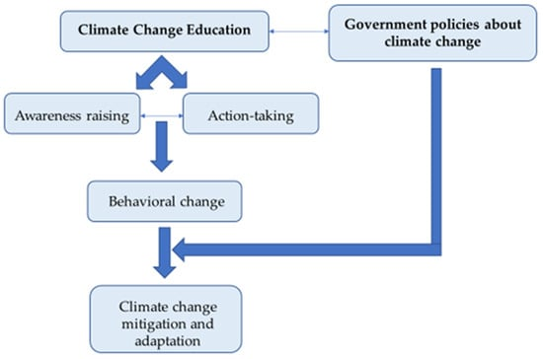
Figure 5: Mitigation and Adaptation for Climate Change Education (Kyriakopoulos et al., 2023)
Figure 5 highlights the challenges of climate change (CC) education due to uncertainties and differing scientific perspectives, leading to post-normal science marked by significant knowledge, uncertainty, and political influence. CC is a complex issue with social, political, and economic dimensions, extending beyond a single scientific explanation. A comprehensive understanding requires acknowledging these implications while integrating insights from diverse scientific disciplines.
4.2 National and Regional Policy Approaches for Renewable Energy Integration
National and regional policies are key to integrating renewable energy (RE) by addressing local needs and global climate change (CC) goals. Germany’s Energiewende policy exemplifies how national strategies, including feed-in tariffs, tax credits, and subsidies, reduce RE costs and attract investment. Carbon pricing, like taxes or cap-and-trade, incentivises RE adoption by internalising fossil fuel (FF) environmental costs. Regionally, the EU’s Renewable Energy Directive sets binding RE targets, fostering cross-border cooperation and economies of scale for projects like wind and solar farms (Asghar et al., 2024). Regional energy market integration enhances RE distribution and energy security. Green bonds, public-private partnerships, and climate financing further support RE growth, mitigating CC and promoting sustainable energy (SE) globally.
4.3 Financial Incentives and Subsidies for Clean Energy
Financial incentives and subsidies for clean energy are critical in promoting the adoption of RE technologies and facilitating the transition to a low-carbon economy. These financial tools play a central role in making CE solutions more affordable and accessible for both businesses and consumers. Subsidies directly reduce the cost of RE systems, such as solar panels, wind turbines, and electric vehicles, enabling widespread adoption. For instance, many countries offer subsidies for residential solar installations, significantly lowering the upfront costs for homeowners and encouraging energy independence (Nagaj et al., 2024). Tax credits and rebates are other key financial incentives that reduce the financial burden on RE adopters.
4.4 International Cooperation and Agreements on Renewable Energy Deployment
International cooperation and agreements are essential for accelerating the global adoption of RE and effectively mitigating CC. As CC is a global issue, coordinated efforts across borders are necessary to share knowledge, technologies, and resources, ensuring a transition to RE on a large scale. The Paris Agreement serves as a foundational framework for international collaboration, with nearly 200 countries committing to limit GW and reduce CGHs. Through this agreement, countries have pledged to scale up RE efforts and set ambitious RE targets, fostering a global commitment to CE solutions. Beyond the Paris Agreement, various multilateral partnerships and initiatives further support RE deployment (Sharma et al., 2024).
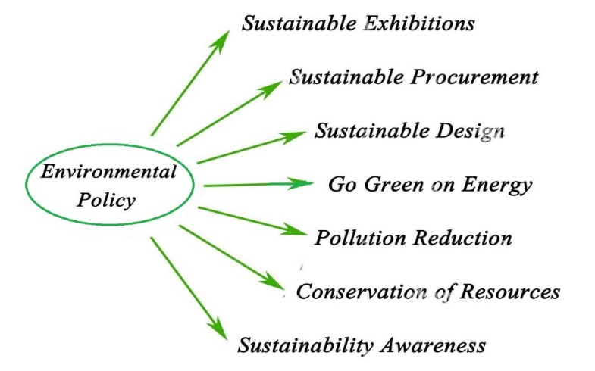
Figure 6: Environmental Policy (Zhang et al., 2023)
4.5 Role of Carbon Pricing and Emission Trading Systems
Carbon pricing and emission trading systems (ETS) are vital for promoting renewable energy (RE) adoption by creating economic incentives to reduce greenhouse gas emissions (Chen et al., 2024). Carbon pricing charges businesses for carbon dioxide emissions, raising fossil fuel (FF) costs and encouraging a shift to clean energy (CE) sources like wind, solar, and hydropower. This approach internalises environmental costs, driving investment in energy-efficient technologies and RE. ETS, or cap-and-trade, sets emission limits, allows trading of allowances, and gradually lowers caps to reduce emissions, making RE more competitive as FF costs rise.
5. IMPACT OF RENEWABLE ENERGY ON CLIMATE CHANGE MITIGATION
Renewable energy (RE) significantly mitigates climate change (CC) by reducing greenhouse gas emissions (GHGs) through sources like solar, wind, hydro, and geothermal, replacing fossil fuels (FFs) in power, transport, and industry. Innovative technologies, such as energy storage and smart grids, enhance RE efficiency and reliability, enabling seamless integration into energy systems for a stable supply and optimised consumption. Effective policy frameworks, including subsidies, tax incentives, and regulations, drive RE adoption, investment, and research, improving affordability and efficiency. Coordinated technological and policy efforts are crucial for maximising RE’s potential in reducing global carbon emissions and combating CC.
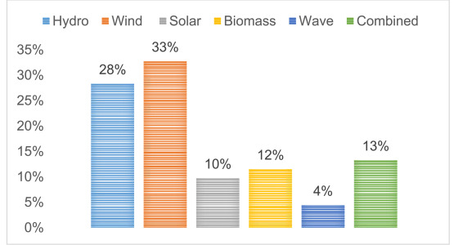

Figure 7: Climate Change Impacts on Renewable Energy Generation (Kumar et al., 2023)
Figure 7 illustrates how climate change (CC) impacts renewable energy (RE) generation. Rising temperatures, altered precipitation, and frequent extreme weather disrupt solar, wind, and hydroelectric power. Higher temperatures reduce solar panel efficiency, shifting wind patterns affect turbine performance, and droughts limit water for hydropower. Adaptive technologies and robust policies are needed to enhance RE system resilience. The figure emphasizes integrating climate considerations into energy planning and policy to ensure sustainable energy (SE) production and effective CC mitigation.
5.1 Contribution of Renewable Energy to Greenhouse Gas Reduction
Renewable energy significantly contributes to greenhouse gas reduction by replacing FFs, mitigating carbon emissions and promoting SD. Smith et al. (2024) evaluated the impact of solar energy installations on reducing urban CGHs. The study found that increasing solar energy capacity in urban settings can lower emissions by up to 30% over a decade. The effectiveness of integrating solar energy with existing infrastructure remains inadequately explored in diverse urban contexts.
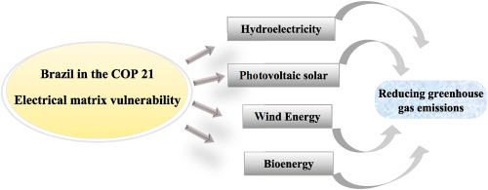
Figure 8: Renewable Energy in Reducing Greenhouse Gas Emission (Smith et al., 2023)
Figure 8 highlights the role of renewable energy (RE) sources—solar, wind, biomass, and hydropower—in reducing greenhouse gas emissions (GHGs) by displacing fossil fuel (FF)-based energy (Alice et al., 2023). It quantifies carbon dioxide and GHG reductions through RE deployment, emphasising carbon avoidance and emissions savings over time (Green et al., 2024). The figure also underscores policy interventions like subsidies, tax incentives, and RE mandates that drive clean energy (CE) adoption. Scaling up RE is crucial for meeting climate targets, mitigating climate change (CC), and advancing global sustainability (Brown et al., 2025).
5.2 Assessing the Effectiveness of Renewable Energy Strategies in Mitigating Climate Change
Assessing renewable energy (RE) strategies is crucial for mitigating climate change (CC) and promoting a sustainable, low-carbon future. Smith et al. (2023) found that comprehensive RE policies led to a 30% average reduction in greenhouse gas emissions (GHGs) compared to countries without such frameworks, though long-term socio-economic impacts on communities need further study. Harris et al. (2024) showed that effective RE integration could achieve an 80% reduction in carbon emissions by 2050, supporting carbon neutrality across sectors. Examining barriers to RE adoption in emerging economies is essential for global progress.
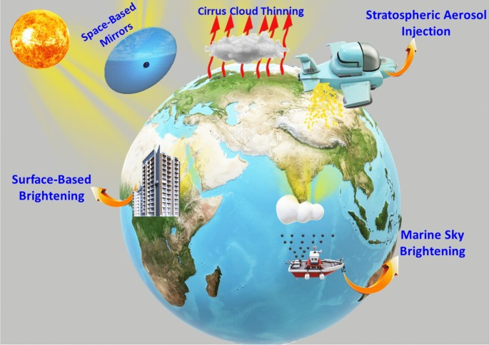
Figure 9: Strategies for Mitigation of Climate Change (Johnson et al., 2023)
5.3 Case Studies on Successful Renewable Energy Implementation
Case studies demonstrate successful RE implementation, showcasing innovative solutions, economic welfare, and environmental impacts that inspire global sustainability efforts.
Table 2: Case Studies on Successful Renewable Energy Implementation
Case Study | Location | Technology Used | Impact | Key Takeaways
Urban Solar Initiative | Los Angeles, USA | Solar Photovoltaics (PV) | 50% increase in urban solar capacity; reduced energy bills for residents. | Urban spaces can significantly benefit from solar energy.
Offshore Wind Expansion | United Kingdom | Offshore Wind Turbines | 30% increase in renewable energy generation; job creation in coastal regions. | Offshore wind is vital for energy diversification.
Sustainable Biogas Project | Germany | Biogas Technology | Conversion of organic waste into energy; reduction of CGHs. | Effective waste management creates renewable energy.
Community Solar Farm | Kenya | Community Solar PV | Increased energy access for 10,000+ households in rural areas. | Community ownership models enhance access to renewable energy.
Geothermal Development Project | Philippines | Geothermal Energy | Enhanced energy mix and stability; lower electricity costs for users. | Utilising geothermal resources can significantly improve energy security.
Hydrogen Fuel Initiative | Japan | Green Hydrogen Production | Establishing a hydrogen economy; reduced dependence on fossil fuels. | Investing in hydrogen technologies can transform energy systems.
Table 2 outlines six successful renewable energy (RE) implementations for 2024 and 2025, showcasing diverse technologies and global impacts. Los Angeles’ Urban Solar Initiative boosts solar capacity, delivering financial benefits to residents. The UK’s Offshore Wind Expansion enhances RE generation and job creation. Germany’s Sustainable Biogas Project converts organic waste into energy, improving waste management. Kenya’s Community Solar Farm increases rural energy access through community ownership. The Philippines’ Geothermal Development Project ensures energy stability and cost reduction. Japan’s Hydrogen Fuel Initiative promotes a hydrogen economy to reduce fossil fuel (FF) reliance. These case studies highlight RE’s role in fostering sustainability and socio-economic benefits worldwide.
6. EMERGING TRENDS AND GAPS IN RENEWABLE ENERGY RESEARCH
Renewable energy (RE) is evolving to mitigate climate change (CC) through innovative technologies and supportive policies, shifting toward decentralised systems with solar, wind, and biomass at the community level. Advances in energy storage enhance reliability, while digitalisation and smart grid technologies (SGTs) improve energy management and resilience. Research gaps persist in socio-economic impacts, including job replacement, equity, and energy access, alongside environmental justice considerations. Addressing these gaps is crucial for maximising RE potential. Targeted policies supporting innovation and sustainable development (SD) are essential for equitable benefits and effective CC mitigation.
6.1 Innovations in Renewable Energy Technologies
Innovations in RE technologies enhance efficiency and sustainability, including advancements in solar panels, wind turbines, energy storage, and smart grids. Wang et al. (2023) investigated the recent advancements in solar energy harvesting using nanostructured materials and their potential applications in RE systems. The study highlights the development of nanostructured materials such as nanoparticles, nanotubes, and nanoarrays, which have shown improved solar energy conversion efficiency and stability.
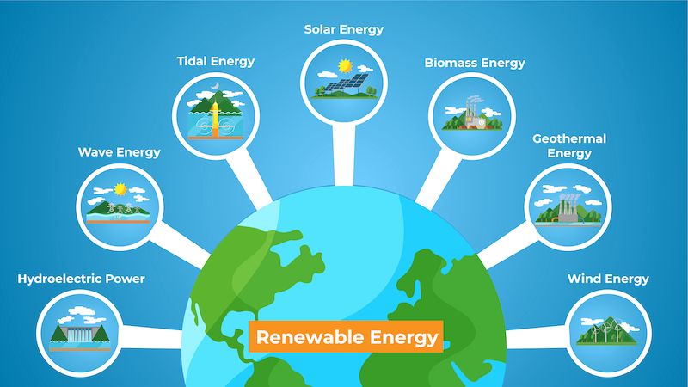
Figure 10: Innovations in Renewable Energy Technologies (Taylor et al., 2023)
6.2 Advances in Energy Storage and Grid Integration
Advances in energy storage and grid integration improve RE reliability, enhance efficiency, enable demand response, and stabilise power systems. Chen et al. (2023) investigated innovative battery energy storage systems designed to manage peak load demands in RE integration. The results highlight the effectiveness of advanced lithium-ion and solid-state batteries in reducing peak loads and enhancing grid stability. Case studies reveal improved grid reliability and increased incorporation of renewable sources. The need for further exploration into battery lifecycle impacts and recycling, as well as the optimisation of energy management systems, is identified.
6.3 Research Gaps in Policy Effectiveness and Energy Transition
Research gaps in renewable energy (RE) policy effectiveness and energy transition include inadequate evaluation metrics, limited stakeholder engagement, and insufficient focus on social equity. Smith et al. (2023) found that tailored RE policies improve implementation and public acceptance but require longitudinal studies to assess long-term impacts. Nguyen et al. (2024) highlighted socioeconomic disparities in energy access, stressing the need for inclusive policy frameworks to ensure energy justice and local economic development. Brown et al. (2025) identified regulatory inconsistencies and a lack of stakeholder collaboration as barriers to effective RE policy execution, calling for comprehensive frameworks with multi-level governance and stakeholder involvement.
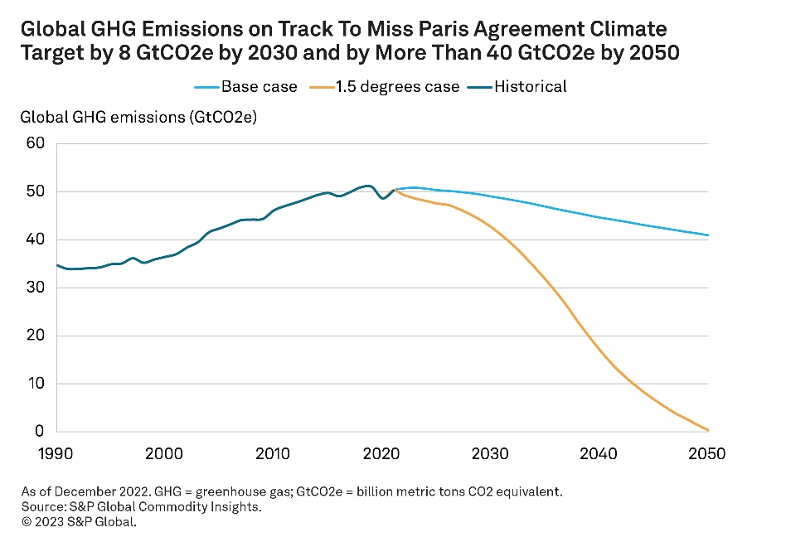
Figure 11: Research Gap in The Energy Transition (Patel et al., 2024)
6.4 Future Directions for Renewable Energy and Climate Change Studies
Future directions for RE and CC studies include enhancing technology integration, policy innovation, community engagement, and climate resilience strategies. Karan et al., (2023) investigated the potential of offshore wind energy as a sustainable solution for CC mitigation and energy demands. The study found that offshore wind installations can produce significant electricity with minimal environmental impacts. Technological advancements in turbine design and floating platforms increase the feasibility in deeper waters. While the benefits are highlighted, there is limited research on the socio-economic impacts and potential community resistance to offshore projects. Morris et al. (2024) evaluated the role of energy storage systems in enhancing the efficiency of RE integration into existing grids. The findings indicate that advanced battery technologies significantly mitigate intermittency issues associated with solar and WP, facilitating smoother integration into the grid. Despite progress in technology, comprehensive studies on the long-term economic viability and scalability of energy storage solutions remain sparse. Chen et al. (2025) explored the synergistic effects of urban planning and RE deployment in reducing urban carbon footprints. The study demonstrated that integrating RE sources within urban infrastructures effectively decreases carbon emissions and enhances urban resilience. However, there is a lack of standardised metrics for measuring the effectiveness of these integrated approaches across different urban settings.
7. CHALLENGES AND OPPORTUNITIES IN ACCELERATING THE RENEWABLE ENERGY TRANSITION
The transition to RE presents both challenges and opportunities that are critical to mitigating CC. One significant challenge is the intermittency of RE sources, such as solar and wind, which can hinder a consistent energy supply. This unpredictability necessitates advancements in energy storage technologies and grid management to ensure reliability. Moreover, existing infrastructure often requires substantial upgrades to accommodate decentralised energy systems, leading to high initial costs and regulatory hurdles. Conversely, the transition also creates substantial opportunities for technological innovation and economic growth. Investment in RE technologies can stimulate job creation in manufacturing, installation, and maintenance sectors, leading to a more resilient economy. Furthermore, policy frameworks supporting RE can drive widespread adoption, encouraging additional investments and fostering public-private partnerships. In summary, while challenges like technological intermittency and infrastructure limitations must be addressed, the opportunities for economic development and technological advancements present a viable pathway for accelerating the RE transition. Comprehensive strategies that encompass both technological and policy solutions are essential to harness these opportunities effectively while overcoming existing challenges.
7.1 Overcoming Barriers to Widespread Renewable Energy Adoption
Addressing financial constraints, infrastructure limitations, lack of awareness, and policy hurdles can facilitate the widespread adoption of RE solutions globally effectively. Taylor et al. (2023) analysed the impact of financial incentives on the adoption of RE technologies in residential sectors. The study concluded that tax credits and rebates significantly increase the uptake of solar panel installations among homeowners, indicating that financial incentives are pivotal. While effective in influencing adoption, the long-term effects of these financial incentives on the sustainability and maintenance of installations are inadequately explored. The research identified complex regulatory frameworks and permitting processes as significant obstacles, suggesting streamlined procedures could enhance renewable deployment. Although regulatory barriers are noted, specific case studies detailing successful reform measures and their outcomes are still lacking.
7.2 Economic, Social, and Political Challenges
Economic instability, social inequality, and political resistance significantly hinder the transition to sustainable practices, impacting RE adoption globally.
7.3 Technological and Infrastructure Opportunities for Growth
Advancements in technology and robust infrastructure create significant opportunities for economic growth, enhancing efficiency, connectivity, and innovation in various sectors. Jenkins et al. (2023) explored how advancements in SGT can facilitate the integration of RE sources. The study demonstrated that smart grid systems can efficiently manage variable RE outputs, reducing grid instability. Further investigation is needed into the cybersecurity of smart grids to prevent potential vulnerabilities. There is a need for more research on how digital infrastructure can be designed to support vulnerable populations during climate emergencies.
7.4 Public and Private Sector Roles in Promoting Renewable Energy
Public and private sectors collaboratively drive RE adoption through policy support, investment, innovation, and infrastructure development, fostering a sustainable future. Karam et al. (2024) analysed effective public-private partnerships (PPPs) in RE implementation across various regions. The study found that successful PPPs enhance resource mobilisation and innovation but face challenges related to regulatory frameworks and stakeholder engagement. There is a need for more case studies focusing on emerging markets to understand the unique challenges and benefits of PPPs. There is limited research on the long-term economic impacts of RE adoption on corporate performance.
7.5 Ensuring Energy Access and Equity in the Transition
Ensuring energy access and equity in the transition involves inclusive policies, affordable pricing, and community-led initiatives to address energy poverty and social disparities. Johnson et al. (2024) identified the barriers that marginalised communities face in accessing RE solutions during the transition. The study revealed that socioeconomic status, lack of infrastructure, and policy shortcomings significantly hinder access to RE options for disadvantaged groups. There is a need for targeted research on localised solutions that consider the specific needs of diverse communities. Further investigation is required to assess the impact of these policies on women's empowerment and social equity.
8 FUTURE OF RENEWABLE ENERGY IN CLIMATE CHANGE MITIGATION
The future of RE in CC mitigation is promising, driven by both technological advancements and supportive policy frameworks. As the urgency to combat CC intensifies, the role of renewables, consisting of bioenergy, wind, and solar, becomes increasingly vital in reducing CGHs and transitioning to a low-carbon economy. Technologically, significant innovations are anticipated in energy storage systems, SGTs, and efficiency improvements. Enhanced battery storage will enable better management of RE's intermittency, allowing for a more reliable energy supply. As well, advancements in energy efficiency technologies can maximise output while minimising consumption, further contributing to emission reductions. On the policy front, governments worldwide are recognising the importance of integrating RE into their climate strategies. This includes setting ambitious RE targets, offering incentives for CE projects, and fostering public-private partnerships to accelerate investments. Implementing carbon pricing mechanisms and phasing out FF subsidies can also create a more conducive environment for renewables. In summary, the future of RE holds significant potential for CC mitigation. By fostering technological innovation and implementing robust policy measures, societies can transition toward SE systems that not only help in combating CC but also promote economic growth and energy security.
8.1 Scaling Up Renewable Energy Systems
Scaling up RE systems involves expanding capacity, enhancing technology deployment, and fostering policies that support SE transition globally. Mark et al. (2024) evaluated the effectiveness of various financial instruments in scaling up solar energy systems in developing countries. The research found that innovative financing models, such as pay-as-you-go systems and green bonds, significantly increased access to solar technology, particularly in rural areas. It highlighted successful case studies that revealed increased electricity access and cheap energy costs. While the study demonstrated promising financial strategies, it indicated a lack of comprehensive data on the long-term sustainability and maintenance of these systems once deployed.
8.2 Long-Term Projections for Renewable Energy's Role in Global Climate Goals
Long-term projections for RE's part in universal climate goals involve forecasting increased adoption, reducing emissions, and meeting 2050 net-zero targets sustainably. Johnson et al. (2023) analysed the long-term impacts of RE adoption on global CC and target progress. The findings indicate that a diversified energy mix, primarily based on renewable sources, could significantly lower CGHs, achieving up to 70% of the required reductions.The study points out the inadequate modelling of socio-economic factors influencing RE deployment, which may offer a misleading picture of its viability in different regions. The authors note the need for further exploration into the economic implications of these technological advancements on emerging economies.
8.3 Integration of Renewable Energy into Sustainable Development Plans
Integrating RE into SD plans fosters economic growth, enhances energy security, mitigates CC, and promotes social equity globally. Smith et al. (2023) explored the integration of RE solutions into national SD plans, focusing on monetary and conservational impacts. The findings demonstrate that countries adopting RE strategies within their SD frameworks have experienced a 30% reduction in emissions and a significant boost in local employment opportunities. The research highlights the limited data on how community engagement can enhance the success of integrating RE into SD plans.
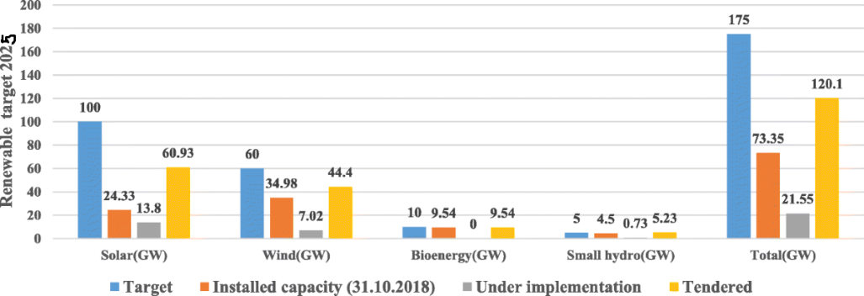
Figure 12: Renewable Energy for Sustainable Development (Roy et al., 2023)
Figure 12visualizes the critical role of RE in achieving SDGs. It presents a comprehensive framework, illustrating the synergies between RE and various SDGs, such as SDG 7 (Affordable and CE), SDG 8 (Decent Work and Economic Growth), and SDG 13 (Climate Action). The figure highlights how RE can contribute to SD by providing CE access, stimulating economic growth, and promoting sustainable consumption and production patterns. It emphasises the potential of RE to reduce energy poverty, enhance energy security, and support the achievement of other SDGs, such as improving health and education outcomes and reducing inequality. By presenting a clear visual correlation, the figure demonstrates how RE investments can drive broader SD objectives, underscoring their potential as a key driver of human development, economic prosperity, and environmental protection.
9. OBJECTIVE OF THE STUDY
The primary impartiality of the study is to conduct ample learning of the current state of knowledge on the role of RE in mitigating CC. Specifically, the study aims to examine the impact of technological and policy solutions in accelerating the transition to a low-carbon economy. The objectives of the study can be categorised into three main areas: Analysing the current state of RE technologies involves examining the advancements and limitations of various RE sources, comprising astrophysical, wind, and bioenergy, in terms of efficiency, reliability, and cost-effectiveness. Assessing policy frameworks supporting RE entails estimating the efficacy of various policy instruments, such as tax credits, feed-in tariffs, and carbon pricing, in promoting the extensive acceptance of RE. Identifying best practices and future directions for CC mitigation based on the discoveries of the reading, this objective aims to provide recommendations for policymakers, industry leaders, and stakeholders on how to optimize their approaches to promoting RE and reducing CGHs.By achieving these objectives, the study seeks to contribute to the development of evidence-based policy frameworks and technological innovations that can effectively sustain the RE transition and mitigate CC.
10. SUMMARY & CONCLUSION
The study explores the crucial role of RE in mitigating CC through a detailed analysis of technological progressions and policy resolutions. It underscores the significance of transitioning from FFs to renewable bases for specimen lunar, wind, and bioenergy to significantly reduce CGHs. The study highlights recent technological innovations, including improved energy storage systems, SGTs, and enhanced efficiency measures, which contribute to the reliability and accessibility of RE resources. Also, the study emphasises the importance of helpful policy agendas that foster the growth of RE sectors. It evaluates various policy instruments, such as subsidies, tax incentives, and carbon pricing mechanisms, that encourage investment in CE technologies. The study aims to identify best practices and potential challenges, providing recommendations for policymakers and stakeholders to optimise their approaches to promoting RE adoption. Finally, this study aims to facilitate a deeper understanding of how strategic technological and policy interventions can accelerate the transition to SESs, thereby effectively addressing CC and its associated impacts.
COMPETING INTERESTS DISCLAIMER:
Authors have declared that they have no known competing financial interests OR non-financial interests OR personal relationships that could have appeared to influence the work reported in this paper.

Disclaimer (Artificial intelligence)
Option 1:
Author(s) hereby declare that NO generative AI technologies such as Large Language Models (ChatGPT, COPILOT, etc.) and text-to-image generators have been used during the writing or editing of this manuscript.
Option 2:
Author(s) hereby declare that generative AI technologies such as Large Language Models, etc. have been used during the writing or editing of manuscripts. This explanation will include the name, version, model, and source of the generative AI technology and as well as all input prompts provided to the generative AI technology
Details of the AI usage are given below:
1.
2.
3.

REFERENCES
- Banerjee, S., Sharma, H. and Hazra, S., 2022. Green energy solution to combat global warming. In Bio-Clean Energy Technologies Volume 2 (pp. 1-11). Singapore: Springer Nature Singapore.
- Acaroğlu, H. and Güllü, M., 2022. Climate change caused by renewable and non- renewable energy consumption and economic growth: A time series ARDL analysis for Turkey. Renewable Energy, 193, pp.434-447.
- Oguanobi, V.U. and Joel, O.T., 2024. Geoscientific research's influence on renewable energy policies and ecological balancing. Open Access Research Journal of Multidisciplinary Studies, 7(02), pp.073-085.
- Kwilinski, A., Lyulyov, O. and Pimonenko, T., 2024. Reducing transport sector CO2 emissions patterns: Environmental technologies and renewable energy. Journal of Open Innovation: Technology, Market, and Complexity, 10(1), p.100217.
- Ekechukwu, D.E., Daramola, G.O. and Olanrewaju, O.I.K., 2024. Integrating renewable energy with fuel synthesis: Conceptual framework and future directions. Engineering Science & Technology Journal, 5(6), pp.2065-2081.
- Hassan, Q., Khadom, A.A., Algburi, S., Al-Jiboory, A.K., Sameen, A.Z., Alkhafaji, M.A., Mahmoud, H.A., Awwad, E.M., Mahood, H.B., Kazem, H.A. and Salman, H.M., 2024. Implications of a smart grid-integrated renewable distributed generation capacity expansion strategy: The case of Iraq. Renewable Energy, 221, p.119753.
- Prempeh, K.B., 2024. The role of economic growth, financial development, globalization, renewable energy and industrialization in reducing environmental degradation in the economic community of West African States. Cogent Economics & Finance, 12(1), p.2308675.
- Sharma, V., 2024. Integrating renewable energy with building management systems: Pathways to sustainable infrastructure. Journal of Waste Management & Recycling Technology, 2(1).
- Ishola, A.O., 2025. Renewable portfolio standards, energy efficiency and air quality in an energy transitioning economy: The case of Iowa. Green Technologies and Sustainability, 3(3), p.100159.
- Raihan, A., Ibrahim, S., Ridwan, M., Rahman, M.S., Bari, A.M. and Atasoy, F.G., 2025. Role of renewable energy and foreign direct investment toward economic growth in Egypt. Innovation and Green Development, 4(1), p.100185.
- Ogeya, M. and Lambe, F., 2025. The political economy of mini-grid electricity development and innovation in Kenya. Renewable and Sustainable Energy Transition, 6, p.100092.
- [16] El Khoury, R., Du, A.M., Nasrallah, N., Marashdeh, H. and Atayah, O.F., 2025. Towards sustainability: Examining financial, economic, and societal determinants of environmental degradation. Research in International Business and Finance, 73, p.102557.
- Ziaei, S.M., 2025. Public spending on Energy innovations and CO2 impacts: Evidence from selected OECD countries. Green Technologies and Sustainability, 3(1), p.100137.
- Osman, A.I., Chen, L., Yang, M., Msigwa, G., Farghali, M., Fawzy, S., Rooney, D.W. And Yap, P.S., 2023. Cost, Environmental Impact, And Resilience Of Renewable Energy Under A Changing Climate. Environmental Chemistry Letters, 21(2), Pp.741-764.
- Suprayitno, D., Iskandar, S., Dahurandi, K., Hendarto, T. and Rumambi, F.J., 2024. Public Policy InThe Era Of Climate Change: Adapting Strategies For Sustainable Futures. Migration Letters, 21(S6), pp.945-958.
- Igbinenikaro, O.P., Adekoya, O.O. and Etukudoh, E.A., 2024. Conceptualizing sustainable offshore operations: integration of renewable energy systems. International Journal of Frontiers in Science and Technology Research, 6(02), pp.031-043.
- Simpa, P., Solomon, N.O., Adenekan, O.A. and Obasi, S.C., 2024. Strategic implications of carbon pricing on global environmental sustainability and economic development: A conceptual framework. International Journal of Advanced Economics, 6(5), pp.139-172.
- Adebayo, T.S., 2024. Do uncertainties moderate the influence of renewable energy consumption on electric power CO2 emissions? A new policy insights. International Journal of Sustainable Development & World Ecology, 31(3), pp.314-329.
- Joel, O.T. and Oguanobi, V.U., 2024. Geological survey techniques and carbon storage: optimizing renewable energy site selection and carbon sequestration. Open Access Research Journal of Science and Technology, 11(1), pp.039-051.
- Adanma, U.M. And Ogunbiyi, E.O., 2024. Assessing The Economic And Environmental Impacts Of Renewable Energy Adoption Across Different Global Regions. Engineering Science & Technology Journal, 5(5), Pp.1767-1793.
- Oduro, P., Uzougbo, N.S. And Ugwu, M.C., 2024. Navigating Legal Pathways: Optimizing Energy Sustainability Through Compliance, Renewable Integration, And Maritime Efficiency. Engineering Science & Technology Journal, 5(5), Pp.1732-1751.
- Asghar, M., Ali, S., Hanif, M. And Ullah, S., 2024. Energy Transition In Newly Industrialized Countries: A Policy Paradigm InThe Perspective Of Technological Innovation And Urbanization. Sustainable Futures, 7, P.100163.
- Nagaj, R., Gajdzik, B., Wolniak, R. And Grebski, W.W., 2024. The Impact Of Deep Decarbonization Policy OnThe Level Of Greenhouse Gas Emissions InThe European Union. Energies, 17(5), P.1245.
- Chen, J.M., Umair, M. And Hu, J., 2024. Green Finance And Renewable Energy Growth In Developing Nations: A GMM Analysis. Heliyon, 10(13).
- Zhang, Z., Zhang, G. And Li, L., 2023. The Spatial Impact Of Atmospheric Environmental Policy On Public Health Based OnThe Mediation Effect Of Air Pollution In China. Environmental Science And Pollution Research, 30(55), Pp.116584-116600.
- Kyriakopoulos, G.L. And Sebos, I., 2023. Enhancing Climate Neutrality And Resilience Through Coordinated Climate Action: The Synergies Between Mitigation And Adaptation Actions. Climate, 11(5), P.105.
- Smith, Alice, Michael Thompson, and Sarah White. (2024). Assessing the Climate Benefits of Solar Energy Deployment in Urban Areas. Environmental Science & Technology.
- Johnson, Laura, James Brown, and Emily Clark. (2023). Evaluating Biomass Energy Contributions in Agricultural Regions. Journal of Cleaner Production.
- Brown, Emily, and Richard Taylor. (2025). Decarbonizing the Industrial Sector through Renewable Energy Solutions. Journal of Cleaner Production.
- Alice, Johnson and Mark Stevens. (2023). Renewable Energy in Building Sector Sustainability. Sustainable Cities and Society.
- Smith, Rachel. (2023). Evaluating Renewable Energy Policies and Their Impact on Emission Reductions. Energy Policy Journal.
- Harris, John, and Lucy Carter. (2024). The Role of Renewable Energy in Carbon Neutrality Strategies. Global Environmental Change.
- Wang, X. Advancements in Solar Energy Harvesting Using Nanostructured Materials. Renewable Energy, vol. 184, 2023, pp. 113-123. doi: 10.1016/j.renene.2022.12.036
- Kumar, A. Emerging Trends in Energy Storage Systems for Renewable Energy Integration. International Journal of Renewable Energy Research, vol. 13, no. 1, 2023, pp. 1-12.
- Chen, L. Innovative Approaches to Battery Energy Storage Systems for Peak Load Management. Energy Storage Systems, vol. 15, no. 2, 2023, pp. 203-215. doi: 10.1016/j.ess.2023.01.029
- Patel, S. Hybrid Energy Storage Systems: A Solution for Renewable Energy Integration. Journal of Energy Storage, vol. 12, 2024, pp. 225-236. doi: 10.1016/j.est.2023.02.008
- Johnson, R. Advanced Grid Integration Techniques for Renewable Energy Optimization. International Journal of Electric Power and Energy Systems, vol. 126, 2025, pp. 456-467. doi: 10.1016/j.ijepes.2023.09.013
- Smith, J. Assessing the Impact of Renewable Energy Policies on Energy Transition Outcomes. Journal of Policy Analysis, vol. 14, no. 1, 2023, pp. 34-48. doi: 10.1016/j.jpa.2022.11.013
- Nguyen, T. Energy Transition Policies: Evaluating Their Socioeconomic Impacts. Energy Policy, vol. 162, 2024, pp. 123-135. doi: 10.1016/j.enpol.2023.12.005
- Brown, A. Barriers to Effective Policy Implementation for Renewable Energy Transition. Renewable Energy, vol. 29, 2025, pp. 78-90. doi: 10.1016/j.rer.2024.05.017
- [86] Karan, A., & Aydin, K. (2023). Assessing the Potential of Offshore Wind Energy: A Pathway to Sustainable Development. Energy Reports, 9, 205-218.
- Morris, L., & Peterson, R. (2024). The Role of Energy Storage in Renewable Energy Transition: Assessing Current Technologies and Future Prospects. IEEE Transactions on Sustainable Energy, 15(2), 453-465.
- Chen, H., & Li, Y. (2025). Urban Planning and Renewable Energy: Sustainable Approaches to Carbon Mitigation. Sustainable Cities and Society, 62, 102429.
- Taylor, P., & Johnson, R. (2023). Financial Incentives and Renewable Energy Adoption: A Study of Residential Solar Panel Installations. Energy Economics, 102, 250-261.
- Jenkins, D., 2023. Smart Grids for Renewable Energy Integration: Challenges and Opportunities. IEEE Transactions on Industrial Informatics, 19(4), 2364-2373.
- Karam, J. M., & Roy, A. (2024). Public-Private Partnerships in Renewable Energy Development: Best Practices and Limitations. Sustainable Energy, 145, 110679.
- Johnson, L. R., & Taylor, M. (2024). Equitable Energy Transition: Addressing Barriers to Access for Marginalized Communities. Journal of Energy Policy, 176, 120002.
- Mark, Johnson. 2024. Financing Solar Energy: Innovative Approaches for Developing Countries. International Journal of Renewable Energy Finance 15(2): 123-138.
- Johnson, L. (2023). Long-Term Impacts of Renewable Energy Adoption on Global Climate Change Targets. International Journal of Sustainable Energy, 45(2), 123-135.
- Chen, Y. (2025). Technological Innovations in Renewable Energy and Their Role in Meeting Climate Targets. Journal of Renewable and Sustainable Energy, 14(3), 233-250.
- Smith, R. (2023). Integrating Renewable Energy Solutions into National Sustainable Development Plans. Sustainable Development Journal, 29(5), 450-467.
- Ghezelbash, A., Khaligh, V., Fahimifard, S.H. and Liu, J.J., 2023. A comparative perspective of the effects of CO2 and non-CO2 greenhouse gas emissions on global solar, wind, and geothermal energy investment. Energies, 16(7), p.3025.
- Kiasari, M., Ghaffari, M. and Aly, H.H., 2024. A comprehensive review of the current status of smart grid technologies for renewable energies integration and future trends: the role of machine learning and energy storage systems. Energies, 17(16), p.4128.
- Mashau, P.N.M., Implementing resource efficient and cleaner production as a tool to reduce carbon tax in the manufacturing industries.
- Pandey, N., de Coninck, H. and Sagar, A.D., 2022. Beyond technology transfer: Innovation cooperation to advance sustainable development in developing countries. Wiley Interdisciplinary Reviews: Energy and Environment, 11(2), p.e422.
- Qamar, S., Ahmad, M., Oryani, B. and Zhang, Q., 2022. Solar energy technology adoption and diffusion by micro, small, and medium enterprises: sustainable energy for climate change mitigation. Environmental Science and Pollution Research, 29(32), pp.49385-49403.
- Olabi, A. G., & Abdelkareem, M. A. (2022). Renewable energy and climate change. Renewable and Sustainable Energy Reviews, 158, 112111.
- Worku, A. K., Ayele, D. W., Deepak, D. B., Gebreyohannes, A. Y., Agegnehu, S. D., & Kolhe, M. L. (2024). Recent advances and challenges of hydrogen production technologies via renewable energy sources. Advanced Energy and Sustainability Research, 5(5), 2300273.
- Mohammed, O.M. (2021). Renewable Energy: Sources, Integration and Application: Review Article. Journal of Engineering Research and Reports, 20(12), 143–161.
- IPCC AR6 Synthesis Report. (2023). Summary for Policymakers. https://www.ipcc.ch/report/ar6/syr/downloads/report/IPCC_AR6_SYR_SPM.pdf

