Analysis of Climate Change Indicators in the Niger Delta Region

Abstract

Climate change is considered to be a change in the climatic conditions over a period due to anthropogenic or natural causes and is considered as one of the natural factors which affect landscape patterns. Therefore, this study assessed the fluctuation and trend in climate change indicators in the Niger Delta Region. This study adopted a cross-sectional research design method while the data set of thirty years from NIMET (Nigeria Meteorological Agency) of 1986 - 2016 were employed in the study, both, descriptive and inferential statistics and student t-test with the aid of graphs and charts were also reflected in the study. The results shows that years with maximum temperature above the mean annual value includes, 1987, 1995, 1998, 2000, 2002, 2003, 2004, 2008, 2009, 2010, 2016. 2016 and 2006 had the maximum and minimum temperature record of 31.76 and 30.25 °C respectively. The average temperature and rainfall increased by 27 °C and 2700 mm, respectively, from 1986 to 2016. By correlation analysis of changes with meteorological factors from 1986 to 2016, the results indicated that changes might be not directly related to temperature and rainfall changes with other land use change. This study concludes that among other things to promote in climate change study is to build resilience, policy reform in climate change awareness.

Keywords: Climate Change, Fluctuation, Trend, Variables.

Introduction
Environmental change in IPCC utilization alludes to an adjustment of the condition of the environment that can be recognized (e.g., utilizing factual tests) by changes in the mean or potentially the fluctuation of its properties, and that continues for a lengthy period, commonly many years or longer. It insinuates any change of climate long term, whether as a result of Environmental Change (IPCC) sees climate as the quantifiable portrayal concerning the mean and variability of the significant barometrical sums, for instance, temperature and precipitation over a huge time interval, which could go from months to thousands or millions of years (IPCC, 2014).In this respect, ecological change is seen as a change of the climatic conditions over a period due to anthropogenic or normal causes which this study embraced as a working definition on natural change. Ecological change has become maybe of the most essential concern in all fields overseeing barometrical correspondences and practical development. It is seen as a huge risk to the perseverance of species and wetland natural frameworks (Ikehi et al., 2023; Sam et al., 2023). Natural change is described as the long change in the estimations of the environment for a given spot and season, over the long run. Ecological change is described including environment parts that go about as markers. IPCC contemporary report on ecological change and a far reaching temperature help IPCC (2013 and 2018) has surveyed the typical example of overall temperature throughout the hour of years 1880-2012, it being identical to 0.85°C, with a degree of weakness going of 0.65°C - 1.06 °C. The climb occurred during the years 2003-2012 is +0.78°C - for something like 0.72°C and a restriction of 0.85 °C (IPCC, 2018; Wali et al., 2020). Public Climatic Server ranch (NCDC) thinks 2014 as the most blazing year anytime recorded, with an irregularity of +, not set in stone for the time 1880-2014 (NOAA, 2015).
The variability in the climate of the Niger Delta region have been declared by different investigates across disciplines, for example, Wali et al., (2020) assessments temperature and precipitation instability in the Niger Delta district of Nigeria. The outcome shows that temperature and precipitation in the assessment zone are on the other hand related. This recommends that as the temperature develops, precipitation lessens in the assessment zone. Nevertheless, the outcome is quantifiably insignificant (p > 0.05). Definitively the information shows that impact of regular change is generally affecting temperature in the locale. Furthermore, in a like cerebrum way, Odigwe et al., (2020) investigate the climate of the Niger Delta Region of Nigeria to decide the assortments in precipitation and temperature of the district over 94 years. The survey revealed that the mean transport of precipitation and temperature in the locale for the past 94 (94) years showed a dropping and up design with a mean of 2238.3mm and 26.7oC in precipitation and temperature independently. While, the most raised and least precipitation (2600.7mm and 1854mm), was kept in 1955 and 1984 which exhibits an augmentation of 746.7mm. The most raised and least temperature (27.4oC and 25.9oC) was kept in 2017, 1977 and 1976 independently which exhibit a rising of 1.5oC. Nwafor et al., (2018) using vector auto in reverse strategies exhibited meteorological data in picked states in Southern Nigeria with emphasis on month to month precipitation and temperature a period of 1972 - 2011. The expected worth from the showed data proposes continues with extension in proportion of month to month precipitation and temperature at different assurance range.
Moreover, Abdullahi et al., (2020) saw that proximity to the Atlantic Ocean and geology contributed phenomenally to assortment in precipitation credits in Nigeria. Despite the spatial differences in precipitation designs, precipitation got across the audit period in Nigeria is unsurprising. Akwa-Ibom and Rivers state are two states in the Niger Delta that has very proximity to the Atlantic Ocean. At any rate there seem, by all accounts, to be discernible assortment in the nature of temperature and precipitation ascribes especially at the yearly scale. This assortment despite having near land ascribes calls for testing to perceive where changes is more expressed. To handle what is going on, this study attempts to look at temperature and precipitation variance over the two ocean front states in the Niger delta area of Nigeria.
In this survey, our point is to see whether the Niger Delta region has experienced characteristic of natural change. The guide isn't toward anticipate future precipitations and temperatures yet to see the advancement of the characteristics of ecological change during the period (1986 to 2016) over the audit region.
Materials and Techniques
The auxiliary information consolidate rough NIMET climatic information of temperature and precipitation from 1986-2016. A basic straight relapse examination, specifically the Least un-square, Different direct relapse, ANOVA, procedure or direct backslide, connection investigation and Understudy's T-test were utilized to distinguish climatic patterns over the long run series. Understudy T-test was utilized to test the meaning of the acquired climatic pattern. Likewise, graphic factual procedures were used to summarize the properties of temperature and precipitation in the survey district. Standard least square backslide method was used to evaluate design in the time series data. Individual thing second association method was used to spread out the association among temperature and precipitation.
The Review Region
The area of study is Niger Delta Region of Nigeria, itself is a convoluted of wetlands covering around 76,000sq km a short depiction of the geography is given underneath (Okonkwo et al.,2015; Iza, 2018). With the ultimate objective of this survey, the Niger Delta district is portrayed as including the area covered by the normal delta of the Niger River and the locales toward its east and west. The customary farthest reaches of the Niger River Delta has been portrayed by its geology and hydrology (ERML, 1997; UNDP, 2006). Its northern cutoff points are tracked down close to the bifurcation of the Niger River at Aboh, while as far as possible are around the Benin River independently. The entire area covers 2,370 square kilometers consolidates Rivers, springs and estuaries and 8,600 square kilometers is included flat swamp (Akachi, 2011; Okonkwo et al., 2015; Iza, 2018). Possibly on account of the possibility of the area, the significant specific climate found in the zone consolidate impediment islands, estuaries, mangroves, freshwater swamps, bog rainforests, Rivers and River lets (Ajao et al., 2002; Iza et al., 2017) Expressly, studies have referred to the presence of six extraordinary organic zones including rainforest, mangrove, flood woods zone, eastern flank, marsh woodlands zone and obstacle islands (Recoil, 2007; Ayanlade, 2014; Iza, 2018). One more audit has organized the climate to consolidate rainforest, mangrove, freshwater swamps, mountain district and derived savanna (Ayanlade, 2014). This proposes slight assortment as creator might want to ponder different ecological zone in the Niger Delta. Conventionally, with the major natural zones as of late referred to, an enormous number of them fall inside the mangroves (estuarine, marine, limit Island), freshwater boondocks and swamp rainforest organic framework. According to Akachi (2011) noted in Iza, (2018), the Niger Delta climate is significantly unique and can maintain a couple of terrestrial and maritime living things. From a greater point of view Niger Delta region, includes six states (See Fig.1) (Akwa Ibom, Bayelsa, Cross River, Delta, Edo, and Rivers) and 185 local government (UNDP, 2016).
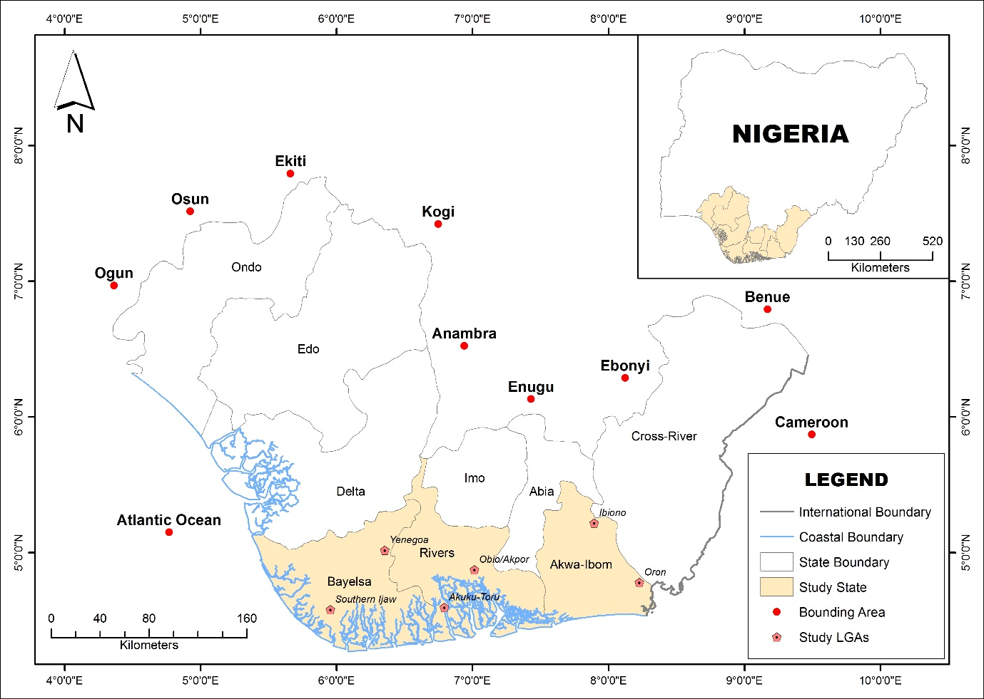

Figure 1: Niger Delta Region Showing Study States and Sampling LGAs.
(Source: Cartography and GIS Unit, Dept. of Geography and Environmental Sustainability, UNN, 2024).
Location/Extent
From Geographical arranging, Niger Delta region of Nigeria is arranged along the Straight of Guinea (Enaruvbe et al., 2014). It is the world's third greatest and Africa's greatest Delta. It is moreover West and Central Africa's most wide wetland (Akegbejo-Samsons&Omoniyi, 2009). The area loosens up from Aboh (5°33′49″ N and 6°31′38″ E) in the North to palm point (4°16′22″ N and 6°05′27″ E) in the South. The East-West limit is between Benin River estuary (5°44′11″ N and 5°3′49″ E) in the West and Imo River estuary (4°27′16″ N and 7°35′27″ E) eastward (Niger Delta Regular Review (NDES), 1997). The Niger Delta locale connects over an area of around 75,000 square kilometers tending to around 12% of Nigeria's full scale surface district. The region orchestrate along a shore of 560 km, contains around 66% of the entire shore of Nigeria and six of Nigeria's constituent states.
The Niger Delta locale of Nigeria features inside a hurricane climate of transitory zone of Koppen Af climatic sorts that changes from the blistering focal forest sort in the southern bogs to the soggy wildernesses in the northern high nations and the cool montane sort in the Obudu level district with postponed and significant stormy season and very short dry season quite a while in the region. Simply the extended lengths of December and January truly qualifies as dry season seemingly forever in the area. During the dry season, the upper east trade wind blowing over the Sahara Desert grows its getting dried out influence consistently towards the equator, showing up at the southern coastline of Nigeria in late December or early January. The period is known as the "Harmattan", which is more noticeable in specific years than others. The harmattan, which climatically influences various metropolitan networks in West Africa, is less expressed in the Niger Delta. The heaviest precipitation in the space occurs among Spring and October (Oyegun and Adeyemo, 1999).
The mean yearly precipitation is put at 2,000mm (Ayoade, 1993). However furthermore goes from over 4,000mm in the ocean front towns of Bonny and Metal in Rivers and Bayelsa States independently, and lessens inland to 3,000mm in the mid-delta around Ahoada in Rivers State, Yenagoa in Bayelsa State, and Warri in Delta States, exclusively; and fairly under 2,400mm in the northern bits of the area. In the north western parts including Edo and Ondo States, yearly precipitation goes from 1,500 - 2,000mm. The Niger Delta locale commonly has a fleeting finish of deluge consistently known as "August Break" (a dry spell) that in between the focal point of the stormy season. The locale has an ordinary month to month temperature above 270C and there is palatable sogginess in basically all of the months. In the district, temperatures are to some degree consistent (high with a mean restriction of around 34oC and a mean least of around 210C); showing little assortment over the range of the year. Relative moisture over Niger Delta is more than 80-90% during the stormy season as a result of the inescapability of warm drenched air mass and high disappearing from the different Rivers and Rivers during this season. In January, depicting the dry season, relative dampness is reduced widely to around 50-60% in view of the impact of the drier tropical central area air mass (Inyang, 1975).
Results and Conversation

Vacillations and Pattern in Environmental Change Markers in the study Area
Temperature is a fundamental environment variable that straightforwardly influences human and normal frameworks and a vital mark of environmental change. The variance and pattern in greatest temperature in the Niger Delta locale is introduced in Figure 2. It is seen that the qualities change from one year to another. The mean greatest temperature esteem during the time span is 31.09°C with a vertical pattern during the time under review. The years with most extreme temperature over the mean yearly worth incorporates, 1987, 1995, 1998, 2000, 2002, 2003, 2004, 2008, 2009, 2010, 2016. 2016 and 2006 had the most extreme and least temperature record of 31.76 and 30.25 °C individually.
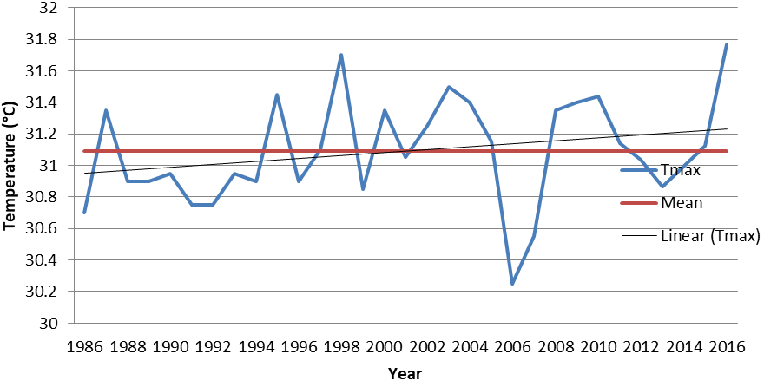

Figure 2: Fluctuations and trend in maximum temperature in the study area (1986-2016)
Figure 3 shows the variations and trend in minimum temperature in the Niger Delta region. During the study period the years with the lowest and highest temperature records are 1989 and 2009 respectively. It has a coefficient of variation of 1.24% and an increasing upward trend of 0.0117°C per year.
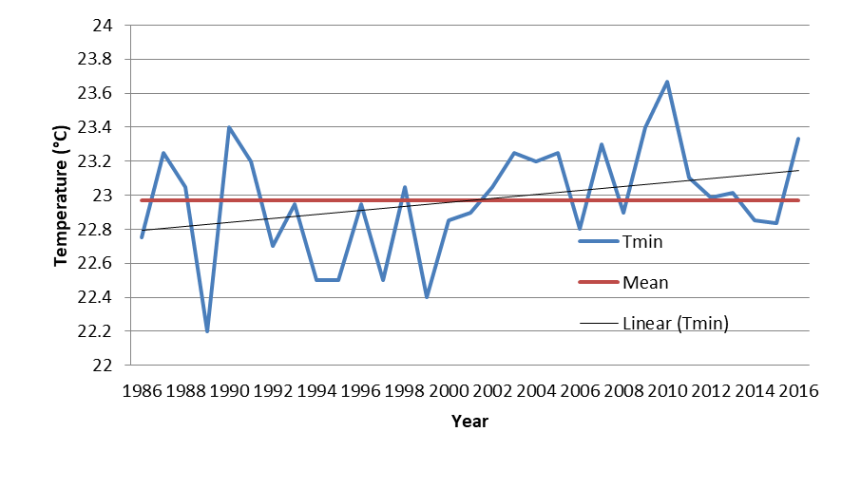

Figure 3: Fluctuations and trend in minimum temperature in the study area (1986-2016)

Fluctuation and trend in mean temperature in the study area is shown in figure 4. Mean temperature value varies from year to year, with the highest and lowest record observed in 2010 (27.55°C) and 2006 (26.52°C). The average temperature for the time period is 27.03°C with a standard deviation of 0.271°C and a Coefficient of variation of 1.00%. Years with above mean temperature includes 1987, 1990,1998, 2000, 2002, 2003,2004, 2005, 2008, 2009, 2010, 2011 and 2016.

Figure 4: Fluctuations and trends in mean temperature in the study area (1986-2016)

Fluctuation and trend in rainfall in the study area is shown in figure 5. The mean annual rainfall value is 2696.42mm with a standard deviation of 322.65mm and a coefficient of variation of 11.97%. Also increasing trend of 0.0106mm per year was observed in the region. The years with below mean rainfall includes 1986 to 1994, 1998, 2000 to 2006, 2008to 2010. The year with the lowest and highest rainfall amount are 2004 (2115.55mm) and 2012 (3483.45mm) respectively.

Figure 5: Fluctuations and trend in rainfall in the study area (1986-2016)
The linear trends in maximum, minimum, mean temperatures and rainfall have been assessed over the period from 1986 to 2016. Table 1 depicts the descriptive statistics, trend and T-test result for the analyzed climatic elements at the 95% significance level. Over all the results demonstrate that there is a significant upward trend in the entire elements with the exception of maximum Temperature. Also, the rate of increase varies from one element to the other. In terms of variability, rainfall is more variable than Temperature in the study region.

Table 1: Descriptive statistics and hypothesis test for change in climatic variables
Climate Element | Mean | Trend | R | Sig | Decision | Coefficient of variation (%)
Tmin | 22.75 | 0.0117 | 0.323 | 0.000 | Ho is rejected | 1.45
Tmax | 31.09 | 0.0094 | 0.26 | 0.214 | Ho is accepted | 1.08
Tmean | 27.03 | 0.0106 | 0.36 | 0.041 | Ho is rejected | 1.00
Rainfall | 2696.42 | 19.336 | 0.55 | 0.000 | Ho is rejected | 11.97

From the result presented in Table 1 above, it can be deduced that there have been significant changes in rainfall, minimum and mean temperature in the study region. This shows that the climate of the region has and is still undergoing changes especially towards higher day-time temperature and increasing rainfall amount.

Furthermore, we assessed decadal changes in climatic variables in the study area. Changes are calculated using the mean climatology as the baseline. Table 2 shows the result. It is deduced that temperature has been generally on the increase during the three decades under study with the exception of maximum and mean temperature during 1987 to 1996 period. In addition, there are changes in rainfall amount within this period, with decrease in rainfall noted in the first two decades.

Table .2: Decadal changes in climate variables in the Niger Delta
Decade | ΔT_Maximum (°C) | ΔT_Minimum (°C) | ΔT_Mean (°C) | ΔRainfall Total (mm)
1987-1996 | -0.12 | 0.12 | -0.105 | -119.91
1997-2006 | 0.06 | 0.175 | 0.0125 | -140.25
2007-2016 | 0.066 | 0.389 | 0.123 | 285.085

Among the temperature variables, minimum temperature had the highest level of change within the study area with reference to the baseline. The relationship between climate change indicators in the Niger Delta was determined using Pearson correlation and their level of significance tested using T-test. The relationship shows that there is a negative strong relationship between climatic elements in the study region. (i.e., as climate change indicators is increasing other factors is decreasing).
In the past 30 years, the climate in the study area has turned from Warm-Dry to Warm-Wet. The average temperature and rainfall increased by 27 °C and 2700 mm, respectively, from 1986 to 2016. By correlation analysis of climate changes indicators from 1986 to 2016, the results indicated that changes might be not directly related to temperature and rainfall alone. The regional differences and the interannual variation trend, caused by the change of rainfall pattern was the main driving factors for the dynamic variation of changes in the study area. Climate change dynamics are the consequence of the interactions among various factors, such as geological structure, climatic conditions and supplement patterns. Climate change, especially temperature and rainfall, observably impacts the human form. Therefore, understanding climate changes and their fluctuations and trends under anthropic disturbance is more complicated.

Conclusion and Recommendations

The result of the analysis indicated that in the past 30 years, climate in the study area has turned from warm-dry to warm-wet which has impacted the Niger Delta environment. The mean maximum temperature during this period is 31.09°C with an upward trend. The years with maximum temperatures above the mean annual include 1987, 1995, 1998, 2000, 2002, 2003, 2004, 2008, 2009, 2010, and 2016 respectively. This present study concludes that among other things to promote in climate change study is to build resilience, policy reform in climate change awareness. Researching into climate change science scenario is worthwhile, since climate change science is gaining its ground in the study area. Therefore, this study recommends the following:
- Niger Delta region should be made to meet nature’s need and be consistent with sustaining resilient and functioning ecological systems under changing climate;
- There must be comprehensive and continuous monitoring of environmental resources of the country to provide up-to-date information required to manage the impact of changing climate.
- The country should advance policy reform (including sustainable implementation of the new policy) and champion a new Nigerian climate ethic in the face of changing climate.
- A climate change awareness Program should be developed that could be rolled out at local level to provide local government officials with the necessary tools to engage with this issue and implement the strategies that are identified.

Disclaimer (Artificial intelligence)
Option 1:
Author(s) hereby declare that NO generative AI technologies such as Large Language Models (ChatGPT, COPILOT, etc) and text-to-image generators have been used during writing or editing of manuscripts.
Option 2:
Author(s) hereby declare that generative AI technologies such as Large Language Models, etc have been used during writing or editing of manuscripts. This explanation will include the name, version, model, and source of the generative AI technology and as well as all input prompts provided to the generative AI technology
Details of the AI usage are given below:
1.
2.
3.

References

Abdullahi, M., Wali, E., Nwankwoala, H.O., & Stephen, H. (2020). Rainfall Change Detection in Africa Using Remote Sensing and GIS between 1999-2018. Big Data in Water Resources Engineering (BDWRE) 1(2), 52-54.

Ajao, E.A; Anurigwo S. (2002): Land-based sources of pollution in the Niger Delta, Nigeria. Ambio. 2002; 31(5):442‒445.
Akachi.O. (2011): Social Consequences of Environmental Change in the Niger Delta of Nigeria. Journal of Sustainable Development. 2011; 4(2):123– 135.

Akegbejo-Samsons, Y., &Omoniyi, I. T. (2009): Management challenges of mangrove forests in Africa: A critical appraisal of the coastal mangrove ecosystem of Nigeria. Nature and Faune, 24, 50–55.

Ayanlade, A. (2014): Remote Sensing of Environmental Change in the Niger Delta, Nigeria. PhD thesis submitted to Department of Geography, School of Social Sciences and Public Policy, King’s College London, University of London; 2014.

Ayoade, J.O. (1993): The Introductory Climatology for the Tropics. Spectrum Books Ltd., Ibadan, Nigeria.

Blench, R. (2007): The mammals of the Niger Delta in Nigeria. The Kay Williamson Education.
Enaruvbe, G. O., &Ozien P. Atafo (2014): Analysis of deforestation pattern in the Niger Delta region of Nigeria. Journal of Land use Science. Taylor & Francis. http: //dx.doi.org/10.1080/1747423X.965279.

ERML (1997): Environmental and Socio-economic Characteristics of the Niger Delta Phase 1: Volume 1. A report submitted by environmental resources managers limited to the Niger Delta Environmental Survey (NDES), Lagos, Nigeria.

Inyang, P. B. E. (1975): “Climate” in OFOMATA G. E. K. (Ed), Nigeria in Maps, Eastern State. Ethiope Publish House, Benin City. Pp 25-26.

IPCC (2013): Summary for policymakers. In T. F. Stocker, D. Qin, G.-K. Plattner, M. Tignor, S. K. Allen, J. Boschung, A. Nauels, Y. Xia, V. Bex and P. M. Midgley (eds.), Climate Change 2013: The Physical science basis. Contribution of working group into the fifth assessment report of the intergovernmental panel on climate change. Cambridge University Press, Cambridge, United Kingdom and New York, NY, USA.

IPCC (2018): IPCC Special Report on the Impacts of Global Warming of 1.5 _C – Summary for Policy Makers. Incheon, Korea.

Izah S.C, Angaye C.N, Aigberua A.O (2017): Uncontrolled bush burning in the Niger Delta region of Nigeria: potential causes and impacts on biodiversity. International Journal of Molecular Ecology and Conservation. 2017; 7(1):1‒15

Izah, S.C (2018): Ecosystem of the Niger Delta Region of Nigeria: Potentials and Threats. Biodiversity International Journal.2018; 2(4): 338-345.DOI:10.15406/bij.2018.02.00084

NDES Niger Delta Environmental Survey (1997): Final Report. Phase One: “Environment and Socio-Economic Conditions”, NDES, Lagos.

NOAA (2015). National Centres for Environmental Information, State of the Climate: Global Climate Report for Annual 2015, published online January 2016

Nwafor G.O; Omini E.E; Odok E.O (2018). Modeling Metrological Parameter via Vector Autoregressive. Scholars Journal of Physics, Mathematics and Statistics. Scholars Academic and Scientific Publishers (SAS Publishers) (An International Publisher for Academic and Scientific Resources.

Odigwe, M., Efe, S.I. and Atubi, A. (2020): A statistical discourse of the climate of the Niger Delta Region of Nigeria. Journal of Management and Social Science Research, Volume 1, Numbers 1/2, pp. 15-33, 2020.
Okonkwo, C. N. P., Kumar, L. and Taylor, S. (2015). The Niger Delta wetland ecosystem: What threatens it and why should we protect it? African Journal Environmental Science Technology, Vol. 9(5), pp 451-463
Oyegun. C. U. and Adeyemo, A. (1999): “Port-Harcourt Region” (ed). Paragraphics Port Harcourt.pp.1-12.

UNITED NATIONS ENVIRONMENTAL PROGRAMMED (UNEP) (2007): The status of the Nigerian Coastal zone.

Wali, E., Abdullahi, M., Nwankwoala, H O, Ekwezuo, C., Hemba, S., &Johnmark, O. (2020). Analysis of Temperature and Rainfall Variability over two Coastal States in the Niger Delta, Nigeria, Annals of Geographical Studies, 3(2), 1-6.

Ikehi ME, Ifeanyieze FO, Onu FM, Ejiofor TE, Nwankwo CU. Assessing climate change mitigation and adaptation strategies and agricultural innovation systems in the Niger Delta. GeoJournal. 2023 Feb;88(1):209-24.
Sam MG, Nwaogazie IL, Ikebude C, Irokwe JO, El Hourani DW, Inyang UJ, Worlu B. Comparative Analysis of Climatic Change Trend and Change-Point Analysis for Long-Term Daily Rainfall Annual Maximum Time Series Data in Four Gauging Stations in Niger Delta. Open Journal of Modern Hydrology. 2023 Aug 24;13(4):229-45.

