Original Research Article
Comparative Study of Antagonistic Effect of Soil-Derived Strains of Trichoderma harzianum Against Sclerotinia sclerotium (Lib). de Bary Under in Vitro conditions

ABSTRACT
Sclerotinia sclerotiorum (Lib.) de Bary is a soil-borne plant fungal pathogen with a broad host range and infects over 400 plant species at all growth and development stages. In chickpeas,it affects both the seedlings as they tend to collapse at the soil line and in grown up plants experience stem rot and non specific wilting. Trichoderma spp. act as an effective biocontrol agent for managing myriads of plant pathogens affecting various crops at different stages of growth. The research aimed to compare the antagonistic potential of lab-maintained Trichoderma harzianum strains (SV-1, SV-2, SV3, SV-14, SV-18, and IRRI-1) with those re-isolated from soil after intervals of 30, 60 and 90 days. Its already known that pathogens if subcultured for long suffer from attenuation in their virulence, on the similar lines we intended to determine whether some degree of loss in their antagonistic potential over the same strains inoculated and re-isolated from their natural ecological niche existed or so. In a dual culture assay, re-isolated strains demonstrated superior antagonistic effects on the pathogen's mycelial growth compared to lab-maintained counterparts. Notably, re-isolated strain SV-18 exhibited a 14.83% increase in antagonistic activity compared to the mother culture, while others showed an increase ranging from 6.99% to 9.32% after 30 days. Although the difference was slightly reduced after 60 days, it underscored the potential loss in antagonistic efficacy for Trichoderma harzianum strains subjected to decade long culturing and sub-culturing. Furthermore, a significant variation was reported in the inhibition %age between the re-isolations performed statistically as F(static) 46.3426 was reported to be much larger than the critical value .These findings highlight the significance of re-isolated strains outperforming in inhibiting the pathogen, emphasizing the importance of biocontrol agents functioning optimally in their natural ecological niches.
Keywords- Antagonistic activity, Biocontrol, Chickpea, Strains, Trichoderma
Introduction
Chickpea (Cicer arietinum L.) is the third most important pulse crop worldwide, following dry beans and peas. Global chickpea production reached approximately 15.87 million tons with an area of 16.01 million hectares in 2022 (FAOSTAT 2022). India is the largest producer of chickpeas globally, contributing around 64.47% of the total production. With a cultivated area spanning 11.97 million hectares and a yield of 9.53 million tonnes, chickpea production in the country remains substantial (Gautam & Maurya, 2023). In recent years, the cultivation of chickpeas has seen significant hindrances due to biotic and abiotic stresses; prominently Sclerotinia stem rot caused by Sclerotinia sclerotiorum. (Lib.) de Bary, is the major disease of chickpea crops. The disease has been reported in India from Himachal Pradesh (Gerwal and Pal in 1986). The disease poses a formidable threat to chickpea production, urging the need for effective control strategies. (Sharma et al., 1999). The overreliance of farmers on fungicides in agriculture has severely damaged ecosystem (Groth, 1993; Ou, 1985), causing biomagnification in organisms and leading to ecological dead ends (Liu et al., 2016; Rusell et al., 2008). They can linger longer in the soil, air, and water, posing a risk to human health and causing diseases like cancer (Lefrancq et al., 2013; Larramendy et al., 2016). About two million tons of pesticides are used worldwide, with herbicides accounting for 47.5%, insecticides for 29.5%, fungicides for 17.5%, and other pesticides for 5.5% (De et al 2014). Biological control of pests, often involves using microorganisms or their metabolites that interact with a plant or its pathogens to control the latter's growth, restrict its negative influence on the host plant, and preserve ecological balance (Kohl et al., 2019).
Certain microorganisms are used commercially to inhibit the growth of phytopathogens. Trichoderma, in particular, is extensively explored as a biocontrol agent against fungal phytopathogens. The recognition of Trichoderma’s potential as a biocontrol agent managing plant disease dates back to early the early 1930s. Specifically, species such as T. harzianum, T. asperellum, and T. virens have been identified as effective biological control agents (BCAs) (Elad et al., 1981; Agrosin et al., 1997; Singh et al., 2007; Tondje et al. 2007 and Joshi et al. 2016). As a promising BCA, Trichoderma employs various antagonistic mechanisms like mycoparasitism, antibiosis, and competition. (Meng et al., 2019; Ghasemi, S. et al., 2020). Over the following years, numerous reports have highlighted its effectiveness in controlling various plant diseases. (Ty´skiewicz et al., 2022). Noteworthy species such as T. harzianum and T. virens have demonstrated efficacy against prevalent soil-borne pathogens like Sclerotium rolfsii and Fusarium oxysporum. (Zin et al., 2020). Research on Trichoderma's antagonistic activities highlights its substantial potential in hindering pathogen growth. However, continuous in vitro-culturing of Trichoderma strains may impact their competitive abilities, necessitating exploration within their original ecological niche (Naar et al., 1998). Trichoderma bio-control agents undergo mass multiplication through solid-state or liquid-state fermentation to facilitate large-scale utilization, resulting in talc-based formulations for efficient field application (Srivastava et al., 2014).Three Trichoderma isolates, T. harzianum-8, T. atroviride PTCC5220 and T. longibrachiatum PTCC5140 have been found to effectively inhibit the growth of S. sclerotiorum, among which T. atroviride showed the most significant reduction (85-93%) in growth and could be used for field biocontrol against S. sclerotiorum (Matroudi et al., 2009). The antagonistic effect was attributed to diffusible metabolites, leading to hyphal breakage and swelling of S. sclerotiorum (Sharma, 1994). Wang et al. (2022) evaluated the antagonistic effect of Trichoderma sp. and found that two Trichoderma strains effectively inhibit the Sclerotinia disease of Asarum. Abdullah et al. (2008) studied the potential of T. harzianum as a biological control agent against S. sclerotiorum as they found it to mycoparasitize the pathogen by coiling over it and leading to hyphal swellings.
Although Trichoderma's antagonistic mechanisms have been extensively studied, and its effectiveness in disease management is well-known, the impact of continuous in vitro culturing on its efficiency raises important questions. This study was designed to compare the antagonistic effect of in vitro cultured strains of Trichoderma harzianum strains with those obtained after inoculation and reisolation from soil after every 30 days for a period of 90 days against S. sclerotium (Lib.) de Bary.

Material and Methods

Antagonistic strains and fungal pathogen
The six Trichoderma harzianum strains (SV-1, SV-2, SV-3, SV-14, SV-18 and IRRI-1) and pathogen Sclerotinia sclerotiorum strain were obtained from biocontrol laboratory of Division of Plant Pathology, Sardar Vallabhbhai Patel University of Agriculture Technology, Meerut, India. All the fungal strains were subcultured on potato dextrose agar (PDA) slants, incubated at 25±2ºC for 7 days and then kept in refrigerator for long term utilization at 4ºC.

Comparing bio-control efficacy of Trichoderma strains against Sclerotinia Sclerotiorum in vitro and in vivo
To determine and compare the biocontrol efficacy of T. harzianum strains under two set of given conditions.
Sterilised soil weighing about 2kg, autoclaved at 121°C at 15 psi pressure for 20 min were taken in 40cm earthen pots. To this soil, the mass multiplied bioagent strains SV-1, SV-2, SV-3, SV-14, SV-18 and IRRI-1, multiplied on wheat grains were added @ 10g per kg of soil. At an interval of every 30 days after inoculation of soil, re-isolation of Trichoderma from the pot conditions were performed by serial dilution plate technique to the dilution factor of 10⁻⁴ from all six different treatments for the period of 90 days.
Before soil application and after isolation from the soil, the colony count of the inoculum were determined by calculating cfu/g of the bioagent. (Rafique et al., 2016).
On the day of isolation, in addition to the isolated strains, the pure cultures of already maintained similar strains in the lab were maintained too in Petri-plates on PDA, i.e., in vitro set. Therefore, we had two sets of 6 strains, one pre-maintained under in vitro conditions and the other re-isolated from soil i.e., in vivo set, and each maintained strain from both the sets were put to confrontation dual culture assay and also to determine the possible difference in antagonistic activity between the pre-maintained Trichoderma and after re-isolation from soil.

Evaluation of antagonistic activity (Dual culture technique)
The antagonistic activity of Trichoderma harzianum strains against fungal pathogen Sclerotinia sclerotiorum was evaluated using dual culture technique (Awad et al., 2018, Shrama et al., 2011). Mycelial bits of 6mm diameter of antagonistic strains were inoculated in PDA plates and placed at 1.5 cm from the side of the plate, in the same way mycelium bits of fungal pathogen was placed on opposite side of the antagonistic strain (T. harzianum strains) on the PDA plates. Plates inoculated with fungal pathogen Sclerotinia sclerotiorum were kept as control and all the plates were incubated at 25±2ºC for 5 days, radial growth of the pathogen was measured after 4th and 7th day of incubation.
The efficacy of the bioagent and inhibition in the growth of the pathogen over control was calculated by using the following formula (Vincent, 1947).
Inhibition percentage (I)= R1-R2 x 100
R2
Where,
I = Inhibition of mycelial growth
R1 = Growth of pathogen in control
R2 = Growth of pathogen in treatment.
Statistical analysis
Data were statistically analysed by OPSTAT (Shorean et al.,1998) using ANOVA. Design of experiment was CRD and the experiments were done in replication of 3 and the data were presented as the average of the triplicates ± standard error. See the supplementary table 1 and 2 at the last of manuscript.
Results
Antagonistic activity of T. harzianum strains maintained in the lab conditions (in vitro set)

The efficacy of different T. harzianum strains against S. sclerotioum was assessed in vitro using a dual culture technique (see table 1).On the fourth day, the control plate registered maximum mycelial growth at 4.9cm, while IRRI1 exhibited minimal growth at 3cm. Other strains (SV-1, SV-18, SV-2, and SV-14) displayed mycelial growth ranging from 3.1 cm to 3.3cm, with SV-3 reaching 3.7cm. IRRI-1 achieved the highest mycelial inhibition at 38.77%, whereas SV-3 showed the lowest at 24.48%. Mycelial inhibition for SV-1, SV-18, SV-2, and SV-14 ranged between 32.65% and 36.73%. On the seventh day, Trichoderma overgrowth led to reduced S. sclerotiorum mycelial growth in the dual culture plate. SV-2 exhibited the least growth at 1.8cm, followed by IRRI-1, SV-1, SV-14, and SV-3, ranging from 1.97cm to 2.1cm.SV-18 displayed maximum growth at 2.5cm, while the control treatment exhibited radial growth of 8cm. Strain SV-2 exhibited the highest mycelial inhibition at 77.5%, while SV-18 showed the lowest inhibition at 68.75%. Trichoderma strains IRRI-1, SV-1, SV-14, and SV-3 demonstrated mycelial inhibition of 75.35%, 75%, 75%, and 73.75% respectively, respectively. Overall, all T. harzianum strains effectively inhibited the pathogens mycelial growth, with SV-2 being the most potent, achieving minimal growth and maximal inhibition. SV-18 exhibited the least inhibition, While SV-1, SV-14, and SV-3 showed similar inhibition levels.
Table: 1. Study of antagonistic activity of Trichoderma harzianum strains maintained in the lab conditions (in vitro set)

S. No | Treatment | Radial growth of pathogen S. sclerotiorum (cm) |  | Percentage inhibition (%)
 |  | 4th day | 7th day | 4th day | 7th day
1. | SV-1 | 3.1 | 2 | 36.73 | 75
2. | SV-2 | 3.3 | 1.8 | 32.65 | 77.5
3. | SV-3 | 3.7 | 2.1 | 24.48 | 73.75
4. | SV-14 | 3.3 | 2 | 32.65 | 75
5. | SV-18 | 3.13 | 2.5 | 36.12 | 68.75
6. | IRRI-1 | 3.00 | 1.97 | 38.77 | 75.35
7. | Control | 4.9 | 8
10. | CD | 1.30
11. | SE m | 0.43

Antagonistic activity of T. harzianum strains re-isolated after 30 days of inoculation into soil against S. sclerotiorum.
After 30 days of T. harzianum inoculation into the soil, re-isolation revealed varying mycelial growth inhibition against S. sclerotiorum. Strain SV-1 exhibited the highest inhibition 62% on day 4, while SV-2 demonstrated superior inhibition 85.55% on day 7, emphasizing their potential as biocontrol agents (Table 2 and figure 2).
Table:2. Bio-efficiency of the re-isolated Trichoderma harzianum strains after 30 days of inoculation into soil against Sclerotinia sclerotiorum.

S. No. | Treatment | Radial growth of pathogen S. sclerotiorum  (cm) |  | Percent inhibition (%)
 |  | 4th day | 7th day | 4th day | 7th day
1. | SV-1 | 1.93 | 1.27 | 62 | 84.32
2. | SV-2 | 2.07 | 1.17 | 58.6 | 85.55
3. | SV-3 | 2.17 | 1.50 | 56.6 | 81.48
4. | SV-14 | 2.23 | 1.40 | 55.4 | 82.71
5. | SV-18 | 2.03 | 1.43 | 59.4 | 82.34
6. | IRRI-1 | 2.20 | 1.33 | 56 | 83.58
7. | Control | 5 | 8.10
8. | CD | 1.75
9. | SE m | 0.58

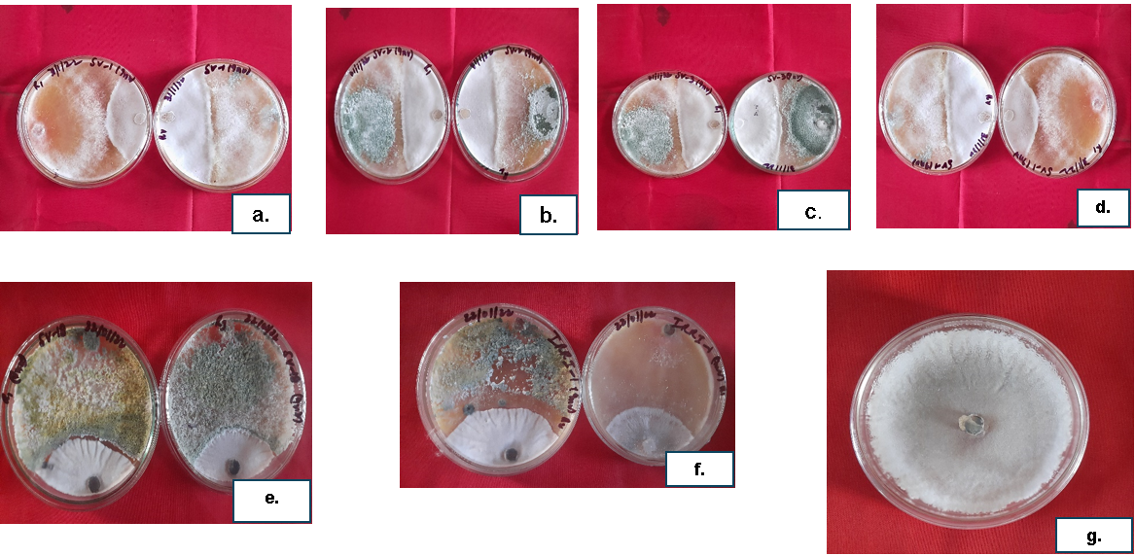

Figure 1: Antagonistic activity of T. harzianum strains re-isolated after 30 days of inoculation into soil against S. sclerotiorum: a. SV-1 strain. b. SV-2 strain, c. SV-3 strain, d. SV-14, e. SV-18, f. IRRI-1, g. Control
Antagonistic activity of T. harzianum strains re-isolated after 60 days of inoculation into soil against S. sclerotiorum.
After 60 days of T. harzianum inoculation into soil, a second re-isolation was performed. On the 4th day, SV-1 exhibited the least mycelial growth 2.1cm, while SV-14 showed the maximum 2.4cm. SV-1 also had the highest mycelial inhibition 59.79% on day 7, outperforming other strains, including SV-3 with lowest inhibition 81.25%. Overall, all strains inhibited S. sclerotiorum, with SV-1 demonstrating superior performance in minimising pathogenic fungus growth. (Table. 3 and Fig.3).
Table: 3. Bio-efficiency of the re-isolated Trichoderma harzianum strains after 60 days of inoculation into soil against Sclerotinia sclerotiorum.
S. No. | Treatment | Radial growth of pathogen S. sclerotiorum  (cm) |  | Percent inhibition (%)
 |  | 4th day | 7th day | 4th day | 7th day
1. | SV-1 | 2.1 | 1.03 | 59.79 | 87.12
2. | SV-2 | 2.23 | 1.06 | 56.87 | 86.75
3. | SV-3 | 2.23 | 1.5 | 54.48 | 81.25
4. | SV-14 | 2.4 | 1.4 | 51.02 | 82.5
5. | SV-18 | 2.27 | 1.44 | 53.67 | 82
6. | IRRI-1 | 2.37 | 1.36 | 51.63 | 83
7. | Control | 5 | 8.0
8. | CD | 1.79
9. | SE m | 0.60%

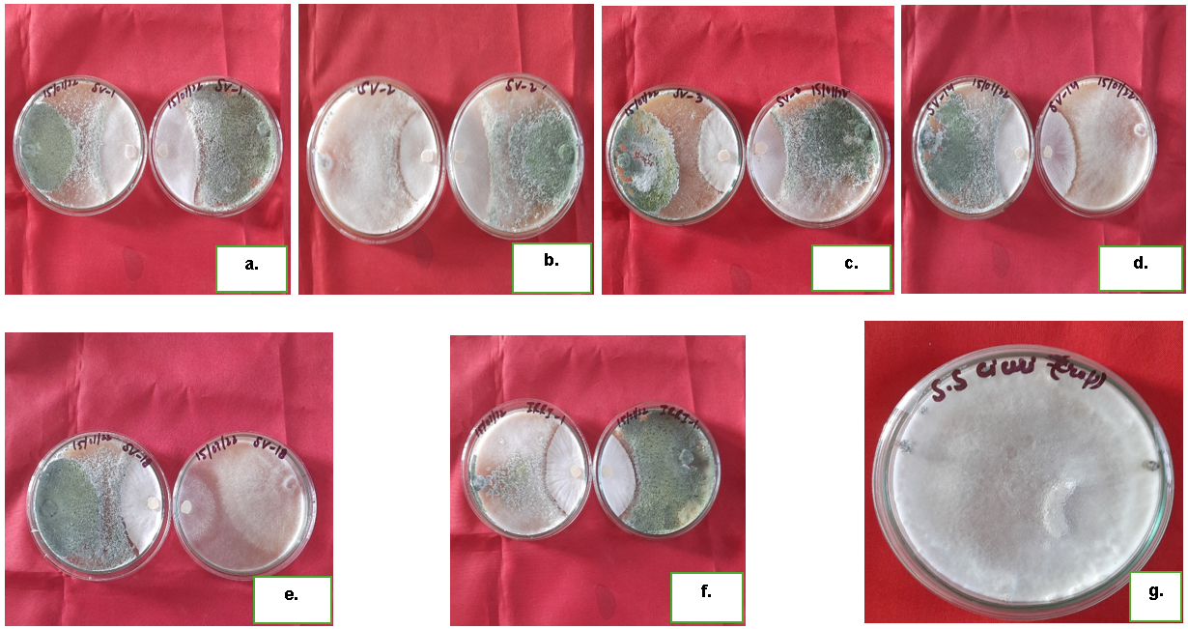

Figure 2: Antagonistic activity of T. harzianum strains re-isolated after 60 days of inoculation into soil against S. sclerotiorum: a. SV-1 strain. b. SV-2 strain, c. SV-3 strain, d. SV-14, e. SV-18, f. IRRI-1, g. Control

Antagonistic activity of T. harzianum strains re-isolated after 90 days of inoculation into soil against S. sclerotiorum.
After 90 days of T. harzinum inoculation into soil, a third re-isolation was conducted. On the 4th day, SV-3 showed the least mycelial growth 2.1cm, while SV-1 exhibited the maximum 2.77cm. SV-3 also demonstrated the highest mycelial inhibition 50% on day 4, outperforming SV-1 with lowest inhibition 38.5%. On day 7, SV-2 had the minimum mycelial growth 1.03cm, and SV-3 exhibited the maximum inhibition 88.55%. Overall, all strains effectively inhibited S. sclerotiorum, with SV-3 showing superior performance in minimising pathogenic fungus growth, especially on day 4. (Table. 4 and fig.4).

Table: 4. Bio-efficiency of the re-isolated Trichoderma harzianum strains after 90 days of inoculation into soil against Sclerotinia sclerotiorum.

S.No | Treatment | Radial growth of pathogen S. sclerotiorum (cm) |  | Percent inhibition (%)
 |  | 4th day | 7th day | 4th day | 7th day
1. | SV-1 | 2.77 | 1.07 | 38.5 | 88.11
2. | SV-2 | 2.43 | 1.03 | 42.14 | 88.55
3. | SV-3 | 2.1 | 1.4 | 50 | 84.44
4. | SV-14 | 2.17 | 1.13 | 48.33 | 87.44
5. | SV-18 | 2.3 | 1.23 | 45.23 | 86.33
6. | IRRI-1 | 2.5 | 1.1 | 40.47 | 87.77
7. | Control | 4.2 | 9
8. | CD | 2.50
9. | SE m | 0.81
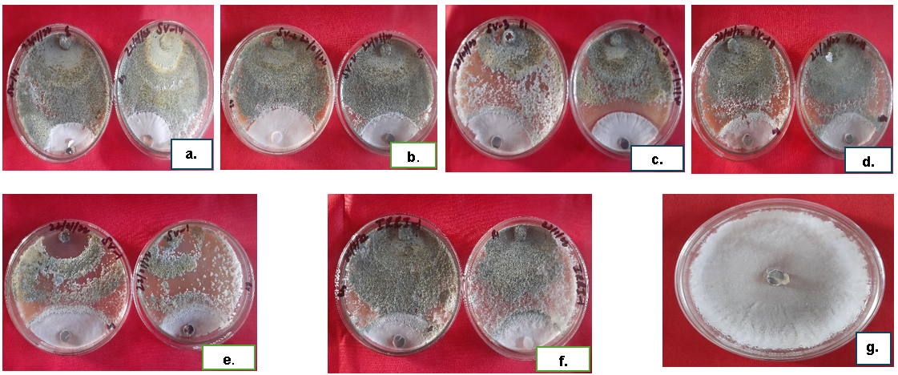
Figure 3: Antagonistic activity of T. harzianum strains re-isolated after 90 days of inoculation into soil against S. sclerotiorum: a. SV-1 strain. b. SV-2 strain, c. SV-3 strain, d. SV-14, e. SV-18, f. IRRI-1, g. Control

Fig 4: Line plot of the 7th and 4th day inhibition percentage of isolated strains of Trichoderma harzianum after 30, 60 and 90 days alongwith lab-maintained set.

Comparison of inhibition percentage between re-isolated T. harzianum strains after 30, 60 and 90 days of inoculation into soil and old lab-maintained Trichoderma strains.
Over varying intervals of 30, 60 and 90 days, the antagonistic activity of strains, initially preserved in lab conditions for over 10 years, was evaluated after re-isolation from soil. Significant changes were observed in their antagonistic capabilities. After 30 days, Trichoderma strain SV-3 exhibited a notable 32.12% increase, followed by SV-2 with a 25.95% increase. During the 5th day incubation in dual culture, strains SV-1, SV-18, and IRRI-1 showed an increase of 25.27%, 23.28%, and 17.23% respectively, compared to their original strains. On the 7th day, a decreasing trend in antagonism was observed, with SV-18 leading with a 13.6% increase. After 60 days, a general decrease in antagonism was noted, with SV-18 showing the highest increase at 14.83%. On the 7th day, SV-18 exhibited the maximum increase 13.25%, followed by SV-1, 12.12%. For the 90th day re-isolation, SV-18 led with a 17.58% increase on the 7th day. Overall. The results highlight the dynamic nature of antagonistic activity in Trichoderma strains over different durations of soil inoculation. (Table 5).

Table: 5. Comparison of bio efficiency of in vitro maintained strains with that of re-isolated from the soil after every 30 days
Treatments | After 4th day of incubation |  |  | After 7th day of incubation
 | Increase in inhibition percentage of T. harzianum 30 days after re-isolation from soil. | Increase in inhibition percentage of T. harzianum 60 days after re-isolation from soil | Increase in inhibition percentage of T. harzianum 90 days after re-isolation from soil | Increase in inhibition percentage of T. harzianum 30 days after re-isolation from soil. | Increase in inhibition percentage of T. harzianum 60 days after re-isolation from soil. | Increase in inhibition percentage of T. harzianum 90 days after re-isolation from soil.
SV-1 | 25.27 | 9.32 | 1.77 | 9.32 | 12.12 | 13.11
SV-2 | 25.95 | 8.05 | 9.49 | 8.05 | 9.25 | 11.05
SV-3 | 32.12 | 7.73 | 25.52 | 7.73 | 7.5 | 10.69
SV-14 | 22.75 | 7.71 | 15.68 | 7.71 | 7.5 | 12.44
SV-18 | 23.28 | 14.83 | 9.11 | 13.6 | 13.25 | 17.58
IRRI-1 | 17.23 | 6.99 | 1.7 | 8.23 | 7.65 | 12.42

Discussion
Biocontrol agents in agriculture are gaining much attention as a viable alternative to fungicides. One such biocontrol agent is Trichoderma, which employs different mechanisms to deter the growth of phytopathogens. Our study showed the antagonistic efficacy of Trichoderma strains as a biocontrol agent against S. sclerotiorum, a devastating fungal pathogen that causes stem rot in chickpea crops. The overreliance on fungicides to control this pathogen has led to environmental damage and increased production costs, necessitating the exploration of sustainable alternatives like biological control.
The research focuses on T. harzianum strains SV-1, SV-2, SV-3, SV-14, SV-18, and IRRI-1, exploring their changes in antagonistic abilities under different conditions after prolonged laboratory maintenance. Findings highlight significant variations in antagonism between strains maintained in vitro and those re-isolated from soil. Hernandez et al. (2011) studied in vitro antagonistic action of Trichoderma strains. They found that the mycelia growth inhibition of S. sclerotiorum and S. cepstrum were 45-63.8 and 50.9-81.5%, respectively, by the effect of Trichoderma strains. The antagonistic activity results indicate that all T. harzianum strains were effective in inhibiting the growth of S. sclerotiorum in vitro. The SV-2 strain showed the highest potency with minimal growth and maximal inhibition, while SV-18 exhibited the least. The other strains (IRRI-1, SV-1, SV-14, and SV-3) demonstrated similar levels of inhibition. The observed differences in inhibition levels among strains suggest the importance of strain selection for optimal disease control outcomes. Sharma et al. (1999) found that T. harzianum was the most effective bioagent in inhibiting Sclerotinia stem rot of chickpea, with a 75% inhibition rate. Absidia cylindrospora and T. viridae also exhibited significant inhibition, while Gliocladium virens showed the least inhibition of pathogens. Dubey and Suresh (2006) conducted a study to evaluate the antagonistic efficacy of 10 Trichoderma isolates. T. viride and T. harzianum were the most effective against Fusarium oxysporum f. sp. ciceris, with a fungal inhibition rate of 61.1% and 60%, respectively.
Re-isolation results of T. harzianum strains after 30 days of inoculation into soil showed that both strains (SV-1 and SV-2) were able to inhibit the mycelial growth of S. sclerotiorum to varying extents.
The re-isolation of T. harzianum strains from the soil after 30, 60, and 90 days of inoculation yielded varying levels of antagonistic activity against S. sclerotiorum. Interestingly, different strains displayed fluctuating patterns of mycelial growth inhibition over time. In the case of the 30-day re-isolation, SV-1 and SV-2 emerged as standout performers, with SV-2 demonstrating superior inhibition on day 7. However, the 60-day re-isolation revealed SV-1's remarkable efficacy in inhibiting mycelial growth, surpassing other strains, including SV-3, which exhibited the least inhibition. Contrarily, the 90-day re-isolation showcased SV-3's dominance, particularly on day 4, where it displayed the highest inhibition. Tančić et al. (2013) evaluated the effect of Trichoderma isolates isolated from different soils in various regions of Vojvodina, Serbia, using a dual culture assay against the pathogen Sclerotinia sclerotiorum. In a similar study, Yassin et al. (2022) found that strains of T. viride and T. harzianum isolated from soil were most effective against Alternaria alternate, showing an inhibition percentage of 75.04% and 67.83%, respectively.
The results obtained showed that all the isolates possess the capability to colonize and exhibit high radial growth inhibition against the tested pathogens. The changing patterns in growth inhibition emphasize the need to consider the time factor while evaluating the effectiveness of Trichoderma strains as biocontrol agents. Moreover, the varying degree of inhibition observed among different strains highlights the significance of conducting a strain-specific assessment to enhance disease management approaches through biocontrol agents. The present findings suggest a reduction in the antagonistic potential of microbial bioagents over extended storage in artificial media. Further detailed studies are necessary to conclusively determine methods for enhancing their antagonistic activity.

Conclusion and Summary
Based on a summary of the experimental findings, the following conclusions can be drawn. Considerable difference in the inhibition percentage in lab maintained and that of inoculated and re-isolated strains from the soil was observed i.e., highest inhibition percentage was observed in case of re-isolated strains than that of their original counterparts. Difference in inhibition percentage among the two sets of Trichoderma harzianum strains suggests that the strains maintained in the lab under artificial conditions have suffered some degree of loss in their antagonistic potential than that of re-isolated from their original ecological niche. Continuous artificial culturing of Trichoderma strains in the nutrient media has led to the domestication syndrome as a result of which they have suffered a partial loss in bio-control potential. Three repeated re-isolations from the soil after 30,60 and 90 days of inoculation and their exposure to dual culture assay suggest that Trichoderma harzianum strains tend to re-gain their full antagonistic potential after they were subjected to natural ecological conditions. Re-isolated strains SV-1, SV-2, SV-14 and IRRI-1 exhibited a considerable increase in inhibition percentage than that of their original counterparts. Re-isolated strains SV-3 and SV-18 also exhibited an increase in inhibition percentage than their original strains maintained in lab but overall proved to be weak performers than other re-isolated strains.
Disclaimer (Artificial intelligence)
Option 1: No use of generative AI technologies have been done.
Author(s) hereby declare that NO generative AI technologies such as Large Language Models (ChatGPT, COPILOT, etc) and text-to-image generators have been used during writing or editing of manuscripts.
Option 2:
Author(s) hereby declare that generative AI technologies such as Large Language Models, etc have been used during writing or editing of manuscripts. This explanation will include the name, version, model, and source of the generative AI technology and as well as all input prompts provided to the generative AI technology
Details of the AI usage are given below:
1.
2.
3.

References:
Abdullah, M. T., Ali, N. Y., & Suleman, P. (2008). Biological control of Sclerotinia sclerotiorum (Lib.) de Bary with Trichoderma harzianum and Bacillus amyloliquefaciens. Crop protection, 27(10), 1354-1359.
Agosin, E., Volpe, D., Mun~ oz, G., San Martin, R., & Crawford, A. (1997). Effect of culture conditions on spore shelf life of the biocontrol agent Trichoderma harzianum. World Journal of Microbiology and Biotechnology, 13(2), 225-232.
Awad NE, Kassem HA, Hamed MA, et al. Isolation and characterization of the bioactive metabolites from the soil derived fungus Trichoderma viride. Mycology. 2018;9:70–80.
De, A., Bose, R., Kumar, A., & Mozumdar, S. (2014). Targeted delivery of pesticides using biodegradable polymeric nanoparticles (Vol. 10, pp. 978-81). New Delhi: Springer India.
Dubey, S. C., & Suresh, M. (2006). Randomly amplified polymorphic DNA markers for Trichoderma species and antagonism against Fusarium oxysporum f. sp. ciceris causing chickpea wilt. Journal of phytopathology, 154(11‐12), 663-669.
Elad, Y., Chet, I., & Henis, Y. (1981). Biological control of Rhizoctonia solani in strawberry fields by Trichoderma harzianum. Plant and Soil, 60, 245-254.
FAO (2022) FAOSTATdata.http://faostat.fao.org/.
Gautam, D. K., & Maurya, N. (2023). Economics of chickpea (Cicer arietinum L.) Production in India: A Descriptive View.
Ghasemi, S.; Safaie, N.; Shahbazi, S.; Shams-Bakhsh, M.; Askari, H. The Role of Cell Wall Degrading Enzymes in Antagonistic Traits of Trichoderma virens Against Rhizoctonia solani. Iran J. Biotechnol. 2020, 18, e2333.
Grewal, J. S., & Pal, M. (1986). Fungal disease problems of chickpea. Vistas in plant pathology, 157-70.
Hernandez Castillo, F. D., Berlanga Padilla, A. M., Gallegos Morales, G., Cepeda Siller, M., Rodriguez Herrera, R., Aguilar Gonzales, C. N., & Castillo Reyes, F. (2011). In vitro antagonist action of Trichoderma strains against Sclerotinia sclerotiorum and Sclerotium cepivorum.
Joshi, D., Singh, P., Singh, A. K., Lal, R. J., & Tripathi, N. (2016). Antifungal potential of metabolites from Trichoderma sp. against Colletotrichum falcatum went causing red rot of sugarcane. Sugar Tech, 18, 529-536.
Khan, M. J., Zia, M. S., & Qasim, M. (2010). Use of pesticides and their role in environmental
Köhl, J., Kolnaar, R., & Ravensberg, W. J. (2019). Mode of action of microbial biological control agents against plant diseases: relevance beyond efficacy. Frontiers in plant science, 845.
Kunstadter, P. (2007). Pesticides in Southeast Asia: environmental, biomedical, and economic uses and effects (pp. xi+-326).
Larramendy, M., & Soloneski, S. (Eds.). (2016). Environmental Health Risk: Hazardous Factors to Living Species. BoD–Books on Demand.
Lefrancq, M., Imfeld, G., Payraudeau, S., & Millet, M. (2013). Kresoxim methyl deposition, drift and runoff in a vineyard catchment. Science of the total environment, 442, 503-508.
Liu, Y., Li, S., Ni, Z., Qu, M., Zhong, D., Ye, C., & Tang, F. (2016). Pesticides in persimmons, jujubes and soil from China: Residue levels, risk assessment and relationship between fruits and soils. Science of the Total Environment, 542, 620-628.
Matroudi, S., & Zamani, M. R. (2009). Antagonistic effects of three species of Trichoderma sp. on Sclerotinia sclerotiorum, the causal agent of canola stem rot. Egyptian Journal of Biology, 11.
Meng, X.; Miao, Y.; Liu, Q.; Ma, L.; Guo, K.; Liu, D.; Ran, W.; Shen, Q. TgSWO from Trichoderma guizhouense NJAU4742 promotes growth in cucumber plants by modifying the root morphology and the cell wall architecture. Microb. Cell Factories 2019, 18, 148.
Mustafa, A., Khan, M. A., Inam-ul-Haq, M., Khan, S. H., & Pervez, M. A. (2009), Mass multiplication of Trichoderma spp. on organic substrate and their effect in management of seed borne fungi. Pak. J. Phytopathol, 21(2): 108-114.
Naar, Z., & Kecskés, M. (1998). Factors influencing the competitive saprophytic ability of Trichoderma species. Microbiological Research, 153(2), 119-129.
Rosell, G., Quero, C., Coll, J., & Guerrero, A. (2008). Biorational insecticides in pest management. Journal of Pesticide Science, 33(2), 103-121.
Schreinemachers, P., & Tipraqsa, P. (2012). Agricultural pesticides and land use intensification in high, middle and low income countries. Food policy, 37(6), 616-626.
Shahid, M., Srivastava, M., Singh A., Kumar, V., Pandey, S., Sharma, A., Rastogi, S., Pathak, N. and Srivastava, A. K. (2014), Production of a nove bioformulation of Trichoderma / Hyprocea using biotechnological approaches. African Journal of Agricultural Research. 9(24): 1895-1905.
Sharma, B.K. (1994), Efficacy of bio-control agents for the control of chickpea stem rot. J. Biol. Control 8: 115-117.
Sharma, S.K. (1995), Management of the stem rot of gram caused by Sclerotinia sclerotiorum (Lib.) de Bary. M.Sc. Thesis, Himachal Pradesh Krishi Vishvavidyalya, Palampur 87 pp.
Sharma, S.K., Verma, B.R. and Sharma, B.K. (1999), Bio-control of Sclerotinia sclerotiorum causing stem rot of chickpea. Indian Phytopathology. 52(1): 44-46 (1999).
Sheorean, O. P; Tonk, D. S; Kaushik, L. S; Hasija, R. C and Pannu, R. S (1998), Statistical Software Package for Agricultural Research Workers. Recent Advances in information theory, Statistics & Computer Applications by D.S. Hooda &R.C. Hasija. Department of mathematics Statistics, CCS HAU, Hisar, pp. (139-143).
Singh, A., Srivastava, S., & Singh, H. B. (2007). Effect of substrates on growth and shelf life of Trichoderma harzianum and its use in biocontrol of diseases. Bioresource technology, 98(2), 470-473.
Singh, S. P., & Singh, H. B. (2012). Effect of consortium of Trichoderma harzianum isolates on growth attributes and Sclerotinia sclerotiorum rot of brinjal. Vegetable Science, 39(2), 144-148.
Singh, S. P., & Singh, H. B. (2012). Effect of consortium of Trichoderma harzianum isolates on growth attributes and Sclerotinia sclerotiorum rot of brinjal. Vegetable Science, 39(2), 144-148.
Tancic, S. L. (2013). Impact of Trichoderma spp. on soybean seed germination and potential antagonistic effect on Sclerotinia sclerotiorum. Pesticides and Phytomedicine/Pesticidi i fitomedicina, 28(3).
Tondje, P. R., Roberts, D. P., Bon, M. C., Widmer, T. O. M. O. T. H. Y., Samuels, G. J., Ismaiel, A., ... & Hebbar, K. P. (2007). Isolation and identification of mycoparasitic isolates of Trichoderma asperellum with potential for suppression of black pod disease of cacao in Cameroon. Biological control, 43(2), 202-212.
Ty´skiewicz, R.; Nowak, A.; Ozimek, E.; Jaroszuk-Sciseł, J. Trichoderma: The Current Status of Its Application in Agriculture for ´ the Biocontrol of Fungal Phytopathogens and Stimulation of Plant Growth. Int. J. Mol. Sci. 2022, 23, 2329.
Vincent, J.M. (1947) Distortion of Fungal Hyphae in the Presence of Certain Inhibitors. Nature, 159, 850.
Wang, Z., Wang, Z., Lu, B., Quan, X., Zhao, G., Zhang, Z., ... & Tian, Y. (2022). Antagonistic potential of Trichoderma as a biocontrol agent against Sclerotinia asari. Frontiers in Microbiology, 13, 997050.
Weindling, R. (1934), Studies on a lethal principle effective in the parasitic action of Trichoderma lignorum on Rhizoctonia solani and other soil fungi. Phytopathology, 24(11), 1153-1179.
Yassin, M. T., Mostafa, A. A. F., & Al-Askar, A. A. (2022). In vitro antagonistic activity of Trichoderma spp. against fungal pathogens causing black point disease of wheat. Journal of Taibah University for Science, 16(1), 57-65.
Zin, N.A.; Badaluddin, N.A. Biological functions of Trichoderma spp. for agriculture applications. Ann. Agric. Sci. 2020, 65, 168–178.

Supplementary:
ANOVA
Source of Variation | SS | df | MS | F | P-value | F crit
Between Groups | 548.3033 | 3 | 182.7678 | 37.56824 | 2.08E­08 | 3.098391
Within Groups | 97.29908 | 20 | 4.864954
Total | 645.6024 | 23
Table 1: ANOVA of the 7th day inhibition %age of treatments after 30, 60 and 90 days of isolation.

ANOVA
Source of Variation | SS | df | MS | F | P-value | F crit
Between Groups | 2195.589 | 3 | 731.8631 | 46.34263 | 3.45E­09 | 3.098391
Within Groups | 315.8488 | 20 | 15.79244
Total | 2511.438 | 23
Table 2: ANOVA of the 7th day inhibition %age of treatments after 30, 60 and 90 days of isolation.

In both the tests, F(static) is reported to be much larger than the critical-value and P-value very small, which reflects the significant difference between group means.

