Demarcation of potential groundwater recharge zones through Remote sensing, GIS, and MCDA: A case study of the Aji River Basin in Saurashtra, Gujarat, India

ABSTRACT
Groundwater is an important and valuable natural resource. Due to extensive agricultural practices and industrial developments, groundwater resources have recently been overexploited and depleted. Therefore, there is a need to adopt sustainable water resource management practices to augment groundwater recharge. This study uses advanced geospatial technologies to identify potential groundwater recharge zones in the Aji River Basin in the Saurashtra region of Gujarat, India. The primary objective was to enhance potential groundwater recharge zones in the Aji River basin region. Therefore, various parameters affecting groundwater availability, including lineament, geology, soil, density, slope, rainfall, land use/land cover, geomorphology, and drainage density, were considered for delineating potential groundwater recharge zones. The integrated approach, using remote sensing (RS), geographical information system (GIS), and multi-criteria decision analysis (MCDA), was employed to achieve this. The influence factor was determined through Satty`s analytic hierarchy process (AHP) method. The sub-parameters were ranked according to the AHP scale, and a weighted overlay analysis tool in ArcGIS software was utilized to map the potential groundwater recharge zones in the basin. The concluding map was categorized into five distinct zones based on potential groundwater recharge zones: ‘Excellent’ (50.50 km², 2.36 %), ‘Good’ (1376.78 km², 64.56 %), ‘Moderate’ (599.14 km², 28.09 %), ‘Poor’ (90.67 km², 4.25 %), and ‘Very Poor’ (15.32 km²,0.718 %). The SCS-Curve number method was employed to assess the potential for rainfall-induced runoff. The Aji River basin exhibited a weighted mean rainfall and runoff of 622.68 mm and 241.07 mm, respectively. The estimated weighted runoff for the Aji River basin was 514.07 million cubic meters (MCM), with a 75 % exceedance probability, resulting in a runoff of 152.97 MCM. This study concludes that integrating remote sensing, GIS, and MCDA techniques effectively identifies and delineates potential groundwater recharge zones, which is crucial for sustainable water resource management.
Keywords: Potential groundwater recharge zones, Groundwater recharge, Analytical hierarchy process, Geographical information system, Remote sensing, Aji river basin.
1. INTRODUCTION
Global climate change enhanced the probability of extreme weather variability, resulting in abiotic stresses like drought, salinity, floods, and heat waves, as well as biotic stresses such as infestation of pests and diseases that seriously affect crop production. Furthermore, the human population is increasing exponentially and will exceed 9.7 billion by 2050 [1]. Moreover, urbanization seriously threatens available agricultural land, indicating that feeding a population with limited land is a herculean task. Projected global food production of primary staple crop production and productivity has declined worldwide [26-27]. It affects biodiversity and ecosystem services of the agricultural production system. The adverse impact of climate change would be more significant in traditional semi-arid or arid rainfed zones, including India [2]. Arid and semi-arid zones in India are approximately 15.8 % and 37 %, respectively, nearly half of the total geographical areas. Hot arid regions falling states are Rajasthan (61 %), Gujrat (19.6 %), Haryana and Panjab (9 %), Andra Pradesh (7 %), Karnataka (3 %) and Maharashtra (0.4 %). This rainfed agriculture production system accounts for 40 % of the food grains and sustains 2/3rd of the livestock population [3].
Groundwater is essential for drinking, irrigation, and domestic and industrial use in these hot-arid areas. As Groundwater in this area is limited, quantity and quality are a severe concern in these areas [3]. Additionally, excessive groundwater extraction and insufficient recharge processes contribute to the depletion of water resources within aquifers. Previous studies showed groundwater recharge is most sensitive, where potential evapotranspiration exceeds precipitation. It showed that the recharge potential of the semi-arid and arid zones would be mostly negatively affected by climate change [4]. Recharging the groundwater is essential for sustainable human and water resource development. Future climate will mainly affect recharge through precipitation changes, amplifying groundwater recharge more than anticipated. Sensitivity to aridity, underestimated by global models, may significantly impact groundwater sustainability, surpassing prior forecasts [5]. Therefore, groundwater recharge potential study through remote sensing (RS) and geographic information systems (GIS) provides assessment, monitoring, and conservation of groundwater resources. Remote sensing imagery is applied to extract key features such as base map, geomorphology, rainfall, slope, drainage density, soil type, land cover, land use, lineament density, and geology [6]. The study involves the development of remote sensing algorithms for feature extraction (base map, geomorphology, etc.), integrate them in ArcGIS software using Satty`s analytic hierarchy process (AHP) and Multi-Criteria Decision Analysis (MCDA) for weighted analysis, estimating rainfall-runoff potential with SCS-CN approach, and validating the results via ground truthing data [6-9]. Furthermore, water harvesting structures (RWH) are predicted based on slope, land use, soil, rainfall, and stream order to assess sub-surface storage capacity and surplus water availability and develop RWH structures [10-11]. A GIS database is accessible for assessing water harvesting potential within semi-arid and arid agroecological regions. It details engineering methodologies and the hydrological model's implications concerning future climate change scenarios.
Artificial groundwater recharge is pivotal, particularly considering that over 45% of the nation's irrigation relies on groundwater. With growing demands from agriculture, households, and industries, the daily draft on groundwater continues to rise. Therefore, in the present study, we explored the integration of remote sensing (RS) and Geographic Information Systems (GIS) to create a composite picture of the Aji River basin's characteristics, analyze rainfall-runoff potential, and identify potential groundwater recharge zones.
2. METHODOLOGY
2.1 Study area overview
The Aji River, the most significant river in Saurashtra, flows through the city of Rajkot and is positioned between latitudes 21̊ 25’N to 22 ̊ 10’N and longitudes 70 ̊45’E to 71 ̊ 20’E. With a length of 164 km and a catchment area of 2132.41 km² (Fig. 1). It plays a crucial role in the region's geography. Major tributaries, including the Nyari, Lalapari, Khokaldadi, Bhankudi, and Dondi, contribute to its flow. The river originates from the hills of Sardar near Atkot and flows to its mouth at the Gulf of Kutch in Ranjit Para of Jamnagar district [12]. Four dams are constructed along the Aji River: Aji-I, Aji-II, Aji River-I II, and Aji River-IV dams. These dams serve various purposes, such as water storage, irrigation, and flood control, contributing to the region's agricultural and environmental needs [13].
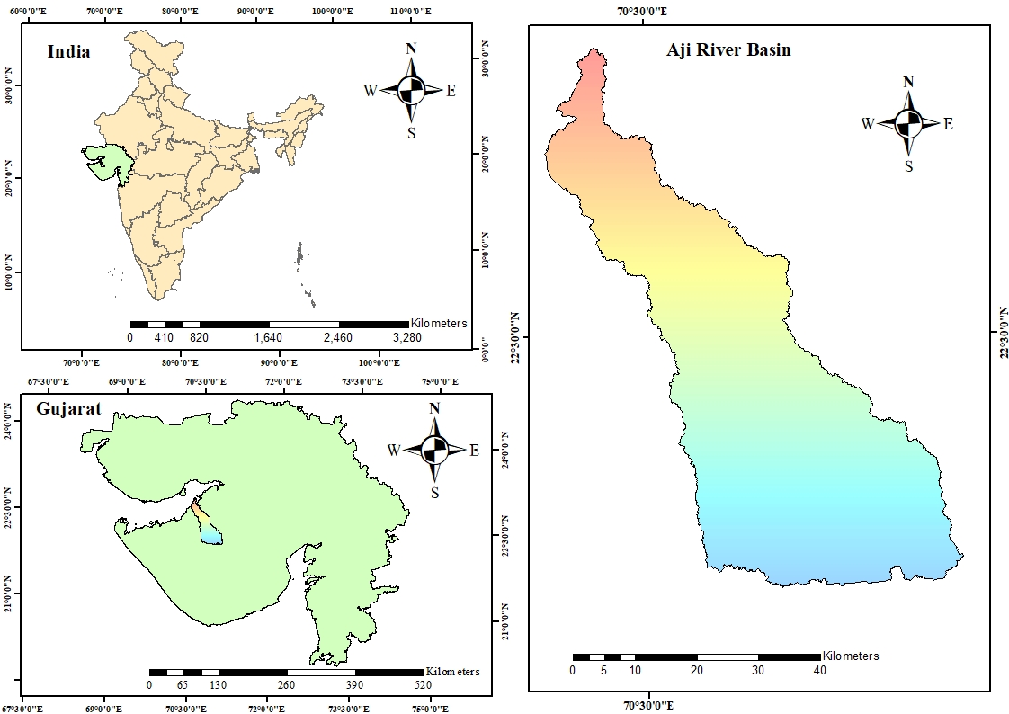

Fig. 1. Study area map of Aji River Basin generated through ArcGIS 10.4.1

2.2 Data acquisition
Data on precipitation covering the past 40 years (1981-2020) were obtained from different stations and sourced through the State Data Centre in Gandhinagar and the Gujarat State Disaster Management Authority. Thematic layers, including slope and drainage density, were generated using open-source digital data from the SRTM DEM obtained from the Earth Explorer-USGS database. Geological and geomorphological maps were acquired from the Bhukosh Geological Survey of India database. The soil map, developed by the National Bureau of Soil Survey & Land Use Planning (NBSS&LUP), was obtained from BISAG in Gandhinagar (Table 1).
Table 1. Different input parameters are used to analyze the potential groundwater zones for the Aji River basin.
Data | Description | Source
Rainfall data | Annual average  rainfall | Gujarat State Disaster Management Authority. (http://www.gsdma.org/).  State Water Data Centre, Gandhinagar.
Remote Sensing Data | LULC  SRTM DEM | Bhaskaracharya Institute for Space Application and Geo-informatics (BISAG), Gandhinagar.  EarthExplorer-USGS (https://earthexplorer.usgs.gov/)
Conventional data | Soil map | Bhaskaracharya Institute for Space Application and Geo-informatics (BISAG), Gandhinagar.
Conventional data | Geomorphology  Geology | Bhukosh – Geological Survey of India. (http://bhukosh.gsi.gov.in/Bhukosh/Public)
Conventional data | Lineament | Bhuvan Indian Geo platform of ISRO  https://bhuvan.nrsc.gov.in/home/index.php

2.3 Estimation of rainfall-runoff potential in the Aji River Basin
The daily flow of water in the Aji River Basin was calculated from 1981 to 2020 using the SCS Curve Number technique. This method involves assessing the potential maximum retention capacity of the watershed, influenced by its wetness, by referring to its physical characteristics and prior moisture conditions. The curve number (CN) depends on the land use pattern and soil conditions. In other words, it is a function of land use/ land cover and soil hydrologic group. The range of the CN values lies between 0 and 100, with 100 associated with higher runoff potential and 0 representing the least or no possibility of the runoff potential. The SCS method of the curve number for determining the runoff potential in the watershed is based on the water balance equation and two basic assumptions given in [23].
2.4 Demarcation of potential groundwater recharge zones
The various thematic maps were processed to delineate the potential groundwater zones.
2.4.1 Base Map
The base map is the foundational representation, delineating the boundary of the Aji River Basin watershed – the primary region of interest. It functions as the fundamental reference map for all subsequent thematic maps. The base map was created with 30 m spatial resolution using SRTM DEM data viz., SRTM1N22E071V3, SRTM1N22E069V3, SRTM1N23E070V3, and SRTM1N22E070V3. The mosaic tool was used to merge them. The Fill and Sink tools were used to remove defects in the DEM. Flow Direction, Flow Accumulation, and streams were generated. A suitable outlet for the Aji River was selected, and the watershed was delineated.

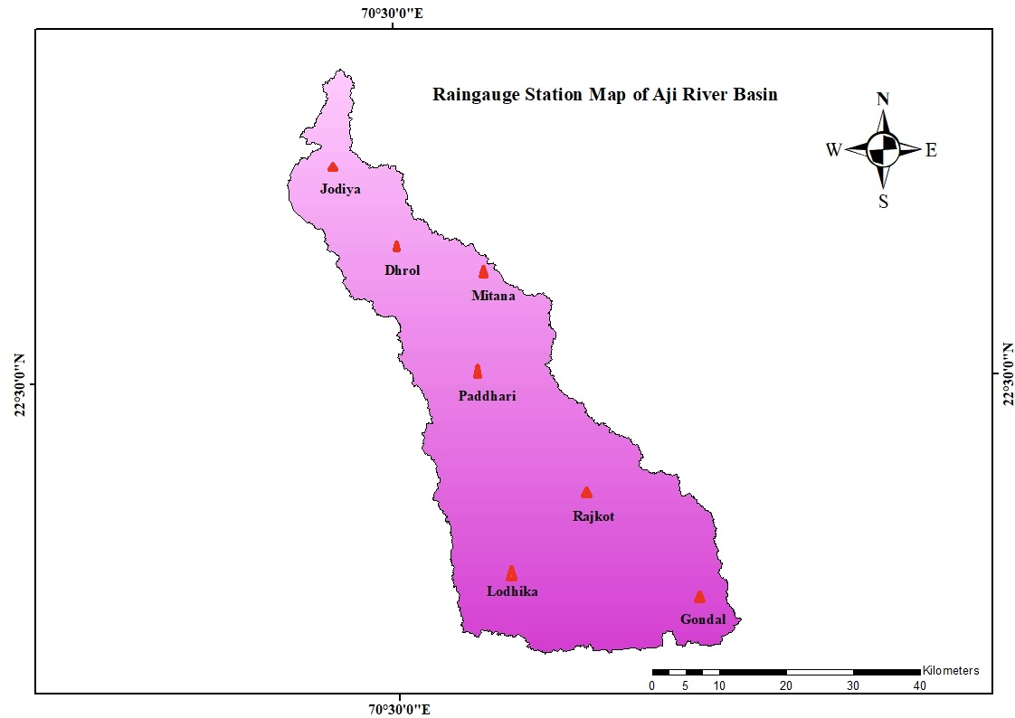
Fig. 2. Map of Rain-gauge Station of Aji River basin generated through ArcGIS 10.4.1
2.4.2 Geomorphology
Geomorphology, depicting diverse landforms and topographic features, is crucial in delineating zones with groundwater potential. It details the dispersion of different landform characteristics and phenomena, such as temperature fluctuations, geochemical reactions, water movement, and freezing and thawing cycles [14]. In the present study, the digital data for the Geomorphology of Gujarat State, India, was obtained from open-source data of the Bhukosh-Geological Survey of India, and the raster file of the Geomorphology Map of the Aji River Basin has developed in ArcGIS 10.4.1 software. The reclassification was done to make the obtained data compatible and clear for further analysis. The “classify tool” under the spatial analyst tool in ArcGIS 10.4.1 was used to reclassify the obtained data.
2.4.3 Rainfall
Rainfall is a critical component in the hydrological cycle, influencing groundwater. Infiltration depends on the duration of rainfall intensity: high intensity/short duration increases runoff, while low intensity/long duration enhances infiltration and reduces runoff. The average precipitation was calculated using daily rainfall data from the last 40 years, 1981 – 2020. The data was collected from 7 rainfall stations in or near the study area, viz., Gondal, Lodhika, Paddhari, Rajkot, Mitana, Dhrol, and Jodia. The annual weighted precipitation of the study region was calculated using the Thiessen Polygon Method. The research area was divided into seven polygons, with each station representing one of the polygons. The Aji River Basin rainfall map was created using the Inverse Distance Weighted Interpolation approach, which weights the sampling points so that the influence of one point on another location decreases as the distance from the new estimated point increases.
2.4.4 Slope
The slope is a crucial topographical feature, indicating the degree of incline on the Earth's surface. It provides valuable insights into the geological and geodynamic processes at a broader geographical level. The steepness of the terrain directly affects surface runoff and the rate at which water infiltrates the ground [14]. The DEM data was used to construct the slope map. The slope map raster file was created in percentages, and the Arc map software utilized the slope tool.
2.4.5 Drainage Density
The drainage network relies on the lithological characteristics of the area and serves as a crucial indicator of infiltration rates. The drainage density is inversely proportional to permeability or infiltration [14]. Drainage density is determined by dividing the total length of all rivers within a drainage basin by the total area of that specific basin [15].
2.4.6
Soil
The soil's capacity for retention or texture significantly influences the groundwater presence. Soil composition, particularly the proportions of silt, clay, and sand, establishes its texture. The clay soil has smaller pores, leading to increased runoff and reduced infiltration, while sandy soil facilitates higher infiltration with larger pores, thus replenishing groundwater [14].
2.4.7 Lineament Density
Lineaments are direct features observed on Earth’s surface, indicating zones of structural movement or weakness in the Earth's crust. Lineament density was calculated using the mathematical formula [16].
2.4.8 Geology
The geological composition plays a significant role in determining the occurrence and groundwater flow within a particular area. The particular rock types in a specific area significantly influence the accessibility and replenishment of groundwater reserves. In this study, the resource map was scanned, rectified, and georeferenced using the Arc GIS 10.4.1 software, and the map of Geology for the Aji River Basin was constructed.
2.4.9 Land Use Land Cover (LULC)
Land use involves various human activities and intentions on a specific land. In contrast, land cover encompasses vegetation, water bodies, rocks/soil, artificial structures, and other features arising from land modifications [8].
2.5 Saaty’s Analytical Hierarchy Process
In the Analytical Hierarchy Process (AHP), decision-makers assign individual weights to evaluation criteria through pairwise comparisons., indicating their relative importance. Subsequently, for a specific criterion, each option is given ratings based on the decision maker's comparisons in a pairwise manner. The AHP consolidates these weights assigned to criteria and the scores allocated to options to calculate an overall score for each option, establishing a ranking. The global score is calculated as a weighted sum across all criteria. Notably, 9 signifies higher importance, 1/9 denotes the least, and 1 signifies equal weight for a parameter or category. Using these weighted criteria, each parameter in the study was categorized accordingly [17] (Table 4).
2.6 Integration of various thematic maps to demarcate potential groundwater recharge zones (PGWRZ)
Several thematic maps covering diverse groups and their standardized weights were integrated into the ArcGIS 10.4.1 framework. The Potential Groundwater Recharge Zone Index (PGWRZI) computation included integrating all thematic maps into the GIS environment using the equation specified by [18].
$GWRPZI=\sum_{i}^{n}{(X_{A}} * Y_{B }$)
Where,
PGWZI = Potential Groundwater Zones Index,
$X_{A}$- Denotes the weightage of the thematic layers, where A = 1, 2, 3, ………., X
$Y_{B}$- Signifies the rank of the thematic layers’ subclass, where B = 1, 2, 3, …..., Y
2.7 Probability analysis of rainfall-runoff data
Rainfall information spanning forty years (1981-2020) was analyzed to calculate the runoff and assess its probability, which was accomplished by applying Weibull's method. Utilizing this method, the calculation of the total runoff produced in the basin area at a 75 % confidence level, as outlined by [19], was performed.
3.
RESULTS AND DISCUSSION
3.1 Study area: The Aji basin is situated within the latitudinal range of 21̊ 25’N to 22 ̊ 10’N and the longitudinal range of 70 ̊45’E to 71 ̊ 20’E. It spans an area of 2132.41 km², and the Aji River measures 164 km in length.

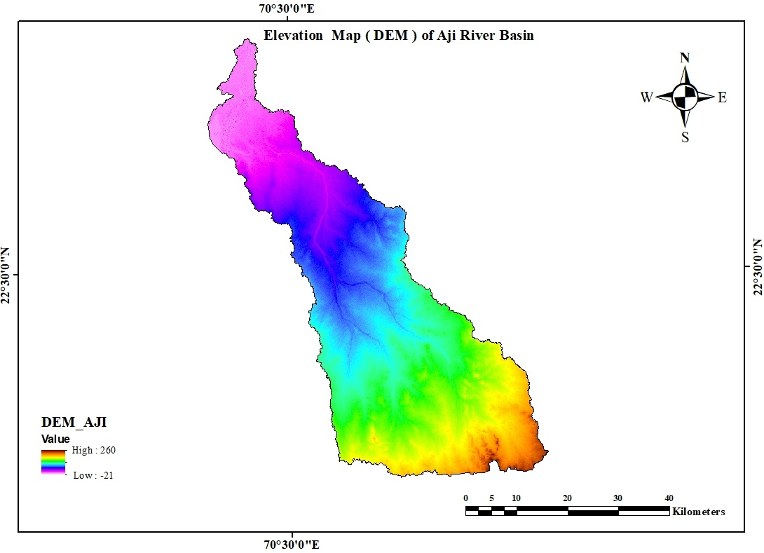 | 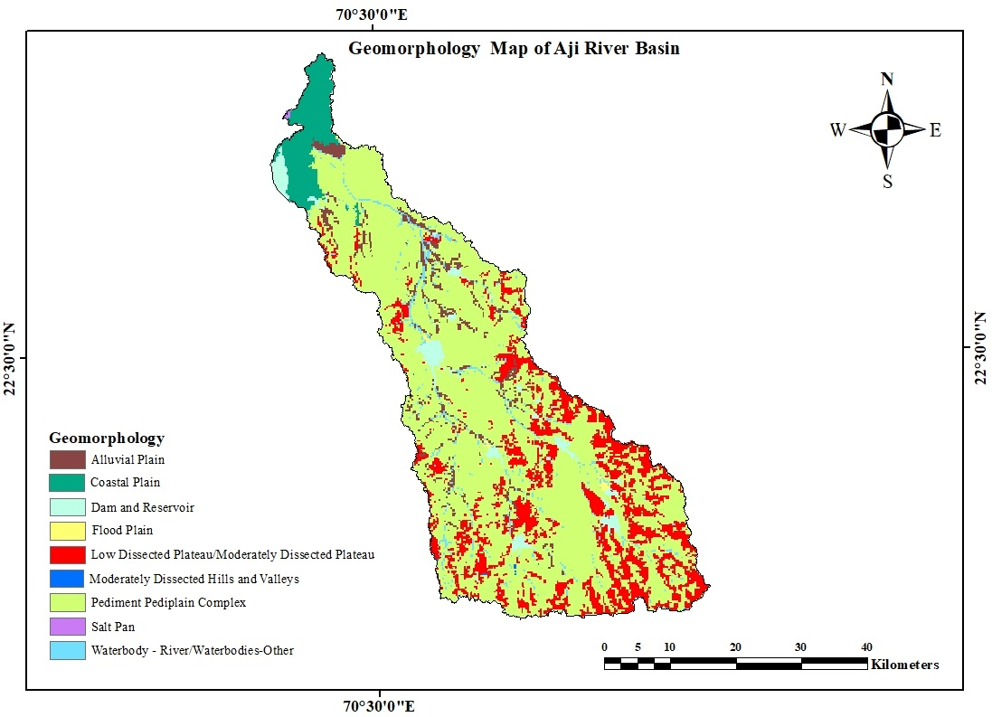
Fig.3 [A] Elevation map (DEM) of the Aji River basin | Fig. 3[B] Geomorphology map of the Aji River basin
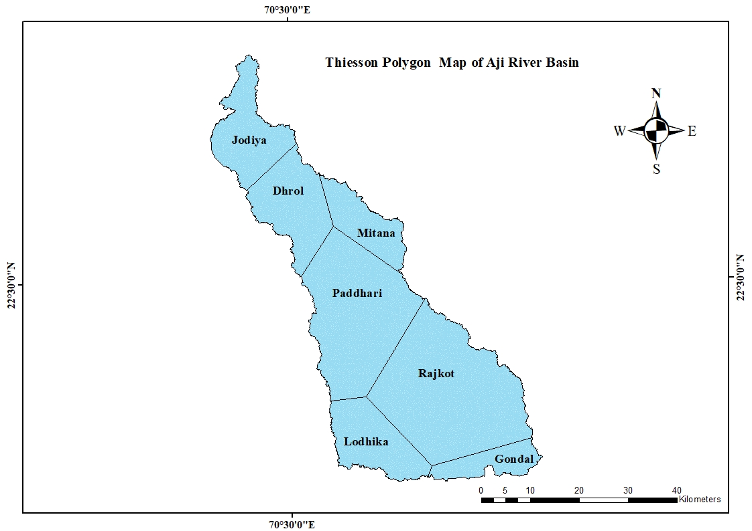 | 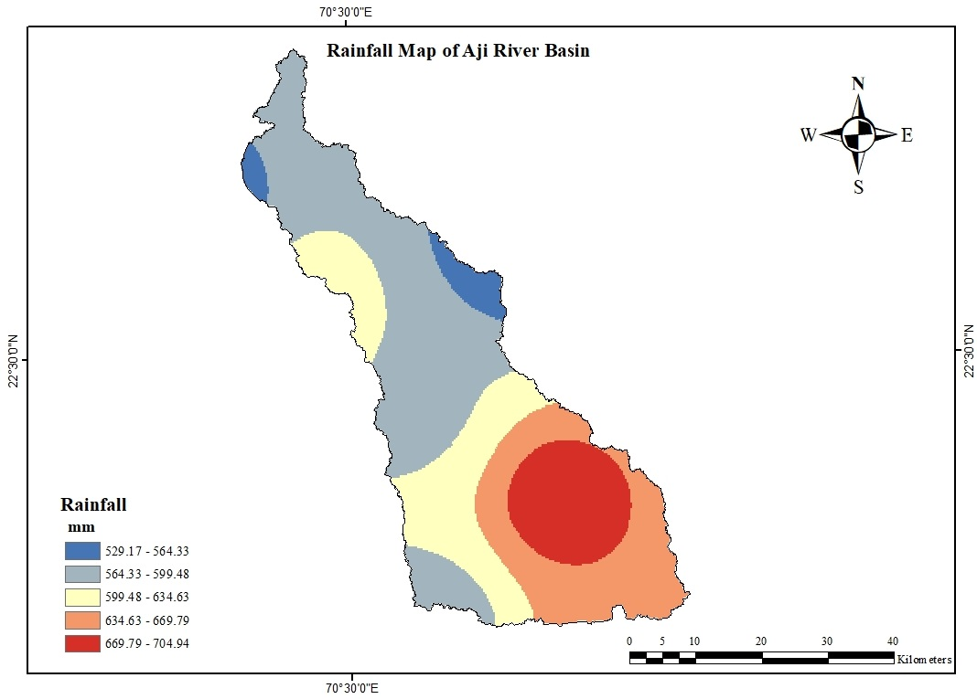
Fig. 3[C] Thiessen Polygon map for rain gauge stations in Aji River Basin | Fig. 3[D] Rainfall map of the Aji River basin
Fig.3. [A] Elevation map, [B] geomorphology map, [C] Thiessen polygon map, and [D] Rainfall map of Aji river basin generated using ArcGIS 10.4.1
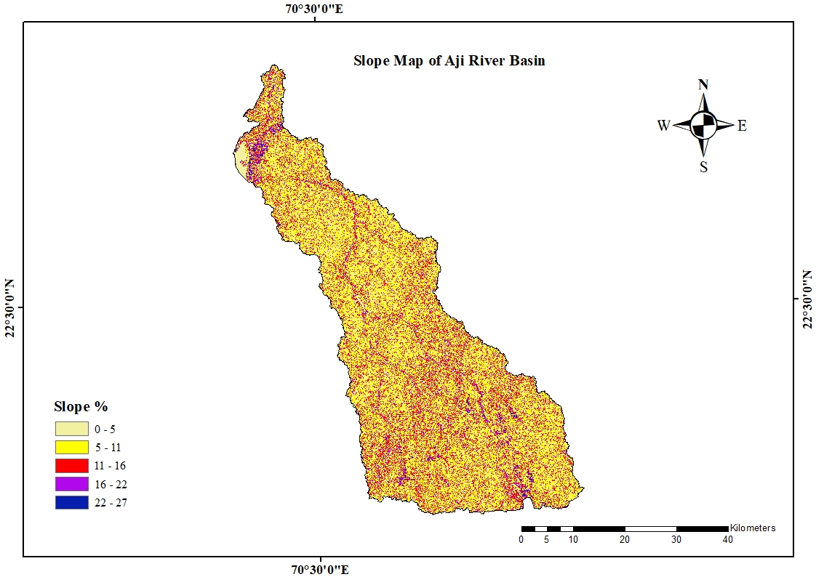 | 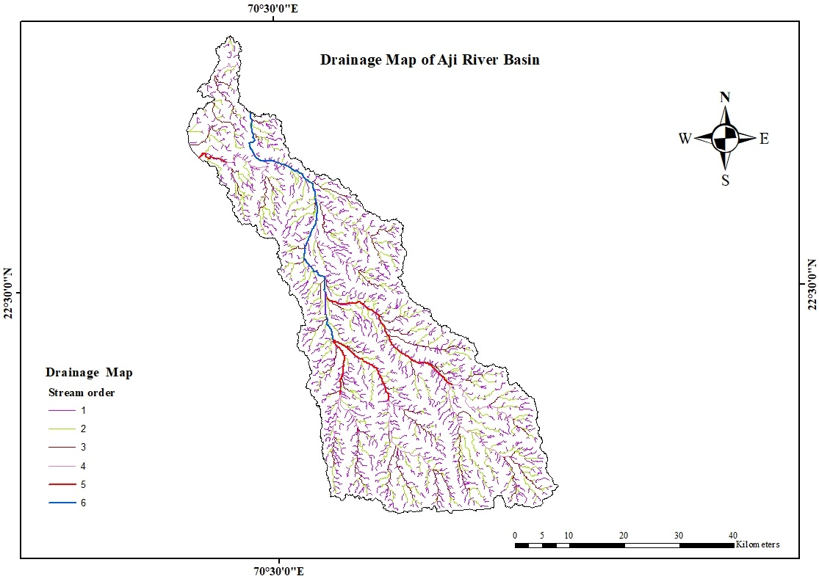
Fig. 4[A]. Slope map of Aji River Basin | Fig. 4[B]. Drainage map of the Aji River basin
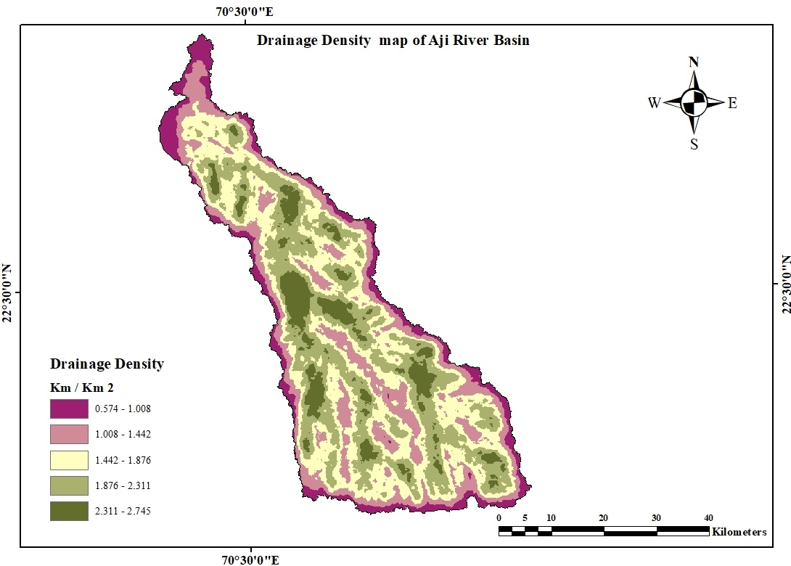 | 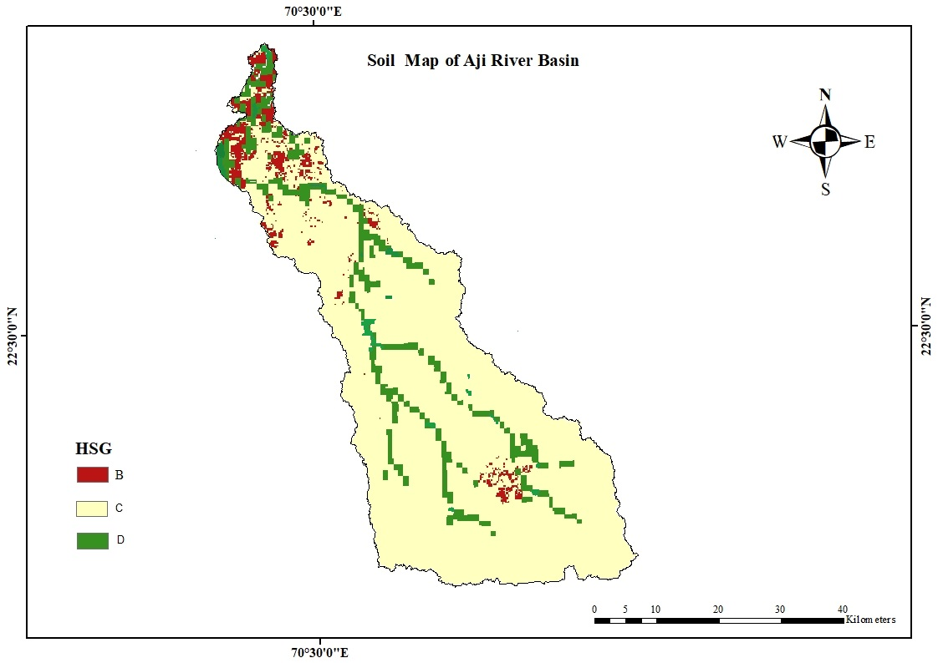
Fig. 4[C]. Drainage Density map of the Aji River basin | Fig. 4[D]. Soil map (HSG) of Aji River basin
Fig. 4 [A] Slope map, [B] Drainage map, [C] Drainage density map, and [D] Soil map of the Aji river basin generated through ArcGIS 10.4.1
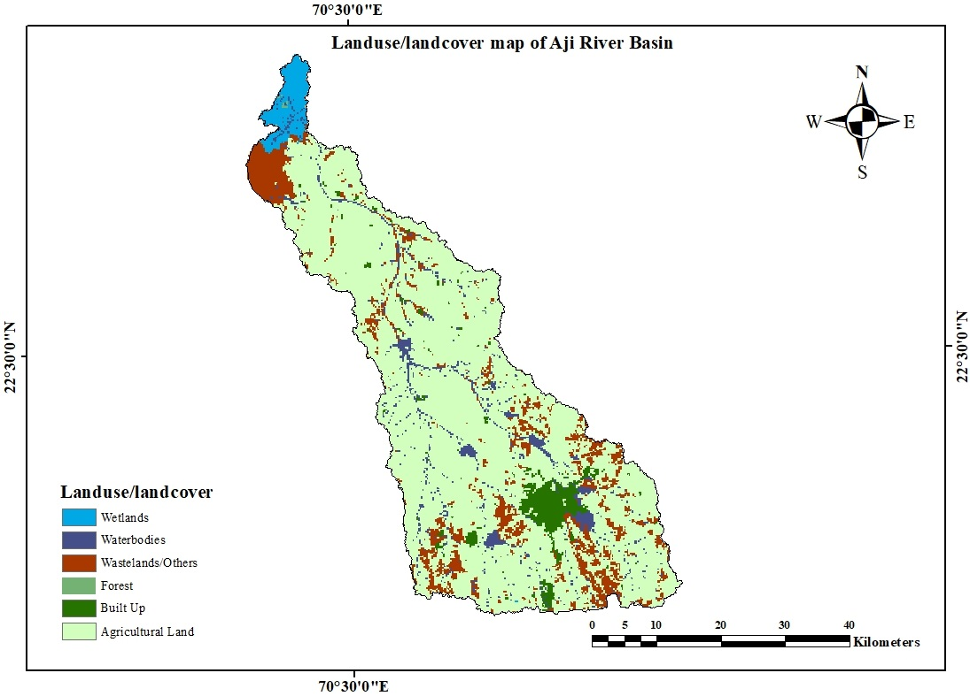 | 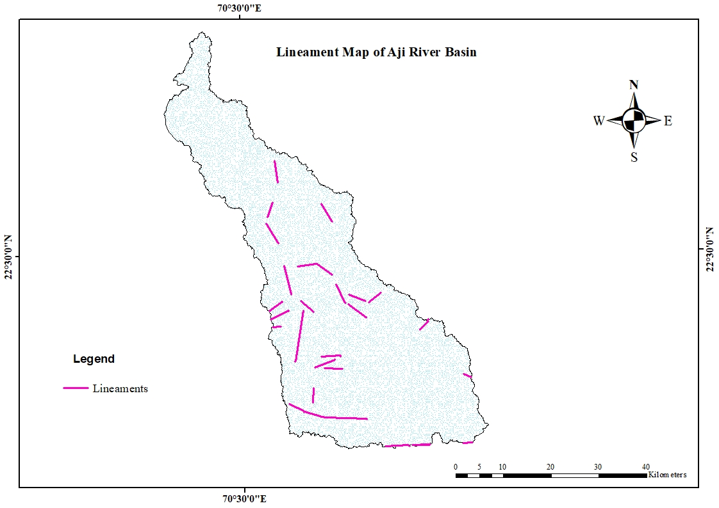
Fig.5 [A]. Land use/ Land cover map of the Aji River basin | Fig.5 [B]. Lineament map of the Aji River basin
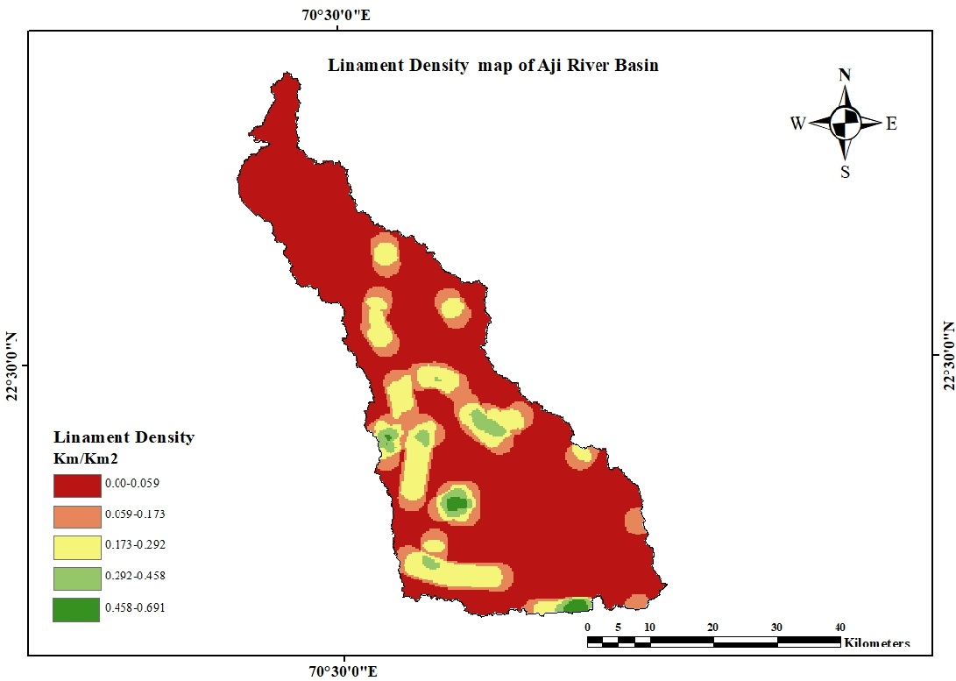 | 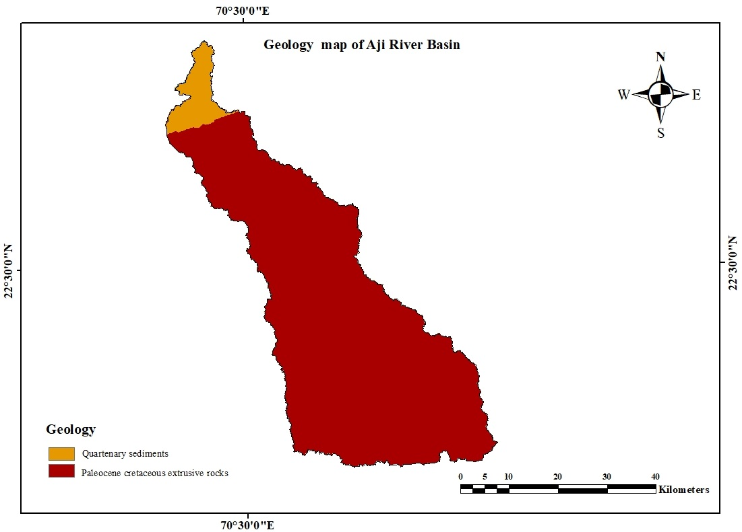
Fig.5 [C]. Lineament Density map of the Aji River basin | Fig.5 [D]. Geology Map of Aji River Basin
Fig. 5. [A] Land cover map, [B] Lineament map, [C] Lineament density map, and [D] Geology map of the Aji river basin generated through ArcGIS 10.4.1
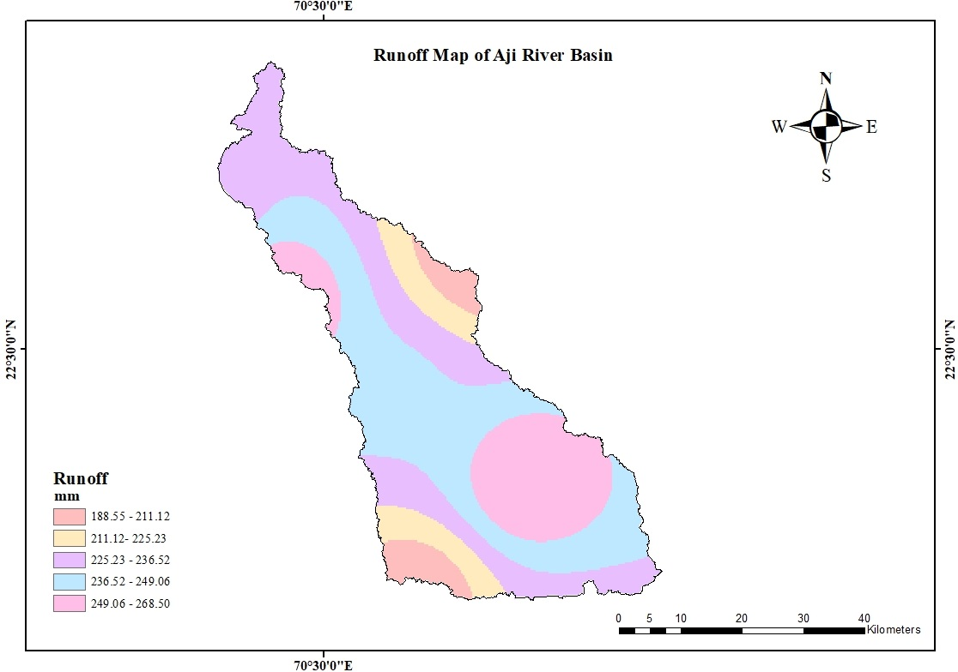
Fig. 6. Runoff Potential Map of Aji River Basin generated through ArcGIS 10.4.1
Table 2. Rainfall-runoff of various zones in the Aji River basin (Fig. 2,3[D], and 6)
Sr. No. | Zone | Rainfall (mm) | Runoff (mm) | Area(m²)
1 | Rajkot | 704.96 | 268.51 | 664967000
2 | Gondal | 675.22 | 227.12 | 104929000
3 | Dhrol | 643.24 | 272.61 | 244785000
4 | Paddhari | 584.32 | 240.21 | 527841000
5 | Lodhika | 570.98 | 192.86 | 213670000
6 | Jodia | 543.17 | 220.80 | 225328000
7 | Mitana | 516.425 | 180.27 | 150887000
Weighted  Average |  | 622.68 | 241.07

The AHP pair-wise matrix was created by assigning scale weights to themes and features, considering their impact on groundwater occurrence. This involved synthesizing insights from literature reviews and expert opinions. A pair-wise comparison matrix, established in an 8 x 8 format using Saaty's analytical hierarchy process, determined influenced weights for each theme based on a rating scale. The consistency ratio of the assigned weights falls within the predefined range of (0.084 < 0.10); it can be concluded that the matrix is consistent, and the allocated weights are deemed acceptable (Table 3).
Table 3. A pair-wise matrix calculation determines the weight assigned to the thematic layers.
Layers | SL | GEO M | SO | GEO | LULC | DD | R | LD
GEO M | 3 | 1 | 6 | 7 | 5 | 5 | 3 | 4
R | 5 | 0.33 | 6 | 9 | 7 | 5 | 1 | 8
SL | 1 | 0.33 | 3 | 7 | 5 | 2 | 0.20 | 6
DD | 0.50 | 0.20 | 2 | 6 | 3 | 1 | 0.20 | 5
SO | 0.33 | 0.16 | 1 | 5 | 2 | 0.5 | 0.16 | 3
LULC | 0.20 | 0.20 | 0.5 | 3 | 1 | 0.33 | 0.14 | 2
LD | 0.16 | 0.25 | 0.33 | 3 | 0.5 | 0.2 | 0.11 | 1
GEO | 0.14 | 0.14 | 0.20 | 1 | 0.33 | 0.16 | 0.11 | 0.33
TOTAL | 10.34 | 2.62 | 19.03 | 41 | 23.83 | 14.20 | 4.93 | 29.33
Where, SL = Slope; GEOM = Geomorphology; SO = Soil; GEO= Geology; LU-LC = Land use / land cover; DD = Drainage Density; R = Rainfall; LD = Lineament Density
The smaller the consistency index, the higher the consistency of the matrix. In the ideal case, CI = 0. The ideally consistent matrix is a rare case, even if the transitivity of its elements has been checked. The consistency degree of matrix P may be determined quantitatively by comparing the calculated consistency index of the matrix with a randomly generated consistency index (based on the scale 1-3-5-7-9) of the inverse symmetrical matrix of the same order (Table 4).
Table 4. Parameters of AHP to check the consistency of weights assigned to thematic layers.

Parameter | Formula | Value
Consistency measures | $$\frac{\left(A column of comparison Matrix\right) x (Eigen Vector)}{Corresponding Eigen Vector of the row}$$ | 70.66
Principal Eigen Value | $λ_{max}$ = $\frac{70.63}{8}$ = 8.83 | 8.83
Consistency Index (CI) | $\frac{λ_{max }-n}{n-1}= \frac{8.83-8}{8-1 }$ = 0.119 | 0.119
Consistency Ratio (CR) | $\frac{CI}{RCI}$ = $\frac{0.119}{1.41}$ = 0.084 | 0.084
The normalized matrix is derived from a pair-wise comparison matrix by adding the entries in each column of the comparison matrix and dividing each entry a_{jk} by the sum of the entries in the corresponding column ∑a_{jk} of the comparison matrix. The sum of normalized entries in each column will equal one (Table 5).
Table 5: Normalized Weights for thematic layer

Sr. No. | Parameters | Value | Eigen Value | Normalized Weightage %
1 | Geomorphology | High | 0.307 | 30.7
2 | Rainfall |  | 0.283 | 28.3
3 | Slope |  | 0.143 | 14.3
4 | Drainage density |  | 0.097 | 9.7
5 | Soil |  | 0.065 | 6.5
6 | Land use/landcover |  | 0.044 | 4.4
7 | Lineament Density |  | 0.036 | 3.6
8 | Geology | Low | 0.020 | 2
Total |  |  |  | 100

Table 6. Weightage allocation to various subclasses of the thematic layers
Parameter | Parameter weight (%) | Sub-class | Potential Groundwater Recharge | Saaty’s scale | Relative weight
Drainage Density (km/km²) | 9.7 | 0.574 – 1.008 | Very high | 9 | 36
Drainage Density (km/km²) | 9.7 | 1.008 – 1.442 | High | 7 | 28
Drainage Density (km/km²) | 9.7 | 1.442 – 1.846 | Moderate | 5 | 20
Drainage Density (km/km²) | 9.7 | 1.876 – 2.311 | Low | 3 | 12
Drainage Density (km/km²) | 9.7 | 2.311 – 2.745 | Very low | 1 | 4
Drainage Density (km/km²) | 9.7 |  | Total | 25 | 100
Geomorphology | 30.7 | Water bodies, Dams and Reservoir | Very high | 9 | 21
Geomorphology | 30.7 | Alluvial Plain | High | 7 | 17
Geomorphology | 30.7 | Pediment Pediplain Complex | High | 7 | 17
Geomorphology | 30.7 | Flood Plain | High | 7 | 17
Geomorphology | 30.7 | Coastal Plain | Moderate | 5 | 12
Geomorphology | 30.7 | Low Dissected Plateau/Moderately Dissected Plateau | Low | 3 | 7
Geomorphology | 30.7 | Moderately Dissected Hills and Valleys | Low | 3 | 7
Geomorphology | 30.7 | Salt Pan | Very low | 1 | 2
Geomorphology | 30.7 |  | Total | 42 | 100
Geology | 2 | Paleocene cretaceous extrusive rocks | Very High | 9 | 65
Geology | 2 | Quarternary sediments | Moderate | 5 | 35
Geology | 2 |  | Total | 14 | 100
Rainfall (mm) | 28.3 | 704.94-671.85 | Very High | 9 | 36
Rainfall (mm) | 28.3 | 671.85-637.39 | High | 7 | 28
Rainfall (mm) | 28.3 | 637.39-603.62 | Moderate | 5 | 20
Rainfall (mm) | 28.3 | 603.62-579.49 | Low | 3 | 12
Rainfall (mm) | 28.3 | 579.49-529.17 | Very low | 1 | 4
Rainfall (mm) | 28.3 |  | Total | 25 | 100
Table 7. Weightage allocation to various subclasses of the thematic layers
Parameter | Parameter weight (%) | Sub-class | Potential Groundwater Recharge | Saaty’s scale | Relative weight
Lineament Density (km/km²) | 3.6 | 0.691-0.458 | Very High | 9 | 36
Lineament Density (km/km²) | 3.6 | 0.458-0.292 | High | 7 | 28
Lineament Density (km/km²) | 3.6 | 0.292-0.173 | Moderate | 5 | 20
Lineament Density (km/km²) | 3.6 | 0.173-0.059 | Low | 3 | 12
Lineament Density (km/km²) | 3.6 | 0.059-0.00 | Very Low | 1 | 4
Lineament Density (km/km²) | 3.6 |  | Total | 25 | 100
Slope (%) | 14.3 | 0- 5 | Very High | 9 | 36
Slope (%) | 14.3 | 5 -11 | High | 7 | 28
Slope (%) | 14.3 | 11- 16 | Moderate | 5 | 20
Slope (%) | 14.3 | 16- 22 | Low | 3 | 12
Slope (%) | 14.3 | 22- 27 | Very Low | 1 | 4
Slope (%) | 14.3 |  | Total | 25 | 100
Landuse/  land cover | 4.4 | Wetlands | Very High | 9 | 27
Landuse/  land cover | 4.4 | Waterbodies | High | 9 | 27
Landuse/  land cover | 4.4 | Agricultural Land | Moderate | 7 | 20
Landuse/  land cover | 4.4 | Forest | low | 5 | 15
Landuse/  land cover | 4.4 | Wastelands/Others | low | 3 | 9
Landuse/  land cover | 4.4 | Build up | Very low | 1 | 2
Landuse/  land cover | 4.4 |  | Total | 34 | 100
Soil (According to HSG | 6.5 | B | Very High | 9 | 50
Soil (According to HSG | 6.5 | C | High | 7 | 39
Soil (According to HSG | 6.5 | D | Very low | 2 | 11
Soil (According to HSG | 6.5 |  | Total | 18 | 100

The Elevation map DEM prepared for the Aji River basin (Fig. 3[A]) shows the highest elevation of 260 m and the lowest Elevation of 21 m. The pediment pediplain complex covers the highest vast area of 1,431.55 km², constituting 67.13 % of the total region, while the salt pan covers 1.01 km², 0.05 of the basin area (Fig. 3[B]) and (Table 6). The range of rainfall classes, the highest precipitation, measuring 704.94 mm, was recorded in the Rajkot station, which covers an area of 664.97 km², calculating 15.76 % of the total area. In contrast, the lowest rainfall, at 516.42 mm, is observed in Mitana, which spreads over 150.89 km² (Fig. 3[C-D]) and (Table 2). In the analysis of slope percentages, the range of 0-5 % encompasses the highest area, covering 2,095.4 km², which accounts for a substantial 98.26 % of the total area, while the range of 22-27 % represents the lowest area, with only 0.01 km² (Fig. 4[A]) and (Table 7). The drainage density, range of (1.008 - 1.442) km/km² represents the highest area, covering 1181.45 km², which accounts for a significant 55.40 % of the total area, while the range of (2.311 - 2.745) km/km² signifies the lowest area, with just 12.84 km² (0.60 %) of the total area (Fig. 4[B-C] and (Table 6).
Group C has the highest area among the hydrologic soil groups, covering 1,802.41 km², representing 84.52 % of the total area. In contrast, Group B, with an area of 110.16 km², constitutes a smaller portion, accounting for 5.16 % of the total area (Fig. 4[D]) and (Table 7). In the Land Use Land Cover (LULC) categories, agricultural land is the most extensive, covering 1,642.84 km², constituting 77.04 % of the total area. Conversely, forest, with an area of only 2.53 km², represents the smallest category, making up just 0.12 % of the total area (Fig. 5[A]) and (Table 7). The lineament density km/km² covers a substantial area of 1,561.38 km², accounting for 73.22 % of the total. In contrast, the 0.458 to 0.691 km/km² range represents a much smaller area, comprising only 13.62 km² or 0.63% of the total area (Fig. 5[B-C]) and (Table 7). In geology features, paleocene cretaceous extrusive rocks dominate with the highest area covering 2019.20 km², representing 94.69 % of the total area. On the other hand, quaternary sediments cover the least area, measuring 113.21 km², representing 5.30 % of the entire area (Fig. 5[D]) and (Table 6). The lowest area in runoff potential class ranges is covered by the 188.55 - 204.54 mm range, spanning 105 km² (4.9 %). In contrast, the highest area is attributed to the 236.52 - 252.51 mm range, encompassing 786 km², representing 36.86% of the total area (Fig. 6) and (Table 9).
3.3 DEMARCATION OF POTENTIAL GROUNDWATER RECHARGE ZONES
Following the assignment of different weights to the thematic layers and their respective attributes, the next step involved the integration of all these thematic maps within the ArcGIS platform. The integration was accomplished by applying the "weighted overlay" spatial analyst tool. The potential groundwater recharge zone index was employed to pinpoint and characterize potential groundwater recharge zones. The outcome of the overlay analysis has been categorized into five zones based on their suitability for groundwater recharge. These five categories include Very Poor, Poor, Moderate, Good, and Excellent (Fig. [7]), and (Table 8) illustrates the ultimate potential groundwater recharge zones in the Aji River basin. After interpretation, it was observed that more than half of the designated area falls within the combined categories of good and moderate zones. This suggests sufficient potential for capturing and replenishing the groundwater table in the river basin. Specifically, the area with excellent groundwater recharge potential comprises 50.50 km² (2.36%), and the zone with good potential covers 1376.78 km² (64.56%). An additional 599.14 km² (28.09%) falls within the moderate zone.
The cumulative area categorized as Poor and Very Poor amounts to approximately 105.99 km² (4.97 %). Table 8 illustrates the spatial distribution of the various zones within the potential groundwater recharge zone in the Aji River basin.
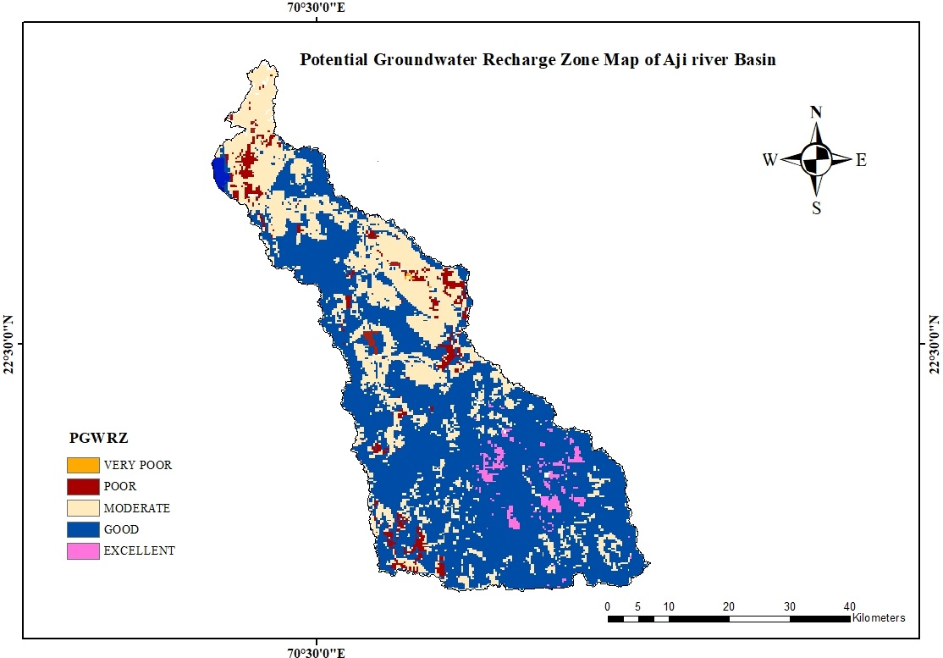
Fig 7. Potential groundwater recharge zones of the Aji River basin generated through ArcGIS 10.4.1
Table 8: Potential groundwater recharge zones of the Aji River basin
Sr. No. | PGWRZ | Area (km²) | Area (%)
1 | Excellent | 50.50 | 2.36
2 | Good | 1376.78 | 64.56
3 | Moderate | 599.14 | 28.09
4 | Poor | 90.67 | 4.25
5 | Very Poor | 15.32 | 0.71
Runoff potential in the basin
To assess the probability of runoff, a probability analysis was conducted using runoff data spanning the past 40 years (1981-2020) shows the runoff calculated at a 75 % confidence level was found to be 152.97 MCM, and the weightage average runoff depth was found to 0.072 m. The total weighted runoff generated in the Aji River basin was found to be 514.07 MCM, as shown in (Table 9)
Table 9. Weighted runoff in the Aji River basin
Sr. No. | Location | Runoff (m) | Area (km²)
1 | Rajkot | 0.2685 | 664.97
2 | Gondal | 0.2271 | 104.93
3 | Dhrol | 0.2726 | 244.79
4 | Paddhari | 0.2402 | 527.84
5 | Lodhika | 0.1928 | 213.67
6 | Jodia | 0.2208 | 225.33
7 | Mitana | 0.1802 | 150.89
Weighted Runoff of Aji River basin = 514.07 MCM

In the present investigation, we determine the rainfall-runoff potential of the Aji River Basin and demarcate the potential groundwater recharge zones using remote sensing and GIS. Many researchers used the integration of MCDA, AHP, RS, and GIS to demarcate potential groundwater recharge zones and storage structures [20, 6, 21, 9]. A similar study was conducted by [6] of the Mand catchment of the Mahanadi River basin using RS and GIS and suggested groundwater potential zones with very low, low to medium, medium to high, and very high groundwater potential encompassing an area of 962.44 km2, 2019.92 km2, 969.19 km2, and 1380.42 km2, respectively. The present investigation showed five distinct zones based on groundwater recharge potential. ‘Excellent’ (50.50 km², 2.36 %), ‘Good’ (1376.78 km², 64.56 %), ‘Moderate’ (599.14 km², 28.09 %), ‘Poor’ (90.67 km², 4.25 %), and ‘Very Poor’ (15.32 km²,0.718 %). A similar study using RS, GIS, and MCDA showed four groundwater potential zones such as very- high (523.58 km2), high (798.22 km2), moderate (646.04 km2), and low (456.66 km²) were suggested. Based on these, suitable storage structures and area distributions such as check dams, percolation ponds, flood and furrows, and ditch and furrows were suggested [22]. Another study of the Bhatgaon catchment of the Kosi River basin showed that 61.9 % of the area is poor to moderate, and 24.1 % has good to moderate recharge potential [9]. A similar study using multicriteria decision-making (MCDM), AHP, and GIS-based of Mornag Plain (North Tunisia) showed five different zones, and 41 % of the area belonged to moderate to very high groundwater recharge potential zones, and approximately 20 % of the total area had very high to high groundwater recharge potential [24]. Groundwater recharge potential zone identification through RS and MODLOW modeling of the Guinea region of Western Africa enabled the interaction between groundwater resources and climate change. The model suggested that groundwater storage was maximum and minimum in the lower and higher elevations, respectively. Topographical features were important in determining groundwater storage, as the western to northern direction area had lower groundwater potential [25]. Identification of groundwater recharge potential using GIS, RS, and AHP was conducted in the Shinile watershed. It showed five distinctive classes of groundwater zones with very high to moderate recharge potential in farmland, forest, and desert sand regions located in the north and northwest regions of the area. Further, the AHP findings were validated with the existing borehole sites and showed that they may be helpful to watershed managers [26].
Future studies should focus on the various hydrological models to forecast future surface-water abstraction scenarios within a complex river basin amidst climate change. Development of GIS-based hydrological models based on precipitation, evapotranspiration, land use, soil properties, and topography and groundwater level data of available and future climate data of the semi-arid and arid zones may help in suggesting a suitable location-specific climate-resilient cropping system based on the crop's water requirement and water availability in the groundwater for the next 30 years to ensure the livelihood security of farmers.
4. CONCLUSION
Combining Remote Sensing and GIS technologies has demonstrated a rapid and cost-efficient approach to groundwater prospecting and exploration. The Aji River basin exhibits a weighted average rainfall of 622.68 mm and a corresponding runoff of 241.07 mm. The calculated weighted runoff volume for the basin is 514.07 million cubic meters (MCM). A significant portion of the area is favorable to groundwater recharge. Specifically, the Excellent groundwater recharge potential zone covers 50.50 km² (2.36%), the good zone spans 1376.780 km² (64.56%), and the Moderate zone comprises 599.14 km² (28.09%). Areas with poor and very poor groundwater recharge potential are 90.67 km² (4.25%) and 15.32 km² (0.718%), respectively (Table 8). The estimated runoff in the basin is 152.97 MCM at a 75% probability of exceedance. Therefore, this area may be used to harness the groundwater potential.
ACKNOWLEDGEMENTS
The corresponding author sincerely thanks the ICAR-JRF, 2021, for providing a scholarship for pursuing an M.Tech in Soil and Water Conservation and the Junagadh Agricultural University for conducting the study.

Disclaimer (Artificial intelligence)
Option 1:
Author(s) hereby declare that NO generative AI technologies such as Large Language Models (ChatGPT, COPILOT, etc) and text-to-image generators have been used during writing or editing of manuscripts.

Option 2:
Author(s) hereby declare that generative AI technologies such as Large Language Models, etc have been used during writing or editing of manuscripts. This explanation will include list the name, version, model, and source of the generative AI technology and as well as the all input prompts provided to a generative AI technology

Details of the AI usage are given below:
1.
2.
3.

REFERENCES
- United Nations. Department of International Economics, United Nations. Department for Economic & Policy Analysis. (2001). World population prospects (Vol. 2). United Nations, Department of International, Economic and Social Affairs.
- Paramesh, V., Kumar, P., Shamim, M., Ravisankar, N., Arunachalam, V., Nath, A. J., ... & Kashyap, P. (2022). Integrated farming systems as an adaptation strategy to climate change: Case studies from diverse agro-climatic zones of India. Sustainability, 14(18), 11629.10.03.2023.
- Ahamad, F., Tyagi, S. K., Singh, M., & Sharma, A. K. (2023). Groundwater in Arid and Semi-arid Regions of India: A Review on the Quality, Management and Challenges (pp. 11–52). https://doi.org/10.1007/978-3-031-43348-1_2
- Dangar, S., Asoka, A., & Mishra, V. (2021). Causes and implications of groundwater depletion in India: A review. Journal of Hydrology, 596, 126103. https://doi.org/10.1016/j.jhydrol.2021.126103
- Berghuijs, W.R., Collenteur, R.A., Jasechko, S. et al. Groundwater recharge is sensitive to changing long-term aridity. Nat. Clim. Chang. (2024). https://doi.org/10.1038/s41558-024-01953-z
- Baghel, S., Tripathi, M. P., Khalkho, D., Al-Ansari, N., Kumar, A., & Elbeltagi, A. (2023). Delineation of suitable sites for groundwater recharge based on groundwater potential with RS, GIS, and AHP approach for Mand catchment of Mahanadi Basin. Scientific Reports, 13(1), 9860. https://doi.org/10.1038/s41598-023-36897-5
- Chandio, I. A., Matori, A. N. B., WanYusof, K. B., Talpur, M. A. H., Balogun, A.-L., & Lawal, D. U. (2013). GIS-based analytic hierarchy process as a multicriteria decision analysis instrument: a review. Arabian Journal of Geosciences, 6(8), 3059–3066. https://doi.org/10.1007/s12517-012-0568-8
- Pande, C. B., Moharir, K. N., Singh, S. K., & Varade, A. M. (2020). An integrated approach to delineate the groundwater potential zones in Devdari watershed area of Akola district, Maharashtra, Central India. Environment, Development and Sustainability, 22(5), 4867–4887. https://doi.org/10.1007/s10668-019-00409-1
- Rani, M., Joshi, H., Kumar, K., Pande, A., & Rawat, D. S. (2019). Development of recharge and conservation site suitability model for groundwater retrieval and evaluation of artificial recharge potential in a complex hydro-geological spring-fed river basin. Arabian Journal of Geosciences, 12(18), 589. https://doi.org/10.1007/s12517-019-4784-3
- Rajasekhar, M., Gadhiraju, S. R., Kadam, A., & Bhagat, V. (2020). Identification of groundwater recharge-based potential rainwater harvesting sites for sustainable development of a semiarid region of southern India using geospatial, AHP, and SCS-CN approach. Arabian Journal of Geosciences, 13(1), 24. https://doi.org/10.1007/s12517-019-4996-6
- Saha, A., Ghosh, M., & Chandra Pal, S. (2021). Identifying Suitable Sites for Rainwater Harvesting Structures Using Runoff Model (SCS-CN), Remote Sensing and GIS Techniques in Upper Kangsabati Watershed, West Bengal, India (pp. 119–150). https://doi.org/10.1007/978-3-030-62397-5_7
- Anonymous. (2021). Topographic and Bathymetric Survey of Reservoirs for Water Resources Department, Govt. of Gujarat at Saurashtra Region, Gujarat – Narmada Water Resources, Water Supply and Kalpsar Department Aji-1 Reservoir Available at https://nhp.mowr.gov.in/docs/NHP/Sedimentation%20Studies/Report/1062/P34320_WRD%20Survey%20report_Aji%201 Rev%204%20with%20annexures.pdf, accessed
- Vithlani, N. S. and Rank, H. D. (2018). An assessment of water balances for Aji Basin using SWAT model. Green Farming, 9(4): 726-730.
- Arulbalaji, P., Padmalal, D., & Sreelash, K. (2019). GIS and AHP Techniques Based Delineation of Groundwater Potential Zones: a case study from Southern Western Ghats, India. Scientific Reports, 9(1), 2082. https://doi.org/10.1038/s41598-019-38567-x
- Horton, R. Drainage Basin Characteristics. American Geophysical Union Trans. 1932; 13: 350–361.
- Greenbaum, D. (1985). Review of remote sensing applications to groundwater exploration in basement and regolith. British Geological Survey Report, OD-85, (8): 36.
- Saaty, T. L. (1980). The analytic hierarchy process mcgraw hill, new york. Agricultural Economics Review, 70(804), 10-21236.
- Malczewski, J. (1999). GIS and multicriteria decision analysis. John Wiley & Sons.
- Raghunath, H. M., (2006). Hydrology: principles, analysis and design. Revised 2nd ed. New Delhi, New Age International. PP: 108.
- Achu, A. L., Thomas, J., & Reghunath, R. (2020). Multi-criteria decision analysis for delineation of groundwater potential zones in a tropical river basin using remote sensing, GIS and analytical hierarchy process (AHP). Groundwater for Sustainable Development, 10, 100365. https://doi.org/10.1016/j.gsd.2020.100365
- Bera, A., Mukhopadhyay, B. P., & Barua, S. (2020). Delineation of groundwater potential zones in Karha river basin, Maharashtra, India, using AHP and geospatial techniques. Arabian Journal of Geosciences, 13(15), 693. https://doi.org/10.1007/s12517-020-05702-2
- Anand, B., Karunanidhi, D., & Subramani, T. (2021). Promoting artificial recharge to enhance groundwater potential in the lower Bhavani River basin of South India using geospatial techniques. Environmental Science and Pollution Research, 28(15), 18437–18456. https://doi.org/10.1007/s11356-020-09019-1
- Handbook of Hydrology (1972). Soil Conservation Department, Ministry of Agriculture, New Delhi.
- Farhat, B., Souissi, D., Mahfoudhi, R. et al. GIS-based multi-criteria decision-making techniques and analytical hierarchical process for delineation of groundwater potential. Environ Monit Assess 195, 285 (2023). https://doi.org/10.1007/s10661-022-10845-8
- Akhtar, S., & Rampurawala, A. (2024). Integrating Remote Sensing Data and MODFLOW Modeling for Sustainable Groundwater Resource Management and Monitoring in the Guinea Region, West Africa. Journal of Geography, Environment and Earth Science International, 28(1), 50-64.
- Bhunia GS. An approach to demarcate groundwater recharge potential zone using geospatial technology. Applied Water Science. 2020 Jun;10(6):1-2.

- Yeh HF, Lee CH, Hsu KC, Chang PH. GIS for the assessment of the groundwater recharge potential zone. Environmental geology. 2009 Jul;58:185-95.

