Climate Justice or Climate Injustice on the Planet Earth: Social, Geopolitical, Legal, Security, and Moral Dimensions

Systematic Review Article

ABSTRACT
This study presents a comprehensive and insightful exploration of climate justice and climate injustice and their social, geopolitical, legal, security, and moral dimensions. It contributes perspectives on the global climate crisis and its implications. Theoretically and practically, the paper adds insight into global climate and environmental processes, concepts of climate justice and injustice, environmental and human security, and legal and moral approaches to the observed topics. Thus, the author problematizes social, geopolitical, security, legal, and moral normative directions regarding the culmination of climate change disasters and environmental and human insecurity in that framework. Besides a meta-analysis, content analysis, thematic analysis, a descriptive method, and an in-depth literature review of various scientific, professional, and expert-based data forms, the study incorporated the representation and analysis of visual expressions of climate change consequences and injustice. It also included human-centric aspects and perceptions through the narratives and voices of climate activists. Accordingly, the paper analyzes the essence and goals of climate justice, the consequences of climate injustice, and the positions of wealthy and poorer countries - mainly and severely affected by climate change, and offers normative solutions. Climate injustice processes and occurrences generate social injustice, inequalities, inequities, climate injustice of exclusions, and challenging human security.
Keywords: Climate justice, Climate injustice, Ecological crisis, Environmental and Human Security, Climate change Policies, Climate change and Law, Geopolitics, Wealthy countries, Poor countries, Social justice, Morality

INTRODUCTION
In the beginning, it is necessary to problematize several terms and concepts. First, climate justice and climate injustice, goals, and the idea of climate justice (legal framework). Then, the position of wealthy and unwealthy countries (Global North and Global South). Thus, states and regions that face the most substantial impact of climate change. Furthermore, climate change policies and funding, climate transition, environmental and human security, moral integrity, and social justice are the core of democracy.

The devastating effects of global warming are not evenly and equally distributed worldwide. Moreover, nations and demographic groups that contributed less to climate change got the worse end of the stick. It is the central issue of the concept of climate justice. For poor countries, mainly from the Global South, to deal with climate change and weather extremes, rich countries have promised them at least 100 billion US dollars annually from 2009 to 2025. That promise, however, has so far been broken, according to the report by the OECD. [1] Accordingly, allocated resources grew yearly, but in 2019, they were still 20% less than the agreed sum. The cases are critical regarding forced displacement of population, i.e., climate migrations. Hundreds of millions of people are at risk of becoming "climate migrants" if the world does not take the necessary measures. Three hundred million people live in highly climate-vulnerable communities and are at risk of exile, warned Amy Pope, head of the International Organization for Migration (IOM).[2]

However, the question arises: Why should the rich countries (mostly Global North) give funds to the poor for climate action? Because only 14% of the world's population lives on the territory of the countries (again, mostly Global North) responsible for almost half of the total cumulative carbon dioxide emissions. [3] Moreover, some critical issues regarding climate justice are how much money they should give and what this has to do with their past and future carbon dioxide emissions. It was among the topics discussed at Glasgow's United Nations (UN) Conference on Climate Change (COP26).

When we analyze examples of climate injustice (comparatively), I maintain that the solution is based on several yet associated directions. It is a just, equal, ethical, moral, and particularly more sustainable approach to climate change, environmental security, and human security.

What are the origin and goals of the concept of climate justice? Climate justice is not the fact that weather extremes such as floods and droughts most often fall on underdeveloped and marginalized communities that have historically had a low share in carbon dioxide emissions and, therefore, a lower level of responsibility in the rise of the average global temperature. It represents a form of justice in environmental protection whose advocates demand fair treatment of all people and freedom from discrimination in passing laws and designing projects to combat climate change. Climate justice is a broad term. However, it is frequently simplified, depending on the framework. Climate justice includes three aspects:

- Distributive justice refers to distributing obligations among individuals, nations, and all generations.
- Procedural justice, which refers to decision-makers, government, and the public involved in decision-making
- Justice through recognition implies basic respect, vigorous engagement, and fair and just appreciation of dissimilarities between various cultures and standpoints.

The term “Climate justice“ arose from the awakening of awareness about climate change among activists from the global South at the end of the last century. It has been popularized since the beginning of the 21st century and is now used by numerous researchers, politicians, media, and non-governmental organizations. Over time, the term evolved into a movement demanding that rich countries recognize their enormous historical contribution to emissions. To fulfill the Paris Agreement's goal and keep the global average temperature increase significantly below two °C, they should react first and make the most ambitious plans in the field of climate action, which they will put into action in the stipulated time frames. However, it is a fact, i.e., evident that the global community does not work according to the principle: one heat wave for Paul from Miami, one for Dasha from Moscow, one for Geoffrey from London, and one for Elenoli from Majuro. And so until the last 7,901,501,884 inhabitants of Planet Earth. [4]

Next, which countries are most substantially affected by climate change, and which have been enriched the most at their expense? The primary starting point of climate justice is the idea that the devastating impacts of global warming (e.g., weather extremes to endangering natural resources to rising sea levels) are not evenly and equally distributed worldwide.

Figure 1. Illustration of climate change's effects and climate injustice: Growing watermelon in a dry riverbed is difficult with sudden rain and rising waters. .Watermelon field, Mekhliganj, India (February 2022) Photo/Uttam Kamati

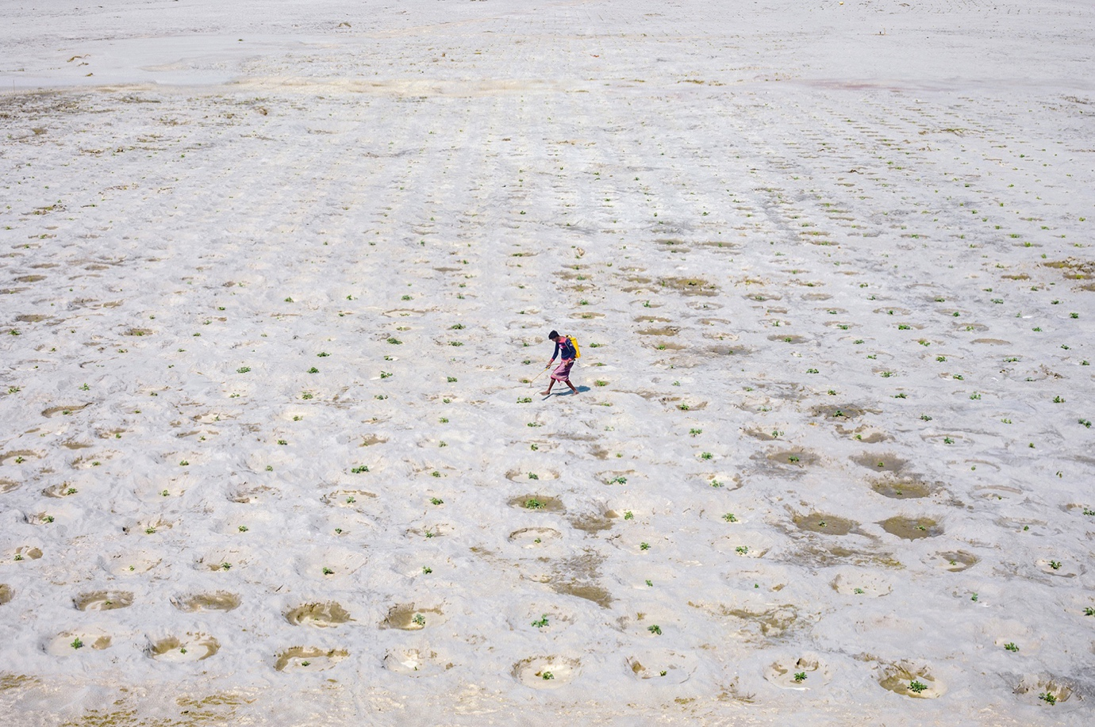

Source: Photography for Humanity, 2022.

Climate changes and accompanying phenomena often have a more pronounced adverse socio-economic effect on the underprivileged population and damage their health to a greater extent. Due to various factors, poorer countries are much more threatened by climate change and will be the first to feel the most severe consequences. Climatic conditions in these countries are already unfavorable. When we look at the geographical position of poor countries, we notice that they are primarily located in unfavorable climates. These are mainly tropical areas that already have temperatures significantly higher than the rest of the world and variable amounts of precipitation throughout the year that make these areas worse for agricultural activities. In general, the geographical position is considered one of the reasons for the lower development of these countries. In research, the economist who deals with the issue of climate change and winner of the Nobel Prize for Economics in 2018, William Nordhaus, concluded that tropical climatic features negatively impact the economic performance of countries compared to the influence of temperate regions. These areas are among the first to feel the severe consequences of climate change. When we take into account that their population is already exposed to unfavourable weather conditions, which are one of the main reasons for the underdevelopment of those countries, it is clear that the changes predicted by scientists in the event of a temperature rise would directly threaten the people who now live in poor countries. Their Future made development even more difficult. The economy of these countries is more sensitive to climate change. The structure of the economy of rich and poor countries differs significantly. Less developed countries are susceptible to the direct impacts of climate change due to their heavy reliance on agriculture and the use of natural ecosystems. At the same time, for example, agriculture is an activity that depends more than others on climatic conditions: high temperatures, droughts, bad weather, hail, and floods. These phenomena significantly affect the quality and can lead to significant shocks and a drop in agricultural production. [5]

How effective the regulation of equity and equality will be embodied in transnational actions to battle climate change issues will assist in determining the content and ambition of such efforts. Industrialized and post-industrialized countries are accountable for a substantial percentage of the historical carbon dioxide (CO2) emissions in the atmosphere we face today. The United States (USA) has emitted more carbon than any other nation and is historically accountable for 25 per cent of recorded emissions. Then we have twenty-seven European nations. The European Union (EU and the UK) are responsible for 22% of global CO2 emissions. Also, China's recorded contributions are evaluated to be around 12.7 per cent historically. However, by contrast, several of the world's largest countries, India, which has 3 per cent, and Brazil, 0.9 per cent, have historically not significantly adversely contributed to global emissions. Similarly, the contributions of African countries are at 3 per cent combined. It has been minimal relative to the continent's size and huge population. Additionally, the wealthy countries of the Global North continually have much higher per capita emissions than the rest of the world. It has not changed till even today. For example, the USA ranked very high among post-industrialized nations in 2019. It was estimated at 16 tonnes of CO2 emissions per capita, only behind Australia with 16.3 tonnes per capita. Canada comes third with 15.4 tonnes per capita. The figures for European countries are typically between 5 and 10 tonnes per capita, depending on the country. Furthermore, Hydrocarbon-based economies (e.g., Russia) and Gulf Cooperation Council constituents in the Persian Gulf Region (e.g., Kuwait, Qatar, Saudi Arabia, and the United Arab Emirates-UAE) also rank very high. Some of these countries rank even higher than countries in the Global North. [6]

Globally, regarding the situation and position, climate impacts are not consistent. The Global Climate Risk Index from 2021 showed that the poorest countries in the world while recording the lowest pollution rate, are most exposed to the damage created by climate change. Proof, i.e. data reveals where they are specifically vulnerable to climate change, its impacts and consequences. Accordingly, climate change broadens current global inequalities, damaging measures aiming at poverty reduction. By 2030, the ecological crisis will put 135 million people into poverty and deprivation. We can review the national levels in global terms. In that case, climate change additionally aggravates inequalities within countries by striking the poorest societies. Black, Indigenous, People of Colour communities, i.e. BIPOC, women and children, are hardest hit by climate change. Thus, most vulnerable groups face the results of global warming daily. For example, even though small farmers in rural economic frameworks deliver 75% of the food supply in multiple developing countries, their work is affected by floods, droughts, temperature increases, and many natural catastrophes. However, many vulnerable groups who are most affected are often the most actively engaged in protecting and conserving natural habitats. Such is the case for many indigenous environmental protectors. Moreover, besides being exposed to the most directly damaging impacts of climate change and global warming, these communities face other issues. They often encounter excessively violent attacks to defend their homes, i.e., natural habitats and the planet. Global Witness documented that 227 environmental and land protectors were killed in 2020 in the Global South. [7]

Additionally, the higher sensitivity of less developed countries to climate change is primarily determined by the fact that their economic sectors are much more vital in their economies than prosperous countries. Another crucial element that increases the sensitivity of these countries to climate change and global warming is the number of people living in rural areas. Almost all people who live in the countryside depend on agriculture and will be threatened by the upcoming changes because they will be most affected by the general degradation of the environment and changes in ecosystems. Faced with new difficulties, residents from rural areas move to cities, where they belong to the poorest strata, mainly due to the lack of necessary skills and social capital. People who live in difficult conditions are the most vulnerable to heat waves, bad weather, and possible epidemics of infectious diseases, the frequency of which will increase due to climate change. Poor countries need more ability to adapt to new conditions. An indisputable fact is that it is already too late to contain the unavoidable consequences of climate change. Extensive quantities of carbon dioxide have already been released into our atmosphere. All countries globally must take severe and various actions to adapt to those issues. However, there is a significant concern. The issue is that not all countries have the same ability to adjust to climate change to adapt effectively. Besides, people as individuals or all communities will adapt to the climate as much as their resources and knowledge allow. Nevertheless, poor countries require more infrastructure, financial resources, and access to public services that should help their populations. [8]

Lack of financial funds is a recognized problem, and various international funding sources provide less developed countries with grants to build their adaptive capacities. There needs to be more than the allocated funds to do everything required, but even if there were, the poor functioning of developing countries still needs to be improved. The need for more development of institutions, significant problems with corruption, and the need for educated personnel greatly complicate the implementation of climate change adaptation projects. Consequently, many of these processes significantly widen the gap between rich and poor. From all of the above, climate change could contribute to the inequality between the developed and less developed parts of the world by practically reinforcing most of the reasons poor countries are already lagging. When we take into account the fact that richer countries are responsible for most of the emissions of gases with the greenhouse effect into the atmosphere, it becomes evident that in the problem of climate change, there is also a significant factor of injustice that imposes a kind of moral responsibility on developed countries to increase their efforts to prevent climate change. Nevertheless, the adaptive capacity of less developed countries must be increased. Even if we ignored the moral aspect, it would be in the interest of wealthy countries to address this problem. The worsening living conditions in poor countries create a suitable ground for various types of instability, which can significantly affect the world economy and security. [9]

According to the Global Climate Risk Index 2021 publication, "Who Suffers Most from Extreme Weather Events? Weather-Related Loss Events in 2019 and 2000-2019. " Hence, the Philippines, Myanmar, Haiti, Puerto Rico, Mozambique, Bahamas, Bangladesh, Thailand, and Pakistan will be hit significantly by these climate or weather extremes. Hurricanes, cyclones, and typhoons most often hit those countries, and analysts included both exposure to weather extremes and economic losses in calculating the climate risk index. Only 14% of the world's population lives on the territory of the countries responsible for almost half of the total cumulative emissions of carbon dioxide. The sum of the combined GDPs of the nine most climate-vulnerable countries is almost 20 times smaller than the GDP of the USA, which had the highest cumulative carbon dioxide emissions from 1850 to 2021, according to Carbon Brief's analysis of the historically most responsible countries for climate change. [10]

Furthermore, fossil fuels have had the largest share in the world's total cumulative carbon dioxide emissions. However, the role of other human activities, such as deforestation, is not negligible either. Only 14% of the world's population lives on the territory of the countries responsible for almost half of the total cumulative emissions of carbon dioxide. Thanks to the burning of fossil fuels, they were the first to industrialize and thus developed into the rich powers they are today. In the name of creating a just world, developed countries should redistribute part of the money to countries with the most substantial impact on global warming and do not have the opportunity to develop through the massive burning of fossil fuels. In this way, more prosperous countries would pay off their "climate debts ." [11]

To define climate justice, we must first refer to its antonym - climate injustice. As the consequences of climate change pile up, a significant challenge is to protect communities that are highly exposed to this problem. Many philosophers and historians who have dealt with social justice theory have determined the starting point for solving this problem and finding a way to climate justice. John Rawls is the one who explored the idea of ​​intergenerational equity based on the principle of the initial position, known as the 'veil of ignorance', which teaches us, above all, empathy and ensures a just world based on the principle of equality. Rawls makes us ask ourselves what kind of world we would like and create for ourselves from the aforementioned initial position where every person is free and equal without any (co)knowledge of personal characteristics and social and historical circumstances that could exist in the world. In short, this principle allows us to create for all humanity the life on Earth that we would like for ourselves. The consequences of climate change are felt and visible all over the world. However, they are disproportionate, which means that some communities face problems of this type more difficult, primarily the poorer ones who do not have the fundamental conditions for everyday life (marginalized groups of society, indigenous tribes, impoverished parts of the world.). Wealthy industrialized countries, widely held responsible for climate change, maintain production and consumption habits harmful to our environment. Communities in the Global South, which constantly struggle with systemic poverty and inequalities that place them vulnerable, are living with the consequences of climate change. On the other hand, the Global South also contributes to climate change so that some communities are forced to find alternative survival methods, mainly practices harmful to the environment. This offensive cycle further contributes to the inequalities these vulnerable groups face, preventing them from fully realizing their fundamental human rights and deepening the gap between the rich and poor sections of society. [12]

What is the concept of just transition? The term has been around since the early and mid-1980s. The movement of the USA trade unions to protect workers affected by new water and air pollution regulations used this term first. In the last 5 to 10 years, this concept has achieved interest regarding fulfilling climate goals. Thus, it guarantees globally that whole societies, communities, workers, and social groups are brought along in the framework of a net-zero future. At the same time, Climate justice (or climate injustice) lies at the heart of democracy, racial equality, and equity. Thus, social justice and promoting equality and equity must indeed be associated. Changes in nature manifest ecological crisis, environmental insecurity, and human insecurity, but its causes are political, economic, and social. The order that causes social injustice is the same one that threatens the living world on planet Earth. There are no partial solutions in the fight against climate change. There is no non-political and isolated ecological struggle that can bring a solution to the problem. That is why movements to solve the climate crisis cannot remain within boundaries, be it geographical, economic, geopolitical, racial, ethnic, or religious (narrowly understood) ecology. Struggles and actions must be unified for climate, social, economic, and gender justice. It is crucial to make the climate crisis relevant to all people's lives, thus raising awareness.

What is the concept of critical security studies (CSC), and what is its connection to climate change? In its theoretical, conceptual and practical terms, CSC should not aim to establish an objective truth. However, it should enable a more comprehensive understanding of security based on considering specific theoretical, but most importantly, political starting matters in its conceptualization. Environmental Security, ecological security, and environmental conservation are topics of across-the-board global security. Environmental Security and environmental protection are issues of overall security because they directly cause open conflicts and wars, condition the birth of terrorism, have the potential to destabilize countries, and can lead to the displacement of the population, massive migrations, and the disintegration of the states. It affects the entire already endangered population (especially the Global South). Concerning the geopolitical impacts of climate change (particularly in the developing countries of the Global South), climate change effects, such as global warming, rising sea levels, water shortages, melting glaciers, and floods (...), impact international relations and geopolitical sphere. The status of conflicts and tensions between countries relies on how strong the relations and shared interests of the countries in particular regions and globally. Some countries significantly depend on the status of the atmosphere and their climate environment.
Moreover, adverse climate change conditions will impact all neighboring countries - even those that are sociopolitically stable, peaceful, financially successful on an international level, and economically prosperous. There is a need for research initiatives on how modern technologies, on the one hand, and the involvement of the younger generations and minorities, can be used and increased to strengthen communities' resilience to disasters and ensure an effective, comprehensive, and sustainable approach. Quality governance and leadership in the field of climate change are crucial for environmental safety. [13]

Figure 2. Illustration of climate change's effects and climate injustice: A man watches as people search for the body of his family member, killed in a landslide. This tragedy killed more than 200 people. Petrópolis, Brazil. (February, 2022) Photo/Mariana Rocha

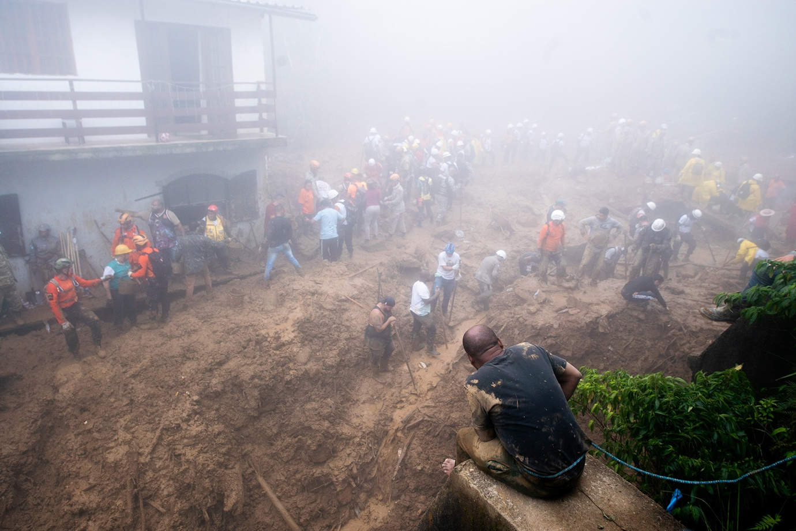
Source: Photography for Humanity, 2022.

Regarding the climate injustice debate, the role of young people is vital in the eco-activist sphere. They express their affiliation with the global movement Fridays for the Future. The young activists are clear in setting their primary demands: declare a climate emergency and encourage a political response to halt environmental degradation primarily by applying the following three fundamental principles from the Paris Agreement: keeping the global temperature increase below 1.5 °C to the pre-industrial level, ensuring climate justice and, above all, following the conclusions of currently available scientific knowledge. Thus, youth activism acquires a new dimension, primarily characterized by the fight for environmental issues but, on the other hand, closely related to the consistent application of the principles of social justice in the fight against climate change. Moreover, it is essential to note that the field of climate change is included in a wide range of environmental issues. Hence, the activism of young people is not closely related to one environmental problem but rather draws attention to several of them, giving a new dimension to the movement in which environmental issues are considered. Thus, through the prism of global justice. Viewing climate change as an issue of global justice sends a much stronger message than, say, images of tree-hugging activists to defend the forest from logging. [14]

The ultimate motivation for urgent climate and environmental action and climate justice are not only social, political, geopolitical, economic, scientific, or even security. However, these factors must also be included in the decision-making process. However, the main reason for action is applied environmental ethics, human ethics, and moral reasoning. Africa, Southeast Asia, the Caribbean, and the Pacific Island countries suffered disproportionate damage, although they contributed very little to the emergence of this crisis. Acute and chronic consequences of the climate crisis create issues such as poverty, infectious diseases, forced migration, and conflicts that spread through globalized systems. Such indirect consequences of the climate crisis affect all countries of the world. COVID-19 was a wake-up call regarding these global dynamics of effects. It is, again, a massive moral question and requires urgent multidimensional action. Climate change is increasingly understood as a social justice issue by academics, policymakers, and the public; however, the nature of these perceptions and their implications for cooperation and decision-making have only recently begun to receive empirical attention. Morality and justice perceptions can serve as both a bridge and a barrier to cooperation around climate change. [15]
The widespread flooding in Pakistan has resulted in over 1,000 deaths since mid-June, impacting over 30 million, with the destruction of homes, crops, roads, bridges, and more critical infrastructure across all four provinces in Pakistan. Right now, first responders, the military, and volunteers are working to evacuate stranded Pakistanis, deliver food to remote regions, and mitigate the spread of waterborne diseases. Agencies estimate that about 6.5 million Pakistanis need shelter, food, potable water, and medicine. It is an environmental injustice. Pakistan produces less than 1% of global greenhouse gas emissions but ranks consistently in the top 10 countries most vulnerable to the effects of climate change.” Early estimates state that these floods alone have cost Pakistan USD 10 billion. This is not an isolated incident. People living in South Asia are more likely to die from climate crisis impacts. This foreshadows the extreme weather that is happening and is to come due to climate change. Racing floods and landslides have also affected Millions across India, Bangladesh, and Afghanistan. Rainfall, flooding, and mudslides in western China are estimated to have left about 1,000 dead. In Ghana, fishers and fishmongers struggle to catch fish, leaving fishing communities, especially women, very vulnerable to the negative impacts of climate change. [16]
I maintain that Somalia's long-term "famine crisis," which arose directly under the impact of climate change, is the moral collapse of the world precisely because food deficit and hunger must not occur and be a reality in the 21st century. Climate change has adversely affected critical human security in Somalia and has hit the most vulnerable people “again.” Climate extremes will keep hunger in Somalia at record highs and devastate deeply food-insecure communities battling to recover from the country's longest recorded drought. Two years of drought pushed the country to famine and has driven half a million people from their homes and disabled families' attempts to rebuild their drought-ravaged livelihoods. It is even more challenging due to Somalia's constant internal (and external) conflicts, state of violence, and alarming human security.

Climate change in Somalia creates persistent human security issues. In 2022, more than 43,000 lives were claimed by Somalia’s drought — the region’s worst in 40 years. The unprecedented lack of rain, exacerbated by climate change, caused extreme hunger, displacement, and inequity throughout the country. Millions of people still struggle daily to find necessities like food and water. Although the latest wet season this spring brought some rain, it did little to undo months upon months of failed crops, deceased livestock, environmental destruction, and poverty caused by the drought. Approximately 8.3 million people in Somalia are struggling to survive multiple crises — 1.8 million are malnourished children, and an estimated 477,700 children suffer from severe malnutrition. To address these ongoing crises, humanitarian partners and donors must work collaboratively to tackle the root causes of food insecurity and provide immediate and sustained support to affected communities. [17]

Visuals, i.e., images, depict climate change as a human rights crisis, as women, children, minorities, the poor, and the marginalized suffer disproportionately as the climate catastrophe escalates.

Figure 3. Illustration of climate change's effects and climate injustice: Children playing on a sea embankment that overflowed due to tidal waves and flooded residential areas. Muara Baru area, Jakarta (August 2022)

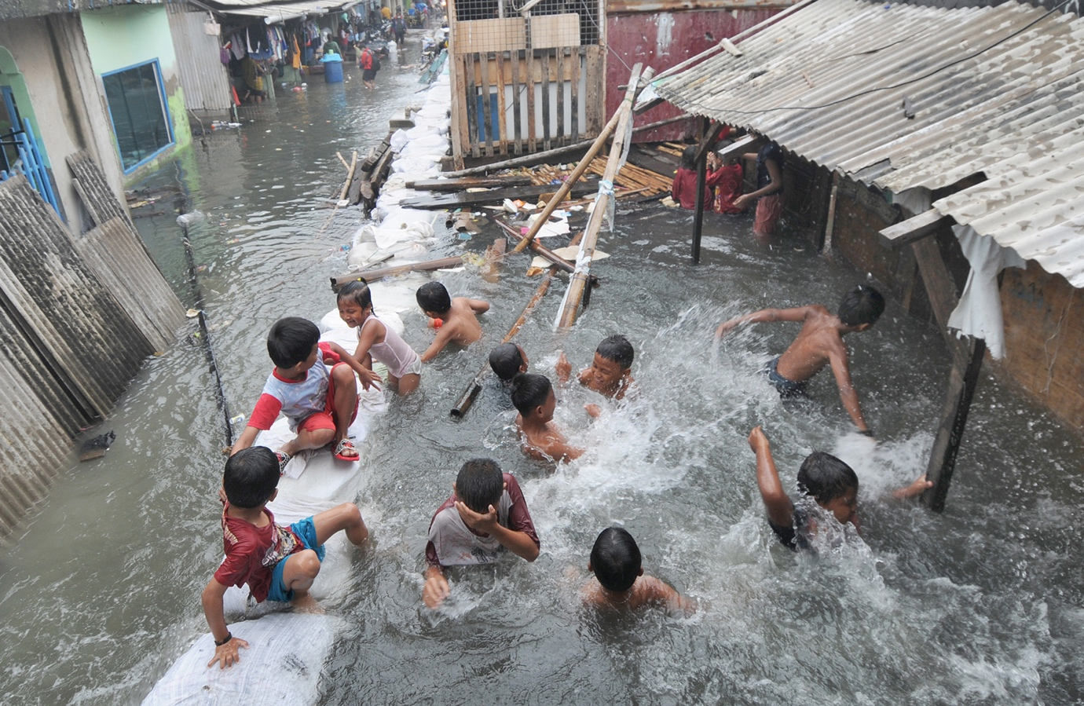

Source: Photography for Humanity, 2022.

This manuscript presents a comprehensive and insightful exploration of climate justice and climate injustice and their social, geopolitical, legal, security, and moral dimensions. It contributes perspectives on the global climate crisis and its implications. On the theoretical and practical it adds insight into global climate and environmental processes, concepts of climate justice, and injustice. The author problematizes social, geopolitical, security, legal, and moral directions regarding climate change disasters and environmental and human insecurity in that framework. The paper analyzes the essence and goals of climate justice, the consequences of climate injustice, and the positions of wealthy and poorer countries, offering normative solutions. Thus, the paper analyses concepts and notions of these highly actual and prudent scientific frameworks/areas, expanding social, political, geopolitical, legal, security, educational, and ethical awareness. This research review adds essential insight into environmental and climate justice actualities, offering normative solutions. Accordingly, the author analyses the positions of wealthy and poorer countries - mainly and severely affected by climate change, environmental security and ecological crisis and fragility, human security, and matters of morality concerning subjects.

METHODOLOGY AND MATERIALS
This research review combined a meta-analysis, content analysis, thematic analysis, a descriptive method, and an in-depth literature review. It examined various scientific, professional, and expert-based data forms. The study incorporated the representation and analysis of visual expressions of climate change consequences and injustice. It also included human-centric aspects and perceptions through the narratives and voices of climate activists. The paper analyses concepts and notions of these highly actual and prudent scientific frameworks/areas, expanding social, political, geopolitical, legal, security, educational, and ethical awareness.

DISCUSSION AND RESULTS
Climate changes have created comprehensive issues, including decreasing sustainable peace and increasing conflicts. Climate change creates a distributive imbalance between the Global North and Global South, between generations, and between indigenous and traditional technologically developed communities, fundamentally compromising these principles. It is why climate change is becoming one of the main threats to global peace, creating tensions at all levels. Accordingly, the question arises as to where we are currently, as a global civilization, concerning these principles. To a considerable extent, the global response to climate change is muted by imposed narratives, which can be reduced to two general, lower-ranking narratives: the imperative of infinite economic growth and the indispensability of the currently prevailing socio-economic system. Contrasted with this are traditional narratives, partially forgotten or neglected but still alive.

The Global South is the least responsible for greenhouse gas emissions but is currently the hardest hit by climate change. The Global South is a part of the world that abounds with tragedies similar to Joanna Sustento's. In that part of the world, we are witnessing the disappearance of the conditions on which people's lives and the normal functioning of society depend. Moreover, developing nations in the South and industrialized and prosperous states in the North have had a complex relationship since WW2. However, modernization theorists argue that globalization and liberalization develop new prospects for the more fragile countries of the South. Developing countries benefit from attracting foreign investments, technology, science, and international knowledge. Accordingly, it is crucial to make necessary adjustments to reverse this direction resulting from globalization. However, many things could be improved. For example, since the Cold War era, South America's strategic relevancy has been additionally weakened by competition. Such as competition regarding foreign finance, investment and international assistance from Eastern European countries and the former Soviet Union. [18]

Climate change is a defining challenge that will undermine the achievement of the Sustainable Development Goals (SDGs). The planet grows hotter, drier, and harder, hit by extreme weather events such as the effects of rising sea levels. Thus, climate change will act as a threat multiplier, disrupting livelihoods, driving displacement and migration, intensifying scarcities of natural resources, which can drive violence and conflict, and raising pressure on state-citizen relations and state capacity to advance development. The people most vulnerable to the effects of climate change are those who already experience systematic exclusion and marginalization. Women and girls, youth and children, indigenous peoples, and climate migrants will bear the brunt of the impact.

Critical elements of achieving transformative climate action through the rule of law include:
- Empowering the most climate-vulnerable people to realize environmental rights and actively participate in decision-making processes
- Strengthening regulatory frameworks and institutional capacity for climate-resilient development
- Improving governance of land and other natural resources with a focus on enhancing land rights and sustaining peace. [19]

The sustainable and advanced approach to security sets global justice, equality, and equity as requirements of any sufficient answer to global insecurity. However, agents and narratives from the Global South countries remain on the periphery of global political and security debates. Such practice is evident, particularly at international institutions and organizations negotiating round-tables. This matter requires to be addressed. Western world organizations could contribute to creating an egalitarian course to international relations by adopting a compact and noteworthy engagement with most of the world. Security analysts, policymakers and academicians must continue engaging and collaborating with Global South peers. It should ensure that the sustainable security task puts the idea of genuine and inclusive international politics into practice. The Global South states will encounter many forthcoming security issues and resolutions. Particularly given their personal experience and intuitive understanding of those issues within populations whose marginalization has resulted in much co-occurring insecurity. Furthermore, climate change will impact the poorest communities hardest. However, simultaneously, with emerging economies (e.g., China, India, and Brazil), the Western world must confront mitigating climate crises to succeed. Non-Western views must be acknowledged and addressed in substantial policies in the influential nations of the Global North. Such policies should be focused on transforming pressures at their root rather than exclusively trying to control violent conflicts. Also, communication is essential. North and South communication is a requirement, giving Western decision-makers more reasons and resources to engage with their counterparts worldwide to create a sustainable global system. [20]

What about the situation when climate change affects living resources and increases violence? In that case, the economic framework played a much more vital role than, for example, religion in joining terrorist organizations. There is a necessity for research initiatives on how modern technologies, on the one hand, and the involvement of the younger generations and minorities, on the other, can be used and improved to strengthen communities' resilience to climate change crises (e.g., natural disasters). Such an approach should ensure an effective, complete, and sustainable approach to overall security. Thus, satisfactory governance and leadership in climate change issues are essential for environmental protection. [21]

Nevertheless, equity matters between the Global North and Global South arise from the asymmetry between countries' emissions and their respective commitments to respond to climate change. It includes the costs of emissions mitigation, adaptation, and other impacts and risks. Most human-driven emissions (GHG) in the atmosphere result from economic activities performed in most economically potent countries or for these states. Nevertheless, poorer countries enduring climate-induced environmental crises carry a more significant impediment to climate change impacts. A further separating condition in climate negotiations results from the contrast between past and future emissions. While prosperous industrialised and post-industrialized nations in the Global North are accountable for most past emissions, these countries led by the European Union (EU) are enforcing policies to decrease their GHG emissions. Furthermore, the emissions of most developing nations (e.g., China) remain on an upward course. However, at least this second group of countries will only reach peak emissions in a decade. As a result, it is a fact that developing countries also share some responsibility for reducing future emissions. These comparing tendencies also create problems of generational justice. Thus, differences correlated with the immediacy of the impacts of climate change shape the diplomacy engaging in the international multilateral climate negotiations. Some parties among nations in the Global South and issue-based coalitions of countries in the Global North and South have emerged based on common problems. Less developed economies, exceptionally tiny island nations, already encounter the existential threat of climate change and are urging immediate answers from prosperous post-industrialized and developing countries. The Organization of the Petroleum Exporting Countries associates demand post-industrialized economies to adopt policies that reduce welfare losses in countries relying on petroleum exports. [22]

Figure 4. Illustration of climate change's effects and climate injustice: Looking for plastic materials to recycle in polluted water. Dhaka, Bangladesh (April, 2022) Photo/Saiful Islam

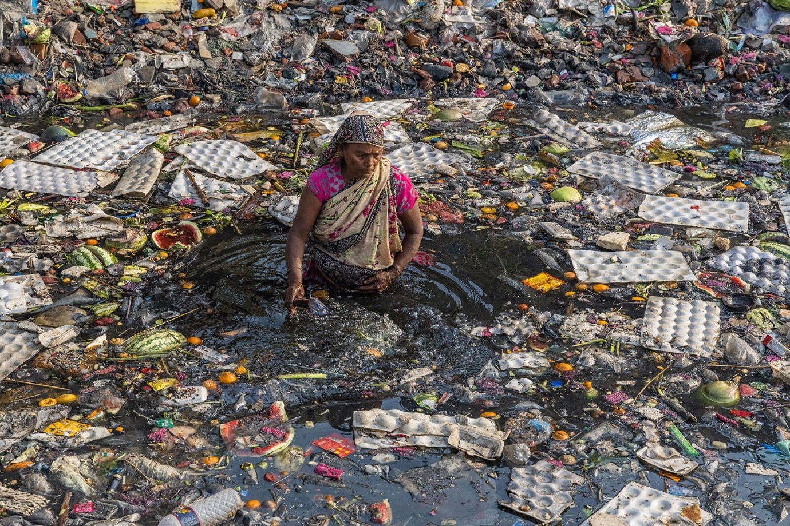

Source: Source: Photography for Humanity, 2022.

As the consequences of climate change pile up, a significant challenge is to protect communities that are highly exposed to this problem. The consequences of climate change are felt and visible all over the world. However, it is generally known that they are disproportionate, which means that some communities face problems of this type more and more difficult, primarily the poor ones who do not have the primary conditions for everyday life (marginalized groups of society, indigenous tribes, impoverished parts of the world). Rich industrialized countries, widely held responsible for climate change, maintain production and consumption habits harmful to our environment. Communities in the Global South, which constantly struggle with systemic poverty and inequalities that place them vulnerable, are living with the consequences of climate change. At the core of the very concept of climate justice is the fight against deep social inequalities exemplified by the uneven distribution of responsibilities in solving the climate crisis and reducing the effects of climate change. Many philosophers and historians who have dealt with social justice theory have determined the starting point for solving this problem and finding a way to climate justice. However, touching on an integral part of the contemporary struggle for climate justice, moral integrity is crucial. Rich countries have a moral obligation to help other countries adapt to a changing climate and a financial responsibility to ensure development that meets developing countries' immediate and short-term basic needs. Well-organized rich countries with high carbon emissions today have the technological, institutional, and financial capacity to reduce emissions and help poorer countries bear the burden of climate change.
There are two critical areas for future development: psychological processes that promote and impede climate vulnerability and enhancing equity in the design and implementation of climate solutions. Conceptualizing climate justice as a multidimensional process addressing social and structural barriers can stimulate new psychological research and help align disparate approaches within the social sciences. [23]
What is the most effective cooperation instrument between prosperous and poorer countries, or is there one? There might be only one efficient collaboration mechanism between the Global North and Global South nations. It is the Green Climate Fund, i.e., GCF. The GCF is a new international organization established under the UNFCCC based in South Korea. Its objective is to collect financial assistance from member countries and mobilize private capital to fund climate and environmental projects in the Global South countries. The GCF gloats some significant institutional innovations that distinguish it from other international financial institutions (e.g., IMF and the World Bank). However, most importantly, in their (GCF) decision-making, there is equality between patron nations in the Global North and donors and recipient nations in the Global South. Taking on the obligation to respond rapidly to climate-associated catastrophes could bring transformations that would speed up strategies carried out by the GCG. It may seem encouraging and optimistic, given the issues the GCF encounters. However, as a laboratory for equitable relations between North and South states, the GCF is the most suitable prospect. [24]

Moreover, while the so-called Global North continues to emit greenhouse gases with undiminished intensity and enjoys the prosperity made possible by extravagance, the Global South suffers the consequences of such an unsustainable way of life. It reveals the fundamental injustice at the very core of climate change. The book "Petroleum Papers - Inside the Far-Right Conspiracy to Cover Up Climate Change" by the Canadian-American journalist and publicist Geoff Dembicki is not the story of Joanna Sustento. However, the story of her tragedy was taken as the narrative backbone for a highly detailed analysis of the origin and development of climate change denial by the fossil fuel industry and the closely related conservative right. The book " Petroleum Papers" is about how the tragedy of Joanna Sustento could have been avoided if the fossil industry had not chosen the path of actively creating and feeding lies on which the denial of climate change is based. [25]

The largest carbon dioxide emitters throughout history should be the first to react and the fastest to reduce CO2 emissions to limit warming to 1.5 °C soon. To properly understand the origin and development of climate change caused by human activities, we should look back at the past. Since the beginning of the Industrial Revolution, humanity has released about 2,500 billion tons of carbon dioxide, i.e., GtCO2, into the atmosphere. Thus, historical accountability for climate change is at the core of the climate justice argument. Hence, the climate justice debate should primarily determine which countries should be the foremost to respond and take the most immediate action to reduce carbon dioxide emissions. According to scientific studies, to keep the average global temperature increase below the desired 1.5 °C, we should not release more carbon dioxide into the atmosphere than what is allowed by the so-called carbon budget. It now amounts to less than 500 billion tons of carbon dioxide, and countries have cut it the most in the past.

Figure 5. Illustration of climate change's effects and climate injustice: To save water at home, a woman washes her clothes by the river. MyinTwin Village, Myanmar
(January, 2022) Photo/Si Thu Ye Myint



Source: Source: Photography for Humanity, 2022.

Climate justice is also heavily interconnected with historical injustices. It relates to how the climate crisis occurred, who caused it, and so, ultimately, who needs to take the most action. Since the foundational UN climate convention was negotiated in the early 1990s, climate justice has been an essential topic of discussion. Global emissions need to be cut to avoid dangerous levels of climate change. Nevertheless, for many, a bedrock of climate justice is the need for fairness in who cuts which emissions, considering both historical and present circumstances. Climate justice means many things to many people, but at its core is the recognition that those disproportionately impacted by climate change tend not to be those most responsible for causing it. Climate change is not only an environmental problem. It interacts with social systems, privileges, and embedded injustices and unequally affects people of different classes, races, genders, geography, and generations. The climate solutions proposed by climate justice advocates aim to address long-standing systemic injustices. "A very wealthy and tiny minority of the world's countries and corporations have been the principal cause of climate change, while the adverse effects of the climate crisis fall first and foremost on the poorest majority. [26]

Carbon Brief, specializing in the science of climate change, recently published an analysis focusing on which countries contributed the most to total carbon dioxide emissions from 1850 to 2021. In addition to emissions from the fossil fuel industry, the analysts also included emissions from land. The first place in the list of the ten largest emitters of carbon dioxide in history is convincingly taken by the United States of America (USA), with cumulative emissions of 509 billion tons of carbon dioxide, corresponding to 20% of the total global cumulative emissions. Second-ranked China had a significantly smaller contribution to the problem of global warming than the US, emitting about 284 billion tons of carbon dioxide since 1850 (a share of about 11% of the world's total cumulative emissions). Russia is in third place on this list, with cumulative emissions of about 172 billion tons of carbon dioxide (about 7%).
Interestingly, China's and Russia's combined cumulative carbon dioxide emissions are lower than the US's. Regarding the historical great powers, Germany and the United Kingdom are responsible for cumulative emissions worth 88 billion tons of carbon dioxide (about 4%) and 74 billion tons of carbon dioxide (about 3%). Germany and the United Kingdom are positioned in sixth and eighth place, while between them, in seventh place, is India, with cumulative emissions of 85 billion tons of carbon dioxide (about 3%). The last two places on the list of the ten largest emitters of carbon dioxide in history are occupied by Japan and Canada, with cumulative emissions of about 68 billion tons (about 3%) and about 65 billion tons of carbon dioxide (about 3%). [27]
The “10 New Insights” report emphasized “how climate change has exacerbated socioeconomic inequalities and stressed the importance of inclusive decision-making for effective and just climate action. It included reflections on the implications for the climate system and climate action of significant developments on the world stage, such as COVID-19 and the Russian-Ukraine war. Overshooting 1.5°C is fast becoming inevitable. Minimizing the magnitude and duration of overshoot is essential. Multiple lines of evidence indicate that, due to insufficient mitigation of greenhouse gases (GHGs), no pathway remains that avoids exceeding 1.5°C global warming for at least some decades, except for truly radical transformations. Minimizing the magnitude and duration of the overshoot period is critical for reducing loss and damage and the risk of irreversible changes. A rapid and managed fossil fuel phase-out is required to stay within the Paris Agreement target range. The fast-shrinking carbon budget means governments and the private sector must stop enabling new fossil fuel projects, accelerate the early retirement of existing infrastructure, and rapidly increase the pace of renewable energy deployment. High-income countries must lead the transition and provide support for low-income countries” [28]. “All countries should pursue an equitable transition, minimizing socio-economic impacts on the most vulnerable segments of the population. Joint governance is necessary to address the interlinked climate and biodiversity emergencies. The international conventions on climate change and biodiversity (the United Nations Framework Convention on Climate Change and the Convention on Biological Diversity, respectively) must find better alignment. Ensuring that the allocation of climate finance has nature-positive safeguards and strengthening concrete cross-convention collaboration are critical actions in the right direction. Human immobility in areas exposed to climate risks is increasing. People facing climate risks may be unable or unwilling to relocate, and existing institutional frameworks need to account for immobility and be insufficient to anticipate or support the needs of these populations. New tools to operationalize justice enable more effective climate adaptation. Monitoring the distinct dimensions of justice and incorporating them as part of strategic climate adaptation planning and evaluation can build resilience to climate change and decrease the risk of maladaptation. Reforming food systems can contribute to just climate action. With viable production and consumption mitigation options, food systems are crucial in climate action. However, interventions should be designed with and for equity and justice as linked outcomes, and mitigation measures should be implemented inclusively with diverse stakeholders across multiple scales”. [28]
Figure 6. Illustration of climate change's effects and climate injustice: Ghulam Mohammad, a 56-year-old man lost his entire family in a flood and now lives in Herat, at an internally displaced camp. Herat, Afghanistan (Unknown date) Photo/Sayed Habib Bidell
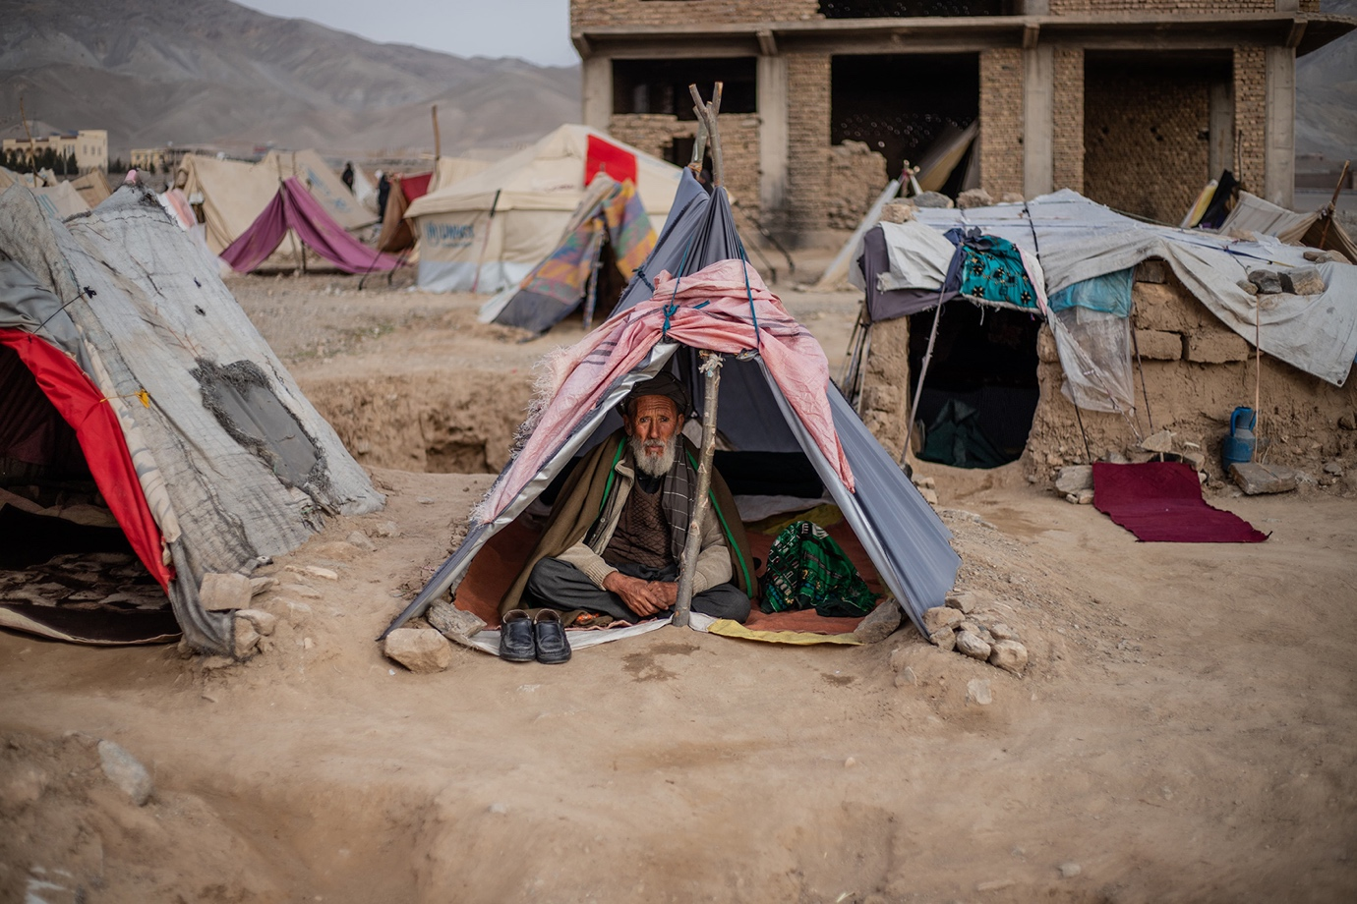Source: Source: Photography for Humanity, 2022.
Why are cumulative carbon dioxide emissions significant? The nations that signed the Paris Agreement agreed to support the increase in the average global temperature below two °C compared to the pre-industrial era. Since scientists have recognized a straightforward relationship between the complete amount of carbon dioxide released due to human activities and the extent of warming of the Earth's surface, it is evident that by the middle of the century, we should drastically reduce carbon dioxide emissions into the atmosphere. Thus, reach a net - zero emissions net zero to implement the agreement's objectives. Adopting the 2015 Paris Agreement questions the shared understanding of equity principles in climate change control. In addition, it has been established that the contribution of carbon dioxide emissions to the increase in temperature can be felt decades, and even centuries, later from the moment of their emission precisely because of the constant accumulation of this gas in the atmosphere. This further means that the current warming results from cumulative carbon dioxide emissions from the beginning of the Industrial Revolution to the present day. To comply with the Paris Agreement and keep the temperature increase to about 1.5 °C by the end of the century, we have a carbon budget of about 500 billion tons of carbon dioxide at our disposal. The carbon budget has been consumed rapidly in recent decades, so even half of the cumulative carbon dioxide emissions since 1850 have been released in the last 40 years. If we have a 50% chance of limiting global warming to 1.5°C and a 90% chance of limiting it to 2°C, a cumulative CO2 emission between now and mid-century must be limited to a “carbon budget” of 500 gigatons (Gt) CO2. This budget assumes, By mid-century, a reduction of around 50% in annual CH4 emissions and 30% in annual nitrous oxide (N2O) emissions. It is certain that “carbon dioxide removals” (CDR) will be required to limit global warming within acceptable limits. [29] Thus, we could use the remaining carbon budget between 7-9 years if current policies remain. Exceeding the carbon budget, and thus the agreed temperature increase could have catastrophic implications for our planet.
With the issue of climate justice, we touch on an integral part of the contemporary struggle for climate justice - moral integrity. Wealthy countries have a moral obligation to help other countries adapt to a changing climate and a financial responsibility to ensure development that meets developing countries' immediate and short-term basic needs. These high-carbon countries today have the technological, institutional and financial capacity to reduce emissions and help poorer countries bear the burden of climate change. Nevertheless, activists should be determined to keep the climate crisis in the focus of public discourse and ensure that it is understood as a crisis and acted upon accordingly. It is a fact that more and more people are joining the strikes daily, either online or on the streets. However, the question is how solid and organized climate movements (particularly youth movements) are to withstand the constant and tireless struggle and the pressure of the political milieu. Moreover, at the core of the very concept of climate justice is the fight against deep social inequalities exemplified by the uneven distribution of responsibilities in solving the climate crisis and reducing the effects of climate change. Thus, the overall concept of social justice, applied to the climate change discourse, also requires moral obligations from the countries that contribute the most to global warming. Their economic abilities should financially and technologically facilitate poorer, underdeveloped countries. The main reason is that these communities who contribute the least to climate change and suffer the most, according to climate justice principles, have the right to receive technology and finance from the big polluters, whose moral duty is to provide it all. This transfer of resources in the fight against climate change would significantly improve the status of communities in the underdeveloped and developing states in the Global South. Most people will agree that mitigating the problems caused by climate change requires a thorough review of current socioeconomic and political practices, or as young activists demand: “ system change, not climate”. [30]

Figure 7. Teen activists tell protesters demanding climate change action: ‘We need to do this now.
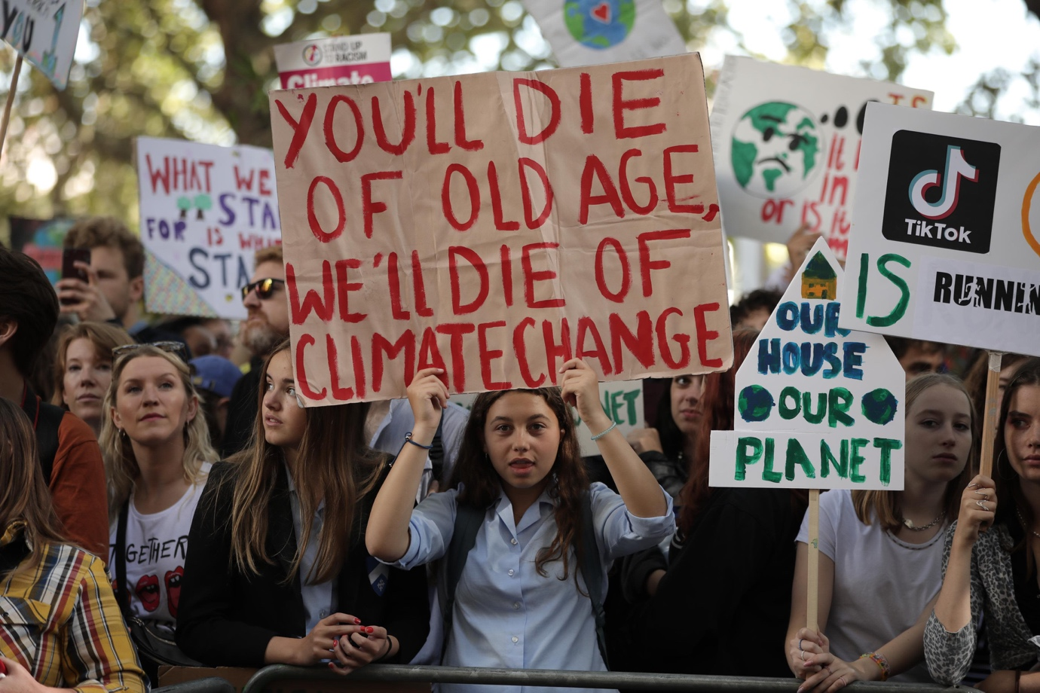
Source: CNN, 2019.

Climate change endangers the Future of human rights, overall development (including sustainable development), health, and the struggle against massive poverty and marginalization. As global warming, disproportionate rainfall, and intense droughts affect agriculture, food supplies will decline. It will increase food prices and deprivation. Such events lead to intractable economic, social, political and human security conditions. Also, sound international and domestic policy opportunities will be significantly harmed. It will impact the increase of violence, armed conflicts and mass migrations. Critical security theory should be both a theoretical obligation and a political direction, as a collection of ideas and concepts that critically and continually explore communities and emancipation within societies. Addressing socio-economic and other disparities within minorities, indigenous and non-indigenous populations, globally impoverished, and community empowerment are essential to improving the resilience to climate change. Tackle persistent socio-economic poverty, inequalities, natural disasters, depletion of natural resources, and environmental destruction within climate change requires collective effort and activity. The existence of a quality state apparatus, an efficient rule of law, and a social and human security welfare framework can alleviate inequity and inequality. Global migrations due to climate change will require elaborate country tactics. Notably, a peaceful solution is needed. Otherwise, the catastrophe's scale is questionable. [31]

Climate change does contribute to increased conflict. It often happens along indirect pathways. There is no group more vulnerable than those who have had to flee their country due to conflict and are now feeling the effects of a hostile climate. People who have been displaced by a combination of both conflict and the consequences of climate change and environmental degradation are doubtful to be able to return home. We are seeing increased food insecurity, urbanization (as small farm holdings no longer remain viable following droughts or disasters), and competition over resources – particularly water- across fragile regions. When combined with other planetary crises, such as land degradation and over-exploitation of the environment, climate change can make an already fraught situation untenable. 90 percent of the world’s refugees originate from countries that are already impacted by the climate emergency and/or have the least capacity to adapt to an increasingly hostile environment. The latter is crucial; while climate change impacts every square meter of this earth, it does not affect everyone equally. Unfortunately, those states that have often contributed the least to global emissions are very much at the forefront of feeling the impacts of the emergency. 3.3-3.6 billion people live in hotspots of high vulnerability to climate change, mainly in Africa, South Asia, South/Central America, and Small Island Developing States. There are increasing gaps between adaptation action taken and what’s needed, with the most significant gaps among lower-income populations. Without urgent, at-scale responses that reduce vulnerability in communities and countries facing the worst impacts, we will see more conflict, displacement, and suffering. Compounded droughts, flooding, locust plagues, environmental degradation, and poor governance lead to an increasingly precarious and complicated situation for tens of millions of people. We do not know enough about the specific triggers for why individuals or communities migrate. Still, we can say that the cascading series of disasters in many parts of the world, including throughout Africa and the Arid Corridor in the Americas, is exacerbating other trends, such as urbanization and the abandonment of small farm holdings. [32]

Figure 8. Illustration of climate change's effects and climate injustice: Due to river erosion, a woman earns $1 USD a day selling fish scales. Gazipur, Bangladesh (Unknown date) Photo/Abdullah Al Mahfuz
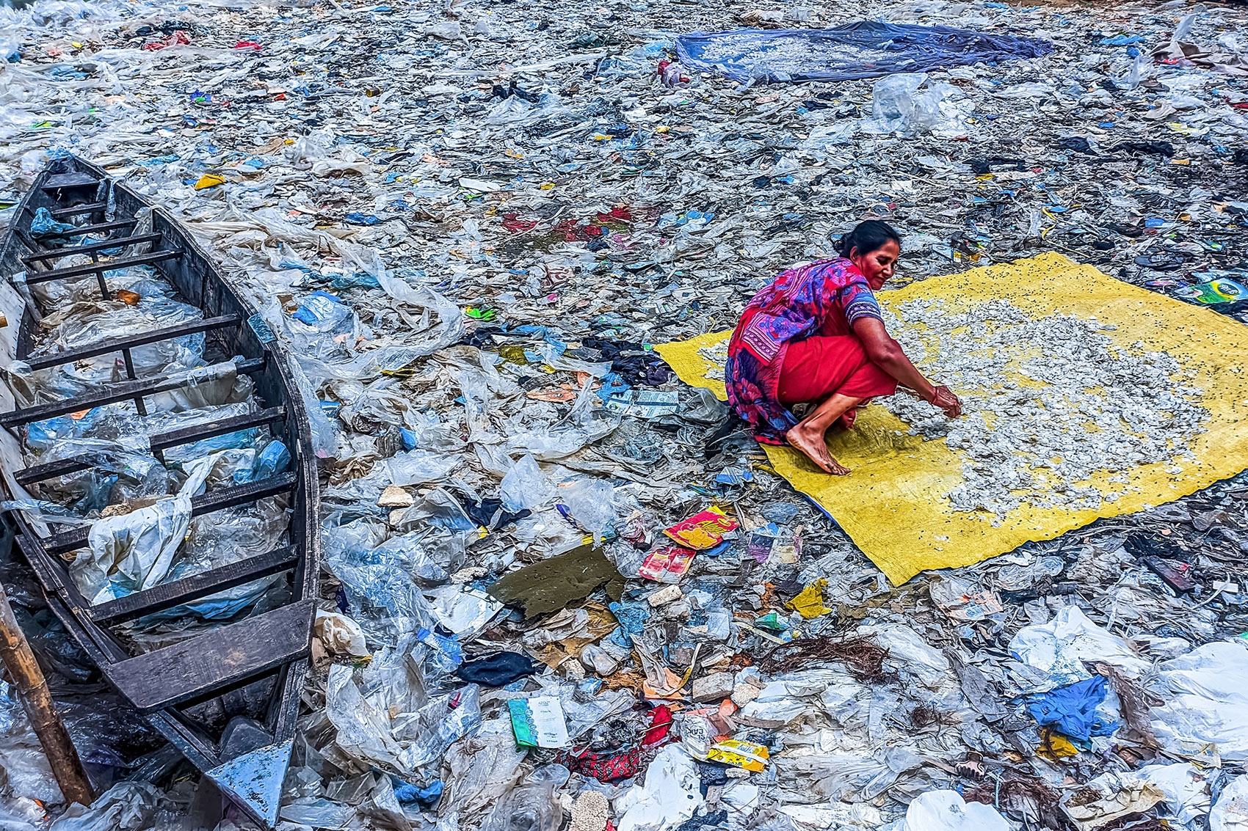Source: Source: Photography for Humanity, 2022.

Regarding adequate and correct policies, there are seven recommendations. We should invest in people-centered laws and institutions to promote transformative climate action. First, we should empower climate-vulnerable communities and people. Legal empowerment and protection of civic space can enable people and communities to claim their environmental rights. At the same time, inclusive policymaking ensures climate policies are informed and more responsive to their needs. Particular emphasis must be placed on climate migrants, providing young people with platforms and support, and ensuring that youth- and child-inclusive approaches are at the heart of climate action. Second, we should invest in people-centered laws and institutions to promote transformative climate action. People-centered justice systems can foster an investment environment attractive to climate finance mechanisms through reduced corruption, effective contract enforcement, and dispute resolution while allowing those most affected by climate change to seek redress and claim their rights. Third, feminist climate action and integrating gender-transformative strategies. Dedicated support should be provided for women-led movements and civil society organizations to contribute to global climate and biodiversity negotiations. Fourth, we must strengthen prospects for sustaining peace and stability by preventing and resolving climate-related disputes. Strengthening frameworks for the governance of land and natural resources and equitable access to both formal and customary and informal justice mechanisms can help reduce conflict risks related to contests over natural resources by preventing disputes and resolving them peacefully while promoting climate-resilient development. Fifth, we should engage with customary, informal, and indigenous justice systems to protect biodiversity and promote sustainable use of natural resources. “Customary, informal, and indigenous actors govern access to land and natural resources for many climate-vulnerable people. However, they are often excluded from the decision-making, and their rights over natural resources should be considered. Sixth, we must harness the transformative potential of the rule of law to address the intersecting effects of climate change. Climate change has a wide-ranging impact on nutrition, health, gender equality, poverty and inequality. The 2030 Agenda provides the transformative framework to advance sustainable development's integrated and indivisible dimensions. The rule of law, as articulated in SDG 16, can serve as a powerful enabler for the institutional and policy transformations needed to address the complex transversal effects of climate change in areas including food and nutrition (SDG 2), health (SDG 3), gender equality (SDG 5) and climate action (SDG 13). Seventh, we should mobilize global multi-stakeholder coalitions to accelerate climate action. Scaling up climate action will require forging new partnerships between States and actors from civil society, the private sector, academia, youth, and citizens' groups. Multilateral frameworks, including the SDGs and UNFCCC, can facilitate international cooperation and foster solidarity and coordinated and intersectoral actions on climate change and related global challenges, such as conflict and migration, grounded in the rule of law and human rights”. [33]

Figure 9. Illustration of climate change's effects and social injustice: Environmental discrimination in a township. Stellenbosch, South Africa (July, 2022) Photo/Luke Kammies

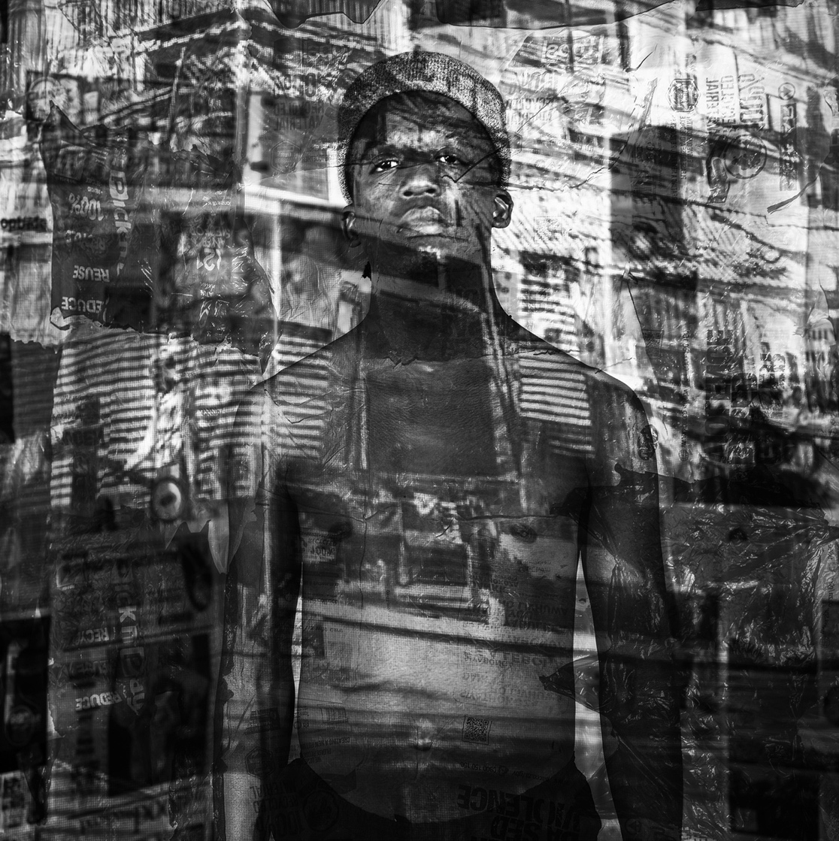
Source: Source: Photography for Humanity, 2022.

Climate change is a system-level issue that requires transformative change. Change demands many levers from social movements, politics, and economics – the law is a powerful tool that can change behaviors and, eventually, social norms. When injustice is recognized, the law can provide accountability, leading to broader societal shifts. People or organizations can use climate litigation – through court cases, legal or regulatory complaints, and other methods – to push for greater climate action ambition and hold institutions, like government and companies, accountable for climate-damaging practices. Climate change must be tackled at all levels. International commitments like the Paris Agreement are significant, as do smaller-scale initiatives like local planning and home insulation schemes. Climate litigation is becoming more and more prevalent around the world. The LSE’s Grantham Institute analysis of climate litigation trends found that globally, the number of climate change-related cases has more than doubled since 2015. The growing number of these cases are broad in scope and can address all sorts of policies, like government planning permissions, financial disclosures, and even advertising standards.
The majority of cases have so far been brought in the Global North. However, there is an increasing number worldwide as developing countries, communities, and their systems of governance and infrastructure take shape.
New laws and policies are addressing climate change in different ways. Legal strategies are also evolving in parallel. The three crucial climate litigation trends that we work on with other organizations are:
- Litigation brought against governments to hold them accountable for climate - including the increasing number of human rights-related claims
- Litigation brought against corporate actors increasingly includes banks and companies outside the oil and gas sector.
- Litigation brought based on ‘greenwashing,’ or misleading green promises - and increasing concerns of the accountability gap between net zero ambition, or plans for Paris alignment and reality [34]

“There have been 2,365 lawsuits relating to the climate crisis worldwide, of which nearly 200 were filed in the past 12 months. The cases have covered various ground, from government carbon reduction targets and strategies to corporate inaction, misinformation, and claims for climate-related damages. With extreme heat gripping parts of the planet from Europe to and disasters likely to increase, people are increasingly turning to the courts for answers, said Andy Raine, the head of international environmental law at Unep. Climate litigation has become a significant trend in how stakeholders seek to advance climate action and accountability. Most cases are still in the US, where a landmark constitutional trial brought by a group of young people against Montana recently drew to a close. It was one of dozens of cases filed against federal and state governments. Over the past year, Switzerland and France have been in the dock at the European Court of Human Rights, accused of breaching the rights of their citizens, and Australia had to defend itself from allegations that it had failed to protect a group of Torres Strait Islanders from climate breakdown, which threatens to destroy their homes. The UK government was forced to redraw its net zero strategy after climate campaigners successfully challenged it. They have applied to go back to court, arguing that the revised version is still insufficient. Action is also increasingly being taken against major corporations. While there have not been any significant successes in the US, a recent Supreme Court to keep a series of lawsuits against oil and gas firms in state court bodes well for plaintiffs”. [35]

Climate change is a global factor in current and future security issues that has yet to penetrate broader security or resilience discourse, particularly in these fragile regions. International cooperation around disaster response and risk reduction is critical. However, adaptation and resilience planning must be active across these most fragile trans-continental regions. It could provide a sound basis for a thorough cross-continental and multilayered understanding of the future threat to improve government will and support risk management planning. The solution lies in climate-resilient development and social and political awareness to adapt to climate change and effectively tackle climate transition. It involves integrating measures to adapt to climate change with actions to reduce or avoid greenhouse gas emissions in ways that provide more comprehensive benefits. Demanding to fight against misconceptions and denial of the climate crisis and environmental fragility is essential because global warming will be consistent globally in these observed fragile Regions and the Global North. Research shows that visuals often impact individuals more than textual information. That is why visualization instruments (cartography, maps, satellite images, photographs, interactive atlases, and video sequences) can be invaluable for climate change and all misunderstandings within action research and collective activism. It is crucial to provide access to a broad audience, both to knowledge and through interactive participation, through zooming the data itself. However, capturing complexity for a specialized audience, scientists and experts, and keeping simplicity for a global audience takes work. Visual Climate impacts are emotionally powerful, and when adequately presented and elaborated, they become effective ways of communicating to an audience. Cartographic visualizations of different features of climate change and the power of climate photography and its narratives are significant for public perception. Satellite images and their models can display how regions will look if global warming and rising sea levels continue. Computer simulations can demonstrate circumstances and future scenarios; numerous areas could lose their centers, and flooding would occur in many populated areas. It would affect the displacement of people, migrations, food security, and crime level and jeopardize human safety. Specular attention should be devoted to using various visual instruments and images to show the increasing fragility caused by the climate crisis. Climate change narratives through images are a vital part of climate change communication, but while there is a decent amount of research, the "power of images" needs to be studied more. Climate change and environmental security can be studied, predicted, and captured using photography. Increasingly, photography can help research the causes and effects of climate change. Likewise, various climate-engaged photographers can assist science in tackling climate change with solutions regarding climate resilience. Climate change visualization and communication are critical and should be examined and comprehended more profoundly. In the near and distant future, the multidisciplinary and trans-disciplinary association between entirely different fields of science will bring more epistemological familiarity that will prevent complex challenges in the future. The effort that invests in mitigating climate change must be more remarkable, especially the general social and psychological awareness of citizens. The reason is that, in addition to the consequences on the economy, society, and the environment, other inevitable consequences of climate change will appear (floods, droughts, heat waves, changes in the amount of rainfall, lack of natural resources, loss of biodiversity, migrations, wars and conflicts, terrorism, etc.). Climate change will even more negatively and strongly affect Africa, the Caribbean, South Asia, and the Pacific Islands, starting with potentially more harmful impacts on human health and already terrible conditions (especially for those who work in an increasingly hot environment), even greater migrations, and other related disorders. As with mitigation, crucial is action- research satisfactory politics. The new focus must be on the technological, social, psychological, and cultural aspects to ensure adequate climate change programs, commissions, governments, and various international expert institutions dealing with the adjustment. During the approaching "climate change transition," in a socio-political sense, it is essential that everyone is more actively involved in the policy-making process. The key is to ensure an appropriate geopolitical and financial focus, a Global South/Global North honest association, and a transformation of the Global North policies during the transition. Climate change action, environmental security, and human security are critical, especially regarding the regions and sectors that will be most affected - countries with fragile human security. We need technology, scientific, and educational focus to fight climate change. However, this is not only a technological and scientific issue but a social problem. Along with the social aspect, there is the problem of inequality, i.e., social justice - climate justice. Those who contributed the most to the climate crisis contribute the least to its solution. The government, practitioners, and policymakers must better understand the value of human security and have a better climate security approach to addressing climate challenges in these regions. The climate policies should integrate and acknowledge the importance of visualizing instruments and climate communication into the resiliency approach. It must also include other workstreams related to environmental and human security. [36]

Figure 10. Illustration of climate change's effects and climate injustice: A Dinka girl surveys her submerged village. Panyagor in Twic East, South Sudan (January 2022) Photo/Mark Naftalin

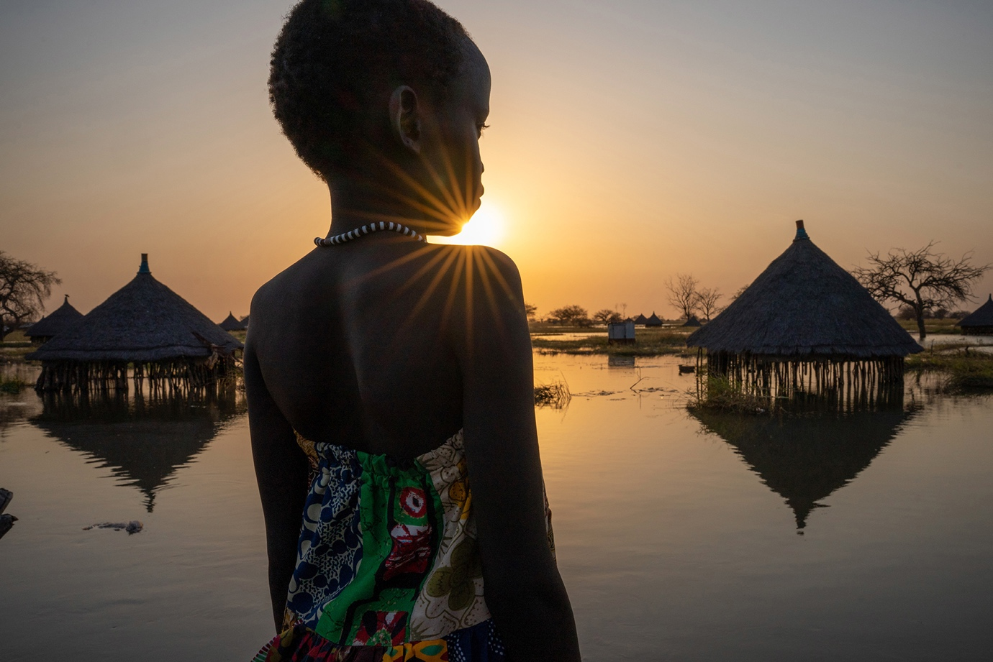
Source: Source: Photography for Humanity, 2022.

“The current drought across the Horn of Africa has dramatically increased food insecurity. However, this drought hasn’t happened in isolation. Over the last 12 years, Somalia has seen three “worst droughts in decades,” beginning in 2010-11 (the worst the country had seen in 60 years). Those seasons of failed rains led to the country declaring famine, which cost the lives of approximately 260,000 people between 2010 and 2012. Over half of these fatalities were children under the age of 5. Like Somalia’s timeline of droughts, its protracted history of conflict has had an impact on its citizens - particularly the most vulnerable - that has increased exponentially over time. Since 1981, the country has experienced periods of violence and civil conflict. The resulting four decades of instability have weakened the country’s health system and left other critical areas of infrastructure undermined. This also means the government’s ability to respond to emergencies like the current drought is limited. Before 1999, droughts happened roughly every five years. Their rate has more than doubled since then, which scientists have linked to the climate crisis. However, this isn’t the only way the climate crisis has impacted the country” [37] . “In 2019, for example, flooding in the Juba and Shabelle rivers affected over half a million people, destroying crops and land used for grazing. This is especially devastating for a country where 75% of its residents live in rural areas, relying on farming and livestock for their livelihoods. Forced migration and displacement are directly associated with climate change and conflict. Both conflict and climate change have left nearly 3 million Somali people internally displaced. Many have left their drought-struck rural areas searching for food, water, and other assistance not to be found closer to home. With nearly 20% of the population displaced, this means that even in Internally Displaced People (IDP) camps and communities, there often isn’t enough to go around. Competition for resources is high and often devastating. While Somalia has had very few confirmed coronavirus cases since the pandemic's start, the long-term economic effects have also contributed to the current hunger crisis. Recent import restrictions have caused the food prices in Somalia to skyrocket. The staple food prices in Somalia affected by the drought are now higher than during the 2017 drought and 2011 famine. At the end of 2021, a 50kg bag of sorghum cost $8. Today, it is now $50. Likewise, the conflict in Ukraine has affected hunger in Somalia, which traditionally relies on Ukraine and Russia for many of its wheat imports”. [37]

Climate change-related floodings in Pakistan have resulted in over 1,000 deaths. Agencies estimate that about 6.5 million Pakistanis need shelter, food, potable water, and medicine. However, at the same time, Europe is also affected by record-breaking heatwaves and wildfires across the Mediterranean. Similarly, in the US, wildfires in California and flooding in the southeast threaten lives and wreak havoc on infrastructure. [38] Thus, the Western world is already affected by climate change. Such a condition is exclusively a basis for required collective social and political action for the Planet.

“The causes of global warming can be identified in human economic activities, which release enormous amounts of greenhouse gas emissions in the atmosphere and as such contribute to climate change. Yet, when talking about our human responsibility in inducing climate change, it is very important to be aware of the different historical contributions of every country to today’s greenhouse gas emissions. The most affluent countries of the world, - Global North, are responsible for around half of all emissions since the Industrial Revolution, as estimated by the World Inequality Database. Privileged lifestyles in Europe, North America and other nations in the Global North produce a carbon footprint 100 times greater than that of the world’s poor nations combined. In 2019, the top 10% of global emitters (771 million individuals) were responsible for about 48% of global CO2 emissions, while the bottom 50% (3.8 billion individuals) were responsible for almost 12% of all emissions. This does not only mean that least developed countries, often located in the Global South, have contributed far less to global warming. It also implies that least developed countries have had a less equal share in the direct benefits of fossil fuel use, including energy consumption”. [39]

CONCLUSIONS
The very concept of "justice" in the phrase, applied to the discourse of climate change, requires moral obligations on the part of the countries that contribute the most to global warming with their economic practices to financially and technologically facilitate poorer, underdeveloped countries on the path of a just transition to a circular economic system with a low share carbon. Because these communities who contribute the least to climate change and suffer the most, according to the principles of climate justice, they have the right to receive technology and finance from the big polluters, whose moral duty is to provide it all. This transfer of resources in the fight against climate change would significantly improve the status of communities in the Global South, and most rational people would agree that mitigating the problems caused by climate change requires a thorough review of current socio-economic and political practices, or as many climate activists demand: system change, not climate.

The solution lies in climate-resilient development and all parties' social, political, and moral cognition to adapt to climate change and effectively implement and lead climate justice. The effort that invests in mitigating climate change must be more remarkable, especially the general social and psychological awareness of citizens. The reason is that, in addition to the consequences on the economy, society, and the environment, other inevitable consequences of climate change will appear (floods, droughts, heat waves, changes in the amount of rainfall, lack of natural resources, loss of biodiversity, migrations, wars and conflicts, terrorism). Climate change will even more negatively and strongly affect the poorer countries, starting with potentially more harmful impacts on human health and already terrible conditions, even greater migrations, and other related disorders.

During the "climate change transition," in a socio-political sense, it is essential that everyone is more actively involved in the policy-making process. The key is to ensure an appropriate geopolitical and financial focus and budget resources through the Green Climate Fund (GCF), an honest association between wealthy and poor countries. A transformation of the Global North objectives and goals during the transition is needed to assist the Global South and prevent further ecological risks. Climate justice is crucial, especially regarding regions, countries, and sectors that will be most affected - areas with fragile general security and critical human insecurity. Social justice, as the core of democracy, is central to climate justice issues. Equality and equity correspond to the complexity of the crisis, and the global power centers should focus on addressing the inherent multilayered unfairness regarding the subjects. Social justice, equity, and equality come to the forefront to protect the most vulnerable population from the adverse effects of global warming and carbon dioxide issues. Also, such policies and activism should provide distributive justice among the present fragile regions, nations, and future generations. Moreover, by following laws and encouraging legal procedures and approaches, we acquire fundamental and satisfactory instruments for tackling climate injustice and delivering climate justice. Climate injustice processes and occurrences generate social injustice, inequalities, inequities, climate injustice of exclusions, and challenging human security.

With all the shortcomings of the current political-economic system and understanding that the current way of life and beings of people have deadly consequences for nature, its resources are not infinite. The climate activism of young people worldwide (significantly using social networks) moved the climate crisis, which had been suppressed by the dominant socio-political discourse, to the forefront. Such activism should be directed even more towards mitigating the socio-economic and human security consequences caused by climate change and empowering climate justice.

Preference must be given to people and groups whose livelihoods are most vulnerable to the effects of climate change, including women and girls, indigenous peoples, and climate migrants. People-centered justice is critical. It can foster an investment environment that is attractive to climate finance agencies. Cogent, inclusive, and ethical institutions, especially in the justice sector, are essential for climate-resilient development and environmental agendas. Within the feminist approach, countries must work to understand and address climate change's different and disproportionate impact on women and girls, counter discrimination, empower women to claim their rights, and integrate women's active engagement in climate decision-making. Indigenous people should be supported to enable inclusive, equitable, and effective climate action and uphold indigenous rights. Thus, we must facilitate indigenous peoples' and local communities' participation and leadership in local, national, and international climate action policymaking. Integrated policy solutions are needed to deliver coherent and coordinated responses to climate change. Climate change has emerged as a significant driver of conflict in fragile contexts. It makes the most vulnerable even more vulnerable. New alliances that can support and ensure solid relations between national and global action and generate the political and governmental will mechanisms and resources required for urgent climate action.

Visuals, particularly images, are omnipresent in the climate change discourse. Research shows that visuals often impact individuals more than textual information. Thus, they are highly relevant when considering elements influencing social and political attitudes toward climate change, environmental protection, and human security.

ACKNOWLEDGEMENTS

No Acknowledgment statement.

AUTHOR CONTRIBUTIONS

The individual contributions of a single author of the manuscript are 100%

FUNDING STATEMENT

Individual and personal funding – independent research/scholar.

CONFLICT OF INTEREST

"The author(s) declare no conflict of interest."

DATA AVAILABILITY
The data in the manuscript is available and can be accessed, including links as appropriate following the References of the Manuscript. "Data supporting these findings are available within the article or upon request."

REFERENCES

1. OECD. Statement from OECD Secretary-General Mathias Cormann on climate finance in 2019. September 17, 2021. https://www.oecd.org/newsroom/statement-from-oecd-secretary-general-mathias-cormann-on-climate-finance-in-2019.htm

2. Tacno.net. UN: Stotine miliona ljudi mogu postati ‘klimatski migranti’. Bosnian.
3. Kozbasic J. Klima101.rs. Šta je klimatska (ne)pravda? 2021. Serbian. https://klima101.rs/klimatska-pravda/
4. Kozbasic J. Klima101.rs. Šta je klimatska (ne)pravda? 2021. Serbian. https://klima101.rs/klimatska-pravda/
5. Milovic N. Klima101.rs. Zašto su siromašne zemlje mnogo više ugrožene klimatskim promenama? 2019. Serbian. https://klima101.rs/siromasne-zemlje-vise-ugrozene-od-klimatskih-promena/
6. Ulgen S. Carnegie Europe. How deep is the North-South Divide on Climate Negotiations? 2021. Available from: https://carnegieeurope.eu/2021/10/06/how-deep-is-north-south-divide-on-climate-negotiations-pub-8549

7. Ulgen S. Carnegie Europe. How deep is the North-South Divide on Climate Negotiations? 2021. Available from: https://carnegieeurope.eu/2021/10/06/how-deep-is-north-south-divide-on-climate-negotiations-pub-8549

8. Kozbasic J. Klima101.rs. Šta je klimatska (ne)pravda? 2021. Serbian. https://klima101.rs/klimatska-pravda/

9. Milovic N. Klima101.rs. Zašto su siromašne zemlje mnogo više ugrožene klimatskim promenama? 2019. Serbian. https://klima101.rs/siromasne-zemlje-vise-ugrozene-od-klimatskih-promena/

10. Eckstein D, Künzel V, Schäfer l. Global Climate Risk Index 2021: Who Suffers Most from Extreme Weather Events? Weather-Related Loss Events in 2019 and 2000-2019. Bonn: Germanwatch e.V. Available from: https://www.germanwatch.org/en/cri#:~:text=Global%20Climate%20Risk%20Index%202021&text=The%20countries%20and%20territories%20affected,Myanmar%20and%20Haiti%20rank%20highest.

11. Kozbasic J. Klima101.rs. Šta je klimatska (ne)pravda? 2021. Serbian. https://klima101.rs/klimatska-pravda/

12. Andreasson K. The Movement Hub. This fall we rise. [2021 September 21]. Available from: https://www.themovementhub.org/stories/this-fall-we-rise/?fbclid=IwAR2OxjDLs0zaOplSPqvcdJ7swS-ILDJo5BW0i5yzKqRmokDKC-_t57duuSM

13. Hadžić F. (2020). The Impact of Climate Change on Human Security: Wars and Terrorism, Panoply Journal. 2020; 1 (1):53–73. Available from: https://www.ciris.info/wp-content/uploads/2020/12/Panoply-Journal-Winter-2020.pdf1

14. 7. Andreasson K. The Movement Hub. This fall we rise. [2021 September 21]. Available from: https://www.themovementhub.org/stories/this-fall-we-rise/?fbclid=IwAR2OxjDLs0zaOplSPqvcdJ7swS-ILDJo5BW0i5yzKqRmokDKC-_t57duuSM

15. Adam R. Pearson 1, Tsai, G. and Clayton, S. Ethics, morality, and the psychology of climate justice. Current Opinion in Psychology. 2021; 42: 36-42

16. 500 Women Scientists, Who pays the price for climate change? Examples of environmental injustice continue to grow. 2022. HTTPS://500WOMENSCIENTISTS.ORG/UPDATES/2022/9/7/WHO-PAYS-THE-PRICE-FOR-CLIMATE-CHANGE-EXAMPLES-OF-ENVIRONMENTAL-INJUSTICE-CONTINUE-TO-GROW

17. Hussein A. Action Against Hunger. Persistent Challenges of Climate Change in Somalia. 2023. https://www.actionagainsthunger.org/story/persistent-challenges-of-climate-change-in-somalia/
18. Mujrai P, Rao L. North-South Conflict Spread and Discriminatory International Economy: A Geospatial Analysis. The Review of Contemporary Scientific and Academic Studies. 2020; 2(3): 1-12. Available from: 10.55454/rcsas.2.3.2022.001
19. International Development Law Organization (IDLO), Climate justice: a rule of law approach for transformative climate action, 2021. https://www.idlo.int/sites/default/files/pdfs/publications/climate_justice_policy_paper_-_climate_action_-_final.pdf
20. 9. Brock H. Climate Change: Drivers of Insecurity and the Global South. [2012 June]. OxfordResearchGroup. Available from: https://www.files.ethz.ch/isn/146109/Climate%20Change%20and%20Insecurity%20in%20the%20Global%20South.pdf

21. Hadžić F. (2020). The Impact of Climate Change on Human Security: Wars and Terrorism, Panoply Journal. 2020; 1 (1):53–73. Available from: https://www.ciris.info/wp-content/uploads/2020/12/Panoply-Journal-Winter-2020.pdf1

22. Ulgen S. Carnegie Europe. How deep is the North-South Divide on Climate Negotiations? [2021 October 6]. Available from: https://carnegieeurope.eu/2021/10/06/how-deep-is-north-south-divide-on-climate-negotiations-pub-8549

23. Adam R. Pearson 1, Tsai, G. and Clayton, S. Ethics, morality, and the psychology of climate justice. Current Opinion in Psychology. 2021; 42: 36-42

24. Kalinowski T. The Research Institute for Sustainability Helmholtz Center Potsdam. The Green Climate Fund as a Bridge Between the Global North and the Global South. [2022 December 7]. Available from: https://www.rifs-potsdam.de/en/blog/2022/12/green-climate-fund-bridge-between-global-north-and-global-south

25. Biliskov N. Znanost-klima.org Naftne lazi, 2023. Croatian. Available from: https://www.znanost-klima.org/naftne-lazi/

26. Timperley, J. BBC. The world's fight for 'climate justice'. 2021. https://www.bbc.com/future/article/20211103-the-countries-calling-for-climate-justice

27. Eckstein D, Künzel V, Schäfer l. Global Climate Risk Index 2021: Who Suffers Most from Extreme Weather Events? Weather-Related Loss Events in 2019 and 2000-2019. Bonn: Germanwatch e.V. Available from: https://www.germanwatch.org/en/cri#:~:text=Global%20Climate%20Risk%20Index%202021&text=The%20countries%20and%20territories%20affected,Myanmar%20and%20Haiti%20rank%20highest.
28. Future Earth, The Earth League, WCRP. 10 New Insights in Climate Science 2020. S2021. Stockholm https://futureearth.org/10-insights-2020
29. Energy Transition Commission, Reaching climate objectives: the role of carbon dioxide removals. ETC Consultation Paper. 2021.
30. . Andreasson K. The Movement Hub. This fall we rise. [2021 September 21]. Available from: https://www.themovementhub.org/stories/this-fall-we-rise/?fbclid=IwAR2OxjDLs0zaOplSPqvcdJ7swS-ILDJo5BW0i5yzKqRmokDKC-_t57duuSM

31. Hadžić F. Critical Security Approach to Climate Change With an Emphasis on Marginalized Global Inequalities, Book "Current Studies in Educational Disciplines," October 2021, Book Chapter, 1 SECTION 1, ENVIRONMENTAL EDUCATION. Turkey: ISRES Publishing, International Society for Research in Education and Science (ISRES). Available from: https://files.eric.ed.gov/fulltext/ED618290.pdf

32. United Nations Climate Change, UNFCC, 2022 Conflict and Climate https://unfccc.int/news/conflict-and-climate

33. International Development Law Organization (IDLO), Climate justice: a rule of law approach for transformative climate action, 2021. https://www.idlo.int/sites/default/files/pdfs/publications/climate_justice_policy_paper_-_climate_action_-_final.pdf

34. ClientEarth. How can the law fight climate change?
The law is a powerful tool in the climate fight. This is how we use it. 2023. https://www.clientearth.org/latest/news/how-can-the-law-fight-climate-change/

35. Kaminski, I. Guardian. Lawsuits are key tool in delivering climate justice, says UN body. 2023. https://www.theguardian.com/environment/2023/jul/27/lawsuits-are-key-tool-in-delivering-climate-justice-says-un-body
36. Hadzic F. Visualization Instruments of Climate Change, Climate Communication, AND Human Security, with an Emphasis on Africa, South Asia, the Caribbean, and the Pacific Islands, International Collective Monograph, Praga, In book: INNOVATIONS IN THE EDUCATION OF THE FUTURE: INTEGRATION OF HUMANITIES, TECHNICAL AND NATURAL SCIENCES, Edition: ISSN 0-745110-169734. Prague; Publisher: FIT CTU in Prague 2023. 10.5281/zenodo.10258799
37. Concerns Worldwide. Hunger in Somalia: Where we are in 2023 and how we got there. 2023. https://www.concern.net/news/hunger-in-somalia

38. 500 Women Scientists, Who pays the price for climate change? Examples of environmental injustice continue to grow. 2022. HTTPS://500WOMENSCIENTISTS.ORG/UPDATES/2022/9/7/WHO-PAYS-THE-PRICE-FOR-CLIMATE-CHANGE-EXAMPLES-OF-ENVIRONMENTAL-INJUSTICE-CONTINUE-TO-GROW

39. Generation Climate Europe. Global North and Global South: How Climate Change Uncovers Global Inequalities. 2022. https://gceurope.org/global-north-and-global-south-how-climate-change-uncovers-global-inequalities/Global North and Global South: How Climate Change Uncovers Global Inequalities
Source
Figures 1, 2, 3, 4, 5, 6, 8, and 9. Photography for Humanity, 2022. https://www.un.org/en/exhibits/exhibit/photography-4-humanity-2022

Figure 7. CNN, 2019. https://edition.cnn.com/2019/09/20/world/global-climate-strike-september-intl/index.html

