Short Research Article

Smudge Cells Reporting in Chronic Lymphocytic Leukemia: Evaluation of Manual Differential Blood Count and the Impact of Albumin Pre-treatment

.
ABSTRACT

Background: Smudge cells are damaged leukocytes commonly seen in blood smears of patients with chronic lymphocytic leukemia (CLL). Their number reflects lymphocyte fragility but varies widely among patients. Additionally, reporting practices regarding smudge cell number significantly differ among laboratories, sometimes also including sample pre-treatment with albumin, which can reduce their formation. Although this approach can substantially facilitate morphological differential count in CLL patients, its widespread in routine hematology remains uncertain.
Aims: This study aims to compare various manual approaches for smudge cell reporting with analyzer differentials in order to identify the most reliable and practical method for routine CLL diagnostics.
Methodology: We conducted a comparative analysis of manual differential blood count (mDIFF) to a hematological analyzer differential (aDIFF). mDIFF was conducted in three manners: by excluding smudge cells from 100 leukocyte count (mDIFF1); by including smudge cells into lymphocyte count (mDIFF2); differential on an albumenized smear (mDIFF_alb). The Mann-Whitney test was used for smudge cell count comparison in standard and albuminized smears, and Friedman’s test for comparison of differential counts (lymphocytes, neutrophils and their ratio). P-value <0.05 was considered significant.
Results: The smudge cell count was significantly lower in albumenized smears (median 7, IQR 4 - 14), compared to standard smears (median 25, IQR 17 - 81), P<0,0001. mDIFF2 results significantly differed in neutrophil and lymphocyte count compared to other methods (P<0.05). The relative lymphocyte count in a manual method mDIFF1 did not significantly differ from the aDIFF.
Conclusion: Although albumin pre-treatment effectively reduces smudge cell formation, it is not essential for obtaining clinically reliable differentials in routine practice. Reporting smudge cells as their number per 100 leukocytes provides a suitable alternative to automated differential leukocyte counts.

Keywords: chronic lymphocytic leukemia (CLL), smudge cells, morphology, Blood Count, Albumin Pre-treatment

1. INTRODUCTION

Chronic lymphocytic leukemia (CLL) is one of the most common types of leukemia, characterized by the clonal proliferation and accumulation of mature B lymphocytes in blood, bone marrow, and lymphoid tissues (Hallek, 2018). The disease predominantly affects elderly individuals and exhibits a highly variable clinical course, ranging from indolent forms requiring only observation to aggressive variants needing early treatment. The diagnosis of CLL relies on a comprehensive and integrative approach, combining detailed clinical evaluation with morphological examination and immunophenotypic analysis to ensure an accurate and definitive diagnosis (Hallek, 2021). Lymphocytosis is defined as the persistent presence of at least 5 × 10⁹/L B-lymphocytes in the peripheral blood for a minimum of three months. The clonal nature of these circulating B-lymphocytes must be confirmed by flow cytometric immunophenotyping (CD19⁺, CD5⁺, CD23⁺, and dim surface immunoglobulin). Additional cytogenetic and molecular analyses, such as the detection of del(17p), del(11q), or TP53 mutations, are essential for risk stratification and therapy selection. On peripheral blood smears, CLL cells typically appear as small, mature lymphocytes with scant cytoplasm and dense, coarsely clumped chromatin without visible nucleoli. These cells may be accompanied by a variable proportion of larger or atypical lymphocytes, cleaved cells, or prolymphocytes, which may constitute up to approximately 55% of lymphoid cells; higher proportions suggest a diagnosis of B-cell prolymphocytic leukemia (PLL) (Melo, 1986). Another characteristic morphological finding in CLL is the presence of Gumprecht nuclear shadows or smudge cells, representing disrupted lymphocytes formed during smear preparation. Accurate laboratory diagnosis plays a pivotal role in the management of CLL, as it enables disease classification, informs prognosis, and guides individualized therapeutic strategies. Reliable microscopic evaluation and differential leukocyte counting remain fundamental in establishing the diagnosis and monitoring disease progression, especially in settings where automated analyzers may not fully capture subtle morphological features.
In this context, while performing manual differential blood counts on smears containing smudge cells, we observed variability in how their numbers are reported. Gumprecht shadows, shadow cells, or smudge cells are leukocytes damaged during smear-making. They can be observed in blood smears of patients with hematological cancers, solid cancers, infections, and out-of-hospital cardiac arrest (Chang, 2016). Smudge cells are one of the common morphologic abnormalities in smears of patients with chronic lymphocytic leukemia (CLL). Their number can vary from 1-75% of total leukocytes. Lymphocytes in CLL are more fragile than normal lymphocytes due to defects of proteins of the nuclear envelope and plasma membrane. These defects make them more prone to smudging while making a blood smear (Gogia, 2014). This phenomenon appears in vitro, but in vivo, these cells stay intact and, therefore, are counted as lymphocytes while performing a leukocyte differential count on a hematological analyser (Marionneaux, 2021). If a blood smear is prepared with albumin, the formation of smudge cells could be decreased (Lunning, 2004).
The issue we came across was a discrepancy in reporting between different guidelines, external quality control management systems, and digital tools. ICSH guidelines suggest that an automatic differential count from a hematological analyzer should be reported in case of a blood smear with a significant number of smudge cells, while their presence may be commented on the smear report. If the report from the analyzer is not available, smudge cells should be counted as the cell line from which they derived in manual differential count if their morphology is apparent (Palmer, 2015). In patients with CLL those would be lymphocytes. If the smudge cells are not identifiable CLSI guidelines suggest their number should be classified separately and reported as others, including a comment on the laboratory report (CLSI H20-A2, 2007). A study that questioned the feasibility of counting smudge cells as lymphocytes suggested an algorithm for reporting differential in patients with CLL (Gulati, 2017). They suggest that the differential leukocyte count should be reported from the analyzer when no flags are present. If flags are generated, the differential should be performed on a non-albuminized peripheral blood smear, with smudge cells classified as lymphocytes. In cases with present blasts or more than 10% other lymphoid cells, an albuminized smear should be used.
When it comes to slide quality control programs, some suggest that smudge cells should be counted as lymphocytes if manual differential is reported, while others include them in 100 leukocyte differentials as a separate category (QSP, 2023; RfB, 2012). Digital microscopy tools, such as Cellavision or Easycell, count such cells as fragments and report their number by expressing the total counted number per 100 leukocytes (CellaVision, 2022). A common practice in laboratories is to exclude smudge cells from a 100-cell differential count and comment their presence on a smear report. Albumenized smears are not so common since albumin is not always easily available, especially in a small laboratory. In order to evaluate different approaches of result reporting, we compared three different methods of manual differential blood count to a differential of a haematological analyser. We conducted a comparative analysis of differential blood count in patients with confirmed CLL diagnosis. This was a group of choice since they have a great tendency of forming smudge cells due to fragility of lymphocytes and, also, we can be confident of the origin of the smudge cells.

2. material and methods

Automatic differential leukocyte counts were performed on 27 samples from patients with CLL on the Siemens ADVIA 2120i hematology analyzer (Siemens, Marburg, Germany) (aDIFF). For each sample, two blood smears were prepared following the protocol illustrated in Figure 1. One smear followed our usual laboratory routine protocol (without additives), and the other was made by using 20% human serum albumin (1 part of albumin solution to 4 parts of blood). Both types of smears were stained by standard May-Grünwald Giemsa protocol. Manual differential (mDIFF) was performed in three manners:
1. On a routine blood smear: excluding smudge cells from 100 leukocyte count and reporting their number on 100 cells (mDIFF1),
2. On a routine blood smear: including smudge cells into lymphocyte count (mDIFF2),
3. On an albumin smear: the presence of smudge cells was minimized, so they were excluded from 100 leukocyte count (mDIFF_alb).
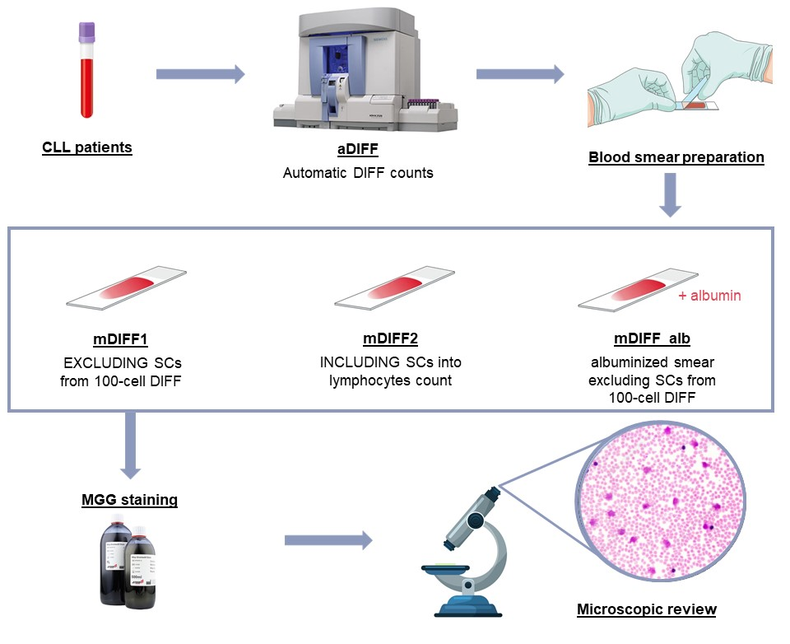
Fig. 1. Workflow of the study aimed at evaluating smudge cell reporting as part of differential leukocyte counts in CLL patients.
CLL- chronic lymphocytic leukemia, DIFF- differentials, SCs- smudge cells.

Our main focus were two leukocyte groups: lymphocytes and neutrophils, and their ratio. Atypical lymphocytes and prolymphocytes were categorized as lymphocytes for this study. Bands were included in the total neutrophil count. Two results were excluded from statistical analysis because the patients were not in absolute lymphocytosis (absolute lymphocyte count <5x10⁹/L). The whole study was performed on leftover routine samples. The Institutional Ethics Committee approved the use of residual patient blood samples for the purposes of laboratory method evaluation and quality improvement (approval number 01-2013).

3. results

Spearman’s rank correlation analysis showed that the number of smudge cells is dependent on total leukocyte count (r= 0.562, 95%CI: 0.231 to 0.776, P= 0.0023). The examples of smudged cells in CLL patient are shown in Figure 2. The smudge cell count was compared in standard (median 25, IQR 17 - 81) and albumenized smears (median 7, IQR 4 - 14) (mDIFF1 and mDIFF_alb) by using the Mann-Whitney test. The reduction in smudge cell formation was statistically significant in albumenized smears (P<0.0001). Medians and ranges of relative neutrophil, lymphocyte counts, and their ratio for three manual differentials and automated differential are listed in Table 1.
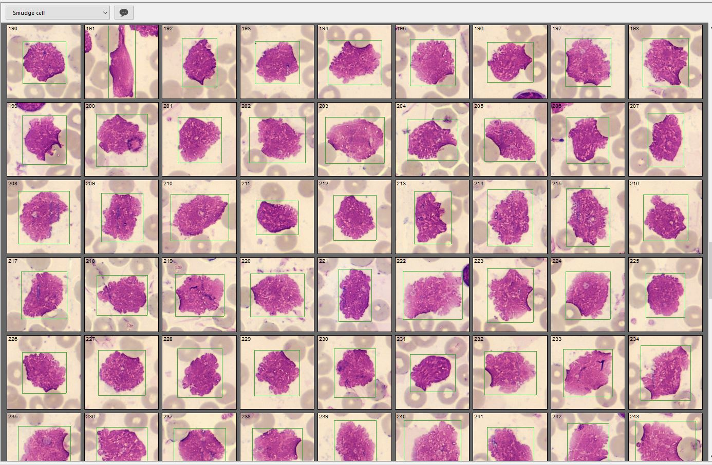
Fig. 2. Smudged cells in a peripheral blood smear from a patient with chronic lymphocytic leukemia, acquired with the CellaVision DC-60 system.

Table 1. Summary statistics on relative fractions of lymphocytes, neutrophils and their ratio (L/N) in automatic differential and three different manual differential types.

N = 27 | aDIFF |  | mDIFF1 |  | mDIFF2 |  | mDIFF_alb
N = 27 | Range | Median (IQR) | Range | Median (IQR) | Range | Median (IQR) | Range | Median (IQR) | P
Lymphocytes (%) | 54.5–96.2 | 80.6  (70.2–91.1) | 52–98 | 82  (63–92) | 58–99 | 86  (79–97) | 44–99 | 84  (72–94) | <0.0001
Neutrophils (%) | 3.1–40.0 | 16.7  (6.0–25.1) | 2–48 | 16  (6–31) | 1–35 | 10  (3–18) | 0–41 | 13  (6–25) | 0.00001
Lymphocytes/Neutrophils | 0.3–31 .0 | 4.3  (2.2–15.2) | 0.2–49 | 4.1  (1.5–13.5) | 0.4–99 | 5.4  (3.1–32.1) | 0.4–99 | 4.1  (2.3–15.7) | 0.00001
aDIFF - Automatic differential leukocyte counts were performed on hematology analyser Siemens ADVIA 2120i;
mDIFF1 - Manual differential by excluding smudge cells from 100 leukocyte count and reporting their number on 100 cells;
mDIFF2 - Manual differential by including smudge cells into lymphocyte count;
mDIFF_alb - Manual differential on an albumenized smear.
Data on the differential counts were compared by using Friedman's test. A statistically significant difference (P<0.05) was obtained for mDIFF2 results for all three variables (neutrophil count, lymphocyte count, and their ratio) when compared to other methods. Lymphocyte count was also significantly different for mDIFF_alb (P<0.05) compared to other three groups (aDIFF, mDIFF1 and mDIFF2), while they did not significantly differ between mDIFF1 and aDIFF.
4. discussion

In this preliminary study, the relative lymphocyte count in a manual method that excluded smudge cells from a 100-cell differential did not differ significantly from the automatic differential, which is considered the preferred reporting option. This finding supports the practice already used in the majority of laboratories, where smudge cells are excluded from the manual differential and only commented upon in the morphological description. On the other hand, when smudge cells were included in the lymphocyte count, results significantly differed from aDIFF and other manual methods, confirming that such an approach may lead to overestimation of lymphocytes and underestimation of neutrophils, and therefore to clinically misleading results.
The use of albumin pre-treatment substantially reduced the number of smudge cells in our study, consistent with earlier observations (Lunning, 2004). Although this method improves smear quality and minimizes artefacts, it is not widely implemented in routine laboratories, mainly due to limited availability of albumin and additional workload. Our results suggest that, in everyday practice, simply excluding smudge cells from the differential yields results most consistent with analyzer data, without the need for albumin pre-treatment. This is especially relevant for smaller laboratories where albumin preparations are not feasible. Beyond analytical considerations, smudge cells have been investigated as potential prognostic markers in CLL. Some studies have reported that a higher percentage of smudge cells correlates with more indolent disease and longer survival, possibly reflecting increased lymphocyte fragility (Gogia, 2014). In line with this, Nowakowski et al. demonstrated that the frequency of smudge cells on routine peripheral blood smears predicts disease and prolonged survival (Nowakowski, 2007). These findings underscore that, while smudge cells may complicate manual differential counts, their documentation carries biologic and prognostic significance. This aspect was beyond the scope of our study, which focused exclusively on their impact on leukocyte differential reporting. Still, the prognostic role of smudge cells reinforces the importance of documenting their presence, even if they are excluded from the manual count.

One of the challenges in diagnosing CLL lies in the fact that, although its clinical and laboratory profile is relatively well-defined, rare cases may overlap with other hematologic malignancies, particularly AML. Reports exist of patients who concurrently had, or subsequently developed, AML in the setting of pre-existing CLL, further complicating both the clinical and laboratory assessment (Al Mussaed, 2016, Rund, 2004, Meloni, 2000). From a clinical perspective, this overlap has important prognostic and therapeutic implications. The development of AML in a patient with CLL is often associated with a more aggressive clinical course, and the treatment strategies for CLL and AML differ substantially. Therefore, early and precise differentiation is critical for optimal therapy selection. In the context of our own research and interpretation of analytical parameters, it is important to recognize that rare CLL patients may harbor a concomitant AML clone. Unexpected blast populations, unusually rapid disease progression, or serial laboratory findings inconsistent with classical CLL should prompt consideration of an AML component.

This study has some limitations. It is performed on a relatively small number of CLL patient samples. However, we did not want to duplicate the smears from the same patients, so the included number reveals the true incidence of CLL patients in our hospital. Additionally, the cell count was performed only once on 100 cells manual count for all the samples. However, while recreating the everyday routine work, we were able to assess the real-life performance of this manual technique and understand the size of the uncertainty of the reported results. A study on a larger number of samples and an additional comparison of a 200-cell differential in the future could provide us with more insight into the selected procedure.

4. Conclusion

In conclusion, our findings indicate that excluding smudge cells from the 100-cell manual differential and reporting their presence separately provides results most consistent with hematology analyzer differentials. Including smudge cells into 100-cell differentials could possibly lead to erroneous results and therefore should be avoided. Although albumin pre-treatment effectively reduces smudge cell formation, it is not essential for obtaining clinically reliable differentials in routine practice.
Based on these results, we recommend that laboratories adopt the practice of excluding smudge cells from the manual differential while documenting their presence in the morphological description for patients suspected of having CLL. This approach align with the international guidelines, minimizes interlaboratory variability, and ensure that differential counts remain accurate and clinically meaningful. Standardization of reporting practices, together with awareness of smudge cell implications, could improve diagnostic accuracy, and ultimately support better patient care in CLL.

Ethical approval

All authors hereby declare that all experiments have been examined and approved by the appropriate ethics committee and have therefore been performed in accordance with the ethical standards laid down in the 1964 Declaration of Helsinki.

COMPETING INTERESTS DISCLAIMER:
Authors have declared that they have no known competing financial interests OR non-financial interests OR personal relationships that could have appeared to influence the work reported in this paper.

Disclaimer (Artificial intelligence)

Author(s) hereby declare that NO generative AI technologies such as Large Language Models (ChatGPT, COPILOT, etc.) and text-to-image generators have been used during the writing or editing of this manuscript.

References

1. Hallek, M., Cheson, B. D., Catovsky, D., Caligaris-Cappio, F., Dighiero, G., Döhner, H. et al. (2018). iwCLL guidelines for diagnosis, indications for treatment, response assessment, and supportive management of CLL. Blood, 131(25), 2745–2760. https://doi.org/10.1182/blood-2017-09-806398
2. Hallek, M., & Al-Sawaf, O. (2021). Chronic lymphocytic leukemia: 2022 update on diagnostic and therapeutic procedures. American journal of hematology, 96(12), 1679–1705. https://doi.org/10.1002/ajh.26367
3. Melo, J. V., Catovsky, D., & Galton, D. A. (1986). The relationship between chronic lymphocytic leukaemia and prolymphocytic leukaemia. I. Clinical and laboratory features of 300 patients and characterization of an intermediate group. British journal of haematology, 63(2), 377–387.
4. Chang, C. C., Sun, J. T., Liou, T. H., Kuo, C. F., Bei, C. H., Lin, S. J. et al (2016). Clinical Significance of Smudge Cells in Peripheral Blood Smears in Hematological Malignancies and Other Diseases. Asian Pacific journal of cancer prevention: APJCP, 17(4), 1847–1850. https://doi.org/10.7314/apjcp.2016.17.4.1847
5. Gogia, A., Raina, V., Gupta, R., Gajendra, S., Kumar, L., Sharma, A. et al (2014). Prognostic and predictive significance of smudge cell percentage on routine blood smear in chronic lymphocytic leukemia. Clinical lymphoma, myeloma & leukemia, 14(6), 514–517. https://doi.org/10.1016/j.clml.2014.02.007
6. Marionneaux, S. M., Keohane, E. M., Lamanna, N., King, T. C., & Mehta, S. R. (2021). Smudge Cells in Chronic Lymphocytic Leukemia: Pathophysiology, Laboratory Considerations, and Clinical Significance. Laboratory medicine, 52(5), 426–438. https://doi.org/10.1093/labmed/lmaa119
7. Lunning, M. A., Zenger, V. E., Dreyfuss, R., Stetler-Stevenson, M., Rick, M. E., White, T. A., Wilson, W. H., & Marti, G. E. (2004). Albumin enhanced morphometric image analysis in CLL. Cytometry. Part B, Clinical cytometry, 57(1), 7–14. https://doi.org/10.1002/cyto.b.10059
8. Palmer, L., Briggs, C., McFadden, S., Zini, G., Burthem, J., Rozenberg, G., Proytcheva, M., & Machin, S. J. (2015). ICSH recommendations for the standardization of nomenclature and grading of peripheral blood cell morphological features. International journal of laboratory hematology, 37(3), 287–303. https://doi.org/10.1111/ijlh.12327
9. Clinical and Laboratory Standards Institute (CLSI) Reference Leukocyte (WBC) Differential Count (Proportional) and Evaluation of Instrumental Methods; Approved Standard—Second Edition. CLSI document H20-A2. Wayne, PA; 2007.
10. Gulati, G., Ly, V., Uppal, G., & Gong, J. (2017). Feasibility of Counting Smudge Cells as Lymphocytes in Differential Leukocyte Counts Performed on Blood Smears of Patients With Established or Suspected Chronic Lymphocytic Leukemia/Small Lymphocytic Lymphoma. Laboratory medicine, 48(2), 137–147. https://doi.org/10.1093/labmed/lmx002
11. QSP Newsletter #42. Monthly Digital Case Study: Acute Leukemia (2023) https://yro2.mjt.lu/nl3/wQf-d78c6kGBZ8WcPxzzQg?m=AVoAADBlFOQAAc3H6YoAALHCktcAAYDOMdcAnsnQAAviVQBliveohvSigr_eRqeAxWEpnR4rGwAL9Xk&b=d5049ce5&e=5e32e65f&x=PWRbu6pszQDfOY55WF3FnZOzEK0ndhH4qCFXMbPjWms
12. Reference Institute for Bioanalytics, RfB - Surveys for Laboratory Medicine (2012). https://www.rfb.bio/cgi/results?rv_type=all&rvTypeForDetails=DF&year=2012&rv_num=4&analyte=all&searchType=rv_type
13. CellaVision, Patient case #1 - Sezary Syndrome (2022). https://www.cellavision.com/patient-case-sezary-syndrome
14. Nowakowski, G. S., Hoyer, J. D., Shanafelt, T. D., Geyer, S. M., LaPlant, B. R., Call, T. G., Jelinek, D. F., Zent, C. S., & Kay, N. E. (2007). Using smudge cells on routine blood smears to predict clinical outcome in chronic lymphocytic leukemia: a universally available prognostic test. Mayo Clinic proceedings, 82(4), 449–453. https://doi.org/10.4065/82.4.449
15. Al Mussaed, E., Osman, H. & Elyamany, G. Simultaneous existence of acute myeloid leukemia and chronic lymphocytic leukemia: a case report. BMC Cancer 16, 739 (2016). https://doi.org/10.1186/s12885-016-2780-5
16. Rund, D., & Ben-Yehuda, D. (2004). Therapy-related leukemia and myelodysplasia: evolving concepts of pathogenesis and treatment. Hematology (Amsterdam, Netherlands), 9(3), 179–187. https://doi.org/10.1080/10245330410001701503
17. Meloni, G., Proia, A., Guerrisi, V., Cordone, I., De Cuia, R., Fenu, S., et al (2000). Acute myeloid leukemia and lung cancer occurring in a chronic lymphocytic leukemia patient treated with fludarabine and autologous peripheral blood stem-cell transplantation. Annals of oncology: official journal of the European Society for Medical Oncology, 11(11), 1493–1495. https://doi.org/10.1023/a:1026505632679

