Physicochemical, phytochemical, and antinutritional characterization of seed shells from five Hevea brasiliensis clones cultivated in Côte d’Ivoire

Abstract
In the context of diversifying the incomes of rubber tree growers and promoting a circular bioeconomy, the valorisation of by-products from Hevea brasiliensis cultivation represents a promising pathway toward the sustainable development of the sector. In Côte d’Ivoire, the National Agricultural Research Centre (CNRA) has developed processes for extracting oil and meal from rubber seeds, which generate abundant shell residues that remain underutilised. This study aimed to characterise the physicochemical, phytochemical and antinutritional properties of seed shells from five Hevea brasiliensis clones commonly cultivated in Côte d’Ivoire (GT1, PB217, IRCA230, IRCA331 and IRCA41) in order to assess their potential for agro-industrial valorisation. The analyses revealed significant inter-clonal variability. Clones IRCA230 and IRCA41 exhibited higher levels of lipids (up to 9.84%), tannins (3.43 mg EAT/100 g) and polyphenols (5.20 mg EAG/100 g), indicating strong antioxidant potential suitable for cosmetic, pharmaceutical and food applications. In contrast, GT1, PB217 and IRCA331 showed higher fibre contents (up to 83%) and total sugars (23 mg/100 g), suggesting potential for energy recovery and biomaterial production. Antinutritional factors such as phytates (30–186 mg/100 g), oxalates (55–81 mg/100 g) and hydrocyanic acid (16–21 mg/100 g) were present at moderate, non-toxic levels. Principal Component Analysis (PCA) and Hierarchical Cluster Analysis (HCA) clearly differentiated two groups of clones according to their biochemical profiles. Overall, the results demonstrate that rubber seed shells often considered waste constitute a valuable lignocellulosic resource for the extraction of bioactive compounds and the development of eco-materials, thereby contributing to the sustainability and competitiveness of the Ivorian rubber sector.
Keywords: Hevea brasiliensis, seed shells, physicochemical composition, phytochemistry, valorisation, circular bioeconomy.

- Introduction
Native to the Amazon basin, Hevea brasiliensis (Euphorbiaceae) is the primary global source of natural rubber and a key industrial crop in tropical regions. Rubber cultivation has expanded across Asia, Africa and Latin America, sustaining the economies of several producing countries (Rodrigo et al., 2011; Gohet et al., 2019). In Côte d’Ivoire, where rubber was introduced in the 1950s, the sector occupies a strategic position: national production reached approximately 1.68 million tonnes in 2024, ranking the country third worldwide and first in Africa (APROMAC, 2024). Beyond its contribution to national exports, rubber production ensures rural income, employment and socio-economic resilience for thousands of smallholders. Nevertheless, the strong dependence of producers on latex prices exposes them to significant income fluctuations due to volatility in the international rubber market (Euronews Business, 2025). To mitigate this vulnerability, the valorisation of secondary products from Hevea brasiliensis cultivation—especially seeds and their derivatives—offers an effective and sustainable pathway to diversify income sources while supporting a circular bioeconomy (Ocho, 1999; Adeoye et al., 2024). Rubber seeds, typically produced in large quantities during the rainy season, contain oil and protein in their kernels and a hard outer shell rich in lignocellulosic material, polyphenols and other functional compounds (Peng et al., 2018; Zainuddin et al., 2021; Owolabi et al., 2023). In many oilseed industries, seed shells are valuable raw materials for energy production, antioxidant extraction, or biomaterial manufacturing (Min et al., 2008; Adeoye et al., 2024). Several studies have shown that controlled pyrolysis, enzymatic hydrolysis, or solvent extraction can transform lignocellulosic residues into bio-oils, fibres, and phenolic-rich extracts with high industrial value (Adeoye et al., 2024; Zhou et al., 2024). However, in Côte d’Ivoire, the shells of Hevea brasiliensis seeds remain largely unexploited and are often discarded, despite representing nearly 50 % of the seed’s mass. This underutilisation constitutes both an economic loss and an environmental management issue. From a biochemical standpoint, rubber seed shells are complex matrices combining structural carbohydrates, lignin, lipids and phenolic compounds with known antioxidant and antimicrobial activities (Bahramsoltani et al., 2014; Owolabi et al., 2023). The relative proportions of these constituents are influenced by genetic and environmental factors, notably the clone, soil fertility, and climatic conditions (Bamba et al., 2023; Afolabi et al., 2025). Evaluating inter-clonal variability in shell composition is therefore essential to identify the most promising clones for targeted valorisation—whether biochemical (antioxidants, bio-oils) or industrial (fibres, biochar, biomaterials). Consequently, the present study aimed to characterise and compare the physicochemical, phytochemical and antinutritional properties of seed shells from five Hevea brasiliensis clones commonly cultivated in Côte d’Ivoire (GT1, PB217, IRCA230, IRCA331 and IRCA41). Through analysis of variance (ANOVA), principal component analysis (PCA) and hierarchical cluster analysis (HCA), this work sought to establish biochemical profiles of the clones and evaluate their potential for agro-industrial and bioeconomic applications. The study ultimately contributes to the sustainable management of rubber by-products and supports Côte d’Ivoire’s transition towards a competitive circular bioeconomy.
- MATERIALS AND METHODS
2.1. Plant material
The plant material used in this study consisted of seed shells from five commonly cultivated Hevea brasiliensis clones in Côte d’Ivoire: GT1 (Gondang Tapen 1), PB217 (Besar 217), and three clones developed by the Rubber Research Institute of Côte d’Ivoire (IRCA) ; namely IRCA41, IRCA230, and IRCA331. The seeds were collected from monoclonal plots located in both traditional and marginal rubber-growing zones. These included the Société Africaine de Plantation d’Hévéa (SAPH) in the Grands Ponts region, the Société Coopérative Agricole Sud-Ouest (SCASO) in the Bas-Sassandra region, and EXAT Agriculture (Kouamé Koffikro plantation) in the Prikro area. Because rubber seed production is seasonal (August–November), the sampling campaign was carried out between August and November 2024. From each site, composite samples were prepared from five one-hectare monoclonal plots to represent a broad range of agroecological conditions across the national territory
.2.2 Methods
2.2.1 Sampling
At each site, a composite sample of 10 kg of whole seeds per clone was collected from representative harvests, yielding 30 kg per clone overall. The seeds were manually cleaned and air-dried, then shelled using a mechanical shelling device to separate the kernels from the shells.
The shells obtained for each clone were homogenised and finely ground using a laboratory grinder (Retsch ZM200). The resulting powder was stored in hermetically sealed containers at ambient temperature prior to analysis. This homogenised powder served as the matrix for all physicochemical, phytochemical and antinutritional analyses.
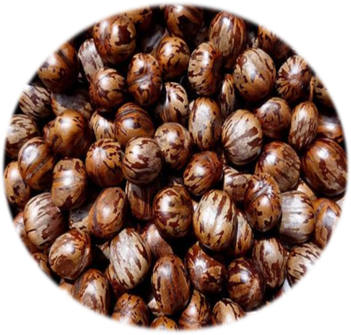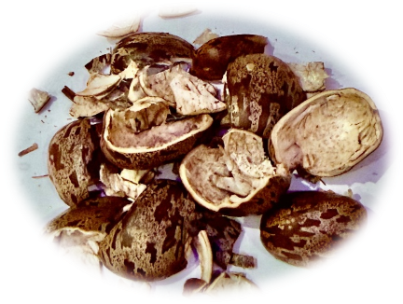
Photo 2: rubber seed kernels
Photo 1: rubber tree seeds

2.2.2 Physicochemical characterisation of the rubber seed shell
The moisture content was determined following the AOAC (1990) method, by oven-drying 10 g of ground shell at 105 ± 2 °C for 24 h (Memmert oven, Germany). The ash content was quantified after incineration at 550 °C for 12 h in a muffle furnace (VOLCA V50), and expressed as a percentage of dry weight. The pH and titratable acidity were measured according to AFNOR (1986). Ten grams of shell powder were homogenised in 100 mL of distilled water and filtered; pH was read using a HANNA portable pH meter, and acidity determined by titration with 0.1 N NaOH in the presence of phenolphthalein. The lipid content was determined by Soxhlet extraction (AFNOR, 1984) using hexane for 8 h at reflux temperature, and expressed as % oil on dry matter basis. Proteins were determined by the Kjeldahl method (AOAC, 1990), using nitrogen-to-protein conversion factor 6.25.
Fibre was determined following Wolf (1968), while total sugars were quantified spectrophotometrically using the phenol–sulphuric acid method (Dubois et al., 1956), and reducing sugars by the DNS method (Bernfeld, 1955).2.2.3 Characterisation of the phytochemical compounds in the seed coats of five rubber tree clones The total polyphenols in the rubber seed coat samples were determined using the method described by Singleton and Rossi (1965), using Folin-Ciocalteu reagent. The optical density (OD) was measured at 760 nm using a spectrophotometer. The control contained distilled water instead of the sample. The difference between the OD values obtained with and without PVPP was used to determine the actual OD corresponding to the total polyphenols in the samples. A calibration curve, obtained from different concentrations of a standard phenolic compound, gallic acid (or 3,4,5-trihydroxybenzoic acid), at an initial concentration of 0.5 mg/mL, was used to determine the total polyphenol content of the rubber seed shells studied. Flavonoids were determined using the method described by Meda et al. (2005). A 1:10 diluted extract solution was prepared from 10 g of ground rubber seed shells dissolved in 90 mL of distilled water. Subsequently, 0.5 mL of this solution was added successively to a test tube, followed by 0.5 mL of distilled water, 0.5 mL of 10% (m/v) aluminium chloride, 0.5 mL of 1 M potassium acetate, and then 2 mL of distilled water. The tube was left to stand for 30 minutes in the dark, then the optical density was read at 415 nm against a blank. A standard curve was established from a quercitrin stock solution (0.1 mg/mL), treated under the same conditions as the sample, in order to determine the flavonoid content of the samples analysed. The tannin content was determined using the method described by Broadhurst and Jones (1978). The tannin content was determined by introducing 1 mL of methanolic extract into a test tube. After adding 5 mL of vanillin reagent (0.1% vanillin in 70% sulphuric acid), the tube was left to stand for 30 minutes in the dark and the optical density (OD) was read at 500 nm against a blank.
2.2.4 Characterisation of antinutritional compounds in the seed coats of five rubber tree clones
Total polyphenols were quantified using the Folin–Ciocalteu reagent following Singleton and Rossi (1965). Results were expressed as mg gallic acid equivalents per 100 g dry weight (mg EAG/100 g). Flavonoids were measured according to Meda et al. (2005) using quercitrin as standard, and expressed as mg quercitrin equivalents per 100 g dry weight (mg EQ/100 g).
Condensed tannins were quantified by the vanillin–H₂SO₄ method (Broadhurst & Jones, 1978) and expressed as mg catechin equivalents per 100 g dry weight (mg EAT/100 g). Oxalates were determined by the titrimetric method of Day and Underwood (1986) using 3 M H₂SO₄ and standard KMnO₄. Phytates were analysed according to Latta and Eskin (1980) using Wade’s reagent (FeCl₃ + sulphosalicylic acid) and expressed in mg/100 g dry matter. Hydrocyanic acid (HCN) content was quantified following the AOAC (1990) distillation-titration method, using AgNO₃ as titrant, and expressed in mg/100 g.

2.2.5 Statistical analysis
The data were subjected to analysis of variance (one-factor ANOVA) to determine the effect of the clone on the various physicochemical, phytochemical and antinutritional parameters of rubber seed shells. Significant differences between means were evaluated at the 5% level using Duncan's test.
Principal component analysis (PCA) was performed to visualise the relationships between variables and identify clusters of clones according to their biochemical profiles. Correlations between variables were also examined to characterise positive and negative associations between the parameters studied.
All statistical analyses were performed using XLSTAT 2022 (Addinsoft, France) and R version 4.3.1 (R Core Team, 2023) software, using the FactoMineR and ggplot2 packages for graphical representation (PCA, correlation circle, dendrogram).
3. RESULTS
3.1 Physicochemical characteristics
Analysis of variance (ANOVA) revealed highly significant differences (p < 0.05) between clones for most of the physicochemical parameters studied (Table 1). Moisture content ranged from 10.27 ± 0.12% (IRCA230) to 12.40 ± 0.17% (PB217), with a significant difference between these two clones. The pH differed significantly (p < 0.05) between clones, ranging from 6.19 ± 0.01 (GT1) to 6.61 ± 0.01 (IRCA331). Titratable acidity also varied from 0.20 ± 0.03 (GT1) to 0.47 ± 0.03 (IRCA41).
Lipids show the greatest inter-clonal variability (p < 0.001) with values ranging from 1.86 ± 0.08% (GT1) to 9.84 ± 0.12% (IRCA230). Fibre content differed significantly (p < 0.05) between 69.49 ± 1.01% (PB217) and 82.84 ± 0.39% (IRCA331ᵃ). Ash varied from 0.64 ± 0.12% (GT1) to 1.13 ± 0.08% (IRCA230), with a significant difference (p < 0.05). Total sugars show significant differences (p < 0.05) between 8.33 ± 0.58 mg/100 g (IRCA41) and 23.00 ± 0.00 mg/100 g (IRCA331). Reducing sugars varied significantly from 1.00 ± 0.00 mg/100 g (GT1) to 3.33 ± 0.58 mg/100 g (IRCA230). Proteins show significant differences between clones (p < 0.05), ranging from 2.92 ± 0.10% (GT1) to 3.62 ± 0.10% (IRCA41).

Table 1: Physico-chemical composition of Hevea seed shells from five clones
 | GT1 | PB217 | IRCA41 | IRCA230 | IRCA331
Moisture content (%) | 11.41± 0.03b | 12.40± 0.17a | 11.28± 0.03b | 10.27± 0.12c | 12.36± 0.10a
Ph | 6.42± 0.01b | 6.61± 0.01a | 6.19± 0.01d | 6.23± 0.01c | 6.60± 0.03a
Titratable acidity | 0.20± 0.03c | 0.38± 0.03b | 0.47± 0.03a | 0.39± 0.03b | 0.23± 0.05c
Lipids (%) | 1.89± 0.04d | 3.38± 0.04c | 7.59± 0.08b | 9.84± 0.12a | 1.86± 0.08d
Fibre (%) | 80.13± 0.07b | 76.54± 0.31c | 77.21± 0.34c | 69.49± 1.01d | 82.84± 0.39a
Ash (%) | 0.64± 0.12b | 1.10± 0.12a | 0.81 ± 0.17b | 1.13± 0.08a | 0.82± 0.07b
Total sugars (mg/100g) | 16.00± 0.00c | 23.00 ± 0.00a | 8.33± 0.58d | 17.00± 0.00b | 23.00± 0.00a
Reducing sugars (mg/100g) | 1.67± 0.58bc | 2.67± 0.58ab | 2.33± 0.58ab | 3.33± 0.58a | 1.00± 0.00c
Protein (%) | 3.33± 0.00b | 3.62± 0.10a | 3.44± 0.10b | 2.92± 0.10c | 3.03± 0.10c
Values are means ± standard deviation (n = 3). Means followed by different superscript letters are significantly different (p < 0.05, Duncan’s multiple range test)

3.2 Phytochemical characteristics
The ANOVA results also show significant differences (p < 0.05) between clones for all phytochemical compounds (Table 2). Total polyphenols ranged from 3.10 ± 0.20 mg EAG/100g (PB217) to 5.20 ± 0.17mg EAG/100g (IRCA230). Flavonoids differed significantly (p < 0.05) between 2.33 ± 0.15 mg EQ/100 g (PB217) and 4.50 ± 0.10 mg EQ/100 g (GT1). Condensed tannins ranged from 1.64 ± 0.00 mg CAT/100 g (GT1) to 3.43 ± 0.01 mg CAT/100 g (IRCA230).
Table 2: Phytochemical composition of Hevea seed shells from five clones
 | GT1 | PB217 | IRCA41 | IRCA230 | IRCA331
Polyphenols (mgEAG/100g) | 3.10± 0.20d | 3.20± 0.17cd | 4.57± 0.06b | 5.20± 0.17a | 3.43± 0.06c
Flavonoids (mgEQ/100g) | 4.50 0.10a | 3.70± 0.20b | 3.03± 0.21c | 2.33± 0.15d | 2.80± 0.17c
Tannins (mgEAT/100g) | 2.00± 0.00d | 2.13± 0.00c | 2.73± 0.00b | 3.43± 0.01a | 1.64± 0.00e
Values are means ± standard deviation (n = 3). Means followed by different superscript letters are significantly different (p < 0.05, Duncan’s multiple range test).

3.3 Antinutritional characteristics
Significant differences (p < 0.05) were observed for the three antinutritional factors analysed (Table 3). Phytates ranged from 30.56 ± 0.04 mg/100 g (GT1) to 186.87 ± 0.05 mg/100 g (IRCA331). Oxalates differed significantly (p < 0.05) from 55.00 ± 11.00 mg/100 g (PB217ᶜ) to 80.67 ± 6.35 mg/100 g (GT1ᵃ). Hydrocyanic acid content varies from 16.85 ± 0.14 mg/100 g (GT1) to 20.61 ± 0.16 mg/100 g (IRCA230).
Table 3: Antinutritional factors in Hevea seed shells from five clones
mg/100g | GT1 | PB217 | IRCA41 | IRCA230 | IRCA331
Phytate | 186.87± 0.05a | 73.36± 0.20c | 64.53± 0.19d | 118.29± 0.03b | 30.56± 0.04e
oxalates | 55.00± 11.00b | 73.33± 6.35ab | 69.67± 6.35ab | 80.67± 6.35a | 77.00± 11.00a
Hydrocyanic acid | 16.85± 0.14d | 20.61± 0.16a | 18.81± 0.16c | 20.34± 0.16a | 19.62± 0.16b

Values are means ± standard deviation (n = 3). Means followed by different superscript letters are significantly different (p < 0.05, Duncan's multiple range test).

3.4 Multivariate analysis

3.4.1 Principal component analysis (PCA) and ascending hierarchical classification

This section presents the results of the Principal Component Analysis (PCA) and hierarchical classification (HCA) performed on the matrices of biochemical and physicochemical parameters of the seed coats of five rubber tree clones grown in Côte d'Ivoire. PCA reduced the data dimension to two principal axes, which together explain 78.50% of the total variance. Axis 1 (PC1) explains 52.82% and axis 2 (PC2) 25.68%. Axis 1 distinguishes clones rich in lipids, tannins and polyphenols (IRCA230 and IRCA41) from clones with high fibre content (PB217, GT1 and IRCA331). Axis 2 mainly separates clones according to their acidity and sugar content.

Fig .1 PCA - Rubber tree seed shells
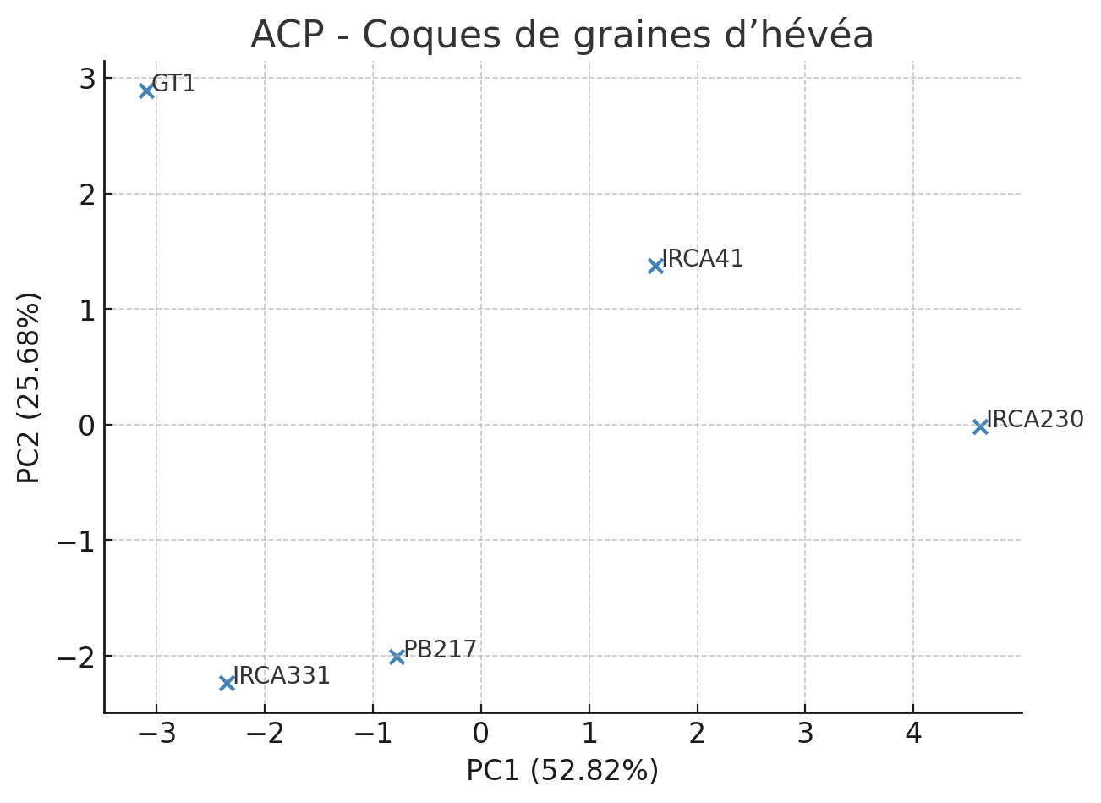

3.4.2 Correlation circle and factorial projection
In order to further interpret the Principal Component Analysis (PCA), a correlation circle and factorial projection of the clones were produced. These representations allow the contribution of the variables and the distribution of the clones to be visualised simultaneously in the plane formed by the first two principal axes. The correlation circle shows that the variables lipids, tannins and polyphenols are strongly positively correlated with axis 1 (PC1), indicating that it expresses a gradient of metabolic richness. In contrast, fibre and moisture are negatively correlated with this same axis. Axis 2 (PC2) is mainly influenced by pH and total sugars, reflecting a biochemical gradient linked to the preservation properties of the shells.

Fig .2 Correlation Circle of Variables (PCA)
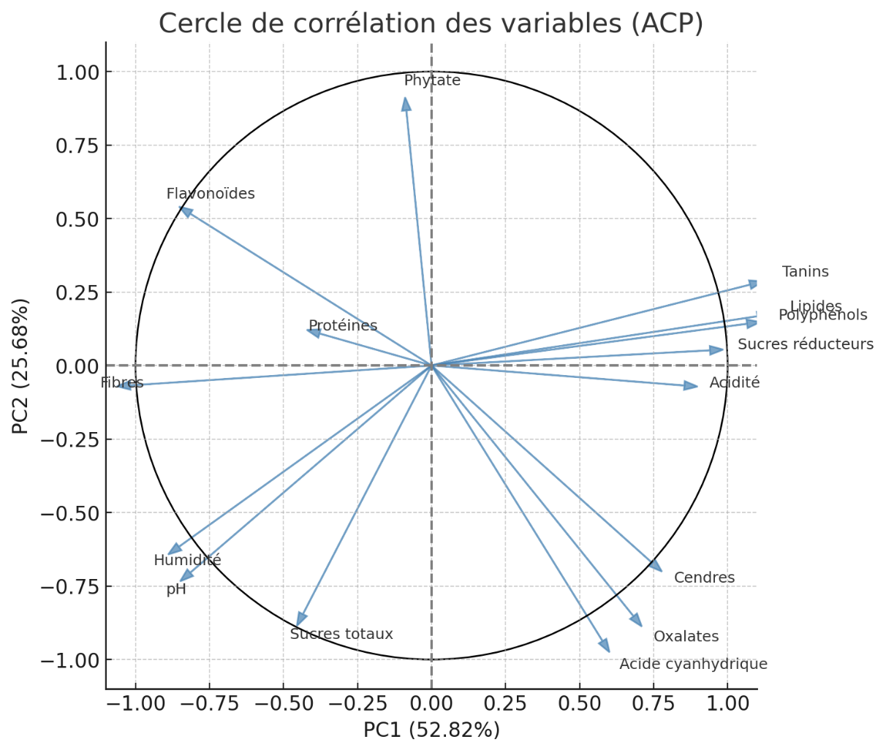
The projection of the clones on the factorial plane shows two distinct groups: the first, composed of IRCA230 and IRCA41, includes the clones richest in bioactive compounds; the second, formed by PB217, GT1 and IRCA331, includes the predominantly fibrous clones. This distribution confirms the results of the dendrogram and reinforces the consistency of the hierarchical classification.

Fig .3 Projection of the clones on the factorial plane (PCA)
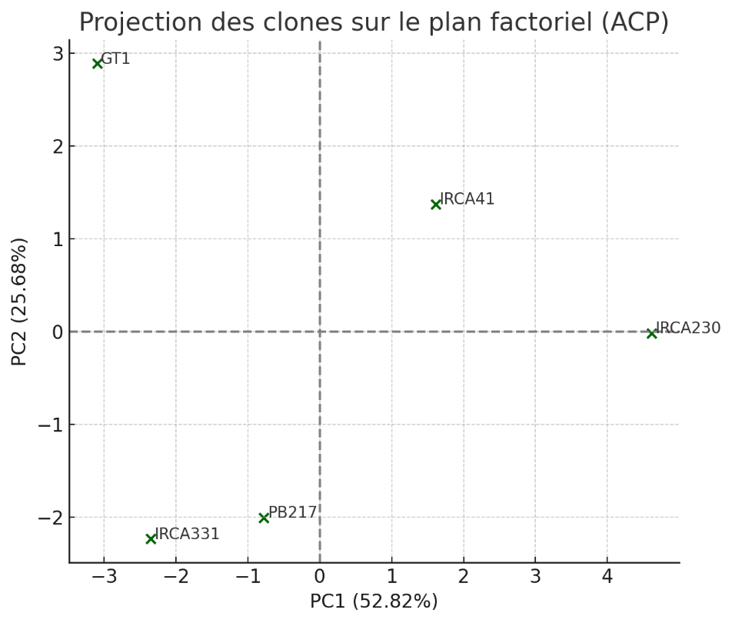

3.4.3 Hierarchical classification (CAH)
The ascending hierarchical analysis groups the clones into two main clusters: IRCA230 and IRCA41 (rich in bioactive compounds), and a second group consisting of PB217, GT1 and IRCA331, characterised by a more fibrous and less lipidic profile.
Fig.4 Dendrogram - Hierarchical Classification of rubber tree clones
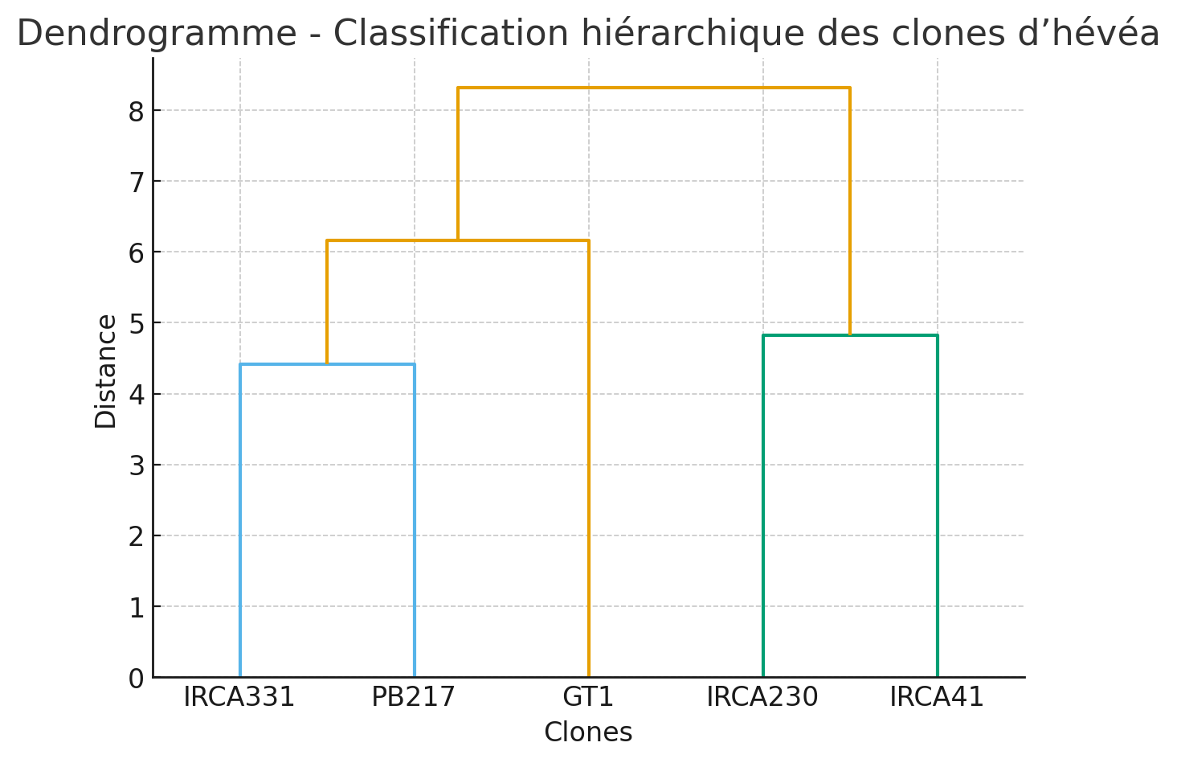

4. DISCUSSION
The present study revealed substantial inter-clonal variation in the physicochemical, phytochemical and antinutritional characteristics of Hevea brasiliensis seed shells from five clones widely cultivated in Côte d’Ivoire. These findings emphasise the biochemical diversity within the species and the potential of specific clones for targeted valorisation strategies. The physicochemical results showed that fibre was the dominant constituent in all clones, confirming the highly lignocellulosic nature of rubber seed shells, as previously reported by Zainuddin et al. (2021) and Peng et al. (2018). The marked variability in lipid and sugar contents among clones (notably the high lipid fraction in IRCA230 and IRCA41) reflects genetic differences and environmental influences such as soil composition and rainfall (Bamba et al., 2023). These compositional differences suggest that Hevea clones could be selected not only for latex yield but also for by-product composition, enhancing multi-purpose breeding strategies. The elevated polyphenol, flavonoid and tannin levels in IRCA230 and IRCA41 indicate a strong antioxidant potential, consistent with earlier reports highlighting the bioactivity of Hevea seed coat extracts (Min et al., 2008; Owolabi et al., 2023). Polyphenols and flavonoids are recognised for their free-radical-scavenging ability and their capacity to stabilise natural formulations in cosmetic, nutraceutical and food industries (Bahramsoltani et al., 2014; Zhou et al., 2024). Similar biochemical profiles have been observed in other lignocellulosic wastes, such as kola nut shells, which Adeoye et al. (2024) successfully valorised through pyrolysis and ultrasonic extraction to produce renewable bio-oils and antioxidants. These parallels reinforce the relevance of Hevea seed shells as a viable raw material for sustainable industrial transformation. The measured concentrations of phytates, oxalates and hydrocyanic acid remained within moderate and non-toxic ranges, in line with values reported for other tropical oilseed residues (Obanla et al., 2023). Such levels are not inhibitory to industrial or feed applications, especially after mild processing treatments such as heating, fermentation or enzymatic degradation (Adeoye et al., 2022). Therefore, detoxification could further broaden the use of rubber seed shells in composite feed formulations and bioprocesses. The PCA and HCA analyses provided a comprehensive visualisation of inter-clonal variability, separating clones according to their biochemical characteristics. The grouping of IRCA230 and IRCA41 into a single cluster reflects their metabolic richness in phenolic and lipid compounds, while GT1, PB217 and IRCA331 were clustered based on high fibre and carbohydrates contents. Such differentiation is highly valuable for guiding clone-specific valorisation pathways. Clones rich in phenolic metabolites (IRCA230, IRCA41) can be prioritised for bio-extract production with applications in pharmaceuticals, cosmetics and food preservation. Conversely, clones dominated by fibrous material (GT1, PB217, IRCA331) may be more suitable for energy recovery (biochar, briquettes) or biomaterial production, supporting green-industry development (Nguyen et al., 2023; Charrier et al., 2002).These findings contribute to the national objective of promoting circular bioeconomy models within the rubber sector. By valorising seed shells currently considered waste—the study supports sustainable waste-management strategies and income diversification for smallholders. Integrating such by-product valorisation into the processing chain can significantly reduce environmental impacts while generating new economic opportunities (Adeoye et al., 2024; FIRCA, 2024). Overall, the compositional heterogeneity of Hevea brasiliensis seed shells highlights their versatility as feedstock for multiple value-added applications. The study thus provides a scientific foundation for developing clone-based valorisation systems, aligning with Côte d’Ivoire’s strategy to transition toward an environmentally responsible and competitive rubber industry.

5-CONCLUSION
This study provides new insights into the physicochemical, phytochemical and antinutritional characteristics of Hevea brasiliensis seed shells from five clones widely cultivated in Côte d’Ivoire. The results revealed significant inter-clonal variability, demonstrating that the biochemical composition of the shells depends strongly on genetic factors. Clones IRCA230 and IRCA41, developed by the Rubber Research Institute of Côte d’Ivoire, exhibited the highest levels of lipids, tannins and polyphenols, confirming their strong antioxidant potential and suitability for the extraction of bioactive compounds. Conversely, GT1, PB217 and IRCA331 showed higher fibre and carbohydrate contents, indicating potential for use as lignocellulosic feedstock in bioenergy and biomaterial production. The overall findings highlight that rubber seed shells currently treated as agricultural waste constitute a valuable renewable resource that can contribute to the development of a sustainable and competitive circular bioeconomy in Côte d’Ivoire. Future research should focus on optimising extraction and transformation processes, assessing economic feasibility, and exploring industrial-scale applications of these by-products.
COMPETING INTERESTS
Authors have declared that no competing interests exist.
DISCLAIMER (ARTIFICIAL INTELLIGENCE)
Author(s) hereby declare that NO generative AI technologies such as Large Language Models (ChatGPT, COPILOT, etc.) and text-to-image generators have been used during the writing or editing of this manuscript.
REFERENCES
Adeoye, A. O., Akintunde, O. O., & Ogunlade, I. (2022). Reduction of anti-nutritional factors in palm kernel shell by heat and fermentation treatments. Journal of Food Biochemistry, 46(12), e14472. https://doi.org/10.1111/jfbc.14472
Adeoye, A. O., Quadri, R. O., Lawal, O. S., & Emojevu, E. O. (2024). Physicochemical characterization, valorization of lignocellulosic waste (kola nut seed shell) via pyrolysis, and ultrasonication of its crude bio-oil for biofuel production. Cleaner Waste Systems, 7, 100138. https://doi.org/10.1016/j.clwas.2024.100138
Agrawal, A. A. (1999). Induced responses to herbivory in wild radish: Effects on several herbivores and plant fitness. Ecology, 80(5), 1713–1723. https://doi.org/10.1890/0012-9658(1999)080[1713:IRTHIW]2.0.CO;2
AFNOR. (1986). NF V03-707 – Agricultural and food products: Determination of pH. Paris: AFNOR. https://www.boutique.afnor.org/en-gb/standard/nf-v03707
AOAC. (1990). Official Methods of Analysis (15ᵗʰ ed.). Arlington, VA: Association of Official Analytical Chemists.
APROMAC. (2024, October). Bulletin mensuel des statistiques d’exportation du caoutchouc naturel. Association des Professionnels du Caoutchouc Naturel de Côte d’Ivoire. https://fr.scribd.com/document/801026005
Bahramsoltani, R., Farzaei, M. H., & Rahimi, R. (2014). Medicinal plants and their natural components as future drugs for the treatment of burn wounds: An integrative review. BioMed Research International, 2014, 314573. https://doi.org/10.1155/2014/314573
Bamba, S., Koné, D., & Koffi, K. (2023). Biochemical variability of Hevea brasiliensis seeds in Côte d’Ivoire. Revue Ivoirienne de Biotechnologie, 25, 45–60. https://doi.org/10.4314/rib.v25i1.5
Bernfeld, P. (1955). Amylases, alpha and beta. In S. P. Colowick & N. O. Kaplan (Eds.), Methods in Enzymology (Vol. 1, pp. 149–158). Academic Press. https://doi.org/10.1016/0076-6879(55)01021-5
Broadhurst, R. B., & Jones, W. T. (1978). Analysis of condensed tannins using acidified vanillin. Journal of the Science of Food and Agriculture, 29(9), 788–794. https://doi.org/10.1002/jsfa.2740290908
Charrier, B., Guibal, D., & Thibaut, B. (2002). Effect of heat treatments on the quality of lignocellulosic biomaterials. Annals of Forest Science, 59(5–6), 715–724. https://doi.org/10.1051/forest:2002056
Day, R. A., & Underwood, A. L. (1986). Quantitative Analysis (5ᵗʰ ed.). Englewood Cliffs, NJ: Prentice-Hall.
Dubois, M., Gilles, K. A., Hamilton, J. K., Rebers, P. A., & Smith, F. (1956). Colorimetric method for determination of sugars and related substances. Analytical Chemistry, 28(3), 350–356. https://doi.org/10.1021/ac60111a017
FIRCA. (2024, August 9). Press-book – Atelier de restitution des résultats de la recherche hévéa en Côte d’Ivoire. https://firca.ci/wp-content/uploads/2025/01/PRESS-BOOK_atelier-restitution-recherche-hevea.pdf
Henry, Y., & Etienne, M. (2001). Plant by-products in animal feed in tropical areas. INRA Productions Animales, 14(3), 203–216. https://doi.org/10.20870/productions-animales.2001.14.3.3815
Kannika, K., Ramasamy, S., & Boonkerd, W. (1981). Oil extraction and composition of Hevea brasiliensis seeds. Journal of the Rubber Research Institute of Malaysia, 29(2), 106–114.
Latta, M., & Eskin, M. (1980). A simple and rapid colorimetric method for phytate determination. Journal of Agricultural and Food Chemistry, 28(6), 1313–1315. https://doi.org/10.1021/jf60232a049
Meda, A., Lamien, C. E., Romito, M., Millogo, J., & Nacoulma, O. G. (2005). Determination of the total phenolic, flavonoid and proline contents in Burkina Faso honey and their radical-scavenging activity. Food Chemistry, 91(3), 571–577. https://doi.org/10.1016/j.foodchem.2004.10.006
Min, D. Y., Yu, S. H., & Lee, J. (2008). Antioxidative activity of natural rubber seed coat extract. Journal of Applied Polymer Science, 110(4), 2485–2491. https://doi.org/10.1002/app.28703
Nguyen, T. T., Tran, H. D., & Bui, Q. (2023). Rubber seed shell-derived biocomposites for sustainable material design. Materials Today Sustainability, 24, 100211. https://doi.org/10.1016/j.mtsust.2023.100211
Obanla, O. J., Adewusi, S. R. A., & Osundahunsi, O. F. (2023). Toxicological evaluation of rubber seed meal and its detoxified derivatives in albino rats. Toxicology Reports, 10, 712–721. https://doi.org/10.1016/j.toxrep.2023.05.021
Ocho, F. L. (1999). Potential of Hevea brasiliensis seed oil as a raw material for bio-industrial products. European Journal of Lipid Science and Technology, 101(5), 223–230. https://doi.org/10.1002/(SICI)1521-4133(199905)101:5<223::AID-EJLT223>3.0.CO;2-1
Owolabi, O. P., Adegbite, J. O., & Alabi, A. O. (2023). Phytochemical composition and antioxidant properties of rubber seed hull extracts. Heliyon, 9(3), e14135. https://doi.org/10.1016/j.heliyon.2023.e14135
Peng, W., Liu, Y., & Wang, X. (2018). Chemical composition and antioxidant activity of rubber seed shell extracts. Industrial Crops and Products, 112, 688–695. https://doi.org/10.1016/j.indcrop.2017.12.052
Quemere, J.-P. (1990). Tropical crop by-products in ruminant feed. Revue Mondiale de Zootechnie, 72, 30–38. https://agris.fao.org/search/en/providers/122439/records/6471cb5277fd37171a6f7fb5
R Core Team. (2023). R: A language and environment for statistical computing. R Foundation for Statistical Computing. https://www.R-project.org
Rodrigo, V. H. L., Gonçalves, P. S., & Seneviratne, P. (2011). Natural rubber: Biology, cultivation and technology. Agricultural Sciences Review, 57(2), 88–102.
Singleton, V. L., & Rossi, J. A. (1965). Colorimetry of total phenolics with phosphomolybdic–phosphotungstic acid reagents. American Journal of Enology and Viticulture, 16(3), 144–158. https://doi.org/10.5344/ajev.1965.16.3.144
Wolf, W. J. (1968). Determination of crude fibre in oilseed meals. Journal of the American Oil Chemists’ Society, 45(6), 532–534. https://doi.org/10.1007/BF02544420
Zainuddin, N., Wahab, R. A., & Rahman, M. F. A. (2021). Characterisation of rubber seed shell as lignocellulosic material for bio-based industries. Bioresource Technology Reports, 14, 100679. https://doi.org/10.1016/j.biteb.2021.100679
Zhou, T., Li, Z., & Wang, Y. (2024). Antioxidant and antimicrobial activity of rubber seed shell extract in cosmetic formulations. Journal of Cleaner Production, 438, 140562. https://doi.org/10.1016/j.jclepro.2024.140562

