Original Research Article
Micro and Nanoscale Structural Properties of the Spider Dragline Silks

.
ABSTRACT

Aims: This study aims to investigate the structural and mechanical properties of major ampullate (MA) dragline silk produced by six different species of spider, using multi-level characterization techniques including spectroscopy, electron microscopy and tensile testing. By examining molecular and nano-scale features, the research seeks to uncover species-specific differences and contribute to the development of high-performance synthetic silk.
Study design: Experimental and employs software for modelling.
Methodology: Major ampullate (MA) dragline silk from six different spider species were analyzed using SAXS, WAXS, and ATR-FTIR for structural insights. SEM-EDX provided surface morphology and elemental data, while mechanical tests evaluated strength and elasticity.
Results: Structural analyses revealed distinct nano-scale arrangements and molecular compositions among the six spider species. SAXS and WAXS data showed variations in nanoscopic and crystalline domain sizes, while ATR-FTIR confirmed differences in protein secondary structures. SEM-EDX highlighted surface morphology and elemental diversity. Mechanical tests demonstrated species-specific differences in tensile strength and elasticity.
Conclusion: This comparative study provides a thorough analysis of major ampullate dragline silk produced by orb-weaving spiders. It focuses on the silk's molecular composition, nanoscale architecture and mechanical performance. The study reveals how specific protein motifs contribute to the silk filaments' hierarchical organisation and extraordinary strength. These findings offer valuable insights for biomimetic material design and support ongoing efforts to replicate the unique properties of natural spider silk in synthetic applications.

Keywords: Spider dragline silk; FTIR; SAXS / WAXS; SEM-EDX

1. INTRODUCTION

The major ampullate gland is the most studied due to its large size and the attractive properties of its dragline silk. It has been found to be comparable to synthetic rubbers in terms of toughness and to have a yield strength one third that of Kevlar fibre. This has led to extensive research into using this material to create synthetic silk analogues or to reproduce elements of silk protein structures in biomimetic polymer fibres (Hardy et al., 2008; Doblhofer et al., 2015; Tsuchiya et al., 2018).

Spider silk and silk-based materials have a wide range of potential applications in the field of biomedicine, including tissue engineering scaffolds, drug delivery carriers, surgical suture and other biomaterials (Bandyopadhyay, et al. 2019, Branković et al. 2024, Babu and Suante 2024, Karahisar et al. 2024, Hu et al 2025)

Natural silk fibers are composite materials composed mainly of multiple proteins along with other minor components such as lipids, glycoproteins, and inorganic salts (Sponner et al., 2007).The molecular structure that leads to the functional properties of the material. A silk’s strength is largely associated with polyalanine β-sheet nanocrystals interconnected by hydrogen bonds, which can break and reform under loading (Keten et al., 2010).

X-ray diffraction studies indicate the presence of three types of structure: amorphous, oriented amorphous and oriented crystalline material (Riekel and Volrath., 2001). The dragline silk proteins compose of a long repetitive domain and highly conserved N-and C-terminal domains, which are assembled into higher ordered macro-molecular and nano-scaled structures. The middle repetitive domain which includes hard β-sheet crystallites have the chemical structures of linear or telechelic poly(l-alanine) (L- or T-polyA) in the sequence of recombinant spider dragline silks. SAXS/WAXS X-ray scattering investigate nanofibrillar structures in silk. Small- and wide-angle X-ray scattering (SAXS/WAXS) techniques have proven to be powerful tools for probing the nanoscale architecture of silk nanofibrils, owing to their high sensitivity to conformational and structural changes in protein assemblies. These methods have been extensively employed to unravel the hierarchical organization, molecular orientation, and phase behavior associated with silk fiber formation and processing, as demonstrated in a broad spectrum of studies (Lefevre et al., 2007; Yang et al., 1997; Sapede et al., 2005; Trancik et al., 2006; Makowski et al., 2008; Mertens et al., 2010; Lin et al., 2017; Tsuchiya et al., 2018; Riekel et al., 2020; Blamires et al., 2023; Türkeş et al., 2018; İde et al., 2011; İde et al., 2017).
The structural model of nano-micro -bundle (globule) was developed to explain extreme mechanical properties of the silk filaments (Fig.1) by the previous studies. Nanoglobular structures may form the basis of micro-globular structures and play an effective role in making the filament structures more robust by clustering.

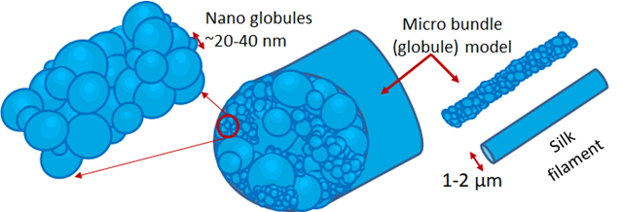

Fig. 1. Micro/nano bundle model of the silk filament

In order to understand how structure and properties are related in silk, it is essential to clarify their structural composition. ATR-FTIR spectroscopy is one of the fast, non-destructive, inexpensive and effective technique, which can be used to determining protein content and protein secondary structure composition (Boulet-Audet et al., 2008; Byrne et al., 2020; Yang et al., 2015).

The mechanical properties of spider dragline silk are of particular note, with a range of potential applications in military and medical contexts (Tintor et al., 2024; Altman et al., 2003). The specific mechanical properties of dragline silk are attributable to different amino acid motifs (Vendrely et al., 2007; Brooks et al., 2005; Gu et al., 2020).

In the current study, an experimental and comparative investigation was conducted on the dragline silk produced by major ampullate silk of orb weavers. Structural characterization was performed by the SAXS/WAXS X-ray scattering techniques using synchrotron source, in conjunction with ATR-FTIR spectroscopy. We also measured the mechanical properties of dragline silk filaments.

2. material and methods

2.1 Materials

The spiders we used were: Aculepeira ceropegia (Ac), Arenaus diadematus(Ad), Araneus quadratus(Aq), Argiope bruennichi (Ab), Argiope lobate(Al) from the Northeastern Black Sea Region of Turkey, (each N=3) and Nephila clavipes (Nc) from Taiwan N=2) (Türkeş et al.; 2018). They are orb-web spiders and members of the spider family Araneida.

2.2 Sample Preparation

The dragline silk samples were collected at laboratory conditions just after the spiders came to laboratory from their natural habitats. The reeling device was designed in-house to allow simultaneous control over rotational and lateral translational speeds of the reel (Fig. 2).

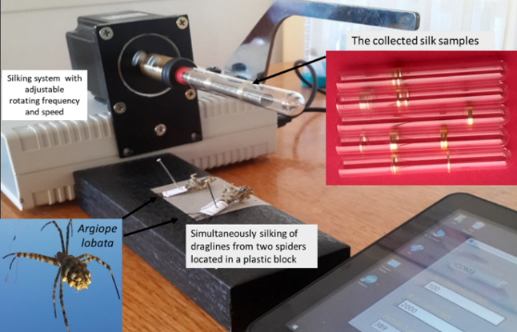

Fig. 2. Apparatus for harvesting dragline spider silk.

Draglines were initially extracted by manually stimulating the spiders to produce silk onto a spooling glass mandrel with a diameter of 5 mm and a length of 100 mm. The reeling speed was set at 20 rpm, an optimal setting for facilitating the natural production of silk by spiders. In one case, the silking length reached 500 cm, consistent with the uniform nanostructured forms of the draglines.
The harvesting time, defined as the duration of silk extraction, was approximately 10 minutes on average per spider when working with silk threads ranging between 80–100 cm in length. In extreme cases, harvesting time extended significantly, reaching the duration required to extract silk from threads as long as 500 cm. These cases involved adult female spiders that were well adapted to the laboratory environment and did not produce egg cocoons after being collected from the field.

2.3 Experimental Methods

The SEM microstructure imaging of spicules was performed using an Environmental Scanning Electron Microscope (FEI model Quanta 200FEG) and Energy Dispersive X-ray Spectrometry (EDX) attached to the scanning microscopy system was used for identifying the elemental composition of spider draglines
Synchrotron radiation (SR) SAXS and WAXS experiments were performed at the BL01C1 and BL23A of National Synchrotron Radiation Research Center (NSRRC), Taiwan, with a monochromatic beam of λ= 0.7748 and 1.2398 Å, respectively. X-ray diffraction pattern was recorded with a Mar 345 image plate and a typical exposure period ~32min. Data collection times varied accordingly, 60s for one image of each silk filament with 350±12 draglines. The X-ray data were analysed using Fit2D software (Peng et al., 2024). All X-ray data were rigorously corrected for electronic noise, sample transmission, background scattering and detector sensitivity. Polyethylene and silver behenate were used for the calibration of the absolute scattering intensity and the scattering wavevector “q respectively. We used Equations 1 and 2 to plot the logarithmic graphics of ln I(q) – q² and ln [I(q).q²] – q².
I(q) = I(0) exp$\left[\frac{{ R_{G}^{2} q}^{2}}{3}\right]$ [-q².R_{g}² /3] (3D, Globular) $\left[\frac{{ R_{G}^{2} q}^{2}}{3}\right]$ (1)

I(q) .q² = I(0) exp [-q².R_{g}²] (2D, Flat) (2)

where, I(q) scattering intensity, q- magnitude of the scattering vector which is defined by 4π sinθ/λ, λ wavelength of X-ray and 2θ is the scattering angle. The radius of gyration (R_{g}) values of the nanostructured aggregations were calculated by using the data in Guinier region (q→0).
FTIR spectra of dragline silks were recorded using a PerkinElmer- Spectrum One FTIR spectrometer equipment with attenuated total reflection (ATR) accessory with a monolithic diamond crystal (Pike, GladiATR). Spectra were collected over the range of 4000-450 cm⁻¹ at 4 cm⁻¹ and 64 co-added scans. Before each measurement, the crystal was cleaned and a new background was acquired. Three spectra were recorded of each sample and average spectra were calculated. For visual demonstration of the spectral differences in the spectra, the average spectra were smoothed using a Savitzky-Golay filter (polynomial order 25), the baseline corrected and then normalized with respect to Amide A (3650–3100 cm⁻¹). The hierarchical cluster analysis (HCA) was implemented with vector normalization was done with OPUS 5.5 software (Bruker Optics, Germany). Spectra were smoothed using 13-points. The dendrogram was calculated using Ward’s method and Euclidean distances.
Silk filaments were prepared with a length of 55 mm and a diameter of 285 ± 10 µm. Zwick/Z010 microscale mechanical testing system (Hacettepe Univ. Dept. of Chemistry, Polymer Lab.) equipped for tensile testing was used to measure stress-strain data.

3. RESULTS AND DISCUSSION

3.1 SEM
A bundle of microfibrils is shown to be the spider dragline in the selected representative SEM images in Fig. 3. EDX analysis revealed the presence of C, N, O and Na, which can be explained by considering the biological components of the silks.

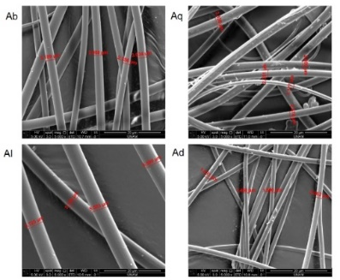

Fig. 3. Scanning Electron Micrographs (SEM) of selected spider silk draglines
(5000X; Scale bar: 20 μm)

3.2 SAXS and WAXS

The 2D SAXS profile were comparatively given in Fig. 4. Guinier data was used to measure Rg (Radius of gyration) values of 3D (Globular) and 2D (Flat) formed nanostructured aggregations. Globular aggregations are related to alanine rich regions while the flat like nanoformations include glycine rich structural contents.

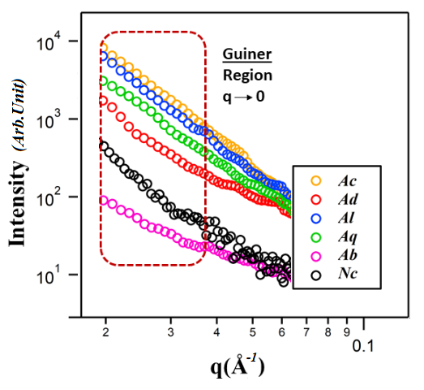

Fig. 4. SAXS profiles of the dragline silk filaments of the studied spider species

The most possible size (Rg) values of the mentioned nano aggregations, which are defined by globules and flat like aggregations were obtained (Table 1). The empirical evidence and the Rg values indicated that the dimensions of the alanine and glycine-rich nano aggregations in the spider dragline silks from Turkey exceed those of the dragline silk content of Nc from Taiwan. Bigger flat nano aggregations may make filaments more flexible due to weak hydrogen bonds in glycine-rich nanoplates.

Table 1. The sizes of the 2D and 3D nano aggregations of the six species

Species | Rg (nm)  (globular) | Rg (nm)  (Flat) | Colour  of the silk
Al | 96.6 ± 0.3 | 65.6 ± 0.4 | Light yellow
Ac | 94.8 ± 0.2 | 64.3 ± 0.3 | White
Aq | 83.2 ± 0.9 | 63.1 ± 0.6 | White
Ad | 89.7 ± 1.1 | 60.4 ± 0.2 | White
Ab | 67.8 ± 1.3 | 55.6 ± 0.9 | Light brown
Nc | 39.3 ± 0.5 | 15.6 ± 0.4 | Light Pink

1D- and 2D-WAXS profiles of the silk filaments are presented in Fig. 5. The crystalline structures and the related interplanar distances were focused on the scattering profiles to evaluate the WAXS data. The profiles also showed the expected traces of the L- and T- polyA crystallographic planes.

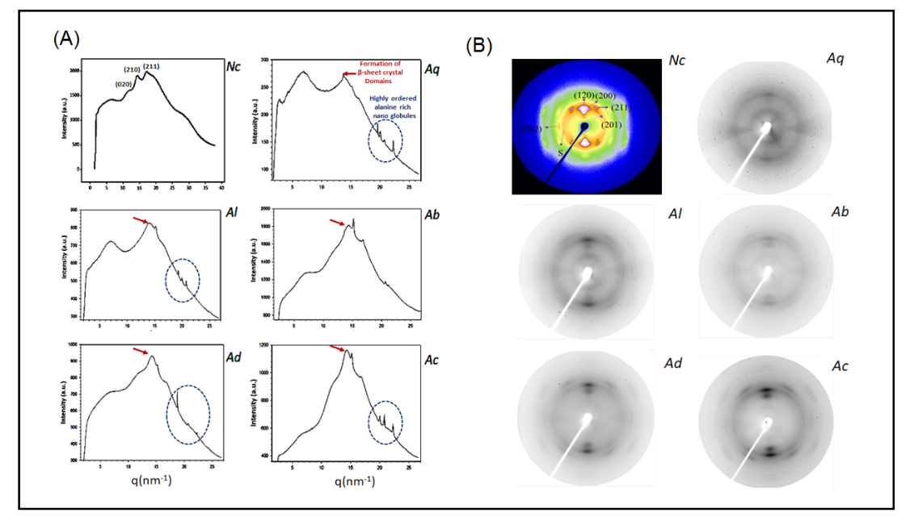

Fig. 5. 1D (A) and 2D-WAXS (B) profiles of the studied dragline silk flaments. The arrows indicate β-sheet crystalline domains’ trace between (020) and (210) peaks (Hammersley, 2016).

The indexing of the peaks related with crystalline ordering were done by using the known and expected crystallographic structural contents as seen in Fig. 6.

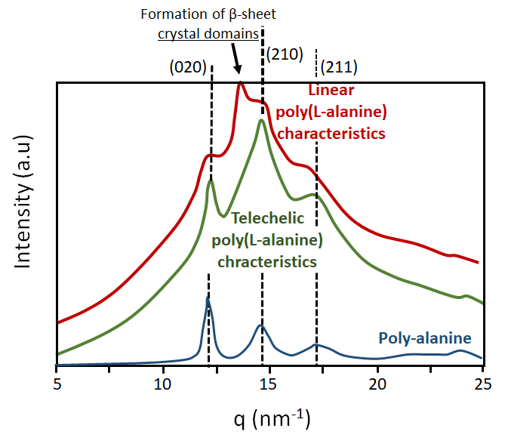

Fig. 6. X-Ray diffraction profiles of polyA based crystalline structures

The average dimensions of the nanodomains along selected [hkl] lattice directions compare well with values from other spider species. The orthorhombic crystallographic planes of (020), (210) and (211) are evidences of the antiparallel pleated β-sheet. These planes indicate d-spacings of 5.1, 4.5, and 3.7 Å, respectively (Lin et al., 2017; Shanthi et al., 2013; Metwalli et al. , 2007; Wang et al., 2019).

The WAXD patterns of the β-sheet crystals of the L-and T-poly A were similar, showing a shift for the peak of the (210) plane (d = 0.43 nm) (Shanthi et al., 2013). It has been demonstrated that no intensive (111) peak is evident in Nc from Taiwan, in contrast to the other species from Turkey, which do exhibit such a peak. This finding is of particular interest given the established relationship between the intensity of the (111) peak and the presence of single-crystal beta-alanine. As can be seen in Fig. 5, Ab has very intense peaks, and the characteristic sharp and broad peaks that are closest to those of Nc (Hammersley, 2016). A distinctive absence of the (111) peak in Nc silk, compared to the intense β-alanine crystalline signatures in species from Turkey highlights unique molecular organization within these silks.

3.3 ATR-FTIR Spectra

Representative ATR-FTIR spectrum of a dragline silk in 4000 to 900 cm⁻¹ region is shown in Fig. 7. The main bands are labeled in the figure and the band assignments are given in Table 2.

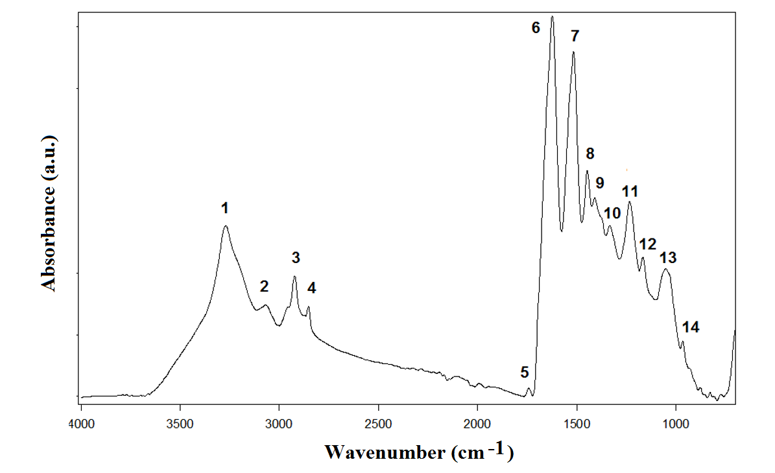

Fig. 7. A general representative ATR-FTIR spectrum of dragline spider silk in 4000 to 900 cm⁻¹ region.

Infrared bands representative of the secondary structure are mainly due to the peptide bonds, especially regarding the amide modes. Amide I and amide II bands are two major bands of the protein infrared spectrum (Wang et al., 2022). These bands originate from different vibrations of protein structure and depend on the protein structural composition. Amide I band mainly result from C=O stretching (80%), with less from C-N stretching (10%) and N-H bending (10%) of the polypeptide and protein backbone. Amide II bands are due to N-H bending (60%) and C-N stretching (40%) of proteins (Ling et al., 2011).

Table 2. Band assignments of major absorptions in ATR-FTIR spectra of dragline spider silk

No | Wavenumber  (cm⁻¹) | Definition of the spectral assignment
1 | 3270 | Amide A: ν(N–H ) protein
2 | 3070 | ν(CH) Amide B: ν(N–H ) protein
3 | 2922 | ν_{a}(CH₂) mainly lipids
4 | 2853 | ν_{s}(CH₂) mainly lipids
5 | 1741 | Saturated ester ν(C=O) phospholipids,
6 | 1623 | Amide I,protein, β- sheets
7 | 1516 | Amide II, protein, β- sheets
8 | 1446 | δ_{a} (CH₃ ) / δ_{a} (CH₂)
9 | 1409 | δ_{s} (CH₂)
10 | 1333 | δ (CH), ω (CH₂)
11 | 1233 | ν(PO₂⁻ ) nucleic acid
12 | 1166 | β-Polyaniline, δ_{s} (CH₃ )
13 | 1050 | Sericin protein , ν(C–O), ν(N–Cα)
14 | 965 | Polyalanine, r(CH₃), β-sheet
* ν- stretching vibration; s - symmetric a- asymmetric δ - In plane bending vibration; r- rocking vibration;

The amide I band in the 1620-1640 cm⁻¹ spectral region is attributed to β -sheet structure, whereas the 1650-1658 cm⁻¹ spectral region is attributed to the α-helical conformation (Whang et al 2022)

The ATR-FTIR spectra of the investigated spider draglines (Fig. 8) revealed the presence of bands at around 1623 cm⁻¹ and 1516 cm⁻¹, indicating that the silk protein is dominated by β-sheet structures in all species (Wang et al., 2022; Bandekar et al., 1980; Barth, 2000; Goormaghtigh et al., 2006; Paquet-Mercier etal., 2013). The shape and position of the amide I bands are similar across the six spider species indicating identical protein conformation. To distinguish among spider dragline molecular structure for six spider species, their averaged infrared spectra in the 4000-450 cm⁻¹ were input in the hierarchical cluster analysis (HCA).

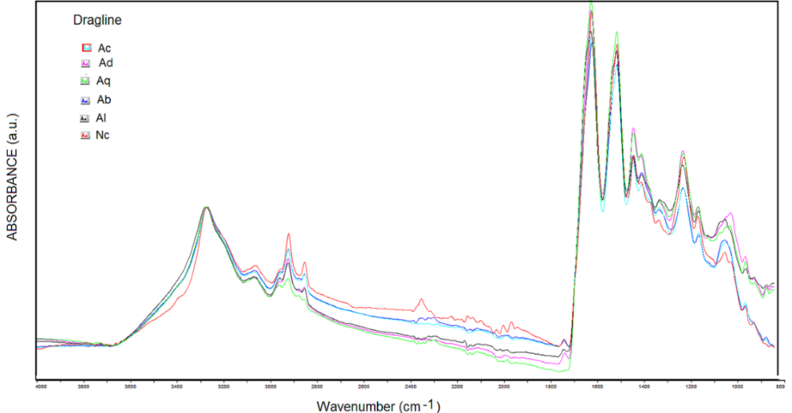

Fig. 8. ATR-FTIR spectra of spider draglines of Aculepeira ceropegia (Ac), Arenaus diadematus (Ad), Araneus quadratus (Aq), Argiope bruennichi (Ab), Argiope lobata (Al) and Nephila clavipes (Nc) in 4000 to 800 cm⁻¹ region (Spectra were normalized with respect to Amide A band)

The dendrogram (Fig. 9) showed two main groups. It indicates similarities between Al and Aq (and between Ad and Ac). However, Nc from Taiwan was separated from the others. The results obtained from the HCA analysis suggest that the samples can be categorized according to their chemical composition. However, these differences were not statistically significant. The relatively small number of samples indicated that the results should be further investigated using a larger number of samples.

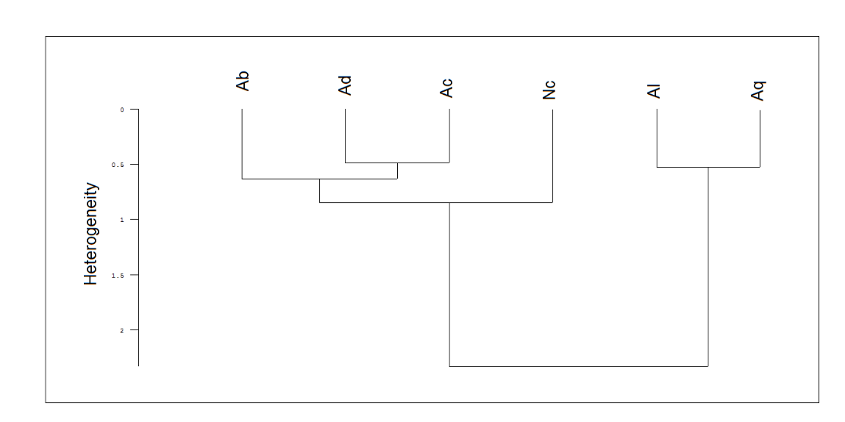

Fig. 9. Dendrogram obtained from hierarchical cluster analysis on spectral cluster averages associated to different spider species. Heterogeneity represents the discriminating distance given by arbitrary units (au).

3.4 Mechanical testing

Among the species examined, Nc demonstrates the highest tensile strength accompanied by minimal elongation (Fig. 10). In contrast, Al is distinguished by its superior flexibility, whereas Ab presents a well-balanced profile of strength and extensibility, suggesting its potential as the most adaptable candidate for diverse mechanical applications (Table 3).

Table 3. Comparison of the mechanical properties of spider silk draglines of selected species.

Species | Maximum F/A (N/mm²) | Maximum  ΔL/L (%) | Mechanical property
Al | 234.5 ± 0.5 | 14.3 ± 0.3 | Max. flexibility
Ab | 255.0 ± 0.5 | 11.3 ± 0.3 | Max. strength and flexibility
Nc | 327.0 ± 0.5 | 10.6± 0.3 | Max. strength

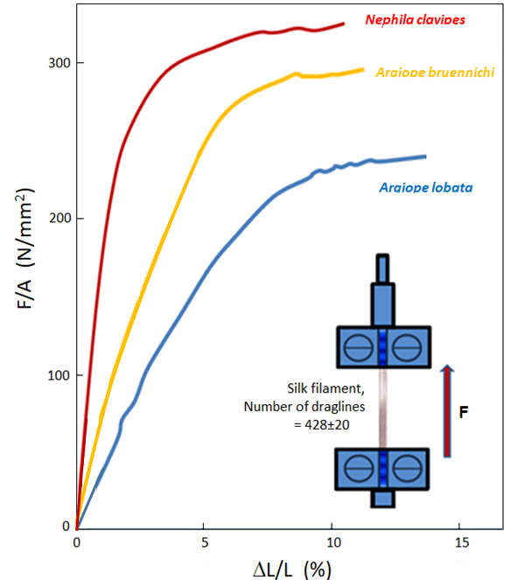

Fig. 10. Stress-Strain curves of dragline silk of Argiope bruennichi, Argiope lobata and Nephila clavipes

The dragline silk of orb-weaving spiders is known for its unique combination of strength, and extensibility (Lefevre et al., 2007; Elices et al., 2009). The strong mechanical properties of the filaments are related to small sized alanine rich nano aggregations and their special hierarchical distributions in the natural composite structure of silks (İde et al., 2011). In general, as the β-sheet content of the MA silk increases the silk becomes stronger (higher in tensile strength) (Ker et al., 2018; Htut et al, 2021).

4. CONCLUSION

This comparative investigation provides a comprehensive analysis of the major ampullate dragline silk produced by orb-weaving spiders, focusing on its molecular composition, nanoscale architecture, and mechanical performance. Through multi-level characterization techniques—including spectroscopy, electron microscopy, and tensile testing—the study reveals how specific protein motifs contribute to the hierarchical organization and extraordinary strength of the silk filaments. These findings offer valuable insights into bioinspired material design and potential applications in engineering and biomedicine.

Structural analyses via synchrotron SAXS/WAXS and ATR-FTIR spectroscopy demonstrated notable species-dependent variations, particularly between spider species from Turkey and Nephila clavipes from Taiwan. The larger alanine- and glycine-rich nanoaggregations in spider silks from Turkey are indicative of more flexible mechanical behaviour, potentially due to weaker hydrogen bonding within glycine-rich nanoplates. The orthorhombic crystallographic planes [(020), (210), (211)] confirmed the presence of antiparallel β-sheet structures, with consistent d-spacings that align with prior reports. Spectral evidence further revealed consistent dominance of β-sheet secondary structures, corroborated by amide I band across all species

Spider webs in Taiwan are generally elastic and resistant to humidity, reflecting adaptations to warm and damp climates, while spider webs in Turkey tend to be more durable and irregular, suited to varying weather conditions. Studying these differences contributes to the development of advanced materials in technology, such as flexible and resilient synthetic fibers. Our results are also supporting these statements. Together, these findings broaden the understanding of spider silk architecture and offer promising implications for the design of bioinspired synthetic fibers. The molecular diversity observed among orb-weavers underscores the potential for tailoring silk-based materials through species-specific structural cues.

DISCLAIMER (ARTIFICIAL INTELLIGENCE)

Author(s) hereby declare that NO generative AI technologies such as Large Language Models (ChatGPT, COPILOT, etc.) and text-to-image generators have been used during the writing or editing of this manuscript.

References

Altman G.H., Diaz F., Jakuba C., Calabro T., Horan R.L., Chen J., Lu H., Richmond J. & Kaplan D.L. (2003). Silk-Based Biomaterials. Biomaterials, 24(3), 401–416.
https://doi.org/10.1016/S0142-9612(02)00353-8,,

Babu P. J., & Suamte L.(2024) Applications of silk-based biomaterials in biomedicine and biotechnologyEngineered Regeneration5(1), 55-69
https://doi.org/10.1016/j.engreg.2023.11.002

Bandekar J. & Krimm S. (1980). Vibrational Spectra and Structure of Peptides and Proteins. Biopolymers, 19(1), 31–36.
https://doi.org/10.1002/bip.1980.360190103

Bandyopadhyay, A., Chowdhury, S.K., Dey, S. Moses J.C. & Mandal B.B . (2019). Silk: A Promising Biomaterial Opening New Vistas Towards Affordable Healthcare Solutions. J Indian Inst Sci 99, 445–487 https://doi.org/10.1007/s41745-019-00114-y

Barth A.(2007). Infrared Spectroscopy of Proteins. Biochim Biophys Acta. 1767(9),1073-1101.
https://doi.org/10.1016/j.bbabio.2007.06.004

Blamires, S.J., Rawal, A., Edwards, A.D., Yarger, J.L., Oberst, S., Allardyce, B.J. & Rajkhowa, R. (2023). Methods for Silk Property Analyses across Structural Hierarchies and Scales. Molecules, 28(5), 2120.
https://doi.org/10.3390/molecules28052120

Boulet-Audet M, Lefèvre T., Buffeteau T. & Pézolet M. (2008). Attenuated Total Reflection Infrared Spectroscopy: An Efficient Technique to Quantitatively Determine the Orientation and Conformation of Proteins in Single Silk Fibers. Appl. Spectrosc., 62(9), 956–962.
https://doi.org/10.1366/000370208785793380

Branković, M., Zivic, F., Grujovic, N., Stojadinovic, I., Milenkovic, S., & Kotorcevic, N. (2024). Review of Spider Silk Applications in Biomedical and Tissue Engineering. Biomimetics, 9(3), 169. https://doi.org/10.3390/biomimetics9030169

Motriuk-Smith D, Smith A, Hayashi C.Y, & Lewis R.V. (2005). Analysis of the Conserved N-Terminal Domains in Major Ampullate Spider Silk Proteins. Biomacromolecules, 6(6), 3152–3159.
https://doi.org/10.1021/bm050472b

Byrne B., Beattie J., Song C.L. & Kazarian S. (2020). ATR-FTIR Spectroscopy and Spectroscopic Imaging of Proteins. Vibrational Spectroscopy in Protein Research, Academic Press pp. 1–22.
https://doi.org/10.1016/B978-0-12-818610-7.00001-3

Doblhofer, E., Heidebrecht, A. & Scheibel, T. (2015). To spin or not to spin: spider silk fibers and more. Appl. Microbiol. Biotechnol., 99(22), 9361-9380.
https://doi.org/10.1007/s00253-015-6948-8

Elices M., Plaza G.R., Arnedo M.A., Pérez-Rigueiro J., Torres F.G. & Guinea G.V. (2009). Mechanical Behavior of Silk During the Evolution of Orb-Web Spinning Spiders, Biomacromolecules, 10(7), 1904–1910.
https://doi.org/10.1021/bm900312c

Goormaghtigh E., Ruysschaert J.M. & Raussens V. (2006). Evaluation of Protein Secondary Structure from FTIR Spectra. Biophys J., 90(8), 2946–2957.
https://doi.org/10.1529/biophysj.105.072017

Gu Y., Yu L., Mou J., Wu D., Zhou P. & Xu M. (2020). Mechanical Properties and Application Analysis of Spider Silk Bionic Material. e-Polymers, 20(1), 443–457.
https://doi.org/10.1515/epoly-2020-0049

Hammersley A.P. (2016). FIT2D: A Multi-Purpose Data Reduction, Analysis and Visualization Program. J. Appl. Cryst., 49, 646–652.
https://doi.org/10.1107/S1600576716000455

Hardy, J.G., Römer, L.M. & Scheibel, T. R. (2008). Polymeric materials based on silk proteins. Polymer, 49(20), 4309-4327.
https://doi.org/10.1016/j.polymer.2008.08.006

Hu S, Wan S, Zhang X, Wang X, Guan L, Ge Y, Li Y, Luo J, & Tang B.(2025) Structure, production and application of spider silks. Int J Biol Macromol. 309,:142939.
https://doi.org/10.1016/j.ijbiomac.2025.142939

Htut K.Z., Alicea-Serrano A.M., Singla S., Agnarsson I., Garb J.E., Kuntner M., Gregorič M., Haney R.A., Marhabaie M., Blackledge T.A. & Dhinojwala A. (2021). Correlation Between Protein Secondary Structure and Mechanical Performance for the Ultra-Tough Dragline Silk of Darwin’s Bark Spider. J Royal Soc Interface, 179, 20210320.
https://doi.org/10.1098/rsif.2021.0320

İde S., Bayarı S.H., Türkeş T., Mergen Y.O., Çelik Ö., Bütün V., Sargon M.F., Kocatepe N. & Kriechbaum M. (2011). Structural Characterization of a Variety of Spider Silks from Turkey Using Different Biophysical Techniques J. Spectroscopy, 25(3-4), 567983.
https://doi.org/10.3233/SPE-2011-0495

Ide S., Orujalipoor I., Chuang W.T., Jeng U-S., Özcan Y. & Türkeş T. (2017). Nanoscale structural analyses on Turkey/Taiwan originated spider cocoons
Acta Crystallographica Section A: Foundations and Advances, 73(a2), C1355–C1355.
https://doi.org/10.1107/S2053273317082201

Karahisar Turan S, Kılıç Süloğlu A, İde S, Türkeş T, Barlas N (2024). In vitro and in vivo investigation of Argiope bruennichi spider silk-based novel biomaterial for medical use. Biopolymers.115(3):e23572. doi: 10.1002/bip.23572.

Kerr G.G., Nahrung H.F., Wiegand A., Kristoffersen J., Killen P., Brown C. & Macdonald J., (2018). Mechanical properties of silk of the Australian golden orb weavers Nephila pilipes and Nephila. plumipes, Biol Open., 7(2), bio029249.
doi: 10.1242/bio.029249

Keten S., Xu, Z., Ihle, B. & Buehler, M. J. (2010). Nanoconfinement controls stiffness, strength and mechanical toughness of β-sheet crystals in silk. Nat. Mater. 9, 359– 367.
https://doi.org/10.1038/nmat2704

Lefevre T., Rousseau M.E. & Pezolet M. (2007). Protein Secondary Structure and Orientation in Silk as Revealed by Raman Spectromicroscopy. Biophys J., 92(8), 2885–2895.
https://doi.org/10.1529/biophysj.106.100339

Lin, T.Y., Masunaga, H., Sato, R., Malay, A.D., Toyooka, K., Hikima, T. & Numata, K. (2017). Liquid Crystalline Granules Align in a Hierarchical Structure To Produce Spider Dragline Microfibrils. Biomacromolecules, 18(4), 1350–1355.
https://doi.org/10.1021/acs.biomac.7b00086

Ling S., Qi Z., Knight D.P., Shao Z. & Chen X. (2011). Synchrotron FTIR Microspectroscopy of Single Natural Silk Fibers. Biomacromolecules, 12(9), 3344–3349.
https://doi.org/10.1021/bm2006032

Makowski, L., Rodi, D.J., Mandava, S., Devarapalli, S. & Fischetti, R.F. (2008). Molecular Crowding Inhibits Intramolecular Breathing Motions in Proteins. J. Mol. Biol., 375(2), 529–546.
https://doi.org/10.1016/j.jmb.2007.07.075

Mertens, H.D.T. & Svergun, D.I. (2010). Structural characterization of proteins and complexes using small-angle X-ray solution scattering. J. Struct. Biol. 172(1), 128–141.
https://doi.org/10.1016/j.jsb.2010.06.012

Metwalli E., Slotta U., Darko C., Roth S.V., Scheibel T. & Papadakis C.M. (2007). Structural Changes of Thin Films from Recombinant Spider Silk Proteins Upon Post-Treatment. Appl. Phys. A, 89, 655–661.
https://doi.org/10.1007/s00339-007-4265-5

Paquet-Mercier F. Lefèvre T., Auger M. & Pézolet M. (2013). Evidence by infrared spectroscopy of the presence of two types of β-sheets in major ampullate spider silk and silkworm silk, Soft Matter, 9, 208-2015.
https://doi.org/10.1039/C2SM26657A

Peng X., Liu Z., Gao J., Zhang Y., Wang H., Li C., Lv X., Gao Y., Deng H., Zhao B., Gao T. & Li H. (2024). Influence of Spider Silk Protein Structure on Mechanical and Biological Properties for Energetic Material Detection. Molecules, 29(5), 1025.
https://doi.org/10.3390/molecules29051025

Riekel, C., & Vollrath, F. (2001). Spider silk fibre extrusion: combined wide- and small-angle X-ray microdiffraction experiments. Int. J. Biol. Macromol., 29(3), 203 -210.

https://doi.org/10.1016/S0141-8130(01)00166-0

Riekel, C., Burghammer, M. & Rosenthal, M. (2020). Mesoscale structures in amorphous silks from a spider’s orb-web. Sci Rep., 10, 18205.
https://doi.org/10.1038/s41598-020-74638-0

Sapede, D., Seydel, T., Forsyth, V.T., Koza, M.M., Schweins, R., Vollrath, F. & Riekel, C. (2005). Nanofibrillar Structure and Molecular Mobility in Spider Dragline Silk. Macromolecules, 38, 8447–8453.
https://doi.org/10.1021/ma0507995

Shanthi D., Selvarajan P., HemaDurga K.K. & Lincy Mary Ponmani A. (2013). Nucleation kinetics, growth and studies of β-alanine single crystals, Spectrochim. Acta - A: Mol. Biomol., 110, 1–6.
https://doi.org/10.1016/j.saa.2013.02.040

Sponner, A., Vater, W., Monajembashi, S., Unger, E., Grosse, F., & Weisshart, K. (2007). Composition and hierarchical organisation of a spider silk. PLoS One, 2, e998. https://doi.org/10.1371/journal.pone.0000998

Tintor Đ., Ninković K., Milošević J. & Polović N. Đ. (2024). ATR-FTIR Spectroscopy for Protein Structure Analysis. Vibrational Spectroscopy, 134, 103726.
https://doi.org/10.1016/j.vibspec.2024.103726,

Trancik, J.E., Czernuszka, J.T., Bell, F.I. & Viney, C. (2006). Nanostructural features of a spider dragline silk as revealed by electron and X-ray diffraction studies. Polymer, 47, 5633–5642.
https://doi.org/10.1016/j.polymer.2005.01.110

Tsuchiya, K., Ishii, T., Masunaga, H. & Numata, K. (2018). Spider dragline silk composite films doped with linear and telechelic polyalanine: Effect of polyalanine on the structure and mechanical properties. Sci Rep 8, 3654.
https://doi.org/10.1038/s41598-018-21970-1

Türkeş T., İde S., Seyyar O., Bayarı S., Demir H. & User J. (2018). Spider Silk Characterization and Biophysical Analysis.TÜBİTAK, 1001 Research Project ID: KBAG 214Z049.
https://search.trdizin.gov.tr/en/yayin/detay/1236862/turkiyenin-dogu-karadeniz-bolgesi-ile-tayvanin-kuzey-bolumunde-yasayan-orumceklerin-aglari-uzerine-nanomikro-skalada-ileri-yapisal-analizler

Vendrely C. & Scheibel T. (2007). Biotechnological Production of Spider-Silk Proteins Enables New Applications. Macromol Biosci., 7, 401–409.
https://doi.org/10.1002/mabi.200600255

Wang Q. & Schniepp H.C. (2019). Nanofibrils as Building Blocks of Silk Fibers: Critical Review of the Experimental Evidence. JOM, 71, 1248–1263.
https://doi.org/10.1007/s11837-019-03340-y

Wang Q., McArdle P., Wang S.L., Wilmington R.L., Xing Z., Greenwood A., Cotten M.L., Qazilbash M.M. & Schniepp H.C. (2022). Protein Secondary Structure in Spider Silk Nanofibrils. Nat Commun., 13, 4329.
https://doi.org/10.1038/s41467-022-31883-3

Yang, Z., Grubb, D.T. & Jelinski L.W. (1997). Small-Angle X-ray Scattering of Spider Dragline Silk. Macromolecules, 30, 8254–8261.
https://doi.org/10.1021/ma970548z

Yang H., Yang S., Kong J., Dong A. & Yu S. (2015). Obtaining Information About Protein Secondary Structures in Aqueous Solution Using Fourier Transform IR Spectroscopy. Nat Protoc., 10, 382–396.
https://doi.org/10.1038/nprot.2015.024

