Review Article
Two Solutions to a Single Issue: Detoxification of Nitro
Xenobiotics by Flavin Oxidoreductases

.
ABSTRACT

This review article details the current knowledge of nitronate monooxygenase (NMO) and nitroalkane oxidase (NAO) both of which detoxify organic nitro compounds. The chemical versatility of these molecules are first described by explaining why they are unusually strong carbon acids. This reactivity led to their widespread use in industry and inevitable release into the environment as pollution. Oxidation of nitro compounds is likely an adaptation of existing enzymatic activities to convert them into carbonyl compounds that can be broken down by normal metabolism. NMO has a marked preference for anionic nitronates while NAO exclusively utilizes neutral substrates. Kinetic studies demonstrating this fact are presented along with a detailed structural analysis to rationalize this observation. NMO uses a conserved histidined to electrostatically stabilize the carbanion formed from nitro compounds where as NAO has a negatively charged aspartate in the active site that repels anionic substrates. Details of the chemical mechanisms of each enzyme are presented showing that NMO uses a flavin radical during catalysis whereas NAO forms a covalent adduct between the cofactor and substrate. Information presented in this article is intended to shed light on two platforms that can be exploited for bioremediation to alleviate nitroalkane pollution.

Keywords: Nitroalkanes; Alkyl Nitronates; Nitronate Monooxygenase; Nitroalkane Oxidase; Flavin
Oxidoreductases; Enzyme Mechanism, pH and Kinetic Isotope Effects, Bioremediation

1. INTRODUCTION

A nitro moiety is typically not a functional group that comes to mind when considering biological chemistry despite the fact that nature exploits its reactivity in many ways in order to sustain life. Several microbial, plant and insect species, for example, utilize nitro groups as part of their defense systems and normal nitrogen metabolism [3, 4]. Human beings have also harnessed the reactivity of organic nitro compounds, particularly the nitroalkanes, by finding many applications of these molecules in medicinal, physical and synthetic chemistry [5]. One of the earliest and most widespread uses of nitroalkanes in synthetic organic chemistry was developed at the University of Chicago by Johann Ulrich Nef [6]. His group demonstrated their utility for the effective production of aldehydes and ketones and later as the starting point to synthesize a variety of other functional groups. Successful applications and extensions of the Nef reaction led to the widespread use of nitroalkanes as building blocks for a wide array of complex molecules with a multitude of pharmaceutical, agricultural and industrial applications [5, 7].

Discoveries of new applications of highly reactive nitro compounds continues to this day leading to their large-scale production (>104 tons/year globally [8]) and use in several chemical industries. While this has proven to be of great benefit to society, the inevitable release of organic nitro compounds into the biosphere has caused significant environmental and agricultural issues [9]. Nitroalkanes and several other organic nitro compounds are metabolized in higher organisms to produce nitrite, nitrogen dioxide, nitrosamines and many other highly carcinogenic or neurodegenerative agents [10, 11]. Nitroalkanes have been shown to be highly toxic to the liver, kidneys and reproductive organs in both males and females [12]. Increased risk for cancers of the lung, breast, bladder, prostate, stomach and glial tissues has all been attributed to metabolites of nitroalkanes in both humans and other animals [10]. An increase in the prevalence of organic nitro compounds in the environment has led to the evolution of new enzymatic activities to degrade these compounds, which in turn, has increased the concentrations of toxic metabolites in foods and other agricultural products used for human consumption [9, 11, 13, 14].

Therefore, there is an increasing need to develop effective bioremediation strategies to counter the health issues caused by the environmental release of organic nitro compounds. This review article intends to raise awareness of two recently evolved fungal enzymes that metabolize organic nitro compounds to produce nitrite and carbonyl compounds. Namely, the properties of nitronate monooxygenase (NMO; E.C.
1.13.12.16) and nitroalkane oxidase (NAO; E.C. 1.7.3.1), will be compared and contrasted. While various aspects of the enzymes have been reviewed in separate articles [15-19], they have never been looked at together in a single comprehensive account. The article starts with a brief description of naturally occurring nitro compounds focusing on those which are substrates for NMO and/or NAO (Section 2). Then, Section
3 describes the physical organic chemistry that governs the ionization of organic nitro compounds, including both the thermodynamic and kinetic factors related to the equilibrium reaction. This section also presents fundamental concepts and experimental data describing flavin cofactors, which both enzymes use to catalyze the detoxification of nitroalkanes. Structural studies of NMO and NAO are outlined next in Section
4, followed by a detailed discussion of the substrate specificities of the enzymes dictated by their structures (Section 5). Proposed catalytic mechanisms and the key experiments to support these are described in Section 6. The article ends with proposals to use both NMO and NAO as a platform for bioremedial strategies to combat industrial pollution caused by the use of nitro compounds. It is hoped the knowledge gained from this review will be applied by both environmental engineers and biochemists alike to the further development of these strategies. This, in turn, will allow for the continued use of organic nitro compounds in agriculture and medicine, while mitigating the damages caused by their environmental release.

2. THE ENZYMATIC REACTIONS OF NITRONATE MONOOXYGENASE AND NITROALKANE OXIDASE

In addition to xenobiotic toxicity, there are several examples of naturally occurring nitro compounds that are produced mainly by microbes and leguminous plants, but also by insects and higher organisms [3, 4, 18,

Figure 1: Ionizations of Organic Nitro Compounds Discussed in This Study The carbon acids on the left side of the equilibria are referred to as neutral molecules or nitroalkanes. The conjugate bases are on the rigght and are called anionic forms or nitronates.
20-22]. Natural production of nitro compounds by these organisms is precisely due to their toxicity, which makes them effective weapons when excreted from the cell. They are used to fight off competing microbes in the soil, herbivory in plants or predators in insects. The most notable these nitro compounds in the context of the current article is 3- nitropropionic acid (3-NPA; Figure 1). Toxicity of 3-NPA arises from its conjugate base, propionate-3-nitronate (P3N) that readily forms under physiological conditions as a result of the acid base equilibrium discussed in Section 3. The molecule is stored as ester conjugates in the cell walls of legumes and is also secreted by a variety of soil microbes. Additionally, several insect species including moths and leaf beetles produce and secrete the toxin for protection [13, 23]. P3N is a potent
inhibitor for both succinate dehydrogenase and fumarase [24, 25] key enzymes in the Krebs cycle. It irreversibly forms a covalent bond with an active site arginine residue in succinate dehydrogenase and is a transition state analogue of the fumarase reaction, so binds very effectively (KD ~ 70 nM at 300 K, pH 7.5) to the enzyme. 3-NPA intoxication thus effectively shuts down catabolism and energy production in poisoned cells thereby preventing both growth and survival of the effected organism. 3-NPA has been widely implicated in the development of neurogenerative disorders in livestock and, in a few cases, humans who ingested the toxin in contaminated foods [26, 27]. Organisms that produce 3NPA/P3N also express flavin dependent enzymes to oxidize the toxin and protect against self-poisoning. These enzymes are the main focus of this review article.

Enzymatic oxidation of nitroalkanes is sometimes an overlooked topic that has potential applications for both medicinal and environmental chemistry. Nitroalkane oxidizing enzymes have been described mainly in fungi [28-30] and bacteria [21, 31-33], but also in most other types of organisms known to produce the toxins [4,
18, 20]. The reactions of NMO and NAO, the two most extensively characterized nitroalkane oxidizing enzymes described to date, are shown in Figure 2. The stoichiometries and side products were determined early on in their characterizations showing that while nitrite is produced as side products in both enzymes, NMO reduces oxygen to water

Figure 2: Reactions of Nitronate Monooxygenase and Nitroalkane oxidase Both enzymes produce carbonyl products and nitrite, but reduce oxygen to produce different side products (water or hydrogen peroxide, respectiv;ey).
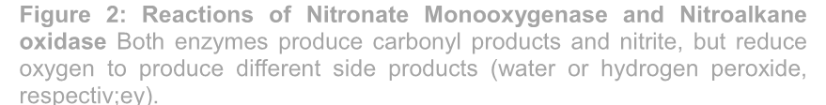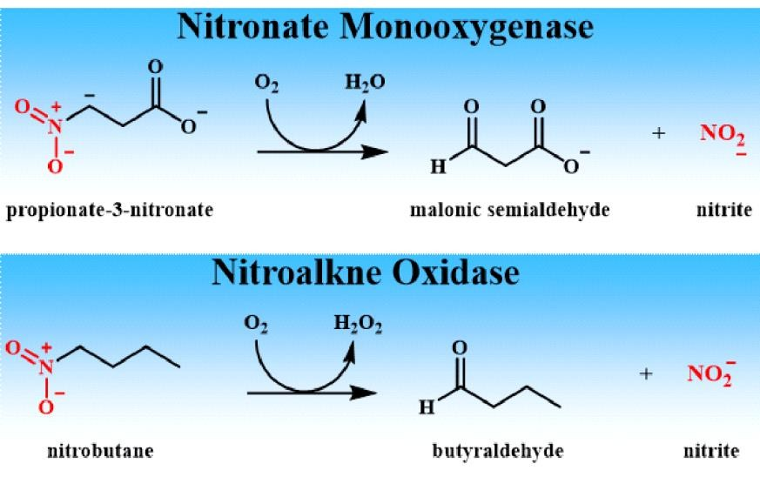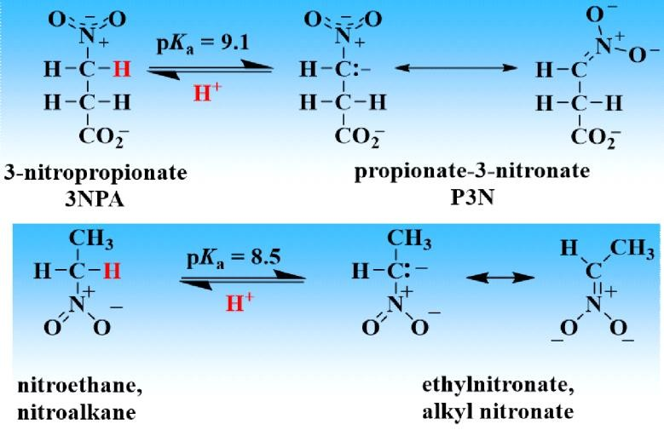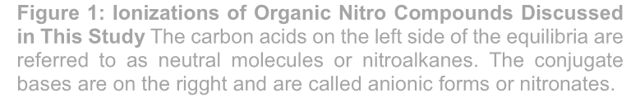whereas NAO makes hydrogen peroxide [34, 35]. The reactions shown in the figure are only representative
examples since each enzyme can act on a range of nitro compounds. The absence or presence of hydrogen peroxide as a side product of the enzymes was detected by coupling reaction with catalase [36]. If hydrogen peroxide is released during steady stae turnover coupling assays with catalase results in only half the amount of oxygen consumption. This is only seeen with NAO and not NMO enzymes [29, 37].

3. BACKGROUND: PHYSICAL ORGANIC CHEMISTRY OF NITRO COMPOUNDS, FLAVIN COFACTORS, NOMENCLATURE USED IN STUDY

The enzymology of NMO and NAO encompasses topics from a diverse range of chemical fields, so a brief description of key concepts is warranted before detailed discussions can commence.
More detailed accounts of these topics can be found in the provided references.

2.1 IONIZATION OF THE α-CARBON IN ORGANIC NITRO COMPOUNFS AND THE PRINCIPLE OF NON-PERFECT SYNCHRONIZATION

The presence of a nitro group in aliphatic hydrocarbons gives the molecule unusual thermodynamic and kinetic properties [5, 7]. Thermodynamically, the ability of electrons to become delocalized upon the molecular orbitals of both the oxygens and nitrogen of the nitro moiety provides a great deal of stabilization energy (65-85 kJ/mol at 300 K) [38]. Both electron delocalization and resonance stabilization are extended upon deprotonation of the carbon atom next to the nitro group (the so called α-carbon). Thus, this C-H bond is unusually liable and acidic with typical pKa values ranging from ~6 to 10 as compared to > 80 for typical alkanes [7]. However, unlike the case for the vast majority of acids, ionization of nitro-carbon acids is an extremely slow process as extensively characterized during the careers of Claude Bernasconi and William Saunders. They and others developed the principle of non-perfect synchronization which states that charge delocalization in the transition state of certain ionization reaction lags charge transfer [39]. This lag in charge transfer makes ionization kinetically slow and manifests in the equilibria presented in Figure 1 taking several hours to a day to be fully establish. This is in contrast to typical acid-base equilibria that are establish in a matter of femtoseconds [40].

Practical implications of this slow approach to equilibrium is that nitroalkane oxidizing enzymes can be studied using either fully protonated (or neutral) forms) of organic nitro acids or fully deprotonated (or anionic) forms) of the molecules. For simplicity this article will refer to all neuTral substrates as nitroalkanes and anionic forms as nitronates even in cases where another functional group may be present. Thus, ionization of the carboxyl group of 3NPA or P3N is ignored. It is rapid and the group exists solely in the anionic form at the pH values used in all studies described in this article (pH 5-10.

2.2 KEY ASPECTS OF FLAVIN COFACTORS

Both NMO and NAO utilize flavin cofactors, so a brief mention of the rich chemistry of this prosthetic group is needed before experiments on the enzymes are described. The two forms of flavin cofactors that occur in enzymes are flavin mononucleotide (FMN) and flavin adenine dinucleotide (FAD) [41]. Redox chemistry occurs exclusively within the isoalloxazine ring system, so it is the only part of the cofactor shown in Figure
3. The remaining part of the molecule serves to anchor it within the protein and has no other biological importance or significant effects on the redox chemistry of the molecule. NMO enzymes all use FMN as
cofactor whereas NAOs utilize FAD. A detailed discussion of the spectroscopic properties of the isoalloxazine ring system is beyond the scope of this review, but since UV-visible absorbance spectroscopy played pivotal roles in deducing the catalytic mechanisms of the enzymes, and are described in Section 5, the absorbance maxima of the various redox states of the cofactor is also presented in the figure. The
cofactors of the resting (substrate free) forms of both NMO and NAO are in the oxidized form with the flavin
(N5) (numbering system in box) lacking electrons or hydride ions. . Flavins can exist in a one electron partially- reduced state. These are known as flavin semiquinones and can either be in a neutral form with the flavin N(5) protonated or be anionic with this position deprotonated. Finally, the ring can become fully reduced by either gaining two electrons in the form of a hydride ion or by forming a covalent bond with the substrate. The distinct spectra of the different redox states of flavins allows for an easy and convenient probe of mechanism as described in detail in Section 6.

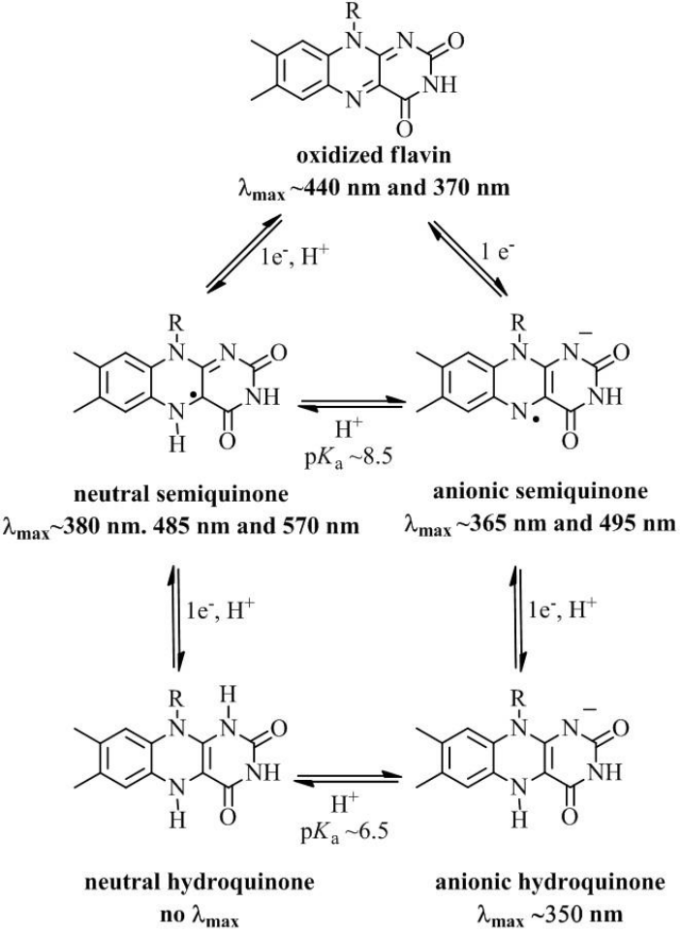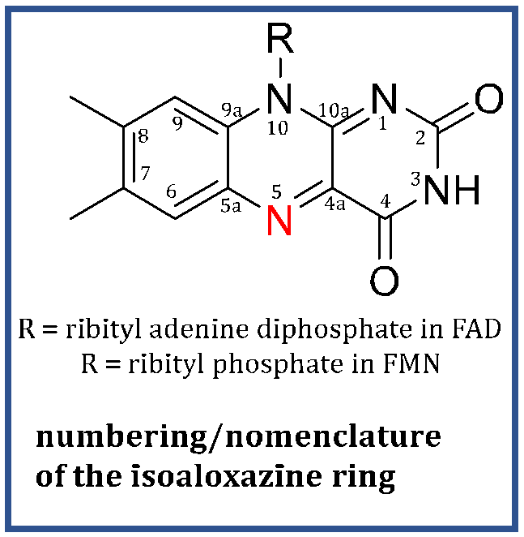

Figure 3: Different Redox States of Flavin Cofactors The numbering system of the isoalloxazine ring system is provided in the box and the values for the absorbance maxima are given in reference [37].

4. STRUCTURAL STUDIES OF NITRONATE MONOOXYGENASE AND NITROALKANE OXIDASE

The three-dimensional structures of both NMO and NAO have been determined through X-ray crystallography [15, 16, 31, 33, 42-44]. These studies validate previous reports on the enzymes in which primarily kinetic methods were employed to establish their catalytic mechanisms and substrate specificities. This section will present the overall structures of the enzymes as well as provide detailed descriptions of their active sites. It will do so largely as an overview to provide a framework for an extensive presentation of the substrate specificities and catalytic mechanisms detailed in Sections 5-6.

4.1 CRYSTAL STRUCTURE OF CLASS I NITRONATE MONOOXYGENASE

In 2014 the first NMO structure was characterized for a protein that had unambiguously been shown to oxidize nitroalkanes [33]. The enzyme was from the bacterium Pseudomonas aeruginosa and provides a
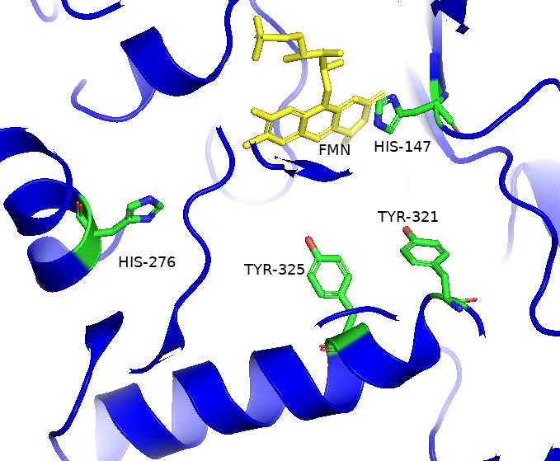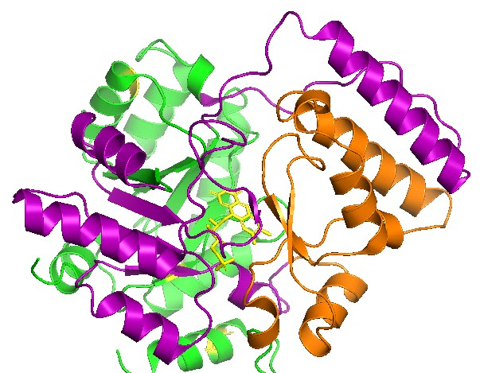

Figure 4: Structure of Nitronate Monooxygenase The structure was solved for the enzyme from C. saturnus PDB ID: 6BPKA and is reported in reference [28]. Left Panel: Overall structure of the homodimeric structure. There is a single active site per subunit. The TIM barrels for cofactor binding are in purple, the substrate binding site is in green and the FMN cofactor is in yellow. Right Panel: Active site of NMOCs showing a conserved histidine (His-147) that forms electrostatic interactions with nitronate substrates to position them fore effective oxidation. Also shown are other conserved residues involved in substrate binding.
benchmark to the study of NMO structure and function.1 In addition to validating the proposed catalytic mechanism of the enzyme [45-47], this study demonstrates that two classes of NMO exist in nature. Bioinformatic analysis of NMO sequences showed that enzymes similar to NMOpa have four structural motifs in common. The presence of these motifs are now used to group NMOs into Class I, and if these are absent, into Class II. To date, no class II NMO structures have been solved including that from the well- studied Neurospora crassa enzyme (NMOnc). Sequence alignments presented in [33], show that class II NMOs contain a conserved activer site Met, Asn and His as well as part of I and III. At the time of publication, structures are only available for NMOpa and NMOCs [33, 42]. They both exhibit an overall TIM (triose phosphate isomerase) fold consisting of eight parallel β-strands surrounded by α-helices. Primary sequences of the four structural motifs an NMO must possess to be categorized as being in Class I is summarized in Table 1. s

Motif Primary Sequence
I P-I-X-Q-A-P-M-X-G-X-S-T-X-X-L-A-A II (V/I)-S-F-H-F-(G/N)-
III (V/I)-X-Q-G-X-E-A-G-G-H-R-G-X-F IV (P/A)-(D/E/P)-Y-P-X-X-Y-D-X-X-K-X-L
Table 1: Conserved Sequences in Class I Nitronate Monooxygenasea

aFrom [33]. Class II NMOs share partial conservation with Motifs I and III.

Class I NMOs contain multiple conserved residues in their active site (Figure 4). The first residue of note is a histidine (His-147 in NMOcs) that serves as an electrostatic catalyst to stabilize the negative charge of the nitronate anion substrates for binding and proper positioning for effective oxidation [33, 42]. This residue is also found in Class II NMOs where functional studies in which the residue was replaced with Asn demonstrated that it serves as a catalytic base for proton abstraction from nitroalkane substrates (more details in Section 6). A second conserved His and several Tyr residues work in concert for substrate binding
and positioning during NMO catalysis. This was established in a study where many active site variants were generated through oligonucleotide directed mutagenesis, purified and characterized [48]. When any one of these residues were altered individually only minimal effects on the kinetic parameters of the enzyme were observed. However, generation of double or triple mutants and studies of pH effects on the kinetic parameters showed significant detrimental effects. Taken together, the data suggests that multiple residues work together for substrate binding and proper positioning for oxidation most likely by serving as hydrogen bond donors to the carboxylate of P3N or the nitro group of other substrates. Since similar hydrogen bond donors are observed in the primary sequences of Class II NMOs [29, 49], a similar hydrogen bonding network is likely operative for substrate positioning in the active site of these enzymes.

4.2 STRUCTURAL STUDIES OF NITROALKANE OXIDASE FROMFUSARIUM OXYSPORUM

Several crystal structures of NAO from F. oxyapsorum have also been solved and reveal notable differences in the active site as compared with NMO (Figure 5) [15, 17, 42-44]. Variations in active site architecture explain different substrate specificities of each enzyme that are presented below in Section 5. The NAO structure, solved to a resolution of 2.2 Å, can be described as a dimer of dimers that give four subunits with separate active sites. Each active site contains a FAD binding domain and a long hydrophobic channel to accommodate the hydrocarbon chain of nitroalkanes [16, 43]. The enzyme does not display cooperativity, but rather each active site operates independently to oxidize organic nitro compounds as discussed below.

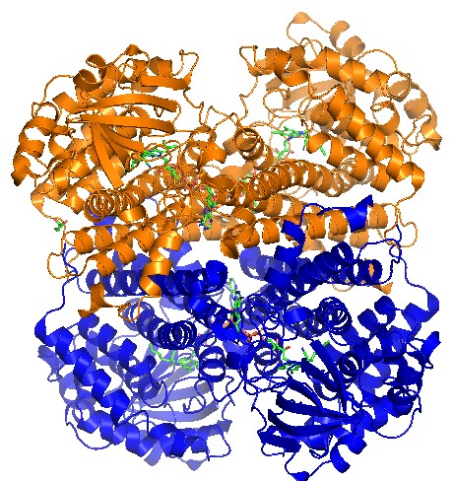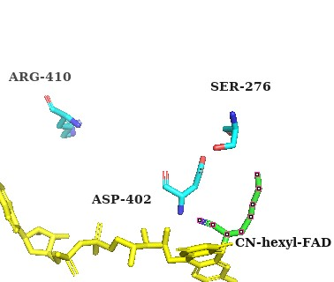The polarity of the active sites of NAO and NMO are significantly different giving rise to the disparate substrate specificities. NMO has a conserved histidine residue in the active site (His147 in Figure 4). This residue acts a as a catalytic base in Class II NMOs [33] and, when in the protonated form, serves to electrostatically stabilize nitronates to position it within the active site for rapid oxidation [49]. On the other hand, NAO uses an aspartate (Asp402 in F. oxysporum) as a catalytic base to deprotonate nitroalkanes. This residue creates a negatively charged active site[43] and would thus repel the charge of nitronates or the carboxylate of 3NPA. Thus, NAO is entirely unable to work on nitronate substrates.[15, 43]. Combined mutagenesis and kinetic investigations of NAO demonstrated that a single arginine residue, Arg-410 is responsible for belectrostatically stabilizing the nitro group of nitroalkane substrates for oxidation and release of nitrite.[16] Mutating this to a negatively charged aspartate abolishes binding of nitro compounds.[43],

Figure 5: Structure of Nitroalkane Oxidase Right Panel: Overall structure of the enzyme from Fusarium oxysporum (PDB: 3D9G) showing that it is a homo-tetramer comprised of a dimer of dimers. Subunits A and B are in blue. Subunits C and D are in orange. Left Panel: The active site contains an aspartate residue that serves as a catalytic base for the oxidation of neutral nitroalkanes. This charge prevents the binding of nitronates or carboxylates such as P3N or 3NPA.

5. Substrate Specificity of Nitronate Monooxygenase and Nitroalkane Oxidase

Extensive kinetic studies of both NMO and NAO were carried out over the course of the past three decades [1, 2, 45, 46, 50-52]. These reports are fully consistent with the structural studies described above and reveal different ways microbes overcome the toxicity of organic nitro compounds. The majority of the studies described in this section were carried out well before the availability of structural information on the enzymes and relied heavily on bioinformatic analysis of primary sequences and the generation and characterization of oligonucleotide directed mutants. These studies are extensively discussed elsewhere [12, 14, 15], so only results obtained for wild type NMO or NAO will be presented here. Studies on both enzymes illustrate how classical enzymology techniques exploring only the kinetic behaviors can reveal valuable insights into their catalytic mechanisms.

Table 2: Substrate Specificity of Microbial NMOsa
substrate kcat, s-1 kcat/Km, M-1s-1
N. crassa NMOb

2-nitropropane | 4.0 ± 0.1 | 250 ± 1
propyl-2-nitronate | 15 ± 1 | (3.1± 0.2) x 103
1o nitroalkanesc | 9.2 ± 0.5 | 670 ± 50
1o alkyl nitronatesc | 50 ± 8 | (1.1 ± 0.1) x 104
3-nitropropionc acidd | 4.4 ± 0.2 | (7.6 ± 0.7) x 103
propionate-3-nitronated 430 ± 10 (1.3 ± 0.7) x 106
C. saturnus NMOe

propyl-2-nitronate | n.d.f | (1.6 ± 0.1) x 103
1o alkyl nitronates | n.d.f | (3.2 ± 0.2) x 105
propionate-3-nitronatea 775 ± 15 (2.8 ± 0.2) x 106
P. aeruginosae

propyl-2-nitronate | n.d.f | (2.9 ± 0.1) x 104
1o alkyl nitronates | 735 ± 50 | (5.9 ± 0.1) x 105
propionate-3-nitronatea | (1.3 ± 0.7) x 103 | (2.8 ± 0.2) x 106
aAssays done at 30 oC under saturating oxygen concentrations and in the presences of radical scavenges if needed.
Data from [33, 46, 47, 53]. bIn 50 mM Tris-Cl pH 8.0 cPrimary nitro aliphatic substrates ranging from two to six carbons were tested (nitromethane not a substrate). Average values ± standard deviation is reported. dIn 50 mM Potassium
phosphate pH 7.5. eNeutral nitroalkanes or 3-nitroprionic acid are not substrates. fNot determined since the Km values
>>> substrate solubility in aqueous solution.

5.1 Nitronate Monooxygenase: Proper Classification Led to Revelations on Biological
Function

Initial characterizations of NMO [39, 40] carried out in the 1970s and 1990s suffered from complications arising from both the reactive nature of nitroalkanes [3] and the propensity of flavin cofactors to non- enzymatically produce reactive oxygen species. [41]. Valuable biochemical information about the enzyme was gleamed, but because end-point kinetic assays were carried out without proper controls to account for the non-enzymatic oxidation of nitroalkanes, the enzyme was incorrectly classified as a 2-nitropropane dioxygenase.[40]. As noted in Section 2, resonance stabilization of the carbanion formed upon deprotonation of the α-carbon of nitroalkanes dramatically lowers pKa values for C-H ionization. The values in fact are within the range of the pH used in the kinetic assays to monitor the activity of the enzyme. Thus, end-point assays measure activity on a mixture of neutral nitroalkane and anionic nitronate forms of the substrates tested. Furthermore, initial studies of NMO did not account for non-enzymatic oxidation of nitroalkanes since assays were done in the absence of free radical scavengers to scrub reactive oxygen species (ROS). Oxidation of nitroalkanes by superoxide anion, for example, is a well described process.[42] Several studies by Porter and Bright conclusively showed that the flavin dependent oxidizes (propionate-3-
nitonate, D-amino acid and glucose oxidase) initiate this reaction in an entirely non-physiological manner.[43-45]. Initial kinetic studies therefore erroneously concluded that 2-nitropropane was the substrate and it was proposed to be a dioxygenase based on 18O labeling experiments that most likely followed the non-enzymatic reaction that would be expected between nitroalkanes with ROS.[46].

The substrate specificity of fungal NMOs was reevaluated starting in the early 2000s, where assays were carried out by measuring initial rates of oxygen consumption by the enzymes during turnover with nitro substrates. Second order rate constants for the ionization reaction of nitroalkanes or alkyl nitronates range from between 5-70 M-1s-1, so it takes several hours for the equilibrium shown in Figure 1 to be established.[5, 7]. Since NMO assays are complete in ~30 s, and are initiated through addition of nitro substrates, essentially no ionization occurred during the experiment. Thus, the kinetic parameters summarized in Table 2 are for either the neutral or anionic form of the substrate as opposed to the mixtures reported by Soda and coworkers. Table 2 also includes results for bacterial NMO obtained more recently and shows a similar substrate specificity as the fungal enzymes. All assays were couple with superoxide dismutase when needed to scavenge ROS and ensure that observed activity exclusively reports on enzymatic oxidation of substrates. As can be seen in the table, 2-nitropropane is not only an extremely poor substrate for the N, crassa enzyme, but absolutely no activity is observed for most NMOs studied to date. In contrast to NAO (see below) the alkyl chain length of the nitro compound shows no discernable effect on either the turnover number (kcat) or the catalytic efficiency of the enzyme (kcat/Km).

The only NMO capable of utilizing neutral nitroalkanes as substrate is that from N. crassa and measurements of primary kinetic isotope effects (KIE) with 1,1-[2H2]-nitroethane as substrate established that proton abstraction from the neutral substrate is being the rate limiting step for catalysis.[45, 49, 50]. Bioinformatic analysis established NMOnc is a class II enzyme whereas all other microbial forms of the enzyme that have been kinetically characterized belong to class I [33]. Importantly, catalytic efficiencies of all NMOs are at least an order of magnitude higher with P3N than any other substrate.

This observation, along with the well-established biological occurrence of the nitro toxin in legumes and other plants [27] led researchers to test it as the physiological substrate for the enzyme. This was first carried out in bacteria where P. aeruginosa was grown on minimal media containing 3NPA as the only source of carbon nitrogen or energy [21]. Bacteria thrived under these conditions and a protein was extracted, partially purified and found to be an NMO. Following the report in 2010, in vivo studies were carried out on the fungal enzymes. Both N. crassa and C. saturnus were only able to grow in the presence of 3NPA if they contained the gene encoding NMO or if purified enzyme was exogenously provided to the cell cultures.[47]. Upon completion of these studies, and the establishment of its catalytic mechanism (see Section 6) the enzyme was officially reclassified from 2-nitropropane dioxygenase to NMO by the International Union of Biochemistry and Molecular Biology in 2010.[34].

5.2 Nitroalkane Oxidase: Elegant Kinetic Studies Predicted Protein Structur

The substrate specificity of NAO from F. oxysporum was explored a full decade before the first crystal structure of the enzyme was solved [35, 44]using methods similar to that described above for NMO. Two notable differences in the substrate specificities of NMO and NAO exists as will be described in this section. The first difference is that unlike most NMOs described to date, NAO strictly requires the protonated form of the substrate (nitroalkanes) for activity. This fact was later explained by the presence of a negatively charge aspartate in the active site of the enzyme (Figure 5 in section 4). The second striking difference in substrate specificity is that, unlike the case for NMO, the length of the alkyl chain of the substrate has a marked influence on the catalytic efficiency of the enzyme. Results demonstrating this conclusion are outlined here. For brevity, detailed analysis of the KIEs and steady state kinetic mechanism established to quantify the results are not presented. Instead, only the calculated values are provided and the reader is referred to the works of the late Paul Fitzpatrick for more details [1, 2, 15-17, 35].

As shown in Figure 6, catalytic efficiencies (kcat/Km) with primary nitroalkanes increase monotonically with increasing chain length reaching a maximum value with nitrobutane as substrate.[1, 2]. From these results it was concluded that each methylene group of the substrate contributes 2.6 kcal/mol of stabilization energy
through hydrophobic interactions with the protein scaffold of the enzyme. These were proposed to be hydrophobic interactions that facilitate either substrate binding or transition state stabilization for catalysis. Additional measurements of the pH and deuterium KIEs on the kinetic parameters of the enzyme with nitroalkanes ranging from one to four carbons was then reported. Measurements of KIEs on both catalytic efficiencies and turnover numbers of NAO with nitroalkane substrates allowed for dissociation constants to be extracted. The results are provided in Figure 6. This analysis suggested that of the 2.6 kcal/mol of stabilization energy provided by each methylene group, 65% contributes to substrate binding and the other
35% (0.9 kcal/mol) is used for transition state stabilization. The results were later validated upon elucidation of the three-dimensional structure of NAO that showed a long hydrophobic channel that accommodates binding of nitroalkane substrates [44].

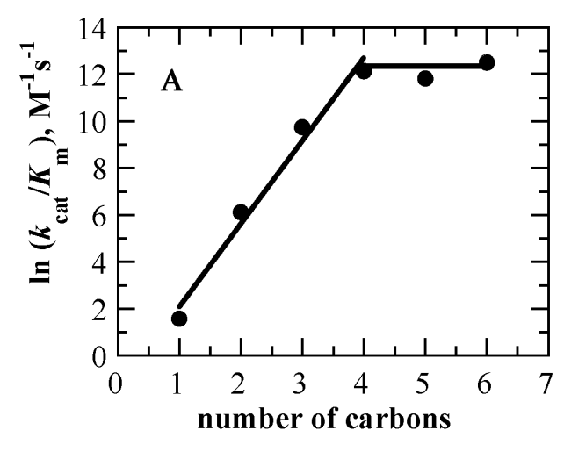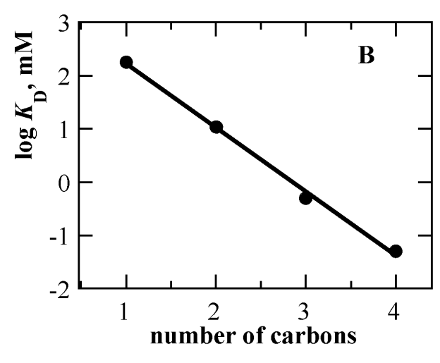Figure 6: Substrate Specificity of Nitroalkane Oxidase Panel A: Initial rates of oxygen consumption was measured in 100 mM air saturated ACES at pH 7.0 and 30 oC with primary nitroalkanes ranging from one to six carbons. The plot was created from data reported in references [1, 2]. Panel B: Dependence of nitroalkane substrate chain length on the KD values of NAO. The plot was created from data reported in reference [1].

6. Catalytic Mechanisms of Nitronate Monooxygenase and Nitroalkane Oxidase

In addition to their potential agricultural and bioremedial applications, both NMO and NAO have received considerable interest as model systems to explore redox reactions catalyzed by flavin dependent enzymes. Mechanistic investigations of the enzymes illuminated several aspects of flavin chemistry that had previously only been observed in solution studies of the free cofactor [41]. Nitroalkane oxidation by the enzymes involve both distinct flavin intermediates and the formation of different side products upon regeneration of the cofactor. Specifically, NMO forms an anionic flavosemiquinone intermediate (Figure 3), whereas NAO catalysis involves a transient flavin N(5)-nitroalkyl adduct (Figure 10 below). Reoxidation of the cofactors of NMO and NAO produce either water or hydrogen peroxide, respectively. This section describes the organic chemistry of the enzymes in detail along with key experimental evidence in support of their proposed catalytic mechanisms.

6.1 The Catalytic Mechanism of Nitronate Monooxygenase Involves an Anionic
Flavosemiquinone Intermediate

NMOnc has been the most extensively characterized P3N oxidizing enzyme studied to date. Its mechanism was explored primarily with the neutral and anionic form of nitroethane as substrate [34, 45, 46, 49, 50], which exhibitss interesting kinetic features that are not the focus of this review. To avoid confusion, and since the essential oxidative features of all NMOs studied are the same, the mechanism characterized with the C. saturnus enzyme with P3N as substrate is presented in Figure 7 [54]. As shown, after the substrate binds (step a) a single electron transfer reaction ensues to generate an anionic flavosemiquinone intermediate and an enzyme bound P3N radical (step b). Instability of these radicals make their subsequent
decay an extremely fast reaction (kobs > 1010 s-1 at 300 K) [55] and therefore difficult to characterize even with traditional rapid kinetic techniques. Two possible fates of the enzyme: radical complex are thus proposed but have never been experimentally measured. In one proposed path (step c), the flavin semiquinone is oxidized by molecular oxygen to generate an enzyme bound superoxide anion that collapses with the P3N radical to generate 3-peroxy-3-nitropropionate. Another possibility is that molecular oxygen forms an adduct with the P3N radical which then acts as the oxidant to regenerate the oxidized cofactor and 3-peroxy-3-nitropropionate (path d). Regardless, the peroxynitro compound would undergo hydrolysis in aqueous solution to generate malonic semialdehyde and nitrite. This process is well descripd for other organic peroxides [56].

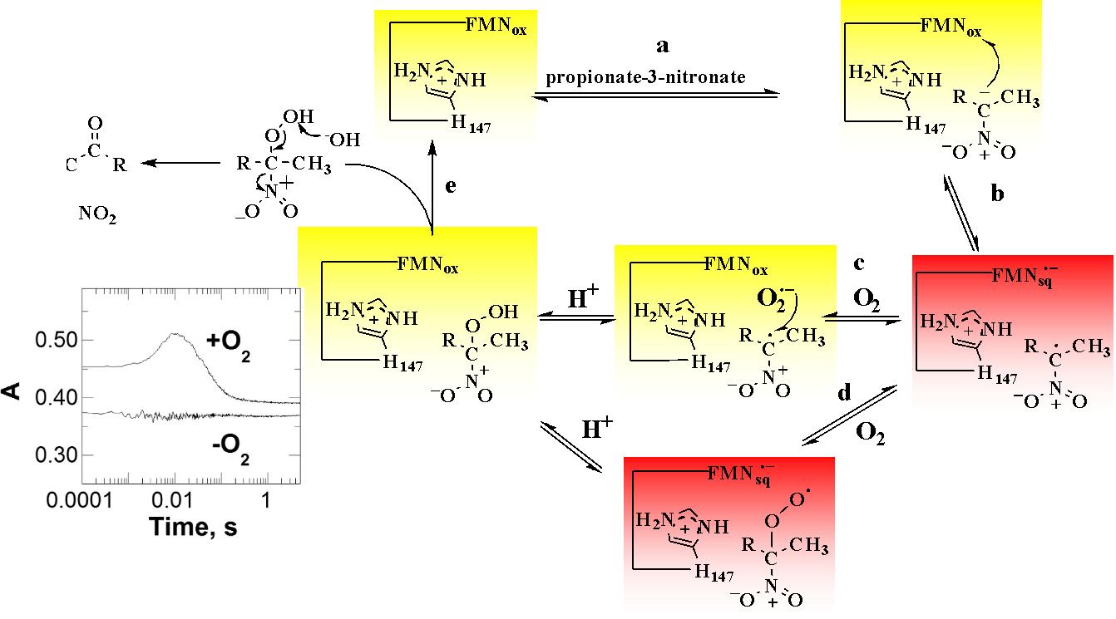

Figure 7:. Catalytic Mechanims of NMOcs with P3N as Substrate The figure was modified from[38] and the stopped flow traces shows the formation and decay of the peroxynitro compound released by the enzyme.

Evidence supporting the mechanism of Figure 7 comes largely from anaerobic substrate reductions and stopped-flow absorbance spectroscopy. Unless otherwise noted, results will be presented using NMOnc as model, though similar experiments were done with the enzymes from other sources. Initial studies measured the pH dependence of the intrinsic kinetic parameters of the enzyme in experiments where concentrations of both the nitroalkane substrate and oxygen are varied [18, 46]. Data from such experiments were best fit to a ternary complex steady state kinetic model that provided evidence for the formation of the E:P3N:O2 complexes shown in Figure 7. Conducting these experiments as a function of pH revealed the requirement of a group which must be deprotonated for the oxidation of neutral nitroalkanes and another that must be protonated for the reaction with nitronates. Subsequent mutagenesis studies confirmed these results and demonstrated that this group is an active site histidine residue that acts as both a catalytic base for proton abstraction from nitroalkanes and an electrostatic catalysts to stabilize the negative charge of nitronates. In class I NMOs that only utilize nitronates, only electrostatic catalysis is operable and crystal structures of NMO have conclusively demonstrated the presence of a catalytic histidine [49, 54, 57]. Similar results were obtained for bacterial NMOs [33, 47, 48].

Visible absorbance spectra of the flavin cofactor taken during NMO turnover with organic nitro substrates provide compelling evidence for the involvement of an anionic flavosemiquinone (Figure 8) during the

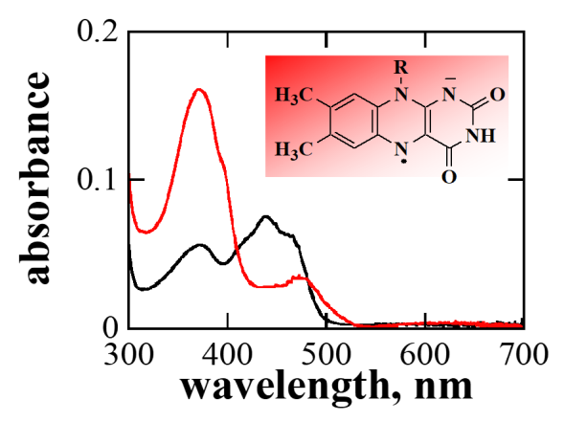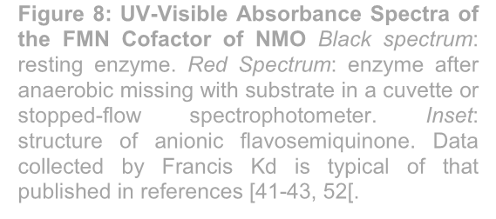Figure 8: UV-Visible Absorbance Spectra of the FMN Cofactor of NMO Black spectrum: resting enzyme. Red Spectrum: enzyme after anaerobic missing with substrate in a cuvette or stopped-flow spectrophotometer. Inset: structure of anionic flavosemiquinone. Data collected by Francis Kd is typical of that published in references [41-43, 52[.
reductive half reaction. These were first obtained through anaerobic mixing of the enzyme with nitroethane in cuvettes that were purged of oxygen. Spectra obtained were characteristic of anionic flavosemiquinones as shown in Figure 8. Anaerobic stopped flow spectroscopy was later used to extensively characterize mechanistic details of the reductive half reaction of the fungal enzymes [45-47, 54]. These studies showed that semiquinone formation occurs during catalytic turnover as evident from observed rates of flavin reduction that far exceeded the steady state turnover numbers of all the enzymes studied. The ease at which this one electron reduced form of the cofactor can be obtained allowed a unique opportunity for an investigation of the fluorescent properties of semiquinones expanding the state of knowledge on the biophysics of flavoenzymes [57].

While the pH dependance of the reductive half reaction was only published for NMOnc [45, 50], it has been determined for each fungal NMO and showed similar trends. Rates of flavin reduction are maximal at low pH which is fully consistent with the reported pH
dependence of the steady state kinetic parameters for all fungal NMOs. Each enzyme contains a conserved histidine residue that would obtain a positive charge when protonated. This would allow for electrostatic catalysis of the negative charge formed on the N(1):C(2) locus of the flavin cofactor (Figure 3). Bacterial NMOs likely utilize a similar mechanism based on the same trends seen in pH profiles of the reductive half reaction. These NMOs do not seem to use a single amino acid for charge neutralization though. Instead, they use a series of residues to produce a positively charged active site as established through structural and functional studies of the wild type and several mutant orms of NMOpa [33, 42, 48, 54].

The formation of the peroxynitro product with P3N as substrate for NMOcs was demonstrated using time resolved absorbance spectroscopy [54]. Rapid mixing of the enzyme with substrate results in the formation of a species absorbing light at 300 nm after 8 ms thent decays withing 100 ms after mixing (Figure 7. Importantly, this species only forms in the presence of oxygen and was never seen in the measurements of the reductive half reaction of the enzyme. This along with the reported spectra for peroxynitroalkanes showing a peak at ~300 nm [58] provides strong support for the product release steps shown in the figure. The peroxynitro compound would rapidly decompose to yield a carbonyl compound and nitrite as detected as far back as the 1970s using colorimetric assays [28, 29].

6.2 The Catalytic Mechanism of Nitroalkane Oxidase Involves Flavin N(5)-Adduct
Formation

NAO does not form radical intermediates during catalytic turnover but rather undergoes the formation of a covalent flavin N(5) adduct with the nitroalkane substrate. Evidence supporting this conclusion is plentiful and comes from close to 20 years of investigations of the enzyme with primary nitroalkanes as substrate for the enzyme from Fusarium oxysporum [15-17]. The catalytic mechanism of NAO is presented in Figure
9. After binding of the substrate (step 1), Asp402 acts as a base to abstract the α-proton from the nitroalkanes to generate a nitronate intermediates (step 2). The nitronate then reacts with the FAD cofactor of NAO to generate the flavin N(5) nitroalkyl adduct (step 3). Instability of the adduct results in its spontaneous decay
to expel nitrite (step 4) from the enzyme. A hydroxide from an active site water undergoes nucleophilic addition with the carbonyl carbon or the iminium form of the adduct to produce a specie’s that decomposes to yield the aldehyde product of the reaction and reduced FAD (steps 5 and 6). FAD is regenerated in step
7 through a reaction with molecular oxygen that produces hydrogen peroxide as a side product.

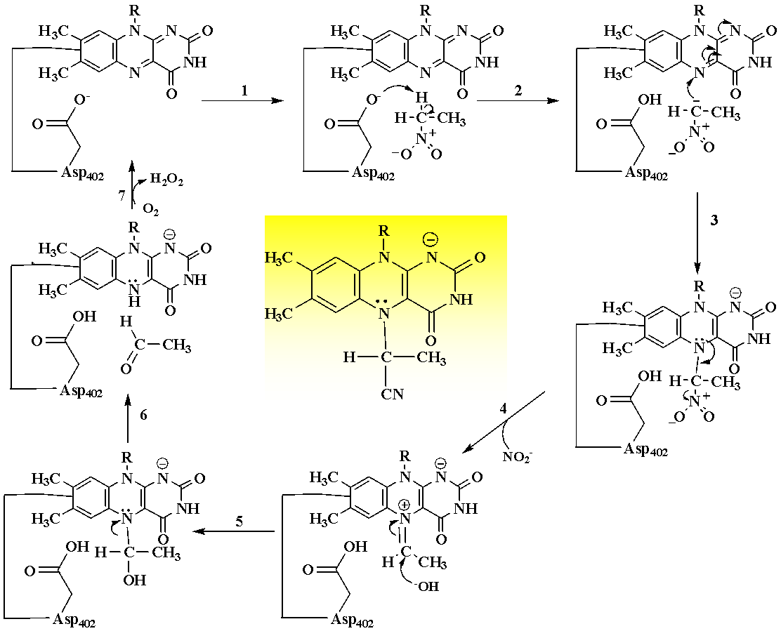

Figure 9: Catalytic Mechanism AO The figure was modified from Fitzpatrick to highlight the flavin N(5) adduct shown in the yellow box [35, 49]. .

The order of substrate binding and product release presented in Figure 9 is supported by experiments in which both the nitroalkane substrate and oxygen were varied [35, 51, 52]. These experiments yielded data that were best fit to equations describing a ping pong steady state kinetic mechanism. Thus, a ternary complex does not form during NAO turnover with nitroalkanes. Additionally, the reactions of nitroalkanes with FAD and subsequent oxidation of the reduced cofactor by molecular oxygen occur independently of each other and must be separated by a irreversible kinetic step. A study in which inhibition patterns with short chain aldehydes were determined with respect to nitroalkanes or oxygen as substrates for NAO was then carried out to determine the steps of substrate binding and product release [52]. This study established that binding/reaction of the enzyme with nitroalkanes and release of the organic product and nitrite occur prior to oxidation of the reduced FAD cofactor to generate hydrogen peroxide.

Steady state kinetic parameters of the enzyme with a variety of nitroalkane substrates increased with increasing pH demonstrating the requirement of a catalytic base for catalysis. The significant primary deuterium KIEs measured for the NAO reaction demonstrated this base is needed for proton abstraction to generate an alkyl nitronate intermediate [59, 60].[ Subsequent mutagenesis studies in which Asp402 was replaced with amino acids that are not Bronsted-Lowry bases showed this to be the catalytic base of NAO [43, 61]. Numerous structures of both the wild-type and variant forms of the enzymes validated these kinetic results [15, 17, 43, 44].

Initial suggestions that NAO may form a flavin N(5) adduct during catalysis came from UV-visible absorbance spectra of the purified enzyme [62]. Instead of the typical flavin spectrum with peaks centered at ~370 and 440 nm (see black spectrum in Figure 8 for an example with NMO) a single peak was observed at ~340 nm with an unusually low extinction coefficient (Figure
10). The FAD cofactor was carefully extracted by acid denaturation of the enzyme and a MALDI-TOF spectrum showed ions consistent with the degradation of nitrobutyl-FAD. Subsequent stopped-flow measurements of the reductive half reaction of NAO showed similar spectra to that in Figure 10 and kinetic
rate constant measured for the formation of the adduct
was consistent with its formation occurring during catalytic turnover[60]. The cationic imine formed in step
4 of Figure 9 was confirmed in trapping experiments using hydrogen cyanide as a nucleophile [63]. Finally, the biochemical and kinetic results were validated by solving the three-dimensional structure of the flavin N(5)-nitrobutyl adduct by Heroux and coworkers [43].

7. Conclusion

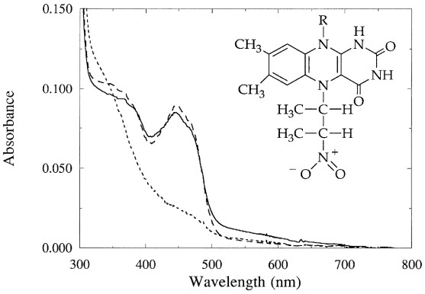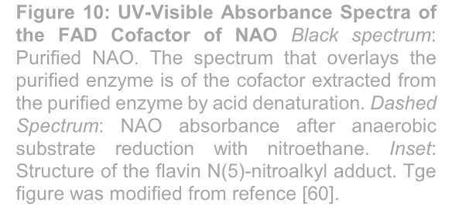Figure 10: UV-Visible Absorbance Spectra of the FAD Cofactor of NAO Black spectrum: Purified NAO. The spectrum that overlays the purified enzyme is of the cofactor extracted from the purified enzyme by acid denaturation. Dashed Spectrum: NAO absorbance after anaerobic substrate reduction with nitroethane. Inset: Structure of the flavin N(5)-nitroalkyl adduct. Tge figure was modified from refence [60].

We hope this article sheds light on varying chemical mechanisms that have evolved to degrade xenobiotic nitro compounds. While the exact origin of the enzymatic activities described here will need to await the completion of ongoing phylogenetic studies, the activities described here are likely adaptations of normal microbial and plant metabolism. The establishment of P3N as the physiological substrate of NMO in 2012 [18, 53] supports the idea that the oxidation of nitro aliphatic compounds is an adaption of existing defense mechanisms in a variety of organisms,[20, 21, 23, 32]. While the physiological role of NAO is unknown, sequencing of genes encoding the enzyme show it is a member of the acyl CoA dehydrogenase family of enzymes. Perhaps NAO is involved in fatty acid metabolism and has adapted its activity to cope with the widespread release of nitro compounds into the environment. Regardless, the wealth of mechanistic and structural information on the enzyme make them an attractive platform for the development of bioremediation strategies to combat industrial pollution by nitro compounds [19].

ACKNOWLEDGEMENTS

This work was supported by a Departmental Research Grant from the Robert A. Welch Foundation AC-
0006.

COMPETING INTERESTS

The authors declare no conflicts of interest.

AUTHORS’ CONTRIBUTIONS

Kevin Francis directed the study and drafted the manuscript. Victoria Patterson and Madelyn Wallace participated in critical discussions and evaluations during the development of the article. They also extensively edited and revised the manuscript before submission. These authors contributed equally to this work.

ABBREVIATIONS

3NPA | 3-Nitroproionic acid | P3N | propionate-3-nitronate
NMO | Nitronate Monooxygenase | NAO | nitroalkane oxidase
FMN | flavin mononucleotide | FAD | flavin adenine dinucleotide
KIE  FOOTNOTES | kinetic isotope effect | ROS | reactive oxygen species

1Since there are slight differences among NMOs described to date it is important to identify the source of the enzyme. This will be done here by a subscript. For example, the enzyme from P. aeruginosa is denoted NMOpa and that from Cyberlindnera saturnus as NMOcs.

DISCLAIMER ARTIFICAL INTELLEGANCE

Author(s) hereby declare that NO generative AI technologies such as Large Language Models (ChatGPT, COPILOT, etc.) and text-to-image generators have been used during the writing or editing of this manuscript.

REFERENCES

1. Gadda G, Choe DY, Fitzpatrick PF: Use of pH and kinetic isotope effects to dissect the effects of substrate size on binding and catalysis by nitroalkane oxidase. Arch Biochem Biophys 2000,
382(1):138-144.
2. Gadda G, Fitzpatrick PF: Substrate specificity of a nitroalkane-oxidizing enzyme. Arch Biochem
Biophys 1999, 363(2):309-313.
3. Parry R, Nishino S, Spain J: Naturally-occurring nitro compounds. Natural Product Reports 2011,
28(1):152-167.
4. Theodore A. Alston DJTP, Harold J. Bright: The bioorganic chemistry of the nitroalkyl group.
Bioorganic Chemistry 1985, 13(4).
5. Ballini RP, A.: Nitroalkanes: Synthesis, Reactivity, and Applications: John Wiley and Sons; 2021.
6. Nef JU: Ueber die Constitution der Salze der Nitroparaffine. Justus Liebigs Annalen der Chemie
1894, 280(2-3):263-291.
7. Feuer H: The chemistry of the nitro and nitroso groups: Interscience Publishers; 1969.
8. Nishiwaki N: A Walk through Recent Nitro Chemistry Advances. Molecules 2020, 25(16).
9. Haleem A, Shafiq A, Chen S-Q, Nazar M: A Comprehensive Review on Adsorption, Photocatalytic and Chemical Degradation of Dyes and Nitro-Compounds over Different Kinds of Porous and Composite Materials. Molecules 2023, 28(3):1081.
10. Garnick L, Gillie C, Kozal J, Monnot A, Spencer P, Quinn J, Maier A: Hazard characterization of carcinogenicity, mutagenicity, and reproductive toxicity for short chain primary nitroalkanes. J Appl Toxicol 2021, 41(12):1910-1936.
11. Peterson LA, Stanfill SB, Hecht SS: An update on the formation in tobacco, toxicity and
carcinogenicity of N'-nitrosonornicotine and 4-(methylnitrosamino)-1-(3-pyridyl)-1-butanone.
Carcinogenesis 2024, 45(5):275-287.
12. Said Abasse K, Essien EE, Abbas M, Yu X, Xie W, Sun J, Akter L, Cote A: Association between Dietary Nitrate, Nitrite Intake, and Site-Specific Cancer Risk: A Systematic Review and Meta- Analysis. Nutrients 2022, 14(3).
13. Teng PY, Kim WK: Roles of Nitrocompounds in Inhibition of Foodborne Bacteria, Parasites, and
Methane Production in Economic Animals. Animals (Basel) 2021, 11(4).
14. Mehra R, Mohanty V, Balappanavar AY, Kapoor S: Bacterial contamination of packaged smokeless tobacco sold in India. Tob Prev Cessat 2020, 6:11.
15. Fitzpatrick PF: Nitroalkane oxidase: Structure and mechanism. Arch Biochem Biophys 2017,
632:41-46.
16. Fitzpatrick PF, Bozinovski DM, Héroux A, Shaw PG, Valley MP, Orville AM: Mechanistic and structural analyses of the roles of Arg409 and Asp402 in the reaction of the flavoprotein nitroalkane oxidase. Biochemistry 2007, 46(48):13800-13808.
17. Fitzpatrick PF, Orville AM, Nagpal A, Valley MP: Nitroalkane oxidase, a carbanion-forming flavoprotein homologous to acyl-CoA dehydrogenase. Arch Biochem Biophys 2005, 433(1):157-
165.
18. Francis K, Smitherman C, Nishino SF, Spain JC, Gadda G: The biochemistry of the metabolic poison propionate 3-nitronate and its conjugate acid, 3-nitropropionate. IUBMB Life 2013,
65(9):759-768.
9. Torres-Guzman JC, Padilla-Guerrero IE, Cervantes-Quintero KY, Martinez-Vazquez A, Ibarra- Guzman M, Gonzalez-Hernandez GA: Peculiarities of nitronate monooxygenases and perspectives for in vivo and in vitro applications. Appl Microbiol Biotechnol 2021, 105(21-22):8019-8032.
20. Hipkin CR, Simpson DJ, Wainwright SJ, Salem MA: Nitrification by plants that also fix nitrogen.
Nature 2004, 430(6995):98-101.
21. Nishino SF, Shin KA, Payne RB, Spain JC: Growth of bacteria on 3-nitropropionic acid as a sole source of carbon, nitrogen, and energy. Appl Environ Microbiol 2010, 76(11):3590-3598.
22. Wang Y, Hou S, Zhang Q, Hou Y, Wang Q: A Novel Cold-Adapted Nitronate Monooxygenase from Psychrobacter sp. ANT206: Identification, Characterization and Degradation of 2-Nitropropane at Low Temperature. Microorganisms 2024, 12(10).
23. Novoselov A, Becker T, Pauls G, von Reuß SH, Boland W: Spodoptera littoralis detoxifies neurotoxic 3-nitropropanoic acid by conjugation with amino acids. Insect Biochemistry and Molecular Biology 2015, 63:97-103.
24. Huang LS, Sun G, Cobessi D, Wang AC, Shen JT, Tung EY, Anderson VE, Berry EA: 3- nitropropionic acid is a suicide inhibitor of mitochondrial respiration that, upon oxidation by complex II, forms a covalent adduct with a catalytic base arginine in the active site of the enzyme. J Biol Chem 2006, 281(9):5965-5972.
25. Porter DJ, Bright HJ: 3-Carbanionic substrate analogues bind very tightly to fumarase and aspartase. J Biol Chem 1980, 255(10):4772-4780.
26. Liao J, Liang X, Li H, Mo L, Mo R, Chen W, Wei Y, Wang T, Jiang W: Biocontrol ability of Bacillus velezensis T9 against Apiospora arundinis causing Apiospora mold on sugarcane. Front Microbiol
2023, 14:1314887.
27. Ludolph AC, He F, Spencer PS, Hammerstad J, Sabri M: 3-Nitropropionic Acid - Exogenous Animal Neurotoxin and Possible Human Striatal Toxin. Canadian Journal of Neurological Sciences / Journal Canadien des Sciences Neurologiques 1991, 18(4):492-498.
28. Gorlatova N, Tchorzewski M, Kurihara T, Soda K, Esaki N: Purification, characterization, and mechanism of a flavin mononucleotide-dependent 2-nitropropane dioxygenase from Neurospora crassa. Appl Environ Microbiol 1998, 64(3):1029-1033.
29. Kido T, Soda K, Suzuki T, Asada K: A new oxygenase, 2-nitropropane dioxygenase of Hansenula mrakii. Enzymologic and spectrophotometric properties. J Biol Chem 1976, 251(22):6994-7000.
30. Porter DJ, Bright HJ: Propionate-3-nitronate oxidase from Penicillium atrovenetum is a flavoprotein which initiates the autoxidation of its substrate by O2. J Biol Chem 1987, 262(30):14428-14434.
31. Ha JY, Min JY, Lee SK, Kim HS, Kim DJ, Kim KH, Lee HH, Kim HK, Yoon HJ, Suh SW: Crystal structure of 2-nitropropane dioxygenase complexed with FMN and substrate. Identification of the catalytic base. J Biol Chem 2006, 281(27):18660-18667.
32. Klinkenberg LG, Karakousis PC: Rv1894c is a novel hypoxia-induced nitronate monooxygenase required for Mycobacterium tuberculosis virulence. J Infect Dis 2013, 207(10):1525-1534.
33. Salvi F, Agniswamy J, Yuan H, Vercammen K, Pelicaen R, Cornelis P, Spain JC, Weber IT, Gadda
G: The combined structural and kinetic characterization of a bacterial nitronate monooxygenase from Pseudomonas aeruginosa PAO1 establishes NMO class I and II. J Biol Chem 2014,
289(34):23764-23775.
34. Gadda G, Francis K: Nitronate monooxygenase, a model for anionic flavin semiquinone intermediates in oxidative catalysis. Arch Biochem Biophys 2010, 493(1):53-61.
35. Heasley CJ, Fitzpatrick PF: Kinetic Mechanism and Substrate Specificity of Nitroalkane Oxidase.
Biochemical and Biophysical Research Communications 1996, 225(1):6-10.
36. Jurtshuk P, Jr., McQuitty DN: Use of a quantitative oxidase test for characterizing oxidative metabolism in bacteria. Appl Environ Microbiol 1976, 31(5):668-679.
37. Kido T, Hashizume K, Soda K: Purification and properties of nitroalkane oxidase from Fusarium oxysporum. J Bacteriol 1978, 133(1):53-58.
38. Zhu W: Chapter 13 - Quantum chemical investigations of reaction mechanism. In: Theoretical and
Computational Chemistry. Edited by Mathieu D, vol. 22: Elsevier; 2022: 291-345.
39. Bernasconi CF: The Principle of Non-perfect Synchronization. In: Advances in Physical Organic
Chemistry. Edited by Bethell D, vol. 27: Academic Press; 1992: 119-238.
40. Nydegger MW, Rock W, Cheatum CM: 2D IR spectroscopy of the C-D stretching vibration of the deuterated formic acid dimer. Phys Chem Chem Phys 2011, 13(13):6098-6104.
41. Massey V: The chemical and biological versatility of riboflavin. Biochem Soc Trans 2000, 28(4):283-
296.
42. Agniswamy J, Reis RAG, Wang YF, Smitherman C, Su D, Weber I, Gadda G: Crystal structure of yeast nitronate monooxygenase from Cyberlindnera saturnus. Proteins 2018, 86(5):599-605.
43. Héroux A, Bozinovski DM, Valley MP, Fitzpatrick PF, Orville AM: Crystal structures of intermediates in the nitroalkane oxidase reaction. Biochemistry 2009, 48(15):3407-3416.
44. Nagpal A, Valley MP, Fitzpatrick PF, Orville AM: Crystal structures of nitroalkane oxidase: insights into the reaction mechanism from a covalent complex of the flavoenzyme trapped during turnover.
Biochemistry 2006, 45(4):1138-1150.
45. Francis K, Gadda G: Probing the chemical steps of nitroalkane oxidation catalyzed by 2- nitropropane dioxygenase with solvent viscosity, pH, and substrate kinetic isotope effects. Biochemistry 2006, 45(46):13889-13898.
46. Francis K, Russell B, Gadda G: Involvement of a flavosemiquinone in the enzymatic oxidation of nitroalkanes catalyzed by 2-nitropropane dioxygenase. J Biol Chem 2005, 280(7):5195-5204.
47. Mijatovic S, Gadda G: Oxidation of alkyl nitronates catalyzed by 2-nitropropane dioxygenase from
Hansenula mrakii. Arch Biochem Biophys 2008, 473(1):61-68.
48. Su D, Aguillon C, Gadda G: Characterization of conserved active site residues in class I nitronate monooxygenase. Arch Biochem Biophys 2019, 672:108058.
49. Francis K, Gadda G: The Nonoxidative Conversion of Nitroethane to Ethylnitronate in Neurospora crassa 2-Nitropropane Dioxygenase Is Catalyzed by Histidine 196. Biochemistry 2008,
47(35):9136-9144.
50. Francis K, Gadda G: Inflated kinetic isotope effects in the branched mechanism of Neurospora crassa 2-nitropropane dioxygenase. Biochemistry 2009, 48(11):2403-2410.
51. Gadda G, Fitzpatrick PF: Mechanism of Nitroalkane Oxidase: 2. pH and Kinetic Isotope Effects.
Biochemistry 2000, 39(6):1406-1410.
52. Gadda G, Fitzpatrick PF: Iso-Mechanism of Nitroalkane Oxidase: 1. Inhibition Studies and
Activation by Imidazole. Biochemistry 2000, 39(6):1400-1405.
53. Francis K, Nishino SF, Spain JC, Gadda G: A novel activity for fungal nitronate monooxygenase:
detoxification of the metabolic inhibitor propionate-3-nitronate. Arch Biochem Biophys 2012, 521(1-
2):84-89.
54. Smitherman C, Gadda G: Evidence for a transient peroxynitro acid in the reaction catalyzed by nitronate monooxygenase with propionate 3-nitronate. Biochemistry 2013, 52(15):2694-2704.
55. Maillard B, Ingold KU, Scaiano JC: Rate constants for the reactions of free radicals with oxygen in solution. Journal of the American Chemical Society 1983, 105(15):5095-5099.
56. Hov n: Final Report to the Commission of the European Communities, ENV4-CT95-0038; 1998.
57. Su D, Kabir MP, Orozco-Gonzalez Y, Gozem S, Gadda G: Fluorescence Properties of Flavin
Semiquinone Radicals in Nitronate Monooxygenase. Chembiochem 2019, 20(13):1646-1652.
58. Vacque V, Sombret B, Huvenne JP, Legrand P, Suc S: Characterisation of the O O peroxide bond by vibrational spectroscopy. Spectrochimica Acta Part A: Molecular and Biomolecular Spectroscopy 1997, 53(1):55-66.
59. Valley MP, Fitzpatrick PF: Reductive half-reaction of nitroalkane oxidase: effect of mutation of the active site aspartate to glutamate. Biochemistry 2003, 42(19):5850-5856.
60. Valley MP, Tichy SE, Fitzpatrick PF: Establishing the kinetic competency of the cationic imine
intermediate in nitroalkane oxidase. J Am Chem Soc 2005, 127(7):2062-2066.
61. Valley MP, Fitzpatrick PF: Inactivation of nitroalkane oxidase upon mutation of the active site base and rescue with a deprotonated substrate. J Am Chem Soc 2003, 125(29):8738-8739.
62. Gadda G, Edmondson RD, Russell DH, Fitzpatrick PF: Identification of the naturally occurring flavin of nitroalkane oxidase from fusarium oxysporum as a 5-nitrobutyl-FAD and conversion of the enzyme to the active FAD-containing form. J Biol Chem 1997, 272(9):5563-5570.
63. Valley MP, Fenny NS, Ali SR, Fitzpatrick PF: Characterization of active site residues of nitroalkane oxidase. Bioorganic Chemistry 2010, 38(3):115-119
64. Tiwari, S. and G. N. Gururaja (2025). "Nitroalkanes as Ketone Synthetic Equivalents in C-N and C- S Bond Formation Reactions." Org Lett 27(18): 4669-4674
65. Zhang H, Wang XY, Sun TF, Chen TJ, Ding JL, Feng MG, Ying SH: A family of nitronate monooxygenase-domain proteins are essential for biocontrol potential of the insect mycopathogen Beauveria bassiana. Pestic Biochem Physiol 2025, 208:106317.

