Resistance to Oxyimino-Cephalosporins via ESBLs Enzyme Production in Klebsiella pneumoniae Strains Isolated from Urine Samples at the Pietro Annigoni Biomolecular Research Center (CERBA), Burkina Faso

Abstract
β-lactam antibiotics represent the most widely developed and utilized class of antimicrobials globally. However, the increasing resistance to these antibiotics—primarily among Gram-negative bacteria such as Klebsiella pneumoniae—poses a significant public health concern. The most commonly observed resistance mechanism involves the enzymatic inactivation of β-lactams by β-lactamases, which hydrolyze the β-lactam ring.
The objective of this study was to investigate resistance to oxyimino-cephalosporins (ceftazidime [CAZ], ceftriaxone [CRO], and cefotaxime [CTX]) through the production of β-lactamase enzymes (SHV, TEM, CTX-M) in K. pneumoniae strains isolated from urine samples, and to assess potential correlations between these resistance enzymes and specific antibiotics.
A total of 23 K. pneumoniae urinary isolates were collected at the Pietro Annigoni Biomolecular Research Center (CERBA) for bacteriological and molecular analysis. Resistance rates to CTX, CRO, and CAZ were found to be 66.67%,53.33%,33.33% respectively. Molecular analysis revealed a predominance of the TEM gene, detected in 50% of the isolates. Correlation analysis demonstrated a positive association between the presence of TEM and resistance to CAZ and CTX, as well as a positive correlation between CTX-M and CRO, indicating the involvement of these enzymes in antibiotic resistance.
This study highlights resistance patterns and the distribution of resistance genes among the isolates, providing valuable insights for guiding therapeutic strategies and strengthening epidemiological surveillance.
Keywords: Oxyimino-cephalosporins, ESBL, Klebsiella pneumoniae, Burkina Faso

Introduction
β-lactam antibiotics constitute the most extensively developed and widely used class of antimicrobials worldwide [1]. Their widespread use is largely attributed to their broad-spectrum activity, low toxicity, high efficacy, and relatively low cost for certain molecules [2,3]. However, bacteria have evolved various resistance mechanisms to counteract their activity, including overexpression of efflux pumps, porin inactivation, and acquisition of β-lactamase genes [1,4,5].
Among Gram-negative bacteria (GNB), Klebsiella pneumoniae is particularly concerning due to its high level of resistance to β-lactam antibiotics [6]. This pathogen is clinically significant in hospital settings, especially in intensive care units (ICUs), where it contributes to increased morbidity and mortality [4]. The most prevalent resistance mechanism to β-lactams is the enzymatic hydrolysis of the β-lactam ring by β-lactamases [7–10].
To date, hundreds of β-lactamases have been identified and classified into four main groups (A, B, C, D) based on their primary structure, according to the Ambler classification [11,12]. Class A enzymes are the most widespread and include the extended-spectrum β-lactamases (ESBLs) such as TEM, SHV, and CTX-M types [13,14].
They are often plasmid-encoded and transmissible by conjugation, making them major contributors to the dissemination of antibiotic resistance [15]. These enzymes pose a particular challenge among GNB, including members of the ESKAPE group (Enterococcus faecium, Staphylococcus aureus, Klebsiella pneumoniae, Acinetobacter baumannii, Pseudomonas aeruginosa and Enterobacter spp.) [8,15,16].
In Burkina Faso, previous studies have reported K. pneumoniae isolates producing GES- or CTX-M-type ESBLs resistant to oxyimino-cephalosporins [17,18]. The increasing prevalence of such resistance mechanisms remains a significant public health concern in the country. The present study aimed to assess the prevalence of TEM, SHV, and CTX-M β-lactamase genes among K. pneumoniae isolates resistant to oxyimino-cephalosporins (CRO, CTX, CAZ), and to evaluate potential correlations between these resistance genes and antibiotic susceptibility patterns. This work seeks to contribute to the understanding of resistance dynamics and to inform therapeutic and epidemiological decision-making.

I. Methodology
1. Sample Collection
A total of 23 urinary isolates of K. pneumoniae were collected from the Pietro Annigoni Biomolecular Research Center (CERBA) over a one-month period (March–April 2024).
2. Bacteriological Analysis
a. Bacterial Identification
Urine samples were examined macroscopically
Urine samples were subjected to standard bacteriological procedures, including macroscopic examination, culture and incubation, microscopic analysis, isolation, identification, and antibiotic susceptibility testing. Bacterial isolation was performed on eosin methylene blue (EMB) selective agar. Presumptive colonies were then identified by biochemical tests using the API 20E identification system, according to the manufacturer's instructions.
b. Antibiotic Susceptibility Testing
Antibiotic susceptibility was assessed using the Mueller-Hinton agar disk diffusion method, following the guidelines of the French Society for Microbiology (CA-SFM). The following antibiotics were tested: Amoxicillin–Clavulanic Acid (AMC), Ceftriaxone (CRO), Ceftazidime (CAZ), and Cefotaxime (CTX).
The antibiotic disks were arranged to visualize the characteristic synergy pattern (champagne-cork appearance) between AMC and oxyimino-cephalosporins, indicative of ESBL production. Only isolates resistant to at least one of the tested antibiotics were selected for molecular analysis. Indeed, out of the 23 K. pneumoniae strains, 9 were resistant to all the tested antibiotics.
3. Bacterial DNA Extraction
Genomic DNA was extracted using the heat-shock method. Briefly, bacterial cells were suspended in sterile water and heated to 100°C for 15 minutes to lyse the cells and release genomic material. The suspension was then centrifuged to separate cellular debris, and the supernatant containing the DNA was recovered. DNA concentration and purity were evaluated using a Nanodrop spectrophotometer prior to PCR amplification.
4. Polymerase Chain Reaction (PCR)
Conventional PCR was conducted to detect the presence of SHV, TEM, and CTX-M resistance genes using specific primers (see Table 1) and thermocycling conditions tailored to each gene (see Table 2). PCR products were analyzed by agarose gel electrophoresis to confirm amplification and visualize expected bands.

Table 1. Primer Sequences Used for PCR Amplification
Genes | Primer Sequences (5' → 3') | Amplicon Size (bp) | REFERENCES
SHV | For: ATGCGTTATATTCGCCTTG  Rev: TTAGCGTTGCCAGTG CTC | 875 bp | [1]
TEM | For: ATAAAATTCTTGAAGACGAAA  Rev: GACAGTTACCAATGCTTAATCA | 1080 bp | [19]
CTX-M | For: GTTACAATGTGTGAGAAGCAG  Rev: CCGTTTCCGCTATTACAAAC | 1000 bp | [1]

Table 2. PCR Conditions for the Amplification of bla<sub>SHV</sub>, bla<sub>TEM</sub>, and bla<sub>CTX-M</sub> Genes
Parameters | blaSHV | BlaTEM | blaCTX-M
Initial denaturation | 96°C for 5 min | 96°C for 5 min | 96°C for 5 min
Denaturation (per cycle) | 96°C for 1 min | 96°C for 1 min | 96°C for 1 min
Annealing | 60°C for 1 min | 58°C for 1 min | 50°C for 1 min
Extension (per cycle) | 72°C for 1 min | 72°C for 1 min | 72°C for 1 min
Final extension | 72°C for 10 min | 72°C for 10 min | 72°C for 10 min
Number of cycles | 35 | 35 | 35
- Data Processing
Data were compiled using Microsoft Excel and statistically analyzed with R software, version 4.3.3.

Results
A total of 23 isolates of K. pneumoniae were collected for this study. A detailed analysis of antibiotic resistance profiles and the presence of resistance genes yielded the following findings:
1. Antibiotic Resistance Rates
Antibiotic susceptibility testing revealed a high level of resistance to CTX and CRO, with resistance rates of 66.67% and 53.33%, respectively. A moderate resistance was observed to CAZ, with a rate of 33.33%.
Table 3: Antibiotic Resistance Rates (%) Among K. pneumoniae Isolates
Species | CAZ_resistance | CRO_resistance | CTX_resistance
K. pneumoniae | 33.33333 | 66.66667 | 53.33333

2. Analysis of Resistance Genes
a- Quantification and verification of DNA purity
Quantification using nanodrop gave a concentration value between 50 and 425 ug /ml. We also obtained values ​​of the R ratio (A260/A280nm) between 1,830 and 1,988. These results show that ADN extracts were in sufficient quantity and of good quality.
a. Overall Gene Prevalence
Molecular analysis revealed that the TEM gene was the most frequently detected, being present in 50% of the isolates. This was followed by the SHV gene, identified in 42.86% of the strains, and the CTX-M gene, found in 28.57% of the isolates (Refer to Table 4).
Table 4: Overall Frequency (%) of Resistance Genes in the Study Population
SHV | CTX_M | TEM
42.85714 | 28.57143 | 50

b. Coexistence of Resistance Genes
Gene combinations were identified in several isolates. The SHV + CTX-M combination was detected in 7.14% of strains, while SHV + TEM and CTX-M + TEM co-occurred in 14.28% of isolates each. Coexistence patterns of resistance genes and the results of the PCR product visualization are displayed respectively in table 5 and Figure 1.
Table 5. Coexistence Patterns (%) of Resistance Genes
Species | SHV_and_CTX_M | SHV_and_TEM | CTX_M_and_TEM | All_three
K. pneumonia | 7.142857 | 14.28571 | 14.28571 | 0
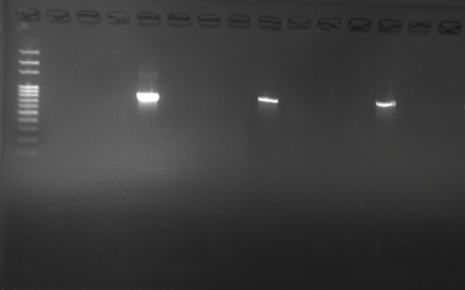
After migration on agarose gel, the extracts were visualized under UV light with the GENE FLASH device and the photos were recorded. M = molecular weight marker (100bp), NC: negative control, 1-13 corresponding to the different DNA extracts. As shown in the image, sample 4 (U18), is positive for the SHV gene with a band appearing at 875 bp
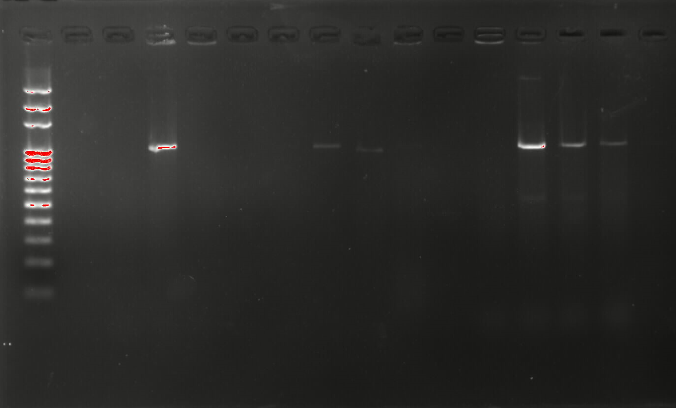
M = molecular weight marker (100bp), NC: negative control, 1-14 corresponding to the different DNA extracts. As shown in the image, sample 3 (U9), is positive for the TEM gene with a band appearing at 1080 bp.
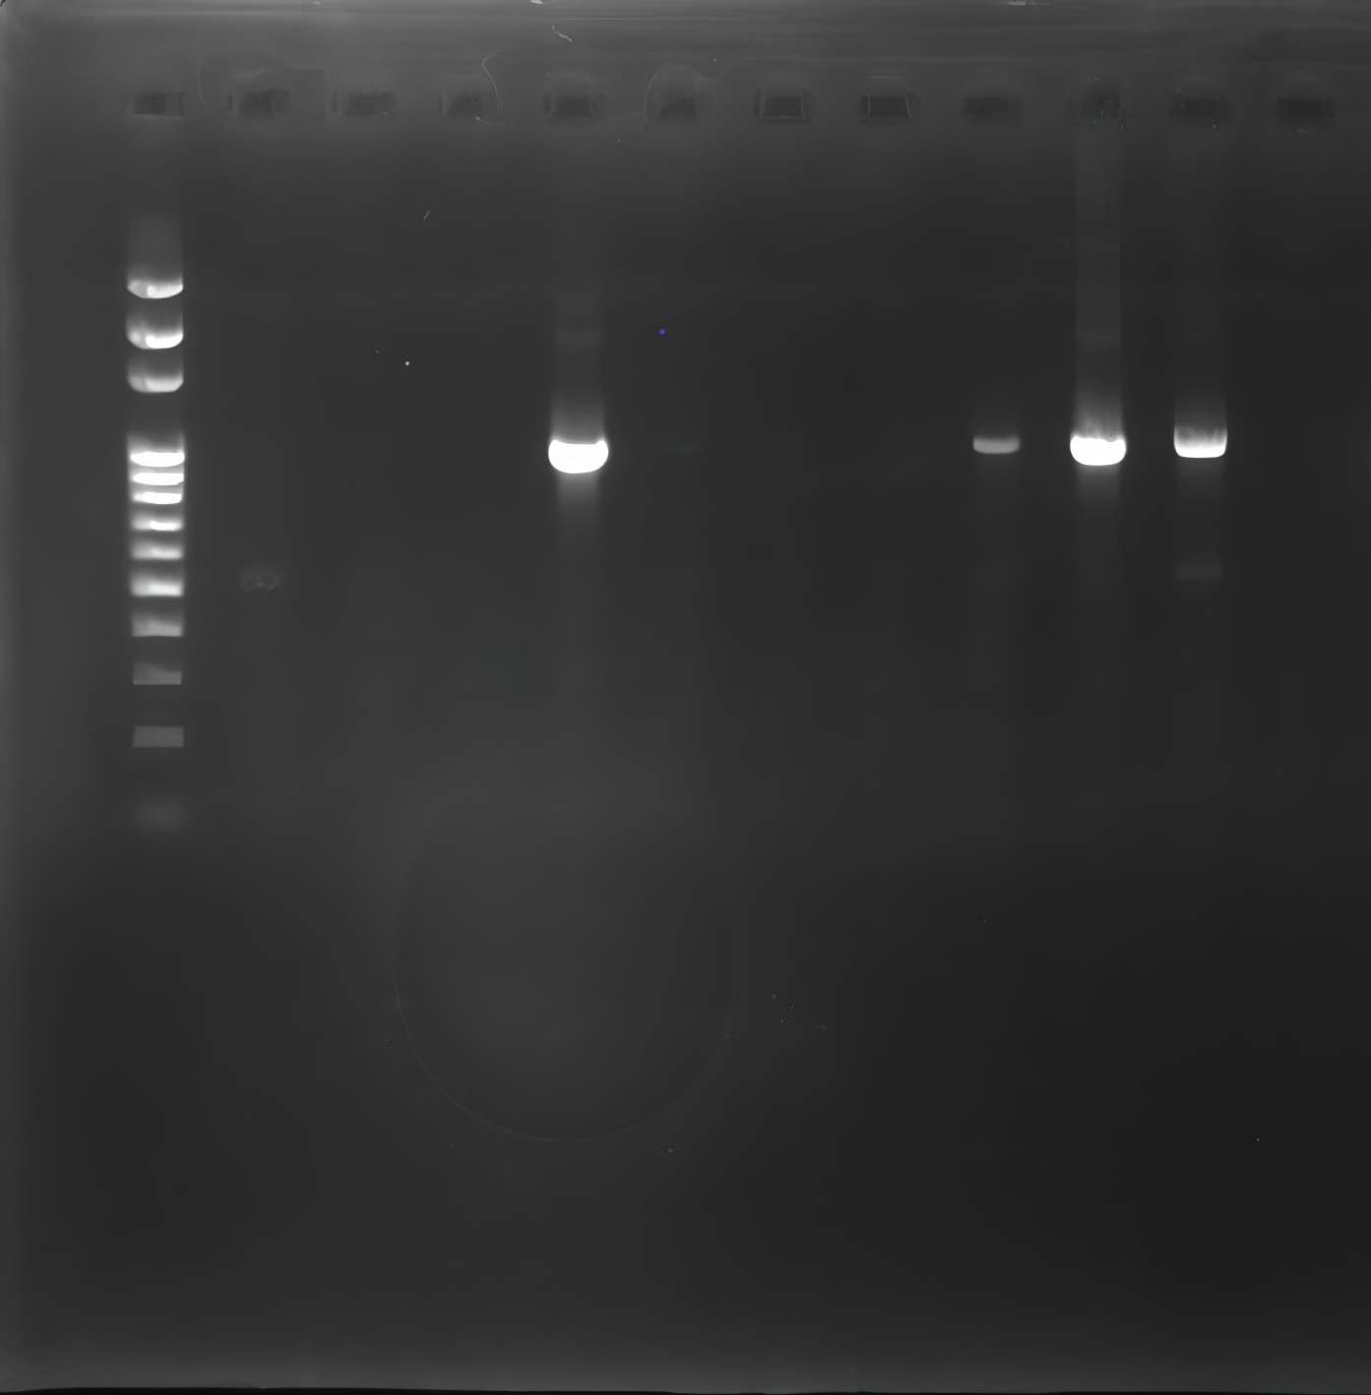

M = molecular weight marker (100bp), NC: negative control, 1-10 corresponding to the different DNA extracts. As shown in the image, sample 4 (U6), is positive for the CTX-M gene with a band appearing at 1000 bp.

M
NC
13
12
11
10
9
8
7
6
5

4
2
1
3
800 bp
Figure 1. Revelation of bla_{SHV} amplicons after electrophoresis

875 bp
100 bp

NC
14
13
12
11
10
9
8
7
6
5
4
3
2
1
M
1000bp
1080bp
1080bp
Figure 2. Revelation of bla_{TEM} amplicons after electrophoresis

100bp

NC
10
9
8
7
6
5
4
3
2
1
M
1000bp
1000 bp
Figure 3. Revelation of bla_{CTX-M} amplicons after electrophoresis

100bp

C- Correlation analysis between resistance genes and the antibiotics
We performed a correlation analysis (Figure 4) between resistance genes and the antibiotics using R software, to which they confer resistance in order to identify potential associations between these variables. The analysis revealed the following relationships:
- A significant positive correlation was observed between the TEM gene and resistance to CAZ (r=0,45) and CTX (r=0,52)
- A non-significant positive correlation was noted between TEM and CRO (r= 0,17).
- The SHV gene showed a non-significant positive correlation with CTX (r= 0,10), and a negative correlation with CAZ (r= -0,04) and CRO (r= - 0,6).
- A significant positive correlation was identified between the C TX-M gene and CRO (r= 0,33), while negative correlations were observed between CTX-M and both CAZ (r= - 0,14) and CTX (r= - 0,06).

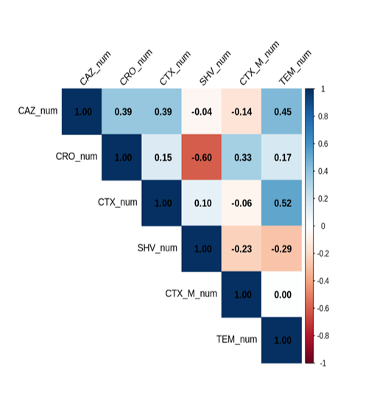

Figure 4. Correlation Between Identified Resistance Genes and Antibiotics
This heatmap illustrates the correlation coefficients between each resistance gene and each antibiotic. The color gradient represents both the strength and direction of the correlation:
- Blue indicates a positive correlation
- Red indicates a negative correlation)
- White denotes weak or no correlation.

DISCUSSION
The primary purpose of antibiotics is to inhibit the growth or eradicate bacteria responsible for infections and diseases [20]. However, the emergence of extended-spectrum β-lactamase (ESBL)-producing bacteria represents a significant development in antimicrobial resistance [21]. K. pneumoniae is a notable opportunistic pathogen of the urinary tract, and its emergence with multiple antibiotic resistance phenotypes has considerably complicated the treatment and management of urinary tract infections [22]. This study focused on the resistance to oxyimino-cephalosporins in ESBL-producing K. pneumoniae isolates. Approximately 33.33% of strains exhibited resistance to CAZ, 66.66% to CTX, and 53.33% to CRO. Similar studies reporting the extent of K. pneumoniae resistance to oxyimino-cephalosporins have been conducted in Burkina Faso [17, 18, 23, 24], Togo [25], Gabon [26], and Asia [27, 28]. The observed resistance rates may be attributed to self-medication practices, unregulated access to antibiotics available over the counter [29, 30], and insufficient infection control measures in healthcare settings, which heighten the risk of dissemination of resistant strains and their plasmids [30]. Clinicians frequently employ β-lactams, including oxyimino-cephalosporins, in large quantities to treat patients. The widespread use of these antimicrobials for treatment or prophylaxis is likely a key driver of resistance, contributing to the emergence and spread of highly resistant bacteria within healthcare facilities [31]. Resistance to oxyimino-cephalosporins in K. pneumoniae is primarily linked to plasmid-mediated ESBL production [32]. In this study, ESBL genes SHV, TEM, and CTX-M involved in oxyimino-cephalosporin resistance were identified, with prevalences of 50%, 42.85%, and 28.57%, respectively. These findings align with those of Sharashi et al. [33], Bajpai et al. [34], Shanmugam et al. [35], and Jaskulski et al. [36], who also reported a predominance of the TEM gene. Conversely, many other studies have identified CTX-M [37, 38] or SHV [39] as the predominant genes. In the 1990s, the main ESBLs derived from TEM- and SHV-type enzymes and predominantly spread within hospital clones of K. pneumoniae and Enterobacter species [9, 40]. Currently, CTX-M enzymes constitute the majority of ESBLs worldwide, with their dissemination described as pandemic [37, 40]. The discrepancy between our results and other studies may be explained by the selection bias in our strain collection, which predominantly harbored TEM genes. Coexistence of resistance genes was observed as follows: CTX-M/SHV (7.14%), SHV/TEM (14.28%), and CTX-M/TEM (14.28%). A similar study in Kenya reported lower prevalences of CTX-M/TEM (9.5%) and CTX-M/SHV (2.4%) [41]. Additional studies from Togo, Tunisia, and Sweden [42–44] have documented coexistence of all three genes SHV/TEM/CTX-M in some isolates.
We also performed correlation analysis between resistance genes and the antibiotics to which they confer resistance, in order to explore potential associations. We observed a significant positive correlation between TEM and CTX (r= 0,52) /CAZ (r=0:45), as well as a significant positive correlation between CTX-M and CRO (r=0,33). Similar findings were reported by Rodriguez et al. [45], and Adamus et al. [46], who also noted strong correlations between TEM and CTX. In the United States, Baunoch et al. observed significant correlations between SHV/TEM/CTX-M genes and cephalosporins CAZ and CRO [47]. Eghbalpour et al.'s study in Iran demonstrated significant correlations between ESBLs TEM/CTX-M/SHV and CAZ/CTX [48]. These positive correlations clearly indicate that antibiotic resistance is linked to the presence of ESBL genes. However, some negative correlations observed despite positive ESBL phenotypes suggest that resistance in these isolates may involve other ESBL classes, warranting further investigation.
In summary, this study revealed a high rate of resistance of K. pneumoniae to oxyimino-cephalosporins and identified SHV, TEM, and CTX-M genes as key contributors. Further investigations should also focus on the plasmid contexts of TEM/CTX-M/SHV, in order to better understand the mechanisms of transmission and co-selection. To mitigate the spread of multidrug-resistant organisms, robust measures must be implemented. In suspected urinary tract infections, a cytobacteriological examination of urine with mandatory antibiotic susceptibility testing is recommended. The antibiogram serves as an essential tool for guiding therapeutic decisions by categorizing bacteria as susceptible, intermediate, or resistant, thereby facilitating evidence-based antibiotic therapy and reducing empiric treatments that promote resistance [49]. Additionally, self-medication should be discouraged through stringent regulation of antibiotic availability in both community and hospital settings. Awareness among health authorities, healthcare professionals, and the general population is critical to ensure adherence to these measures [40]. Future research should explore the efficacy of combined β-lactamase inhibitors and other antibiotics against multidrug-resistant bacteria to expand therapeutic options.

CONCLUSION
In conclusion, this analysis highlights the resistance patterns to oxyimino-cephalosporins and the distribution of SHV, TEM, and CTX-M resistance genes in K. pneumoniae. We observed a high prevalence of antibiotic resistance and resistance genes, underscoring the significant burden of antimicrobial resistance. These findings may inform therapeutic decision-making and enhance epidemiological surveillance.
Disclaimer (Artificial intelligence)
Option 1:
Author(s) hereby declare that NO generative AI technologies such as Large Language Models (ChatGPT, manuscript.

REFERENCES
[1] Mètuor, A., « Caractérisations moléculaire et cinétique des types de β-lactamases à spectre élargi (BLSE) de souches bactériennes collectées au Centre Hospitalier Universitaire Pédiatrique Charles de Gaulle (CHUP-CDG) de Ouagadougou ». Université de Ouagadougou, Ouagadougou. (2014)
[2] F. Robin, L. Gibold, et R. Bonnet, « Résistances naturelles et acquises aux β-lactamines chez les entérobactéries : comment les identifier en pratique quotidienne ? », Revue Francophone des Laboratoires, vol. 2012, nº 445, p. 47‑58, sept. 2012, doi: 10.1016/S1773-035X(12)71676-3.
[3] S. Faure, « Transfert d’un gène de résistance aux bêta-lactamines blaCTX-M-9 entre Salmonella et les entérobactéries de la flore intestinale humaine : influence d’un traitement antibiotique ».
[4] J. Oliveira et W. C. Reygaert, « Gram-Negative Bacteria », in StatPearls, Treasure Island (FL): StatPearls Publishing, 2025. Disponible sur: http://www.ncbi.nlm.nih.gov/books/NBK538213/
[5] S. Alfei et A. M. Schito, « β-Lactam Antibiotics and β-Lactamase Enzymes Inhibitors, Part 2: Our Limited Resources », Pharmaceuticals (Basel), vol. 15, nº 4, p. 476, avr. 2022, doi: 10.3390/ph15040476.
[6] R. Cohen, L. Dortet, M. Caseris, J. Raymond, M. Lorrot, et J. Toubiana, « Treatment of Resistant Gram-negative bacilli in children », Infect Dis Now, vol. 53, nº 8S, p. 104794, nov. 2023, doi: 10.1016/j.idnow.2023.104794.
[7] S. E. Boyd, A. Holmes, R. Peck, D. M. Livermore, et W. Hope, « OXA-48-Like β-Lactamases: Global Epidemiology, Treatment Options, and Development Pipeline », Antimicrob Agents Chemother, vol. 66, nº 8, p. e0021622, août 2022, doi: 10.1128/aac.00216-22.
[8] C. O. Vrancianu et al., « Emerging Strategies to Combat β-Lactamase Producing ESKAPE Pathogens », Int J Mol Sci, vol. 21, nº 22, p. 8527, nov. 2020, doi: 10.3390/ijms21228527.
[9] E. Ruppé, « Épidémiologie des bêta-lactamases à spectre élargi : l’avènement des CTX-M », Antibiotiques, vol. 12, nº 1, p. 3‑16, mars 2010, doi: 10.1016/j.antib.2010.01.003.
[10] A. P. Soubeiga, D. S. Kpoda, O. Traoré, C. Zongo, et A. Savadogo, « Prevalence of β-lactamase genes and integrons among multidrug-resistant Escherichia coli and Salmonella spp recovered from food samples in Ouagadougou, Burkina Faso », Scientific African, vol. 25, p. e02302, sept. 2024, doi: 10.1016/j.sciaf.2024.e02302.
[11] X. Zhao et al., « Characterization of Extended-Spectrum β-Lactamase-Producing Escherichia coli Isolates That Cause Diarrhea in Sheep in Northwest China », Microbiol Spectr, vol. 10, nº 4, p. e01595-22, doi: 10.1128/spectrum.01595-22.
[12] S. Zhang, X. Liao, T. Ding, et J. Ahn, « Role of β-Lactamase Inhibitors as Potentiators in Antimicrobial Chemotherapy Targeting Gram-Negative Bacteria », Antibiotics (Basel), vol. 13, nº 3, p. 260, mars 2024, doi: 10.3390/antibiotics13030260.
[13] T. Shimamura et al., « Structures intermédiaires acyliques de la classe de spectre étendu A - Lactamase, Toho-1, en Complexe avec cefotaxime, céphalotine et benzylpénicilline* », Journal of Biological Chemistry, vol. 277, nº 48, p. 46601‑46608, nov. 2002, doi: 10.1074/jbc.M207884200.
[14] Tooke CL, Hinchliffe P, Bragginton EC, Colenso CK, Hirvonen VHA, Takebayashi Y, Spencer J. β-Lactamases and β-Lactamase Inhibitors in the 21st Century. J Mol Biol. 2019 Aug 23;431(18):3472-3500. doi: 10.1016/j.jmb.2019.04.002. Epub 2019 Apr 5. PMID: 30959050; PMCID: PMC6723624.
[15] T. Palzkill, « Structural and Mechanistic Basis for Extended-Spectrum Drug-Resistance Mutations in Altering the Specificity of TEM, CTX-M, and KPC β-lactamases », Front Mol Biosci, vol. 5, p. 16, févr. 2018, doi: 10.3389/fmolb.2018.00016.
[16] J. N. Pendleton, S. P. Gorman, et B. F. Gilmore, « Clinical relevance of the ESKAPE pathogens », Expert Review of Anti-infective Therapy, vol. 11, nº 3, p. 297‑308, mars 2013, doi: 10.1586/eri.13.12.
[17] R. Y. W. Tiemtoré, A. Mètuor Dabiré, D. Ouermi, S. Sougué, S. Benao, et J. Simporé, « Isolation and Identification of Escherichia coli and Klebsiella pneumoniae Strains Resistant to the Oxyimino-Cephalosporins and the Monobactam by Production of GES Type Extended Spectrum Bêta-Lactamase (ESBL) at Saint Camille Hospital Center in Ouagadougou, Burkina Faso », Infect Drug Resist, vol. 15, p. 3191‑3204, juin 2022, doi: 10.2147/IDR.S360945.
[18] M. D. Amana, Z. K. Jacob, Z. Boukaré, M. Jihad, B. Marie, et E. J. Mondher, « Resistances to the Oxyimino-Cephalosporins by Ctx-M-15 Producing Klebsiella Isolated From the Urines Samples of Patients in the University Hospital Complex Paediatric Charles De Gaulle (Chup-CDG) Of Ouagadougou in Burkina Faso », Journal of Asian Scientific Research, vol. 3, nº 9, Art. nº 9, sept. 2013.
[19] Ramazanzadeh R, Rouhi S, Hosainzadegan H, Shakib P, Nouri B. Co-occurrence of Extended-Spectrum Beta-Lactamases in Isolated Enterobacter spp. From Patients Specimens.Arch Clin Infect Dis.2016;11(3):e26837.https://doi.org/10.5812/archcid.26837.
[20] TIEMTORE Rahimatou Yasmina Wendkuni, METUOR DABIRE Amana, OUERMI Djeneba, DJIGMAFlorencia Wenkuuni, ZONGO Luc, SIMPORE Jacques, 2023. Extrait de Boswellia dalzielii pour l’efficacité des antibiotiques de la famille des beta lactamines
[21] M. K. Chaudhary, I. Jadhav, et M. R. Banjara, « Molecular detection of plasmid mediated blaTEM, blaCTX-M,and blaSHV genes in Extended Spectrum β-Lactamase (ESBL) Escherichia coli from clinical samples », Ann Clin Microbiol Antimicrob, vol. 22, nº 1, p. 33, mai 2023, doi: 10.1186/s12941-023-00584-0.
[22] S. Clegg et C. N. Murphy, « Epidemiology and Virulence of Klebsiella pneumoniae », Microbiology Spectrum, vol. 4, nº 1, p. 10.1128/microbiolspec.uti-0005‑2012, févr. 2016, doi: 10.1128/microbiolspec.uti-0005-2012.
[23] A. K. Ouattara, B. Ouédraogo, A. M. Dabiré, R. Y. W. Tiemtoré, S. Sougué, et J. Simporé, « First Detection of NDM-type Carbapenemase-Producing K. pneumoniae isolated from Clinical Samples in Ouagadougou, Burkina Faso », Archives of Microbiology & Immunology, vol. 7, nº 4, p. 236‑241, oct. 2023.
[24] R. O. Badini et al., « Detection of Antibiotic Resistance Genes bla SHV, bla TOHO and bla NDM in Pathogenic Gram-Negative Bacilli at the Pietro Annigoni Biomolecular Research Center », Current Journal of Applied Science and Technology, vol. 42, nº 48, p. 87‑96, déc. 2023, doi: 10.9734/cjast/2023/v42i484335.
[25] F. D. Salah et al., « Augmentation de la résistance aux antibiotiques des Entérobactéries isolées à l’Institut National d’Hygiène de Lomé de 2010 à 2017: Increase in antibiotic resistance of Enterobacteriaceae isolated at the National Institute of Hygiene of Lomé from 2010 to 2017 », Journal of Interventional Epidemiology and Public Health, vol. 4, nº 3, Art. nº 3, 2021, Disponible sur: https://www.ajol.info/index.php/jieph/article/view/237894
[26] Y. Mouanga Ndzime et al., « Epidemiology of Community Origin Escherichia coli and Klebsiella pneumoniae Uropathogenic Strains Resistant to Antibiotics in Franceville, Gabon », Infect Drug Resist, vol. 14, p. 585‑594, 2021, doi: 10.2147/IDR.S296054.
[27] E. Abbasi et E. Ghaznavi-Rad, « High frequency of NDM-1 and OXA-48 carbapenemase genes among Klebsiella pneumoniae isolates in central Iran », BMC Microbiology, vol. 23, p. 98, avr. 2023, doi: 10.1186/s12866-023-02840-x.
[28] M. B. Jalil et M. Y. N. Al Atbee, « The prevalence of multiple drug resistance Escherichia coli and Klebsiella pneumoniae isolated from patients with urinary tract infections », J Clin Lab Anal, vol. 36, nº 9, p. e24619, juill. 2022, doi: 10.1002/jcla.24619.
[29] L. E. B. Bambara, A. M. Dabire, O. Traore, Y. Tiemtore, T. Zohoncon, et J. Simpore, « Genetic and Kinetic Profiles of Bacterial Resistance Enzymes to IMP and NDM Type Antibiotics in Gram-negative Pathogenic Bacilli », International Journal of Biochemistry Research & Review, vol. 32, nº 6, p. 7‑21, août 2023, doi: 10.9734/ijbcrr/2023/v32i6819.
[30] S. Sanou et al., « Prevalence and Molecular Characterization of Extended Spectrum β-Lactamase, Plasmid-Mediated Quinolone Resistance, and Carbapenemase-Producing Gram-Negative Bacilli in Burkina Faso », Microbial Drug Resistance, vol. 27, nº 1, p. 18‑24, janv. 2021, doi: 10.1089/mdr.2020.0134.
[31] Kankara AS, Dutsinma UA, Yusuf I. Antimicrobial Activities of Piperacillin-tazobactam Plus Oxyimino-cephalosporins and Gentamicin against Extensively Drug-resistant Non-carbapenemase-producing Enterobacteriaceae Isolated from Immunocompromised Patients in a Nigerian Hospital. Mediterr J Infect Microb Antimicrob. 2022;11:18. DOI: 10.4274/mjima.galenos.2022.2021.18
[32] R. G. Melano, R. J. Davidson, H. L. Musgrave, et K. R. Forward, « Cephalosporin resistance in Klebsiella pneumoniae from Nova Scotia, Canada », Diagnostic Microbiology and Infectious Disease, vol. 56, nº 2, p. 197‑205, oct. 2006, doi: 10.1016/j.diagmicrobio.2006.04.016.
[33] J. Y. Sharahi, A. Hashemi, A. Ardebili, et S. Davoudabadi, « Molecular characteristics of antibiotic-resistant Escherichia coli and Klebsiella pneumoniae strains isolated from hospitalized patients in Tehran, Iran », Ann Clin Microbiol Antimicrob, vol. 20, p. 32, avr. 2021, doi: 10.1186/s12941-021-00437-8.
[34] T. Bajpai, M. Pandey, M. Varma, et G. S. Bhatambare, « Prevalence of TEM, SHV, and CTX-M Beta-Lactamase genes in the urinary isolates of a tertiary care hospital », Avicenna J Med, vol. 07, nº 01, p. 12‑16, janv. 2017, doi: 10.4103/2231-0770.197508.
[35] S. Kaliappan et al, « Urinary tract infection in urolithiasis: Antimicrobial resistance and clinico-microbiological association between risk factors and positive stone culture from a tertiary care hospital in south India, oct. 2024, doi: 10.51585/gjm.2023.1.0020.
[36] M. R. Jaskulski et al., « Assessment of extended-spectrum β-lactamase, KPC carbapenemase and porin resistance mechanisms in clinical samples of Klebsiella pneumoniae and Enterobacter spp », Int J Antimicrob Agents, vol. 42, nº 1, p. 76‑79, juill. 2013, doi: 10.1016/j.ijantimicag.2013.03.009.
[37] D. S. Kpoda et al., « Distribution of resistance genes encoding ESBLs in Enterobacteriaceae isolated from biological samples in health centers in Ouagadougou, Burkina Faso », BMC Res Notes, vol. 11, p. 471, juill. 2018, doi: 10.1186/s13104-018-3581-5.
[38] O. B. Ahmed et A. Hussain. Asghar, « The Coexistence of Extended-Spectrum β-lactamase and Metallo-β-Lactamase Genes in Gram-Negative Bacteria », Arch. Pharm. Pract, vol. 12, nº 3, p. 22‑28, 2021, doi: 10.51847/TGx8aLP7mY.
[39] « (PDF) Molecular Profile of Emerging Hypervirulent Klebsiella pneumoniae Clinical Isolates in Diabetic Patients », ResearchGate, févr. 2025, doi: 10.22207/JPAM.19.1.15.
[40] Z. D. Rakotovao-Ravahatra, F. M. Randriatsarafara, S. Rasoanandrasana, L. Raverohanta, et A. L. Rakotovao, « Phénotypes de résistance des souches d’Escherichia coli responsables d’infection urinaire au laboratoire du Centre Hospitalo-Universitaire de Befelatanana Antananarivo », Pan Afr Med J, vol. 26, p. 166, mars 2017, doi: 10.11604/pamj.2017.26.166.11828.
[41] H. Saisi, C. Makobe, M. Kangongo, et S. Kariuki, « Prevalence of CTXM, SHV, TEM AND OXA Genes among Extended-Spectrum Beta-Lactamase Producing Klebsiella pneumoniae from Mukuru Slum, Kenya », Advances in Microbiology, vol. 9, nº 10, Art. nº 10, oct. 2019, doi: 10.4236/aim.2019.910052.
[42] D. S et al., « Detection of High Prevalence of TEM/SHV/CTX-M Genes in ESBL Producing and Multidrug Resistant <em>Klebsiella Pneumoniae</em> and <em>Klebsiella Oxytoca</em> », JBR Journal of Clinical Diagnosis and Research, vol. 2016, oct. 2016, doi: 10.4172/2376-0311.1000129.
[43] S. Alibi, A. Ferjani, et J. Boukadida, « Molecular characterization of extended spectrum beta-lactamases produced by Klebsiella pneumoniae clinical strains from a Tunisian Hospital », Médecine et Maladies Infectieuses, vol. 45, nº 4, p. 139‑143, avr. 2015, doi: 10.1016/j.medmal.2015.01.010.
[44] MONSTEIN - 2007« Multiplex PCR amplification assay for the detection of blaSHV, blaTEM and blaCTX‐M genes in Enterobacteriaceae - APMIS - Wiley Online Library ». Disponible sur: https://onlinelibrary.wiley.com/doi/10.1111/j.1600-0463.2007.00722.x
[45] S. Rodriguez-Mozaz et al., « Occurrence of antibiotics and antibiotic resistance genes in hospital and urban wastewaters and their impact on the receiving river », Water Research, vol. 69, p. 234‑242, févr. 2015, doi: 10.1016/j.watres.2014.11.021.
[46] W. Adamus-Białek et al., « The genetic background of antibiotic resistance among clinical uropathogenic Escherichia coli strains », Mol Biol Rep, vol. 45, nº 5, p. 1055‑1065, oct. 2018, doi: 10.1007/s11033-018-4254-0.
[47] D. Baunoch et al., « Concordance Between Antibiotic Resistance Genes and Susceptibility in Symptomatic Urinary Tract Infections », Infection and Drug Resistance, vol. 14, p. 3275‑3286, août 2021, doi: 10.2147/IDR.S323095.
[48] F. Eghbalpoor, M. Habibi, O. Azizi, M. R. Asadi Karam, et S. Bouzari, « Antibiotic resistance, virulence and genetic diversity of Klebsiella pneumoniae in community- and hospital-acquired urinary tract infections in Iran », AMicr, vol. 66, nº 3, p. 349‑366, févr. 2019, doi: 10.1556/030.66.2019.006.
[49] F. Caron, « L’antibiogramme : un quadruple outil pour le clinicien », Journal des Anti-infectieux, vol. 14, nº 4, p. 168‑174, nov. 2012, doi: 10.1016/j.antinf.2012.10.002.

