Review Article
Integration of Renewable Energy in Food Processing and Farm Mechanization: A Review

Abstract
Energy is a critical input in modern agriculture and food processing systems, influencing productivity, profitability, and sustainability. The growing demand for energy in the agri-food sector, coupled with the challenges of fossil fuel depletion and environmental degradation, necessitates the transition toward renewable energy sources. This review discusses the role, potential, and applications of renewable energy in food processing and farm mechanization. The paper highlights key renewable technologies such as solar, biomass, wind, biogas, and small hydropower, along with their integration in operations like irrigation, drying, milling, cooling, packaging, and transportation. Barriers, policy initiatives, and future prospects for renewable energy adoption in agriculture are also analyzed. The study concludes that integrating renewable energy technologies can significantly reduce greenhouse gas emissions, lower operational costs, and promote sustainable rural development.
Keywords: Renewable energy, Food processing, Farm mechanisation, Solar energy, Biomass, Sustainability, Rural development.
1. Introduction
Agriculture and food processing are among the most energy-intensive sectors due to heavy dependence on fossil fuels for irrigation pumps, tractors, threshers, dryers, cold storages, and processing units (Wang, 2014). The unabated use of conventional energy sources-like diesel, coal, and electricity sourced from non-renewable fuels-has increased the cost of energy, carbon emissions, and resource depletion rates (Freedman, et al., 2024). These processes pose serious threats to the sustainability of modern agriculture and food systems in general and to the developing world in particular, where population pressure and demand for energy are increasing rapidly (Khatri, et al., 2024).
Mechanical, thermal, and electrical power requirements at different value chain levels arise from both food processing industries and the substantial share of total rural energy used by the agricultural sector alone (Sims, 2015). With the continuous decline in fossil fuel reserves and growing global concern for climate change, there is an increasing need to shift towards clean, renewable energy (Singh, and Singh, 2012). Indeed, besides helping to reduce GHG emissions, integrating renewable energy systems into agricultural operations strengthens the resilience and self-reliance of rural economies (Kadaba, et al., 2023).
Renewable energy utilisation in agriculture involves the usage of solar, wind, biomass, biogas, and small hydropower for performing vital mechanical, electrical, and thermal functions (Kodirov, et al., 2020). This covers a wide range from solar-powered irrigation pumps and dryers, through heating with biomass-based gasifiers, to biogas systems generating electricity or fuel for machinery (Manimaran, 2025). Application of these technologies contributes to the increase of energy efficiency, reduction of production costs, and long-term environmental protection (Omer, 2008). Integration of renewable energy ensures energy security, climate-smart agriculture, and sustainable development goals related to affordable and clean energy, responsible production, and climate action (Bogdanski, 2012).
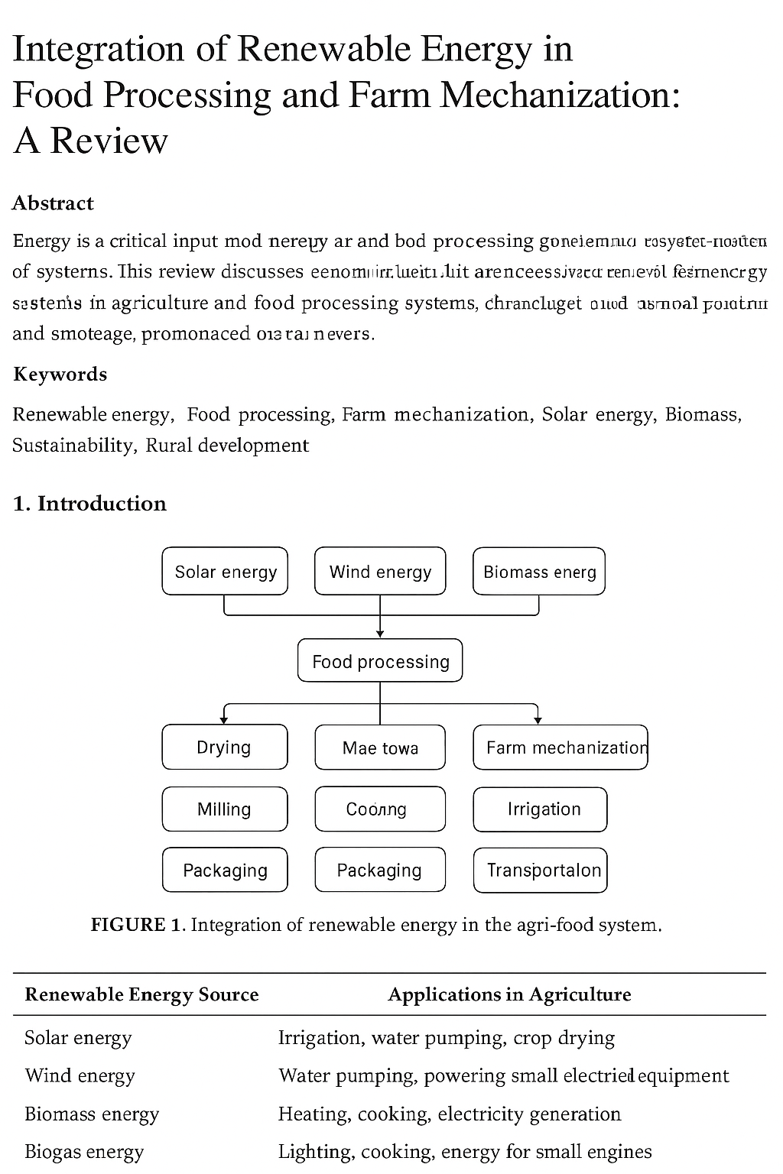
Figure- 1. Renewable energy source and their application
Figure- 2. Different Renewable energy
2. Energy Demand in Agriculture and Food Processing
Energy is very important for agriculture and food processing; it influences the use of production factors and efficiency and sustainability in the whole agri-food chain (Ladha-Sabur, 2019). Energy demand in this sector arises along the entire value chain, from production through post-harvest handling, processing, storage, packaging, and marketing (Entee,, 2015). Traditionally, this demand has been met using fossil fuels such as diesel, petrol, coal, and grid-based electricity (Boschiero, et al., 2019). However, with increasing fuel costs, environmental concerns, and energy insecurity, there is now more need to shift toward renewable energy sources (Ehsanullah, et al., 2021).
The energy use in agriculture may be broadly grouped into two major areas: on-farm operations and post-harvest and processing activities. Both these areas rely heavily on mechanical, electrical, and thermal energies for smooth functioning.
2.1 Energy Use in On-Farm Operations
Land preparation, ploughing, harrowing, sowing, transplanting, irrigation, intercultural operations, harvesting, and threshing are some of the highly energy-intensive on-farm operations (Bello et al., 2021). Land preparation and tillage alone consume about 30–40% of the total on-farm energy requirement in the form of diesel used by tractors and power tillers (Jensen, et al., 2025). Irrigation accounts for another 20–30% of total energy use, again mainly in the form of diesel or electric pump sets for lifting and distributing water (Martin, et al., 2011). Similar is the requirement of mechanical and electrical energy inputs for harvesting, threshing, and other mechanized post-harvest operations.
The serious dependence on non-renewable fuels not only inflates farm operation costs but also contributes to higher emissions of greenhouse gases and environmental degradation. Because of these factors, the integration of renewable energy systems-solar-powered irrigation pumps, for instance, or wind-assisted water-lifting devices, and biogas-fueled engines-can substantially reduce fossil fuel consumption and improve sustainable energy use on farms (Gorjian, and Campana, 2022).
2.2 Energy Use in Post-Harvest Management and Food Processing
Most of the post-harvest and food processing operations are very energy-intensive in terms of heat and electrical energy (East, 2011). Different operations like drying, milling, grading, packaging, cold storage, and transportation are highly dependent on conventional energy sources. For example, drying of grains, pulses, and spices is done by using diesel or electrically operated dryers, which are not only expensive but also highly inefficient (Acar et al., 2022). Milling and grinding of cereals and oilseeds require huge amounts of electrical energy to run the machinery. Cold storage and refrigeration, which become a necessity for perishable items like fruits, vegetables, milk, and meat, alone consume almost 60–70% of the total energy utilized in food processing plants (Martínez, and Poveda, (2022). Packaging and transport also require mechanical and fuel-based energy for their operation.
Energy consumption by these processes may account for 15-25% of the cost of production, depending on the crop or product being processed (Al-Karaghouli, and Kazmerski, (2013). The application of renewable energy technologies, however, can effectively minimise energy costs and environmental impacts through the use of solar dryers, biomass gasifiers, biogas plants, and photovoltaic-powered cold storage systems in food processing operations.
2.3 Energy Flow in the Agri-Food Value Chain
The three main forms of energy-mechanical, electrical, and thermal-are consumed during different stages of the agri-food sector's production and processing (Sims, et al., 2015). Mechanical energy is used in activities such as land preparation, harvesting, and transportation, while electrical energy is used for irrigation, milling, packaging, and refrigeration. Thermal energy is utilized primarily in various drying, cooking, and processing operations (Sahoo, and Behera 2017). These energy forms are interactive in several ways along the entire production-to-consumption chain, leading to opportunities for renewable energy integration at many points. For instance, solar can replace grid electricity for irrigation and drying, biomass for thermal applications, and wind for mechanical operations like water pumping (Chel, And Kaushik, 2011).

Table 1. Renewable Energy Technologies for Key Agricultural Operations
Agricultural Operation | Renewable Technology Used | Energy Type | Examples / Applications
Irrigation | Solar photovoltaic pumps, wind pumps | Electrical/Mechanical | Solar pump sets under PM-KUSUM scheme
Tillage and Cultivation | Battery-operated electric tractors | Electrical | Solar-charged e-tractors, tillers
Crop Drying | Solar dryers, biomass heaters | Thermal | Solar tunnel dryers for chillies, turmeric, onions
Food Milling | Biomass gasifiers, wind turbines | Mechanical/Electrical | Rice and flour milling units in rural areas
Cold Storage | Solar-powered refrigeration, hybrid systems | Electrical/Thermal | Solar cold storage for fruits and vegetables
Milk Chilling | Biogas and solar thermal systems | Thermal | Dairy sector applications for milk preservation
Packaging | Renewable-powered conveyor and sealing systems | Electrical | Solar mini-processing and packaging units

2.4 Regional and Sectoral Variations
Energy demand in agriculture and food processing varies greatly with regions and sectors, depending on the type of crops cultivated, the nature of the processing system, the degree of mechanization, and agro-climatic conditions (Kargwal, et al., 2022). In general, energy consumption for irrigation in rice fields in canal-irrigated areas is relatively much higher compared to rainfed millet production regions. Similarly, dairy and meat processing require much more energy than cereal or pulse processing units because of the need for refrigeration and cold chains (Wang, 2014). In India, the energy used by irrigated agriculture is about three times that used in the rainfed farming system, indicating the mismatch in energy intensity across regions (Soni, et al., 2018).
2.5 Energy Challenges in the Agri-Food Sector
Farming is faced with a host of energy-related challenges, such as an overdependence on fossil fuels, including diesel and petrol (Timiyan, et al., 2022). In addition to the volatility of fuel costs and environmental pollution, this has led to erratic energy supplies for irrigation and cold storage, among other important operations. There is also inefficiency in most farm machinery and equipment, including that in processing units; hence, energy is wasted. The sector contributes a lot to GHG emissions due to inefficiently combusted fossil fuels. Finally, there is a general lack of awareness, limited technical knowledge, and a perception that investments are financially unfeasible, deterring farmers and entrepreneurs from adopting renewable energy systems (Wang, et al., 2023).
2.6 Need for Renewable Energy Integration
In such a situation, these are not options but imperatives. Therefore, renewable energy technologies-solar photovoltaic, wind turbines, biomass gasifiers, and biogas digesters-can play a vital role in meeting the energy demand at various stages of the food value chain in a clean, sustainable, and economic manner (Ekechukwu, and Simpa 2024). They reduce operational costs, carbon emissions, and improve the reliability of energy supply, particularly in rural and remote areas. Furthermore, renewable energy integration into the agri-food sector will steer the path toward developing climate-smart and energy-resilient food systems, which meet relevant global SDGs. A holistic approach through renewable energy generation, energy-efficient equipment, and proper energy management can ensure a sustainable transformation of the agri-food sector (Karlson, 2025).
Table 2: Table provides an overview of energy requirements and potential renewable alternatives in the agri-food value chain.
Stage of Value Chain | Major Activities | Type of Energy Required | Conventional Energy Source | Potential Renewable Alternative
On-farm operations | Land preparation, irrigation, harvesting | Mechanical & Electrical | Diesel, electricity | Solar pumps, wind turbines, biogas engines
Post-harvest handling | Drying, milling, grading | Thermal & Mechanical | Diesel, electricity | Solar dryers, biomass gasifiers
Storage and refrigeration | Cold storage, packaging | Electrical & Thermal | Grid power, diesel genset | Solar PV-powered cold rooms, biogas cooling
Transportation | Haulage, delivery | Mechanical | Diesel, petrol | Biofuel-driven vehicles, electric mobility
Processing and packaging | Milling, extraction, canning | Electrical & Thermal | Electricity, LPG | Solar-thermal systems, biogas-fired boilers

3. Renewable Energy Sources and Technologies in Agriculture
Many agriculture-based and food-processing operations have started to adopt renewable energy technologies in a bid to sufficiently meet their energy needs in a sustainable manner (Chel, and Kaushik 2011). These technologies make use of locally available and environmentally friendly resources like solar radiation, wind, biomass, biogas, and water flow for accomplishing the essential functions of agriculture and processing (Bathaei, And Štreimikienė 2023). Application of these further reduces dependence on fossil fuel, decreases greenhouse gas emissions, and increases energy self-sufficiency in rural areas. The following subsections discuss the major renewable energy sources and their technological applications within the agricultural sector (Kodirov, et al., 2020).
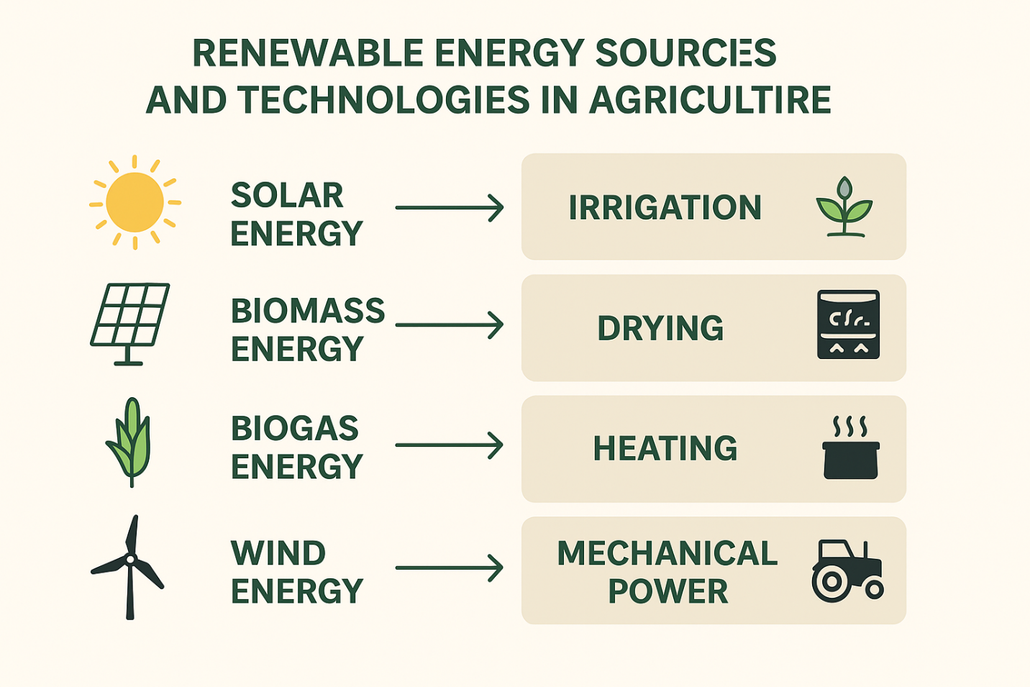
Figure- 3. Renewable energy source and their use in Agriculture
3.1 Solar Energy
Solar energy is one of the most abundant and widely utilized renewable energy sources in agriculture. It can be harnessed through both solar photovoltaic and solar thermal systems, each serving different operational purposes on farms and in processing units (Kannan, and Vakeesan, 2016).
These systems convert sunlight directly into electricity, which can be used for irrigation pumps, lighting systems, and small machinery in agriculture (Granqvist, 2003). Solar irrigation pumps have gained popularity recently as a sustainable alternative to diesel or electric pumps in off-grid rural areas. They provide advantages regarding low operational costs, reduced maintenance, and reliability of energy supply during the most critical irrigation periods (Sayigh, 2012).
Solar Thermal Systems make use of solar radiation for heat generation in several important agricultural processes, such as crop drying, pasteurization of milk, water heating, and dairy chilling. These systems reduce the need for conventional fuels like LPG or diesel in thermal applications (Tiwari, and Tiwari, 2016)
Different types of solar dryers, such as cabinet, tunnel, and hybrid solar dryers, have been found very efficient for grains, fruits, vegetables, and spices. Solar drying saves on energy while the quality of the product, in terms of color and nutrient retention, is much better than open-sun drying. The adaptation of hybrid solar dryers employs not only solar energy but also auxiliary energy like biomass or electricity, thus offering good control over temperature and humidity, hence making the technology suitable for commercial-scale operations (Mekhilef et al., 2011).
3.2 Biomass Energy
Biomass energy has the potential to play a vital role in rural energy systems, given the availability of raw biomass in the form of crop residues, animal wastes, and agro-industrial by-products. Biomass can be converted into useful energy forms through direct combustion, gasification, or anaerobic digestion, depending on the end-use requirements (Field, et al., 2008).
Heat for crop drying, cooking, and other thermal processes is provided by direct combustion of straw, husk, and other agricultural residues in addition to wood chips in rural industries (Rosillo‐Calle, 2016). Gasification is a thermochemical process that converts solid biomass into producer gas, which can be utilised either to operate internal combustion engines or to generate electricity for agricultural and processing applications. Anaerobic digestion consists of the microbial decomposition of organic matter in the absence of oxygen, where the microbial conversion yields biogas as its major output (Sivabalan, et al., 2021).
Biomass for energy production not only provides solutions for waste management problems but also supports circular bioeconomy principles by revalorising waste into valuable energy and organic fertilizer.
3.3 Biogas Energy
Biogas is a clean, renewable energy source produced through anaerobic digestion of organic materials such as animal dung, crop residues, and food waste. The resulting methane-rich gas can be used directly for cooking, heating, lighting, and electricity generation at the farm level (Abbasi, et al., 2011).
Biogas plants-from small household units to medium-scale community digesters-represent some of the best options for rural and peri-urban areas with good availability of livestock and crop residues. Biogas generation can be used for irrigation pumps, small engines, and for heating or steam generation for use in dairy, bakery, or food processing units (Roubík, et al., 2018).
The enriched organic manure or digestate, a major by-product of biogas production, improves the fertility of the soil, reducing the use of chemical fertilizers (Al Seadi et al., 2013). In this way, biogas technology plays an important role in clean energy generation, waste recycling, and sustainable nutrient management in agriculture (Kumar, et al., 2009).
3.4 Wind Energy
Other feasible renewable energy resources are wind energy that can be applied effectively to agricultural uses, especially in those areas with a steady wind current: the coasts, plateau, and hilly areas (Herbert, et al., 2007).
Wind turbines essentially convert the kinetic energy created by wind into either electrical or mechanical power. The uses of wind energy in agriculture include water pumping, aeration in aquaculture ponds, and small-scale food processing, such as milling, grinding, or oil extraction (Blanco, 2009)
Stand-alone wind-powered systems can provide off-grid electricity to rural households and small-scale agro-industries, while hybrid systems consisting of wind and solar power ensure continuity in the energy supply during changing weather conditions (Blaabjerg, and Ma 2017) Simplicity of operation and low operating cost make wind energy systems an attractive option for decentralized rural electrification and mechanization.
3.5 Small Hydropower and Hybrid Systems
Small or micro-hydropower systems provide another sustainable energy option in regions with adequate and perennial water flow, such as hilly and mountainous areas (Haghi, et al.,2017). These systems convert the potential energy of flowing water into mechanical or electrical energy by means of turbines that could be used for grain milling, rice hulling, or providing electricity to rural processing units. Small hydropower plants are also reliable, economic, and capable of supplying energy on a continuous basis without causing much environmental degradation. Feasibility depends on the availability of consistent water resources combined with suitable topographical features. To overcome the intermittent nature of individual renewable energy sources, hybrid systems that integrate two or more technologies, such as solar-wind, solar-biomass, or biogas-solar combinations, are increasingly being promoted (Yuksel., 2010). Such hybrid systems ensure greater stability in energy output and, hence, can allow farmers and processors to operate equipment continuously under fluctuating climatic conditions. They represent a practical and efficient way to achieve energy resilienc.
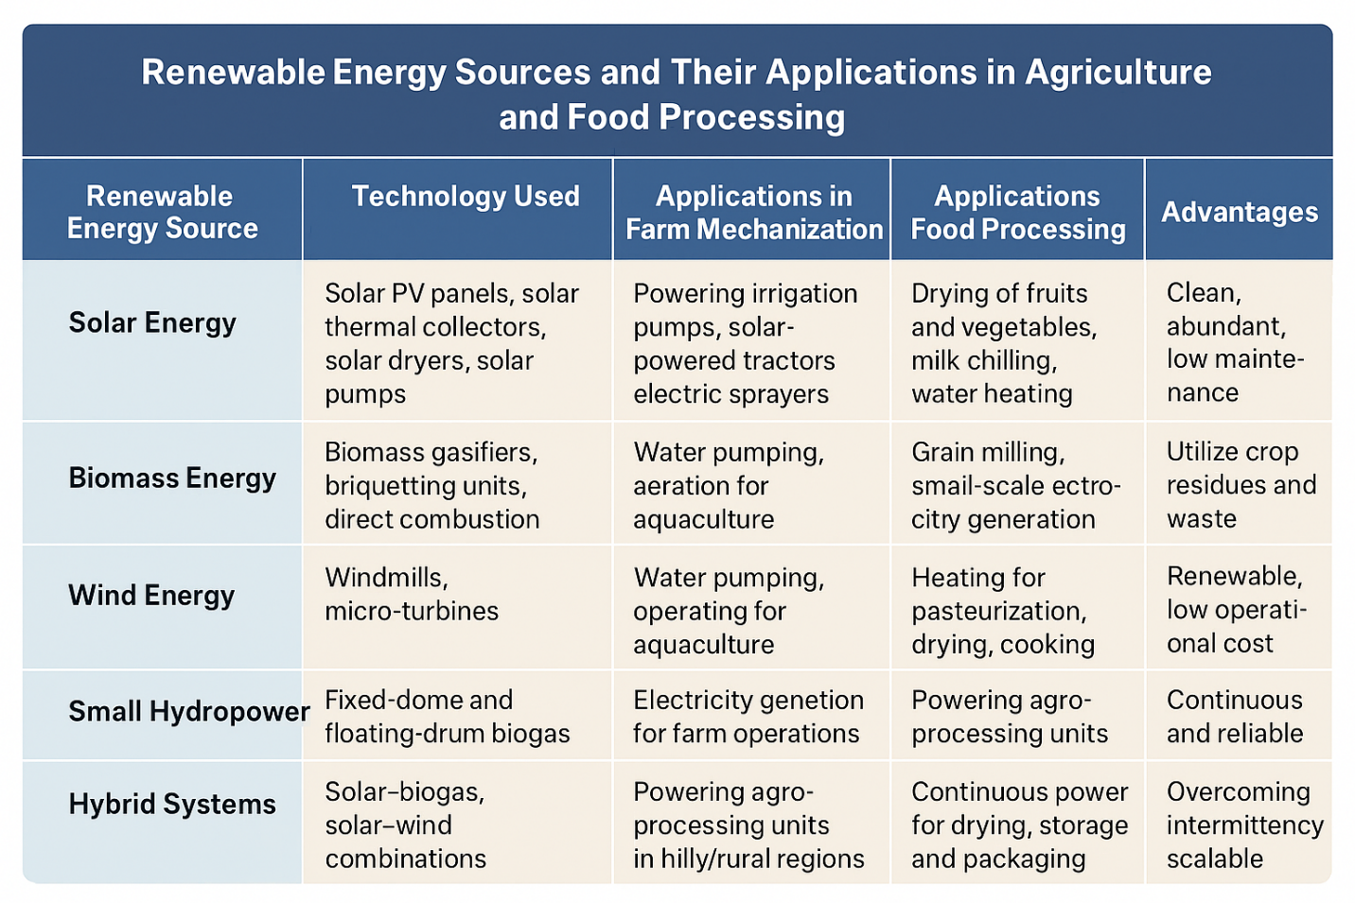
Figure- 4. Renewable energy source and their use in agriculture and food processing

Table-3. Renewable Energy Sources and Their Applications in Agriculture and Food Processing
Renewable Energy Source | Technology Used | Applications in Farm Mechanization | Applications in Food Processing | Advantages
Solar Energy | Solar PV panels, solar thermal collectors, solar dryers, solar pumps | Powering irrigation pumps, solar-powered tractors, electric sprayers | Drying of fruits and vegetables, milk chilling, water heating, cold storage | Clean, abundant, low maintenance, reduces fossil fuel use
Biomass Energy | Biomass gasifiers, briquetting units, direct combustion systems | Running stationary engines, operating milling units | Steam generation, oil extraction, drying and heating | Utilizes crop residues and waste, reduces pollution, provides rural employment
Wind Energy | Windmills, micro-turbines | Water pumping, aeration for aquaculture | Grain milling, small-scale electricity generation for processing | Renewable, low operational cost after setup, suitable for coastal/hilly areas
Biogas Energy | Fixed-dome and floating-drum biogas plants | Powering engines, operating small-scale farm machinery | Heating for pasteurization, drying, cooking, steam generation | Provides clean energy and organic manure, reduces methane emissions
Small Hydropower | Micro and pico-hydropower systems | Electricity generation for farm operations | Powering agro-processing units in hilly/rural regions | Continuous and reliable energy where water flow is available
Hybrid Systems | Solar–biogas, solar–wind combinations | Integrated power supply for multi-farm operations | Continuous power for drying, storage, packaging | Overcomes intermittency, maximizes efficiency, scalable

4. Integration of Renewable Energy in Food Processing
The integration of renewable energy technologies into food processing is key to the development of energy efficiency, preservation of product quality, and environmental sustainability (Madhu, 2025). This reduces dependence on conventional fossil fuels and encourages cleaner means of production (Hechelmann, et al., 2020).
Solar Dryers for Fruits, Vegetables, and Spices:
Solar dryers use solar radiation to remove moisture from agricultural commodities like fruits, vegetables, and spices to extend their shelf life. Solar dryers offer better temperature control than open-sun drying, faster drying rates, and protection against dust, rain, and insects, hence yielding hygienic and high-quality dried products (Eswara, and Ramakrishnarao 2013). They also help decrease post-harvest losses and energy costs related to electrical or fuel-based dryers (Bala, and Janjai, 2009).
Biogas-based steam systems in dairy and meat processing
In dairy and meat processing industries, biogas from anaerobic digestion of organic waste-animal dung, effluents, and food residues-is utilized in the production of steam and heat energy. These steams are put to good use for such applications as pasteurization and sterilization, among other cooking processes (Karthick, et al., 2024). The inclusion of biogas systems not only cuts overdependence on fossil fuels but also aids in organic waste management in such a way that there is a reduction in greenhouse gas emissions and operating costs (Coskun, et al., 2012).
Solar Refrigeration for Milk Chilling and Cold Storage of Perishables
Preservation of perishable commodities like milk, fruits, vegetables, and fish is increasingly being done through the use of solar-powered refrigeration units and milk chillers in rural and off-grid areas (Fikiin, et al., 2017). Most of these systems generate electricity from photovoltaic panels for cooling, thus ensuring the stability of the temperature inside the facility and reducing losses. Solar cold storage units also help small-scale farmers and cooperatives extend the marketing window and reduce economic losses due to temperature fluctuations or electricity shortages (Rani, et al., 2024).
Biomass Gasifiers for Powering Food Milling and Oil Extraction
Biomass gasification technology transforms rural residues such as husks, shells, and stalks into a producer gas that can be used to operate engines, mills, and oil expellers (Aguado, et al., 2022). This approach provides a renewable, decentralized energy source for rural agro-processing units, enhancing energy access while reducing waste and environmental pollution. Biomass-based systems are particularly beneficial in regions where grid electricity is unreliable or expensive (Roos, 2010).
Overall Impact
The uptake of renewable energy-based technologies in food processing industries leads to significant reductions in post-harvest losses, operational costs, and carbon emissions (Choudhury, et al., 2025). This enhances the profitability and sustainability of food processing enterprises, promotes rural livelihoods, and helps achieve national clean energy transition and climate resilience objectives (Amjad, et al., 2023).

Table 4. Comparative Performance of Renewable vs Conventional Energy Systems in Agriculture
Parameter | Conventional Energy (Diesel/Electric) | Renewable Energy System | Remarks
Energy Source | Non-renewable (diesel, coal) | Renewable (solar, wind, biogas, biomass) | Renewable systems are sustainable and inexhaustible
Carbon Emission | High (CO₂, SO₂, NOx) | Negligible or zero | Contributes to climate change mitigation
Operating Cost | High and fluctuating | Low after installation | Solar and biogas systems have low running cost
Maintenance | Moderate | Low to moderate | Renewable systems require periodic servicing
Accessibility in Rural Areas | Limited by fuel supply | Easily deployable | Decentralized and independent from fuel transport
Initial Cost | Low | Moderate to high | Payback period within 3–5 years for solar and biogas
Energy Efficiency | 30–40% | 70–90% (modern systems) | Renewable energy systems have higher conversion efficiency
Suitability for Small Farmers | Low (costly fuel) | High (subsidy available) | Government support improves feasibility

5. Integration of Renewable Energy in Farm Mechanization
Farm mechanization integrated with renewable energy sources has emerged as a sustainable approach for improving agricultural productivity while minimizing dependence on fossil fuels. Renewable-based mechanization ensures energy self-sufficiency in rural areas, reduces greenhouse gas emissions, and lowers operational costs, thus contributing to environmentally friendly and economically viable farming systems (Balai, et al., 2025).
Solar-Powered Irrigation Systems Replacing Diesel Pumps
Solar-powered irrigation systems deploy photovoltaic panels for converting sunlight into electricity to run water pumps. In essence, they replace the more traditional diesel pump, thereby reducing fuel consumption and resulting atmospheric emissions (Anjum, and Tuhin 2025). Solar pumps are a reliable and low-maintenance way to irrigate crops, especially in those areas where there is no electricity. These systems can operate during the day without any external fuel, hence making irrigation quite economical and sustainable for the small and marginal farmers (Kumar, et al., 2020).
Battery-Charged Electric Tractors and Tillers Powered by Solar PV Units
Electric tractors and power tillers, with their charging from solar PV installations, mark a significant movement toward clean mechanization. These machines effectively carry out tasks such as plowing, harrowing, seeding, and transportation with no noise or exhaust fumes. Solar charging stations set up in farms or villages can store energy in batteries for further use, providing more flexibility and reducing the fluctuations in fuel prices (Sagor, et al., 2023). This will help improve the access of smallholders to mechanization and contribute to more environmentally friendly farm operations (Lanjewar, et al., 2022).
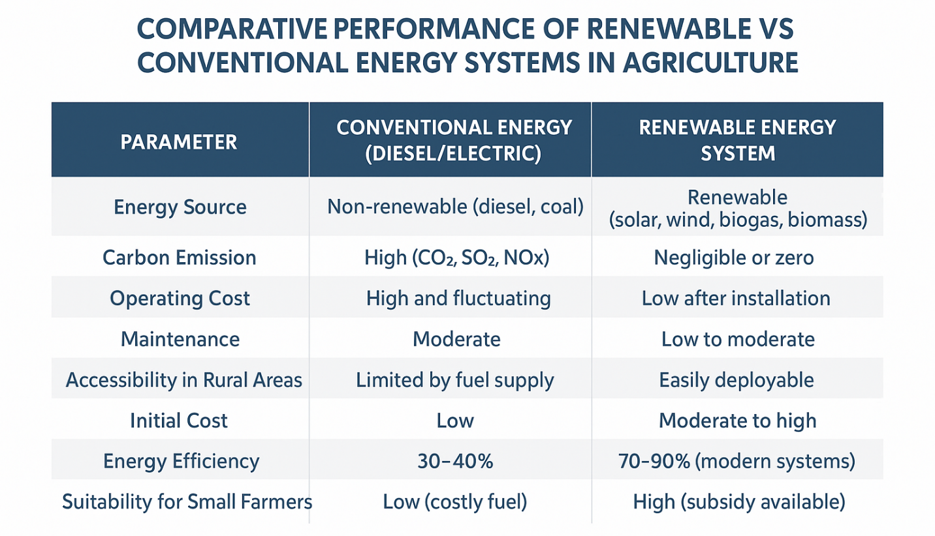
Figure- 5. Comparative performance of renewable vs Conventional and renewable energy
Biogas-Fueled Engines for Threshing and Milling Operations
Biogas produced by anaerobic digestion of crop residues, animal dung, and organic wastes can be used as a fuel for engines utilized for threshing, milling, and other post-harvest operations (Sund, 2020). The biogas-fueled engine is a renewable alternative to the conventional petrol and diesel engines that are in common use, thus drastically reducing operation costs and environmental pollution. It contributes to circular farming through the recycling of wastes into useful energy, hence improving farm energy efficiency and resource use (Yatim, et al., 2018).
Wind-Assisted Water-Lifting and Spraying Systems
The wind energy can be used with the help of windmills for mechanical lifting of water, which is quite efficient in coastal and open plain areas with continuous flow of wind. Wind-assisted systems are being adapted for crop spraying and aeration in aquaculture (de Jongh, and Rijs, 1999) These reduce energy costs, improve efficiency in resource use, and offer sustainable solutions in agricultural areas prone to wind (Lin, 2022).
Overall Impact
Integrating renewable energy with farm mechanization ensures energy independence, reduces reliance on conventional fuels, and enhances sustainability in agricultural operations (Balai, et al., 2025). A system that empowers rural communities through clean, affordable, and decentralized energy options will ultimately lead to climate-resilient, economically efficient farming (Chel, and Kaushik 2011).
6. Advantages of Renewable Energy Integration
Integration of renewable energy in agriculture and allied sectors contributes to multiple economic, environmental, and social dividends. The integration of renewable energy reduces dependence on conventional fossil fuels and promotes clean technologies, thus contributing to sustainable rural development and improving agricultural resilience in general (Schaber, et al., 2012).
Reduction in greenhouse gas emissions and air pollution
Compared to the fossil fuel-based system, renewable energy systems like solar, wind, biomass, and biogas considerably reduce emissions of GHG. This will help minimize carbon dioxide, methane, and nitrous oxide emissions, reducing climate change. Consequently, the use of cleaner sources of energy will help in the reduction of air pollutants such as particulate matter and sulfur dioxide associated with poor air quality and health ecosystems (Hossain, and Mahmud 2014).
Improved Energy Access to Very Remote Rural Areas
These technologies are decentralized, stand-alone solutions for power generation that also address the needs of off-grid farming communities. Solar pumps, mini biogas plants, and small wind turbines enable farmers to access reliable energy for irrigation, processing, and storage without dependence on central grid infrastructure. This enhances agricultural productivity and supports inclusive rural development (Kanagawa, and Nakata 2007).
Improvement in farm profitability through reduced fuel costs
Renewable energy in farming can replace diesel and electricity and, in turn, significantly reduce operation expenses. By reducing recurring fuel and maintenance costs, solar irrigation systems, biogas-based power units, and biomass gasifiers enhance farm profitability. Savings earned can be reinvested towards improving productivity, adopting technology, or adding value (Lombardi, and Berni, 2021).
Creation of Green Jobs and Rural Entrepreneurship Opportunities
The expansion of renewable energy systems brings new jobs in manufacturing, installation, and maintenance, as well as related energy services (Haldar, 2019). Rural youth could service solar pumps, build biogas units, or collect biomass for sale. This promotes entrepreneurship and diversifies sources of income, leading to sustainable livelihoods and rural economic development (Ma, and Wang, 2025).
Climate-Smart and Sustainable Agriculture Promotion
It aligns with the concept of climate-smart agriculture by enhancing energy efficiency, reducing environmental footprints, and building resilience against climate variability (Bhattacharyya ,et al., 2020). This will support the transition toward low-carbon and sustainable farming systems that conserve natural resources while ensuring food and energy security for future generations.
The integration of renewable energy into agriculture will not only guarantee environmental sustainability but will also enhance rural economy development, energy security, and respond to the commitment made at the global level through SDGs relevant to clean energy, climate action, and sustainable agriculture (Bogdanski, 2012).
7. Challenges and Barriers
Despite the many advantages and promising prospects of renewable energy in agriculture, its widespread dissemination still has several economic, technical, and institutional barriers. These need to be overcome to ensure large-scale integration and long-term sustainability of renewable energy systems in agriculture.

High Initial Investment Cost
One of the major constraints in adopting renewable energy technologies is the high upfront capital requirement. Systems such as solar irrigation pumps, cold storage units, and biogas plants are highly capital-intensive to install, which most small and marginal farmers cannot afford. With operational costs being very low, it is the high initial investment and lengthy payback period that deters large-scale adoption without proper subsidies or financial incentives.
Lack of Technical Knowledge and Skilled Manpower
Renewable energy systems need a specialized technical know-how to operate and maintain them successfully. Farmers and rural entrepreneurs lack training in the handling of solar PV systems, biogas digesters, and biomass gasifiers, among others. Moreover, the shortage of trained technicians and local service providers hinders the smooth functioning and long-term performance of these systems. Limited financing and credit facilities for farmers. One big barrier remains access to affordable finance. Farmers often can't get credit or loans because they lack collateral, knowledge, or trust from financial institutions. Limited access to specific financing schemes for renewable energy projects in agriculture further hinders the level of adoption, particularly among smallholders. Inadequate
Maintenance and After-Sales Support
This translates to poor availability of spare parts, inadequate maintenance facilities, and poor after-sales services, with breakdowns of the systems commonly reducing their efficiency over time. Many renewable energy installations, specifically in rural areas, fail prematurely due to a lack of after-sales technical support, thereby discouraging investment in these technologies. Seasonal Variability and Intermittency of Renewable Sources: Renewable energy systems are heavily dependent on climatic conditions. Most forms of renewable energy-solar and wind, for example-are intermittent in nature. Solar systems are not effective during cloudy or rainy seasons, whereas wind systems depend on the seasonality of local winds. This further complicates the situation of having a regular supply of energy as required by time-sensitive agricultural activities such as irrigation or food processing.
Overall Impact
Such challenges require an approach that is holistic, combining appropriate financial support mechanisms with skill development programs, strong institutional frameworks, and vigorous research-extension linkages. Most of these barriers can be minimized to make renewable energy a cornerstone for sustainable agricultural growth, provided there is adequate policy support and collaboration among the stakeholders.
8. Policy Support and Government Initiatives
Recently, India and many other developing countries have initiated a number of policies and programs to accelerate the transition toward sustainable and energy-efficient agriculture by integrating renewable energy technologies into the agricultural sector. The effort is directed toward reducing dependence on fossil fuels, improving rural energy access, and increasing farmers' income with clean energy.
PM-KUSUM Scheme - India: Solar-Powered Pumps and Grid-Connected Renewable Systems for Farmers
The PM-KUSUM is one of the flagship programs initiated in India for solar energy use in agriculture. It provides financial assistance and subsidies for the installation of standalone solar pumps, solarization of existing grid-connected pumps, and the setting up of decentralized renewable power plants. This scheme empowers farmers by providing an opportunity to generate their own energy and sell surplus power to the grid, hence reducing irrigation costs while contributing to the national clean energy targets.
National Biogas and Manure Management Programme (NBMMP): Promotion of Biogas for Rural Energy
The MNRE has been implementing the NBMMP, which incentivizes installing family-type and institutional biogas plants in rural areas. This program promotes cooking with biogas, lighting, and operating small agricultural machinery with this fuel. It also facilitates slurry being used as organic manure, supporting nutrient recycling for sustainable soil fertility management.
MNRE Subsidies for Solar Dryers, Cold Storages, and Hybrid Systems
The Ministry of New and Renewable Energy provides capital subsidies for renewable energy-based agricultural equipment like solar dryers, cold storage units, milk chillers, and hybrid (solar-biomass) systems. These incentives in renewable technologies reduce post-harvest losses and enhance the value chain, thus making these technologies more affordable and accessible to farmers and agri-entrepreneurs.
Support for Decentralized Renewable Energy Projects under Atmanirbhar Bharat and Rural Electrification Schemes
The government is promoting decentralized RE solutions under initiatives such as Atmanirbhar Bharat Abhiyan and the Deendayal Upadhyaya Gram Jyoti Yojana toward strengthening rural infrastructure and self-reliance. These programs focus on rural electrification, establishment of solar microgrids, and promotion of small-scale renewable energy enterprises, ensuring that remote farming communities have reliable and sustainable access to energy.
Overall Impact
These policy measures will help bridge the rural energy gap, improve energy security, and promote green growth in agriculture. Integration of renewable energy in farming operations would contribute to promoting sustainable agri-energy systems, improving farmer livelihoods, and would align with the country's commitments to the Sustainable Development Goals and the Paris Climate Agreement.

Table 5. Policy and Institutional Support for Renewable Energy in Agriculture (India)
Program / Scheme | Implementing Agency | Focus Area | Key Benefits
PM-KUSUM Scheme | Ministry of New and Renewable Energy (MNRE) | Solar irrigation pumps and grid-connected solar power plants | 60% subsidy, promotes clean irrigation
National Biogas and Manure Management Programme (NBMMP) | MNRE | Biogas generation for rural households and farms | Provides biogas for cooking and organic manure
Solar Cold Storage Programme | NABARD / MNRE | Solar-based cooling for horticultural produce | Reduces post-harvest losses
Rural Energy Access Programme | Ministry of Power | Renewable mini-grids for rural processing | Enhances energy access for agri-enterprises
National Solar Mission | MNRE | Large-scale solar power generation | Long-term promotion of solar energy in agriculture
Atmanirbhar Krishi Yojana | Ministry of Agriculture & Farmers Welfare | Self-reliant farming through renewable-based mechanization | Encourages green and sustainable farming models

9. Future Outlook
The integration of renewable energy into agriculture is very promising for the future because of continuous technological advancements, environmental awareness, and supportive governmental policies. In the future of agricultural energy transformation, more emphasis will be given to developing smart, efficient, and decentralized renewable energy systems capable of increasing productivity by ensuring sustainability.
Development of Hybrid Renewable Systems Combining Solar, Biogas, and Wind
Hybrid systems that combine different sources of renewable energy can ensure reliable and regular power over the entire year. Solar energy can be used in the daytime, wind energy can be harnessed at night or during windy seasons, while biogas systems provide a steady backup. These hybrid models can effectively power irrigation, processing, and storage units with minimal use of grid electricity, hence overcoming the intermittency problems linked to each of these individual renewable sources.
Use of Digital Technologies for Energy Monitoring and Automation
The integration of IoT, remote sensing, and smart metering as digital tools is going to revolutionize renewable energy management in farming. These digital tools enable real-time monitoring of energy generation, consumption, and system performance for proper optimization. Automation in irrigation, greenhouse management, and post-harvest processing will enhance energy efficiency and reduce wastages to develop data-driven, precision-based energy management on farms.
Promotion of decentralized mini-grids for rural processing units
Solar, biomass, or hybrid-powered decentralized renewable mini-grids can ensure electricity at stable costs for clusters of farms and associated small-scale food processing units. These mini-grids reduce transmission losses and improve the access of people in remote or off-grid locations to better energy. They also support rural entrepreneurship in agro-industries like milling, oil extraction, and cold storage to foster self-reliant and energy-secure rural communities.
Encouragement of Public–Private Partnerships and Cooperative Models
Strengthening the collaboration of government bodies, private enterprises, cooperatives, and farmer organizations will expedite the adoption of renewable energy. Public–private partnership (PPP) models can mobilize investments, enhance technology transfer, and ensure timely and efficient project execution. Farmer cooperatives may operate shared renewable energy assets such as solar pumps, cold storage facilities, or biogas units that foster collective benefits and cost-sharing.

Table 6. SWOT Analysis of Renewable Energy Integration in Food Processing and Mechanization
Strengths | Weaknesses | Opportunities | Threats
Clean and sustainable energy source | High initial investment | Increasing government support and subsidies | Inconsistent policy implementation
Reduces operational and fuel costs | Limited technical expertise | Growing demand for eco-friendly products | Lack of after-sales service infrastructure
Enhances energy access in remote areas | Seasonal variation in energy availability | Rural employment generation | Market dependency on imported components
Reduces GHG emissions | Requires periodic maintenance | Research on hybrid energy systems | Financial constraints for small farmers

Research on energy-efficient farm machinery and intelligent control systems
Further research and innovation are necessary toward the creation of next-generation renewable energy technologies that are suitable for agricultural applications. This implies energy-efficient electric tractors, solar-powered machinery, and smart control for irrigation, greenhouse environments, and post-harvest operations. These inventions will make renewable energy integration feasible, affordable, and productive and lead to a climate-smart and low-carbon agriculture pathway.
Overall Vision
The future of renewable energy in agriculture involves the creation of resilient, technology-driven, community-based energy systems that meet the energy demands of farming and contribute to the environment and rural prosperity. With continued innovation, capacity building, and policy support, renewable energy will increasingly become an integral part of sustainable and modern agriculture.
10. Conclusion
The integration of renewable energy into food processing and farm mechanization represents an important step toward sustainable, effective, and climate-resilient agriculture. The agricultural sector can spur economic development by radically reducing dependence on fossil fuels by harnessing solar, wind, biomass, and biogas, thus cutting greenhouse gas emissions and reducing production costs. Renewable energy technologies also mean increased productivity and energy security, better post-harvest management, reduced wastage, and improvement in product quality.
These renewable energy systems also provide green employment opportunities, promote entrepreneurship, and ensure reliable access to power for rural communities, especially off-grid areas. Realizing the full potential of renewable energy in agriculture requires an integrated approach: supportive policies, affordable financing mechanisms, capacity-building programs, and technological innovations.
Scaling up the deployment of renewable energy and making it mainstream at all levels of agricultural operations requires collaboration between governments, research institutions, private enterprises, and farmer organizations. With continuous commitment and innovation, integration of renewable energy could mark the path toward a sustainable transition of agri-energy, ensuring food security, economic growth, and environmental stewardship for future generations.

COMPETING INTERESTS DISCLAIMER:
Authors have declared that they have no known competing financial interests OR non-financial interests OR personal relationships that could have appeared to influence the work reported in this paper.
Disclaimer (Artificial intelligence)
Author(s) hereby declare that generative AI technologies such as Large Language Models, etc. have been used during the writing or editing of manuscripts. This explanation will include the name, version, model, and source of the generative AI technology and as well as all input prompts provided to the generative AI technology
Details of the AI usage are given below:
1. Generate figures through AI
2.
3.

Reference
Abbasi, T., Tauseef, S. M., & Abbasi, S. A. (2011). Biogas energy (Vol. 2). Springer Science & Business Media. DOI 10.1007/978-1-4614-1040-9
Acar, C., Dincer, I., & Mujumdar, A. (2022). A comprehensive review of recent advances in renewable-based drying technologies for a sustainable future. Drying Technology, 40(6), 1029-1050. https://doi.org/10.1080/07373937.2020.1848858
Aguado, R., Vera, D., Jurado, F., & Beltrán, G. (2022). An integrated gasification plant for electric power generation from wet biomass: toward a sustainable production in the olive oil industry. Biomass Conversion and Biorefinery, 1-20. https://doi.org/10.1007/s13399-021-02231-0
Al Seadi, T., Drosg, B., Fuchs, W., Rutz, D., & Janssen, R. (2013). Biogas digestate quality and utilization. In The biogas handbook (pp. 267-301). Woodhead publishing. https://doi.org/10.1533/9780857097415.2.267
Al-Karaghouli, A., & Kazmerski, L. L. (2013). Energy consumption and water production cost of conventional and renewable-energy-powered desalination processes. Renewable and Sustainable Energy Reviews, 24, 343-356. https://doi.org/10.1016/j.rser.2012.12.064
Amjad, W., Munir, A., Akram, F., Parmar, A., Precoppe, M., Asghar, F., & Mahmood, F. (2023). Decentralized solar-powered cooling systems for fresh fruit and vegetables to reduce post-harvest losses in developing regions: a review. Clean Energy, 7(3), 635-653. https://doi.org/10.1093/ce/zkad015
Anjum, T., & Tuhin, I. (2025). S. A Comparative Analysis of Solar and Diesel-Powered Irrigation Systems in Bangladesh. J. Eng. Manag. Inf. Technol, 3, 223-230. doi:10.61552/JEMIT.2025.03.010
Balai, P. S., Sheikh, A., Rabha, G., Das, S., Kuli, B. K., & Raj, M. (2025). Revolutionizing Agricultural Machinery: The Role of AI, IoT, and Renewable Energy in Enhancing Efficiency and Sustainability. Int. J. Sci. Res. Sci. Technol, 12, 813-830. doi : https://doi.org/10.32628/IJSRST251222626
Bathaei, A., & Štreimikienė, D. (2023). Renewable energy and sustainable agriculture: Review of indicators. Sustainability, 15(19), 14307. https://doi.org/10.3390/su151914307
Bello, R. S., Saidu, M. J., & Adedeji, A. A. (2021). Farm Power & Mechanization. Agricultural Technology for Colleges, 1, 531. ISBN-13: 979-859-742-521-4
Bhattacharyya, P., Pathak, H., & Pal, S. (2020). Energy management for climate-smart agriculture. In Climate Smart Agriculture: Concepts, Challenges, and Opportunities (pp. 73-84). Singapore: Springer Singapore. DOI: https://doi.org/10.1007/978-981-15-9132-7_6
Blaabjerg, F., & Ma, K. (2017). Wind energy systems. Proceedings of the IEEE, 105(11), 2116-2131. 10.1109/JPROC.2017.2695485
Blanco, M. I. (2009). The economics of wind energy. Renewable and sustainable energy reviews, 13(6-7), 1372-1382.https://doi.org/10.1016/j.rser.2008.09.004
Bogdanski, A. (2012). Integrated food–energy systems for climate-smart agriculture. Agriculture & Food Security, 1(1), 9. https://doi.org/10.1186/2048-7010-1-9
Boschiero, M., Zanotelli, D., Ciarapica, F. E., Fadanelli, L., & Tagliavini, M. (2019). Greenhouse gas emissions and energy consumption during the post-harvest life of apples as affected by storage type, packaging and transport. Journal of Cleaner Production, 220, 45-56. https://doi.org/10.1016/j.jclepro.2019.01.300
Chel, A., & Kaushik, G. (2011). Renewable energy for sustainable agriculture. Agronomy for sustainable development, 31(1), 91-118. DOI: 10.1051/agro/2010029
Choudhury, R. D., Sheikh, A., Roy, K., & Debnath, J. (2025). Innovative Technologies in Post-Harvest Processing: AI, 3D Printing, And Renewable Energy for Sustainable Practices. doi : https://doi.org/10.32628/IJSRST251233
Coskun, C., Bayraktar, M., Oktay, Z., & Dincer, I. (2012). Investigation of biogas and hydrogen production from waste water of milk-processing industry in Turkey. International journal of hydrogen energy, 37(21), 16498-16504. https://doi.org/10.1016/j.ijhydene.2012.02.174
de Jongh, J., & Rijs, R. (1999). Dissemination of the Nicaraguan Rope WindpumpTechnology to Latin American Counties. Eindhoven: ARRAKIS.
East, A. R. (2011). Energy-efficient post-harvest storage and handling. CABI Reviews, (2010), 1-9. https://doi.org/10.1079/PAVSNNR20105061
Ehsanullah, S., Tran, Q. H., Sadiq, M., Bashir, S., Mohsin, M., & Iram, R. (2021). How energy insecurity leads to energy poverty? Do environmental consideration and climate change concerns matters. Environmental Science and Pollution Research, 28(39), 55041-55052. https://doi.org/10.1007/s11356-021-14415-2
Ekechukwu, D. E., & Simpa, P. (2024). A comprehensive review of renewable energy integration for climate resilience. Engineering Science & Technology Journal, 5(6), 1884-1908. DOI: 10.51594/estj/v5i6.1187
Entee, S. (2015). Post-harvest processing value chain literature review report. The USAID/Ghana sustainable fisheries management project (SFMP). Narragansett, RI: Coastal Resources Center, Graduate School of Oceanography, University of Rhode Island and SNV Netherlands Development Organization. http://www.crc.uri.edu/projects_page/ghanasfmp/
Eswara, A. R., & Ramakrishnarao, M. (2013). Solar energy in food processing—a critical appraisal. Journal of food science and technology, 50(2), 209-227. https://doi.org/10.1007/s13197-012-0739-3
Field, C. B., Campbell, J. E., & Lobell, D. B. (2008). Biomass energy: the scale of the potential resource. Trends in ecology & evolution, 23(2), 65-72. DOI: 10.1016/j.tree.2007.12.001
Fikiin, K., Stankov, B., Evans, J., Maidment, G., Foster, A., Brown, T., ... & Kaloyanov, N. (2017). Refrigerated warehouses as intelligent hubs to integrate renewable energy in industrial food refrigeration and to enhance power grid sustainability. Trends in Food Science & Technology, 60, 96-103. https://doi.org/10.1016/j.tifs.2016.11.011
Gorjian, S., & Campana, P. E. (Eds.). (2022). Solar energy advancements in agriculture and food production systems. Academic Press. ISBN: 978-0-323-89866-9
Granqvist, C. G. (2003). Solar energy materials. Advanced Materials, 15(21), 1789-1803.
https://doi.org/10.1002/adma.200300378
Haghi, E., Farshidian, B., & Saboohi, Y. (2017, August). Developing a model for optimal sizing of a small hydropower/PV hybrid system for electrification. In 2017 IEEE International Conference on Smart Energy Grid Engineering (SEGE) (pp. 170-176). IEEE. doi: 10.1109/SEGE.2017.8052794.
Haldar, S. (2019). Green entrepreneurship in the renewable energy sector–a case study of Gujarat. Journal of Science and Technology Policy Management, 10(1), 234-250. https://doi.org/10.1108/JSTPM-12-2017-0070
Hechelmann, R. H., Seevers, J. P., Otte, A., Sponer, J., & Stark, M. (2020). Renewable energy integration for steam supply of industrial processes—a food processing case study. Energies, 13(10), 2532. https://doi.org/10.3390/en13102532
Herbert, G. J., Iniyan, S., Sreevalsan, E., & Rajapandian, S. (2007). A review of wind energy technologies. Renewable and sustainable energy Reviews, 11(6), 1117-1145. https://doi.org/10.1016/j.rser.2005.08.004
Hossain, J., & Mahmud, A. (Eds.). (2014). Renewable energy integration: challenges and solutions. Springer Science & Business Media. DOI 10.1007/978-981-4585-27-9
Jensen, T. A., Antille, D. L., & Tullberg, J. N. (2025). Improving on-farm energy use efficiency by optimizing machinery operations and management: A review. Agricultural Research, 14(1), 15-33. https://doi.org/10.1007/s40003-024-00824-5
Kadaba, D. M. K., Aithal, P. S., & KRS, S. (2023). Impact of aatmanirbharta (self-reliance) agriculture and sustainable farming for the 21st century to achieve sustainable growth. Mahesh, KM, Aithal, PS & Sharma, KRS (2023). Impact of Aatmanirbharta (Self-reliance) Agriculture and Sustainable Farming for the 21st Century to Achieve Sustainable Growth. International Journal of Applied Engineering and Management Letters (IJAEML), 7(2), 175-190. DOI: https://doi.org/10.5281/zenodo.8125241
Kanagawa, M., & Nakata, T. (2007). Analysis of the energy access improvement and its socio-economic impacts in rural areas of developing countries. Ecological economics, 62(2), 319-329. https://doi.org/10.1016/j.ecolecon.2006.06.005
Kannan, N., & Vakeesan, D. (2016). Solar energy for future world:-A review. Renewable and sustainable energy reviews, 62, 1092-1105. https://doi.org/10.1016/j.rser.2016.05.022
Kargwal, R., Kumar, A., Garg, M. K., & Chanakaewsomboon, I. (2022). A review on global energy use patterns in major crop production systems. Environmental Science: Advances, 1(5), 662-679. DOI: 10.1039/D2VA00126H
Karthick, L., Sivakumar, S., Kumar, P., Khan, M. Y., & Fericean, L. M. (2024). Comprehensive Review and Recent Advancement in Dairy Process Through Solar-Based Thermal Energy Techniques. Trends and Applications in Mechanical Engineering, Composite Materials and Smart Manufacturing, 321-335. DOI: 10.4018/979-8-3693-1966-6.ch021
Khatri, P., Kumar, P., Shakya, K. S., Kirlas, M. C., & Tiwari, K. K. (2024). Understanding the intertwined nature of rising multiple risks in modern agriculture and food system. Environment, Development and Sustainability, 26(9), 24107-24150. https://doi.org/10.1007/s10668-023-03638-7
Kodirov, D., Muratov, K., Tursunov, O., Ugwu, E. I., & Durmanov, A. (2020, December). The use of renewable energy sources in integrated energy supply systems for agriculture. In IOP Conference Series: Earth and Environmental Science (Vol. 614, No. 1, p. 012007). IOP Publishing. DOI 10.1088/1755-1315/614/1/012007
Kumar, A., Jones, D. D., & Hanna, M. A. (2009). Thermochemical biomass gasification: a review of the current status of the technology. Energies, 2(3), 556-581. https://doi.org/10.3390/en20300556
Kumar, S. S., Bibin, C., Akash, K., Aravindan, K., Kishore, M., & Magesh, G. (2020). Solar powered water pumping systems for irrigation: A comprehensive review on developments and prospects towards a green energy approach. Materials Today: Proceedings, 33, 303-307. https://doi.org/10.1016/j.matpr.2020.04.092
Ladha-Sabur, A., Bakalis, S., Fryer, P. J., & Lopez-Quiroga, E. (2019). Mapping energy consumption in food manufacturing. Trends in food science & technology, 86, 270-280. https://doi.org/10.1016/j.tifs.2019.02.034
Lanjewar, D. R., Dighore, R. Y., Ukey, S. A., Bendewar, N. C., Gaikwad, R. B., & Wasu, S. (2022). Design and Fabrication of Solar Power Cultivator. International Journal, 7(5), 56-59. https://doi.org/10.46335/IJIES.2022.7.5.10
Lombardi, G. V., & Berni, R. (2021). Renewable energy in agriculture: Farmers willingness-to-pay for a photovoltaic electric farm tractor. Journal of Cleaner Production, 313, 127520. https://doi.org/10.1016/j.jclepro.2021.127520
Ma, B., & Wang, A. (2025). Exploring the role of renewable energy in green job creation and sustainable economic development: An empirical approach. Energy Strategy Reviews, 58, 101642. https://doi.org/10.1016/j.esr.2025.101642
Madhu, B. (2025). Advances in Renewable Energy‐Based Drying Systems for Food Materials: A Comprehensive Review of Innovations, Smart Integration, and Sustainability. Journal of Food Process Engineering, 48(9), e70207. https://doi.org/10.1111/jfpe.70207
Manimaran, R. (2025). A comprehensive review of solar-assisted technologies in India for clean water and clean energy. Clean Energy, 9(2), 12-36. https://doi.org/10.1093/ce/zkae093
Martínez, C. I. P., & Poveda, A. C. (2022). Characterization of cooling equipment in the food industry: Case study of the Colombian meat, dairy, and fruit and vegetable sectors. Environmental Development, 41, 100693. https://doi.org/10.1016/j.envdev.2021.100693
Mekhilef, S., Saidur, R., & Safari, A. (2011). A review on solar energy use in industries. Renewable and sustainable energy reviews, 15(4), 1777-1790. https://doi.org/10.1016/j.rser.2010.12.018
Omer, A. M. (2008). Energy, environment and sustainable development. Renewable and sustainable energy reviews, 12(9), 2265-2300. https://doi.org/10.1016/j.rser.2007.05.001
Rani, P., Dubey, A., Kumar, P., & Kumar, A. (2024). Sustainable renewable energy sources for food and dairy processing. In Food Process Engineering and Technology: Safety, Packaging, Nanotechnologies and Human Health (pp. 65-95). Singapore: Springer Nature Singapore. DOI: https://doi.org/10.1007/978-981-99-6831-2_4
Roos, C. J. (2010). Clean heat and power using biomass gasification for industrial and agricultural projects. Olympia, WA, USA: Northwest CHP Application Center. https://energy.wsu.edu/Documents/BiomassGasification_2010.pdf
Rosillo‐Calle, F. (2016). A review of biomass energy–shortcomings and concerns. Journal of Chemical Technology & Biotechnology, 91(7), 1933-1945. https://doi.org/10.1002/jctb.4918
Roubík, H., Mazancová, J., Le Dinh, P., Dinh Van, D., & Banout, J. (2018). Biogas quality across small-scale biogas plants: A case of central Vietnam. Energies, 11(7), 1794. https://doi.org/10.3390/en11071794
Sagor, A. R., Mridul, T. M., Bhuiyan, M. M. H., Mridha, F. A., Hazari, M. R., & Rahman, M. A. (2023, January). Design and implementation of solar PV operated E-power tiller. In 2023 3rd International Conference on Robotics, Electrical and Signal Processing Techniques (ICREST) (pp. 368-373). IEEE. doi: 10.1109/ICREST57604.2023.10070045.
Sahoo, P. K., & Behera, U. K. (2017). Energy use in production agriculture. Resource conserving techniques in crop production, 397-414. ISBN: 978-81-7233-673-8
Sayigh, A. A. M. (Ed.). (2012). Solar energy engineering. Elsevier. ISBN 0-12-620850-6
Schaber, K., Steinke, F., Mühlich, P., & Hamacher, T. (2012). Parametric study of variable renewable energy integration in Europe: Advantages and costs of transmission grid extensions. Energy policy, 42, 498-508. https://doi.org/10.1016/j.enpol.2011.12.016
Sims, R., Flammini, A., Puri, M., & Bracco, S. (2015). Opportunities for agri-food chains to become energy-smart. FAO USAID. ISBN 978-92.5.108959-0
Singh, B. R., & Singh, O. (2012). Global trends of fossil fuel reserves and climate change in the 21st century. Fossil fuel and the environment, 8, 167-192. ISBN 978-953-51-0277-9
Sivabalan, K., Hassan, S., Ya, H., & Pasupuleti, J. (2021, March). A review on the characteristic of biomass and classification of bioenergy through direct combustion and gasification as an alternative power supply. In Journal of physics: conference series (Vol. 1831, No. 1, p. 012033). IOP Publishing. DOI 10.1088/1742-6596/1831/1/012033
Soni, P., Sinha, R., & Perret, S. R. (2018). Energy use and efficiency in selected rice-based cropping systems of the Middle-Indo Gangetic Plains in India. Energy reports, 4, 554-564. https://doi.org/10.1016/j.egyr.2018.09.001
Tiwari, G. N., & Tiwari, A. (2016). Handbook of solar energy. In Energy systems in electrical engineering. Springer Science Singapore. https://doi.org/10.1007/978-981-10-0807-8
Wang, J., Li, W., Haq, S. U., & Shahbaz, P. (2023). Adoption of renewable energy technology on farms for sustainable and efficient production: exploring the role of entrepreneurial orientation, farmer perception and government policies. Sustainability, 15(7), 5611. https://doi.org/10.3390/su15075611
Wang, L. (2014). Energy efficiency technologies for sustainable agriculture and food processing. Sustainable Energy Solutions in Agriculture, 97-122. https://doi.org/10.1201/b16643
Wang, L. (2014). Energy efficiency technologies for sustainable food processing. Energy efficiency, 7(5), 791-810. https://doi.org/10.1007/s12053-014-9256-8
Yatim, A., Luthfi, A., & Chemilo, R. (2018). Biogas-fuelled Stirling engine for electric power generation. In E3S Web of Conferences (Vol. 67, p. 02015). EDP Sciences.
https://doi.org/10.1051/e3sconf/20186702015
Yüksel, I. (2010). Hydropower for sustainable water and energy development. Renewable and Sustainable Energy Reviews, 14(1), 462-469. https://doi.org/10.1016/j.rser.2009.07.025

