Original Research Article
Nutritional Evaluation and Acceptability of Mulberry Leaf–Fortified Traditional Foods

.
ABSTRACT

Aim: Mulberry is a perennial and woody plant, being the primary food plant for the monophagous insect Bombyx mori L., has a special significance in sericulture industry and an unexploited potential in the food industry. The study was aimed at preparation and evaluation of value-added product using mulberry leaves in different concentrations, assessing nutrient composition and working out the economics of the best accepted nutrient composition.
Study design: Data was analyzed using one-way analysis of variance (ANOVA) procedure in a randomized complete block design with three replications.
Place and Duration of Study: The study was carried out in the Department of Sericulture, University of Agricultural Sciences, Bengaluru-65, Karnataka during 2021 and 2022
Methodology: A lab experiment was conducted to prepare mulberry leaf pakoda using different proportions (2.5, 5, 7.5 and 10%) of dehydrated mulberry leaves and control (without mulberry leaves) with other commonly used ingredients. Whereas, the analysis of nutrient status and economics of best accepted treatment was carried out. Developed variations of mulberry leaves pakoda were also evaluated for organoleptic characteristics.
Results: It was found that mulberry leaf pakoda at 5% scored significantly higher values for sensory attributes against appearance, texture, aroma, taste and overall acceptability i.e., 8.00, 7.00, 8.00, 7.50, 8.00 and 8.05 respectively and also best accepted among all the other variations. Whereas mulberry leaves pakoda (MLCP) at 5% contain significantly higher energy value 420.2 Kcal than control and also higher zinc (3.28 mg), iron (14.5 mg), copper (2.68 mg) and calcium (121.5 mg) contents. Moreover, the antinutritional factors such as phytates and oxalates in MLCP at 5% are significantly lesser than control.
Conclusion: Among different concentrations, 5 percent mulberry leaves pakoda was well accepted and then nutrient analysis results revealed that the best accepted treatment had high proximate and mineral composition and less anti-nutrient content compared to control. The cost analysis showed that pakoda containing mulberry leaves (5%) was 11.22 rupees high with difference of 0.41 paisa compared to control. Hence, value addition of different traditional products with dehydrated mulberry leaves can be advocated in the daily diets of vulnerable sections of population as a feasible food-based approach to combat micronutrient malnutrition in India.

Keywords: Pakoda, Organoleptic evaluation, Mulberry leaf, Nutrient and Cost analysis.

1. INTRODUCTION
India is in developmental transition and is facing the dual burden of malnutrition. The pre-transition diseases like undernutrition and infectious diseases as well as post-transition, lifestyle related degenerative diseases such as obesity, diabetes, hypertension, cardiovascular diseases and cancers are wide-spread in India. Simultaneously, the burden of over nutrition has increased to about 20% in adult men and women. Humans need a wide range of nutrients to lead a healthy and active life. The required nutrients for different physiological groups can only be derived from a well-balanced diet. Components of the diet must be chosen judiciously to provide all the nutrients to meet the human requirements in proper proportions for the different physiological activities (ICMR, 2020).
Mulberry is a perennial and woody plant, belongs to the family Moraceae and genus Morus a native of China. Mulberry leaves are mainly used for rearing of silkworms in sericulture. Mulberry is a fast-growing deciduous plant that grows well in different climatic conditions (i.e., tropical, subtropical and temperate). The reports indicate that mulberry leaves are quite nutritious and are nontoxic (Rajendra Prasad et al., 2015). Since the mulberry leaves contain all the essential and non-essential nutrients required by mankind, they are considered as rich, nutritious and palatable comparable to the leafy vegetables namely amaranth, spinach etc. Mulberry leaves are found to contain 22.13 per cent protein, 5.9 per cent of crude fiber, 13.53 per cent ash, 3.3 per cent of calcium and 1.43 per cent of phosphorous (Sreekumar et al., 1994). Reports indicate that mulberry leaves on an average contain crude protein from 6.0-6.9% in fresh leaves as compared with 2% protein content for vegetables (Gopalan et al., 1999 and Southgate, 1995).
Protein energy malnutrition, vitamin A deficiency and anemia are the major nutritional problems in India. Vitamin A deficiency accounts for the higher incidence of blindness among preschool children. Xerophthalmia causes 0.5 billion people per year to become blind and is equal to approximately 5% of world blindness (WHO, 1991). Over the years, medicinal plants have been found useful in the treatment and management of various health problems. About 80% of the world population relies on the use of traditional medicine, which is predominantly based on plant material. Mulberry plant is one of the conventional herbs used in medicine. Since time immemorial due to its chemical composition and pharmacological function, most parts of mulberry plant are used in Chinese medicine. Supplementation of foods with functional or bioactive ingredients has become an increasingly interesting way to develop new functional foods for health-conscious consumers. Enhancement of mulberry utilization has driven consumers to be more aware that a product can serve both nutrition and health promotion goals (Shivakumar,1995 and Srivastsava,2009).
Green leafy vegetables are recognized as an excellent component of the habitual diet in the tropical and temperate countries and are important protective foods and highly beneficial for the maintenance of health and prevention of diseases. The diverse agro climatic conditions of India ensure the availability of different varieties of fresh fruits and vegetables. Considering fruit and vegetable production in the world, India stands second next to China. India produced 162.19 million metric tonnes of vegetables with cultivated area of 9.21 million hectares as per National Horticulture Database published by National Horticulture Board of India, during 2012-13. According to 2016 report vegetables are grown over 9.5 million hectares with the production of 168.30 million tonnes (Mazumder et al., 2016).
Green leafy vegetables are micronutrient dense nature’s gift to mankind and are essential for well-balanced diet since they supply vitamins, minerals, dietary fiber and phytochemicals. Every vegetable is a source of specific bioactive compounds like vitamins, anthocyanin, flavonoids, carotenoids and polyphenols. All these compounds have the ability in disease prevention because of their antioxidant property. Considering food and nutritional security, the vegetables play an important role in Indian agriculture (Singh et al., 2014). For green leafy vegetables (GLVs), it is recommended to consume 150g of GLVs, to meet the requirements of all the vitamins and minerals (Knez et al. 2024).
Mulberry is a source of high value-added compounds, with nutraceutical application as functional ingredients, which include anthocyanins, phenols, flavonoids, alkaloids, and other bioactive compounds (Hu et al. 2021). Hence this plant has remarkable effect in lowering serum glucose and blood cholesterol levels enabling their use in traditional Chinese herbal and folk medicines (Liu et al. 2023). Different parts of the mulberry, from the root bark to the leaves, have been extensively investigated for their various health benefits (Pant, 2011 and Priya, 2012).
It is equally important that agriculture should help developing countries not only to produce enough food for a growing population, but should also lead to the generation of more income and opportunities for skilled employment to remove the skewed distribution among the population (Swanmathan, 1999). The inadequacy of nutritious food in the diet leads to a gap between consumption and nutrient requirement. The solution to this problem in developing countries like India does not call for excessive supplementation. Instead, it can be solved by exploitation of neglected and lesser-known plants with food potentials, like the mulberry (Morus alba), where it can be used both as fresh and leaves for cooking but blanching before cooking is necessary for using fresh leaves.
Though in this study we made an attempt for preparing product using mulberry leaves at different concentrations, still there is a need to evaluate different household processing methods for acceptability of mulberry leaves as green leafy vegetable, several other products can be developed using mulberry leaves, for commercialization of products to exploit nutritional, therapeutic value and health benefits. Clinical studies can be conducted to assess health benefits and mainly creating awareness among the people about nutrition and health benefit of mulberry for accepting it as a green leafy vegetable and to use it in daily diet.
2. material and methods
Four variations of pakoda with mulberry leaves powder and one control without mulberry leaf powder were developed. Developed variations of mulberry leaves pakoda were evaluated for organoleptic characteristics. Further highly accepted mulberry leaves pakoda was analyzed for nutrient content and cost calculation.
2.1 Preparation of mulberry leaves powder
The collected Victory-1 variety mulberry leaves were manually separated and the leaves were washed in tap water to remove extraneous matter. Fresh leaves were boiled for 5 minutes at 80˚C, where blanching is done to inhibit enzyme activity and then dried in tray drier at 60± 5˚C for 3 hours.
2.2 Development of mulberry leaves pakoda
Four variations of mulberry leaves pakoda, prepared using dried mulberry leaves powder (2.5, 5, 7.5 and 10%) and compared with control for sensory parameters. Fig.1 and Table.1.
Table 1: Ingredients for pakoda preparation
Sl. No. | Ingredients (g) | I | II | III | IV | Control
1 | Gram flour | 62 | 59.5 | 57 | 54.5 | 54
2 | Onion | 17.5 | 17.5 | 17.5 | 17.5 | 27
3 | Chilli | 5 | 5 | 5 | 5 | 5
4 | Rice flour | 10 | 10 | 10 | 10 | 10
5 | Soda | 1 | 1 | 1 | 1 | 1
6 | Salt | 2 | 2 | 2 | 2 | 2
7 | Mulberry leaves | 2.5 | 5 | 7.5 | 10 | -
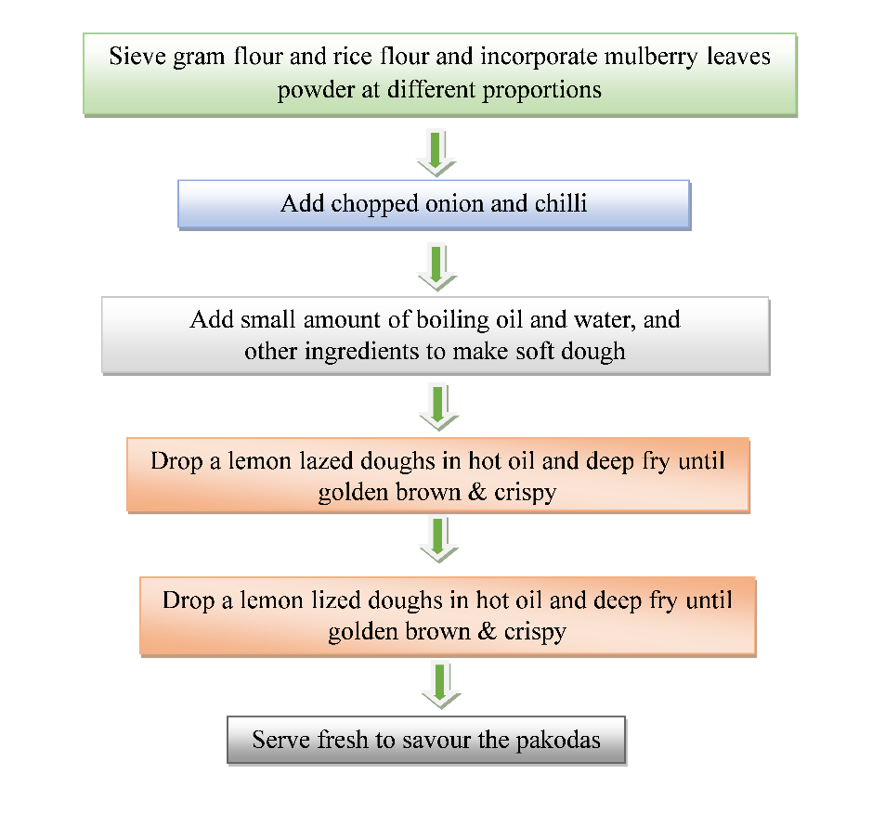

Fig. 1: Procedure to prepare mulberry leaf pakoda

2.3 Organoleptic evaluation of prepared products
The prepared products were evaluated organoleptically by a semi-trained panel of 21 judges. The judges were served each preparation with one control and four test samples. Control samples were prepared from ingredients used in usual recipes and test samples of Pakoda were prepared by using dehydrated mulberry leaves at four different levels of 2.5 per cent, 5 percent 7.5 per cent, 10 per cent and control. Different sample with different levels of mulberry leaf powder used in the food products were given to panelists, the levels were not revealed to get their exact feedback of the samples. Sensory evaluation of the developed products was carried out to determine the most suitable level of mulberry leaves incorporated in pakoda. The panels were provided with 9-point hedonic scale for attributes like appearance, colour, texture, aroma, taste and overall acceptability. The mean scores for the varieties for each product were then calculated. The sensory evaluation was performed in controlled environmental conditions with minimum distractions to reduce the effect of physical conditions on panelist’s judgment (Plate. 1). The scores assigned were as follows:
Grading Scores: Like extremely- 9, Like very much -8, Like moderately -7, Like moderately 6, Like slightly -5, Dislike slightly- 4, Dislike moderately -3, Dislike very much -2, Dislike extremely- 1.

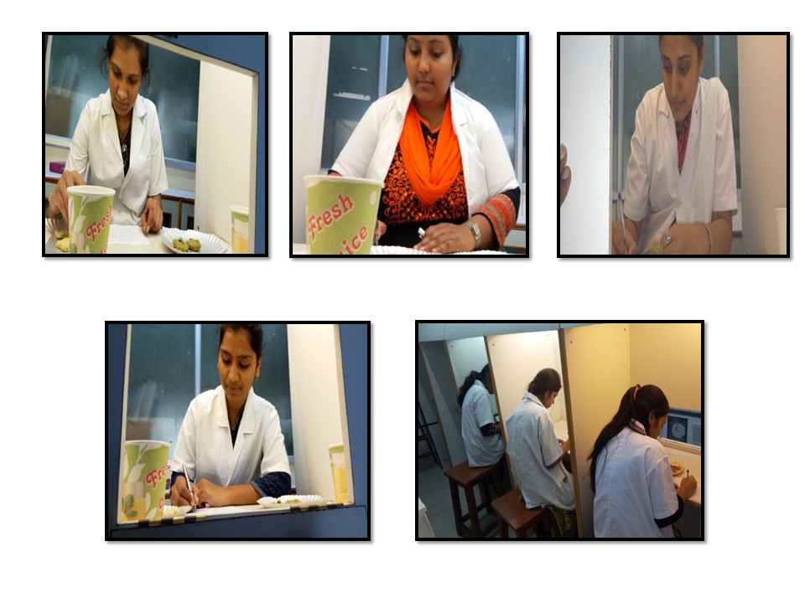

Plate 1: Sensory evaluation of mulberry leaf incorporated pakoda by the panelists
2.4 Nutrient analysis
The nutrient content of highly accepted variation of mulberry leaf powder pakoda was analyzed. Moisture free sample was used for analysis. The proximate composition (moisture, total protein, fat, fiber and total minerals) was carried out as per procedures prescribed by A.O.A.C. (1980). Carbohydrate content was calculated by difference method. Calcium was estimated by EDTA method. Trace elements (iron, copper, zinc and magnesium) were estimated by Atomic Absorption Spectrophotometer (Perkin R Elmer Model - 3110). The values for all nutrients were averages of triplicate value on dry weight basis. The data of acceptability of four developed variations of mulberry leaves powder pakoda were statistically analyzed by one-way analysis of variance and ‘F’ values were calculated to find out the difference among the developed variations of herbal composite.
2.5 Cost calculation of the developed pakoda
Cost calculation was done for the best accepted products. This included cost of the ingredients and overhead charges at 30 per cent which include Labour charge, electricity, machinery, packaging cost, etc. and then the total price was calculated for 100 g of the products.
2.6 Statistical analysis
Data was analyzed using one-way analysis of variance (ANOVA) procedures in a randomized complete block design with three replications.
3. results and discussion
3.1 Sensory evaluation of mulberry leaves pakoda (MLP)
Five variations of pakoda were prepared by incorporating mulberry leaf powder at different levels (2.5%, 5%, 7.5%, and 10%) and compared with a control sample without mulberry leaf powder. The products were subjected to sensory evaluation using a 9-point hedonic scale by a semi-trained panel of 21 members. Mean scores for sensory characteristics such as appearance, colour, texture, flavour, taste, and overall acceptability are shown in Table 2.
All sensory attributes differed significantly (p ≤ 0.05) among the treatments. The results revealed that pakoda incorporated with 5% mulberry leaf powder (MLP 5%) was most preferred with the highest overall acceptability score (8.05). The incorporation of 5% leaf powder improved appearance, flavour and taste which might be attributed to the natural green pigment, mild herbal aroma and characteristic flavour of mulberry leaves. In contrast, the control sample recorded the lowest scores for appearance (6.0), flavour (5.5) and taste (6.75), indicating that the inclusion of mulberry leaf powder enhanced the sensory appeal of the product. However, at higher incorporation levels (7.5% and 10%), the sensory scores declined slightly, possibly due to an increased greenish tint, a bitter or earthy aftertaste, and a denser texture caused by higher leaf content interfering with batter consistency.
These results are in agreement with findings by Sarkar et al. (2023) and Londhe, (2023) who reported that the addition of green leafy powders such as spinach or moringa at 5-6% improved colour and acceptability in fried snacks, while higher incorporation levels reduced consumer preference. Overall, the sensory evaluation clearly indicates that 5% incorporation of mulberry leaf powder produced the most acceptable product, balancing nutritional enrichment with desirable sensory properties.
Table 2: Mean sensory score of mulberry leaf pakoda (MLP)
Products | Sensory attributes
Products | Appearance | Texture | Colour | Flavour | Taste | Overall  acceptability
MLP (2.5 %) | 7.0^{b} | 7.0^{b} | 7.5^{b} | 7.0^{b} | 7.75^{c} | 7.50^{c}
MLP (5 %) | 8.0ª | 7.0^{b} | 8.0ª | 7.5ª | 8.00ª | 8.05ª
MLP (7.5%) | 8.0ª | 8.0ª | 8.0ª | 7.5ª | 8.00ª | 7.75^{b}
MLP (10 %) | 6.5^{c} | 6.5^{c} | 7.5^{b} | 6.5^{c} | 7.50^{b} | 7.20e
Control | 6.0^{d} | 6.0^{d} | 8.0ª | 5.5^{d} | 6.75^{d} | 7.25^{d}
F-test | * | * | * | * | * | *
SEm± | 0.057 | 0.075 | 0.049 | 0.070 | 0.056 | 0.045
CD @ 5 % | 0.171 | 0.225 | 0.14 | 0.20 | 0.166 | 0.133
*Significance, at 5 per cent level, MLP- Mulberry leaves pakoda (2.5 per cent), MLP- Mulberry leaves pakoda (5 per cent), MLP- Mulberry leaves pakoda (7.5 per cent), MLP- Mulberry leaves pakoda (10 per cent).
3.2 Proximate composition of Pakoda
The proximate composition of the best accepted sample (MLP 5%) was compared with the control (Table 3). The incorporation of mulberry leaf powder improved the nutritional composition of pakoda. Moisture content slightly decreased from 3% to 2.32%, which could be attributed to the fibrous nature of mulberry leaves absorbing less oil and moisture during frying.
Table 3: Proximate compositions of pakoda
Proximate | Control | MLP (5 %) | t value
Moisture (%) | 3 | 2.32 | 7.98*
Protein (g) | 17.27 | 18.57 | 29.30*
Fat (g) | 20.61 | 21.2 | 9.24*
Fibre (g) | 5.6 | 6.5 | -
Ash (g) | 12 | 13.13 | 5.01*
CHO (g) | 41.52 | 38.28 | 9.58*
Energy (Kcal) | 407.5 | 420.2 | 33.57*
T test -NS- non significant, * significant, MLP- mulberry leaves pakoda
Protein content increased from 17.27 g in the control to 18.57 g in MLP 5%. This rise can be attributed to the native protein present in mulberry leaves, which are known to have approximately 25-28% crude protein on a dry weight basis. Similarly, fat content (21.2 g) showed a marginal increase due to oil absorption during frying, while crude fibre (6.5 g) increased significantly compared to control (5.6 g), indicating improved dietary fibre content beneficial for digestion. Ash content, a measure of mineral concentration, was also higher in the MLP sample (13.13 g) than in control (12 g), confirming that mulberry leaves contributed additional mineral elements. However, carbohydrate content showed a slight reduction (from 41.52 g to 38.28 g) due to partial replacement of gram flour with mulberry leaf powder, which is relatively lower in starch. The same result was found in the study conducted by Verma and Jain (2012) that substantial increase in the nutritional value of the products enriched by green vegetable.
The increase in energy value (420.2 kcal compared to 407.5 kcal) may be due to the rise in protein and fat contents. These findings corroborate previous studies by Kaur et al. (2022) and Ruth, et al. (2021), who observed that the addition of green leaf powders enhanced the protein and mineral contents of traditional fried products. Thus, the incorporation of mulberry leaves not only improved the sensory appeal but also enriched the proximate composition, making the product more nutrient-dense.
3.3 Mineral composition of Pakoda
The mineral composition of control and 5% MLP samples are presented in Table 4. Significant increases were observed in zinc, iron, copper, and calcium levels in the MLP sample compared to the control. Zinc increased from 2.9 mg to 3.28 mg, iron from 13.58 mg to 14.5 mg, and copper from 1.9 mg to 2.68 mg. The calcium content showed a remarkable increase from 87.2 mg to 121.5 mg, indicating that mulberry leaves serve as an excellent source of calcium.
Table 4: Mineral composition of pakoda
Micro nutrients (mg) | Control | MLP (5%) | t value
Zinc | 2.9 | 3.28 | 23.14*
Iron | 13.58 | 14.5 | 35.81
Manganese | 1.75 | 1.89 | -
Copper | 1.9 | 2.68 | 6.7*
Calcium | 87.2 | 121.5 | 3.12*
T test- NS- non significant, * significant, MLP- mulberry leaves pakoda.
The higher mineral content in mulberry leaf incorporated pakoda can be attributed to the rich mineral profile of mulberry leaves, which are reported to contain high amounts of iron, calcium, and zinc. These minerals play critical roles in various physiological functions iron in oxygen transport, zinc in enzymatic activities and immunity, and calcium in bone health. Although manganese content increased slightly (1.75 to 1.89 mg), the difference was statistically non-significant, suggesting a minor contribution of mulberry leaves to this particular mineral.

3.4 Anti-nutrient content of pakoda
The anti-nutritional factors such as phytates, oxalates, and tannins in the control and 5% MLP samples are presented in Table 5. The levels of phytates and oxalates decreased slightly in the MLP sample, while tannin content showed a non-significant reduction.
Phytic acid reduced from 83.9 mg to 82.54 mg and oxalic acid from 63.54 mg to 62.29 mg. This minor reduction may be due to the heat treatment during frying, which can degrade or inactivate some anti-nutritional compounds. Mulberry leaves themselves contain moderate levels of these compounds. However, the overall effect was negligible due to dilution in the composite batter. These results are consistent with studies by Kumari et al. (2009) who found that cooking and frying processes significantly reduced anti-nutrient levels in green leaf-fortified snacks, improving the bioavailability of minerals. Hence, the incorporation of mulberry leaves at 5% did not adversely affect the safety or nutritional quality of the pakoda. On the contrary, it slightly reduced anti-nutritional factors, enhancing its overall nutritive value.
Table 5: Anti-nutrient contents of pakoda
Anti-nutrients | Control | MLP (5 %) | t value
Phytates (mg/100g) | 83.9 | 82.54 | 4.48*
Oxalates (mg/100g) | 63.54 | 62.29 | 3.92*
Tannin(mg/100g) | 0.125 | 0.121 | -
T-test, *Significance, NS- Non significant at 5per cent level, MLP- Mulberry leaves pakoda (5 per cent), Control- with no mulberry leaf.
3.5 Cost of production of best accepted mulberry leaves pakoda
The production cost of the best accepted mulberry leaves pakoda (5 per cent) and control without mulberry leaves was calculated and depicted in the Table 6. The cost of raw material for control was 5.66 and pakoda prepared with mulberry leaves was 5.872, production cost for control is 1.69 and for best accepted one is 1.76 and selling price for 100gm is pakoda for best accepted one was Rs.11.22 and for control was Rs.10.81 respectively. Cost of mulberry leaves pakoda is slightly high compared to control but it is not varied very high because the cost of mulberry leaves is very less and the quantity per kg is also more compared to other green leafy vegetables.
Pakoda was prepared by incorporating mulberry leaf powder at different levels i.e. 2.5, 5, 7.5 and 10 per cent and control (with no mulberry leaf incorporation). Mulberry leaf pakoda (MLP) with 5 per cent incorporation was found to be best accepted with scores for appearance 8, texture 7, colour 8, flavor 7.5, taste 8, and overall acceptability 8.05, respectively.
Nutrient analysis results showed that proximate composition and mineral content was found highest in best accepted treatment i.e., mulberry leaves pakoda at 5 per cent and it was also noticed that anti-nutrient content was found less in 5 per cent mulberry leaves pakoda compared to control which may be due to less anti-nutrient content found in mulberry leaves and due to blanching of leaves also leads to decrease in anti-nutrient content and increase in minerals and protein content.
The nutrient analysis of mulberry leaf pakoda at 5 per cent concentration revealed that it had high nutrient content compared to control by adding mulberry leaves where similar results obtained by Manohar (2017) evaluated nutrient composition of vada using curry leaf powder containing different proportions ranging from 2.5 to 7.5 per cent. It was observed that test sample supplemented with 2.5 percent dehydrated curry leaves was found to be highly acceptable amongst the test samples. The nutrient composition of test sample had iron (4.43 mg/100g) and Calcium (219.30 mg/100g).
Table 6: Production cost of mulberry leaves pakoda (per 100 g)
Ingredients | Ingredients  cost/kg | Control |  | 5 per cent
Ingredients | Ingredients  cost/kg | Ingredients  used (g) | Price  Rs | Ingredients  used (g) | Price  Rs
- Raw material cost/kg (Total)
Mulberry leaves | 20 | - | - | 5 | 0.1
Gram flour | 75 | 54 | 4.05 | 59 | 4.46
Onion | 25 | 30 | 0.75 | 20.5 | 0.512
Chilli | 60 | 6 | 0.36 | 5 | 0.3
Rice flour | 50 | 10 | 0.5 | 10 | 0.5
Yield (g) |  | 100 | - | 100 | -
Total cost Raw material |  | - | 5.66 | - | 5.872
B. Production cost including machinery and labour cost @ 30 per cent of raw material cost |  |  | 1.69 |  | 1.76
Sub total |  | - | 7.35 | - | 7.632
C. Institutional charges @ 10 per cent (A+B) |  |  | 1.30 |  | 1.35
Sub total |  | - | 8.65 | - | 8.982
D. Profit @ 10 per cent (A+B+C) |  |  | 2.16 |  | 2.24
Cost per 100 g |  | - | 10.81 | - | 11.22

4. Conclusion
Mulberry leaves have been used in traditional Chinese medicine since time immemorial due to presence of high nutrient and less anti-nutrient content and mainly presence of 1-Deoxynojirimycin which is α-glucose inhibitor helps in lowering blood glucose level and it is being used in preparation of different food products in China and Korea, where as in India mulberry is mainly cultivated for sericulture i.e., rearing silkworm and less awareness of its nutrient and health benefits, thus this study revealed that addition of mulberry leaves at 5 per cent in pakoda has been accepted organoleptically by a semi-trained panel of 21 judges and the presence of mulberry leaves increased proximate and mineral composition and mainly decreased anti-nutrient content of pakoda and cost of product is also reasonable. Hence, value addition of different traditional products with dehydrated mulberry leaves can be advocated as a feasible food-based approach to combat micronutrient malnutrition.

Consent (where ever applicable)
Not Applicable

Ethical approval (where ever applicable)
Not Applicable

Disclaimer (Artificial intelligence)
Option 1:
Author(s) hereby declares that NO generative AI technologies such as Large Language Models (ChatGPT, COPILOT, etc.) and text-to-image generators have been used during the writing or editing of this manuscript.

References
A.O.A.C., 1980, Official methods of analysis, 13th edition. Association of official agricultural chemists, Washington, D. C.
Gopalan, C., Ramashastri, B. V. And Balasubramanium, S. C., (1999). Nutritive Value of Indian foods, National Institution of Nutrition, ICMR.
Hu L, Wang C, Guo X, Chen D, Zhou W, Chen X, Zhang Q. (2021). Flavonoid levels and antioxidant capacity of mulberry leaves: Effects of growth period and drying methods. Frontiers in Plant Science. Aug 4; 12:684974.
ICMR, (2020) Recommended dietary allowances and estimated average requirements nutrient requirements for Indians. National Institute of Nutrition, 1-304.
Kaur, N., Agarwal, A. and Sabharwal, M., (2022). Food fortification strategies to deliver nutrients for the management of iron deficiency anaemia. Current Research in Food Science, 5,pp.2094-2107.
Knez, M., Mattas, K., Gurinovic, M., Gkotzamani, A., & Koukounaras, A. (2024). Revealing the power of green leafy vegetables: Cultivating diversity for health, environmental benefits, and sustainability. Global Food Security, 43, 100816.
Kumari, R., Srivastava, S., & Srivastava, R. P. (2009). Nutritional evaluation of fresh leaves of mulberry genotypes. Agricultural Science Digest, 29(3), 198–201.
Liu, C. H., Liu, F., & Xiong, L. (2023). Medicinal parts of mulberry (leaf, twig, root bark, and fruit) and compounds thereof are excellent traditional Chinese medicines and foods for diabetes mellitus. Journal of Functional Foods, 106, 105619.
Londhe, S., (2023). Effect of Spinach (Spinacia oleracea) and Moringa (Moringa olerifia) Powder on Physcio-chemical and Sensory Attributes of Chicken Meat Balls.
Manohar Lal, (2017). Development and nutritional evaluation of value-added fermented food products using curry leaves (Murraya koenigii), Thesis (M.Sc.). Punjab Agricultural University Ludhiana, 41-57.
Mazumder, S., Roychowdhury, A. And Banerjee, S., (2016). Development and storage stability of aseptically processed ash gourd- mint leaves juice. Inter. Food Res. J., 19 (3): 823- 828.
Pant, R., (2011). Development and nutritional evaluation of value-added cereal pulse-based products using drumstick leaves (Moringa oleifera), Punjab Agricultural University, Ludhiana, pp. 41.
Priya, S., (2012). Medicinal Values of Mulberry –An Overview, Journal of Pharmacy Research, 5 (7): 3588-3596.
Rajendra Prasad, M. P., Dayankar, B. R., Kalpana, K And Ratnavathi, C., (2015). Organoleptic Properties and Nutrient Composition of Indian traditional snack recipes prepared from sorghum. Kar. J. Agri sci., 11(1): 43-48.
Ruth, O. N., Unathi, K., Nomali, N., & Chinsamy, M. (2021). Underutilization versus nutritional-nutraceutical potential of the Amaranthus food plant: a mini-review. AppliedSciences, 11(15),6879.
Sarkar, T., Salauddin, M., Roy, S., Chakraborty, R., Rebezov, M., Shariati, M.A., Thiruvengadam, M. and Rengasamy, K.R.R., (2023). Underutilized green leafy vegetables: frontier in fortified food development and nutrition. Critical Reviews in Food Science and Nutrition, 63(33), pp.11679-11733.
Shivakumar, G. R., Anatha Rainan, K. V., Magadum, S. B. And Datta, R. K., (1995). Medicinal values of mulberry. Indian Silk, 34 (7), 15- 16.
Singh, A., Grover, K. And Sharma, N. (2014). Nutrition evaluation of value-added products using dehydrated greens for security of haematinic nutrient. Food Sci. Res. J., 5(2): 168- 173.
Southgate, D. A., (1995) Digestion and metabolism of sugars. American. J. Clin. Nutri., 62 (1).
Sreekumar, S., Nair, G. S., Appaswamy, P., Vijayraghavan, K. And Thiagarajan, V., (1994). Now, mulberry on your dining table. Indian Silk, 33, 45.
Srivastsava, S., Arya, C., Chaturvedi, R And Srivastava, R. P., (2009). Mulberry leaf-based soups: Nutritional Aspects. Indian silk, 8(3): 10-11.
Swanmathan, M. S., (1999). Food Security in India in the 21st Century. Proc Nutc Soc. Inrliu. 46, 1-10.
Verma, S. and Jain, S., (2012). Fortification of mathri with fresh and dehydrated vegetables and assessment of nutritional quality. Rajasthan Journal of Extension Education, 20, pp.155-158.
World Health Organization (1991): Prevalence of blindness. Statistics Annual, 16- 17.

