Formulation and Optimisation of Functional Greek Style Yoghurt Sauce

ABSTRACT

Aims: To develop and optimize a Functional Greek Style Yoghurt Sauce by incorporating nutrient-rich ingredients and to evaluate the effect of different inclusion levels on sensory characteristics and to identify the most acceptable combination.
Study design: Formulation of Functional Greek Style Yoghurt Sauce using varying levels of functional ingredients followed by sensory evaluation to determine the optimized formulation based on overall acceptability.
Place and Duration of Study: The study was conducted at the Department of Dairy Technology, Dairy Science College, Hebbal, Bengaluru, Karnataka, India, during the period from December 2024 to September 2025.
Methodology: Standardized cow milk (3.5% fat, 8.5% SNF) was fortified with 3% WPC-80 and heated at 90°C for 2–3 min, cooled to 42°C, inoculated with Streptococcus thermophilus and Lactobacillus delbrueckii subsp. bulgaricus at 2% (v/v). yoghurt culture, incubated for 5 h, and The whey was separated at 7±1°C for 8 h to obtain Greek style yoghurt. And then it blended with 10% olive oil, 1% salt, and different levels of dried spinach (3–7%), proso millet (1–3%), dried thyme, and green chili (0.5–1%). The developed product was assessed by trained panelists through a 9-point hedonic sensory evaluation.
Results: Among the different levels tested, best acceptability was observed with 3% spinach, 1% proso millet, 0.75% thyme, and 0.5% green chili, significantly improving flavor, colour and appearance, body and texture and overall acceptability.
Conclusion: The study concluded that fortification of Greek style yoghurt Sauce with functional ingredients such as dried spinach, proso millet, thyme, and green chili positively enhances sensory quality and delivering a required nutrition when used at optimized levels, making it a promising health-oriented dairy condiment for the market.

Keywords: Greek style yoghurt, Sauce ,Whey Protein Concentrate, Virgin Olive oil, Dried Spinach, Proso millet, Green chili

1. INTRODUCTION

India, the world’s largest milk producer, contributes nearly 25% of global milk supply, producing about 239.30 million tonnes in 2023–24 (FA0, 2024).The global yoghurt industry was worth approximately USD 125.16 billion in 2024 and is forecasted to expand to about USD 189.19 billion by 2032, reflecting a CAGR of 5.3% (Statista, 2023; GII, 2023). Similarly, the sauces market reached USD 9.8 billion in 2024 and is anticipated to increase to USD 17.2 billion by 2033, driven by consumers’ growing preference for convenient and flavour-enhancing condiments. Globally, the yoghurt market was valued at around USD 125.16 billion in 2024 and is projected to reach USD 189.19 billion by 2032, growing at a CAGR of 5.3% (Statistica, 2023; GII ,2023). In the table Sauces segment, the market stood at USD 9.8 billion in 2024 and is expected to grow to USD 17.2 billion by 2033, fueled by rising consumer demand for convenience and flavor- rich condiments.
Modern lifestyles have greatly influenced food habits, increasing the demand for quick, convenient, and ready-to-eat meals. With less time for home cooking, precooked dishes have become popular, and Sauces play an important role in enhancing flavor, texture, and appeal (Herranz et al., 2019). Sauces, now a global staple, are not just convenient but also nutritionally and economically significant in modern diets (García et al., 2016). Typically, they are prepared using vegetable oil emulsified with milk proteins and stabilized with thickeners, often combined with salt, spices, flavors, and additives (Szafrańska et al., 2021). However, high consumption of ultra-processed foods has been linked to higher risks of cardiovascular, coronary, and cerebrovascular diseases. Factors such as nutrient composition, additives, and even packaging materials may contribute to these risks (Srour et al., 2019). As a healthier option, yoghurt-based Sauces are gaining popularity, offering rich flavor with added health benefits. Yoghurt is widely regarded as a functional food due to its, probiotic activity, and positive effects on gut health, making it an excellent base for developing low-fat, probiotic-rich products such as synbiotic yoghurt Sauces (Kazemeini et al., 2023). The concept of functional foods aligns with the age-old saying, “Let food be thy medicine and medicine be thy food”. While this idea dates back to Hippocrates, modern science is transformed it into a research-driven approach to improving human health. The concept of functional foods first emerged in Japan in 1984, when the government established the Food for Specific Health Uses (FOSHU) category to recognize food products that provide scientifically validated health benefits. (Temple, 2022). Inspired by this, the United States introduced its first Health Claim Act in the 1990s, formally recognizing the role of food in disease prevention. With growing health consciousness, consumers increasingly prefer food products that contribute to overall well-being rather than merely fulfilling nutritional needs. The surge in lifestyle-related illnesses, including diabetes, obesity, and cardiovascular diseases, has also strengthened the interest in functional foods as a proactive approach to maintaining health and preventing disease. (Topolska et al., 2021). According to FAO (2022) functional foods are those that, in addition to nutrients, also contain other components that may be beneficial to health. In general, functional foods are defined as products that contain biologically active compounds and provide clinically proven health benefits beyond basic nutrition, offering both nutritive and medicinal value. These foods are now widely incorporated into everyday diets. Examples in the dairy sector include fortified cheese and phycocyanin yoghurt, while in the cereal category they include wheat bread dough enriched with microalgae or doughnuts and biscuits with added ascorbic acid. Functional ingredients are also found in products such as chocolate shakes with added fibre, extruded snacks designed for high nutritional value, and spreads and dressings fortified with omega-3 polyunsaturated fatty acids such as EPA and DHA (Yuan et al., 2024)
Greek-style yoghurt is a thick and creamy form of traditional Yoghurt, produced by straining to remove a portion of the whey along with water-soluble components such as lactose and minerals. As specified by the Codex Alimentarius, strained yoghurt is derived from full-fat yoghurt by partial whey removal, and when prepared using cow or goat milk, it must contain a minimum protein content of 5.6%.Most commonly produced from bovine milk, Greek style yoghurt involves fermentation with Streptococcus thermophilus and Lactobacillus delbrueckii subsp. Following fermentation, whey is removed through centrifugation, producing a richer, thicker Yoghurt with increased total solids and a more pronounced tangy flavor (Karastamatis et al., 2022)
Spinach (Spinacia oleracea) is a nutrient-rich leafy vegetable containing vitamins A, C, E, K, folate, and essential minerals. It is also high in phytochemicals, flavonoids (quercetin, myricetin), and carotenoids (lutein, β-carotene, zeaxanthin), which provide strong antioxidant and anti-inflammatory benefits. Regular consumption supports eye health, lowers cholesterol and blood sugar, and helps manage body weight due to thylakoids. Spinach intake is also associated with reduced risk of chronic diseases, including breast, colon, and oesophageal cancers (Chokkara et a., 2022)
Proso millet (Panicum miliaceum) is an ancient, climate-resilient grain believed to have originated in China. It grows well with minimal water, tolerating drought conditions with 200–500 mm rainfall. Nutritionally rich, it contains 11.3–17% protein, dietary fiber (14.2 g/100 g), essential minerals (iron, zinc, copper, manganese), and key amino acids such as leucine, isoleucine, and methionine. Being gluten-free, it supports heart and liver health, diabetes management, and may help reduce cancer risk (Bhat et al., 2019)
Thyme (Thymus vulgaris) is a Mediterranean perennial herb valued for culinary and medicinal uses. Its leaves contain vitamins A, C, K, and E, along with minerals like potassium, calcium, iron, manganese, and magnesium. Thyme’s key bioactive compounds, especially thymol and carvacrol, provide strong antioxidant and anti-inflammatory benefits. It is widely recognized for its antimicrobial properties, effectively inhibiting bacterial, fungal, and viral growth and disrupting biofilms, making it beneficial for overall health and disease prevention (Hammoudi et al., 2022)
Green chili (Capsicum annuum) is a widely used spice rich in provitamin A, vitamins C, E, B1, B2, and B3, along with minerals such as potassium, calcium, manganese, phosphorus, and magnesium. It is also an efficient iron source, producing nearly twice the iron per unit of land compared to cereals. Capsaicin, responsible for pungency, offers strong antioxidant, anti-inflammatory, and analgesic effects while improving calcium, iron, and zinc absorption. According to the Olatunji and Afolayan 2018, green chilies also contain bioactive compounds with antimicrobial, antiviral, and anticancer activities.
The study aimed to develop a functional Greek yoghurt sauce with nutrient-rich ingredients and assess the sensory impact of varied levels to identify the best formulation.
2. material and methods

2.1 Materials
Fresh cow milk, containing 3.5% fat, 8.5% solids not-fat (SNF), 0.104% acidity (as lactic acid), and a pH of 6.61, was obtained from the Students Experimental Dairy Plant, Dairy Science College, Hebbal, Bengaluru.This milk served as the primary ingredient in the preparation of the Functional Greek style yoghurt Sauce. The freeze-dried Yoghurt starter cultures used for fermentation were sourced from Delvo DSL Pvt. Ltd., Netherlands, and preserved at −40°C to maintain their viability. Before inoculation, the cultures were activated by propagating them in MRS broth at 37°C for 24 hours. The resulting cells were then resuspended in a 10% skim milk solution and incubated at 37–38°C for 18 hours to develop an active starter culture suitable for Greek Yoghurt production. From this active culture, 2% (v/v) inoculum was used for fermentation.. Virgin olive oil (Tata Simply Better, Tata Consumers Pvt. Ltd., West Bengal, India) and edible iodized salt (TATA Salt, Tata Chemicals Ltd., Mumbai, India) were sourced from the local market. Dried spinach powder (Nature’s Gift, Maharashtra, India) and proso millet powder (Desi Nutri, marketed by Aditi Millets & Organics, Bengaluru, India) were also procured commercially. Dried thyme leaves (Agri Club, Himachal Pradesh, India) and fresh green chilies were purchased from More Supermarket, R.T. Nagar, Bengaluru, India, ensuring good quality raw ingredients for the study.

2.2. Methods
The Functional Greek style yoghurt Sauce (FGYS) developed with standardized cow milk (fat 3.5%, SNF 8.5%). And it was subjected to heat treatment at 90°C for 2–3 minutes. The heated milk was then cooled to 42°C before the addition of a starter culture Streptococcus thermophilus and Lactobacillus delbrueckii subsp. bulgaricus at 2% (v/v). The inoculated milk was incubated at 42°C for 5 hours to allow proper fermentation. After incubation, the coagulum was dewheyed at 7±1°C for 8 hours to obtain Greek style yoghurt.The Greek style yoghurt was incorporated with Whey protein concentrate (WPC-80) at a concentration of 3%, then blended under aseptic conditions with virgin olive oil, iodised salt, dried spinach, proso millet powder, dried thyme and green chili to prepare the Functional Greek style yoghurt Sauce. The developed sauce was filled into 100 g PET containers and stored at 7 ± 1°C until analysis. The complete preparing procedure and experimental design are illustrated in the process flow diagram (Fig. 1).

2.2.1 Optimisation of Functional Greek Style Yoghurt Sauce
To develop a Functional Greek style yoghurt Sauce with improved sensory qualities, different levels of functional ingredients were tested. Dried spinach was added at 3%, 5%, and 7% to enhance colour and nutritional value. Proso millet flour was incorporated at 1%, 2%, and 3% to improve body, texture, and fiber content. Dried thyme and green chilli were each added at 0.5%, 0.75%, and 1.0% to enhance flavour and contribute health benefits. All formulated samples were then evaluated by trained panelists for sensory evaluation.

2.3 Sensory evaluation
The sensory qualities of the developed Functional Greek Style Yoghurt Sauce were assessed by trained panelists using a 9-point hedonic scale, where a score of 1 indicated “dislike extremely” and 9 indicated “like extremely.” The evaluation included key attributes such as flavour, colour and appearance, body and texture, and overall acceptability.Each sample was coded with a random three-digit number to ensure blind testing, and the evaluations were conducted under controlled conditions at refrigeration temperature (7± 1°C) to minimize external influences. The assessment followed standardized sensory protocols and ethical guidelines, ensuring both scientific rigor and the safety of the panelists (Peryam and Pilgrim 1957).

Cow Milk (Fat 3.5%, SNF 8.5%)

WPC- 80 (3 %)
Heat Treatment of milk (90 ºC/ 2-3 min) Milk
Cooling (42 ºC)
Addition of starter culture(Streptococcus thermophilus and Lactobacillus bulgaricus @ 2%) Incubation @ 42 ºC/5h
Removing of whey @ 7±1℃ /8h
Greek Yoghurt
Addition of virgin olive oil (10%)
Addition of Iodised salt 1.0%

Greek Yoghurt Sauce
Reconstituting with 1: 1 Pasteurized Yoghurt Whey
Addition of dried spinach (3,5,7 %)

Addition of proso millet powder (1,2,3%)
Addition of dried thyme (0.5, 0.75, 1%)
Addition of green chili (0.5, 0.75, 1%)
Blending (Under hygienic conditions)
Functional Greek Yoghurt Sauce

Packaging (PET cups,100g
Storage (7±1°C)

Fig 1 Process Flow Chart for the development of Functional Greek Style Yoghurt Sauce

3. results and discussion
3.1 Optimisation of dried spinach for development of Functional Greek Style Yoghurt Sauce
The present study revealed that incorporation of dried spinach in Greek style yoghurt Sauce significantly affected sensory attributes. Among the treatments, 3% dried spinach was found to be the most acceptable level, recording the highest scores for flavour (8.43), colour and appearance (8.54), body and texture (8.27), and overall acceptability (8.34). Compared to the control, 3% supplementation markedly improved sensory appeal. However, when the concentration was further increased to 5% and 7%, gradual declines in flavour, colour and appearance, body and texture, and overall acceptability were observed, suggesting that higher additions led to undesirable sensory effects such as off-notes and texture imbalances.
El-Sayed 2021 developed UF soft cheese enriched with varying concentrations of spinach nano powder (0.50 to 2.00%). Among the formulations, cheese containing 0.50% spinach powder recorded the highest sensory scores, showing values very close to the control: outer appearance 19.15, body & texture 38.19, aroma & flavour 39.00, and total score 96.34. As the concentration of spinach powder increased, sensory scores gradually declined: 1.00%.received a total score of 95.56, 1.50% scored 94.81, and the highest concentration of 2% scored 92.51.
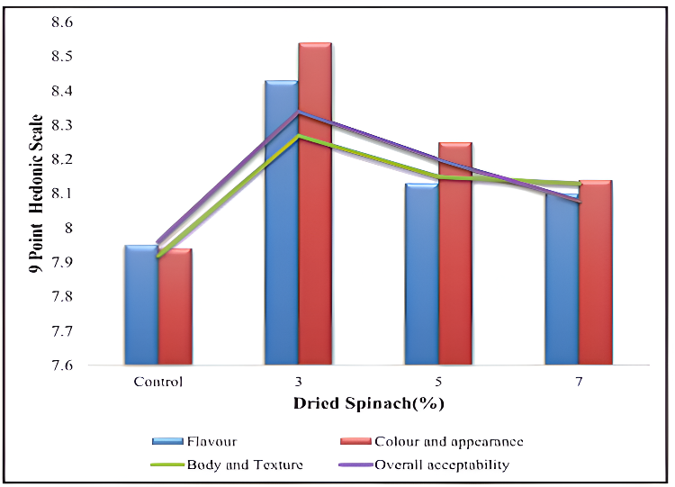

Fig 2. Graph showing the Effect of various levels of dried spinach on the sensory characteristics of Functional Greek Style Yoghurt Sauce

3.2 Optimisation of proso millet for development of Functional Greek Style Yoghurt Sauce
Among the treatments, 1% proso millet was found to be the most acceptable level, recording the highest scores for flavour (8.32), colour and appearance (8.29), body and texture (7.92), and overall acceptability (8.26). Compared to the control, 1% supplementation markedly improved sensory appeal. However, when the concentration was further increased to 2% and 3%, gradual declines in flavour, colour, body, and overall acceptability were observed, with 2% showing moderate values and 3% the lowest, suggesting that higher additions led to undesirable sensory effects such as off-notes and texture imbalances.

Thao et al. (2025) demonstrated that kefir yoghurt produced with the addition proso millet was significantly influenced by technological parameters. The highest sensory acceptability was obtained at a 1:1 millet-to-water ratio, with colour (4.00), aroma (3.25), flavour (3.25), consistency (3.25), and overall acceptability (3.44), indicating that proper processing conditions play an important role in enhancing consumer preference.
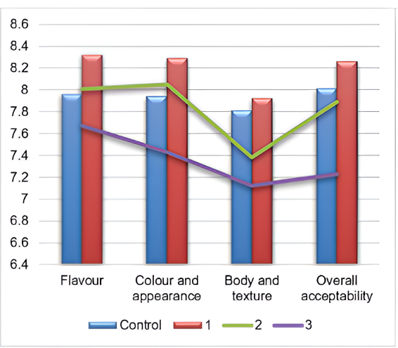

Fig 3. Graph showing the Effect of various levels of proso millet on the sensory characteristics of Functional Greek Style Yoghurt Sauce
3.3 Optimisation of dried thyme for development of Functional Greek Style Yoghurt Sauce
Incorporation of dried thyme in Functional Greek Style Yoghurt Sauce significantly influenced sensory attributes. Among the tested concentrations, 0.75% dried thyme yielded the most favourable sensory profile, with the highest scores for flavour (8.56), colour and appearance (8.59), body and texture (8.42), and overall acceptability (8.63). This indicates that moderate incorporation enhances overall sensory quality. In contrast, the 0.5% level showed moderate improvements over the control, while the highest concentration (1%) led to a marked decline in acceptability, suggesting that excessive addition adversely affects flavour and body and texture.
Abdelhamid et al. (2021) demonstrated that thyme oil-flavoured acidophilus Labneh achieved a total sensory score of 86 on day 1, with body and texture 37, flavour 40, and appearance 9, reflecting positive effects on sensory attributes, although the control sample scored slightly higher (91).
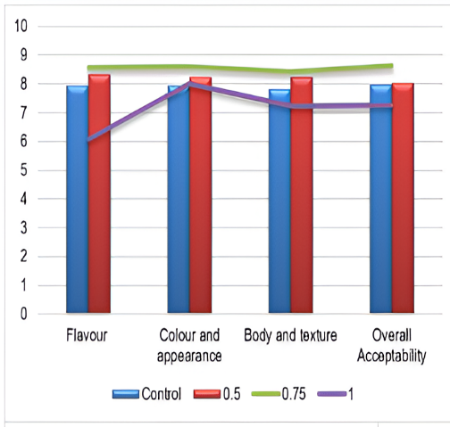

\
Fig 4. Graph showing the Effect of various levels of dried thyme on the sensory characteristics of Functional Greek Style Yoghurt Sauce
3.4 Optimisation of green chili for development of Functional Greek Style Yoghurt Sauce
The control sample recorded a flavour score of 7.95, while the Functional Greek style yoghurt Sauce containing 0.5%, 0.75%, and 1.0% green chili achieved scores of 8.66, 8.34, and 8.10, respectively. Statistical analysis showed that the 0.5% green chili sample had a significantly higher flavour score than both the control and other concentrations. The enhanced score at this level can be attributed to the mild pungency and fresh aroma of green chili, which complemented the creamy yoghurt base and enriched the overall flavour profile. However, at higher concentrations (0.75% and 1.0%), the strong heat intensity slightly overpowered the base flavour, leading to a reduction in consumer preference.
Kovsari et al. (2024) observed that stirred yoghurt fortified with 200 ppm green pepper extract obtained the most favourable sensory scores for taste (8.63) and aroma (6.83). Although the 300 ppm sample had slightly higher numerical scores (taste 9.29, aroma 6.85), the 200 ppm sample was considered more favourable in terms of overall acceptance. Our findings on yoghurt fortified with chili extract correspond with this trend, confirming that moderate incorporation enhances product acceptability, while higher levels diminish consumer acceptance.
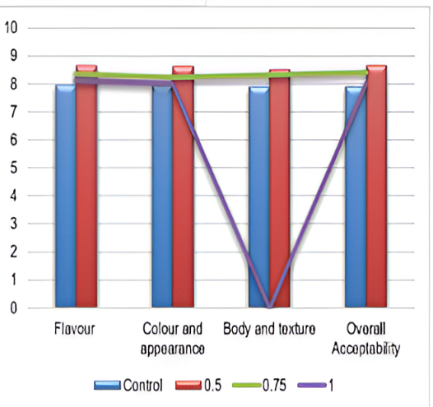

Fig 5. Graph showing the Effect of various levels of green chili on the sensory characteristics of Functional Greek Yoghurt Sauce

3. 5 Sensory analysis of Control sample and optimized Functional Greek Style Yoghurt Sauce

The results related to the effect of incorporation of functional ingredients whey protein concentrate, virgin olive oil, dried spinach, proso millet, dried thyme and green chili into Greek style yoghurt Sauce on sensory characteristics are presented in Fig 5
The mean sensory score for flavour of the control sample was 7.94 as compared to 8.66 for the developed Functional Greek style yoghurt Sauce (FGYS). Statistical evaluation indicated that the Functional Greek Yoghurt Sauce (FGYS) received significantly higher flavour ratings (8.66) compared to the control (7.94). A notable improvement was also observed in colour and appearance, where the FGYS scored 8.64 against the control’s 7.93. Similarly, the body and texture score of the FGYS (8.52) was significantly superior to that of the control sample (7.62)., while the developed FGYS scored 8.52. The statistical analysis showed that there was a significant difference between the control and developed sample, and FGYS secured the highest score (8.52) compared to control (7.62).The overall acceptability score of the control was 8.01 as compared to 8.67 for the developed FGYS. Statistical analysis indicated that the FGYS was significantly different and achieved the highest acceptability score (8.67) compared to the control (8.01).
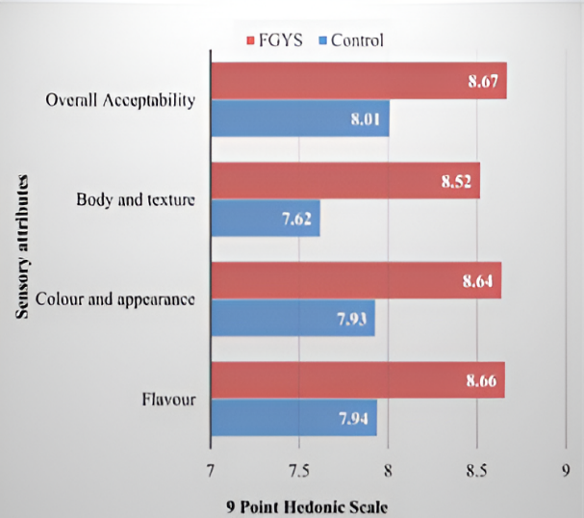

Fig 6. Graph showing Sensory analysis of Control sample and optimized Functional Greek Style Yoghurt Sauce

4. Conclusion

The study established that incorporation of selected functional ingredients had a positive influence on the quality characteristics of Greek style yoghurt Sauce. Among all combinations tested, the formulation containing 3% dried spinach, 1% proso millet, 0.75% dried thyme, and 0.5% green chili was identified as the most suitable, based on statistically superior sensory scores for flavour, colour and appearance, body and texture, and overall acceptability. The improvement in product performance is attributed to enhanced nutrient density, better viscosity contribution from millet and spinach solids, and balanced flavour enhancement from thyme and green chili. The use of natural, GRAS-status ingredients ensures product safety with no adverse health risks. Overall, the optimized Functional Greek style yoghurt Sauce demonstrates strong potential as a value-added dairy product, meeting both sensory and functional quality requirements for consumer acceptance and commercialization.

DISCLAIMER (ARTIFICIAL INTELLIGENCE)
Author(s) hereby declare that no generative AI technologies such as Large Language Models (ChatGPT, COPILOT, etc.) and text-to-image generators have been used during the writing or editing of this manuscript.

REFERENCE

Abdelhamid, S. M., Alnashi, B. A., Hassouna, H. Z., & El Dairouty, R. K. (2021). Acidophilus labneh milk flavored with Thymus vulgaris and Nigella sativa: A new functional dairy product. International Journal of Dairy Science, 16, 48–57.
Bhat, S., Nandini, C., Srinathareddy, S., & Jayarame, G. (2019). Proso millet (Panicum miliaceum L.) – A climate resilient crop for food and nutritional security: A review. Environment Conservation Journal, 20(3), 113–124.
Chokkara Sri Lasya. (2022). Spinach and its health benefits: A review. The Pharma Innovation Journal, 11(8), 1232–1239.
El-Sayed, S. M., & El-Sayed, H. S. (2021). Antimicrobial nanoemulsion formulation based on thyme EO for UF labneh. Journal of Materials Research and Technology, 10, 1029–1041.
Food and Agriculture Organization (FAO). (2024). World milk production statistics 2024. https://www.fao.org/faostat/
García-Casal, M. N., Peña-Rosas, J. P., & Malavé, H. G. (2016). Sauces, spices, and condiments: Definitions, potential benefits, consumption patterns, and global markets. Annals of the New York Academy of Sciences, 1379(1), 3–16.
Global Information, Inc. (GII). (2023). Global Yoghurt market: Industry trends and forecast to 2032. https://www.giiresearch.com/
Hammoudi Halat, D., Krayem, M., Khaled, S., & Younes, S. (2022). A focused insight into thyme: Biological, chemical, and therapeutic properties of an indigenous Mediterranean herb. Nutrients, 14(10), 2104.
Herranz, B., Martínez, A., & Alvarez, M. D. (2019). Influence of fiber addition on white Sauces made with corn starch: Effect on their freezing/thawing stability. Journal of Food Science, 84(8), 2128–2138.
Karastamatis, S., Zoidou, E., Moatsou, G., & Moschopoulou, E. (2022). Effect of modified manufacturing conditions on the composition of Greek strained Yoghurt and the quantity and composition of generated acid whey. Foods, 11(24), 3953.
Kazemeini, H., Azizian, A., & Ahmadi, K. (2023). Preparation of synbiotic Yoghurt Sauce containing Spirulina platensis microalgae extract and its effect on Lactobacillus acidophilus. BioMed Research International, 2023(1), 8434865.
Kovsari, E., Gilani, P. S., Shokri, S., Borazgh, A. M., Rezagholizade-Shirvan, A., & Nia, A. P. (2024). Green pepper extract in yoghurt. Food Chemistry: X, 21, 101070.
Olatunji, T. L., & Afolayan, A. J. (2018). The suitability of chili pepper (Capsicum annuum L.) for alleviating human micronutrient dietary deficiencies: A review. Food Science & Nutrition, 6(8), 2239–2251.
Peryam, D. R., & Pilgrim, F. J. (1957). Hedonic scale method of measuring food preferences. Food Technology, 11(9), 9–14.

Srour, B., Fezeu, L. K., Kesse-Guyot, E., Allès, B., Méjean, C., Andrianasolo, R. M., … & Touvier, M. (2019). Ultra-processed food intake and risk of cardiovascular disease: NutriNet-Santé cohort study. BMJ, 365, l1451.
Statista. (2023). Global yoghurt market value from 2018 to 2032. https://www.statista.com/
Szafrańska, J. O., Muszyński, S., Tomasevic, I., & Sołowiej, B. G. (2021). Influence of dietary fibers on acid casein processed cheese Sauces with whey proteins and coconut oil or milk fat. Foods, 10(4), 759.
Temple, N. J. (2022). Rational definition for functional foods. Frontiers in Nutrition, 9, 957516.
Thao, T. T. T. (2025). Kefir from millet quality study. Norwegian Journal of Development of the International Science, 156, 37.
Topolska, K., Florkiewicz, A., & Filipiak-Florkiewicz, A. (2021). Functional food — consumer motivations. International Journal of Environmental Research and Public Health, 18(10), 5327.
Yuan, X., Zhong, M., Huang, X., Hussain, Z., Ren, M., & Xie, X. (2024). Industrial production of functional foods for human health and sustainability. Foods, 13(22), 3546.

