Review Article
Identification and Management of Postharvest Pathogens in Tomato (Solanum lycopersicum) Using Low-Cost Botanical Treatments and Affordable Storage Solutions in Sub-Saharan Africa

.
ABSTRACT

Problem Statement: Postharvest losses of tomatoes in Sub-Saharan Africa (SSA) remain alarmingly high, reaching up to 50% in some regions, due to fungal and bacterial pathogens, poor handling practices, and inadequate storage infrastructure.
Aims: This review aims to synthesize current knowledge on major tomato postharvest pathogens, evaluate conventional and emerging control strategies, and highlight the potential of integrating locally available botanicals with low-cost storage solutions to reduce postharvest losses.
Methodology: The review evaluates major tomato postharvest pathogens, conventional and emerging control strategies, and the potential of integrating botanicals (such as neem, garlic, ginger, clove, and African basil) with low-cost storage solutions (like evaporative coolers, hermetic storage, and solar-powered cold chains).
Results: Evidence suggests that botanicals possess strong antifungal properties, while innovations in storage technologies can extend shelf life under SSA's challenging climatic conditions. However, critical gaps remain in region-specific pathogen profiling, socio-economic adoption studies, and integrated field validation of combined botanical–storage systems.
Conclusion: An integrated, farmer-oriented framework that combines botanicals and low-cost storage solutions holds promise for reducing postharvest tomato losses, enhancing food security, improving farmer income, and promoting sustainable, climate-resilient postharvest management in SSA.

Keywords: Tomato postharvest losses, Sub-Saharan Africa, Botanical antifungals, Affordable storage solutions, Sustainable postharvest management

1. INTRODUCTION
Tomato (Solanum lycopersicum) is the second most cultivated vegetable worldwide, serving as a cornerstone of global agriculture and a critical source of nutrition and income (Kumar et al., 2020; Zoran et al., 2014). Its importance spans multiple sectors, including fresh produce markets, food processing industries, and even pharmaceutical applications, due to its rich content of vitamins, antioxidants, and bioactive compounds such as lycopene (Kumar et al., 2020; Cao et al., 2023). In Sub-Saharan Africa (SSA), tomatoes are more than a dietary staple; they are a key cash crop that supports rural livelihoods, empowers women and youth through small-scale agribusiness, and contributes to both food security and economic resilience (Ouattara and Konate, 2024; Ogunsola and Ogunsina, 2021).
Globally, tomato production is concentrated in countries like China and India, with Africa’s major producers, Egypt and Nigeria ranking 5th and 10th, respectively (Kumar et al., 2020). While advanced production systems such as greenhouse cultivation and organic farming have helped meet increasing demand in some regions (Gatahi, 2020; Lops, 2024), SSA’s production landscape is constrained by climatic variability, pest and disease pressures, and inadequate infrastructure (Xin et al., 2012; Ogunsola and Ogunsina, 2021). Despite these challenges, the region’s diverse agroecological zones offer opportunities for improved productivity and value addition through targeted interventions.
However, the potential of tomato production in SSA is undermined by severe postharvest losses, a problem that extends across the broader horticultural sector. Fruits and vegetables losses in SSA often range from 30% to 50%, with tomatoes experiencing pre-consumer losses of 9.5% to 13.4% in certain countries (Amjad et al., 2023; Sibomana et al., 2016, Chinenye, 2011). These losses occur predominantly during on-farm handling, transportation, and early stages of distribution, driven by factors such as inadequate cold chain infrastructure, poor storage facilities, and suboptimal handling practices (Kirigia et al., 2017; Mohamed et al., 2024). Beyond the economic impact, postharvest deterioration also reduces the nutritional quality and marketability of produce, exacerbating food insecurity in vulnerable communities (Ndindeng et al., 2022; Ruiz-Martínez et al., 2020).
The urgency to address these losses is compounded by SSA’s socio-economic and climatic realities. High temperature and humidity accelerate pathogen proliferation and spoilage, while energy poverty limits the use of conventional cold storage solutions (Lahouar et al., 2016; Kaminski and Christiaensen, 2014). Conventional postharvest management practices such as refrigeration, chemical treatments, and modified atmosphere packaging are often financially inaccessible or environmentally unsuitable for smallholder farmers (Qadri et al., 2020; Janghu et al., 2024). This underscores the need for integrated, affordable, and eco-friendly solutions that align with local resources, cultural practices, and environmental conditions (Musonye et al., 2020; Bohnenberger, 2023).
This review synthesizes current knowledge on the identification of postharvest pathogens affecting tomatoes in SSA and evaluates the potential of low-cost botanical treatments and affordable storage solutions as integrated management strategies (Cighir et al., 2024; Vakilinia et al., 2022). It aims to bridge gaps between pathogen epidemiology, postharvest loss mitigation, and context-specific innovations for smallholder systems. By highlighting sustainable, and locally adaptable approaches. This review seeks to inform researchers, policymakers, and practitioners working toward reducing tomato postharvest losses, enhancing food security, and promoting socio-economic resilience in SSA.
2. Potential of Botanical Treatments and Affordable Storage Solutions
One promising avenue is the use of low-cost botanical treatments combined with affordable storage solutions to mitigate postharvest pathogen impacts. Botanicals such as neem (Azadirachta indica), garlic (Allium sativum), ginger (Zingiber officinale), clove (Syzygium aromaticum), and basil (Ocimum gratissimum) have demonstrated significant antifungal activity against common tomato pathogens including Fusarium spp., Alternaria alternata, and Rhizopus stolonifer (A.I. and I.A., 2024; Gao et al., 2024). When integrated into accessible storage systems such as solar-powered evaporative coolers or low-cost hermetic containers these treatments can reduce microbial decay while extending shelf life, thereby improving market access and farmer incomes (Mayanja and Oluk, 2023; Geofrey et al., 2025).
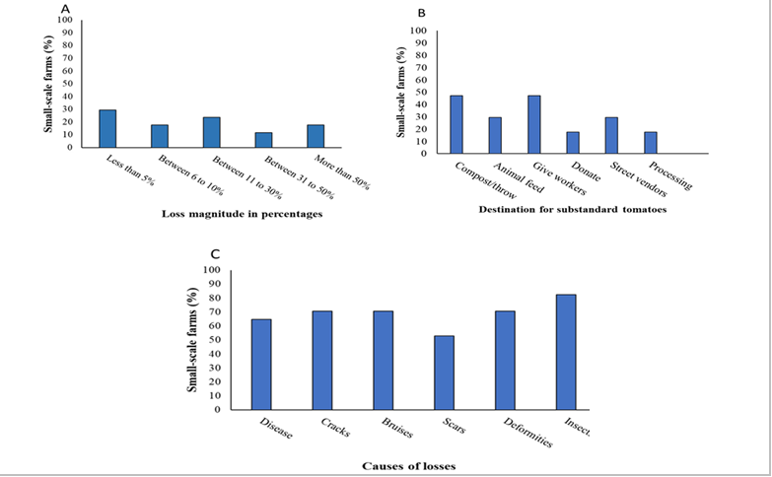
Figure 1. Geographical distribution and postharvest loss patterns in tomato production. Adapted from (Molelekoa et al., 2025).
Postharvest losses in tomatoes are a complex issue influenced by multiple factors. Understanding these drivers is crucial for developing effective strategies to mitigate losses and improve food security. The major drivers of postharvest tomato losses in Sub-Saharan Africa are summarized in Table 1
Table 1. Major drivers of postharvest tomato losses in Sub-Saharan Africa (SSA)
Factor | Description | Representative References
Climatic conditions | High ambient temperatures, fluctuating humidity, and seasonal rainfall patterns accelerate deterioration. | Sibomana et al., 2016
Pathogen prevalence | Widespread occurrence of fungal and bacterial pathogens such as Botrytis cinerea, Alternaria alternata, and Rhizopus stolonifer. | Magala et al., 2024
Poor handling practices | Bruising, contamination during harvesting, transportation in open vehicles, and inadequate packaging. | Gwaze et al., 2011
Inadequate storage infrastructure | Limited access to cold chain facilities, reliance on open-air markets, and absence of temperature-controlled storage. | Affognon et al., 2015
Economic constraints | High cost of synthetic chemicals, limited access to credit, and low market bargaining power for smallholders. | Borelli et al., 2020

3. IDENTIFICATION OF POSTHARVEST PATHOGENS IN TOMATO
Major Fungal Pathogens
Fungal pathogens are the predominant cause of postharvest tomato deterioration in Sub-Saharan Africa (SSA), with Botrytis cinerea, Rhizopus stolonifer, Alternaria alternata, and Fusarium spp. among the most prevalent (Mugao and Birgen, 2021; Zakari et al., 2023). The incidence of these pathogens varies with climatic conditions, reflecting the region’s diverse agroecological zones. Visual symptoms and morphological features of Fusarium oxysporum f.sp. lycopersici and Alternaria alternata are shown in Figure 2 (Pandey et al., 2023).
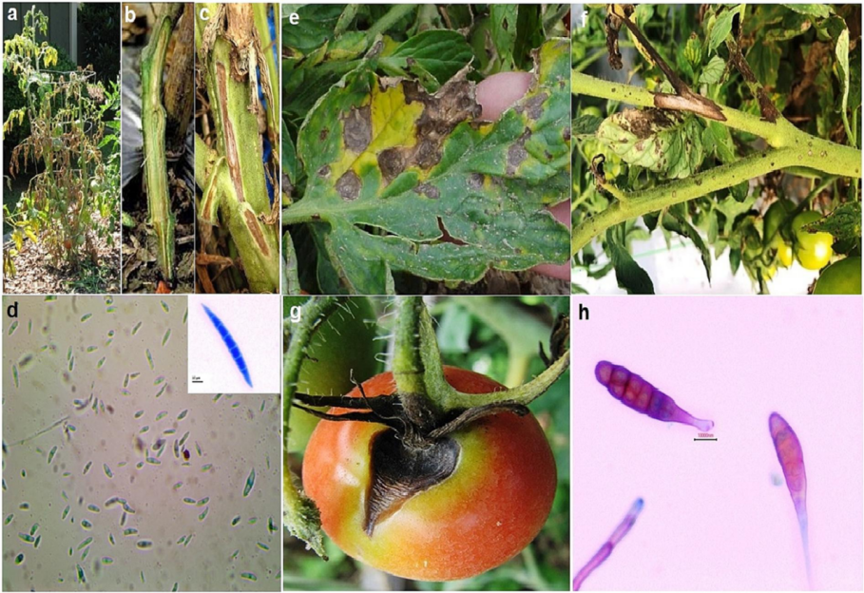Figure 2. Symptoms and morphological features of major fungal pathogens in tomato. (a) Tomato plant infected with Fusarium wilt; (b, c) internal wilt symptoms; (d) Fusarium oxysporum f.sp. lycopersici microconidia and macroconidium; (e) early blight symptoms on leaves; (f) canker on stem; (g) canker on fruit; and (h) Alternaria alternata conidia. Adapted from (Pandey et al., 2023).
In humid climates, high relative humidity and mild to warm temperatures promote the spread of Botrytis cinerea, which causes gray mold through necrotrophic infection strategies, accelerating ripening and cell wall degradation (Petrasch et al., 2019). In tropical zones, Rhizopus stolonifer thrives, particularly during storage and transportation, where its rapid colonization can cause near-complete crop losses (Al-Sadi, 2016; Gwa and Lum, 2023). In semi-arid areas, Alternaria alternata demonstrates broad host adaptability, infecting both pre- and postharvest produce (Basso et al., 2022; Reddy, 2016). Fusarium species, including F. oxysporum and F. solani, persist across all climatic zones due to their soil-borne nature and ability to survive in plant debris, making them chronic threats to tomato storage and marketability (Zakaria, 2023; Al-Sadi, 2016).
Geographical surveys reveal distinct pathogen profiles: in Nigeria, Phytophthora infestans and Sclerotium rolfsii are also recorded, whereas in Kenya, Fusarium spp. and Rhizopus spp. dominate (Mugao and Birgen, 2021; Gwa and Lum, 2023). Emerging pathogens like Curvularia alcornii, newly identified in tomato postharvest rot, highlight the evolving threat landscape (Baral et al., 2022).

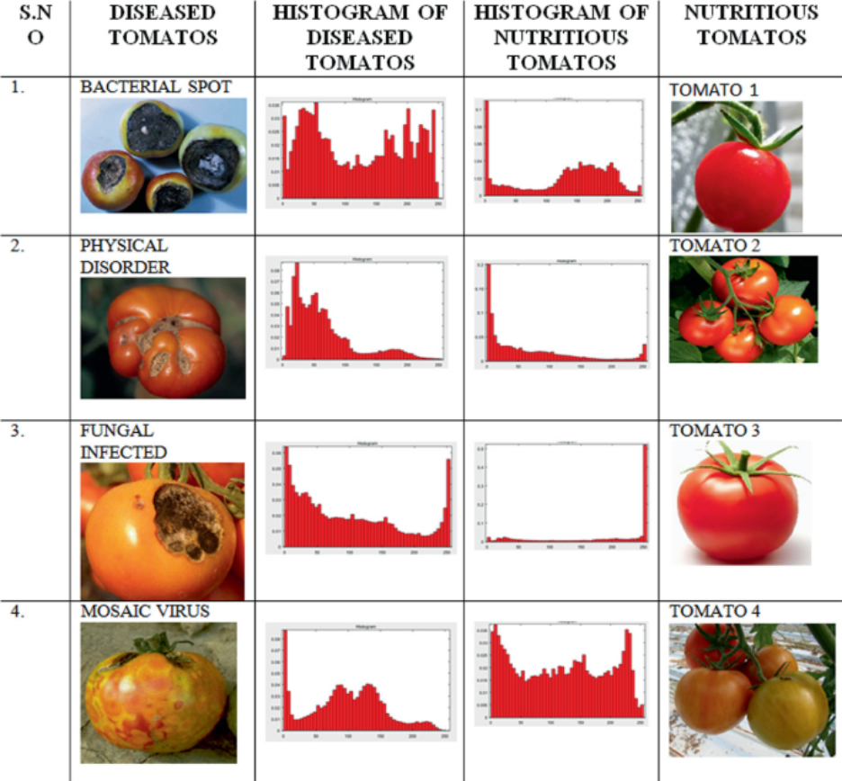
Figure 3. Examples of diseased and healthy tomatoes with corresponding histograms. Visual comparison of four tomato conditions—bacterial spot, physical disorder, fungal infection, and mosaic virus—alongside histograms illustrating pixel intensity distributions for diseased and healthy fruit images. These visual profiles can aid in both manual and automated classification of tomato quality for postharvest handling and pathogen identification. Adapted from (Jain et al., 2021).

Tomatoes are susceptible to a range of postharvest pathogens that can cause significant losses in quality and quantity. Understanding the types of pathogens, their symptoms, and prevalence is crucial for developing effective management strategies. The major postharvest pathogens affecting tomatoes in Sub-Saharan Africa are summarized in Table 2.
Table 2. Major postharvest pathogens of tomato in Sub-Saharan Africa (SSA)
Pathogen | Type | Common Symptoms | SSA Prevalence | Representative References
Botrytis cinerea | Fungal | Gray mold, water-soaked lesions, fluffy gray sporulation | High in humid and cool storage environments | Magala et al., 2024
Rhizopus stolonifer | Fungal | Soft rot with cottony mycelium, rapid fruit collapse | Common in warm, humid climates | Gwaze et al., 2011
Alternaria alternata | Fungal | Black mold, sunken dark lesions with concentric rings | Widespread in field and market conditions | Makule et al., 2022
Fusarium spp. | Fungal | Dry rot, vascular discoloration, shriveling | Found in both pre- and postharvest stages | Ogendo et al., 2011; Magala et al., 2024
Pseudomonas spp. | Bacterial | Soft, watery rot with sour odor | Higher incidence during rainy seasons | Borelli et al., 2020; Affognon et al., 2015
Erwinia spp. | Bacterial | Wet, mushy breakdown with foul smell | Occurs in both field injuries and storage | Makule et al., 2022

Bacterial Involvement
Bacterial spoilage, while less visually dramatic than fungal rot, significantly contributes to tomato losses. Pseudomonas spp., psychrotrophic in nature, spoil a range of food products by producing proteases and lipases that degrade cell structures, leading to softening and off-flavors (Chang et al., 2024; Psychrotrophic Bacteria: Pseudomonas Spp., 2022). These bacteria can survive under refrigerated conditions, complicating cold storage as a preservation strategy. In tomatoes, surface contamination from Pseudomonas can occur via handling tools, packaging, and water sources (Bhandari et al., 2024; Abdul-Mutalib et al., 2019).
Erwinia carotovora, a soft rot agent, accelerates spoilage by enzymatically breaking down pectic substances in plant cell walls, leading to tissue maceration and fluid leakage. Synergistic interactions between Pseudomonas and Erwinia, as well as with certain fungi, can intensify spoilage (Ahmed et al., 2016). For example, Pseudomonas biofilms can protect co-occurring microbes, enhancing their resilience to environmental stressors.
Climate and Postharvest Contamination
Climatic conditions in SSA strongly influence postharvest pathogen dynamics. High temperatures accelerate fungal metabolism and mycotoxin production, Aspergillus flavus, for instance, produces aflatoxins optimally at around 37 °C in high water activity conditions (Lahouar et al., 2016). Elevated humidity not only favors fungal sporulation but also increases bacterial virulence; for example, Ralstonia solanacearum enhances extracellular polysaccharide production under warmer conditions (Kumar and Mukhopadhyay, 2024).
Rainfall patterns can exacerbate contamination risks through splash dispersal of soil- or waterborne pathogens onto fruit surfaces during harvest and transport. Inadequate drying or aeration post-harvest further increases susceptibility to decay (Surnacheva et al., 2022; Benjamin et al., 2024). Seasonal climatic extremes such as prolonged rainy periods followed by sudden temperature rises are especially problematic, as they create alternating favorable environments for different pathogen groups.
Climate and Postharvest Handling as the Primary Driver
While climate clearly shapes pathogen prevalence and severity, poor postharvest handling practices are equally critical in determining spoilage rates. Climatic conditions such as persistent humidity and heat create baseline risks (Bradford et al., 2018; Mugilan et al., 2024), but lack of cold chain infrastructure, improper packaging, and rough handling during transport often accelerate deterioration (Kaur and Watson, 2024; Watson et al., 2023). Up to 60% of losses occur during early supply chain stages due to inadequate storage and poor market access (Makule et al., 2022).
The “climate-first” argument emphasizes that even with perfect handling, high pathogen loads driven by environmental factors can overwhelm storage systems. Conversely, the “handling-first” perspective notes that appropriate interventions such as immediate cooling, clean water use, and improved ventilation can mitigate much of the climate-driven risk. Evidence suggests an interaction effect: climatic stress increases the vulnerability of produce, while poor handling accelerates the onset and spread of decay. Effective mitigation in SSA therefore requires integrated strategies addressing both environmental adaptation and postharvest practice improvement.
4. CONVENTIONAL POSTHARVEST MANAGEMENT PRACTICES
Common Synthetic Control Methods
Conventional postharvest management systems often rely on synthetic chemical treatments and controlled storage technologies to maintain produce quality and extend shelf life. Fungicides are widely used to suppress fungal pathogens such as Botrytis cinerea, Rhizopus stolonifer, and Alternaria alternata. Chemical formulations like imazalil, thiabendazole, and prochloraz act by disrupting fungal cell membrane integrity or inhibiting spore germination, thereby reducing decay incidence during storage and transport (Qadri et al., 2020). In certain high-value supply chains, sulfur dioxide (SO₂) pads are inserted into packaging to inhibit mold growth, particularly in grapes and other climacteric fruits. Their mode of action involves slow release of SO₂ gas, which interferes with fungal respiration (Janghu et al., 2024).
Modified Atmosphere Packaging (MAP) is another prevalent technology, altering oxygen (O₂), carbon dioxide (CO₂), and nitrogen (N₂) levels inside packaging to slow respiration and microbial growth (Shah et al., 2020; Kargwal et al., 2020). Polymer films with selective gas permeability maintain an optimal gaseous balance, preserving color, firmness, and nutritional quality while extending shelf life. Recent advancements include antimicrobial packaging films and intelligent MAP systems that monitor spoilage indicators in real time (McMillin, 2020; Owolabi et al., 2024).
Limitations in SSA
Despite their proven efficacy, the adoption of synthetic control methods in Sub-Saharan Africa is constrained by multiple barriers. Cost remains a primary limitation, as many smallholder farmers cannot afford recurring fungicide applications, specialized packaging films, or MAP-compatible infrastructure (Musembi, 2011). The high price of inputs, coupled with poor market access, makes large-scale implementation economically unviable.
Residue concerns are also significant. Fungicide residues on tomatoes can pose health risks if maximum residue limits are exceeded, especially in contexts where monitoring and consumer awareness are limited (Leal, 2022; Akotowanou et al., 2023). Weak regulatory enforcement in several SSA countries exacerbates this issue, allowing the circulation of counterfeit or substandard chemical products, which may be ineffective or hazardous (Sithole and Olorunfemi, 2024).
Moreover, repeated use of the same active ingredients fosters pathogen resistance, reducing treatment effectiveness over time. Resistance has been reported in several fungal pathogens, necessitating rotation of fungicide modes of action a practice often impractical for resource-limited farmers (Ricker-Gilbert et al., 2022). Infrastructural deficiencies, such as inadequate cold chains and poor storage facilities, further reduce the efficacy of chemical-based preservation methods, as environmental exposure can negate treatment benefits (Makule et al., 2022) (Table 3).

Table 3. Common synthetic control methods for tomato postharvest pathogens and their limitations in SSA
Method | Mode of Action | Advantages | Limitations in SSA | Representative References
Fungicides (e.g., imazalil, thiabendazole, prochloraz) | Inhibit fungal growth by targeting cell membrane synthesis or enzyme function | Highly effective against a broad spectrum of pathogens | High cost, residue concerns, pathogen resistance, restricted availability, weak regulatory enforcement | Shai et al., 2024
SO₂ pads | Release sulfur dioxide gas to suppress fungal spores, especially Botrytis cinerea | Simple to use, effective during storage and transport | Limited availability, safety concerns, less effective under high humidity, regulatory restrictions | Sibomana et al., 2016
Modified Atmosphere Packaging (MAP) | Alters O₂ and CO₂ levels around produce to slow respiration and microbial growth | Extends shelf life, maintains fruit firmness and quality | Cost of materials, need for controlled conditions, less effective in high temperature and humidity settings | Affognon et al., 2015; Borelli et al., 2020
Can Smallholder Farmers in SSA Realistically Sustain Chemical-Intensive Postharvest Systems?
The feasibility of sustaining chemical-intensive systems in SSA remains contested. Proponents argue that such systems can drastically reduce losses and ensure consistent quality, potentially increasing farmer incomes. Critics counter that economic, environmental, and health constraints make them unsuitable for the region’s smallholder-dominated agricultural landscape (Geofrey et al., 2025; Harris et al., 2019).
Smallholder farmers often face financial barriers to purchasing agrochemicals and maintaining application equipment, compounded by limited access to credit or insurance Notably, the environmental sustainability of chemical-intensive methods is questionable, as over-reliance can degrade soil health, pollute water sources, and disrupt ecological balances (Schilling, 2023; Durga et al., 2024). Health risks from chronic exposure to chemical residues both for farm workers and consumers further reduce their desirability.
A growing body of evidence suggests that sustainable intensification and intermediate technologies, such as solar-powered dryers, evaporative cooling systems, and botanical treatments, may offer more viable long-term solutions (Mayanja and Oluk, 2023; Rahmadani et al., 2024) (Figure 4). These alternatives balance productivity with environmental protection and are better aligned with smallholders’ financial capacities. Thus, while chemical-intensive postharvest systems have clear technical merits, their socio-economic and ecological limitations make widespread, sustained adoption in SSA unlikely without substantial structural support and subsidies (Clark and Hobbs, 2018; Rashvand et al., 2023).
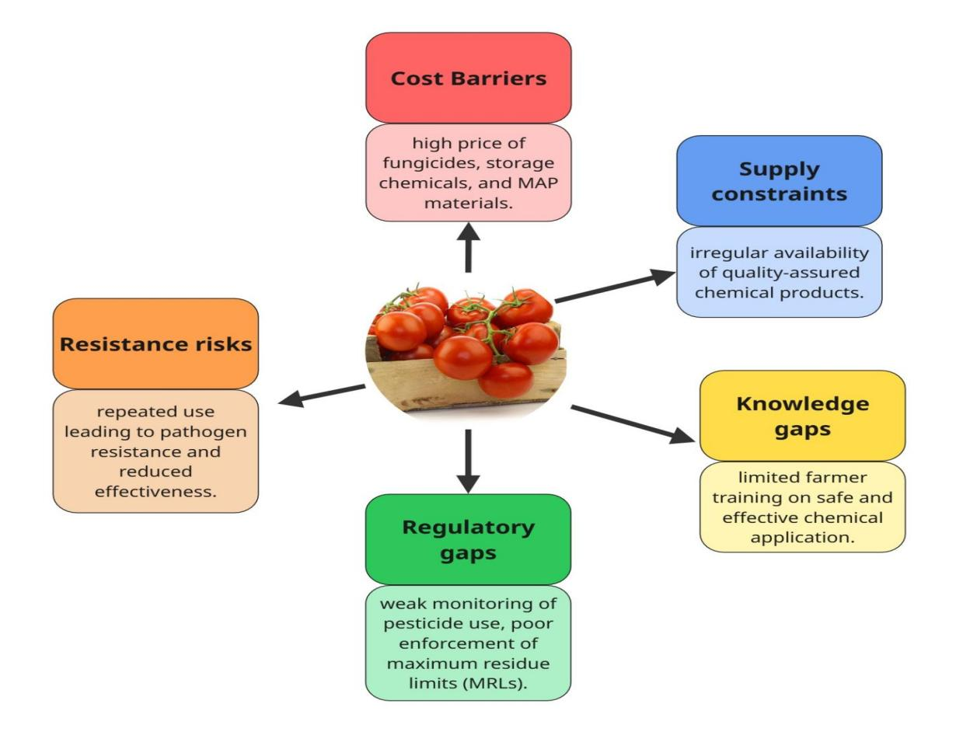
Figure 4. Adoption challenges of chemical-intensive postharvest systems in Sub-Saharan Africa. Infographic illustrating the primary barriers cost constraints, regulatory gaps, and pathogen resistance risks limiting the uptake of synthetic control measures among smallholder tomato farmers. These factors interact to reduce adoption and highlight the need for affordable, eco-friendly alternatives.
5. LOW-COST BOTANICAL TREATMENTS
Antifungal Botanicals Common in SSA
Botanical extracts from locally available plants have shown significant potential in reducing postharvest losses in tomatoes by inhibiting fungal growth. In Sub-Saharan Africa (SSA), key species include neem (Azadirachta indica), garlic (Allium sativum), ginger (Zingiber officinale), clove (Syzygium aromaticum), and basil (Ocimum gratissimum). These plants are widely cultivated or easily sourced from local markets, making them accessible to smallholder farmers (Kale et al., 2024).
Neem extracts have demonstrated broad-spectrum antifungal activity against pathogens such as Fusarium oxysporum and Alternaria alternata, attributed to limonoids like azadirachtin (Bello et al., 2018). Garlic’s allicin content disrupts fungal and bacterial cell structures, showing efficacy against Rhizopus stolonifer and Botrytis cinerea (Rahman et al., 2025). Ginger rhizome extracts, rich in gingerols and shogaols, have inhibited Aspergillus niger and Alternaria spp., while clove oil containing high concentrations of eugenol has effectively suppressed Fusarium spp. and Colletotrichum gloeosporioides (Kale et al., 2024). Basil’s essential oils, primarily composed of linalool and eugenol, exhibit fungistatic effects against storage pathogens, making them suitable for edible coating formulations.
Table 4. Antifungal botanicals common in Sub-Saharan Africa and their postharvest applications in tomato preservation
Botanical | Scientific Name | Primary Antifungal Compounds | Mode of Action | Common Formulations | Representative References
Neem | Azadirachta indica | Azadirachtin, nimbin | Disrupts fungal cell membranes and enzyme systems; interferes with spore germination | Aqueous/ethanol extracts, oil emulsions | Shai et al., 2024
Garlic | Allium sativum | Allicin, ajoene | Inhibits fungal enzymes and disrupts membrane permeability | Aqueous extracts, oil emulsions | Borelli et al., 2020
Ginger | Zingiber officinale | Gingerols, shogaols | Disrupts membrane lipids; inhibits mycelial growth | Aqueous extracts, edible coatings | Affognon et al., 2015
Clove | Syzygium aromaticum | Eugenol | Causes leakage of cellular contents and enzyme inactivation | Oil emulsions, vapor treatments | Makule et al., 2022
African basil | Ocimum gratissimum | Eugenol, thymol | Alters membrane structure; inhibits spore germination | Essential oils, aqueous extracts | Ogendo et al., 2011; Shai et al., 2024
Mechanisms of Action
The antifungal properties of botanicals stem from their bioactive phytochemicals—terpenoids, phenolics, alkaloids, and sulfur-containing compounds that interfere with multiple cellular targets in pathogens. Essential oil components such as eugenol, thymol, and citral disrupt fungal cell membrane integrity, leading to leakage of cellular contents and eventual cell death (Kale et al., 2024). Some phytochemicals inhibit enzymatic systems, such as those involved in ergosterol biosynthesis, which is critical for maintaining fungal membrane structure (Opara and Okoronkwo, 2024; Bello et al., 2018).
Other compounds act at the molecular level, modulating gene expression in pathogens to suppress virulence factors. For instance, allicin has been reported to interfere with quorum sensing and biofilm formation in both fungal and bacterial species (Aloyce et al., 2017; Farthing et al., 2021). Synergistic effects often occur when multiple bioactive compounds are present, providing broad-spectrum activity and reducing the likelihood of resistance development.
Formulation and Application
The effectiveness of botanical treatments depends heavily on formulation and mode of application. Common approaches include water and ethanol extracts, oil emulsions, edible coatings, and dips. Water extracts are generally cheaper to prepare and safer for household-level application, though they may have lower stability compared to ethanol-based formulations. Oil emulsions, particularly those using clove or basil essential oils, offer enhanced penetration and prolonged antifungal activity.
Edible coatings incorporating botanical extracts such as starch or chitosan films infused with neem or clove oil provide a physical barrier against moisture loss while releasing antifungal compounds gradually. Dipping tomatoes in diluted botanical solutions postharvest can significantly reduce surface pathogen load, especially when combined with proper storage conditions (Guo et al., 2015; Govender et al., 2011). However, optimizing concentration, exposure time, and drying methods is essential to balance efficacy with preservation of fruit sensory quality.
Availability and Cost in SSA
One of the strongest advantages of botanical treatments is their local availability and low cost. Many of these plants are cultivated as food crops, spices, or ornamentals, allowing farmers to source raw materials without relying on expensive imports. For example, ginger and garlic are staples in local cuisines, while neem trees grow widely in semi-arid and tropical regions of SSA. This reduces input costs and enables on-farm preparation, which can make postharvest management more sustainable for smallholders.
Additionally, small-scale processing such as community-based essential oil distillation can create local value chains, generating employment and increasing adoption potential. Nevertheless, the absence of standardized extraction protocols and quality assurance mechanisms remains a challenge for scaling up their use.
Why Have Botanicals Proven in Lab Studies Not Scaled Widely in SSA’s Smallholder Systems?
Despite promising laboratory results, the adoption of botanical treatments in real-world smallholder contexts remains limited. Critics point to formulation instability, as many extracts degrade quickly under high temperatures and light exposure typical of SSA environments (Kale et al., 2024; Nqoro et al., 2025). The labor intensity of preparation and application can also deter farmers, particularly during peak harvest periods when labor is scarce.
Moreover, inconsistent efficacy under field conditions due to variability in raw material quality, extraction methods, and pathogen pressure reduces farmer confidence. The lack of extension services and technical training means many farmers are unaware of proper preparation and application techniques. From a market perspective, limited regulatory frameworks for botanical pesticides further hinder commercialization and wider distribution (Salaria et al., 2022; Ogolla et al., 2024).
To achieve wider adoption, future strategies must integrate botanical treatments into holistic postharvest management systems, combining them with affordable storage technologies and farmer training programs. This will require collaboration between researchers, extension officers, policymakers, and private-sector actors to translate lab success into field impact.
6. AFFORDABLE STORAGE SOLUTIONS
Passive and Low-Cost Technologies in SSA
Affordable storage technologies are essential in Sub-Saharan Africa (SSA), where high postharvest losses are exacerbated by the absence of reliable cold chain systems. Evaporative coolers utilize the cooling effect of water evaporation to reduce storage temperature, making them suitable for smallholder farmers in arid and semi-arid regions (Kitinoja and AlHassan, 2012; Goel et al., 2024). Zero-Energy Cool Chambers (ZECCs), constructed from brick and sand, achieve temperature drops of 10–15 °C and relative humidity above 90%, prolonging the freshness of perishable produce without electricity (Chitranshi et al., 2020; Siddiqua et al., 2022).
Mud evaporative stores, often built with locally available clay and thatch, are widely used for short-term storage of fruits and vegetables in rural areas. They offer low construction costs but require regular water replenishment to maintain cooling efficiency. Hermetic storage, typically applied for grains, is being adapted for certain horticultural products using airtight containers or polymer bags that limit oxygen availability, slowing microbial growth (Ratto et al., 2022; Ouattara and Konate, 2024). These passive technologies offer cost-effective, decentralized solutions but must be adapted to different climates and crop types.
Climate Adaptation
The high ambient temperatures and variable humidity of SSA present unique challenges for storage design. Passive systems must optimize heat dissipation through increased airflow, reflective surfaces, and shading to maintain target storage conditions. In coastal or tropical zones with high humidity, controlling excess moisture is critical to prevent fungal growth; this can be achieved by integrating desiccants or ensuring periodic ventilation (Apribowo et al., 2022).
Electricity-reliant solutions face operational constraints due to unreliable grid power. Off-grid adaptations such as incorporating solar photovoltaic (PV) systems for fans or auxiliary cooling enhance resilience while maintaining low operating costs (Affognon et al., 2015; Sola et al; 2014). Locally appropriate designs that account for seasonal climate variability can help maintain produce quality despite environmental extremes.
Combining Botanicals with Storage
Integrating botanical treatments with affordable storage systems offers a synergistic preservation strategy. For example, dipping tomatoes in neem or clove oil solutions before placing them in evaporative coolers can reduce surface microbial load while the cooler slows pathogen proliferation (Adhikari et al., 2020; Petrasch et al., 2019). Edible coatings enriched with basil or ginger extracts can further enhance this synergy by providing both a physical barrier to moisture loss and a sustained release of antifungal compounds.
Such combinations can extend tomato shelf life by several days to weeks, depending on environmental conditions and pathogen pressure. This approach aligns well with smallholder realities, as both botanicals and passive storage materials can be sourced locally, reducing dependence on imported preservation technologies.
AkoFresh Cold Storage (Ghana)
An example of an innovative localized storage solution is the AkoFresh system in Ghana a solar-powered, IoT-enabled, mobile cold storage unit designed for smallholder farmers. The system operates entirely off-grid, using photovoltaic panels to power cooling units, and is equipped with remote temperature monitoring via mobile networks. This setup extends the shelf life of perishable produce, including tomatoes, from as little as five days to up to 21 days (Petrotos and Gerasopoulos, 2022; Fernández-Acero et al., 2019).
By adopting a pay-as-you-store model, AkoFresh reduces the upfront financial burden on farmers while enabling them to sell produce at higher prices when market conditions are favorable. Its mobility allows it to serve multiple communities, making it a practical alternative to fixed-location cold rooms (Figure 5).
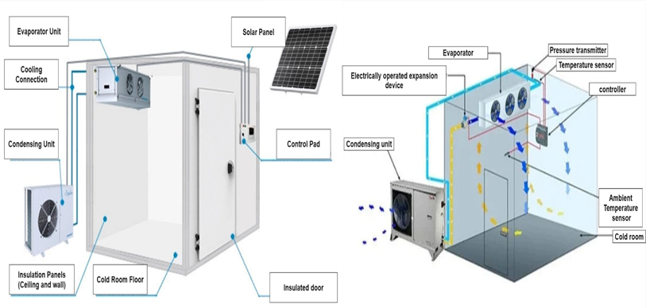Figure 5: Schematic of an evaporative cooler and AkoFresh cold storage unit
Decentralized and Centralized Storage
The question of whether SSA should invest more in decentralized farmer-level storage or centralized aggregation hubs remains contested. Decentralized systems, such as on-farm evaporative coolers or mobile cold units, offer immediate access and reduce losses during early postharvest handling. However, they may lack economies of scale and advanced temperature control features.
Centralized storage hubs, often located near markets or transport nodes, can provide large-scale cold rooms with better quality control and longer storage capacity. Yet, they require significant infrastructure investment and depend on efficient supply chain logistics to ensure timely produce delivery (Patel et al., 2022; Oliveira et al., 2024).
A hybrid approach deploying decentralized storage to stabilize produce soon after harvest, followed by aggregation in centralized hubs for longer-term storage and market distribution may provide the most balanced solution for SSA’s diverse agricultural systems.
7. ALTERNATIVE AND EMERGING APPROACHES
Biocontrol Agents
Biological control agents (BCAs) offer a sustainable alternative to synthetic fungicides for postharvest disease management in tomatoes. Among the most studied are Bacillus subtilis and Pseudomonas fluorescens, both of which have demonstrated antagonistic effects against major fungal pathogens such as Botrytis cinerea, Rhizopus stolonifer, and Fusarium spp. (Sharma et al., 2024; Ghosh et al., 2013; Budianto and Suprastyani, 2017).
Bacillus subtilis produces lipopeptides such as iturin, fengycin, and surfactin, which disrupt fungal cell membranes, inhibit spore germination, and induce systemic resistance in the host plant. Pseudomonas fluorescens exerts its effects through siderophore-mediated iron competition, production of hydrogen cyanide, and synthesis of antibiotics like pyoluteorin (Singh et al., 2024; Alnafisah, 2023).
Recent advances in molecular breeding have demonstrated the potential of multi-omics approaches to enhance tomato resistance against major postharvest pathogens such as Fusarium oxysporum f.sp. lycopersici and Alternaria alternata. By integrating genomics, transcriptomics, proteomics, and metabolomics, researchers can identify key resistance genes and molecular pathways involved in pathogen defense, enabling the development of improved cultivars adapted to SSA conditions (Figure 6) (Pandey et al., 2023; Prakash et al., 2022).
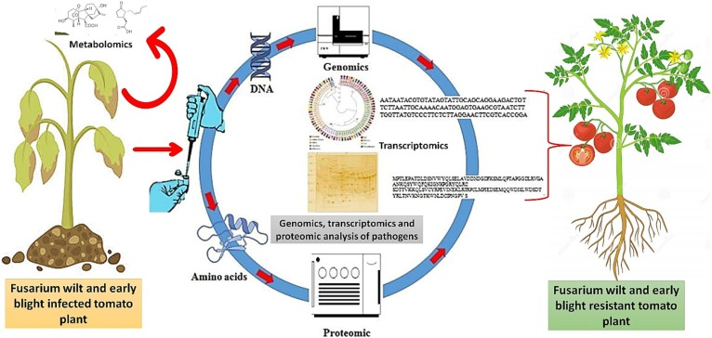
Figure 6. Application of multi-omics approaches for developing Fusarium wilt- and early blight-resistant tomato cultivars. Comparative gene expression analysis, along with genomics, transcriptomics, proteomics, and metabolomics, can generate data on tomato plant responses to biotic stress, enabling resistance breeding. Adapted from (Pandey et al., 2023).
In SSA contexts, small-scale trials have shown that locally isolated strains can reduce decay incidence by 30–60% when applied as pre-storage dips or sprays (Wilson et al., 2019; Nyarko et al., 2022). However, challenges remain in maintaining microbial viability during storage, scaling up production, and ensuring consistent efficacy under variable temperature and humidity conditions.
Physical Methods
Physical preservation methods present chemical-free alternatives that can be adapted to resource-limited settings. Solar drying is widely used for reducing the moisture content of tomatoes, thereby slowing microbial growth. When designed with improved airflow and UV exposure, solar dryers can retain more nutrients and color compared to open sun drying (El-Sayed et al., 2019; Stathers et al., 2018).
UV-C light treatments (200–280 nm) can inactivate surface pathogens by causing DNA damage, reducing decay while also inducing resistance responses in the fruit. Portable UV-C devices have been tested on tomatoes with promising results, though dose optimization is critical to avoid skin damage (Figure 7).
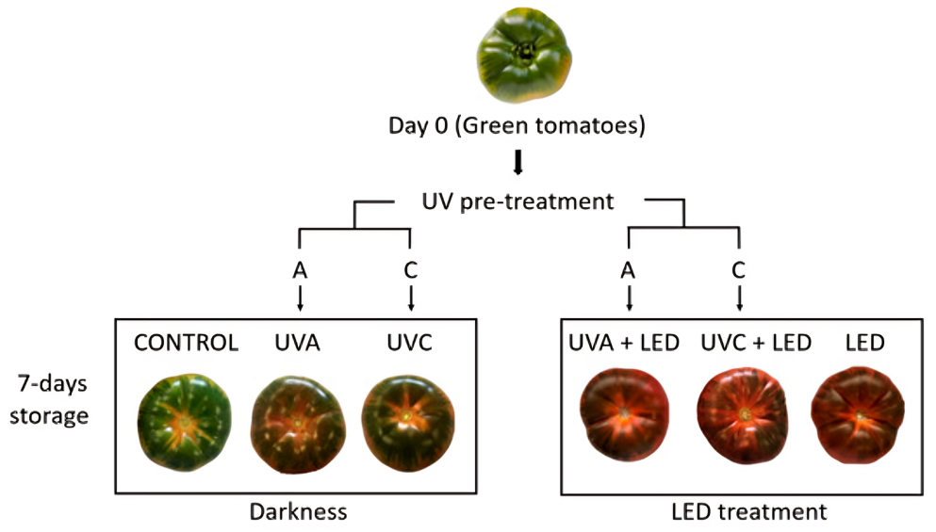
Figure 7. Overview of tomato light treatments, including 5 h UVA/UVC pre-treatment and 7-day LED/dark storage at 6 ± 1 °C and 90 ± 1% RH (M J et al., 2025)
Cold plasma technology which generates reactive oxygen and nitrogen species to destroy microbial cells has emerged as a non-thermal method capable of decontaminating produce surfaces without chemical residues (Nziguheba et al., 2021; Misra et al., 2011). While effective in laboratory trials, its application in SSA remains limited by the high cost of plasma generators, energy demands, and need for technical expertise.
Low-Tech and High-Tech in SSA
The choice between low-tech, locally maintained systems and advanced, high-tech solutions hinges on the realities of SSA’s agricultural landscape. Low-tech approaches such as solar drying, botanical treatments, and small-scale biocontrol applications offer affordability, simplicity, and local ownership, making them easier to sustain without heavy infrastructure investment (Aghofack-Nguemezi et al., 2019; Wei et al., 2019). However, they may provide shorter shelf-life extensions and less precision in pathogen control compared to high-tech methods.
Advanced solutions like cold plasma or automated UV-C treatment units can deliver superior efficacy and longer preservation, but their high initial costs, reliance on stable electricity, and specialized maintenance limit scalability for most smallholder farmers (Pirozzi et al., 2020; Pachauri et al., 2024). A context-driven hybrid approach deploying low-cost methods at the farm level and integrating high-tech solutions in centralized processing hubs could balance accessibility with performance, enabling gradual technology adoption without overwhelming local capacities (Arah et al., 2015).
8. NOVELTY OF THE STUDY
SSA-Specific Focus
This study is the first to propose an integrated postharvest management framework for tomatoes that is specifically designed for Sub-Saharan Africa (SSA) value chains. It directly addresses the region’s unique socio-economic and environmental conditions, including high ambient temperatures, seasonal humidity fluctuations, poor market infrastructure, and limited cold chain access (Pradhan et al., 2023; Sibomana et al., 2016). While existing studies often apply generalized global recommendations, this work contextualizes solutions for SSA’s smallholder-driven tomato production systems, ensuring relevance and applicability at the grassroots level.
Hybrid Approach
Unlike conventional studies that focus on either botanical treatments or storage technologies in isolation, this research introduces a hybrid methodology the simultaneous use of locally derived botanical extracts with affordable, low-energy storage solutions (Pirozzi et al., 2021). By merging indigenous plant-based antifungal agents such as Azadirachta indica (neem) and Allium sativum (garlic) with passive or renewable-energy-based storage (e.g., evaporative coolers, solar-powered units), the framework seeks to maximize pathogen suppression while extending shelf life without costly chemical inputs or energy-intensive infrastructure (Shai et al., 2024; Ogendo et al., 2011).

Climate-Adapted Design
The proposed interventions are tailored to tropical and semi-arid environments, accounting for SSA’s climatic stressors that exacerbate postharvest losses. This includes designing storage systems with passive cooling adaptations for high temperatures, moisture control in humid areas, and compatibility with intermittent energy access (Magala et al., 2024; Ranieri et al., 2015). In addition, the botanical treatments selected are known for resilience and efficacy under warm, humid conditions, ensuring consistent performance despite environmental variability.
Local Resource Orientation
This study prioritizes readily available, low-cost local resources to enhance feasibility and farmer adoption. Botanicals are sourced from plants already cultivated or wild-harvested in farming communities, minimizing procurement costs and dependency on imports (Mgwenya et al., 2025; Borelli et al., 2020). Storage designs utilize indigenous materials such as clay, plant fibers, and agricultural residues, reducing financial barriers while promoting circular economy principles. The approach supports community-led innovation by leveraging existing knowledge systems and enhancing self-reliance.

Field-Oriented Validation
Beyond laboratory trials, this research emphasizes on-farm and market-level validation under real operating conditions in SSA. Such testing ensures the interventions are practically deployable, taking into account farmer participation, local handling practices, market dynamics, and infrastructural constraints (Subha et al., 2024; Gwaze et al., 2011). This step bridges the persistent gap between controlled-environment studies and actual smallholder realities, enabling a realistic pathway for scaling and adoption.
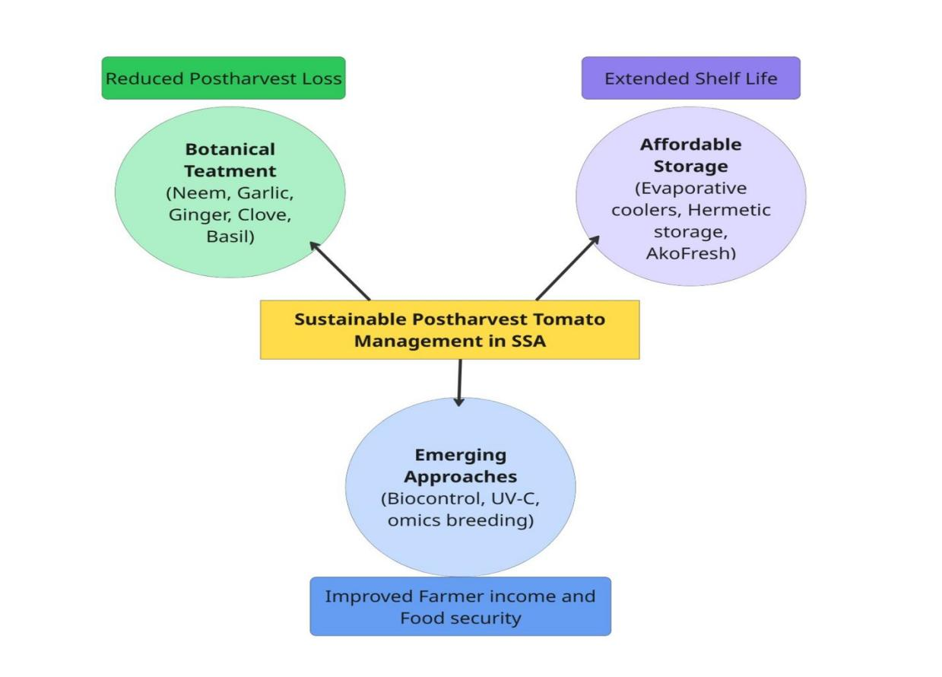
Figure 8. Conceptual framework integrating botanical treatments, affordable storage technologies, and emerging approaches for sustainable postharvest tomato management in Sub-Saharan Africa.
This integrated model emphasizes the synergistic potential of locally available botanicals, low-cost storage, and innovative biocontrol/physical methods to reduce pathogen-induced losses, extend shelf life, and improve farmer livelihoods (Palei et al., 2024).
9. RESEARCH GAPS
Despite substantial research into postharvest pathogen management, several critical gaps limit the development of sustainable, scalable solutions for tomato preservation in Sub-Saharan Africa (SSA).
First, there is a lack of integrated studies that combine locally available botanical treatments with affordable storage technologies. Most existing research examines these interventions in isolation laboratory trials on plant extracts or engineering studies on low-cost storage but fails to assess their combined performance under real-world smallholder conditions. The potential synergy between pathogen suppression from botanicals and extended shelf life from passive storage remains largely unquantified in SSA contexts.
Second, there is insufficient region-specific pathogen profiling for tomatoes across SSA’s diverse agro-ecological zones. Current studies are often geographically limited and seasonally restricted, providing incomplete data on the prevalence, virulence, and resistance patterns of fungal and bacterial species. Without a comprehensive pathogen database that reflects the variability between humid coastal zones, semi-arid savannahs, and highland areas, it is difficult to tailor postharvest strategies effectively.
Third, there is a scarcity of socio-economic adoption studies examining how smallholder farmers perceive, access, and sustain postharvest innovations. While technological feasibility is well-documented in controlled environments, understanding of adoption barriers including cultural preferences, gender roles in postharvest handling, financial constraints, and trust in new methods is limited. This gap undermines efforts to scale up even the most promising solutions.
Addressing these research gaps will require multidisciplinary collaboration, combining plant pathology, agricultural engineering, socio-economics, and extension science. Such an integrated approach can generate evidence-based recommendations tailored to SSA’s complex agricultural systems and accelerate the transition from experimental success to widespread adoption.
10. CONCLUSION
Tomatoes (Solanum lycopersicum) are a critical food and income source in Sub-Saharan Africa (SSA), yet their postharvest losses remain alarmingly high due to a convergence of climatic pressures, pathogen prevalence, poor handling practices, and limited access to preservation technologies. The reviewed highlights that fungal pathogens such as Botrytis cinerea, Rhizopus stolonifer, Alternaria alternata, and Fusarium spp., along with bacterial agents like Pseudomonas and Erwinia, contribute significantly to deterioration in the region’s diverse agro-ecological zones. Conventional synthetic control methods, though effective in some contexts, face adoption barriers in SSA due to high costs, residue concerns, resistance development, and infrastructural limitations.
Emerging research on low-cost botanical treatments particularly neem, garlic, ginger, clove, and basil demonstrate strong antifungal potential through multiple mechanisms, including membrane disruption, enzyme inhibition, and gene expression modulation. However, most studies remain confined to laboratory trials and fail to assess real-world performance under SSA’s environmental and socio-economic conditions. Affordable storage technologies, ranging from evaporative coolers and zero-energy chambers to solar-powered cold storage units like AkoFresh in Ghana, offer promising avenues for loss reduction, especially when integrated with botanical treatments in synergistic systems.
Despite these advances, major research gaps persist: the lack of integrated botanical storage studies, insufficient region-specific pathogen profiling, and limited socio-economic analyses of technology adoption among smallholders. Addressing these gaps requires multidisciplinary collaboration to develop solutions that are not only technically effective but also socially and economically viable.
The proposed study is positioned to fill these gaps by pioneering an SSA-specific, climate-adapted hybrid approach that combines locally sourced botanicals with affordable storage solutions, validated through on-farm and market-level trials. By leveraging materials and plants readily accessible to farmers, and aligning design with local climatic realities, the research offers a pathway toward sustainable, affordable, and farmer-friendly postharvest practices. Such interventions have the potential to reduce losses, improve food security, increase farmer incomes, and strengthen the resilience of tomato value chains across SSA.

Disclaimer (Artificial intelligence)
Option 1:
Author(s) hereby declare that NO generative AI technologies such as Large Language Models (ChatGPT, COPILOT, etc.) and text-to-image generators have been used during the writing or editing of this manuscript.

REFERENCES

A.I., B., and I.A., I. A. L. (2024). Control of Fungal Pathogens Associated with Post-Harvest Rot Agents of Groundnut using Plant Extracts. Deleted Journal. https://doi.org/10.62154/hzzc5a26
Abdul-Mutalib, N. A., Osman, M., S, A. N., N, I., Tashiro, K., Sakai, K., Tashiro, Y., T, M., and Shirai, Y. (2019). Prevalence of spoilage microorganism, Pseudomonas spp. on restaurants cutting boards collected in Seri Kembangan, Malaysia.Journal of Food Science and Nutrition. https://doi.org/10.35841/FOOD-SCIENCE.2.2.7-12
Adhikari, K., Bhandari, S., Niraula, D., and Shrestha, J. (2020). Use of neem (Azadirachta indica A. Juss) as a biopesticide in agriculture: A review. https://doi.org/10.11594/JAAB.01.02.08
Affognon, H., Mutungi, C., Sanginga, P., and Borgemeister, C. (2015). Unpacking postharvest losses in sub-Saharan Africa: a meta-analysis. World development, 66, 49-68. https://doi.org/10.1016/j.worlddev.2014.08.002
Aghofack-Nguemezi, J., Hoffmann, T., and Schwab, W. (2019). Effects of bio-based coatings on the ripening and quality attributes of tomato (Solanum lycopersicum) fruits.Journal of the Science of Food and Agriculture. https://doi.org/10.1002/JSFA.9378
Ahmed, F. A., Sipes, B. S., and Alvarez, A. M. (2016). Natural Products to Control Postharvest Gray Mold of Tomato Fruit-Possible Mechanisms.Journal of Plant Pathology and Microbiology. https://doi.org/10.4172/2157-7471.1000367
Akotowanou, O., Adjou, E. S., Kougblénou, S. D., Akpo, E., Ahoussi, E., Yessoufou, A., Bankole, H., and Sohounhloue, D. C. K. (2023). Occurrence of Foodborne Bacteria with Outbreak Potentials and Fungi Associated with Tomato (Solanum lycopersicum L.) in Postharvest.Journal of Advances in Microbiology. https://doi.org/10.9734/jamb/2023/v23i7732
Alnafisah, Y. (2023). Pseudomonas spp. causing spoilage in Brazilian cheeses by pigment production. https://doi.org/10.47328/ufvbbt.2023.049
Aloyce, A., Ndakidemi, P. A., and Mbega, E. R. (2017). Identification and Management Challenges Associated with Ralstonia solanacearum (Smith), Causal Agent of Bacterial Wilt Disease of Tomato in Sub-Saharan Africa.Pakistan Journal of Biological Sciences. https://doi.org/10.3923/PJBS.2017.530.542
Al-Sadi, A. M. (2016). Epidemiology and Management of Fungal Diseases in Dry Environments. https://doi.org/10.1007/978-3-319-47928-6_7
Alternative Green and Novel Postharvest Treatments for Minimally Processed Fruits and Vegetables. (2023). https://doi.org/10.5772/intechopen.111978
Amjad, W., Munir, A., Parmar, A., Precoppe, M., Asghar, F., and Mahmood, F. (2023). Decentralized solar-powered cooling systems for fresh fruit and vegetables to reduce post-harvest losses in developing regions: a review.Clean Energy. https://doi.org/10.1093/ce/zkad015
An Incentive-Compatible Mechanism for Decentralized Storage Network. (2023). IEEE Transactions on Network Science and Engineering. https://doi.org/10.1109/tnse.2023.3245326
Anjum, S., Naveed, Z., Anees, M., Sarwar, M., Mustaq, Z., Tariq, M. R., Ashraf, M., and Gulraiz, Ch. Z. (2024). Evaluation of different plant extracts as a postharvest management strategy for enhancement of shelf life in Tomato fruit.Journal of Agriculture and Biology. https://doi.org/10.55627/agribiol.002.02.0965
Apribowo, C. H. B., Sarjiya, S., Hadi, S. P., and Wijaya, F. D. (2022). Optimal Planning of Battery Energy Storage Systems by Considering Battery Degradation due to Ambient Temperature: A Review, Challenges, and New Perspective.Batteries. https://doi.org/10.3390/batteries8120290
Arah, I. K., Amaglo, H., Kumah, E. K., and Ofori, H. (2015). Preharvest and Postharvest Factors Affecting the Quality and Shelf Life of Harvested Tomatoes: A Mini Review.International Journal of Agronomy. https://doi.org/10.1155/2015/478041
Baral, D., Thapa, S., and Saha, J. L. (2022). First report of Curvularia alcornii as a plant pathogen causing post‐harvest rot of tomatoes.New Disease Reports. https://doi.org/10.1002/ndr2.12078
Basso, C. N., Sosa, M. C., and Lutz, M. C. (2022). INFECCIONES TEMPRANAS DE Botrytis cinerea Y Alternaria spp. Y SU RELACIÓN CON PUDRICIONES DE POSTCOSECHA EN PERA D´ANJOU. https://doi.org/10.29393/chjaa38-30jubf10030
Bello, M. G. D., Knight, R., Gilbert, J. A., and Blaser, M. J. (2018). Preserving microbial diversity. Science, 362(6410), 33-34. https://doi.org/10.1126/science.aau8816
Benjamin, J., Oyedokun, D. O., Oziegbe, E. V., Oni, J. O., Ogundare, E. B., Ujah, G. O., and Adebayo, A. A. (2024). Cereal production in Africa: the threat of current plant pathogens in changing climate-a review.Discover Agriculture. https://doi.org/10.1007/s44279-024-00040-3
Bhandari, R., Kaur, A., Russell, I., Romanus, O. M., Brokaw, D., Keinath, A. P., Snipes, Z., Rollins, P., Baugher, N., Meadows, I., Torrance, T., Dutta, B., Sikora, E. J., Molinari, R., Soubeyrand, S., and Potnis, N. (2024). Climatic fluctuations modulate eco-evolutionary processes associated with pathogen dynamics and continue to fuel bacterial spot epidemics in tomato. https://doi.org/10.1101/2024.09.27.615185
Bohnenberger, K. (2023). Peaks and gaps in Eco-Social policy and sustainable welfare: A systematic literature map of the research landscape.European Journal of Social Security. https://doi.org/10.1177/13882627231214546
Borelli, T., Hunter, D., Padulosi, S., Amaya, N., Meldrum, G., Beltrame, D. M. de O., Samarasinghe, G., Wasike, V. W., Güner, B., Tan, A., Dembélé, Y. K., Lochetti, G., Sidibé, A., and Tartanac, F. (2020). Local Solutions for Sustainable Food Systems: The Contribution of Orphan Crops and Wild Edible Species.Agronomy. https://doi.org/10.3390/AGRONOMY10020231
Bradford, K. J., Dahal, P., Asbrouck, J. V., Kunusoth, K., Bello, P., Thompson, J. F., and Wu, F. (2018). The dry chain: Reducing postharvest losses and improving food safety in humid climates.Trends in Food Science and Technology. https://doi.org/10.1016/J.TIFS.2017.11.002
Budianto, B., and Suprastyani, H. (2017). Aktivitas Antagonis Bacillus subtilis terhadap Streptococcus iniae dan Pseudomonas fluorescens (ANTAGONIST ACTIVITY OF BACILLUS SUBTILIS AGAINST STREPTOCOCCUS INIAE AND PSEUDOMONAS FLUORESCENS).Jurnal Veteriner. https://doi.org/10.19087/JVETERINER.2017.18.3.409
Cao, J., Wang, T., Li, Y., Cao, S., and Fan, T. (2023). Ellagic Acid Treatment Improves Postharvest Quality of Tomato Fruits by Enhancing the Antioxidant Defense System.Journal of Food Biochemistry. https://doi.org/10.1155/2023/8375867
Chang, G., Li, Q., Wang, T., Zhang, B., Wu, W., Lv, C., Sun, T., Zhou, T., Zheng, W., Wang, Y., and Wang, X. (2024). Characterization of Pseudomonas spp. Contamination and in situ spoilage potential in pasteurized milk production process.Food Research International. https://doi.org/10.1016/j.foodres.2024.114463
Chinenye, N. M. (2011). Development of a Low-Cost Mud Evaporative Cooler for Preservation of Fruits and Vegetables. Agricultural Engineering International: The CIGR Journal.
Chitranshi, S., Dubey, N., and Sajjad, M. (2020). Sustainable botanical products for safe post-harvest management of perishable produce: A review. https://doi.org/10.22077/JHPR.2019.2703.1083
Cighir, A., Mare, A., Coșeriu, R. L., and Man, A. (2024). Invasive fungal pathogens from the tropical and temperate areas - a challenge in pathology and diagnosis.Journal of Infection in Developing Countries. https://doi.org/10.3855/jidc.18206
Clark, L. F., and Hobbs, J. E. (2018). Beyond the Farm Gate: Postharvest Loss and the Role of Agro‐Processors in Sub‐Saharan African Food Security.International Journal on Food System Dynamics. https://doi.org/10.18461/IJFSD.V9I3.934
Durga, N., Schmitter, P., Ringler, C., Mishra, S., Magombeyi, M. S., Ofosu, A., Pavelic, P., Hagos, F., Melaku, D., Verma, S., Minh, T. T., and Matambo, C. (2024). Barriers to the uptake of solar-powered irrigation by smallholder farmers in sub-saharan Africa: A review.Energy Strategy Reviews. https://doi.org/10.1016/j.esr.2024.101294
Farthing, A., Craig, M. T., and Reames, T. G. (2021). Optimizing Solar-Plus-Storage Deployment on Public Buildings for Climate, Health, Resilience, and Energy Bill Benefits.Environmental Science and Technology. https://doi.org/10.1021/ACS.EST.1C02955
Fernández-Acero, F. J., Knapp, S. J., and Blanco-Ulate, B. (2019). Infection Strategies Deployed by Botrytis cinerea, Fusarium acuminatum, and Rhizopus stolonifer as a Function of Tomato Fruit Ripening Stage. Frontiers in Plant Science. https://doi.org/10.3389/FPLS.2019.00223
Gao, J., Liu, Y., and Miao, M. (2024). Feruloyl Glyceride Mitigates Tomato Postharvest Rot by Inhibiting Penicillium expansum Spore Germination and Enhancing Suberin Accumulation.Foods. https://doi.org/10.3390/foods13081147
Gatahi, D. M. (2020). Challenges and Opportunities in Tomato Production Chain and Sustainable Standards.Journal of Horticultural Science. https://doi.org/10.22059/IJHST.2020.300818.361
Geofrey, R., Mkuna, E., Nyamwero, N. M., and Mang’ana, K. M. (2025). Impact of postharvest handling technologies on income of tomato (Solanum lycopersicum L.) smallholder farmers in Mvomero, Morogoro, Tanzania.African Journal of Science, Technology, Innovation and Development. https://doi.org/10.1080/20421338.2024.2420377
Ghosh, S., Singh, U. K., Meli, V. S., Kumar, V., Kumar, A., Irfan, M., Chakraborty, N., Chakraborty, S., and Datta, A. (2013). Induction of Senescence and Identification of Differentially Expressed Genes in Tomato in Response to Monoterpene.PLOS ONE. https://doi.org/10.1371/JOURNAL.PONE.0076029
Goel, V., Dwivedi, A., Mehra, K. S., Pathak, S. K., Tyagi, V. V., Bhattacharyya, S., and Pandey, A. K. (2024). Solar drying systems for Domestic/Industrial Purposes: A State-of-Art review on topical progress and feasibility assessments.Solar Energy. https://doi.org/10.1016/j.solener.2023.112210
Govender, N. P., Chiller, T., Poonsamy, B., and Frean, J. (2011). Neglected Fungal Diseases in Sub-Saharan Africa: A Call to Action. Current Fungal Infection Reports. https://doi.org/10.1007/S12281-011-0072-8
Guo, M., Guo, M., Feng, J., Zhang, P., Jia, L., and Chen, K. (2015). Postharvest treatment with trans-2-hexenal induced resistance against Botrytis cinerea in tomato fruit.Australasian Plant Pathology. https://doi.org/10.1007/S13313-014-0331-6
Gwa, V. I., and Lum, A. F. (2023). Isolation and Identification of Fungi Associated with Fruit Rot Disease of Tomato (Solanum lycopersicum L.) in the Southern Guinea Savannah, Nigeria.International Journal of Pathogen Research. https://doi.org/10.9734/ijpr/2023/v12i6257
Gwaze, F. R., Mwale, M., and Chimonyo, M. (2011). Challenges encountered in conducting farmer-oriented livestock research among resource-limited farmers of Sub-Saharan Africa: A review.African Journal of Agricultural Research. https://doi.org/10.5897/AJAR10.006
Harris, D., Chamberlin, J., and Mausch, K. (2019). Can African smallholders farm themselves out of poverty?. The Conversation. http://oar.icrisat.org/id/eprint/11351
Hasan, J. (2025). Production and marketing challenges of tomato (Solanum lycopersicum L.) in Ethiopia. Review.Vegetable Crops of Russia. https://doi.org/10.18619/2072-9146-2025-1-58-61
Hemp, flax and other plant fibres. (2023). https://doi.org/10.1016/b978-0-12-824052-6.00017-2
Ilić, Z., Fallik, E., Manojlović, M., Kevrešan, Ž., and Mastilović, J. (2018). Postharvest Practices for Organically Grown Products. https://doi.org/10.2478/CONTAGRI-2018-0011
Irani, R., Chatterjee, A., and Das, S. (2024). Non-Thermal Processing as a Preservation Tool for Health-Promoting Technologies. https://doi.org/10.1201/9781003436560-7
Jain, R., Mishra, V., Chahande, M., and Dubey, A. K. (2021). Characterization and identification of tomato plant diseases. In M. Prateek, T. P. Singh, T. Choudhury, H. M. Pandey, and N. Gia Nhu (Eds.), Proceedings of International Conference on Machine Intelligence and Data Science Applications (pp. 301–312). Algorithms for Intelligent Systems. Springer. https://doi.org/10.1007/978-981-33-4087-9_27. CC BY 4.0.
Janghu, S., Kumar, V., and Yadav, A. K. (2024). Post-Harvest Management of Fruits and Vegetables. https://doi.org/10.9734/bpi/cpafs/v7/7984e
Jiang, H., Lin, Q., Shi, W., Yu, X., and Wang, S. (2022). Food preservation by cold plasma from dielectric barrier discharges in agri-food industries.Frontiers in Nutrition. https://doi.org/10.3389/fnut.2022.1015980
Jin, T. Z., Huang, M., Niemira, B. A., and Cheng, L. (2017). Microbial Reduction and Sensory Quality Preservation of Fresh Ginseng Roots Using Nonthermal Processing and Antimicrobial Packaging.Journal of Food Processing and Preservation. https://doi.org/10.1111/JFPP.12871
Kale, S., Kaldoke, A., and Rane, P. S. (2024). Exploring the antifungal properties of neem (Azadirachta indica) during: A comprehensive review (2010-2020). Current Trends in Pharmacy and Pharmaceutical Chemistry. https://doi.org/10.18231/j.ctppc.2024.020
Kamaya, B., Dikti, J. V., Vroumsia, T., and Ndjonka, D. (2022). Distribution and molecular identification of Meloidogyne spp. associated with tomato (Lycopersicon esculentum) cultivation in the Agro-ecological zone of the Guinean high savannah of Cameroon (Adamawa). GSC Biological and Pharmaceutical Sciences. https://doi.org/10.30574/gscbps.2022.18.2.0076
Kaminski, J., and Christiaensen, L. (2014). Post-Harvest Loss in Sub-Saharan Africa -- What Do Farmers Say?Social Science Research Network. http://documents.worldbank.org/curated/en/782981468008454485
Kanmegne, G., and Phounzong, E. T. (2023). Optimization of Edible Coating Formulation Using Response Surface Methodology for Delaying the Ripening and Preserving Tomato (Solanum lycopersicum) Fruits.Journal of Food Quality. https://doi.org/10.1155/2023/7710980
Kansanga, M. M., Mohammed, K., Batung, E., and Luginaah, I. (2023). Lost harvest: examining the association between postharvest food loss and food insecurity in semi-arid Ghana. https://doi.org/10.1080/13504509.2023.2198507
Kapilan, N., and Patil, V. K. (2023). Development and evaluation of a low-cost evaporative cooling system for agricultural product storage.Research in Agricultural Engineering. https://doi.org/10.17221/41/2021-rae
Kargwal, R., Garg, M., Singh, V. K., Garg, R., and Kumar, N. (2020). Principles of modified atmosphere packaging for shelf life extension of fruits and vegetables: An overview of storage conditions.International Journal of Chemical Studies. https://doi.org/10.22271/CHEMI.2020.V8.I3AF.9545
Kaundal, M., Sharma, K., and Anand, H. (2024). Processing, Value Addition and Post-Harvest Technology of Tomato: A Scoping Review on Global and Indian Perspective.Journal of Advances in Biology and Biotechnology. https://doi.org/10.9734/jabb/2024/v27i111619
Kaur, R., and Watson, J. A. S. (2024). A Scoping Review of Postharvest Losses, Supply Chain Management, and Technology: Implications for Produce Quality in Developing Countries.Journal of the ASABE. https://doi.org/10.13031/ja.15660
Khaleel, R. I. (2017). Efficacy of Some Plant Extracts and Biodegradables Wrapping Materials as an Alternative to Fungicides in Increasing Shelf Life Citrus Fruits.Open Journal of Ecology. https://doi.org/10.4236/OJE.2017.712042
Kharwar, R. N., Sharma, V. K., Sharma, V. K., Mishra, A. K., Kumar, J., Kumar, J., Singh, D. K., Verma, S. K., Gond, S. K., Kumar, A., Kaushik, N., Revuru, B., and Kusari, S. (2020). Harnessing the Phytotherapeutic Treasure Troves of the Ancient Medicinal Plant Azadirachta indica (Neem) and Associated Endophytic Microorganisms.Planta Medica. https://doi.org/10.1055/A-1107-9370
Kirigia, D., Kasili, R., and Mibus, H. (2017). African Leafy Vegetables Pre-harvest and Post-harvest constrains and Technologies for losses reduction along the field to consumer chain.Journal of Horticultural Science.
https://doi.org/10.18697/ajfand.111.22085 20737

Kitinoja, L., and AlHassan, H. Y. (2012).Identification of Appropriate Postharvest Technologies for Small Scale Horticultural Farmers and Marketers in Sub-Saharan Africa and South Asia - Part 1. Postharvest Losses and Quality Assessments. https://doi.org/10.17660/ACTAHORTIC.2012.934.1
Kolade, O., Mafimisebi, O. P., and Aluko, O. (2019).Beyond the farm gate: can social capital help small-holders to overcome constraints in the agricultural value chain? https://doi.org/10.1007/978-3-030-41513-6_6
Kumar, A., Kumar, V., Gull, A., and Nayik, G. A. (2020).Tomato (Solanum Lycopersicon). https://doi.org/10.1007/978-981-15-7470-2_10
Kumar, D., and Mukhopadhyay, R. (2024). Climate change and plant pathogens: Understanding dynamics, risks and mitigation strategies.Plant Pathology. https://doi.org/10.1111/ppa.14033
Kumar, P., Mahato, D. K., Gupta, A., Pandhi, S., Mishra, S., Barua, S., Tyagi, V. V. S., Kumar, A., Kumar, R., and Kamle, M. (2022). Use of essential oils and phytochemicals against the mycotoxins producing fungi for shelf‐life enhancement and food preservation.International Journal of Food Science and Technology. https://doi.org/10.1111/ijfs.15563
Kwarteng, J. O.-, Kehinde, B., Ohomeng-Boahen, G., Mantey, J. K. A., Decardi-Nelson, T., and Agyei, D. (2024). The role of indigenous and traditional foods in achieving food security in Africa: A bibliometric snapshot and farm-to-fork perspective.Cab Reviews: Perspectives in Agriculture, Veterinary Science, Nutrition and Natural Resources. https://doi.org/10.1079/cabireviews.2024.0022
Kwarteng, J. O.-, Kehinde, B., Ohomeng-Boahen, G., Mantey, J. K. A., Decardi-Nelson, T., and Agyei, D. (2024). The role of indigenous and traditional foods in achieving food security in Africa: A bibliometric snapshot and farm-to-fork perspective.Cab Reviews: Perspectives in Agriculture, Veterinary Science, Nutrition and Natural Resources. https://doi.org/10.1079/cabireviews.2024.0022
Lahouar, A., Marín, S., Crespo-Sempere, A., Saïd, S., and Sanchis, V. (2016). Effects of temperature, water activity and incubation time on fungal growth and aflatoxin B1 production by toxinogenic Aspergillus flavus isolates on sorghum seeds.Revista Argentina De Microbiologia. https://doi.org/10.1016/J.RAM.2015.10.001
Leal, A. (2022). From Soil to Fork: Can Sustainable Intensification Guarantee Food Security for Smallholder Farmers?Sustainability Sciences in Asia and Africa. https://doi.org/10.1007/978-981-16-6771-8_2
Lops, F. P. (Ed.). (2024). Tomato Cultivation and Consumption: Innovation and Sustainability. BoD–Books on Demand. https://doi.org/10.5772/intechopen.111285
Lutuf, H., Nyaku, S. T., Cornelius, E., Yahaya, S. J. S., and Acheampong, M. A. (2018). Prevalence of plant-parasitic nematodes associated with tomatoes in three agro-ecological zones of Ghana.Ghana Journal of Agricultural Science. https://doi.org/10.4314/GJAS.V52I1
M J, G., Gunny, A. A. N., Devi, M., Hussain, M., and Bibi, A. (2025). Trends and advances in quality management of horticultural produce by lighting strategies–A comprehensive review. Food and Bioprocess Technology, 1-39. https://doi.org/10.1007/s11947-025-03948-w
Magala, D. B., Egessa, J., Atim, J., Sseruwu, G., and Namirimu, T. (2024). Measures for Reducing Tomato Post-Harvest Losses at Farmer Level in the Lake Victoria Crescent Agro-Ecological Zone.Uganda Journal of Agricultural Sciences. https://doi.org/10.4314/ujas.v22i1.6
Makalima, M. (2024). Ecological sustainability in social housing delivery: A path towards a greener future in South Africa.Acta Carolus Robertus. https://doi.org/10.33032/acr.4864
Makule, E. E., Dimoso, N., and Tassou, S. A. (2022). Precooling and Cold Storage Methods for Fruits and Vegetables in Sub-Saharan Africa—A Review.Horticulturae. https://doi.org/10.3390/horticulturae8090776
Marambanyika, T., Mutekwa, T., and Kusena, W. (2014).Adoption and Utilization of Ethno-postharvest Technologies by Smallholder Farmers in Semi-arid Regions of Zimbabwe: Case of Buhera District. https://doi.org/10.1007/978-94-007-7957-0_21
Marandure, T., Marandure, T., Dzama, K., Bennett, J., Makombe, G., Chikwanha, O. C., and Mapiye, C. (2020).Farmer challenge-derived indicators for assessing sustainability of low-input ruminant production systems in sub-Saharan Africa. https://doi.org/10.1016/J.INDIC.2020.100060
Mayanja, I., and Oluk, I. (2023). Intermediate Technologies: The Key to Eradicating Post-harvest Losses (PHLs) in Sub-Saharan Africa (SSA). https://doi.org/10.56557/jafsat/2023/v10i48419
McMillin, K. W. (2020). Modified Atmosphere Packaging. https://doi.org/10.1007/978-3-030-42660-6_26
Merlec, M. M., and In, H. P. (2024). Blockchain-Based Decentralized Storage Systems for Sustainable Data Self-Sovereignty: A Comparative Study.Sustainability. https://doi.org/10.3390/su16177671
Mgolozeli, S., Nciizah, A. D., Wakindiki, I. I. C., and Mudau, F. N. (2020). Innovative Pro-Smallholder Farmers’ Permanent Mulch for Better Soil Quality and Food Security Under Conservation Agriculture.Agronomy. https://doi.org/10.3390/AGRONOMY10040605
Mgwenya, L. I., Agholor, I. A., Ludidi, N., Morepje, M. T., Sithole, M. Z., Msweli, N. S., and Thabane, V. N. (2025). Unpacking the Multifaceted Benefits of Indigenous Crops for Food Security: A Review of Nutritional, Economic and Environmental Impacts in Southern Africa.World. https://doi.org/10.3390/world6010016

Misra, N. N., Tiwari, B. K., Raghavarao, K. S. M. S., and Cullen, P. J. (2011). Nonthermal plasma inactivation of food-borne pathogens. Food Engineering Reviews, 3(3), 159-170. https://doi.org/10.1007/s12393-011-9041-9
Mohamed, A., Liet, Z., Goru, D., and David, J. (2024). Losses after Harvesting and Management.E3S Web of Conferences. https://doi.org/10.1051/e3sconf/202447700076
Molelekoa, T., Karoney, E. M., Siyoum, N., Gokul, J. K., and Korsten, L. (2025). Quality and Quantity Losses of Tomatoes Grown by Small-Scale Farmers Under Different Production Systems. Horticulturae, 11(8), 884. https://doi.org/10.3390/horticulturae11080884
Morgan, W. B., and Solarz, J. A. (1994). Agricultural crisis in Sub-Saharan Africa: Development constraints and Policy Problems.The Geographical Journal. https://doi.org/10.2307/3060142
Mugao, L. G., and Birgen, J. K. (2021). Pathogens associated with tomato Post-harvest losses in Mwea, Kenya. International Journal of Multidisciplinary Research and Growth Evaluation, 2(2), 225-232. https://doi.org/10.54660/.ijmrge.2021.2.2.225-232
Mugilan, M., J., P. P., Saravanan, M., Mounesh, M., and Raj, R. J. R. (2024). IoT-Enhanced Smart Cold Storage Facility for Horticultural Products. IRO Journal On Sustainable Wireless Systems. https://doi.org/10.36548/jsws.2024.2.009
Musembi, D. K. (2011). The Dilemma of Using Fertilizer to Power the Green Revolution in Sub-Saharan Africa. https://doi.org/10.1007/978-90-481-2543-2_110
Musonye, X. S., Davíðsdóttir, B., Kristjansson, R., Asgeirsson, E. I., and Stefansson, H. (2020). Integrated energy systems’ modeling studies for sub-Saharan Africa: A scoping review.Renewable and Sustainable Energy Reviews. https://doi.org/10.1016/J.RSER.2020.109915
Ndindeng, S. A., Candia, A., Mapiemfu, D. L., Rakotomalala, V., Danbaba, N., Kulwa, K., Houssou, P., Mohammed, S., Jarju, O. M., Jarju, C. O. M., Coulibaly, S. S., Baidoo, E., Moreira, J., and Futakuchi, K. (2022). Replication Data for: Valuation of Rice Postharvest Losses in Sub-Saharan Africa and Its Mitigation Strategies. https://doi.org/10.7910/dvn/oywuhl
Nqoro, X., Taziwa, R., Hasheni, T., and Giwa, S. O. (2025). Emerging Passive Cooling Technologies and Their Multidisciplinary Applications: An Integrative Review.International Journal of Energy Research. https://doi.org/10.1155/er/3489021
Nyarko, B., Oppong Mensah, N., Boateng, K. A., and Donkor, A. (2022). Influences of E-commerce Adoption on Sales performance among agrochemical input dealers in the Ghanaian City. Cogent Business and Management, 9(1), 2038763. https://doi.org/10.1080/23311975.2022.2038763
Nziguheba, G., Heerwaarden, J. van, and Vanlauwe, B. (2021). Quantifying the prevalence of (non)-response to fertilizers in sub-Saharan Africa using on-farm trial data. Nutrient Cycling in Agroecosystems. https://doi.org/10.1007/S10705-021-10174-1
Ogendo, J. O., Deng, A. L., Kostyukovsky, M., Matasyoh, J. C., Ravid, U., Bett, P. K., ... and Shaaya, E. (2011). Plant essential oils as potential toxicants and protectants of stored food commodities: is there hope for food security for smallholder farmers https://www.cabidigitallibrary.org/doi/pdf/10.5555/20133200250
Ogolla, F., Muraya, M. M., and Onyango, B. O. (2023). Pathogenicity of Alternaria Species Causing Tomato Blight in Agro-Ecological Zones of Kirinyaga County in Kenya. Asian Journal of Advances in Agricultural Research. https://doi.org/10.9734/ajaar/2023/v22i1430
Ogunsola, O. A., and Ogunsina, G. A. (2021). Tomato Production and Associated Stress: a Case of African Climate. https://doi.org/10.35248/2168-9431.21.10.003
Oliveira, H. M. L., Pasquali, M. A. de B., Anjos, A. I. dos, Sarinho, A. M., Melo, E. D. de, Andrade, R., Batista, L., Lima, J., Diniz, Y., and Barros, A. (2024). Innovative and Sustainable Food Preservation Techniques: Enhancing Food Quality, Safety, and Environmental Sustainability.Sustainability. https://doi.org/10.3390/su16188223
Opara, C., and Okoronkwo, K. A. (2024). Identification of Foodborne Pathogens on Four Species of Tomatoes (Lycopersicon esculentum). https://doi.org/10.54117/ijnfs.v3i2.42
Ouattara, S., and Konate, M. (2024). The Tomato: A Nutritious and Profitable Vegetable to Promote in Burkina Faso. https://doi.org/10.21608/asejaiqjsae.2024.332758
Owolabi, O. F., Ogundipe, D. S., and Makinde, P. (2024). Integration of renewable energy-powered cold storage solutions for reducing post-harvest food waste in rural agricultural areas. World Journal Of Advanced Research and Reviews. https://doi.org/10.30574/wjarr.2024.24.1.3202
Pachauri, S., Coldrey, O., Falchetta, G., and Pelz, S. (2024). Innovation in distributed energy services for sustainable development: Case studies from sub-Saharan Africa. Environmental Research Letters. https://doi.org/10.1088/1748-9326/ad8460
Palei, S., Badu, M., Kabi, M., Mohanty, A., Tripathy, S., Singh, A., Kherawat, B. S., and Kesawat, M. S. (2024). Efficacy of Plant Extracts to Prolong Shelf Life: A Study on Neem and Turmeric in Preservation of Mango (Mangifera indica L.) Fruits.Journal of Advances in Biology and Biotechnology. https://doi.org/10.9734/jabb/2024/v27i111698
Pandey, A. K., Dinesh, K., Sam Nirmala, N., Kumar, A., Chakraborti, D., and Bhattacharyya, A. (2023). Insight into tomato plant immunity to necrotrophic fungi. Current Research in Biotechnology, 6, 100144. https://doi.org/10.1016/j.crbiot.2023.100144
Patel, D., Jain, S., Lakhawat, S. S., and Wadhawan, N. (2022). A low‐cost storage for horticulture commodities for enhancing farmer’s income: An overview on evaporative cooling.Journal of Food Process Engineering. https://doi.org/10.1111/jfpe.14134
Petrasch, S., Silva, C. J., Mesquida-Pesci, S. D., Gallegos, K., Van Den Abeele, C., Papin, V., ... and Blanco-Ulate, B. (2019). Infection strategies deployed by Botrytis cinerea, Fusarium acuminatum, and Rhizopus stolonifer as a function of tomato fruit ripening stage. Frontiers in Plant Science, 10, 223. https://doi.org/10.3389/fpls.2019.00223
Petrotos, K., and Gerasopoulos, K. (2022). Sustainable use of tomato pomace for the production of high added value food, feed, and nutraceutical products. In Membrane Engineering in the Circular Economy (pp. 315-342). Elsevier. https://doi.org/10.1016/B978-0-323-85253-1.00014-9
Pirozzi, A., Grosso, V. D., Ferrari, G., and Donsì, F. (2020). Edible Coatings Containing Oregano Essential Oil Nanoemulsion for Improving Postharvest Quality and Shelf Life of Tomatoes. Foods. https://doi.org/10.3390/FOODS9111605
Pirozzi, A., Grosso, V. D., Ferrari, G., Pataro, G., and Donsì, F. (2021). Combination of Edible Coatings Containing Oregano Essential Oil Nanoemulsion and Pulsed Light Treatments for Improving the Shelf Life of Tomatoes. Chemical Engineering Transactions. https://doi.org/10.3303/CET2187011
Pradhan, Dr. M., Deshpande, A., Dhumal, Y., Jadhav, K., and Bagal, G. (2023). Decentralized Storage Rental System. International Journal for Research in Applied Science and Engineering Technology. https://doi.org/10.22214/ijraset.2023.56790
Prakash, B., Singh, P. P., Kumar, A., and Gupta, V. (2022). Botanicals for Sustainable Management of Stored Food Grains: Pesticidal Efficacy, Mode of Action and Ecological Risk Assessment Using Computational Approaches. Anthropocene Science. https://doi.org/10.1007/s44177-022-00016-2
Qadri, R., Azam, M., Khan, I., Yang, Y., Ejaz, S., Akram, M. T., and Khan, M. A. (2020). Conventional and Modern Technologies for the Management of Post-Harvest Diseases. https://doi.org/10.1007/978-3-030-35955-3_7
Rahmadani, E., Heryadi, D. Y., Parandy, L. M., Raden, I., and Dahliana, A. B. (2024). Sustainable Intensification of Smallholder Farming Systems.Global International Journal of Innovative Research. https://doi.org/10.59613/global.v2i8.279
Rahman, M. A., Hasnain, S. M. M., Paramasivam, P., Zairov, R., and Ayanie, A. G. (2025). Solar Drying for Domestic and Industrial Applications: A Comprehensive Review of Innovations and Efficiency Enhancements.Global Challenges. https://doi.org/10.1002/gch2.202400301
Ranieri, E., Schwan-Estrada, K. R. F., Oliveira, J. S. B., Mesquini, R. M., Clemente, E., and Cruz, M. E. S. (2015). Utilização de compostos bioativos de plantas medicinais na pós-colheita de tomate.Scientia Agraria Paranaensis. https://doi.org/10.18188/SAP.V14I3.9111
Rashvand, M., Matera, A., Altieri, G., Genovese, F., Fadiji, T., Opara, U. L., Mohammadifar, M. A., and Feyissa, A. H. (2023). Recent advances in the potential of modeling and simulation to assess the performance of modified atmosphere packaging (MAP) systems for the fresh agricultural product: Challenges and development.Trends in Food Science and Technology. https://doi.org/10.1016/j.tifs.2023.04.012
Ratto, F., Bruce, T. J. A., Chipabika, G., Mwamakamba, S. N., Mkandawire, R., Khan, Z. R., Mkindi, A. G., Pittchar, J. O., Sallu, S. M., Whitfield, S. C., Wilson, K., and Sait, S. M. (2022). Biological control interventions reduce pest abundance and crop damage while maintaining natural enemies in sub-Saharan Africa: a meta-analysis.Proceedings of The Royal Society B: Biological Sciences. https://doi.org/10.1098/rspb.2022.1695
Reddy, P. P. (2016). Fungal Diseases and Their Management. https://doi.org/10.1007/978-981-287-952-3_12
Ricker-Gilbert, J., Omotilewa, O., and Kadjo, D. K. (2022). The Economics of Postharvest Loss and Loss-Preventing Technologies in Developing Countries.Annual Review of Resource Economics. https://doi.org/10.1146/annurev-resource-111820-020601
Ruiz-Martínez, J., Aguirre-Joya, J. A., Rojas, R., Vicente, A. A., Aguilar-González, M. A., Rodríguez-Herrera, R., Alvarez-Pérez, O. B., Torres-León, C., and Aguilar, C. N. (2020). Candelilla Wax Edible Coating with Flourensia cernua Bioactives to Prolong the Quality of Tomato Fruits.Foods. https://doi.org/10.3390/FOODS9091303
Salaria, P., Singh, A., Jain, S., and Singh, G. (2022). Management of Stemphylium Blight of Garlic (Allium sativum) by Botanicals.Pesticide Research Journal. https://doi.org/10.5958/2249-524x.2022.00011.5
Schilling, D. (2023). Sustainable Farming in Practice: Building Resilient and Profitable Smallholder Agricultural Systems in Sub-Saharan Africa.Sustainability. https://doi.org/10.3390/su15075731
Shah, M. A., Wani, S. M., Ganai, S. A., Mir, S. A., Ahmad, T., and Dar, B. N. (2020). Modified Atmosphere Packaging as a Tool to Improve the Shelf Life of Fruits. https://doi.org/10.1201/9780429264481-5
Shai, K. N., Chakale, M., Materechera, S. A., Amoo, S. O., and Aremu, A. O. (2024). Utilisation of botanicals for the management of pests and diseases affecting crops in sub-Saharan Africa: A review.Journal of Natural Pesticide Research. https://doi.org/10.1016/j.napere.2023.100066
Sharma, U., Mishra, P., and Tayal, P. (2024). Harvesting nature’s potential: botanical biomass for unprecedented sustainable energy solutions. https://doi.org/10.58532/v3birs3p9ch2
Sibomana, M. S., Workneh, T. S., and Audain, K. A. (2016). A review of postharvest handling and losses in the fresh tomato supply chain: a focus on Sub-Saharan Africa.Food Security. https://doi.org/10.1007/S12571-016-0562-1
Siddiqua, F., M., S. R., Dolon, M. T., Nayna, T. F. A., Rashid, M., and Razzak, Md. A. (2022). IoT-Based Low-Cost Cold Storage Atmosphere Monitoring and Controlling System. https://doi.org/10.1109/wispnet54241.2022.9767151
Singh, Z., Tokala, V. Y., Hasan, M. U., and Woodward, A. (2024). Postharvest management of apple quality. https://doi.org/10.19103/as.2023.0127.11
Sithole, A., and Olorunfemi, O. (2024). Sustainable Agricultural Practices in Sub-Saharan Africa: A Review of Adoption Trends, Impacts, and Challenges Among Smallholder Farmers.Sustainability. https://doi.org/10.3390/su16229766
Sola, P., Mvumi, B. M., Ogendo, J. O., Mponda, O., Kamanula, J. F., Nyirenda, S. P., Belmain, S. R., Stevenson, P. C., and Stevenson, P. C. (2014). Botanical pesticide production, trade and regulatory mechanisms in sub-Saharan Africa: making a case for plant-based pesticidal products.Food Security. https://doi.org/10.1007/S12571-014-0343-7
Stathers, T., Ognakossan, K. E., Priebe, J., Mvumi, B. M., and Tran, B. (2018). Counting losses to cut losses: quantifying legume postharvest losses to help achieve food and nutrition security.Julius-Kühn-Archiv. https://doi.org/10.5073/JKA.2018.463.004
Subha, S., M, H. P., F, A. N., Deepika, R., and Indhumathi, G. (2024). Low Cost Cold Storage for Horticultural Produce. https://doi.org/10.59544/xwtp4969/icmtem24p3
Surnacheva, V. V., Kazancev, M. P., Korobejnikov, A. S., and Ashmarina, L. F. (2022). Effect of temperature and humidity on the composition of wheat phytopathogens during grain storage.Сибирский Вестник Сельскохозяйственной Науки. https://doi.org/10.26898/0370-8799-2022-5-6
Vakilinia, I., Wang, W., and Xin, J. (2022). An Incentive-Compatible Mechanism for Decentralized Storage Network. IEEE Transactions on Network Science and Engineering. https://doi.org/10.1109/TNSE.2023.3245326
Watson, S. C., Furbeck, R. A., Fernando, S. C., Chaves, B. D., and Sullivan, G. A. (2023). Spoilage Pseudomonas survive common thermal processing schedules and grow in emulsified meat during extended vacuum storage.Journal of Food Science. https://doi.org/10.1111/1750-3841.16557
Wei, Y., Wei, Y., Zhou, D., Zhenjie, W., Tu, S., Shao, X., Peng, J., Pan, L., and Tu, K. (2018). Hot air treatment reduces postharvest decay and delays softening of cherry tomato by regulating gene expression and activities of cell wall-degrading enzymes.Journal of the Science of Food and Agriculture. https://doi.org/10.1002/JSFA.8692
Wilson, M., Stanley, R., Eyles, A., and Ross, T. (2019). Innovative processes and technologies for modified atmosphere packaging of fresh and fresh-cut fruits and vegetables.Critical Reviews in Food Science and Nutrition. https://doi.org/10.1080/10408398.2017.1375892
Xie, G., Tan, S., and Yu, L. (2012). Morphological and molecular identification of pathogenic fungal of post-harvest tomato fruit during storage.African Journal of Microbiology Research. https://doi.org/10.5897/AJMR12.596
Zakari, B., Ishfaq, M., Kiri, A. S., and Idi, A. (2023). Study on the Pathogenic Fungi Threatening Pepper Cultivation in the Northern Guinea Savannah Ecological Zone of Nigeria.Journal of Environmental Bioremediation and Toxicology. https://doi.org/10.54987/jebat.v6i2.987
Zakaria, L. (2023). Fusarium Species Associated with Diseases of Major Tropical Fruit Crops.Horticulturae. https://doi.org/10.3390/horticulturae9030322
Zoran, I. S., Nikolaos, K., and Ljubomir, Š. (2014). Tomato Fruit Quality from Organic and Conventional Production. https://doi.org/10.5772/58239

