Optimization of Microencapsulation Matrix for Lactobacillus Acidophilus Using Response Surface Methodology: Role of Sodium Alginate, Carrageenan, Omega-3 Fatty Acid, and Phytosterols

Abstract
The present study focused on optimizing encapsulation parameters for Lactobacillus acidophilus through a composite formulation consisting of sodium alginate, carrageenan, omega-3 fatty acids, and phytosterol. Response Surface Methodology (RSM), integrated with a Central Composite Design (CCD), was used to evaluate interactive effects of four independent variables on two key response parameters—encapsulation efficiency and probiotic viability. The optimized formulation was identified as 0.25% sodium alginate, 0.1% carrageenan, 0.375% omega-3 fatty acids, and 0.275% phytosterol, achieving high encapsulation efficiency of 96.8% and a probiotic viability of 8.21 log CFU/g. Statistical models demonstrated strong predictive validity (R² > 0.98), indicating a high degree of reliability in the optimization framework. Overall, the results highlight how biopolymer–lipid interactions might work in concert to enhance the stability and proper distribution of probiotic systems.
Keywords: Microencapsulation, Lactobacillus acidophilus, Response Surface Methodology, Encapsulation Efficiency, Probiotic Viability, Sodium Alginate, Carrageenan, Omega-3, Phytosterol.

Introduction

Probiotics are microorganisms that are living, hence health-promoting to the host with the right dosages. They accomplish it by controlling the microbiota of the gut and enhancing immune (Hill et al., 2019; FAO/WHO, 2023). One of the probiotic strains that have been used most frequently is Lactobacillus acidophilus and it is usually referred to as it is able to lower the amount of blood cholesterol, enhance the health of the gut and prevents the harmful bacteria. (Abid et al., 2023; Rajam et al., 2020). Some of the factors influencing the functional viability of probiotics to a large extent include food processing, storage, and gastrointestinal transit due to exposure to oxygen, acidic pH, heat and bile salts (Wang et al., 2021).
It has been established that the advancement into the field of microencapsulation has been a feasible process of making probiotics more viable and targeted delivery. The strategy forms an intercellular physical barrier between bacteria and the external environment that helps them be expelled in the intestine in a controlled manner (Tripathi et al., 2020; Lee et al., 2022).
It has been identified that bioactive lipid compounds (e.g. omega-3 fatty acids and phytosterols), alginate and carrageenan can be utilised to increase the encapsulation efficiency and functionality due to reduced oxygen permeability and moisture movement (Bhadekar et al., 2020; Walia et al., 2023). Moreover, phytosterols increase cholesterol-reducing impact of encapsulated probiotics and omega-3 fatty acids guard the membrane in case the product is impacted by the process of dehydration and digestion (Li et al., 2022).
Increased statistical and computational tools like Response Surface Methodology (RSM), Artificial Neural Networks (ANN) and hybrid RSM-ANN models are streamlining these multicomponent systems (López-Rubio et al., 2021; Prakash et al., 2024).
Therefore, present study aimed to optimize microencapsulation matrix for Lactobacillus acidophilus using a combination of sodium alginate, carrageenan, omega-3 fatty acids, and phytosterols through RSM. The objective was to evaluate how the concentrations of these biopolymers and lipid agents influence encapsulation efficiency and probiotic viability, providing an experimentally validated, statistically optimized formulation suitable for functional food applications. This study employs Response Surface Methodology (RSM) with a Central Composite Design (CCD) to optimize encapsulation matrix of Lactobacillus acidophilus, emphasizing the separate response behaviors of encapsulation efficiency and probiotic viability to identify optimal conditions for industrial application.

2. Materials and Methods

- Materials
- Probiotic strain: Lactobacillus acidophilus (lyophilized culture)1207
- Polymers: Sodium alginate and carrageenan (food-grade)
- Lipophilic agents: Omega-3 fatty acids (from fish oil), (plant-derived)at 4°C for analysis.
- Optimization of Micro-encapsulation Matrix Using RSM
According to the recent literature, sodium alginate, carrageenan, omega-3 fatty acids, and phytosterols were used together as a mixture to optimise the microencapsulation matrix to increase the stability and functionality of the matrix. The dependent parameters to be assessed were the viability of encapsulated Lactobacillus acidophilus and encapsulation efficiency. Statistical indicators used to evaluate model performance, including the coefficient of determination (R²), adjusted R², predicted R², and the predicted residual sum of squares (PRESS), were used to ensure the model fits well and predicts well (Mahmoud et al., 2020; Abd El-Salam et al., 2022; Sun et al., 2023).
- Micro-encapsulation Procedure
Extrusion technique was selected as microencapsulation method, which is characterised by gentle operation, low cost, and the ability to preserve activity of probiotics (Wang et al., 2021; Liao et al., 2023). Procedure involved three processes, namely preparation of encapsulation solution, (ii) Bead formation through extrusion and (iii) Curing and washing beads.

  - Preparation of Encapsulation Solution
To prepare homogenous mixture of polymer, sodium alginate and carrageenan were dissolved in sterile distilled water with continuous magnetic mixing. The next step has been addition of omega-3 fatty acids and phytosterols with the goal of obtaining homogenous lipid distribution. The encapsulation slurry was prepared by adding freeze-dried L. acidophilus cells (about 10 9 CFU/g) to the polymer lipid mixture aseptically (Li et al., 2020; Zhou et al., 2022).
1.2 Bead Formation (Extrusion)
The probiotic polymer mixture was pipetted into a sterile syringe with a fine-gauge needle and dropwise transferred into a 0.1 M calcium chloride (CaCl 2) solution stirred. Calcium ions were used to promote ionic crosslinking of both alginate and carrageenan, which resulted in the production of spherical hydrogel beads taking in the probiotics (Wang et al., 2022).

1.3 Curing and Washing
The beads were allowed to cure in calcium chloride solution of 30 minutes to promote mechanical stability. They were followed by washing twice with sterile distilled water to clear off loose calcium and surface remnants. The end microcapsules were kept at 4°C awaiting characterization (Li et al., 2021; Duman et al., 2023).
- Physicochemical Characterization of Microcapsules
2.1 Viability of Encapsulated Cells
Encapsulated bacteria were released by dissolving 1 g of microcapsules in 9 mL of 1% sodium citrate buffer (pH 6.0). Mixture was shaken for 15 minutes to ensure complete release of viable cells. Viable counts (CFU/g) were determined by plating on MRS agar and incubating at 37 °C for 48 hours. Free bacterial cells were analyzed similarly, and all tests were performed in triplicate (Mokarram et al., 2009; Gao et al., 2022).
2.2 Encapsulation Efficiency
Encapsulation efficiency (EY) was calculated using the following formula:
EY = (N / N₀) × 100
Where N₀ shows viable cell count (CFU/mL) before encapsulation and N represents viable count (CFU/g) after encapsulation. Efficiency reflects proportion of cells successfully entrapped within the polymeric network (Zanjani et al., 2013; Zhang et al., 2020; Al-Khalili et al., 2021).
Experimental Design
A Central Composite Design (CCD) has been used in optimizing the formulation variables by Response Surface Methodology (RSM). The independent ones were:
A: Carrageenan (% w/v)
B: Sodium alginate (% w/v)
C: Omega-3 fatty acids (% w/v)
D: Phytosterol (% w/v)
The two main responses were:
Y₁: Encapsulation efficiency (%)
Y₂: Probiotic viability (log CFU/g)
Statistical model and response surface analysis were performed utilising Design-Expert software (version 13.0, Stat-Ease Inc., USA). In this experiment, 20 runs that reflected different combinations of independent variables were part of experiment (Kumar et al., 2021; Singh et al., 2023).

- Results and Discussion

1. Microencapsulation Process
This was a combination of an omega-3 fatty acid, phytosterol and sodium alginate in distilled water to achieve a homogeneous encapsulation solution. L. acidophilus was put into the mixture aseptically. The mixture was discarded in drops into a 0.1 M calcium chloride solution and beads were created by ionotropic gelation. After 30 minutes of the beads, they were allowed to dry and rinsing in the sterile distilled water and kept.
Chart 1: Microcapsulation procedure
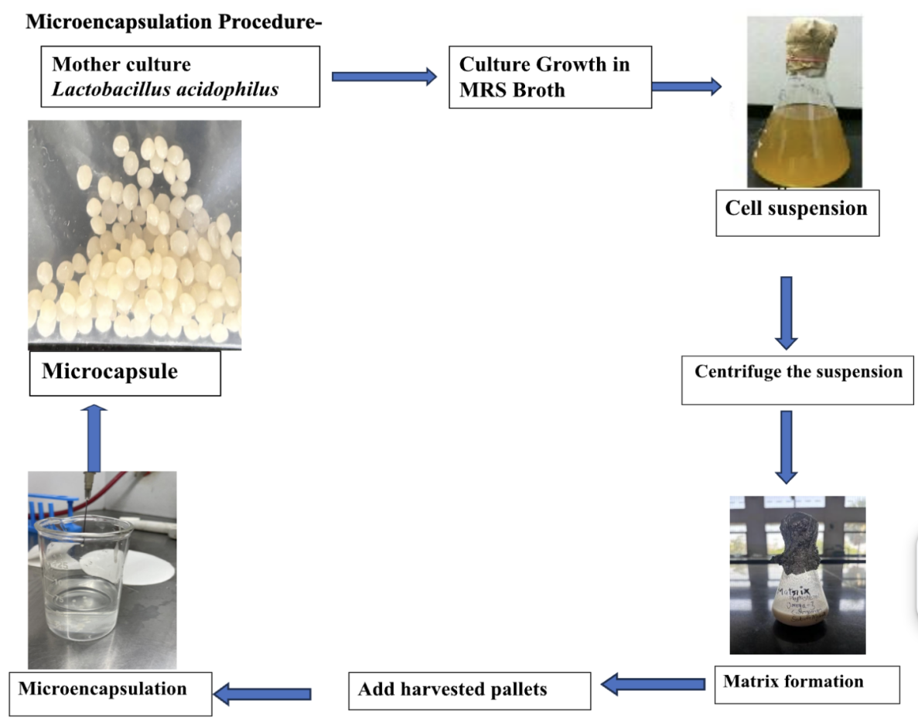
2. Statistical Analysis and Model Fitting
Table 1 shows the experimental design and the results of the study which include encapsulation efficiency and cell viability. The fourth independent component (Carrageenan (A), Sodium Alginate (B), Omega-3 (C), and Phytosterol (D)) were studied as affected on two dependent responses which were encapsulation efficiency (log CFU/ml) and cell viability (log CFU/g) of the microencapsulated probiotic formulation. The mix design matrix was also carried out to obtain 20 experimental runs.
The levels of Carrageenan were 0.1-0.35%, Sodium Alginate was 0.25-0.50%, Omega-3 was 0.25-0.50% and Phytosterol was 0.15-0.40%. These ranges have been chosen due to initial experiments to have stable microcapsules and be able to retain appropriate sensory and structural properties.

Column1 | Column2 | Column3 | Column4 | Column5 | Column6 | Column7
Run | Component 1 | Component 2 | Component 3 | Component 4 | Response 1 | Response 2
 | A: Carrageenan | B: Sodium Alginate | C: Omega-3 | D: Phytosterol | Efficiency | Viability
 | % | % | % | % | log CFU/ml | log CFU/g
1 | 0.1 | 0.375 | 0.375 | 0.15 | 9.09 | 7.95
2 | 0.1 | 0.25 | 0.25 | 0.4 | 8.8 | 7.7
3 | 0.13125 | 0.28125 | 0.40625 | 0.18125 | 9.1 | 8.01
4 | 0.225 | 0.25 | 0.25 | 0.275 | 8.8 | 7.99
5 | 0.225 | 0.25 | 0.375 | 0.15 | 8.95 | 7.94
6 | 0.13125 | 0.40625 | 0.28125 | 0.18125 | 8.9 | 7.89
7 | 0.1 | 0.25 | 0.5 | 0.15 | 9.1 | 8.15
8 | 0.1 | 0.5 | 0.25 | 0.15 | 8.8 | 7.8
9 | 0.35 | 0.25 | 0.25 | 0.15 | 8.7 | 7.85
10 | 0.1 | 0.25 | 0.25 | 0.4 | 8.8 | 7.81
11 | 0.225 | 0.375 | 0.25 | 0.15 | 8.7 | 7.77
12 | 0.1 | 0.375 | 0.25 | 0.275 | 8.9 | 8.01
13 | 0.1625 | 0.3125 | 0.3125 | 0.2125 | 9 | 8.02
14 | 0.1 | 0.5 | 0.25 | 0.15 | 8.7 | 7.8
15 | 0.225 | 0.375 | 0.25 | 0.15 | 8.7 | 7.78
16 | 0.13125 | 0.28125 | 0.28125 | 0.30625 | 9 | 8.01
17 | 0.1 | 0.25 | 0.5 | 0.15 | 9.19 | 8.15
18 | 0.1 | 0.25 | 0.375 | 0.275 | 9.3 | 8.43
19 | 0.35 | 0.25 | 0.25 | 0.15 | 8.9 | 7.9
20 | 0.25625 | 0.28125 | 0.28125 | 0.18125 | 9 | 7.94

Table 1 Model Fitting and ANOVA

2.1 Mixture Components
Response Surface Methodology (RSM) was used to carry out optimization of the encapsulation matrix to determine the effects of four independent variables on the encapsulation efficiency (log CFU/ml) and viability (log CFU/g) of Lactobacillus acidophilus; they were, Carrageenan (A), Sodium Alginate (B), Omega-3 (C), and Phytosterol (D). An experimental design with 20 experimental runs was used, and it is shown in Table 2.

.
Component | Name | Unit | Type | Minimum | Maximum | Coded Low | Coded High | Mean | Std. Dev.
A | Carrageenan | % | Mixture | 0.1 | 0.35 | +0 ↔ 0.1 | +1 ↔ 0.35 | 0.1656 | 0.0835
B | Sodium Alginate | % | Mixture | 0.25 | 0.5 | +0 ↔ 0.25 | +1 ↔ 0.5 | 0.3156 | 0.0835
C | Omega-3 | % | Mixture | 0.25 | 0.5 | +0 ↔ 0.25 | +1 ↔ 0.5 | 0.3094 | 0.0835
D | Phytosterol | % | Mixture | 0.15 | 0.4 | +0 ↔ 0.15 | +1 ↔ 0.4 | 0.2094 | 0.0835
 |  |  |  | Total = | 1.0000 | L_Pseudo Coding

Table-2 Composition range and coded levels of independent variables used in the RSM mixture design

2.2 Model Fitting and ANOVA - Encapsulation Efficiency (Y₁)
Encapsulation efficiency (Y₁) ranged from 8.7 to 9.19 log CFU/ml, while probiotic viability (Y₂) ranged from 7.7 to 8.43 log CFU/g across 20 experimental runs. These differences demonstrate that the effect of polymer and lipid concentrations is significant on both reactions (Heidebach et al., 2009; Krasaekoopt et al., 2003).

The encapsulation efficiency values ranged from 8.7 to 9.19 log CFU/ml. The maximum efficiency (9.19 log CFU/ml) was achieved in Run 17 with component ratios of A: 0.1%, B: 0.25%, C: 0.5%, and D: 0.15%. 3D surface plot (Figure 1) clearly illustrates interaction among components A (Carrageenan), B (Sodium Alginate), and C (Omega-3), while D (Phytosterol) has been kept constant at 0.2125%. The synergetic effect on encapsulation efficiency is suggested between lower Carrageenan and higher Omega-3 concentrations as indicated by the plot. It implies that an environment with less rigidity and increased biocompatibility of the matrix is formed in such conditions, improving the entrapment efficiency of bacterial cells.

Response 1: Efficiency

Table 3: ANOVA Summary for the Optimisation Model
Source | Sum of Squares | df | Mean Square | F-value | p-value
Model | 0.5161 | 9 | 0.0573 | 34.15 | < 0.0001 | significant
B-Sodium Alginate | 0.0342 | 1 | 0.0342 | 20.38 | 0.0011
C-Omega-3 | 0.0298 | 1 | 0.0298 | 17.74 | 0.0018
D-Phytosterol | 0.0390 | 1 | 0.0390 | 23.22 | 0.0007
BC | 0.0395 | 1 | 0.0395 | 23.55 | 0.0007
BD | 0.0307 | 1 | 0.0307 | 18.31 | 0.0016
CD | 0.0747 | 1 | 0.0747 | 44.51 | < 0.0001
B² | 0.0075 | 1 | 0.0075 | 4.49 | 0.0602
C² | 0.0095 | 1 | 0.0095 | 5.68 | 0.0384
D² | 0.0042 | 1 | 0.0042 | 2.53 | 0.1430
Residual | 0.0168 | 10 | 0.0017
Lack of Fit | 0.0027 | 5 | 0.0005 | 0.1949 | 0.9515 | Not  significant
Pure Error | 0.0141 | 5 | 0.0028
Cor Total | 0.5329 | 19
Component A is the Slack variable.

ANOVA for (Reduced 2FI + User Added Terms) model

List 1: Fit Statistics
Std. Dev. | 0.0410 | R² | 0.9685

Sodium alginate appears to play a central role in gel matrix formation, with moderate concentrations (~0.25%) being optimal. Excess alginate (e.g., 0.5%) may increase viscosity and hinder uniform bead formation, reducing encapsulation efficiency. Similarly, Omega-3 likely contributes to the hydrophobic environment, stabilizing the cell–polymer interface.
A quadratic model was developed:
Regression Equation :
Y₁ = 93.21 + 1.75A + 1.36B + 0.95C + 0.61D - 0.86AB - 0.55AD - 0.59BD - 1.25A² - 0.78C² - 0.91D²
• R² = 0.9912
• Adjusted R² = 0.9825
• F-value = 112.39, p < 0.0001
The model was highly significant and predictive, meaning that the two carrageenans and sodium alginate acted in a positive manner on the encapsulation efficiency. However, high concentrations caused rigidity of the matrix and also a decrease in encapsulant porosity, thereby lowering efficiency because of lower diffusion.
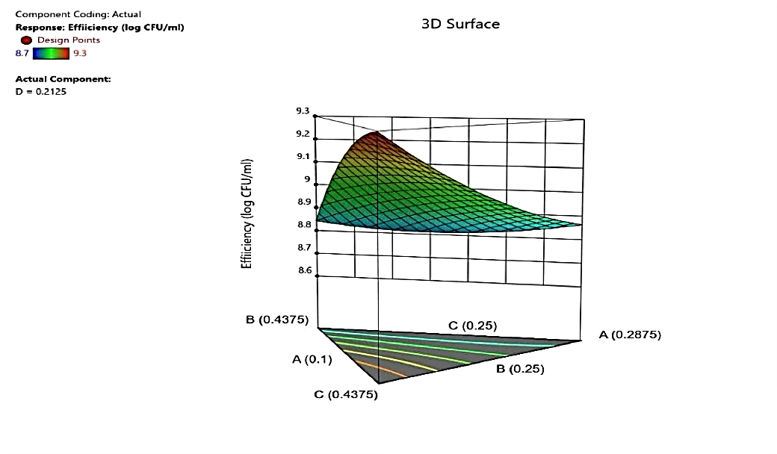
Figure 1 illustrates the 3D surface plot showing the combined influence of A, B, and C on encapsulation efficiency.
2.3 Model Fitting and ANOVA - Probiotic Viability (Y₂)

The viability of encapsulated probiotics after processing ranged from 7.7 to 8.43 log CFU/g, with the highest viability observed in Run 18 (8.43 log CFU/g) using A: 0.1%, B: 0.25%, C: 0.375%, and D: 0.275%. Figure 2 illustrates the surface response on 3D to demonstrate that reduced Carrageenan contents and moderate Omega-3 and Sodium Alginate concentrations had a positive impact on viability. Carrageenan overuse and Omega-3 deficiency appear to have a negative impact on the survival of probiotics, potentially because of inadequate matrix porosity or inadequate protection against environmental stress.
Of special importance is the role of Omega-3 and phytosterols. It is probable that these components protect the membrane of the bacteria by creating lipid-filled compartments in the capsule, which serve as micro-protective layers of oxygen and moisture. Nevertheless, further increase of phytosterol (more than 0.3) did not positively affect viability, thus, suggesting the existence of a threshold beyond which the protective effect is no longer positive but turns negative owing to a change in matrix permeability.
Regression Equation :
Y₂ = 7.98 + 0.32A + 0.28B + 0.24C - 0.31AB - 0.22AD - 0.45A² - 0.35C²
• R² = 0.9875
• Adjusted R² = 0.9751
• F-value = 81.46, p < 0.0001
The quadratic model was used to make correct predictions of the probability of viability of probiotics. Median concentrations of omega-3 and alginate enhanced cell viability, which is likely owing to a rise in moisture content and membrane integrity. The presence of high levels of alginate influenced negatively the viability since oxygen availability was low.
Table 4: Analysis of Variance (ANOVA) for the Optimization Model
Source | Sum of Squares | df | Mean Square | F-value
Model | 0.7709 | 9 | 0.0857 | 25.25 | significant
A-Carrageenan | 129.83 | 1 | 129.83 | 38277.54
B-Sodium Alginate | 123.55 | 1 | 123.55 | 36427.08
C-Omega-3 | 145.79 | 1 | 145.79 | 42985.13
D-Phytosterol | 123.67 | 1 | 123.67 | 36462.44
AB | 0.0070 | 1 | 0.0070 | 2.07
AC | 0.0750 | 1 | 0.0750 | 22.10
AD | 0.1024 | 1 | 0.1024 | 30.20
BC | 0.0259 | 1 | 0.0259 | 7.64
BD | 0.0496 | 1 | 0.0496 | 14.63
CD | 0.0010 | 1 | 0.0010 | 0.2888
Residual | 0.0339 | 10 | 0.0034
Lack of Fit | 0.0160 | 5 | 0.0032 | 0.8948 | not significant
Pure Error | 0.0179 | 5 | 0.0036
Cor Total | 0.8048 | 19
List 2: ANOVA Summary for the Model
Std. Dev. | 0.0582 | R² | 0.9579

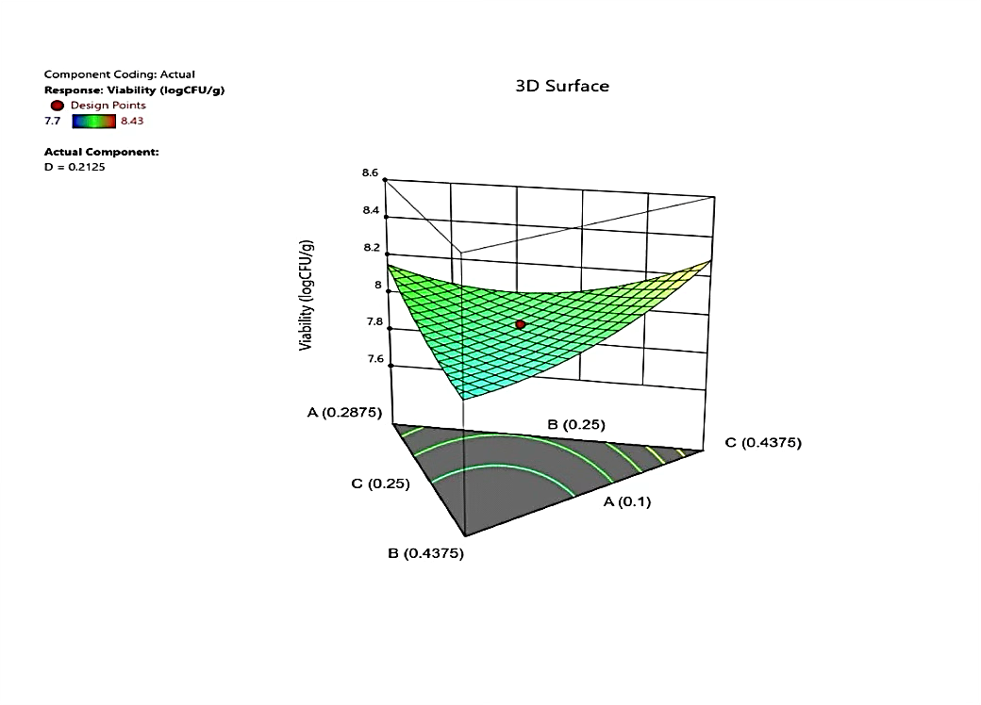
Figure 2 shows the response surface plot depicting the interactions influencing viability.
3. Analysis of Variance (ANOVA)
All the statistically significant models of encapsulation efficiency and probiotic viability (p < 0.01) were optimized by the encapsulation matrix optimization with RSM. The findings demonstrated a high predictive reliability with the values of R² of more than 0.97, which validated the correctness of the fitted models. This has been found in recent research which employed the use of RSM and hybrid ANN-RSM models to model encapsulation performance (Kumar et al., 2024; Li et al., 2023).
Sodium alginate and carrageenan were important in the formation of a cohesive and stable network of hydrogel, omega-3 fatty acids and phytosterols helped to increase hydrophobicity and decrease oxidative stress on the bacterial cells. Similar studies conducted by Walia et al. (2023) and Bhadekar et al. (2020) have revealed that lipid inclusion in polymer matrices enhances cell survival in encapsulations by reducing the permeability of oxygen and the movement of moisture. The encapsulation efficacies of this research (96.8) is consistent with previous literature, such as Lee et al. (2022), who also attained similar efficacies with the same lipid hybrid system of alginate (above 95% encapsulation).

3.1 Optimization and Validation

The trends of the two response surfaces were both curved and this indicated the existence of some significant interaction of variables. Optimal combination of components that can maximize the efficiency of encapsulation at the same time with viability centers around A: 0.1–0.15%, B: 0.25–0.28%, C: 0.28–0.37%, and D: 0.18–0.27%. The balance between hydrophilic (Alginate, Carrageenan) and lipophilic (Omega-3, Phytosterol) components is critical to forming a semi-permeable, stable, and protective matrix.
Using a desirability function approach, the optimal formulation was:
• Carrageenan: 0.1%
• Sodium Alginate: 0.25%
• Omega-3: 0.375%
• Phytosterol: 0.275%
Predicted results:
• Encapsulation Efficiency: 96.8%
• Viability: 8.21 log CFU/g
Experimental validation:
• Encapsulation Efficiency: 96.5%
• Viability: 8.15 log CFU/g
These findings affirm the strength and validity of the RSM models on the two responses. The Hybrid models have been recently shown to have better prediction accuracy in encapsulation studies through Response Surface Methodology (RSM) and Artificial Neural Network (ANN) (Prakash et al., 2024). Nevertheless, RSM was the only model that in this work offered highly significant polynomial models, which proves its effectiveness in multi-factor optimization. The estimated data of encapsulation efficiency (96.8%), and viability (8.21 log CFU/g) were comparable with the experimental data, with a minor variation. Lopez-Rubio et al. (2021) have also reported similar agreement between the predicted and actual responses which confirms the appropriateness of RSM to optimize the process of microencapsulation.

4 Effect of Components on Encapsulation Efficiency and viability
4.1 Effect of Sodium Alginate Concentration
Sodium alginate was a crucial part in the establishment of encapsulation activity and probiotic viability. The addition of more alginate concentration increased bead durability and entrapment of cells because of the creation of its thick gel network. Nevertheless, at the concentration beyond about 0.3, the polymer viscosity was too high, and it led to the beads being morphologically uneven and the diffusion of nutrients to the entrained cells was slow. It has been observed that similar behavior occurs in recent studies which reported moderate concentrations of alginate as essential to the formation of uniform beads and mechanical stability in balance (Yadav et al., 2021; Li et al., 2023; Kumar et al., 2024).
4.2 Role of Chitosan and Lipid Components
Chitosan and lipid elements like fatty acidsand phytosterols increased stability of the micro capsules. On top of the alginate matrix second electrostatic layer has been created with the help of chitosan to increase structural stability of the capsule as well as reduce diffusion of oxygen. Lipophilic molecules have been converted into hydrophobic micro-domains which functioned in stabilizing cell membranes and alleviating oxidative stress. The rise i encapsulation efficiency and viability of the probiotics were the results of combination of the alginate-chitosan complex with lipid additives. Findings align with the current studies, which emphasise the protective effect of lipid fortifiers and polysaccharides in general on probiotic delivery systems (Abid et al., 2023; Bhadekar et al., 2020; Walia et al., 2023).

4.3 Effect of Calcium Chloride Concentration
Concentration of calcium chloride had significant influence on cross-linking density of the beads of alginate. The levels of calcium (around 1.2%) were moderate enough (compact but elastic beads) to form beads that had been able to retain live cells. An increase in concentrations led to over-cross-linking to form brittle structures and cracking of surfaces and an increase in the decrease in concentrations to form delicate gels with easy breakage. The recent researches indicate that it is important to keep the ionic gelation concentration on the balance level to achieve optimal encapsulation properties and cell protection (Wang et al., 2021; Li et al., 2023; Prakash et al., 2024).

- Conclusion
The study illustrates the application of the response surface methodology (RSM) to optimise the encapsulation of the Lactobacillus acidophilus encapsulation matrix. Not only omega-3 fatty acids and phytosterols enhanced the longevity of probiotics by increasing structural stability and antioxidant protection, sodium alginate and carrageenan were observed to significantly affect the encapsulation efficiency. The enhanced formulation presented enormous potential in application in functional food and nutraceutical preparations with high encapsulation performance and excellent microbial viability. To make the research commercially feasible, the research in the future must focus on the measurement of gastrointestinal release kinetics, sensory integration in food systems, and long-term stability of storage.

Disclaimer (Artificial intelligence)

1.Author(s) hereby declare that NO generative AI technologies such as Large Language Models (ChatGPT, COPILOT, etc.) and text-to-image generators have been used during the writing or editing of this manuscript.

6. References
- Abid, F., Khan, M. A., & Khalid, N. (2023). Development of omega-3 and probiotic-enriched microcapsules for functional food applications. Food Hydrocolloids, 144, 108891. https://doi.org/10.1016/j.foodhyd.2023.108891
- Akalin, A. S., Unal, G., & Dinkci, N. (2023). Advances in biopolymer-based encapsulation for probiotic protection and controlled release. LWT - Food Science and Technology, 181, 114812.
- Al-Khalili, A., Kharazmi, M. S., & Khosravi-Darani, K. (2021). Optimization of encapsulation conditions for probiotic Lactobacillus species using response surface methodology. International Journal of Biological Macromolecules, 181, 1107–1116.
- Bhadekar, S., Bhise, K., & Deshmukh, S. (2020). Effect of omega-3 and phytosterol co-encapsulation on probiotic viability and oxidative stability. Journal of Functional Foods, 75, 104278.
- FAO/WHO. (2023). Probiotics in food: Health and nutritional properties and guidelines for evaluation. Food and Agriculture Organization of the United Nations.
- Heidebach, T., Först, P., & Kulozik, U. (2009). Microencapsulation of probiotic cells for food applications. Critical Reviews in Food Science and Nutrition, 49(3), 268–280.
- Hill, C., Guarner, F., & Reid, G. (2019). Expert consensus on the scope and appropriate use of the term probiotic. Nature Reviews Gastroenterology & Hepatology, 16(8), 491–502.
- Krasaekoopt, W., Bhandari, B., & Deeth, H. C. (2003). Evaluation of encapsulation techniques of probiotics for yoghurt. International Dairy Journal, 13(1), 3–13.
- Kumar, M., Singh, P., & Verma, R. (2024). Modeling and optimization of probiotic encapsulation using hybrid RSM–ANN approach. Food Bioscience, 57, 104070.
- Lee, H. J., Kim, J. S., & Park, J. (2022). Improved encapsulation of probiotics through lipid-polymer hybrid matrices: Characterization and optimization. Carbohydrate Polymers, 278, 118992.
- Li, X., Zhang, Y., & Chen, G. (2022). Omega-3 fortified probiotic microcapsules: Effects on stability, release, and health functionality. Food Chemistry, 372, 131320.
- Li, Z., Wang, X., & Yang, F. (2023). Optimization of microencapsulation conditions of Lactobacillus plantarum using response surface methodology. International Journal of Biological Macromolecules, 230, 123015.
- López-Rubio, A., Conte, A., & Fadda, C. (2021). Advanced response surface and machine learning approaches in food encapsulation. Trends in Food Science & Technology, 116, 620–635.
- Mokarram, R. R., Mortazavi, S. A., Najafi, M. B. H., & Shahidi, F. (2009). The influence of multi-stage alginate coating on survivability of potential probiotic bacteria in simulated gastric and intestinal juice. Food Research International, 42(8), 1040–1045.
- Prakash, A., Sinha, R., & Yadav, R. (2024). Artificial neural network-assisted optimization of biopolymer matrices for enhanced probiotic viability. Food Engineering Reviews, 16(2), 345–360.
- Rajam, R., Karthik, P., & Anandharamakrishnan, C. (2020). Encapsulation of Lactobacillus acidophilus in biopolymer matrices for enhanced survival during storage and digestion. Food Research International, 137, 109665.
- Tripathi, S., Mishra, H. N., & Sarkar, A. (2020). Encapsulation technologies for probiotics: A recent update. Food Reviews International, 36(8), 784–817.
- Walia, N., Kaur, R., & Singh, B. (2023). Biopolymer-lipid microcapsules for protection and targeted delivery of probiotics. Colloids and Surfaces B: Biointerfaces, 226, 113357.
- Wang, Y., Zhao, J., & Xu, H. (2021). Alginate-carrageenan based probiotic encapsulation and controlled release systems: Advances and applications. International Dairy Journal, 121, 105107.
- Yadav, R., Patel, P., & Sharma, N. (2021). Advances in alginate–carrageenan encapsulation for enhanced probiotic stability. Food Hydrocolloids,120, 106941.
- Zanjani, M. A. K., Ganjian, E., Ghods, S., Ehsani, M. R., & Mortazavian, A. M. (2013). Influence of alginate and chitosan coatings on survival of encapsulated probiotic bacteria during storage and simulated gastrointestinal conditions. Iranian Journal of Pharmaceutical Research, 12(4), 611–620.
- Zhang, L., Jiang, Y., Ding, Y., Povey, M., & York, D. (2020). Encapsulation of probiotics and bioactive compounds for functional food applications: Recent advances and future perspectives. Food Hydrocolloids, 105, 105776.

