Health risk assessment of carcinogenic compounds in the Ivorian street food “Garba”: a popular dish of fried tuna and attiéké

ABSTRACT

The “Garba,” an iconic Ivorian dish made of attiéké (fermented cassava semolina) and fried tuna, is widely consumed in Abidjan due to its affordability and cross-social popularity. However, the frequent and excessive reuse of frying oils raises major public health concerns, particularly regarding consumer exposure to carcinogenic neo-formed contaminants.
A dietary survey was conducted among 154 consumers in three municipalities of Abidjan (Cocody, Abobo, and Yopougon). Fried tuna and frying oil samples were collected from 90 vendors. Concentrations of polycyclic aromatic hydrocarbons (benzo[a]pyrene, anthracene, fluoranthene) were determined by gas chromatography–mass spectrometry (GC-MS), while acrylamide was quantified using high-performance liquid chromatography (HPLC). Cancer risk assessment followed the United States Environmental Protection Agency (USEPA) model, including the estimation of daily intake doses and hazard quotients.
Mean concentrations of benzo[a]pyrene, anthracene, fluoranthene, and acrylamide in fried tuna were 1.36 ± 0.58 µg/kg, 2.66 ± 0.42 µg/kg, 2.60 ± 0.37 µg/kg, and 69.43 ± 6.7 µg/kg, respectively. In reused frying oil, corresponding concentrations were 1.99 ± 0.60 µg/kg, 2.00 ± 0.35 µg/kg, 2.08 ± 0.31 µg/kg, and 20.6 ± 3.8 µg/kg. Hazard quotients (HQ) for acrylamide and benzo[a]pyrene exceeded unity (HQ_acrylamide = 148.77; HQ_benzo[a]pyrene = 12.71 in tuna), indicating potential health risks. Estimated lifetime cancer risks were 0.14 for acrylamide and 0.003 for benzo[a]pyrene, surpassing the USEPA acceptable threshold (1×10⁻⁴)
These findings reveal chronic exposure to potentially carcinogenic compounds through routine consumption of “Garba.” Regular consumption thus represents a silent public health threat. It is crucial to strengthen awareness campaigns on safe frying practices and implement strict control measures to mitigate foodborne risks.

Keywords: Garba; reused frying oil; cancer risk; PAHs; acrylamide; Côte d’Ivoire

- INTRODUCTION

In recent years, street food consumption has expanded considerably in major urban areas of sub-Saharan Africa, driven by rapid urbanization, economic constraints, and the fast-paced lifestyle of urban populations. Côte d’Ivoire, with its iconic dish known as “Garba”, is no exception to this trend. Composed of attiéké (fermented cassava semolina) and fried tuna, Garba has become an emblematic and affordable meal, widely accessible across social classes. It is consumed daily in most municipalities of Abidjan, especially by students, informal sector workers, and low-income households [1].
However, the artisanal preparation of garba raises serious health concerns. Tuna is usually fried under empirical conditions, without technical guidance or quality control, and often involves the prolonged reuse of frying oils. In restaurants, the oil used to prepare tuna is reused more than seven times continuously, even when it has turned blackish, at uncontrolled temperatures ranging from 160°C to over 180°C during a frying time that varies from 5 to 10 minutes. Such practices promote the formation of toxic new compounds [2,3], including polycyclic aromatic hydrocarbons (PAHs) and acrylamide, generated by complex thermal reactions during high-temperature cooking [4; 5; 6]. These substances, particularly benzo(a)pyrene, are known to have genotoxic and carcinogenic effects in humans [7].

In Côte d’Ivoire, while a few studies have examined the nutritional and microbiological composition of attiéké or the fish used in Garba, very few have addressed the carcinogenic risk associated with the presence of PAHs and acrylamide in this dish, while integrating actual population consumption patterns.

In a previous study, Massogbè and al. [8] reported the presence of PAHs and acrylamide in fried tuna and used frying oil collected from street vendors in Abidjan, with levels sometimes exceeding the regulatory limits set by the European Union (EU No. 1881/2011), especially for benzo(a)pyrene and acrylamide. However, these findings, while alarming in terms of food quality, did not quantify the actual risk to consumers, which depends on the amounts ingested, the frequency of consumption, and the demographic profile of exposed individuals.

This study specifically addresses that gap. It aims to estimate the carcinogenic risk associated with Garba consumption in Abidjan, based on previously quantified concentrations of PAHs (benzo(a)pyrene, anthracene, fluoranthene) and acrylamide, combined with data from a detailed dietary survey. This survey collected precise information on consumption frequency, quantities of tuna and oil ingested, and sociodemographic characteristics of consumers.

The carcinogenic risk assessment follows the methodology of the United States Environmental Protection Agency [9], modeling chronic exposure to toxic substances by calculating estimated daily intakes (EDI) and hazard quotients (HQ), followed by lifetime cancer risk estimation. This rigorous approach is widely used in food safety risk assessment, particularly in contexts of unregulated urban food consumption [10: 11].
By integrating validated chemical data with real consumption profiles, this study provides solid scientific evidence to better characterize the hazards associated with a popular dish often perceived as harmless. It is part of a public health surveillance initiative, aiming to support regulatory policies on artisanal processing practices and raise awareness among consumers and informal sector stakeholders about the potential health impacts of their food choices.

2. MATERIALS AND METHODS
2.1. Study area
The study was conducted in three municipalities of Abidjan: Cocody, Abobo, and Yopougon (Figure 1 et 2). These areas were selected for their high population density, socio-economic diversity, and the large presence of street stalls specializing in Garba. Abidjan, the economic capital of Côte d’Ivoire, is located in the south of the country, between latitudes 5°16′ and 5°28′ N and longitudes 3°45′ and 4°5′ W. Cocody is a residential, academic, and administrative district. Abobo is a densely populated working-class area, while Yopougon is the largest and most populated municipality in Abidjan, with a high concentration of street food vendors. This geographical and social diversity allows for representative sampling of Garba consumption habits in different urban settings.

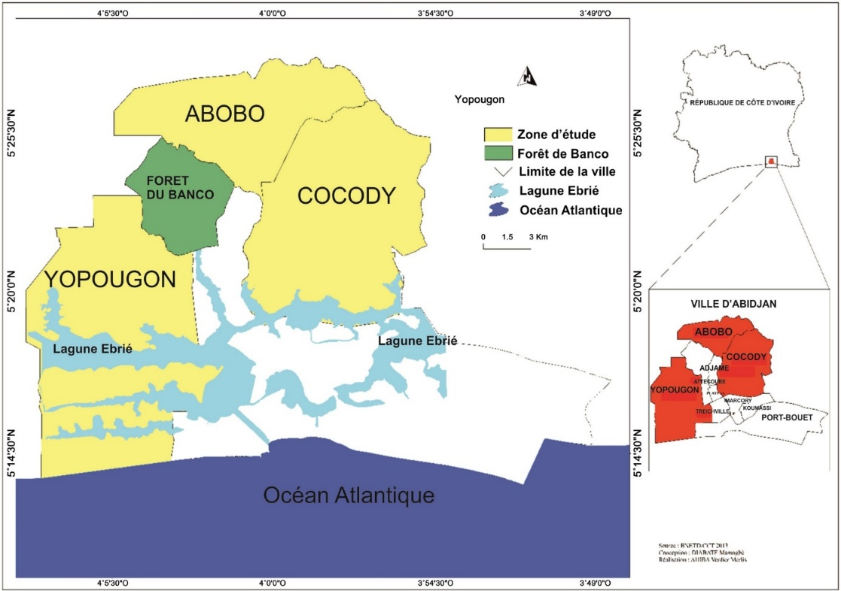
Figure 1. Map of the District of Abidjan showing the selected communes [8].

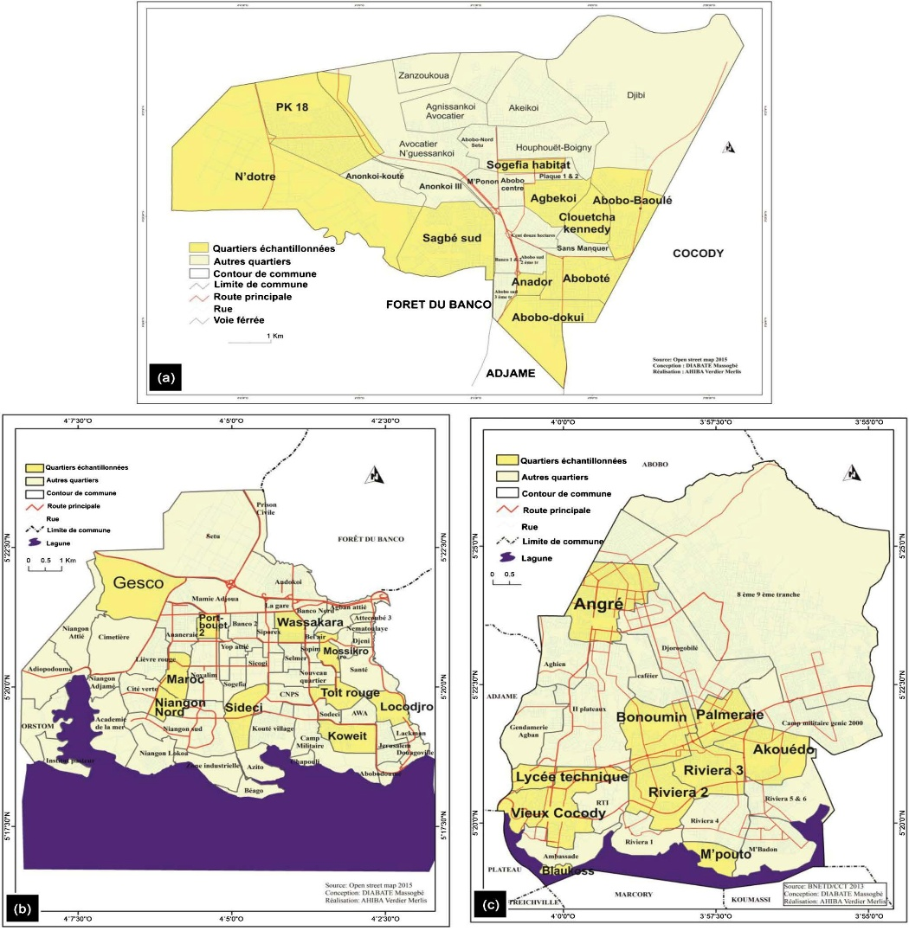
Figure 2. Study area. (a) Commune of Abobo; (b) Commune of Yopougon; (c) Commune of Cocody [8]

2.2. Consumption survey data collection

A descriptive and cross-sectional dietary survey was conducted in three districts of Abidjan — Cocody, Abobo, and Yopougon — selected for their high population density, socio-economic diversity, and the strong concentration of “Garba” street food outlets.
Data related to the consumption habits of Garba were collected using a semi-structured questionnaire.
The selection of (90) restaurants (“Garbadromes”)/ (30) par commune (“Garbadromes”) and 154 consumers followed a three-stage sampling design:
First stage: the sampling frame was established based on the official list of the communes of Abidjan, according to data from the General Population and Housing Census [12];
Second stage: ten (10) sectors or neighborhoods were randomly selected within each commune (Figure 2);
Third stage: consumers were randomly selected within the chosen food outlets in Abobo, Cocody, and Yopougon.
In total, 154 adult consumers (≥ 18 years old) were surveyed, distributed as follows: Abobo (n = 58), Cocody (n = 46), and Yopougon (n = 50).
Respondents were approached directly at the food outlets or in their immediate vicinity.
A snowball sampling method was also applied to identify regular consumers of the dish. Each participant was invited to recommend other individuals meeting the inclusion criteria, ensuring a representative diversity of social profiles and eating habits.
The questionnaire, administered face-to-face by trained interviewers, collected the following information:
frequency of Garba consumption (average number of meals per week);
verage quantities of fried tuna, oil, and attiéké consumed per portion;
regularity and context of consumption (on-site or take-away);
sociodemographic characteristics (sex, age, education level, occupation).
Average quantities consumed were estimated from standardized portions weighed directly at the time of the survey.
.

2.3. Sampling of food products
Garba vending sites were randomly selected in each municipality. At each site, samples of fried tuna and frying oil were collected. Per municipality, 30 restaurants were selected, from which 45 mL of oil and five pieces of fried tuna of similar size, with an average mas of 300 g (Figure 3a, 3b, 3c), were randomly collected immediately after frying. Samples were transported under controlled conditions to the laboratory for analysis.
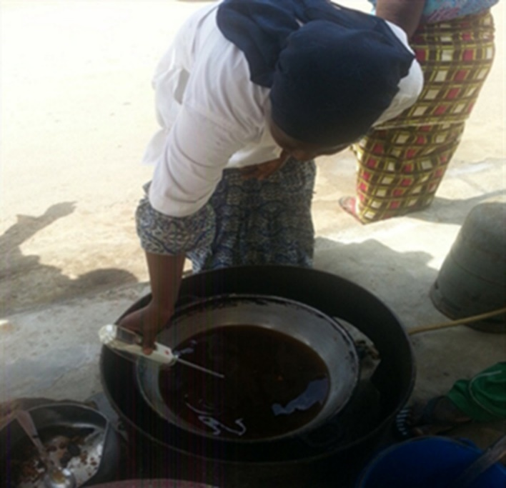
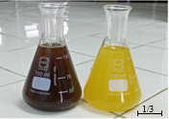

Figure 3b: Reused and fresh oils sampled from street vendors

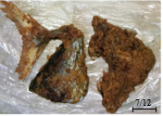

Figure 3a: In situ measurement of the content of neoformed compounds in reused frying oil used for tuna frying in a restaurant in Abobo using an oil tester (Photo: Massogbè Diabaté).

Figure 3c: Fried tuna portions sampled from street vendors.

2.4. Analysis of chemical contaminants (PAHs and acrylamide)

All analyses were conducted in accordance with internal Quality Assurance and Quality Control (QA/QC) protocols, compliant with ISO/IEC 17025 standards. Field procedures included the collection of blank and duplicate samples to ensure representativeness and analytical reliability. In the laboratory, method blanks, spiked recoveries (substitute standards), and matrix fortifications were performed for each analytical batch.
Reported concentrations were corrected for recovery rates. Limits of detection (LOD) and limits of quantification (LOQ) were established for each analyte. Recovery rates for target compounds ranged from 78% to 105%, and the relative standard deviation (RSD) was below 12% for all major analytes. Instrument calibration was performed using certified reference standards, and linearity was verified with correlation coefficients (r² > 0.995).
The analytical methods applied for the quantification of polycyclic aromatic hydrocarbons (PAHs) and acrylamide in fried tuna and frying oils were previously described in detail by Massogbè and al. [8]. All food samples were handled following standardized protocols to preserve the integrity of neoformed compounds.
- The determination of PAHs (benzo[a]pyrene, anthracene, fluoranthene) was performed using gas chromatography coupled with mass spectrometry (GC–MS), according to the analytical method developed by [13] for quantifying PAHs in food matrices. The equipment used was a Supelco system (Belefonte, USA) equipped with a flame ionization detector (FID). The analytical column was a fused-silica capillary column (SP 2560, 100 m × 250 μm i.d. × 0.20 μm film thickness), which ensured efficient separation and accurate quantification of target compounds in both lipid and protein matrices.
- Acrylamide determination was carried out using high-performance liquid chromatography (HPLC) coupled with a UV detector, following the procedure described by Chen et al. [14]). This method allows reliable identification and quantification of acrylamide at low concentrations in complex matrices such as reused frying oils and fried products. The HPLC analyses were performed on an Agilent 1100 HPLC system (Santa Clara, CA, USA) equipped with a quaternary pump, an autosampler, and a thermostated column oven, coupled to an Agilent 1100 mass spectrometric detector with an electrospray ionization interface. The analytical column was a Kinetex C18 (100 × 4.6 mm, 2.6 µm, Phenomenex, Torrance, CA, USA). The mobile phase consisted of acetonitrile and aqueous formic acid solution (1/1000, v/v 30:70) at a flow rate of 0.2 mL/min.

It is important to note that these analytical results, previously published, form the basis of the present study, which introduces a new integrated approach to estimate the carcinogenic risk associated with the consumption of the traditional Ivorian dish “Garba.” This assessment combines measured contaminant concentrations with the dietary profiles of consumers collected in the field.

  - Estimation of carcinogenic Risk (USEPA Model)
The estimation of cancer risk was carried out according to the methodology of the United States Environmental Protection Agency [9].
- The Estimated Daily Intake (EDI) values were calculated based on the measured concentrations of contaminants, the quantities consumed, and the body weight of individuals, using the standard formula:

$EDI=\frac{C_{neoformed compound}×Qm}{BW}$ (1)

Where C (µg/kg) is the concentration of the neoformed compound in the consumed food; Qm (g/day) represents the maximum daily amount of fried tuna and oil consumed per person in the study area; and BW (kg) is the average body weight of the consumers who participated in the survey.

- The hazard quotient (HQ) was then obtained using the equation described by Mok et al. [15].

$\text{ HQ=}\frac{\text{EF×ED×Qm×}C_{neoformed compound}}{\text{P×DORf×TEn}}\text{×0,001}$ (2)

Where HQ is the hazard quotient; EF is the exposure frequency (365 days/year); ED is the exposure duration (70 years); Qm is the maximum amount of food consumed per person per day (fried tuna: 300 g/person/day, equivalent to two fish portions of 150 FCFA each; reused oil: 100 g/person/day, equivalent to four tablespoons); C is the concentration of neoformed compounds in fried tuna and reused frying oil (µg/kg); RfD is the oral reference dose established by the USEPA, estimated for acrylamide (2×10⁻³ µg/g/day), benzo(a)pyrene (3×10⁻³ µg/g/day), anthracene (3×10⁻¹ µg/g/day), and fluoranthene (4×10⁻² µg/g/day); BW is the average body weight (70 kg); and ATn is the average exposure time for non-carcinogenic substances (ED × 365 days/year).

If HQ < 1, the occurrence of toxic effects is unlikely.
If HQ > 1, the occurrence of toxic effects cannot be excluded.

- Hazard Index and Cancer Risk

The Hazard Index (HI) was calculated as the sum of the individual hazard quotients (HQ) [8].

$\text{ HI =}\sum_{\text{1}}^{\text{n}}{\text{HQ(i)}}$ (3)

Where HI is the hazard index; HQ(i) is the hazard quotient of each neoformed compound i; and n is the total number of compounds considered.

The cancer risk (CR) was estimated using the following mathematical equation [9]:

$\text{ CR=}\frac{\text{EF×ED ×Qm×}{\text{C}}_{{}_{neoformed compound}}\text{×CSF}}{\text{P×TEc}}\text{×}{\text{10}}^{\text{-3}}$ (4)
Where CR is the cancer risk; EF is the exposure frequency; Ccompound is the concentration of neoformed compounds in the consumed food (µg/g); Qm is the maximum daily food intake (g/day); ED is the exposure duration (70 years) to carcinogenic substances; and CSF is the oral cancer slope factor (mg/kg body weight/day). Among the studied compounds, acrylamide and benzo(a)pyrene are the major neoformed carcinogens, with cancer slope factors of 1 mg/kg/day and 5×10⁻¹ mg/kg/day, respectively. ATc is the average exposure time for carcinogenic substances (365 days × 70 years), as applied by the USEPA [9].

2.6. Statistical analysis
Data were analyzed using XLSTAT software. To assess overall consumption practices, quantitative data were subjected to a two-way analysis of variance (ANOVA) with Commune and Sex as fixed factors. Multiple mean comparisons were performed using the Student–Newman–Keuls test, and results were expressed as means ± standard deviation. ANOVA tests and Pearson’s correlation analyses were used to evaluate relationships between consumption variables and exposure levels. The level of statistical significance was set at p < 0.05. The Pearson’s Chi-square test was used to assess variability of criteria across districts.

- RESULTS
3.1. Results
3.1.1. Social profile of consumers
Data collected from the survey made it possible to define the typology of consumers. Table 1 presents the socio-economic profile of individuals consuming the dish “Garba” included in the sampling. The results show that, across all municipalities, most consumers were manual workers (40.7%), followed by unemployed individuals (27%) and students (25%). The study population consisted mainly of men (62.4%), compared with women (37.6%). The most represented age groups were 20–30 years (45.5%) and 31–40 years (32.5%), indicating a high consumption rate among young adults.
A majority of participants (68.2%) reported consuming Garba at least three times per week, while 24.0% consumed it daily. The average portion per meal was estimated at 150 ± 23 g of fried tuna and 80 ± 17 g of oil absorbed or incorporated into the dish. The mean body weight of respondents was 70 ± 8.2 kg.
These findings indicate frequent and substantial consumption, particularly among young urban workers, suggesting potential chronic exposure to contaminants present in the fried ingredients. The main characteristics of the consumers are presented below.

3.1.2. Characterization of consumption practices
Consumption practices for the dish “Garba” were characterized based on responses to the administered questionnaire; the main results are presented in Table 2. The analysis reveals that the majority of respondents report using an average of six tablespoons of frying oil per dish, corresponding to approximately 100 g of oil per serving. The tuna consumed is generally salted and fried, with an average portion estimated as a whole fish weighing approximately 300 g per meal. Regarding consumption frequency, most respondents consume Garba at least once per day, confirming the regularity of this dish in urban dietary habits. In addition, 70% of consumers systematically add ingredients such as chili, onions and tomatoes to their dish.
Salted tuna is the most consumed fish, representing 68.2% of stated preferences. For seasoning the attiéké, salt is preferred (75%) over commercial bouillon cubes, which are often considered too expensive or less accessible. Attiéké is almost always consumed with fried tuna, forming a standardized combination at sales points commonly referred to as “Garbadromes.”
These practices, combined with frequent consumption and a lack of awareness of frying conditions, underline the need to assess the risks related to chronic exposure to neoformed contaminants present in tuna and in the frying oil.
Table 1. Socio-economic profiles of consumers of the dish “Garba” (percent).
Variable | Category | Frequency (%)
Sex | Men | 62.40
Sex | Women | 37.60
Age (years) | Unknown | 20.40
Age (years) | 18$≤$ Age$≤$ 25 | 43.90
Age (years) | Age$>$25 | 35.70
Body mass (kg) | Unknown | 29.90
Body mass (kg) | 45$≤$ Body mass$<$ 70 | 28.70
Body mass (kg) | Body mass $≥$70 | 41.40
Profession | Unemployed | 27.40
Profession | Students | 25.50
Profession | Managers/Professionals | 6.40
Profession | Workers | 40.70
¹ = number of respondents surveyed.

Table 2. Consumption practices for the dish “Garba” (percent by locality).
Variable | Modality | Number of respondents by locality (%) |  |  | Total ^{(%)}
Variable | Modality | Abobo | Cocody | Yopougon | Total ^{(%)}
Quantity of frying oil added to attiéké | | 2–4 tablespoons (70 g) | 7.50 | 34.80 | 17.20 | 19.10
Quantity of frying oil added to attiéké | | 5–6 tablespoons (100 g) | 92.50 | 65.20 | 82.80 | 80.90
Consumption frequency | Once/day | 84.30 | 52.10 | 62.10 | 73.20
Consumption frequency | Twice/day | 5.10 | 10.90 | 20.70 | 10.80
Consumption frequency | Rarely | 10.60 | 37.00 | 17.20 | 16.00
Accompaniment -chili | Yes | 98.10 | 87.00 | 91.40 | 92.30
Accompaniment -chili | No | 1.90 | 13.00 | 8.60 | 7.70
Accompagnement bouillon | Oui | 41.50 | 69.60 | 43.10 | 42.60
Accompagnement bouillon | No | 58.50 | 30.40 | 56.90 | 57.40
Accompagnement sel | Yes | 94.30 | 10.90 | 77.60 | 75.10
Accompagnement sel | No | 5.70 | 89.10 | 22.40 | 24.90
Accompagnement oignon | Yes | 92.50 | 54.30 | 81.00 | 77.10
Accompagnement oignon | No | 7.50 | 45.70 | 19.00 | 22.90
Accompagnement tomate | Yes | 35.80 | 97.80 | 51.70 | 60.40
Accompagnement tomate | No | 64.2 | 2.20 | 48.30 | 30.60
Number of fish per plate | 1 fish | 62.30 | 63.00 | 69.00 | 65.00
Number of fish per plate | 2 fish | 35.80 | 34.80 | 31.00 | 33.80
Number of fish per plate | 3 fish | 1.90 | 2.20 | 0.00 | 1.20
Type of fish | Mackerel | 1.90 | 28.30 | 1.70 | 1.30
Type of fish | Tuna | 98.10 | 71.70 | 98.30 | 98.70
Tuna preference | Unsalted | 3.80 | 8.70 | 37.90 | 17.80
Tuna preference | Salted | 94.30 | 65.20 | 46.60 | 68.20
Tuna preference | Indifferent | 1.90 | 26.10 | 15.50 | 14.00
¹ = number of respondents surveyed.
3.1.3. Statistical analysis of consumption practices according to consumer profile
Analysis of data by sex and municipality for Garba consumption practices revealed no significant differences (Figure 4). These results suggest homogeneity of consumption habits in the areas covered by the study. In addition, a Correspondence Factor Analysis (CFA) was carried out to explore relationships between consumer types and accompaniment modalities by municipality. Figure 5 illustrates the projection of socio-professional categories and consumption habits on the main factorial axes. This analysis shows that male and female professionals in the Cocody municipality, as well as male professionals in Yopougon, consume Garba predominantly with fresh tomato as an accompaniment ingredient. In contrast, other social groups — notably students and workers — more frequently associate the dish with chili or onion. Male workers in Abobo are distinguished by a marked consumption of commercial bouillon cubes as seasoning.
A second CFA exploring relationships among consumed oil quantities, tuna type, consumption frequency and consumer categories was performed (Figure 5). The first two axes of this analysis explain 87.11% of the total inertia, reflecting strong data structuring. The analysis indicates that men and women living in Yopougon, as well as students, mainly consume salted tuna accompanied by around 100 g of frying oil, up to twice per day. In contrast, in Cocody, both male and female professionals and female workers consume both salted and unsalted tuna, indicating greater diversity in dietary practices.
Figure 4: Garba consumption practices by municipality and sex
Error bars represent standard errors. Bars sharing the same letter are not significantly different according to the Student–Newman–Keuls test (P 0.05).

Figure 5: Consumer categories and ingredient accompaniment practices projected onto factorial axes.
Figure 6: Tuna consumption practices and professional categories projected onto factorial axes.

3.1.4. PAH concentrations
PAH concentrations determined in reused frying oil and in fried tuna are presented in Figure 7. The PAHs analyzed were benzo[a]pyrene, anthracene and fluoranthene. Concentrations of these compounds in frying oil were significantly higher (p < 0.05) than those observed in fried tuna. Nevertheless, both in the frying oil and in the fried fish, benzo[a]pyrene exhibited the highest concentration among the PAHs studied. The benzo[a]pyrene concentration in frying oil was 1.99 ± 0.60 µg/kg and that in tuna was 1.36 ± 0.58 µg/kg.

3
2.5
2
1.5
1
0.5
0
PAH content µg/kg
Reused oil
Fried tuna
Figure 7: Concentrations of benzo[a]pyrene, anthracene and fluoranthene in reused frying oil and in fried tunas from the Garba dish.
3.1.5. Acrylamide contents
The acrylamide concentrations determined in reused frying oil and fried tuna samples are presented in Figure 8. The results showed that fried tuna (69.43 ± 6.7 µg/kg) contained significantly higher (p < 0.05) levels of acrylamide compared to the reused frying oil (20.6 ± 3.8 µg/kg).

.

fried tunas reused oils
Food
Figure 8 Acrylamide concentrations in reused frying oil and fried tuna samples from the “Garba” dish
3.1.6. Estimated exposures to neoformed compounds
Estimated daily intake (EDI) values for neoformed compounds from consumption of fried tuna and reused oil are presented in Table 3. In this study, the estimated daily exposures (µg/kg/day) for benzo[a]pyrene, anthracene, fluoranthene and acrylamide were, respectively, 3.81; 2.66; 2.60; 297.6 µg/kg/day for consumption of fried tunas and 2.86; 2.00; 2.08; 28.6 µg/kg/day for consumption of reused oils.
Table 3 : Estimated daily intake (EDI) values associated with consumption of fried tuna and reused frying oil.
Neoformed compound | EDI-fried tunas (µg/kg/day) | reused oils (µg/kg/day)
Benzo(a) pyrène | 3.81 | 2.86
Anthracène | 2.66 | 2.00
Fluoranthène | 2.60 | 2.08
Acrylamide | 297.60 | 28.60

3.1.7. Hazard indices related to consumption of fried tuna and frying oil
• Hazard quotient (HQ)
Table 4 below reports hazard quotient (HQ) values for benzo[a]pyrene, anthracene, fluoranthene and acrylamide determined in fried tunas and in reused oils. These values are, respectively for benzo[a]pyrene, anthracene, fluoranthene and acrylamide: 12.71; 0.008; 0.06; 148.77 for consumption of fried tunas, and 9.53; 0.006; 0.05; 14.27 for consumption of reused oil from the Garba dish. HQ values for benzo[a]pyrene and acrylamide are greater than 1 — the reference value according to the USEPA — for both sample types (oils and tunas).
Table 4: Hazard quotients (HQ) associated with consumption of fried tuna and reused frying oil.
Neoformed compound | | HQ — fried tunas | HQ — reused oils | Reference
Benzo(a) pyrène | 12.710 | 9.530
Anthracène | 0.008 | 0.006 | 1
Fluoranthène | 0.060 | 0.050
Acrylamide | 148.770 | 14.270

• Hazard index (HI)
Figure 9 depicts hazard indices for fried tunas and reused oils. The calculated hazard indices (HI) are greater than 1 and amount to 161.548 and 23.85 for fried tunas and reused oils, respectively. HI values far exceeding 1 indicate that the set of four neoformed compounds present in fried tuna and in the reused oil are toxic and represent a hazard for consumers of this meal. Acrylamide alone accounts for 92% of the hazard associated with consumption of fried tuna and 60% of the hazard associated with consumption of reused oil (Figure 10).
fried tunas reused oils Reference
Foods
Hazard index (HI)
Figure 9: Hazard indices for fried tunas and reused frying oils.

Figure 10: Contribution of neoformed compounds to the hazard index associated with consumption of (A) fried tuna and (B) reused oil.

- Cancer Risk

The cancer risk (CR) associated with the consumption of fried tuna and frying oil was estimated for benzo(a)pyrene and acrylamide, based on their carcinogenic potency doses, as illustrated in Figure 11. The CR values related to the consumption of fried tuna were 0.003 for benzo(a)pyrene and 0.14 for acrylamide. For the consumption of reused frying oils, the CR values were 0.008 for benzo(a)pyrene and 0.04 for acrylamide.
Cancer Risk
0.08
0.06
0.16
0.14
0.12
0.1
0.08
0.06
0.04
0.02
0

Figure 11: Cancer risk associated with consumption of fried tuna and reused frying oil.

4. DISCUSSION
This study highlights a high prevalence of consumption of the street food “Garba” in Abidjan, particularly in densely populated districts such as Yopougon, Abobo, and Cocody. The widespread popularity of this dish stems from its affordability, quick preparation, and cultural symbolism in Ivorian urban diets. These findings align with Soungari and al. [16], who described street foods as a central component of the evolving food systems in African cities.
However, this high consumption is accompanied by worrying frying practices, especially the repeated reuse of frying oils for economic reasons. This behavior promotes the formation of neo-formed contaminants such as polycyclic aromatic hydrocarbons (PAHs) and acrylamide — compounds known for their genotoxicity and carcinogenic potential [17, 18]. A previous study by Massogbe and al. [8] reported the occurrence of these compounds in “Garba” but without assessing the associated health risks. The present study addresses this gap by applying the USEPA carcinogenic risk model to real consumption patterns.
The results revealed high hazard quotient (HQ) and cancer risk (CR) values for acrylamide (HQ: 148.77; CR: 0.14) and benzo[a]pyrene (HQ: 12.71; CR: 0.003), particularly in fried tuna. According to USEPA standards, a cancer risk greater than 1 × 10⁻⁴ is considered unacceptable, a threshold largely exceeded in this study. Similar findings were reported by Loren et al. [19] and Amadou et al. [20] in their epidemiological studies, confirming that chronic exposure to genotoxic substances such as benzo[a]pyrene (BaP) and acrylamide increases the risk of breast cancer and other cancer types.
From a nutritional and toxicological perspective, these findings raise major public health concerns. The chronic intake of PAHs and acrylamide has been associated with oxidative stress, DNA damage, and increased risks of cancer and cardiovascular disease [21; 22; 23]. In African settings where informal food sectors dominate, such risks are exacerbated by inadequate regulation and limited consumer awareness. Furthermore, repeated heating of oils also alters their fatty acid profile, reducing the content of essential polyunsaturated fatty acids and increasing the formation of trans fats, thereby deteriorating nutritional quality [24; 25].
A particularly concerning aspect revealed by this study is the lack of consumer awareness regarding the degradation of frying oils and the associated health risks. This knowledge gap is consistent with Agueh and al. [26], who demonstrated that food safety practices among street food vendors are closely linked to education and economic constraints. In the present context, low-cost meals such as “Garba” are primarily consumed by young workers and students, representing socially vulnerable groups at higher risk of cumulative exposure to foodborne contaminants.
The factorial correspondence analysis (FCA) performed in this study also revealed distinct clusters of consumption behavior by socioeconomic profile and locality. Students, workers, and traders were found to consume fried tuna and reused oils more frequently, while consumers from higher socioeconomic backgrounds in Cocody tended to diversify their protein sources and use fresh oils. These findings highlight the importance of socioeconomic and educational factors in dietary risk exposure and call for targeted interventions.
From a public health standpoint, the implications extend beyond Côte d’Ivoire. The street food economy is expanding across Africa and increasingly in Europe due to migration and globalization of traditional foods. Therefore, understanding the nutritional safety of such foods is crucial for designing transnational risk prevention policies. The European Food Safety Authority (EFSA) and African agencies such as the National Nutrition Program (PNN) and National Institute of Public Health (INSP) could collaborate on joint frameworks to monitor contaminants in street foods and educate vendors on safer frying practices.
Ultimately, this study underscores a paradox: a culturally cherished and nutritionally valued dish simultaneously poses a silent carcinogenic threat when cooking practices are inadequate. By providing the first integrated assessment of dietary exposure to carcinogenic compounds in “Garba,” this work establishes an evidence base for public health interventions and contributes to a broader understanding of food safety challenges in low- and middle-income countries.
5. CONCLUSION
This study assessed the carcinogenic risk associated with the consumption of the traditional street food “Garba” in Abidjan by combining a dietary consumption survey with the analysis of neoformed contaminants, notably acrylamide and polycyclic aromatic hydrocarbons (PAHs). The findings highlight a high daily consumption of Garba, coupled with inappropriate frying practices, particularly the excessive reuse of cooking oils. Application of the USEPA cancer risk assessment model revealed alarming risk levels, far exceeding the acceptable thresholds for acrylamide and benzo[a]pyrene.
These results underscore a major public health concern: a significant portion of the population—especially young people, workers, and low-income groups—is chronically exposed to potentially carcinogenic compounds, often unknowingly. This situation calls for a multisectoral response, including consumer awareness programs, vendor training on safer frying practices, and the establishment of regulatory standards governing oil use in street food vending.
This research provides a strong scientific basis for guiding food safety policies in urban settings and highlights the urgent need to integrate street foods into national monitoring and nutritional intervention programs. Furthermore, it opens perspectives for longitudinal studies to assess the long-term health impacts of such exposure, as well as investigations into safer technological or culinary alternatives adapted to the Ivorian context.

Consent
Written Informed consent was obtained from all participants prior to inclusion in the study.
Data Statements:
The data used in this study was generated as part of a project funded by the International Foundation for Science (IFS). Due to confidentiality restrictions, these data cannot be shared publicly without prior permission from IFS.
Disclaimer (Artificial intelligence)
Author(s) hereby declare that generative AI technologies such as Large Language Models, etc. have been used during the writing or editing of manuscripts. This explanation will include the name, version, model, and source of the generative AI technology and as well as all input prompts provided to the generative AI technology
Details of the AI usage are given below:
1. GPT-5, OpenAI, 2025 was used solely for linguistic revision and improvement of the English translation.

6. References
[1] Assanvo J., B., Agbo GN, Farah Z. (2019). Surveys on the Consumption of Attiéké (Traditional and Commercial, Garba) in Côte d’Ivoire, J Food Res, 8(4), https://doi.org/10.5539/jfr.v8n4p23
[2] Choe, E., & Min, D.,B., (2007). Chemistry of deep-fat frying oils. Journal of Food Science, 72(5), R77–R86. https://doi.org/10.1111/j.1750-3841.2007.00352.x
[3] Diabaté M., Dossou J., Nimaga D., Gbogouri A. G., et Amani N. G. (2018). Diagnostic study of tuna frying practices in the dish “Garba” consumed in Abidjan (Côte d’Ivoire). Int. J. Biol. Chem. Sci.; 12(3) : 1333-1344.
DOI: https://dx.doi.org/10.4314/ijbcs.v12i3.21
[4] Courtois F., Mohammad Z., Trezzani I., Trystram G. (2012). Friture profonde : les interactions huile-produit. OCL,19(2): 89-95 https://doi.org/10.1051/ocl.2012.0444
[5] Krishna-Kumar T., Visvanathan R. (2014). Acrylamide in food product: A review. J Food Process Technol, 5 : 344, https://doi.org/10.4172/2157-7110.1000344
[6] Gertz, C., Aladedunye, F., Popp, M., & Matthäus, B. (2023). The impact of fat deterioration on formation of acrylamide in fried foods. European Journal of Lipid Science and Technology, 125(4), 2200144.
[7] IARC (International Agency for Research on Cancer). (2010). Some non-heterocyclic polycyclic aromatic hydrocarbons and some related exposures. IARC Monographs on the Evaluation of Carcinogenic Risks to Humans, Vol. 92, Lyon: WHO Press. (available on: https://publications.iarc.fr/Book-And-Report-Series/Iarc-Monographs-On-The-Identification-Of-Carcinogenic-Hazards-To-Humans/Some-Non-Heterocyclic-Polycyclic-Aromatic-Hydrocarbons-And-Some-Related-Exposures-2010)
[8] Massogbè, D., Daouda, N., Charlemagne, N., Virgile A., Joseph, D., N’Guessan G., A. (2019). Peroxide Index, Trans Fatty Acids, Acrylamide and Polycyclic Aromatic Hydrocarbons (Pah) Contents in Frying Oils and Fried Tuna Fish Involved in “Garba” Production in Côte d’Ivoire. Journal of Food and Nutrition Sciences, 10, 947-962. https://doi.org/10.4236/fns.2019.108068
[9] USEPA. (2011). USEPA Regional Screening Level (RSL) Summary Table: November 2011. Available at: http://www.epa.gov/regshwmd/risk/human/Index.htm, last update.
[10] EFSA. (2011) Scientific Report of EFSA- results on acrylamide level in food from monitoring years 2007-2009 and exposure assessment. EFSA J, 9(4): 2133, https://doi.org/10.2903/j.efsa.2011.2133.
[11] WHO (World Health Organization). (2016). Global report on diabetes. Geneva: World Health Organization.ISBN: 9789241565257
[12] Institut national de la statistique de Côte d’Ivoire (2015). Rapport d’activités de l’Institut national de la statistique des résultats du 4ème Recensement Général de la Population et de l’Habitat (RGPH) de 2014. www.ins.ci.

[13] Tan Y.A., Kuntom A. (1994). Gas chromatographic determination of hydrocarbons m crude palm kernel oil. Journal of AOAC International, volume77, issue 1,1 january 1994, pages 67-73, https:/doi.org/10.1093/jaoac/77.1.67.
[14] Chen Y., H., Xia E-Q, Xu X.,R.,, Ling W.,H.,, Li S., Wu S, Deng G.,F., Zou Z.,F., Zhou J., Li, H., (2012). Evaluation of Acrylamide in Food from China by a LC/MS/MS Method, Int. J. Environ. Res. Public Health, 9: 4150-4158, https://doi.org/10.3390/ijerph9114150.
[15] Mok J.S., Kwon J.,Y., Son K.,T., Choi W.,S., Shim K., B., Lee T., S.,, Kim J., H., (2014). Distribution of heavy metals in muscles and internal organs of Korean cephalopods and crustacea: risk assessment for human health. J food protec, 77(12) : 2168-2175, https://doi.org/10.4315/0362-028X.JFP-14-317.
[16] Koffi, F. K., Monin, A. J., N’Cho, C. M., N’Cho, J. A., Djetouan, K. J., Kouakou, N. D., & Amoikon, K. E. (2019). Preliminary study of the social and demographic profile of street food in Côte d’Ivoire: Eaters of garba. Médecine et Santé Tropicales, 29(4), 385-391.
[17] Başaran B., Çuvalcı B., Kaban G.(2023). Dietary Acrylamide Exposure and Cancer Risk: A Systematic Approach to Human Epidemiological Studies, Foods, 12(2): 346, https://doi.org/10.3390/foods12020346
[18] EFSA (European Food Safety Authority). (2015). Scientific opinion on acrylamide in food. EFSA Journal, 13(6):4104, 321 pp. https://doi.org/10.2903/j.efsa.2015.4104
[19] Loren L., Jennifer S., S., Robert E., T., Joseph K., M. (2012). Review of epidemiologic studies of dietary acrylamide intake and the risk of cancer. Eur J Cancer Prev 21(4):375-86. Doi: 10.1097/CEJ.0b013e3283529b64

[20] Amadou A., Praud D., Coudon T, Deygas F., Grassot L., Faure E., Couvidat F., Caudeville J., Bessagnet B., Salizzoni P. (2021). Risk of Breast Cancer Associated with Long-Term Exposure to Benzo[a]Pyrene (BaP) Air Pollution: Evidence from the French E3N Cohort Study, Environ. Int, , 149:106399,
https://doi.org/10.1016/j.envint.2021.106399
[21] Kobets T., Smith B.,P.,C.,, Williams G.,M.( 2022). Food-Borne Chemical Carcinogens and the Evidence for Human Cancer Risk, Foods, 11(18): 2828, https://doi.org/10.3390/foods11182828.
[22] Chen Y., H., Xia E-Q., Xu X.,R., Ling W.,H., Li S., Wu S., Deng G., F.,, Zou Z.,F., Zhou J., Li H. (2012,). Evaluation of Acrylamide in Food from China by a LC/MS/MS Method, Int. J. Environ. Res. Public Health, 9: 4150-4158, https://doi.org/10.3390/ijerph9114150.
[23] Mok J.,S., Kwon J.,Y., Son K.,T., Choi W.,S., Shim K.,B., Lee T.,S.,, Kim J.,H., (201). Distribution of heavy metals in muscles and internal organs of Korean cephalopods and crustacea: risk assessment for human health. J food protec, 77(12) : 2168-2175, https://doi.org/10.4315/0362-028X.JFP-14-317.
[24] Salman A., El-Ghazouly D.,S.,, El-Beltagy M., (2020). Role of Ascorbic Acid Versus Silymarin in Amelioration of Hepatotoxicity Induced by Acrylamide in Adult Male Albino Rats: Histological and Immunohistochemical Study, Int. J. Morphol, 38, 1767–1778. http://dx.doi.org/10.4067/S0717-95022020000601767.
[25] Rota M., Bosetti C., Boccia S., Boffetta P. (2014). La Vecchia C, Occupational Exposures to Polycyclic Aromatic Hydrocarbons and Respiratory and Urinary Tract Cancers, An Updated Systematic Review, Arch. Toxicol.;88:1479–1490. https://doi.org/10.1007/s00204-014-1296-5.
[26] Yu K.,S., Cho H., Hwang K.,T., (2017). Physicochemical properties and oxidative stability of frying oils during repeated frying of potato chips, Food Sci Biotechnol, 27(3): 651-659. https://doi.org/10.1007/s10068-017-0292-y.

