Review Article
Polysaccharides used in the Agricultural Field: A Review

Abstract
Polysaccharide is naturally occurring carbohydrates with long chain structure that derived from various plants and plant’s products, algae, fungi and some microorganism which are emerged as versatile, maintainable materials which shows applicability towards agricultural fields. Their inherent biodegradable, biocompatible, film forming nature and capability to alter water holding, systematic release of nutrients that represents them as conditioners of soil, seed covering, sustainable release of fertilizers, biopesticide haulers, insulating films and safeguard of post harvesting. In this review we emphasized to the sources and constituents of agricultural polysaccharides as cellulose, starch, pectin, alginate, chitosan, gaur, xanthan and carrageenan, their extraction scheme, extraction frameworks, alteration approaches, observes’ mechanism by which enhanced the production of crop, sustainable toward environment, reviews significant applications with specific examples and also discussed about the technical contest and future research guidelines.
Keywords: Agriculture; alginate; biodegradable films; controlled release; polysaccharides; seed coating; soil conditioner
1. Introduction
For the nourishing of human life, agriculture field acting an important role and it also insured word wide safekeeping of food (Cláudia et.al., 2022). Though the agricultural uses tackles problems in decay of soil (Mohammad et.al., 2025), reduction in crop yield, extreme chemicals manures and pesticides used which enhance the atmospheric pollution (Mohammad et.al., 2025 & Punniyakotti et.al., 2025). The minimizing of developed problem the above agricultural practices diverted recently toward supportable uses that reduced the atmospheric effect and also maintained the crop yields. Though polysaccharides that have ecofriendly, reusability and adaptable efficient character hence it attracts the attention for the agricultural practices (Hongkun et.al., 2025 & Ouyang et.al., 2024).
Polysaccharides composed of repeated units of monosaccharides by liking with glycosidic bonds and it also known as complex of carbohydrates (Zichao et.al., 2023). It frequently available in nature that easily obtained as cellulose, starch and pectin from plant, chitin and chitosan by animal (Yao et.al.2022, Joseph et.al. 2020 & Wu et.al. 2017) while xanthan and pullulan from microbial sources (Pandey et.al. 2021 & Mahmoud et.al.2021). These derived biopolymers show a variety of physicochemical characters that represents them as applicable toward various agricultural uses as conditioning of soil, water holding capacity, effective agrochemicals release, seed coating, development of plant growth and protect to the plants with pathogens (Thiago et.al. 2022, Raj et.al. 2011 & Zaryab et.al. 2023). The recent development in material science and technology in polymeric materials facilitate the tailoring in polysaccharide by which it improved their effectiveness in agricultural fields (Kunal et.al. 2025). Developments of polysaccharides-based hydrogels enhanced the water retaining capability, competency to use nutrient so that it reduced irrigation frequency and misused of manures (Dastnaei et. al. 2025). Likewise, film of polysaccharides and nanoparticles an emerging material that have competent carriers of fertilizers, pesticides and micronutrients for sustainable development and it also ensuring in optimum grasped by plants and minimum contamination occurs by atmosphere (Oluwatoyin et.al. 2025).
In this review paper author emphasized on the new developments about polysaccharides and their application in agricultural area and also covers its structural behaviour, functional alterations and importance in improving in crop yields and health of soil. Moreover, it also emphasized about the new contest future prospective that indicates the developments of materials of polysaccharides that make suitable for agricultural practices.
2. Sources and Structures of Major Polysaccharides
2.1 Cellulose
The vascular plants are core source of the cellulose, that can be occurs in wood, cotton several others substances of plants as agricultural waste, grasses and straw represents in figure 1a. It can also be derived from some microorganism like bacteria and algae. It is biopolymer that abundantly available in nature, that have linear structure with β-(1→4)-linked glucan produced microfibrils as in crystalline form. There is wood, crops residues as straw, husk and some bacteria are the main source of cellulose. It’s have mechanically strong and easily film forming capability that facilitate to cellulose and their carboxymethyl cellulose (CMC) and methylcellulose derivatives helped for coating and transportations of agricultural products (Zichao et.al., 2023 & Devabaktuni et.al. 2011). The structure of cellulose given in figure 1b. (Collard, et.al.2014).
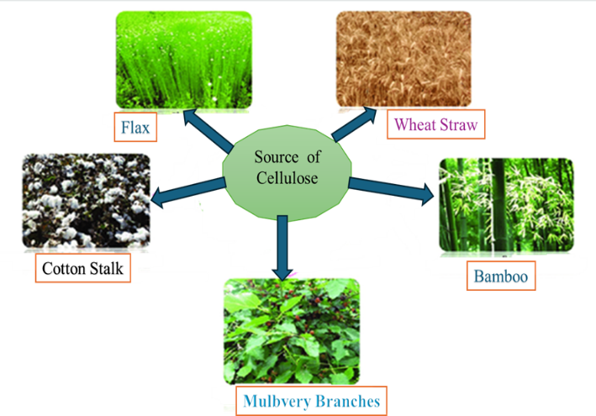
Figure1a: Sources of Cellulose

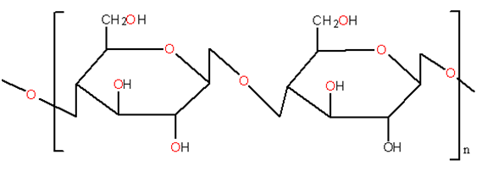
Figure1b: Structure of Cellulose

2.2. Starch
This polysaccharide obtained by the combination of linear amylose with α-(1→4) and branched amylopectin α-(1→4)/ (1→6) linkage. The naturally occurring starch classified in to three class which are based on the sources and their structure is given in figure 2a and 2a respectively as (Ming et.al. 2022, Wang et.al. 1998 & Yang et.al. 2025),
2.2.1. A types Strach
It is distinct class of grains, their primary source is cereals as wheats, corns and sago having size more than 10 µm in diameter and it also shows specific physical and chemical properties shown in figure 2. In these compounds contained much larger amount of amylose contents that makes smooth surface. These characteristic of starch encouraged the behaviour in processing likes more gelatinous temperature and pasting viscosity. The film of starch polysaccharides is economical, encapsulation matrices and controlled release formulations (Kumar, R. et.al. 2023& Moon et.al. 2024).
2.2.2. B-Class of Starch
This class of starch are smaller granules, tapioca, potato and water chestnuts is the main source natural starch, size of this type of starch is oval or polygonal and has 1 to 10 µm in diameter. These polysaccharides have variable physicochemical properties as compare to large granular size A type starch. Because of their size is smaller, variable molecular structure and it formed variable stages by development of grains. Therefore, it contains more gelatinization temperature, larger percentage of lipid and protein and it also show elasticity nature in a dough (Kumar, R. et.al. 2023& Moon et.al. 2024).
2.2.3. C-type starch
This type of starch is a mixture of both A and B types of starch with crystalline moiety; it formed much complex as compare to A type obtained from cereals an B type occurs in potatoes starches. Seeds, legumes rhizomes other crops and several parts of plants are main source of this class of starches that have more resistance and leisurely digestible physicochemical properties (Cai et.al.,2014).

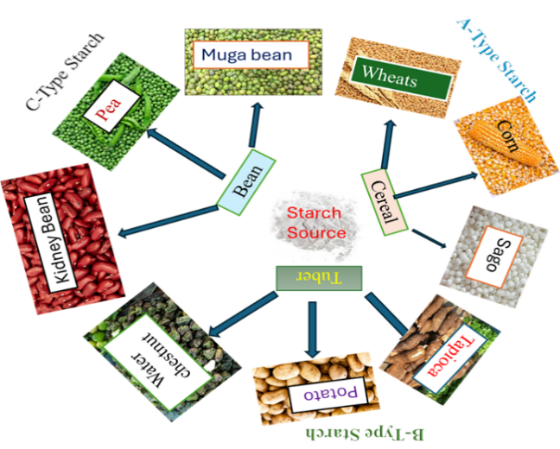
Figure 2a: Source of starch
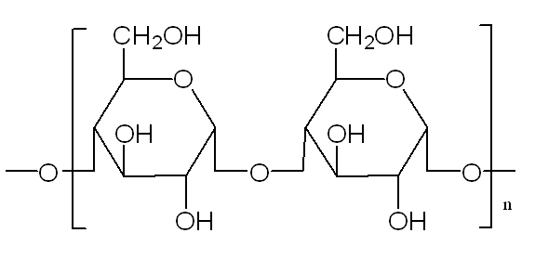
Figure 2b: structure of starch

2.3. Pectin
The pectin is mainly obtained by citrus and apple pomace on commercial scale, juice industry isolated in form of byproduct. Out of these fruits large amount of pectin obtained from quince, mangoes and passion fruits out of these sugar beet pulp, sunflower heads and some other wastage of fruits and vegetables are alternative source of pectin illustrated in figure 3a and its structure shown in figure 3b (Han, et.al.2025). The slightly under ripe fruits contains abundant amount of pectin as compare to ripe fruits. Pectin a kind of heteropolysaccharide which contains enormous amount of galacturonic acid, formation of gel in acidic medium or in presence of calcium ions, it has encapsulated and coating are easily degradable with atmospheric conditions (Roman-Benn et.al. 2023).
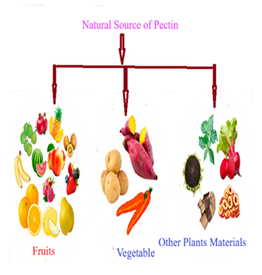
Figure 3a: Source of pectin
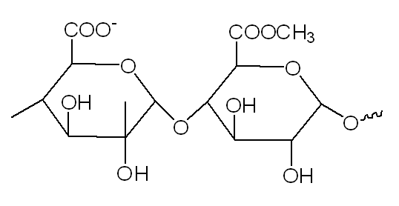
Figure 3b: Structure of pectin

2.4 Alginate
The primary source of alginate is brown seaweed also known as kelp, it can also be derived from specific bacteria. The bacteria as Macrocystis pyrifera, Laminaria and Ascophyllum are the primary commercial source, such types of species are universally on several coastal areas.
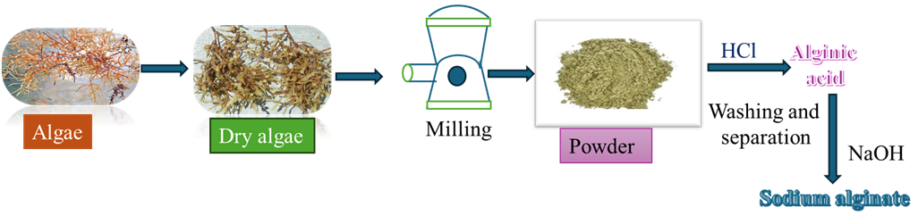
Figure 4a: Source of alginates
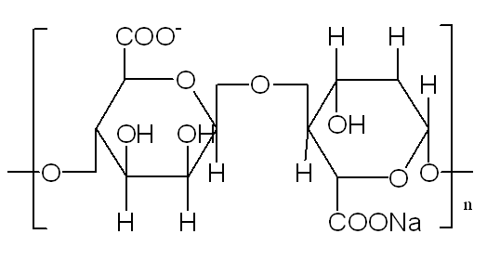
Figure 4b: Structure of alginates

In spite of these Pseudomonas aeruginosa bacteria also can generates alginates that have define chemical structure, it can potentially use in various agricultural purpose. Their isolation routs are given in figure 4. The alginates mainly extracted from brown seaweeds it is copolymer that contains mannuronic and guluronic acids. The divalent cations viz. Ca2+ ions with ionotropic gelation emphasized glib bead and bead encapsulation process for fertilizers, useful microbes and pesticides (Nath, (2025, Paques, et.al.2014, Qosim, et.al., 2024, Rahman et. al. 2024 & Zabihi et.al. 2024).
2.5 Chitosan
The main source of chitosan by the deacetylation of chitin which are obtained from crabs and shrimp’s crustaceans exoskeletons, fungi, insects, few algae and mollusks. The waste of fishing occupation is commercial source of chitosan given in figure 5. Chitosan can directly be obtained by some specific fungi and it can also be isolated by processing with chemically and biologically of both crustaceans and fungi (Román-Doval et.al. 2023).

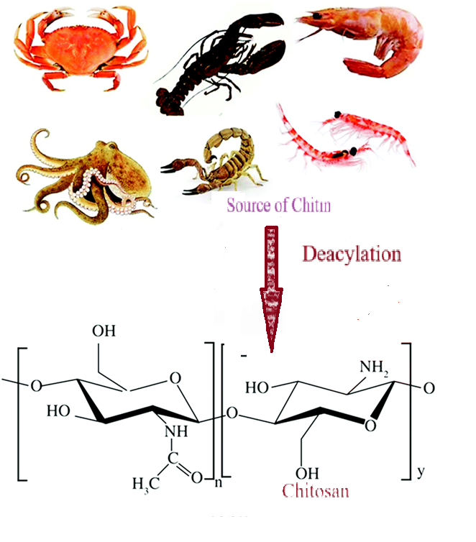
Figure 5: Source of chitosan
The isolated chitosan has cationic polysaccharides that have ability to wards antimicrobial activity and development of film. Their cationic nature facilitates the interact with surface with negatively charge i.e. seed coats, soil particles and also favourable to complexation with negatively charged molecules (Nath, 2025, Kluczka, et.al.2023 &Picos-Corrales et.al., 2023).
2.6 Galactomannans, Xanthan, Carrageenan
The main source of galactomannans are seeds of leguminous plants such as guar (Cyamopsis tetragonolobus), locust bean gum from carob tree seeds fenugreek gums from fenugreek (Trigonella foenumgraecum) and tara gum from tara plants seeds (Caesalpinia spinosa) which are obtained by the extraction process. While xanthan gum obtained through fermentation of Xanthomonas campestris bacteria and carrageenan is obtained by the extraction Rhodophyceae family in which Eucheuma and Kappaphycus is main source that belong to a class of red seaweeds besides of these Agardhiella, Solieria, Iridaea, Gigartina and Chondrus genus also involved in production of carrageenan. These have viscous, gelatinous and film formation character fragmented in soil adjustment, adhesives of seeds, and encapsulants (Dos Santos et.al., 2025& Salachna et.al., 2021).
3. Extraction and Chemical/Physical Modifications
The fresh polysaccharide characteristically abstracted through aqueous, enzymes of light chemicals treatment and the polymers are recovered by biomass or microbial cultures. It can be easily modified which change their properties. Some general alterations are as-
- It can easily be crosslinked with other chemicals or ions formed hydrogels having flexible, swelling and mechanically strong character.
- To change the properties of solubility, hydrophobicity, mechanical concert by carboxymethylation, acetylation and grafting process.
- By the nano structuring produce composite materials of polysaccharides with nanoparticles like cellulose nanocrystals and nanofibers that boost the reinforcement composite and thin seats.
- The improvement of water retention, strength, or release kinetics by the blending of polysaccharides with some other biopolymers or inorganic grouts.
These alteration in polysaccharides facilitate the matrix’s structure that provide controlled released of nutrients, managing water and delivery of bioactive agents at prescribed points (Chen et.al., 2024).
4. Action mechanism in Agricultural Contexts
The polysaccharide involved various mechanistic routes for the agricultural purpose as-
- It formed physical barricade and defencing thin seat that it formed a protective layer around the seeds, and foliar thin provide safety by desiccation, pathogens and mechanical damage.
- There structural matrix provides encapsulate modulate that helped in diffusion and degradation motivate controlled nutrients and pesticides and it also protect leaching and volatilization.
- Polysaccharide modified the soil structure and enhanced the water retention capacity which also increase the collective stability.
- Chitosan polysaccharide shows antimicrobial or inducer activities that minimise the defence responses of plants.
- Encapsulation behaviour of polysaccharides sustains feasibility of organic manure and biocontrol carrier’s trough storage and after used (Mamede et.al. 2023).
5. Applicability of polysaccharides in Agriculture
5.1 Soil Conditioners and Water Retention
Polysaccharides like alginate, starch, cellulose derivatives and synthetic natural mixture-based hydrogel have high water absorption and retention potential, it released water slowly, reduced stress towards drought and enhancing the survival of seedling, it retained the mobile ions in their structural matrix so that it reduced the leaching of nutrient soil conditioning of polysaccharide shown in figure6 (Zaryab et.al. 2023).

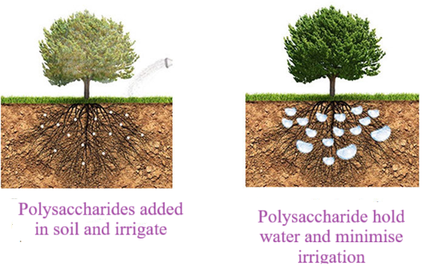
Figure 6: Soil conditioning
5.2 Systematic Release Fertilizers
The fertilizers as urea, mixture of nitrogen, phosphorous and potassium (NPK) and micronutrients encapsulate into the matrix of polysaccharides that deliver time release manures given in figure 7. The releasing of manures time based on hydrophilicity, crosslinking density of polymer and atmospheric situations like temperature, pH, and microbial activity. Systematic release of fertilizers reduced the manures quantity, enhance nutrients used capability and minimise environmental infection (Thiago et.al., 2022 & Oluwatoyin et.al., 2025).
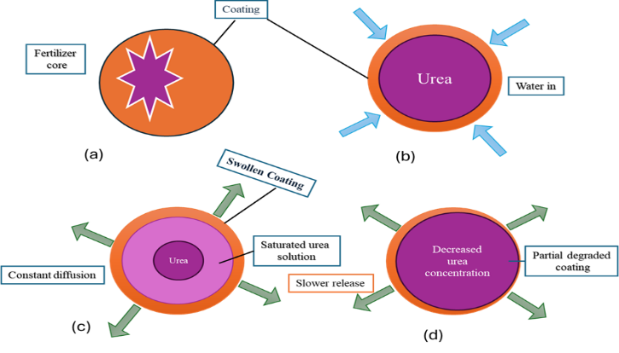
Figure7: Systematic release of fertilizer and nutrients
5.3 Seed Coatings and Pelleting
Seed coating means that seed is covering with thin layer formed by the materials that used for this purpose, whereas pelleting of seeds that makes thicker, extra considerable coating that changed size and shape of seeds given in figure 8. Coating of seed mainly protects and enhances dynamic constituents without significantly varying the type of seed, while pelleting changes asymmetrical seeds into symmetrical form and make it into smoother that facilitate in mechanized planting. Both methods are enhanced the handling of seed, germination and systematically released valuable goods as nutrients or pesticides.
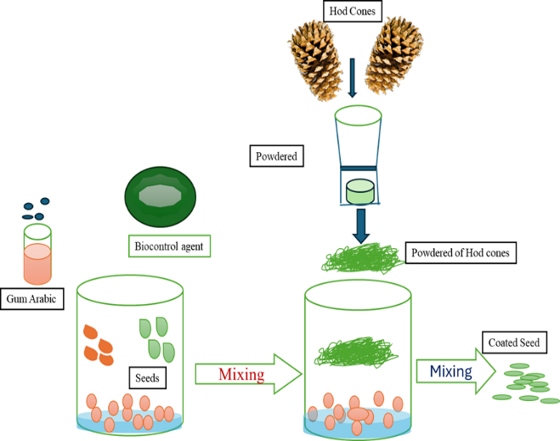
Figure 8: Seed coating
Covering of seed by CMC, alginate or starch which facilitate the sowing performance, saved towards pathogens and premised the nutrients insertion, promote plants growth mediators of biocontrol. Bead forms of alginate encapsulate to the rhizobia and mycorrhiza fungi which improved the existence throughout sowing and encourages primary synergy (Kocira et.al., 2021 & Xue et.al., 2021).
5.4 Delivery Systems for Pesticides and Biopesticides
This system traditionally used as foliar sprays and treatment of soil while for systematic release, nano- encapsulation a recent technique is used. Generally foliar spray i.e. directly prepared liquid spray on the plants or for roots absorption using them directly to the soil, where as some other methods applying seed coating or accurate apparatus that used for targeting in specific areas. Development of nanomaterials that produced “nano-biopesticides” that offered continual or responsible with stimulus that released active components. The polysaccharides’ structure modulates the release of pesticides, minimise large concentrations and untargeted contact. Nanoparticles of chitosan and beads of alginate have been applying to carrying botanical juices, bacillus spp., and fungi with entomopathogenic nature (Thiago et.al., 2022 & Oluwatoyin et.al., 2025).
5.5 Biodegradable Protective Films and Packaging
Some common ecofriendly and easily degradable polymers that used in protection of plant and also used in packaging purpose as -
Natural or polymers such types of polymers are obtained from biological sources as renewable biomass like polysaccharides and microorganisms some of polymers as-
    - Polylactic acid: It is a polyester that derived from biological mass it can be formed by using lactic acid. Generally lactic acid generates from sugars like corn, starch and sugar cane by fermentation process. The monomer lactic acid involved polymerization through ring opening and produced a polymeric material as polylactic acids having large molecular weight (Tertyshnaya et.al., 2023).
    - Polyhydroxyalkanoates: These polymeric materials also a polyester that can be derived from microorganisms it has storage capacity of carbon and energy. The precise structure of this polymer can be stabilized through the selection of microorganism and controlled conditions of fermentations (Amelia et.al. 2019).
    - Thermoplastic starch: Such types of polymers obtained by the processing of starch with plasticizers that convert into formable flexible films. It has low mechanical and water-resistant properties so that these properties can be enhanced by the blending with some other polymers (Luis et.al., 2024).
    - Polymers of cellulose: cellulose that obtained by plants is converted into tailored materials as carboxymethyl cellulose. For the conversion cellulose into films, it blending with some others biopolymeric substance. The films obtained by the blending of starch with cellulose nanofibers or proteins that improved the biodegradability behaviour of films. These films decreased the pollutants nature of plastics and it improved the temperature of soil and retention of water and finally it degrades into soil organic matter. These films helped into the seed coating and packaging of agricultural products which provide suitable condition for trading (Zichao et.al.,2023 & Devabaktuni et.al., 2011).
    - Post harvest Coating: The edible substance that coated by polysaccharides as pectin, alginate and chitosan improved their life trough restrictive respiration, loss of moisture, and microbial spoilage. This substance contained natural antioxidants, antimicrobials properties that reduced the artificial preservatives process (Kocira et.al., 2021 & Xue et.al., 2021).

5.7. Bio-stimulants and Plant Défense Provoker
The oligosaccharides like oligochaetes and oligogalacturonides which obtained from the hydrolysis of polysaccharide that provoke and it also performed as biological stimulants that improved the plant growth and lenience to ward anxiety (Gamage et.al., 2022).
6. Typical Case Studies and Action Metrics
- Alginate encapsulation rhizobia: It expands existence under dehydration and interrupt the release into the rhizosphere, boosting nodulation effectiveness in leguminous plants (Mamede et.al., 2024).
- Urea granules coated with chitosan: it minimised the loss of nitrogen through evaporation and it provide nitrogen systematically to the plants as compared to uncoated urea (Ming et.al.2022 & Wang et.al.,1998).
- Starch based protected films: It shows the no-long range performance as compared to polyethylene whine rapidly degrade in soil atmospheres (Picos-Corrales et.al., 2023).
The concert metrics frequently comprise cumulative kinetics as release over time, water captivation and retaining potential, degree of seed germination, plant biomass yield and microbial viability for encapsulated inoculums.
7. Conservational, Economic, and Monitoring Reflections
Materials which derived from polysaccharides shows minimum ecotoxicity and better degradation properties as compare to substances obtained from petroleum. Several polysaccharides are found from residues of agro industries, refining circularity. While the cost competitiveness based on obtainability of feedstocks, extent of mass production, and constancy routine as compare to obligatory technologies. Governing ways for original biopolymer agro-contributions vary by authority and necessitate demonstration of security for unrelated organisms and health of soil (Wilen et.al., 2010).
8. Challenges and Knowledge Gaps
- The manufacturing of polysaccharides commercially that faced difficulty toward the maintaining their quality greater modification as nanocellulose and grafted polymers.
- The soil has heterogenous in nature that contains a variety of microbes and variable climates which favoured the rate of degradation, so that it difficult to controlled the degradation of polysaccharides.
- The regular degradation of polysaccharide materials occurs in soil environment so it faced that standardization in field testing frameworks and system of measurement compare varied materials accurately.
- To require the long-term studies about the evaluation of effects on structure of microbiome, nutrient cycle and development of humus.
- To require the modification in the polysaccharides that enhanced the stability, specially encapsulated microbes biopesticides, sustaining feasibility throughout storage is serious.
9. Future Directions and Research Opportunities
- It can be introducing progressive functional groups in to the polysaccharides structure which converts into smart materials that respond to stimulus as pH, moisture and roots exudations to initiation release.
- Polysaccharides can be converted into the hybrid materials by combination with inorganic nanofillers as clay nanoparticles and biochar, it introduced multifunctional character towards adsorption of nutrients, increased mechanical strength and steady release of water and nutrients.
- By the advancement of modular abstraction channels which converts straw, husks and shells agricultural residues into valuable efficient polysaccharides.
10. Conclusion
The polysaccharides that derived from biological sources as in form of biopolymers which stablished the in sustainable used in agricultural fields. These contains a variables functional character as easy degradability with atmospheric conditions, biocompatibility, water holding capability, ability to formation of films and conditioning of soil that it emphasized as ecofriendly uses in recent farming. The biopolymeric materials likes cellulose, chitosan, starch, alginate and gaur gum which are polysaccharides-based substances. These substances have been potentially applied in sustainable fertilizer release, soil alteration, covering of seeds and development of plant growth. It also plays a key role in soil health refining, facilitating the use potential of nutrients and make them favourable to atmosphere which emphasized the importance in attaining green and bearable farming.
Disclaimer (Artificial intelligence)
Author hereby declares that no generative AI technologies such as Larger Language Models (ChatGPT, COPILOT, etc.) and text-to- image generators have been used during the writing of editing of this manuscript.
References:
Amelia, T.S.M., Govindasamy, S., Tamothran, A.M., Vigneswari, S. & Bhubalan, K. (2019). Applications of PHA in Agriculture. In: Kalia, V. (eds) Biotechnological Applications of Polyhydroxyalkanoates. Springer, Singapore. https://doi.org/10.1007/978-981-13-3759-8_13.
Cai, J., Cai, C., Man, J., Zhou, W. & Wei, C. (2014). Structural and functional properties of C-type starches. Carbohydrate Polymers,101, 289-300.
Chen, X., Shen, M., Yu, Q., Chen, Y. & Xie, J. (2024). Recent advance in chemistry modified methods of natural polysaccharides and their applications, Trends in Food Science & Technology, 144, 104317.
Cláudia, M. V., Dulce, F., Patrícia A., Jorge, R. & Paulo, P. (2022). Agricultural land systems importance for supporting food security and sustainable development goals: A systematic review. Science of The Total Environment, 806(3),150718.
16 Dastnaei, P. G. (2025). Applications and properties of hydrogels suitable for the agricultural industry, Journal of Medical. Chemical and Biomedical Engineering, 1(3), 206-214.
Collard, F.-Xavier & Blin, J. (2014). A review on pyrolysis of biomass constituents: Mechanisms and composition of the products obtained from the conversion of cellulose, hemicelluloses and lignin.Renewable and Sustainable Energy Reviews, 38, ,594-608.
Gamage, A., Liyanapathiranage, A., Manamperi, A., Gunathilake, C., Mani, S., Merah, O. & aMadhujith, T. (2022). Applications of Starch Biopolymers for a Sustainable Modern Agriculture. Sustainability 14(10), 6085.
Devabaktuni, L., Kulkarni, P.K., Dixit, M., Raavi, P. K., Krishna, L.N.V. (2011). Sources of cellulose and their applications – A review. International Journal of Drug Formulation and Research, 2(6), Nov.-Dec.
Dos Santos, A. E., de Matos, F. J, Monteiro, A.R. & Valencia, G.A.(2025). Galactomannans: A Suitable Biopolymer to Produce Advanced Food Packaging. International Journals of Food Science, 2025, 9577986.
Han,Y., Jin,X., Ziyan Zhang, Z. & Sun, Q. (2025). Characterization of pectin with different structural features and its effects on Yogurt quality. LWT, 229, 118236.
Hongkun X., Ping, W., Lihong, J., Kaixuan, Z., Shaoqin, G. & Jiaqi T. (2025). Polysaccharide-based hydrogels: Materials, preparation, and applications in medicine, food, adsorption, and agriculture. Journal of Agriculture and Food Research, 24, 102395.
Joseph, A.A., Pardo-Vargas, A. & Seeberger, P.H. (2020). Total synthesis of polysaccharides by automated glycan assembly. Journal of the American Chemical Society 142(19),8561-8564.
Kluczka, J. (2023). Chitosan: Structural and Chemical Modification, Properties, and Application, International Journal of Molecular Sciences (IJMS), 25(1), 554.DOI:10.3390/ijms25010554.
Kocira, A., Kozłowicz, K., wicz, K. P., Staniak M., Szpunar-Krok E.& Hortyńska, P. (2021). Polysaccharides as Edible Films and Coatings: Characteristics and Influence on Fruit and Vegetable Quality:A Review. Agronomy, 11(5), 813.
Kumar, R., Singh,N. & Khatkar, B. S. (2023).Effects of A- and B-type starch granules on composition, structural, thermal, morphological, and pasting properties of starches from diverse wheat varieties.Food Bioengineering: Volume 2(4), 291-419.
Kunal, V., Chandrani, S. & Sampa, S. (2025). Exploration of biodegradable polymeric particles in agriculture: a holistic approach for sustainable farming. Environmental Science Advances 4(3), 15, 409-431.
Luis, J., Terán, L., Victoria, E., Maldonado, C., del Carmen, J., Range, A., Otazo J. P. & Rico, M. I. B. (2024). Development of Antibacterial Thermoplastic Starch with Natural Oils and Extracts: Structural, Mechanical and Thermal Properties. Polymers, 16(2), 180.
Mahmoud Y.A., El-Naggar M.E., Abdel-Megeed A.& El-Newehy M. (2021). Recent Advancements in Microbial Polysaccharides: Synthesis and Applications. Polymers (Basel). 13(23): 4136.
Mamede, M., Cotas, J., Bahcevandziev, K. & Pereira, L. (2023). Seaweed Polysaccharides in Agriculture: A Next Step towards Sustainability. Applied. Science,13,659.
Mamede, M., Cotas, J., Pereira, L. & Bahcevandz, K. (2024). Seaweed Polysaccharides as Potential Biostimulants in Turnip Greens Production. Horticulturae, 10(2), 130.
Ming, L., Tian, Y. & Dhital, S. (2022). Starch Extraction: Principles and Techniques. In Starch and Starchy Food Products. pp. 17-40. CRC.
Mohammad, N., Md, M. B. & Ravi, N. (2025). Diffuse soil pollution from agriculture: Impacts and remediation. Science of The Total Environment, 962, 178398.
Moon, Y. & Kweon, M. (2024). Distinctive characteristics of A- and B-type starch granules in high-amylose wheat: A comprehensive analysis of morphology, structure, and digestibility. LWT, 203(1),116411.
Nath, A. (2025). Application of Polymeric Hydrogels in the Medical Field: A General Review. IJFMR, 7(5), 1-8.
Qosim, N., Negeri, P., Malang, N., Dai, Y. & Williams, G.R. (2024). Structure, properties, forming, and applications of alginate fibers: A review. International Materials Reviews 69(5-6):309-333.
DOI:10.1177/09506608241280419
Oluwatoyin, A. F., Ayorinde, V. O. & Hector, S. M. (2025). Polysaccharide polymer-based nanoparticles for nano fertilizer and nano pesticides–A review, Carbohydrate Polymer Technologies and Applications 12, 101009.
Ouyang, S., Wang, V., Liu, V., et al. (2024). Current status of research on polysaccharide-based functional gradient gel materials: a review. Carbohydrate Polymer, 344, 122520.
Pandey, A.K., Sirohi, R., Gaur, V. K. & Pandey, A. (2021). Chapter 8 - Production and applications of pullulan Biomass, Biofuels, Biochemicals, Biodegradable Polymers and Composites - Process. Engineering to Commercialization, Pages 165-221.
Paques, J. P., van der Linden, E., van Rijn, C.J.M. & Leonard M.C. (2014). Sagis, Preparation methods of alginate nanoparticles. Advances in Colloid and Interface Science, 209, 163-171.
Picos-Corrales, L. A., Morales-Burgo, A. M., Ruelas-Leyva, J. P., Crini, G., García-Armenta, E., Jimenez-Lam, S. A. et.al. (2023). Chitosan as an Outstanding Polysaccharide Improving Health-Commodities of Humans and Environmental Protection. Polymers (Basel), 15(3), 526. doi: 10.3390/polym15030526.
Punniyakotti, E., Xuke, G., Punniyakotti, P., Junyu, L. & Jinjie C. (2025). Agrochemical pollution: A serious threat to environmental health. Current Opinion in Environmental Science & Health,43, 100597.
Qosim, N., Negeri, P., Malang, N.,Dai, Y. & Williams, G.R. (2024). Structure, properties, forming, and applications of alginate fibers: A review. International Materials Reviews 69 (5-6) 309-333.DOI:10.1177/09506608241280419
Rahman, M.M., Shahid, M.A. & Hossain, M.T. et al. (2024). Sources, extractions, and applications of alginate: a review. Discover Applied Science, 6, 443, https://doi.org/10.1007/s42452-024-06151-2.
Raj, S. N., Lavanya, S.N., Sudisha, J.& Shetty H. S. (2011). Applications of Biopolymers in Agriculture with Special Reference to Role of Plant Derived Biopolymers in Crop Protection, Book Editor(s): Susheel Kalia, Luc Avérous, First published: 01 August https://doi.org/10.1002/9781118164792.ch16
Roman-Benn, A., Contador, C. A., Man-Wah, L., Hon-Ming, L., Ah-Hen, K. & Ulloa, P. E., Ravanal, M. C. (2023). Pectin: An overview of sources, extraction and applications in food products, biomedical, pharmaceutical and environmental issues. Food Chemistry Advances, 2, 100192.
Román-Doval, Sandra, P., Torres-Arellanes, Aldo, Y., Tenorio-Baraja, Gómez-Sánchez, A., Anai A. & Valencia-Lazcano. (2023). Chitosan: Properties and Its Application in Agriculture in Context of Molecular Weight Ramón. Polymers,15(13), 2867.
Salachna, P. & Pietrak, A. (2021). Evaluation of Carrageenan, Xanthan, Gum and Depolymerized Chitosan Based Coatings for Pineapple Lily Plant Production. Horticulture, 7, 19. https://doi.org/10.3390/horticulturae7020019.
Tertyshnaya, Y. V., Podzorova, M. V., Varyan, I. A., Tcherdyntsev, V. V., Zadorozhnyy, M. Y.& Medvedeva, E. V. (2023). Promising Agromaterials Based on Biodegradable Polymers: Polylactide and Poly-3-Hydroxybutyrate. Polymers (Basel), 15(4):1029. doi: 10.3390/polym15041029.
Thiago, O. M., Justin, G., Claudia, S., Pedro, H.H., de Araújo & Michel L. (2022). Ehrenhard, Frederik R. Wurm, Biopolymer-based nanocarriers for sustained release of agrochemicals: A review on materials and social science perspectives for a sustainable future of agri- and horticulture. Advances in Colloid and Interface Science, 303, 102645.
Wang, T. L., Bogracheva, T. Y. & Hedley, C.L. (1998). Starch: as simple as A, B, C? Journal of Experimental Botany, 49(320), 481–502.
Wilen, J. E., Zilberman, D., Lichtenberg, E. & Shortle, J. S. (2010). Natural Resource Economics and Conservation: Contributions of Agricultural Economics and Agricultural Economists. American Journal of Agricultural Economics, 92(2), 469-486, DOI:10.1093/ajae/aaq006.
Wu, Y., Xiong, D.C., Chen, S.C., Wang, Y.S. & Ye, X.S. (2017). Total synthesis of mycobacterial arabinogalacta containing 92 monosaccharide units. Nature Communications 8(1), 14851.
Xue, J., Ma, X., Hou, Z., Guo, M. & Zha, X. (2024). Experimental Study on the Pelleting and Coating Performance of Red Clover Seeds. Coatings, 14(11), 1443.
Yang, F., Qiao, J., Li, T., Zhang, X., Liu, D., Li, W. & et.al. (2025). Response of starch molecular structure and functional properties of novel perennial Tartary buckwheat lines to different nitrogen and phosphorus fertilizer levels. Carbohydrate Polymers, 373, 124585.
Yao, W., Xiong, D.C., Yang, Y., Geng, C., Cong, Z., Li, F. et.al., (2022). Automated solution-phase multiplicative synthesis of complex glycans up to a 1,080-mer. Nature Synthesis 1(11), 854-863.
Zabihi, M. (2024). Applications of Alginate in the Fields of Research Medicine, Industry and Agriculture. In book: Alginate - Applications and Future Perspectives, DOI:10.5772/ intechopen.110209.
Zaryab, T., Dure, N. I., Muhammad, R., Muhammad, A., Muhammad, F. & Mahmood, A. (2023). Signiﬁcance of biopolymer-based hydrogels and their applications in agriculture: a review in perspective of synthesis and their degree of swelling for water holding. RSC Advanced,13,2473.
Zichao, W., Xueyan, Z., Lili, S., Di, Z., Xinxin, Z. & Yaping, P. et;al. (2023). Effect of ultrasonic degradation on the structural feature, physicochemical property and bioactivity of plant and microbial polysaccharides: A review. International Journal of Biological Macromolecules, 236, 123924.

