DEVELOPMENT OF ACTIVE-PASSIVE COMBINATION OF TILLAGE IMPLEMENT SUITABLE FOR MINI TRACTOR
ABSTRACT
An experimental tillage tool that combines active and passive tillage implements (Cultivator tines with rotavator (cultivator tines is the front set and rotavator is the rear set) was field tested. Because the active elements were forward-rotating and, thus, resulted in a negative draft, overall draft requirements of the total tool was decreased considerably. A combination machine with two active and two passive elements required 87% less draft and draft power than a tool with four passive elements, although total power was similar. Based on assumed power transmission efficiencies, the combination machine was predicted to be 34% more energy efficient than a similar passive tillage tool. The tillage performance parameters such as draft force, fuel consumption, wheel slip, power requirement was measured. The digital dynamometer at different operating depths. The draw bar power requirement of the combination tillage implement was calculated. During field evaluation it was observed that the draft force of the rotavator with tines observed as 0.46, 1.7, 3.5 kW at forward speed of 1.5, 2.5 and 3.5 km h⁻¹, respectively.

Keywords: draft, depth, combination tillage implement
Introduction
The energy use in field preparation is of great concern for scientists and farmers. Among all field operations, conventional tillage requires highest amount of energy input. It requires several passes of various soil-turning and soil-pulverizing equipment’s requiring more time, fuel and labour. Moreover several passes of tractor with tillage implement increase soil compaction (Classen, 1996). In order to overcome these difficulties, one has to reduce the number ofpasses required to prepare the seedbed without sacrificing the quality of work. This is possible by combining tillage implements to be operated simultaneously (Sahu and Raheman, 2006).The combination tillage implement comprises combination ofactive and passive tillage implements. In case of passive implements, power losses are more at tire-soil interface and also a considerable weight is required on drive wheels of tractor to provide necessary traction that results into detrimental soil compaction. Active tillage implements require considerable power per unit width as they till a greater volume of soil than is required in most field crop systems. Srivastava et al. (1993) stated that rotor develops a forward thrust resulting in anegative draft that may require further energy inputs to control tractor steering and three-point hitch and also may be harmful tothe tractor drive train. A way to control this detrimental forward thrust is to combine active and passive elements that may result into following potential benefits:
Power for tilling the soil can be transmitted to the tillage elements through a mechanical power train more efficiently than through the tire-soil interface. Hendrick (1980) estimated an overall average power transmission efficiency of 82% for PTO powered active tillage elements and 49% for drawbar passive tillage elements. The negative draft of the active elements can be used to provide full or part of the draft of the passive elements and this will reduce draft of tillage tools and results in lesser wheel slip and improved field productivity and allow the use of lighter tractors to reduce soil compaction. Reduced draft of tillage tools will also allow operations to be performed in more difficult traction conditions requiring the use of extra ballast, dual tires or assistance from the front wheels (Shinners et al., 1990).
Materials and Methods
2.Development of Active-Passive Combination Tillage Implement With Cultivator and Rotavator
The rotavator provided with the test tractor was used for the present study. The reason to develop this implement is to utilize the negative draft force developed by the rotavator. While developing the implement, it was kept in mind that, the tines must be placedat front of the rotavator to utilize the negative draft force. Four tines having 39 cm length with shovel length of 20 cm was used in the present study. The width and thickness of the tines are 4 and 2 cm respectively. These tines are specially fabricated with suitable dimensions for mounting on the rotavator to act as front passive set. The developed tines are fitted on an angular bar having length of 120 cm using ‘U’ clamps and nut and bolt system at an equal interval of 30 cm and bar was connected to the rotavator using two supporting arms mounted on both sides of rotavator (Fig.1).A provision was made in such a way that the tine length could be increased as well as decrease based on the depth requirement, also tines were fitted to the frame of rotavator at an angle of 25⁰ to penetrate in to the soil engage with less draft force. The developed Active-passive combination tillage implement under laboratory is shown in (Fig.1) and the developed implement with test tractor is shown in Fig.(2). The CAD view of developed front passive set is shown in (Fig.3).
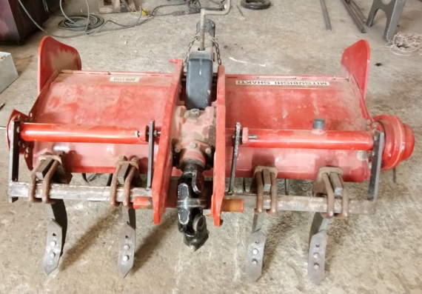
3
2
1
1. Supporting frame; 2. Supporting arms; 3. Tines
Fig.1. Developed active-passive combination tillage implement
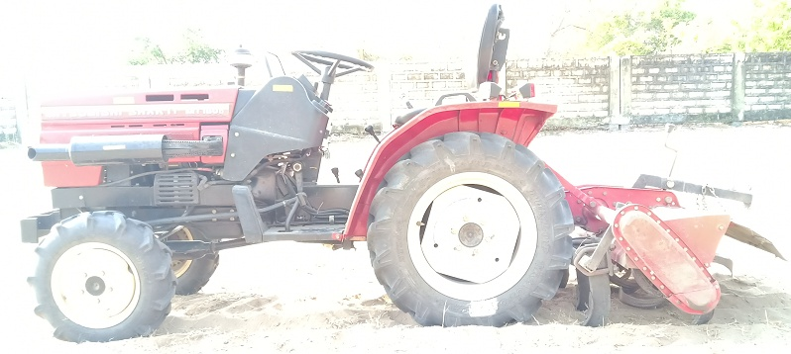
Fig. 2.Developed active-passive combination tillage implement with test
Tractor
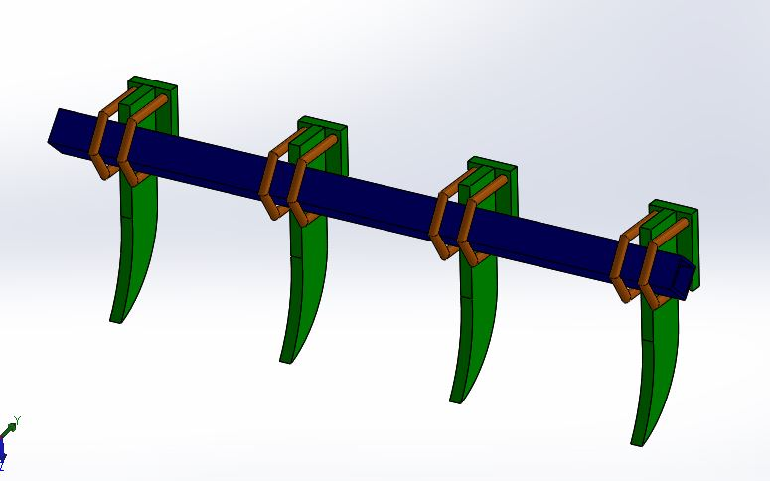
1
2
3
- Frame; 2. Tines; 3. U clamps
Fig.3. CAD view of developed front passive set

2.1Dynamic Simulation of Developed Tine

A dynamic simulation has been carried out to know the load bearing capacity of the mounted tines to the rotavator using Ansy’s software. A maximum load of 10000 N was applied on each tine in opposite to the face of the cultivator.It was observed that, the von misses are found to vary from 7.74 x 10¹to 2.33 x 10⁷ N/m², where as the yield strength of the develop tine is 4.6x10⁻⁸.The dynamic simulation of the developed tine is shown in (Fig. 4)
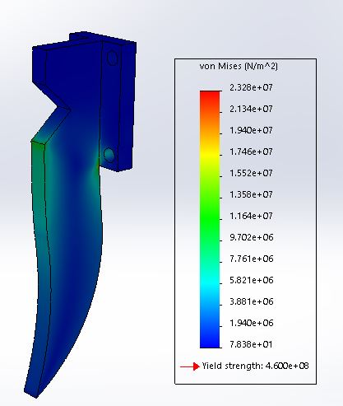
Fig. 4. Dynamic simulation of developed tine
2.1.2Dynamic Force Analysis of Tractor- Mounted Implement Combination

Fig 5. Shows the side view of tractor mould board plough combination. The analysis will remain same for other mounted implements like cultivator, disk harrow etc. Following major assumptions were made in developing the dynamic equations of tractor implement combination.
- Center of gravity of tractor is located without operator.
- Angular motion of wheel of tractor is ignored.
- Implement is operating at uniform depth.
- The sinkage and deflection of tyres are reasonably small as compared to the rolling radii of the tyres and hence neglected.
- The center of gravity and center of resistance of implement are assumed to be acting in same vertical plane
- Vertical soil reaction is 0.3 times the horizontal soil reaction.
- The two lower links are of equal length and coincide together when viewed from the sides i.e two lower hitch points lie at the same height above the ground level.
- Centre of resistance is located at a distance of two-third of depth of operation from ground surface.

Y
d
X
cgt
T
d
e
r
H
d
X
cgi
W
m
D
e
f
R
r
R
f

P
y
CG
i
A
B
O
1
O
2
H
p
X
cgt
T
d
e
r
H
d
X
cgi
W
m
D
e
f
R
r
R
f
P
y
CG
i
A
B
O
1
O
2
H
p
X
cgt
T
d
W_{t}
e
r
L
H
d
X
cgi
W
m
D
e
f
R
r
R
f
CG_{t}
P
y
CG
i
A
B
O
1
O
2
H
p
Y
d

Y
d
X
cgt
T
d
e
r
H
d
X
cgi
W
m
D
e
f
R
r
R
f

P
y
CG
i
A
B
O
1
O
2
H
p
X
cgt
T
d
e
r
H
d
X
cgi
W
m
D
e
f
R
r
R
f
P
y
CG
i
A
B
O
1
O
2
H
p
X
cgt
T
d
W_{t}
e
r
L
H
d
X
cgi
W
m
D
e
f
R
r
R
f
CG_{t}
P
y
CG
i
A
B
O
1
O
2
H
p
Y
d

Fig. 5. Free body diagram of tractor-implement combination

R_{f} + R_{r} = W_{t}+ W_{m} + P_{y}
Taking moment of forces about point ‘B’ the dynamic weight on tractor rear axle was calculated as follows:
R _{r} (L - e_{r}+ e_{f}) – W_{t}(L + e_{f} – X_{cgt}) – (w_{m} + P_{y} )(X_{cgi}+ H_{d}+ L + e_{f}) DY_{d} = 0
Or
------ (2.1)
Or R _{f} = ( W_{t} + W_{m} + P_{y}) – R _{r -------} (2.2)
Where, = rear wheel dynamic weight;= front wheel dynamic weight;RWS = rear wheel static weight; FWS = front wheel static weight; W_{t} = weight of tractor acting at CG_{t;} W_{m} = weight of implement acting at CG_{i;}X_{cgi} = horizontal distance of CG of implement from tractor lower hitch point H_{p;}H_{d} = horizontal distance of tractor lower hitch point from the rear axle center;L = wheel base;D = draft;P_{y}= vertical component of soil force and was assumed 0.3 times the draft;X_{cgt} = horizontaldistance of CG of tractor from the rear axlecenter;Y_{d}= , depth at which draftacted(assumed);= depth of operation;e_{r}= rear wheel eccentricity= ρ_{r}r_{r} (Liljedahlet al.,, 1996); r_{r} = rolling radius of the rear wheel of tractor; e_{f} = front wheel eccentricity= ρ_{f}r_{f} (Liljedahlet al.,, 1996); r_{f} = rolling radius of the front wheel of tractor; ρ_{r} = coefficient of rolling resistance of the rear wheel of tractor;ρ_{f} = coefficient of rolling resistance of the front wheel of tractor. In present study the above theory was used for measurement dynamic rear wheel reaction with different implements and combination implement.
Table.1.Research plan for field tests
Independent variables |  | Dependent variables
Tillage Implement | Cultivator, Disc harrow and Combination tillage | Draft force
Speed of operation | In the range of 1.5 to 3.5 km/h | Wheel slip
Depth of operation | In the range of 5.7 to 15.1 cm as depth was measured | Width of cut
 |  | Fuel consumption

Table. 2. Particle size diameter of soil samples after tillage operation
Soil Samples | Before operation of the tillage implements |  | After operation of the tillage implements
 | C-DH | C-CC | C-DH | C-CC
Sample 1 | 2 | 2 | 0.71 | 0.5
Sample 2 | 2 | 2 | 0.7 | 0.51
Sample 3 | 2 | 2 | 0.72 | 0.53

2.2Draft Force Measurement
Draft force of the developed combination tillage implements were measured using a digital drawbar dynamometer using a dummy tractor. The developed implements were mounted to the test tractor using 3-point linkage of hydraulic system. A digital dynamometer was kept in between two tractors using specially fabricated iron rod to measure the subjected draft during operation.
Initially, the implement was lifted and the test tractor was placed in neutral gear and it then pulled by an auxiliary tractor up to 20 m. The force required to pull the implement was recorded. Similarly, the implement was engaged in to the soil and again the test tractor was pulled using an auxiliary tractor up to 20 m. The force required for pulling the tractor was recorded. The difference between initial and final draft force values obtained from the draft requirement of the implement was considered as draft force. The draft was measured at different depths. Measurement of draft force of the developed tillage implement under actual field conditions is shown in Fig.6.
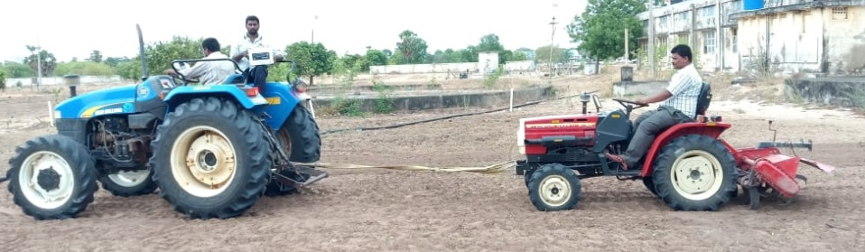
Fig.6. Test tractor with implement; 2. Auxiliary tractor; 3. Load cell;
4. Digital indicator;

2.3 Parameters Measured During Field Experiments
All the field experiments were conducted in a Dr. NTR College of Agricultural Engineering, Bapatla. The following performance parameters were measured during the field evaluation developed combination tillage implement.
2.3.1 Power requirement
The drawbar power of the tractor i.e. power requirement to pulling of implement is calculated using following formula(Alwan et al.,2016)
Power (hp) = (draft (kgf)x speed (m/sec))/75
2.3.2Measurement of speed of operation
The time taken to travel 25 m distance was measured with a mechanical stopwatch and the speed of operation was calculated by
$Va=3.6×25/t$
Where V_{a} = speed of operation, km/h, t = time, s
2.3.3 Measurement of Wheel Slip of tractor
The measurement of wheel slip was based on the fixed number of rear wheel revolution. The distance covered in ten wheel revolutions was recorded with and without load and the values were used to calculate slip using the following expression. (Ashok et al.,2016 )
S $=\frac{d_{t}-d_{a}}{d_{t}}×100$
Where S = Slip %
d_{t} = distance covered in 10 revolutions of drive wheel at no load in field
d_{a} = distance covered in 10 revolutions of drive wheel with load in fie
2.3.4 Width of cut
The width of cut of tillage implement was measured by measuring the width of furrow with a measuring tape at an interval of 3 m along the length of furrow. The average of five reading was taken to determine the width of cut of a tillage implement.
2.3.5Depth of operation
The depth of a tillage implement was measured by measuring the depth distance between furrow sole and ground level) using a steel rule along a furrow wall at an interval of about 5 m along the length of furrow. The average of five readings was calculated to determine the depth of operation of tillage implement.
2.3.6Turning time
The turning time for 180⁰ turn of a tractor-implement system during a tillage operation was measured using a mechanical stopwatch at both ends of the field and was expressed as the difference between the time of engaging the implement after turn and the time of lifting the implement before turn.
2.3.7 Fuel demand
Fuel consumption (F_{c}) was measured by top fill method. The fuel tank was filled up to its maximum capacity before testing. After tillage operation using test tractor with developed combination tillage implements the fuel tank was filled up to its maximum capacity. The refilled of fuel was measured using measuring jar. Then the fuel consumption was measured using the following equation.(Alsharifi and Ameen .,2018)

It was expressed in liter per hour.
$$F_{c }\left( Lh^{-1}\right) = \frac{V}{t}$$
Where, V= volume of fuel consumed, Lt= total operating time, h
2.3.8. Theoretical field capacity
Theoretical field capacity (TFC) is rate of field coverage of the implement based on 100 percent of time at the rated speed and covering 100 percent of its rated width. For calculating theoretical field capacity, first the speed and width of the implement was measured. The speed was calculated by recording the time required to travel 10m distance. The TFC was calculated by using following Equation.( Alsharifi 2009)
$$\text{TFC }\left(\frac{\text{ha}}{\text{h}}\right)\text{ = }\frac{\text{S}\text{×}\text{W}}{\text{10}}$$
Where, S = forward speed, km h⁻¹
W = width of the implement, m
2.3.9 Effective field capacity
Effective field capacity (EFC) is the actual average rate of coverage by the machine, based upon the total field time. It is a function of the rated width of the machine, the percentage of rated width actually utilized, speed of the travel and the amount of field time lost during the operation. Effective field capacity is usually expressed as hectare per hour. The EFCwas calculated by using following Equation.$EFC ({ha}/{hr)} = \frac{A}{T_{p }+ T_{np}}$
$\text{EFC (ha⁄(h)) = A/(T(p )+ T(np )}$EFC (ha/h)) = A/(T(p) + T (np))
Where,
A = Area of coverage, ha
T_{P} = Productive time, h
T_{np} = Non-productive time, h
2.3.10 Field efficiency
Field efficiency(F_{e}) is the ratio of effective field capacity to the theoretical field capacity, expressed as percentage. It was calculated using following Equation.(Alsharifi,2018) $F_{e}\left(\%\right) = \frac{EFC}{ TFC } ×100$
where,
E.F.C = Effective field capacity, ha h⁻¹ and
T.F.C = Theoretical field capacity, ha h⁻¹.
2.3.11 Volume of soil handled
The volume of soil handled per unit time could be expressed as:
Where,
V_{s} = Volume of soil tilled per unit time, m³/h
T_{d} = depth of operation, m
AFC = Actual field capacity, ha/h
2.3.12Overall performance
Considering the above mentioned parameters, an index known as performance index (PI) could be used to find out overall performance tillage implements. The PI is considered to be directly proportional to depth, AFC and S_{i} and inversely proportional to draft. Mathematically, it could be expressed as:
Where,
PI = Performance index,
T_{d} = depth in cm,
AFC = Effective field capacity in hectare per hour,
S_{i} = Soil inversion,
D = draft in kgf/cm²
Results and discussion
This chapter deals with the outcomes and discussions of the findings obtained from different experiments conducted with tractor and developed combination tillage implements and are presented under following headings:
i. Development of combination tillage implement
ii. Performance evaluation of Tractor - Implement Combination
3.1Development of Combination Tillage Implements
The development of the combination tillage implements was selected, based on the mini tractor specifications which were discussed in the following section. A combination tillage implement, cultivator tines with rotavator (R-T) was developed. The speed range of selected tractor considered for operating the developed cultivator tines with rotavatorcombination tillage implement was range of 1-3.5 kmph. The suitable range of tractor was selected on the basis of power utilization, front axle weight lifted tractor where slip of the test tractor.
3.2Performance Evaluation of Tractor- Implement Combination

Field tests were conducted with a 18hp, MITSUBISHI SHAKTI MT 180_{D} 2WD tractor and developed combination implement such Rotavator with tines (R-T) to evaluate the performance of tractor-implement combination on the basis of tractive and performance index parameters. The results obtained as discussed under the following heads.
  - Tractive performance parameters ii) Performance index parameters.
3.2.1 Tractive performance
The tractive performance of the tractor-implement combination was evaluated on the basis of the draft and slip parameters.
3.2.1.1 Draft Force measurement
During evaluation of the developed combination tillage implements under actual field condition, it was observed that, the draft force requirement of the active-passive combination combination tillage implement found to vary from116 to 137 kg at an average depth of 5.7 cm as change in speed of operation from 1.5 to 3.5 km/h. The Effect of depth of operation on draft force of implement as shown in below Fig 7

Fig.7 Effect of depth of operation on draft force of implements
3.2.1 Power requirement of the combination tillage implements
The power requirement of developed combination tillage implement were measured at different forward speeds ranged from 1.5 to 3.5 km h⁻¹. It is very difficult to measure the power requirement of the implement directly; hence it was measured indirectly by measuring the draft force at different depths and forward speeds.The power requirement of combination tillage implements such asrotavator with tines observed as 0.46,1.7,2.7 kwat forward speed of 1.5, 2.5 and 3.5 km h⁻¹, respectively. It was observed that combinations of tillage implement the power requirement is increasing as forward speed increases from 1.5 to 3.5 km h⁻¹. This may be due to the acceleration of the soil particles and imparted kinetic energy to the soil. It was also found that, power requirement of active–passive combination tillage implement i.e. rotavator with tines is less with the values varied from 0.46 to 2.7 kW this may be due to negative draft force of the rotavator. The effect of the effect of forward speed on power requirement of the developed combination tillage implement is shown in Fig. 8.

Fig. 8 Effect of forward speed on power requirement of combination tillage implements
3.2.2 Wheel slip measurement
The slip data obtained from the field experiments of developed combination tillage implements at different depths and constant speed of operation.The slip of driving wheels of the tractor with developed implements were found to be within the range of 5.6 to 7.8 % for the given set of test conditions. It increased with increase in depth and speed. This behavior could be due to higher draft requirement of an implement with increase in depth and speed causing thrust requirement at drive wheels to increase and thus resulting in more slip. It was found that during different depths at constant forward speed of the tractor, the wheel slip was increased while increasing the depth of operation as shown in Fig.9 The reasons for increasing the wheel slip while increasing the depth of operation maybe due to increase in draft force of the tillage implements.Effect of depth of operation on wheel slippage of combination tillage implement as shown in below Fig. 9

Fig. 9Effect of depth of operation on wheel slippage ofcombination tillage implements
3.2.3 Performance index
The performance index of the developed tractor-implement combination was evaluated on the basis of mean weight diameter (MWD) of soil aggregates, soil inversion, depth of cut, actual field capacity and unit draft. The overall performance of the tractor implement combination was expressed in terms of performance index. The performance index data obtained from the field experiments are presented in Table 3for the three speeds of operation.
Table.3 Performance index of implement with different depth and speed of operation of tines with rotavator
Speed,km/h | Depth of operation  cm | Mean weight diameter (MWD), mm | Soil inversion (S_{i}),  % | Draft,  Kgf/cm² | Fuel consumed per unit time (F_{u}), l/h | PI
1.5 | 5.7 | 0.71 | 60.0 | 0.17 | 1.8 | 313.83
1.5 | 10.8 | 0.7 | 58.4 | 0.09 | 1.82 | 1093.24
1.5 | 15.1 | 0.72 | 58.0 | 0.07 | 1.84 | 1951.75
2.5 | 5.7 | 0.5 | 54.1 | 0.17 | 1.95 | 480.25
2.5 | 10.8 | 0.51 | 57.3 | 0.10 | 2.0 | 639.92
2.5 | 15.1 | 0.53 | 57.5 | 0.07 | 2.2 | 986.94
3.5 | 5.7 | 0.42 | 46.1 | 0.20 | 2.3 | 499.26
3.5 | 10.8 | 0.4 | 46.3 | 0.12 | 2.5 | 583.46
3.5 | 15.1 | 0.41 | 46.7 | 0.0.09 | 2.6 | 939.13
3.2.4Field Capacity of Combination Tillage
The theoretical field capacity of developed tines with rotavator varied from 0.18 to 0.42 ha h⁻¹. Whereas the effective field capacity varied from 0.1563 to 0.3809 ha h⁻¹ as change in speed of operationfrom of 1.5 to 3.5 km h⁻¹ . It was observed that the field capacity of the combination tillage implement with tines and rotavator (R-T) was increased with increase in forward speed from 1.5 to 3.5 kmph⁻¹. This may be due to decrease in rate of time required unit area with increase in forward speed. The effect of forward speed on field capacity tines with rotavator (R-T) is shown in Fig.10From 10, it is clearly observed that, the combination tillage implements, the effective field capacity of rotavator with tines was comparatively more with the values from 0.1562 to 0.3809 ha h⁻¹ due to les non- productive time demand compared with other two developed combinations.

Fig. 10Effect of forward speed on field capacity of rotavator with tines
4.2.6 Fuel Consumption of Combination Tillage Implements
Fuel demand of developed tines with rotavator found to vary from 2.195 to 3.335 L h⁻¹as the depth varied from 5.7 to 15.1 cm at different gears of test tractor such as L1, L2, L3 and H1 at fuel demand of developed tines with rotavator increased as increase in gear level from L1 to H1. The effect of depth of operation on fuel demand of the test tractor at different depths and operating speeds is shown Fig.11.

Fig. 11Effect of depth of operation on fuel consumption of the test tractor with rotavator and tines
Summary and conclusion
Field efficiencies of developed tillage implement found to varied from 81.5% to 90.7% at forward speeds of 1.5 to 3.5 km h⁻¹. Field efficiencies of developed implements was found to increase as increase in forward speed, because of decrease in non productive time as increase in forward speed.
- It was found that among these developed implements, combination of cultivator tines with rotavator field efficiency comparatively more than other two developed implements with the values varied from 86.83% to 90.07%, because of non productive time demand of cultivator with rotavator was less than other two combinations.
- The overall performance of the developed tillage implements could be expressed in terms of performance index taking into account the MMD of soil aggregates, inversion, volume of soil handled per unit time and draft. By using the implement both the implements such as primary and secondary can be done simultaneously.
- The number of passes of the draft implement can be reduced during the field preparation the observing cost of cultivaton can be saved. By literature by reducing the reducing the number passes
Reference
Classen, S.L. 1996. Mechanized minimum and no-till crop production for research farms. IITA Research Guide 11.
Sahu, R.K. and Raheman, H. 2006. Draught Prediction of Agricultural Implements using Reference Tillage Tools in Sandy Clay Loam Soil. Biosystems Engineering. 94 (2): 275-284.
Sahu, R.K. and Raheman, H. 2008. A Decision Support System on Matching and Field Performance Prediction of Tractor-Implement System. Computers and Electronics in Agriculture. 60 (1): 76-86
Shinners, K.J., Alcock, R. and Wilkes, J.M. 1990. Combining Active and Passive Tillage Elements to Reduce Draft Requirements. Transactions of the ASAE. 33(2): 400-404.
Srivasthava, A.k., C.E Rohrbach, R.P., 1993 Engineering principles of Agricultural Machines. ASAE Textbook No.6 American Society of Agricultural Engineers, 2950 niles Road, St. Joseph,mich.ASAE.
Hendrick, J.G. 1980. A powered rotary chisel. Transactions of the ASAE 23(6): 1349-1352.

Alsharifi, S.K.; Ameen, H.A. (2018). Study some performance indicators and soil physical properties for wheat Zagros variety. Euphrates Journal of Agriculture Science, 10(4): 23-35.

Alsharifi, S.K. (2018). Affecting on threshing machine types, grain moisture content and cylinder speeds for maize, Cadiz variety. Agricultural Engineering International: CIGR journal, 20(3): 233–244.

Alwan, S. K. A., A. Arabhosseini, M. H. Kianmeher, and A. M.Kermani. 2016. Effect of husking and whitening machines onrice Daillman cultivar. Agricultural Engineering International:CIGR journal, 18(4): 232–242.

Al Sharifi, S.K. (2009). The effect of two types of ploughs atdifferent depths and speeds in the performance ofmechanical unit and some physical soil properties. J. ofUni. of Babylon, 17(1): 182- 205
Ashok Kumar, A., V.K. Tewari., Chanchal Gupta., C.M. Pareek(2016). A device to measure wheel slip to improve the fuel efficiency of off road vehicles. Journal of Terramechanics 70 (2017) 1–11.

