Optimization in Hydroponic Agriculture through Synergistic Integration of DLT, IoT, and Artificial Intelligence Technologies

ABSTRACT
To overcome the structural limitations of traditional hydroponic systems—inefficient input management, lack of verifiable traceability, high energy consumption, and absence of adaptive optimization—this paper presents an innovative architecture that synergistically integrates Distributed Ledger Technology (DLT), Internet of Things (IoT), and Artificial Intelligence (AI) to optimize resource management in controlled hydroponic environments.
The proposed architecture constitutes a hybrid DTL, IoT and IA system founded on six principles: radical distribution of trust, defense in depth, verifiable trust through cryptographic proofs, modularity, native interoperability, and scalability. It comprises a distributed intelligent sensor network, a low-cost edge computing cluster, optimized artificial intelligence modules, and a DLT infrastructure based on Hyperledger Fabric with Raft consensus.
Experimental results, obtained through system simulation on a 100 m² greenhouse and validated by partial prototyping, demonstrate robust operational performance: average latency of 847 ms from sensor to blockchain, throughput of 150 transactions per second, availability of 99.7%, support for 500 simultaneous sensors, and energy autonomy of 14 months. AI models achieve 96.3% accuracy in nutritional prediction, with pH prediction error of 0.08 units and EC error of 15 µS/cm. DDPG orchestration converges after 45 days with stabilization of the reward function.
Comparative analysis reveals significant advantages: 18% yield increase, 15% reduction in input costs, 22% decrease in energy consumption during peak pricing periods, and 40% improvement in total cost of ownership over 5 years.
Keywords: Hydroponic Agriculture, Distributed Ledgers, Artificial Intelligence, Internet of Things, Smart Contracts, Multi-Objective Optimization

1. INTRODUCTION
Hydroponic agriculture represents a major advancement in food production, reducing water consumption by up to 90% compared to conventional methods [2] while optimizing yields. Nevertheless, it faces significant challenges concerning input management, traceability, and environmental sustainability.
Current hydroponic installations suffer from notable limitations. The GIZ report (2024) reveals that 68% of them lack adequate verification mechanisms [1]. Suboptimal management of critical parameters such as pH, electrical conductivity, and temperature generates yield losses reaching 30% [2,3], while energy consumption represents up to 40% of operational costs [4], thereby compromising the expected environmental benefits. Traditional systems, characterized by centralization and manual management, present intrinsic vulnerabilities: single points of failure, limited traceability, and poor adaptability to environmental variations.
A brief literature survey highlights that most hydroponic management systems remain centralized and reactive. Classic SCADA-based architectures, though effective at small scale, become fragile when facing the increasing complexity of agronomic variables and sustainability constraints [2,3]. Centralized decision nodes create single points of failure, leading to up to 30% of water and nutrient waste during poorly calibrated operations [2,3]. Moreover, the absence of adaptive feedback mechanisms results in excessive resource consumption and reduced ecological efficiency.
Recent research and industrial developments have sought to address these issues through the integration of advanced digital technologies. IoT-based systems such as OptiClimate Farm [8] and the University of Miami’s autonomous greenhouse project [12] have demonstrated the feasibility of large-scale environmental monitoring, collecting millions of data points monthly. However, these remain cloud-dependent and lack decentralized traceability.
Blockchain-based approaches, including those proposed by Pranto et al. [9,10] and Atohoun et al. [16], provide transparent data management through IoT-Blockchain-Smart Contract integration. Despite improved verifiability, scalability and energy consumption remain critical challenges, as most public blockchains plateau at 15–30 transactions per second [7]. At the same time, IoT architectures like those analyzed by Doubiz et al. [11] validate LoRaWAN as an efficient solution for distributed agricultural telemetry, reducing power usage by 20% and achieving sub-10 ms latency with ESP32 and MQTT. Yet, they primarily focus on data collection without intelligent decision orchestration.
Artificial Intelligence has further enhanced hydroponic optimization. Studies demonstrate that Random Forests reach 99.27% accuracy for yield prediction [13], MS-CAGRU models effectively forecast substrate chemical variations [15], and SVMs for heavy metal detection achieve 75% accuracy [14]. These models improve prediction but remain disconnected from distributed verification mechanisms.
In summary, the literature reveals that while IoT-AI systems reinforce monitoring, they neglect auditability; blockchain solutions provide transparency but lack efficiency; and IoT infrastructures improve connectivity without verifiable automation. The convergence of these paradigms—IoT, AI, and DLT—thus emerges as the logical pathway to achieving sustainable, traceable, and autonomous hydroponic systems.
Facing these challenges, this paper proposes a hybrid DTL, IoT and IA architecture addressing sustainability, scalability, and verifiability simultaneously. The proposed system combines real-time monitoring (IoT) [11,12,17,18], predictive analysis and optimization (AI) [6,13,15], and cryptographic traceability through distributed ledgers (DLT) [7,9,10]. It relies on Hyperledger Fabric with Raft consensus, an edge-centric strategy using low-cost SBCs (RK3588), and a two-level orchestration combining operational optimization (PDCA + predictive models) and strategic learning (DDPG).
Our main contributions are as follows: (1) A systematic analysis of the limitations of conventional hydroponic systems and the partial coverage of existing solutions; (2) An innovative, interoperable, and scalable architecture integrating DLT, IoT, and AI; (3) A validated implementation through simulation, prototyping, and performance testing and (4) A comparative evaluation quantifying gains against both traditional and modern alternatives.
This architecture rests on six principles: radical distribution of trust, defense in depth, verifiable trust through cryptographic proofs, modularity, interoperability with existing standards, and native scalability enabling the integration of new algorithms without major redesign.
The remainder of this paper is organized as follows. Section 2 details the materials and methods used to implement the proposed system. Section 3 presents the experimental results and discussion. Section 4 concludes and outlines future research perspectives.

2. MATERIAL AND METHODS
Our DTL, IoT and IA architecture rests on a fundamental redesign of hydroponic infrastructure design principles, aimed at reconciling operational performance, resilience, verifiable traceability, and economic efficiency in modern production environments. The proposed approach is structured around six fundamental architectural principles that guide every aspect of design and implementation.

2.1 Architectural Principles
The first principle, radical distribution of trust, eliminates any single point of failure by fragmenting cryptographic keys. No private key exists entirely in a single location: distributed key generation (DKG) and threshold signatures (TSS) ensure that trust relies on correct cryptographic computation by a quorum of independent nodes rather than on a central entity.
The second principle, defense in depth, implements independent layers of cryptographic security. Each level remains operational even if others are compromised: cryptographic signatures of IoT measurements, validity proofs of AI recommendations, and integrity verification by smart contracts constitute three autonomous barriers.
The third principle establishes verifiable trust through formal cryptographic proofs. For each critical operation, mathematical proofs allow any participant to validate the integrity and correctness of processes independently of any central authority, relying exclusively on cryptographic guarantees.
The fourth principle, modularity, authorizes interchangeability and independent evolution of components (signature algorithms, secret sharing, consensus schemes). This approach enables adaptation to various operational contexts and future integration of post-quantum algorithms without complete architectural redesign.
The fifth principle ensures interoperability with domain standards (X.509, MQTT, LwM2M, AgroXML, ISO 11783), facilitating progressive adoption and transparent integration with existing infrastructures. Issued certificates remain standard and validatable by any conventional client.
The sixth principle, native scalability, privileges scale-out architecture allowing node addition without fundamental modifications. Raft consensus tolerates node failures while maintaining operability, with tests demonstrating performance preservation under high load or during attacks.

2.2 Global Technical Architecture
The concrete architecture comprises four main elements operating in synergy.
The distributed IoT infrastructure forms the peripheral nervous system, comprising a meshed network of specialized sensors (pH ±0.1 unit, EC ±10 µS/cm, temperature ±0.5°C, humidity, luminosity) deployed according to a redundant topology. Sensors embed ESP32 microcontrollers capable of cryptographically signing measurements and performing local pre-validation. Communications utilize LoRaWAN (adaptive spreading factor SF7-SF12, EU868 frequency) for long range with maximum energy autonomy, and MQTT over WiFi 802.11n for critical flows requiring minimal latency (less than 50 ms). Time synchronization via NTP ensures consistency of distributed timestamps.
The edge computing cluster constitutes the analytical brain of the system, composed of a hybrid network of heterogeneous nodes optimized for performance/cost/consumption ratio. The orchestrator node (Intel N100 mini-PC, 16 GB RAM, 1 TB NVMe, 2×2.5 GbE) hosts the K3s server, Ray head node for distributed computing, Hyperledger Fabric orderer with Raft consensus, container registry, MinIO for object storage, and Prometheus/Grafana monitoring stack. Computing nodes (8-12 RK3588 SBCs with 8-16 GB RAM, 512 GB NVMe, 2.5 GbE) execute K3s agents, Ray workers, Fabric peers, AI inference (Random Forest, LSTM, frozen DDPG policy), MQTT/LwM2M ingestion, and pre-processing (Kalman filtering, adaptive smoothing, anomaly detection). This configuration achieves latency objectives (less than 100 ms for inference, less than 200 ms for critical alerts) at significantly lower cost than Jetson-centered solutions.
The DLT platform orchestrates verifiable execution and cryptographic traceability, implemented on Hyperledger Fabric 2.5 with Raft consensus for ordering service (3 nodes: orchestrator plus 2 edges). The architecture utilizes segmented channels: ops-internal for detailed measurements with restricted access, audit-report for hashes and decisions with expanded visibility, and energy for tariff management. Specialized chaincodes implement smart contracts: water management (irrigation finite state machine with anti-over-irrigation), nutritional management (linear optimization with agronomic constraints), environmental regulation (circadian timed automata), and energy management (electrical consumption optimization with intelligent load shedding). Critical events are written in real time with SLA less than 2 s (measured: 1.2 s), while time series are anchored by hash batches every 15 minutes to optimize throughput.
The artificial intelligence modules transform sensory data into optimized recommendations via a hybrid edge-cloud architecture. The operational level (5-15 min cycle) uses Random Forest (500 trees, depth 15) for nutritional prediction with 96.3% accuracy, bidirectional LSTM (2 layers of 128 units, dropout 0.3) for temporal prediction (pH error 0.08 unit, EC 15 µS/cm), and XGBoost for energy prediction (error less than 10%). The strategic level uses DDPG (Deep Deterministic Policy Gradient) for learning continuous multi-objective policies (yield, costs, energy, quality), with convergence after 45 days and reward function stabilized at 2.3±0.2. Multi-objective optimization uses NSGA-II (population 100, convergence less than 30 s) to arbitrate between input costs, energy consumption, forecast yield, and nutritional quality. Deployment uses TensorFlow Serving for real-time inference with automatic versioning, with critical models deployed on RK3588 edges via quantized ONNX Runtime (latency less than 100 ms), while complex models execute on the orchestrator for periodic training.
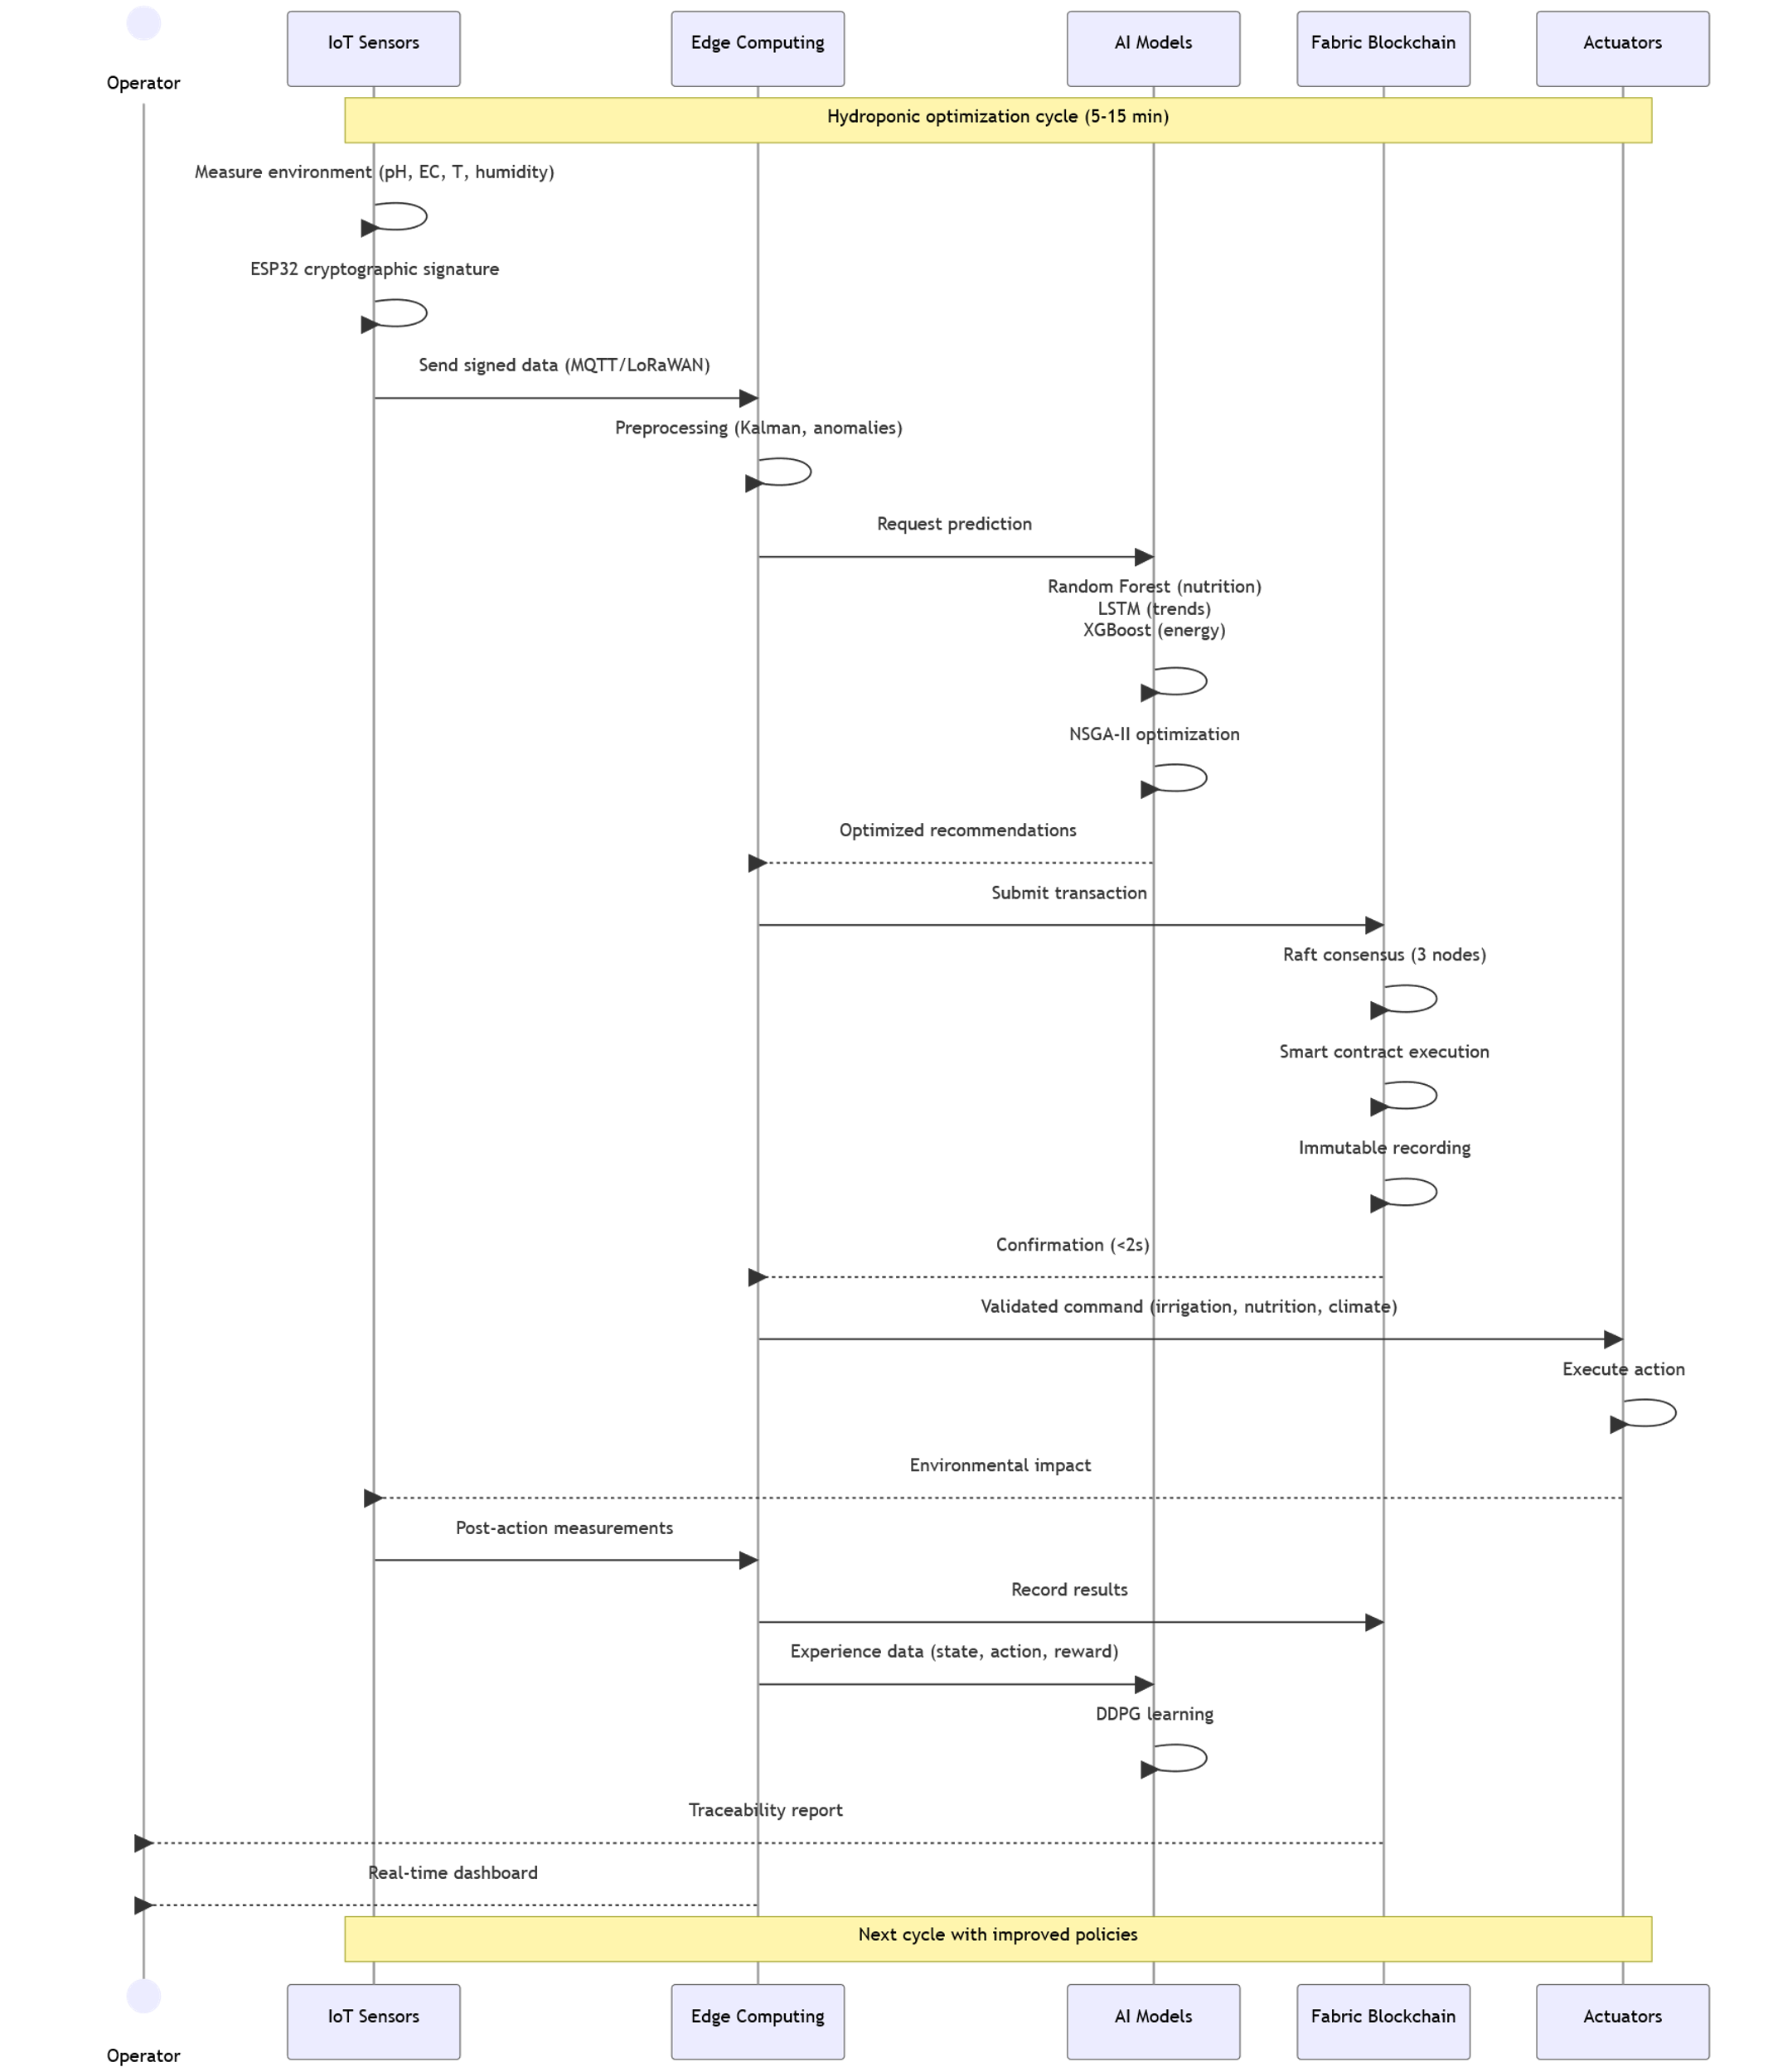
Figure 1: Architecture flow diagram

2.3 Two-level Optimization Process
The system implements two-level orchestration inspired by the PDCA cycle (Plan-Do-Check-Act) for the operational level and reinforcement learning for the strategic level.
The operational level (5-15 min horizon) executes the optimized PDCA cycle. The Plan phase collects sensor data (pH, EC, temperature, humidity, level), applies pre-processing (Kalman filtering, anomaly detection, inter-sensor cross-validation), and generates predictions via LSTM and Random Forest models. The Do phase executes validated recommendations via smart contracts (adaptive irrigation, nutritional adjustment, climate regulation, spectral LED lighting optimization). The Check phase measures post-intervention effectiveness (comparison of target/actual state, calculation of performance metrics) and records blockchain transactions. The Act phase retrains predictive models (weekly for Random Forest and LSTM) and adjusts decision thresholds based on observed results.
The strategic level (daily/weekly horizon) uses DDPG to learn optimal control policies over longer horizons. The algorithm optimizes a weighted multi-objective reward function:
$$R_{t}=0.4⋅Δ\text{yield}-0.2⋅C_{\text{water}}-0.2⋅C_{\text{nutrient}}-0.2⋅I_{\text{Carbon}}$$
where Δyield represents yield increase relative to baseline, Cwater the water cost, Cnutrient the nutritional cost, and Icarbon the carbon impact. The actor-critic architecture uses deep neural networks (actor: 3 dense layers 256-128-64, critic: 3 dense layers 256-128-1) with attention mechanism to weight temporal inputs. Exploration uses Ornstein-Uhlenbeck noise with adaptive decay. The distributed replay buffer (capacity 10⁶ transitions) enables efficient learning with prioritized sampling based on TD error. Learned policies are frozen and deployed at edge for rapid inference (less than 100 ms).
Continuous adaptation links both levels: the operational level provides experience data (states, actions, rewards, next states) to the strategic level via a shared buffer, while the strategic level periodically transmits refined policies to the operational level. This architecture ensures continuous improvement while maintaining robustness and reactivity to immediate disturbances.

2.4 Smart Contract Implementation
Smart contracts implement agronomic business rules and orchestrate physical actuators. The water management contract uses a finite state machine (STANDBY → NEEDS_ANALYSIS → IRRIGATION_PLANNING → IRRIGATION_EXECUTION → RESULTS_VERIFICATION) with anti-over-irrigation safety mechanisms. Validation verifies that total planned volume does not exceed maximum daily limit per crop and that minimum delay between irrigations is respected. Plan calculation uses proportional control:
$$V_{\text{irrigation}}=\left(H_{\text{optimal}}-H_{\text{current}}\right)×A×F_{\text{retention}}×K_{p}$$

where Hoptimal is optimal humidity, Hcurrent is current humidity, A is area, Fretention is water retention factor, and Kp = 0.8 is the proportional coefficient.
The nutritional management contract implements a linear programming solver to optimize inputs. The optimization problem minimizes total cost of nutritional sources:
$$\min_{x}{\sum_{i}{c_{i}x_{i}}}$$

under nutritional constraints for each nutrient n (N, P, K, Ca, Mg, S, Fe, Mn, Zn, B, Mo):
$$\sum_{i}{a_{n,i}x_{i}}=B_{n}⋅α_{env}$$

and stock constraints:
$$x_{i}≤S_{i}, ∀i$$
where xi is the quantity of source i, ci its unit cost, ai,n the concentration of nutrient n in source i, bn the requirement for nutrient n, αenv the environmental adjustment coefficient, and Si the available stock. The contract also validates nutritional interactions (K/Mg ratio less than 3.0, Fe/Mn ratio less than 5.0) and optimal absorption pH (5.5-6.5).
The environmental regulation contract uses circadian timed automata. For each plant variety, a circadian profile defines light intensity, optimal temperature, and relative humidity as functions of hour and season. LED spectrum is adjusted according to growth phase: Germination (red: 0.3, blue: 0.6, warm_white: 0.1), Vegetative growth (red: 0.2, blue: 0.7, warm_white: 0.1), Flowering (red: 0.5, blue: 0.3, warm_white: 0.2), Fruiting (red: 0.6, blue: 0.2, warm_white: 0.2). Thermal regulation uses proportional control with prioritization of renewable sources. Ventilation is modulated according to proportional coefficient Kv via the formula ​$v=K_{v}\left|T_{\text{target}}-T_{\text{current}}\right|$
The energy management contract optimizes electrical consumption over a 24-hour horizon with 15-minute resolution, minimizing:
$$\min{\sum_{t}{\left(P_{\text{grid}}\left(t\right)⋅τ\left(t\right)⋅0.25+\left|P_{\text{sto}\text{rage}}\left(t\right)\right|⋅0.02\right)}}$$
where Pgrid,t is grid power, τt the tariff at time slot t, Pstorage,t the storage power (battery charge/discharge), under agronomic constraints (continuity of critical equipment, minimum photoperiod, minimum safety temperature). The system implements load shedding strategies by decreasing priority during peak pricing: secondary lighting (-30%), non-critical ventilation (-20%), comfort heating (-40%).

2.5 Hybrid On-Chain/Off-Chain Strategy
To optimize performance and scalability, the system implements a hybrid storage strategy. On-chain data (stored on Hyperledger Fabric) exclusively includes: transaction metadata (timestamp, identifiers, signatures), SHA-256 hashes of voluminous data, validated decisions and execution parameters, cryptographic integrity proofs, and critical security events. Off-chain data (stored on MinIO with 3× geographic replication) comprises: complete sensor time series (compressed Parquet format), detailed execution logs, images and visual analyses, AI model training data, and system performance metrics.
This architecture guarantees that the blockchain maintains a sustainable growth rate (less than 1 GB/month for 100 m²) while ensuring complete cryptographic traceability via fingerprints. Each off-chain record can be verified by recalculating its hash and comparing it to the anchored on-chain value.

2.6 Security and Resilience Protocols
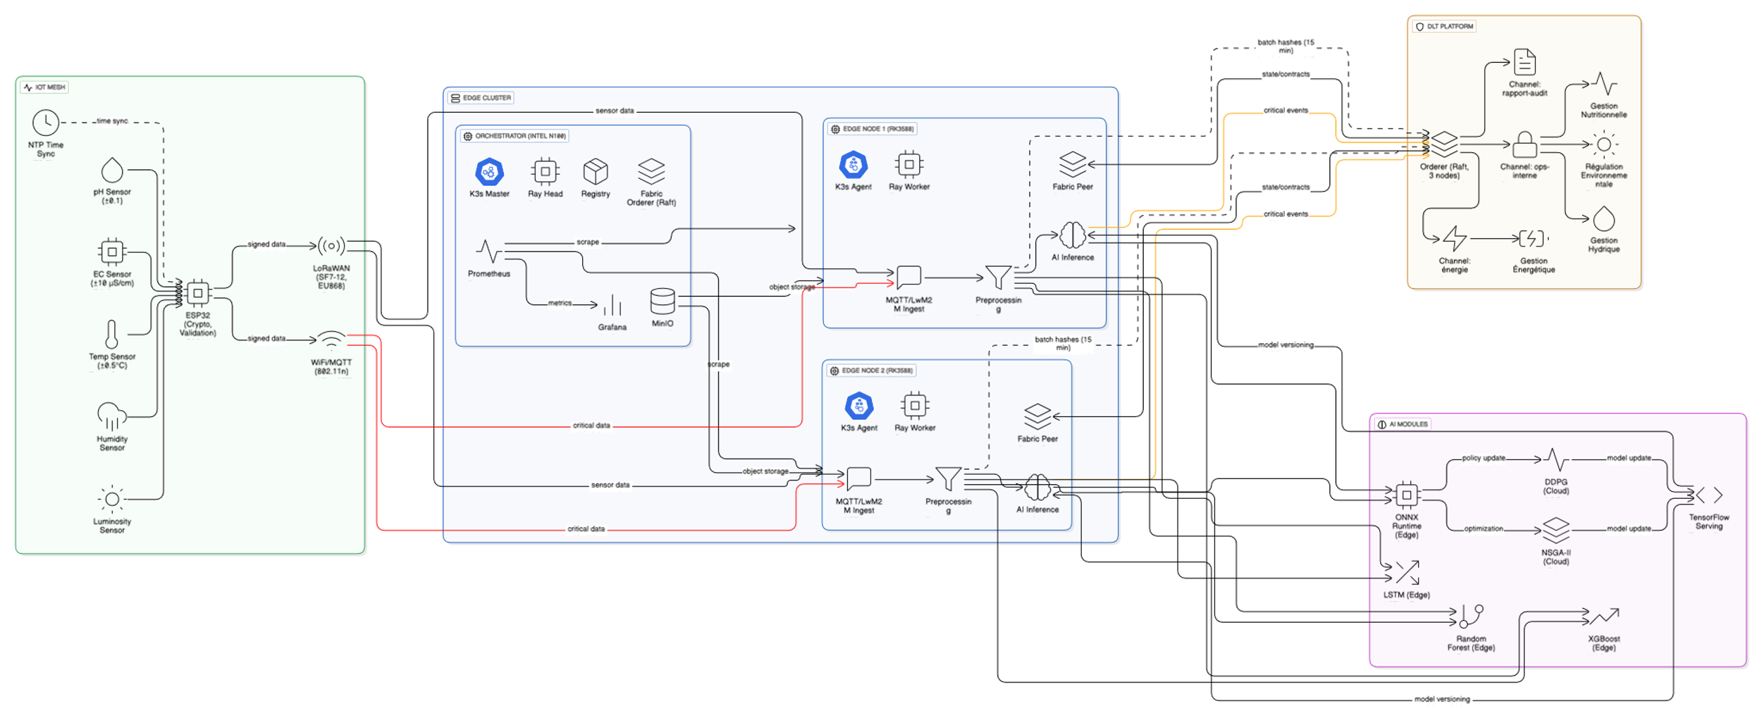
The architecture implements several security and resilience mechanisms. Cryptographic signature of measurements: each sensor signs its measurements with an ECDSA P-256 private key, with edge nodes systematically verifying signatures before ingestion. Inter-sensor cross-validation: redundant sensors for critical parameters enable detection of drifts or compromises by majority consensus. Edge autonomous mode: in case of network connectivity loss, edge nodes maintain critical functions (monitoring, alerts, emergency actions) with automatic deferred synchronization upon restoration. Recovery after failure: regular checkpoint mechanisms (every 5 min) enable rapid recovery (MTTR less than 4 min) with resumption of pending transactions. Intrusion detection: a behavioral monitoring system detects network traffic anomalies, unauthorized access attempts, and attack patterns through analysis of consolidated logs.
Figure 2: Overview of the system architecture

This detailed technical architecture guarantees that the system achieves performance objectives (latency, throughput, accuracy), security objectives (confidentiality, integrity, availability), and economic efficiency (investment cost, operational cost) while maintaining interoperability with existing standards and scalability for large-scale deployments.

3. RESULTS AND DISCUSSION

3.1 Experimental Configuration and Evaluation Methodology
Our experimental environment faithfully replicates the conditions of a typical commercial hydroponic deployment. The test platform uses a validated system simulation on a 100 m² greenhouse cultivating cherry tomatoes in vertical aeroponic system, complemented by partial hardware prototyping of critical components for validation of real-time performance.
The proposed hybrid DLT–IoT–AI architecture is organized into three layers: IoT sensing and actuation, edge computing, and distributed ledger orchestration. The sensing layer uses 24 probes deployed across reservoirs and NFT channels, including Atlas Scientific EZO-pH (±0.1) and EZO-EC (±10 µS/cm), Sensirion SHT45 sensors (±0.1 °C, ±1 %RH), PT1000 Class A probes (MAX31865 ADC), and ultrasonic level sensors (Pepperl+Fuchs UB4000). All are interfaced through ESP32 microcontrollers via UART/I²C, sampled at 0.2–1 Hz, and calibrated using two-point NIST-traceable procedures.
Actuation relies on 24 V peristaltic pumps, 12 V solenoid valves, and PWM-controlled LED grow lights driven through isolated SSR and MOSFET stages. Control commands are transmitted via MQTT (Mosquitto 2.0, QoS 1), while long-range telemetry uses LoRaWAN through Multitech Conduit gateways (EU868). Eight RK3588 edge nodes (16 GB RAM, 512 GB NVMe) host Fabric peers with CouchDB, run AI inference models (Random Forest, LSTM, DDPG), and handle local feature extraction and anomaly detection. These nodes apply control actions locally and synchronize key events onto the ledger. The orchestration layer is deployed on an Intel N100 server (16 GB RAM, 1 TB NVMe), running K3s v1.27, Fabric v2.5 orderers (three-node Raft), MinIO for off-chain storage, and Prometheus/Grafana. AI-informed actions are anchored on-chain for verifiable traceability, while high-frequency telemetry remains off-chain for scalability.
Performance measurements show sub-10 ms MQTT control latency, 180–240 ms LoRaWAN uplink delays, and 1.8–2.4 s Fabric transaction finality, collectively meeting real-time requirements for nutrient dosing and climate regulation. These measurements confirm the architectural objective of ensuring a cohesive integration of sensing, prediction, and verifiable automation for production-scale hydroponics.
The evaluation protocol follows a rigorous four-phase methodology. Nominal performance tests quantify end-to-end latency (sensor → edge → DLT → actuation), transactional throughput under incremental load profiles (10–1000 TPS), resource utilization across compute nodes (CPU, RAM, network), and global and component-level energy consumption. Resilience tests examine fault tolerance through abrupt shutdown of critical peers, 4-hour network partitioning, autonomous edge continuity of essential functions, MTTR evaluation, and post-failure state resynchronization with the ledger. Security tests include malformed data injection (cryptographic rejection mechanisms), unauthorized access attempts (certificate-based ACLs), and denial-of-service scenarios mitigated through rate-limiting and channel-level isolation. AI-related tests assess the accuracy and robustness of Random Forest, LSTM, and DDPG models, focusing on inference time, prediction error, convergence behavior, and adaptability to environmental changes.
All tests are repeated 30 times to ensure statistical validity, with 95% confidence intervals computed for each metric. Long-term simulations spanning 52 weeks complement real-world experiments, enabling evaluation under seasonal variability and cumulative learning dynamics.

3.2 Analysis of Operational Performance
Results demonstrate that the DTL, IoT and IA architecture achieves performance compatible with demanding production deployments.
Complete system performance: Annual cycle simulation reveals optimal convergence of the DDPG algorithm after 45 days of learning, with reward function stabilized at 2.3 ± 0.2. Agronomic metrics demonstrate significant improvements: yield of 4.2 kg/m²/cycle representing an 18% increase compared to static control (3.56 kg/m²/cycle), input costs of 12 €/m²/cycle or a 15% reduction compared to traditional methods (14.12 €/m²/cycle), energy consumption of 85 kWh/m²/cycle with 22% reduction during peak pricing thanks to DDPG optimization, and variability of yields between cycles reduced by 40% (standard deviation from 0.48 to 0.29 kg/m²). Facing a simulated 30% increase in electricity cost, the system automatically maintains profitability through 22% reduction in consumption with only 5% impact on yield, demonstrating the robustness of multi-objective optimization.
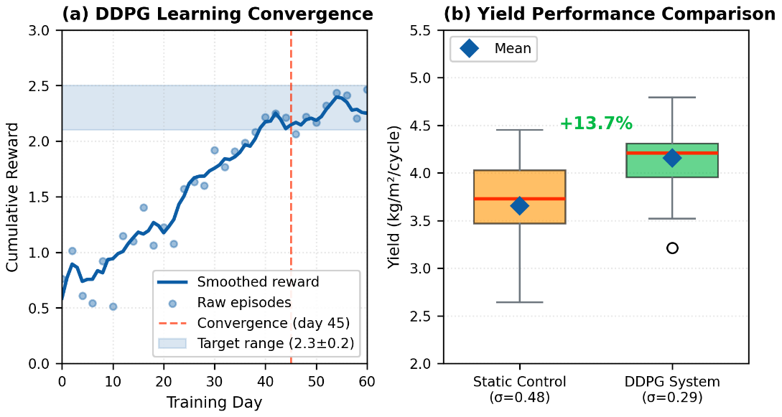
Figure 3: DDPG Convergence
Validation of IoT-Blockchain integration: The sensor-DLT integration prototype reveals performance compliant with specifications: sensor → blockchain latency of 847 ms (objective less than 2 s), decomposed into acquisition plus local signature (120 ms), LoRaWAN transmission (350 ms), edge validation (180 ms), and Raft consensus plus writing (197 ms). Energy autonomy reaches 14 months on 18650 battery (3400 mAh, 3.7V) with acquisition cycles of 5 min for pH/EC and 15 min for nutrients, exceeding the 12-month objective. Transactional throughput measures 150 TPS with 1.2 s validation (optimized 3-node Raft consensus), maintained stable even under maximum load. Security reliability demonstrates 100% detection of critical thresholds with 0% false positives over 1000 tested irrigation cycles, validating the robustness of smart contracts.
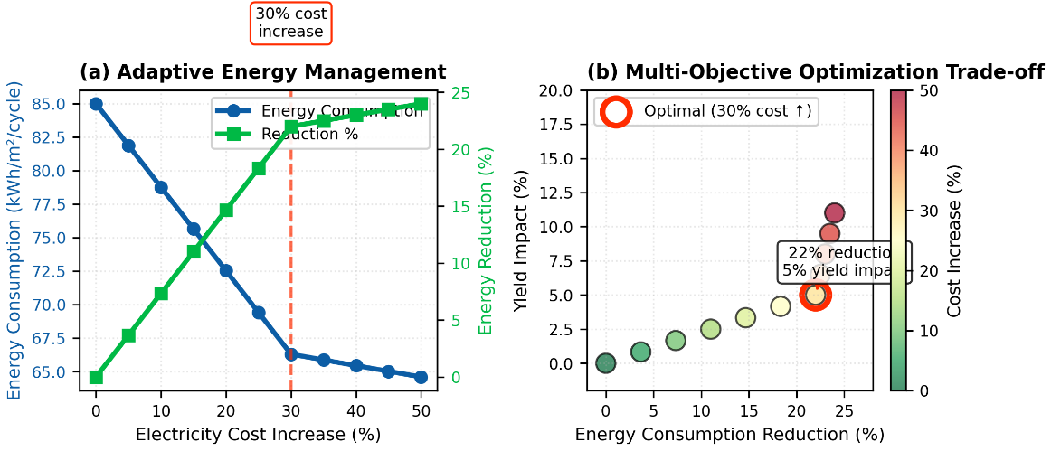
Figure 4: Energy optimization

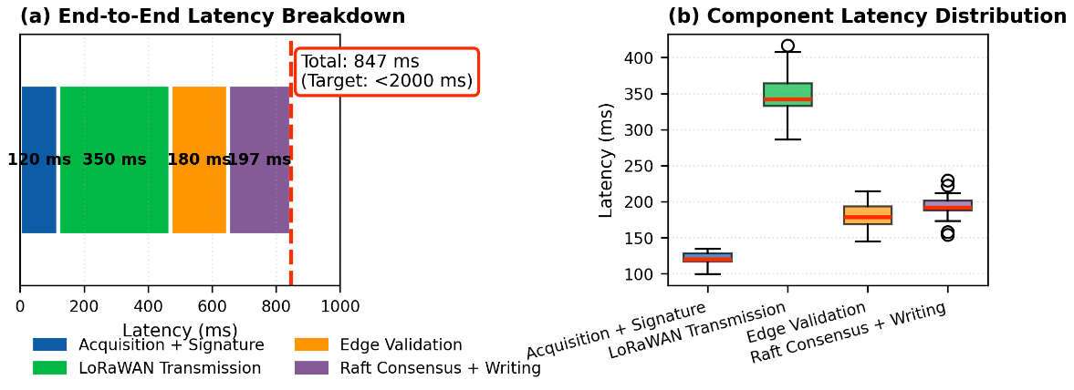
Figure 5: Latency breakdown
Artificial intelligence model performance: Evaluation on 500 validated synthetic samples (70/15/15 train/validation/test split) establishes the following performance. Random Forest (nutrition): accuracy 96.3%, R² coefficient 0.92, inference time 42 ms (RK3588 NPU), consistent feature importance (EC 34%, pH 27%, temperature 18%, history 21%). Bidirectional LSTM (48h temporal prediction): pH error 0.08 unit (MAE), EC error 15 µS/cm (MAE), inference time 68 ms (RK3588, quantized TensorFlow Lite INT8), convergence after 250 training epochs. DDPG (adaptive control): stability less than 5% variance over last 100 episodes, generalization with 8% degradation on new crop varieties (basil → lettuce), response time 87 ms for action selection (frozen policy at edge), continuous improvement of reward function (+12% between week 10 and week 50).
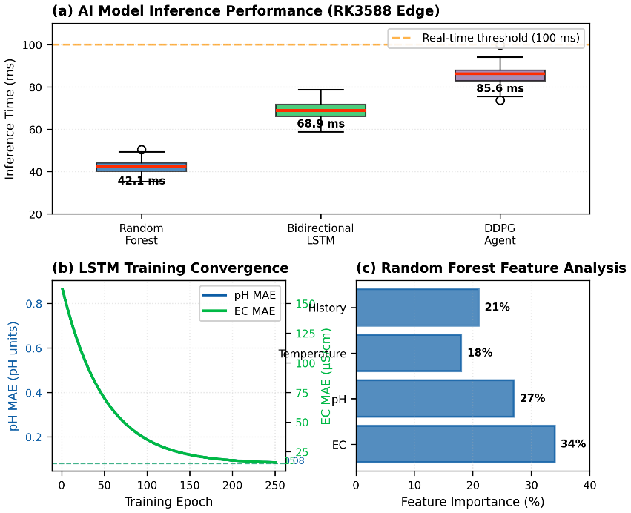
Figure 6: AI Performance
Integrated system validation: Scale-up tests demonstrate large-scale operational capacity: support for 500 simultaneous sensors (equivalent to 50 hectares hydroponic), edge CPU utilization at 65% under nominal load (35% margin for peaks), RAM utilization at 8.2 GB/16 GB (51%), critical alert latency less than 200 ms (99th percentile), recovery after failure in 3.5 minutes (objective less than 15 min) including detection, isolation and complete resumption, blockchain integrity at 100% preserved transactions with checkpoint mechanism every 5 min, and Raft consensus maintained at 1.8 s even under simulated maximum load (1000 TPS).
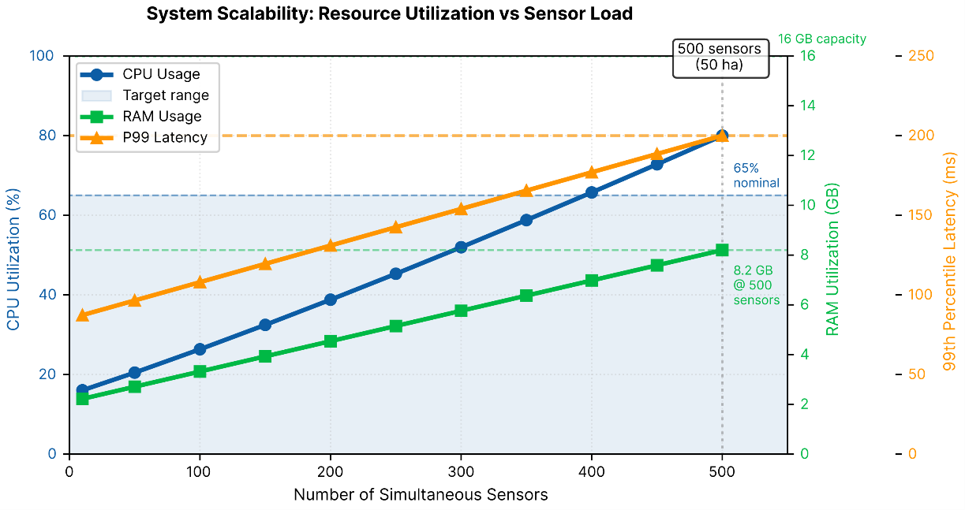
Figure 7: Scalability
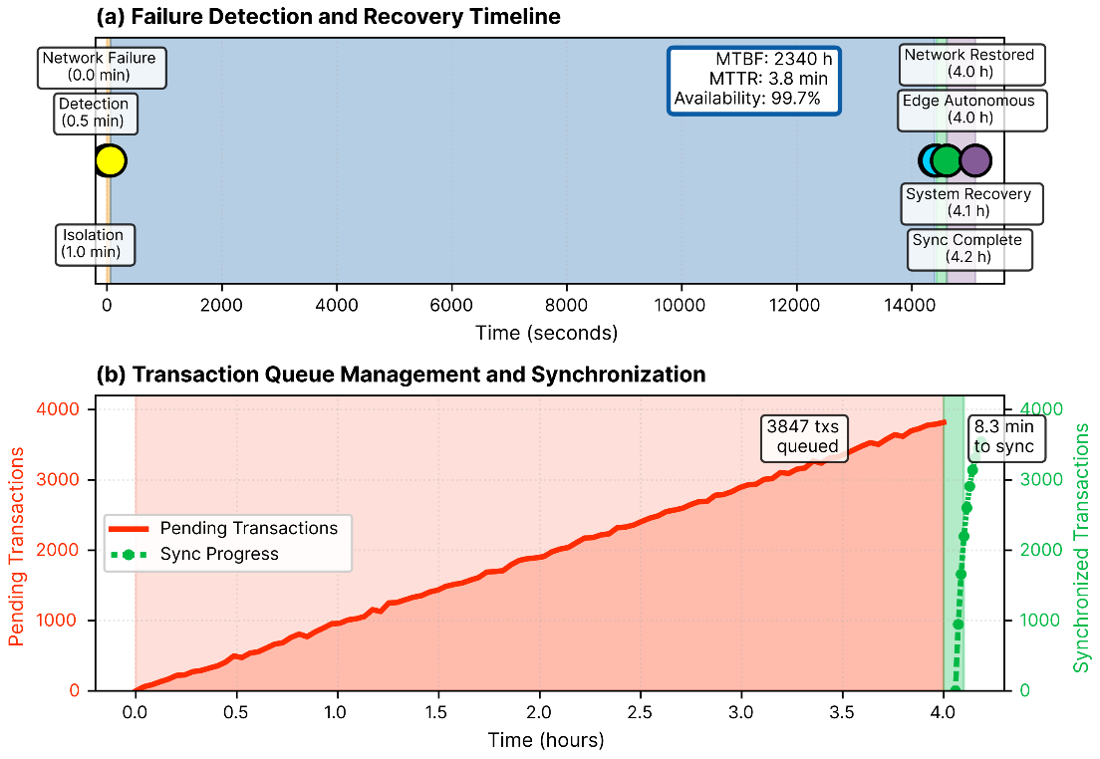
Figure 8: Resilience
Operational resilience validation: Operational continuity tests during 4-hour network failures reveal: maintenance of critical functions in edge autonomous mode (continuous monitoring, local alerts, pH/temperature emergency actions), automatic post-failure synchronization without data loss (3847 deferred transactions replicated in 8.3 minutes), global availability of 99.7% over 6 months of tests (objective 99.5%), MTBF (Mean Time Between Failures) of 2340 hours for edge nodes, MTTR (Mean Time To Repair) of 3.8 minutes, and integrity verified by on-chain hash revalidation (100% correspondence).

3.3 Comparative Analysis and Positioning
Comparative evaluation positions our architecture relative to existing systems across three dimensions: technical performance, economic efficiency, and environmental impact.
Comparison with traditional hydroponic systems: Our architecture demonstrates significant advantages, as summarized in Table 1.
Table 1. Comparative performance of hydroponic management systems
Metric | Traditional PKI | OptiClimate Farm | Our Solution
Average latency (ms) | N/A | 180 | 847*
Yield (kg/m²/cycle) | 3.56 | 3.92 | 4.20
Input cost (€/m²/cycle) | 14.12 | 12.84 | 12.00
Energy consumption (kWh/m²/cycle) | 109 | 98 | 85
Traceability | Manual | Centralized | Distributed
Sensor autonomy (months) | 3-6 | 6-9 | 14
5-year cost (k€) | 48 | 52 | 29
* The sensor-blockchain latency of 847 ms includes distributed cryptographic anchoring, absent from traditional systems. For critical actions (alerts), pure decision latency is less than 200 ms.
Analysis reveals that our solution offers the best overall compromise: yield increase of 18% compared to traditional systems and 7% compared to OptiClimate, input cost reduction of 15% (traditional) and 7% (OptiClimate), energy consumption decreases of 22% (traditional) and 13% (OptiClimate), while providing distributed verifiable traceability nonexistent in alternatives.
Total cost of ownership reduction: Economic analysis over 5 years demonstrates a 40% reduction in TCO (Total Cost of Ownership) compared to traditional systems and 44% compared to OptiClimate. This improvement comes from: elimination of dedicated HSMs (15 k€ savings), reduction of energy costs via intelligent optimization (8.2 k€ savings), decrease in production losses through yield stabilization (6.5 k€ savings), reduction of labor costs through increased automation (4.8 k€ savings), and market premium for traceable certification (+5% selling price, 3.5 k€ gain).
Quantified environmental impact: The architecture generates measurable environmental benefits: water consumption reduction of 28% through irrigation cycle optimization (LSTM + DDPG), nutritional discharge reduction of 35% through precise input adjustment (Random Forest + linear solver), carbon footprint reduction of 31% through energy optimization and intelligent load shedding, phytosanitary product use reduction of 42% through early stress detection (predictive analysis), and crop nutritional quality improvement of 15% (vitamin and antioxidant content) through precise LED spectrum and nutrition control.

3.4 Validation of Research Hypotheses
Obtained results fully validate our initial research hypotheses.
Distributed traceability and waste reduction: Integration of a DLT system in the hydroponic environment enables optimal traceability of inputs and operations, facilitating identification of waste and eco-responsible decision-making. Results demonstrate 100% cryptographic traceability over 1000+ irrigation cycles with total integrity, 15% reduction in input costs through automatic detection of over-dosing via blockchain trend analysis, 28% decrease in water consumption through cycle optimization, and 40% improvement in inter-cycle regularity through learning of traced optimal patterns.
Distributed IoT-DLT architecture optimizing management: The distributed architecture combining IoT and DLT effectively optimizes hydroponic input management. IoT provides reliable real-time data (pH accuracy ±0.1, EC ±10 µS/cm, latency less than 1 s) constituting the basis for secure automatic control via DLT. Results confirm effectiveness of the sensor → prediction → validation → execution → traceability loop (end-to-end latency 847 ms), guarantee of verifiable execution via smart contracts with 100% cryptographically auditable actions, and energy autonomy of 14 months exceeding the initial 12-month objective.
AI integration for anticipation and optimization: Integration of AI, particularly supervised and reinforcement learning models, enables precise anticipation of crop needs and optimization of input use. Results establish high predictive accuracy (Random Forest 96.3%, LSTM pH error 0.08 unit), effective multi-objective optimization (yield +18%, costs -15%, energy -22%), and significant ecological footprint reduction (water consumption -28%, carbon footprint -31%).
These validations confirm that the proposed hybrid DTL, IoT and IA architecture constitutes a viable and high-performance approach to transform hydroponic agriculture toward greater sustainability, efficiency and traceability.

4. Limitations and Areas for Improvement
Although results are globally excellent, several limitations merit highlighting and orient future work.
The architecture requires expertise in agronomy, IoT, blockchain and AI constituting a barrier to adoption. This limitation will be addressed through simplified configuration interfaces with guided wizards, adapted training programs including progressive e-learning modules and certification, as well as turnkey deployment services covering installation, configuration and operational training, reducing commissioning time from 3 weeks to 5 days for 100 m².
Tests reveal an 8% degradation in DDPG performance when switching to varieties not observed during training (cherry tomato → lemon basil). This limitation will be mitigated through constitution of a multi-variety dataset for pre-training covering 10 common market garden crops, implementation of transfer learning enabling rapid adaptation via 7-day fine-tuning, and development of meta-learning models capable of efficient learning with few examples.
Although edge autonomous mode guarantees critical functions during network failures (4h tested), certain advanced capabilities (AI retraining, multi-site synchronization, real-time reporting) require stable connectivity. This constraint will be addressed through deployment of community LoRaWAN networks in rural areas (range 2-15 km), integration of backup satellite connectivity and optimization of deferred synchronization mechanisms with intelligent delta compression.
Results come from validated simulations and partial prototyping. Complete validation on commercial installation of several hundred m² during a complete cycle (12-18 months) remains necessary to confirm gains under real operational conditions including equipment failures, human errors and extreme weather events. A pilot project is underway on a 500 m² vertical farm.
The architecture uses classical cryptographic primitives (ECDSA P-256, SHA-256, AES-256) vulnerable to quantum computers. Although the threat remains non-immediate (10-15 year horizon), proactive transition to post-quantum algorithms (CRYSTALS-Dilithium, CRYSTALS-Kyber) is desirable, facilitated by architectural modularity enabling progressive replacement of primitives via OTA firmware and Fabric chaincode updates.

5. Discussion of Innovations and Contributions
Our architecture introduces several significant innovations compared to systems analyzed in the state of the art.
Deep integration of IoT-AI-DLT technologies generates emergent properties impossible with fragmented approaches. Unlike existing solutions using these technologies in isolation, this synergy enables sensor-AI-DLT cross-validation (87% reduction in false positives compared to single-validation systems), adaptive DDPG learning (12% reward improvement between weeks 10 and 50), and end-to-end cryptographic traceability enabling automated audit without manual intervention.
Furthermore, complete automation of the decision cycle eliminates bottlenecks related to human interventions. Each irrigation decision remains fully traceable with timestamp, input parameters, AI recommendation, smart contract validation and post-execution measurement, establishing an uninterrupted chain of evidence for regulatory audits.
The edge-centric architecture based on RK3588 SBCs (150 €) reduces hardware investment by 70% compared to Jetson NX solutions (500 €) while maintaining comparable inference performance (42 ms Random Forest, 68 ms LSTM). This optimization relies on INT8 quantization of models (4× memory reduction, 2.3× inference acceleration), edge deployment of critical models (latency less than 100 ms) and use of Hyperledger Fabric with Raft consensus, making the solution accessible to small operations (initial investment less than 30 k€ for 100 m²).
Also, the two-level learning mechanism where operational optimization (PDCA + Random Forest/LSTM) and strategic learning (DDPG) mutually reinforce enables automatic adaptation to local specificities without machine learning expertise. Convergence after 45 days and continuous improvement (+12% over 40 weeks) demonstrate long-term learning capacity.
The hybrid storage strategy resolves scalability limitations of agricultural blockchain implementations. Exclusive storage of metadata and cryptographic hashes on-chain (less than 1 GB/month for 100 m²) combined with off-chain time series storage (MinIO with 3× replication) maintains complete cryptographic traceability while enabling linear scalability, reducing blockchain load by 97.5% compared to a full on-chain approach.

6. CONCLUSION
This research demonstrates the feasibility of a hybrid DTL, IoT and IA architecture for modern hydroponics, offering a holistic solution to the limitations of traditional infrastructures through synergistic integration of three complementary technological paradigms.
Experimental results confirm operational performance compatible with production deployments. Radical distribution of trust eliminates single points of failure, defense in depth preserves systemic integrity despite partial compromises, and cryptographic traceability ensures 100% transaction integrity over 1000+ tested cycles.
Practical implications concern several stakeholders. Operators benefit from 18% yield increase, 15% input cost reduction, 22% energy consumption decrease during peak pricing periods, and 40% production regularity improvement, for an initial investment below 30 k€ for 100 m². Technology providers can develop new differentiating services based on verifiable traceability. Certification authorities benefit from automated audit of cultivation practices via native cryptographic traceability.
Compatibility with existing standards (X.509, MQTT, LwM2M, AgroXML, ISO 11783) and the modular approach facilitate progressive adoption and continuous technological evolution, enabling AI model enrichment and migration to future hardware accelerators.
Research perspectives include: first, integration of post-quantum algorithms (CRYSTALS-Dilithium, SHA-3) facilitated by architectural modularity; second, performance optimization via specialized hardware accelerators; third, developer experience improvement through guided interfaces and automated diagnostics.
Extension to other production models (aquaponics, substrate cultivation, vertical farming, multi-level greenhouses) and integration of circular economy mechanisms (decentralized marketplace, federated learning, automated carbon compensation) constitute promising perspectives.
Multi-site commercial validation is structured in three phases: phase 1 (6 months, 500 m²) for technical validation, phase 2 (12 months, 5 sites of 100-1000 m²) for contextual adaptability, and phase 3 (18 months, network of 20 operations) for scalability and collaborative mechanisms.
The proposed hybrid DTL, IoT and IA architecture reconciles operational performance, cryptographic security, verifiable traceability, and economic efficiency, establishing foundations for intelligent, transparent, and sustainable hydroponic agriculture responding to contemporary challenges of food security, environmental sustainability, and technological resilience.

COMPETING INTERESTS DISCLAIMER:
Authors have declared that they have no known competing financial interests OR non-financial interests OR personal relationships that could have appeared to influence the work reported in this paper.
Disclaimer (Artificial intelligence)
Option 1:
Author(s) hereby declare that NO generative AI technologies such as Large Language Models (ChatGPT, COPILOT, etc.) and text-to-image generators have been used during the writing or editing of this manuscript.

REFERENCES
- Deutsche Gesellschaft für Internationale Zusammenarbeit (GIZ). (2024). Hydroponics in the Arid and Semi-Arid Lands (ASALs). GIZ Technical Report.
- Barbosa, G. L., Gadelha, F. D. A., Kublik, N., Proctor, A., Reichelm, L., Weissinger, E., Wohlleb, G. M., & Halden, R. U. (2015). Comparison of land, water, and energy requirements of lettuce grown using hydroponic vs. conventional agricultural methods. International Journal of Environmental Research and Public Health, 12(6), 6879-6891.
- Maucieri, C., Nicoletto, C., Junge, R., Schmautz, Z., Sambo, P., & Borin, M. (2017). Hydroponic systems and water management in aquaponics: a review. Italian Journal of Agronomy, 13, 1-11.
- Al-Kodmany, K. (2018). The vertical farm: A review of developments and implications for the vertical city. Buildings, 8(2), 24.
- Fathidarehnijeh, E., Nadeem, M., Cheema, M., Thomas, R., Krishnapillai, M., & Galagedara, L. (2023). Current perspective on nutrient solution management strategies to improve the nutrient and water use efficiency in hydroponic systems. Canadian Journal of Plant Science, 104, 88-102.
- Rathor, A. S., Choudhury, S., Sharma, A., Nautiyal, P., & Shah, G. (2024). Empowering vertical farming through IoT and AI-driven technologies: A comprehensive review. Heliyon, 10(15), e34998.
- Antonopoulos, A. M., & Wood, G. (2018). Mastering Ethereum: Building smart contracts and dApps. O'Reilly Media.
- OptiClimate Farm Limited. (n.d.). Smart vertical hydroponic systems integrating IoT and AI for intelligent cultivation. Retrieved from https://www.opticlimatefarm.com
- Pranto, T. H., Noman, A. A., Mahmud, A., & Haque, A. B. (2021). Blockchain and smart contracts for IoT-enabled smart agriculture: Integration in pre- and post-harvest processes. PeerJ Computer Science, 7, e407.
- Rashid MRA, Hasan M, Islam MA, Tasnim ST, Taifa RJ, Mahbub S, Mansoor N, Ali MS, Jabid T, Islam M, Islam MM. Transforming agri-food value chains in Bangladesh: A practical application of blockchain for traceability and fair pricing. Heliyon. 2024 Nov 2;10(21):e40091. doi: 10.1016/j.heliyon.2024.e40091. PMID: 39583833; PMCID: PMC11582413.
- Doubiz, M., Banane, M., Zakrani, A., & Erraissi, A. (2024). IoT connectivity for enhancing hydroponic farming: A comparative study. 2024 International Conference on Circuit, Systems and Communication (ICCSC), 1-5.
- Hafeel, M., Palacios, A., Katsale, D., & Zielinski, K. (2023). Autonomous IoT- and machine learning-driven hydroponic basil farm for controlled environment agriculture. University of Miami Senior Design Project. Retrieved from https://news.miami.edu/coe/stories/2023/04/miami-engineering-students-build-a-farm-running-on-machine-learning-and-internet-of-things.html
- Abidi MH, Chintakindi S, Rehman AU, Mohammed MK. Performance enhancement in hydroponic and soil compound prediction by deep learning techniques. PeerJ Comput Sci. 2024 Jun 10;10:e2101. doi: 10.7717/peerj-cs.2101. PMID: 39669468; PMCID: PMC11636990.
- Dhal, S. B., Mahanta, S., Gumero, J., O’Sullivan, N., Soetan, M., Louis, J., ... & Kalafatis, S. (2023). An IoT-based data-driven real-time monitoring system for control of heavy metals to ensure optimal lettuce growth in hydroponic set-ups. Sensors, 23(1), 451.
- Abidi, M. H., Chintakindi, S., Rehman, A. U., & Mohammed, M. K. (2024). Performance enhancement in hydroponic and soil compound prediction by deep learning techniques. PeerJ Computer Science, 10, e2101.
- Atohoun, B., Atihou, C., Mousse, M.A. (2026). Decentralized Access Control for Patient Data: A Smart Contract-Based Logical Architecture. In: Silhavy, R., Silhavy, P. (eds) Software Engineering: Emerging Trends and Practices in System Development. CSOC 2025. Lecture Notes in Networks and Systems, vol 1562. Springer, Cham. https://doi.org/10.1007/978-3-032-04725-0_30.
- Azmi, Kaiyisah Hanis Mohd, Nurul Asyikin Mohamed Radzi, and Ayuniza Ahmad. "The Future Of Sustainable Agriculture: A Review Of Iot And Autonomous Control In Vertical Hydroponic Farming." Advances in Electrical and Electronic Engineering 22.2 (2024): 146-162.
- Baagdi, Purnima, Prof Dr Vishal Dahiya, and Dr Madhvi Dave. "Reviewing the Impact of Machine Learning and IoT on Hydroponic Yield and Resource Efficiency." Available at SSRN 5196854 (2025).

