Short Research Article

Ionospheric Phase Scintillation during Solar Cycle 24 over West Africa: Analysis from GPS Stations at Koudougou and Ouagadougou (BF01)

Abstract
Ionospheric scintillation is a phenomenon of rapid and irregular fluctuations in the intensity of radiofrequency signals passing through the ionosphere. It generally arises from interactions between GNSS signals and irregularities in the ionospheric plasma. These interactions can lead to rapid variations in the amplitude and/or phase of the signals passing through the ionosphere, giving rise to what is called amplitude and/or phase scintillation. Phase scintillation was the subject of this study. Based on the RINEX data available at the GPS stations of Koudougou and BF01 of Ouagadougou, we calculated for solar cycle 24 (2008-2018), the daily and monthly hourly values ​​of the rate of total electron content change index (ROTI) which is a good indicator of phase scintillation. The study of the ROTI in these two equatorial stations, shows an ionospheric phase scintillation after sunset from 2000 LT to 2300 LT during periods of quiet geomagnetic activity. At this moment of night, maximum ROTI values ​​of approximately 1 tecu/min are recorded. The phenomenon often continues at a low intensity (approximately 0.5 tecu/min) during the night between 0000LT and 0200LT. The nocturnal scintillation phenomenon is explained by the formation of plasma bubbles caused by the Rayleigh-Taylor instability after sunset. Phase scintillation is strongly influenced by solar activity. The ROTI is indeed higher at solar maximum with a peak value exceeding 1.5 tecu/min. Seasonal effects are also noted in the disturbance of GNSS signals. ROTI values ​​are indeed higher at the equinoxes than at the solstices. During geomagnetic storms, phase scintillation is inhibited when the main phase occurs in the morning. When the main phase occurs after sunset, scintillation occurs in the same evening during the main phase or in the overlap phase. After sunset, the increase in the intensity of the ring current in the main phase causes the formation of ionospheric irregularities responsible for scintillation. It is very important to understand ionospheric irregularities in order to better optimize the reliability of GNSS system.
Keywords: Scintillation, ROTI index, TEC, Plasma bubbles, magnetic storms

- INTRODUCTION
The ionosphere plays a very important role in telecommunication, navigation, and GPS satellite positioning systems. Radio signals passing through this layer of the Earth's atmosphere are often disrupted by irregularities in electron density within ionospheric plasma bubbles. The interaction of these irregularities with the Global Navigation Satellite System (GNSS) could lead to rapid fluctuations in the amplitude and/or phase of the signals, giving rise to a phenomenon known as scintillations (Aarons, 1982). Ionospheric scintillations vary depending on the frequency of the emitted signal, geomagnetic latitude, local time, season and solar activity. They are very important in the equatorial region. Indeed, the geomagnetic field is horizontal and the ionospheric height is strongly controlled by the electric field, making the ionosphere unstable especially after nightfall (Aarons and Basu, 1994). The GPS receivers of Koudougou and BF01 of Ouagadougou (Burkina Faso) are located in the equatorial ionization trough near the northern ridge of the West African zone. They provide respectively RINEX (Receiver Independent Exchange Format) data and raw data convertible into RINEX format (Ouédraogo et al., 2024). This work focuses on the available data for solar cycle 24 (2008-2018). Based on these RINEX data, we study phase scintillation at the two equatorial stations. It should be noted that ROTI is used to evaluate the rapidity of variations in total electron content (TEC), which can affect GNSS signals by causing scintillations.
Section 2 of this work deals with the data and methodology used. In Section 3 we present the obtained results followed by discussion. The results concern on the one hand the hourly variations of the ROTI index during periods of calm activity according to solar phases and seasons and on the other hand the evaluation of the impact of some geomagnetic storms on the hourly variation of the ROTI. Section 4 is devoted to the conclusion and study perspectives.
- Data and methodology
In this section, we indicate on the one hand the data used and on the other hand the methodology adopted for the study.
  - Data used
In this work we used RINEX (Receiver Independent Exchange Format) data from the GPS stations of Koudougou (Geo Lat: 12°15’N; Geo Long: -2°20’E) and BF01 of Ouagadougou (Geo Lat: 12°37’N; Geo Long: -1°51W). Koudougou GPS receiver was provided by the Institut Mines-Télécom (formerly Ecole Nationale de Télécommunication de Bretagne) as part of the IHY (International Heliophysical Year) project initiated by GIRGEA (Europe-Africa Study and Research Group). As for the BF01 station, it is one of the thirteen permanent stations of the GNSS-CORS (Global Navigation Satellite System-Continuously Operating Reference Station) network of the Geographic Institute of Burkina (IGB). The raw data from this station have already been processed and converted to RINEX format by Ouédraogo et al. (2024) and made available to us. We also used data such as:
- Sunspot numbers $R_{z}$ and Disturbance Storm Time (Dst) indices available on http://omniweb.gsfc.nasa.gov/form/dx1.html;
- Geomagnetic indices Aa extracted from the site http://www.isgi.unistra.fr/indices_aa.php;
- Sudden Storm Commencement (SSC) dates are available at https://www.isgi.unistra.fr .

  - Methodology

- Determination of solar phases:
We used the cutting proposed by Pahima et al. (2023). Table 1 presents the results of the cutting of the phases of the cycle 24 ( 2008-2018).

Table 1: Distribution of years in cycle 24 by solar phase (Pahima et al., 2023)
Solar phase | Years
Minimum | 2008 ; 2009 et 2010
Ascending | 2011 et 2012
Maximum | 2013 et 2014
Descending | 2015 ; 2016 ; 2017 et 2018

- Division of seasons :
According to several studies (Zhang et al., 2021; Kahindo Murumba et al., 2017; Ackah et al, 2011, Abdu et al., 2006; …) the scintillation phenomenon strongly depends on the seasons. Concerning our work, the seasons were divided as follows: (i) winter (December, January, February); (ii) spring (March, April, May); (iii) summer (June, July, August); (iv) autumn (September, October, November)
- Selection of quiet days:
According to the criteria of Ouattara and Amory-Mazaudier (2009) that we used, days of quiet geomagnetic activity correspond to days when the daily average values ​​of Aa are less than $20nT$ . The other days correspond to $Aa≥20nT$. Table 2 summarizes the number of quiet days for each year of cycle 24.

TABLE 2. Summary of the number of quiet days for each year of cycle 24.
Years | 2008 | 2009 | 2010 | 2011 | 2012 | 2013 | 2014 | 2015 | 2016 | 2017 | 2018
number of quiet days | 271 | 345 | 305 | 278 | 259 | 273 | 270 | 199 | 212 | 230 | 276

- Selection of geomagnetic storms:
Geomagnetic storms are periods of intense unrest due to a global disturbance of the Earth's magnetic field resulting from the interaction between the Earth's magnetosphere, fast solar winds, solar flares and coronal mass ejections (CMEs) from the Sun. In this work, we used only the Dst index to characterize the storms. Gonzalez et al. (1994) defined three classes of geomagnetic storms according to their intensity based on the Dst index: (i) intense storm (D$st≤-100nT$); (ii) moderate storm ($-50 nT ≥Dst>-100 nT$); (iii) weak storm $(-30 nT≥Dst>-50 nT$). We selected some intense storms for which we have GPS data to study the variation of ROTI as a function of Dst.
- Determination of the ROTI index:
The rate of total electron content change index (ROTI) is a measure of the variations in the total electron content (TEC) in the ionosphere. It is defined by Pi et al. (1997) to assess ionospheric irregularities from the phase fluctuations of GPS signals. According to Basu et al. (1999), ROTI is a good indicator of the presence of scintillations caused by small-scale ionospheric irregularities in the equatorial region of the ionosphere. The ROTI index is calculated every 30 seconds from the standard deviation of the ROT (Rate of TEC Change) over a period of 10 minutes with a minimum of 10 points (Pi et al., 1997). This index is used to assess the rapidity of TEC variations, which can affect GNSS signals by causing scintillations.
$ROTI=\sqrt{\left\langle {ROT}^{2}\right\rangle -{⟨ROT⟩}^{2}}$
With the symbol $⟨ ⟩$ representing the average value.
ROT (Rate of TEC Change) represents the rate of change of the STEC, derived from phase measurements recorded in RINEX files at 30-second intervals:
$ROT=\frac{{STEC}_{k+1}-{STEC}_{k}}{{time}_{k+1}-{time}_{k}}×60$
$STEC$ : the oblique TEC; $k$ is a time in the day, defined as being between 0 and 86400 seconds, and represents the time exactly 30 seconds later.
ROTI is expressed in tecu/min ( 1tecu = ${10}^{6} electrons/m^{2}$).
Using RINEX data from both stations, we use MATLAB programs to generate daily hourly variation curves of ROTI and 2D maps of monthly hourly variations. For cycle 24, the RINEX data available at the Koudougou station cover the period from 2012 to 2015 and at the BF01 station from 2013 to 2018.
- RESULTS AND DISCUSSION
In this part of the work, we first analyze the diurnal and seasonal variations of the ROTI index during periods of quiet geomagnetic activity. Second, we study the impact of geomagnetic storms on phase scintillation.
  - Variation of ROTI during periods of quiet activity

    - Diurnal variation of ROTI by solar phase
During cycle 24, the data available at station BF01 cover the entire maximum phase (2013 and 2014) and the descending phase (2015-2018). Figure 1 shows 2D maps of the ROTI index as a function of solar phases. Except for the last two years of the descending phase, the phase scintillation phenomenon is recorded at night from 0000 LT(LT=UT) to 0200 LT and from 1900 LT to 2300 LT. Relatively higher ROTI values ​​(approximately 1 tecu/min) are observed after sunset between 1900 LT and 2300 LT.
At the Koudougou station, the available data cover one year of the ascending phase (2012), the entire maximum phase, and one year of the descending phase (2015). Figure 2 shows 2D maps of the ROTI index by solar phase. There are some traces of scintillation between 0000TL and 0200TL with ROTI values ​​slightly above 0.5 tecu/min. However, after sunset between 1900 LT and 2300 LT, ROTI values ​​above 1 tecu/min are recorded in all solar cycle phases. These values show a relatively more intense phase scintillation.
At both stations, phase scintillation appears significantly after sunset between 1900 LT and 2300 LT. It continues later into the night between 0000 LT and 0200 LT with low ROTI values. In accordance with the work of Kahindo Murumba et al. (2017), Akala et al. (2017), Akala et al. (2015), Akala et al. (2011), ionospheric scintillation in the equatorial region during periods of quiet activity is a post-sunset phenomenon. According to Kahindo et al. (2017), scintillation is present from sunset and can continue for a few hours after midnight. The phase scintillation phenomenon is caused by irregularities in the electron density within equatorial plasma bubbles (Ackah et al., 2011). Indeed, the formation of plasma bubbles caused by the Rayleigh-Taylor instability after sunset leads to a disturbance in the amplitude and/or phase of satellite signals. The low scintillation intensity observed between 0000 LT and 0200 LT could be explained by a reorganization of the ionospheric plasma. Indeed, after the Rayleigh-Taylor instabilities at sunset, the ionosphere seeks to stabilize later in the night. The plasma bubbles gradually fade, thus leading to a reduction in the scintillation intensity.
It is also noted that the phenomenon is more intense at the peak of the solar cycle. Indeed, in both stations, the ROTI index reaches maximum values of up to 1.5 tecu/min during March 2014 (maximum phase). Furthermore, Figure 3 is an example of daily ROTI variations on October 7, 2013 (maximum phase) and March 27, 2015 (descending phase). During the maximum solar phase, maximum ROTI values of approximately 3 tecu/min around 2000LT are recorded in both stations. However, at the same time during the descending phase, ROTI values are approximately 2 tecu/min. The intense solar activity at the maximum phase causes a more significant phase scintillation. In this regard, Akala et al. (2015) estimate that the annual variations in scintillation occurrences could be attributed to changes in solar activity.)
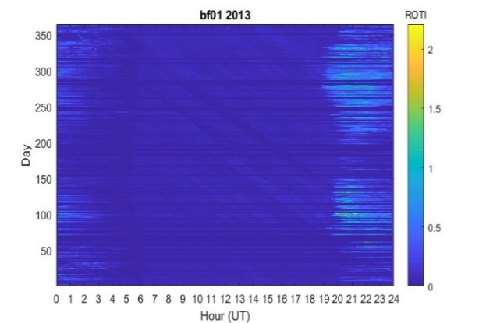 | 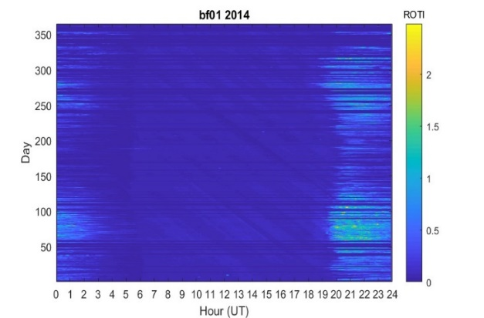
Maximum Phase
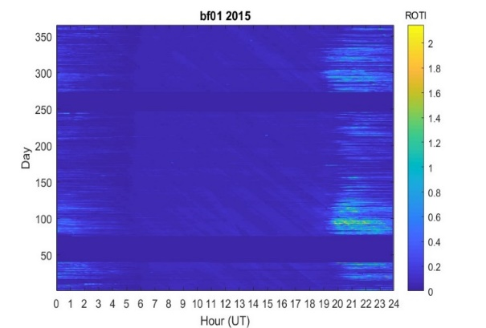 | 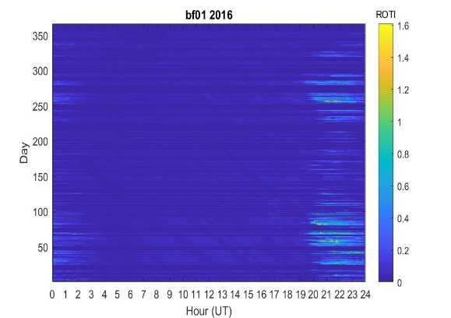
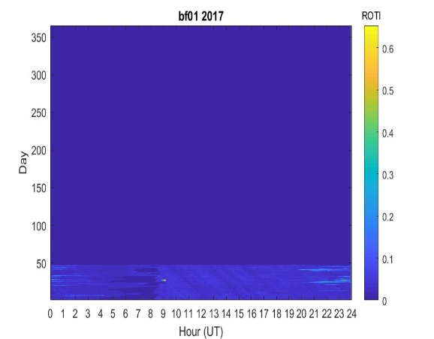 | 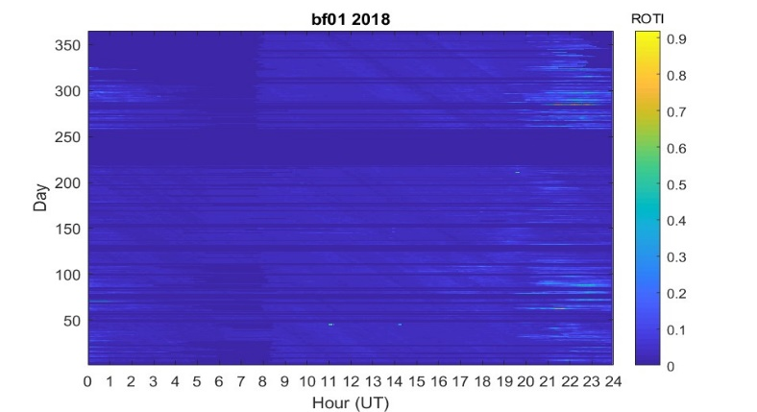
Decreasing Phase

Fig.1. Diurnal variation of ROTI as a function of solar phases at station BF01

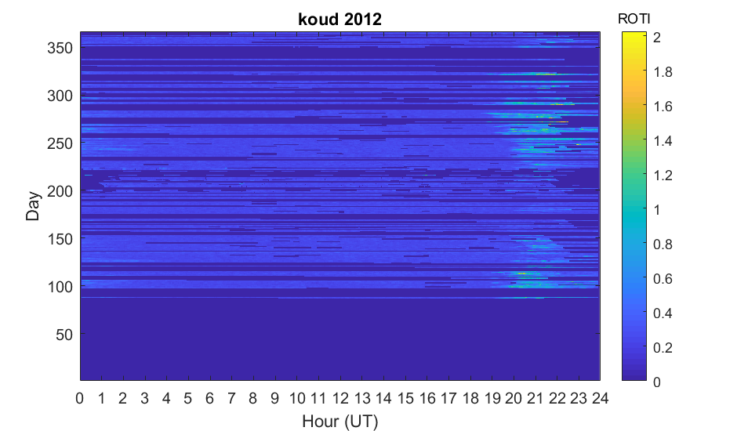
Ascending Phase
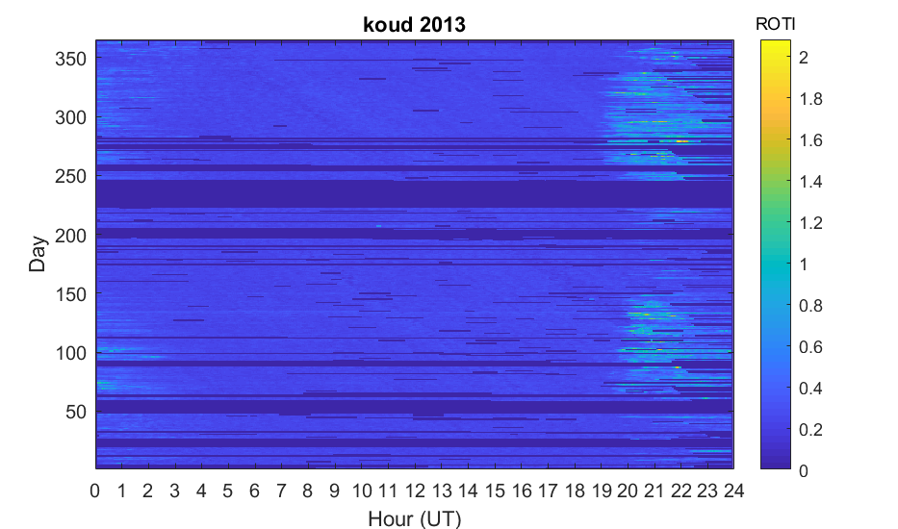 | 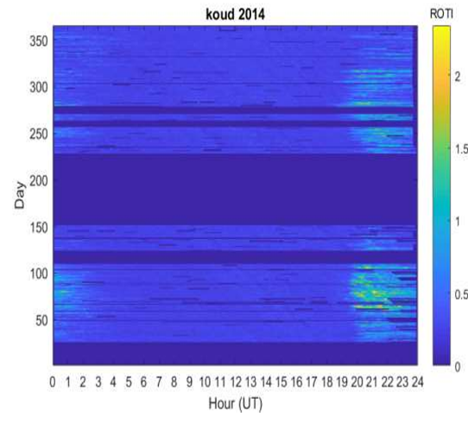
Maximum Phase
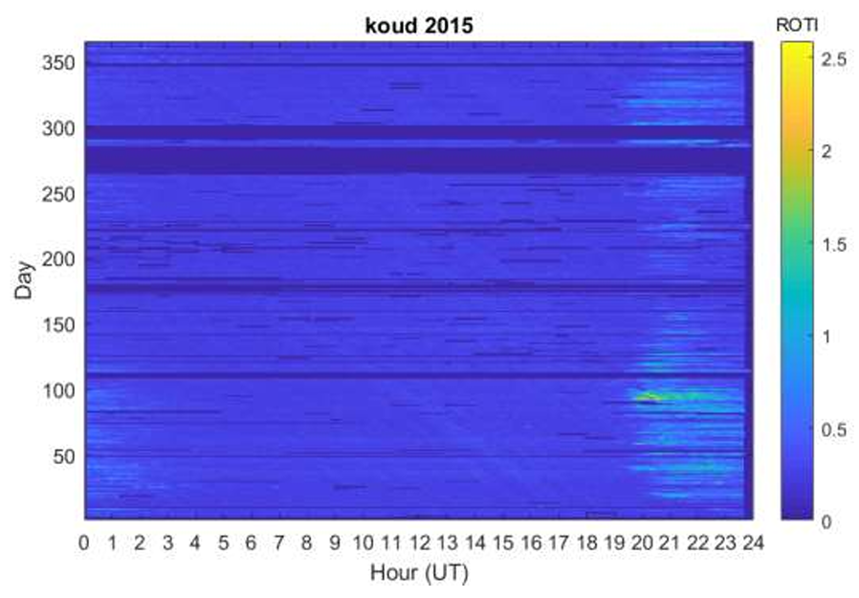
Decreasing Phase

Fig.2. Diurnal variation of ROTI as a function of solar phases at station of Koudougou

October 7, 2013 (Maximum) | 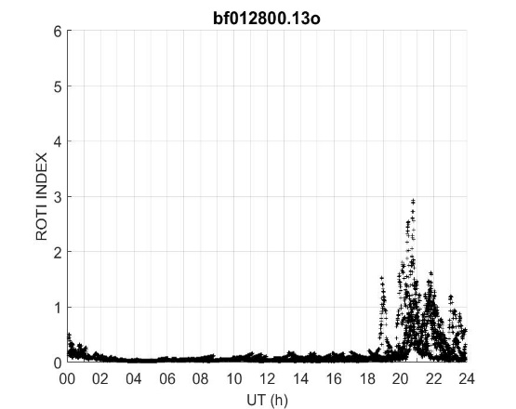 | 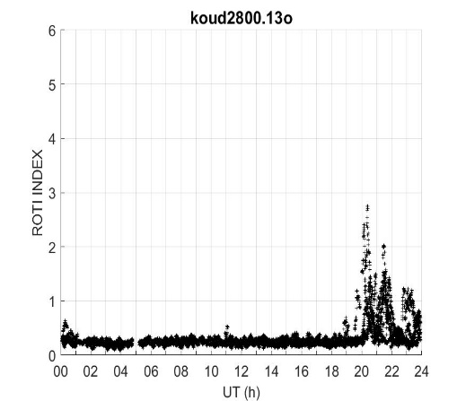
March 26, 2015 (Decreasing) | 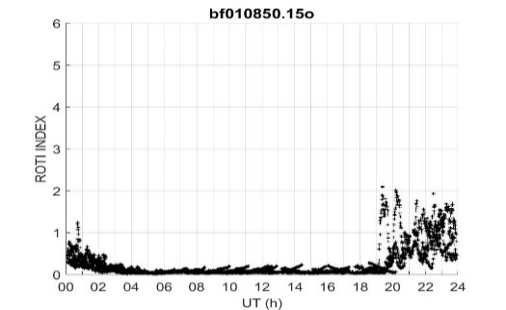 | 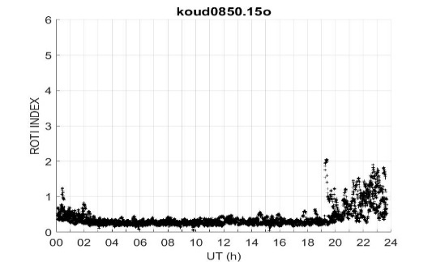

Fig.3. Example of daily variation of ROTI at maximum and descending phases

    - Seasonal variation of ROTI
The monthly variation of ROTI during periods of quiet activity shows a very remarkable seasonal effect. Indeed, Figure 4 shows a phase scintillation between 1900 LT and 2300LT around the months of March and September at station BF01 in Ouagadougou from 2013 to 2016. The ROTI values ​​ are higher in March equinox (between 0.6 and 1.5 tecu/min) than in September (between 0.5 and 0.9 tecu/min). Figure 5 also shows a phase scintillation at the Koudougou station between 1900TL and 2300TL around the equinox months from 2012 to 2015. Except for the year 2014, we note that the ROTI values ​​are higher at the March equinoxes (about 1.0 tecu/min) than in September (about 0.8 tecu/min). Figure 6 also provides an illustration of daily variations in ROTI during the spring and autumn equinoxes. An equinoctial asymmetry is clearly observed. In fact, at both stations, the maximum ROTI values ​​reach approximately 1.5 tecu/min in spring compared to a maximum value of approximately 1.0 tecu/min in autumn.
Zhang et al. (2021) showed that the intensity and frequency of scintillations in spring and autumn are higher and more frequent than those in summer and winter. According to Kahindo Murumba et al. (2017), scintillation exhibits a strong seasonal effect, manifested by intense scintillation values ​​in the equinox months compared to the solstice periods. This is attributable to seasonal variations in ionospheric and solar conditions that influence the formation of irregularities responsible for scintillation. At the equinoxes, the angle of inclination of solar radiation to the equator is maximum, leading to significant ionization of the equatorial ionosphere. This increase in ionization promotes the formation of irregularities in the electron density, responsible for scintillations (Galmiche, 2019).
Phase scintillation at the Koudougou and BF01 stations in Ouagadougou exhibits equinox asymmetry. Maximum ROTI values ​​are recorded in spring compared to autumn. Ackah et al. (2011) show that scintillation occurrence is greater at equinoxes than solstices, with a higher occurrence at the March equinox. The difference in scintillation intensity between the spring and autumn equinoxes could be related to asymmetries in ionospheric dynamics. For Azzouzi et al. (2016), factors such as variations in the Earth's magnetic field and high-altitude neutral winds can influence the distribution and intensity of plasma irregularities, leading to more pronounced scintillations in spring. Abdu et al. (2006) suggested that a cross-equatorial wind could suppress the Rayleigh-Taylor instability and cause equinoctial asymmetry in scintillation occurrence.
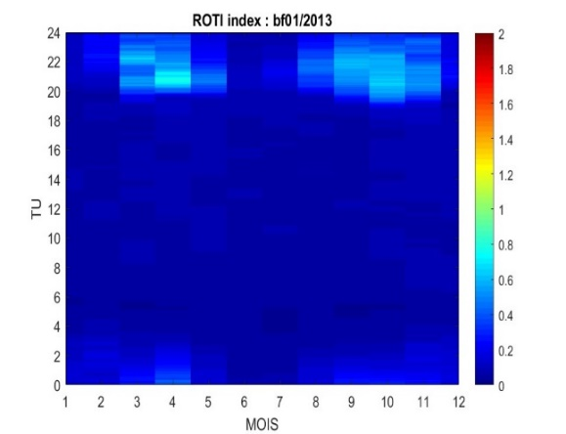 | 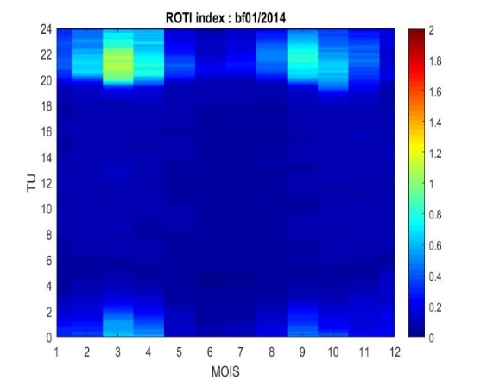
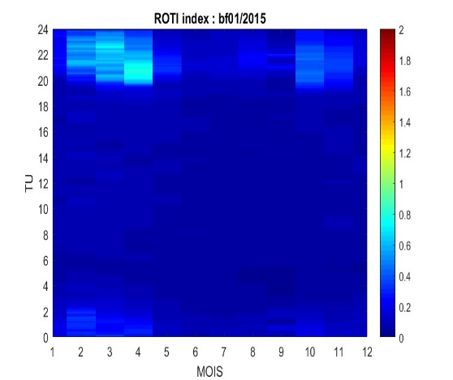 | 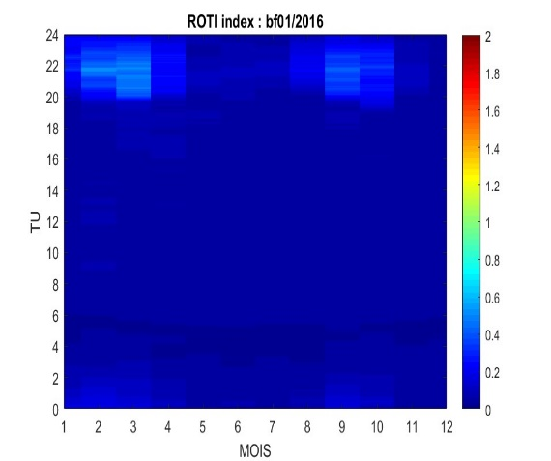
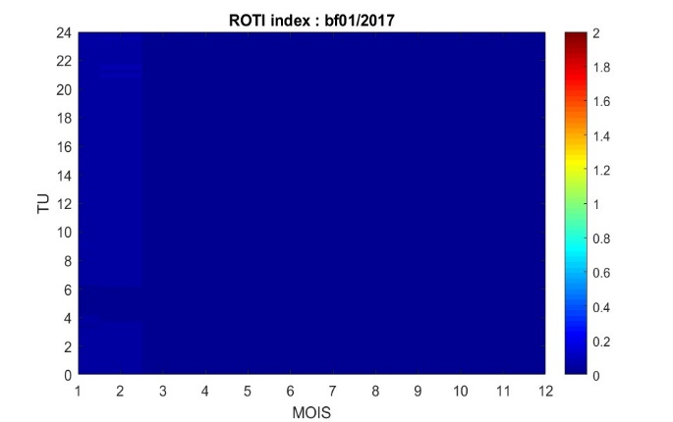 | 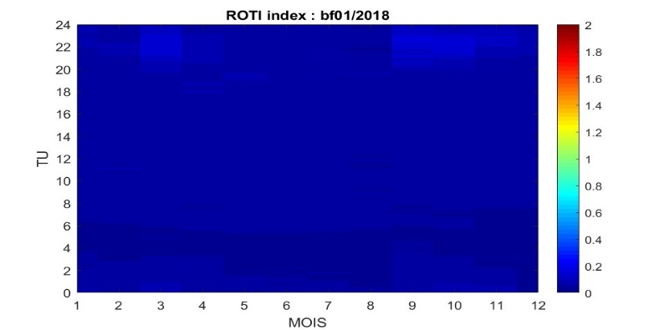

Fig. 4. Monthly variations of the ROTI index at GPS station BF01 from 2013 to 2018

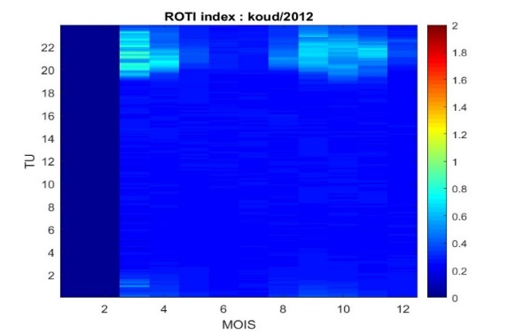 | 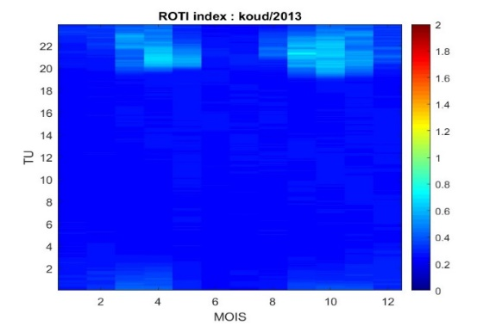
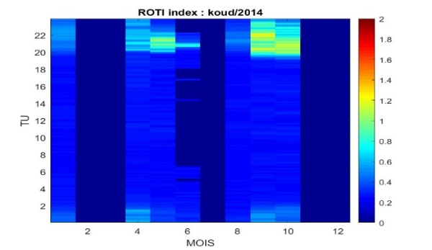 | 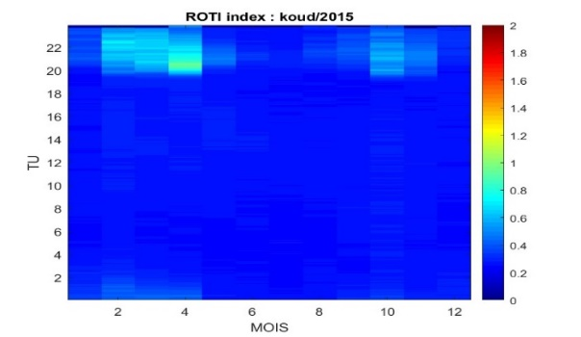

Fig. 5. Monthly variation of the ROTI index at the Koudougou GPS station from 2012 to 2015

Spring equinox (May 13, 2013) | 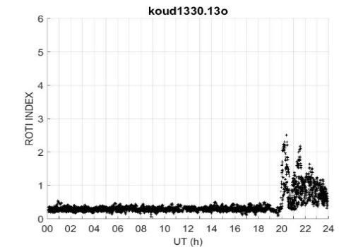 | 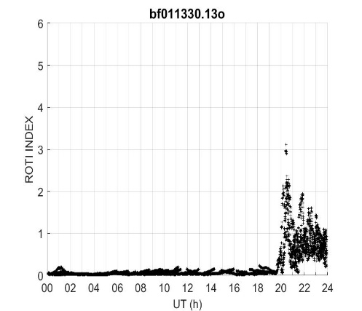
Autumn equinox (October,10,2013) | 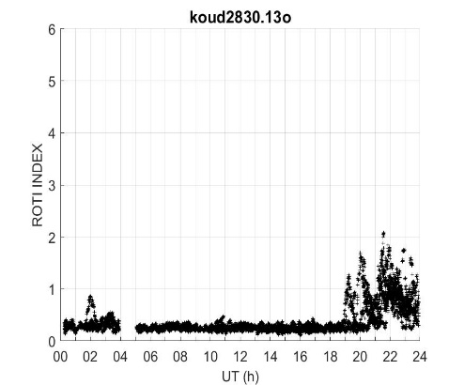 | 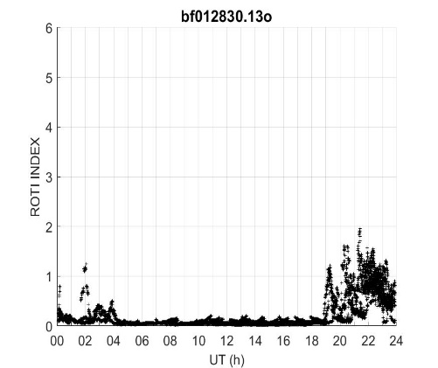

Fig. 6. Example of daily variations in ROTI during periods of quiet activity during the equinoxes

  - Impact of magnetic storms on phase scintillation
Figure 7 shows the variation of ROTI as a function of Dst during some magnetic storms. Except for the storm of March 17, 2013, the lack of data did not allow us to have the variation of ROTI in the two stations during each storm.
- Graph (a) and (b): Storm of 03/17/2013 at BF01 and Koudougou
From 0500 TL to 0600 TL, an increase in Dst was observed, ranging from -7 nT to 15 nT in the morning of 03/17/2013, marking the initial phase of the storm. The main phase then established itself during the day until the night at 2000 TL with a Dst of -132 nT. The recovery phase occurred after this time and continued into 03/18/2013.
The night before the onset of this storm, phase scintillation was recorded between 2100 TL and 2300 TL at the BF01 stations of Ouagadougou and Koudougou, with maximum ROTI values ​​of 0.84 tecu/min and 0.76 tecu/min reached at 2200 TL, respectively. The following night, during the end of the main phase and the beginning of the recovery phase, the absence of scintillation is observed in both stations. Towards the end of the recovery phase, the phenomenon reappears at the Koudougou station with a maximum ROTI of 0.79 tecu/min at 2100TL.
- Graph (a) and (b): Storm of 03/17/2013 at BF01 and Koudougou
From 0500 TL to 0600 TL, an increase in Dst was observed, ranging from -7 nT to 15 nT in the morning of 03/17/2013, marking the initial phase of the storm. The main phase then established itself during the day until the night at 2000 TL with a Dst of -132 nT. The recovery phase occurred after this time and continued into 03/18/2013.
The night before the onset of this storm, phase scintillation was recorded between 2100 TL and 2300 TL at the BF01 stations of Ouagadougou and Koudougou, with maximum ROTI values ​​of 0.84 tecu/min and 0.76 tecu/min reached at 2200 TL, respectively. The following night, during the end of the main phase and the beginning of the recovery phase, the absence of scintillation is observed in both stations. Towards the end of the recovery phase, the phenomenon reappears at the Koudougou station with a maximum ROTI of 0.79 tecu/min at 2100TL
- Graph (c): Storm of March 17, 2015 at Koudougou
Between 0400TL and 0500TL the storm started with its initial phase. It continued with the main phase in the morning until the night at 2200TL where the Dst reached -234 nT. After 2200TL the recovery continued into the following day. The day before the storm, scintillation was recorded between 2000TL and 2200TL with a maximum ROTI of 0.73 tecu/min at 2100TL. The following nights (end of the main phase and that of the recovery phase), the scintillation phenomenon completely disappeared.
- Graph (d): Storm of October 2, 2013 at BF01
The initial phase occurred at night from 0100TL to 0200TL with a Dst varying between -3nT and 26nT. The main phase then settled until the morning at 0700TL with a Dst of -72 nT. The scintillation was recorded the day before from 2000TL (0.65tec/min) to 2100TL (0.58 tecu/min). The phenomenon persisted during the storm recovery phase. Indeed, on 02/10/2013, the phenomenon appeared between 2000TL and 2200TL with a maximum ROTI of 0.7tecu/min at 2000TL. The night of 03/10/2013, it appeared between 1900TL and 2200TL with a maximum ROTI of 0.62 tecu/min at 2200TL.
- Graph (e): Storm of February 27, 2014 at BF01.
The initial phase occurred between 1600TL and 1700TL and the main phase continued until 2300TL with a Dst of -97nT. The recovery phase started from 0000TL. The scintillation is recorded the day before the storm between 2100TL and 2200TL. During the main phase of the storm, the scintillation phenomenon occurred between 1900TL and 2200TL with a maximum ROTI of 0.79tecu/min at 2000TL.
- Graph (f): Storm of June 22, 2015 at BF01
This storm started at 1700 TL with the initial phase. Its main phase occurred from 1900 TL and continued all night until 0400 TL with a Dst of -198 nT. The recovery phase continued into the following day. Phase scintillation did not appear the day before the storm but it is present at the beginning of the main phase at 1900 TL with a ROTI of 0.54 tecu/min.

(a)

Figure 7. Variation of ROTI as a function of Dst during magnetic storms

During the storms of March 17, 2013 and 2015 (graphs a, b and c), the main phases began during the morning and this seems to inhibit the manifestation of the scintillation phenomenon during the night of the storm. On the other hand, in graphs (d), (e) and (f), the main phases of the storms occurred at night and the scintillation was appeared during these phases or during the overlapping phases.
Azzouzi et al. (2016) showed that, generally speaking, during periods of geomagnetic disturbances, there is an inhibition of ionospheric scintillation phenomena. During the main phase, there is an increase in the ring current. According to Aarons (1991), the suppression and enhancement of irregularities during geomagnetic disturbances can be attributed to changes in the ring current. This author put forward three hypotheses regarding the generation or inhibition of irregularities:
- If the maximum Dst excursion occurs during daylight hours and well before sunset, the normal elevation of the F layer is disrupted, and irregularities are inhibited that night;
- Whether the significant excursion occurs between midnight and after midnight, the layer height increases and then decreases, creating irregularities;
- If the large Dst excursion occurs after sunset and before midnight, the elevation of the layer is not disturbed and irregularities form as during an undisturbed night
The study of scintillation during intense thunderstorms at low-latitude stations by Zaourar et al. (2017) showed that the phenomenon can be inhibited or triggered depending on the phase and timing of the storm. Correia et al. (2018) also showed that ionospheric irregularities can be inhibited during geomagnetic storms whose main phases occur during the day.
The disappearance of the scintillation phenomenon during the nights of the storms of March 17, 2013 and March 17, 2015 at the Koudougou and BF01 stations in Ouagadougou could be explained by the fact that the main phases of these storms began in the morning.
The scintillation continued during the nights of the storms of October 2, 2013, February 27, 2014 and June 22, 2014. In fact, the main phases of these storms occurred after nightfall and the significant excursion of the Dst at this phase caused a strengthening of the plasma irregularities favorable to scintillation.

- CONCLUSION
This work is a study of phase scintillation in the West African equatorial region during solar cycle 24 using GNSS data from the GPS stations of Koudougou and BF01 of Ouagadougou in Burkina Faso. During periods of quiet geomagnetic activity, the hourly variation of the ROTI index shows that the ionospheric scintillation phenomenon occurs after nightfall between 1900TL and 2300TL and continues late into the night between 0000TL and 0200TL. The Rayleigh-Taylor instability is the main cause. In addition, intense solar activity at the maximum phase causes greater phase scintillation. The seasonal variation of ROTI in quiet periods shows phase scintillation during the equinox months. There is also an equinoctial asymmetry where spring ROTI values ​​are higher than those of autumn. The seasonal effect of phase scintillation could be explained by significant ionization at the equinoxes caused by the increase in the angle of inclination of solar radiation on the equator (Galmiche, 2019). Equinoctial asymmetry could be explained by variations in the Earth's magnetic field and high-altitude neutral winds that influence the distribution and intensity of plasma at the spring equinoxes (Azzouzi et al., 2016). The study of the impact of some intense thunderstorms shows that phase scintillation is inhibited by the thunderstorm when its main phase occurs during the day. On the other hand, phase scintillation occurs during the thunderstorm when its main phase occurs after nightfall. Depending on the period of the onset of the thunderstorm, the increase in the annular current during the main phase strengthens or inhibits the irregularities of the ionospheric plasma. The study of scintillation in the West African equatorial zone could continue with GNSS data from other receivers by involving other indices such as S4 and $σ_{∅}$ to explore the amplitude perturbations. Improved GNSS system performance depends on studies conducted on ionospheric irregularities.
COMPETING INTERESTS DISCLAIMER:
Authors have declared that they have no known competing financial interests OR non-financial interests OR personal relationships that could have appeared to influence the work reported in this paper.
Disclaimer (Artificial intelligence)
Author(s) hereby declare that NO generative AI technologies such as Large Language Models (ChatGPT, COPILOT, etc.) and text-to-image generators have been used during the writing or editing of this manuscript.

REFERENCES

Aarons, J. (1982). Global morphology of ionospheric scintillations. Proc IEEE 70 (4) : 360-378. https://doi.org/10.1109/PROC.1982.12314

Aarons, J. (1991) The role of ring current in the generation or inhibtion of equatorial F layer irregularities during magnetic storms. Radio Science, Volume 26, Number 4, Pages 1131-1149, July-August .

Aarons, J., Basu, S. (1994). Ionospheric amplitude and phase fluctuations at the GPS frequencies. 7th International Technical Meeting, Satell. Div. of the Inst. For Nav/, Salt Lake city, Utah.

Abdu, M. A., Iyer, K.N., De Medeiros, R.T., Batista, I. S., Sobral, J.H.A. (2006). Thermospheric meridional wind control of equatorial spread F and evening prereversal electric field, Geophysical Research Letters, Vol.33, L07106, doi:10.1029/2005GL024835,
Ackah, J. B., Obrou, O. K., Zaka., Z., Mene, M. N. and Groves, K. (2011). Stady of Ionospheric Equatorial Scintillation and TEC characteistics at Solar minimum using GPS-SCINDA data. Son and Geosphere, 6(1) :27-30.
Akala, A. O., Ejalonibu, A. H., Doherty, P. H., Radicella, S. M., Groves, K., Carrano, C. S. et al. (2017). Characteization of GNSS Amplitude Scintillations over Adis Ababa during 2009-2013. Advance in Space Research 59(8). DOI: 10.1016/j.asr.2017.01.044
Akala, A. O., Amaeshi, L. L. N., Somoye, E. O., Idolor, R. O., Okoro, E., Doherty. P. H., et al. (2015). Climatology of GPS amplitude scintillations over equatorial Africa during the minimum and ascending phases of solar cycle 24. Astrophysic Space Science, vol.357, no.17.
Azzouzi, I., Mogoya-Orué, Y., Coisson, P., Amory-Mazaudier, C., Fleury, R. and Radicella, S. M. (2016). Day-to-day variability of VTEC and ROTI in October 2012 with impact of high-speed solar wind stream on 13 october 2012. Sun and Geosphere, BBC SWS Regional Network, vol.11, no.1, pp.7-22.
Basu, S.; Groves, K. M., Quinn, J. M. and Doherty, P. A. (1999). Comparison of TEC fluctuations and scintillations at Ascension Island. Journal of Atmospheric and Solar –Terrestrial Physics, vol.61, no.16, pp. 1219-1226.

Correia, E., Muella, M., Lucilla, A., Prol, F.S., Camargo P. (2018). GPS Scintillations and Total Electron Content Climatology in the Southern American Sector. In: Dr. Dogan Ugur Sanli. (Org.). Accuracy of GNSS Methods. 1ed. London: IntechOpen, 1:47-70.
Galmiche, A. (2019). Modélisation de la scintillation ionosphérique en zone équatoriale : application à l’inversion de signaux GNSS pour la caractérisation de la turbulence. Thèse de doctorat à l’université de Toulouse,.
Gonzalez, W., Joselyn, J.A., Kamide, Y. et al. (1994). What is a geomagnetic storm ? Journal of geophysical Research: Space Physics, vol. 99, no. A4, pp. 5771-5792.
Kahindo-Murumba, B., Kazadi Mukenga Bantu, A., Fleury, R., Kakule Kaniki M., Amory-Mazaudier, C. & Groves, K. (2017). Contribution à l’étude de la scintillation ionosphérique équatoriale sur la crête sud de l’Afrique. Journal des sciences, vol.17, no.2, pp.27-47.
Ouattara, F., Amory-Mazaudier, C. (2009). Solar-geomagnetic activity and Aa indices toward a standard classification. J. Atmospheric Sol.-Terr. Phys., 71 (17-18): 1736-1748.
Ouattara, F., Amory-Mazaudier, C. (2012). Statistical study of the equatorial F2 layer critical frequency at Ouagadougou during solar cycles 20, 21 and 22, using Legrand and Simon’s classification of geomagnetic activity. Journal of Space Weather and Space climate 2, A19.
Ouédraogo, P., Karim, G., Abidina, D., Rolland, F., Frédéric, O. (2024). Extractio of ionospheric vertical total electron content (VTEC) using global navigation satellite system-continuously operating reference station (GNSS-CORS) data from station BF01 in Ouagadougou. Int. J. Phys. Sci.; 19(1):26-34. https://doi.org/10.5897/IJPS2023.5065 .
Pahima, T., Gnabahou, D A., Sandwidi, S. A., Ouattara, O. (2023). Koudougou Station TEC’s variability seasonal anomalies Analysis during fluctuating events over solar cycle 24. Applied Physics Research, vol.15, No.1. https://doi.org/10.5539/apr.v15n1p50
Pi, X., Mannucci, A. J., Lindqwister, U.J and Ho, C. M. (1997). Monitoring of global ionospheric irregularities using the Wordewide GPS network. Geophysical Research Letter, vol.24, no.18, pp.2283-2286.
Zaourar, N., Amory-Mazaudier, C., Fleury, R. (2017). Hemispheric asymmetries in the ionosphere response observed during the high-speed solar wind streams of the 24-28 August 2010. Advances in Spaces Research 59, 2229-2247.
Zhang, S., Li H., Li, J. and Meng, L. (2021). Characteristics of Ionospheric Scintillation in Chengdu, China. Scholl of electronic Science Engineering, University of Electronic Science and technology of China. National Astronomical Observatories, Chinese Academy of science. Annales Geophysical.

