Development of groundnut (Arachis hypogaea L.) breeding populations for yield and Late leaf spot resistance under Togo Conditions

Original Research Article

ABSTRACT

Aims: The development and release of high-yielding, and late leaf spot (LLS)-resistant groundnut varieties have significant market potential in Togo and West Africa. This study aimed to identify suitable breeding populations for developing farmer-preferred, LLS-resistant varieties.
Study design: F2 progenies from a North Carolina II factorial mating design were evaluated across three agroecological environments in Togo using an alpha lattice design.
Place and Duration of Study: F1s were produced at ICRISAT-WCA in Bamako (August–September 2019), and 16 F2 families were assessed across four agroecological zones in Togo (April–November 2021).
Methodology: Eight genotypes were crossed in a factorial mating design. Genetic analysis was used to assess LLS resistance and yield-related traits of the F2s progenies. General combining ability (GCA), specific combining ability (SCA), and heritability (h²) were estimated, and correlations between traits and marker-based genetic distances were evaluated.
Results: LLS resistance was mainly governed by additive gene effects (h² = 0.86–0.89), while most yield traits also showed additive variance (h² = 0.73–0.86), except pod weight. Significant GCA correlations were observed between LLS, hundred-seed weight (r = 0.90; P = 0.008), and shelling percentage (r = 0.83; P = 0.04), indicating that a selection index approach would be effective. No correlation was found between SNP-based genetic distance and SCA. Populations derived from lines 43AH and ICG7878 exhibited the highest GCA and are promising for LLS-resistant variety development, while populations from lines 12CS22 and 12CS36 are recommended for high-yielding variety advancement.
Conclusion: Additive gene effects predominate for LLS resistance and most yield traits, suggesting strong potential for genetic improvement. Specific F2 populations have been identified as promising candidates for developing farmer-preferred, high-yielding, LLS-resistant groundnut varieties in Togo.

Keywords: Groundnut varieties – Genetic - High yield – Late Leaf Spot resistance – Breeding

1. INTRODUCTION

Groundnut (Arachis hypogaea L.) is a key legume crop in Togo, playing an important role in both agricultural economy and local diets (DSID, 2022). The rising demand for groundnut seeds and oil has prompted the establishment of breeding programs focused on improving desirable traits (Banla et al., 2018). Despite the availability of genetic engineering tools that can enhance agronomic traits (Khedikar et al., 2010; Krishna et al., 2015; Zongo et al., 2017), breeding programs in resource-limited settings, such as Togo, continue to rely on conventional breeding methods to improve crop characteristics (Salimath et al., 2007; Chukwu et al., 2019; Pallavi et al., 2023).
Selecting suitable parental lines for breeding remains a challenge in conventional breeding, and choosing poor combinations can waste valuable time and resources (Bertan et al., 2007; Syngenta, 2020). However, recent advancements in morphological (Cobb et al., 2013; Lobos et al., 2017) and molecular data (Khaki et al., 2020; Kassie et al., 2023), as well as machine learning techniques (Chung & Liao, 2020; Michel et al., 2022), have introduced more sophisticated tools for predicting offspring genetic potential. Despite these advancements, the traditional method of crossing genotypes to evaluate their potential remains effective in groundnut breeding (Wang et al., 2021; Jannat et al., 2022), relying on the performance of offspring to assess the potential of parental lines (Balzarini, 2000; Bertan et al., 2007; Piepho et al., 2008).
Assessing a line’s combining ability through specific mating designs not only helps in selecting the best parental combinations but also provides insights into gene action (Sprague & Tatum, 1942; Hallauer & Carena, 2010). The full factorial design, also known as the North Carolina II design, is one of the most reliable methods for identifying optimal parental combinations and estimating additive and non-additive variances for phenotypic traits (Desmae et al., 2019; Cobb et al., 2019).
Late Leaf Spot (LLS) caused by Nothopassalora personata (formerly Phaeoisariopis personata) is a major concern in groundnut production areas in Togo (Banla et al., 2018). LLS can reduce haulm quality and lead to up to 50-70% pod yield loss (Pande et al., 2003; Singh et al., 2011; Padmashree et al., 2023). Groundnut haulms are valuable as livestock fodder in Togo and many other West African countries, so preventing LLS-induced damage to leaves can significantly improve farmers' income. Resistant lines from cultivated Arachis species (Chu et al., 2019; Oteng-Frimpong et al., 2023; Sonaniya et al., 2025) are available and can be used to introgress LLS resistance into popular local varieties.
In addition to LLS resistance, farmers in Togo also prefer high-yielding groundnut varieties with large pods and seeds (Banla et al., 2018). A recent study on Togo’s groundnut germplasm revealed substantial genetic diversity, highlighting the potential for improving traits like yield (Banla et al., 2020). However, it also showed that LLS resistance often comes with unwanted agronomic traits, such as poor pod characteristics and late maturity. These findings underscore the need to develop groundnut lines that combine both LLS resistance and the yield traits favored by farmers. This study aims to identify the most promising populations from crosses between eight groundnut lines to combine LLS resistance with desired yield-related traits, contributing to the broader goal of enhancing groundnut cultivation in Togo.

2. material and methods
2.1 Plant materials
Eight genotypes were selected from three clusters identified in a diversity study conducted with groundnut germplasm in Togo (Banla et al., 2020). Local farmer varieties (38AH, 09AH, 68AH, and 43AH) were used as male parents, while two genotypes (12CS_22 and 12CS_36) from Senegal and two genotypes (ICG7878 and ICGV02271) from ICRISAT were employed as female parents in the population development. These selections were made based on their contrasting characteristics for LLS incidence and pod characteristics (Table 1). The genetic distance between parents, as determined by SNP data, confirmed the phenotypic diversity among the parents (Table 2).
2.2 Population development
The crosses were performed following a factorial mating design (North Carolina II design). F1 hybrids were produced at ICRISAT-WCA in Bamako during the rainy season from August to September 2018. Male parents were planted in a single row with 40 plants per male parent two weeks prior to female parents. Female parents were planted in four rows, each 4 meters long, with 30 cm spacing between hills and 1 meter between rows. Hand emasculation was carried out in the afternoon, followed by pollination in the early morning of the next day by skilled workers at the International Crops Research Institute for the Semi-Arid Tropics (ICRISAT, Bamako) under the researcher's supervision, with precautions taken to prevent contamination.
Verification of F1 hybridity was based on visual traits such as plant height, leaf color and shape, and pod shape and color in an unreplicated trial that included F1 seeds and both parents during the off-season. F2 seeds were subsequently harvested from the selected hybrids, and the F2 populations were used for multi-location trials.
Table 1 Parent genotypes characteristics
Genotype | Status | Pedigree | Cluster group | LLS resistance | Pod and seed size
38AH | Male | Accession (Togo) | II | Low | Small
09AH | Male | Accession (Togo) | II | Low | Small
43AH | Male | Accession (Togo) | II | Low | Small
68AH | Male | Accession (Togo) | I | Moderate | Large
12CS_22 | Female | Fleur11 x AiAB | I | Moderate | Medium
12CS_36 | Female | Fleur11 x AiAB | I | Moderate | Medium
ICG 7878 | Female | Accession (North Carolina) | III | High | Medium
ICGV 02271 | Female | TAG 24 x ICGV 86031 | III | High | Medium

Table 2. Euclidian distance between parent genotypes based on SNP data
 | 09HA | 38AH | 43AH | 68AH | 12CS_22 | 12CS_36 | ICG 7878 | ICGV 02271
09AH | 0.00
38AH | 9.63 | 0.00
43AH | 9.64 | 2.59 | 0.00
68AH | 11.59 | 12.01 | 12 | 0.00
12CS_22 | 11.65 | 12.12 | 12.07 | 5.89 | 0.00
12CS_36 | 11.53 | 11.82 | 11.89 | 5.33 | 4.6 | 0.00
ICG 7878 | 15.54 | 15.54 | 15.47 | 14.57 | 14.67 | 14.57 | 0.00
ICGV 02271 | 13.54 | 14.63 | 14.23 | 13.82 | 14.53 | 14.22 | 10.21 | 0.00

2.3 Test environments and experimental design
An alpha-lattice design with four blocks per replication and three replications was used to evaluate sixteen F2 cross-combination families along with their respective parental lines in Togo. All families were assessed in major agro-ecological areas, including Tantigou (E 0°12’3.6’’; N 10°52’23.88’’), Kara (E 1°11’34.8’’; N 9°32’45.6’’), Sotouboua (E 0° 11’37.2’’; N 8°33’54’’), and Ativeme (E 1°7’33.6’’; N 6°19’19.2’’) in 2020. These agro-ecological zones are representative of the environmental variations in Togo.
Each family was planted in 4 rows, each row measuring 4 meters in length, with a spacing of 50 cm between consecutive rows and 20 cm between plants within the same row. Prior to the podding stage, weeding was performed as needed through hoeing. From the podding stage to harvest, the field was kept weed-free through manual weeding.
2.4 Data collection
Data were collected for late leaf spot disease (LLS) using a nine-point scale (Subrahmanyam et al., 1995) to score 10 randomly selected individual plants in the two central rows. Regarding the yield parameters, 40 plants were assessed for pod weight per plant and the number of pods per plant. Hundred-pod weight and hundred-seed weight were recorded on a per-plot basis. Similarly, thirty pods and seeds were randomly selected from the plot harvest for recording pod width, pod length, seed width, and seed length.
However, due to the severe drought in Ativémé, data from this site were deemed unreliable and consequently removed from the statistical analysis.
2.5 Data analysis
2.5.1 Variance component estimates
A Restricted Maximum Likelihood (REML) model (Neff & Pitcher, 2005; Bates et al., 2015) was employed to partition phenotypic variances into additive, non-additive, and maternal effects using the 'fullfact' R package as follows:
$$Y_{ijklmn}=μ+B_{i}+L_{j}+M_{k}+F_{l}+I_{m}+e_{ijklmn}$$
were, Y_{ijklmn} represents the phenotypic response, μ is the mean value, Bi is the block effect, L_{j} is the location effect, M_{k} is the kth male effect, F_{l} is the l^{th} female effect, I_{m} is the m^{th} interaction effect between males and females, and eijklmn is the random residual. Both the random and fixed effects of all factors were estimated.
For normally distributed traits, the significance of block, location, male, female, and the interaction were estimated using the likelihood ratio test with the 'observLmer3' function in the 'fullfact' R package (Houde & Pitcher, 2016). Additive variance (V_{A}), non-additive variance (V_{NA}), and maternal variance (V_{M}) were calculated as follows: V_{A} = 4Vm; V_{NA} = 4VI; V_{M} = Vf - Vm; where V_{m} represents male variance, V_{f} is the female variance and V_{I} the interaction between male and female variance (Lynch & Walsh, 1998). Narrow sense heritability was estimated and value below 0.4 was considered as low heritability, score of 0.4 to 0.6 as moderate heritability and greater than 0.6 as high heritability.
2.5.2 Combining ability estimates
GCA and SCA were estimated using the "lme4" package in R software version 3.3.1 with the following model:
$$X_{ijklmn}=μ+g_{i}+g_{j}+s_{ij}+(\frac{1}{b})Σ_{k}e_{ijklmn}$$
where $μ$ = the population mean; $g_{i}$ = the general combining ability effect of the ith parent;$g_{i}$ = the general combining ability effect of the jth parent; $s_{ij}=$the specific combining ability effect of the cross between i^{th} and j^{th} parents; $e_{ijklmn}$= the environmental effect associated with ijk^{th} observation; b = number of blocks/replication. The figures were generated using the ggplot2 package (Wickham, 2016). An evaluation of the correlation between genetic distance and SCA was carried out using the Euclidean genetic distance between the parents (Hedrick, 2005).

3. results and discussion
3.1. Results
3.1.1 Variance components in LLS and yield-related traits
The analysis of variance showed that there was a statistically significant difference between female lines for pod weight per plant [F(3, 104) = 4.41, P=0.006], shelling percentage [F(3, 104) = 7.47, P<0.001], pod width [F(3, 104) = 29.07, P<0.001], pod length [F(3, 104) = 9.22, P<0.001], seed length [F(3, 104) = 11.16, P<0.001], seed width [F(3, 104) =3.57, P=0.017], hundred pod weight [F(3, 104) = 8.61, P<0.001], hundred seed weight [F(3, 104) = 15.96, P<0.001] and for LLS [F(3, 104) = 70.47, P<0.001]. Among the male lines, statistically significant differences were found between them only for pod weight per plant [F(3, 104) = 4.03, P=0.010] and shelling percentage [F(3, 104) = 3.99, P=0.011].
Significant interactions between the environment and variance components for LLS (Table 3) and most yield-related traits (Table 4) were observed. Additive gene effects played the major role over the locations. Maternal effects were slightly higher in Sotouboua and Kara than in Dapaong. Across locations, additive genetics explained the largest part of the phenotypic variance observed (63.48%) for LLS disease incidence, while non-additive variance was very low (0.15 %) with high heritability estimated in each location (0.76-0.79).
Table 3. Variance component for LLS by sites
Sites |  |  | Variance components (%)
Sites | V_{m} | V_{f} |  | V_{I} | V_{A} | V_{D} | Vm | V_{E} | h²
Dapaong | 1.01 | 24.89 |  | 1.61 | 51.80 | 6.43 | 23.88 | 1.32 | 0.76
Kara | 0.00 | 26.83 |  | 0.00 | 53.53 | 0.00 | 26.83 | 6.25 | 0.79
Sotouboua | 0.00 | 26.89 |  | 1.01 | 52.50 | 4.05 | 26.89 | 2.42 | 0.79
Over location | 0.04 | 19.73 |  | 0.04 | 63.48 | 0.15 | 19.69 | 0.67 | 0.88
V_{I}, V_{m} and V_{f} represent the phenotypic variance components (%) of male effect, female effects, and male x female interaction, respectively. V_{A}, V_{D} and V_{M} represent the variance components for additive genetic, dominance genetic and maternal genetic effect, respectively.
As for late leaf spot (LLS), additive genetic variance appeared to dominate over other variance components for yield-related traits (Table 4). The highest additive variance was observed for pod length and seed length, while the lowest was exhibited by hundred-seed weight and seed width. Heritability was high for pod length (0.77), pod width (0.73), seed length (0.86), hundred-pod weight (0.78), hundred-seed weight (0.84), and shelling percentage (0.74) and moderate for the number of pods per plant (0.55) and pod weight per plant (0.55).
Overall, dominance variance was observed in the number of pods per plant (Pods/plant) and pod weight per plant (Table 4). Maternal effects were not negligible for pod length (26.34%), pod width (36.44%), seed length (24.89%), hundred-seed weight (28.09%), and hundred-pod weight (28.09%).
Table 4. Variance components for yield and yield-related traits across sites
 | Variance components (%)
Traits | V_{m} | V_{f} | V_{I} | V_{A} | V_{D} | Vm | V_{E} | h²
Pods / plant | 0 | 3.27 | 6.11 | 55.12 | 14.97 | 2.07 | 29.91 | 0.55
Pod length | 0.64 | 26.98 | 0 | 84.27 | 2.43E-14 | 26.34 | 22.22 | 0.77
Pod width | 0.017 | 36.50 | 0 | 73.03 | 0 | 36.44 | 26.97 | 0.73
Seed length | 1.29 | 26.18 | 0 | 86.53 | 0 | 24.89 | 13.46 | 0.86
Seed width | 1.49 | 6.81 | 0 | 16.60 | 0 | 5.33 | 83.39 | 0.16
100 Pod weight | 0 | 12.74 | 0 | 31.92 | 0 | 12.74 | 8.58 | 0.78
100 seed Weight | 0 | 28.09 | 6.1E-15 | 21.07 | 2.4E-14 | 28.09 | 15.72 | 0.84
Pod weight/plant | 5.08 | 7.15 | 3.74 | 55.12 | 14.97 | 2.06 | 29.90 | 0.55
Shelling % | 6.13 | 17.37 | 0 | 74.02 | 0 | 11.23 | 25.98 | 0.74
Vm, Vf, and V_{I} represent the phenotypic variance components (%) explained by male effects, female effects, and male x female interaction, respectively. VA, VD, VM and VE represent the variance components for additive genetic, dominance, maternal effects, and environmental respectively.
3.1.2 GCA for LLS and yield-related traits
Estimates of GCA effects across environments for the tested genotypes are presented in Figures 1 and 2. As suggested by Bookmyer et al. (2009) and Mukankusi et al. (2011), based on the LLS scale - where lower disease incidence corresponds to lower scores - negative combining ability effects are desirable for disease resistance. The results revealed that genotype and ICG7878 among the female lines (Figure 1a) and 43AH among the male lines (Figure 2a) exhibited higher GCA effects for LLS severity. Although the line 68AH showed a negative but low GCA for LLS incidence, all the other tested lines exhibited positive GCA effects for disease severity.
Regarding yield-related traits among the female parents, line 12CS36 exhibited the highest GCA for the number of pods per plant, pod length, seed length, and shelling percentage, while line 12CS16 showed the highest GCA for pod weight per plant and ranked second for the number of pods per plant, seed length, and shelling percentage (Figure 1). Line ICGV02271 recorded the highest GCA for seed length, hundred-pod weight, and hundred-seed weight (Figures 1f-h).
Despite exhibiting the highest GCA for pod width (Figure 1b), line ICG7878 showed negative GCA effects for most yield-related traits, particularly the number of pods per plant, hundred-pod weight, hundred-seed weight, pod weight per plant, and shelling percentage (Figure 1g-j).

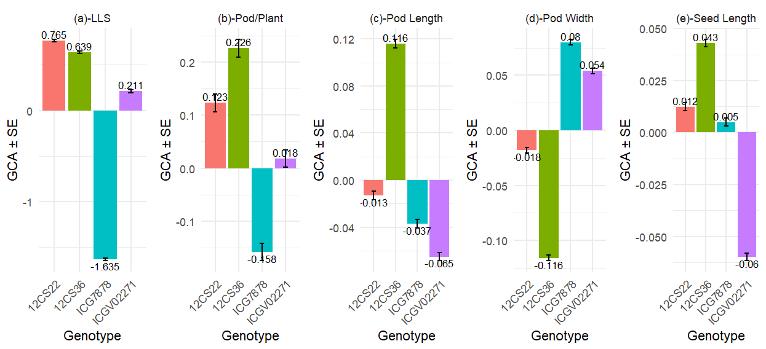
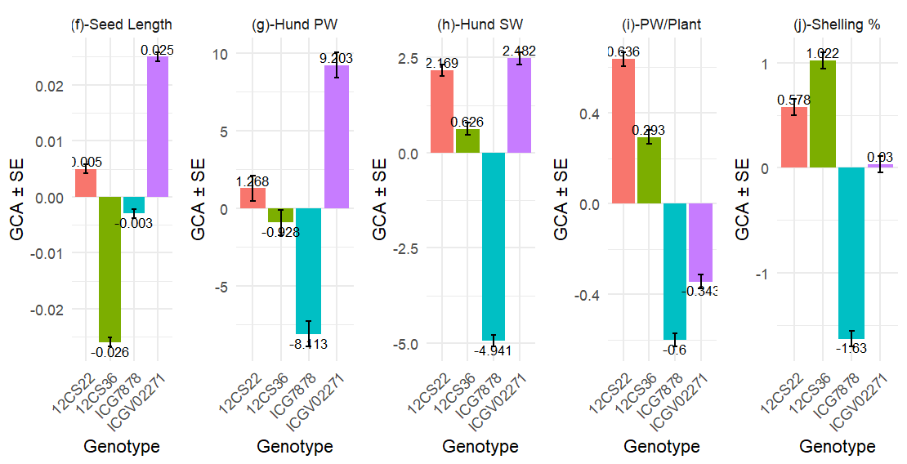
Figure 1. General combining ability for LLS and yield-related traits of the female genotypes used as parents
LLS= Late leaf spot; Pod/Plant= Number of pods per plant, Hund PW = hundred pod weight, Hund SW = hundred seed weight, PW/Plant L= pod weight per plant, Shelling%= Shelling percentage
Among the male parents, line 43AH exhibited the highest GCA for pod size (Figures 2b and 2c), seed width (Figure 2e), hundred-pod weight (Figure 2g), and shelling percentage (Figure 2d). Line 09AH also showed the highest GCA for seed length, while the other three male parents exhibited negative GCA values for this trait; it ranked second for hundred-seed weight, behind 38AH. In addition, 68AH was the best combiner for the number of pods per plant and pod weight per plant, and ranked second for pod width and hundred-pod weight (Figures 2c, 2f, 2g, and 2i). Line 43AH appeared to combine both good GCA effects for LLS resistance and favorable values for several yield-related traits.
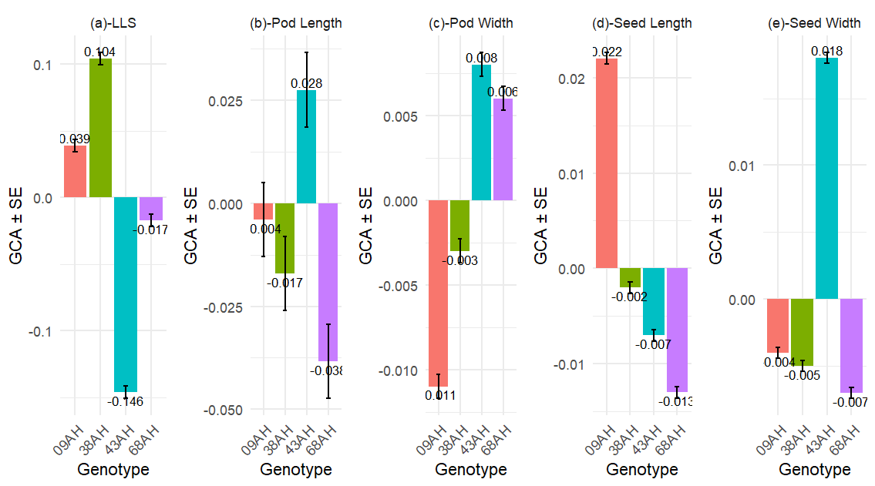

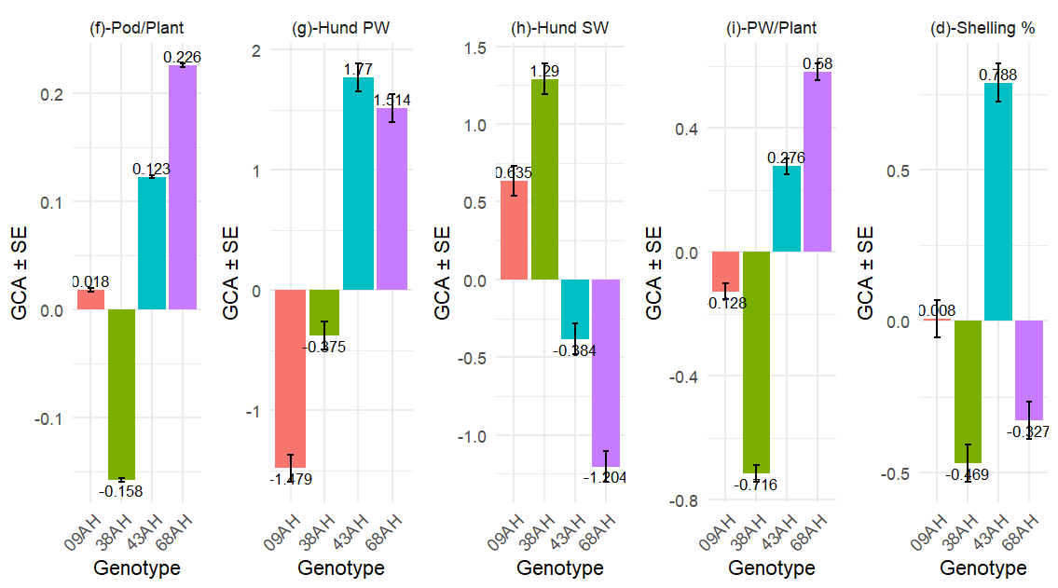

Figure2. General combining ability for LLS and yield-related traits of the male lines used as parents
LLS= Late leaf spot; Pod/Plant= Number of pods per plant, Hund PW = hundred pod weight, Hund SW = hundred seed weight, PW/Plant L= pod weight per plant, Shelling%= Shelling percentage
3.1.3 SCA for LLS and yield-related traits
SCA estimation revealed a significant environmental effect in a multi-environment analysis for all assessed traits. The environmental effect appeared as slight changes in SCA rankings across different environments. Both positive and negative SCAs were observed for yield-related traits and LLS severity across the three environments (Figure 3a). Eight combinations exhibited negative SCA for LLS, with the lowest values found in 12CS22×38AH, ICG 7878×68AH, and ICGV 02271×43AH, representing moderate × susceptible, resistant × moderate, and resistant × susceptible interactions, respectively.
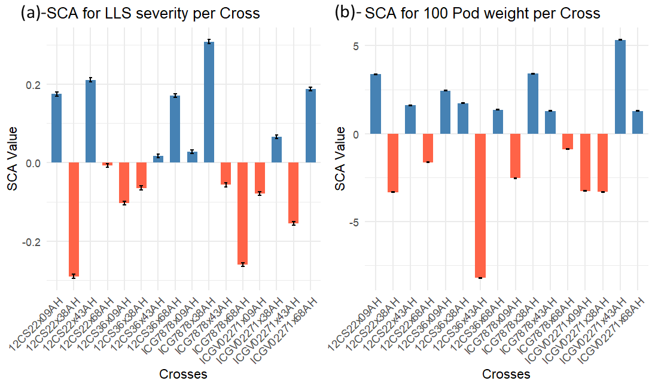
Figure 3. Specific combining ability of cross combination for LLS and hundred Pod weight.

For pod-related parameters, different cross combinations appeared as the best specific combiners (Figure 4). The combinations 12CS36×68AH and 12CS32×43AH were the best for the number of pods per plant and pod weight per plant, respectively (Figures 4a and 4b). The combinations ICGV7878×38AH, 12CS22×68AH, and ICGV02271×38AH showed the highest SCA values for pod length (Figure 4c), while 12CS36×68AH and 12CS22×09AH exhibited the highest SCA effects for pod width (Figure 4d). For hundred-pod weight, ICGV02271×43AH and ICGV7878×68AH recorded the highest SCA values (Figure 3b).
Regarding shelling percentage and hundred-seed weight, the highest SCA values were obtained for the combinations ICG7878×43AH, 12CS22×68AH, 12CS22×09AH, and ICGV02271×38AH (Figure 5b). For seed size, the combinations ICGV02271×09AH, ICGV02271×38AH, and ICG7878×09AH exhibited the highest SCA values for seed length, whereas ICGV02271×43AH, 12CS36×68AH, and ICGV7878×38AH showed the highest SCA values for seed width (Figure 5d).
.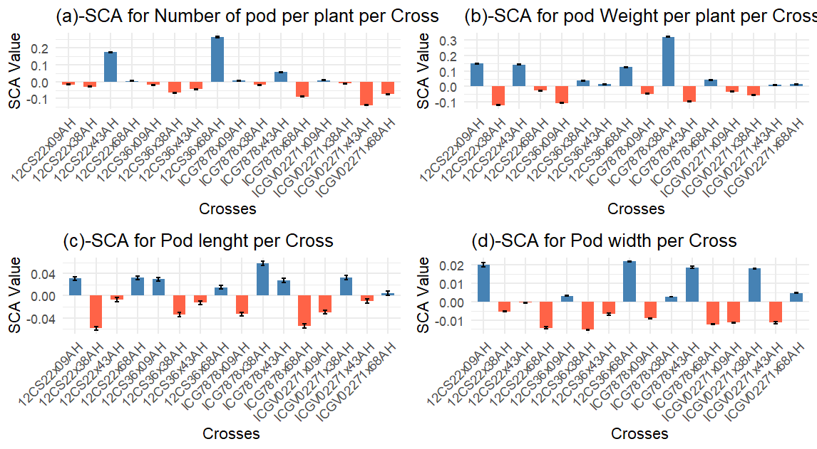
Figure 4. Specific combining ability of cross combination for pod traits
All of these highest SCA combinations involved pairs of high GCA×high GCA, high GCA×low GCA, and low GCA×low GCA for the different traits. There was no statistically significant difference in specific combining ability for pod length, pod width, seed length, and seed width between the cross combinations.
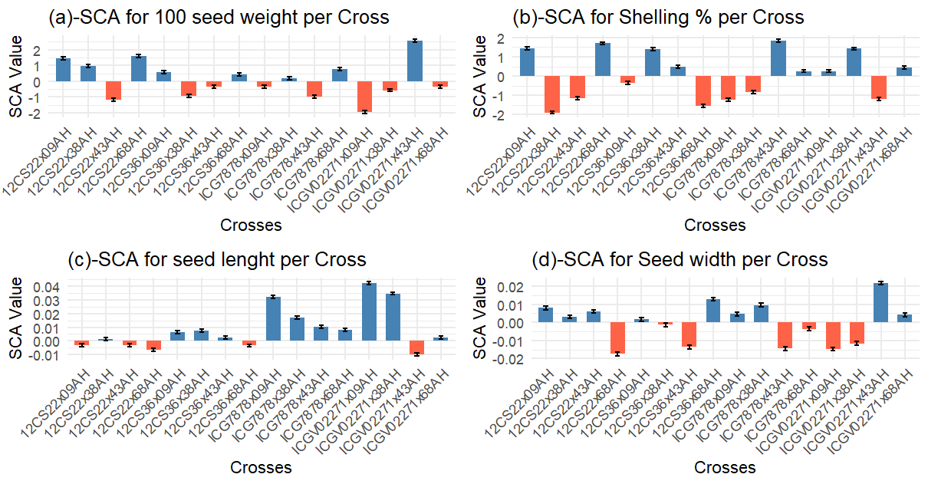
Figure 5. Specific combining ability of cross combination for yield and seed related traits
3.1.4 GCA and Phenotypic Traits: Correlation Analysis
The phenotypic trait correlation analysis revealed low, moderate, and high correlations (Table 5). LLS showed a negative correlation with pod width (r=-0.48; P<0.001) and a positive but low correlation with hundred-pod weight (r=0.21; P=0.05) and hundred-seed weight (r=0.28; P<0.001). A strong positive correlation was observed between the number of pods per plant and hundred-pod weight (0.45; P<0.001) as well as pod weight per plant (r=0.67; P<0.001). Other moderate to strong positive correlations were found between: Hundred-pod weight and hundred-seed weight (r=0.57; P<0.001), Hundred-pod weight and pod weight per plant (r=0.47; P<0.001), Pod weight per plant and shelling percentage (r=0.43; P<0.001) (Table 5).
Regarding GCA correlations, high positive correlations were observed for: Pod length and seed length (r=0.74; P=0.02), number of pods per plant and seed length (r=0.76; P=0.05), number of pods per plant and pod weight per plant (r=0.72; P=0.04), LLS and hundred-seed weight (r=0.90; P=0.008), LLS and shelling percentage (r=0.83; P=0.04). Conversely, high negative GCA correlations were found between: Pod length and pod width (r=−0.88; P=0.007), Pod width and shelling percentage (r=−0.73; P=0.05), Seed length and seed width (r=−0.81; P=0.02)
A comparison of phenotypic trait correlations and GCA correlations showed that the number of pods per plant was positively and strongly correlated with pod weight per plant, hundred-seed weight, and hundred-pod weight in both cases. However, pod weight per plant showed a moderate correlation with hundred-pod weight and shelling percentage in phenotypic traits but had no significant GCA correlation. Additionally, LLS GCA was positively correlated with hundred-seed weight and shelling percentage, despite the weak or negative correlations observed for these traits at the phenotypic level (Table 5).
Table 5. GCA and phenotypic traits’ correlation
 | LLS | PPP | PL | PW | SL | SW | HPW | HSW | PWP | SH
LLS |  | 0.003 | 0.02 | -0.48*** | -0.12 | -0.10 | 0.21* | 0.28*** | 0.04 | -0.07
PPP | 0.23 |  | 0.36*** | 0.10 | 0.02 | 0.23** | 0.45*** | 0.31*** | 0.67*** | 0.21*
PL | 0.38 | 0.49 |  | 0.17* | 0.37*** | 0.17* | 0.30*** | 0.38*** | 0.33*** | 0.37***
PW | -0.71* | -0.57 | -0.88** |  | 0.01 | 0.33*** | 0.14 | 0.04 | 0.11 | 0.18*
SL | 0.12 | 0.76* | 0.74* | -0.69 |  | 0.11 | -0.16 | 0.10 | 0.14 | 0.33*
SW | -0.07 | -0.55 | -0.63 | 0.66 | -0.81* |  | 0.40*** | 0.31*** | 0.27*** | 0.17*
HPW | 0.62 | -0.45 | -0.23 | 0.01 | -0.68 | 0.59 |  | 0.57*** | 0.47*** | 0.11
HSW | 0.90** | -0.16 | 0.13 | -0.41 | -0.18 | 0.24 | 0.77* |  | 0.33*** | 0.38***
PWP | 0.54 | 0.72* | 0.21 | -0.48 | 0.25 | -0.11 | 0.23 | 0.22 |  | 0.43***
SH | 0.83* | 0.34 | 0.59 | -0.73* | 0.23 | 0.08 | 0.50 | 0.67 | 0.61
Top right diagonal = Phenotypic trait correlation, bottom left diagonal = GCA corelation, LLS=late leaf spot, PPP=Number of pods per plant, PL=pod length, PW=pod width, SL=Seed length, SW=Seed width, HPW= 100 pod weight, 100Seed weight, PWP=pod weight per plant, and SH = Shelling %; Significance codes: **0.01; *0.05
3.1.5 SCA and genetic distance (GD) correlation
The SCA correlation analysis (Table 6) revealed distinct patterns among the studied traits. Significant positive correlations were observed between late leaf spot (LLS) scores and pod weight per plant (r=0.51; P=0.04) as well as with seed width (r=0.65; P=0.01), suggesting that genotypes showing higher SCA effects for yield components also tended to be more susceptible to LLS. Pod width was strongly and positively associated with hundred pod weight (r=0.62; P=0.009), hundred seed weight (r=0.66; P=0.006), and seed width (r=0.91; P=0.007), indicating that wider pods generally contained larger and heavier seeds. Likewise, hundred pod weight was positively related to seed width (r=0.66; P=0.009), and hundred seed weight correlated strongly with seed width (r=0.74; P=0.007), emphasizing the close interdependence between seed size and yield components.
In contrast, pod width and seed width showed significant negative correlations with shelling percentage (r=−0.49; P=0.048 and r=−0.66; P=0.008, respectively), implying that larger pods and seeds tend to have a lower proportion of kernel weight to pod weight. The estimation of the correlation between genetic distance among parents and their SCA effects showed no significant relationship for any of the traits assessed (results not presented).
Overall, the correlation pattern indicates that yield-related traits are positively interrelated, while disease severity is positively associated with some yield traits in an undesirable way, emphasizing the need to select genotypes that combine high yield with low LLS scores. The absence of a significant correlation between genetic distance and SCA effects suggests that hybrid performance was not directly related to parental genetic divergence.

Table 6. Correlation pattern between SCA
 | LLS | PP | PWP | PL | PW | HPW | HSW | SH | SL | SW
LLS
PP | 0.56*
PWP | 0.51* | 0.49*
PL | 0.63** | 0.16 | -0.03
PW | 0.57* | 0.25 | 0.18 | 0.59*
HPW | 0.47 | 0.42 | 0.23 | 0.18 | 0.62**
HSW | 0.24 | 0.31 | 0.09 | 0.15 | 0.66** | 0.41
SH | -0.39 | 0.10 | 0.10 | -0.36 | -0.49* | -0.08 | -0.37
SL | -0.33 | -0.34 | -0.36 | -0.01 | -0.18 | -0.06 | -0.27 | 0.02
SW | 0.65** | 0.28 | 0.10 | 0.51* | 0.91** | 0.66** | 0.74** | -0.66** | -0.22
GD vs SCA | -0.06 | -0.22 | 0.05 | -0.20 | -0.11 | -0.13 | -0.23 | 0.22 | -0.39 | -0.17
LLS=late leaf spot, PP=Number of pods per plant, PL=pod length, PW=pod width, SL=Seed length, SW=Seed width, HPW= 100 pod weight, 100Seed weight, PWP=pod weight per plant, SH= Shelling % and GD vs SCA = Genetic distance and SCA correlation;
Significance codes: **0.01; *0.05
3.2. Discussion
The groundnut market in Togo favors large pod and seed sizes, but production is limited by late leaf spot (LLS) disease and low-yielding varieties (Banla et al., 2018). This highlights the need for improved varieties adapted to local conditions. This study evaluated LLS resistance and yield traits in groundnut F2 populations derived from selected national germplasm to identify promising breeding lines.
3.2.1 Gene action
In this study, additive genetic effects were found to be more significant than non-additive effects for LLS resistance. A relatively high heritability for LLS incidence suggests that selection for LLS resistance in early generations can be effective. This result is consistent with previous studies that also found LLS resistance to be predominantly controlled by additive gene action (Wambi et al., 2015). Non-additive effects varied across the studied locations but remained lower than the additive effects. Similar findings have been reported in other studies on LLS resistance (Dwivedi et al., 2002; Pasupuleti et al., 2013; Wambi et al., 2015). Furthermore, a maternal effect was detected for LLS resistance, indicating that selecting the resistant female parent for breeding population development is a promising approach.
For yield traits, additive gene action also predominated, similar to the pattern observed for LLS resistance. Traits such as pod length, pod width, seed length, seed width, hundred-seed weight, and shelling percentage were more strongly influenced by additive genetic effects, consistent with previous genetic studies on groundnut yield traits (Azad et al., 2014; Gupta et al., 2015; Abady et al., 2021). However, some studies have reported non-additive gene effects for pod yield traits (Mothilal & Ezhil, 2010; Patil et al., 2017; Vishnuprabha et al., 2021). Differences in heritability estimates are often due to factors such as the genetic makeup of the populations used, experimental designs, or analytical methods. The varying magnitudes of heritability observed for traits like pod length, pod width, seed length, hundred-pod weight, hundred-seed weight, and shelling percentage indicate that improvement can be achieved for pod and seed size through selection, with each agronomic trait responding differently to selection (He et al., 2017).
3.2.2 Implications of Trait Correlations for groundnut breeding in Togo
From an ecological genetics perspective, genetic correlations can constrain phenotypic evolution and adaptation, especially over short time scales (Agrawal et al., 2010). However, favorable correlations among traits of interest to breeders offer valuable opportunities for simultaneous genetic improvement (Neyhart et al., 2019).
In this study, strong correlations were observed between the number of pods per plant and pod weight per plant, hundred-seed weight, and hundred-pod weight for both phenotypic traits and GCA. These positive correlations suggest that selection could lead to simultaneous improvement in these traits. Despite weak or negative phenotypic correlations between LLS and hundred-seed weight and shelling percentage, strong positive GCA correlations were observed for these traits. The inconsistency between phenotypic and GCA correlations indicates that these traits are governed by different genetic mechanisms.
Unfavorable correlations, whether negative or positive, can limit the potential for simultaneous genetic gain in key traits (Conner et al., 2011). In this study, considering that LLS is a major disease affecting groundnut production in Togo, the GCA correlations between LLS and hundred-seed weight, shelling percentage, and pod width pose a challenge for the breeding program. However, these results suggest that using a selection index approach and marker-assisted selection could help identify transgressive segregants with both high yield and LLS resistance. Overall, the favorable or neutral correlations observed for most traits in this study present significant opportunities for the Togo groundnut breeding program.
3.2.3 Identification of optimal populations for LLS resistance and yield improvement
Interactions between the environment and genetics, along with the involvement of multiple Quantitative Trait Loci (QTL) in LLS resistance (Han et al., 2018; Chu et al., 2019; Zhang et al., 2020), have restricted the deployment and utilization of markers in groundnut breeding, despite recent progress (Dang et al., 2021). Thus, accurate identification of good combiners remains a crucial step in groundnut breeding programs, particularly with limited access to new technologies (Jannat et al., 2022).
In this study, GCA estimates identified genotypes 43AH and ICG 7878 as the best general combiners for LLS resistance. Notably, the local cultivar 43AH exhibited a significant GCA effect for yield-related traits such as pod width, hundred pod weight, pod weight per plant, and shelling percentage, making it a promising candidate for population development targeting multiple traits. In contrast, the top general combiner for LLS resistance, ICG 7878, appears to carry undesired genes for most yield-related traits, suggesting the need for background selection in the population derived from this genotype to eliminate negative genes. Genotypes 12CS_22 and 12CS_36 from Senegal outperformed other lines in terms of yield improvement, warranting a focus on populations derived from these genotypes for enhancing local cultivars for yield characteristics. Overall, local cultivars did not exhibit a significant difference in GCA effect for the number of pods per plant, pod length, and seed width. These genotypes, selected and maintained by farmers for preferred traits like earliness and yield, show similarities across different origins, possibly due to the relatively uniform environmental conditions in groundnut production areas in Togo.
In this study, high SCA were obtained by crossing genotypes with high LLS-resistance x high LLS-resistance, high resistance x low resistance, and low resistance x low resistance GCA. For pure line development, as intended in the current breeding program, the focus should be on obtaining superior transgressive segregants from these populations (Kuczyńska et al., 2007). In such cases, the pedigree breeding method or single seed descent (Yan et al., 2017) should be efficient for advancing generations from crosses ICGV 02271×43AH and ICG7878×68AH for LLS resistance, and 12CS22×68AH and 12CS32×43AH for high yield.
The variations in soil types, rainfall, and other environmental factors across the studied locations highlight the significant interactions between the environment and GCA for yield-related traits. Additionally, differences in production constraints, agronomic practices, and preferences in key groundnut-producing areas of Togo suggest that the environmental specificity within the country should be considered when developing product profiles.
4. Conclusion
The predominance of additive gene action for Late Leaf Spot (LLS) resistance and most yield-related traits suggests that improvement can be achieved through selection in the developed populations. Populations derived from 43AH and ICG7878 for LLS resistance, and 12CS22 and 12CS36 for yield-related traits, are the most promising for the current breeding program objectives. Despite the positive correlation between LLS and some yield traits, multi-trait improvement can be implemented in these promising populations. The identified breeding promising populations should be advanced and subjected to selection for disease resistance and yield traits to address farmers' constraints and meet trait preference targeted at the diverse environmental conditions of groundnut production in Togo.

COMPETING INTERESTS DISCLAIMER:
Authors have declared that they have no known competing financial interests OR non-financial interests OR personal relationships that could have appeared to influence the work reported in this paper.

Disclaimer (Artificial intelligence)

Author(s) hereby declare that NO generative AI technologies such as Large Language Models (ChatGPT, COPILOT, etc.) and text-to-image generators have been used during the writing or editing of this manuscript.

References

Abady, S., Shimelis, H., Janila, P., Deshmukh, D., Wankhade, A., Chaudhari, S., et al. (2021). Combining ability analysis of groundnut (Arachis hypogaea L.) genotypes for yield and related traits under drought-stressed and non-stressed conditions. Euphytica, 217, 1-19.
Agrawal, A. A., Conner, J. K., & Rasmann, S. (2010). Tradeoffs and negative correlations in evolutionary ecology. Evolution since Darwin: the first, 150, 243-268.
Azad, M. A. K., Hamid, M. A., Rafii, M. Y., & Malek, M. A. (2014). Combining ability of pod yield and related traits of groundnut (Arachis hypogaea L.) under salinity stress. The Scientific World Journal, 2014.
Balzarini, M. G. (2000). Biometrical models for predicting future performance in plant breeding. Louisiana State University and Agricultural & Mechanical College.
Banla, E. M., Dzidzienyo, D. K., Beatrice, I. E., Offei, S. K., Tongoona, P., & Desmae, H. (2018). Groundnut production constraints and farmers’ trait preferences: a pre-breeding study in Togo. Journal of ethnobiology and ethnomedicine, 14(1), 1-14.
Banla, E. M., Dzidzienyo, D. K., Diangar, M. M., Melomey, L. D., Offei, S. K., Tongoona, P., et al. (2020). Molecular and phenotypic diversity of groundnut (Arachis hypogaea L.) cultivars in Togo. Physiology and Molecular Biology of Plants, 26, 1489-1504.
Bates, D., Kliegl, R., Vasishth, S. & Baayen, H., 2015. Parsimonious mixed models. arXiv preprint arXiv, 1506, 04967.
Bertan, I., de Carvalho, F. I., & Oliveira, A. C. D. (2007). Parental selection strategies in plant breeding programs. Journal of crop science and biotechnology, 10(4), 211-222.
Bookmyer, J.M, Bonos, S.A, & Meyer W.A.(2009). Inheritance characteristics of brown patch resistance in tall fescue. Crop Science, 49(6), 2302-2308.
Chu, Y., Chee, P., Culbreath, A., Isleib, T. G., Holbrook, C. C., & Ozias-Akins, P. (2019). Major QTLs for resistance to early and late leaf spot diseases are identified on chromosomes 3 and 5 in peanut (Arachis hypogaea). Frontiers in plant science, 10, 883.
Chukwu, S. C., Rafii, M. Y., Ramlee, S. I., Ismail, S. I., Hasan, M. M., Oladosu, Y. A., et al. (2019). Bacterial leaf blight resistance in rice: a review of conventional breeding to molecular approach. Molecular biology reports, 46(1), 1519-1532.
Chung, P. Y., & Liao, C. T. (2020). Identification of superior parental lines for biparental crossing via genomic prediction. PloS one, 15(12), e0243159.
Cobb JN, DeClerck G, Greenberg A, Clark R, McCouch SR (2013) Next-generation phenotyping: requirements and strategies for enhancing our understanding of genotype–phenotype relationships and its relevance to crop improvement. Theor Appl Genet 126:867–887. https://doi.org/10.1007/s00122-013-2066-0
Cobb, J. N., Juma, R. U., Biswas, P. S., Arbelaez, J. D., Rutkoski, J., Atlin, G., et al. (2019). Enhancing the rate of genetic gain in public-sector plant breeding programs: lessons from the breeder’s equation. Theoretical and applied genetics, 132(3), 627-645.
Conner, J. K., Karoly, K., Stewart, C., Koelling, V. A., Sahli, H. F., & Shaw, F. H. (2011). Rapid independent trait evolution despite a strong pleiotropic genetic correlation. The American Naturalist, 178(4), 429-441.
Dang, P. M., Lamb, M. C., & Chen, C. Y. (2021). Association of differentially expressed R-gene candidates with leaf spot resistance in peanut (Arachis hypogaea L.). Molecular Biology Reports, 48, 323-334.
Desmae, H., Janila, P., Okori, P., Pandey, M. K., Motagi, B. N., Monyo, E., et al. (2019). Genetics, genomics and breeding of groundnut (Arachis hypogaea L.). Plant Breeding, 138(4), 425-444.
Direction des Statistiques Agricoles de l’Information et de la Documentation (DSID). (2020). Principales caractéristiques de l’agriculture togolaise, 4ème recensement national de l’agriculture 2011–2014 / volume 4: module de base. 2019.
Dwivedi, S.L, Pande S, Rao, J.N, & Nigam, S.N., 2002. Components of resistance to late leaf spot and rust among interspecific derivatives and their significance in a foliar disease resistance breeding in groundnut (Arachis hypogaea L.). Euphytica, 125(1), 81-88.

Gupta, R. P., Vachhani, J. H., Kachhadia, V. H., Vaddoria, M. A., & Reddy, P. (2015). Genetic variability and heritability studies in Virginia groundnut (Arachis hypogaea L.). Electronic Journal of Plant Breeding, 6(1), 253-256.
Hallauer, A. R., & Carena, M. J. (2010). Testers and combining ability. In Quantitative genetics in maize breeding (pp. 383-423). Springer, New York, NY.
Han, S., Yuan, M., Clevenger, J.P., Li, C., Hagan, A., Zhang, X., Chen, C., & He, G. (2018). A SNP-based linkage map revealed QTLs for resistance to early and late leaf spot diseases in peanut (Arachis hypogaea L) Front Plant Sci.;9:1012. doi: 10.3389/fpls.2018.01012.
He, X., Houde, A.L.S., Pitcher, T.E. & Heath, D.D., 2017. Genetic architecture of gene transcription in two Atlantic salmon (Salmo salar) populations. Heredity, 119(2), 117.
Hedrick, P.W., 2005. A standardized genetic differentiation measure. Evolution, 59(8), 1633-1638.
Houde, A.L.S. & Pitcher, T.E., 2016. fullfact: an R package for the analysis of genetic and maternal variance components from full factorial mating designs. Ecology and Evolution, 6(6), 1656-1665.
Jannat, S., Ul Hassan, M., Shah, M. K. N., Shah, A. H., Fariq, A., Mehmood, S., et al. (2022). Genetic improvement of peanut (Arachis hypogea L.) genotypes by developing short duration hybrids. Saudi Journal of Biological Sciences, 29(4), 3033-3039.
Kassie, F. C., Nguepjop, J. R., Ngalle, H. B., Assaha, D. V., Gessese, M. K., Abtew, W. G., et al. (2023). An Overview of Mapping Quantitative Trait Loci in Peanut (Arachis hypogaea L.). Genes, 14(6), 1176.
Khedikar, Y. P., Gowda, M. V. C., Sarvamangala, C., Patgar, K. V., Upadhyaya, H. D., & Varshney, R. K. (2010). A QTL study on late leaf spot and rust revealed one major QTL for molecular breeding for rust resistance in groundnut (Arachis hypogaea L.). Theoretical and applied genetics, 121(5), 971-984.
Khaki, S., Khalilzadeh, Z., & Wang, L. (2020) Predicting yield performance of parents in plant breeding: A neural collaborative filtering approach. PLoS ONE 15(5): e0233382. https://doi.org/10.1371/journal.pone.0233382
Krishna, G., Singh, B. K., Kim, E. K., Morya, V. K., & Ramteke, P. W. (2015). Progress in genetic engineering of peanut (Arachis hypogaea L.)—A review. Plant Biotechnology Journal, 13(2), 147-162.
Kuczyńska, A., Surma, M., & Adamski, T. (2007). Methods to predict transgressive segregation in barley and other self-pollinated crops. Journal of applied genetics, 48, 321-328.
Lobos, G.A., Camargo, A.V., del Pozo, A., Araus, J.L., Ortiz, R., & Doonan, J.H. (2017) Editorial: plant phenotyping and phenomics for plant breeding. Front Plant Sci 8:2181. https://doi.org/10.3389/fpls.2017.02181
Lynch, M., & Walsh, B., 1998. Genetics and analysis of quantitative traits. Sunderland, MA, Sinauer, 1, 535-557.
Michel, S., Löschenberger, F., Moreno‐Amores, J., Ametz, C., Sparry, E., Abel, E., et al. (2022). Balancing selection gain and genetic diversity in the genomic planning of crosses. Plant Breeding.
Mothilal, A. & Ezhil, A., (2010). Combining ability analysis for yield and its components in groundnut (Arachis hypogaea L.). Electronic Journal of Plant Breeding, 1(2), 162-166.
Mukankusi, C., Derera, J., Melis, R., Gibson, P.T., & Buruchara, R., 2011. Genetic analysis of resistance to Fusarium root rot in common bean. Euphytica, 182, 11-23.
Neff, B. D., & Pitcher T. E. (2005). Genetic quality and sexual selection: an integrated framework for good genes and compatible genes. Molecular Ecology, 14,19-38.

Neyhart, J. L., Lorenz, A. J., & Smith, K. P. (2019). Multi-trait improvement by predicting genetic correlations in breeding crosses. G3: Genes, Genomes, Genetics, 9(10), 3153-3165.
Oteng-Frimpong, R., Karikari, B., Sie, E. K., Kassim, Y. B., Puozaa, D. K., Rasheed, M. A., et al. (2023). Multi-locus genome-wide association studies reveal genomic regions and putative candidate genes associated with leaf spot diseases in African groundnut (Arachis hypogaea L.) germplasm. Frontiers in Plant Science, 13, 1076744.
Padmashree, R., Shanthala, J., Honnappa, M., & DL, S. (2023). Identification of high-yielding and late leaf spot disease-tolerant families in groundnut (Arachis hypogaea L.). International Journal of Environment and Climate Change, 13(6), 461-471.
Pallavi, M., Reddy, P. S., Ratnavathi, C. V., & Krishna, K. V. R. (2023). Combining ability for rancidity and associated traits in pearl millet (Pennisetum glaucum). Plant Breeding, 142(3), 345-356.
Pande, S., Bandyopadhyay, R., Blümmel, M., Rao, J. N., Thomas, D., & Navi, S. S. (2003). Disease management factors influencing yield and quality of sorghum and groundnut crop residues. Field Crops Research, 84(1-2), 89-103.
Pasupuleti, J., Ramaiah, V., Rathore, A., Rupakula, A., Reddy, R. K., Waliyar, F., et al. (2013). Genetic analysis of resistance to late leaf spot in interspecific groundnuts. Euphytica, 193, 13-25.
Patil, K. S., Kenchanagoudar, P. V., & Kulmi, M. R. M. (2017). Combining ability studies for yield and its component traits in groundnut (Arachis hypogaea L.). International Journal of Current Microbiology and Applied Science, 6(8), 336-342.
Piepho, H. P., Möhring, J., Melchinger, A. E., & Büchse, A. (2008). BLUP for phenotypic selection in plant breeding and variety testing. Euphytica, 161(1), 209-228.
Salimath, P. M., Toker, C., Sandhu, J. S., Kumar, J., Suma, B., Yadav, S. S., et al. (2007). Conventional breeding methods. Chickpea breeding and management. CAB International, Wallingford, 369-390.
Singh, M. P., Erickson, J. E., Boote, K. J., Tillman, B. L., Jones, J. W., & Van Bruggen, A. H. (2011). Late leaf spot effects on growth, photosynthesis, and yield in peanut cultivars of differing resistance. Agronomy journal, 103(1), 85-91.
Sonaniya, P., Sikarwar, R. S., Sharma, S., Solanki, R., Jamnotia, C., Paliwal, S., et al. (2025). Evaluation of Groundnut Germplasm for Late Leaf Spot Resistance. Journal of Advances in Biology & Biotechnology, 28(9), 1692-1698.
Sprague, G. F., & Tatum, L. A. (1942). General vs. specific combining ability in single crosses of corn.
Subrahmanyam, P., McDonald, D., Waliyar, F., Reddy, L. J., Nigam, S. N., Gibbons, R. W., et al. (1995). Screening methods and sources of resistance to rust and late leaf spot of groundnut. Information Bulletin no. 47. International Crops Research Institute for the Semi-Arid Tropics.
Syngenta. Syngenta Crop Challenge In Analytics. (2020). Available from: https://www.ideaconnection.com/syngenta-crop-challenge/challenge.php.
Tian, H. Y., Channa, S. A., & Hu, S. W. (2017). Relationships between genetic distance, combining ability and heterosis in rapeseed (Brassica napus L.). Euphytica, 213, 1-11.
Vishnuprabha, R. S., Viswanathan, P. L., Manonmani, S., Rajendran, L., & Selvakumar, T. (2021). Estimation of heterosis and combining ability of yield traits in groundnut (Arachis hypogaea L.). Indian Journal of Agricultural Research, 55(3), 310-316.
Wambi, W., Tukamuhabwa, P., Tirumalaraju, S. V., Okello, D. K., Deom, C. M., Bravo-Ureta, B. E., et al. (2015). Genetic variability studies of Valencia groundnut varieties for late leaf spot (Phaeoisariopsis personata) resistance. African Journal of Plant Science, 9(8), 327-333.
Wang, C., Wang, Z., Han, H., Li, J., Li, H., Sun, X., et al. (2021). Combining ability for main quality traits in peanut (Arachis hypogaea L.). Oil Crop Science, 6(4), 175-179.
Yan, G., Liu, H., Wang, H., Lu, Z., Wang, Y., Mullan, D., et al. (2017). Accelerated generation of selfed pure line plants for gene identification and crop breeding. Frontiers in plant science, 8, 1786.
Wickham, H. (2016). ggplot2: Elegant Graphics for Data Analysis. Springer-Verlag New York. https://ggplot2.tidyverse.orgZhang, H., Chu, Y., Dang, P., Tang, Y., Jiang, T., Clevenger, J. P., et al. (2020). Identification of QTLs for resistance to leaf spots in cultivated peanut (Arachis hypogaea L.) through GWAS analysis. Theoretical and applied genetics, 133, 2051-2061.
Zongo, A., Khera, P., Sawadogo, M., Shasidhar, Y., Sriswathi, M., Vishwakarma, M. K., et al. (2017). SSR markers associated to early leaf spot disease resistance through selective genotyping and single marker analysis in groundnut (Arachis hypogaea L.). Biotechnology reports, 15, 132-137.

