A Gender-based Comparative Study on Cardiac Adaptation of Elite Moroccan Football Players

.
ABSTRACT

Objective: This study assessed the cardiac adaptation in elite Moroccan male and female football players using electrocardiography and echocardiography, with a focus on gender-specific similarities and differences.
Methods: Cross-sectional electrocardiography and echocardiography data from male and female athletes from football clubs in the Marrakech-Safi region, were collected at the Avicenna Military Hospital, Marrakech, during pre-competition assessments for Royal Moroccan Football Federation (RMFF) and FIFA competitions (2024-2025). Electrocardiography and echocardiography findings were interpreted according to international athlete-specific reference criteria.
Results: A total of 210 athletes were included (119 [56.1%] male; mean [SD] age, 22.5 [1.7] years). Female athletes showed a higher prevalence of normal training-related electrocardiography findings, while males displayed a slightly higher prevalence of mildly abnormal patterns (3.8% vs 2.8%, P < .001). Voltage criteria for left ventricular hypertrophy were present in 4.7% of males and 6.6% of females. No distinct electrocardiography abnormalities were detected. Echocardiography revealed no pathologic findings requiring restriction from sport, although some athletes exceeded ranges for exercise-induced remodeling defined in the guidelines. Increased left ventricular mass index was observed in 3 female athletes (3.1%) but in no males. Left ventricular wall thickness was normal in all athletes. Left ventricular cavity diameter >54 mm was observed in 6% of females, whereas no male athlete exceeded 60 mm.
Conclusions: Moroccan male and female football players exhibit limited electrocardiography and echocardiographic characteristics, consistent with physiological cardiac remodeling induced by intensive training. Accurate distinction between these benign adaptations and pathological findings is vital for reliable cardiovascular assessment and safe athletic performance.

Keywords: Athlete’s heart; football ; sex differences; Electrocardiography; Echocardiography.

- Introduction :

Regular athletic training induces a spectrum of structural and functional cardiac adaptations, collectively defined as the “athlete’s heart.” Such adaptations are due to both acute responses and chronic remodeling caused by sustained volume and pressure overload during exercise [1]. D’Andrea et al. highlighted the difference between acute and chronic cardiac responses, describing the athlete’s heart as a "supernormal" physiological state [2]. This remodeling is usually benign, but can sometimes resemble early stages of cardiomyopathy, which complicates diagnosis.
Echocardiography and electrocardiography currently remain fundamental tools for differentiating physiological remodeling from structural heart disease. [3]. Echocardiographic evaluation in this population is essential not only for detecting early pathological findings but also for understanding physiological variations related to age, sex, and ethnicity.
Several studies have explored the cardiac adaptation in different regions and sports. Radmilovic et al. highlighted how endurance and mixed-sport athletes often show proportional enlargement of all cardiac chambers, with preserved systolic and diastolic function [4]. Similarly, Niederseer et al. noted how the role of echocardiography is in both primary prevention and risk stratification of sudden cardiac death among competitive athletes [2]. Despite these advances, data from African and specifically North African athletes remains limited.
The majority of normative datasets originate from European or North American cohorts, which limits their applicability to other populations with different body composition and training profiles. Eze Nwafor et al. recently reported gender-based ECG differences among professional footballers in southern Nigeria, confirming that both biological sex and ethnic background influence repolarization patterns [5]. This demonstrates the need for region-specific studies integrating both ECG and echocardiographic data.
In Morocco, football represents the most widely practiced sport at the professional level. Yet, no prior study has comprehensively described elite Moroccan football players ‘cardiac morphology and electrophysiological profile in detail. Understanding these adaptations is important for improving local screening protocols and distinguishing physiological adaptation from potential pathology.
The aim of the present study was to describe the electrocardiographic and echocardiographic parameters of elite Moroccan male and female football players, highlighting gender similarities and differences.

- Methods

- Study Design : It was a cross-sectional study during pre-competition assessments for the 2024/2025 season.
- Participants : Top male and female soccer players from Marrakesh-Safi region clubs that were preparing for competitions to be held by the Royal Moroccan Football Federation (RMFF) and FIFA were considered. Athletes were eligible if they had completed a full competitive season and were free of known cardiovascular disease or contraindication to exercise. Exclusion criteria included any history of structural heart disease, systemic hypertension, diabetes mellitus, or use of cardioactive medication.
- Each athlete completed a structured questionnaire covering training history and playing position. Mean weekly training time was 10.5 ± 2.1 hours, including field and gym sessions. Mean football experience was 9.3 ± 3.7 years with no sex difference (P = 0.214).
Player positions were goalkeepers 10.9% (n = 23), defenders 31.2% (n = 66), midfielders 35.8% (n = 75), and forwards 22.1% (n = 46). Training load and competition level were similar between male and female athletes. All were registered for national-level events under the RMFF.

- Setting : All the tests were done in the Department of Cardiology, Avicenna Military Hospital, Marrakech.
- Data Collection : Each participant was subjected to a standard 12-lead electrocardiogram (ECG) and transthoracic echocardiography according to international guidelines. ECG findings were graded according to the International Criteria for ECG Interpretation in Athletes. Echocardiographic measurements were interpreted according to European Society of Cardiology guidelines for evaluating athletes.
- Outcome Measures : The principal results were electrocardiographic and echocardiographic characteristics, analyzed independently for male and female sportsmen.
- Statistical Analysis : Continuous data were expressed as mean ± standard deviation (SD), while categorical data were expressed as frequency and percentages. Continuous variables were compared between sex groups using Student’s t tests and are expressed as mean SD. Categorical variables were compared using chi squared or Fisher’s exact test and are expressed as number (percent). A two-tailed P value of less than 0.05 was considered statistically significant. Statistical analysis was performed using The Jamovi (Version 2.6) [Computer Software].

- Results
- Participant Characteristics
A total of 212 elite soccer players were included in the study: 93 females and 119 males. The cohort was composed predominantly of North African Arab-Berber athletes, although a few were of sub-Saharan African descent. This demographic distribution was consistent for both genders.
The mean age was similar in groups (22.1 ± 4.3 vs. 22.5 ± 1.7 years; P = 0.378). As expected, the men were significantly taller (178 ± 5.4 vs. 163 ± 5.9 cm; P < 0.001), heavier (72.5 ± 6.2 vs. 59.0 ± 8.5 kg; P < 0.001), and had a larger body surface area (1.89 ± 0.10 vs. 1.63 ± 0.14 m²; P < 0.001). The men's body mass index was slightly but significantly greater (22.7 ± 1.3 vs. 22.0 ± 2.6 kg/m²; P = 0.014).
No differences were significant regarding systolic blood pressure. Diastolic blood pressure was, however, slightly higher in female players(66.7 ± 6.8 vs. 63.7 ± 3.9 mmHg; P < 0.001), and the resting heart rate was lower in men(51.7 ± 9.9 vs. 64.6 ± 8.5 bpm; P < 0.001).(Table1)

Table 1. Clinical Characteristics by Sex

 | Female players (n=93 ) | Male players (n=119 ) | P-Value  (T de student)
Age, y | 22,1±4,33 | 22,5±1,70 | 0.378
Height, cm | 163±5,91 | 178±5,36 | <.001
Weight, kg | 59,0±8,47 | 72,5±6,17 | <.001
Body surface area, m² | 1,63±0,135 | 1,89±0,104 | <.001
Body mass index,kg/m² | 22,0±2,59 | 22,7±1,33 | 0.014
SBP, mmHg | 116±9,93 | 117±4,17 | 0.322
DBP, mmHg | 66,7±6,77 | 63,7±3,89 | <.001
HR, beats/min | 64,6±8,45 | 51,7±9,90 | <.001

Data expressed as mean ± standard deviation. T de student : statistical test. SBP : systolic blood pressure. DBP : diastolic blood pressure. HR : Heart rate.

- Electrocardiographic Findings
Men had longer PR and QRS intervals compared to women (both P < 0.001), while the corrected QT interval was slightly shorter in men (399 ± 26.6 vs. 411 ± 21.9 ms; P < 0.001).
With regard to international ECG criteria, early repolarization (26.9% vs. 3.8%; P < 0.001) and sinus bradycardia (44.8% vs. 13.2%; P < 0.001) were more frequent in men. First-degree atrioventricular block was also observed more often in men (6.6% vs. 1.4%; P = 0.023). The rest of the borderline or abnormal findings, such as incomplete right bundle branch block, axis abnormalities, or atrial enlargement, presented no sex-related differences relevant to the results. No high-risk ECG patterns such as ventricular pre-excitation, Brugada pattern, or significant repolarization abnormalities were observed in any of the players. (Table 2)

Table 2. Electrocardiographic findings by Sex.
 | Female players (n=93 ) | Male players (n=119 ) | P-Value
ECG data( Intervals, mean (SD) [range]), ms
PR | 152±20,7 [120 to 224] | 175±22,0 [130 to 210] | <.001ª
QRS | 83,9±8,94 [66 to 106] | 94,3±4,95 [80 to 99] | <.001ª
QTc | 411±21,9 [373 to 454] | 399±26,6 [367 to 444] | <.001ª
International ECG criteria, No. (%)
Normal findings
LVH | 14(6,6) | 10(4,7) | 0.129 ^{b}
RVH | 0 | 0
Incomplete RBBB | 9(4,2) | 19(9) | 0,180 ^{b}
Early repolarization | 8(3,8) | 57(26,9) | <.001 ^{b}
Sinus bradycardia | 28(13,2) | 95(44,8) | <.001 ^{b}
Sinus arrhythmia | 3(1,4) | 5(2,4) | 1.000 ^{c}
Ectopic atrial rhythm | 0 | 0
Junctional rhythm | 0 | 0
Black athlete repolarization  pattern | 3(1,4) | 5(2,4) | 1.000 ^{c}
First degree AV block | 3(1,4) | 14(6,6) | 0.023 ^{b}
Mobitz type 1 2° AV block | 0 | 0
Mildly abnormal findings
Complete RBBB | 0 | 1(0,5) | 1.000 ^{c}
Left axis deviation | 3(1,4) | 0 | 0.083 ^{c}
Left atrial enlargement | 0 | 2(0,9) | 0.505 ^{c}
Right axis deviation | 3(1,4) | 5(2,4) | 1.000 ^{c}
Distinctly abnormal findings
Complete left bundle branch  block | 0 | 0
Ventricular pre-excitation | 0 | 0
Brugada pattern | 0 | 0
ST-segment depression/ T wave inversion | 0 | 0
Mobitz type II 2° AV block/ 3° AV block | 0 | 0
Profound sinus bradycardia | 0 | 0
Tachyarrhythmia | 0 | 0
LVH : left ventricular hypertrophy, RVH : right ventricular hypertrophy, RBBB : right bundle branch block.
ª : test de T student, ^{b} : test de χ2, ^{c} : test exact de Fisher

- Echocardiographic Findings
Male athletes also possessed significantly greater left ventricular size and wall thickness compared with female athletes (figure 1). LV end-diastolic diameter (50.1 ± 2.7 vs. 45.1 ± 4.4 cm), interventricular septal thickness (9.8 ± 0.7 vs. 7.3 ± 1.0 cm), posterior wall thickness (9.0 ± 1.0 vs. 7.5 ± 1.1 cm), and LV mass index (89.3 ± 13.2 vs. 63.7 ± 14.0 g/m²) were all significantly increased in men (P < 0.001 for all) (figure 2).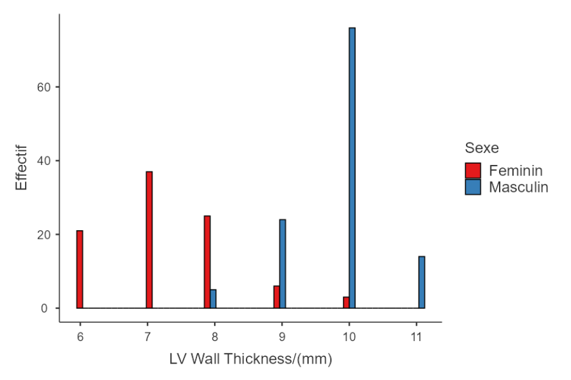
Fig 1: Distribution of Left Ventricular Wall Thickness by Sex

LV end-diastolic volume, indexed and absolute, was greater in men (118 ± 16 vs. 79.9 ± 17.8 ml; P < 0.001). Ejection fraction was slightly elevated in men (62.9% vs. 59.7%; P = 0.004) (figure 2).
Left atrial end-systolic dimension and right atrial dimension also were larger in men, but indexed left atrial dimension and volume were similar between the sexes. Aortic root and proximal ascending aortic dimensions were also larger in men (P < 0.001) (figure2).
Doppler findings indicated elevated E/A ratio, elevated lateral e′ velocity, and elevated pulmonary artery acceleration time in men, Adequate tricuspid regurgitation envelope for pulmonary artery systolic pressure (PASP) estimation was present in 78% of the cohort. For the remaining athletes, PASP was not estimated due to insufficient Doppler signal. All calculated PASP values were within normal limits.
Right ventricular function and size were normal in all players (Table 3).
Myocardial strain and deformation indices were not evaluated in this cohort.
Table 3. Echocardiographic Findings by Sex.
 | Female players (n=93 ) | Male players (n=119 ) | P-Value  (T de student)
Structural, volumes and ventricular function.
LVEDD, cm * | 45,1±4,39[35 to 55] | 50,1±2,74[47 to 56] | < .001
LVEDD indexed , cm * | 27,6±2,6[22,3 to 35,9] | 26,5±1,97[22,4 to 29,3] | < .001
IVST, cm * | 7,29±1,01[6 to 10] | 9,83±0,68[8 to 11] | < .001
Posterior wall thickness, cm * | 7,51±1,1[6 to 10] | 8,97±1[8 to 10] | < .001
LV mass indexed, g/m² * | 63,7±14,0[38,8 to 96,3] | 89,3±13,2[69,7 to 115] | < .001
LV RWT * | 0,33±0,05[0,21 to 0,49] | 0,35±0,03[0,32 to 0,42] | < .001
LVEDV, ml * | 79,9±17,8[40 to 139] | 118±16[92 to 154] | < .001
LVEDV indexed, ml/m² * | 49,3±10,9[23 to 72] | 60,4±8,48[49 to 81] | < .001
LV ejection fraction, % * | 59,7±7,03[50 to 76] | 62,9±[51 to 78] | 0.004
LA ESD, mm * | 30,6±2,65 [24 to 37] | 36,2±5,59[27 to 49] | < .001
LA ESD indexed,mm/m² * | 18,8±1,70[15,4 to 22,3] | 19,1±2,80[13,8 to 22,5] | 0.304
LA ESV indexed ml/m² * | 21,4±5,86[10 to 34] | 21,2±4,88[15 to 29] | 0,797
RAESA cm² * | 14,6±4,34[8 to 26] | 18,7±3,77[10 to 24] | < .001
Aortic sinus diameter, cm * | 22,8± 3,20[17 to 31] | 25,8±2,30[23 to 30] | < .001
Proximal ascending aorta, mm * | 25,1±2,64[19 to 30] | 27,7±1,80[25 to 31] | < .001
Spectral and tissue doppler.
E/A ratio * | 1,49±0,46[0,8 to2,4 ] | 1,70±0,33[1,2 to 2,6] | < .001
Lateral e′, cm/s * | 15,4±1,63[11,9 to 18] | 16,6±1,18[15,2 to 18,1] | < .001
Pulmonary artery acceleration time,ms* | 117±15,7[98 to 160] | 138±16,0[110 to 157] | < .001
PASP**, mmhg * | 19,6±6,81[9 to 32] | 20,7±6,36[15 to 34] | 0,245
Right ventricular dimensions, volume and function were normal in all players.
* :( Intervals, mean (SD) [range]), LVEDD : LV end-diastolic dimension, IVST : Interventricular septum, LV :left ventricular, RWT : Relative wall thickness, LVEDV : LV end-diastolic volume, LA ESD : left atrium end systolic diameter, LAESV : left atrium end systolic volume, RAESA : right atrium end systolic area, PASP** : pulmonary artery systolic pressure calculated using tricuspid valve velocity.

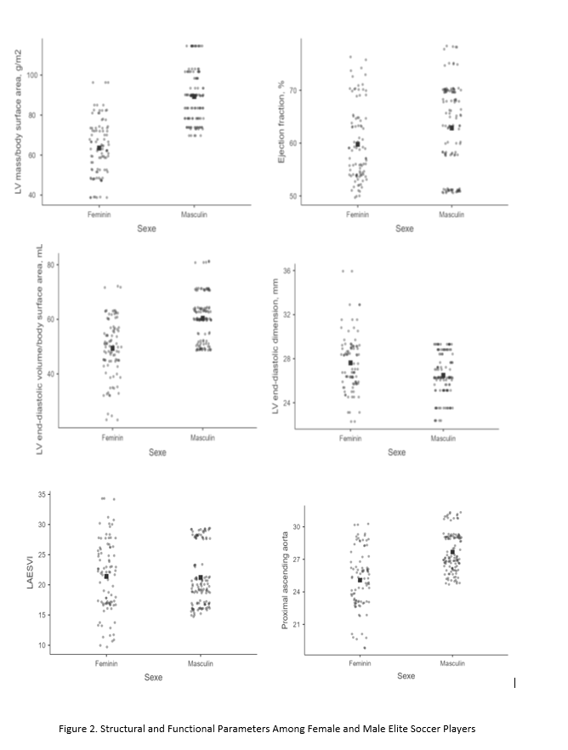

- Discussion
This study provides new insights into the echocardiographic and electrocardiographic characteristics of elite Moroccan footballers and highlights sex-specific differences. These findings add regional data to the global understanding of the athlete’s heart, which has been extensively characterized in European and North American cohorts, although rarely in North African populations. Our studies show that the male and female athletes exhibit findings consistent with physiological remodeling and do not demonstrate any evidence for pathological alterations requiring sport restriction. The pattern observed aligns with recent evidence that athletic remodeling represents a “supernormal” cardiac adaptation to exercise rather than subclinical disease, as noted by D’Andrea et al [1]. Interestingly, sex-specific patterns were observed and are consistent with international literature while also providing new knowledge using a North African population.
Our findings support those produced by Churchill et al. [6] in presenting that elite female soccer players had decreased left ventricular (LV) cavity dimensions and decreased LV mass compared to men while retaining the same training intensity. Female athletes in the present study also had decreased diameters at the LV, and some values were higher than values recommended by the guidelines, once more highlighting the fact that sex-specific reference values should be employed while analyzing athletic data. Niederseer et al. similarly emphasized that systematic echocardiographic evaluation is crucial for distinguishing physiological remodeling from pathology during athlete screening [2].
The African perspective matters particularly because there isn't much research targeting this population. Ngabea et al. [7], in their study of Nigerian national football players, they registered the occurrence of physiological ECG and echocardiographic patterns in the absence of pathologic findings. Similarly, the Ph.D. thesis done by P.Pambo [8] that investigated the patterns of echocardiography among the Ghana football team members emphasized the anticipated properties of the athlete’s heart and the need to establish the normative values adapted to African athletes. Later, Eze Nwafor and Agi later showed that both ethnicity and sex affect the ECG repolarization patterns in African athletes, supporting the need for population-specific interpretation criteria [5]. Our results among Moroccan football players confirm the trend and sustain the hypothesis that regional and racial differences may influence the range of the standard cardiac remodeling, as also suggested by Rawlins et al. [9] and Di Paolo et al. [10].
From a global perspective, our data support the findings of Sharma et al. [11] and Finocchiaro et al. [12] that the physiological limits of remodeling, particularly left ventricular hypertrophy and chamber size, are preserved in clearly defined borders for most athletes. Similar results were observed by Radmilovic et al., who found proportional enlargement of cardiac chambers with preserved function in elite athletes [4], while recent 2025 British Society of Echocardiography guidelines , which reaffirm the distinction between physiological and pathological adaptation [3]. No participants showed echocardiographic patterns suggestive of hypertrophic cardiomyopathy, dilated cardiomyopathy, or other pathological remodeling types, highlighting the importance of differentiating disease and benign adaptation to avoid unnecessary disqualification [13, 14]
The clinical implications are significant. Association with sudden cardiac death among young athletes is most commonly observed in football, as documented in previous studies[ [15, 16]. Systematic pre-competition medical assessments, therefore, as recommended by FIFA [17]cannot be overstated. Our study supports the inclusion of ECG and echocardiography in such screening, in line with international recommendations [11, 18]. Recent reviews by Niederseer et al. [2] and Oxborough et al. [3] have further emphasized echocardiography’s critical role in risk stratification and early detection of potentially dangerous remodeling patterns.
Strengths and Limitations
One important strength of this study lies in the large and sex-balanced population of North African athletes, who offer new perspectives on a population in sports cardiology research. A further strength is the systematic use of identical international standard criteria, enhances the comparability of our results with global literature. Echocardiographic analyses were conducted under consistent loading conditions by experienced operators, ensuring data reliability.
Limitations exist. The cross-sectional design prevents tracking changes over time or after detraining. The single-center setting limits generalization to all Moroccan or African players. The absence of a non-athlete control group restricts comparison with the general population. Data on hormonal status and menstrual cycle in female athletes were not collected, which may influence some parameters. Myocardial strain and deformation indices were not assessed, which could have provided additional insight into subclinical myocardial adaptation. Examinations were reviewed independently by two cardiologists, but interobserver variability was not tested statistically.
Future studies should seek to establish normative reference values for North African athletes by multicenter and longitudinal studies covering both sexes and different sport activities. Integration of strain imaging and longitudinal follow-up should be prioritized to better characterize the dynamics of cardiac adaptation in this population.

Conclusion
This study provides new reference data on the cardiac profile of elite Moroccan football players, a population underrepresented in sports cardiology research. The findings confirm that both male and female athletes display physiological, sex-specific patterns of cardiac remodeling, consistent with international norms. None of the participants had evidence of pathological alterations requiring medical restriction.
These results support the importance of integrating ECG and echocardiography in pre-participation screening programs, as recently endorsed by international guidelines. Data also emphasize the need for regional reference values tailored to North African athletes, given that sex and ethnicity are key modifiers of normal cardiac adaptation.
Future multicenter and longitudinal studies using strain imaging are needed to better define the spectrum of normal cardiac remodeling in African athletes and to monitor its evolution with training and detraining.

Ethical approval and Consent:

All authors declare that the study was reviewed and approved by the Ethics Committee of the Avicenna Military Hospital, Marrakech.
All procedures were conducted in accordance with the ethical standards of the institutional and national research committees and with the 1964 Declaration of Helsinki and its later amendments.
Verbal informed consent was obtained from all participants before inclusion. Data were collected anonymously, and confidentiality was maintained throughout the study.

Abbreviations

- AV – Atrioventricular
- BSA – Body surface area
- BMI – Body mass index
- DBP – Diastolic Blood pressure
- ECG – Electrocardiography / Electrocardiogram
- EF – Ejection fraction
- HR – Heart rate
- IVST – Interventricular septal thickness
- LA – Left atrium
- LA ESD – Left atrium end-systolic diameter
- LA ESVi – Left atrium end-systolic volume indexed
- LV – Left ventricle / ventricular
- LVEDD – Left ventricular end-diastolic diameter
- LVEDV – Left ventricular end-diastolic volume
- LVH – Left ventricular hypertrophy
- LV RWT – Left ventricular relative wall thickness
- PASP – Pulmonary artery systolic pressure
- PR – PR interval
- QTc – Corrected QT interval
- RA – Right atrium
- RAESA – Right atrium end-systolic area
- RBBB – Right bundle branch block
- RVH – Right ventricular hypertrophy
- SBP – Systolic blood pressure

Disclaimer (Artificial intelligence)
Authors hereby declare that NO generative AI technologies such as Large Language Models (ChatGPT, COPILOT, etc.) and text-to-image generators have been used during the writing or editing of this manuscript.

References

[1] | F. T. R. L. S. R. A. R. M. F. e. a. D’Andrea A, "Acute and chronic response to exercise in athletes: The “supernormal heart.”," J Cardiovasc Ultrasound., 2023.
[2] | "Niederseer D, Rossi VA, Kissel C, Scherr J, Caselli S, Tanner FC, et al.," Role of echocardiography in screening and evaluation of athletes., 2024.
[3] | G. K. C. R. B. R. R. T. Z. A. e. a. Oxborough D, "Echocardiography in the cardiac assessment of young athletes: a 2025 guideline from the British Society of Echocardiography.," Echo Res Pract., 2025.
[4] | D. A. D. A. T. E. S. S. R. L. e. a. Radmilovic J, "Echocardiography in athletes in primary prevention of sudden death.," Eur J Prev Cardiol., 2024.
[5] | A. C. Eze Nwafor C, "Gender-Related ECG Differences Among Professional Footballers in Southern Nigeria," Int J Med Eng Phys Res., 2024.
[6] | P. B. W. M. G. J. W. R. S. T. e. a. Churchill TW, "Cardiac structure and function in elite female and male soccer players.," JAMA Cardiol. 2020;5(12):1419-25., 2020.
[7] | O. I. O. O. Ngabea MA, "Pattern of electrocardiographic and echocardiographic findings amongst Nigeria national football team players.," Niger Med J. 2023;66(2):97-104., 2023.
[8] | Prince Pambo, "Electrocardiographic and echocardiographic findings in Ghanaian soccer players," Saarbrücken: Saarland University, Institute of Sports and Preventive Medicine, 2020.
[9] | C. F. K. G. P. M. C. N. E. C. e. a. Rawlins J, "Ethnic differences in physiological cardiac adaptation to intense physical exercise in highly trained female athletes.," Circulation. 2010;121(9):1078-85., 2010.
[10] | S. C. Z. Y. J. A. Q. F. C. F. e. a. Di Paolo FM, "The athlete’s heart in adolescent Africans: an electrocardiographic and echocardiographic study," J Am Coll Cardiol. 2012;59(11):1029-36, 2012.
[11] | D. J. B. A. P. M. W. M. P. J. e. a. Sharma S, "International recommendations for electrocardiographic interpretation in athletes.," J Am Coll Cardiol. 2017;69(8):1057-75., 2017.
[12] | D. H. D. A. M. A. S. A. M. L. e. a. Finocchiaro G, "Effect of sex and sporting discipline on LV adaptation to exercise.," JACC Cardiovasc Imaging. 2017;10(9):965-72., 2017.
[13] | M. B. C. F. S. A. C. G. Pelliccia A, "Athlete’s heart in women: echocardiographic characterization of highly trained elite female athletes.," JAMA. 1996;276(3):211-5., 1996.
[14] | R. N. O. R. M. A. P. M. W. M. e. a. Schnell F, "Recognition and significance of pathological T-wave inversions in athletes.," Circulation. 2015;131(2):165-73., 2015.
[15] | A. A. Higgins JP, "Soccer and sudden cardiac death in young competitive athletes: a review.," J Sports Med (Hindawi Publ Corp). 2013;2013:967183., 2013.
[16] | D. J. S. C. M. T. F.-M. Kramer EB, "promoting the prevention and management of sudden cardiac arrest in football.," Br J Sports Med. 2015;49(9):597-8., 2015.
[17] | FIFA, "Pre-competition medical assessment (PCMA). Fédération Internationale de Football Association; 2015," 2015. [Online]. Available: https://www.fifa.com/who-we-are/official-documents/#fifamedical.
[18] | R. P. B. L. C. B. F. J. F. M. e. a. Mitchell C, "Guidelines for performing a comprehensive transthoracic echocardiographic examination in adults: recommendations from the American Society of Echocardiography.," J Am Soc Echocardiogr. 2019;32(1):1-64., 2019.
[19] | e. a. Sharma, "Physiologic limits of left ventricular hypertrophy in elite junior athletes: relevance to differential diagnosis of athlete’s heart and hypertrophic cardiomyopathy," J Am Coll Cardiol.2002;40(8):1431-6., 2002.

APPENDIX: Data Collection Form
The standardized questionnaire included:
- Demographic information (age, sex, height, weight, body surface area).
- Training characteristics (years of practice, weekly training hours, playing position).
- Medical history (previous cardiovascular symptoms, family history of cardiac disease, medications).
- Pre-competition screening results (blood pressure, resting heart rate, ECG, echocardiographic parameters).
Measurement Standards
- ECGs were interpreted according to the International Criteria for ECG Interpretation in Athletes (2017).
- Echocardiographic parameters followed the European Society of Cardiology guidelines for athletes (2020)

