Partial Purification, Biochemical Characterization and Biotechnological Application of Cellulase Isolated from Aspergillus niger for Juice Clarification

ABSTRACT
Cellulase enzymes are key biocatalysts with wide industrial relevance, particularly in food and beverage processing. Despite its significance, efficient production and purification methods are still needed to meet industrial demands. Recent studies have explored the cellulose-degrading potential of bacteria and fungi associated with long-horn beetles, highlighting their promising role as a novel source of cellulases. Aspergillus niger, isolated from the gut of long horned beetles, presents a promising new source of cellulase with potential for enhanced stability and activity. Therefore, this study sought to investigate the purification, characterization, and biotechnological application of cellulase produced by Aspergillus niger isolated from the gut of the long-horned beetle (Cerambycidae latreille). The fungus was cultivated under optimized submerged fermentation conditions, and the crude cellulase extract was purified using ammonium sulfate precipitation followed by ion-exchange chromatography. The purification process resulted in a significant increase in specific activity and enzyme yield. Characterization of the purified enzyme was performed to assess the effects of various inhibitors, including sodium nitrate, SDS, Tween 20, β-mercaptoethanol, cysteine, urea, Triton X, and EDTA, on enzymatic activity. Kinetic parameters (K_{m} and V_{max}) were determined using cellulose as substrate at varying concentrations, demonstrating high substrate affinity and catalytic efficiency. The enzyme’s potential for industrial application was evaluated through juice clarification tests using apple, pineapple, orange, and watermelon juices. The findings revealed that cellulase treatment markedly improved juice clarity, reduced viscosity, and enhanced filterability without compromising nutritional quality. Overall, cellulase from A. niger isolated from Cerambycidae latreille represents an eco-friendly and efficient biocatalyst suitable for large-scale juice clarification and other biotechnological processes.
KEYWORDS: Submerged fermentation; isolation; purification; characterization; juice clarification.
1.0 INTRODUCTION
Cellulose constitutes a homopolymer composed of D-glucose units connected by β-1, 4 bonds. As the most prevalent biomass, it serves as a crucial structural element in plants, presenting a renewable energy source within the biosphere (Islam and Roy, 2018; Sohail et al., 2009). They play a vital role in the carbon cycle and have numerous industrial applications, including biofuel production, textile processing, and animal feed. Microbial sources are the primary source of cellulases used commercially, with fungi being the most important producers. Among the different fungal species, Aspergillus niger is a well-studied cellulase producer and has been extensively used in various industrial applications (Santos et al., 2022; Sohail et al., 2009)
The ability of cellulase enzymes to efficiently break down cellulose into fermentable sugars has made them integral in the development of sustainable and eco-friendly technologies, contributing to the utilization of renewable resources for energy and various other applications. Several studies have reported that the addition of cellulase enzymes greatly improves the activity of hydrolytic cellulases, resulting in a more efficient conversion of cellulose to fermentable sugars (Nwamba et al., 2021). Furthermore, the synergistic interaction of cellulase enzymes with accessory enzymes, such as xylanase, has been shown to significantly improve cellulose accessibility, thereby enhancing enzyme accessibility and improving the efficiency of cellulose hydrolysis (Chen et al., 2019). Cellulase can convert lignocellulosic biomass into fermentable sugars in an environmentally friendly manner, providing a promising approach for this process (Chaudhari et al., 2023). Indeed, the demand for these enzymes is growing more rapidly than ever before, becoming the driving force for research on engineering cellulolytic enzymes (Ben Hmad & Gargouri, 2017).
The most important limiting factors for cellulase recycling include enzyme inhibition by glucose, loss of enzyme activities, and non-productive binding of enzymes to insoluble biomass solids (Kim et al., 2019). Cellulases are used in various industrial applications, such as fiber modification in the paper and textile industries, extraction of vegetable dyes, and the production of fermentable sugars for biofuels (Ejaz et al., 2021). The cost of cellulase enzymes represents a significant challenge for the commercial conversion of lignocellulosic biomass into renewable chemicals such as ethanol and monomers for plastics (Ou et al., 2009). Cellulase is a generic name for the enzymes group that catalyzes the hydrolysis of cellulose and related celluoligosaccharide derivatives (Iqbal et al., 2011).
Long-horn beetles (Cerambycidae latreille) are a diverse group of insects with over 35,000 described species (Nie et al., 2021). They are known for their long antennae, which can be several times the length of their body. These beetles often inhabit wood, and their larvae feed on decaying wood or living trees. This association with wood suggests that long-horn beetles may harbor a rich diversity of microbes, including potential cellulase producers (Wang et al., 2022). Recent studies have explored the cellulose-degrading potential of bacteria and fungi associated with long-horn beetles, highlighting their promising role as a novel source of cellulases (Payne et al., 2015).
A. niger, a common fungal species known for its enzymatic capabilities, has shown promise in cellulase production. Long-horned beetles thrive on cellulose-rich woody materials and harbor microorganisms within their digestive systems, potentially including cellulolytic fungi like Aspergillus niger. Despite its potential, the production, purification, and detailed characterization of cellulase enzymes from A. niger sourced from Longhorn beetles remain relatively unexplored. Understanding the enzymatic properties and optimizing the production of cellulase from this source is crucial for enhancing the efficiency of cellulose degradation. Therefore, the aim of this research is to produce, purify and characterize cellulase obtained from A. niger isolated from the gut of Long-horned beetles. This study holds significance by potentially advancing industrial biotechnology for biofuel production, contributing to our understanding of microbial diversity and ecology in unique environments, offering insights into the ecological dynamics of wood-feeding insects, optimizing enzyme production for industrial applications, and suggesting innovative strategies for pest control in the context of wood-feeding pests.
2.0 MATERIALS AND METHODS
2.1 Materials
2.1.1 Source of organism
Aspergillus niger which had been previously isolated from the gut of Long-beetles (cerembycidae latreille) according to the method described by Hassan and Emara (2015) was collected from the department of Biochemistry, Federal University of Technology Akure.
2.1.2 Reagents/Chemicals
Chemical reagents such as, carboxymethyl cellulose (CMC), dinitrosalicylic acid (DNSA), diethylaminoethyl (DEAE) and bovine serum albumin (BSA) were products of Sigma-Aldrich CHEMIE GmbH, US while chemicals such as agar, sodium acetate, citric acid, sulphuric acid, distilled water, hydrochloric acid (HCl), sodium hydroxide, Tris-HCl buffer, sodium chloride, magnesium sulphate, glycine, ethylenediaminetetraacetic acid (EDTA), copper sulfate, calcium chloride, manganese sulphate, barium chloride, cobalt chloride, calcium chloride, iron chloride, dithiothreitol, β-mercaptoethanol, sodium dodecyl sulfate, L-cysteine, tween 20, Triton X-100, ethanol, isopropanol, butanol, xylene, cyclohexane, methanol, n-hexane, toluene, benzene, water or isotonic buffer, Lysis Solution, Fungal/Bacterial DNA Binding Buffer, DNA Pre-Wash Buffer, Fungal/Bacterial DNA Wash Buffer, and DNA Elution Buffer were of analytical grade.
2.1.3 Equipment
The equipment used for this research were; a portable pressure steam sterilizer (Model YX- 18LM), UV–visible spectrophotometer (Axiom 721 vis spectrophotometer UK), pH meter (Philips India), water bath shaker (WHY-2, USA), water bath (HH-W420 thermostatic water cabinet, UK), refrigerated centrifuge (AFI, India), analytical and top loading balance (OHAUS Corporation, US), microwave, ZR BashingTM Lysis Tube, Zymo-SpinTM IV Spin Filter, Zymo-SpinTM IIC Column, PCR machine, Trans-illuminator, agarose gel tank, and fume hood. Other materials include glassware, spatula, glass stirrer, inoculating loop, and microliter pipette.
2.2 Methods
2.2.1 Preparation of Seed culture
Potato dextrose agar (PDA) of 3.9 g was dissolved in 100 ml of distilled water, and was sieved to remove agar and thereafter sterilized using autoclave at 121 °c for 15 min after which it was allowed to cool before being inoculated with Aspergillus niger followed by incubation with water bath shaker at 30 °c, 150 rpm for 48hrs.
2.2.2 Production of Amylase from Aspergillus niger
Ten gramme of carboxymethyl cellulose (CMC), 5g of peptone, 2g of (NH₄)₂SO4, 1g of KH₂PO₄, and 0.01g of MgCl₂ were measured and dissolved in 1000 mL of distilled water in a conical flask. The solution was thoroughly mixed, and the pH was adjusted to 7.0 using KHPO₄. The resulting mixture was divided among four conical flasks, autoclaved at 121 °C for 15 minutes, and then allowed to cool. Afterward, 3 milliliters of the seed culture were inoculated into each flask. The flasks were placed on an orbital shaker at 150 rpm and incubated at 30 °C for 36-48 hours. Following incubation, the culture fluid was centrifuged at 10,000 rpm for 15 minutes using a refrigerated centrifuge. The supernatant, considered the crude enzyme, was collected and stored at 4 °C. Additionally, the volume of the crude enzyme was measured by weight.
2.2.3 Determination of Cellulase Activity
Cellulase activity was determined according to the standard assay method. 250 µL of CMC in 20 mM phosphate buffer (7.0) was placed in a test tube 250 µL of crude enzyme was added. The reaction mix was incubated at 37◦C for 30 min and the reaction was stopped by adding 500 µL of 3, 5- dinitrosalicylic acid (DNSA) regent. The tubes were heated at 100 °C for 10 min and then cooled at room temperature. The absorbance was taken at 540 nm. The blank was set up without the enzyme and treated in the same condition with the sample test tubes.
2.2.4 Determination of Protein Concentration
The protein concentration was routinely determined according to the method of Bradford (1976) using Bovine Serum Albumin (BSA) standard and the absorbance was read against blank at 595 nm with a spectrophotometer.
2.2.5 Partial purification of cellulase
2.2.5.1 Ammonium sulphate precipitation
Eight hundred and ninety millilitre of the crude enzyme was prepared and brought to 60% saturation with solid ammonium sulphate at 4 ◦C. The quantity, in grams, equivalent to 60% saturation of solid ammonium sulfate was determined using a standard calculator available at www.encorbio.com. The solid ammonium sulfate was gradually added in small amounts while gently stirring to prevent ladder (foaming) and left to settle overnight. The resulting precipitate was centrifuged at 10,000 rpm for 15 minutes, and the pellet was then diluted using 0.02 M phosphate buffer (pH 7.0) and stored in the refrigerator.
2.2.5.2 Dialysis of Crude enzyme
The pellet obtained was dialyzed against 0.02 M phosphate buffer (pH 7.0) at 4 ºC using a pre-treated dialysis bag, with three buffer changes. Subsequently, the partially purified sample was assayed for both enzyme activity and protein content.
2.2.5.3 Ion-Exchange Chromatography
The enzyme obtained from dialysis was added to a well-packed DEAE Sephadex column sized at 2.5 cm × 1.25 cm. The resin was equilibrated with 0.02 M phosphate buffer at pH 7.0, and the enzyme was introduced into the column. Unbound proteins were collected initially, followed by the elution of bound proteins using 1 M NaCl dissolved in the buffer solution. Protein presence was confirmed by measuring the collected fractions at 280 nm, while enzyme activity was assayed following the standard assay procedure. Fractions with cellulase activity were pooled together r and stored at 4 °C.
2.2.6 Characterization of Partially Purified Cellulase
2.2.6.1 Effects of pH on the activity of partially purified cellulase
The effect of pH on the cellulase activity was investigated by carrying out cellulase assay at various pH ranging from 2.0 to 12.0. The substrate solutions were prepared by dissolving 0.01g of carboxylmethyl cellulase (CMC) in 100 mL of each of the buffer solution while the Cellulase activity at each pH medium was determined using standard assay procedure.
2.2.6.2 Effect of Temperature on the activity of partially purified cellulase
The effect of temperature on the partially purified enzyme was determined by varying the temperature condition of the reacting mixture. The reacting mixture was incubated at different temperature ranging between 20- 90◦C at an interval of 10 °C. The enzyme activity was carried out according to the standard assay procedure.
2.2.6.3 Thermal Stability of Cellulase from Aspergillus niger
The thermal stability was evaluated by incubating the partially purified cellulase at different temperature incubation ranging from 30-90 °C, with 10 °C intervals, across a 3-hour duration. At every 30-minute interval during pre-incubation, a 250 µL sample of the pre-incubated cellulase was taken. Following this, the cellulase activity of each extracted sample was assessed using the standard assay procedure.
2.2.6.4 Effect of pH on the Stability of Cellulase from Aspergillus niger
The stability of the partially purified enzyme across different pH levels was investigated using buffers ranging from pH 2.0 to 12.0. In each buffer solution, a 250 µL enzyme solution was pre-incubated. An initial aliquot of the enzyme was withdrawn at 0 hours, followed by subsequent withdrawals at 1-hour intervals for 6 hours. Enzyme activity was then assessed using the designated procedure, and the relative activity was also calculated.
2.2.6.5 Effects of Inhibitors on the activity of Partially Purified Cellulase
The effect of different Inhibitors on the activity of the purified enzyme at 5 and 10 mM were determined using L-cysteine, dithiothreitol, sodium dodecyl sulfate, mercapto-ethanol, Triton X-100, Tween 20, Urea and EDTA. The substrate was pre-incubated with the above listed inhibitors and enzyme activity was carried out using the standard assay procedure.
2.2.6.6 Measurement of Kinetic Constant
The kinetic constants, K_{m} and V_{max} of the partially purified cellulase was determined using Lineweaver-Burk plot (1934), by measuring the amylase activity at different concentrations of substrate (carboxylmethyl cellulose) from 0.1- 0.8% prepared in 0.02 M Phosphate buffer (pH 7.0). The enzyme activity (initial velocity) was determined according to the standard assay procedure. Then, inverse of initial velocities (V⁻¹) and substrate concentrations ([S]⁻¹) of each concentration were plotted. However, V_{max} and K_{m} were calculated using Lineweaver-Burk plot.
2.2.7 Method of Clarification of Fruit Juices
2.2.7.1 Extraction of Fruit Juices from Pineapple, Apples, Oranges, and Watermelon
The fruits to be extracted were bought from FUTA fruit vendor and transported to Food and science Technology department, FUTA where the extraction was carried out. The fruits were properly washed to remove dirt and in an aseptic environment they were peeled and cut into small fractions. With the aid of an electric juice extractor, the juice for each fruit was extracted and filtered, then transferred into labelled, clean and sterile containers.
2.2.7.2 Clarification of Fruit Juices with partially Purified cellulase
For clarity of the juices using the partially purified enzyme, 10 ml each of the extracted fruit juice transferred into test tubes was sterilized at 100 ⁰C for 15 minutes and allowed to cool down. 2 ml of the purified enzyme was added to each test tubes and incubated at 40 ⁰C for 3 hours. Then 2 ml of distilled water was added to each test tubes and mixed together. Each fruit sample was transferred into centrifuge tubes and cold centrifuged at 4500 rpm for 20 minutes. The supernatant for each fruit was collected and the clarity was checked with the aid of spectrophotometer by reading the absorbance at 660 nm, using water as the blank. The volume of each of the fruits treated with enzyme was recorded.
2.2.7.3 Clarification of the Fruit Juices with Gelatin
Clarification of the fruit juices using gelatin was carried out with 0.5 g of gelatin, which was introduced into 10 ml of each extracted fruit juice in test tubes and incubated for 3hours at 37 °C. They juices were then filtered using a clean muslin cloth (Thamer, 2013). The volume of each of the fruits treated with gelatin was recorded.
2.2.7.4. Determination of Reducing Sugars on ruit Juice treated with Cellulase
The concentration of the reducing sugars was determined with 0.5 µl of each fruit treated with enzyme was transferred into test tubes and 0.5µl DNSA was added, then boiled a t 100 ⁰C for 10 minutes and left to cool down and read at the absorbance of 540 nm using a UV-VIS spectrophotometer (Kothari et al., 2013).
2.3. Statistical Analysis
All experiments were conducted in triplicate, and data sets were analysed using Microsoft Excel 2016. Mean values were calculated and recorded alongside standard deviations (Mean ⁺ STDEV).

3.0 RESULTS & DISCUSSION
3.1 Activity of cellulase produced from Aspergillus niger
Cellulase activity and protein concentration results on the crude and partially purified enzymes were found to be (3.638 units/mL and 4.58 mg/mL) and (10.72 units/mL and 14.22 mg/mL) respectively as presented in Table 1.
3.2 Partial purification of cellulase from Aspergillus niger
The summary of the partial purification of cellulase from Aspergillus niger is presented in Table 1. The dialysate obtained after dialysis of precipitated protein using ammonium sulphate showed yield of 5.6% with 94.5-fold purification. When the dialysate was loaded on DEAE sephacel (ion exchange chromatography), a sharp peak activity (Figure 1) was observed with 5.4% recovery and 15.2-purification fold.

Figure 1. Elution from ion- exchange chromatography using DEAE Sephacel resin (1.25 × 2.5cm)
Table 1. Purification Table of Cellulase from Aspergillus niger.
Step | Total Vol.  (ml) | Protein conc.  (mg/ml) | Total Protein  (mg/ml) | Activity  (Unit/ml) | Total activity  (Unit) | Specific activity  (U/mg) | Purification fold | Yield  (%)
Crude | 350 | 4.58 | 1603 | 3.638 | 1273.3 | 0.794 | 1 | 100
(NH₄)₂SO₄ | 45 | 2.12 | 95.4 | 1.591 | 71.59 | 0.750 | 94.5 | 5.6
DEAE Sephacel | 40 | 14.22 | 568.8 | 10.72 | 68.8 | 0.121 | 15.2 | 5.4

Total Protein (mg) = Protein concentration (mg/mL) x Total volume (mL)
Total Activity (U) = Activity in the fraction (U/mL) x Total volume (mL)
Specific Activity (U/mg) = Total activity (U) / Total protein (mg)
Yield (%) = (Total Activity of Purified step / Total Activity of the crude) x 100
Purification Fold = Specific Activity of Purified Step / Specific Activity of the Crude

3.3 Characterization of Partially Purified Cellulase
3.3.1 Effect of pH on the Activity of cellulase from Aspergillus niger
The effect of pH on the activity of partially purified cellulase from Aspergillus niger is presented in Figure 2a. The partially purified cellulase was found to be active in all the pH investigated. The relative activity increased from 42.01% to 65.54% between pH 2.0-7.0 while the pH optimum was observed to be 8.0. However, a gradual decline in relative activity was observed from pH 9.0-12.0 with a relative activity of 0% at 12.0.
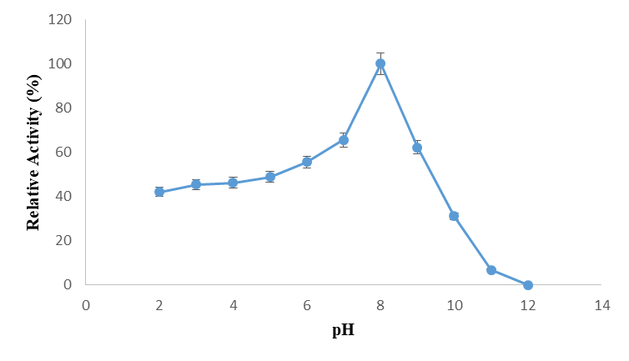
Figure 2a: Effect of pH on Cellulase Activity
3.3.2 Effect of pH on the stability of cellulase from Aspergillus niger
The effect of pH on the stability of partially purified cellulase is presented in Figure 2b. A maximum enzyme stability was obtained at pH 9.0 with 78.46 % residual activity after 1 hour of incubation while the enzyme exhibited decrease in residual activities of 10.32 - 22.72 % at pH 2.0 - 12.0 after 6 hours of incubation.

Figure 2b: Effect of pH on the Stability of Partially Purified Cellulase
3.3.3 Effect of Temperature on the activity of partially purified cellulase
The effects of temperature on the activity of partially purified cellulase produced from Aspergillus niger is presented in Figure 3. The enzymatic activity of partially purified cellulase increases as temperature is increasing up to 50◦C where optimum activity was optimum at 50◦C. However, a minimum relative activity of 37.5% and 14.16% was obtained at 80◦C and 90◦C.
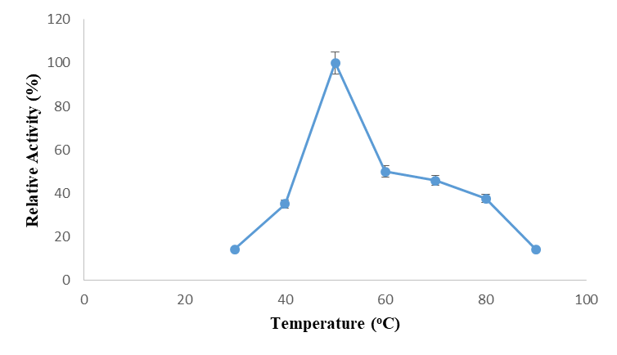
Figure 3a: Effect of Temperature on Cellulase Activity

3.3.4 Thermal Stability of Cellulase from Aspergillus niger
Thermal stability of partially purified cellulase is shown in Figure3b. The partially purified cellulase retained its original activity after 2 h incubation period. However, a residual activity of 65-80 % was observed between 60-80 °C after 1 h incubation period following its decline in residual activity. A remaining activity of 75 % was observed at 40 and 60 °C and over 60 % at 70 and 80 °C; whereas the enzymatic activity was almost deactivated at 90 °C with less than 5 % remaining activity recorded after 2 h incubation period.

Figure 3b: Thermal Stability of Partially Purified Cellulase
3.3.5 Effects of Inhibitors on the Activity of Partially Purified Cellulase
The effect of inhibitors on the activity of partially purified amylase is presented in Figure 4. The results indicated that sodium azide, SDS, tween- 20, β-mercaptoethanol, L-cysteine, urea and triton X- 100, and EDTA were resistant to enzymatic activity at 5 mM concentration, and rather led to enhancement in the enzymatic activity. Noticeably, activity enhancement was more pronounced in the presence of 5 mM SDS. Conversely, the enzymatic activity showed a significant decrease at 10 mM of all the inhibitors investigated with over 60% loss in the enzymatic activity.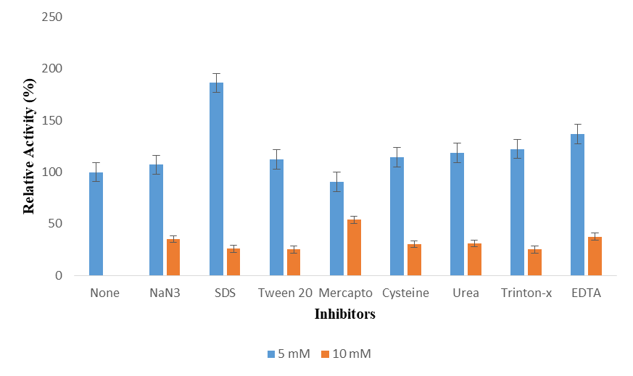
Figure 4: Effects of Inhibitors on the Activity of Partially Purified Cellulase

3.3.6 Kinetic Analysis
Linewaver- Burk of partially purified cellulase is presented in Figure 6. The K_{m} and V_{max} of cellulase was determined to be 0.215 mM and 0.2911 mg/ml/min.

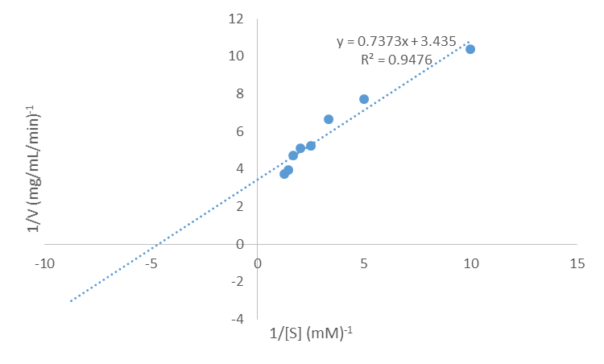

Figure 5: Kinetic parameters of the Partially Purified Cellulase

3.4. Clarification of Fruit Juices with partially Purified cellulase
The viscosity of all fruit juices decreased significantly following treatment with cellulase. Among the juices, pineapple, originally characterized by cloudiness and higher viscosity, exhibited the greatest increase in absorbance post-enzyme treatment, indicating a more pronounced enzymatic effect compared to apple, orange, and watermelon. The results in Table 2 illustrate the volume of fruit juices treated with cellulase, along with the corresponding percentages of clarity and yield. Pineapple displayed the highest % clarity, while watermelon exhibited the lowest. Apple recorded the highest % yield, contrasting with pineapple, which had the lowest. In Table 3, detailing the effects of gelatin treatment on fruit juices, watermelon emerged with the highest volume and % yield. The analysis of reducing sugar content in fruit juices treated with cellulase, as presented in Table 4, revealed watermelon to have the highest concentration at an absorbance of 540 nm. Volume of fruit juice treated with water is shown in Table 5, apple had the highest volume while watermelon had the lowest volume.
Table 2: Fruits treated with Cellulase
Fruit | Volume  (ml) | % Clarity | % Yield
Apple | 13.5 | 140 | 112.5
Pineapple | 8.5 | 450 | 70.83
Orange | 13 | 327.5 | 108.3
Watermelon | 13.5 | 42.5 | 112.5
Blank (Water) = 0.04, Volume of fruit juices treated with water= 12 ml
Table 3: Fruits treated with Gelatin
Fruit | Volume (ml) | % yield
Apple | 6.5 | 54.16
Pineapple | 5.0 | 41.60
Orange | 5.5 | 45.83
Watermelon | 8.5 | 70.83
Volume of fruit juices treated with water = 12 ml

Table 4: Determination of reducing sugar on fruit juices treated with cellulase
Fruit | Reducing sugar (glucose)  (mg/ml)
Apple | 43.38
Pineapple | 42.25
Orange | 42.79
Watermelon | 44.67
Blank (Water) = 0.412
Table 5: Volume of fruit juice treated with water
Fruits | Volume (ml)
Apple | 11.0
Pineapple | 6.50
Orange | 10.0
Watermelon | 9.0

Discussion
The present study focused on the production, partial purification and characterization of cellulase from Aspergillus niger isolated from the gut of longhorn beetles (Cerambycidae latreille). The occurrence of cellulase activity in A. niger isolated from the gut of longhorned beetles in this present study is not unusual as several authors (Afe et al., 2023); (Nandy et al., 2021); (Kouboya et al., 2023), had isolated, purified and characterized this important hydrolytic enzyme from different microorganisms isolated from different invertebrates like beetles, termites, snails, termite, caterpillar etc. (Hatefi et al., 2017; Banerjee et al., 2020; Nandy et al., 2021; Afe et al., 2023; Kouboya et al. 2023). Various researchers have reported cellulase microbial actions in the digestive tract of insects. Microbial cellulase production and their cellulolytic potential have been reported from four diverse invertebrates (termite, snail, caterpillar, and bookworm) (Gupta et al., 2012). (Huang et al., 2012) as well, reported detection of cellulolytic activity in bacteria from the gut of Holotrichia parallela larvae (coleoptera: scarabacidae) while (S. B et al., 2012) gave account on the production of cellulase and protease from microorganisms isolated from gut of Archachatina marginata (giant African snail). Therefore, the guts of herbivorous insects serve as microbial habitats for digestion of plant materials owing to inherent ability of microbiota in the animals to degrade cellulosic material of the plant.
The summary of the partial purification of Cellulase isolated from A. niger is presented in Table 1. However, from the results, a 5.4% yield with a 15.2-fold purification obtained from this study is a good starting point for cellulase purification which is high when compared to the result obtained by (Isam & Roy, 2018) from cellulase producing bacteria in molasses with a purification fold of 5.59 while lower purification fold of 2.30 was obtained by (Mahmood et al., 2013) for purification from Aspergillus fumigatus and (Sajith et al., 2014) reported 1.09% recovery with 68.2-fold purification and specific activity of 260.88 U/mg protein from A. niger. This high yield suggests that the chosen precipitation conditions were well-suited for the cellulase, minimizing its loss during the process (Islam, 2019). However, purification folds and yields are influenced by various factors, including the type of resins, purification conditions such as pH of the buffer, and size of the resin, which influences the elution rate (S. Chen et al., 2022).
The enzyme retained the highest residual activity (78.46%) after 1 hour of incubation at pH 9.0, this observation aligns with the findings of (Parab et al., 2023; Ribeiro Lima et al., 2021), who noted that xylanase exhibited pH optima of 8.0 and retained 92% of its residual activity after a 24-hour incubation period at pH 8.0, demonstrating high stability at alkaline pH. This indicates that the protein structure and catalytic function are most stable under these alkaline conditions, this could be as a result of presence of crucial amino acid residues with pKa values around 9.0 that are necessary for proper protein folding and enzyme activity (Pahari et al., 2019). The residual activity of the enzyme decreased by 10.32 % to 22.72 % at pH 2.0 to 12.0 after 6 hours of incubation, this suggests that the protein structure and/or function is compromised at acidic and highly alkaline pH, leading to partial inactivation, this observation is consistent with the findings of (Reynolds et al., 2018), who reported that polygalacturonase activity decreased with increasing ethanol, indicating the impact of environmental factors on enzyme activity. The enzyme also exhibited promising thermo-stability, retaining complete activity up to 50 °C even after 3 hours of incubation. This finding is consistent with the study by (Hosseini et al., 2018), which revealed that the optimum temperature for free enzyme activity is 50 °C, and at higher temperatures, the activity of the free enzyme dramatically decreased.
An important application of the purified A. niger cellulase explored in this thesis was clarification of fruit juices. Recently, cellulases from insect-associated A. niger strains have indeed been applied for improving fruit juice quality and yield, validating this application avenue (Nayak et al., 2020). Ridge et al. (2021) addressed the enzymatic clarification challenges of Muscat grape juice, highlighting the potential of cellulase in improving the quality and extraction of grape juice.
In this study, K_{m} and V_{max} of cellulase was determined to be 0.215 mM and 0.2911 mg/ml/min respectively, as shown in Figure 5. This information aligns with the findings of (Qamar et al., 2021), who reported slower maximum reaction velocity (V_{max}) and higher K_{m} values for cellulase compared to free cellulase. These kinetic parameters are crucial for understanding the substrate affinity and maximum reaction rate of the enzyme, providing valuable insights into its catalytic efficiency and potential industrial applications.
CONCLUSION
This research focused on the production, purification and characterization of cellulase from Aspergillus niger isolated from the gut of longhorn beetles. The occurrence of cellulase activity in the fungal isolate aligns with previous studies showing that wood-feeding insects harbor cellulolytic microbes. A high yield and purification fold was achieved for the cellulase using ammonium sulfate precipitation and ion exchange chromatography. The purified enzyme retained stability over a wide pH range, distinguishing it from typical fungal cellulases. It also displayed good thermostability up to 50°C for over 3 hours. Metal ions like Cu²⁺, Zn²⁺, and Mg2⁺ stimulated cellulase activity while Ca²⁺ inhibited it. The cellulase effectively clarified fruit juices by degrading cellulosic fibers, validating its potential application in the beverage industry. Kinetic constants K_{m} and V_{max} were determined as 0.215 mM and 0.2911 mg/ml/min respectively. Overall, this study provides a strong foundation for assessing the biotechnological potential of longhorn beetle-derived A. niger cellulases. Key findings on purification, stability, metal effects and kinetics align with and build on previous cellulase research. Further studies can explore recombinant approaches to improve the catalytic efficiency and industrial viability of this novel cellulase source. The longhorn beetle gut represents an underexplored reservoir of novel lignocellulolytic enzymes for biofuel and biorefinery applications.
DISCLAIMER (ARTIFICIAL INTELLIGENCE)
Authors hereby declare that NO generative AI technologies such as Large Language Models (ChatGPT, COPILOT, etc.) and text-to-image generators have been used during the writing or editing of this manuscript.

DECLARATION OF COMPETING INTEREST
Authors report that there are no competing interests to declare.

REFERENCES
Afe, A. E., Lawal, O. T., Oyelere, B. R., Bamidele, O. S., & Sanni, D. M. (2023). Optimization, Isolation, Purification, and Characterization of a Thermally Stable, Acidophilic Cellulase from Aspergillus awamori AFE1 for Industrial and Biotechnological Applications [Preprint]. In Review. https://doi.org/10.21203/rs.3.rs-3056605/v1
Banerjee, S., Maiti, T. K., & Roy, R. N. (2020). Production, purification, and characterization of cellulase from Acinetobacter junii GAC 16.2, a novel cellulolytic gut isolate of Gryllotalpa africana, and its effects on cotton fiber and sawdust. Annals of Microbiology, 70(1), 28. https://doi.org/10.1186/s13213-020-01569-6
Ben Hmad, I., & Gargouri, A. (2017). Neutral and alkaline cellulases: Production, engineering, and applications. Journal of Basic Microbiology, 57(8), 653–658. https://doi.org/10.1002/jobm.201700111
Bradford, M.A. 1976. Rapid and sensitive method for the quantitiation of microgram quantities of protein utilizing the principle of protein-dye binding. Anal of Biochemistry, 72, 248-254.
Chaudhari, Y. B., Várnai, A., Sørlie, M., Horn, S. J., & Eijsink, V. G. H. (2023). Engineering cellulases for conversion of lignocellulosic biomass. Protein Engineering, Design & Selection: PEDS, 36, gzad002. https://doi.org/10.1093/protein/gzad002
Chen, S., Tan, Y., Zhu, Y., Sun, L., Lin, J., & Zhang, H. (2022). Application of Ultrafiltration and Ion Exchange Separation Technology for Lysozyme Separation and Extraction. Fermentation, 8(7), 297. https://doi.org/10.3390/fermentation8070297
Chen, X., Xin, D., Wang, R., Qin, Y., Wen, P., Hou, X., & Zhang, J. (2019). Factors affecting hydrolytic action of xylanase during pennisetum saccharification: Role of cellulose and its derivatives. Industrial Crops and Products, 130, 49–56. https://doi.org/10.1016/j.indcrop.2018.12.077
Ejaz, U., Sohail, M., & Ghanemi, A. (2021). Cellulases: From Bioactivity to a Variety of Industrial Applications. Biomimetics (Basel, Switzerland), 6(3), 44. https://doi.org/10.3390/biomimetics6030044
Gupta, P., Samant, K., & Sahu, A. (2012). Isolation of Cellulose-Degrading Bacteria and Determination of Their Cellulolytic Potential. International Journal of Microbiology, 2012, 1–5. https://doi.org/10.1155/2012/578925
Hassan, R. M., & Emara, M. (2015). "Isolation and identification of Aspergillus species from the gut of the Longhorn beetle, Acanthocinus aedilis (L.)." Mycological Progress, 14(5), 1039-1048.
Hatefi, A., Makhdoumi, A., Asoodeh, A., & Mirshamsi, O. (2017). Characterization of a bi-functional cellulase produced by a gut bacterial resident of Rosaceae branch borer beetle, Osphranteria coerulescens (Coleoptera: Cerambycidae). International Journal of Biological Macromolecules, 103, 158–164. https://doi.org/10.1016/j.ijbiomac.2017.05.042
Hosseini, S. H., Hosseini, S. A., Zohreh, N., Yaghoubi, M., & Pourjavadi, A. (2018). Covalent Immobilization of Cellulase Using Magnetic Poly(ionic liquid) Support: Improvement of the Enzyme Activity and Stability. Journal of Agricultural and Food Chemistry, 66(4), 789–798. https://doi.org/10.1021/acs.jafc.7b03922
Huang, S., Sheng, P., & Zhang, H. (2012). Isolation and Identification of Cellulolytic Bacteria from the Gut of Holotrichia parallela Larvae (Coleoptera: Scarabaeidae). International Journal of Molecular Sciences, 13(3), 2563–2577. https://doi.org/10.3390/ijms13032563
Iqbal, H. M. N., Ahmed, I., Zia, M. A., & Irfan, M. (2011). Purification and characterization of the kinetic parameters of cellulase produced from wheat straw by Trichoderma viride under SSF and its detergent compatibility. Advances in Bioscience and Biotechnology, 02(03), 149–156. https://doi.org/10.4236/abb.2011.23024
Islam, F. (2019). Isolation and Characterization of Cellulase-producing Bacteria from Sugar Industry Waste. American Journal of BioScience, 7(1), 16. https://doi.org/10.11648/j.ajbio.20190701.13
Islam, F., & Roy, N. (2018). Screening, purification and characterization of cellulase from cellulase producing bacteria in molasses. BMC Research Notes, 11(1), 445. https://doi.org/10.1186/s13104-018-3558-4
Kim, J. K., Yang, J., Park, S. Y., Yu, J.-H., & Kim, K. H. (2019). Cellulase recycling in high-solids enzymatic hydrolysis of pretreated empty fruit bunches. Biotechnology for Biofuels, 12, 138. https://doi.org/10.1186/s13068-019-1476-x
Koubová, A., Lorenc, F., Horváthová, T., Chroňáková, A., & Šustr, V. (2023). Millipede gut-derived microbes as a potential source of cellulolytic enzymes. World Journal of Microbiology and Biotechnology, 39(7), 169. https://doi.org/10.1007/s11274-023-03620-5
Lineweaver, H. Burk, D.1934. The determination of enzyme dissociation constants. Journal of American Chemistry and Societies. 56, 658-660
Mahmood, R. T., Asad, M. J., Mehboob, N., Mushtaq, M., Gulfraz, M., Asgher, M., Minhas, N. M., & Hadri, S. H. (2013). Production, Purification, and Characterization of Exoglucanase by Aspergillus fumigatus. Applied Biochemistry and Biotechnology, 170(4), 895–908. https://doi.org/10.1007/s12010-013-0227-x
Nandy, G., Chakraborti, M., Shee, A., Aditya, G., & Acharya, K. (2021). Gut Microbiota from Lower Groups of Animals: An Upcoming Source for Cellulolytic Enzymes with Industrial Potentials. Biointerface Research in Applied Chemistry, 11, 13614–13637. https://doi.org/10.33263/BRIAC115.1361413637
Nayak, P. K., Basumatary, B., Chandrasekar, C. M., Seth, D., & Kesavan, R. K. (2020). Impact of thermosonication and pasteurization on total phenolic contents, total flavonoid contents, antioxidant activity, and vitamin C levels of elephant apple ( Dillenia indica ) juice. Journal of Food Process Engineering, 43(8), e13447. https://doi.org/10.1111/jfpe.13447
Nie, R., Vogler, A. P., Yang, X., & Lin, M. (2021). Higher‐level phylogeny of longhorn beetles (Coleoptera: Chrysomeloidea) inferred from mitochondrial genomes. Systematic Entomology, 46(1), 56–70. https://doi.org/10.1111/syen.12447
Nwamba, M. C., Song, G., Sun, F., Mukasekuru, M. R., Ren, H., Zhang, Q., Cao, T., Wang, H., Sun, H., & Hong, J. (2021). Efficiency enhancement of a new cellulase cocktail at low enzyme loading for high solid digestion of alkali catalyzed atmospheric glycerol organosolvent pre-treated sugarcane bagasse. Bioresource Technology, 338, 125505. https://doi.org/10.1016/j.biortech.2021.125505
Ou, M. S., Mohammed, N., Ingram, L. O., & Shanmugam, K. T. (2009). Thermophilic Bacillus coagulans Requires Less Cellulases for Simultaneous Saccharification and Fermentation of Cellulose to Products than Mesophilic Microbial Biocatalysts. Applied Biochemistry and Biotechnology, 155(1–3), 76–82. https://doi.org/10.1007/s12010-008-8509-4
Pachauri, P., V., A., More, S., Sullia, S. B., & Deshmukh, S. (2020). Purification and characterization of cellulase from a novel isolate of Trichoderma longibrachiatum. Biofuels, 11(1), 85–91. https://doi.org/10.1080/17597269.2017.1345357
Pahari, S., Sun, L., & Alexov, E. (2019). PKAD: A database of experimentally measured pKa values of ionizable groups in proteins. Database, 2019. https://doi.org/10.1093/database/baz024
Parab, P. D., Khandeparker, R. D., & Amberkar, U. (2023). Isolation, Purification and Characterization of Xylanase produced by Bacillus sp. NIORKP76 strain under solid state fermentation and its application in saccharification of various agro-residues into fermentable sugars [Preprint]. In Review. https://doi.org/10.21203/rs.3.rs-3193700/v1
Payne, C. M., Knott, B. C., Mayes, H. B., Hansson, H., Himmel, M. E., Sandgren, M., Ståhlberg, J., & Beckham, G. T. (2015). Fungal Cellulases. Chemical Reviews, 115(3), 1308–1448. https://doi.org/10.1021/cr500351c
Qamar, S. A., Qamar, M., Bilal, M., Bharagava, R. N., Ferreira, L. F. R., Sher, F., & Iqbal, H. M. N. (2021). Cellulose-deconstruction potential of nano-biocatalytic systems: A strategic drive from designing to sustainable applications of immobilized cellulases. International Journal of Biological Macromolecules, 185, 1–19. https://doi.org/10.1016/j.ijbiomac.2021.06.079
Reynolds, A., Knox, A., & Di Profio, F. (2018). Evaluation of Macerating Pectinase Enzyme Activity under Various Temperature, pH and Ethanol Regimes. Beverages, 4(1), 10. https://doi.org/10.3390/beverages4010010
Ribeiro Lima, A. K., Dias Batista, R., Pereira Araújo, L., Ribeiro Da Silva, S., Vieira-Almeida, E. C., & Almeida, A. F. (2021). Production of xylanase by Aspergillus sp. ART500.1 on agroindustrial residues and its biochemical properties. Scientia Plena, 17(8). https://doi.org/10.14808/sci.plena.2021.081510
Ridge, M., Sommer, S., & Dycus, D. A. (2021). Addressing Enzymatic Clarification Challenges of Muscat Grape Juice. Fermentation, 7(3), 198. https://doi.org/10.3390/fermentation7030198
Oyeleke S. B., Egwim, E. C., Oyewole, O. A., & John, E. E. (2012). Production of Cellulase and Protease from Microorganisms Isolated from Gut of Archachatina marginata (Giant African Snail). Science and Technology, 2(1), 15–20. https://doi.org/10.5923/j.scit.20120201.03
Sajith, S., Sreedevi, S., Priji, P., Unni, K. N., & Benjamin, S. (2014). Production and partial purification of cellulase from a novel fungus, Aspergillus flavus BS1. Annals of Microbiology, 64(2), 763–771. https://doi.org/10.1007/s13213-013-0711-0
Santos, G. B., De Sousa Francisco Filho, Á., Rêgo Da Silva Rodrigues, J., & Rodrigues De Souza, R. (2022). Cellulase production by Aspergillus niger using urban lignocellulosic waste as substrate: Evaluation of different cultivation strategies. Journal of Environmental Management, 305, 114431. https://doi.org/10.1016/j.jenvman.2022.114431
Shanmugarajah, M., & Kapilan, R. (2021). Purification and characterization of cellulase from Aspergillus unguis isolated from decaying coconut wood. AGRIEAST: Journal of Agricultural Sciences, 15(1), 14. https://doi.org/10.4038/agrieast.v15i1.98
Thamer, A. (2013). EFFECT OF FUNGAL PECTINASES AND GELATIN ON APPLE JUICE CLARIFICATION.Mesopotamia Journal of Agriculture, 41(4), 313–317. https://doi.org/10.33899/magrj.2013.84786
Wang, L., Li, C., Wang, X., Wang, G., Shang, S., Dou, Z., & Luo, Y. (2022). Gut Lignocellulose Activity and Microbiota in Asian Longhorned Beetle and Their Predicted Contribution to Larval Nutrition. Frontiers in Microbiology, 13, 899865. https://doi.org/10.3389/fmicb.2022.899865

